Desk Number ________

Student Number _______________________

Student Name _______________________

**School of Science and Engineering**

**MIDTERM EXAMINATION**

Semester 2, 2020

**CSC1001 Introduction to Computer Science:**

**Programming Methodology**

Examination Duration: 120 minutes

Reading Time: 10 minutes

This examination has __3__ questions.

**Exam Conditions:**

This is a FORMAL Examination

This is a RESTRICTED OPEN BOOK Exam. Maximum of one (1) sheet of notes double sided are permitted

**Materials Permitted In The Exam Venue:**

Maximum of one (1) sheet of handwritten notes double sided are permitted. **NO OTHER MATERIALS PERMITTED**

Any calculators without the functionalities of programming and file storage are permitted.

**Materials To Be Supplied To Students:**

1 × 9 Page Answer Booklet

Question 1. (10 × 3% = 30%)

Pick the correct option in each of the following sub-questions. Note that only ONE option is correct.

1. Which of the following is **NOT** a high-level programming language? **C**

A. C/C++ language B. Java language C. Assembly language D. C# language

1. Hexadecimal number 3FA9.B and binary number 11010110.001 equal to decimal numbers: **C**

A. 16297.6875 and 428.125 B. 16553.6875 and 214.125

C. 16297.6875 and 214.125 D. 16553.625 and 428.125

1. which of the following statement is **NOT** correct? **D**

A. The theoretical foundation of computer science is built by Alan Turing.

B. The key difference between high- and low-level programming languages iswhether programmer has to deal with memory addressing directly.

C. Higher level languages have higher development efficiency, and it cannot be executed directly.

D. Compiler is a computer program that directly executes.

1. Concerning Python variables, which of the following is correct? **D**

A. Variable names must start with a letter;

B. Variable names can only contain letters and underscore;

C. Variable names are not case sensitive;

D. A variable is a named space in the memory;

1. Concerning information unit, which of the following statement is correct? **D**

A. Byte is the smallest information unit in computer programming;

B. 1 KB = 1024 bits;

C. 1 GB = 1000 MB;

D. 1 Byte = 8 bits;

1. What is the output of the following program? **D**

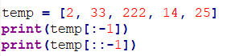

|  |  |  |  |
| --- | --- | --- | --- |
| A. | 25  [25, 14, 222, 33, 2] | B. | [25, 14, 222, 33, 2]  [2, 33, 222, 14] |
| C. | [25, 14, 222, 33, 2]  25 | D. | [2, 33, 222, 14]  [25, 14, 222, 33, 2] |

1. What is the output when we execute list(“hello”)? **B**

A. [‘h’, ‘e’, ‘l’, ‘l’, ‘o’]

B. [‘hello’]

C. [‘llo’]

D. [‘olleh’]

1. What is the output of the following program? **A**



A. 111111 B. 33 C. 3*11 D. None of the above

1. What is the output of the following program? **B**

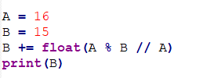

A. 16.0 B. 15.0 C. 15 D. 16

1. What is the output of the following program? **D**

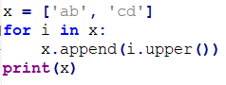

A. [‘AB’, ‘CD’] B.  [‘ab’, ‘cd’, ‘AB’, ‘CD’]

C.  [‘ab’, ‘cd’] D. None of the above

Question 2. (10 × 4% = 40%)

Pick the correct option/s in each of the following sub-questions. Note that there may be MULTIPLE correct options for each sub-question. You will get 2 points when your answers are partially right.

1. Which of the following statement(s) is (are) true? **ABC**
2. A central processing unit (CPU) contains two units, a control unit (CU) and an arithmetic/logic unit (ALU).
3. The computers used nowadays can understand only binary number (i.e. 0 and 1).
4. High level programming languages cannot be executed directly and must be converted into low level language.
5. 10 in the hexadecimal system is equal to 10 in the decimal number system.
6. Concerning the following program, which of the following statement(s) is (are) true? **D**

a = int(“1”+”2”)

print(a)

b = int(“1+2”)

print(b)

c = int(“1”+2)

print(c)

1. The first print() statement will output 3.
2. The second print() statement will output 3.
3. The third print() statement will output 3.
4. None of above is true.
5. The following 4 options show 4 statements and their outputs; in which option(s) the output is (are) correct? **AC**
6. Statement: print(str(3*3))

Output: “9”

1. Statement: a = “hello”

print(a.split(“l”)[1])

Output: “o”

1. Statement: for i in range(4):

if i == 1:

continue

elif i == 2:

break

print(i)

Output: 0

1. Statement: a = “hallo”

a[1] = “e”

print(a)

Output: “hello”

1. Concerning the following program, which of the following statement(s) is (are) true? **B**

s1 = “1”+“3”

s2 = “1*3”

s3 = “1”*3

print(s1+s2*3+s3)

1. The output is “43333”.
2. The output is “131*31*31*3111”.
3. The output is “131*31*31*33”.
4. The output is “13111111111111”
5. Concerning the following program, which of the following statement(s) is (are) true? **AD**

a = 1

b = 3

c = 5

if a<b or b<c:

print(a+b+c)

if a>b and b<c:

print(a,b,c)

if a>b or b<c:

print(str(a)*b+str(c))

if a<b and b!=c:

print(str(a)+str(b)+str(c))

1. The first print() will be executed and the output is 9.
2. The second print() will be executed and the output is “1 3 5”.
3. The third print() will be executed and the output is “135”.
4. The fourth print() will be executed and the output is “135”.
5. Which of the following statement(s) is (are) true? **D**
6. The output of print(eval(2*3+1)) is 7.
7. The output of print(type((1,2,3,4))) is <class ‘list’>
8. After we execute import math, the output of print(sin(pi/2)) is 1.0.
9. None of above is true.
10. Concerning the following two programs, which of the following statement(s) is (are) true? **BD**

Program 1:

x = [1,2,3]

for i in x:

x.append(i*2)

print(x)

Program 2:

x = [“1”,”2”,”3”]

x_new = [“1”,”2”,”3”]

for i in x:

x_new.append(i*2)

print(x_new)

1. Program 1 will output [1,2,3,2,4,6].
2. Program 1 will not be terminated.
3. Program 2 will output [“1”,”11”,”2”,”22”,”3”,”33”]
4. Program 2 will output [“1”,”2”,”3”,”11”,”22”,”33”]
5. Concerning the following two programs, which of the following statement(s) is (are) true? **BD**

Program 1:

n = 1

while True:

if n-1 >= 0:

print(n)

else:

break

Program 2:

n = 1

while n>0:

print(n)

n -= n-1

1. Program 1 will output 1.
2. Program 1 will not be terminated.
3. Program 2 will output 1
4. Program 2 will not be terminated.
5. Concerning the following program, which of the following statement(s) is (are) true? **BD**

x = 1

def increase():

global x

print(x)

x = x + 1

x = 2

increase()

print(x)

1. The output of the first print() is 1
2. The output of the first print() is 2
3. The output of the second print() is 2
4. The output of the second print() is 3
5. Concerning the following program, which of the following statement(s) is (are) true?

**ABD**

numlist = list()

while True:

print(“Enter \’done\’ to stop input.”)

inp = input(“Enter a number or \’done\’:”)

if inp == “done”: break

numlist.append(float(inp))

average = sum(numlist)/len(numlist)

1. User can enter ‘done’ as the input to break the loop.
2. This program uses an indefinite loop to ask the user to input some numbers.
3. The length of the list numlist has been set beforehand.
4. The data type of average is float.

Question 3. (6% + 6% + 10% + 8% = 30%)

Read the following programs and answer the corresponding questions.

* 1. Concerning the following program.

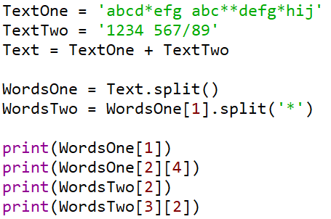

What are the outputs of this program?

Answer: (1”, 2”, 1”, 2”)



* 1. What is the printout of the following code?

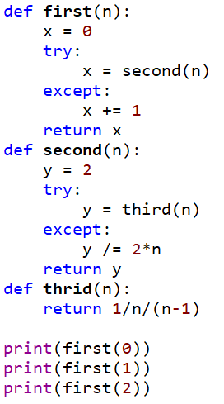

Answer: (2”, 2”, 2”)



* 1. Concerning the following program.

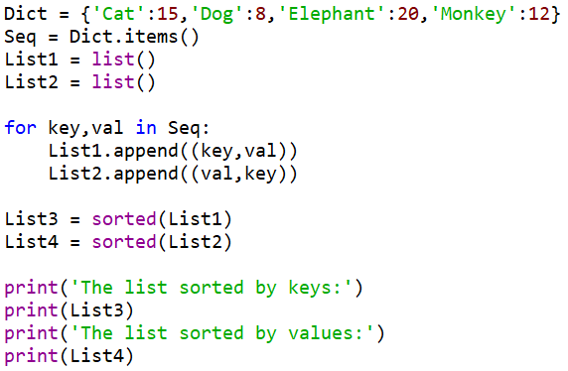

Answer the following questions:

1. How many lists have we defined in this program?
2. What are the data types of elements in lists List1 and List2?
3. How many elements are there in lists List3 and List4?
4. Are the elements in list List3 the same as the elements in list List1? Are the elements in list List4 the same as the elements in list List2?
5. What are the outputs of this program?

Answer:

1) 4 (1”)

2) tuple, tuple (1”)

3) 4, 4 (1”)

4) Yes, No (3”)

5

* 1. Concerning the following program.

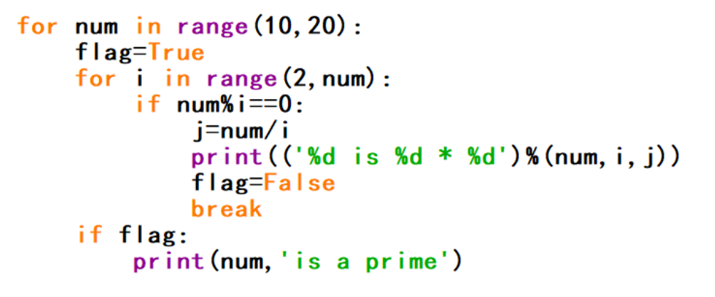

1. How many iterations does the program execute?
2. Please list out the first three outputs of program.
3. If we change the third line of the program as



please list out the new first three outputs.

Answer:

1) 59 (2”)

2) (3”)

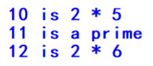

3) (3”)

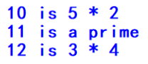

**END OF EXAMINATION**