Danny Sapato
sapato2
Manual Test Plan

At this current stage, the GUI is not supposed to support interaction, so testing is limited. Currently all is needed is to run the application, and then look at the default screen. It should look like this.
Default Chess Setup
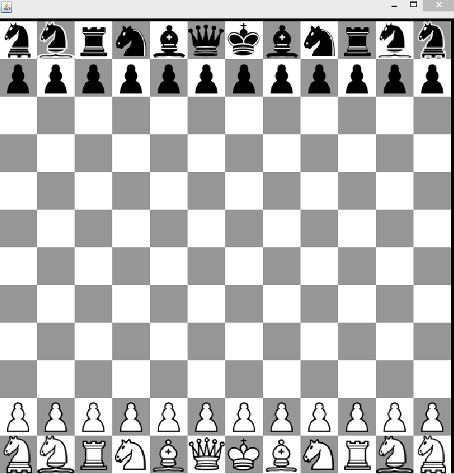

The board should be made up of SIZE x SIZE squares of alternating color. Size is currently 12, the standard 8 in addition to the 2 on each side for the added pieces. The pieces should be all pawns on the second-to-top and second-to-bottom rows. Then from left to right the pieces should be...

1. Chancellor
2. Archbishop
3. Rook
4. Knight
5. Bishop
6. Queen
7. King
8. Bishop
9. Knight
10. Rook
11. Archbishop
12. Chancellor

That's about all to worry about at this stage of production!

