Computer Graphics
(BIT352CO)

Unit 1 : Introduction

What is Computer Graphics?
Computer graphics refers to a technology that generates images on a computer screen. It is the intersection of design and computer science, enabling the creation, manipulation, and display of visual content. Digital photography, film and television, video games, and electronic devices all rely on computer-generated graphics to create engaging and interactive displays.

Examples of Computer Graphics
Computer graphics are ubiquitous in modern life. Some notable examples include:
- The 2009 film Avatar used advanced facial motion capture technologies to create the lifelike Na’vi species.
- The images, icons, and animations you see when using mobile applications are products of computer graphics.
- Charts, graphs used in presentations or reports are common examples of computer graphics in professional settings.
- Real-time 3D graphics and immersive environments in games are powered by computer graphics technologies.

1.1 History of Computer Graphics
The history of computer graphics dates back to the 1950s, when computers were first used for scientific and engineering calculations. Since then, computer graphics have come a long way, evolving into a powerful tool for creating stunning visual representations of complex data and ideas.

- Early Beginnings (1950s-1960s)
The first computer graphics were simple line drawings created by IBM's SAGE air defense system in the 1950s, which displayed radar data using vector graphics. In the 1960s, Ivan Sutherland developed Sketchpad, a groundbreaking program that allowed users to draw and manipulate objects on a computer screen using a light pen. This laid the foundation for interactive computer graphics. During this time, MIT's Whirlwind computer also pioneered the use of CRT displays for graphical output.

- The Rise of 3D Graphics (1970s-1980s)
In the 1970s, 3D graphics began to emerge with the development of wireframe modeling techniques, enabling objects to be represented in three dimensions. Gouraud shading (1971) and Phong shading (1975) improved the realism of 3D rendering. The 1980s saw the rise of graphical user interfaces (GUIs) and personal computers. Pixar Animation Studios, founded in 1986, released Luxo Jr., the first 3D computer-animated short film, marking a major milestone in computer graphics. Ray tracing techniques also advanced during this period.

- The Age of Digital Graphics (1990s-2000s)
The 1990s witnessed the widespread adoption of digital graphics with software like Adobe Photoshop and Illustrator, enabling users to create and manipulate digital images easily. The introduction of GPUs revolutionized real-time 3D graphics, and APIs like OpenGL (1992) and DirectX (1995) standardized graphics development. Video games and CGI in films saw rapid advancements. In the 2000s, photorealistic rendering, global illumination, and GPU acceleration became standard, while shader programming allowed for more complex visual effects. Motion capture and procedural animation also advanced significantly.

- The Modern Era (2010s-Present)
The 2010s brought real-time ray tracing, virtual reality (VR), and augmented reality (AR) into the mainstream. Deep learning and AI began influencing computer graphics, enabling techniques like neural rendering and AI-driven animation. The 2020s have seen continued advancements in real-time photorealistic rendering, AI-generated graphics, and immersive technologies like VR/AR. Tools like Unreal Engine 5 and NVIDIA's RTX GPUs are pushing the boundaries of interactivity.

- The Future of Computer Graphics
As technology continues to advance, the future of computer graphics looks promising. Augmented reality (AR) is expected to revolutionize industries like medicine, education, and entertainment by overlaying digital information onto the real world. Machine learning and artificial intelligence will further enhance the realism and intelligence of virtual characters and environments. The integration of AI with graphics tools will enable more intuitive and creative workflows, ensuring that computer graphics remain at the forefront of innovation.

1.2 Application of Computer Graphics
Computer graphics play a vital role in various fields, transforming how we design, interact, visualize, and create. Below are some key applications of computer graphics:
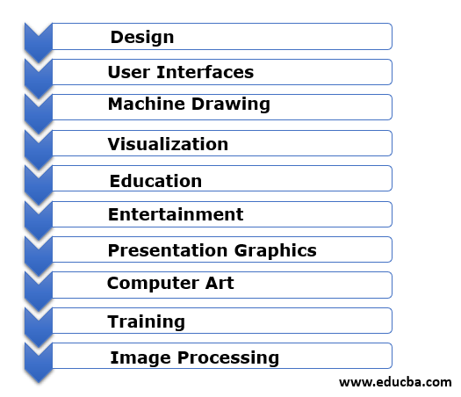
Design
Computer graphics are widely used in engineering and architecture for designing and prototyping. Designers can create, modify, and analyze models iteratively to find optimal solutions. For example, in electronic circuit design, developers use graphical tools to place components, route wires, and visualize layouts. This process is made efficient and accurate with the help of computer graphics.

User Interfaces
Computer graphics have revolutionized human-machine interaction. Modern interfaces, like those in office workstations, use icons, menus, and visual elements to simplify tasks. For instance, clicking on a mailbox icon can display emails, while a trash icon deletes them. These intuitive graphical interfaces make technology accessible and user-friendly.

Machine Drawing
Computer graphics are essential for creating precise and detailed drawings of machine parts and assemblies. The accuracy and clarity provided by these drawings ensure safe and efficient manufacturing processes.

Visualization
Visualization is critical for understanding complex data and systems. Computer graphics enable the creation of charts, graphs, and 3D models that help analyze and interpret information, making it easier to identify patterns and insights.

Education
Computer-generated models and simulations enhance learning by making abstract concepts more tangible. Educational tools using computer graphics can generate interactive and engaging content, improving student understanding and interest.

Entertainment
The entertainment industry heavily relies on computer graphics for movies, TV shows, video games, and music videos. From animated films to realistic game environments, computer graphics bring stories and experiences to life.

Presentation Graphics
Computer graphics are used to create visual aids like bar graphs, pie charts, and time charts for summarizing and presenting data in fields such as business, science, and research.

Computer Art
Artists use computer graphics to create digital paintings, animations, and commercial art. Software tools allow for modeling shapes, defining movements, and producing visually stunning artwork.

Training
Simulators and training modules built with computer graphics provide realistic and interactive environments for learning. These tools are especially useful in fields like aviation, medicine, and military training.

Image Processing
Computer graphics techniques are used to enhance and optimize images for various applications. This includes editing photographs, improving image quality, and preparing visuals for presentations or publications.

