

**Color by Number**

**Funded and Hosted by: Saulis Inc.**

**Developed by: Darrenn Saulis**

**Written by: Darrenn Saulis**

**In Partnership with: Joint Economic Development and CCNB**

Table of Contents

**Introduction** 3

Purpose 3

Definitions 3

System Overview 3

**Overall Description** 3

Product Perspectives 3

System Interfaces 3

**Use Cases:** 4

6

Communication Interfaces 6

Memory constraints 7

Product Functions 7

Color by Number is a pretty simple game to learn. The game is where you are given a blank numbered drawings, and matching numbered colors. Then you need to fill in the blank space with the corresponding color. The game will also have a multiple features where you will be able to share your artwork to social networking platforms, you will be able to print your artwork from a wireless printer and you will be able to create your own color by number pictures by changing the pre-set colors to your own. 7

User Characteristics 7

Specific Requirements 7

External interface requirements 7

User experience 7

Performance requirements 7

Design constraints 8

Software System 8

Availability 8

References 9

**Introduction**

Purpose

The main purpose of developing Color by Number mobile game application is to provide smartphones users a unique way to color pictures while on the go or at home. The target market would smartphone user that enjoy coloring a picture or just looking to pass some time, the intended age group would be from 2-100.

Definitions

Within the proposal there are a terms that are used as acronyms such as:

1. Saulis Inc. stand for Saulis Incorporated
2. RAM Stands for Random Access Memory.
3. LAN stands for Local Access Network.
4. FPS stands for Frames per Second.
5. OS stands for Operating System.

System Overview

This documents will contain the aspects retaining to the Color by Number mobile game application. It will explain the features, and how the app will interact with Saulis Inc, Tomahawk Severs. Also, the user will be able to connect their social networking platforms and to their wireless printers. The documents also include the wireframes and the use cases, which illustrates how the app will work.

**Overall Description**

Product Perspectives

Color by Number will rely on highly external resources in order to operate on Saulis Inc., and will be the main host of the app, storing all the major components on Tomahawk servers, which is located with Saulis Inc grounds.

System Interfaces

The system will interact with the servers to store any of the pictures that are all colored and stores all the information regarding the colors, pictures and, if the user has login into any social network. They will also store all the software, such as graphics (as in animations ), sounds and any updates. The app will be run on both iOS and Android phones and will be available for downloading on Google Play Store (Android) or App Store (iOS). The app will also be using the GPU, RAM, storage, etc. While the GPU speed may vary from phone to phone, it helps run the app. RAM and Storage will vary per device, if you have more storage and RAM available it will run much smoother.

User Interfaces

The diagrams below illustrate how Color by Number app will function on the user interface.

Use Cases:

**Case #01:** Application is launched

**Actors:** User

**Trigger:** User launches app

**Consequences: -** Loading screen and bar will open,

-Start menu open giving the user options to choose from.

**Case #02:** Share Artwork

**Actors:** Player

**Trigger:** player presses the share button

**Consequences:** the player presses the share button, then an menu appears asking where they would like to share the

**Case #03:** Start game

**Actors:** User,

**Trigger:** User presses the start game button

**Consequences:** Hover menu appears and options are given for the stages the user would like to play.

**Case #04:** First stage launches

**Actors:** User, player

**Trigger:** User select beginner stage

**Consequences:** Scrollable menu will appear and displays the picture.

**Case #05:** Selects a picture

**Actors:** User, Player

**Trigger:** player selecting the picture

**Consequences:** Picture appears

**Case #6:** Zoom

**Actors:** Player

**Trigger:** Player pinch touch the screen to zoom into the pictures

**Consequences:** when the player pinches the picture eathir outwards or inwards the picture will zoom in or zoom out.

**Case #07:** Selects Color

**Actors:** Player

**Trigger:** Player selects the color

**Consequences:** The selected color is now on the paint brush

**Case #08:** Area Painted

**Actors:** Player

**Trigger:** selecting the area with the corresponding number

**Consequences:**  The player clicks the area and the area then changes to that color

**Case #09:** Printable

**Actors:** player

**Trigger:** User select print button

**Consequences:** Menu appears for options for the user to connect to the printer through a wireless connection.

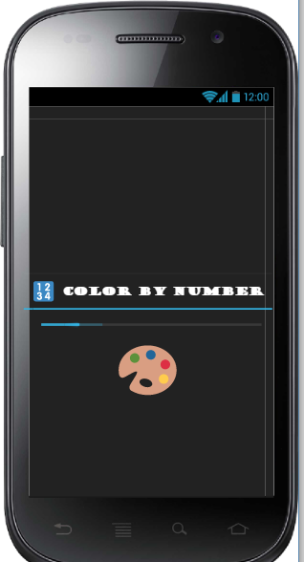

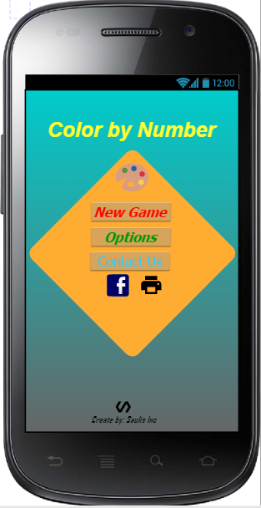

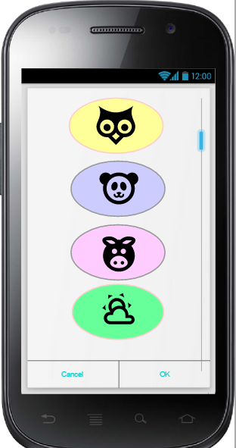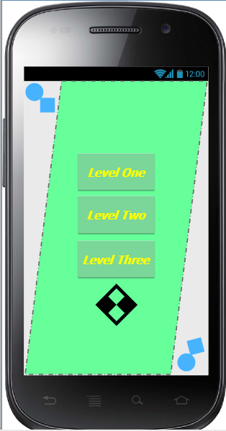

Communication Interfaces

The application will be in communication with the servers at Tomahawk facility located within Saulis Inc. Color by Number will also have a feature where you can connect wireless printer and print the picture you. The app will need an internet connection in order to operate the advertisements.

Memory constraints

Color by Number requires a minimum of 25MB of primary memory and 125MB of secondary memory (the external SD). When you run out of memory or RAM, the operating system will fall back on the hard disk as a memory cache. If you’ve run out of RAM, the OS will put the application on the hard disk. Switch back, and the operating system retrieves that application and puts the other one onto the hard drive.  
  
Site Adaptations Requirements

Color by Number will automatically adapt to Android OS or iOS. Using built in code to adjust to the screen size and RAM of the devices. If you are not connected to the internet you will still be able to access the app and color the picture you downloaded, however the user will not be able to access any of the other pictures.

Product Functions  Color by Number is a pretty simple game to learn. The game is where you are given a blank numbered drawings, and matching numbered colors. Then you need to fill in the blank space with the corresponding color. The game will also have a multiple features where you will be able to share your artwork to social networking platforms, you will be able to print your artwork from a wireless printer and you will be able to create your own color by number pictures by changing the pre-set colors to your own.

User Characteristics

The target market of Color by Number would be users that are from the ages of 2 to 100. They would typically be users that like to color pictures. This game is super easy to learn and play

Specific Requirements

External interface requirements

User experience

Color by Number is a game that can be played by anyone that has an interest in coloring a picture. The user can also connect with friends and share their artwork.

Performance requirements

The measured Frames Per Second will be averaged to 30-60 per second depending on your device. The app will be updated to the latest OS, generally the user will be updated with Android OS, which is 8.1 Oreo and for iPhone users, they will use iOS 11.

Design constraints

1.  Unable to create your own color by number

2.   Updates take awhile

3.   Broken data passing

4.   Responsiveness.

5.   Memory size

6.   Battery life

7. Connection to social network

Logical database requirement

This individual app does not then need to know the exact structure of the relevant database tables and especially not their foreign key relationships. Instead, it can rely on the logical database to read the database entries in the right order during the GET event. The logical database requirements will store the pictures.

Software System

Availability

Color by number will only be available when there is an internet connection.  
Security

Saulis Inc will provide a low- level security  
Maintainability

Saulis Inc will We will try to update it every so often with new cards, or features in the app over time.

References

**Icon for cover page -**[**https://www.google.ca/search?biw=1366&bih=657&tbm=isch&sa=1&ei=i5fxW4KhJ-eIggfjhJW4Ag&q=color+icons&oq=color+icons&gs_l=img.3..0l10.19919.23642..23761...2.0..0.377.3634.2-6j6......1....1..gws-wiz-img.....0..35i39j0i67j0i5i30j0i8i30.-21ocWrZrAM#imgrc=mGivgUwplS7v7M:**](https://www.google.ca/search?biw=1366&bih=657&tbm=isch&sa=1&ei=i5fxW4KhJ-eIggfjhJW4Ag&q=color+icons&oq=color+icons&gs_l=img.3..0l10.19919.23642..23761...2.0..0.377.3634.2-6j6......1....1..gws-wiz-img.....0..35i39j0i67j0i5i30j0i8i30.-21ocWrZrAM%23imgrc=mGivgUwplS7v7M:)