EX-3
Replaced the smb_common with smb_common_v2 for new task.
Modified the launch file as
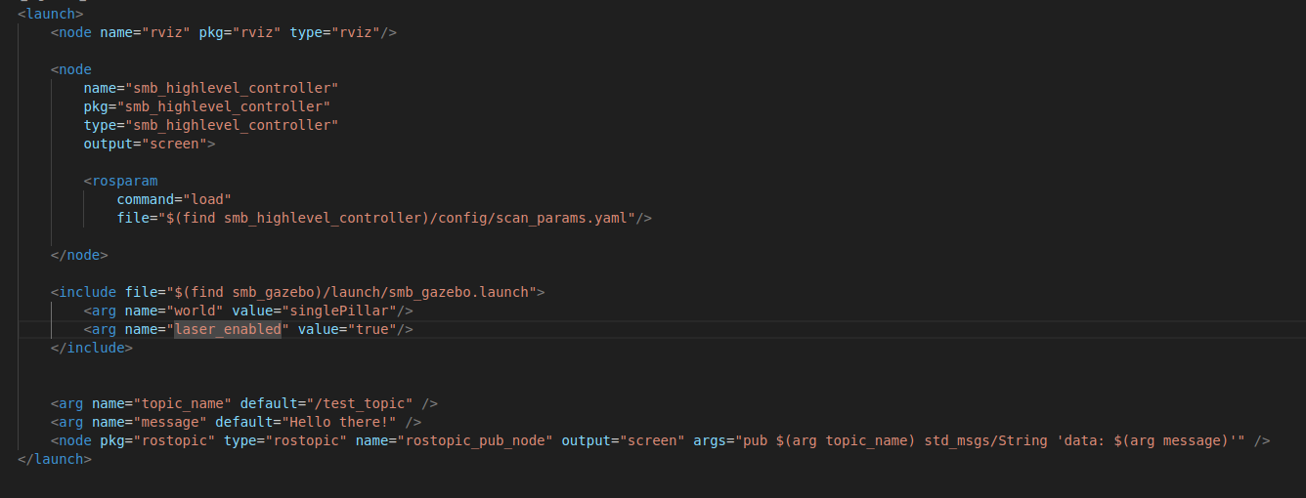
Removed the teleport keyboard and changed the world file.

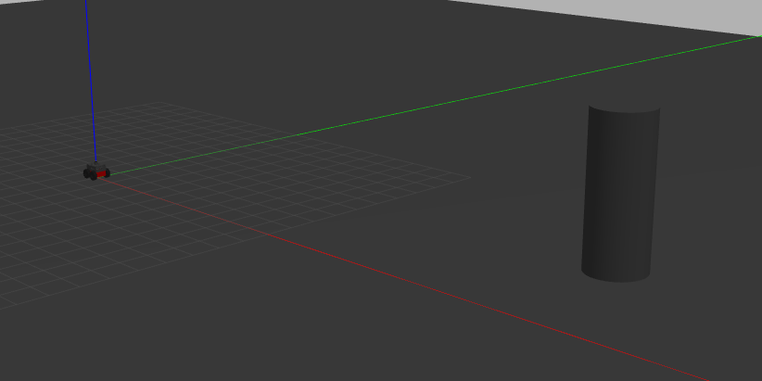
The new world launch file.
Then created a new publisher by modifing the scan subscriber to output relative postiton of pillar with respect to car.

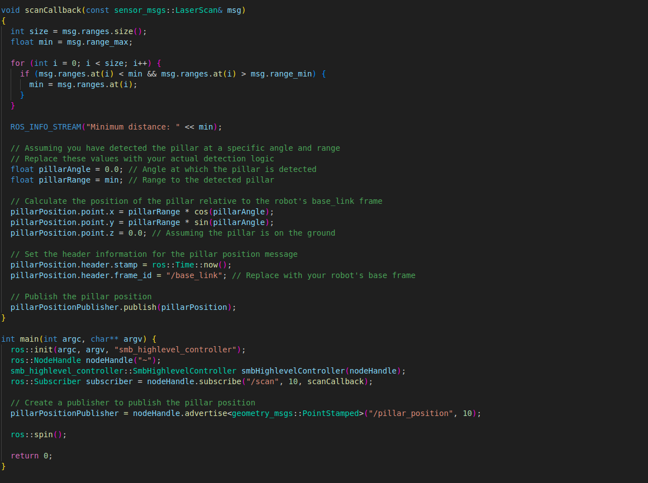

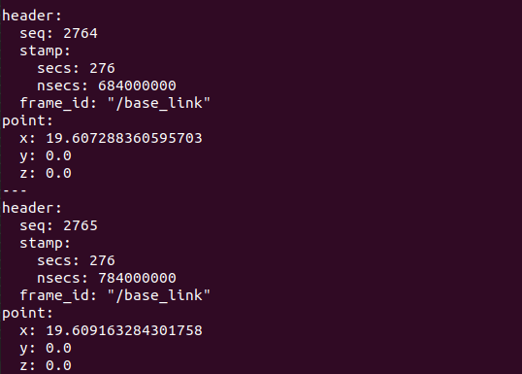
The new published node is::

Created a new publisher insided the same file to get /cmd_vel.

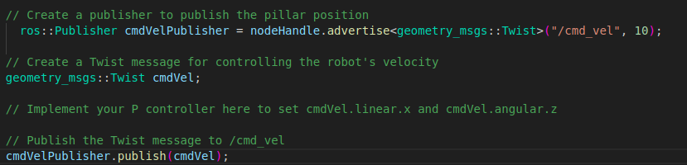

Added required changes in Cmake and package.xml file

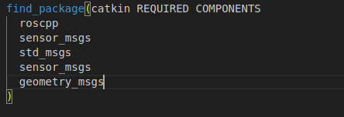

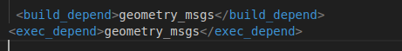

To write a PID controller
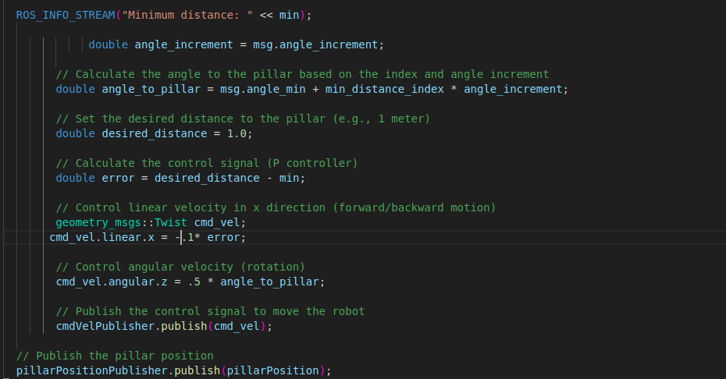

Needed to define publisher gloablly.
Ouput

