EXERCISE -2

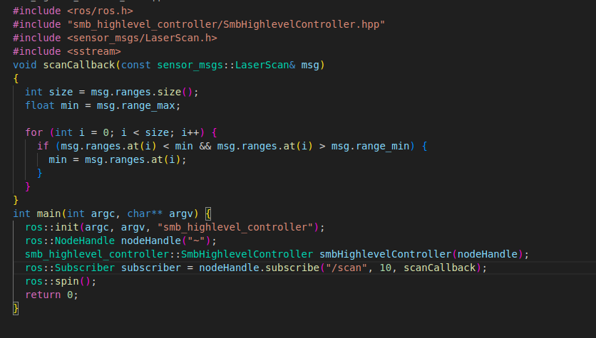
1) Created the scanner usinng the code

Added the parameter file in cofig folder.

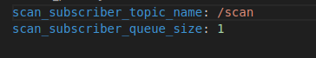

No need to edit Cmake file scanner file is already added there as executable.
2) I added my ex-1 launch file and worlds file in this package and included a new launch with

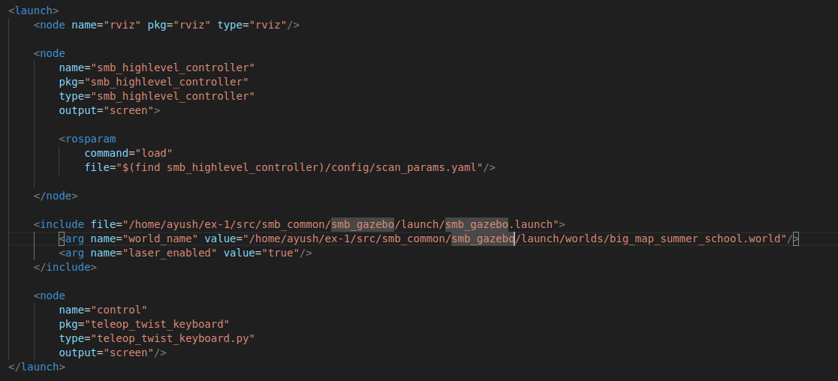

I have tried to use absolute path for my ex-1 launch file inclusion and world file.
ERROR:
on launching the file

SOL: use the0 “world_file” in place of “world_name” in arg name

3) After launching
rqt graph showing subscriber is subscribing to scan topic.

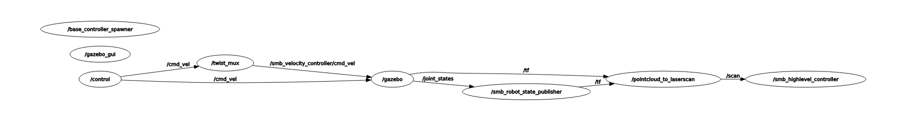
ERROR: while running the node subscriber got an eror file was not executbale
FIX:

NOTE:: The world file given in smb_gazebo i.e ex-1 takes a lot of time to load in general.
Ouput of scan subscriber
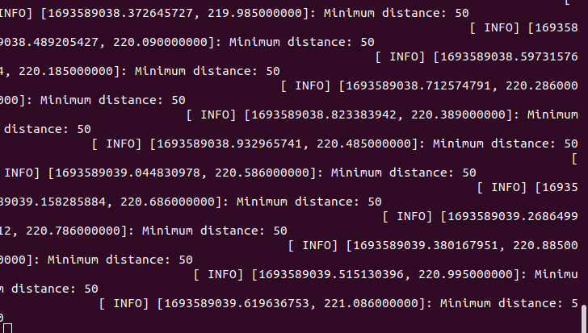

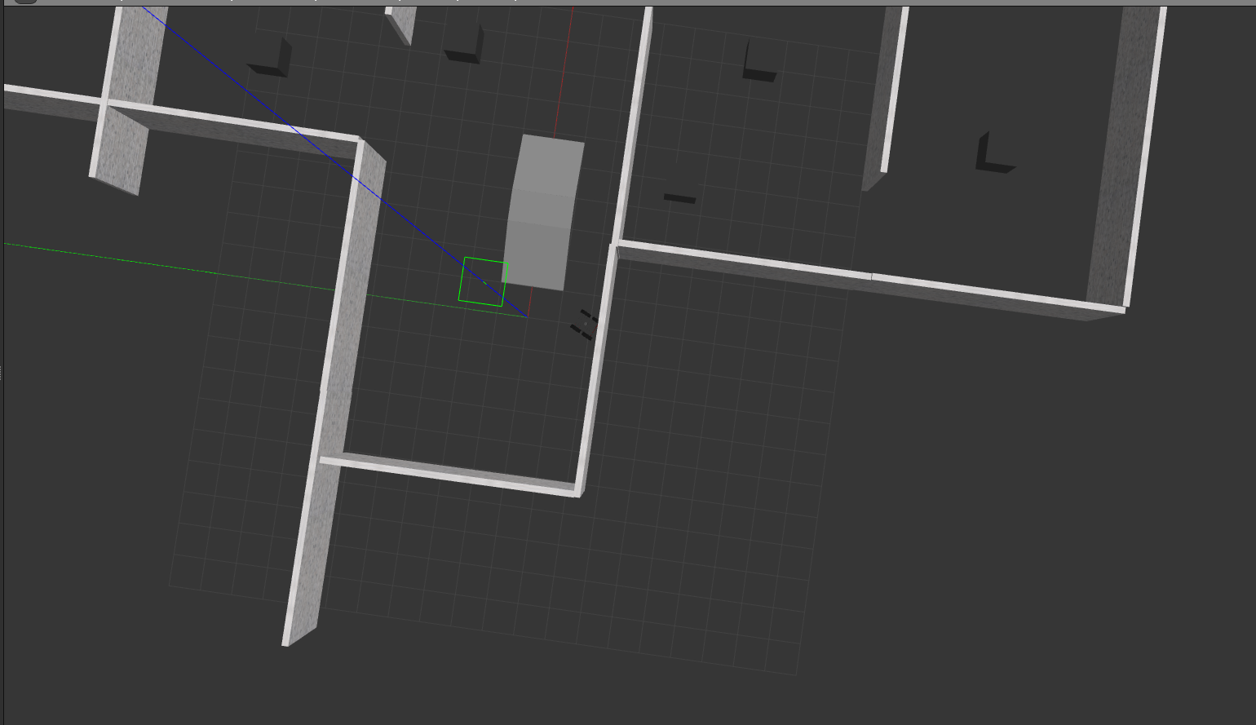
Final ouptut

