**CMSC203 Assignment 0**

Class: CMSC203 CRN 30376

 Program: Assignment 0

Instructor: Grinberg

 Summary of Description: Setup GitHub, Install and setup JDK, install and setup Eclipse and JavaFX

 Due Date: 01/30/2023

 Integrity Pledge: I pledge that I have completed the programming assignment independently.

 I have not copied the code from a student or any source.

David Sawma

**Complete the following five parts of Assignment 0:**

**Part1: Setup GitHub:** Provide the screen shots of your GitHub account with Assignment 0 file is uploaded here:

\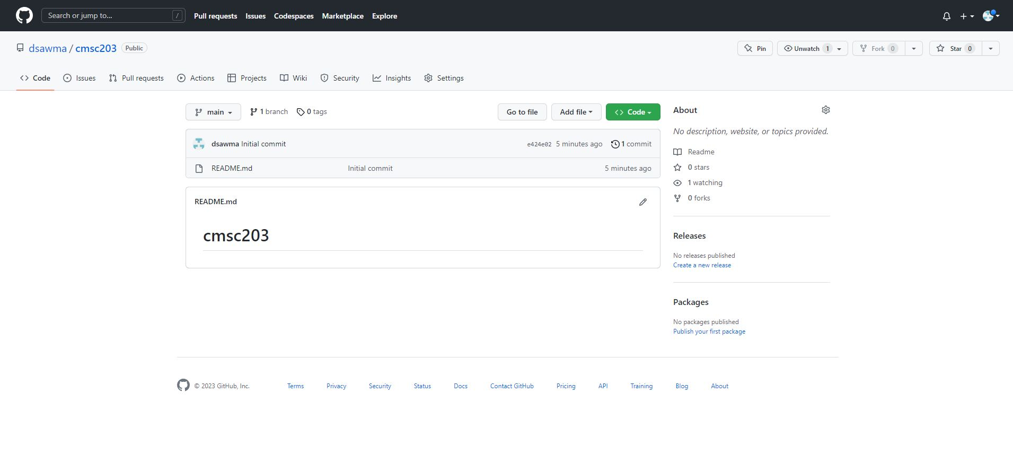

**Part 2 -Install JDK, Test java Application from Command Line**

Provide the screen shots from Step 1 and 2 here:

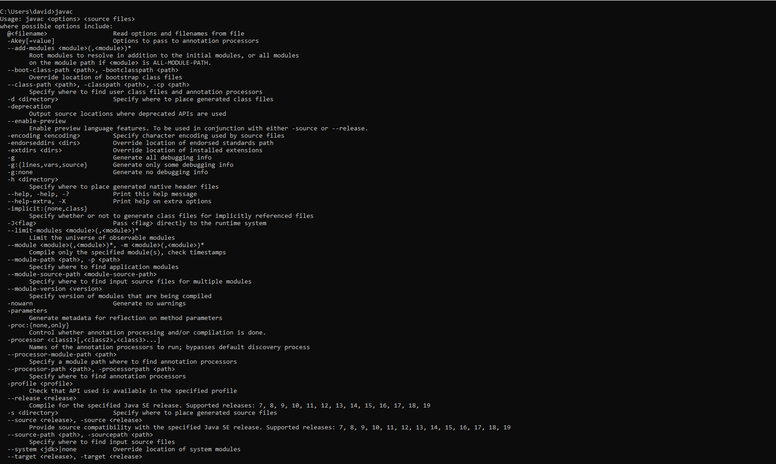

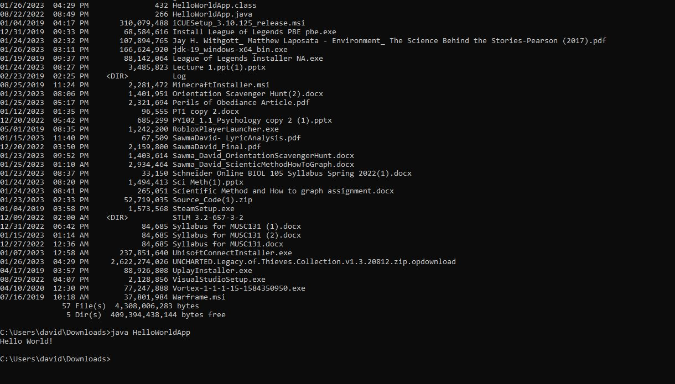

**Part 3 - Install Eclipse, Test Eclipse Java Application**

Provide the screen shots from Step 1 and 2 here:

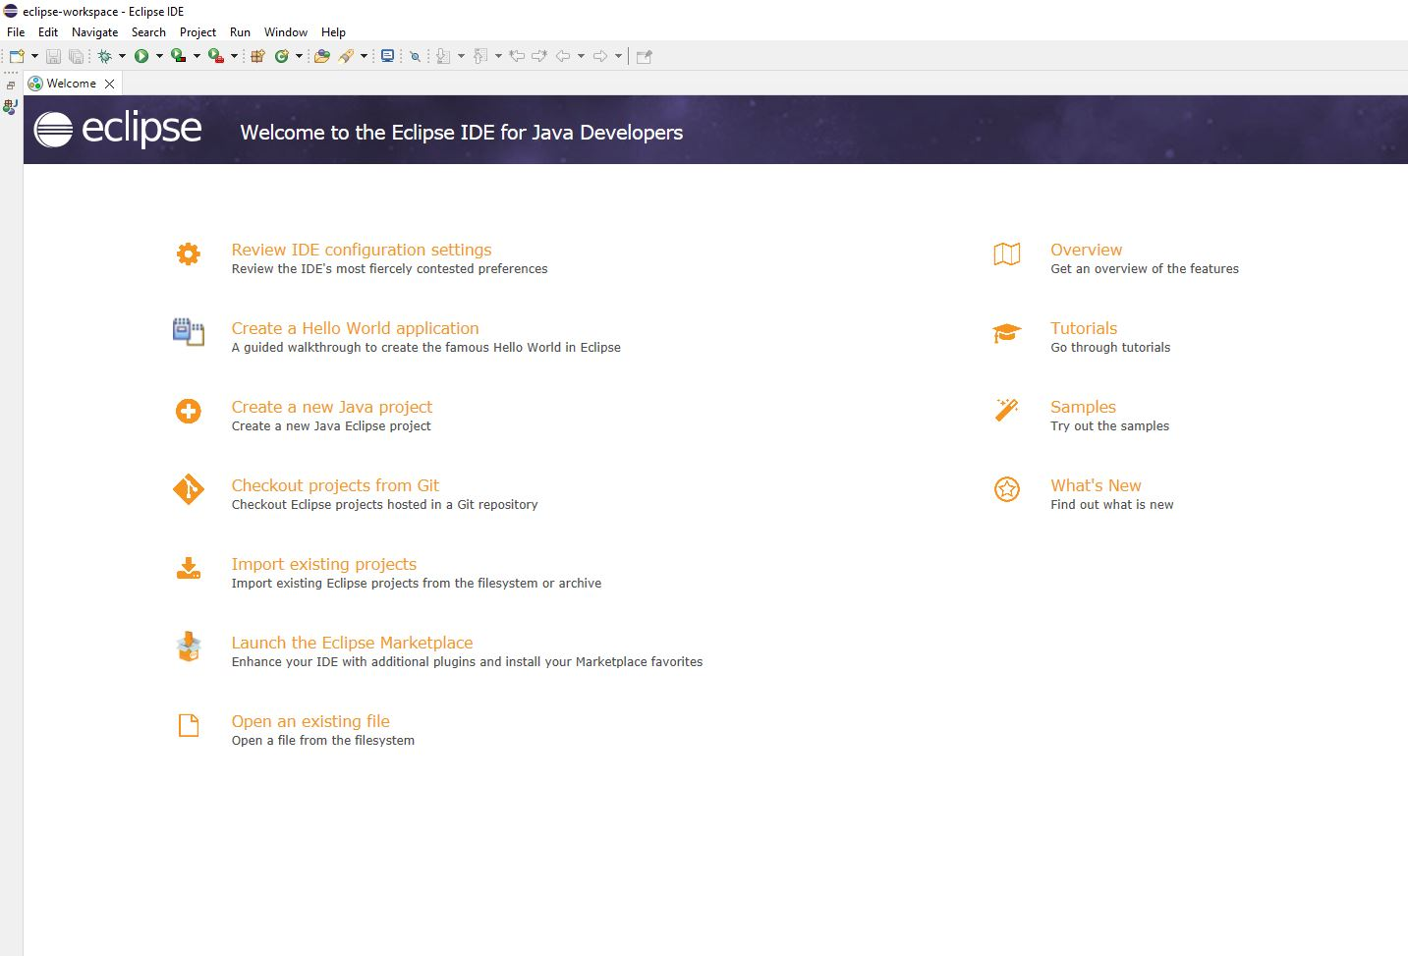

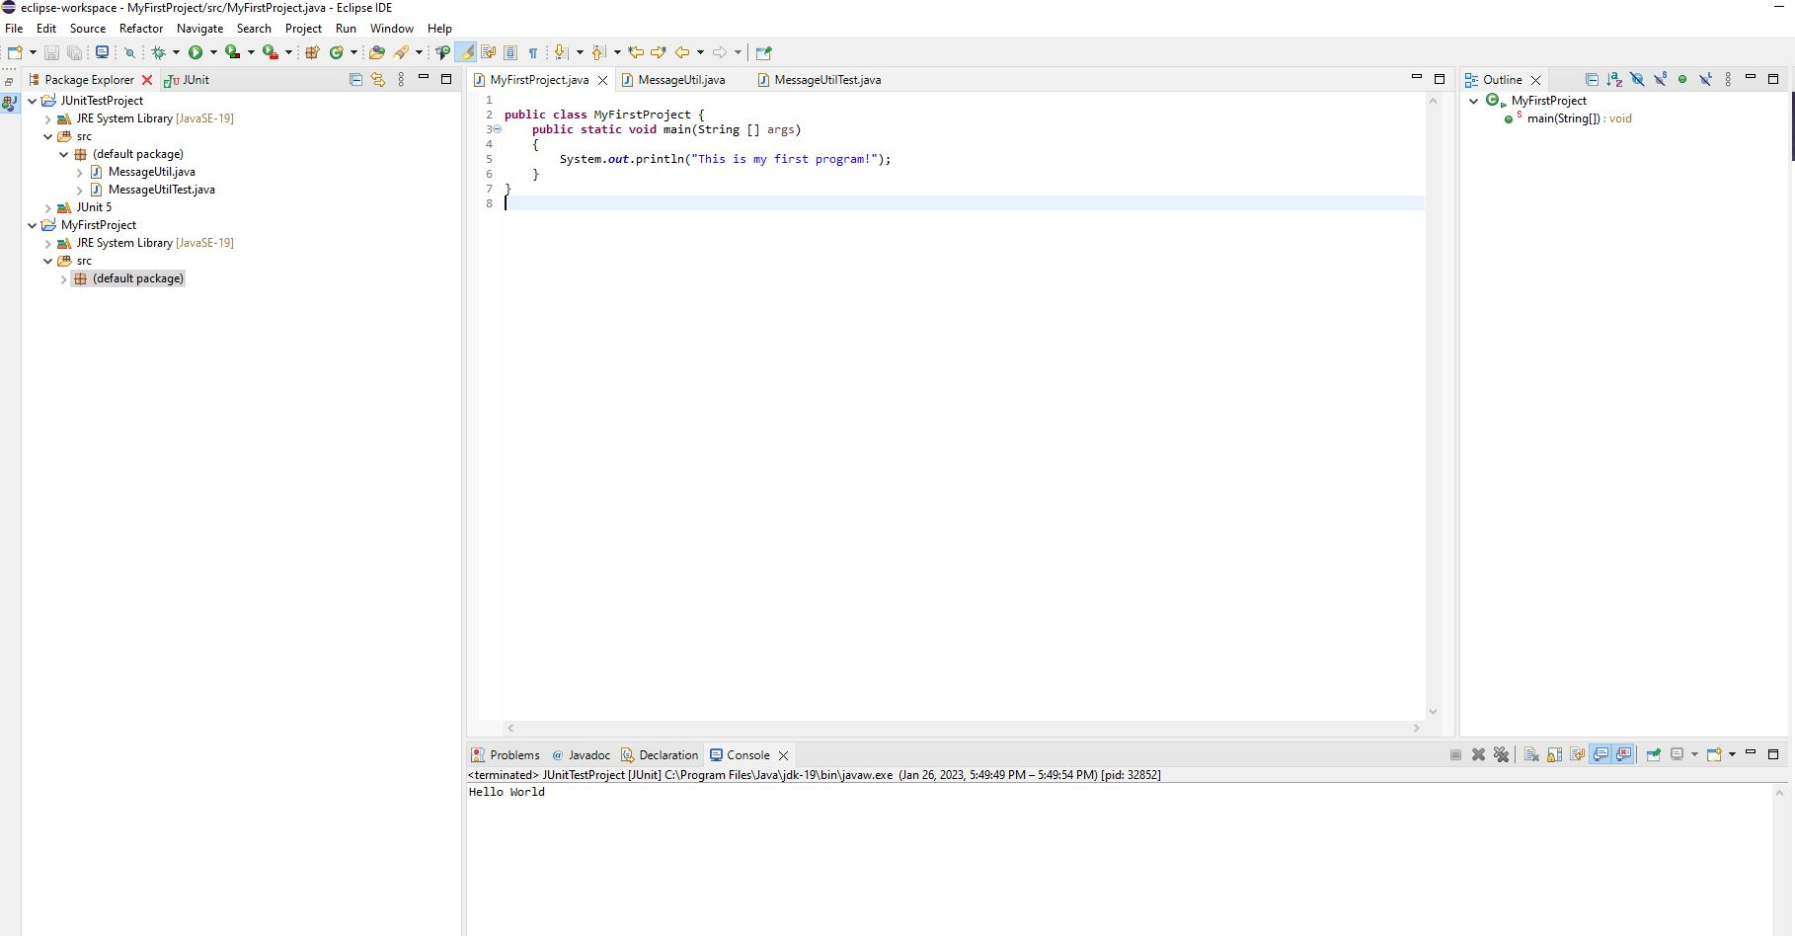

**Part 4 - Install, Setup, Test Junit Program.**

Provide the screen shots showing:

* 1. Eclipse with working JUnit Test example
  2. Project screenshot
  3. Running example screenshot

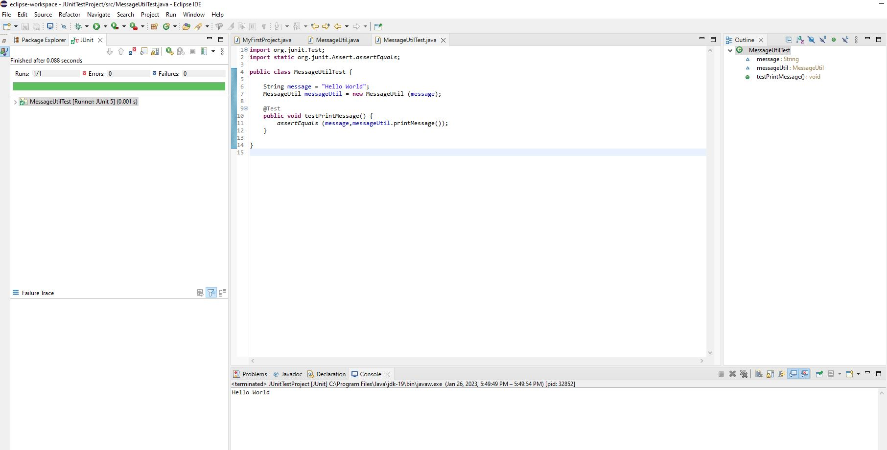

**Part 5 - Install, Setup, and Test JavaFX Application.**

Provide the screen shots showing:

1. JavaFX Project screenshot
2. Running example screenshot
3. Java Source Code File

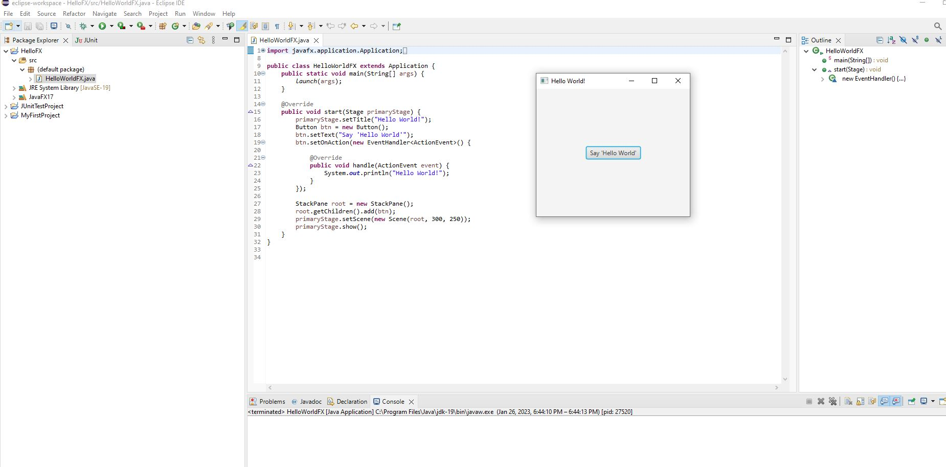

**Lessons Learned** <Provide answers to the questions listed below>**:**

Write about your Learning Experience, highlighting your lessons learned and learning experience from working on this assignment.

What have you learned?

I learned how to install jdk, eclipse, and javaFx. I also learned to create and test my own program.

What did you struggle with?

I had problems with installing javafx and accessing the directory of my java files

What parts of this assignment were you successful with, and what parts (if any) were you not successful with?

I thought I was successful with using eclipse and running the program and files.

Provide any additional resources/links/videos you used to while working on this assignment.

**https://www.youtube.com/watch?v=_7OM-cMYWbQ**

**Check List:** <Provide answers to the column Y/N or N/A >**:**

|  |  |  |  |
| --- | --- | --- | --- |
| **#** |  | **Y/N** | **Comments** |
|  | **Assignment files:** |  |  |
|  | * FirstInitialLastName_Assignment0.docx/pdf | **Yes** |  |
|  | * Source java files | **Yes** |  |
|  | **Program compiles** | **Yes** |  |
|  | **Program runs with desired outputs related to a Test Plan** | **Yes** |  |
|  | **Documentation file: Screenshots of** |  |  |
|  | * Part1: Setup GitHub | **Yes** |  |
|  | * Part 2 -Install JDK, Test java Application from Command Line | **Yes** |  |
|  | * Part 3 - Install Eclipse, Test Eclipse Java Application | **Yes** |  |
|  | * Part 4 - Install, Setup, Test Junit Program | **Yes** |  |
|  | * Part 5 - Install, Setup, and Test JavaFX Application. | **Yes** |  |
|  | * Lessons Learned | **Yes** |  |
|  | * Checklist is completed and included in the Documentation | **Yes** |  |