**Beginning the RPA Challenge**

Logging Onto the Virtual Machine

It will be possible to log onto your challenge VM in the window that you have scheduled with Nathan. If you attempt the steps below at any other time, you will be unable to connect to the machine:

1. Open the .rdp file attached in the email
2. Use the username and password provided in the same email
3. Select “Yes” if you receive a certificate warning:

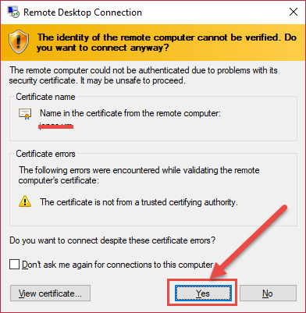

Beginning the Challenge

1. Click on “Challenge Instructions” on your Desktop:

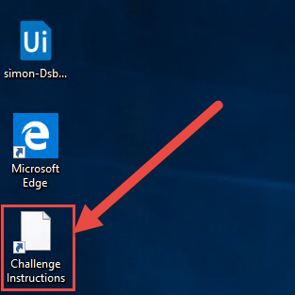

1. Begin the challenge!