XPontus XML Editor Developer Guide

About this document
This document is a developer guide to XPontus XML Editor. It covers the main aspects of XPontus XML Editor. You'll hopefully learn how to the software works and how to build modules on XPontus XML Editor platform.

Intended audience
This document targets intermediary to experienced Java developers.

About XPontus XML Editor
XPontus XML Editor is a Java Swing based XML Editor. It's oriented towards text editing. It was a simple software but it's growing into a full blown platform. The software's homepage is :
http://xpontus.sourceforge.net/index.html

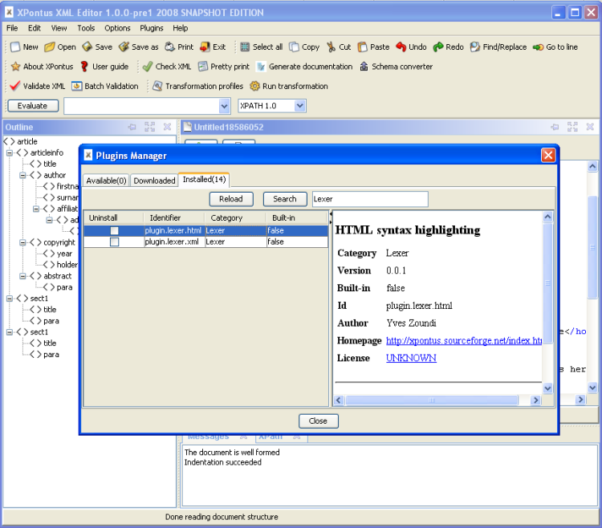
Licence

Copyright (c) 2008 Yves Zoundi.

Permission is granted to copy, distribute and/or modify this document under the terms of the GNU Free Documentation License, Version 1.2 or any later version published by the Free Software Foundation; with no Invariant Sections, no Front-Cover Texts, and no Back-Cover Texts. A copy of the license is included in the section entitled "GNU Free Documentation License".

Contents
Architecture 5
Programming architecture 5
Under the scenes 5
Project code structure 6
Requirements 7
Get the tools 7
Get the sources 7
Import the project in your favorite IDE 7
Eclipse users 7
Idea users 7
Netbeans users 7
Building and running XPontus 8
Get the default settings archive 8
Windows 8
Unix/Linux 8
Building modules for XPontus 9
Introduction 9
Create a new maven project 9
Add required dependencies 10
Create the plugin class 11
Decide where to want to « plug » your plugin! 12
Create the plugin interface implementation 13
Create the event which will be trigger from the menu of the plugin 14
Create the plugin descriptor 15
Package the plugin 15
Install the plugin 16
Test your plugin 16
Learning more about Xpontus 17
XPontus news 17
Mailing lists 17

Architecture

Programming architecture
XPontus is not written using a pure MVC architecture. Most of the time here's how it happens :
- The model classes have a java.beans.PropertyChangeSupport object or they extend java.util.Observable.
- The model classes are bind to the model using JGoodies bindings or by implementing java.util.Observer interface in the view/controller class.
- The events binding : Most of the time I use reflection with the java.beans.EventHandler class
o.addActionListener(EventHandler.create(ActionListener.class, controller, "method"));
// the controller class would look like this
class SimpleController{
void method(){}
}

Under the scenes
At the startup of the application :
- Default settings are created
- Plugins are collected and started
- The application window is created
- The event handlers of the visual plugins are added to the toolbar or the menubar or both
- The main window of the application is displayed

The main class of the application is XPontusRunner in the project xpontus_core. It is located under the package net.sf.xpontus.controllers.impl.

Project code structure
The XPontus XML Editor maven project has 20 modules(sub-projects) :
- codecompletion_plugin : The code completion module
- evaluator_plugin : The experssion evaluator module
- gendoc_plugin : The documentation generator module
- i18n_plugin : The localization module
- icons_plugin : The icon pack module
- indentation_plugin : The code indentation module
- lexer_plugin : The text analysis module responsible for syntax coloring
- outline_plugin : The code structure plugin to display an outline of documents
- perspectives_plugin : The perspective module to present a document based on it's content type
- pluginsbrowser : The plugins manager module to add/remove/upgrade plugins
- preview_plugin : The transformation preview plugin to display the result of a transformation
- quicktoolbar_plugin : The quicktoolbar module which display some buttons for commons actions, based on the document type)
- scenario_plugin : The users transformation profiles module. Many engines such as Xalan, Saxon can be plugged to transform a document.
- schema_converter_plugin : The schema converter plugin which allows to generate schemas from document or to convert schemas to XML.
- scripting_plugin : The scripting module. You'll be able to develop Xpontus plugins using some scripting languages such as groovy, jruby, jython, beanshell, etc.
- themes_plugin : The themes pack module
- validation_plugin : The validation module which validates document
- vfs_plugin : Virtual file system module
- xmlsecurity : The XML signature module(sign and decrypt XML documents)
- xpontus_core : The heart of the application (you run Xpontus XML Editor from this project)

Requirements

Get the tools

- You need to install maven2(maven 2.0.8 is preferred). The maven bin folder must be in your PATH environment variable.
- Java (jdk 1.5 or later). Don't forget to target jdk 1.5 platforms if you're using Jdk 1.6 or later. I would like the software to keep running for users still using jdk 1.5
- An IDE like Eclipse, NetBeans, Jdeveloper, Idea or a simple text editor
- Access to the internet (or a Maven 2 repository)
- A subversion client like TortoiseSVN, SmartSVN, RapidSVN or the command line client

Get the sources
The latest version of the source code is in the trunk for now. To get it, use the Subversion client of your choice and checkout the folder :https://xpontus.svn.sourceforge.net/svnroot/xpontus/trunk/xpontus/

Import the project in your favorite IDE
If you are using a simple text editor. You can skip this step.

Eclipse users
In the xpontus directory run the command
mvn eclipse:eclipse

Idea users
In the xpontus directory run the command
mvn idea:idea

Netbeans users
You can open directly the project in Netbeans 5.x and later. I use Netbeans 6.0.

Building and running XPontus

Get the default settings archive
Please download the latest plugins.zip file from this address : http://xpontus.sourceforge.net/snapshot and extract it in your home folder. That will allow you to get the default settings and all the plugins.

Windows
Extract the archive in the folder C:\documents and settings\myusername where myusername is your login name. Overwrite any existing files or directories.

Unix/Linux
Extract the archive in the folder /home/myusername where myusername is your login name. Please, overwrite any existing files or directories.

Building modules for XPontus

Introduction
Plugins are created using JPF architecture(http://jpf.sourceforge.net/). JPF is a simple plugin framework easier than OSGI(http://en.wikipedia.org/wiki/OSGi). OSGI is used by popular projects such as Eclipse(http://en.wikipedia.org/wiki/Eclipse_%28software%29). Every XPontus module requires the main module of the application called xpontus_core. The xpontus_core module gives you access to the Xpontus XML Editor API.

Note : If you are developing an extension to an existing module the chances are that the module you're extending already imports the Xpontus XML Editor core API. (ie. You could create efficientValidation plugin in the Validation module.)

Create a new maven project
Create a maven project under the xpontus directory using maven command line or the IDE of your choice.
mvn archetype:create -DgroupId= com.mycompany.xpontus.plugins.mymodule -
DartifactId= mymodule -Dpackagename= com.mycompany.xpontus.plugins.mymodule

Add required dependencies
The parent of your project will be xpontus and you should have the project xpontus_core as a dependency. Here is what your maven pom.xml should look like :

<?xml version="1.0" encoding="UTF-8"?>
<project>
<parent>
<artifactId>xpontus</artifactId>
<groupId>net.sf.xpontus</groupId>
<version>1.0.0-pre1</version>
</parent>
<modelVersion>4.0.0</modelVersion>
<groupId>com.mycompany.xpontus.plugins.mymodule</groupId>
<artifactId>mymodule</artifactId>
<name>MyModuleName</name>
<version>1.0.0-pre1</version>
<dependencies>
<dependency>
<groupId>junit</groupId>
<artifactId>junit</artifactId>
<version>3.8.1</version>
<scope>test</scope>
</dependency>
<dependency>
<groupId>net.sf.xpontus</groupId>
<artifactId>xpontus_core</artifactId>
<version>1.0.0-pre1</version>
<scope>compile</scope>
</dependency>
</dependencies>
<description>MyModule description</description>
<build>
<resources>
<resource>
<directory>src/main/java</directory>
<excludes>
<exclude>*/**.java</exclude>
<exclude>*/**.form</exclude>
</excludes>
</resource>
</resources>
<plugins>
<plugin>
<artifactId>maven-compiler-plugin</artifactId>
<configuration>
<source>1.5</source>
<target>1.5</target>
</configuration>
</plugin>
</plugins>
</build>
</project>

Create the plugin class

/*
* My licence headers
*/
package com.mycompany.xpontus.plugins.mymodule;

import org.java.plugin.Plugin;

/**
* Plugin description
* @author Me
*/
public class MyModulePlugin extends Plugin {
protected void doStart() throws Exception {
}

protected void doStop() throws Exception {
}
}

Decide where to want to « plug » your plugin!
Do you want your plugin to appear in the menubar, the toolbar, both? Is your plugin a non visual plugin? Does your plugin integrate into an existing plugin?

Create the plugin interface implementation
Let's say we decide to add a plugin as a menu in the application's menubar. We'll implement the extension point interface of the menubar.
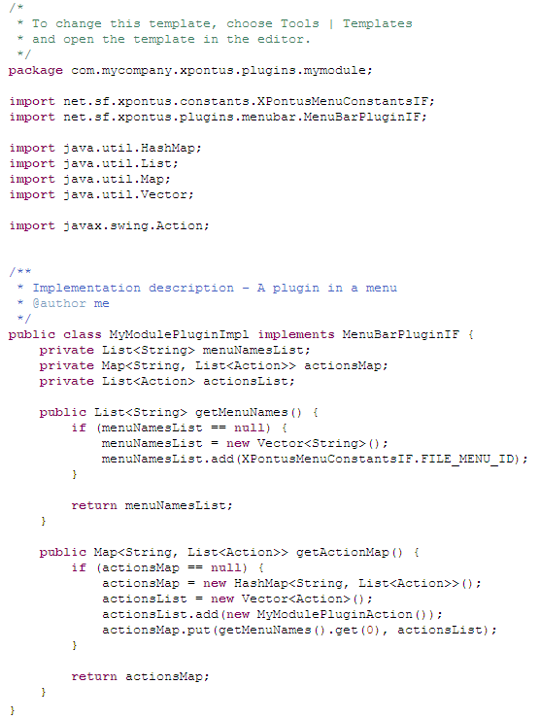

Create the event which will be trigger from the menu of the plugin

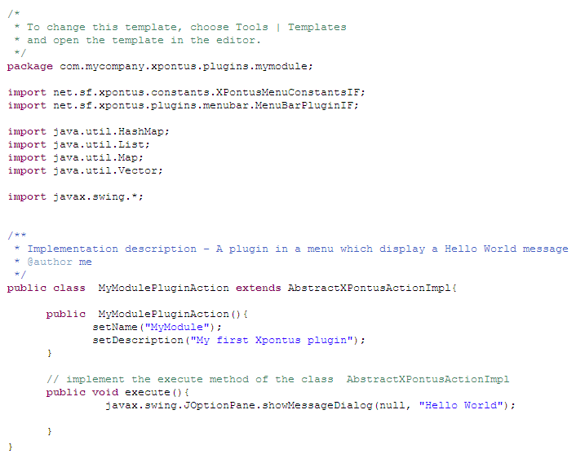

Create the plugin descriptor
<?xml version="1.0" ?>
<!DOCTYPE plugin PUBLIC "-//JPF//Java Plug-in Manifest 1.0" "http://jpf.sourceforge.net/plugin_1_0.dtd">
<plugin id="com.mycompany.xpontus.plugins.mymodule" version="0.0.1" vendor="Me" class="com.mycompany.xpontus.plugins.mymodule.MyModulePlugin">
<attributes>
<attribute id = "Built-in" value = "false"/>
<attribute id="Category" value = "Tools"/>
<attribute id="Homepage" value = "http://www.mycompany.com/oss/xpontus/plugins/index.html"/>
<attribute id="Description" value = "Test plugin"/>
<attribute id = "DisplayName" value = "My first plugin"/>
<attribute id = "License" value = "http://www.gnu.org/licenses/gpl-2.0.txt"/>
<attribute id = "date" value = "26-02-2008"/>
</attributes>
<requires>
<import plugin-id="plugin.core.menubar" />
</requires>
<runtime>
<library id="com.mycompany.xpontus.plugins.mymodule.lib" path="lib/mymodule-1.0.0-pre1.jar" type="code" >
<export prefix="*"/>
</library>
<!-- You can add dependencies this way, If your jar dependency already exists in the xpontus_core module, you don't need to add it
<library id="mydependency" version="1.0" path="lib/mydependency-1.0.jar" type="code" >
<export prefix="*"/>
</library> -->
</runtime>

<extension plugin-id="plugin.core.menubar" point-id="menubarpluginif" id="mymoduleExtension">
<parameter id="class" value="com.mycompany.xpontus.plugins.mymodule.MyModulePluginImpl" />
</extension>

</plugin>

Package the plugin
Here is the proposed directory structure to bundle your plugin
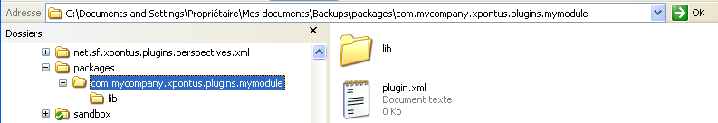
Create a zip file containg the directory com.mycompany.xpontus.plugins.mymodule.

Install the plugin

- Launch Xpontus XML editor, open the plugins manager from the menu Plugins->Plugins Manager. Select the downloaded tab.
- Click on the Add plugin button and select your zip archive.
- Click on the Install button.

If you don't see any errors, that means that your plugin should be installed.

Test your plugin
Restart XPontus XML Editor and you should see your plugin under the menu File of the application.

Learning more about XPontus XML Editor

XPontus XML Editor news
You can read my blog at http://yveszoundi.blogspot.com

Mailing lists
You can find the mailing lists of the project here http://sourceforge.net/mail/?group_id=118253

