WeRateDogs ACT Report

Introduction :

WeRateDogs is a Twitter account that rates people's dogs with a humorous comment about the dog. It was launched in 2015 by college student Matt Nelson, and has received international media coverage for its popularity.
This account allows people to send photos of their dog, then tweets selected photos rating and a humorous comment. Dogs are rated on a scale of one to ten, but are invariably given ratings in excess of the maximum, such as "13/10". Popular posts are re-posted on Instagram and Facebook. Besides, the account's language has spawned an Internet language about "doggos" and "puppers"
In October 2017, the Twitter account had nearly 3.75 million followers. As of July 2018, 7.08 million followers.

Observations:

We see a decline for the number of tweets. According to the data that we have it started from very high number of tweets(300-370) which dropped significantly by January 2016 to 150 and decreased gradually.

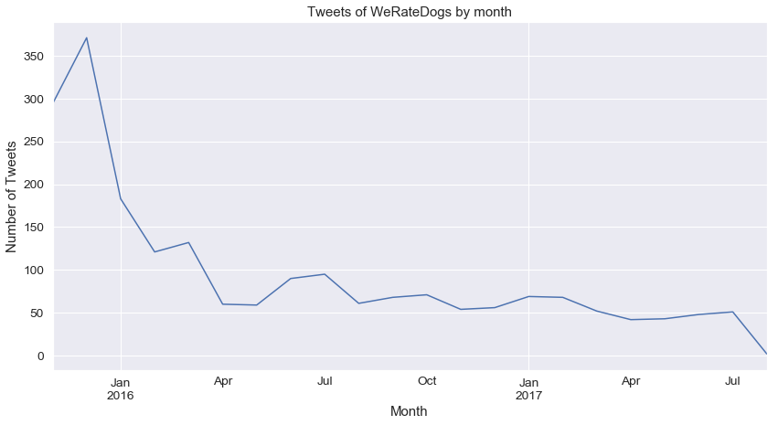
However, the popularity(retweets and likes) increased over the time.

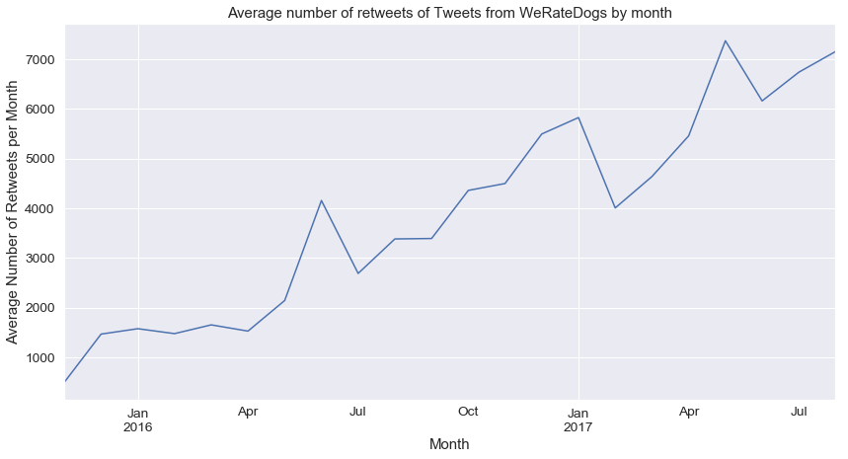

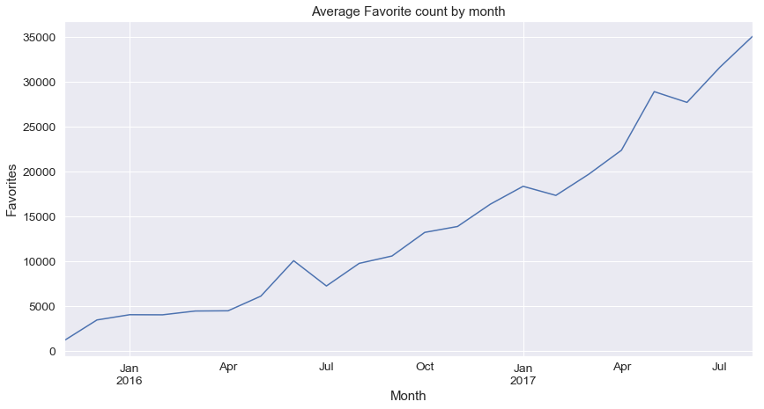

We also see that it started a trend in rating the dogs. Where the numerator is greater than the denominator. And it gradually increased over time. Why not, “They are good dogs Brent”.
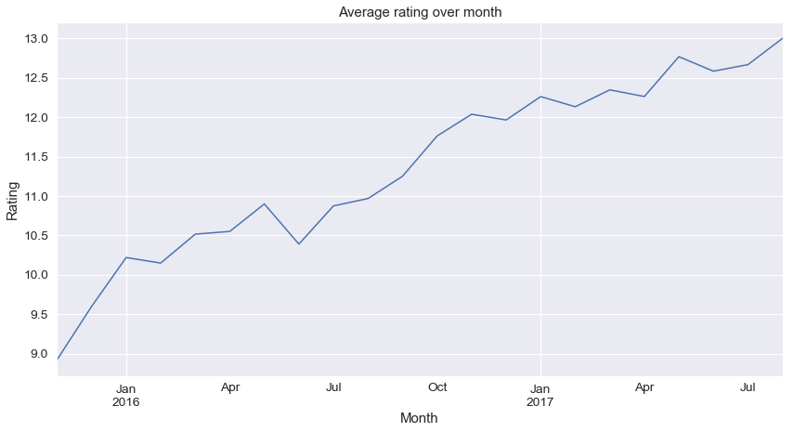
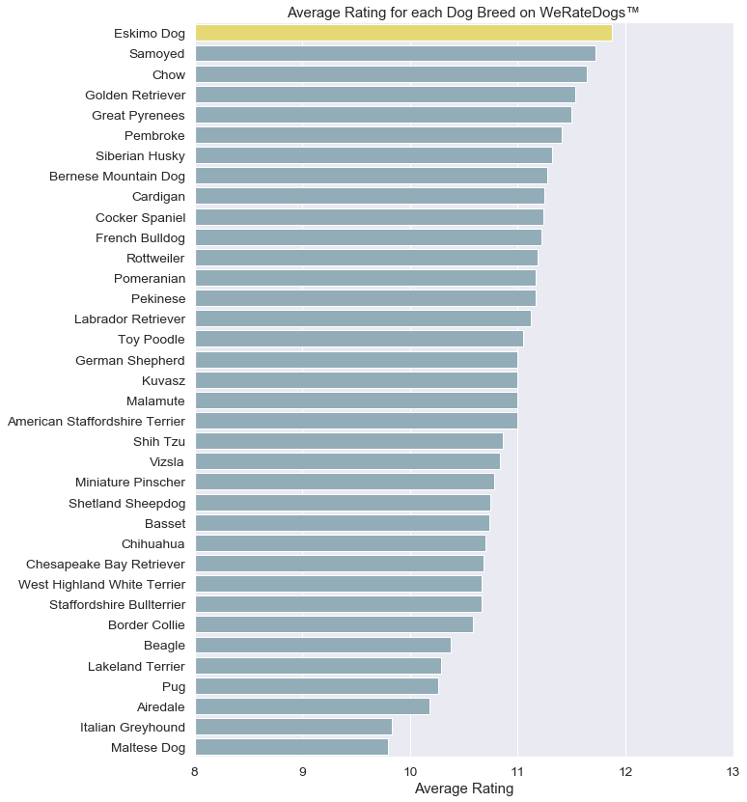
We then tried to find out which dog breed received the highest ratings. Eskimo dog followed by samoyed, chow and golden retriever.

So, we might have concluded that Eskimo dogs are mostly rated. But, we observed that the most common ratings are for Golden retrievers followed by labrador, pembroke and chihuahua.

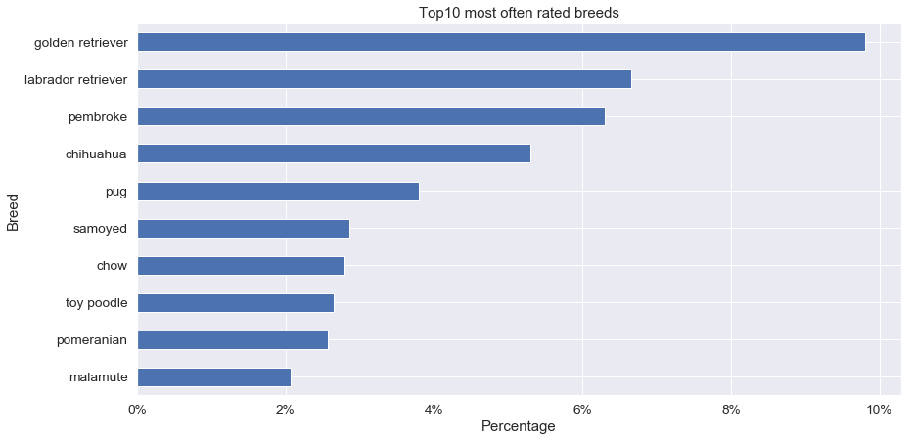
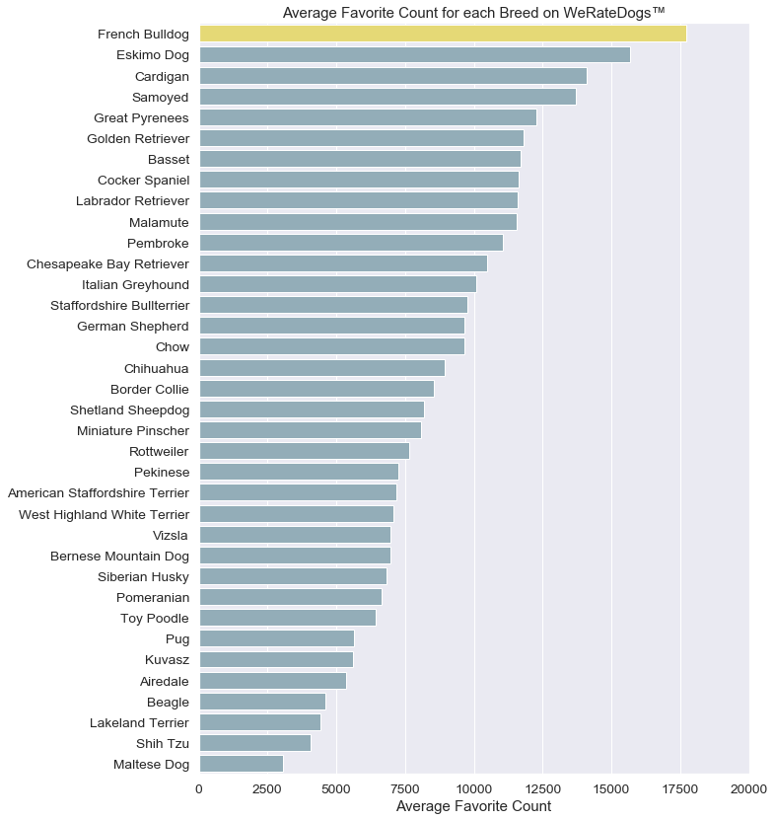
So, this clarifies that golden retriever is the most common dog breed but Eskimo dogs are most highly rated. You might think looking at the above visualizations and think that out of the above two one must be most loved one(which received most likes).

No, the most liked dog breed is French bulldog.

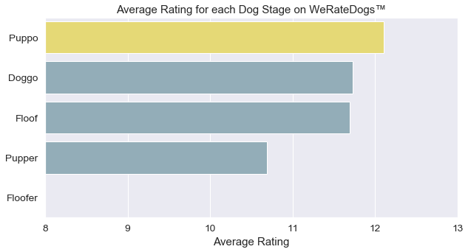
However puppos basically puppies are mostly liked and received highest rating on an average.

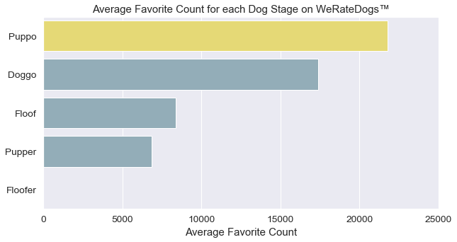

Now, lets see which were the most common names for dogs.

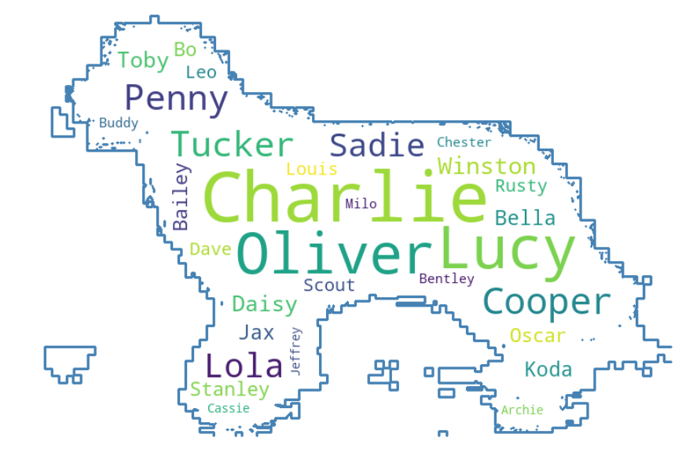
And lets see the most common words in the tweets;

