Group B Assignment No: 3

**Title of the Assignment:** Write a simple program in SCALA using Apache Spark framework.

**Objective of the Assignment:** Students should be able to Write a simple program in SCALA using Apache Spark framework.

**----------------------------------------------------------------------------------------------------------------------------**

# Prerequisites:

1. basic knowledge of Scala
2. basic knowledge of Java syntax
3. installation of Java
4. Operating System recommended: - 64-bit Open source Linux or its derivative/Windows

**---------------------------------------------------------------------------------------------------------------------------**

# Contents for Theory:

* 1. **What is Scala?**
  2. **Apache Spark**
  3. **Steps to Install Scala & Apache Spark Framework Installation (Windows)**
  4. **Steps to Install Scala & Apache Spark Framework Installation (Ubuntu)**
  5. **Write a simple program in SCALA using Apache Spark framework.**

**------------------------------------------------------------------------------------------------------------------------**

# What is Scala

Scala is an acronym for “**Scalable Language**”. It is a general-purpose programming language designed for the programmers who want to write programs in a concise, elegant, and type-safe way. Scala enables programmers to be more productive. Scala is developed as an object oriented and functional programming language.

If you write a code in Scala, you will see that the style is similar to a scripting language. Even though Scala is a new language, it has gained enough users and has a wide community support. It is one of the most user-friendly languages.

The design of Scala started in 2001 in the programming methods laboratory at EPFL (École Polytechnique Fédérale de Lausanne). Scala made its first public appearance in January 2004 on the JVM platform and a few months later in June 2004, it was released on the .(dot)NET platform. The .(dot)NET support of Scala was officially dropped in 2012.

A few more characteristics of Scala are:

* 1. Scala is pure Object-Oriented programming language
  2. Scala is a functional language
  3. Scala is a compiler based language (and not interpreted)

# What is Apache Spark?

Apache Spark is an open source data processing framework for performing Big data analytics on distributed computing cluster.

Spark was initially started by Matei Zaharia at UC Berkeley's AMPLab in 2009. It was an academic project in UC Berkley. Initially the idea was to build a cluster management tool, which can support different kind of cluster computing systems. The cluster management tool which was built as a result is Mesos. After Mesos was created, developers built a cluster computing framework on top of it, resulting in the creating of Spark.

Spark was meant to target interactive iterative computations like machine learning. In the year 2013, the spark project was passed on to the Apache Software Foundation.

Apache Spark has other features, such as:

* 1. Supports wide variety of operations, compared to Map and Reduce functions.
  2. Provides concise and consistent APIs in Scala, Java and Python.
  3. Spark is written in Scala Programming Language and runs in JVM.
  4. It currently has support in the following programming languages to develop applications in Spark: Scala, Java, Python, R
  5. Features interactive shell for Scala and Python. This is not available in Java yet.
  6. It leverages the distributed cluster memory for doing computations for increased speed and data processing.
  7. Spark enables applications in Hadoop clusters to run up to as much as 100 times faster in memory and 10 times faster even when running in disk.
  8. It is most suitable for real time decision making with big data.
  9. It runs on top of existing Hadoop cluster and access Hadoop data store (HDFS), it can also process data stored by HBase structure. It can also run without Hadoop with apache Mesos or alone in standalone mode.
  10. Apache Spark can be integrated with various data sources like SQL, NoSQL, S3, HDFS, local file system etc.
  11. Good fit for iterative tasks like Machine Learning (ML) algorithms.
  12. In addition to Map and Reduce operations, it supports SQL like queries, streaming data, machine learning and data processing in terms of graph.

**Spark Built on Hadoop**

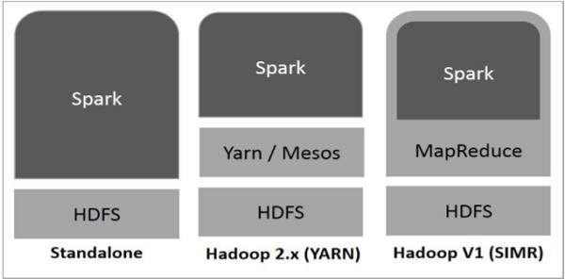

**Components of Spark**

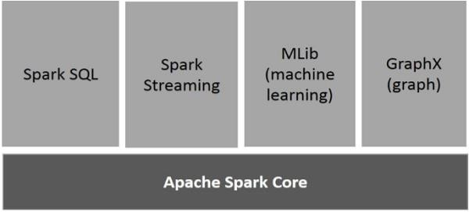

**Apache Spark Core**

Spark Core is the underlying general execution engine for spark platform that all other functionality is built upon. It provides In-Memory computing and referencing datasets in external storage systems.

## Spark SQL

Spark SQL is a component on top of Spark Core that introduces a new data abstraction called SchemaRDD, which provides support for structured and semi-structured data.

## Spark Streaming

Spark Streaming leverages Spark Core's fast scheduling capability to perform streaming analytics. It ingests data in mini-batches and performs RDD (Resilient Distributed Datasets) transformations on those mini-batches of data.

## MLlib (Machine Learning Library)

MLlib is a distributed machine learning framework above Spark because of the distributed memory- based Spark architecture. It is, according to benchmarks, done by the MLlib developers against the

Alternating Least Squares (ALS) implementations. Spark MLlib is nine times as fast as the Hadoop disk-based version of Apache Mahout (before Mahout gained a Spark interface).

## GraphX

GraphX is a distributed graph-processing framework on top of Spark. It provides an API for expressing graph computation that can model the user-defined graphs by using Pregel abstraction API. It also provides an optimized runtime for this abstraction.

# Steps to Install Scala & Apache Spark Framework Installation (Windows)

## Step 1: Java Installation

Java installation is one of the mandatory things in installing Spark. Try the following command to verify the JAVA version.

java -version

If Java is already, installed on your system, you get to see the following response −

java version "1.7.0_71"

Java(TM) SE Runtime Environment (build 1.7.0_71-b13) Java HotSpot(TM) Client VM (build 25.0-b02, mixed mode)

In case you do not have Java installed on your system, then Install Java before proceeding to next step.

## Step 2: Scala installation

You should Scala language to implement Spark. So let us verify Scala installation using following command.

scala –version

if Scala is already installed on your system, you get to see the following response –

Scala code runner version 2.11.6 -- Copyright 2002-2013, LAMP/EPFL

In case you don’t have Scala installed on your system, then proceed to next step for Scala installation.

## Step 3: Apache Spark Download & Installation

Download the latest version of Scala by visit the following link: <https://spark.apache.org/downloads.html>

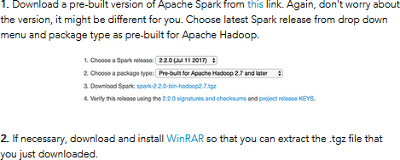

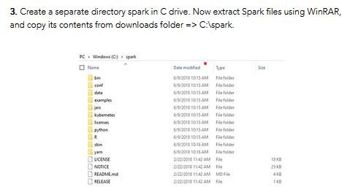

**Step 4: Configuring Windows Environment for Apache Spark**

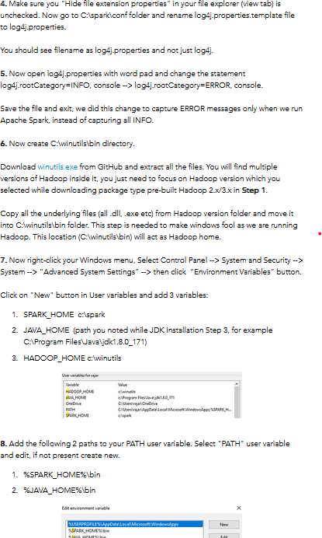

**Step 5: Download & Install Scala IDE**

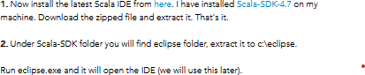

**Step 6: Test the Environment**

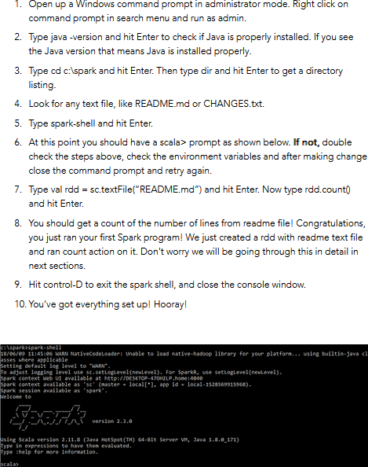

**Step 7: Choosing a development environment**

Once you have installed Scala, there are various options for choosing an environment. Here are the 3 most common options:

* Terminal / Shell based
* Notepad / Editor based
* IDE (Integrated development environment)

Choosing right environment depends on your preference and use case. I personally prefer writing a program on shell because it provides a lot of good features like suggestions for method call and you can also run your code while writing line by line.

## Step 8: Warming up: Running your first Scala program in Shell:

**Write a simple program in SCALA using Apache Spark framework.**

Let’s write a first program which adds two numbers. scala> var Var4 = 2

Output: Var4: Int = 2 scala> var Var5 = 3 Output: Var5: Int = 3

Now, let us apply some operations using operators in Scala.

## Apply ‘+’ operator

Var4+Var5 Output:

res1: Int = 5

## Step 9: Writing & Running a program in Scala using an editor

Let us start with a “Hello World!” program. It is a good simple way to understand how to write, compile and run codes in Scala. No prizes for telling the outcome of this code!

object HelloWorld {

def main(args: Array[String]) { println("Hello, world!")

}

}

As mentioned before, if you are familiar with Java, it will be easier for you to understand Scala. If you know Java, you can easily see that the structure of above “HelloWorld” program is very similar to Java program.

This program contains a method “main” (not returning any value) which takes an argument – a string array through command line. Next, it calls a predefined method called “Println” and passes the argument “Hello, world!”.

You can define the main method as static in Java but in Scala, the static method is no longer available.

## Step 10: Compile a Scala Program

To run any Scala program, you first need to compile it. “Scalac” is the compiler which takes source program as an argument and generates object files as output.

Let’s start compiling your “HelloWorld” program using the following steps:

1. For compiling it, you first need to paste this program into a text file then you need to save this program as HelloWorld.scala.
2. Now you need change your working directory to the directory where your program is saved.
3. After changing the directory you can compile the program by issuing the command. scalac HelloWorld.scala
4. After compiling, you will get Helloworld.class as an output in the same directory. If you can see the file, you have successfully compiled the above program.

## Step 11: Compile a Scala Program

After compiling, you can now run the program using following command: scala HelloWorld

You will get an output if the above command runs successfully. The program will print “Hello, world!”

# Steps to Install Scala & Apache Spark Framework Installation (Ubuntu)

1. **Install Scala**

**Step 1)** java -version

**Step 2)** Install **Scala** from the apt repository by running the following commands to search for scala and install it.

sudo apt search scala ⇒ Search for the package sudo apt install scala ⇒ Install the package

**Step 3)** To verify the installation of **Scala**, run the following command. scala -version

1. **Apache Spark Framework Installation**

Apache Spark is an open-source, distributed processing system used for **big data workloads**. It utilizes in-memory caching, and optimized query execution for fast analytic queries against data of any size.

**Step 1)** Now go to the official Apache Spark download page and grab the latest version (i.e. 3.2.1) at the time of writing this article. Alternatively, you can use the wget command to download the file directly in the terminal.

wget <https://apachemirror.wuchna.com/spark/spark-3.2.1/spark-3.2.1-bin-hadoop2.7.tgz>

**Step 2)** Extract the Apache Spark tar file. tar -xvzf spark-3.1.1-bin-hadoop2.7.tgz

**Step 3)** Move the extracted **Spark** directory to **/opt** directory. sudo mv spark-3.1.1-bin- hadoop2.7 /opt/spark

# Configure Environmental Variables for Spark

**Step 4)** Now you have to set a few environmental variables in **.profile** file before starting up the spark.

echo "export SPARK_HOME=/opt/spark" >> ~/.profile

echo "export PATH=$PATH:/opt/spark/bin:/opt/spark/sbin" >> ~/.profile echo "export PYSPARK_PYTHON=/usr/bin/python3" >> ~/.profile

**Step 5)** To make sure that these new environment variables are reachable within the shell and available to Apache Spark, it is also mandatory to run the following command to take recent changes into effect. source ~/.profile

**Step 6)** ls -l /opt/spark

# Start Apache Spark in Ubuntu

**Step 7)** Run the following command to start the **Spark** master service and slave service.

start-master.sh

start-workers.sh spark://localhost:7077

(if workers not starting then remove and install openssh:

sudo apt-get remove openssh-client openssh-server sudo apt-get install openssh-client openssh-server)

**Step 8)** Once the service is started go to the browser and type the following URL access spark page. From the page, you can see my master and slave service is started. <http://localhost:8080/>

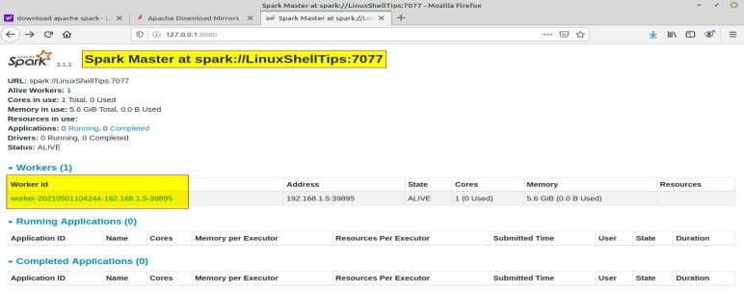

**Step 9)** You can also check if **spark-shell** works fine by launching the **spark-shell** command. Spark-shell

# Source Code:

## /* Sample Code to print Statement */

object ExampleString {

def main(args: Array[String]) {

//declare and assign string variable "text"

val text : String = "You are reading SCALA programming language.";

//print the value of string variable "text" println("Value of text is: " + text);

}

}

## /*The if-else expression in Scala*/

In Scala, if-else expression is used for conditional statements. You can write one or more conditions inside “if”. Let’s declare a variable called “Var3” with a value 1 and then compare “Var3” using if- else expression.

var Var3 =1

if (Var3 ==1){ println("True")}else{ println("False")} Output: True

## /*Iteration in Scala*/

Like most languages, Scala also has a FOR-loop which is the most widely used method for iteration. It has a simple syntax too.

for( a <- 1 to 10){

println( "Value of a: " + a );

}

Output: Value of a: 1 Value of a: 2 Value of a: 3 Value of a: 4 Value of a: 5

Value of a: 6 Value of a: 7 Value of a: 8 Value of a: 9 Value of a: 10

## /**Scala program to find a number is positive, negative or positive. */

object ExCheckNumber {

def main(args: Array[String]) {

/**declare a variable*/ var number= (-100);

if(number==0){ println("number is zero"); }

else if(number>0){

println("number is positive"); } else{ println("number is negative"); }

}

}

## /*Scala program to print your name*/

object ExPrintName {

def main(args: Array[String]) { println("My name is Mike!")

}

}

## /**Scala Program to find largest number among two numbers. */

object ExFindLargest {

def main(args: Array[String]) {

var number1=20; var number2=30; var x10;

if( number1>number2){ println("Largest number is:" + number1);

} else{ println("Largest number is:" + number2);

}

}

}

**Conclusion-** In this way we have Written a simple program in SCALA using Apache Spark framework.