**First degree price discrimination**, each unit of the good is sold to the individual who values it most highly, at the maximum price that this individual is willing to pay for it. Ex: (student financial aid-willingness to pay)

**Second degree price discrimination** is charging a nonlinear price based on the quantity purchased. An example is buy one get one free.

**Third degree price discrimination** occurs when the monopolist sells output to different groups of people for different prices. The groups are based on defined (and verifiable) characteristics such as: age, gender, student status, or geographic region.

**Bundling** involves packaging a bunch of items together and selling the entire thing for a single Price. Newspapers put a variety of news articles together and then charge a single price per newspaper. Computers come bundled with software. Software itself is often a bundle (eg Microsoft Office.) The correlation in demand for goods in the bundle must be negative for bundling to be profitable.

**A two-part tariff** involves a fixed fee and a price per unit. Typically the price per unit is constant, but in some cases the price per unit may vary with quantity.

**A reaction function** is a function that tells us how the follower will react to the leader's choice of output.

**Bertrand Equilibrium**: The equilibrium price is the competitive price p = MC. At any price higher than p = MC, firms will undercut each other until they reach p = MC.

**A dominant strategy** is a strategy in which each player has a best response that is not affected by choices of the other player.

**Nash Equilibrium** We will say that a pair of strategies is a NE if A's choice is optimal, given B's choice and B's choice is optimal given A's choice.

**Price visibility** easier to monitor prices and punish deviations from the collusive price.

**Complements**: Commodity A complements commodity B if more of commodity A increases the value of an extra unit of commodity B. Some examples include DVDs and DVRs or Apps and Phones/Tablets or software and computers.

**Lock-in** occurs when switching costs are very high. This allows the firm to charge high prices to existing customers. Customers anticipate this and there is often significant competition (and large discounts) in the adoption period. Some examples include businesses and Oracle accounting systems or large enterprise HR systems or students and one year leases.

**Network externalities** occur when the value of a good to one consumer depends on how many other consumers purchase or use it. Some examples include: Facebook, Linked in, rating sites such as Trip advisor or Yelp, and dating sites.

**A market is Pareto efficient** if it achieves the maximum possible total gains-to-trade.

A standard monopoly is **not Pareto efficient**, because some consumers who are willing to pay p ≥ MC are not allowed to purchase the good

**Inter-temporal price discrimination:** Here consumers are separated into different groups with different demand elasticities by charging different price at different points in time.

***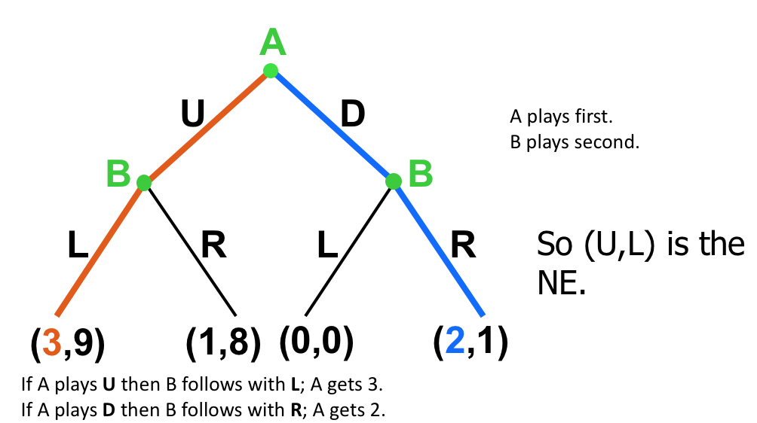*What is collusion?–**In the extreme, firms act jointly as if they were a monopolist–More generally, firms acting to raise prices above what they would have been in the non-cooperative Cournot case–Collusion is hard, because firms have an incentive to cheat on the collusive agreement

**Explicit collusion**–Feasible to prosecute based on evidence of meetings to fix prices

**Tacit collusion** –Nearly impossible to prosecute•Rapid Price Communication–Difficult to differentiate from‘good business practice’and competitive behavior

There are 2 firms in the 3D printer market. The demand curve for 3D printers is Q=200-2P, where Q is the total market demand. Each firm i’s cost is 10qi, where qi is the quantity for firm i. **a)** If firms conduct Cournot competition, what would be the price, total output, and profit per firm? **b)** If the two firms collude, what would be the price, total output, and profit per firm assuming they do not engage in price discrimination? **c)** Suppose the colluding firms are producing equal quantities, and one firm decides to produce more (i.e. cheat). If the firm 1 assumes that firm 2 will continue to produce the collusive quantity, how much should firm 1 produce? What will the profit per firm? (Note, the profits here do have decimal points.)**d)** Use the profits that you computed to fill in the payoffs in this game.

*a) Cournot Profit = (100 – 0. 5q1 – 0. 5q2)q1 – 10q1.*

*Derivative = 100 –q1 – 0.5q2 – 10 = 0. Solving gives q1 = 90 – 0.5q2.*

*The firm are symmetric, so q2 = 90 – 0.5q1. Solving gives q1 = q2 = 60. Q = 120. P = 40., Profit for each firm = 60*40 – 60*10 = 1800.*

*b) Monopoly Profit = (100 – 0.5Q)Q – 10Q.*

*Derivative = 100 – Q – 10 = 0. Solving gives Q = 90, so each firm produces 45. P = 55 Profit for each firm = 45*55 – 45*10 = 2025*

*c) Cheating (collude, cournot best response): One firm produces 45, the other produces q2 = 90 – 0.5(45) = 67.5*

*Total quantity = 45 + 67.5 = 112.5. P = 100 – Q/2 = 100 – 56.25 = 43.75*

*Profit for the firm that produces 45 = 45*43.75– 45*10 = 1518.75*

*Profit for the firm that produces 67.5 = 67.5*43.75– 67.5*10 = 2278.125*

*d). Equilibrium is both competing under Cournot*

***Follower Maximization Max: p[y1+y2]y2-c2(y2) where firm 2 is follower***

***Leader Maximization Max p[y1+f2(y1)]y1-c1(y1) where firm 1 is leader***

*A monopoly faces a demand curve D(p) = 80 – 2p. Its cost function is c(y) = 2y.*

*If the monopoly operates at the profit maximizing level of output and price, what is the deadweight loss? Show your work.*

*Profit = p*y – 2y. The inverse demand curve is p = 40 – y/2. Profit = (40 – y/2)*y – 2y. Maximization implies 40 – y – 2 = 0. Solving gives us y = 38 and p = 21.*

*Competitive markets p = MC = 2, y = 80-2(2) = 76*

***DWL = 0.5(yc – ym)(pm – MC) = 0.5(76-38)(21-2)=0.5*38*19 = 361***

***HHI is the Herfindahl-Hirschman Index•Sum of the squares of the market shares in an industry•One firm with 100% = (100)2 = 10,000•100 firms with 1% = 100*(1)2 = 100•10 firms with 10% = 10*(10)2 = 1,000***

*Two cruise lines, FancyCruise and SuperCruise, are thinking about entering a new market – cruises to the Arctic. They anticipate that demand for a cruise will be 800 – P/2. The firms have the identical cost structures, where c(q) = 400q + 1600. FancyCruise manages to launch its ship first and so acts as a Stackelberg leader. What will be the equilibrium price and quantity per firm, and profit per firm?*

***a) Compute price, total quantity, and quantity per firm under Stackelberg.***

*b) Compare the profit for each firm. Would you rather be the leader or the follower?*

*First solve for the reaction function of the following firm, assuming the leader’s production action is known. Then use that reaction function, in the decision of the leader firm, to determine the leader firm’s optimal actions.*

*Demand: Y = 800 – P/2mInverse Demand: 2Y =1600 – P,P = 1600 – 2Y,P = 1600 – 2 (y1 + y2), where y1 is leader and y2 is followerProfit for Follower:= p*y2 – 400y2 – 1600,= 1600y2 – 2(y1 + y2)y2 – 400y2 – 1600= 1200y2 – 2(y1 + y2)y2 - 1600Reaction function for follower:= dProfit2 / dy2 (derivative of follower profit wrt to y2, their chosen output)= 1200 – 2y1 – 4y2.(set equal to zero to solve for optimal y2):0 = 1200 – 2y1 – 4y2y2* = (600 – y1)/2*

*Substitute reaction function into Leader firm’s profit (which is very similar to before, since they have the same cost structure):= 1600y1 – 2(y1 + y2)y1 – 400y1 – 1600,= 1200y1 – 2(y1 + (600-y1)/2)*y1 – 1600,= 1200y1 – (y1+600) *y1 -1600= 1200y1 – (y1+600) *y1 -1600= 600y1 – y1^2Taking derivative of this to find maximum profit:= 600 – 2y1Setting equal to zero to solve for optimal y1:y1* = 300.(a)quantity y1 = 300quantity y2 = 150total quantity = 450equilibrium price = 700(b)profit1 = 700y1 – 400*y1 – 1600 = 88,400profit2 = 750y2 – 400y2 – 1600 = 43,400You’d rather be the leader! (because you can anticipate the follower’s actions)*



