Problem Statement:

As there’s a rise in Corona and lockdown become sporadic (word jumbled), an ever increasing need to have good health through workout becomes necessity.

Proposed Solution:

Our app proposes a small definition of “SplitIt” so called as it split essential morning routine and help user to keep track of exercises and and past events using RoomDB and live data. We’ve used co-routines and have implemented a daily exercise tracking system. Anyone can start excercising using tts speech system speaking out the next exercise. Anyone can use this application to follow 7 exercises such as plank, rotational plank, triceps, chair etc.

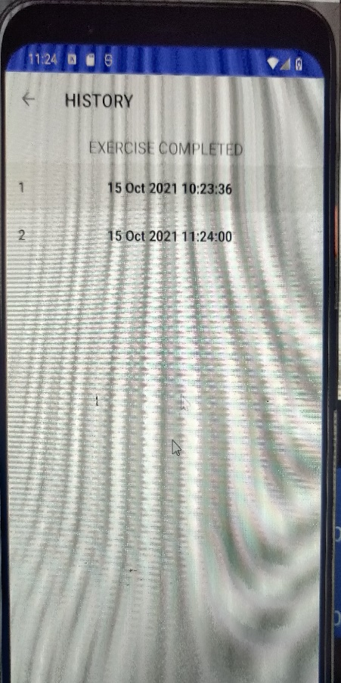 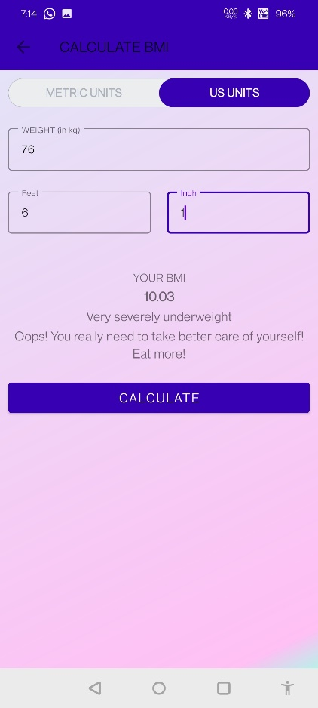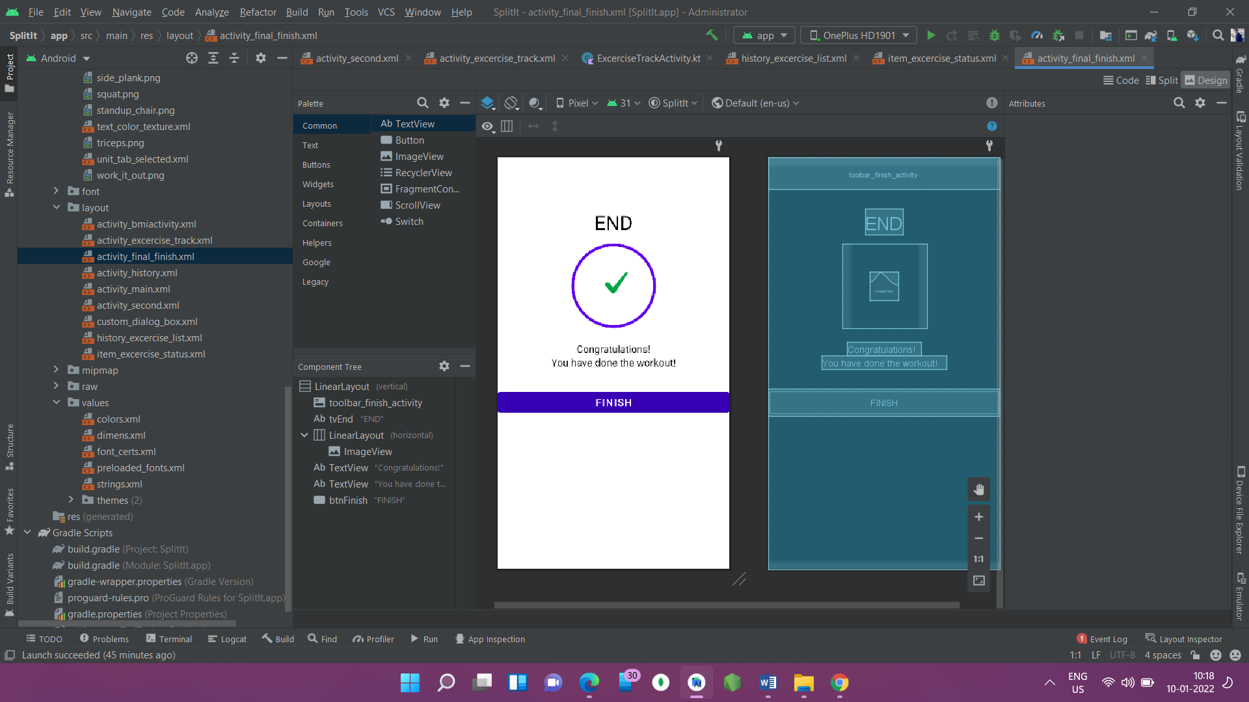

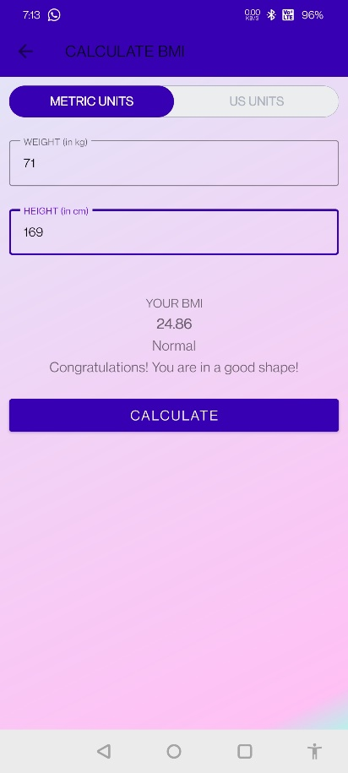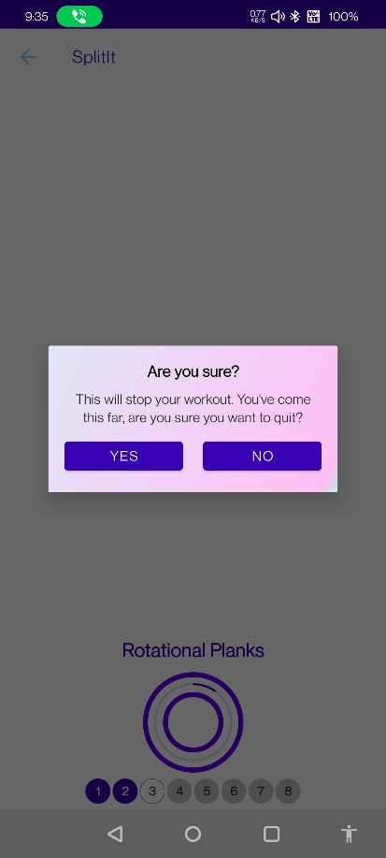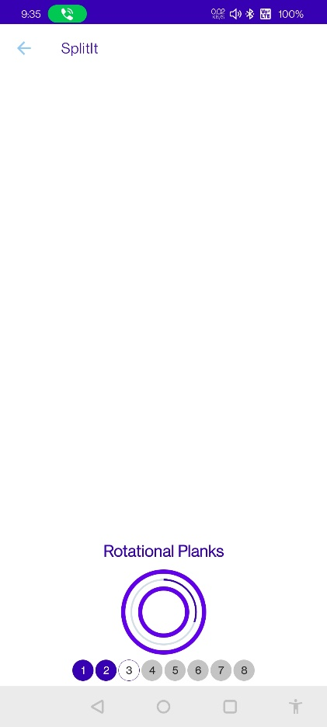

Functionality & Concepts used:

* A very simplistic UI, clean and easy to understand. We’ve tried our best to follow a logic flow of the app with and maintaining the lifecycle. These are the functionalities added to achieve the screen.
* Constraint Layout : - an adaptive UI is created which can dynamically be settled to different screen sizes.
* Progress Bar : To switch to another screen.
* DialogBox(User_made) : - Dialog Box pop’s up if someone wants to end exercise sessions.
* Recycler View : A recycler view is added to show the list of past history exercises done.
* LiveData & Room DB – To store all the past exercises time- wise data so that user can keep easy track and hence can improve the timing.

Application Link & Future Scope: -

This app is currently in testing mode as students have focused on implementing everything from scratch can have some errors. Anyone can access the app from here

Once the app has been successfully worked out with Firebase and other login and registration page, the app will be an ideal app to track exercises. We aim on improving the source code and modify it to a better, much streamlined UI app.