Final Project Analysis

CRYSTAL CONTRERAS

DSC 423 Spring 2021

* Import dataset;

**DATA** bank;

INFILE "cleaned-bank.csv" FIRSTOBS=**2** DELIMITER=',';

INPUT i age job $ marital $ education $ default $ housing $ loan $ contact $ month $ day_of_week $ duration campaign pdays previous poutcome $ emp_var_rate cons_price_idx cons_conf_idx euribor3m nr_employed y $;

* Drop the index column from our data since it is not needed;

DROP i;

* Create dummy variables for categorical attributes;

job1=(job='blue-collar');

job2=(job='services');

job3=(job='admin.');

job4=(job='self-employed');

job5=(job='technician');

job6=(job='management');

job7=(job='retired');

job8=(job='entrepreneur');

job9=(job='housemaid');

job10=(job='unemployed');

job11=(job='student');

marital1=(marital='married');

marital2=(marital='single');

marital3=(marital='divorced'); * could also mean widowed;

ed0=(education='illiterate');

ed1=(education='basic.4y');

ed2=(education='basic.6y');

ed3=(education='basic.9y');

ed4=(education='high.school');

ed5=(education='professional.course');

ed6=(education='university.degree');

credit_default=(default='yes'); * 1 = yes, 0 = no;

housing_loan=(housing='yes');

has_loan=(loan='yes');

cellphone=(contact='cellular'); * 0 = telephone;

* survey conducted between March - December;

month3=(month='mar');

month4=(month='apr');

month5=(month='may');

month6=(month='jun');

month7=(month='jul');

month8=(month='aug');

month9=(month='sep');

month10=(month='oct');

month11=(month='nov');

month12=(month='dec');

day1=(day_of_week='mon');

day2=(day_of_week='tue');

day3=(day_of_week='wed');

day4=(day_of_week='thu');

day5=(day_of_week='fri');

prev_outcome1=(poutcome='failure');

prev_outcome2=(poutcome='nonexistent');

prev_outcome3=(poutcome='success');

target=(y='yes');

**RUN**;

**PROC** **PRINT**;

**RUN**;

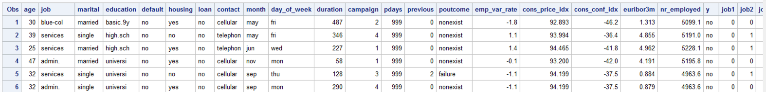

* Create a copy of the dataset that omits duplicate attributes - the ones we created dummy variables for;

**DATA** bank_new;

SET bank;

DROP job marital education month default housing loan contact day_of_week poutcome y;

**RUN**;

TITLE "Bank New";

**PROC** **PRINT**;

**RUN**;

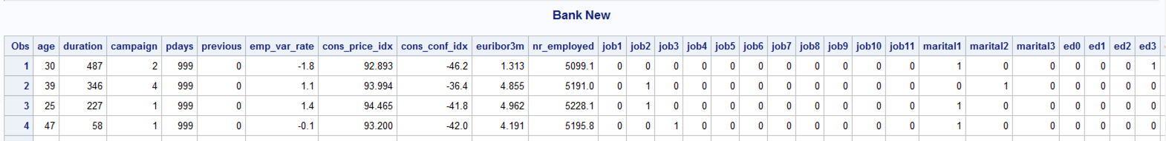

* Check the frequency of our target variable to ensure we have enough samples of each side;

**PROC** **FREQ**;

TITLE "Dependent Variable's Frequency";

TABLES target;

**RUN**;

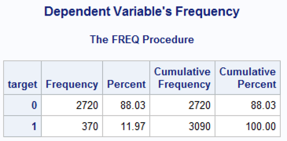

We have 2720 samples of 'no' = 88% Probability, and 370 samples of 'yes' = 12% Probability.

odds(y=1) = 0.12/0.88 => The odds that event Y = 1 occurs is 0.136 to 1. This means we have a higher chance of failure.

odds(y=0) = 0.88/0.12 => 7.33 to 1 (slide 8 of lecture 7)

I predict this will affect our Probability, threshold, train/test split.

1. Find out what percentage of each Y value we should have in relation to our dataset.

- Slide 35 of Lecture 7 states 10-30 cases per independent variable. 53 (w/dummy) * 10 = 530 observations we should have.

" - Make sure it has enough observations for each case (1 & 0).

If there isn't enough samples or there are many cells with no response,

parameter estimates and standard errors are likely to be unstable & maximum likelihood estimation

(MLE) of parameters could be impossible to obtain."

2. Either remove some observations of 'no', add in more 'yes' samples, or both.

Check the following:

1. is the Y variable binary?
2. Is there enough samples?
   1. What is the sample size n?
   2. How many predictors are there (k)?
   3. How many observations have Y=1 & y=0?
   4. Do we have enough sample (sample/k=10+)?

* Run Logistic Regression on the full model;

**PROC** **LOGISTIC**;

TITLE "Logistic Regression on Full Model";

MODEL target (event='1') = age duration campaign pdays previous emp_var_rate cons_price_idx cons_conf_idx euribor3m nr_employed job1 job2 job3 job4 job5 job6 job7 job8 job9 job10 job11 marital1 marital2 marital3 ed0 ed1 ed2 ed3 ed4 ed5 ed6 credit_default housing_loan has_loan cellphone month3 month4 month5 month6 month7 month8 month9 month10 month11 month12 day1 day2 day3 day4 day5 prev_outcome1 prev_outcome2 prev_outcome3 / STB RSQUARE;

**RUN**;

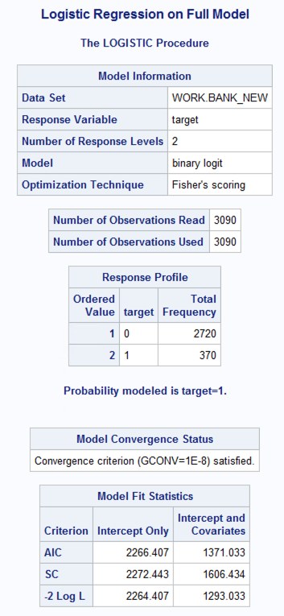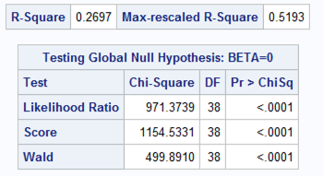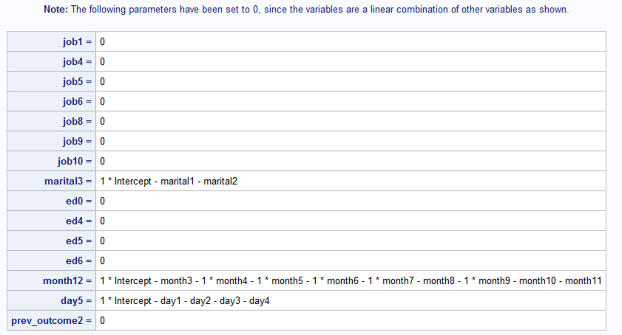

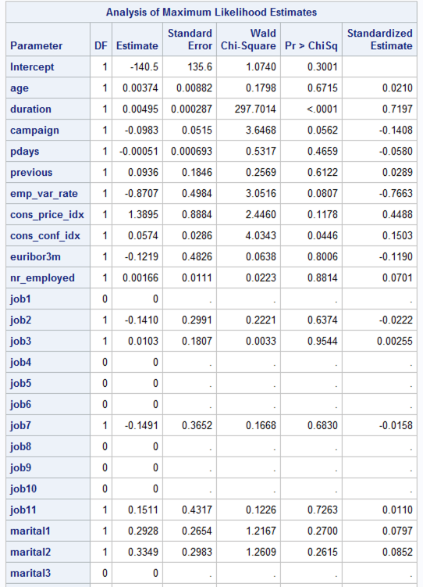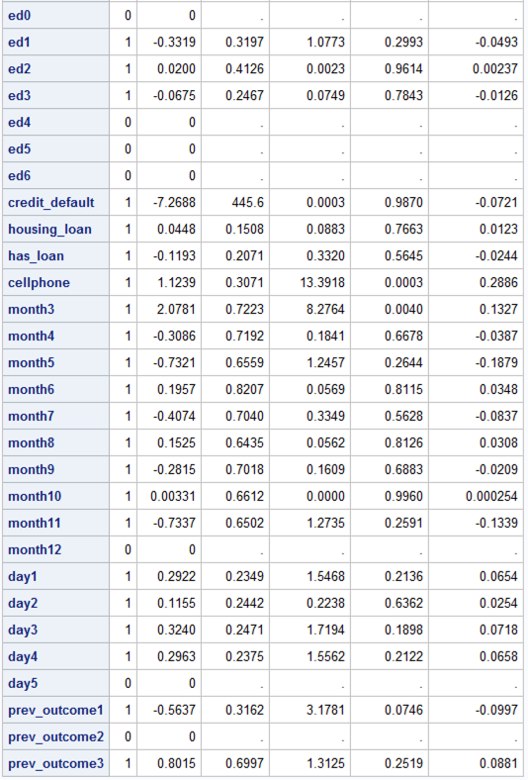

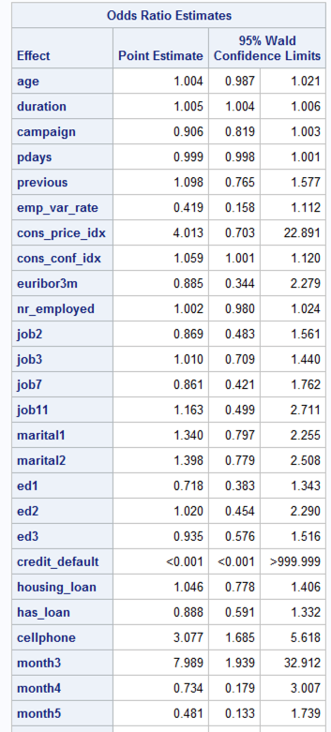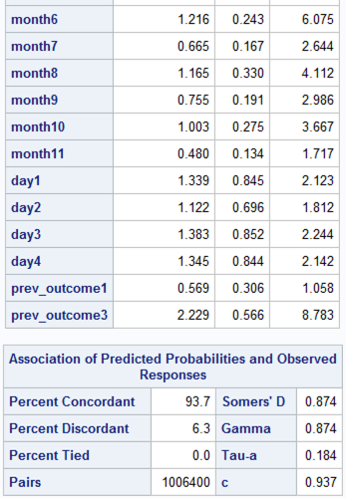

Fit the full model with standardized coefficients.

1. Which variables have the highest influence?
   1. Duration, 0.7197
   2. Second highest influence: emp_var_rate, -0.7663
2. Which vars have sig effect on odd of Y=1?
   1. Credit_default: -7.2688
   2. 2nd highest sig effect: month3: 2.078
3. Were any of the highest influential predictors insignificant?
   1. No. the top 2 predictors with the highest influence were not considered insignif.
4. Write full model equation

R-SQUARE = 0.2697

Log(P(target=1/target=0)) = -140.5 + 0.00374*age + 0.00495*duration – 0.0983*CAMPAIGN – 0.00051*PDAYS + 0.0936*PREVIOUS – 0.8707*EMP_VAR_RATE + 1.3895*CONS_PRICE_IDX + 0.0574*CONS_CONF_IDX – 0.1219EURIBOR3M + 0.00166*NR_EMPLOYED + 0*JOB1 – 0.140*JOB2 + 0.0103*JOB3 + 0JOB4 + 0 JOB5 + 0 JOB6 -0.1491*JOB7 + 0*JOB8 + 0*JOB9 + 0*JOB10 + 0.1511*JOB11 + 0.29*28*MARITAL1 + 0.3349*MARITAL2 + 0*MARITAL3 + 0*ED0 – 0.3319*ED1 + 0.02*ED2 – 0.0675*ED3 + 0*ED4 + 0*ED5 + 0*ED6 – 7.2688*CREDIT_DEFAULT + 0.0448*HOUSING_LOAN – 0.1193*HAS_LOAN + 1.1239*CELLPHONE + 2.0781*MONTH3 – 0.3086*MONTH4 - 0.7321*MONTH5 + 0.1957*MONTH6 – 0.4074*MONTH7 + 0.1525*MONTH8 – 0.2815*MONTH9 + 0.003*MONTH10 – 0.73*MONTH11 + 0*MONTH12 + 0.2922*DAY1 + 0.1155*DAY2 + 0.3240*DAY3 + 0.2963*DAY4 + 0*DAY5 – 0.5637*PREV_OUTCOME1 + 0*PREV_OUTCOME2 + 0.8015*PREV_OUTCOME3

Where job1=(job='blue-collar');

job2=(job='services');

job3=(job='admin.');

job4=(job='self-employed');

job5=(job='technician');

job6=(job='management');

job7=(job='retired');

job8=(job='entrepreneur');

job9=(job='housemaid');

job10=(job='unemployed');

job11=(job='student');

marital1=(marital='married');

marital2=(marital='single');

marital3=(marital='divorced'); * could also mean widowed;

ed0=(education='illiterate');

ed1=(education='basic.4y');

ed2=(education='basic.6y');

ed3=(education='basic.9y');

ed4=(education='high.school');

ed5=(education='professional.course');

ed6=(education='university.degree');

credit_default=(default='yes'); * 1 = yes, 0 = no;

housing_loan=(housing='yes');

has_loan=(loan='yes');

cellphone=(contact='cellular'); * 0 = telephone;

* survey conducted between March - December;

month3=(month='mar');

month4=(month='apr');

month5=(month='may');

month6=(month='jun');

month7=(month='jul');

month8=(month='aug');

month9=(month='sep');

month10=(month='oct');

month11=(month='nov');

month12=(month='dec');

day1=(day_of_week='mon');

day2=(day_of_week='tue');

day3=(day_of_week='wed');

day4=(day_of_week='thu');

day5=(day_of_week='fri');

prev_outcome1=(poutcome='failure');

prev_outcome2=(poutcome='nonexistent');

prev_outcome3=(poutcome='success');

target=(y='yes');

* Run a selection method for logistic regression;

**PROC** **LOGISTIC**;

TITLE "Stepwise selection method";

MODEL target (event='1') = age duration campaign pdays previous emp_var_rate cons_price_idx cons_conf_idx euribor3m nr_employed job1 job2 job3 job4 job5 job6 job7 job8 job9 job10 job11 marital1 marital2 marital3 ed0 ed1 ed2 ed3 ed4 ed5 ed6 credit_default housing_loan has_loan cellphone month3 month4 month5 month6 month7 month8 month9 month10 month11 month12 day1 day2 day3 day4 day5 prev_outcome1 prev_outcome2 prev_outcome3 / SELECTION=STEPWISE RSQUARE;

**RUN**;

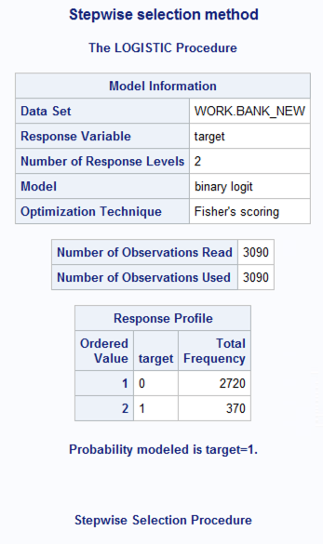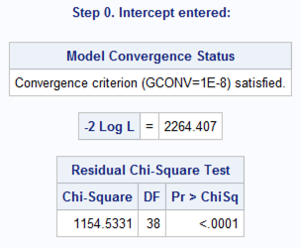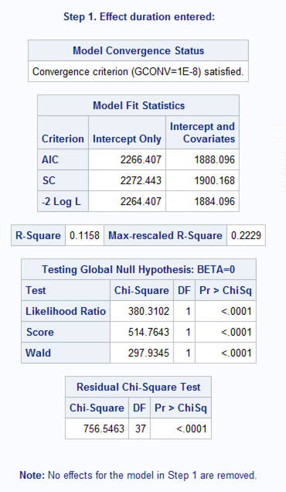

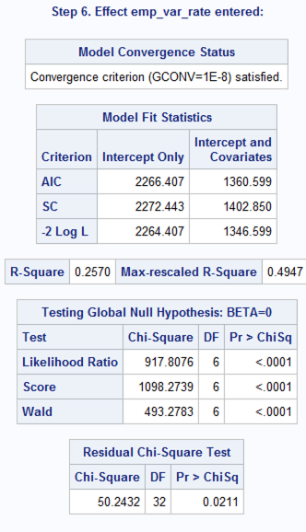 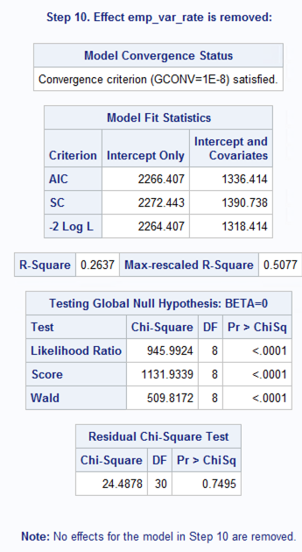

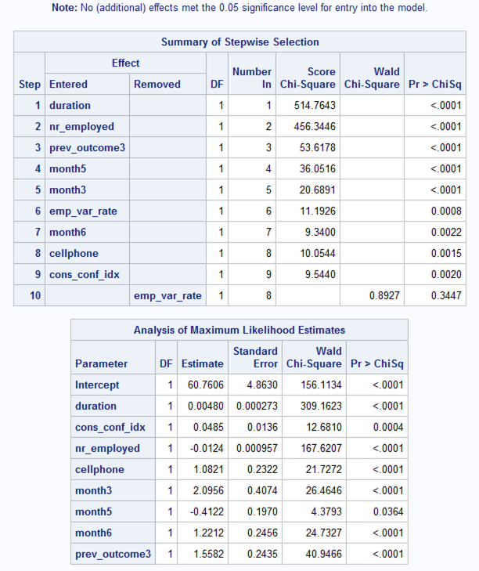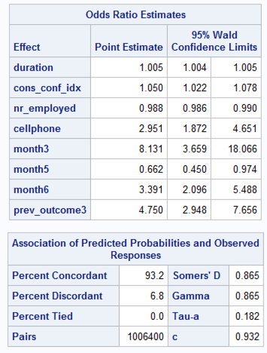

RSQUARE = 0.2637

Month5 (May) was seen as significant in the STEPWISE selection method.

This is biased because it's the month with the most calls.

Month3 (March) followed as significant. It has the 2nd lowest frequency (good thing),

but it's also the 1st month of the campaign. Finally, month6 (June) followed as significant.

This month may also be biased because it has the 2nd highest frequency of calls.

The selection method chose 8 out of the 53 attributes, but the R2 value was only 0.2637.

I want to test if removing some observations would increase the Rsquare value,

specifically observations that meet the following criteria:

- target = 0

- pdays = 999 (b/c 95% of our data is comprised of those values)

- month = 'may' (month w/the highest amount of calls)

Another option could be to add in more 'yes' samples from the full dataset to add

more variance and increase the probability that event Y will occur.

*/

Use stepwise and backward selection methods. Compare the 2 methods.

1. Did both of them select the same predictors?
2. Did they select the identical models (i.e. same parameter estimates, CI)?

Fit the final model to check the following

1. Are there multicollinearity among predictors that are in the final model?
2. Are there influential points and outliers?
3. If you see collinearity among predictors what actions would you take?
4. If you see influential points or outliers, what actions would you take?

For the final model

1. Write down the likelihood ratio test (null hypothesis, statistic and p-value)
2. Write down the final model equation
3. Ananlyze conditional effect of each varianle on the odds of Y=1. Use coefficient values and the confidence intervals to explain your answer.

R