Abstract

Which Miami neighborhoods have a coffee shop and a park?

ADS Capstone – Battle of the neighborhoods

Miami Neighborhoods

Table of Contents

1. Introduction 2

1.1 Problem 2

2. Data acquisition and cleansing 2

2.1 Data sources 2

2.2 Data cleaning 2

3. Methodology 3

3.1 Map Miami Neighborhoods with Pandas and Folium 3

3.2 Map Neighborhoods with Coffee Shop and Park with Foursquare 4

4. Results 5

5. Discussion and Observations 5

6. Conclusion 5

# Introduction

## 1.1 Problem

A client planning to visit Miami, Florida has solicited assistance in identifying neighborhoods; further identifying those within half mile radius that have both a coffee shop and a park. Ideally, this information will be displayed on map with markers.

# 2. Data acquisition and cleansing

## 2.1 Data sources

Miami, Florida neighborhood data with coordinates can be found on Wikipedia page [here](https://en.wikipedia.org/wiki/List_of_neighborhoods_in_Miami)​.

Using the neighborhood coordinates from Wikipedia data, venue information can be obtained from Foursquare location data.

## 2.2 Data cleaning

Data from Wikipedia page containing list of Miami neighborhoods was extracted and loaded into a Pandas dataframe. The latitude and longitude were combined in one column in the data set; to be able to use this for retrieving venues from Foursquare, the Coordinates column was split and new columns, Latitude and Longitude, were created. Since only the neighborhood along with latitude and longitude were needed all other columns were dropped from the dataframe. Upon further review of the data, rows with invalid coordinates were observed; these rows were also dropped from the dataframe since this would cause errors retrieving venues from Foursquare location data. This data was used to create map of Miami neighborhoods with markers and popup text of neighborhood name.

Foursquare api was used to retrieve nearby venues based on cleansed data set resulting in a dataset with 1154 rows. Since the interest is only in venues that are in categories Coffee Shop and Park, all other venue categories were dropped from dataset; this reduced the number of rows to 64. Additionally, a new column 'Category ID' was created and populated with value calculated based on venue category; this will later be used for formatting map markers based on category.

Using this new dataset of only the venues within our selected categories, a count of venues is obtained for each neighborhood and venue category. Once the count of venues for each venue category is known, neighborhoods that do not have both a coffee shop and a park are dropped from the dataset.

# Methodology

## 3.1 Map Miami Neighborhoods with Pandas and Folium

Utilizing Pandas, Miami neighborhood data was extracted from Wikipedia page and loaded into dataframe using Pandas as shown in Figure 1. Data was then cleansed to result in only the data needed for mapping the neighborhoods as shown in Figure 2.



Figure 1 - Miami Neighborhood Data Example



Figure 2 - Miami Neighborhood Data Example, Cleansed

After data was extracted and cleansed, Geocoder Nominatum was used to extract coordinates for the city of Miami. Folium was utilized to create feature group to draw map and create markers with neighborhood depicted in popup text when user clicks on marker as shown in Figure 3.

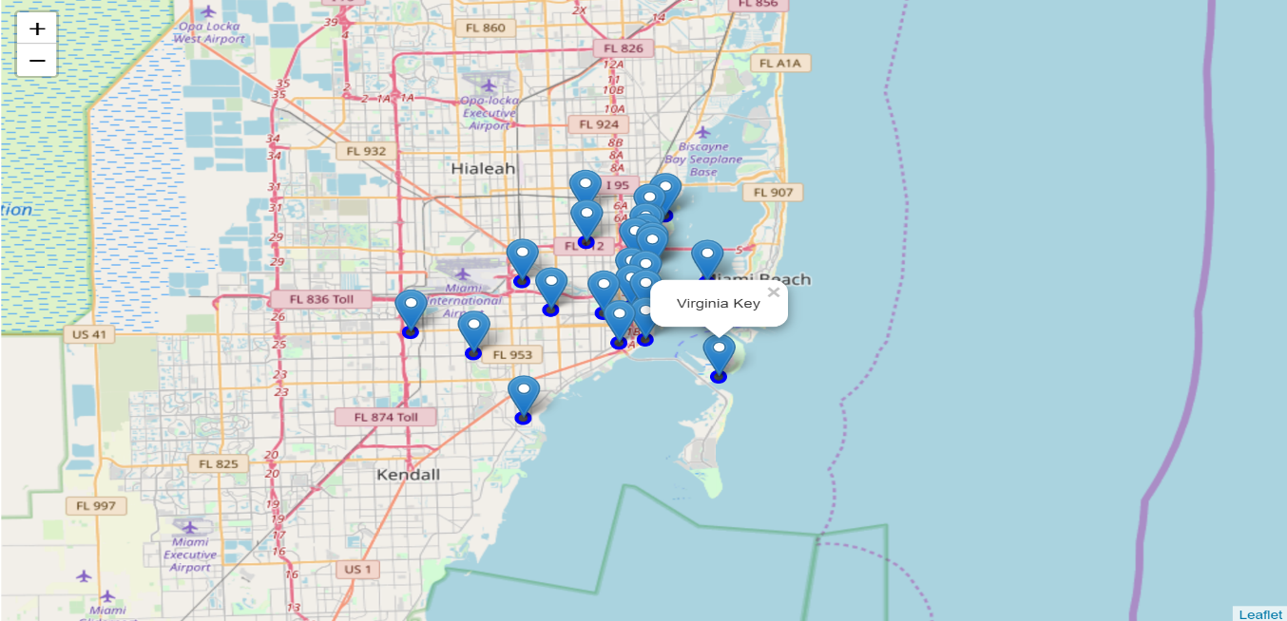

Figure 3 - Miami Neighborhood Data, Mapped

## 3.2 Map Neighborhoods with Coffee Shop and Park with Foursquare

Foursquare API was used to get neighborhood venues within half mile radius of Miami. This resulted in 1143 venues, an example of data returned is shown in Figure 4 below.



Figure 4 - Miami Neighborhood Venues Data Example

Since we are only interested in neighborhoods with coffee shops and parks, all other venue categories were dropped resulting in 63 venues. An example of the resulting data is shown in Figure 5.



Figure 5 - Miami Neighborhoods with Coffee Shop or Park Data Example

Upon further analysis of the data, it was observed that not all neighborhoods had both a coffee shop and a park. The neighborhoods that did not meet this criterion were dropped from the data set resulting in the 10 neighborhoods shown below in Figure 6. Additionally, a neighborhood ID was created for mapping.



Figure 6 - Neighborhoods with Both a Coffee Shop and Park

# Results

The venue data for the ten neighborhoods that had both a coffee shop and a park was then created resulting in 28 unique venues in ten neighborhoods. These venues were mapped and depicted by markers and pop up text as shown on map below.

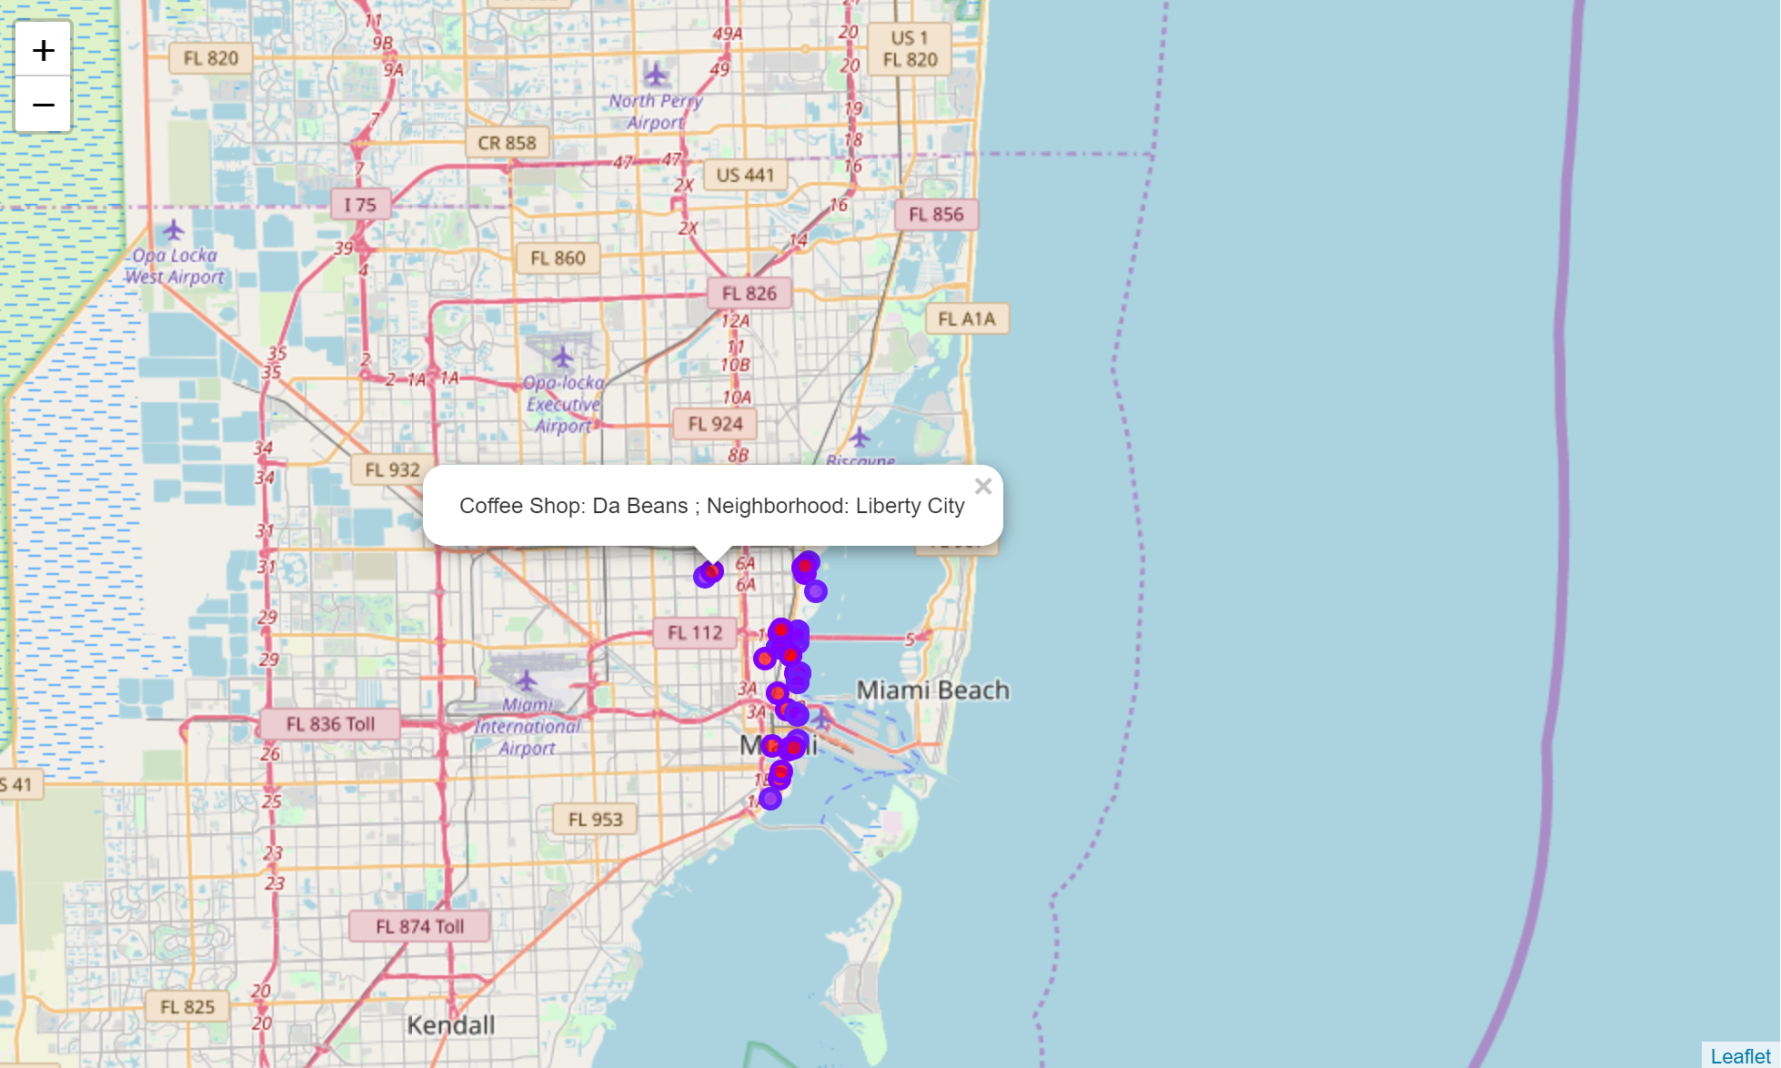

Figure 7 - Miami Neighborhoods with Coffee Shop and Park Venues

# Discussion and Observations

The neighborhood with the highest number of coffee shops (6) was Midtown while the one with highest number of parks (4) was Buena Vista (See Figure 6). In comparison, Liberty City has only one coffee shop and one park. Other neighborhoods with only one park were Midtown, Downtown and Brickell although each had multiple coffee shops.

# Conclusion

The data clearly shows there are neighborhoods in Miami where our client, and others, can easily grab their favorite cup of coffee and enjoy it while taking a stroll in the park.