Fuzzy Logic Approach for Modeling a Traffic Signal Controller for an Isolated Intersection

D. A. Scerbo¹, L. Dumaliang²
¹Department of Modeling and Simulation Engineering, Old Dominion University, Norfolk, VA, USA
²Department of Modeling and Simulation Engineering, Old Dominion University, Norfolk, VA, USA
Abstract—Traffic congestion is a major problem throughout cities all around the world. By using an Intelligent Traffic Control System (ITS), a control system that continuously senses and adjusts the timing of traffic lights based on the actual load, may be a solution to this problem. Some intersection used conventional traffic light controllers that operate on a constant cycle based on pre-determined data. Since fluctuations in Traffic patterns can be highly stochastic, due to various unexpected events (i.e. accidents, weather, special events) these convention methods do not always provide an optimal control. A fuzzy logic based traffic controller, on the other hand, can be used for optimum control of the fluctuating volumes of traffic. In this articles a fuzzy logic based ITS approach will be considered and applied for an isolated intersection. The number of vehicles arriving to an intersection and the number of vehicles currently at the red light will be used in order to determine an allocated green light time. The presence of a pedestrian crossing the intersection will also be taken into account and effect the green light allocation time. Upon getting all relevant data for the model, MATLAB will then be used for the simulation software. The proposed method of traffic control is an attempt to reproduce already finished research. The model created will be compared to the research and then an attempt to produce a fuzzy controller suited for Norfolk Hampton Roads will be done.

Keywords—Fuzzy Logic, Traffic Control, Fuzzy Traffic Controller

I. INTRODUCTION

Transportation is a key part of the continual development of modern society and has become integral to every person. A large increase in traffic is the result of the demand for a constantly increasing transportation industry while infrastructure growth has stayed primarily in a static state. This increase in traffic is easily seen when looking at a system such as a city during times of high volume such as mornings or holidays. Traffic as a whole has many adverse effects. Not only does it affect drivers at a personal level, i.e. stress, loss of time and opportunities, the economy also is impact due to increased transportation costs, unpredictable travel times and loss of productivity. One major contributing factor to this problem is intersections that utilize traffic lights because this area acts as a bottleneck for most traffic flow. By improving the efficiency of intersections, this

bottleneck can be widened allowing for a great decrease in traffic congestion.
Currently many intersections utilize a technique for determining traffic light cycles based on predetermined fixed timing data and their corresponding time pattern. In this system, an intersection may choose to extend the length of a green light if it is the morning of a weekday. However, this type of system does not take into account any other factors and cannot be adaptive to changing conditions. A better system for an intersection would adapt to the current conditions and not need to have any predetermined cycles. The most efficient method for determining a traffic light’s status would be to have a human operator looking at the current conditions and making their best judgment on what the current light status would be. This method is unrealistic as there are too many intersections and not enough skilled operators for this type of job. However, if this human like decision making could be replicated in an automated system, the intersection may be just as efficient. One such way to implement this type of intersection is to use a fuzzy logic inference system.

II. METHODOLOGY

The experiment is broken up into multiple stages in order to obtain results. An initial model is creating using membership values and rules from the research conducted by Sandeep Mehan. This model is the basis for the rest of the research and needs to be verified before modifying the experiment. After creating the initial model new membership values a needed for the focus area. This research focuses on the traffic flows surrounding the Old Dominion University Norfolk campus. This system also implements a new variable, pedestrians, which needs to be taken into account when creating the fuzzy logic system.

A. Design Criteria and Decisions

MATLAB’s fuzzy logic tool will be used in order to develop the traffic light controller model. The following design decisions were made prior to implementation:
- The junction of interest is a 4-way intersection with parallel opposite traffic flows;
- As one route, i.e. north-south, is active, flow east-west is stopped, and vice versa;
- The fuzzy controller will observe the density of traffic traveling toward the intersection;

B. Initial Model

In this method for developing the traffic controller two inputs are considered, the quantity of the vehicles arriving to the side that currently has a green light (Arrival Density), and the quantity of vehicles that are present at the red light for the perpendicular route (Queue Sze). The types of membership functions used for these inputs are triangular and trapezoidal. Depending on the quantity the arrival density and queue size, the value will map to either {very small, small, medium, larger, very large}. Below, in Table 1, are the quantities of vehicles used in the model by Sandeep Mehan and will be replicated in the input membership function for the initial model.

Table 1 - Input Membership Functions
Number of vehicles | Queue Size | Arrival Density
Very Small | 0-10 | 0-20
Small | 5-15 | 10-30
Medium | 10-20 | 20-40
Large | 15-25 | 30-50
Very Large | 20-35 | 40-60

The green light allocation time will be the output in this model. This output membership function will assume either a short, medium, or long allocation times. The possible outcomes for the green light levels will fit the following time ranges respectively: 0-30, 20-70, and 60-110. These time ranges used for the duration of the green light are in seconds.

A fuzzy rule base is able to represent human-like reasoning, in IF-THEN form combined with AND/OR operators. Using this logic, a combination of fuzzy inputs (queue size, arrival density), is correlated to fuzzy output stating the appropriate green light allocation time.

Table 2 - Initial Model Rules
Queue  Arrivals | VS | S | M | L | VL
VS | S | S | S | S | M
S | S | S | S | M | M
M | S | S | M | M | L
L | S | M | M | L | L
VL | M | M | L | L | L

After replicating this model a comparison of the membership functions, set of rules, and rule surface were with the model designed by Sandeep Mehan. In conclusion to this comparison, the model is able to reproduce the results obtained by Sandeep Mehan. The developing this initial model will serve the purpose of being a validated and verified base model in which can be built on. In the following sections this model will be enhanced in order to accommodate results suited for the area of focus.

C. Data Collection and Fuzzification

In order to create a modified version of the initial model new data is necessary. The data collect is used to create new fuzzy input value distributions representing the focus area. Two values were recorded for the raw data, traffic flow in vehicles per minute and maximum number of vehicles waiting at a red light. These two values were recorded in pairs at different times during the day. Table 3 is a sample of the data recorded and used to create the fuzzy input values.

Table 3 - Sample of collect data
Time | Queue Size (# cars) | Flow  (#cars / min) | Fuzzification
8:23 am | 19 | 45 | [Very High, High…
12:02 pm | 15 | 36 | [Medium, High…
8:01 pm | 6 | 15 | [Small, Medium, Small...
10:22 pm | 2 | 10 | [Small, Very Small…
... | ... | ... | ...

The raw data collected is converted into fuzzy input values by using a small group of study participants. This group consisted of five individuals from differing areas and educational disciplines. Each study participant mapped the recorded values to either Very Small, Small, Medium, Large, or Very Large. In addition to the displaying the raw value to the participant, a picture of the queue size or a short video of the flow rate is shown in order to facilitate a better understanding of the numerical values. The resulting linguistic values are used in R to generate a distribution for each fuzzy value.

D. Modified Model

The modified model is very similar to the initially created model with two major modifications. The fuzzy input values are changed based on the data collected and resulting fuzzification. The modified model also takes into account the addition of pedestrians into the system. Pedestrians are modeled by implementing a Boolean value of present or not-present and this value is determined by a button located at a crosswalk. If pedestrians are not present, the fuzzy output is the same as the initial model with a Short, Medium, or Long green light allocation. However, if there is/are a pedestrian(s) present, i.e. the button is actuated, there are only two fuzzy output values, Medium and Long green light allocations. This change is based on the research conducted by Mladen Antunovic and Mrvoje Glavas

Table 4 – Modified Model Rules
Queue  Arrivals | VS | S | M | L | VL
VS | S / M | S / M | S /M | S / M | M / M
S | S / M | S / M | S /M | M / M | M / L
M | S / M | S / M | M / M | M / L | L / L
L | S / M | M / M | M / L | L / L | L / L
VL | M / M | M / L | L / L | L / L | L / L
Key: | No Pedestrian Present / Pedestrians Present

Table 4 is the list of outputs based on the given inputs for the modified model. These rules take into account both pedestrians present and no pedestrians present.

III. RESULTS

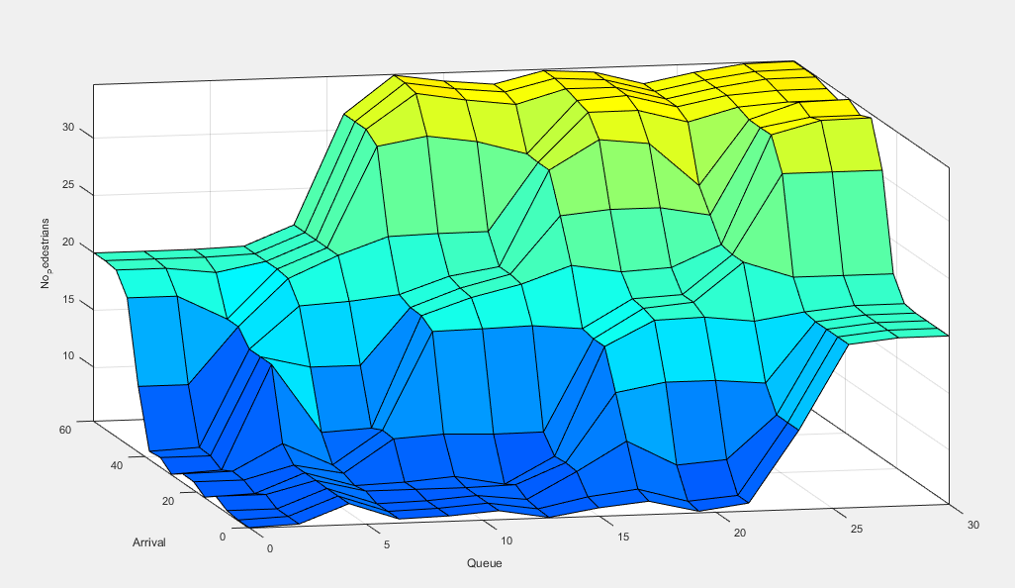

Results

IV. CONCLUSION AND FUTURE WORKS

Necessary to show pictures instead of just numbers for fuzzification

V. ACKNOWLEDGMENT

T

REFERENCES

[1] Sandeep Mehan, “Introduction of Traffic Light Controller with Fuzzy Control System”
[2] Mladen Antunovie, Hrvoje Glavas, “Fuzzy Logic Approach for Traffic Signals Control of an Isolated Intersection”

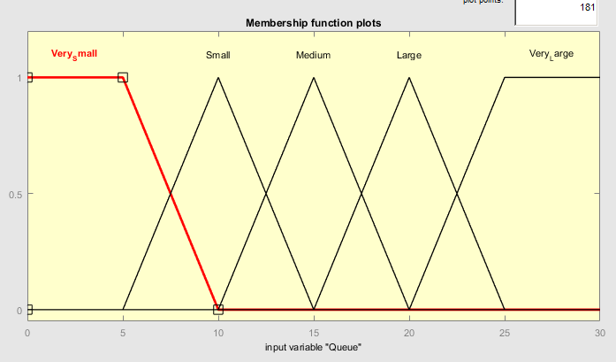
Figure 1. Input Membership
Function for Queue Size

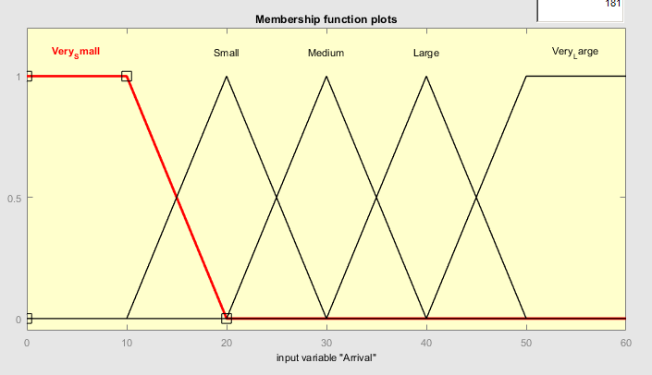
Fig. 2. Membership function for number
of vehicles arriving to intersection.

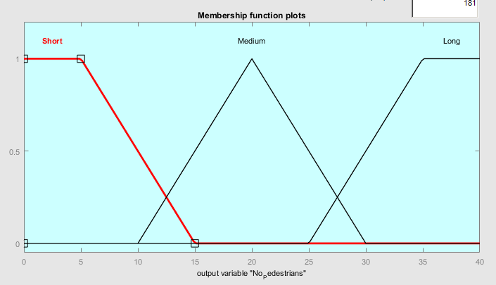

Fig. 3. Output membership function for
green light allocation time.

Table 1. Fuzzy Control Rules

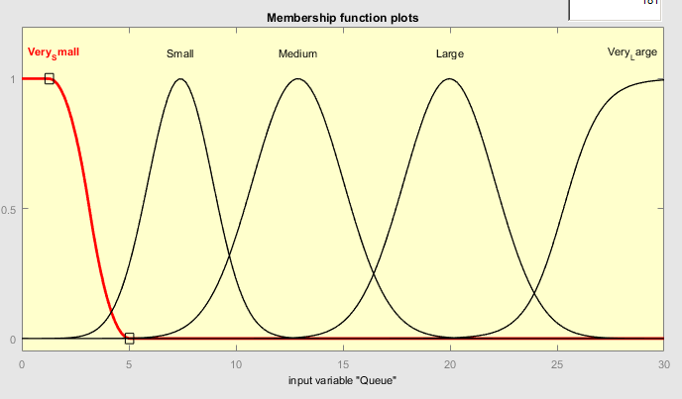

Fig. 4. Input membership function
pedestrian model queue size.

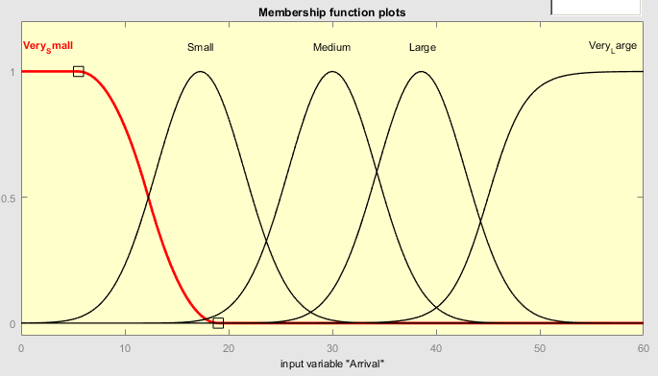

Fig. 5. Number of vehicles arriving to
Intersection for pedestrian model.

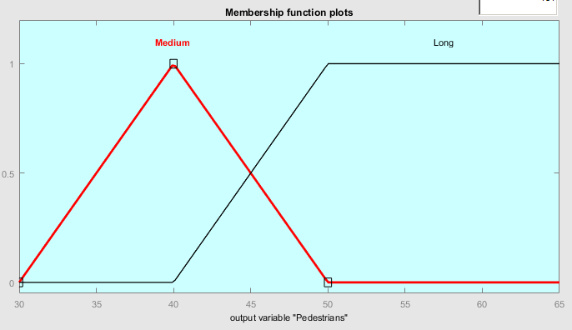

Fig. 6. Membership function for allocated
green light for pedestrian.

Table 2. Pedestrian Model Rules

