**4. Discussion**

In this chapter, the results and the methodology will be discussed.

***4.1 Dataset validation: comparing LAIre to LAI3g***

*Comparing raw LAI data*

The high correlation coefficients between raw LAIre and LAI3g data suggests that the model created by Stöckli indeed produces LAI values comparable to remotely sensed data and can therefore be used for further analysis. This is also supported by the comparison of yearly minimum, maximum and mean LAI values between the two datasets, which show even higher correlation coefficients.

Variations between the two datasets can be explained mainly due to the slightly different values they represent. In the LAIre dataset, a bimonthly value as well as the yearly min/mean/max values are gathered from daily modelled LAI values. In the LAI3g dataset on the other hand, a bimonthly value represents the mean of an unspecified number of acquisitions for each 15-day period. Furthermore, atmospheric effects and the saturation of values at higher LAI in densely vegetated areas can play a role (Zhao et al. 2012). This is particularly evident when looking at a scatterplot between two datasets (Fig X1) where a group of pixels in the tropics get a higher LAI value in the LAI\*\* dataset as compared to the LAI\*\*.

The resampling of the LAI3g also lead to differences in coastal areas due to it being a mix of water and land pixels which can also be seen in the scatterplot in figure X1.

*Comparing LSP parameters*

Even though the very low correlation coefficients for all extracted LSP parameters might suggest that there is little agreement between the two datasets, a visual analysis of where the differences are show a different picture however. The two datasets agree well in regions where there is one distinct growing season per year, for example in high and moderate northern latitudes. For those regions, small differences of around 15 to 30 days are expected due to the temporal resolution of the datasets. Moderate and high southern latitudes show more variability which corresponds to prior findings (White et al. 2009; Garonna et al. 2014).

In other regions, the growing patterns and the LSP extraction methods may explain the differences. In tropical regions for example, where there is no clear start and end of season, small differences in data can lead to LSP shifts of half a year. These differences arise from a combination of tropical growing season patterns and the LSP extraction methods and do not necessarily indicate a disagreement between the two datasets.

The effect of different LSP extraction methods can also be seen when comparing the results from the MI method to the MP method. The correlation coefficients for the LSP parameters extracted with the MI method are only half as high as correlation coefficients for the MP method. This corresponds to prior research where it was found that the MI method generally shows more variability from year to year, and therefore also between two slightly different datasets of the same year, as compared to the more stable MP method (Garonna et al. 2014).

*Trend analysis 1982 – 2011*

The trend analysis for both dataset shows similar regional patterns for all three LSP parameters. The decadal change rates for the LAI3g dataset are however much stronger compared to the LAIre. This is particularly true for densely populated areas in China, where the LAI3g shows a strong shift in SOS towards an earlier day of the year, whereas the LAIre shows almost no change in those areas over the last 30 years. This difference in measured data and modelled data suggests that non-climatic factors, such as improved agricultural productivity to support economic and population growth (Cao & Birchenall 2013), cause these particular shifts.

A big difference in the two datasets can be seen in the ecotone between savannah and desert in the Sahel. The LAIre shows a much later onset of SOS, which leads to a shortening of the GSL. The LAI3g however shows a slightly later onset of EOS, leading to a slight increase of the GSL. The satellite based observations and matching field observations were already described by Dardel et al. (2014). The difference in modelled and remotely sensed observations most likely arises from regional desertification and re-greening of the Sahel and therefore the changes in land-cover type (Foody 2001; Dardel et al. 2014; Mishra et al. 2015) which are not taken into account in the modelled LAIre. Another factor is the nature of growing seasons in the subtropics and the extraction methods used for LSP parameter extraction as discussed in the chapter before.

***4.2 Climatic Controls***

*Yearly Dominating Controls*

The results for yearly dominating controls mirror those of Jolly et al. (2005). In contrast to Jolly, no areas of “no seasonal constraints” in the tropics were defined, instead those areas appear as radiation controlled since daylength is the limiting factor. The methodology used in this thesis also does not take into account multiple influencing factors as Jolly did. This was done to get a clearer picture of domination changes over the years.

Visible and large-scale change of dominating control happens in South America where parts of Brazil change from a radiation-control dominated environment in the 1980s to a moisture-controlled environment in the 2000s. This change coincides with several strong drought events in Brazil in the years 2000 – 2010 (Anderson et al. 2015). Since drought events are extreme weather phenomena, the change in dominance should not be overstated just yet, since it is only really visible from 2000 onwards. Further statistical analysis and longer time series are needed to assess long term change in climatic controls in this region.

Small changes in dominating controls run mainly along borders of areas with different domination controls and vary by year without a clear trend in one direction. These areas correspond to the areas of mixed controls in Jolly’s work and are usually along ecotones. An interesting exception is northern Europe, which, even though it is temperature dominated in most years, shows some years (1989/1990, 2000, 2005 and 2011) where the radiation control is the dominating factor over a large area. A possible explanation of these outliers could be the North Atlantic Oscillation (NAO), which shows particularly positive NOA-index values for the affected years (Gouveia et al. 2008).

*Quarterly Trends for Climatic Controls*

To extend Jolly’s analysis of how climatic controls vary within a single year, a trend analysis for each quarter of the year gives an insight into how the controls change.

*Temperature*

As expected based on the latest report from the IPCC (IPCC 2014), globally rising temperatures lead to a decrease of influence for the temperature control factor. Because mainly the northern hemisphere is affected by temperature control, this is also where the change is most visible.

Looking at the change from quarter to quarter, a south to north pattern can be observed starting in the Middle East in the first quarter and travelling upwards to northern Europe in the third quarter. This is because the change in control factors happens only when temperatures are within the thresholds of the GSI-factor, roughly around -2 to 5 degrees centigrade, depending on PFT. If temperatures change outside of this window of constraint, it will not be visible in this analysis.

Even though a decrease in influence of temperature was expected, the rate of change particularly in Iran in the first quarter of over 20% per decade was surprising. This is particularly interesting since other studies found no significant mean, minimum and maximum temperature change for the first quarter from 1960 to 2010 (Ghasemi 2015; Saboohi et al. 2012). Ghasemi mentions though that a steeper increase from the 1990s is expected.

It is also worth looking at the areas where temperature control has increased, as is the case in the second quarter in eastern Australia and western Canada. Jacobs et al. (2013) showed that eastern Australia did not show a significant annual warming trend from 1979 to 2010 which makes a slight increase in temperature control intra-annually plausible. Additionally, they found a cooling trend on eastern Australian land surface during La Niña episodes. However, their analysis is also based on ERA Interim data, like the climatic control data in the LAIre dataset, and should therefore be verified with an independent source.

For western Canada, the situation is very different. The literature unanimously shows an increase in mean, minimum and maximum temperatures for all seasons in this period (Bonsal & Prowse 2003; Beaubien & Freeland 2000; BCMoWLAP 2002), making an actual increase in temperature control questionable. Closer inspection of the bimonthly climatic data from which the quarterly trends are aggregated shows that an increase in temperature control only shows up in 2 of the 6 relevant 15-day periods from April to June, each in a slightly different region. Therefore this increase in temperature control should be treated as a statistical outlier due to the aggregation.

*Moisture*

The moisture trends are more varied globally but most regions show a strong increase in moisture control of up to 10% per decade. As Matsoukas et al. (2011) note, part of the increase in control is due to the ERA Interim data showing a faster rise in air temperature T than the rise in dew point temperature Td, leading to bigger estimates for VPD.

While a lot of the areas showing a strong increase in moisture control are semi-arid and arid regions, which are dominated by moisture control anyway, the more interesting cases are the regions that are not dominated by moisture control. This is the case in Europe, which shows an increase in control particularly during the second quarter of the year, when plant growth rates are at a peak.

Strong increases in moisture control can also be found in South America over all four periods. This increase is likely amplified by several big drought events between the years 2000 and 2010 in southern America, the impact of this change in control does not correlate with LAI measurements however (Anderson et al. 2015). Anderson et al. suggest that other biophysical parameters influence phenology more than evaporative stress.

The decrease of moisture control in southern Africa and north-eastern Australia, which are nonetheless dominated by moisture control over all 30 years, are also worth discussing. The effective decrease of VPD, or increase in moisture, has been analysed in prior research for both regions based on modelled as well as remotely sensed data (Dorigo et al. 2012; Chen et al. 2014). While Dorigo et al. point out that precipitation is the main driver for the increase southern African soil moisture, there is no clear consensus yet how precipitation and soil moisture influence each other in this region (Dorigo et al. 2012; Cook & Pau 2013) or how and how strongly ocean current anomalies such as the ENSO influence southern African precipitation and soil moisture (Reason & Jagadheesha 2005).

* 1. ***Climatic Controls compared to Phenology***

In this chapter, results from all three research questions are combined to analyse the impact of changes in climatic controls during Start and End of Season.

*Dominating Controls during EOS and SOS*

When comparing dominating controls during Start and End of Season, big differences are visible in the spatial distribution of the controls. During SOS the pattern is very similar to those found in yearly dominating controls. This is in strong contrast to the dominating controls at EOS, which show a completely different pattern, particularly for the northern hemisphere. Similar differences can be found when looking at the temporal variability of dominating controls during SOS and EOS. For the SOS, the changes over time are small and are located around at the borders of different dominating controls. For EOS on the other hand, large scale changes in dominance can be seen over time particularly for the northern hemisphere, but also in southern Africa and South America.

*Start of Season in the northern hemisphere*

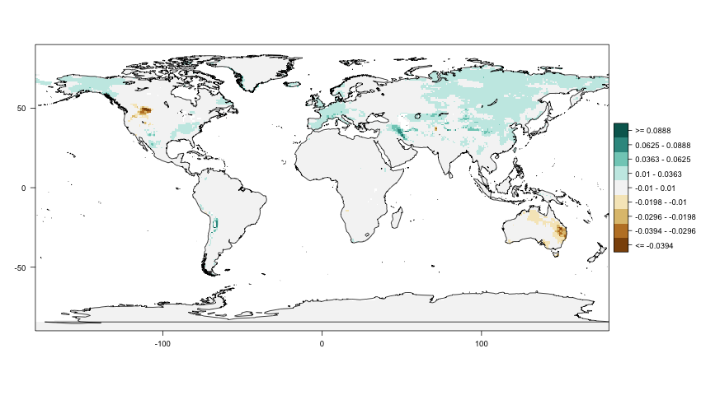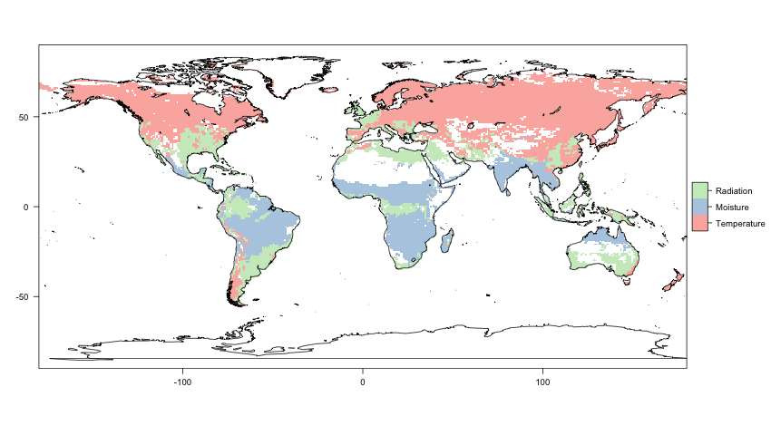

For the Start of Season in the northern hemisphere, the temperature domination coupled with decrease of temperature control observed in the second quarter results in an earlier SOS (see section 4.2 and 4.1 respectively). This is a strong indication that temperature was and still is the main driver for plant growth for the northern hemisphere, as has been the general consensus in the literature (Jeong et al. 2011; Badeck et al. 2004). This is further confirmed by the trend analysis of temperature control during Start of Season. It shows very little change during start of season for most of the northern hemisphere, implying that the SOS and minimum temperature change uniformly. Exceptions are Scandinavia, Britain as well as China, where influence of temperature control is getting smaller during SOS, implying other processes started having an influence on SOS during the last 30 years.

With rising temperatures and earlier SOS onset, other factors might start having a stronger impact on the Start of Season.

*Start of season for South America*

|  |  |  |
| --- | --- | --- |
| Macintosh HD:Users:davidschenkel:Documents:Uni:Masterarbeit:3_cc-LAI:yearly_dominating:plots:LAIre:SOS_dominating_control_2007.png | Macintosh HD:Users:davidschenkel:Documents:Uni:Masterarbeit:2_controls:bimonthly_changes:plots:quarter_MOIST_FAC_18.png | Macintosh HD:Users:davidschenkel:Documents:Uni:Masterarbeit:1_LAI_comparison:decade_change:plots:LAIre_changeperdec_SOS_MP.png |
| Moisture control dominant | Increase in moisture control over 30 years | Later onset of Growing season |

By looking at the same combination of factors for Brazil, one can find that the shift in SOS towards a later date can be explained by the moisture control. Moisture is the dominating factor for the affected region and shows an increase in control over the 30 years analysed. This dependence on moisture has already been shown for seasonal behaviour for certain forest types in Brazil (Funch et al. 2002) but not in a long-range trend analysis such as this thesis. Interestingly, changes in moisture availability and LSP due to large scale logging in the Brazilian amazon rain forest which were found based on MODIS time series analysis (Koltunov et al. 2009) did not show up in the analysis on this larger spatial and temporal scale. While some change in moisture in the Amazonian rainforest can be seen, a large part of the major increase in moisture control is outside of the rainforest and its causes are therefore likely not connected to logging.

*End of Season*

Similar comparisons for EOS are not as easy due to inter-annual variability of dominating controls. Particularly for the northern hemisphere, this could be an indication that the climatic factors influencing the End of Season are more complicated and multi-facetted than the temperature dominated Start of Season. However, it could also be an indication that the main drivers for End of Season happen earlier than the 1-month period studied in this thesis. For the northern hemisphere this seems to be the case according to Jeong et al. (2011) who found that temperature related effects initiating the End of Season might be shifted back 3 to 4 months before actual EOS.

Nonetheless, more varied climatic control factors during EOS could be particularly important to help explain why the delay of EOS has increased in recent years in Europe, while the rate of earlier onset of SOS has remained more or less stable (Jeong et al. 2011; Garonna et al. 2014). Furthermore, the high spatial variability during EOS indicates that a more regional analysis based on regional climate models is needed to understand the exact effects on plant senescence.

In the southern hemisphere, as well as East Asia, the temporal variability is not as high but the dominating control is radiation for most areas. Since radiation is mainly a factor of day-length, this has not changed significantly during the last 30 years and hence does not hold up for a comparison as was done for the rest of the northern hemisphere.

* Challenges:
  + Getting quantitative results
  + Climatic Controls model questionable
  + ALL models rely heavily on MODIS data to model them. source of possible systematic error
  + Very coarse resolution used, possible errors due to resizing/averaging too much over different land cover types -> results still useful/applicable for lower resolution?