Short explainer of what I did here :

Preproccessing :
First I made the image black and white and then I downsampled it just like you guys had ( down by a factor of 10. We could do more)

1) Grabbing edges

You can easily grab edges by subtracting the Gaussian . I then maximized the pixel values so the edges would be clearly visible, since they are very dim and thin ( this is just done by setting everything above a threshold of 10 to 255, the maximum brightness of pixels)

This is what it looked like after these 3 operations :

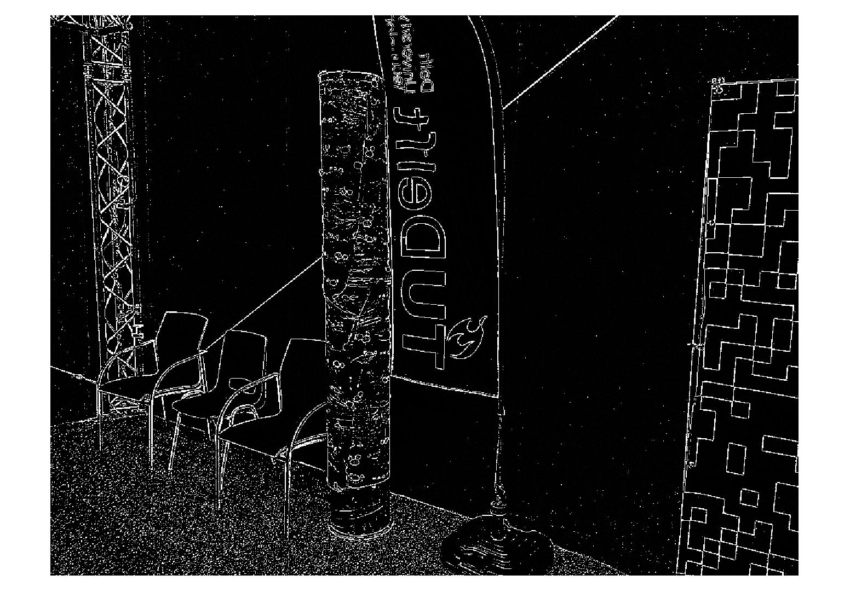

2) Grabbing vertical edges only :

The objects we care about are the columns ( is this true? What does he want with the black and white “QR code” checker boards ? ) . We also mostly care about horizontal optic flow ( optic flow for yaw turning and forward motion) . We can maximize horizontal optic flow by taking orthoganal features, so , vertical lines.

I did this by doing a “morphological feature” detector ( also called “closing” ). This is just taking the minimum value of pixels iterating using a vertical kernel. Maybe I can change this a little bit for more robust results.

Here the “verticle lines” I found. Theres another image where you can see them in yellow, the old stuff from the previous image is in red. You can see the “TU Delft” flag, the 2 columns ( though the further away one is harder to see ) , and some details around the room like the legs of some chairs and the metal thing in the background.

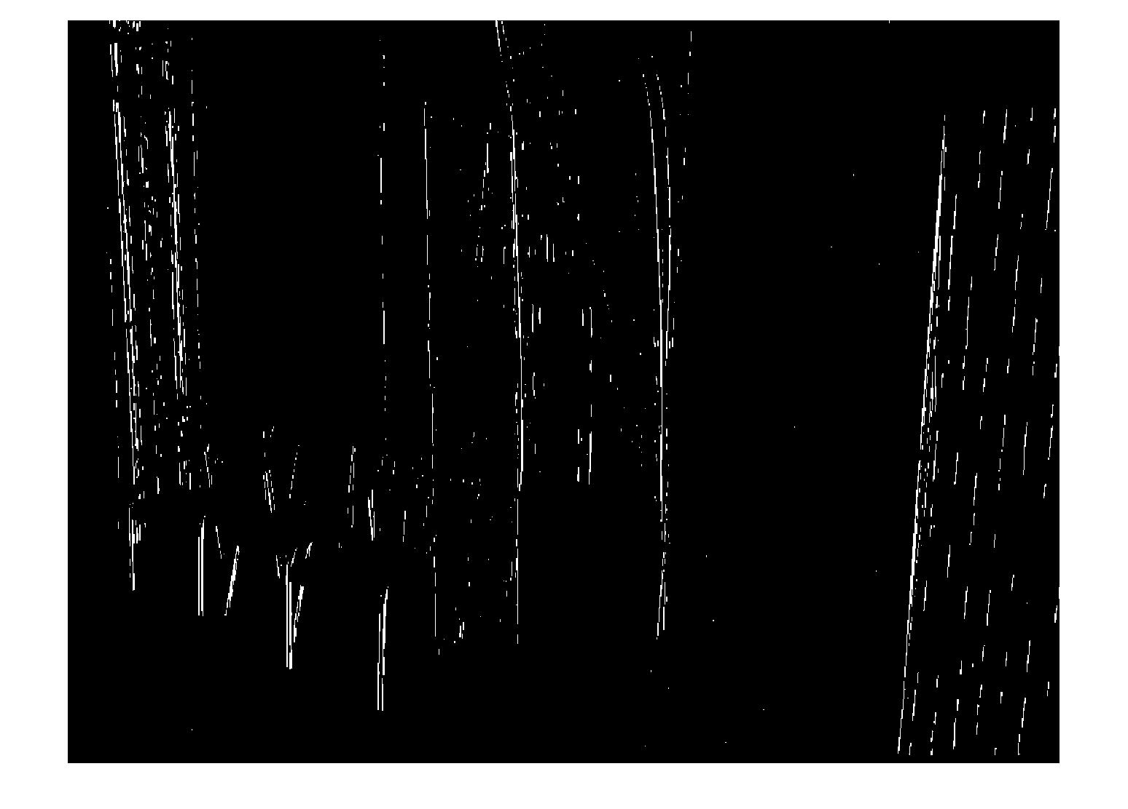

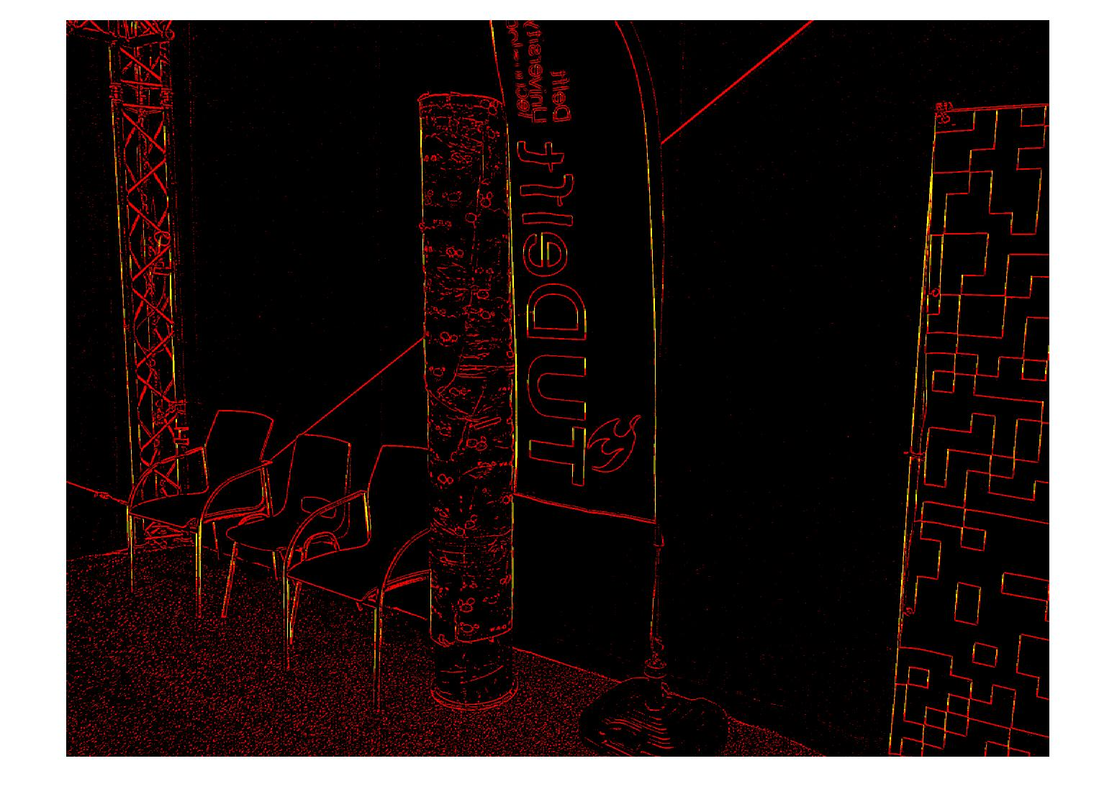

I was worried that there would be a problem with the Fisheye from the drone but everything seems fantastic :

Here I did it on the drone image. Notice the picture is upside down. The horizontal lines from the pole , the box, and the metal thing in the zoo are all outlined.

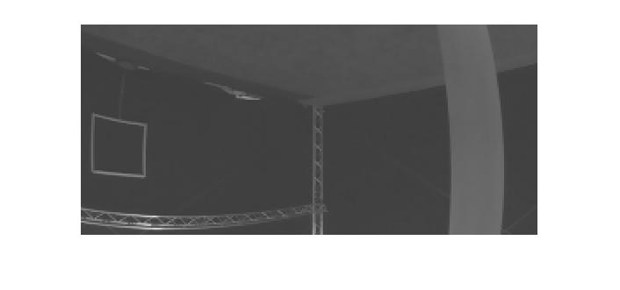

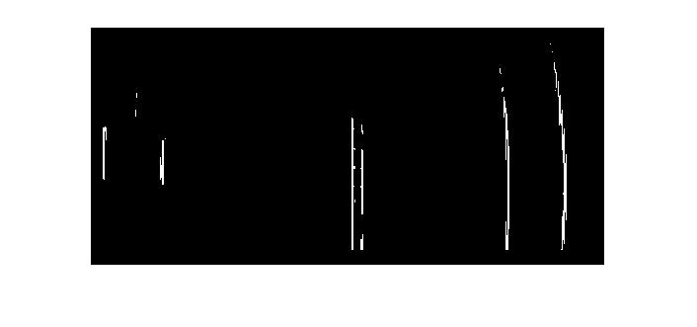

Review:
Things I like :
* It seems to grab the edges of objects pretty well in a very simple way ( I did lots of experimenting :) )

* It will (hopefully) maximize optic flow in the direction we want

* it actually works better with the drone image, with fisheye

Things I don’t like:

* It’s sensitive to the drone being parallel to the floor and will go blind if the drone goes too much in roll axis

* It doesn’t recognize the boundaries of the room. Everything is either a vertical line or its black . Is this a problem ?

* Its too slow :( (2.5 seconds with the small downsampled image)

