# Installing XUbuntu in VirtualBox

XUbuntu is an Ubuntu flavour which is lighter on RAM and graphics memory. Oracle VirtualBox is freeware virtualisation software, allowing you to run a different operating system (OS) inside the host OS. Running software inside a virtualbox also allows you to have a separate sandbox, ensuring that configuration changes will not affect the host system. Before your begin, download the XUbuntu ISO from here:

<http://ubuntu.mirror.ac.za/ubuntu-cdimage/xubuntu/bionic/daily-live/20180520/>

Download and install VirtualBox, and you should see this screen when it starts up.

<https://www.virtualbox.org/wiki/Downloads>

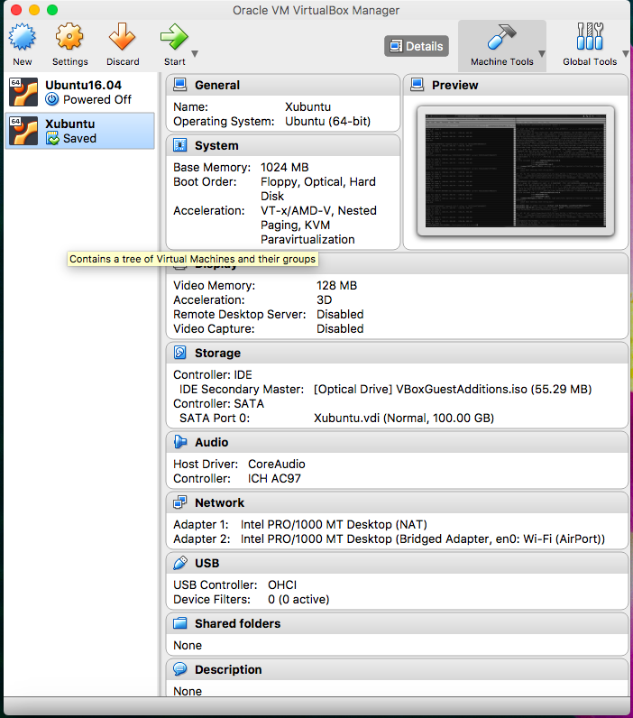

Select New, then you should see this screen:

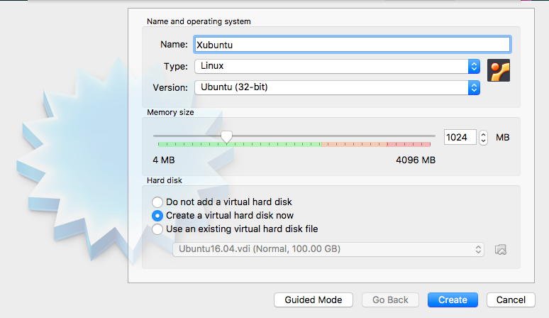

Select all the options as above, and press Create.

This screen will show you how to create the virtual disk image. Select the options below, as well as selecting the directory in which to save the virtual disk (using the folder icon).

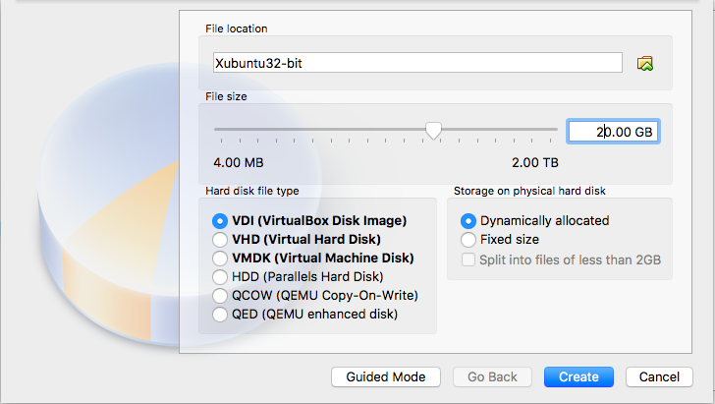

Once the device is created, you will be directed back to the main screen. Select the Setting icon, and navigate to the Storage tab. Click on the CD drive (Empty). Click on the small CD drive icon next to “IDE Secondary Master” on the right hand side.

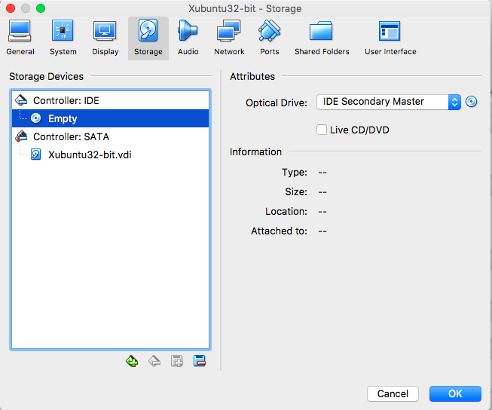

Select Choose Virtual Optical Disk File from the drop down menu.

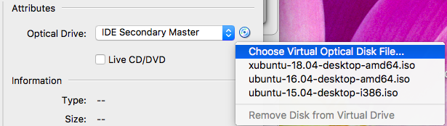

This will open a file select window. Select the .ISO file that you wish to install. Click Open.

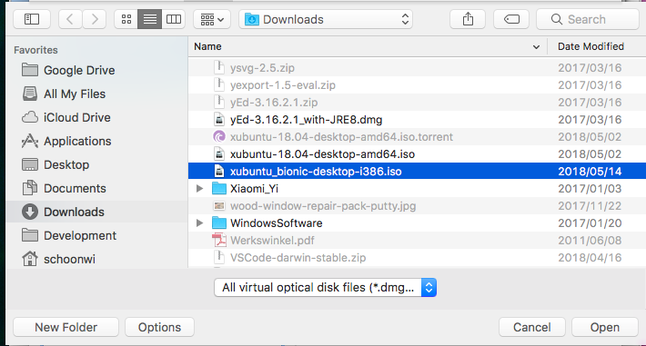

After you have completed setting up the CD drive, select the Display tab. Set all the values as shown in this picture below. Press OK.

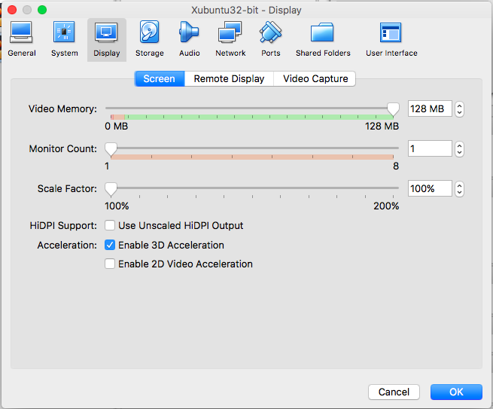

Finally, go to the Network tab. Enable “Adapter 2” and set it up as follow. The “Name” variable will probably be different on your PC, select the one that refers to your wireless networking card.

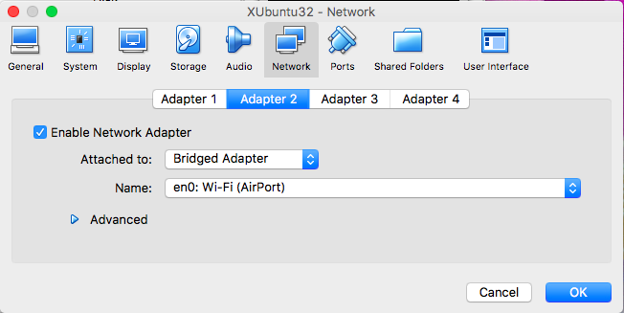

On the main screen, select the green arrow to start the virtual machine.

Once the virtual machine has booted up, you should see the following install screen for XUbuntu. Select Install XUbuntu.

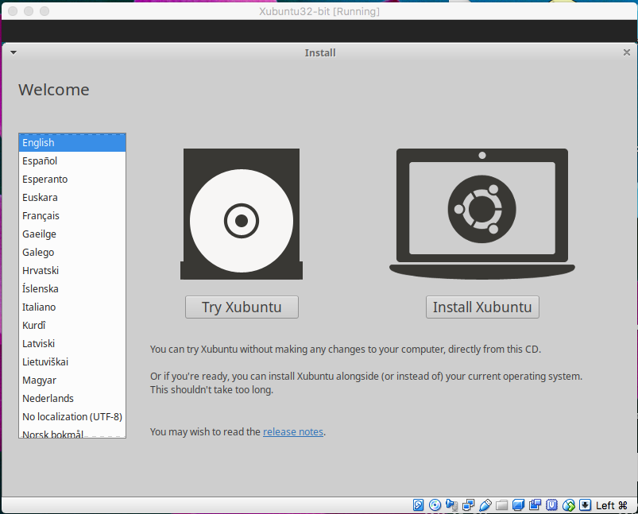

Follow all the prompts. On this next page uncheck “Download updates while installing Xubuntu” to save time during installation.

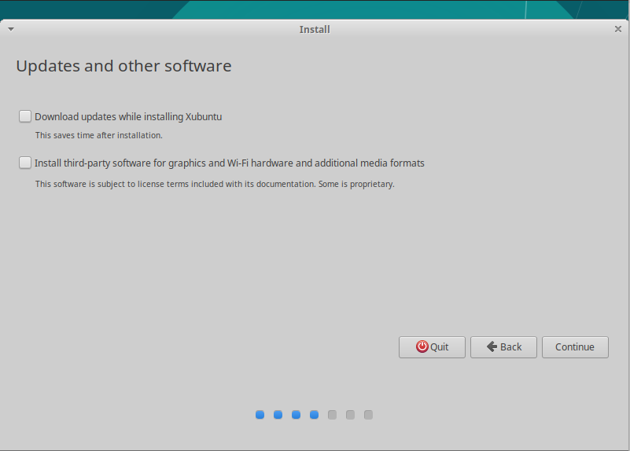

When you see the screen below, do not change anything. Select

“Install Now”.

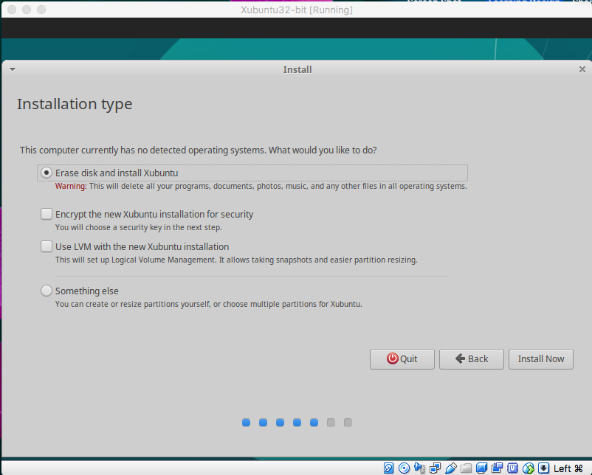

The following warning will be displayed. You do not need to be worried: all of these changes will remain inside the virtual machine itself and will not affect your host OS in any way. Select “Continue”.

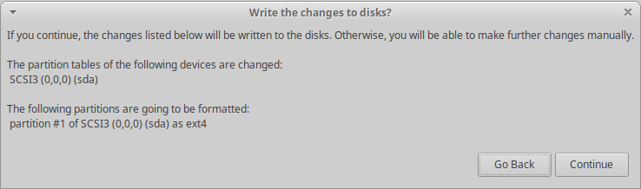

Create your own username and password. Select “Log in automatically” for ease of use.

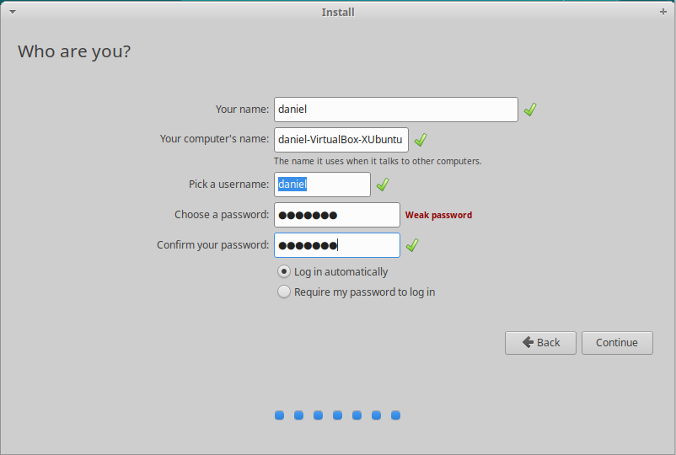

After the installation is complete (around 20 – 30 mins), you should see this screen. Select “Restart Now”. Your virtual machine will restart and boot into XUbuntu for the first time.

