

Description of 2A12 Message

PIP® 2A12
Validated 11.00.00

Specification Information
Name | Description of 2A12 Message
PIP | Distribute Product Master
Cluster | Product Information
Segment | Preparation For Distribution
Publication Date | 07 July 2008
Version Identifier | V11.00

Table of Content

1. Document Management 6
1.1 Legal Disclaimer 6
1.2 Copyright 6
1.3 Trademarks 6
1.4 Acknowledgments 6
1.5 Related Documents 6
1.6 Document Version History 7
1.7 Document Purpose 7
2. Interchange Model 8
2.1 ProductMasterDistribution 8
2.1.1 Interchange Diagram 8
2.1.2 Dependency Diagram 9
2.1.3 ChangeOrderWindow 9
2.1.4 OrderProvision 10
2.1.5 ProductAttribute 10
2.1.6 ProductLifeCycle 11
2.1.7 ProductMaster 12
2.1.8 ProductMasterDistribution 12
2.1.9 ProductMasterLineItem 13
2.1.10 ProductProcurement 14
3. Domain Model 16
3.1 Procurement 16
3.1.1 Procurement 16
3.1.1.1 Dependency Diagram 16
3.1.1.2 IsCallFactory 16
3.1.1.3 LeadTimeQuantity 17
3.1.1.4 ProductDistribution 17
3.1.1.5 ProductLeadTime 18
3.1.1.6 ProductQuantityRange 19
3.1.2 CodeList 19
3.1.2.1 LeadTimeClassificationCode 19
3.1.2.2 ProductProcurementType 20
3.2 Design 22
3.2.1 Design 22
3.2.1.1 Dependency Diagram 22
3.2.1.2 LifeCycleStatus 22
3.2.2 CodeList 23
3.2.2.1 ABCCode 23
3.2.2.2 ProductLifeCycleStatusCode 23
3.2.2.3 AssemblyLevelCode 24
3.3 Shared 25
3.3.1 Shared 25
3.3.1.1 Dependency Diagram 25
3.3.1.2 ManufacturedDate 25
3.3.1.3 ProductQuantity 26
3.3.2 CodeList 26
3.3.2.1 ProductStatusCode 26
3.3.2.2 Interval 26
4. Universal Structure 28
4.1 ContactInformation 28
4.1.1 ContactInformation 28
4.2 DataType 29
4.2.1 Contact 29
4.2.2 DUNS 29
4.2.3 DUNSPlus4 30
4.2.4 GLN 30
4.2.5 GTIN 31
4.2.6 PercentAmount 31
4.3 Dates 32
4.3.1 DatePeriod 32
4.4 Locations 32
4.4.1 AlternativeIdentifier 32
4.5 PartnerIdentification 33
4.5.1 KnownPartner 33
4.5.2 KnownPartnerContact 33
4.5.3 PartnerIdentification 34
4.5.4 PartnerIdentificationChoice 35
4.5.5 SpecifiedKnownPartner 35
4.6 ProductIdentification 36
4.6.1 ProductDescription 36
4.6.2 ProductIdentification 37
4.6.3 ProductIdentificationChoice 37
4.6.4 TextualDescription 38
4.7 CodeList 38
4.7.1 Language 38
4.7.2 MimeTypeQualifier 38
4.7.3 UnitOfMeasure 49
4.7.4 ProcessRoleIdentifier 56
5. System Structure 60
5.1 BusinessProcessIdentifier 60
5.2 BusinessServiceInformation 60
5.3 ContractInformation 61
5.4 CorrelationInformation 61
5.5 DocumentHeader 62
5.6 DocumentIdentification 63
5.7 DocumentIdentificationChoice 63
5.8 DocumentInformation 64
5.9 DocumentManifest 64
5.10 DocumentSecurity 65
5.11 ManifestItem 66
5.12 PipIdentifier 67
5.13 PipVersion 67
5.14 Receiver 68
5.15 RequestingDocumentInformation 69
5.16 Sender 69
5.17 StandardDocumentIdentification 70
5.18 TpirPipIdentification 70
5.19 VersionIdentifier 71
5.20 CodeList 72
5.20.1 TPIRFileType 72
6. XML Data Type 73
6.1 anyURI 73
6.2 boolean 73
6.3 date 73
6.4 dateTime 73
6.5 decimal 73
6.6 duration 73
6.7 float 73
6.8 positiveInteger 74
6.9 string 74

Table of Figures

Figure 2-1 Interchange 8
Figure 2-2 Dependency 9
Figure 2-3 ChangeOrderWindow 9
Figure 2-4 OrderProvision 10
Figure 2-5 ProductAttribute 10
Figure 2-6 ProductLifeCycle 11
Figure 2-7 ProductMaster 12
Figure 2-8 ProductMasterDistribution 12
Figure 2-9 ProductMasterLineItem 13
Figure 2-10 ProductProcurement 14
Figure 3-1 Dependency 16
Figure 3-2 IsCallFactory 16
Figure 3-3 LeadTimeQuantity 17
Figure 3-4 ProductDistribution 17
Figure 3-5 ProductLeadTime 18
Figure 3-6 ProductQuantityRange 19
Figure 3-7 Dependency 22
Figure 3-8 LifeCycleStatus 22
Figure 3-9 Dependency 25
Figure 3-10 ManufacturedDate 25
Figure 3-11 ProductQuantity 26
Figure 4-1 ContactInformation 28
Figure 4-2 Contact 29
Figure 4-3 DUNS 29
Figure 4-4 DUNSPlus4 30
Figure 4-5 GLN 30
Figure 4-6 GTIN 31
Figure 4-7 PercentAmount 31
Figure 4-8 DatePeriod 32
Figure 4-9 AlternativeIdentifier 32
Figure 4-10 KnownPartner 33
Figure 4-11 KnownPartnerContact 33
Figure 4-12 PartnerIdentification 34
Figure 4-13 SpecifiedKnownPartner 35
Figure 4-14 ProductDescription 36
Figure 4-15 ProductIdentification 37
Figure 4-16 TextualDescription 38
Figure 5-1 BusinessProcessIdentifier 60
Figure 5-2 BusinessServiceInformation 60
Figure 5-3 ContractInformation 61
Figure 5-4 CorrelationInformation 61
Figure 5-5 DocumentHeader 62
Figure 5-6 DocumentIdentification 63
Figure 5-7 DocumentInformation 64
Figure 5-8 DocumentManifest 64
Figure 5-9 DocumentSecurity 65
Figure 5-10 ManifestItem 66
Figure 5-11 PipIdentifier 67
Figure 5-12 PipVersion 67
Figure 5-13 Receiver 68
Figure 5-14 RequestingDocumentInformation 69
Figure 5-15 Sender 69
Figure 5-16 StandardDocumentIdentification 70
Figure 5-17 TpirPipIdentification 70
Figure 5-18 VersionIdentifier 71

Document Management

Legal Disclaimer
RosettaNet, its members, officers, directors, employees, or agents shall not be liable for any injury, loss, damages, financial or otherwise, arising from, related to, or caused by the use of this document or the specifications herein, as well as associated guidelines and schemas. The use of said specifications shall constitute your express consent to the foregoing exculpation.

Copyright
©2008 RosettaNet. All rights reserved. No part of this publication may be reproduced, stored in a retrieval system, or transmitted, in any form or by any means, electronic, mechanical, photocopying, recording, or otherwise, without the inclusion of this copyright notice. Any derivative works must cite the copyright notice. Any public redistribution or sale of this publication or derivative works requires prior written permission of the publisher.

Trademarks
RosettaNet, Partner Interface Process, PIP and the RosettaNet logo are trademarks or registered trademarks of "RosettaNet," a non-profit organization. All other product names and company logos mentioned herein are the trademarks of their respective owners. In the best effort, all terms mentioned in this document that are known to be trademarks or registered trademarks have been appropriately recognized in the first occurrence of the term.

Acknowledgments
This document has been prepared by RosettaNet (http://www.rosettanet.org/) from requirements gathered during the Milestone Program and in conformance with the methodology.

Related Documents
- Associated PIP Message Schemas (included with PIP Specification only)
- Description of Partner Interface Process for 2A12
- Message Structure

Document Version History
Version | Date | Description
Validated 11.00.00 | 07 July 2008 | Validated Version: RosettaNet Schema to Market to Validation 2008

Document Purpose
The purpose of the document is to explain the structure, the association between objects, the content of objects and the definition for single elements to a non-technical audience.

Interchange Model

ProductMasterDistribution

Interchange Diagram
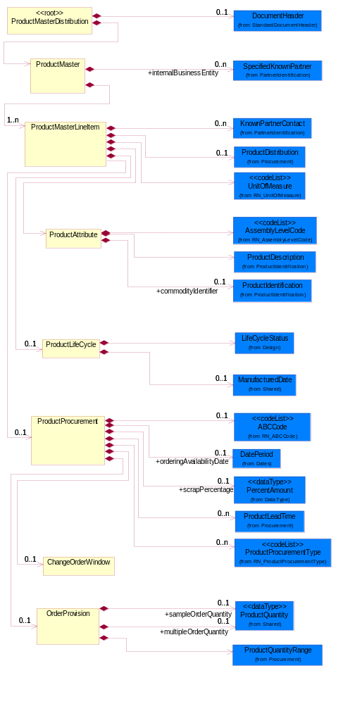
Figure 2-1 Interchange

Dependency Diagram
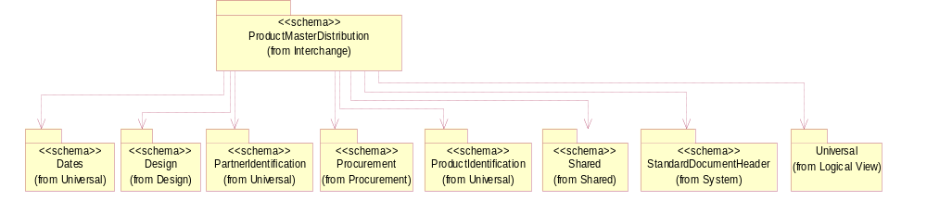
Figure 2-2 Dependency

ChangeOrderWindow
The collection of business properties that describes time constraints for canceling or changing an order once it has been placed.
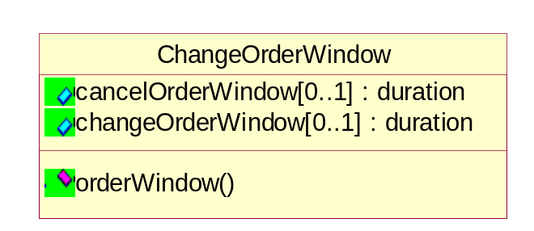
Figure 2-3 ChangeOrderWindow

Attribute | Type | Documentation
cancelOrderWindow[0..1] | duration | The number of days before the seller's confirmed scheduled ship date that the product buyer can no longer cancel the order.
changeOrderWindow[0..1] | duration | The number of days before the seller's confirmed scheduled ship date that the product buyer can no longer change the order.

Constraint | Documentation
orderWindow | At least one occurrence of "cancelOrderWindow" or "changeOrderWindow" is required.

OrderProvision
The collection of business properties that describe various types of product quantity used in an ordering process.
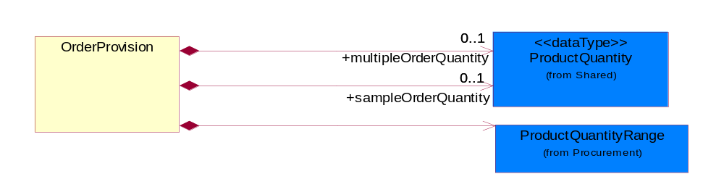
Figure 2-4 OrderProvision

Composition | Cardinality | Type | Documentation
multipleOrderQuantity | 0..1 | ProductQuantity | The ordering multiple for this part.
sampleOrderQuantity | 0..1 | ProductQuantity | The maximum ordering quantity for samples of this part.
ProductQuantityRange | 1 | ProductQuantityRange | The collection of business properties that describe an upper and lower range of product quantity.

ProductAttribute
The collection of business properties that describes attributes of the product.
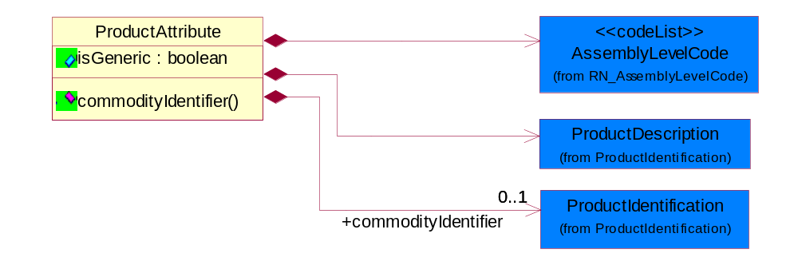
Figure 2-5 ProductAttribute

Attribute | Type | Documentation
isGeneric | boolean | To identify the subsequent product reporting as a product family (generic) reporting.

Composition | Cardinality | Type | Documentation
AssemblyLevelCode | 1 | AssemblyLevelCode | States that describe the level of assembly.
ProductDescription | 1 | ProductDescription | The business document must allow for the identification of the product and multiple textual descriptions of a product.
commodityIdentifier | 0..1 | ProductIdentification | An identifier used to assign a commodity code to a part.

Constraint | Documentation
commodityIdentifier | If occurrence of "commodityIdentifier" is between '1' and '1' then the occurrence of "commodityIdentifier/AlternativeIdentifier" MUST be between '1' and 'unbounded'.

ProductLifeCycle
The collection of business properties that describes lifecycle information about the product.
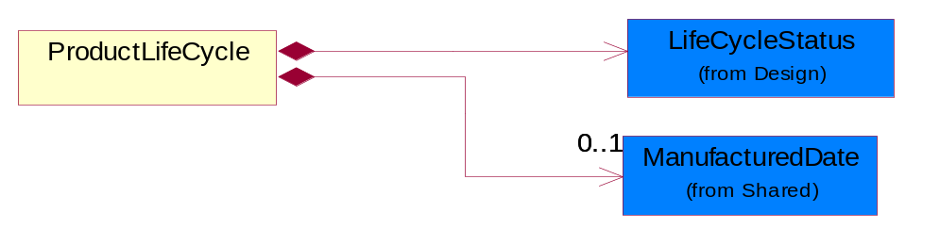
Figure 2-6 ProductLifeCycle

Composition | Cardinality | Type | Documentation
LifeCycleStatus | 1 | LifeCycleStatus | An indication of a product's state at a point in time in the entire existence of a product from concept to the point where the product no longer exists for any business purposes.
ManufacturedDate | 0..1 | ManufacturedDate | The date the product was manufactured.

ProductMaster
The collection of business properties that describes product master requirements information.
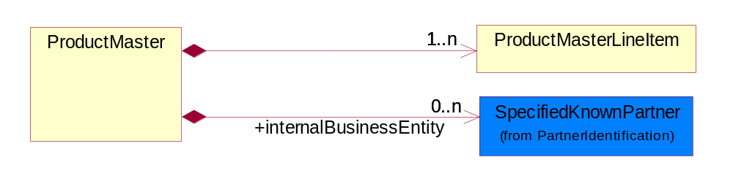
Figure 2-7 ProductMaster

Composition | Cardinality | Type | Documentation
ProductMasterLineItem | 1..n | ProductMasterLineItem | The collection of business properties that describes product master requirements information for an individual product.
internalBusinessEntity | 0..n | SpecifiedKnownPartner | Identifies proprietary divisions, planning units, organizations, warehouses, or any other grouping that would cause different contacts or different planning and procurement information. Used to distinguish between multiple divisions.

ProductMasterDistribution
The root element for PIP2A12.
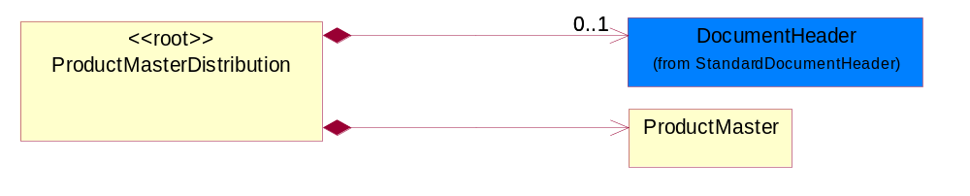
Figure 2-8 ProductMasterDistribution

Composition | Cardinality | Type | Documentation
DocumentHeader | 0..1 | DocumentHeader | The object allows for the identification of the sender and receiver of the business document.
ProductMaster | 1 | ProductMaster | The collection of business properties that describes product master requirements information.

ProductMasterLineItem
The collection of business properties that describes product master requirements information for an individual product.
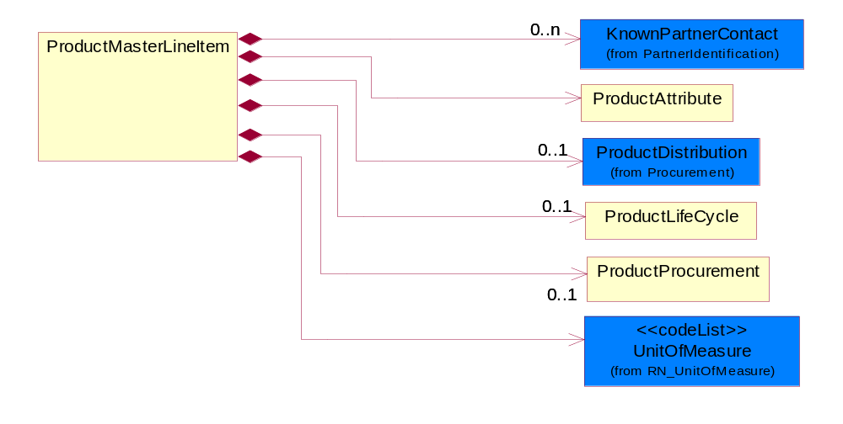
Figure 2-9 ProductMasterLineItem

Composition | Cardinality | Type | Documentation
KnownPartnerContact | 0..n | KnownPartnerContact | The business document must describe the trading partners in the business transaction.
ProductAttribute | 1 | ProductAttribute | The collection of business properties that describes attributes of the product.
ProductDistribution | 0..1 | ProductDistribution | The collection of business properties that describes distribution information about the product.
ProductLifeCycle | 0..1 | ProductLifeCycle | The collection of business properties that describes lifecycle information about the product.
UnitOfMeasure | 1 | UnitOfMeasure | Code identifying a product unit of measure.

ProductProcurement
The collection of business properties that describes procurement information about the product.
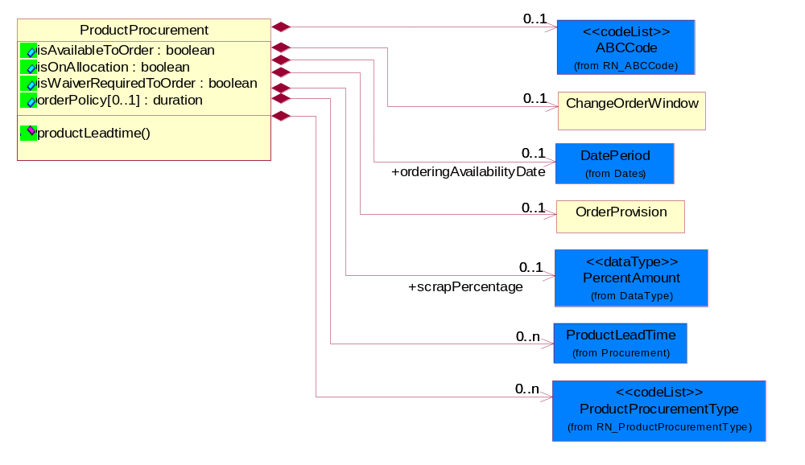
Figure 2-10 ProductProcurement

Attribute | Type | Documentation
isAvailableToOrder | boolean | Indicates whether the product is available to order.
isOnAllocation | boolean | Indicates whether the product is on allocation.
isWaiverRequiredToOrder | boolean | Indicates whether a waiver is required to order the product.
orderPolicy[0..1] | duration | Number of consecutive calendar days of product demand that is added together to determine the quantity to order or to assemble. If product is purchased or assembled in discrete lots, this value will be zero.

Composition | Cardinality | Type | Documentation
ABCCode | 0..1 | ABCCode | Code identifying manufacturing process classifications for inventory used to communicate inventory importance to a company based upon cost and usage.
ChangeOrderWindow | 0..1 | ChangeOrderWindow | The collection of business properties that describes time constraints for canceling or changing an order once it has been placed.
orderingAvailabilityDate | 0..1 | DatePeriod | The date the product is available for ordering by a partner role.
OrderProvision | 0..1 | OrderProvision | The collection of business properties that describe various types of product quantity used in an ordering process.
scrapPercentage | 0..1 | PercentAmount | The expected loss from a lot, batch or run, expressed as percentage. This is the inverse of the expected yield from a lot, batch or run.
ProductLeadTime | 0..n | ProductLeadTime | The collection of business properties that describe lead time information about the product.
ProductProcurementType | 0..n | ProductProcurementType | States that describe product procurement conditions.

Constraint | Documentation
productLeadtime | If the value of "isOnAllocation" is equal to 'false' then the occurrence of "ProductLeadTime" MUST be between '1' and 'unbounded'.

Domain Model

Procurement

Procurement

Dependency Diagram
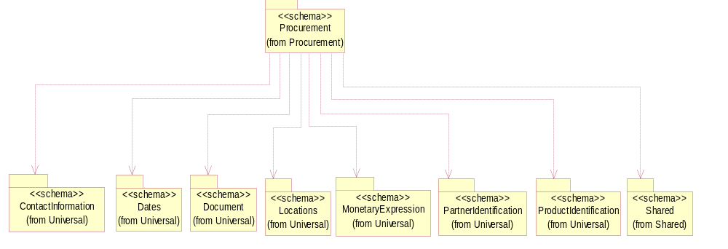
Figure 3-11 Dependency

IsCallFactory
An indicator for the receiver to call the manufacturer to obtain current information.
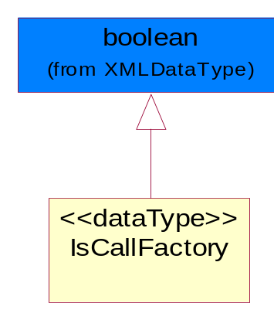
Figure 3-12 IsCallFactory

LeadTimeQuantity
The collection of business propeties that describe manufacturing lead time quantity from the time of order placement to the time the product ships.
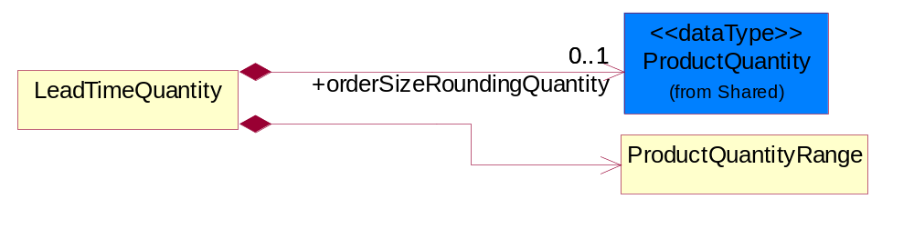
Figure 3-13 LeadTimeQuantity

Composition | Cardinality | Type | Documentation
orderSizeRoundingQuantity | 0..1 | ProductQuantity | The quantity of products which is a standard ordering unit. Actual order quantities must be multiples of this quantity and is equal to or smaller than the minimum.
ProductQuantityRange | 1 | ProductQuantityRange | The collection of business properties that describe an upper and lower range of product quantity.

ProductDistribution
The collection of business properties that describes distribution information about the product.
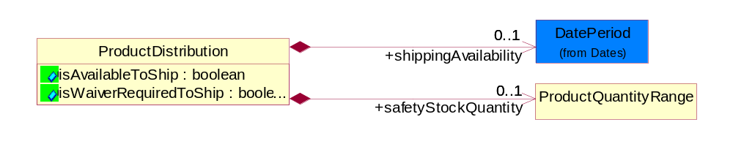
Figure 3-14 ProductDistribution

Attribute | Type | Documentation
isAvailableToShip | boolean | Indicates whether the product is available to ship.
isWaiverRequiredToShip | boolean | Indicates whether a waiver is required to ship the product.

Composition | Cardinality | Type | Documentation
shippingAvailability | 0..1 | DatePeriod | This object represents the first and last dates the product can be shipped.
safetyStockQuantity | 0..1 | ProductQuantityRange | The quantity of the safety stock.

ProductLeadTime
The collection of business properties that describe lead time information about the product.
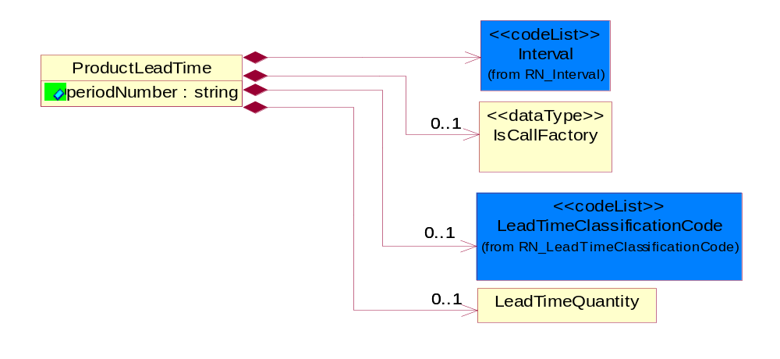
Figure 3-15 ProductLeadTime

Attribute | Type | Documentation
periodNumber | string | The number of measurable units in a date/time period.

Composition | Cardinality | Type | Documentation
Interval | 1 | Interval | Code specifying a forecasting interval.
IsCallFactory | 0..1 | IsCallFactory | An indicator for the receiver to call the manufacturer to obtain current information.
LeadTimeClassificationCode | 0..1 | LeadTimeClassificationCode | Code identifying the classification of a product lead time for ordering.
LeadTimeQuantity | 0..1 | LeadTimeQuantity | The collection of business propeties that describe manufacturing lead time quantity from the time of order placement to the time the product ships.

ProductQuantityRange
The collection of business properties that describe an upper and lower range of product quantity.
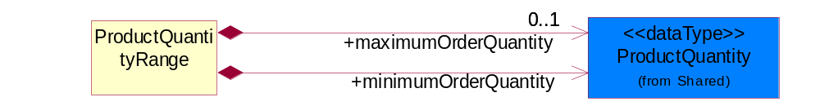
Figure 3-16 ProductQuantityRange

Composition | Cardinality | Type | Documentation
maximumOrderQuantity | 0..1 | ProductQuantity | A numeric expression of the maximum number of product line items that may be ordered.
minimumOrderQuantity | 1 | ProductQuantity | A numeric expression of the minimum number of product line items that may be ordered.

CodeList

LeadTimeClassificationCode
Code identifying the classification of a product lead time for ordering.

Name | Documentation
ASA | As Available - A product marked as "As Available" orders for this product but supply is quite uncertain-normally this has been used when a product is being WDFM (withdraw from marketing) or has reached end of life (EOL).
ASS | Assembly - Time period required by a company production line to manufacture a component or module from sub components. This lead-time may include actual manufacturing cycle time, testing time, and queuing time.
CLF | Call Factory - Contact the factory for the most current information.
DTS | Dock to Stock - Time period required to move product from a product seller's or product receiver's dock through a warehousing process until the product is documented as available for buyer's use. If the seller's dock is identified, this lead-time also includes carrier transit time between seller's dock to buyer's dock.
EOL | End of Life.
INS | Individual Scheduled-a product marked as "Individual Scheduled" by the manufacturing facility. When doing this they will take into consideration the current supply situation / extended leadtime as well as capacity situation for the current product.
MAR | Market - Time period quoted by a seller for the availability of product. This lead time includes actual manufacturing cycle time and existing.
NOS | No Supply - A product marked "No Supply" and will not be able to fulfill orders for this product.
ODP | Order Processing - Time period required by a seller to receive a purchase order and respond with a confirmation to the buyer.
PLA | Planned Availability - A product marked as "Planned Availability" yet available on the market but has been announced with a certain date. Once this date has been passed the product will get a "normal" leadtime.
PRC | Procurement - Time period required by a buyer to process a quote or internal demand signal to issue a purchase order.
PRD | Production.
SUP | Start Up.
TRN | Transit - Time period required to move a product from one location to another.

ProductProcurementType
States that describe product procurement conditions.

Name | Documentation
AAP | Product is eligible to be ordered as part of Authorized Assembly Program.
ALC | Allocation.
BLK | Bulk.
CQS | Custom QS is the availability of expedited shipping for certain models or configurations (but not all) of the product specified.
CSU | Product is eligible for customer set up.
DPA | Distributor Price Adjustment - Used to indicate that the distributor price is negotiable.
JIT | Just in Time.
LBD | Limited Book Device - Engineering devices that have not reached final revision, or sample products.
NAP | Not Applicable.
NCN | Non-Cancelable, Non-returnable.
NPB | Non Published Book device - Products available for sale but not published in General Price Book.
NPI | New Product Introduction - Products that are new to the market.
NSB | Non Stockable Book devices - Software products or other products containing software that will under go revision changes. (software, boards, evaluation tools).
ONC | On Contract - Used to indicate that the product is attached to the purchase agreement.
QUS | Quickship - QuickShip is the availability of expedited shipping for the product specified.
REP | Replenishment - Product is eligible to be ordered for inventory replenishment agreements.
SBD | Standard Book Device - Standard products available for sale.
SEG | Segmented - Used to identify products that are under planned procurement processes.
SPS | Supply Split.
SUB | Sub contract.
VMI | Vendor Management Inventory.

Design

Design

Dependency Diagram
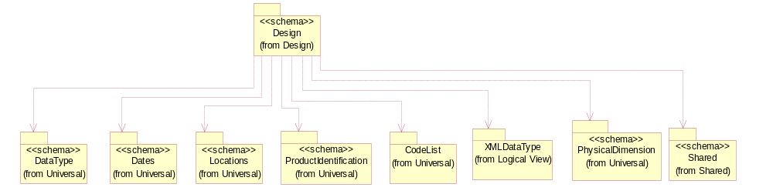
Figure 3-17 Dependency

LifeCycleStatus
An indication of a product's state at a point in time in the entire existence of a product from concept to the point where the product no longer exists for any business purposes.
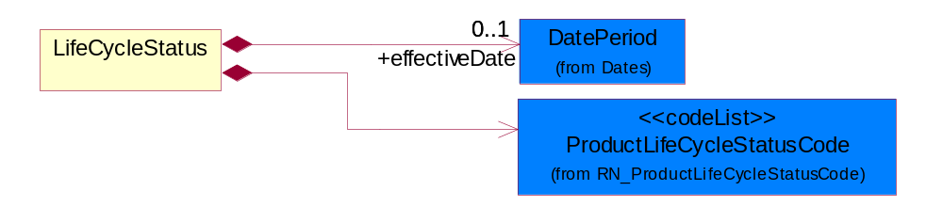
Figure 3-18 LifeCycleStatus

Composition | Cardinality | Type | Documentation
effectiveDate | 0..1 | DatePeriod | The date information or an activity becomes effective, i.e. product design released date after design approval and prototyping.
ProductLifeCycleStatusCode | 1 | ProductLifeCycleStatusCode | States that describe the product lifecycle.

CodeList

ABCCode
Code identifying manufacturing process classifications for inventory used to communicate inventory importance to a company based upon cost and usage.

Name | Documentation
CDA | Highest importance.
CDB | Medium importance.
CDC | Lowest importance.

ProductLifeCycleStatusCode
States that describe the product lifecycle.

Name | Documentation
ACT | Active.
ALO | The quantity available to buyer.
BOR | Back Ordered.
DCN | Discontinued. No longer available.
DCN | Discontinued - No longer available.
EOL | End of Life - period or date where the product obsolescence begins, ship or order still active.
LOD | Product Phase Out/See Last Order Date. Limitations on shipments can occur, but orders are pressed toward final and last buy. Product should not be considered for new designs. Capacity declining rapidly. Formal discontinuance notice may be issued.
NPR | New Product.
NPR | New product.
NRC | Not Recommended/Declining. Orders and shipments permitted. Product not recommended for new designs.Capacity beginning to decline.
OBS | Obsolete no longer orderable or shippable.
OHL | On Hold - Orderable, but not shippable.
PEN | Product Introduction Pending No orders or product shipments permitted. Product is in planning or early design stage. Samples may or may not exist. Specification changes can occur and planned introduction dates may be delayed.
PLS | Product Last Shipments. Shipments made to existing orders. Manufacturing capacity limitations may exist. New orders are limited to existing or residual inventory. Product in final stage of shipments after a formal Life Time Buy notice or product cancellation.
PMA | Product Maturity/Saturation. Orders and shipments permitted. Sales and capacity have leveled out.
POS | Purchase order with supplier.
POS | Purchase Order with Supplier.
REP | Replaced.
REP | Replaced.
RGW | Product Rapid Growth. Orders and shipments permitted. Product in rapid growth phase. Manufacturing capacity is being added.
RMP | Product Newly Introduced/Ramp-Up. Orders and shipments permitted. Beginning to ramp up production. Can supply limited quantities.
RPO | Removed From Active Portfolio. No new orders, no shipments, and no inventory exist. Product is considered no longer available. Inventory is removed. All supporting hardware, software, and documentation for the product are removed.
SGM | Product Stable Growth/Maturity. Orders and shipments permitted. Product is highly recommended for use in new designs. Product growth stabilizes and peaks. Product quality is very high.
UAV | Unavailable through program - May not use.
UNR | Unreleased - Upcoming product, not orderable.

AssemblyLevelCode
States that describe the level of assembly.

Name | Documentation
COM | Component.
PHA | Phantom. A product that is not currently stocked, assembled or purchased, but does have a Bill of Materials (BOM).
SAS | Sub Assembly.
TLA | Top Level Assembly.

Shared

Shared

Dependency Diagram
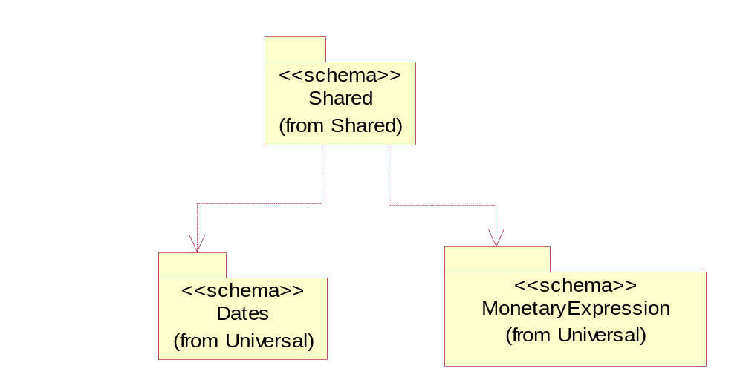
Figure 3-19 Dependency

ManufacturedDate
The date the product was manufactured.
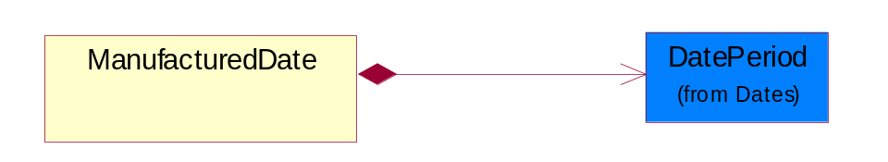
Figure 3-20 ManufacturedDate

Composition | Cardinality | Type | Documentation
DatePeriod | 1 | DatePeriod | The business document must allow for the computation or statement of a duration based upon a beginning and an ending date.

ProductQuantity
A quantity specifying the number of product units.
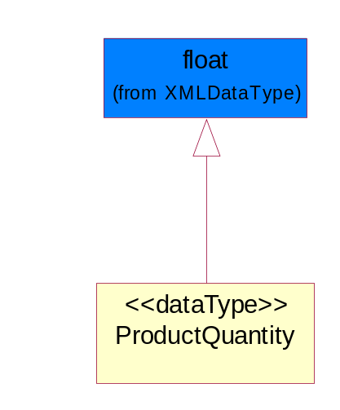
Figure 3-21 ProductQuantity

CodeList

ProductStatusCode
Code specifying the production status of an item.

Name | Documentation
ACT | Active.
ALO | The quantity available to buyer.
BOR | Back Ordered.
DCN | Discontinued. No longer available.
NPR | New Product.
POS | Purchase Order with Supplier.
REP | Replaced.

Interval
Code specifying a forecasting interval.

Name | Documentation
1WM | 1st week of the month.
2WM | 2nd week of the month.
3WM | 3rd week of the month.
4WM | 4th week of the month.
5DW | 5 day work week-Monday through Friday.
5WM | 5th week of the month.
CAD | Calendar day-period given as a number of days including weekends and holidays.
CAW | Calendar week-period given as a number of 7 day-weeks including holidays.
DAY | Day.
FMP | Four month period.
FRI | Friday.
HFM | Half month.
HFW | Half week.
HFY | Half year.
HOU | Hour.
IND | Indefinite-an indefinite period.
MIN | Minute.
MOD | Monday.
MON | Month.
MTF | Monday through Friday.
MTS | Monday through Saturday.
MTU | Monday through Sunday.
QUA | Quarter.
SAT | Saturday.
SUN | Sunday.
TDP | Ten days period-period of 10 days.
THU | Thursday.
TMP | Two month period.
TUE | Tuesday.
TWP | Two week period.
UNS | Unspecified.
WDY | Work day.
WED | Wednesday.
WEE | Week.
WOR | Working days - days when the partner company normally works.
YEA | Year.

Universal Structure

ContactInformation

ContactInformation
The business document must allow for the identification of the name of the department, service or individual to be contacted regarding the context of the business document.
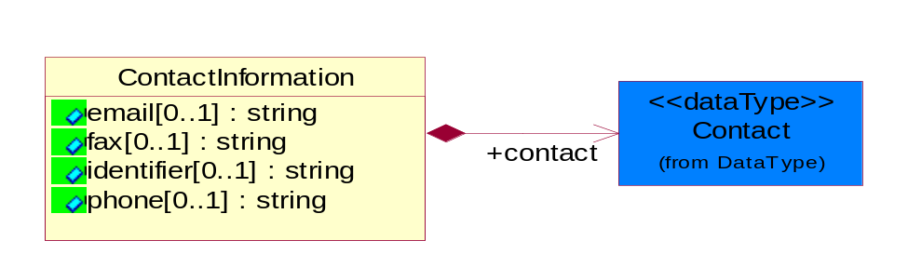
Figure 4-22 ContactInformation

Attribute | Type | Documentation
email[0..1] | string | The electronic mail for the specified contact.
fax[0..1] | string | The fax number for the specified contact.
identifier[0..1] | string | Identifies the role of the contact (i.e. Service Technician, Account Manager) in the Business Process.
phone[0..1] | string | The telephone number for the specified contact.

Composition | Cardinality | Type | Documentation
contact | 1 | Contact | The name of the department, service or individual to be contacted within the organization.

DataType

Contact
The name of the department, service or individual to be contacted within the organization.
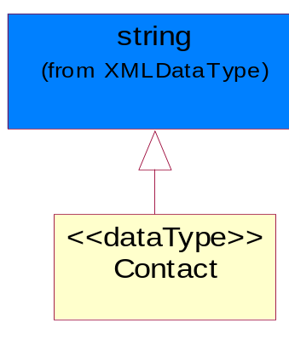
Figure 4-23 Contact

DUNS
A number assigned by Dun and Bradstreet to identify a business location.
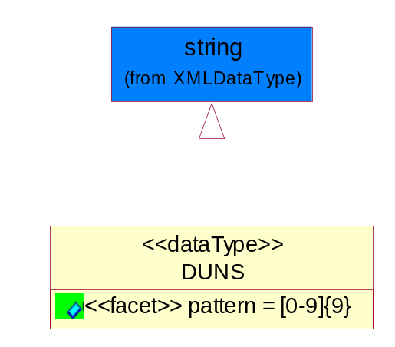
Figure 4-24 DUNS

Attribute | Type | Documentation
pattern |  | [0-9]{9}

DUNSPlus4
A identifier to specify a specific location within a business location.
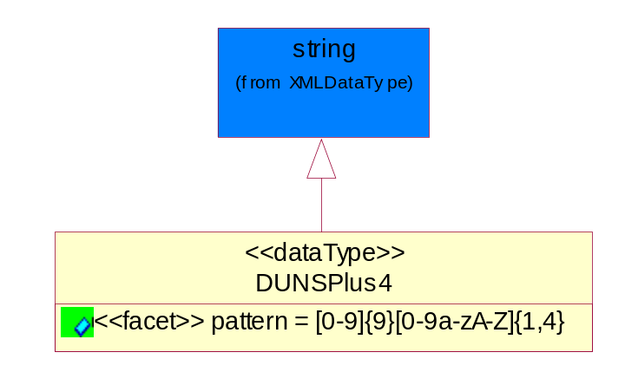
Figure 4-25 DUNSPlus4

Attribute | Type | Documentation
Pattern |  | Data Universal Numbering System +4 (DUNS+4) number means the DUNS number assigned by Dun and Bradstreet, Inc. (D&B) plus an alphanumeric of length 4 suffix that may be assigned by a business concern.

GLN
Global Location Number (GLN) - A identifier to identify legal entities, trading parties and location.
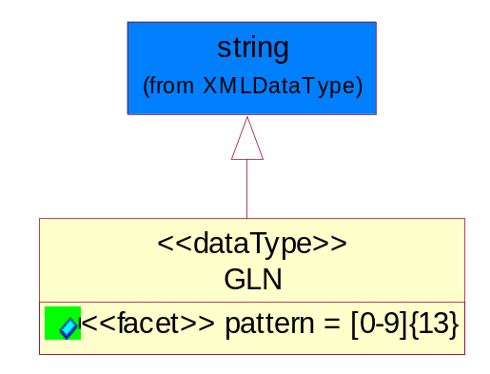
Figure 4-26 GLN

Attribute | Type | Documentation
Pattern |  | [0-9]{13}

GTIN
Global Trade Identification Number (GTIN).
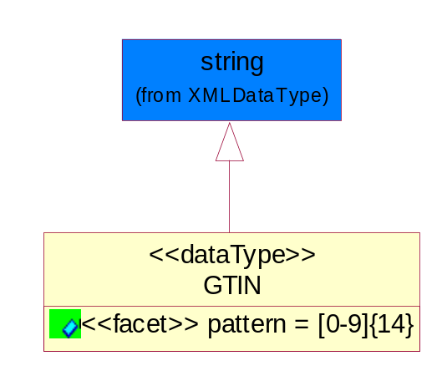
Figure 4-27 GTIN

Attribute | Type | Documentation
Pattern |  | [0-9]{14}

PercentAmount
A number representing a percentage value, e.g. 75.125 represents 75 1/8 percent.
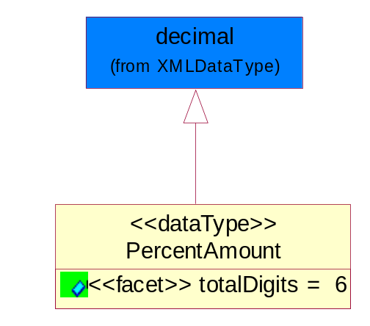
Figure 4-28 PercentAmount

Attribute | Type | Documentation
totalDigits |  | 6

Dates

DatePeriod
The business document must allow for the computation or statement of a duration based upon a beginning and an ending date.

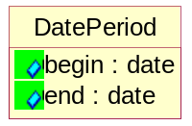
Figure 4-29 DatePeriod

Attribute | Type | Documentation
begin | date | The date indicating the beginning of the date period.
end | date | The date indicating the ending of the date period.

Locations

AlternativeIdentifier
Identifies the specified code and the name of the organization that a code is utilized from.
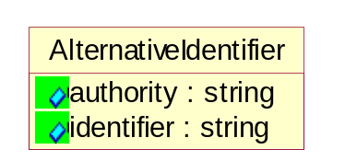
Figure 4-30 AlternativeIdentifier

Attribute | Type | Documentation
authority | string | The name of the organization that a code is utilized from.
identifier | string | The specified code to represent an entity (e.g. product, location, partner, etc.).

PartnerIdentification

KnownPartner
The business document must describe the trading partners in the business transaction.
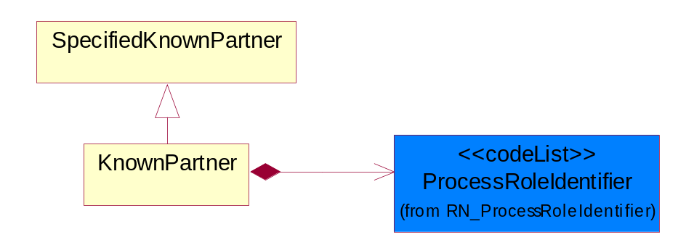
Figure 4-31 KnownPartner

Composition | Cardinality | Type | Documentation
ProcessRoleIdentifier | 1 | ProcessRoleIdentifier | Describes the role of the partner in the business process. A partner will fulfill at least one or more roles during the business process.

KnownPartnerContact
The business document must describe the trading partners in the business transaction.
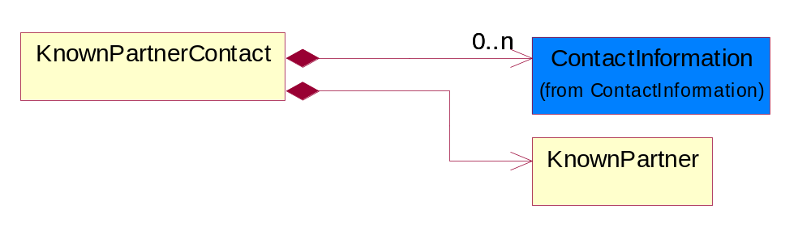
Figure 4-32 KnownPartnerContact

Composition | Cardinality | Type | Documentation
ContactInformation | 0..n | ContactInformation | The business document must allow for the identification of the name of the department, service or individual to be contacted regarding the context of the business document.
KnownPartner | 1 | KnownPartner | The business document must describe the trading partners in the business transaction.

PartnerIdentification
The business document must allow for the identity of one or more parties to the transaction.
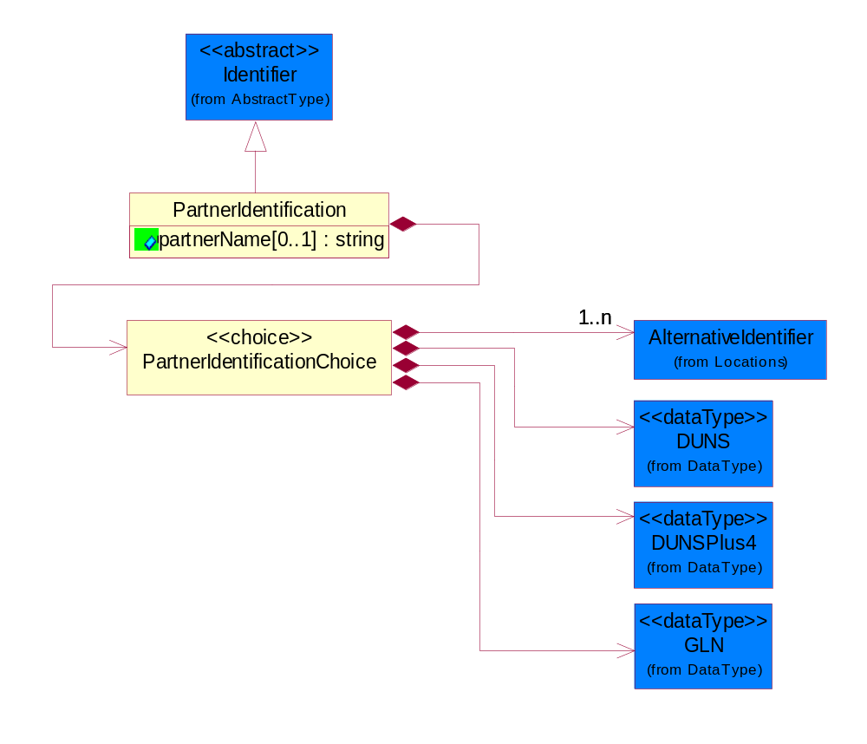
Figure 4-33 PartnerIdentification

Attribute | Type | Documentation
partnerName[0..1] | string | The name of the partner’s company/business.

Composition | Cardinality | Type | Documentation
PartnerIdentificationChoice | 1 | PartnerIdentificationChoice

PartnerIdentificationChoice

Composition | Cardinality | Type | Documentation
AlternativeIdentifier | 1..n | AlternativeIdentifier | Identifies the specified code and the name of the organization that a code is utilized from.
DUNS | 1 | DUNS | A number assigned by Dun and Bradstreet to identify a business location.
DUNSPlus4 | 1 | DUNSPlus4 | A identifier to specify a specific location within a business location.
GLN | 1 | GLN | Global Location Number (GLN) - A identifier to identify legal entities, trading parties and location.

SpecifiedKnownPartner
The business document must describe the trading partners in the business transaction.
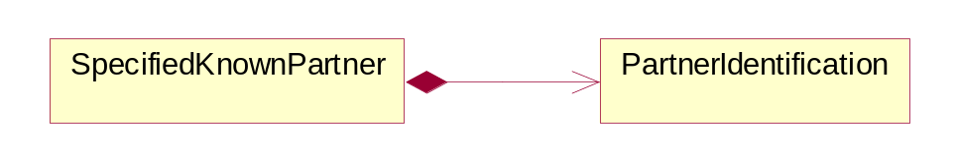
Figure 4-34 SpecifiedKnownPartner

Composition | Cardinality | Type | Documentation
PartnerIdentification | 1 | PartnerIdentification | The business document must allow for the identity of one or more parties to the transaction.

ProductIdentification

ProductDescription
The business document must allow for the identification of the product and multiple textual descriptions of a product.
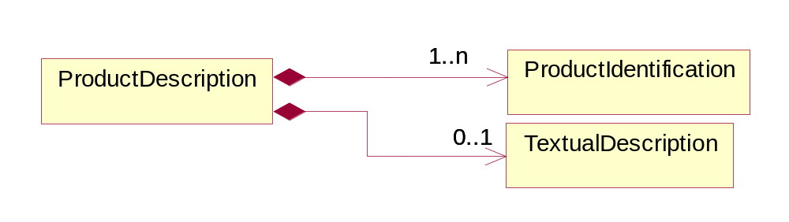
Figure 4-35 ProductDescription

Composition | Cardinality | Type | Documentation
ProductIdentification | 1..n | ProductIdentification | The object provides the identifier(s) of a product.
TextualDescription | 0..1 | TextualDescription | The business document must allow for multiple levels of textual description of an event or object.

ProductIdentification
The object provides the identifier(s) of a product.
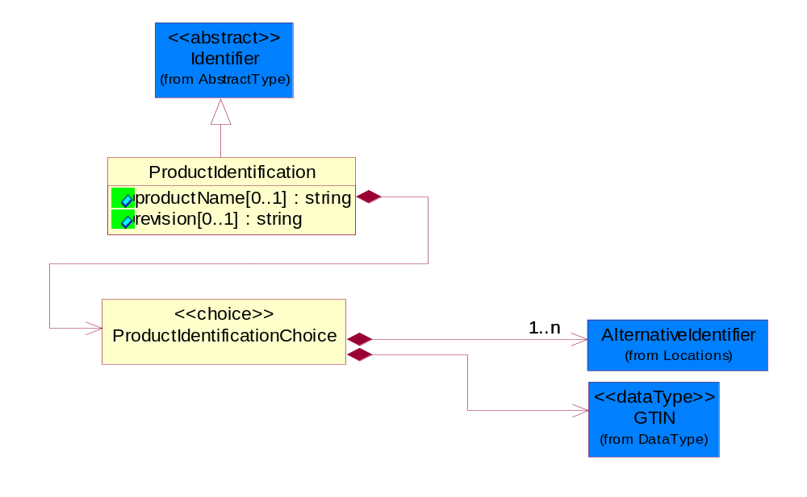
Figure 4-36 ProductIdentification

Attribute | Type | Documentation
productName[0..1] | string | The name of the product.
revision[0..1] | string | Referenced the specified product revision.

Composition | Cardinality | Type | Documentation
ProductIdentificationChoice | 1 | ProductIdentificationChoice

ProductIdentificationChoice

Composition | Cardinality | Type | Documentation
AlternativeIdentifier | 1..n | AlternativeIdentifier | Identifies the specified code and the name of the organization that a code is utilized from.
GTIN | 1 | GTIN | Global Trade Identification Number (GTIN).

TextualDescription
The business document must allow for multiple levels of textual description of an event or object.
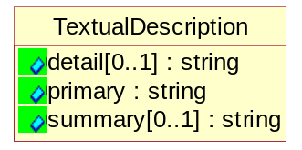
Figure 4-37 TextualDescription

Attribute | Type | Documentation
detail[0..1] | string | A detail description of an event or object.
Primary | string | A phrase or single word description of an event or object.
summary[0..1] | string | A condensed description of an event or object.

CodeList

Language
For representation of Language name RosettaNet has adopted ISO 639-2; 1998. Refer to the following web page to get the latest version of the standard:
http://www.loc.gov/standards/iso639-2/iso639jac.html

If you need more information about the ISO standard please contact ISO for more details.

MimeTypeQualifier
The MIME type as defined by IANA.

Please refer to http://www.iana.org/assignments/media-types/ for a list of types.

Instance | Documentation
application/activemessage | [Shapiro]
application/andrew-inset | [Borenstein]
application/applefile | [Faltstrom]
application/atomicmail | [Borenstein]
application/batch-SMTP | [RFC2442]
application/beep+xml | [RFC3080]
application/cals-1840 | [RFC1895]
application/cnrp+xml | [RFCCNRP]
application/commonground | [Glazer]
application/cpl+xml
application/cybercash | [Eastlake]
application/dca-rft | [Campbell]
application/dec-dx | [Campbell]
application/dicom | [RFC3240]
application/dvcs | [RFC3029]
application/EDI-Consent | [RFC1767]
application/EDIFACT | [RFC1767]
application/EDI-X12 | [RFC1767]
application/eshop | [Katz]
application/font-tdpfr | [RFC3073]
application/http | [RFC2616]
application/hyperstudio | [Domino]
application/iges | [Parks]
application/index | [RFC2652]
application/index.cmd | [RFC2652]
application/index.obj | [RFC2652]
application/index.response | [RFC2652]
application/index.vnd | [RFC2652]
application/iotp | [RFC2935]
application/ipp | [RFC2910]
application/isup | [RFC3204]
application/mac-binhex40 | [Faltstrom]
application/macwriteii | [Lindner]
application/marc | [RFC2220]
application/mathematica | [Van Nostern]
application/msword | [Lindner]
application/news-message-id | [RFC1036,Spencer]
application/news-transmission | [RFC1036, Spencer]
application/ocsp-request | [RFC2560]
application/ocsp-response | [RFC2560]
application/octet-stream | [RFC2045,RFC2046]
application/oda | [RFC2045,RFC2046]
application/ogg | [RFC-walleij-ogg-mediatype-08.txt]
application/parityfec | [RFC3009]
application/pdf | [Lindner]
application/pgp-encrypted | [RFC3156]
application/pgp-keys | [RFC3156]
application/pgp-signature | [RFC3156]
application/pkcs10 | [RFC2311]
application/pkcs7-mime | [RFC2311]
application/pkcs7-signature | [RFC2311]
application/pkix-cert | [RFC2585]
application/pkixcmp | [RFC2510]
application/pkix-crl | [RFC2585]
application/postscript | [RFC2045,RFC2046]
application/prs.alvestrand.titrax-sheet | [Alvestrand]
application/prs.cww | [Rungchavalnont]
application/prs.nprend | [Doggett]
application/prs.plucker | [Janssen]
application/qsig | [RFC3204]
application/reginfo+xml | [RFC-ietf-sipping-reg-event-00.txt]
application/remote-printing | [RFC1486,Rose]
application/riscos | [Smith]
application/rtf | [Lindner]
application/sdp | [RFC2327]
application/set-payment | [Korver]
application/set-payment-initiation | [Korver]
application/set-registration | [Korver]
application/set-registration-initiation | [Korver]
application/sgml | [RFC1874]
application/sgml-open-catalog | [Grosso]
application/sieve | [RFC3028]
application/slate | [Crowley]
application/timestamp-query | [RFC3161]
application/timestamp-reply | [RFC3161]
application/tve-trigger | [Welsh]
application/vemmi | [RFC2122]
application/vnd.3gpp.pic-bw-large | [Meredith]
application/vnd.3gpp.pic-bw-small | [Meredith]
application/vnd.3gpp.pic-bw-var | [Meredith]
application/vnd.3gpp.sms | [Meredith]
application/vnd.3M.Post-it-Notes | [O'Brien]
application/vnd.accpac.simply.aso | [Leow]
application/vnd.accpac.simply.imp | [Leow]
application/vnd.acucobol | [Lubin]
application/vnd.acucorp | [Lubin]
application/vnd.adobe.xfdf | [Perelman]
application/vnd.aether.imp | [Moskowitz]
application/vnd.amiga.ami | [Blumberg]
application/vnd.anser-web-certificate-issue-initiation | [Mori]
application/vnd.anser-web-funds-transfer-initiation | [Mori]
application/vnd.audiograph | [Slusanschi]
application/vnd.blueice.multipass | [Holmstrom]
application/vnd.bmi | [Gotoh]
application/vnd.businessobjects | [Imoucha]
application/vnd.canon-cpdl | [Muto]
application/vnd.canon-lips | [Muto]
application/vnd.cinderella | [Kortenkamp]
application/vnd.claymore | [Simpson]
application/vnd.commerce-battelle | [Applebaum]
application/vnd.commonspace | [Chandhok]
application/vnd.contact.cmsg | [Patz]
application/vnd.cosmocaller | [Dellutri]
application/vnd.ctc-posml | [Kohlhepp]
application/vnd.cups-postscript | [Sweet]
application/vnd.cups-raster | [Sweet]
application/vnd.cups-raw | [Sweet]
application/vnd.curl | [Byrnes]
application/vnd.cybank | [Helmee]
application/vnd.data-vision.rdz | [Fields]
application/vnd.dna | [Searcy]
application/vnd.dpgraph | [Parker]
application/vnd.dreamfactory | [Appleton]
application/vnd.dxr | [Duffy]
application/vnd.ecdis-update | [Buettgenbach]
application/vnd.ecowin.chart | [Olsson]
application/vnd.ecowin.filerequest | [Olsson]
application/vnd.ecowin.fileupdate | [Olsson]
application/vnd.ecowin.series | [Olsson]
application/vnd.ecowin.seriesrequest | [Olsson]
application/vnd.ecowin.seriesupdate | [Olsson]
application/vnd.enliven | [Santinelli]
application/vnd.epson.esf | [Hoshina]
application/vnd.epson.msf | [Hoshina]
application/vnd.epson.quickanime | [Gu]
application/vnd.epson.salt | [Nagatomo]
application/vnd.epson.ssf | [Hoshina]
application/vnd.ericsson.quickcall | [Tidwell]
application/vnd.eudora.data | [Resnick]
application/vnd.fdf | [Zilles]
application/vnd.ffsns | [Holstage]
application/vnd.FloGraphIt | [Floersch]
application/vnd.framemaker | [Wexler]
application/vnd.fsc.weblaunch | [D.Smith]
application/vnd.fujitsu.oasys | [Togashi]
application/vnd.fujitsu.oasys2 | [Togashi]
application/vnd.fujitsu.oasys3 | [Okudaira]
application/vnd.fujitsu.oasysgp | [Sugimoto]
application/vnd.fujitsu.oasysprs | [Ogita]
application/vnd.fujixerox.ddd | [Onda]
application/vnd.fujixerox.docuworks | [Taguchi]
application/vnd.fujixerox.docuworks.binder | [Matsumoto]
application/vnd.fut-misnet | [Pruulmann]
application/vnd.grafeq | [Tupper]
application/vnd.groove-account | [Joseph]
application/vnd.groove-help | [Joseph]
application/vnd.groove-identity-message | [Joseph]
application/vnd.groove-injector | [Joseph]
application/vnd.groove-tool-message | [Joseph]
application/vnd.groove-tool-template | [Joseph]
application/vnd.groove-vcard | [Joseph]
application/vnd.hbci | [Hammann]
application/vnd.hhe.lesson-player | [Jones]
application/vnd.hp-HPGL | [Pentecost]
application/vnd.hp-hpid | [Gupta]
application/vnd.hp-hps | [Aubrey]
application/vnd.hp-PCL | [Pentecost]
application/vnd.hp-PCLXL | [Pentecost]
application/vnd.httphone | [Lefevre]
application/vnd.hzn-3d-crossword | [Minnis]
application/vnd.ibm.afplinedata | [Buis]
application/vnd.ibm.electronic-media | [Tantlinger]
application/vnd.ibm.MiniPay | [Herzberg]
application/vnd.ibm.modcap | [Hohensee]
application/vnd.ibm.secure-container | [Tantlinger]
application/vnd.informix-visionary | [Gales]
application/vnd.intercon.formnet | [Gurak]
application/vnd.intertrust.digibox | [Tomasello]
application/vnd.intertrust.nncp | [Tomasello]
application/vnd.intu.qbo | [Scratchley]
application/vnd.intu.qfx | [Scratchley]
application/vnd.irepository.package+xml | [Knowles]
application/vnd.is-xpr | [Natarajan]
application/vnd.japannet-directory-service | [Fujii]
application/vnd.japannet-jpnstore-wakeup | [Yoshitake]
application/vnd.japannet-payment-wakeup | [Fujii]
application/vnd.japannet-registration | [Yoshitake]
application/vnd.japannet-registration-wakeup | [Fujii]
application/vnd.japannet-setstore-wakeup | [Yoshitake]
application/vnd.japannet-verification | [Yoshitake]
application/vnd.japannet-verification-wakeup | [Fujii]
application/vnd.jisp | [Deckers]
application/vnd.kde.karbon | [Faure]
application/vnd.kde.kchart | [Faure]
application/vnd.kde.kformula | [Faure]
application/vnd.kde.kivio | [Faure]
application/vnd.kde.kontour | [Faure]
application/vnd.kde.kpresenter | [Faure]
application/vnd.kde.kspread | [Faure]
application/vnd.kde.kword | [Faure]
application/vnd.kenameaapp | [DiGiorgio-Haag]
application/vnd.koan | [Cole]
application/vnd.liberty-request+xml | [McDowell]
application/vnd.llamagraphics.life-balance.desktop | [White]
application/vnd.lotus-1-2-3 | [Wattenberger]
application/vnd.lotus-approach | [Wattenberger]
application/vnd.lotus-freelance | [Wattenberger]
application/vnd.lotus-notes | [Laramie]
application/vnd.lotus-organizer | [Wattenberger]
application/vnd.lotus-screencam | [Wattenberger]
application/vnd.lotus-wordpro | [Wattenberger]
application/vnd.mcd | [Gotoh]
application/vnd.mediastation.cdkey | [Flurry]
application/vnd.meridian-slingshot | [Wedel]
application/vnd.micrografx.flo | [Prevo]
application/vnd.micrografx.igx | [Prevo]
application/vnd.mif | [Wexler]
application/vnd.minisoft-hp3000-save | [Bartram]
application/vnd.mitsubishi.misty-guard.trustweb | [Tanaka]
application/vnd.Mobius.DAF | [Kabayama]
application/vnd.Mobius.DIS | [Kabayama]
application/vnd.Mobius.MBK | [Devasia]
application/vnd.Mobius.MQY | [Devasia]
application/vnd.Mobius.MSL | [Kabayama]
application/vnd.Mobius.PLC | [Kabayama]
application/vnd.Mobius.TXF | [Kabayama]
application/vnd.mophun.application | [Wennerstrom]
application/vnd.mophun.certificate | [Wennerstrom]
application/vnd.motorola.flexsuite | [Patton]
application/vnd.motorola.flexsuite.adsi | [Patton]
application/vnd.motorola.flexsuite.fis | [Patton]
application/vnd.motorola.flexsuite.gotap | [Patton]
application/vnd.motorola.flexsuite.kmr | [Patton]
application/vnd.motorola.flexsuite.ttc | [Patton]
application/vnd.motorola.flexsuite.wem | [Patton]
application/vnd.mozilla.xul+xml | [McDaniel]
application/vnd.ms-artgalry | [Slawson]
application/vnd.ms-asf | [Fleischman]
application/vnd.mseq | [Le Bodic]
application/vnd.ms-excel | [Gill]
application/vnd.msign | [Borcherding]
application/vnd.ms-lrm | [Ledoux]
application/vnd.ms-powerpoint | [Gill]
application/vnd.ms-project | [Gill]
application/vnd.ms-tnef | [Gill]
application/vnd.ms-works | [Gill]
application/vnd.ms-wpl | [Plastina]
application/vnd.musician | [Adams]
application/vnd.music-niff | [Butler]
application/vnd.netfpx | [Mutz]
application/vnd.noblenet-directory | [Solomon]
application/vnd.noblenet-sealer | [Solomon]
application/vnd.noblenet-web | [Solomon]
application/vnd.novadigm.EDM | [Swenson]
application/vnd.novadigm.EDX | [Swenson]
application/vnd.novadigm.EXT | [Swenson]
application/vnd.obn | [Hessling]
application/vnd.osa.netdeploy | [Klos]
application/vnd.palm | [Peacock]
application/vnd.pg.format | [Gandert]
application/vnd.pg.osasli | [Gandert]
application/vnd.powerbuilder6 | [Guy]
application/vnd.powerbuilder6-s | [Guy]
application/vnd.powerbuilder7 | [Shilts]
application/vnd.powerbuilder75 | [Shilts]
application/vnd.powerbuilder75-s | [Shilts]
application/vnd.powerbuilder7-s | [Shilts]
application/vnd.previewsystems.box | [Smolgovsky]
application/vnd.publishare-delta-tree | [Ben-Kiki]
application/vnd.pvi.ptid1 | [Lamb]
application/vnd.pwg-multiplexed | [RFC3391]
application/vnd.pwg-xhtml-print+xml | [Wright]
application/vnd.Quark.QuarkXPress | [Scheidler]
application/vnd.rapid | [Szekely]
application/vnd.s3sms | [Tarkkala]
application/vnd.sealed.net | [Lambert]
application/vnd.seemail | [Webb]
application/vnd.shana.informed.formdata | [Selzler]
application/vnd.shana.informed.formtemplate | [Selzler]
application/vnd.shana.informed.interchange | [Selzler]
application/vnd.shana.informed.package | [Selzler]
application/vnd.smaf | [Takahashi]
application/vnd.sss-cod | [Dani]
application/vnd.sss-dtf | [Bruno]
application/vnd.sss-ntf | [Bruno]
application/vnd.street-stream | [Levitt]
application/vnd.svd | [Becker]
application/vnd.swiftview-ics | [Widener]
application/vnd.triscape.mxs | [Simonoff]
application/vnd.trueapp | [Hepler]
application/vnd.truedoc | [Chase]
application/vnd.ufdl | [Manning]
application/vnd.uplanet.alert | [Martin]
application/vnd.uplanet.alert-wbxml | [Martin]
application/vnd.uplanet.bearer-choice | [Martin]
application/vnd.uplanet.bearer-choice-wbxml | [Martin]
application/vnd.uplanet.cacheop | [Martin]
application/vnd.uplanet.cacheop-wbxml | [Martin]
application/vnd.uplanet.channel | [Martin]
application/vnd.uplanet.channel-wbxml | [Martin]
application/vnd.uplanet.list | [Martin]
application/vnd.uplanet.listcmd | [Martin]
application/vnd.uplanet.listcmd-wbxml | [Martin]
application/vnd.uplanet.list-wbxml | [Martin]
application/vnd.uplanet.signal | [Martin]
application/vnd.vcx | [T.Sugimoto]
application/vnd.vectorworks | [Pharr]
application/vnd.vidsoft.vidconference | [Hess]
application/vnd.visio | [Sandal]
application/vnd.visionary | [Aravindakumar]
application/vnd.vividence.scriptfile | [Risher]
application/vnd.vsf | [Rowe]
application/vnd.wap.sic | [WAP-Forum]
application/vnd.wap.slc | [WAP-Forum]
application/vnd.wap.wbxml | [Stark]
application/vnd.wap.wmlc | [Stark]
application/vnd.wap.wmlscriptc | [Stark]
application/vnd.webturbo | [Rehem]
application/vnd.wrq-hp3000-labelled | [Bartram]
application/vnd.wt.stf | [Wohler]
application/vnd.wv.csp+wbxml | [Salmi]
application/vnd.xara | [Matthewman]
application/vnd.xfdl | [Manning]
application/vnd.yellowriver-custom-menu | [Yellow]
application/whoispp-query | [RFC2957]
application/whoispp-response | [RFC2958]
application/wita | [Campbell]
application/wordperfect5.1 | [Lindner]
application/x400-bp | [RFC1494]
application/xhtml+xml | [RFC3236]
application/xml | [RFC3023]
application/xml-dtd | [RFC3023]
application/xml-external-parsed-entity | [RFC3023]
application/zip | [Lindner]
audio/32kadpcm | [RFC2421,RFC2422]
audio/AMR | [RFC3267]
audio/AMR-WB | [RFC3267]
audio/basic | [RFC2045,RFC2046]
audio/CN | [RFC3389]
audio/DAT12 | [RFC3190]
audio/DVI4
audio/EVRC | [RFC-ietf-avt-evrc-smv-03.txt]
audio/EVRC0 | [RFC-ietf-avt-evrc-smv-03.txt]
audio/G.722.1 | [RFC3047]
audio/G722
audio/G723
audio/G726-16
audio/G726-24
audio/G726-32
audio/G726-40
audio/G728
audio/G729
audio/G729D
audio/G729E
audio/GSM
audio/GSM-EFR
audio/L16 | [RFC2586]
audio/L20 | [RFC3190]
audio/L24 | [RFC3190]
audio/L8
audio/LPC
audio/MP4A-LATM | [RFC3016]
audio/MPA
audio/mpa-robust | [RFC3119]
audio/mpeg | [RFC3003]
audio/parityfec | [RFC3009]
audio/PCMA
audio/PCMU
audio/prs.sid | [Walleij]
audio/QCELP
audio/RED
audio/SMV | [RFC-ietf-avt-evrc-smv-03.txt]
audio/SMV0 | [RFC-ietf-avt-evrc-smv-03.txt]
audio/telephone-event | [RFC2833]
audio/tone | [RFC2833]
audio/VDVI
audio/vnd.3gpp.iufp | [Belling]
audio/vnd.cisco.nse | [Kumar]
audio/vnd.cns.anp1 | [McLaughlin]
audio/vnd.cns.inf1 | [McLaughlin]
audio/vnd.digital-winds | [Strazds]
audio/vnd.everad.plj | [Cicelsky]
audio/vnd.lucent.voice | [Vaudreuil]
audio/vnd.nortel.vbk | [Parsons]
audio/vnd.nuera.ecelp4800 | [Fox]
audio/vnd.nuera.ecelp7470 | [Fox]
audio/vnd.nuera.ecelp9600 | [Fox]
audio/vnd.octel.sbc | [Vaudreuil]
audio/vnd.qcelp | [Lundblade]
audio/vnd.rhetorex.32kadpcm | [Vaudreuil]
audio/vnd.vmx.cvsd | [Vaudreuil]
image/cgm | Computer Graphics Metafile
image/g3fax | [RFC1494]
image/gif | [RFC2045,RFC2046]
image/ief | [RFC1314] Image Exchange Format
image/jpeg | [RFC2045,RFC2046]
image/naplps | [Ferber]
image/png | [Randers-Pehrson]
image/prs.btif | [Simon]
image/prs.pti | [Laun]
image/t38 | [RFC3362]
image/tiff | [RFC3302] Tag Image File Format
image/tiff-fx | [RFC3250] Tag Image File Format Fax eXtended
image/vnd.cns.inf2 | [McLaughlin]
image/vnd.djvu | [Bottou]
image/vnd.dwg | [Moline]
image/vnd.dxf | [Moline]
image/vnd.fastbidsheet | [Becker]
image/vnd.fpx | [Spencer]
image/vnd.fst | [Fuldseth]
image/vnd.fujixerox.edmics-mmr | [Onda]
image/vnd.fujixerox.edmics-rlc | [Onda]
image/vnd.globalgraphics.pgb | [Bailey]
image/vnd.mix | [Reddy]
image/vnd.ms-modi | [Vaughan]
image/vnd.net-fpx | [Spencer]
image/vnd.svf | [Moline]
image/vnd.wap.wbmp | [Stark]
image/vnd.xiff | [S.Martin]
Message/delivery-status | [RFC1894]
Message/disposition-notification | [RFC2298]
Message/external-body | [RFC2045,RFC2046]
Message/http | [RFC2616]
Message/news | [RFC 1036, H.Spencer]
Message/partial | [RFC2045,RFC2046]
Message/rfc822 | [RFC2045,RFC2046]
Message/s-http | [RFC2660]
Message/sip | [RFC3261]
Message/sipfrag | [RFC3420]
model/iges | [Parks]
model/mesh | [RFC2077]
model/vnd.dwf | [Pratt]
model/vnd.flatland.3dml | [Powers]
model/vnd.gdl | [Babits]
model/vnd.gs-gdl | [Babits]
model/vnd.gtw | [Ozaki]
model/vnd.mts | [Rabinovitch]
model/vnd.parasolid.transmit.binary | [Parasolid]
model/vnd.parasolid.transmit.text | [Parasolid]
model/vnd.vtu | [Rabinovitch]
model/vrml | [RFC2077]
multipart/alternative | [RFC2045,RFC2046]
multipart/appledouble | [Faltstrom]
multipart/byteranges | [RFC2068]
multipart/digest | [RFC2045,RFC2046]
multipart/encrypted | [RFC1847]
multipart/form-data | [RFC2388]
multipart/header-set | [Crocker]
multipart/mixed | [RFC2045,RFC2046]
multipart/parallel | [RFC2045,RFC2046]
multipart/related | [RFC2387]
multipart/report | [RFC1892]
multipart/signed | [RFC1847]
multipart/voice-message | [RFC2421,RFC2423]
text/calendar | [RFC2445]
text/css | [RFC2318]
text/directory | [RFC2425]
text/enriched | [RFC1896]
text/html | [RFC2854]
text/parityfec | [RFC3009]
text/plain | [RFC2646,RFC2046]
text/prs.lines.tag | [Lines]
text/rfc822-headers | [RFC1892]
text/richtext | [RFC2045,RFC2046]
text/rtf | [Lindner]
text/sgml | [RFC1874]
text/t140 | [RFC2793]
text/tab-separated-values | [Lindner]
text/uri-list | [RFC2483]
text/vnd.abc | [Allen]
text/vnd.curl | [Byrnes]
text/vnd.DMClientScript | [Bradley]
text/vnd.fly | [Gurney]
text/vnd.fmi.flexstor | [Hurtta]
text/vnd.in3d.3dml | [Powers]
text/vnd.in3d.spot | [Powers]
text/vnd.IPTC.NewsML | [IPTC]
text/vnd.IPTC.NITF | [IPTC]
text/vnd.latex-z | [Lubos]
text/vnd.motorola.reflex | [Patton]
text/vnd.ms-mediapackage | [Nelson]
text/vnd.net2phone.commcenter.command | [Xie]
text/vnd.sun.j2me.app-descriptor | [G.Adams]
text/vnd.wap.si | [WAP-Forum]
text/vnd.wap.sl | [WAP-Forum]
text/vnd.wap.wml | [Stark]
text/vnd.wap.wmlscript | [Stark]
text/xml | [RFC3023]
text/xml-external-parsed-entity | [RFC3023]
video/BMPEG
video/BT656
video/CelB
video/DV | [RFC3189]
video/H261
video/H263
video/H263-1998
video/H263-2000
video/JPEG
video/MP1S
video/MP2P
video/MP2T
video/MP4V-ES | [RFC3016]
video/mpeg | [RFC2045,RFC2046]
video/MPV
video/nv
video/parityfec | [RFC3009]
video/pointer | [RFC2862]
video/quicktime | [Lindner]
video/SMPTE292M | [RFC-avt-smpte292-video-08.txt]
video/vnd.fvt | [Fuldseth]
video/vnd.motorola.video | [McGinty]
video/vnd.motorola.videop | [McGinty]
video/vnd.mpegurl | [Recktenwald]
video/vnd.nokia.interleaved-multimedia | [Kangaslampi]
video/vnd.objectvideo | [Clark]
video/vnd.vivo | [Wolfe]

UnitOfMeasure
Code identifying a product unit of measure.

Instance | Documentation
10P | 10-pack.
1BF | 100 Board Feet.
1FC | 20 Foot Container.
1GR | Gram/Cubic Centimeter.
1GT | 10,000 Gallon Tankcar.
1KB | 25 Kilogram Bulk Bag.
1KD | 10 Kilogram Drum.
1KP | 1000-pack.
1PA | 20-Pack.
1PB | 50 Pound Bag.
1PD | 100 Pound Drum.
2FC | 40 Foot Container.
2GR | Gram/square meter.
2GT | 20,000 Gallon Tankcar.
2KB | 300 Kilogram Bulk Bag.
2KD | 15 Kilogram Drum.
2PA | 100-Pack.
3GR | Grams Per 100 Centimeters.
3KB | 500 Kilogram Bulk Bag.
3KD | 55 Gallon Drum.
4GR | Grams Per 100 Grams.
4KD | 115 Kilogram Drum.
50P | 50-pack.
5GR | Grams Per Cubic Centimeter.
6GR | Grams Per Square Centimeter.
7GR | Grams Per Square Meter.
ACR | Acre.
ACT | Actual Pounds.
ALU | Aluminum Pounds Only.
AMP | Ampere.
ASM | Angstrom.
BAB | Base Box.
BAC | Batch.
BAE | Bale.
BAG | Bag.
BAL | Ball.
BAN | Band.
BAP | Batting Pound.
BAR | Bar.
BAS | Basket.
BAT | Batt.
BAW | Base Weight.
BEA | Beam.
BEC | Becquerel/kilogram.
BEL | Belt.
BIL | Billet.
BIN | Bin.
BIT | Bit.
BKC | Bulk Car Load.
BLO | Block.
BOA | Board.
BOF | Board Feet.
BOL | Bolt.
BOT | Bottle.
BOX | Box.
BRD | Barrels Per Day.
BRE | Barrel.
BRI | Barrel (Imperial).
BRM | Barrels Per Minute.
BTF | British Thermal Units (BTUs) Per Cubic Foot.
BTP | British Thermal Units (BTUs) Per Pound.
BTU | British Thermal Unit (BTU).
BUC | Bucket.
BUD | Bushel, Dry Imperial.
BUK | Bunks.
BUL | Bulk.
BUN | Bundle.
BUP | Bulk Pack.
BUS | Bushel.
BYT | Bytes.
CAA | Carat.
CAB | Carboy.
CAC | Card.
CAD | Candela.
CAG | Cartridge.
CAK | Cask.
CAL | Calorie.
CAN | Can.
CAO | Carload.
CAR | Car.
CAS | Case.
CAT | Canister.
CAW | Catchweight.
CEL | Cell.
CEM | Centimeter.
CEP | Centipoise (CPS).
CET | Centiliter.
CGM | Centigram.
CHA | Chains (Land Survey).
CHE | Chest.
CNN | Connector.
COG | Coil Group.
COI | Coil.
COL | Coulomb.
COM | Composite Product Pounds (Total Weight).
CON | Cone.
COT | Container.
COV | Cover.
CRA | Crate.
CRT | Carton.
CSE | Cassette.
CUB | Cubic centimeter.
CUC | Cubic centimeter/second.
CUF | Cubic Foot.
CUI | Cubic inch.
CUM | Cubicmeter.
CUP | Cup.
CUY | Cubic yard.
CYC | Cycles.
CYL | Cylinder.
DAY | Day.
DCB | Decibels.
DCG | Decagram.
DCL | Deciliter.
DEA | Deal.
DEC | Decimeter.
DEF | Degree Fahrenheit.
DEG | Degree Celsius.
DEP | Dep. Factor.
DGM | Decigram.
DIE | Die.
DIL | Display.
DIP | Dispenser.
DOZ | Dozen.
DRA | Dram.
DRU | Drum.
DRY | Dry Pounds.
EAC | Each.
ELE | Electrical Capacitance.
FAR | Farads.
FFA | Femtofarad.
FLO | Fluid Ounce.
FOI | Fluid Ounce (Imperial).
FOO | Foot.
FOU | Fluid Ounce US.
FUU | Fuel Usage (Gallons).
GAL | Gallon.
GAS | Gage Systems.
GIH | Gigahertz.
GIJ | Gigajoules.
GIL | Gill (Imperial).
GOB | Gross Barrels.
GOG | Gross Gallons.
GOK | Gross Kilogram.
GOT | Gross Ton.
GOY | Gross Yard.
GRA | Gram.
GRG | Great Gross (Dozen Gross).
GRK | Grams Per Kilogram.
GRL | Grams Per Liter.
GRM | Grams Per Milliliter.
GRN | Grain.
GRO | Gross.
GRP | Group.
HAG | Half Gallon.
HAH | Half Hour.
HAL | Half Liter.
HAN | Hank.
HEA | Heat lots.
HEC | Hectare.
HEL | Hectoliter.
HEP | Hectopascal.
HER | Hertz.
HNY | Henry.
HOS | Hours.
HOU | Hour.
HUA | Hundredth of a Carat.
HUB | Hundred Boxes.
HUC | Hundred Count.
HUS | Hundred Sheets.
IMG | Imperial Gallons.
INC | Inch.
JAR | Jar.
JOI | Joint.
JOU | Joule.
KBY | Kilobyte.
KEG | Keg.
KEL | Kelvin.
KHO | Kilometer/hour.
KIC | Kilogram per cubic meter.
KIE | Kilometer.
KIG | Kilogram.
KIH | Kilohertz.
KIK | Kilobecquerel/Kilogram.
KIL | Kiloampere.
KIM | Kilogram/square meter.
KIO | Kiloohm.
KIS | Kilogramm pro Sekunde.
KIT | Kit.
KIV | Kilovolt.
KIW | Kilowatt.
KJL | Kilojoule.
KKG | Kilogram/Kilogram.
KUD | Kubikdezimeter.
KUM | Kubikmeter pro Sekunde.
KWH | Kilowatt-hour.
LIF | Lifts.
LIM | Link.
LIQ | Liquid Pounds.
LIT | Liter.
LOA | Load.
LOT | Lot.
LUG | Lug.
MAM | Milliamps/mm.
MAT | Mat.
MBY | Megabyte.
MCG | Microgram.
MCM | Milligrams Per Cubic Meter.
MCR | Micron.
MEG | Megagram.
MEH | Megahertz.
MEP | Megapascal.
MET | Meter.
MEW | Megawatt.
MGM | Milligram.
MIB | Million BTU's.
MIC | Mikrogram/cubic meter.
MIG | Micrograms Per Cubic Meter.
MIL | Mile.
MIM | Micrometer.
MIN | Minute.
MIP | Millipascal seconds.
MIS | Microsecond.
MIT | Miter.
MIV | Millivolt.
MIW | Milliwatt.
MJO | Millijoule.
MLA | Milliampere.
MLB | Millibar.
MLC | Milligram/cubic meter.
MLI | Milliliter.
MLK | Milligram/kilogram.
MLL | Milligram/Liter.
MLS | Miles.
MME | Millimeter.
MMH | Millimeter H20.
MMK | Millimol/kilogram.
MMO | Millimol.
MOK | Mol/kilogram.
MOL | Mol.
MON | Month.
MPH | Megagrams Per Hour.
MSC | Millisecond.
MSM | Milligrams Per Square Meter.
MTA | Millitesla.
MTQ | Meter pro Quadratsekunde.
MTS | Meters per second.
MUL | Multichip - When 2 or more dies (chips) are merged into one package.
MVS | Millivolts.
MVT | Millivolt.
NAA | Nanoamps.
NAM | Nanometer.
NAS | Nanosecond.
NEB | Net Barrels.
NEG | Net Gallons.
NEI | Net Imperial Gallons.
NEL | Net Liters.
NEW | Newton.
OCT | Ohm/ct.
OHM | Ohm.
OMM | Ohm/mm.
ONE | One.
OSQ | Ohm/sq.
OTP | One Thousand Pieces.
OUN | Ounce.
OVI | Ohm/via.
PAC | Parcel.
PAD | Pad.
PAG | Package.
PAI | Pail.
PAK | Pack (PAK).
PAL | Pallet.
PAN | Panel.
PAR | Pair.
PAS | Pascal.
PAT | Packet.
PEC | Percent.
PEG | Percentage.
PEH | Percent Per 1000 Hours.
PEN | Pennyweight.
PER | Per Hundred Pieces.
PEW | Percent Weight.
PFR | Picofarad.
PID | Pint U.S. Dry.
PIE | Piece.
PIL | Pint - US liquid.
PLA | Plate.
PLL | Pallet (Lift).
PLT | Pallete.
PLU | Pallet/Unit Load.
POF | Pounds Per Foot.
POG | Pounds Per Gallon.
PON | Pound.
POP | Pounds Per Piece of Product.
POS | Pounds Per 1000 Square Feet.
POT | Pounds Per Thousand.
PPB | Parts per billion (US).
PPM | Parts per million.
PPP | Pounds Per Pound of Product.
PSC | Picosecond.
PSS | Pascal second.
QUA | Quart - US liquid.
RAC | Rack.
REA | Ream of 500 Sheets.
REE | Reel.
RIN | Ring.
ROD | Rod.
ROL | Roll.
SAC | Sack.
SBB | Super Bulk Bag.
SEC | Second.
SET | Set.
SHE | Sheet.
SHI | Shipment.
SHM | Sheet - Metric measure.
SHO | Shot.
SID | Disk (Disc).
SKE | Skein.
SKI | Skid.
SLE | Sleeve.
SLI | Slip Sheet.
SMI | Square mile.
SMM | Square millimeter.
SPO | Spool.
SQF | Square foot.
SQI | Square inch.
SQK | Square kilometer.
SQM | Square meter.
SQS | Square meter/second.
SQU | Square.
SQY | Square Yard.
STI | Stick.
STM | Statute Mile.
STR | Strip.
TAB | Tablet.
TAN | Tank.
TAT | Tank Truck.
TES | Tesla.
THO | Thousand.
TNN | Tonne.
TON | Ton.
TOR | Torr.
TOT | Tote.
TRA | Train.
TRF | Track Foot.
TRL | Trailer.
TRO | Troy.
TRU | Truckload.
TRY | Tray.
TRZ | Troy OZ.
TUB | Tube.
ULU | Unitless Unit of Measure.
UNT | Unit.
USG | US gallon.
USP | US pound.
UST | US ton.
VIA | Vial.
VOL | Volt.
VTA | Volts (Alternating Current).
VTD | Volts (Direct Current).
VTM | Volts Per Meter.
WAF | Wafer.
WAR | Watt.
WEE | Week.
WRA | Wrap.
YAR | Yard.
YEA | Year.

ProcessRoleIdentifier
Describes the role of the partner in the business process. A partner will fulfill at least one or more roles during the business process.

Instance | Documentation
ADM | Administered by - The party who is the administrative authority of an account.
ALT | Alternate approval by - The party who has approved a request in the event the approver is not able to respond.
APP | Approval by - The party who has approved a request.
BIF | Bill from - The party that will issue the invoice.
BIT | Bill to - The party that will pay the invoice.
CBK | Customs Broker - CustomsBroker  This object represents the party that declare the shipment on behalf of declarant.
CLM | Claimed By - This object represents the claimant.
CNC | Cancellation party - The party who is cancelling the shipping order.
COR | Change originated by - The party who originates a proposed change.
COW | Change owned by - The party who owns or who is assigned responsibility for a proposed change.
CRA | Credit applicant - The party who is applying for credit.
CRE | Created by - The party responsible for creating a process or task.
CSP | Contract Service Provider.
DCE | DesignCustomerApplicationEngineer. The demand customer's Field Application Engineer.
DCT | Declared To - This object represents the party that the declaration goes to.
DCU | DesignCustomer. The owner of the product for which the design has been created.
DIS | Distributed by - The party who supplies products to retailers.
DST | Distributed To - This object represents the party to send information to.
FIN | Financed by - The party who is the financier.
FNB | Founded by - The party who performs the act, process, or art of casting metals.
FOR | Forwarded to - The party to whom a business document has been forwarded.
INL | Inventory location - The party where the inventory product entry is located.
INO | Inventory owner - The party that owns the inventory product entry.
ITF | In transit from - The party sending the product quantity in a product location transfer.
ITT | In transit to - The party receiving the product quantity in a product location transfer.
LGP | Logistics Provided By - The party who handles the details of an operation.
MFG | Manufactured by - The party who creates, processes or produces goods especially in large quantities and by means of industrial machines.
OWN | Owned by - The party who owns a process.
PAE | ProductProviderFieldApplicationEngineer. The product provider Field Application Engineer.
PCW | Primary Contract With - The primary party with whom a contract is formed.
PNB | Planning By - The party who establishes goals, policies or procedures.
PSR | ProductProviderSalesRepresentative. The product provider sales representative.
PUR | Purchased by - The party who is a purchaser of a product.
REA | Requested approval by - The party who has been selected to approve a request.
REC | Received by - The party who has received a product shipment.
REQ | Requested by - The party who has initiated a request.
RES | Respond to - The party to whom a responding business document must be sent when it is not equal to the partner specified in the document header.
RET | Return by - The party responsible for either carrying or forwarding the returned product.
REV | Reviewed by - The party responsible for reviewing a business document.
RLS | Released By - This object represents the party that releases the goods.
RPB | Repaired By - The collection of business properties used to identify the business partner responsible for the repair or  rework of a product.
RTT | ReturnTo - The partner and/or location to which the returned product must be delivered.
SBF | Self-billing from - The party who initiates the billing in self-billing scenario.
SBT | Self-billing to - The party whom the invoice is addressed to.
SCB | Subcontracted By - The party who is contracted to perform part or all of another party's contract.
SCP | Shipping charges paid by - The party responsible for administering payment of the shipping charges.
SCW | Secondary Contract With - The subsequent party(ies) with whom a contract is formed.
SHF | Ship From - The collection of business properties used to identify the business partner initiating a shipment or transaction.
SHT | Ship To - The partner and/or location to which the product must be delivered.
SLD | Sold to - The party to whom a product has been sold.
SOB | Sold By - The seller involved in a business transaction.
SPL | Supplied by - The party who supplies an item, part or assembly.
SPS | Service Provider Site - Identification for the location of the ASP site that is ordering the replacement parts and/or performing the repair.
SRT | Submit returns to - The party to whom product returns are to be submitted.
STR | Stored By - This object represents the party that stores the goods.
SVA | ShipVia - The partner and/or location through which the product must be shipped, such as the "cross dock" at a shipping hub.  It must not be specified for the last leg, since this would be the same as the final destination specified in the ShipmentInformation/shipTo.
TFR | Transfer From - The party responsible for making the payment (Payer).
TRA | Transported by - The party responsible for either carrying or forwarding the product.
TSB | Tested By - The collection of business properties used to identify the specific location and resources used to conduct a defined cycle or steps or measurements required to confirm a result or event.
TTR | Transfer To - The party who is receiving the payment (payee).
ULR | Ultimate recipient - The party who ultimately receives the shipment, when an intermediate party takes responsibility for payment and final delivery.
USE | Used by - The party who is the end user of the product.
UST | Unstuffed By - This object represents the party that unstuffs the goods.
WHB | Warehoused By - The party who stocks or stores products.

System Structure

BusinessProcessIdentifier
A Business Process Identifier to uniquely define the TPIR-PIP 'role' within a Business Scenario at a company or MNC level. The identifier MUST be composed of alphanumeric characters only and its length MUST be between one and twelve characters.
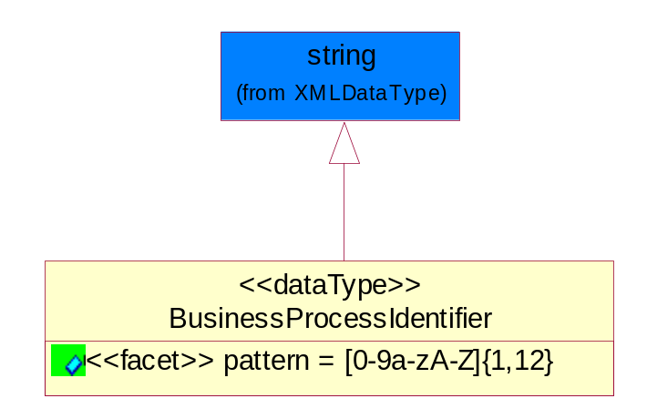
Figure 5-38 BusinessProcessIdentifier

Attribute | Type | Documentation
Pattern |  | [0-9a-zA-Z]{1,12}

BusinessServiceInformation
The object allows the specification of the business service utilized within the partner company. This may or may not be the same as the information sent by the RNIF.
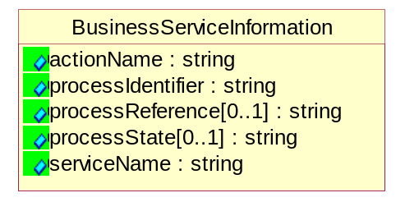
Figure 5-39 BusinessServiceInformation

Attribute | Type | Documentation
actionName | string | The name of Action. For RosettaNet usually any of Request/Confirm/Notify/Query/Response.
processIdentifier | string | The name of the PIP e.g. Notify of Forecast Reply.
processReference[0..1] | string | The URN for the PIP that includes Cluster/Segment/Process pattern used to identify the interface process (such as PIP3A4)
processState[0..1] | string | The business process (or service) state of the sender of a document. When a service receives this document, the receiver may use the state as a precondition.
serviceName | string | The name of the Business Activity with the "Request/Confirm" part removed. E.g., for the Activity "Request Purchase Order"==> "Purchase Order".

ContractInformation
A block of information used to correlate a contract in an executing choreography.

Figure 5-40 ContractInformation

Attribute | Type | Documentation
contractIdentifier[0..1] | string | Unique identification of a contract between the Sender and the Receiver
contractType[0..1] | string | The type of the contract: an attribute describing the type of the ContractIndentification. Valid values are URI, URN,ebXMLCPA, or other values defined by partners.

CorrelationInformation
A block of information used to correlate a requesting document to a responding document and to the contract in an executing choreography.
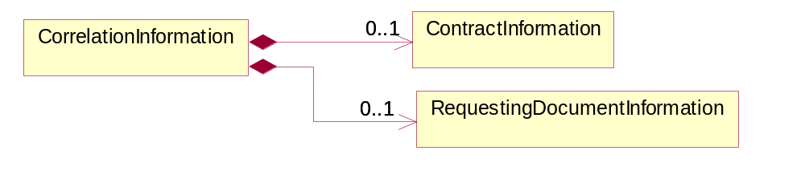
Figure 5-41 CorrelationInformation

Composition | Cardinality | Type | Documentation
ContractInformation | 0..1 | ContractInformation | A block of information used to correlate a contract in an executing choreography.
RequestingDocumentInformation | 0..1 | RequestingDocumentInformation | A block of information used to correlate a requesting document to a responding document in an executing choreography.

DocumentHeader
The object allows for the identification of the sender and receiver of the business document.
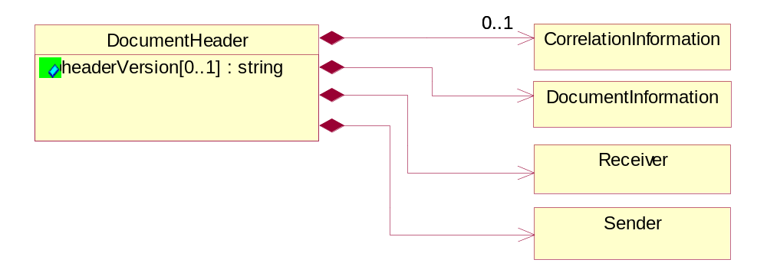
Figure 5-42 DocumentHeader

Attribute | Type | Documentation
headerVersion[0..1] | string | The UN/CEFACT version of the document header.

Composition | Cardinality | Type | Documentation
CorrelationInformation | 0..1 | CorrelationInformation | A block of information used to correlate a requesting document to a responding document and to the contract in an executing choreography.
DocumentInformation | 1 | DocumentInformation | The object specifies information to identify the business document, a summary of attachments, and information about the business document security.
Receiver | 1 | Receiver | The object allows the identification of the receiving party of the business message.
Sender | 1 | Sender | The object allows the identification of the initiating party of the business message.

DocumentIdentification
The object specifies all information necessary to identify the business document.
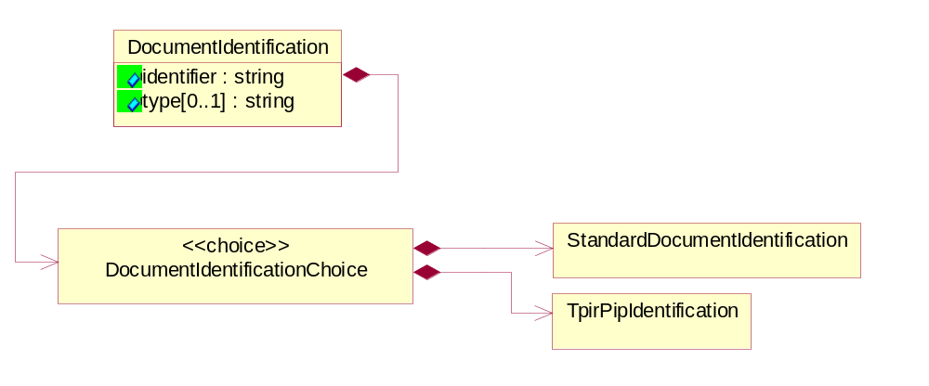
Figure 5-43 DocumentIdentification

Attribute | Type | Documentation
identifier | string | The unique identifier for the document being sent.
type[0..1] | string | Name of the Action Message

Composition | Cardinality | Type | Documentation
DocumentIdentificationChoice | 1 | DocumentIdentificationChoice

DocumentIdentificationChoice

Composition | Cardinality | Type | Documentation
StandardDocumentIdentification | 1 | StandardDocumentIdentification | The object specifies additional information necessary to identify the standard business document.
TpirPipIdentification | 1 | TpirPipIdentification | The object specifies all information necessary to uniquely identify a TPIR-PIP within a Registry or trading partner repository.

DocumentInformation
The object specifies information to identify the business document, a summary of attachments, and information about the business document security.
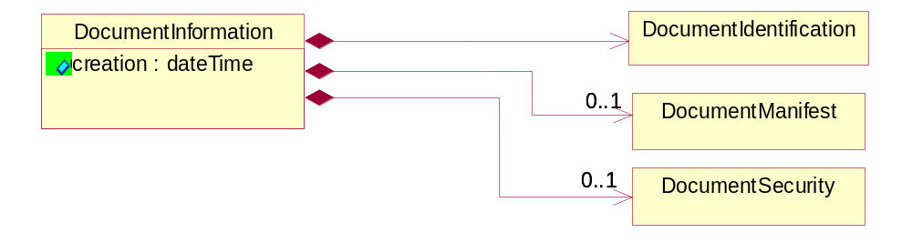
Figure 5-44 DocumentInformation

Attribute | Type | Documentation
Creation | dateTime | The creation date and time of the specified Business Document (i.e. the Purchase Order date).

Composition | Cardinality | Type | Documentation
DocumentIdentification | 1 | DocumentIdentification | The object specifies all information necessary to identify the business document.
DocumentManifest | 0..1 | DocumentManifest | The block provides a brief summary of attachments and Service Content.
DocumentSecurity | 0..1 | DocumentSecurity | The object provides additional granularity in specifying business document security (this is in addition to the specified PIP security).

DocumentManifest
The block provides a brief summary of attachments and Service Content.
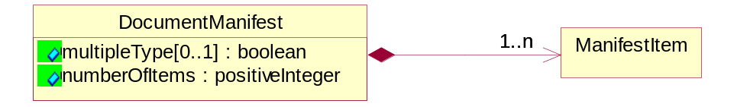
Figure 5-45 DocumentManifest

Attribute | Type | Documentation
multipleType[0..1] | boolean | Indicates whether the manifest contains documents of multiple types. True if yes, and False if no.
numberOfItems | positiveInteger | Total number of documents in the message. The physical count of the attachments in the payload plus the RosettaNet Business Message (for Service Content). The value of this field will be at least 1.

Composition | Cardinality | Type | Documentation
ManifestItem | 1..n | ManifestItem | The object provides details about the specific attachment(s).

DocumentSecurity
The object provides additional granularity in specifying business document security (this is in addition to the specified PIP security).

Figure 5-46 DocumentSecurity

Attribute | Type | Documentation
nonRepudiableReceipt | boolean | The value "true" will indicate that a signed acknowledgement for the business document is necessary.
persistentEncryption | boolean | The value "true" will indicate that the Business Document (including the header) needs to be encrypted when stored or transported.
persistentSignature | boolean | The value "true" will indicate that a signature is required to be stored with the document while stored or transported.

ManifestItem
The object provides details about the specific attachment(s).
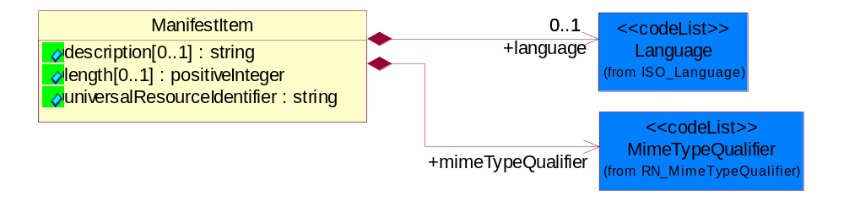
Figure 5-47 ManifestItem

Attribute | Type | Documentation
description[0..1] | string | A description of the attachment.
length[0..1] | positiveInteger | The size of the attachment in bytes (i.e. 1 000 000 bytes)
universalResourceIdentifier | string | The generic set of all names/addresses that are short strings that refer to resources.

Composition | Cardinality | Type | Documentation
language | 0..1 | Language | For representation of Language name RosettaNet has adopted ISO 639-2; 1998. Refer to the following web page to get the latest version of the standard:  http://www.loc.gov/standards/iso639-2/iso639jac.html  If you need more information about the ISO standard please contact ISO for more details.
mimeTypeQualifier | 1 | MimeTypeQualifier | The MIME type as defined by IANA.  Please refer to http://www.iana.org/assignments/media-types/  for a list of types

PipIdentifier
PIP Identification.[ i.e. PIP3A4]
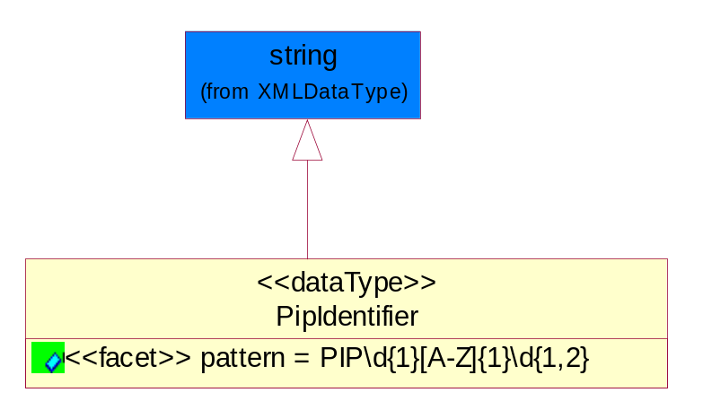
Figure 5-48 PipIdentifier

Attribute | Type | Documentation
Pattern |  | PIP\d{1}[A-Z]{1}\d{1,2}

PipVersion
PIP version number (i.e. 02.02.00).
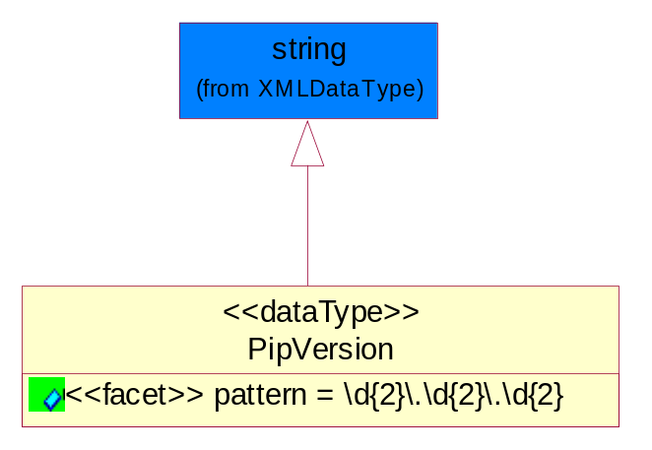
Figure 5-49 PipVersion

Attribute | Type | Documentation
Pattern |  | \d{2}\.\d{2}\.\d{2}

Receiver
The object allows the identification of the receiving party of the business message.
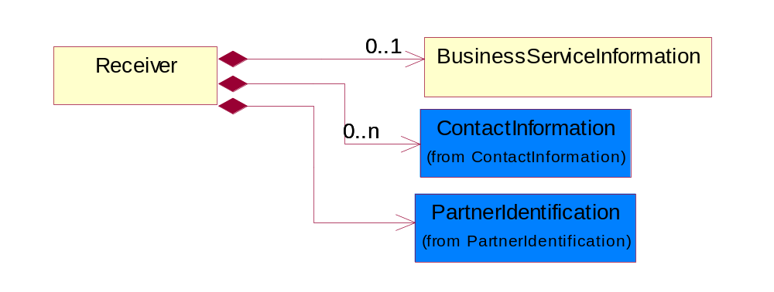
Figure 5-50 Receiver

Composition | Cardinality | Type | Documentation
BusinessServiceInformation | 0..1 | BusinessServiceInformation | The object allows the specification of the business service utilized within the partner company. This may or may not be the same as the information sent by the RNIF.
ContactInformation | 0..n | ContactInformation | The business document must allow for the identification of the name of the department, service or individual to be contacted regarding the context of the business document.
PartnerIdentification | 1 | PartnerIdentification | The business document must allow for the identity of one or more parties to the transaction.

RequestingDocumentInformation
A block of information used to correlate a requesting document to a responding document in an executing choreography.
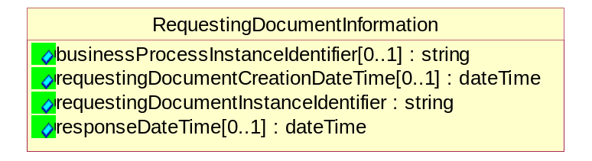
Figure 5-51 RequestingDocumentInformation

Attribute | Type | Documentation
businessProcessInstanceIdentifier[0..1] | string | The identifier for the public business process instance being sent that both the sender and receiver can identify.
requestingDocumentCreationDateTime[0..1] | dateTime | The date-time of the requesting business document.
requestingDocumentInstanceIdentifier | string | The Business Document identification number that identifies the requesting Business Document.
responseDateTime[0..1] | dateTime | The expected time to receive the response. This can not be greater than the PIP TimeToPerform.

Sender
The object allows the identification of the initiating party of the business message.
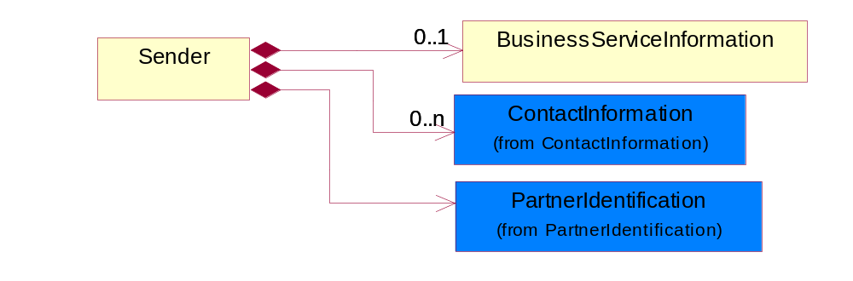
Figure 5-52 Sender

Composition | Cardinality | Type | Documentation
BusinessServiceInformation | 0..1 | BusinessServiceInformation | The object allows the specification of the business service utilized within the partner company. This may or may not be the same as the information sent by the RNIF.
ContactInformation | 0..n | ContactInformation | The business document must allow for the identification of the name of the department, service or individual to be contacted regarding the context of the business document.
PartnerIdentification | 1 | PartnerIdentification | The business document must allow for the identity of one or more parties to the transaction.

StandardDocumentIdentification
The object specifies additional information necessary to identify the standard business document.
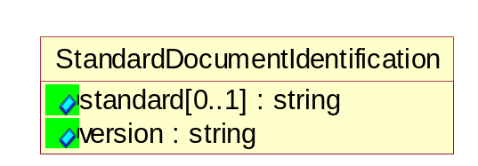
Figure 5-53 StandardDocumentIdentification

Attribute | Type | Documentation
Standard[0..1] | string | Identifies the standard used to submit the business document. (e.g. RosettaNet).
Version | string | PIP3A4v01.00

TpirPipIdentification
The object specifies all information necessary to uniquely identify a TPIR-PIP within a Registry or trading partner repository.
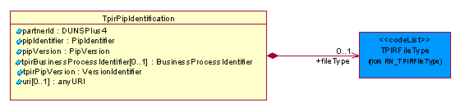
Figure 5-54 TpirPipIdentification

Attribute | Type | Documentation
partnerId | DUNSPlus4 | The Trading Partner Identification of MNC that is creating this TPIR PIP.
pipIdentifier | PipIdentifier | A TPIR PIP Identification [i.e., 3A4 ).
pipVersion | PipVersion | A TPIR PIP version number (i.e., 02.02.00)
tpirBusinessProcessIdentifier[0..1] | BusinessProcessIdentifier | A Business Process Identifier to uniquely define the TPIR-PIP 'role' within a Business Scenario at a company or MNC level. The identifier MUST be composed of alphanumeric characters only and its length MUST be between one and twelve characters.
tpirPipVersion | VersionIdentifier | A TPIR-PIP Version Number (i.e., major and minor version number as XX.XX).
uri[0..1] | anyURI | Describes the destination uri for the TPIR form.

Composition | Cardinality | Type | Documentation
fileType | 0..1 | TPIRFileType | Describes the file type of the TPIR form (PDF, XDP or XML).

VersionIdentifier
Version Number (i.e., major and minor version number as XX.XX).
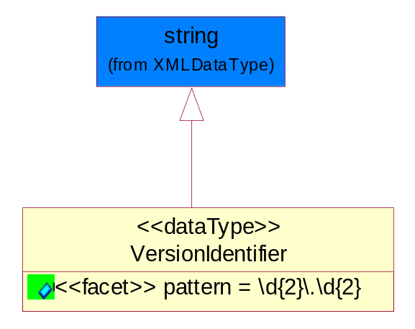
Figure 5-55 VersionIdentifier

Attribute | Type | Documentation
pattern |  | \d{2}\.\d{2}

CodeList

TPIRFileType
A code identifying the file type of TPIR form.

Name | Documentation
PDF | Portable Document Format.
XDP | XML Data Package.
XML | eXtensible Markup Language.

XML Data Type

anyURI
Represents a URI as defined by RFC 2396. An anyURI value can be absolute or relative, and may have an optional fragment identifier.

boolean
Represents Boolean values, which are either "true" or "false".

date
For the represents a calendar date.
The pattern for a date is CCYY-MM-DD where CC represents the century, YY the year, MM the month, and DD the day, with an optional time zone indicator as allowed for dateTime.

dateTime
Represents a specific instance of time.
The pattern for dateTime is CCYY-MM-DDThh:mm:ss where CC represents the century, YY the year, MM the month, and DD the day, preceded by an optional leading negative (-) character to indicate a negative number. If the negative character is omitted, positive (+) is assumed. The T is the date/time separator and hh, mm, and ss represent hour, minute, and second respectively. Additional digits can be used to increase the precision of fractional seconds if desired. For example, the format ss.ss... with any number of digits after the decimal point is supported. The fractional seconds part is optional.
This representation may be immediately followed by a "Z" to indicate Coordinated Universal Time (UTC) or to indicate the time zone. For example, the difference between the local time and Coordinated Universal Time, immediately followed by a sign, + or -, followed by the difference from UTC represented as hh:mm (minutes is required). If the time zone is included, both hours and minutes must be present.

decimal
A data type that contains decimal numbers scaled by a power of 10.

duration
Represents a duration of time.
The pattern for duration is PnYnMnDTnHnMnS, where nY represents the number of years, nM the number of months, nD the number of days, T the date/time separator, nH the number of hours, nM the number of minutes, and nS the number of seconds.

float
Represents single-precision 32-bit floating-point numbers.

positiveInteger
Represents an integer that is greater than zero. This data type is derived from nonNegativeInteger.

string
Represents character string.

