

Description of
Partner Interface Process® for 2A12

Validated 11.00.00

Specification Information
Name | Distribute Product Master
Cluster | Product Information
Segment | Preparation For Distribution
Publication Date | 07 July 2008
Version Identifier | V11.00

Table of Contents
1 Document Management 4
1.1 Legal Disclaimer 4
1.2 Copyright 4
1.3 Trademarks 4
1.4 Acknowledgments 4
1.5 Related Documents 4
1.6 Document Version History 4
1.7 Document Structure 4
2 Business Process 6
2.1 Business Process Definition 6
2.2 PIP Scope Description 6
2.2.1 Business Process Scope Diagram 7
2.3 PIP Business Document 8
2.4 PIP Business Process Flow Diagram 8
2.5 PIP Start State 9
2.6 PIP End States 10
2.7 Partner Role Descriptions 10
2.8 Business Process Activity Controls 10
3 Network and Implementation Specification 12
3.1 Business Action and Business Signal Specifications 12
3.2 Business Transaction Dialog Specification 12
3.2.1 Message Exchange Controls 13
3.2.2 Communications Specification 14

List of Figures:
Figure 1: Business Process Scope Diagram 7
Figure 2: Activity Diagram of Distribute Product Master 8
Figure 3: Sequence Diagram of Distribute Product Master 12

List of Tables:
Table 1: PIP Business Document 8
Table 2: PIP Start State 9
Table 3: PIP End State 10
Table 4: PIP Failure State 10
Table 5: Partner Role Description 10
Table 6: Business Activity Description 10
Table 7: Business Activity Performance Control 11
Table 8: Network Component Specification 12
Table 9: Business Action – Business Document Mapping 12
Table 10: Message Exchange Control 13
Table 11: Dialog: Service-Service 14

Document Management

Legal Disclaimer
RosettaNet™, its members, officers, directors, employees, or agents shall not be liable for any injury, loss, damages, financial or otherwise, arising from, related to, or caused by the use of this document or the specifications herein, as well as associated guidelines and schemas. The use of said specifications shall constitute your express consent to the foregoing exculpation.

Copyright
©2008 RosettaNet. All rights reserved. No part of this publication may be reproduced, stored in a retrieval system, or transmitted, in any form or by any means, electronic, mechanical, photocopying, recording, or otherwise, without the prior written permission of the publisher. Printed in the United States of America.

Trademarks
RosettaNet, Partner Interface Process, PIP and the RosettaNet logo are trademarks or registered trademarks of "RosettaNet," a non-profit organization. All other product names and company logos mentioned herein are the trademarks of their respective owners. In the best effort, all terms mentioned in this document that are known to be trademarks or registered trademarks have been appropriately recognized in the first occurrence of the term.

Acknowledgments
This document has been prepared by RosettaNet (http://www.rosettanet.org/) from requirements gathered during the Milestone Program and in conformance with the methodology

Related Documents
- Associated PIP Message Schemas (included within the PIP Specification package only)
- Description of 2A12 Message
- Messages Structure
- XML instance of ebXML BPSS for PIP 2A12

Document Version History
Version | Date | Description
Validated 11.00.00 | 07 July 2008 | Validated Version: RosettaNet Schema to Market to Validation 2008

Document Structure
A Partner Interface Process (PIP) Specification is comprised of the following two parts:
- Business Process. Captures the semantics of the business process and the flow of the message exchange between roles as they perform business activities.
- Network and Implementation Specification. Specifies the network protocol message formats and communications requirements between peer-protocols supported by network components in the RosettaNet Implementation Framework.

Business Process

Business Process Definition
Large Manufacturing Resource Planning (MRP) systems provide complex capabilities for automating the selection of suppliers from a previously identified list, based on inventory importance, product lead-times and lifecycle information. Product identification at the family attribute level may also be required to support the selection of alternative, but similar devices to support the product buyer’s performance and build schedule requirements. Typically, this requires the collection and maintenance of data, which is used by the MRP system to generate purchase order releases, schedule data changes and cancellations.
This “master” product data is required for a company implementing a hub model and serves as baseline data for such a company to implement business processes to achieve the following:
- Inventory management. This PIP references ABC Codes supported by the American Production and Inventory Control Society (see http://www.apics.org for more information). Optional fields for proprietary commodity identification and product status are included in this PIP.
- Assurance of supply. This PIP references lifecycle stages supported by the JEDEC Solid State Technology Association (see http://www.jedec.org for more information).
- Demand fulfillment, including purchase order and build releases. This PIP also includes fields to specify product distribution information, such as minimum order and purchase quantities.
- Exception reporting.
The hub owner must address the technical capability for product data to be accessed securely among partners. Such security access must also be addressed in the Trading Partner Agreement (TPA).
Other TPA terms should include the mechanics and timing for database population, refresh and obsolete product disposition.

PIP Scope Description
The purpose of this PIP is to specify the process for a Product Information Distributor, who is typically a product supplier, to provide device-level product identification, including family attributes, location specific data, procurement data and limited product lifecycle information, required for the MRP system of a Product Information User, who is typically a product buyer.
This PIP is not intended for the distribution of a product catalog; PIP 2A1 is intended for this purpose. This PIP is not intended for the distribution of product technical data; PIP 2A9 is intended for this purpose. This PIP is intended for communicating the current state of a product master.

Business Process Scope Diagram
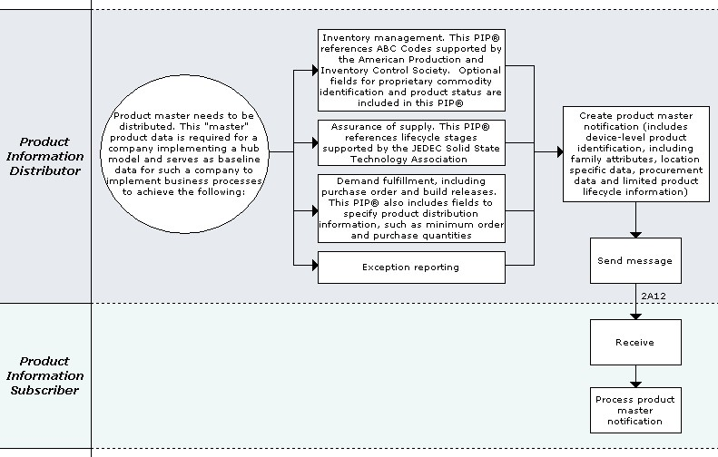
Figure 1: Business Process Scope Diagram

PIP Business Document
Business Document are generated and exchanged by roles performing activities in this PIP. Business Document is listed and defined in Table 1.
Table 1: PIP Business Document
Business Document | Description
Product Master Distribution | An unsolicited notification of the Product Master information. The status reflects the current state of the Product Master at the specified location at the time of the notification.

PIP Business Process Flow Diagram
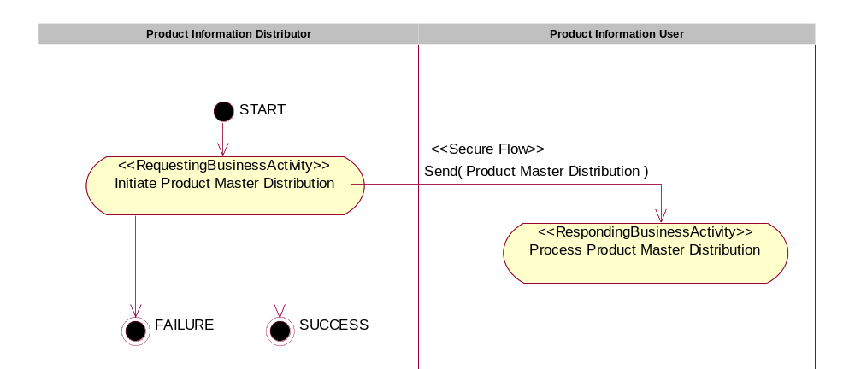
Figure 2: Activity Diagram of Distribute Product Master

PIP Start State
The start state is comprised of the following conditions:
Table 2: PIP Start State
 | Approved | Exist |  | Valid | Non-Repudiated | Retry Count | Authorized
 | Approved | Party | In Backend System
TPA |  |  | 
Sending Partner |  |  |  | 
Receiving Partner |  | 
Business Document |  |  |  | 

PIP End States
The end state is comprised of the following conditions:
Table 3: PIP End State
 | Approved | Exist |  | Valid | Non-Repudiated | Retry Count | Authorized
 | Approved | Party | In Backend system
Acknowledgment of Receipt |  |  |  | 
Receiving Partner |  |  |  |  |  |  | 
The PIP failure state is comprised of one or more of the following conditions:
Table 4: PIP Failure State
 | NO | Exceeded
Success | 
Retry Count |  | 

Partner Role Descriptions
Table 5 describes the partner roles in this PIP.
Table 5: Partner Role Description
Role Name | Role Description
Product Information Distributor | A supplier of products, i.e. a component manufacturer, contract manufacturer or distributor.
Product Information User | A purchaser of products, i.e. a manufacturer who buys components, a distributor who resells components or an OEM.

Business Process Activity Controls
Table 6 describes the interaction between roles performing business activity in this PIP.
Table 6: Business Activity Description
Role  Name | Activity Name | Activity Description
Product Information Distributor | Initiate Product Master Distribution | The Product Information Distributor distributes a Product Master to a destination address.

Table 7 details the security, audit and process controls relating to activity performed in the PIP.
Table 7: Business Activity Performance Control
Role  Name | Activity  Name | Acknowledgment  of Receipt |  | Time to Perform | Retry Count | Is Authorization Required? | Non-Repudiation of Origin and Content?
Role  Name | Activity  Name | Non-Repudiation Required? | Time to Acknowledge
Product Information Distributor | Initiate Product Master Distribution | N | 2 hrs | N/A | 3 | N | N

Network and Implementation Specification
Each network component maps into a role of the PIP model. Table 8 specifies the mapping between roles and network components.
Table 8: Network Component Specification
Network Component | Classification | Maps to Role in Business Process
Product Information Distributor Service | Business Service | Product Information Distributor
Product Information User Service | Business Service | Product Information User

Each business action maps to a Business Document of the PIP model. Table 9 specifies the mapping between Business Documents and business actions.
Table 9: Business Action – Business Document Mapping
Business Action | Business Document | Document Function
Product Master Distribution Action | Product Master Distribution | Request

Business Transaction Dialog Specification
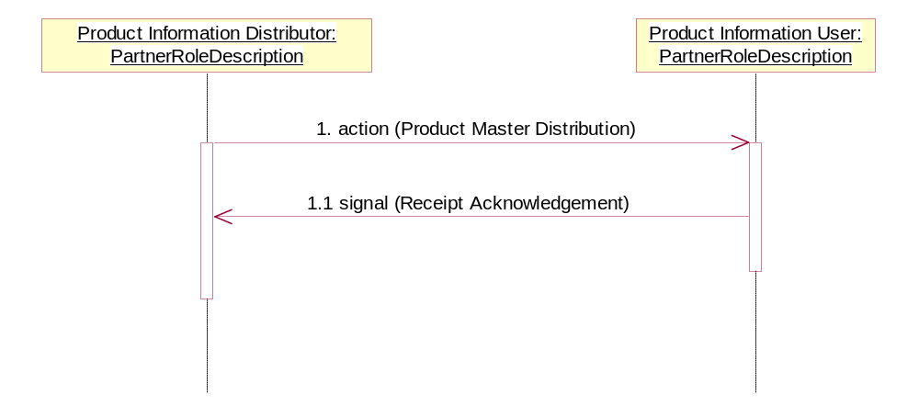
Figure 3: Sequence Diagram of Distribute Product Master

Message Exchange Controls
Table 10: Message Exchange Control
# | Name |  | Time to Acknowledge Receipt Signal |  | Time to Respond to Action |  | Included in Time to Perform |  | Is Authorization Required? |  | Is Non-Repudiation Required? |  | Is Secure Transport Required?
1. |  | Product Master Distribution |  | 2 hrs |  | N/A |  | N/A |  | N |  | N |  | Y
1.1. |  | Receipt Acknowledgment |  | N/A |  | N/A |  | N/A |  | N |  | N |  | Y

Communications Specification
Table 11: Dialog: Service-Service
# | Business Message | Digital Signature Required? | SSL Required?
1. | Product Master Distribution | Y | Y
1.1. | Receipt Acknowledgment | Y | Y

