

Description of 2A13 Message

PIP® 2A13
Validated 11.00.00

Specification Information
Name | Description of 2A13 Message
PIP | Distribute Material Composition Information
Cluster | Product Information
Segment | Preparation for Distribution
Publication Date | 10 Jan 2005
Version Identifier | V11.00

Table of Content

1. Document Management 6
1.1 Legal Disclaimer 6
1.2 Copyright 6
1.3 Trademarks 6
1.4 Acknowledgments 6
1.5 Related Documents 7
1.6 Document Version History 7
1.7 Document Purpose 7
1.8 Document Structure 7
2. Interchange Model 8
2.1 MaterialCompositionInformationDistribution 8
2.1.1 Interchange Diagram 8
2.1.2 Dependency Diagram 9
2.1.3 MaterialCompositionInformationDistribution 9
2.1.4 ProductInformation 10
2.1.5 ProductInformationHeader 12
2.1.6 ProductInformationObject 12
3. Domain Model 13
3.1 Design 13
3.1.1 Design 13
3.1.1.1 Dependency Diagram 14
3.1.1.2 ActualValue 14
3.1.1.3 Attachment 15
3.1.1.4 CAS 15
3.1.1.5 DependentCondition 16
3.1.1.6 Mass 17
3.1.1.7 MassPercentage 18
3.1.1.8 Material 18
3.1.1.9 MaterialMass 19
3.1.1.10 Note 20
3.1.1.11 ProductMass 20
3.1.1.12 Radioactivity 21
3.1.1.13 ReferenceLocator 22
3.1.1.14 ReferenceLocatorChoice 23
3.1.1.15 Subpart 23
3.1.1.16 Substance 24
3.1.1.17 SubstanceIdentification 26
3.1.1.18 SubstanceIdentificationChoice 26
3.1.1.19 SubstanceMass 27
3.1.1.20 Tolerance 27
3.1.1.21 url 28
3.1.1.22 Value 28
3.1.2 CodeList 29
3.1.2.1 ActionCode 29
3.1.2.2 Level 29
4. Universal Structure 30
4.1 ContactInformation 30
4.1.1 ContactInformation 30
4.2 DataType 30
4.2.1 Contact 30
4.2.2 Duns 31
4.2.3 DunsPlus4 31
4.2.4 Gtin 32
4.2.5 PercentAmount 32
4.3 Document 33
4.3.1 BusinessDocumentReference 33
4.4 Locations 33
4.4.1 AlternativeIdentifier 33
4.5 PartnerIdentification 34
4.5.1 KnownPartner 34
4.5.2 PartnerIdentification 35
4.5.3 PartnerIdentificationChoice 35
4.5.4 SpecifiedKnownPartner 36
4.6 ProductIdentification 36
4.6.1 ProductDescription 36
4.6.2 ProductIdentification 37
4.6.3 ProductIdentificationChoice 37
4.6.4 TextualDescription 37
4.7 CodeList 38
4.7.1 Language 38
4.7.2 DocumentType 38
4.7.3 MimeTypeQualifier 40
4.7.4 UnitOfMeasure 50
4.7.5 ProcessRoleIdentifier 57
5. System Structure 59
5.1 BusinessServiceInformation 59
5.2 ContractInformation 60
5.3 CorrelationInformation 60
5.4 DocumentHeader 61
5.5 DocumentIdentification 62
5.6 DocumentIdentificationChoice 62
5.7 DocumentInformation 62
5.8 DocumentManifest 63
5.9 DocumentSecurity 64
5.10 ManifestItem 65
5.11 PipIdentifier 65
5.12 PipVersion 66
5.13 Receiver 67
5.14 RequestingDocumentInformation 67
5.15 Sender 68
5.16 StandardDocumentIdentification 69
5.17 TpirPipIdentification 69
5.18 VersionIdentifier 70
6. XML Data Type 70
6.1 boolean 70
6.2 dateTime 70
6.3 decimal 70
6.4 float 70
6.5 nonNegativeInteger 70
6.6 positiveInteger 70
6.7 string 71

Table of Figures
Figure 2-1 Interchange 8
Figure 2-2 Dependency 9
Figure 2-3 MaterialCompositionInformationDistribution 9
Figure 2-4 ProductInformation 10
Figure 2-5 ProductInformationHeader 12
Figure 2-6 ProductInformationObject 12
Figure 3-1 Dependency 14
Figure 3-2 ActualValue 14
Figure 3-3 Attachment 15
Figure 3-4 CAS 16
Figure 3-5 DependentCondition 16
Figure 3-6 Mass 17
Figure 3-7 MassPercentage 18
Figure 3-8 Material 18
Figure 3-9 MaterialMass 19
Figure 3-10 Note 20
Figure 3-11 ProductMass 21
Figure 3-12 Radioactivity 21
Figure 3-13 ReferenceLocator 22
Figure 3-14 Subpart 24
Figure 3-15 Substance 25
Figure 3-16 SubstanceIdentification 26
Figure 3-17 SubstanceMass 27
Figure 3-18 Tolerance 27
Figure 3-19 url 28
Figure 3-20 Value 28
Figure 4-1 ContactInformation 30
Figure 4-2 Contact 30
Figure 4-3 Duns 31
Figure 4-4 DunsPlus4 31
Figure 4-5 Gtin 32
Figure 4-6 PercentAmount 32
Figure 4-7 BusinessDocumentReference 33
Figure 4-8 AlternativeIdentifier 33
Figure 4-9 KnownPartner 34
Figure 4-10 PartnerIdentification 35
Figure 4-11 SpecifiedKnownPartner 36
Figure 4-12 ProductDescription 36
Figure 4-13 ProductIdentification 37
Figure 4-14 TextualDescription 38
Figure 5-1 BusinessServiceInformation 59
Figure 5-2 ContractInformation 60
Figure 5-3 CorrelationInformation 60
Figure 5-4 DocumentHeader 61
Figure 5-5 DocumentIdentification 62
Figure 5-6 DocumentInformation 63
Figure 5-7 DocumentManifest 63
Figure 5-8 DocumentSecurity 64
Figure 5-9 ManifestItem 65
Figure 5-10 PipIdentifier 66
Figure 5-11 PipVersion 66
Figure 5-12 Receiver 67
Figure 5-13 RequestingDocumentInformation 67
Figure 5-14 Sender 68
Figure 5-15 StandardDocumentIdentification 69
Figure 5-16 TpirPipIdentification 69
Figure 5-17 VersionIdentifier 70

Document Management

Legal Disclaimer
RosettaNet, its members, officers, directors, employees, or agents shall not be liable for any injury, loss, damages, financial or otherwise, arising from, related to, or caused by the use of this document or the specifications herein, as well as associated guidelines and schemas. The use of said specifications shall constitute your express consent to the foregoing exculpation.

Copyright
©2004 - 2005 RosettaNet. All rights reserved. No part of this publication may be reproduced, stored in a retrieval system, or transmitted, in any form or by any means, electronic, mechanical, photocopying, recording, or otherwise, without the inclusion of this copyright notice. Any derivative works must cite the copyright notice. Any public redistribution or sale of this publication or derivative works requires prior written permission of the publisher.

Trademarks
RosettaNet, Partner Interface Process, PIP and the RosettaNet logo are trademarks or registered trademarks of "RosettaNet," a non-profit organization. All other product names and company logos mentioned herein are the trademarks of their respective owners. In the best effort, all terms mentioned in this document that are known to be trademarks or registered trademarks have been appropriately recognized in the first occurrence of the term.
  - Acknowledgments
This document has been prepared by RosettaNet (http://www.rosettanet.org/) from requirements gathered during the Milestone Program and in conformance with the methodology. Listed below are the legal entities that contributed to the design and development of this PIP.
ADOS Co., Ltd. | Agere Systems
Agilent Technologies | Amkor Technology, Inc.
Centor Software | Cisco Systems
Korea Electronics Industry, including Samsung & LG | Ericsson
Future Electronics Inc. | Globetronics SDH. BHD
Intel Corporation | KYOCERA Corporation
LG Electronics Inc., Quality & Reliability Center | MIMOS Berhad
Motorola | Motorola, Inc.
Motorola Semiconductor Products Sector | Motorola SPS
National Semiconductor | NEC Corporation
NEC Electronics | NEC Electronics (Europe) GmbH
Nichicon Corporation | Nippon Chemi-Con Corporation
Nokia | Nokia Corporation
Nokia Oyj | SAP
Siemens AG | School of Social Ecology, University of California Irvine
Sony | Sony EMCS Corporation
Sony Corporation | Sterling Commerce
STMicroelectronics | STMicroelectronics Inc
STMicroelectronics N.V. | Synapsis Technology, Inc.
Ted Haas Consulting, LLC | Texas Instruments
Texas Instruments, Inc. | Texas Instruments, Japan Ltd.

Related Documents
- Associated PIP Message Schemas (included with PIP Specification only)
- Description of Partner Interface Process for 2A13
- Message Structure

Document Version History
Version | Date | Description
Validated 11.00.00 | 10 Jan 2005 | RosettaNet: Marking the end of validation period with PIP version promotion. Made few changes to the message due to approved change requests submitted by validation partners.

Document Purpose
The purpose of the document is to explain the structure, the association between objects, the content of objects and the definition for single elements to a non-technical audience.

Document Structure
The Message Description document is composed of four sections. The sections are:

- Description of the message objects based on their occurrence in the message.
- Alphabetic listing and description of the data types used in the message.
- Alphabetic listing and description of the simple types used on the message.
- Alphabetic listing and description of the enumerated types (code lists) used in the message.

Interchange Model

MaterialCompositionInformationDistribution

Interchange Diagram
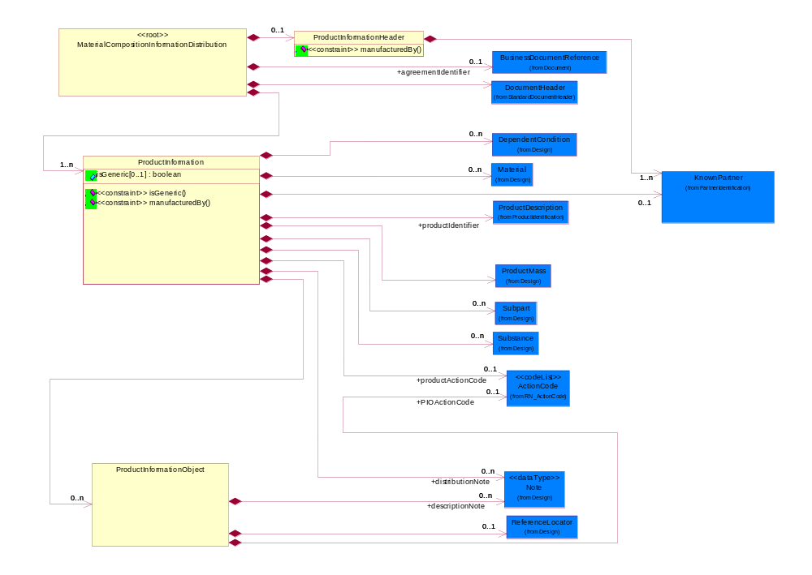
Figure 2-1 Interchange

Dependency Diagram
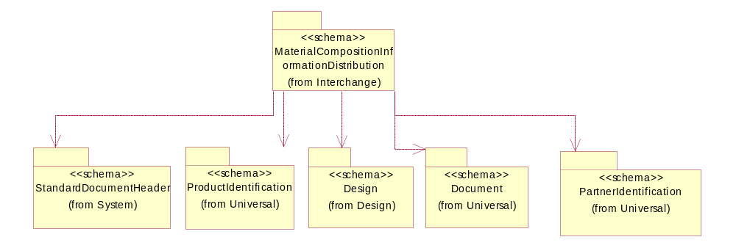
Figure 2-2 Dependency

MaterialCompositionInformationDistribution
A message wrapper or root element for PIP2A13

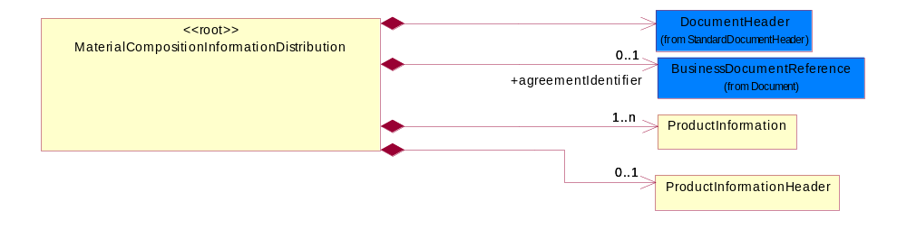
Figure 2-3 MaterialCompositionInformationDistribution

Composition | Cardinality | Type | Documentation
DocumentHeader | 1 | DocumentHeader | The object allows for the identification of the sender and receiver of the business document.
ProductInformationHeader | 0..1 | ProductInformationHeader | The collection of header information(s) related to one or more product.
agreementIdentifier | 0..1 | BusinessDocumentReference | The business document reference object allows for the indirect referencing of a relationship to other business related documents.
ProductInformation | 1..n | ProductInformation | The collection of information related to a product or a product family.

ProductInformation
The collection of information related to a product or a product family.

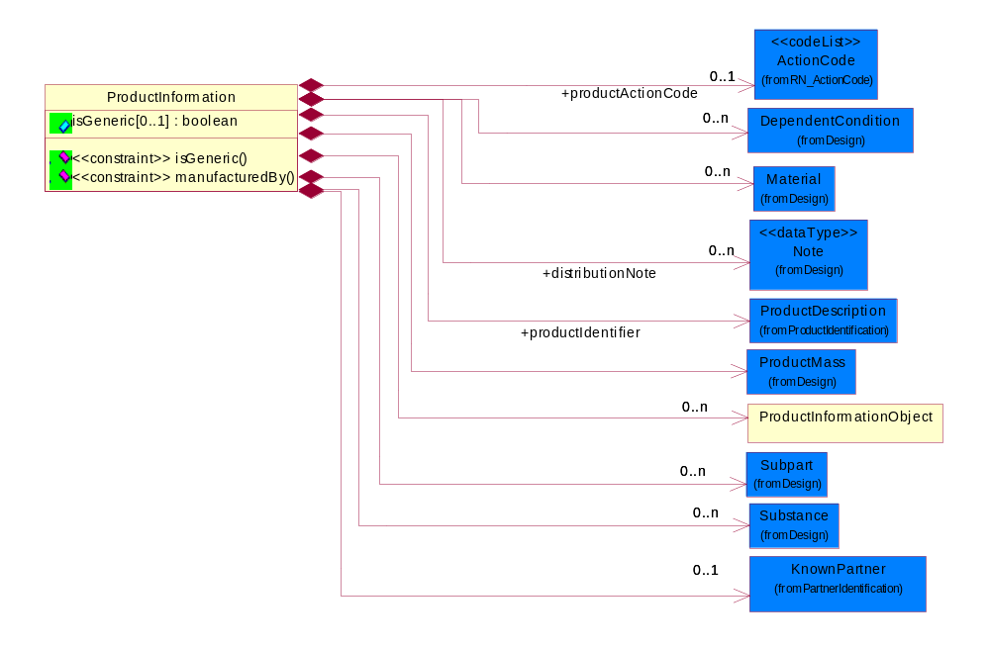
Figure 2-4 ProductInformation
Attribute | Type | Documentation
isGeneric[0..1] | boolean | To identify the subsequent product reporting as a product family (generic) reporting.

Composition | Cardinality | Type | Documentation
ProductMass | 1 | ProductMass | Product Total Mass (weight) MUST be specified in KIG (kg) (kilogram) even the actual value ranges from nano grams to giga kilograms. The unit of measure would still be KIG (kg).
Subpart | 0..n | Subpart | Subpart indicates the aggregation for all such subparts; i.e., if there are four such subparts, the values indicated are totaled and sent.  A typical implementation of subpart(s) within subpart(s) would be in one of the following nested levels of 0, 1 and/or 2.
Substance | 0..n | Substance | Substance definition block/class.
Material | 0..n | Material | Material definition block/class.
DependentCondition | 0..n | DependentCondition | An operational or testing condition necessary to produce the value for a given property. To report results of a material composition when "one or more conditions" have been applied to it. The list of conditions could grow, such is the case of a product, the list of conditions could be represented as a table of values. The example below explains the use of "Dependent conditions".
ProductInformationObject | 0..n | ProductInformationObject | A Meta data structure used to describe a logical representation of arbitrary data. This is also known as Attachments. This will be used as a sub-class subordinate to the ProductInformation data structure.
productIdentifier | 1 | ProductDescription | The business document must allow for the identification of the product and multiple textual descriptions of a product.
productActionCode | 0..1 | ActionCode | Code identifying the business action that must be performed on or with data. These codes will result in a subsequent action to the Material Composition data.
distributionNote | 0..n | Note | Additonal notation for the notification, product information, substance or radioactivity.
KnownPartner | 0..1 | KnownPartner | The business document must describe the trading partners in the business transaction.

Constraint | Documentation
isGeneric | If occurrence of isGeneric is 1 then the value of isGeneric MUST be 'true'.
manufacturedBy | If occurrence of KnownPartner is 1 then the value of KnownPartner/ProcessRoleIdentifier MUST be 'MFG'.

ProductInformationHeader
The collection of header information(s) related to one or more product.

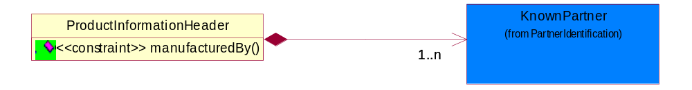
Figure 2-5 ProductInformationHeader

Composition | Cardinality | Type | Documentation
KnownPartner | 1..n | KnownPartner | The business document must describe the trading partners in the business transaction.

Constraint | Documentation
manufacturedBy | If occurrence of ProductInformationHeader is 1 then the value of KnownPartner/ProcessRoleIdentifier MUST be 'MFG'.

ProductInformationObject
A Meta data structure used to describe a logical representation of arbitrary data. This is also known as Attachments. This will be used as a sub-class subordinate to the ProductInformation data structure.

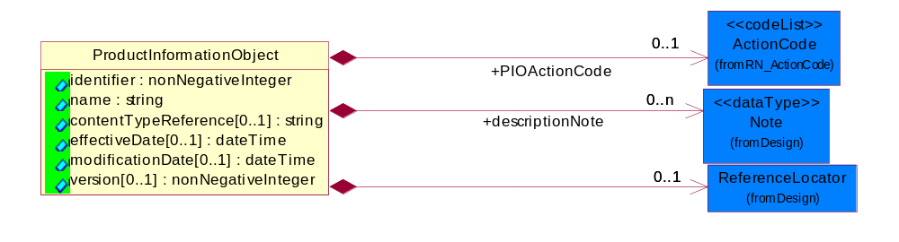
Figure 2-6 ProductInformationObject

Attribute | Type | Documentation
identifier | nonNegativeInteger | The identifier for a ProductInformationObject unique in the namespace of the notification.
name | string | The name of the ProductInformationObject, also known as Attachment.
contentTypeReference[0..1] | string | A unique identifier that defines the category of information provided by this ProductInformationObject.
effectiveDate[0..1] | dateTime | The date when the information becomes effective.
modificationDate[0..1] | dateTime | The last time a change was made.
version[0..1] | nonNegativeInteger | An arbitrary identifier indicating a content revision level.

Composition | Cardinality | Type | Documentation
PIOActionCode | 0..1 | ActionCode | Code identifying the business action that must be performed on or with data. These codes will result in a subsequent action to the Material Composition data.
ReferenceLocator | 0..1 | ReferenceLocator | Meta data describing a logical representation of a set of arbitrary data. A collection of properties identifying a ProductInformationObject with an attachment.
descriptionNote | 0..n | Note | Additonal notation for the notification, product information, substance or radioactivity.

Domain Model

Design

Design
Enables distribution and periodic update of product and detailed design and composite information, including product change notices, product technical specifications, product catalogs, Design Engineering information and material composition

Dependency Diagram
Design
<<schema>>
(from Design)
DataType
<<schema>>
(from Universal)
PhysicalDimension
<<schema>>
(from Universal)
ProductIdentification
<<schema>>
(from Universal)
CodeList
(from Universal)
XMLDataType
(from Logical View)
Figure 3-7 Dependency

ActualValue
Collection of elements to capture value and type.

Tolerance
UnitOfMeasure
(from RN_UnitOfMeasure)
<<codeList>>
Level
(from RN_Level)
<<codeList>>
ActualValue
value : float
<<constraint>> negativeTolerance()
<<constraint>> positiveTolerance()
0..1
+negativeTolerance
0..1
0..1
+positiveTolerance
0..1
0..1
+type
0..1
Figure 3-8 ActualValue

Attribute | Type | Documentation
value | float | The actual value recorded from the tests conducted based on test condition or dependent conditions. Extension to DependentCondition.

Composition | Cardinality | Type | Documentation
negativeTolerance | 0..1 | Tolerance | Collection defined to specify tolerance levels. Extension to DependentCondition.
positiveTolerance | 0..1 | Tolerance | Collection defined to specify tolerance levels. Extension to DependentCondition.
UnitOfMeasure | 1 | UnitOfMeasure | Code identifying a product unit of measure.
type | 0..1 | Level | This is to qualify the type of the product, material or substance mass either maximum, minimum, typical, nominal independently or with any combination such as when specifying range of mass between minimum and maximum. In this case, the mass reporting will loop and for each instance it will have different Level entry.

Constraint | Documentation
negativeTolerance | If value of type/Level is equal to 'NOM' then the occurrence of negativeTolerance MUST be 1.
positiveTolerance | If value of type/Level is equal to 'NOM' then the occurrence of positiveTolerance MUST be 1.

Attachment
Meta data describing a logical representation of a set of arbitrary data. A collection of properties identifying a ProductInformationObject with an attachment.

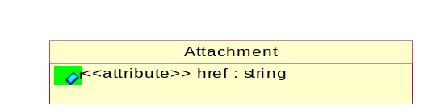
Figure 3-9 Attachment

Attribute | Type | Documentation
href | string | A reference to the Content-Id attribute of MIME-attachment specified as "cid:MIME_content-id_of_attachment" in accrodance with RFC 2392 (http://rfc.fh-koeln.de/rfc/html/rfc2392.html) and RNIF 2.0

CAS
The CAS identifier is part of the CAS Registry and is a numeric identifier that can contain up to 9 digits, divided by hyphens into 3 parts: the right digit is a check digit to verify by computer the validity and uniqueness of the entire number for example, 58-08-2 is the CAS Registry Number for caffeine. If other than CAS numbers are used, this string pattern could be different.

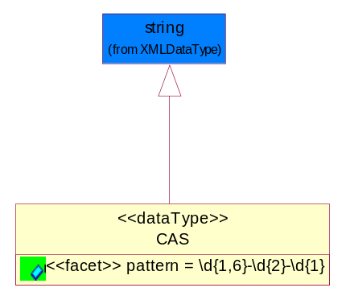
Figure 3-10 CAS

Attribute | Type | Documentation
pattern |  | \d{1,6}-\d{2}-\d{1}

DependentCondition
An operational or testing condition necessary to produce the value for a given property. To report results of a material composition when "one or more conditions" have been applied to it. The list of conditions could grow, such is the case of a product, the list of conditions could be represented as a table of values. The example below explains the use of "Dependent conditions".

ActualValue
DependentCondition
name[0..1] : string
1..n
1..n
ActionCode
(from RN_ActionCode)
<<codeList>>
Figure 3-11 DependentCondition

Attribute | Type | Documentation
name[0..1] | string | The name of the condition which could be a pre-defined rule in Information Distribution Agreement. For example, ISO test #123ABC could be the condition rule used to test outer wrapping of a power cord which has 0.1% Cadmium.

Composition | Cardinality | Type | Documentation
ActionCode | 1 | ActionCode | Code identifying the business action that must be performed on or with data. These codes will result in a subsequent action to the Material Composition data.
ActualValue | 1..n | ActualValue | Collection of elements to capture value and type.

Mass
Based on ECTD/IEC specification, Mass should be specified in kilogram (KG) per IEC 61360 - 1 (Annex B) - (http://www.iec.ch/tc3/txt/143.htm) format for floating point, positive or negative.
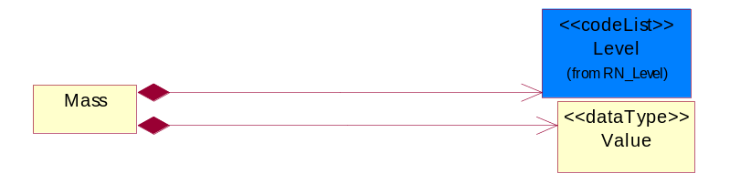
Figure 3-12 Mass
Composition | Cardinality | Type | Documentation
Value | 1 | Value | Based on ECTD/IEC specification, Mass should be specified in kilogram (KG) per IEC 61360 - 1 (Annex B) - (http://www.iec.ch/tc3/txt/143.htm) format for floating point, positive or negative.  Example:  a. 2kg - will be specified as 2.0E KG  b. 200g - will be specified as 200.0E - 3 KG  c. 20mg - will be specified as 20.0E- 6 KG
Level | 1 | Level | This is to qualify the type of the product, material or substance mass either maximum, minimum, typical, nominal independently or with any combination such as when specifying range of mass between minimum and maximum. In this case, the mass reporting will loop and for each instance it will have different Level entry.

MassPercentage
Weight percentage of total mass. Usually specified for parts per million (ppm). A number representing a percentage value, e.g. 75.125 represents 75 1/8 percent.

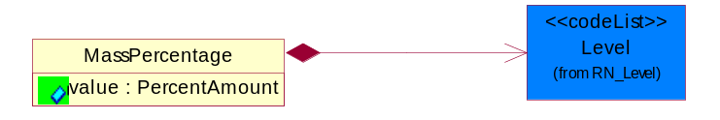
Figure 3-13 MassPercentage

Attribute | Type | Documentation
value | PercentAmount | A number representing a percentage value, e.g. 75.125 represents 75 1/8 percent

Composition | Cardinality | Type | Documentation
Level | 1 | Level | This is to qualify the type of the product, material or substance mass either maximum, minimum, typical, nominal independently or with any combination such as when specifying range of mass between minimum and maximum. In this case, the mass reporting will loop and for each instance it will have different Level entry.

Material
Material definition block/class.

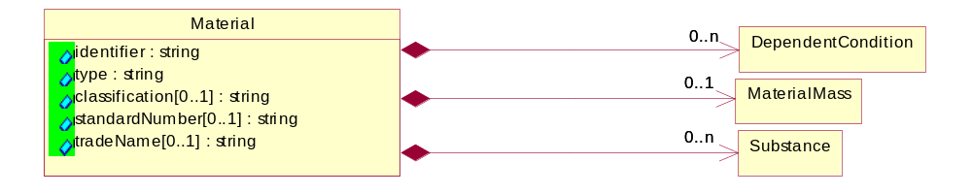
Figure 3-14 Material

Attribute | Type | Documentation
identifier | string | Identifier for the material either using ISO, or MaterialClassification
type | string | The name of the material e.g Copper, Alloy, Polymer, Glass, etc.
classification[0..1] | string | Classification e.g. JGPSSI classification system
standardNumber[0..1] | string | ISO or other international standards number identifying material
tradeName[0..1] | string | Commercial name of the material

Composition | Cardinality | Type | Documentation
MaterialMass | 0..1 | MaterialMass | Material Total Mass (weight) MUST be specified in KIG (kg) (kilogram) even the actual value ranges from nano grams to giga kilograms. The unit of measure would still be KIG (kg).
DependentCondition | 0..n | DependentCondition | An operational or testing condition necessary to produce the value for a given property. To report results of a material composition when "one or more conditions" have been applied to it. The list of conditions could grow, such is the case of a product, the list of conditions could be represented as a table of values. The example below explains the use of "Dependent conditions".
Substance | 0..n | Substance | Substance definition block/class.

MaterialMass
Material Total Mass (weight) MUST be specified in KIG (kg) (kilogram) even the actual value ranges from nano grams to giga kilograms. The unit of measure would still be KIG (kg).

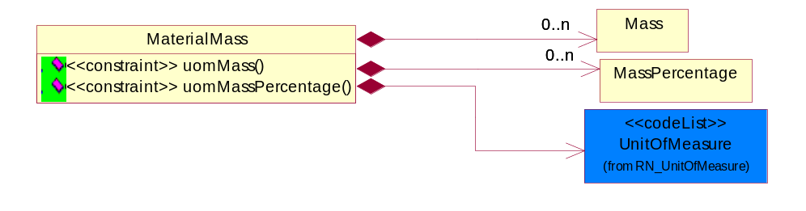
Figure 3-15 MaterialMass

Composition | Cardinality | Type | Documentation
Mass | 0..n | Mass | Based on ECTD/IEC specification, Mass should be specified in kilogram (KG) per IEC 61360 - 1 (Annex B) - (http://www.iec.ch/tc3/txt/143.htm) format for floating point, positive or negative.
UnitOfMeasure | 1 | UnitOfMeasure | Code identifying a product unit of measure.
MassPercentage | 0..n | MassPercentage | Weight percentage of total mass. Usually specified for parts per million (ppm). A number representing a percentage value, e.g. 75.125 represents 75 1/8 percent.

Constraint | Documentation
uomMass | If occurrence of Mass is between 1 and unbounded then the value of UnitOfMeasure MUST be 'KIG'.
uomMassPercentage | If occurrence of MassPercentage is between 1 and unbounded then the value of UnitOfMeasure MUST be 'KIG'.

Note
Additonal notation for the notification, product information, substance or radioactivity.

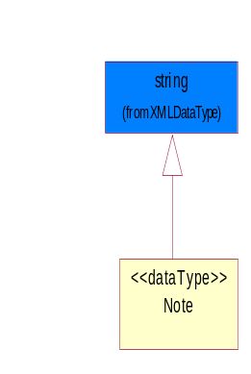
Figure 3-16 Note

ProductMass
Product Total Mass (weight) MUST be specified in KIG (kg) (kilogram) even the actual value ranges from nano grams to giga kilograms. The unit of measure would still be KIG (kg).


Mass
UnitOfMeasure
(from RN_UnitOfMeasure)
<<codeList>>
MassPercentage
ProductMass
<<constraint>> uomMass( )
1..n
1..n
0..n
0..n
Figure 3-17 ProductMass
Composition | Cardinality | Type | Documentation
Mass | 1..n | Mass | Based on ECTD/IEC specification, Mass should be specified in kilogram (KG) per IEC 61360 - 1 (Annex B) - (http://www.iec.ch/tc3/txt/143.htm) format for floating point, positive or negative.
UnitOfMeasure | 1 | UnitOfMeasure | Code identifying a product unit of measure.
MassPercentage | 0..n | MassPercentage | Weight percentage of total mass. Usually specified for parts per million (ppm). A number representing a percentage value, e.g. 75.125 represents 75 1/8 percent.

Constraint | Documentation
uomMass | If occurrence of Mass is between 1 and unbounded then the value of UnitOfMeasure MUST be 'KIG'.

Radioactivity
Radioactivity isotope name, code and other details

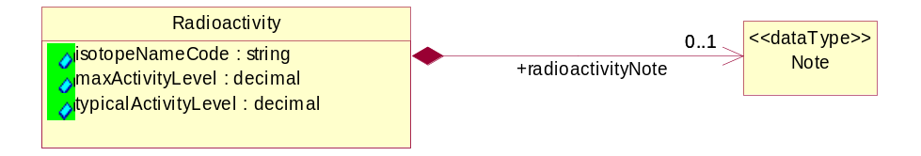
Figure 3-18 Radioactivity
Attribute | Type | Documentation
isotopeNameCode | string | If the substance is radioactive the radioactive Isotope element name and code e.g. Ni-63 should be provided.
maxActivityLevel | decimal | The maximum activity level in MBecquerel's (MBq).
typicalActivityLevel | decimal | The typical activity level in MBecquerel's (MBq)

Composition | Cardinality | Type | Documentation
radioactivityNote | 0..1 | Note | Additonal notation for the notification, product information, substance or radioactivity.

ReferenceLocator
Meta data describing a logical representation of a set of arbitrary data. A collection of properties identifying a ProductInformationObject with an attachment.

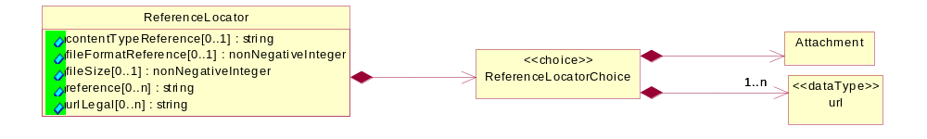

Figure 3-19 ReferenceLocator

Attribute | Type | Documentation
contentTypeReference[0..1] | string | A unique identifier that defines the category of information provided by this ProductInformationObject
fileFormatReference[0..1] | nonNegativeInteger | A unique identifier that defines the type data encoding for this ProductInformationObject.
fileSize[0..1] | nonNegativeInteger | The size of an object.
reference[0..n] | string | Represented as a URL (Uniform Resource Locator defined in accordance with RFC 2396 http://www.w3.org/Addressing). The URL's purpose is to provide supplementary information related to the ProductInformationObject.
urlLegal[0..n] | string | Using a URL (Uniform Resource Locator defined in accordance with RFC 2396 http://www.w3.org/Addressing) to describe terms, conditions, disclaimers, warnings, limitations, or other information related to the ProductInformationObject.

Composition | Cardinality | Type | Documentation
ReferenceLocatorChoice | 1 | ReferenceLocatorChoice

ReferenceLocatorChoice

Composition | Cardinality | Type | Documentation
url | 1..n | url | The URL (Uniform Resource Locator defined in accordance with RFC 2396 http://www.w3.org/Addressing) is used for accessing dynamic supplementary information maintained by a domain authority. It is used as a storage area for an attachment. When this request is rendered it will return only the requested attached data.
Attachment | 1 | Attachment | Meta data describing a logical representation of a set of arbitrary data. A collection of properties identifying a ProductInformationObject with an attachment.

Subpart
Subpart indicates the aggregation for all such subparts; i.e., if there are four such subparts, the values indicated are totaled and sent.
A typical implementation of subpart(s) within subpart(s) would be in one of the following nested levels of 0, 1 and/or 2.

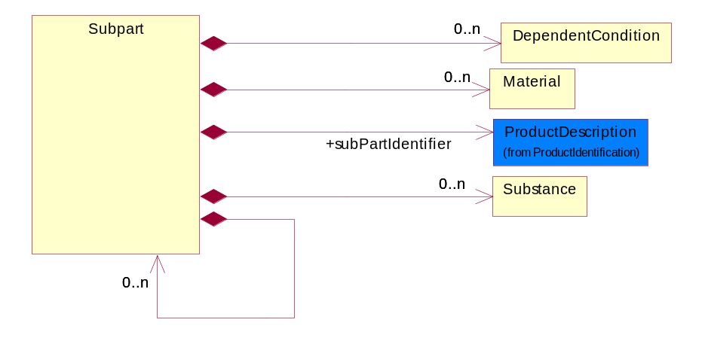
Figure 3-20 Subpart
Composition | Cardinality | Type | Documentation
subPartIdentifier | 1 | ProductDescription | The business document must allow for the identification of the product and multiple textual descriptions of a product.
DependentCondition | 0..n | DependentCondition | An operational or testing condition necessary to produce the value for a given property. To report results of a material composition when "one or more conditions" have been applied to it. The list of conditions could grow, such is the case of a product, the list of conditions could be represented as a table of values. The example below explains the use of "Dependent conditions".
Material | 0..n | Material | Material definition block/class.
Substance | 0..n | Substance | Substance definition block/class.

Substance
Substance definition block/class.

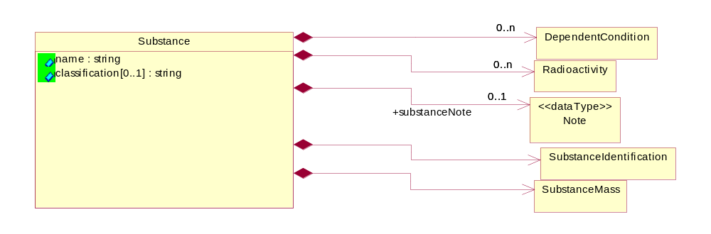
Figure 3-21 Substance

Attribute | Type | Documentation
name | string | The substance name e.g. Copper (Cu) or group name e.g. Nickel compunds
classification[0..1] | string | Classification e.g. JGPSSI classification system

Composition | Cardinality | Type | Documentation
Radioactivity | 0..n | Radioactivity | Radioactivity isotope name, code and other details
substanceNote | 0..1 | Note | Additonal notation for the notification, product information, substance or radioactivity.
SubstanceMass | 1 | SubstanceMass | Substance Total Mass (weight) MUST be specified in KIG (kg) (kilogram) even the actual value ranges from nano grams to giga kilograms. The unit of measure would still be KIG (kg).
SubstanceIdentification | 1 | SubstanceIdentification | A structured and broadly accepted way of identifying a substance. RosettaNet has adopted CAS (Chemical Abstract Numbering System), http://chemfinder.camsoft.com or any alternative identifiers.
DependentCondition | 0..n | DependentCondition | An operational or testing condition necessary to produce the value for a given property. To report results of a material composition when "one or more conditions" have been applied to it. The list of conditions could grow, such is the case of a product, the list of conditions could be represented as a table of values. The example below explains the use of "Dependent conditions".

SubstanceIdentification
A structured and broadly accepted way of identifying a substance. RosettaNet has adopted CAS (Chemical Abstract Numbering System), http://chemfinder.camsoft.com or any alternative identifiers.

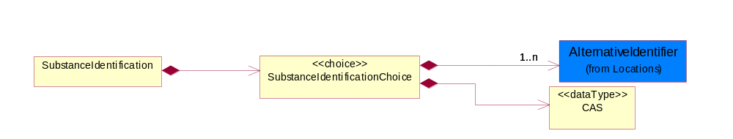
Figure 3-22 SubstanceIdentification
Composition | Cardinality | Type | Documentation
SubstanceIdentificationChoice | 1 | SubstanceIdentificationChoice

SubstanceIdentificationChoice

Composition | Cardinality | Type | Documentation
CAS | 1 | CAS | The CAS identifier is part of the CAS Registry and is a numeric identifier that can contain up to 9 digits, divided by hyphens into 3 parts: the right digit is a check digit to verify by computer the validity and uniqueness of the entire number for example, 58-08-2 is the CAS Registry Number for caffeine. If other than CAS numbers are used, this string pattern could be different.
AlternativeIdentifier | 1..n | AlternativeIdentifier | Identifies the specified code and the name of the organization that a code is utilized from.

SubstanceMass
Substance Total Mass (weight) MUST be specified in KIG (kg) (kilogram) even the actual value ranges from nano grams to giga kilograms. The unit of measure would still be KIG (kg).
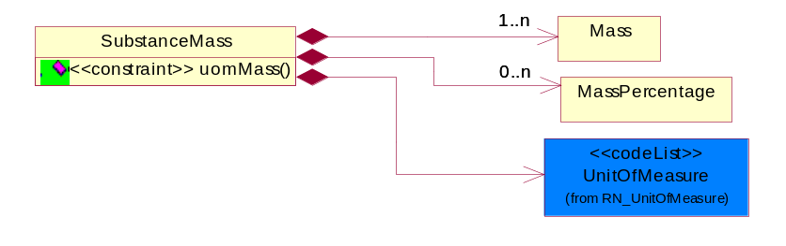
Figure 3-23 SubstanceMass
Composition | Cardinality | Type | Documentation
Mass | 1..n | Mass | Based on ECTD/IEC specification, Mass should be specified in kilogram (KG) per IEC 61360 - 1 (Annex B) - (http://www.iec.ch/tc3/txt/143.htm) format for floating point, positive or negative.
UnitOfMeasure | 1 | UnitOfMeasure | Code identifying a product unit of measure.
MassPercentage | 0..n | MassPercentage | Weight percentage of total mass. Usually specified for parts per million (ppm). A number representing a percentage value, e.g. 75.125 represents 75 1/8 percent.

Constraint | Documentation
uomMass | If occurrence of Mass is between 1 and unbounded then the value of UnitOfMeasure MUST be 'KIG'.

Tolerance
Collection defined to specify tolerance levels. Extension to DependentCondition.
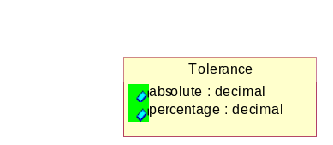
Figure 3-24 Tolerance

Attribute | Type | Documentation
absolute | decimal | A tolerance expressed as a real number
percentage | decimal | A tolerance expressed as a percentage of the current value

url
The URL (Uniform Resource Locator defined in accordance with RFC 2396 http://www.w3.org/Addressing) is used for accessing dynamic supplementary information maintained by a domain authority. It is used as a storage area for an attachment. When this request is rendered it will return only the requested attached data.

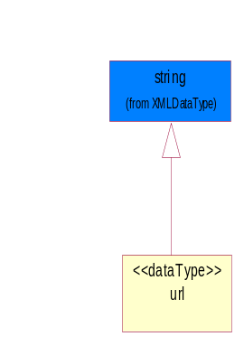
Figure 3-25 url

Value
Based on ECTD/IEC specification, Mass should be specified in kilogram (KG) per IEC 61360 - 1 (Annex B) - (http://www.iec.ch/tc3/txt/143.htm) format for floating point, positive or negative.

Example:
a. 2kg - will be specified as 2.0E KG
b. 200g - will be specified as 200.0E - 3 KG
c. 20mg - will be specified as 20.0E- 6 KG

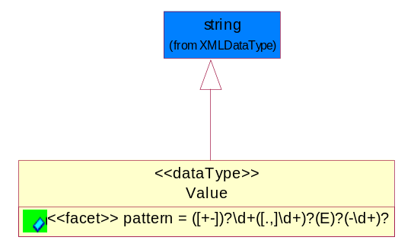
Figure 3-26 Value
Attribute | Type | Documentation
pattern |  | For reals, MAY have (+-) and then MUST have 1 or more digits, and then MUST have a period (or comma) and then MUST have 1 or more digits.  For floating numbers, MAY have (+-) and then MUST have 1 or more digits, and then MUST have a period (or comma) and then MUST have 1 or more digits and then MAY have 'E' and then MAY have (-) sign and then MAY have 1 or more digits.

CodeList

ActionCode
Code identifying the business action that must be performed on or with data. These codes will result in a subsequent action to the Material Composition data.

Name | Documentation
ADD | Add the business information to an information system
CHG | The change request made accepted
DEL | Delete the business infomation from an information system
REQ | The business information accepted with change
REV | Revise the business information from an information system

Level
This is to qualify the type of the product, material or substance mass either maximum, minimum, typical, nominal independently or with any combination such as when specifying range of mass between minimum and maximum. In this case, the mass reporting will loop and for each instance it will have different Level entry.

Name | Documentation
MAX | A Maximum level of the mass (weight) MUST be specified as KIG (kilogram) using ECTD/IEC/ISO Specification for the UOM field.
MIN | A Minimum level of the mass (weight) MUST be specified as KIG (kilogram) using ECTD/IEC/ISO Specification for the UOM field.
NOM | A Nominal level of the mass (weight) MUST be specified as KIG (kilogram) using ECTD/IEC/ISO Specification for the UOM field.
TYP | A Typical level of the mass (weight) MUST be specified as KIG (kilogram) using ECTD/IEC/ISO Specification for the UOM field.

Universal Structure

ContactInformation

ContactInformation
The business document must allow for the identification of the name of the department, service or individual to be contacted regarding the context of the business document.

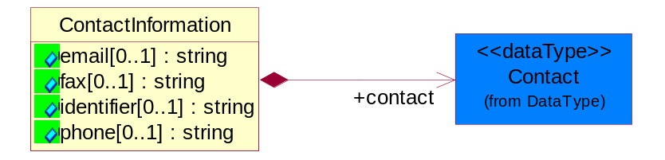
Figure 4-27 ContactInformation
Attribute | Type | Documentation
email[0..1] | string | The electronic mail for the specified contact.
fax[0..1] | string | The fax number for the specified contact.
identifier[0..1] | string | Identifies the role of the contact (i.e. Service Technician, Account Manager) in the Business Process.
phone[0..1] | string | The telephone number for the specified contact.

Composition | Cardinality | Type | Documentation
contact | 1 | Contact | The name of the department, service or individual to be contacted within the organization.

DataType

Contact
The name of the department, service or individual to be contacted within the organization.
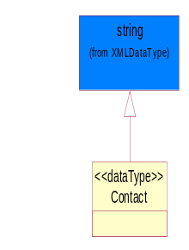
Figure 4-28 Contact

Duns
A number assigned by Dun and Bradstreet to identify a business location.

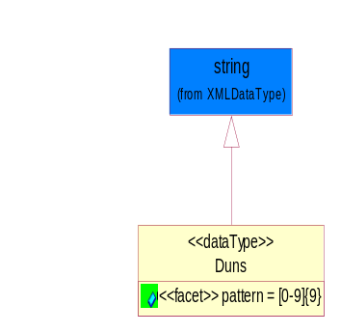
Figure 4-29 Duns
Attribute | Type | Documentation
pattern |  | [0-9]{9}

DunsPlus4
A identifier to specify a specific location within a business location.
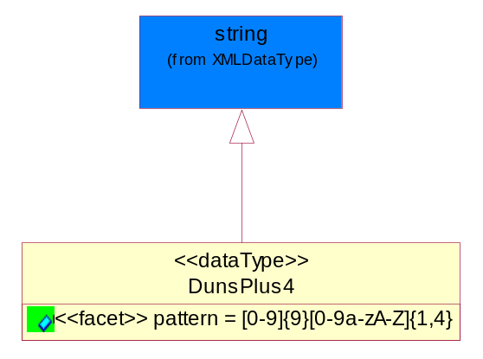
Figure 4-30 DunsPlus4
Attribute | Type | Documentation
pattern |  | Data Universal Numbering System +4 (DUNS+4) number means the DUNS number assigned by Dun and Bradstreet, Inc. (D&B) plus an alphanumeric of length 4 suffix that may be assigned by a business concern.

Gtin
Global Trade Identification Number (GTIN).
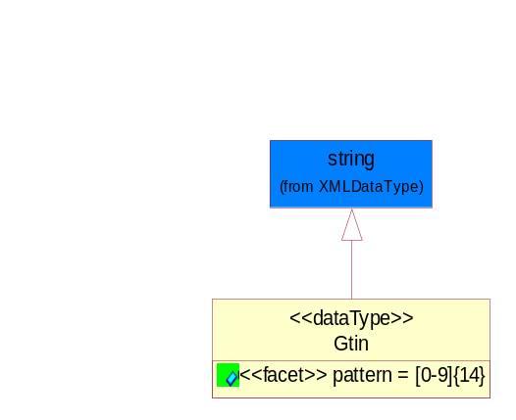
Figure 4-31 Gtin
Attribute | Type | Documentation
pattern |  | [0-9]{14}

PercentAmount
A number representing a percentage value, e.g. 75.125 represents 75 1/8 percent.

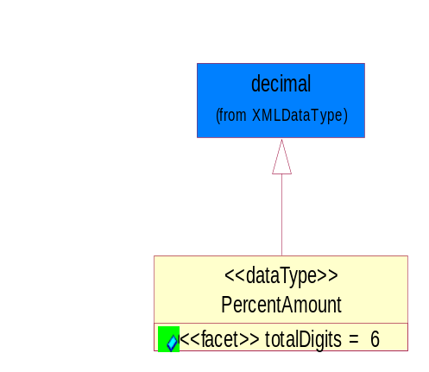
Figure 4-32 PercentAmount
Attribute | Type | Documentation
totalDigits |  | 6

Document

BusinessDocumentReference
The business document reference object allows for the indirect referencing of a relationship to other business related documents.

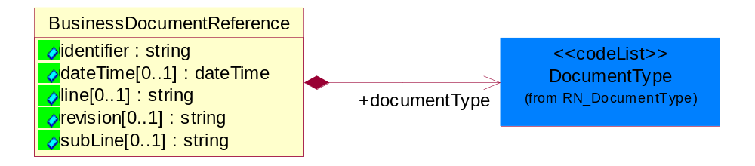
Figure 4-33 BusinessDocumentReference
Attribute | Type | Documentation
identifier | string | Unique identification of the referenced business document.
dateTime[0..1] | dateTime | The date-time stamp indicating on the referenced business document.
line[0..1] | string | References the specific line number of the specified business document.
revision[0..1] | string | Referenced the revision of the specified business document.
subLine[0..1] | string | References the specific subline number of the specified business document.

Composition | Cardinality | Type | Documentation
documentType | 1 | DocumentType | A code identifying the business context of a document.

Locations

AlternativeIdentifier
Identifies the specified code and the name of the organization that a code is utilized from.

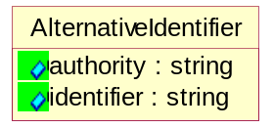
Figure 4-34 AlternativeIdentifier

Attribute | Type | Documentation
authority | string | The name of the organization that a code is utilized from.
identifier | string | The specified code to represent an entity (e.g. product, location, partner, etc.)

PartnerIdentification

KnownPartner
The business document must describe the trading partners in the business transaction.

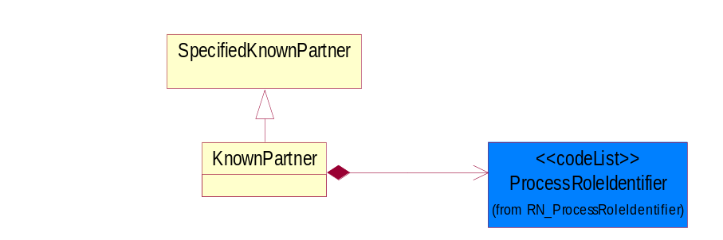
Figure 4-35 KnownPartner
Composition | Cardinality | Type | Documentation
ProcessRoleIdentifier | 1 | ProcessRoleIdentifier | Describes the role of the partner in the business process. A partner will fulfill at least one or more roles during the business process.

PartnerIdentification
The business document must allow for the identity of one or more parties to the transaction.
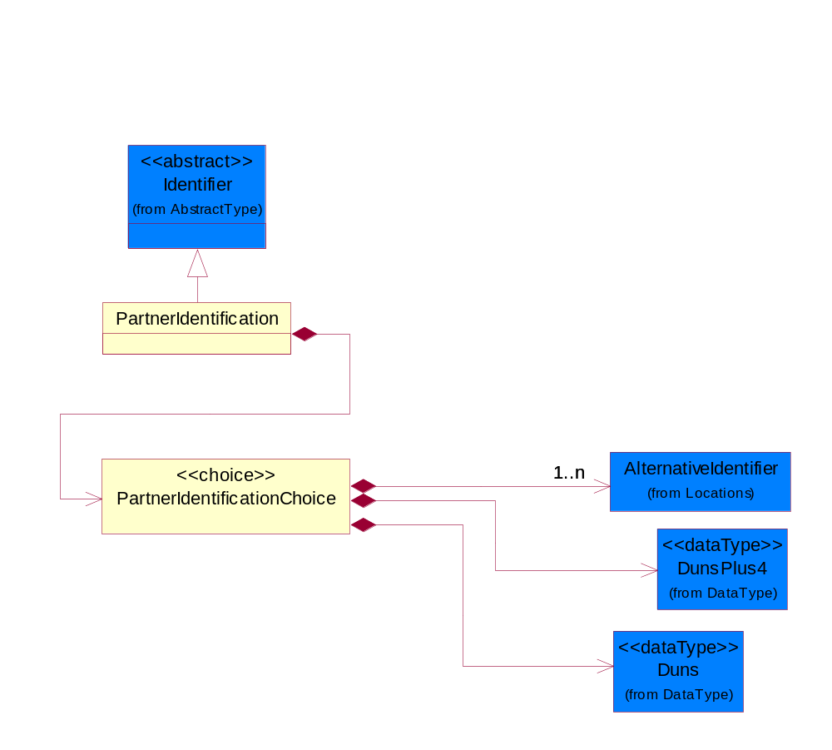
Figure 4-36 PartnerIdentification

Composition | Cardinality | Type | Documentation
PartnerIdentificationChoice | 1 | PartnerIdentificationChoice

PartnerIdentificationChoice

Composition | Cardinality | Type | Documentation
Duns | 1 | Duns | A number assigned by Dun and Bradstreet to identify a business location.
DunsPlus4 | 1 | DunsPlus4 | A identifier to specify a specific location within a business location.
AlternativeIdentifier | 1..n | AlternativeIdentifier | Identifies the specified code and the name of the organization that a code is utilized from.

SpecifiedKnownPartner
The business document must describe the trading partners in the business transaction.

PartnerIdentification
SpecifiedKnownPartner
Figure 4-37 SpecifiedKnownPartner
Composition | Cardinality | Type | Documentation
PartnerIdentification | 1 | PartnerIdentification | The business document must allow for the identity of one or more parties to the transaction.

ProductIdentification

ProductDescription
The business document must allow for the identification of the product and multiple textual descriptions of a product.
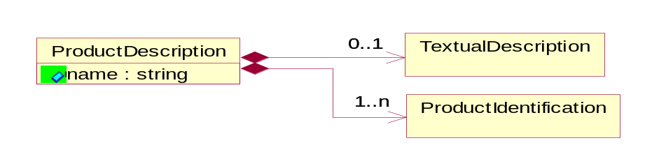
Figure 4-38 ProductDescription
Attribute | Type | Documentation
name | string | The name of the product.

Composition | Cardinality | Type | Documentation
ProductIdentification | 1..n | ProductIdentification | The object provides the identifier(s) of a product.
TextualDescription | 0..1 | TextualDescription | The business document must allow for multiple levels of textual description of an event or object.

ProductIdentification
The object provides the identifier(s) of a product. 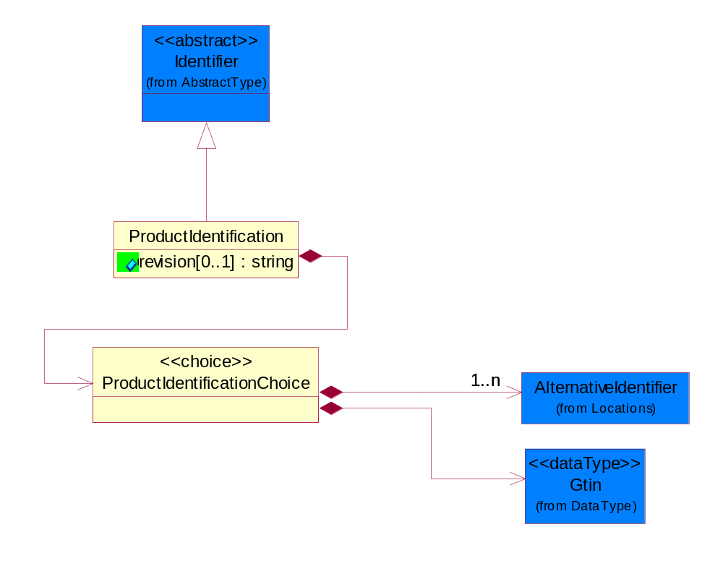
Figure 4-39 ProductIdentification

Attribute | Type | Documentation
revision[0..1] | string | Referenced the specified product revision.

Composition | Cardinality | Type | Documentation
ProductIdentificationChoice | 1 | ProductIdentificationChoice

ProductIdentificationChoice

Composition | Cardinality | Type | Documentation
AlternativeIdentifier | 1..n | AlternativeIdentifier | Identifies the specified code and the name of the organization that a code is utilized from.
Gtin | 1 | Gtin | Global Trade Identification Number (GTIN).

TextualDescription
The business document must allow for multiple levels of textual description of an event or object.

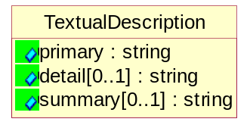
Figure 4-40 TextualDescription

Attribute | Type | Documentation
primary | string | A phrase or single word description of an event or object.
detail[0..1] | string | A detail description of an event or object.
summary[0..1] | string | A condensed description of an event or object.

CodeList

Language
For representation of Language name RosettaNet has adopted ISO 639-2; 1998. Refer to the following web page to get the latest version of the standard:

http://www.loc.gov/standards/iso639-2/iso639jac.html

If you need more information about the ISO standard please contact ISO for more details.

DocumentType
A code identifying the business context of a document.

Instance | Documentation
CBN | Product batch number of customer.
CCN | Customs clearance number.
CFA | Failure Analysis request document that will accompany the product providing characteristics of the component failure.
CIN | Commercial Invoice
CNM | Traditional credit note or memo.
CON | In a virtual sourcing relationship, a third party trading partner is supplying a part to a customer on behalf of another company that has taken the order for the customer. In this case a Customer Order Number is associated to the request for material that is sent to the virtual trading partners.
COT | Contract
CRN | Unique consumption reference number identifying the product consumption issue i.e. one-to-one relationship with physical flow.
DEM | Traditional debit note or memo.
DEN | Delivery Note
DIN | Discontinuation Notice.
DRN | Drawing Number
FUO | Sales order or transfer order fulfilling demand out of a facility (outbound shipment).
INV | Invoice
MEN | Master Event Number
MON | Model Number
OCL | The unique identifier assigned by the OEM for a warranty claim.
OPO | The unique identifier assigned by the OEM for a part order.
OPR | The unique identifier assigned by the OEM for a part return.
PFA | Failure Analysis request document that will accompany the product providing characteristics of the product failure.
PII | Refers to previously issued invoice.
PLS | Unique number that identifies packing form prior to shipment.
POI | Purchase Order IN
PON | Production order number for material release.
POO | Purchase Order OUT
PRC | Product Catalog.
PSI | Refers to previously issued self-billing invoice.
PUO | Purchase Order
QUO | Quote
REC | Document identifying the receipt of materials or products into a facility against a purchase order or transfer order (inbound shipment).
REO | Purchase order or transfer order replenishing inventory into a facility (inbound shipment).
REQ | Requisition
RMA | Returned Material Authorization
RPO | Purchase order for materials or product returned to and reworked by a supplier.
SAO | Sales Order
SBC | Credit Memo used in self-billing scenario.
SBD | Debit Memo used in self-billing scenario.
SBI | Invoice in self billing scenario.
SBN | Product batch number of supplier.
SCA | Similar to contracts. Contains the quantity of an article that is to be ordered from a vendor and the price for article or service that is to be procured.
SEN | Serial Number
SEO | A document that gives a repair provider the necessary authorization to repair or upgrade a product either at the customer site or at the repair provider’s site.
SNC | Shipset Number on Code List
SPC | The unique identifier assigned by the ASP for a warranty claim.
SPN | Spec Number
SPO | The unique identifier assigned by the ASP for a part order.
SPR | The unique identifier assigned by the ASP for a part return.
SPW | The unique identifier assigned by the ASP to reference a work order.
SRI | A document that contains the shipping reference number which allows the product to be tracked within the outsourced logistic providers network.
TRO | Order which results in materials or products being moved from one facility to another (outbound shipment and inbound shipment).
WAB | Waybill
WAC | Denotes a warranty claim.
WOO | Work Order

MimeTypeQualifier
The MIME type as defined by IANA.

Please refer to http://www.iana.org/assignments/media-types/ for a list of types.

Instance | Documentation
application/activemessage | [Shapiro]
application/andrew-inset | [Borenstein]
application/applefile | [Faltstrom]
application/atomicmail | [Borenstein]
application/batch-SMTP | [RFC2442]
application/beep+xml | [RFC3080]
application/cals-1840 | [RFC1895]
application/cnrp+xml | [RFCCNRP]
application/commonground | [Glazer]
application/cpl+xml
application/cybercash | [Eastlake]
application/dca-rft | [Campbell]
application/dec-dx | [Campbell]
application/dicom | [RFC3240]
application/dvcs | [RFC3029]
application/EDI-Consent | [RFC1767]
application/EDIFACT | [RFC1767]
application/EDI-X12 | [RFC1767]
application/eshop | [Katz]
application/font-tdpfr | [RFC3073]
application/http | [RFC2616]
application/hyperstudio | [Domino]
application/iges | [Parks]
application/index | [RFC2652]
application/index.cmd | [RFC2652]
application/index.obj | [RFC2652]
application/index.response | [RFC2652]
application/index.vnd | [RFC2652]
application/iotp | [RFC2935]
application/ipp | [RFC2910]
application/isup | [RFC3204]
application/mac-binhex40 | [Faltstrom]
application/macwriteii | [Lindner]
application/marc | [RFC2220]
application/mathematica | [Van Nostern]
application/msword | [Lindner]
application/news-message-id | [RFC1036,Spencer]
application/news-transmission | [RFC1036, Spencer]
application/ocsp-request | [RFC2560]
application/ocsp-response | [RFC2560]
application/octet-stream | [RFC2045,RFC2046]
application/oda | [RFC2045,RFC2046]
application/ogg | [RFC-walleij-ogg-mediatype-08.txt]
application/parityfec | [RFC3009]
application/pdf | [Lindner]
application/pgp-encrypted | [RFC3156]
application/pgp-keys | [RFC3156]
application/pgp-signature | [RFC3156]
application/pkcs10 | [RFC2311]
application/pkcs7-mime | [RFC2311]
application/pkcs7-signature | [RFC2311]
application/pkix-cert | [RFC2585]
application/pkixcmp | [RFC2510]
application/pkix-crl | [RFC2585]
application/postscript | [RFC2045,RFC2046]
application/prs.alvestrand.titrax-sheet | [Alvestrand]
application/prs.cww | [Rungchavalnont]
application/prs.nprend | [Doggett]
application/prs.plucker | [Janssen]
application/qsig | [RFC3204]
application/reginfo+xml | [RFC-ietf-sipping-reg-event-00.txt]
application/remote-printing | [RFC1486,Rose]
application/riscos | [Smith]
application/rtf | [Lindner]
application/sdp | [RFC2327]
application/set-payment | [Korver]
application/set-payment-initiation | [Korver]
application/set-registration | [Korver]
application/set-registration-initiation | [Korver]
application/sgml | [RFC1874]
application/sgml-open-catalog | [Grosso]
application/sieve | [RFC3028]
application/slate | [Crowley]
application/timestamp-query | [RFC3161]
application/timestamp-reply | [RFC3161]
application/tve-trigger | [Welsh]
application/vemmi | [RFC2122]
application/vnd.3gpp.pic-bw-large | [Meredith]
application/vnd.3gpp.pic-bw-small | [Meredith]
application/vnd.3gpp.pic-bw-var | [Meredith]
application/vnd.3gpp.sms | [Meredith]
application/vnd.3M.Post-it-Notes | [O'Brien]
application/vnd.accpac.simply.aso | [Leow]
application/vnd.accpac.simply.imp | [Leow]
application/vnd.acucobol | [Lubin]
application/vnd.acucorp | [Lubin]
application/vnd.adobe.xfdf | [Perelman]
application/vnd.aether.imp | [Moskowitz]
application/vnd.amiga.ami | [Blumberg]
application/vnd.anser-web-certificate-issue-initiation | [Mori]
application/vnd.anser-web-funds-transfer-initiation | [Mori]
application/vnd.audiograph | [Slusanschi]
application/vnd.blueice.multipass | [Holmstrom]
application/vnd.bmi | [Gotoh]
application/vnd.businessobjects | [Imoucha]
application/vnd.canon-cpdl | [Muto]
application/vnd.canon-lips | [Muto]
application/vnd.cinderella | [Kortenkamp]
application/vnd.claymore | [Simpson]
application/vnd.commerce-battelle | [Applebaum]
application/vnd.commonspace | [Chandhok]
application/vnd.contact.cmsg | [Patz]
application/vnd.cosmocaller | [Dellutri]
application/vnd.ctc-posml | [Kohlhepp]
application/vnd.cups-postscript | [Sweet]
application/vnd.cups-raster | [Sweet]
application/vnd.cups-raw | [Sweet]
application/vnd.curl | [Byrnes]
application/vnd.cybank | [Helmee]
application/vnd.data-vision.rdz | [Fields]
application/vnd.dna | [Searcy]
application/vnd.dpgraph | [Parker]
application/vnd.dreamfactory | [Appleton]
application/vnd.dxr | [Duffy]
application/vnd.ecdis-update | [Buettgenbach]
application/vnd.ecowin.chart | [Olsson]
application/vnd.ecowin.filerequest | [Olsson]
application/vnd.ecowin.fileupdate | [Olsson]
application/vnd.ecowin.series | [Olsson]
application/vnd.ecowin.seriesrequest | [Olsson]
application/vnd.ecowin.seriesupdate | [Olsson]
application/vnd.enliven | [Santinelli]
application/vnd.epson.esf | [Hoshina]
application/vnd.epson.msf | [Hoshina]
application/vnd.epson.quickanime | [Gu]
application/vnd.epson.salt | [Nagatomo]
application/vnd.epson.ssf | [Hoshina]
application/vnd.ericsson.quickcall | [Tidwell]
application/vnd.eudora.data | [Resnick]
application/vnd.fdf | [Zilles]
application/vnd.ffsns | [Holstage]
application/vnd.FloGraphIt | [Floersch]
application/vnd.framemaker | [Wexler]
application/vnd.fsc.weblaunch | [D.Smith]
application/vnd.fujitsu.oasys | [Togashi]
application/vnd.fujitsu.oasys2 | [Togashi]
application/vnd.fujitsu.oasys3 | [Okudaira]
application/vnd.fujitsu.oasysgp | [Sugimoto]
application/vnd.fujitsu.oasysprs | [Ogita]
application/vnd.fujixerox.ddd | [Onda]
application/vnd.fujixerox.docuworks | [Taguchi]
application/vnd.fujixerox.docuworks.binder | [Matsumoto]
application/vnd.fut-misnet | [Pruulmann]
application/vnd.grafeq | [Tupper]
application/vnd.groove-account | [Joseph]
application/vnd.groove-help | [Joseph]
application/vnd.groove-identity-message | [Joseph]
application/vnd.groove-injector | [Joseph]
application/vnd.groove-tool-message | [Joseph]
application/vnd.groove-tool-template | [Joseph]
application/vnd.groove-vcard | [Joseph]
application/vnd.hbci | [Hammann]
application/vnd.hhe.lesson-player | [Jones]
application/vnd.hp-HPGL | [Pentecost]
application/vnd.hp-hpid | [Gupta]
application/vnd.hp-hps | [Aubrey]
application/vnd.hp-PCL | [Pentecost]
application/vnd.hp-PCLXL | [Pentecost]
application/vnd.httphone | [Lefevre]
application/vnd.hzn-3d-crossword | [Minnis]
application/vnd.ibm.afplinedata | [Buis]
application/vnd.ibm.electronic-media | [Tantlinger]
application/vnd.ibm.MiniPay | [Herzberg]
application/vnd.ibm.modcap | [Hohensee]
application/vnd.ibm.secure-container | [Tantlinger]
application/vnd.informix-visionary | [Gales]
application/vnd.intercon.formnet | [Gurak]
application/vnd.intertrust.digibox | [Tomasello]
application/vnd.intertrust.nncp | [Tomasello]
application/vnd.intu.qbo | [Scratchley]
application/vnd.intu.qfx | [Scratchley]
application/vnd.irepository.package+xml | [Knowles]
application/vnd.is-xpr | [Natarajan]
application/vnd.japannet-directory-service | [Fujii]
application/vnd.japannet-jpnstore-wakeup | [Yoshitake]
application/vnd.japannet-payment-wakeup | [Fujii]
application/vnd.japannet-registration | [Yoshitake]
application/vnd.japannet-registration-wakeup | [Fujii]
application/vnd.japannet-setstore-wakeup | [Yoshitake]
application/vnd.japannet-verification | [Yoshitake]
application/vnd.japannet-verification-wakeup | [Fujii]
application/vnd.jisp | [Deckers]
application/vnd.kde.karbon | [Faure]
application/vnd.kde.kchart | [Faure]
application/vnd.kde.kformula | [Faure]
application/vnd.kde.kivio | [Faure]
application/vnd.kde.kontour | [Faure]
application/vnd.kde.kpresenter | [Faure]
application/vnd.kde.kspread | [Faure]
application/vnd.kde.kword | [Faure]
application/vnd.kenameaapp | [DiGiorgio-Haag]
application/vnd.koan | [Cole]
application/vnd.liberty-request+xml | [McDowell]
application/vnd.llamagraphics.life-balance.desktop | [White]
application/vnd.lotus-1-2-3 | [Wattenberger]
application/vnd.lotus-approach | [Wattenberger]
application/vnd.lotus-freelance | [Wattenberger]
application/vnd.lotus-notes | [Laramie]
application/vnd.lotus-organizer | [Wattenberger]
application/vnd.lotus-screencam | [Wattenberger]
application/vnd.lotus-wordpro | [Wattenberger]
application/vnd.mcd | [Gotoh]
application/vnd.mediastation.cdkey | [Flurry]
application/vnd.meridian-slingshot | [Wedel]
application/vnd.micrografx.flo | [Prevo]
application/vnd.micrografx.igx | [Prevo]
application/vnd.mif | [Wexler]
application/vnd.minisoft-hp3000-save | [Bartram]
application/vnd.mitsubishi.misty-guard.trustweb | [Tanaka]
application/vnd.Mobius.DAF | [Kabayama]
application/vnd.Mobius.DIS | [Kabayama]
application/vnd.Mobius.MBK | [Devasia]
application/vnd.Mobius.MQY | [Devasia]
application/vnd.Mobius.MSL | [Kabayama]
application/vnd.Mobius.PLC | [Kabayama]
application/vnd.Mobius.TXF | [Kabayama]
application/vnd.mophun.application | [Wennerstrom]
application/vnd.mophun.certificate | [Wennerstrom]
application/vnd.motorola.flexsuite | [Patton]
application/vnd.motorola.flexsuite.adsi | [Patton]
application/vnd.motorola.flexsuite.fis | [Patton]
application/vnd.motorola.flexsuite.gotap | [Patton]
application/vnd.motorola.flexsuite.kmr | [Patton]
application/vnd.motorola.flexsuite.ttc | [Patton]
application/vnd.motorola.flexsuite.wem | [Patton]
application/vnd.mozilla.xul+xml | [McDaniel]
application/vnd.ms-artgalry | [Slawson]
application/vnd.ms-asf | [Fleischman]
application/vnd.mseq | [Le Bodic]
application/vnd.ms-excel | [Gill]
application/vnd.msign | [Borcherding]
application/vnd.ms-lrm | [Ledoux]
application/vnd.ms-powerpoint | [Gill]
application/vnd.ms-project | [Gill]
application/vnd.ms-tnef | [Gill]
application/vnd.ms-works | [Gill]
application/vnd.ms-wpl | [Plastina]
application/vnd.musician | [Adams]
application/vnd.music-niff | [Butler]
application/vnd.netfpx | [Mutz]
application/vnd.noblenet-directory | [Solomon]
application/vnd.noblenet-sealer | [Solomon]
application/vnd.noblenet-web | [Solomon]
application/vnd.novadigm.EDM | [Swenson]
application/vnd.novadigm.EDX | [Swenson]
application/vnd.novadigm.EXT | [Swenson]
application/vnd.obn | [Hessling]
application/vnd.osa.netdeploy | [Klos]
application/vnd.palm | [Peacock]
application/vnd.pg.format | [Gandert]
application/vnd.pg.osasli | [Gandert]
application/vnd.powerbuilder6 | [Guy]
application/vnd.powerbuilder6-s | [Guy]
application/vnd.powerbuilder7 | [Shilts]
application/vnd.powerbuilder75 | [Shilts]
application/vnd.powerbuilder75-s | [Shilts]
application/vnd.powerbuilder7-s | [Shilts]
application/vnd.previewsystems.box | [Smolgovsky]
application/vnd.publishare-delta-tree | [Ben-Kiki]
application/vnd.pvi.ptid1 | [Lamb]
application/vnd.pwg-multiplexed | [RFC3391]
application/vnd.pwg-xhtml-print+xml | [Wright]
application/vnd.Quark.QuarkXPress | [Scheidler]
application/vnd.rapid | [Szekely]
application/vnd.s3sms | [Tarkkala]
application/vnd.sealed.net | [Lambert]
application/vnd.seemail | [Webb]
application/vnd.shana.informed.formdata | [Selzler]
application/vnd.shana.informed.formtemplate | [Selzler]
application/vnd.shana.informed.interchange | [Selzler]
application/vnd.shana.informed.package | [Selzler]
application/vnd.smaf | [Takahashi]
application/vnd.sss-cod | [Dani]
application/vnd.sss-dtf | [Bruno]
application/vnd.sss-ntf | [Bruno]
application/vnd.street-stream | [Levitt]
application/vnd.svd | [Becker]
application/vnd.swiftview-ics | [Widener]
application/vnd.triscape.mxs | [Simonoff]
application/vnd.trueapp | [Hepler]
application/vnd.truedoc | [Chase]
application/vnd.ufdl | [Manning]
application/vnd.uplanet.alert | [Martin]
application/vnd.uplanet.alert-wbxml | [Martin]
application/vnd.uplanet.bearer-choice | [Martin]
application/vnd.uplanet.bearer-choice-wbxml | [Martin]
application/vnd.uplanet.cacheop | [Martin]
application/vnd.uplanet.cacheop-wbxml | [Martin]
application/vnd.uplanet.channel | [Martin]
application/vnd.uplanet.channel-wbxml | [Martin]
application/vnd.uplanet.list | [Martin]
application/vnd.uplanet.listcmd | [Martin]
application/vnd.uplanet.listcmd-wbxml | [Martin]
application/vnd.uplanet.list-wbxml | [Martin]
application/vnd.uplanet.signal | [Martin]
application/vnd.vcx | [T.Sugimoto]
application/vnd.vectorworks | [Pharr]
application/vnd.vidsoft.vidconference | [Hess]
application/vnd.visio | [Sandal]
application/vnd.visionary | [Aravindakumar]
application/vnd.vividence.scriptfile | [Risher]
application/vnd.vsf | [Rowe]
application/vnd.wap.sic | [WAP-Forum]
application/vnd.wap.slc | [WAP-Forum]
application/vnd.wap.wbxml | [Stark]
application/vnd.wap.wmlc | [Stark]
application/vnd.wap.wmlscriptc | [Stark]
application/vnd.webturbo | [Rehem]
application/vnd.wrq-hp3000-labelled | [Bartram]
application/vnd.wt.stf | [Wohler]
application/vnd.wv.csp+wbxml | [Salmi]
application/vnd.xara | [Matthewman]
application/vnd.xfdl | [Manning]
application/vnd.yellowriver-custom-menu | [Yellow]
application/whoispp-query | [RFC2957]
application/whoispp-response | [RFC2958]
application/wita | [Campbell]
application/wordperfect5.1 | [Lindner]
application/x400-bp | [RFC1494]
application/xhtml+xml | [RFC3236]
application/xml | [RFC3023]
application/xml-dtd | [RFC3023]
application/xml-external-parsed-entity | [RFC3023]
application/zip | [Lindner]
audio/32kadpcm | [RFC2421,RFC2422]
audio/AMR | [RFC3267]
audio/AMR-WB | [RFC3267]
audio/basic | [RFC2045,RFC2046]
audio/CN | [RFC3389]
audio/DAT12 | [RFC3190]
audio/DVI4
audio/EVRC | [RFC-ietf-avt-evrc-smv-03.txt]
audio/EVRC0 | [RFC-ietf-avt-evrc-smv-03.txt]
audio/G.722.1 | [RFC3047]
audio/G722
audio/G723
audio/G726-16
audio/G726-24
audio/G726-32
audio/G726-40
audio/G728
audio/G729
audio/G729D
audio/G729E
audio/GSM
audio/GSM-EFR
audio/L16 | [RFC2586]
audio/L20 | [RFC3190]
audio/L24 | [RFC3190]
audio/L8
audio/LPC
audio/MP4A-LATM | [RFC3016]
audio/MPA
audio/mpa-robust | [RFC3119]
audio/mpeg | [RFC3003]
audio/parityfec | [RFC3009]
audio/PCMA
audio/PCMU
audio/prs.sid | [Walleij]
audio/QCELP
audio/RED
audio/SMV | [RFC-ietf-avt-evrc-smv-03.txt]
audio/SMV0 | [RFC-ietf-avt-evrc-smv-03.txt]
audio/telephone-event | [RFC2833]
audio/tone | [RFC2833]
audio/VDVI
audio/vnd.3gpp.iufp | [Belling]
audio/vnd.cisco.nse | [Kumar]
audio/vnd.cns.anp1 | [McLaughlin]
audio/vnd.cns.inf1 | [McLaughlin]
audio/vnd.digital-winds | [Strazds]
audio/vnd.everad.plj | [Cicelsky]
audio/vnd.lucent.voice | [Vaudreuil]
audio/vnd.nortel.vbk | [Parsons]
audio/vnd.nuera.ecelp4800 | [Fox]
audio/vnd.nuera.ecelp7470 | [Fox]
audio/vnd.nuera.ecelp9600 | [Fox]
audio/vnd.octel.sbc | [Vaudreuil]
audio/vnd.qcelp | [Lundblade]
audio/vnd.rhetorex.32kadpcm | [Vaudreuil]
audio/vnd.vmx.cvsd | [Vaudreuil]
image/cgm | Computer Graphics Metafile
image/g3fax | [RFC1494]
image/gif | [RFC2045,RFC2046]
image/ief | [RFC1314] Image Exchange Format
image/jpeg | [RFC2045,RFC2046]
image/naplps | [Ferber]
image/png | [Randers-Pehrson]
image/prs.btif | [Simon]
image/prs.pti | [Laun]
image/t38 | [RFC3362]
image/tiff | [RFC3302] Tag Image File Format
image/tiff-fx | [RFC3250] Tag Image File Format Fax eXtended
image/vnd.cns.inf2 | [McLaughlin]
image/vnd.djvu | [Bottou]
image/vnd.dwg | [Moline]
image/vnd.dxf | [Moline]
image/vnd.fastbidsheet | [Becker]
image/vnd.fpx | [Spencer]
image/vnd.fst | [Fuldseth]
image/vnd.fujixerox.edmics-mmr | [Onda]
image/vnd.fujixerox.edmics-rlc | [Onda]
image/vnd.globalgraphics.pgb | [Bailey]
image/vnd.mix | [Reddy]
image/vnd.ms-modi | [Vaughan]
image/vnd.net-fpx | [Spencer]
image/vnd.svf | [Moline]
image/vnd.wap.wbmp | [Stark]
image/vnd.xiff | [S.Martin]
message/delivery-status | [RFC1894]
message/disposition-notification | [RFC2298]
message/external-body | [RFC2045,RFC2046]
message/http | [RFC2616]
message/news | [RFC 1036, H.Spencer]
message/partial | [RFC2045,RFC2046]
message/rfc822 | [RFC2045,RFC2046]
message/s-http | [RFC2660]
message/sip | [RFC3261]
message/sipfrag | [RFC3420]
model/iges | [Parks]
model/mesh | [RFC2077]
model/vnd.dwf | [Pratt]
model/vnd.flatland.3dml | [Powers]
model/vnd.gdl | [Babits]
model/vnd.gs-gdl | [Babits]
model/vnd.gtw | [Ozaki]
model/vnd.mts | [Rabinovitch]
model/vnd.parasolid.transmit.binary | [Parasolid]
model/vnd.parasolid.transmit.text | [Parasolid]
model/vnd.vtu | [Rabinovitch]
model/vrml | [RFC2077]
multipart/alternative | [RFC2045,RFC2046]
multipart/appledouble | [Faltstrom]
multipart/byteranges | [RFC2068]
multipart/digest | [RFC2045,RFC2046]
multipart/encrypted | [RFC1847]
multipart/form-data | [RFC2388]
multipart/header-set | [Crocker]
multipart/mixed | [RFC2045,RFC2046]
multipart/parallel | [RFC2045,RFC2046]
multipart/related | [RFC2387]
multipart/report | [RFC1892]
multipart/signed | [RFC1847]
multipart/voice-message | [RFC2421,RFC2423]
text/calendar | [RFC2445]
text/css | [RFC2318]
text/directory | [RFC2425]
text/enriched | [RFC1896]
text/html | [RFC2854]
text/parityfec | [RFC3009]
text/plain | [RFC2646,RFC2046]
text/prs.lines.tag | [Lines]
text/rfc822-headers | [RFC1892]
text/richtext | [RFC2045,RFC2046]
text/rtf | [Lindner]
text/sgml | [RFC1874]
text/t140 | [RFC2793]
text/tab-separated-values | [Lindner]
text/uri-list | [RFC2483]
text/vnd.abc | [Allen]
text/vnd.curl | [Byrnes]
text/vnd.DMClientScript | [Bradley]
text/vnd.fly | [Gurney]
text/vnd.fmi.flexstor | [Hurtta]
text/vnd.in3d.3dml | [Powers]
text/vnd.in3d.spot | [Powers]
text/vnd.IPTC.NewsML | [IPTC]
text/vnd.IPTC.NITF | [IPTC]
text/vnd.latex-z | [Lubos]
text/vnd.motorola.reflex | [Patton]
text/vnd.ms-mediapackage | [Nelson]
text/vnd.net2phone.commcenter.command | [Xie]
text/vnd.sun.j2me.app-descriptor | [G.Adams]
text/vnd.wap.si | [WAP-Forum]
text/vnd.wap.sl | [WAP-Forum]
text/vnd.wap.wml | [Stark]
text/vnd.wap.wmlscript | [Stark]
text/xml | [RFC3023]
text/xml-external-parsed-entity | [RFC3023]
video/BMPEG
video/BT656
video/CelB
video/DV | [RFC3189]
video/H261
video/H263
video/H263-1998
video/H263-2000
video/JPEG
video/MP1S
video/MP2P
video/MP2T
video/MP4V-ES | [RFC3016]
video/mpeg | [RFC2045,RFC2046]
video/MPV
video/nv
video/parityfec | [RFC3009]
video/pointer | [RFC2862]
video/quicktime | [Lindner]
video/SMPTE292M | [RFC-avt-smpte292-video-08.txt]
video/vnd.fvt | [Fuldseth]
video/vnd.motorola.video | [McGinty]
video/vnd.motorola.videop | [McGinty]
video/vnd.mpegurl | [Recktenwald]
video/vnd.nokia.interleaved-multimedia | [Kangaslampi]
video/vnd.objectvideo | [Clark]
video/vnd.vivo | [Wolfe]

UnitOfMeasure
Code identifying a product unit of measure.

Instance | Documentation
1BF | 100 Board Feet
1FC | 20 Foot Container
1GR | Gram/Cubic Centimeter
1GT | 10,000 Gallon Tankcar
1KB | 25 Kilogram Bulk Bag
1KD | 10 Kilogram Drum
1PA | 20-Pack
1PB | 50 Pound Bag
1PD | 100 Pound Drum
2FC | 40 Foot Container
2GR | Gram/square meter
2GT | 20,000 Gallon Tankcar
2KB | 300 Kilogram Bulk Bag
2KD | 15 Kilogram Drum
2PA | 100-Pack
3GR | Grams Per 100 Centimeters
3KB | 500 Kilogram Bulk Bag
3KD | 55 Gallon Drum
4GR | Grams Per 100 Grams
4KD | 115 Kilogram Drum
5GR | Grams Per Cubic Centimeter
6GR | Grams Per Square Centimeter
7GR | Grams Per Square Meter
ACR | Acre
ACT | Actual Pounds
ALU | Aluminum Pounds Only
AMP | Ampere
BAB | Base Box
BAC | Batch
BAE | Bale
BAG | Bag
BAL | Ball
BAN | Band
BAP | Batting Pound
BAR | Bar
BAS | Basket
BAT | Batt
BAW | Base Weight
BEA | Beam
BEC | Becquerel/kilogram
BEL | Belt
BIL | Billet
BIN | Bin
BKC | Bulk Car Load
BLO | Block
BOA | Board
BOF | Board Feet
BOL | Bolt
BOT | Bottle
BOX | Box
BRD | Barrels Per Day
BRE | Barrel
BRI | Barrel (Imperial)
BRM | Barrels Per Minute
BTF | British Thermal Units (BTUs) Per Cubic Foot
BTP | British Thermal Units (BTUs) Per Pound
BTU | British Thermal Unit (BTU)
BUC | Bucket
BUD | Bushel, Dry Imperial
BUK | Bunks
BUL | Bulk
BUN | Bundle
BUP | Bulk Pack
BUS | Bushel
CAA | Carat
CAB | Carboy
CAC | Card
CAD | Candela
CAG | Cartridge
CAK | Cask
CAL | Calorie
CAN | Can
CAO | Carload
CAR | Car
CAS | Case
CAT | Canister
CAW | Catchweight
CEL | Cell
CEM | Centimeter
CEP | Centipoise (CPS)
CET | Centiliter
CHA | Chains (Land Survey)
CHE | Chest
CNN | Connector
COG | Coil Group
COI | Coil
COL | Coulomb
COM | Composite Product Pounds (Total Weight)
CON | Cone
COT | Container
COV | Cover
CRA | Crate
CRT | Carton
CSE | Cassette
CUB | Cubic centimeter
CUC | Cubic centimeter/second
CUF | Cubic Foot
CUI | Cubic inch
CUM | Cubicmeter
CUP | Cup
CUY | Cubic yard
CYC | Cycles
CYL | Cylinder
DAY | Day
DEA | Deal
DEC | Decimeter
DEF | Degree Fahrenheit
DEG | Degree Celsius
DEP | Dep. Factor
DIE | Die
DIL | Display
DIP | Dispenser
DOZ | Dozen
DRA | Dram
DRU | Drum
DRY | Dry Pounds
EAC | Each
ELE | Electrical Capacitance
FAR | Farads
FFA | Femtofarad
FLO | Fluid Ounce
FOI | Fluid Ounce (Imperial)
FOO | Foot
FOU | Fluid Ounce US
FUU | Fuel Usage (Gallons)
GAL | Gallon
GAS | Gage Systems
GIH | Gigahertz
GIJ | Gigajoules
GIL | Gill (Imperial)
GOB | Gross Barrels
GOG | Gross Gallons
GOK | Gross Kilogram
GOT | Gross Ton
GOY | Gross Yard
GRA | Gram
GRG | Great Gross (Dozen Gross)
GRK | Grams Per Kilogram
GRL | Grams Per Liter
GRM | Grams Per Milliliter
GRN | Grain
GRO | Gross
GRP | Group
HAG | Half Gallon
HAH | Half Hour
HAL | Half Liter
HAN | Hank
HEA | Heat lots
HEC | Hectare
HEL | Hectoliter
HEP | Hectopascal
HER | Hertz
HOS | Hours
HOU | Hour
HUA | Hundredth of a Carat
HUB | Hundred Boxes
HUC | Hundred Count
HUS | Hundred Sheets
IMG | Imperial Gallons
INC | Inch
JAR | Jar
JOI | Joint
JOU | Joule
KEG | Keg
KEL | Kelvin
KHO | Kilometer/hour
KIC | Kilogram per cubic meter
KIE | Kilometer
KIG | Kilogram
KIH | Kilohertz
KIK | Kilobecquerel/Kilogram
KIL | Kiloampere
KIM | Kilogram/square meter
KIO | Kiloohm
KIS | Kilogramm pro Sekunde
KIT | Kit
KIV | Kilovolt
KIW | Kilowatt
KKG | Kilogram/Kilogram
KUD | Kubikdezimeter
KUM | Kubikmeter pro Sekunde
KWH | Kilowatt-hour
LIF | Lifts
LIM | Link
LIQ | Liquid Pounds
LIT | Liter
LOA | Load
LOT | Lot
LUG | Lug
MAM | Milliamps/mm
MAT | Mat
MCM | Milligrams Per Cubic Meter
MCR | Micron
MEG | Megagram
MEH | Megahertz
MEP | Megapascal
MET | Meter
MEW | Megawatt
MIB | Million BTU's
MIC | Mikrogram/cubic meter
MIG | Micrograms Per Cubic Meter
MIL | Mile
MIM | Micrometer
MIN | Minute
MIP | Millipascal seconds
MIS | Microsecond
MIT | Miter
MIV | Millivolt
MIW | Milliwatt
MJO | Millijoule
MLA | Milliampere
MLB | Millibar
MLC | Milligram/cubic meter
MLI | Milliliter
MLK | Milligram/kilogram
MLL | Milligram/Liter
MME | Millimeter
MMH | Millimeter H20
MMK | Millimol/kilogram
MMO | Millimol
MOK | Mol/kilogram
MOL | Mol
MON | Month
MPH | Megagrams Per Hour
MSC | Millisecond
MSM | Milligrams Per Square Meter
MTA | Millitesla
MTQ | Meter pro Quadratsekunde
MTS | Meters per second
MUL | Multichip - When 2 or more dies (chips) are merged into one package.
NAA | Nanoamps
NAM | Nanometer
NAS | Nanosecond
NEB | Net Barrels
NEG | Net Gallons
NEI | Net Imperial Gallons
NEL | Net Liters
NEW | Newton
OCT | Ohm/ct
OHM | Ohm
OMM | Ohm/mm
ONE | One
OSQ | Ohm/sq
OTP | One Thousand Pieces
OUN | Ounce
OVI | Ohm/via
PAC | Parcel
PAD | Pad
PAG | Package
PAI | Pail
PAK | Pack (PAK)
PAL | Pallet
PAN | Panel
PAR | Pair
PAS | Pascal
PAT | Packet
PEC | Percent
PEG | Percentage
PEH | Percent Per 1000 Hours
PEN | Pennyweight
PER | Per Hundred Pieces
PEW | Percent Weight
PID | Pint U.S. Dry
PIE | Piece
PIL | Pint - US liquid
PLA | Plate
PLL | Pallet (Lift)
PLT | Pallete
PLU | Pallet/Unit Load
POF | Pounds Per Foot
POG | Pounds Per Gallon
PON | Pound
POP | Pounds Per Piece of Product
POS | Pounds Per 1000 Square Feet
POT | Pounds Per Thousand
PPB | Parts per billion (US)
PPM | Parts per million
PPP | Pounds Per Pound of Product
PSC | Picosecond
PSS | Pascal second
QUA | Quart - US liquid
RAC | Rack
REA | Ream of 500 Sheets
REE | Reel
RIN | Ring
ROD | Rod
ROL | Roll
SAC | Sack
SBB | Super Bulk Bag
SEC | Second
SET | Set
SHE | Sheet
SHI | Shipment
SHM | Sheet-Metric measure
SHO | Shot
SID | Disk (Disc)
SKE | Skein
SKI | Skid
SLE | Sleeve
SLI | Slip Sheet
SMI | Square mile
SMM | Square millimeter
SPO | Spool
SQF | Square foot
SQI | Square inch
SQK | Square kilometer
SQM | Square meter
SQS | Square meter/second
SQU | Square
SQY | Square Yard
STI | Stick
STM | Statute Mile
STR | Strip
TAB | Tablet
TAN | Tank
TAT | Tank Truck
TES | Tesla
THO | Thousand
TNN | Tonne
TON | Ton
TOR | Torr
TOT | Tote
TRA | Train
TRF | Track Foot
TRL | Trailer
TRO | Troy
TRU | Truckload
TRY | Tray
TRZ | Troy OZ
TUB | Tube
ULU | Unitless Unit of Measure
USG | US gallon
USP | US pound
UST | US ton
VIA | Vial
VOL | Volt
WAF | Wafer
WAR | Watt
WEE | Week
WRA | Wrap
YAR | Yard
YEA | Year

ProcessRoleIdentifier
Describes the role of the partner in the business process. A partner will fulfill at least one or more roles during the business process.

Instance | Documentation
ADM | Administered by, the party who is the administrative authority of an account.
ALT | Alternate approval by, the party who has approved a request in the event the approver is not able to respond.
APP | Approval by, the party who has approved a request.
BIF | Bill from, the party that will issue the invoice.
BIT | Bill to, the party that will pay the invoice.
CNC | Cancellation party, the party who is cancelling the shipping order.
COR | Change originated by, the party who originates a proposed change.
COW | Change owned by, the party who owns or who is assigned responsibility for a proposed change.
CRA | Credit applicant, the party who is applying for credit.
CRE | Created by, the party responsible for creating a process or task.
DIS | Distributed by, the party who supplies products to retailers.
FIN | Financed by, the party who is the financier.
FOR | Forwarded to, the party to whom a business document has been forwarded.
INL | Inventory location, the party where the inventory product entry is located.
INO | Inventory owner, the party that owns the inventory product entry.
ITF | In transit from, the party sending the product quantity in a product location transfer.
ITT | In transit to, the party receiving the product quantity in a product location transfer.
MFG | Manufactured by, the party who creates, processes or produces goods especially in large quantities and by means of industrial machines.
OWN | Owned by, the party who owns a process.
PUR | Purchased by, the party who is a purchaser of a product.
REA | Requested approval by, the party who has been selected to approve a request.
REC | Received by, the party who has received a product shipment.
REQ | Requested by, the party who has initiated a request.
RES | Respond to, the party to whom a responding business document must be sent when it is not equal to the partner specified in the document header.
RET | Return by, the party responsible for either carrying or forwarding the returned product.
REV | Reviewed by, the party responsible for reviewing a business document.
SBF | Self-billing from, the party who initiates the billing in self-billing scenario.
SBT | Self-billing to, the party whom the invoice is addressed to.
SCP | Shipping charges paid by, the party responsible for administering payment of the shipping charges.
SHF | Ship From, the collection of business properties used to identify the business partner initiating a shipment or transaction.
SHT | Ship To, the partner and/or location to which the product must be delivered.
SLD | Sold to, the party to whom a product has been sold.
SOB | Sold By, the seller involved in a business transaction.
SPL | Supplied by, the party who supplies an item, part or assembly.
SRT | Submit returns to, the party to whom product returns are to be submitted.
TRA | Transported by, the party responsible for either carrying or forwarding the product.
ULR | Ultimate recipient, the party who ultimately receives the shipment, when an intermediate party takes responsibility for payment and final delivery.
USE | Used by, the party who is the end user of the product.

System Structure

BusinessServiceInformation
The object allows the specification of the business service utilized within the partner company. This may or may not be the same as the information sent by the RNIF.

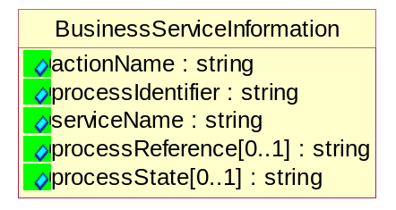
Figure 5-41 BusinessServiceInformation

Attribute | Type | Documentation
actionName | string | The name of Action. For RosettaNet usually any of Request/Confirm/Notify/Query/Response.
processIdentifier | string | The name of the PIP e.g. Notify of Forecast Reply.
serviceName | string | The name of the Business Activity with the "Request/Confirm" part removed. E.g., for the Activity "Request Purchase Order"==> "Purchase Order".
processReference[0..1] | string | The URN for the PIP that includes Cluster/Segment/Process pattern used to identify the interface process (such as PIP3A4)
processState[0..1] | string | The business process (or service) state of the sender of a document. When a service receives this document, the receiver may use the state as a precondition.

ContractInformation
A block of information used to correlate a contract in an executing choreography.

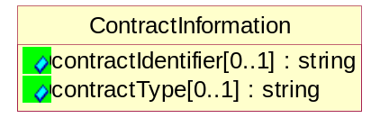
Figure 5-42 ContractInformation
Attribute | Type | Documentation
contractIdentifier[0..1] | string | Unique identification of a contract between the Sender and the Receiver
contractType[0..1] | string | The type of the contract: an attribute describing the type of the ContractIndentification. Valid values are URI, URN,ebXMLCPA, or other values defined by partners.

CorrelationInformation
A block of information used to correlate a requesting document to a responding document and to the contract in an executing choreography.
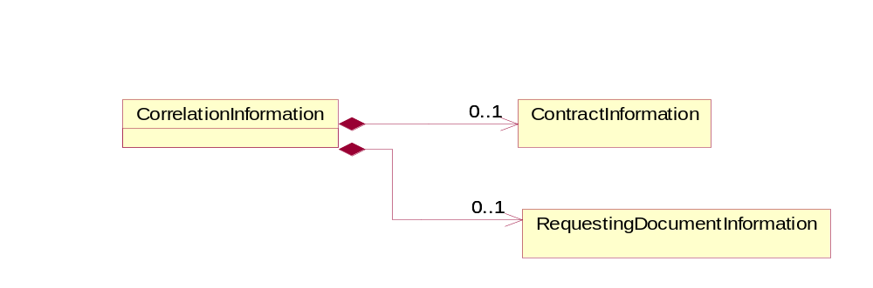
Figure 5-43 CorrelationInformation

Composition | Cardinality | Type | Documentation
ContractInformation | 0..1 | ContractInformation | A block of information used to correlate a contract in an executing choreography.
RequestingDocumentInformation | 0..1 | RequestingDocumentInformation | A block of information used to correlate a requesting document to a responding document in an executing choreography.

DocumentHeader
The object allows for the identification of the sender and receiver of the business document.

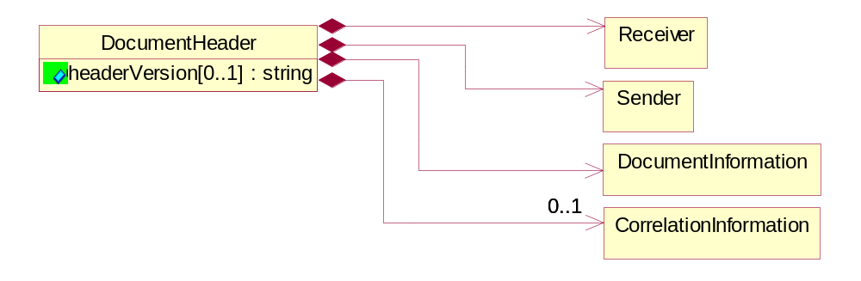
Figure 5-44 DocumentHeader
Attribute | Type | Documentation
headerVersion[0..1] | string | The UN/CEFACT version of the document header.

Composition | Cardinality | Type | Documentation
Sender | 1 | Sender | The object allows the identification of the initiating party of the business message.
CorrelationInformation | 0..1 | CorrelationInformation | A block of information used to correlate a requesting document to a responding document and to the contract in an executing choreography.
DocumentInformation | 1 | DocumentInformation | The object specifies information to identify the business document, a summary of attachments, and information about the business document security.
Receiver | 1 | Receiver | The object allows the identification of the receiving party of the business message.

DocumentIdentification
The object specifies all information necessary to identify the business document.

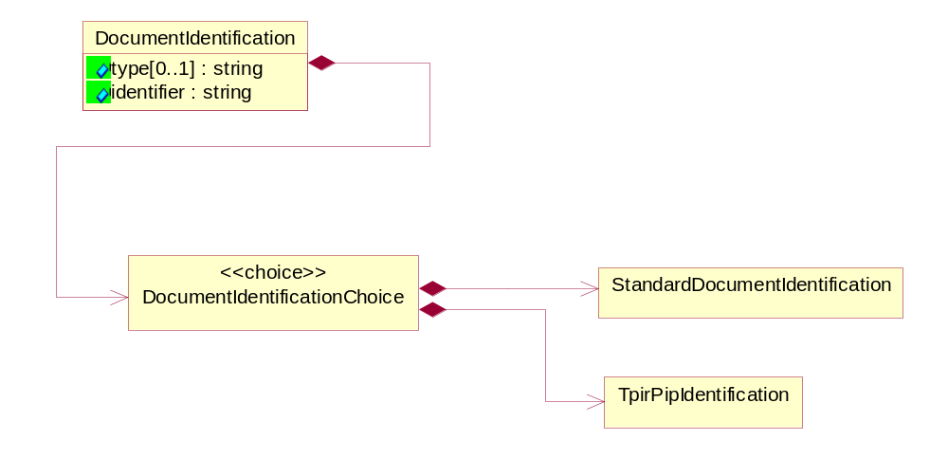
Figure 5-45 DocumentIdentification
Attribute | Type | Documentation
type[0..1] | string | Name of the Action Message
identifier | string | The unique identifier for the document being sent.

Composition | Cardinality | Type | Documentation
DocumentIdentificationChoice | 1 | DocumentIdentificationChoice

DocumentIdentificationChoice

Composition | Cardinality | Type | Documentation
StandardDocumentIdentification | 1 | StandardDocumentIdentification | The object specifies additional information necessary to identify the standard business document.
TpirPipIdentification | 1 | TpirPipIdentification | The object specifies all information necessary to uniquely identify a TPIR-PIP within a Registry or trading partner repository.

DocumentInformation
The object specifies information to identify the business document, a summary of attachments, and information about the business document security.

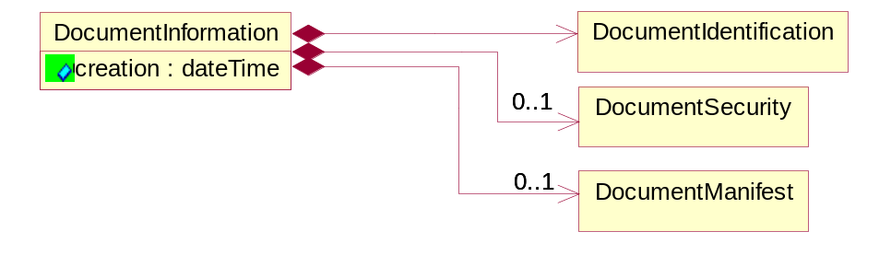
Figure 5-46 DocumentInformation
Attribute | Type | Documentation
creation | dateTime | The creation date and time of the specified Business Document (i.e. the Purchase Order date).

Composition | Cardinality | Type | Documentation
DocumentIdentification | 1 | DocumentIdentification | The object specifies all information necessary to identify the business document.
DocumentSecurity | 0..1 | DocumentSecurity | The object provides additional granularity in specifying business document security (this is in addition to the specified PIP security).
DocumentManifest | 0..1 | DocumentManifest | The block provides a brief summary of attachments and Service Content.

DocumentManifest
The block provides a brief summary of attachments and Service Content.

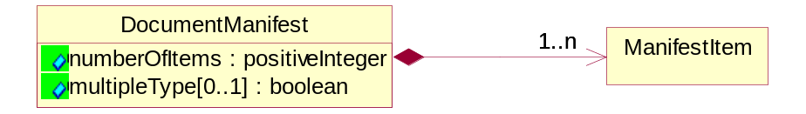
Figure 5-47 DocumentManifest

Attribute | Type | Documentation
numberOfItems | positiveInteger | Total number of documents in the message. The physical count of the attachments in the payload plus the RosettaNet Business Message (for Service Content). The value of this field will be at least 1.
multipleType[0..1] | boolean | Indicates whether the manifest contains documents of multiple types. True if yes, and False if no.

Composition | Cardinality | Type | Documentation
ManifestItem | 1..n | ManifestItem | The object provides details about the specific attachment(s).

DocumentSecurity
The object provides additional granularity in specifying business document security (this is in addition to the specified PIP security).

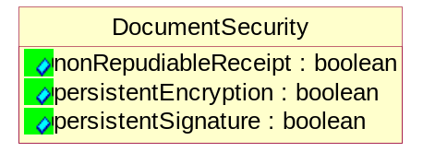
Figure 5-48 DocumentSecurity

Attribute | Type | Documentation
nonRepudiableReceipt | boolean | The value "true" will indicate that a signed acknowledgement for the business document is necessary.
persistentEncryption | boolean | The value "true" will indicate that the Business Document (including the header) needs to be encrypted when stored or transported.
persistentSignature | boolean | The value "true" will indicate that a signature is required to be stored with the document while stored or transported.

ManifestItem
The object provides details about the specific attachment(s).

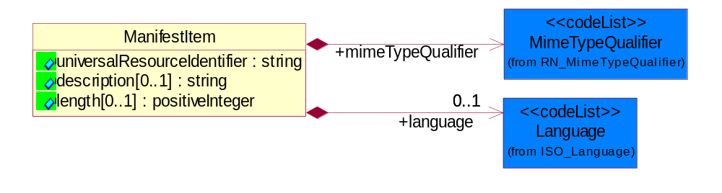
Figure 5-49 ManifestItem

Attribute | Type | Documentation
universalResourceIdentifier | string | The generic set of all names/addresses that are short strings that refer to resources.
description[0..1] | string | A description of the attachment.
length[0..1] | positiveInteger | The size of the attachment in bytes (i.e. 1 000 000 bytes)

Composition | Cardinality | Type | Documentation
mimeTypeQualifier | 1 | MimeTypeQualifier | The MIME type as defined by IANA.  Please refer to http://www.iana.org/assignments/media-types/ for a list of types.
language | 0..1 | Language | For representation of Language name RosettaNet has adopted ISO 639-2; 1998. Refer to the following web page to get the latest version of the standard:  http://www.loc.gov/standards/iso639-2/iso639jac.html  If you need more information about the ISO standard please contact ISO for more details.

PipIdentifier
PIP Identification.[ i.e. PIP3A4]

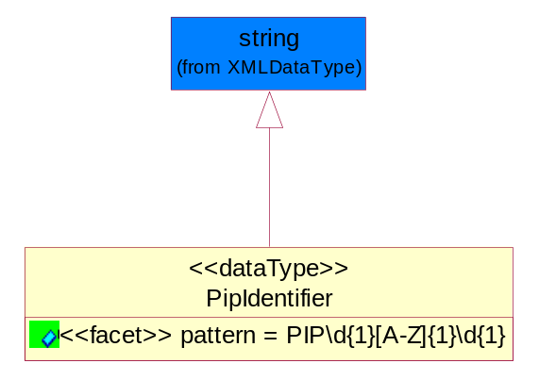
Figure 5-50 PipIdentifier

Attribute | Type | Documentation
pattern |  | PIP\d{1}[A-Z]{1}\d{2}

PipVersion
PIP version number (i.e. 02.02.00).

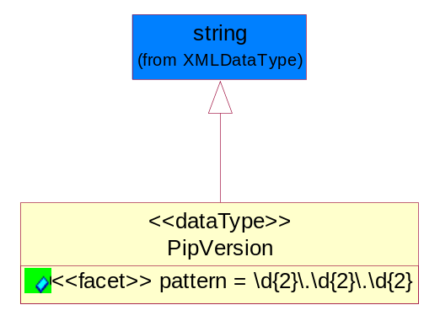
Figure 5-51 PipVersion
Attribute | Type | Documentation
pattern |  | \d{2}\.\d{2}\.\d{2}

Receiver
The object allows the identification of the receiving party of the business message.

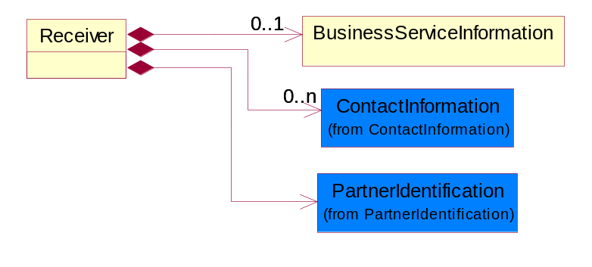
Figure 5-52 Receiver
Composition | Cardinality | Type | Documentation
BusinessServiceInformation | 0..1 | BusinessServiceInformation | The object allows the specification of the business service utilized within the partner company. This may or may not be the same as the information sent by the RNIF.
PartnerIdentification | 1 | PartnerIdentification | The business document must allow for the identity of one or more parties to the transaction.
ContactInformation | 0..n | ContactInformation | The business document must allow for the identification of the name of the department, service or individual to be contacted regarding the context of the business document.

RequestingDocumentInformation
A block of information used to correlate a requesting document to a responding document in an executing choreography.

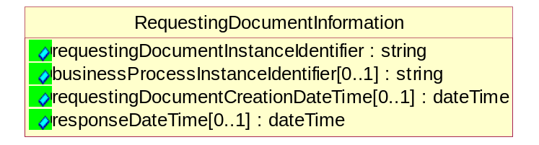
Figure 5-53 RequestingDocumentInformation
Attribute | Type | Documentation
requestingDocumentInstanceIdentifier | string | The Business Document identification number that identifies the requesting Business Document.
businessProcessInstanceIdentifier[0..1] | string | The identifier for the public business process instance being sent that both the sender and receiver can identify.
requestingDocumentCreationDateTime[0..1] | dateTime | The date-time of the requesting business document.
responseDateTime[0..1] | dateTime | The expected time to receive the response. This can not be greater than the PIP TimeToPerform.

Sender
The object allows the identification of the initiating party of the business message.

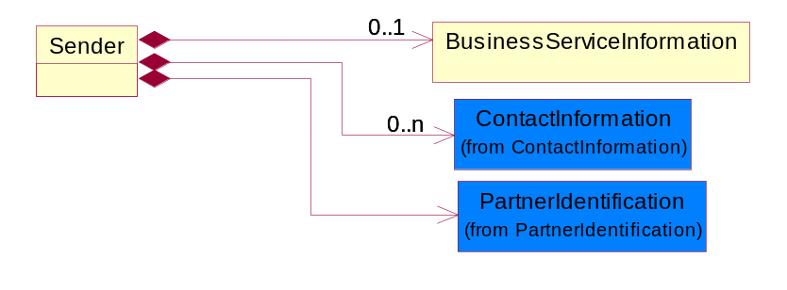
Figure 5-54 Sender

Composition | Cardinality | Type | Documentation
PartnerIdentification | 1 | PartnerIdentification | The business document must allow for the identity of one or more parties to the transaction.
BusinessServiceInformation | 0..1 | BusinessServiceInformation | The object allows the specification of the business service utilized within the partner company. This may or may not be the same as the information sent by the RNIF.
ContactInformation | 0..n | ContactInformation | The business document must allow for the identification of the name of the department, service or individual to be contacted regarding the context of the business document.

StandardDocumentIdentification
The object specifies additional information necessary to identify the standard business document.

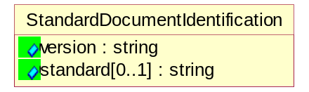
Figure 5-55 StandardDocumentIdentification
Attribute | Type | Documentation
version | string | PIP3A4v01.00
standard[0..1] | string | Identifies the standard used to submit the business document. (e.g. RosettaNet).

TpirPipIdentification
The object specifies all information necessary to uniquely identify a TPIR-PIP within a Registry or trading partner repository.
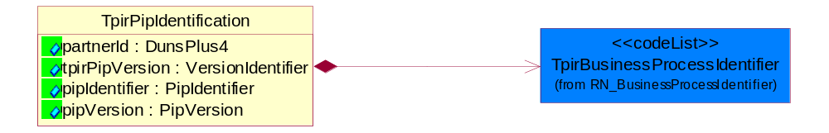
Figure 5-56 TpirPipIdentification

Attribute | Type | Documentation
partnerId | DunsPlus4 | The Trading Partner Identification of MNC that is creating this TPIR PIP.
tpirPipVersion | VersionIdentifier | A TPIR-PIP Version Number (i.e., major and minor version number as XX.XX).
pipIdentifier | PipIdentifier | A TPIR PIP Identification [i.e., 3A4 ).
pipVersion | PipVersion | A TPIR PIP version number (i.e., 02.02.00)

Composition | Cardinality | Type | Documentation
TpirBusinessProcessIdentifier | 1 | TpirBusinessProcessIdentifier | A two alphanumeric character Business Process Identifier to uniquely define the TPIR-PIP "role" within a Business Scenario at a company or MNC level.

VersionIdentifier
Version Number (i.e., major and minor version number as XX.XX).

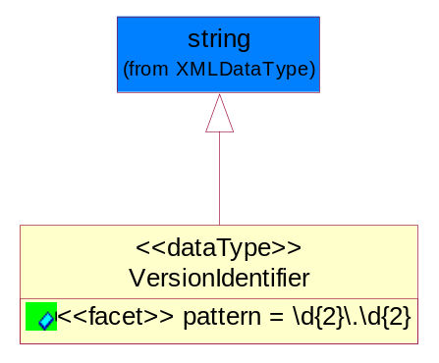
Figure 5-57 VersionIdentifier

Attribute | Type | Documentation
pattern |  | \d{2}\.\d{2}

XML Data Type

boolean
Represents Boolean values, which are either "true" or "false".

dateTime
Represents a specific instance of time.
The pattern for dateTime is CCYY-MM-DDThh:mm:ss where CC represents the century, YY the year, MM the month, and DD the day, preceded by an optional leading negative (-) character to indicate a negative number. If the negative character is omitted, positive (+) is assumed. The T is the date/time separator and hh, mm, and ss represent hour, minute, and second respectively. Additional digits can be used to increase the precision of fractional seconds if desired. For example, the format ss.ss... with any number of digits after the decimal point is supported. The fractional seconds part is optional.

This representation may be immediately followed by a "Z" to indicate Coordinated Universal Time (UTC) or to indicate the time zone. For example, the difference between the local time and Coordinated Universal Time, immediately followed by a sign, + or -, followed by the difference from UTC represented as hh:mm (minutes is required). If the time zone is included, both hours and minutes must be present.

decimal
A data type that contains decimal numbers scaled by a power of 10.

float
Represents single-precision 32-bit floating-point numbers.

nonNegativeInteger
Represents an integer that is greater than or equal to zero. This data type is derived from integer.

positiveInteger
Represents an integer that is greater than zero. This data type is derived from nonNegativeInteger.

string
Represents character string.

