

Description of 2A13 Message

PIP® 2A13
Validated 11.01.00

Specification Information
Name | Description of 2A13 Message
PIP | Distribute Material Composition Information
Cluster | Product Information
Segment | Preparation for Distribution
Publication Date | 30 Mar 2005
Version Identifier | V11.01

Table of Content

1. Document Management 6
1.1 Legal Disclaimer 6
1.2 Copyright 6
1.3 Trademarks 6
1.4 Acknowledgments 6
1.5 Related Documents 7
1.6 Document Version History 7
1.7 Document Purpose 7
1.8 Document Structure 7
2. Interchange Model 8
2.1 MaterialCompositionInformationDistribution 8
2.1.1 Interchange Diagram 8
2.1.2 Dependency Diagram 9
2.1.3 MaterialCompositionInformationDistribution 9
2.1.4 ProductIdentifier 10
2.1.5 ProductInformation 10
2.1.6 ProductInformationHeader 13
2.1.7 ProductInformationObject 13
3. Domain Model 16
3.1 Design 16
3.1.1 Design 16
3.1.1.1 Dependency Diagram 16
3.1.1.2 ActualValue 16
3.1.1.3 Attachment 18
3.1.1.4 CAS 18
3.1.1.5 DependentCondition 19
3.1.1.6 Directive 21
3.1.1.7 ManufacturingProcessInfo 23
3.1.1.8 Mass 24
3.1.1.9 MassPercentage 25
3.1.1.10 Material 26
3.1.1.11 MaterialMass 27
3.1.1.12 Note 29
3.1.1.13 ProcessValue 30
3.1.1.14 ProcessValueChoice 30
3.1.1.15 ProductMass 31
3.1.1.16 Radioactivity 32
3.1.1.17 ReferenceLocator 33
3.1.1.18 ReferenceLocatorChoice 34
3.1.1.19 Subpart 35
3.1.1.20 Substance 37
3.1.1.21 SubstanceIdentification 38
3.1.1.22 SubstanceIdentificationChoice 39
3.1.1.23 SubstanceMass 40
3.1.1.24 Text 41
3.1.1.25 Tolerance 41
3.1.1.26 url 42
3.1.1.27 Value 43
3.1.2 CodeList 44
3.1.2.1 ActionCode 44
3.1.2.2 Level 44
4. Universal Structure 45
4.1 ContactInformation 45
4.1.1 ContactInformation 45
4.2 DataType 46
4.2.1 Contact 46
4.2.2 Duns 46
4.2.3 DunsPlus4 47
4.2.4 Gtin 47
4.2.5 PercentAmount 48
4.3 Document 49
4.3.1 BusinessDocumentReference 49
4.4 Locations 50
4.4.1 AlternativeIdentifier 50
4.5 PartnerIdentification 51
4.5.1 KnownPartner 51
4.5.2 PartnerIdentification 52
4.5.3 PartnerIdentificationChoice 52
4.5.4 SpecifiedKnownPartner 53
4.6 ProductIdentification 54
4.6.1 ProductDescription 54
4.6.2 ProductIdentification 55
4.6.3 ProductIdentificationChoice 55
4.6.4 TextualDescription 56
4.7 CodeList 57
4.7.1 Language 57
4.7.2 DocumentType 57
4.7.3 MimeTypeQualifier 58
4.7.4 UnitOfMeasure 69
4.7.5 ProcessRoleIdentifier 76
5. System Structure 78
5.1 BusinessServiceInformation 78
5.2 ContractInformation 79
5.3 CorrelationInformation 79
5.4 DocumentHeader 80
5.5 DocumentIdentification 81
5.6 DocumentIdentificationChoice 81
5.7 DocumentInformation 82
5.8 DocumentManifest 83
5.9 DocumentSecurity 84
5.10 ManifestItem 84
5.11 PipIdentifier 86
5.12 PipVersion 86
5.13 Receiver 87
5.14 RequestingDocumentInformation 88
5.15 Sender 89
5.16 StandardDocumentIdentification 90
5.17 TpirPipIdentification 90
5.18 VersionIdentifier 91
6. XML Data Type 92
6.1 boolean 92
6.2 dateTime 92
6.3 decimal 92
6.4 float 92
6.5 nonNegativeInteger 92
6.6 positiveInteger 92
6.7 string 92

Table of Figures
Figure 2-1 Interchange 8
Figure 2-2 Dependency 9
Figure 2-3 MaterialCompositionInformationDistribution 9
Figure 2-4 ProductIdentifier 10
Figure 2-5 ProductInformation 11
Figure 2-6 ProductInformationHeader 13
Figure 2-7 ProductInformationObject 14
Figure 3-1 Dependency 15
Figure 3-2 ActualValue 15
Figure 3-3 Attachment 17
Figure 3-4 CAS 18
Figure 3-5 DependentCondition 19
Figure 3-6 Directive 20
Figure 3-7 ManufacturingProcessInfo 22
Figure 3-8 Mass 23
Figure 3-9 MassPercentage 24
Figure 3-10 Material 25
Figure 3-11 MaterialMass 26
Figure 3-12 Note 28
Figure 3-13 ProcessValue 29
Figure 3-14 ProductMass 30
Figure 3-15 Radioactivity 31
Figure 3-16 ReferenceLocator 32
Figure 3-17 Subpart 34
Figure 3-18 Substance 36
Figure 3-19 SubstanceIdentification 37
Figure 3-20 SubstanceMass 39
Figure 3-21 Text 40
Figure 3-22 Tolerance 40
Figure 3-23 url 41
Figure 3-24 Value 42
Figure 4-1 ContactInformation 44
Figure 4-2 Contact 45
Figure 4-3 Duns 45
Figure 4-4 DunsPlus4 46
Figure 4-5 Gtin 46
Figure 4-6 PercentAmount 47
Figure 4-7 BusinessDocumentReference 48
Figure 4-8 AlternativeIdentifier 49
Figure 4-9 KnownPartner 50
Figure 4-10 PartnerIdentification 51
Figure 4-11 SpecifiedKnownPartner 52
Figure 4-12 ProductDescription 53
Figure 4-13 ProductIdentification 54
Figure 4-14 TextualDescription 55
Figure 5-1 BusinessServiceInformation 77
Figure 5-2 ContractInformation 78
Figure 5-3 CorrelationInformation 78
Figure 5-4 DocumentHeader 79
Figure 5-5 DocumentIdentification 80
Figure 5-6 DocumentInformation 81
Figure 5-7 DocumentManifest 82
Figure 5-8 DocumentSecurity 83
Figure 5-9 ManifestItem 83
Figure 5-10 PipIdentifier 85
Figure 5-11 PipVersion 85
Figure 5-12 Receiver 86
Figure 5-13 RequestingDocumentInformation 87
Figure 5-14 Sender 88
Figure 5-15 StandardDocumentIdentification 89
Figure 5-16 TpirPipIdentification 89
Figure 5-17 VersionIdentifier 90

Document Management

Legal Disclaimer
RosettaNet, its members, officers, directors, employees, or agents shall not be liable for any injury, loss, damages, financial or otherwise, arising from, related to, or caused by the use of this document or the specifications herein, as well as associated guidelines and schemas. The use of said specifications shall constitute your express consent to the foregoing exculpation.

Copyright
©2004 - 2005 RosettaNet. All rights reserved. No part of this publication may be reproduced, stored in a retrieval system, or transmitted, in any form or by any means, electronic, mechanical, photocopying, recording, or otherwise, without the inclusion of this copyright notice. Any derivative works must cite the copyright notice. Any public redistribution or sale of this publication or derivative works requires prior written permission of the publisher.

Trademarks
RosettaNet, Partner Interface Process, PIP and the RosettaNet logo are trademarks or registered trademarks of "RosettaNet," a non-profit organization. All other product names and company logos mentioned herein are the trademarks of their respective owners. In the best effort, all terms mentioned in this document that are known to be trademarks or registered trademarks have been appropriately recognized in the first occurrence of the term.
  - Acknowledgments
This document has been prepared by RosettaNet (http://www.rosettanet.org/) from requirements gathered during the Milestone Program and in conformance with the methodology. Listed below are the legal entities that contributed to the design and development of this PIP.
ADOS Co., Ltd. | Agere Systems
Agilent Technologies | Amkor Technology, Inc.
Centor Software | Cisco Systems
Korea Electronics Industry, including Samsung & LG | Ericsson
Future Electronics Inc. | Globetronics SDH. BHD
Intel Corporation | KYOCERA Corporation
LG Electronics Inc., Quality & Reliability Center | MIMOS Berhad
Motorola | Motorola, Inc.
Motorola Semiconductor Products Sector | Motorola SPS
National Semiconductor | NEC Corporation
NEC Electronics | NEC Electronics (Europe) GmbH
Nichicon Corporation | Nippon Chemi-Con Corporation
Nokia | Nokia Corporation
Nokia Oyj | SAP
Siemens AG | School of Social Ecology, University of California Irvine
Sony | Sony EMCS Corporation
Sony Corporation | Sterling Commerce
STMicroelectronics | STMicroelectronics Inc
STMicroelectronics N.V. | Synapsis Technology, Inc.
Ted Haas Consulting, LLC | Texas Instruments
Texas Instruments, Inc. | Texas Instruments, Japan Ltd.

Related Documents
- Associated PIP Message Schemas (included with PIP Specification only)
- Description of Partner Interface Process for 2A13
- Message Structure

Document Version History
Version | Date | Description
Validated 11.00.00 | 10 Jan 2005 | RosettaNet: Marking the end of validation period with PIP version promotion. Made few changes to the message due to approved change requests submitted by validation partners.
Validated 11.01.00 | 30 Mar 2005 | Validated version. Updated to accommodate requirement from iNEMI, to support WEEE and RoHS Directives.

Document Purpose
The purpose of the document is to explain the structure, the association between objects, the content of objects and the definition for single elements to a non-technical audience.

Document Structure
The Message Description document is composed of four sections. The sections are:

- Description of the message objects based on their occurrence in the message.
- Alphabetic listing and description of the data types used in the message.
- Alphabetic listing and description of the simple types used on the message.
- Alphabetic listing and description of the enumerated types (code lists) used in the message.

Interchange Model

MaterialCompositionInformationDistribution

Interchange Diagram
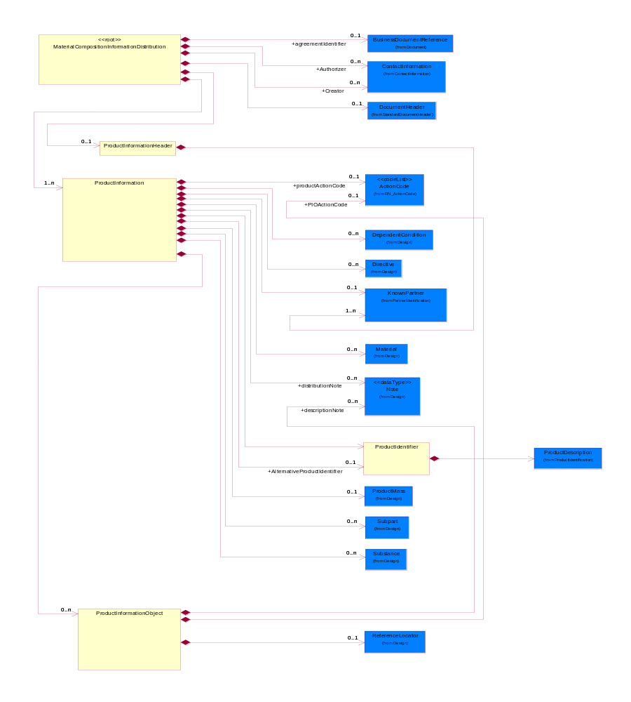
Figure 2-1 Interchange

Dependency Diagram
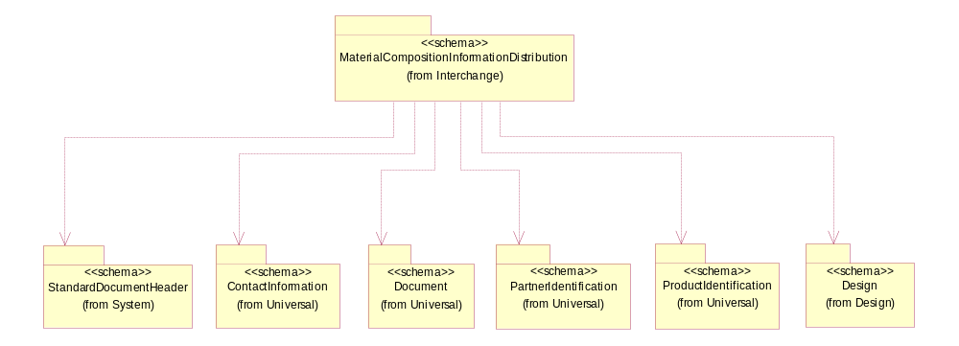
Figure 2-2 Dependency

MaterialCompositionInformationDistribution
A message wrapper or root element for PIP2A13

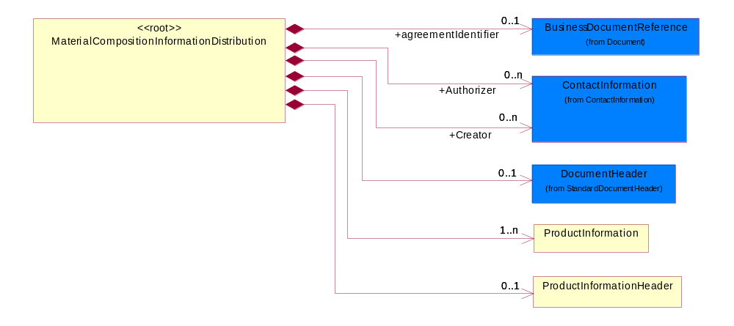
Figure 2-3 MaterialCompositionInformationDistribution

Composition | Cardinality | Type | Documentation
DocumentHeader | 0..1 | DocumentHeader | The object allows for the identification of the sender and receiver of the business document.
ProductInformationHeader | 0..1 | ProductInformationHeader | The collection of header information(s) related to one or more product.
agreementIdentifier | 0..1 | BusinessDocumentReference | The business document reference object allows for the indirect referencing of a relationship to other business related documents.
ProductInformation | 1..n | ProductInformation | The collection of information related to a product or a product family.
Authorizer | 0..n | ContactInformation | The business document must allow for the identification of the name of the department, service or individual to be contacted regarding the context of the business document.
Creator | 0..n | ContactInformation | The business document must allow for the identification of the name of the department, service or individual to be contacted regarding the context of the business document.

ProductIdentifier
The collection of data structure to identify a product or a product family.

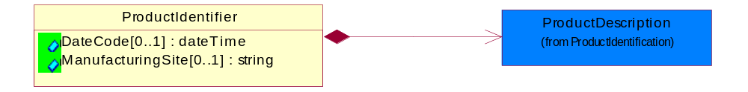
Figure 2-4 ProductIdentifier

Attribute | Type | Documentation
DateCode[0..1] | dateTime | The date when the group or batch of product becomes effective.
ManufacturingSite[0..1] | string | Identify the site where a group or batch of product is manufactured.

Composition | Cardinality | Type | Documentation
ProductDescription | 1 | ProductDescription | The business document must allow for the identification of the product and multiple textual descriptions of a product.

ProductInformation
The collection of information related to a product or a product family.

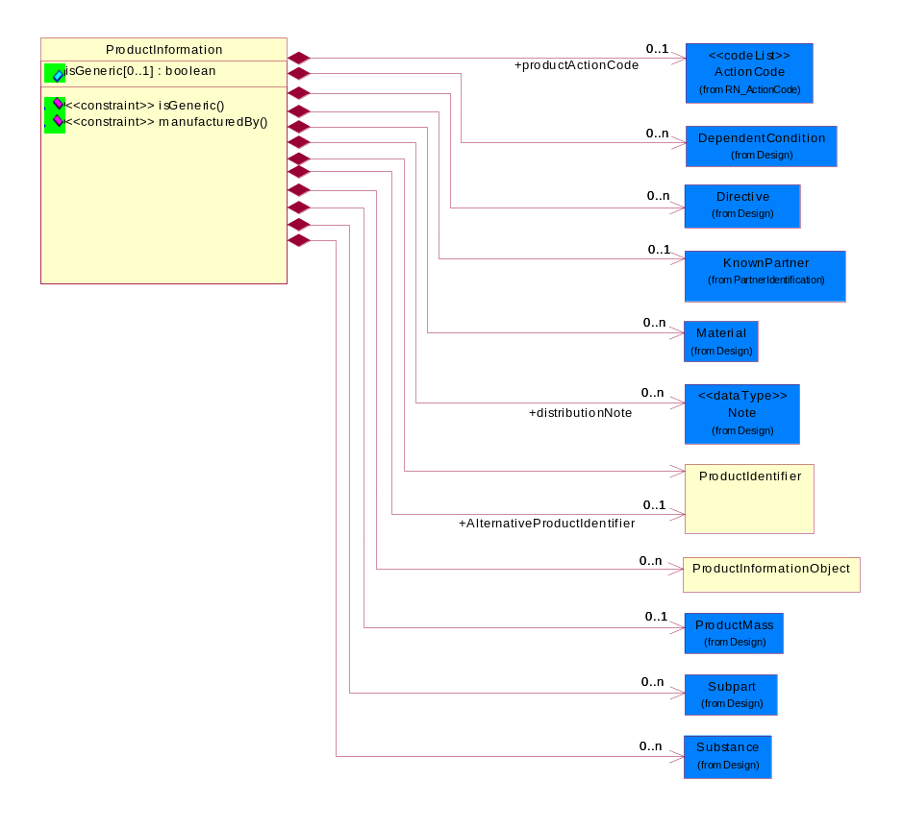
Figure 2-5 ProductInformation
Attribute | Type | Documentation
isGeneric[0..1] | boolean | To identify the subsequent product reporting as a product family (generic) reporting.

Composition | Cardinality | Type | Documentation
ProductMass | 0..1 | ProductMass | Product Total Mass (weight) MUST be specified in KIG (kg) (kilogram) even the actual value ranges from nano grams to giga kilograms. The unit of measure would still be KIG (kg).
Subpart | 0..n | Subpart | Subpart indicates the aggregation for all such subparts; i.e., if there are four such subparts, the values indicated are totaled and sent.  A typical implementation of subpart(s) within subpart(s) would be in one of the following nested levels of 0, 1 and/or 2.
Substance | 0..n | Substance | Substance definition block/class.
Material | 0..n | Material | Material definition block/class.
DependentCondition | 0..n | DependentCondition | An operational or testing condition necessary to produce the value for a given property. To report results of a material composition when "one or more conditions" have been applied to it. The list of conditions could grow, such is the case of a product, the list of conditions could be represented as a table of values. The example below explains the use of "Dependent conditions".
ProductInformationObject | 0..n | ProductInformationObject | A Meta data structure used to describe a logical representation of arbitrary data. This is also known as Attachments. This will be used as a sub-class subordinate to the ProductInformation data structure.
ProductIdentifier | 1 | ProductIdentifier | The collection of data structure to identify a product or a product family.
AlternativeProductIdentifier | 0..1 | ProductIdentifier | The collection of data structure to identify a product or a product family.
productActionCode | 0..1 | ActionCode | Code identifying the business action that must be performed on or with data. These codes will result in a subsequent action to the Material Composition data.
distributionNote | 0..n | Note | Additonal notation for the notification, product information, substance or radioactivity.
KnownPartner | 0..1 | KnownPartner | The business document must describe the trading partners in the business transaction.
Directive | 0..1 | Directive | Describes the explicit declaration of compliance to one or more compliance directives; and also specify any exemption to the compliance.

Constraint | Documentation
isGeneric | If occurrence of isGeneric is 1 then the value of isGeneric MUST be 'true'.
manufacturedBy | If occurrence of KnownPartner is 1 then the value of KnownPartner/ProcessRoleIdentifier MUST be 'MFG'.

ProductInformationHeader
The collection of header information(s) related to one or more product.

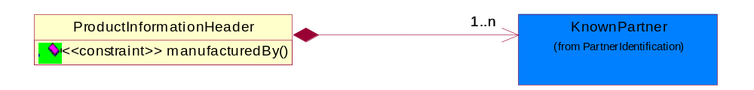
Figure 2-6 ProductInformationHeader

Composition | Cardinality | Type | Documentation
KnownPartner | 1..n | KnownPartner | The business document must describe the trading partners in the business transaction.

Constraint | Documentation
manufacturedBy | If occurrence of ProductInformationHeader is 1 then the value of KnownPartner/ProcessRoleIdentifier MUST be 'MFG'.

ProductInformationObject
A Meta data structure used to describe a logical representation of arbitrary data. This is also known as Attachments. This will be used as a sub-class subordinate to the ProductInformation data structure.

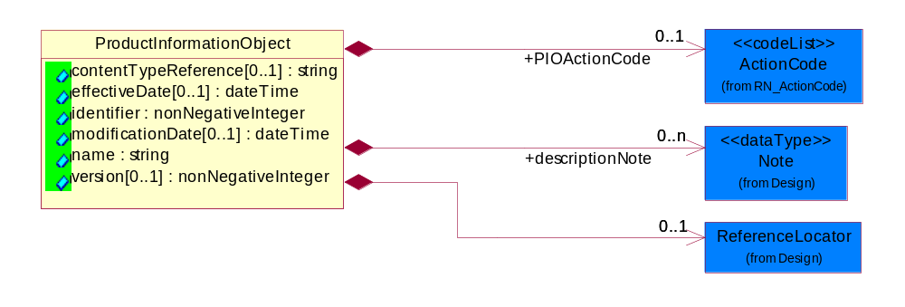
Figure 2-7 ProductInformationObject
Attribute | Type | Documentation
identifier | nonNegativeInteger | The identifier for a ProductInformationObject unique in the namespace of the notification.
name | string | The name of the ProductInformationObject, also known as Attachment.
contentTypeReference[0..1] | string | A unique identifier that defines the category of information provided by this ProductInformationObject.
effectiveDate[0..1] | dateTime | The date when the information becomes effective.
modificationDate[0..1] | dateTime | The last time a change was made.
version[0..1] | nonNegativeInteger | An arbitrary identifier indicating a content revision level.

Composition | Cardinality | Type | Documentation
PIOActionCode | 0..1 | ActionCode | Code identifying the business action that must be performed on or with data. These codes will result in a subsequent action to the Material Composition data.
ReferenceLocator | 0..1 | ReferenceLocator | Meta data describing a logical representation of a set of arbitrary data. A collection of properties identifying a ProductInformationObject with an attachment.
descriptionNote | 0..n | Note | Additonal notation for the notification, product information, substance or radioactivity.

Domain Model

Design

Design

Dependency Diagram
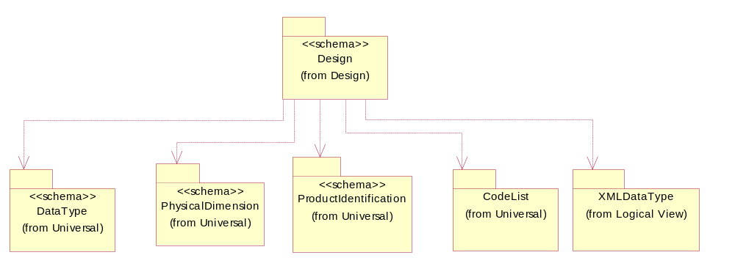
Figure 3-8 Dependency

ActualValue
Collection of elements to capture value and type.

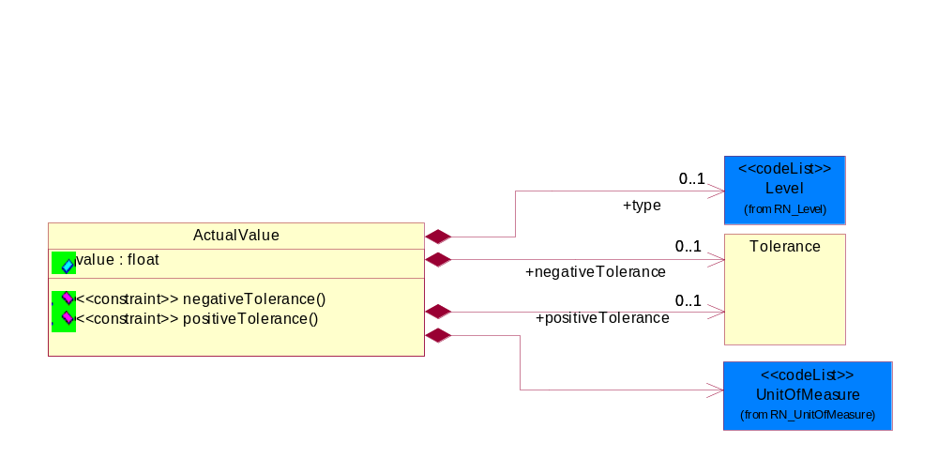
Figure 3-9 ActualValue

Attribute | Type | Documentation
value | float | The actual value recorded from the tests conducted based on test condition or dependent conditions. Extension to DependentCondition.

Composition | Cardinality | Type | Documentation
negativeTolerance | 0..1 | Tolerance | Collection defined to specify tolerance levels. Extension to DependentCondition.
ActualValue | 1..n | ActualValue | Collection of elements to capture value and type.
positiveTolerance | 0..1 | Tolerance | Collection defined to specify tolerance levels. Extension to DependentCondition.
UnitOfMeasure | 1 | UnitOfMeasure | Code identifying a product unit of measure.
type | 0..1 | Level | This is to qualify the type of the product, material or substance mass either maximum, minimum, typical, nominal independently or with any combination such as when specifying range of mass between minimum and maximum. In this case, the mass reporting will loop and for each instance it will have different Level entry.
measurement | 1 | ActualValue | The measurement value of a manufacturing process. Example are surface thickness, temperature etc.
ActualValue | 1..n | ActualValue | Collection of elements to capture value and type.

Constraint | Documentation
negativeTolerance | If value of type/Level is equal to 'NOM' then the occurrence of negativeTolerance MUST be 1.
positiveTolerance | If value of type/Level is equal to 'NOM' then the occurrence of positiveTolerance MUST be 1.

Attachment
Meta data describing a logical representation of a set of arbitrary data. A collection of properties identifying a ProductInformationObject with an attachment.

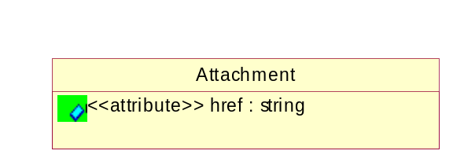
Figure 3-10 Attachment

Attribute | Type | Documentation
href | string | A reference to the Content-Id attribute of MIME-attachment specified as "cid:MIME_content-id_of_attachment" in accrodance with RFC 2392 (http://rfc.fh-koeln.de/rfc/html/rfc2392.html) and RNIF 2.0

Composition | Cardinality | Type | Documentation
Attachment | 1 | Attachment | Meta data describing a logical representation of a set of arbitrary data. A collection of properties identifying a ProductInformationObject with an attachment.

CAS
The CAS identifier is part of the CAS Registry and is a numeric identifier that can contain up to 9 digits, divided by hyphens into 3 parts: the right digit is a check digit to verify by computer the validity and uniqueness of the entire number for example, 58-08-2 is the CAS Registry Number for caffeine. If other than CAS numbers are used, this string pattern could be different.

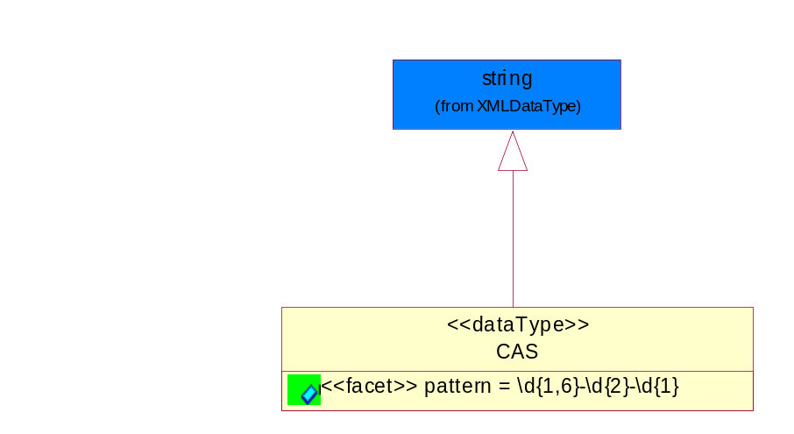
Figure 3-11 CAS

Attribute | Type | Documentation
pattern |  | \d{1,6}-\d{2}-\d{1}

Composition | Cardinality | Type | Documentation
CAS | 1 | CAS | The CAS identifier is part of the CAS Registry and is a numeric identifier that can contain up to 9 digits, divided by hyphens into 3 parts: the right digit is a check digit to verify by computer the validity and uniqueness of the entire number for example, 58-08-2 is the CAS Registry Number for caffeine. If other than CAS numbers are used, this string pattern could be different.

DependentCondition
An operational or testing condition necessary to produce the value for a given property. To report results of a material composition when "one or more conditions" have been applied to it. The list of conditions could grow, such is the case of a product, the list of conditions could be represented as a table of values.

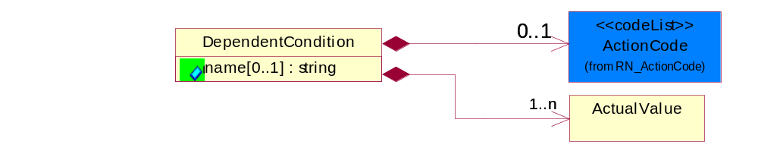
Figure 3-12 DependentCondition

Attribute | Type | Documentation
name[0..1] | string | The name of the condition which could be a pre-defined rule in Information Distribution Agreement. For example, ISO test #123ABC could be the condition rule used to test outer wrapping of a power cord which has 0.1% Cadmium.

Composition | Cardinality | Type | Documentation
ActionCode | 0..1 | ActionCode | Code identifying the business action that must be performed on or with data. These codes will result in a subsequent action to the Material Composition data.
ActualValue | 1..n | ActualValue | Collection of elements to capture value and type.
DependentCondition | 0..n | DependentCondition | An operational or testing condition necessary to produce the value for a given property. To report results of a material composition when "one or more conditions" have been applied to it. The list of conditions could grow, such is the case of a product, the list of conditions could be represented as a table of values.
DependentCondition | 0..n | DependentCondition | An operational or testing condition necessary to produce the value for a given property. To report results of a material composition when "one or more conditions" have been applied to it. The list of conditions could grow, such is the case of a product, the list of conditions could be represented as a table of values.
DependentCondition | 0..n | DependentCondition | An operational or testing condition necessary to produce the value for a given property. To report results of a material composition when "one or more conditions" have been applied to it. The list of conditions could grow, such is the case of a product, the list of conditions could be represented as a table of values.

Directive
Describes the explicit declaration of compliance to one or more compliance directives; and also specify any exemption to the compliance.

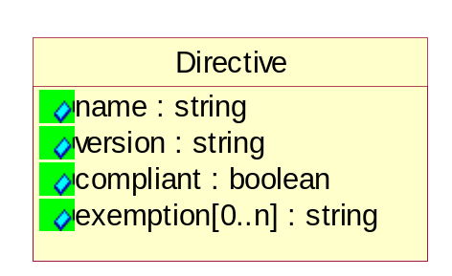
Figure 3-13 Directive

Attribute | Type | Documentation
name | string | The unique name of the directive of legistlation. Example EU RoHS, WEEE etc.
version | string | The version of the directive for which this part is being declared.
compliant | boolean | Indicating whether the part compliant or not with the directive.
exemption[0..n] | string | Provides the exemptions claimed for this part of this directive. A part may be compliant to a directive but only because it falls under one or more exemptions.

Composition | Cardinality | Type | Documentation
Directive | 0..n | Directive | Describes the explicit declaration of compliance to one or more compliance directives; and also specify any exemption to the compliance.
Directive | 0..n | Directive | Describes the explicit declaration of compliance to one or more compliance directives; and also specify any exemption to the compliance.

ManufacturingProcessInfo
Provides information with regards to the manufacturing process of a product or subpart.

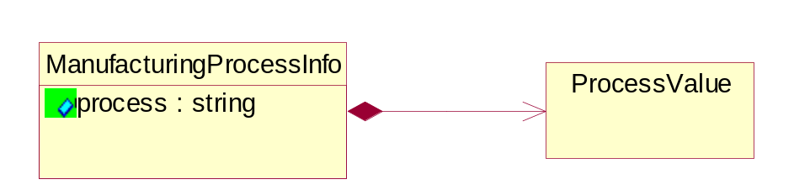
Figure 3-14 ManufacturingProcessInfo

Attribute | Type | Documentation
process | string | Describes a process invloved in manufacturing a product. Example are Add Terminal Plating and Surface Thickness, Terminal Base Alloy and Base or Core Thickness, Grid Array Materials, Max Reflow Temperature, Max Reflow Cycles, J-STD-020 Moisture etc.

Composition | Cardinality | Type | Documentation
ProcessValue | 1 | ProcessValue | Describes the value of manufacturing process. Example are surface thickness measurement, temperature setting, material type etc.
ManufacturingProcessInfo | 0..n | ManufacturingProcessInfo | Provides information with regards to the manufacturing process of a product or subpart.

Mass
Based on ECTD/IEC specification, Mass should be specified in kilogram (KG) per IEC 61360 - 1 (Annex B) - (http://www.iec.ch/tc3/txt/143.htm) format for floating point, positive or negative.

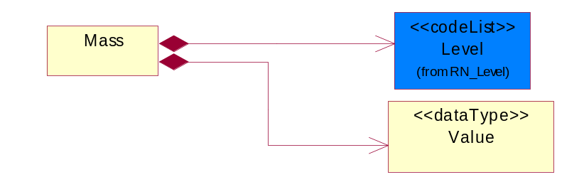
Figure 3-15 Mass

Composition | Cardinality | Type | Documentation
Value | 1 | Value | Based on ECTD/IEC specification, Mass should be specified in kilogram (KG) per IEC 61360 - 1 (Annex B) - (http://www.iec.ch/tc3/txt/143.htm) format for floating point, positive or negative.  Example of preferred format:  a. 2kg - will be specified as 2.0E KG  b. 200g - will be specified as 200.0E - 3 KG  c. 20mg - will be specified as 20.0E- 6 KG
Mass | 1..n | Mass | Based on ECTD/IEC specification, Mass should be specified in kilogram (KG) per IEC 61360 - 1 (Annex B) - (http://www.iec.ch/tc3/txt/143.htm) format for floating point, positive or negative.
Mass | 0..n | Mass | Based on ECTD/IEC specification, Mass should be specified in kilogram (KG) per IEC 61360 - 1 (Annex B) - (http://www.iec.ch/tc3/txt/143.htm) format for floating point, positive or negative.
Mass | 1..n | Mass | Based on ECTD/IEC specification, Mass should be specified in kilogram (KG) per IEC 61360 - 1 (Annex B) - (http://www.iec.ch/tc3/txt/143.htm) format for floating point, positive or negative.
Level | 1 | Level | This is to qualify the type of the product, material or substance mass either maximum, minimum, typical, nominal independently or with any combination such as when specifying range of mass between minimum and maximum. In this case, the mass reporting will loop and for each instance it will have different Level entry.

MassPercentage
Weight percentage of total mass. Usually specified for parts per million (ppm). A number representing a percentage value, e.g. 75.125 represents 75 1/8 percent.

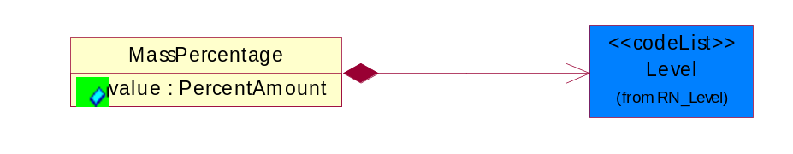
Figure 3-16 MassPercentage

Attribute | Type | Documentation
value | PercentAmount | A number representing a percentage value, e.g. 75.125 represents 75 1/8 percent

Composition | Cardinality | Type | Documentation
Level | 1 | Level | This is to qualify the type of the product, material or substance mass either maximum, minimum, typical, nominal independently or with any combination such as when specifying range of mass between minimum and maximum. In this case, the mass reporting will loop and for each instance it will have different Level entry.
MassPercentage | 0..n | MassPercentage | Weight percentage of total mass. Usually specified for parts per million (ppm). A number representing a percentage value, e.g. 75.125 represents 75 1/8 percent.
MassPercentage | 0..n | MassPercentage | Weight percentage of total mass. Usually specified for parts per million (ppm). A number representing a percentage value, e.g. 75.125 represents 75 1/8 percent.
MassPercentage | 0..n | MassPercentage | Weight percentage of total mass. Usually specified for parts per million (ppm). A number representing a percentage value, e.g. 75.125 represents 75 1/8 percent.

Material
Material definition block/class.

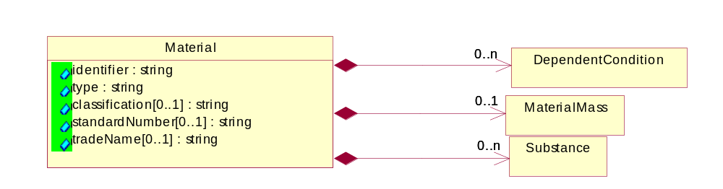
Figure 3-17 Material

Attribute | Type | Documentation
identifier | string | Identifier for the material either using ISO, or MaterialClassification
type | string | The name of the material e.g Copper, Alloy, Polymer, Glass, etc.
classification[0..1] | string | Classification e.g. JGPSSI classification system
standardNumber[0..1] | string | ISO or other international standards number identifying material
tradeName[0..1] | string | Commercial name of the material

Composition | Cardinality | Type | Documentation
MaterialMass | 0..1 | MaterialMass | Material Total Mass (weight) MUST be specified in KIG (kg) (kilogram) even the actual value ranges from nano grams to giga kilograms. The unit of measure would still be KIG (kg).
Material | 0..n | Material | Material definition block/class.
DependentCondition | 0..n | DependentCondition | An operational or testing condition necessary to produce the value for a given property. To report results of a material composition when "one or more conditions" have been applied to it. The list of conditions could grow, such is the case of a product, the list of conditions could be represented as a table of values.
Substance | 0..n | Substance | Substance definition block/class.
Material | 0..n | Material | Material definition block/class.

MaterialMass
Material Total Mass (weight) MUST be specified in KIG (kg) (kilogram) even the actual value ranges from nano grams to giga kilograms. The unit of measure would still be KIG (kg).

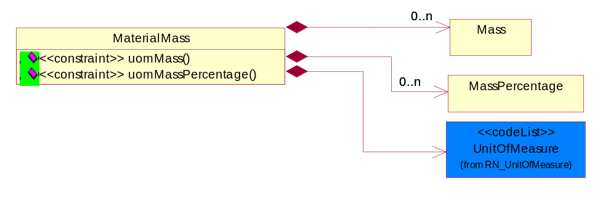
Figure 3-18 MaterialMass

Composition | Cardinality | Type | Documentation
Mass | 0..n | Mass | Based on ECTD/IEC specification, Mass should be specified in kilogram (KG) per IEC 61360 - 1 (Annex B) - (http://www.iec.ch/tc3/txt/143.htm) format for floating point, positive or negative.
MaterialMass | 0..1 | MaterialMass | Material Total Mass (weight) MUST be specified in KIG (kg) (kilogram) even the actual value ranges from nano grams to giga kilograms. The unit of measure would still be KIG (kg).
UnitOfMeasure | 1 | UnitOfMeasure | Code identifying a product unit of measure.
MassPercentage | 0..n | MassPercentage | Weight percentage of total mass. Usually specified for parts per million (ppm). A number representing a percentage value, e.g. 75.125 represents 75 1/8 percent.

Constraint | Documentation
uomMass | If occurrence of Mass is between 1 and unbounded then the value of UnitOfMeasure MUST be 'KIG'.
uomMassPercentage | If occurrence of MassPercentage is between 1 and unbounded then the value of UnitOfMeasure MUST be 'KIG'.

Note
Additonal notation for the notification, product information, substance or radioactivity.

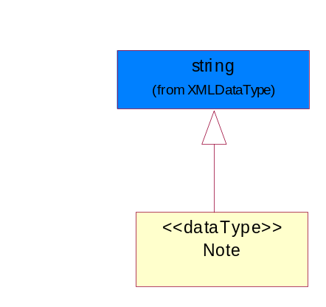
Figure 3-19 Note

Composition | Cardinality | Type | Documentation
radioactivityNote | 0..1 | Note | Additonal notation for the notification, product information, substance or radioactivity.
substanceNote | 0..1 | Note | Additonal notation for the notification, product information, substance or radioactivity.
descriptionNote | 0..n | Note | Additonal notation for the notification, product information, substance or radioactivity.
distributionNote | 0..n | Note | Additonal notation for the notification, product information, substance or radioactivity.

ProcessValue
Describes the value of manufacturing process. Example are surface thickness measurement, temperature setting, material type etc.

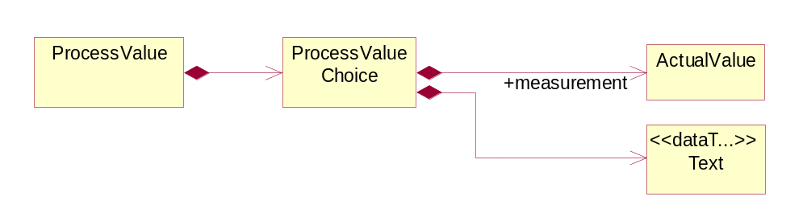
Figure 3-20 ProcessValue

Composition | Cardinality | Type | Documentation
ProcessValueChoice | 1 | ProcessValueChoice
ProcessValue | 1 | ProcessValue | Describes the value of manufacturing process. Example are surface thickness measurement, temperature setting, material type etc.

ProcessValueChoice

Composition | Cardinality | Type | Documentation
ProcessValueChoice | 1 | ProcessValueChoice
measurement | 1 | ActualValue | The measurement value of a manufacturing process. Example are surface thickness, temperature etc.
Text | 1 | Text | The textual value of a manufacturing process. Example are material type, moisture setting standard etc.

ProductMass
Product Total Mass (weight) MUST be specified in KIG (kg) (kilogram) even the actual value ranges from nano grams to giga kilograms. The unit of measure would still be KIG (kg).

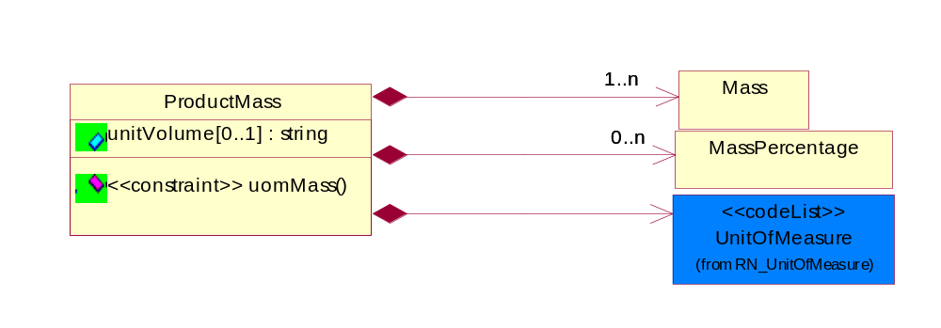
Figure 3-21 ProductMass

Attribute | Type | Documentation
unitVolume[0..1] | string | Describes the scoped weight to a unit volume such as cubic meter or cubic feet, square meter or square foot etc. To provide concise reporting of bulk materials, components, sub-assemblies and finished products.

Composition | Cardinality | Type | Documentation
Mass | 1..n | Mass | Based on ECTD/IEC specification, Mass should be specified in kilogram (KG) per IEC 61360 - 1 (Annex B) - (http://www.iec.ch/tc3/txt/143.htm) format for floating point, positive or negative.
UnitOfMeasure | 1 | UnitOfMeasure | Code identifying a product unit of measure.
MassPercentage | 0..n | MassPercentage | Weight percentage of total mass. Usually specified for parts per million (ppm). A number representing a percentage value, e.g. 75.125 represents 75 1/8 percent.
ProductMass | 0..1 | ProductMass | Product Total Mass (weight) MUST be specified in KIG (kg) (kilogram) even the actual value ranges from nano grams to giga kilograms. The unit of measure would still be KIG (kg).
ProductMass | 0..1 | ProductMass | Product Total Mass (weight) MUST be specified in KIG (kg) (kilogram) even the actual value ranges from nano grams to giga kilograms. The unit of measure would still be KIG (kg).

Constraint | Documentation
uomMass | If occurrence of Mass is between 1 and unbounded then the value of UnitOfMeasure MUST be 'KIG'.

Radioactivity
Radioactivity isotope name, code and other details

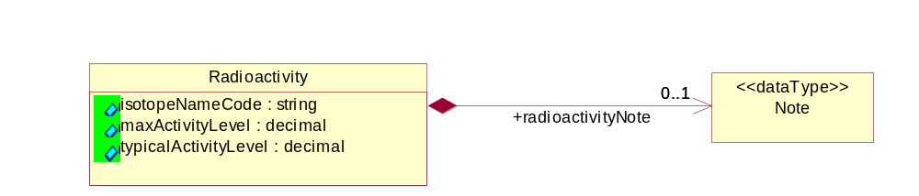
Figure 3-22 Radioactivity

Attribute | Type | Documentation
isotopeNameCode | string | If the substance is radioactive the radioactive Isotope element name and code e.g. Ni-63 should be provided.
maxActivityLevel | decimal | The maximum activity level in MBecquerel's (MBq).
typicalActivityLevel | decimal | The typical activity level in MBecquerel's (MBq)

Composition | Cardinality | Type | Documentation
Radioactivity | 0..n | Radioactivity | Radioactivity isotope name, code and other details
radioactivityNote | 0..1 | Note | Additonal notation for the notification, product information, substance or radioactivity.

ReferenceLocator
Meta data describing a logical representation of a set of arbitrary data. A collection of properties identifying a ProductInformationObject with an attachment.

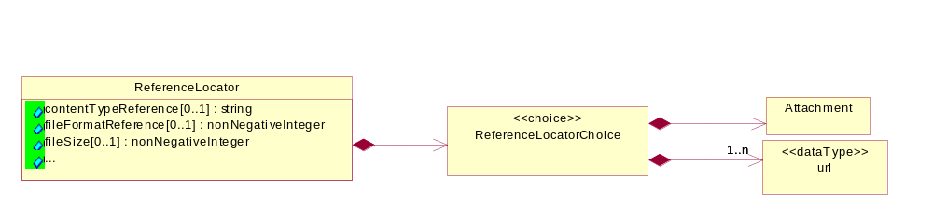
Figure 3-23 ReferenceLocator

Attribute | Type | Documentation
contentTypeReference[0..1] | string | A unique identifier that defines the category of information provided by this ProductInformationObject
fileFormatReference[0..1] | nonNegativeInteger | A unique identifier that defines the type data encoding for this ProductInformationObject.
fileSize[0..1] | nonNegativeInteger | The size of an object.
reference[0..n] | string | Represented as a URL (Uniform Resource Locator defined in accordance with RFC 2396 http://www.w3.org/Addressing). The URL's purpose is to provide supplementary information related to the ProductInformationObject.
urlLegal[0..n] | string | Using a URL (Uniform Resource Locator defined in accordance with RFC 2396 http://www.w3.org/Addressing) to describe terms, conditions, disclaimers, warnings, limitations, or other information related to the ProductInformationObject.

Composition | Cardinality | Type | Documentation
ReferenceLocatorChoice | 1 | ReferenceLocatorChoice
ReferenceLocator | 0..1 | ReferenceLocator | Meta data describing a logical representation of a set of arbitrary data. A collection of properties identifying a ProductInformationObject with an attachment.

ReferenceLocatorChoice

Composition | Cardinality | Type | Documentation
url | 1..n | url | The URL (Uniform Resource Locator defined in accordance with RFC 2396 http://www.w3.org/Addressing) is used for accessing dynamic supplementary information maintained by a domain authority. It is used as a storage area for an attachment. When this request is rendered it will return only the requested attached data.
ReferenceLocatorChoice | 1 | ReferenceLocatorChoice
Attachment | 1 | Attachment | Meta data describing a logical representation of a set of arbitrary data. A collection of properties identifying a ProductInformationObject with an attachment.

Subpart
Subpart indicates the aggregation for all such subparts; i.e., if there are four such subparts, the values indicated are totaled and sent.
A typical implementation of subpart(s) within subpart(s) would be in one of the following nested levels of 0, 1 and/or 2.

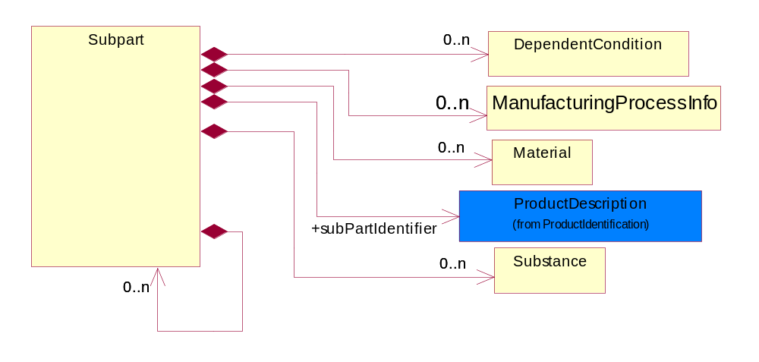
Figure 3-24 Subpart

Composition | Cardinality | Type | Documentation
subPartIdentifier | 1 | ProductDescription | The business document must allow for the identification of the product and multiple textual descriptions of a product.
Subpart | 0..n | Subpart | Subpart indicates the aggregation for all such subparts; i.e., if there are four such subparts, the values indicated are totaled and sent.  A typical implementation of subpart(s) within subpart(s) would be in one of the following nested levels of 0, 1 and/or 2.
DependentCondition | 0..n | DependentCondition | An operational or testing condition necessary to produce the value for a given property. To report results of a material composition when "one or more conditions" have been applied to it. The list of conditions could grow, such is the case of a product, the list of conditions could be represented as a table of values.
Material | 0..n | Material | Material definition block/class.
Substance | 0..n | Substance | Substance definition block/class.
ManufacturingProcessInfo | 0..n | ManufacturingProcessInfo | Provides information with regards to the manufacturing process of a product or subpart.
Subpart | 0..n | Subpart | Subpart indicates the aggregation for all such subparts; i.e., if there are four such subparts, the values indicated are totaled and sent.  A typical implementation of subpart(s) within subpart(s) would be in one of the following nested levels of 0, 1 and/or 2.

Substance
Substance definition block/class.

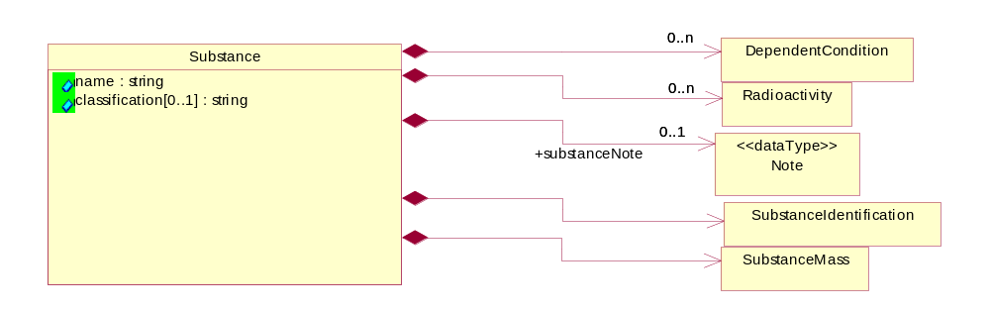
Figure 3-25 Substance

Attribute | Type | Documentation
name | string | The substance name e.g. Copper (Cu) or group name e.g. Nickel compunds
classification[0..1] | string | Classification e.g. JGPSSI classification system

Composition | Cardinality | Type | Documentation
Radioactivity | 0..n | Radioactivity | Radioactivity isotope name, code and other details
substanceNote | 0..1 | Note | Additonal notation for the notification, product information, substance or radioactivity.
SubstanceMass | 1 | SubstanceMass | Substance Total Mass (weight) MUST be specified in KIG (kg) (kilogram) even the actual value ranges from nano grams to giga kilograms. The unit of measure would still be KIG (kg).
SubstanceIdentification | 1 | SubstanceIdentification | A structured and broadly accepted way of identifying a substance. RosettaNet has adopted CAS (Chemical Abstract Numbering System), http://chemfinder.camsoft.com or any alternative identifiers.
Substance | 0..n | Substance | Substance definition block/class.
DependentCondition | 0..n | DependentCondition | An operational or testing condition necessary to produce the value for a given property. To report results of a material composition when "one or more conditions" have been applied to it. The list of conditions could grow, such is the case of a product, the list of conditions could be represented as a table of values.
Substance | 0..n | Substance | Substance definition block/class.
Substance | 0..n | Substance | Substance definition block/class.

SubstanceIdentification
A structured and broadly accepted way of identifying a substance. RosettaNet has adopted CAS (Chemical Abstract Numbering System), http://chemfinder.camsoft.com or any alternative identifiers.

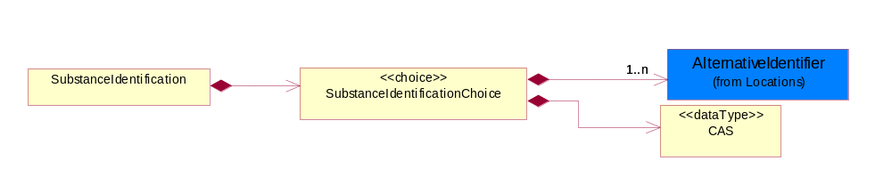
Figure 3-26 SubstanceIdentification

Composition | Cardinality | Type | Documentation
SubstanceIdentificationChoice | 1 | SubstanceIdentificationChoice
SubstanceIdentification | 1 | SubstanceIdentification | A structured and broadly accepted way of identifying a substance. RosettaNet has adopted CAS (Chemical Abstract Numbering System), http://chemfinder.camsoft.com or any alternative identifiers.

SubstanceIdentificationChoice

Composition | Cardinality | Type | Documentation
SubstanceIdentificationChoice | 1 | SubstanceIdentificationChoice
CAS | 1 | CAS | The CAS identifier is part of the CAS Registry and is a numeric identifier that can contain up to 9 digits, divided by hyphens into 3 parts: the right digit is a check digit to verify by computer the validity and uniqueness of the entire number for example, 58-08-2 is the CAS Registry Number for caffeine. If other than CAS numbers are used, this string pattern could be different.
AlternativeIdentifier | 1..n | AlternativeIdentifier | Identifies the specified code and the name of the organization that a code is utilized from.

SubstanceMass
Substance Total Mass (weight) MUST be specified in KIG (kg) (kilogram) even the actual value ranges from nano grams to giga kilograms. The unit of measure would still be KIG (kg).

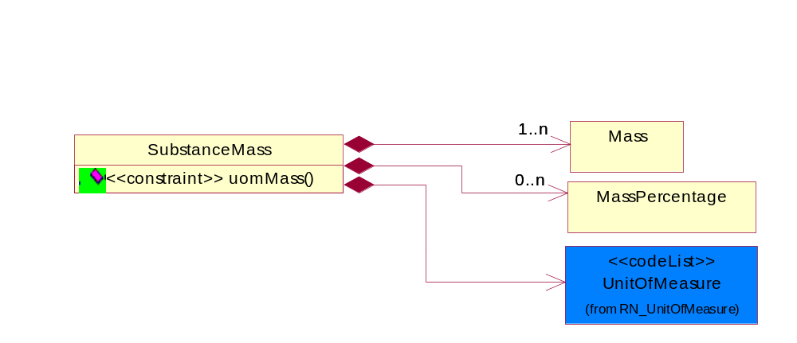
Figure 3-27 SubstanceMass

Composition | Cardinality | Type | Documentation
Mass | 1..n | Mass | Based on ECTD/IEC specification, Mass should be specified in kilogram (KG) per IEC 61360 - 1 (Annex B) - (http://www.iec.ch/tc3/txt/143.htm) format for floating point, positive or negative.
SubstanceMass | 1 | SubstanceMass | Substance Total Mass (weight) MUST be specified in KIG (kg) (kilogram) even the actual value ranges from nano grams to giga kilograms. The unit of measure would still be KIG (kg).
UnitOfMeasure | 1 | UnitOfMeasure | Code identifying a product unit of measure.
MassPercentage | 0..n | MassPercentage | Weight percentage of total mass. Usually specified for parts per million (ppm). A number representing a percentage value, e.g. 75.125 represents 75 1/8 percent.

Constraint | Documentation
uomMass | If occurrence of Mass is between 1 and unbounded then the value of UnitOfMeasure MUST be 'KIG'.

Text
The textual value of a manufacturing process. Example are material type, moisture setting standard etc.

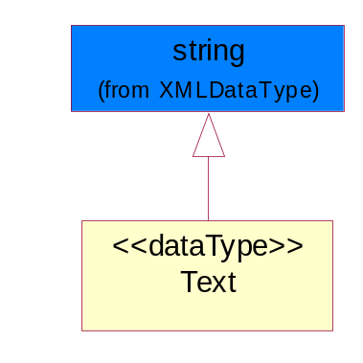
Figure 3-28 Text

Composition | Cardinality | Type | Documentation
Text | 1 | Text | The textual value of a manufacturing process. Example are material type, moisture setting standard etc.

Tolerance
Collection defined to specify tolerance levels. Extension to DependentCondition.

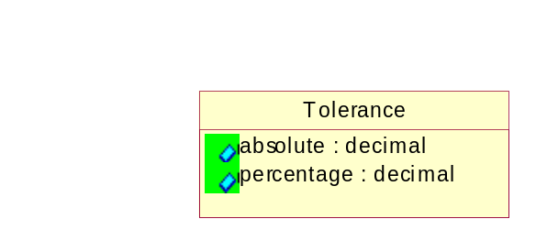
Figure 3-29 Tolerance

Attribute | Type | Documentation
absolute | decimal | A tolerance expressed as a real number
percentage | decimal | A tolerance expressed as a percentage of the current value

Composition | Cardinality | Type | Documentation
negativeTolerance | 0..1 | Tolerance | Collection defined to specify tolerance levels. Extension to DependentCondition.
positiveTolerance | 0..1 | Tolerance | Collection defined to specify tolerance levels. Extension to DependentCondition.

url
The URL (Uniform Resource Locator defined in accordance with RFC 2396 http://www.w3.org/Addressing) is used for accessing dynamic supplementary information maintained by a domain authority. It is used as a storage area for an attachment. When this request is rendered it will return only the requested attached data.

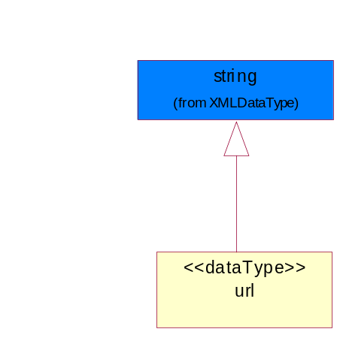
Figure 3-30 url

Composition | Cardinality | Type | Documentation
url | 1..n | url | The URL (Uniform Resource Locator defined in accordance with RFC 2396 http://www.w3.org/Addressing) is used for accessing dynamic supplementary information maintained by a domain authority. It is used as a storage area for an attachment. When this request is rendered it will return only the requested attached data.

Value
Based on ECTD/IEC specification, Mass should be specified in kilogram (KG) per IEC 61360 - 1 (Annex B) - (http://www.iec.ch/tc3/txt/143.htm) format for floating point, positive or negative.
Example of preferred format:
a. 2kg - will be specified as 2.0E KG
b. 200g - will be specified as 200.0E - 3 KG
c. 20mg - will be specified as 20.0E- 6 KG
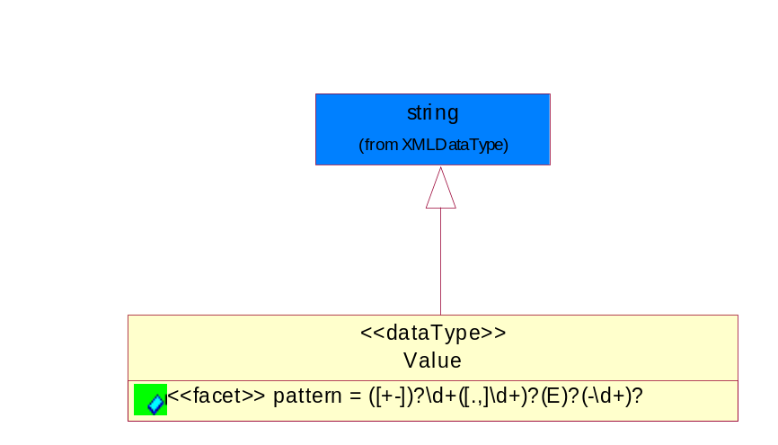
Figure 3-31 Value

Attribute | Type | Documentation
pattern |  | For reals, MAY have (+-) and then MUST have 1 or more digits, and then MUST have a period (or comma) and then MUST have or more digits.  For floating numbers, MAY have (+-) and then MUST have 1 or more digits, and then MUST have a period (or comma) and then MUST have or more digits and then MAY have 'E' and then MAY have (-) sign and then MAY have 1 or 2 digits

Composition | Cardinality | Type | Documentation
Value | 1 | Value | Based on ECTD/IEC specification, Mass should be specified in kilogram (KG) per IEC 61360 - 1 (Annex B) - (http://www.iec.ch/tc3/txt/143.htm) format for floating point, positive or negative.  Example of preferred format:  a. 2kg - will be specified as 2.0E KG  b. 200g - will be specified as 200.0E - 3 KG  c. 20mg - will be specified as 20.0E- 6 KG

CodeList

ActionCode
Code identifying the business action that must be performed on or with data. These codes will result in a subsequent action to the Material Composition data.

Name | Documentation
ADD | Add the business information to an information system
CHG | The change request made accepted
DEL | Delete the business infomation from an information system
REQ | The business information accepted with change
REV | Revise the business information from an information system

Level
This is to qualify the type of the product, material or substance mass either maximum, minimum, typical, nominal independently or with any combination such as when specifying range of mass between minimum and maximum. In this case, the mass reporting will loop and for each instance it will have different Level entry.

Name | Documentation
MAX | A Maximum level of the mass (weight) MUST be specified as KIG (kilogram) using ECTD/IEC/ISO Specification for the UOM field.
MIN | A Minimum level of the mass (weight) MUST be specified as KIG (kilogram) using ECTD/IEC/ISO Specification for the UOM field.
NOM | A Nominal level of the mass (weight) MUST be specified as KIG (kilogram) using ECTD/IEC/ISO Specification for the UOM field.
TYP | A Typical level of the mass (weight) MUST be specified as KIG (kilogram) using ECTD/IEC/ISO Specification for the UOM field.

Universal Structure

ContactInformation

ContactInformation
The business document must allow for the identification of the name of the department, service or individual to be contacted regarding the context of the business document.

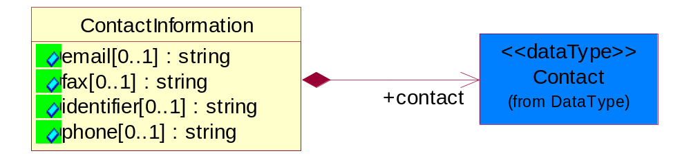
Figure 4-32 ContactInformation

Attribute | Type | Documentation
email[0..1] | string | The electronic mail for the specified contact.
fax[0..1] | string | The fax number for the specified contact.
identifier[0..1] | string | Identifies the role of the contact (i.e. Service Technician, Account Manager) in the Business Process.
phone[0..1] | string | The telephone number for the specified contact.

Composition | Cardinality | Type | Documentation
contact | 1 | Contact | The name of the department, service or individual to be contacted within the organization.

DataType

Contact
The name of the department, service or individual to be contacted within the organization.

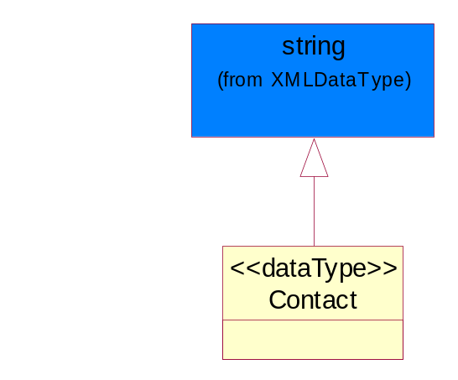
Figure 4-33 Contact

Duns
A number assigned by Dun and Bradstreet to identify a business location.

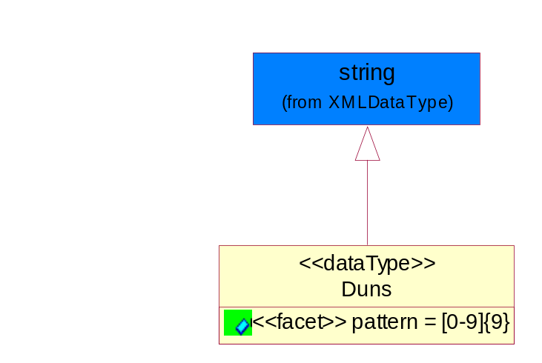
Figure 4-34 Duns

Attribute | Type | Documentation
pattern |  | [0-9]{9}

DunsPlus4
A identifier to specify a specific location within a business location.

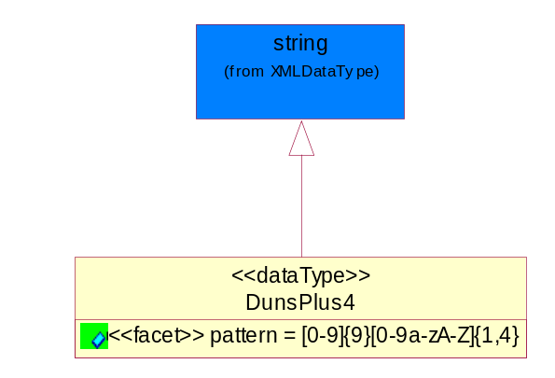
Figure 4-35 DunsPlus4

Attribute | Type | Documentation
pattern |  | Data Universal Numbering System +4 (DUNS+4) number means the DUNS number assigned by Dun and Bradstreet, Inc. (D&B) plus an alphanumeric of length 4 suffix that may be assigned by a business concern.

Gtin
Global Trade Identification Number (GTIN).

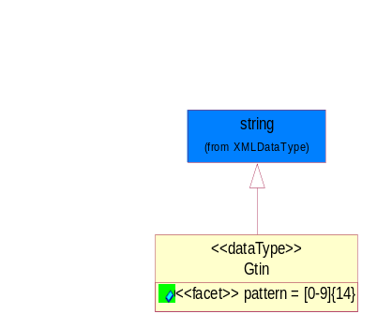
Figure 4-36 Gtin

Attribute | Type | Documentation
pattern |  | [0-9]{14}

PercentAmount
A number representing a percentage value, e.g. 75.125 represents 75 1/8 percent.

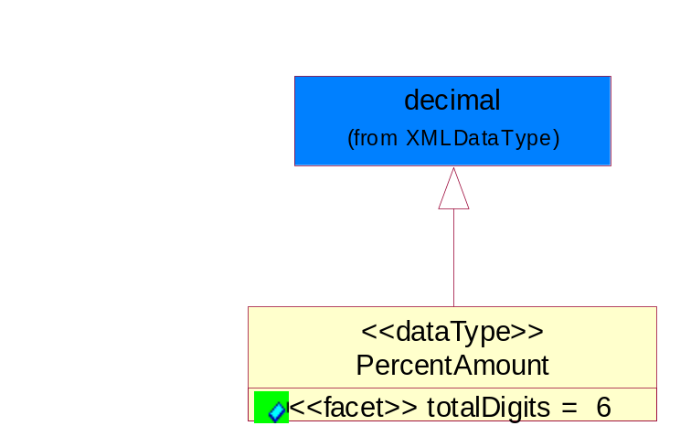
Figure 4-37 PercentAmount

Attribute | Type | Documentation
totalDigits |  | 6

Document

BusinessDocumentReference
The business document reference object allows for the indirect referencing of a relationship to other business related documents.

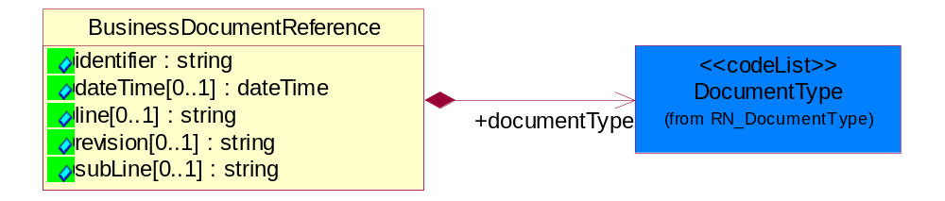
Figure 4-38 BusinessDocumentReference

Attribute | Type | Documentation
identifier | string | Unique identification of the referenced business document.
dateTime[0..1] | dateTime | The date-time stamp indicating on the referenced business document.
line[0..1] | string | References the specific line number of the specified business document.
revision[0..1] | string | Referenced the revision of the specified business document.
subLine[0..1] | string | References the specific subline number of the specified business document.

Composition | Cardinality | Type | Documentation
documentType | 1 | DocumentType | A code identifying the business context of a document.

Locations

AlternativeIdentifier
Identifies the specified code and the name of the organization that a code is utilized from.

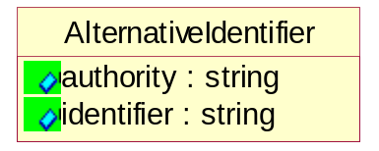
Figure 4-39 AlternativeIdentifier

Attribute | Type | Documentation
authority | string | The name of the organization that a code is utilized from.
identifier | string | The specified code to represent an entity (e.g. product, location, partner, etc.)

PartnerIdentification

KnownPartner
The business document must describe the trading partners in the business transaction.

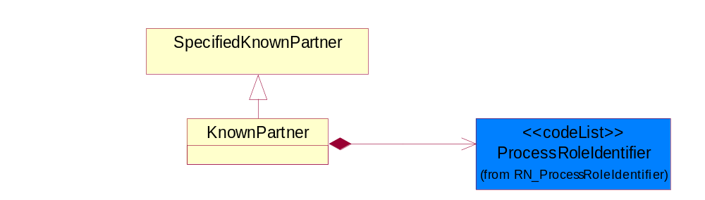
Figure 4-40 KnownPartner

Composition | Cardinality | Type | Documentation
ProcessRoleIdentifier | 1 | ProcessRoleIdentifier | Describes the role of the partner in the business process. A partner will fulfill at least one or more roles during the business process.

PartnerIdentification
The business document must allow for the identity of one or more parties to the transaction.
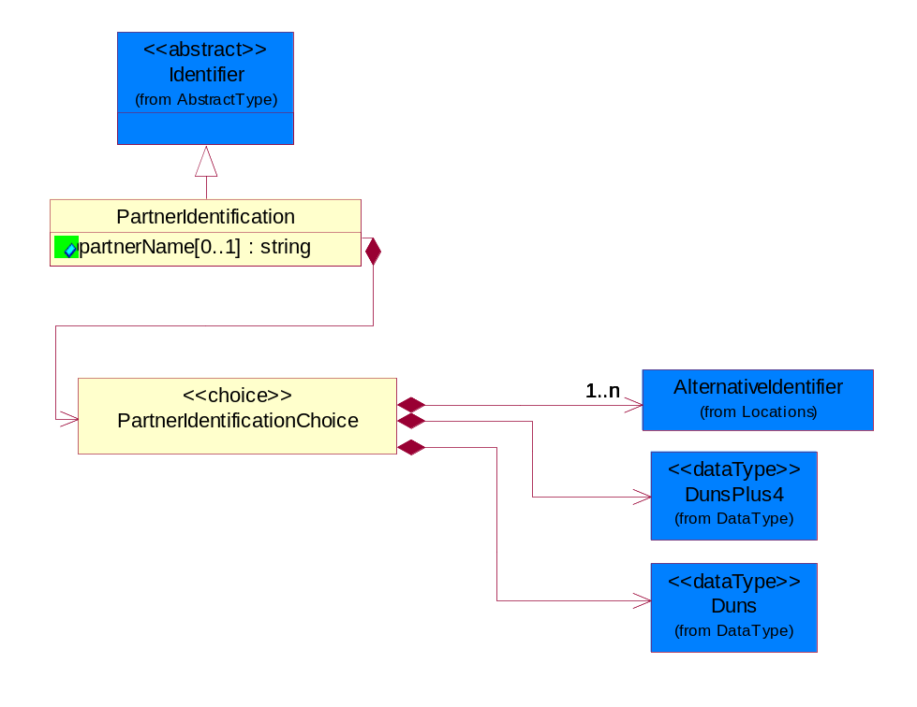
Figure 4-41 PartnerIdentification

Attribute | Type | Documentation
partnerName[0..1] | string | The name of the partner.

Composition | Cardinality | Type | Documentation
PartnerIdentificationChoice | 1 | PartnerIdentificationChoice

PartnerIdentificationChoice

Composition | Cardinality | Type | Documentation
Duns | 1 | Duns | A number assigned by Dun and Bradstreet to identify a business location.
DunsPlus4 | 1 | DunsPlus4 | A identifier to specify a specific location within a business location.
AlternativeIdentifier | 1..n | AlternativeIdentifier | Identifies the specified code and the name of the organization that a code is utilized from.

SpecifiedKnownPartner
The business document must describe the trading partners in the business transaction.

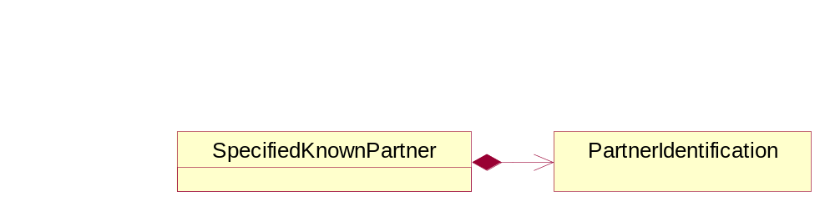
Figure 4-42 SpecifiedKnownPartner

Composition | Cardinality | Type | Documentation
PartnerIdentification | 1 | PartnerIdentification | The business document must allow for the identity of one or more parties to the transaction.

ProductIdentification

ProductDescription
The business document must allow for the identification of the product and multiple textual descriptions of a product.

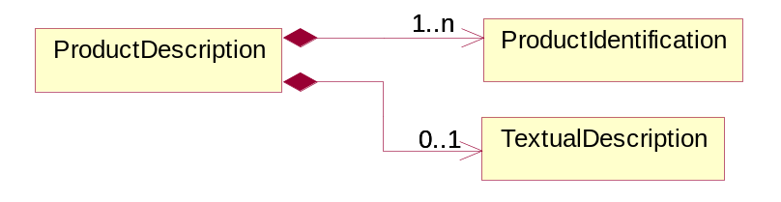
Figure 4-43 ProductDescription

Composition | Cardinality | Type | Documentation
ProductIdentification | 1..n | ProductIdentification | The object provides the identifier(s) of a product.
TextualDescription | 0..1 | TextualDescription | The business document must allow for multiple levels of textual description of an event or object.

ProductIdentification
The object provides the identifier(s) of a product.

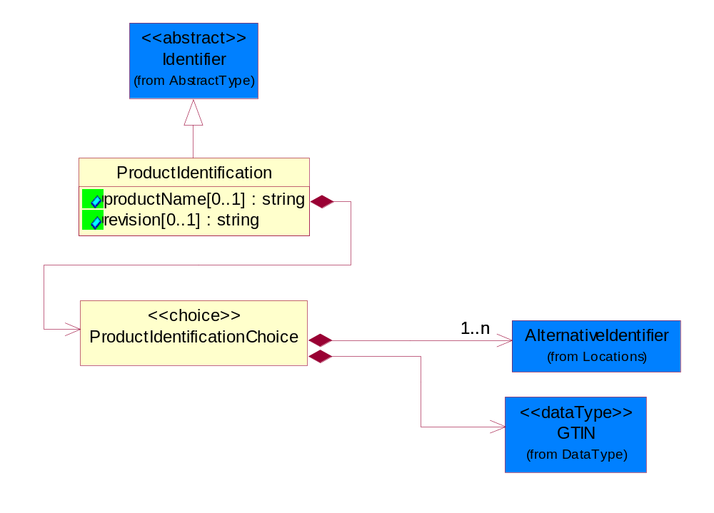
Figure 4-44 ProductIdentification

Attribute | Type | Documentation
productName[0..1] | string | The name of the product.
revision[0..1] | string | Referenced the specified product revision.

Composition | Cardinality | Type | Documentation
ProductIdentificationChoice | 1 | ProductIdentificationChoice

ProductIdentificationChoice

Composition | Cardinality | Type | Documentation
AlternativeIdentifier | 1..n | AlternativeIdentifier | Identifies the specified code and the name of the organization that a code is utilized from.
Gtin | 1 | Gtin | Global Trade Identification Number (GTIN).

TextualDescription
The business document must allow for multiple levels of textual description of an event or object.

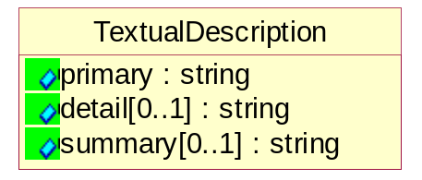
Figure 4-45 TextualDescription

Attribute | Type | Documentation
primary | string | A phrase or single word description of an event or object.
detail[0..1] | string | A detail description of an event or object.
summary[0..1] | string | A condensed description of an event or object.

CodeList

Language
For representation of Language name RosettaNet has adopted ISO 639-2; 1998. Refer to the following web page to get the latest version of the standard:
http://www.loc.gov/standards/iso639-2/iso639jac.html

If you need more information about the ISO standard please contact ISO for more details.

DocumentType
A code identifying the business context of a document.

Instance | Documentation
CBN | Product batch number of customer.
CCN | Customs clearance number.
CFA | Failure Analysis request document that will accompany the product providing characteristics of the component failure.
CIN | Commercial Invoice
CNM | Traditional credit note or memo.
CON | In a virtual sourcing relationship, a third party trading partner is supplying a part to a customer on behalf of another company that has taken the order for the customer. In this case a Customer Order Number is associated to the request for material that is sent to the virtual trading partners.
COT | Contract
CRN | Unique consumption reference number identifying the product consumption issue i.e. one-to-one relationship with physical flow.
DEM | Traditional debit note or memo.
DEN | Delivery Note
DIN | Discontinuation Notice.
DRN | Drawing Number
FUO | Sales order or transfer order fulfilling demand out of a facility (outbound shipment).
INV | Invoice
MEN | Master Event Number
MON | Model Number
OCL | The unique identifier assigned by the OEM for a warranty claim.
OPO | The unique identifier assigned by the OEM for a part order.
OPR | The unique identifier assigned by the OEM for a part return.
PFA | Failure Analysis request document that will accompany the product providing characteristics of the product failure.
PII | Refers to previously issued invoice.
PLS | Unique number that identifies packing form prior to shipment.
POI | Purchase Order IN
PON | Production order number for material release.
POO | Purchase Order OUT
PRC | Product Catalog.
PSI | Refers to previously issued self-billing invoice.
PUO | Purchase Order
QUO | Quote
REC | Document identifying the receipt of materials or products into a facility against a purchase order or transfer order (inbound shipment).
REO | Purchase order or transfer order replenishing inventory into a facility (inbound shipment).
REQ | Requisition
RMA | Returned Material Authorization
RPO | Purchase order for materials or product returned to and reworked by a supplier.
SAO | Sales Order
SBC | Credit Memo used in self-billing scenario.
SBD | Debit Memo used in self-billing scenario.
SBI | Invoice in self billing scenario.
SBN | Product batch number of supplier.
SCA | Similar to contracts. Contains the quantity of an article that is to be ordered from a vendor and the price for article or service that is to be procured.
SEN | Serial Number
SEO | A document that gives a repair provider the necessary authorization to repair or upgrade a product either at the customer site or at the repair provider’s site.
SNC | Shipset Number on Code List
SPC | The unique identifier assigned by the ASP for a warranty claim.
SPN | Spec Number
SPO | The unique identifier assigned by the ASP for a part order.
SPR | The unique identifier assigned by the ASP for a part return.
SPW | The unique identifier assigned by the ASP to reference a work order.
SRI | A document that contains the shipping reference number which allows the product to be tracked within the outsourced logistic providers network.
TRO | Order which results in materials or products being moved from one facility to another (outbound shipment and inbound shipment).
WAB | Waybill
WAC | Denotes a warranty claim.
WOO | Work Order

MimeTypeQualifier
The MIME type as defined by IANA.

Please refer to http://www.iana.org/assignments/media-types/ for a list of types.

Instance | Documentation
application/activemessage | [Shapiro]
application/andrew-inset | [Borenstein]
application/applefile | [Faltstrom]
application/atomicmail | [Borenstein]
application/batch-SMTP | [RFC2442]
application/beep+xml | [RFC3080]
application/cals-1840 | [RFC1895]
application/cnrp+xml | [RFCCNRP]
application/commonground | [Glazer]
application/cpl+xml
application/cybercash | [Eastlake]
application/dca-rft | [Campbell]
application/dec-dx | [Campbell]
application/dicom | [RFC3240]
application/dvcs | [RFC3029]
application/EDI-Consent | [RFC1767]
application/EDIFACT | [RFC1767]
application/EDI-X12 | [RFC1767]
application/eshop | [Katz]
application/font-tdpfr | [RFC3073]
application/http | [RFC2616]
application/hyperstudio | [Domino]
application/iges | [Parks]
application/index | [RFC2652]
application/index.cmd | [RFC2652]
application/index.obj | [RFC2652]
application/index.response | [RFC2652]
application/index.vnd | [RFC2652]
application/iotp | [RFC2935]
application/ipp | [RFC2910]
application/isup | [RFC3204]
application/mac-binhex40 | [Faltstrom]
application/macwriteii | [Lindner]
application/marc | [RFC2220]
application/mathematica | [Van Nostern]
application/msword | [Lindner]
application/news-message-id | [RFC1036,Spencer]
application/news-transmission | [RFC1036, Spencer]
application/ocsp-request | [RFC2560]
application/ocsp-response | [RFC2560]
application/octet-stream | [RFC2045,RFC2046]
application/oda | [RFC2045,RFC2046]
application/ogg | [RFC-walleij-ogg-mediatype-08.txt]
application/parityfec | [RFC3009]
application/pdf | [Lindner]
application/pgp-encrypted | [RFC3156]
application/pgp-keys | [RFC3156]
application/pgp-signature | [RFC3156]
application/pkcs10 | [RFC2311]
application/pkcs7-mime | [RFC2311]
application/pkcs7-signature | [RFC2311]
application/pkix-cert | [RFC2585]
application/pkixcmp | [RFC2510]
application/pkix-crl | [RFC2585]
application/postscript | [RFC2045,RFC2046]
application/prs.alvestrand.titrax-sheet | [Alvestrand]
application/prs.cww | [Rungchavalnont]
application/prs.nprend | [Doggett]
application/prs.plucker | [Janssen]
application/qsig | [RFC3204]
application/reginfo+xml | [RFC-ietf-sipping-reg-event-00.txt]
application/remote-printing | [RFC1486,Rose]
application/riscos | [Smith]
application/rtf | [Lindner]
application/sdp | [RFC2327]
application/set-payment | [Korver]
application/set-payment-initiation | [Korver]
application/set-registration | [Korver]
application/set-registration-initiation | [Korver]
application/sgml | [RFC1874]
application/sgml-open-catalog | [Grosso]
application/sieve | [RFC3028]
application/slate | [Crowley]
application/timestamp-query | [RFC3161]
application/timestamp-reply | [RFC3161]
application/tve-trigger | [Welsh]
application/vemmi | [RFC2122]
application/vnd.3gpp.pic-bw-large | [Meredith]
application/vnd.3gpp.pic-bw-small | [Meredith]
application/vnd.3gpp.pic-bw-var | [Meredith]
application/vnd.3gpp.sms | [Meredith]
application/vnd.3M.Post-it-Notes | [O'Brien]
application/vnd.accpac.simply.aso | [Leow]
application/vnd.accpac.simply.imp | [Leow]
application/vnd.acucobol | [Lubin]
application/vnd.acucorp | [Lubin]
application/vnd.adobe.xfdf | [Perelman]
application/vnd.aether.imp | [Moskowitz]
application/vnd.amiga.ami | [Blumberg]
application/vnd.anser-web-certificate-issue-initiation | [Mori]
application/vnd.anser-web-funds-transfer-initiation | [Mori]
application/vnd.audiograph | [Slusanschi]
application/vnd.blueice.multipass | [Holmstrom]
application/vnd.bmi | [Gotoh]
application/vnd.businessobjects | [Imoucha]
application/vnd.canon-cpdl | [Muto]
application/vnd.canon-lips | [Muto]
application/vnd.cinderella | [Kortenkamp]
application/vnd.claymore | [Simpson]
application/vnd.commerce-battelle | [Applebaum]
application/vnd.commonspace | [Chandhok]
application/vnd.contact.cmsg | [Patz]
application/vnd.cosmocaller | [Dellutri]
application/vnd.ctc-posml | [Kohlhepp]
application/vnd.cups-postscript | [Sweet]
application/vnd.cups-raster | [Sweet]
application/vnd.cups-raw | [Sweet]
application/vnd.curl | [Byrnes]
application/vnd.cybank | [Helmee]
application/vnd.data-vision.rdz | [Fields]
application/vnd.dna | [Searcy]
application/vnd.dpgraph | [Parker]
application/vnd.dreamfactory | [Appleton]
application/vnd.dxr | [Duffy]
application/vnd.ecdis-update | [Buettgenbach]
application/vnd.ecowin.chart | [Olsson]
application/vnd.ecowin.filerequest | [Olsson]
application/vnd.ecowin.fileupdate | [Olsson]
application/vnd.ecowin.series | [Olsson]
application/vnd.ecowin.seriesrequest | [Olsson]
application/vnd.ecowin.seriesupdate | [Olsson]
application/vnd.enliven | [Santinelli]
application/vnd.epson.esf | [Hoshina]
application/vnd.epson.msf | [Hoshina]
application/vnd.epson.quickanime | [Gu]
application/vnd.epson.salt | [Nagatomo]
application/vnd.epson.ssf | [Hoshina]
application/vnd.ericsson.quickcall | [Tidwell]
application/vnd.eudora.data | [Resnick]
application/vnd.fdf | [Zilles]
application/vnd.ffsns | [Holstage]
application/vnd.FloGraphIt | [Floersch]
application/vnd.framemaker | [Wexler]
application/vnd.fsc.weblaunch | [D.Smith]
application/vnd.fujitsu.oasys | [Togashi]
application/vnd.fujitsu.oasys2 | [Togashi]
application/vnd.fujitsu.oasys3 | [Okudaira]
application/vnd.fujitsu.oasysgp | [Sugimoto]
application/vnd.fujitsu.oasysprs | [Ogita]
application/vnd.fujixerox.ddd | [Onda]
application/vnd.fujixerox.docuworks | [Taguchi]
application/vnd.fujixerox.docuworks.binder | [Matsumoto]
application/vnd.fut-misnet | [Pruulmann]
application/vnd.grafeq | [Tupper]
application/vnd.groove-account | [Joseph]
application/vnd.groove-help | [Joseph]
application/vnd.groove-identity-message | [Joseph]
application/vnd.groove-injector | [Joseph]
application/vnd.groove-tool-message | [Joseph]
application/vnd.groove-tool-template | [Joseph]
application/vnd.groove-vcard | [Joseph]
application/vnd.hbci | [Hammann]
application/vnd.hhe.lesson-player | [Jones]
application/vnd.hp-HPGL | [Pentecost]
application/vnd.hp-hpid | [Gupta]
application/vnd.hp-hps | [Aubrey]
application/vnd.hp-PCL | [Pentecost]
application/vnd.hp-PCLXL | [Pentecost]
application/vnd.httphone | [Lefevre]
application/vnd.hzn-3d-crossword | [Minnis]
application/vnd.ibm.afplinedata | [Buis]
application/vnd.ibm.electronic-media | [Tantlinger]
application/vnd.ibm.MiniPay | [Herzberg]
application/vnd.ibm.modcap | [Hohensee]
application/vnd.ibm.secure-container | [Tantlinger]
application/vnd.informix-visionary | [Gales]
application/vnd.intercon.formnet | [Gurak]
application/vnd.intertrust.digibox | [Tomasello]
application/vnd.intertrust.nncp | [Tomasello]
application/vnd.intu.qbo | [Scratchley]
application/vnd.intu.qfx | [Scratchley]
application/vnd.irepository.package+xml | [Knowles]
application/vnd.is-xpr | [Natarajan]
application/vnd.japannet-directory-service | [Fujii]
application/vnd.japannet-jpnstore-wakeup | [Yoshitake]
application/vnd.japannet-payment-wakeup | [Fujii]
application/vnd.japannet-registration | [Yoshitake]
application/vnd.japannet-registration-wakeup | [Fujii]
application/vnd.japannet-setstore-wakeup | [Yoshitake]
application/vnd.japannet-verification | [Yoshitake]
application/vnd.japannet-verification-wakeup | [Fujii]
application/vnd.jisp | [Deckers]
application/vnd.kde.karbon | [Faure]
application/vnd.kde.kchart | [Faure]
application/vnd.kde.kformula | [Faure]
application/vnd.kde.kivio | [Faure]
application/vnd.kde.kontour | [Faure]
application/vnd.kde.kpresenter | [Faure]
application/vnd.kde.kspread | [Faure]
application/vnd.kde.kword | [Faure]
application/vnd.kenameaapp | [DiGiorgio-Haag]
application/vnd.koan | [Cole]
application/vnd.liberty-request+xml | [McDowell]
application/vnd.llamagraphics.life-balance.desktop | [White]
application/vnd.lotus-1-2-3 | [Wattenberger]
application/vnd.lotus-approach | [Wattenberger]
application/vnd.lotus-freelance | [Wattenberger]
application/vnd.lotus-notes | [Laramie]
application/vnd.lotus-organizer | [Wattenberger]
application/vnd.lotus-screencam | [Wattenberger]
application/vnd.lotus-wordpro | [Wattenberger]
application/vnd.mcd | [Gotoh]
application/vnd.mediastation.cdkey | [Flurry]
application/vnd.meridian-slingshot | [Wedel]
application/vnd.micrografx.flo | [Prevo]
application/vnd.micrografx.igx | [Prevo]
application/vnd.mif | [Wexler]
application/vnd.minisoft-hp3000-save | [Bartram]
application/vnd.mitsubishi.misty-guard.trustweb | [Tanaka]
application/vnd.Mobius.DAF | [Kabayama]
application/vnd.Mobius.DIS | [Kabayama]
application/vnd.Mobius.MBK | [Devasia]
application/vnd.Mobius.MQY | [Devasia]
application/vnd.Mobius.MSL | [Kabayama]
application/vnd.Mobius.PLC | [Kabayama]
application/vnd.Mobius.TXF | [Kabayama]
application/vnd.mophun.application | [Wennerstrom]
application/vnd.mophun.certificate | [Wennerstrom]
application/vnd.motorola.flexsuite | [Patton]
application/vnd.motorola.flexsuite.adsi | [Patton]
application/vnd.motorola.flexsuite.fis | [Patton]
application/vnd.motorola.flexsuite.gotap | [Patton]
application/vnd.motorola.flexsuite.kmr | [Patton]
application/vnd.motorola.flexsuite.ttc | [Patton]
application/vnd.motorola.flexsuite.wem | [Patton]
application/vnd.mozilla.xul+xml | [McDaniel]
application/vnd.ms-artgalry | [Slawson]
application/vnd.ms-asf | [Fleischman]
application/vnd.mseq | [Le Bodic]
application/vnd.ms-excel | [Gill]
application/vnd.msign | [Borcherding]
application/vnd.ms-lrm | [Ledoux]
application/vnd.ms-powerpoint | [Gill]
application/vnd.ms-project | [Gill]
application/vnd.ms-tnef | [Gill]
application/vnd.ms-works | [Gill]
application/vnd.ms-wpl | [Plastina]
application/vnd.musician | [Adams]
application/vnd.music-niff | [Butler]
application/vnd.netfpx | [Mutz]
application/vnd.noblenet-directory | [Solomon]
application/vnd.noblenet-sealer | [Solomon]
application/vnd.noblenet-web | [Solomon]
application/vnd.novadigm.EDM | [Swenson]
application/vnd.novadigm.EDX | [Swenson]
application/vnd.novadigm.EXT | [Swenson]
application/vnd.obn | [Hessling]
application/vnd.osa.netdeploy | [Klos]
application/vnd.palm | [Peacock]
application/vnd.pg.format | [Gandert]
application/vnd.pg.osasli | [Gandert]
application/vnd.powerbuilder6 | [Guy]
application/vnd.powerbuilder6-s | [Guy]
application/vnd.powerbuilder7 | [Shilts]
application/vnd.powerbuilder75 | [Shilts]
application/vnd.powerbuilder75-s | [Shilts]
application/vnd.powerbuilder7-s | [Shilts]
application/vnd.previewsystems.box | [Smolgovsky]
application/vnd.publishare-delta-tree | [Ben-Kiki]
application/vnd.pvi.ptid1 | [Lamb]
application/vnd.pwg-multiplexed | [RFC3391]
application/vnd.pwg-xhtml-print+xml | [Wright]
application/vnd.Quark.QuarkXPress | [Scheidler]
application/vnd.rapid | [Szekely]
application/vnd.s3sms | [Tarkkala]
application/vnd.sealed.net | [Lambert]
application/vnd.seemail | [Webb]
application/vnd.shana.informed.formdata | [Selzler]
application/vnd.shana.informed.formtemplate | [Selzler]
application/vnd.shana.informed.interchange | [Selzler]
application/vnd.shana.informed.package | [Selzler]
application/vnd.smaf | [Takahashi]
application/vnd.sss-cod | [Dani]
application/vnd.sss-dtf | [Bruno]
application/vnd.sss-ntf | [Bruno]
application/vnd.street-stream | [Levitt]
application/vnd.svd | [Becker]
application/vnd.swiftview-ics | [Widener]
application/vnd.triscape.mxs | [Simonoff]
application/vnd.trueapp | [Hepler]
application/vnd.truedoc | [Chase]
application/vnd.ufdl | [Manning]
application/vnd.uplanet.alert | [Martin]
application/vnd.uplanet.alert-wbxml | [Martin]
application/vnd.uplanet.bearer-choice | [Martin]
application/vnd.uplanet.bearer-choice-wbxml | [Martin]
application/vnd.uplanet.cacheop | [Martin]
application/vnd.uplanet.cacheop-wbxml | [Martin]
application/vnd.uplanet.channel | [Martin]
application/vnd.uplanet.channel-wbxml | [Martin]
application/vnd.uplanet.list | [Martin]
application/vnd.uplanet.listcmd | [Martin]
application/vnd.uplanet.listcmd-wbxml | [Martin]
application/vnd.uplanet.list-wbxml | [Martin]
application/vnd.uplanet.signal | [Martin]
application/vnd.vcx | [T.Sugimoto]
application/vnd.vectorworks | [Pharr]
application/vnd.vidsoft.vidconference | [Hess]
application/vnd.visio | [Sandal]
application/vnd.visionary | [Aravindakumar]
application/vnd.vividence.scriptfile | [Risher]
application/vnd.vsf | [Rowe]
application/vnd.wap.sic | [WAP-Forum]
application/vnd.wap.slc | [WAP-Forum]
application/vnd.wap.wbxml | [Stark]
application/vnd.wap.wmlc | [Stark]
application/vnd.wap.wmlscriptc | [Stark]
application/vnd.webturbo | [Rehem]
application/vnd.wrq-hp3000-labelled | [Bartram]
application/vnd.wt.stf | [Wohler]
application/vnd.wv.csp+wbxml | [Salmi]
application/vnd.xara | [Matthewman]
application/vnd.xfdl | [Manning]
application/vnd.yellowriver-custom-menu | [Yellow]
application/whoispp-query | [RFC2957]
application/whoispp-response | [RFC2958]
application/wita | [Campbell]
application/wordperfect5.1 | [Lindner]
application/x400-bp | [RFC1494]
application/xhtml+xml | [RFC3236]
application/xml | [RFC3023]
application/xml-dtd | [RFC3023]
application/xml-external-parsed-entity | [RFC3023]
application/zip | [Lindner]
audio/32kadpcm | [RFC2421,RFC2422]
audio/AMR | [RFC3267]
audio/AMR-WB | [RFC3267]
audio/basic | [RFC2045,RFC2046]
audio/CN | [RFC3389]
audio/DAT12 | [RFC3190]
audio/DVI4
audio/EVRC | [RFC-ietf-avt-evrc-smv-03.txt]
audio/EVRC0 | [RFC-ietf-avt-evrc-smv-03.txt]
audio/G.722.1 | [RFC3047]
audio/G722
audio/G723
audio/G726-16
audio/G726-24
audio/G726-32
audio/G726-40
audio/G728
audio/G729
audio/G729D
audio/G729E
audio/GSM
audio/GSM-EFR
audio/L16 | [RFC2586]
audio/L20 | [RFC3190]
audio/L24 | [RFC3190]
audio/L8
audio/LPC
audio/MP4A-LATM | [RFC3016]
audio/MPA
audio/mpa-robust | [RFC3119]
audio/mpeg | [RFC3003]
audio/parityfec | [RFC3009]
audio/PCMA
audio/PCMU
audio/prs.sid | [Walleij]
audio/QCELP
audio/RED
audio/SMV | [RFC-ietf-avt-evrc-smv-03.txt]
audio/SMV0 | [RFC-ietf-avt-evrc-smv-03.txt]
audio/telephone-event | [RFC2833]
audio/tone | [RFC2833]
audio/VDVI
audio/vnd.3gpp.iufp | [Belling]
audio/vnd.cisco.nse | [Kumar]
audio/vnd.cns.anp1 | [McLaughlin]
audio/vnd.cns.inf1 | [McLaughlin]
audio/vnd.digital-winds | [Strazds]
audio/vnd.everad.plj | [Cicelsky]
audio/vnd.lucent.voice | [Vaudreuil]
audio/vnd.nortel.vbk | [Parsons]
audio/vnd.nuera.ecelp4800 | [Fox]
audio/vnd.nuera.ecelp7470 | [Fox]
audio/vnd.nuera.ecelp9600 | [Fox]
audio/vnd.octel.sbc | [Vaudreuil]
audio/vnd.qcelp | [Lundblade]
audio/vnd.rhetorex.32kadpcm | [Vaudreuil]
audio/vnd.vmx.cvsd | [Vaudreuil]
image/cgm | Computer Graphics Metafile
image/g3fax | [RFC1494]
image/gif | [RFC2045,RFC2046]
image/ief | [RFC1314] Image Exchange Format
image/jpeg | [RFC2045,RFC2046]
image/naplps | [Ferber]
image/png | [Randers-Pehrson]
image/prs.btif | [Simon]
image/prs.pti | [Laun]
image/t38 | [RFC3362]
image/tiff | [RFC3302] Tag Image File Format
image/tiff-fx | [RFC3250] Tag Image File Format Fax eXtended
image/vnd.cns.inf2 | [McLaughlin]
image/vnd.djvu | [Bottou]
image/vnd.dwg | [Moline]
image/vnd.dxf | [Moline]
image/vnd.fastbidsheet | [Becker]
image/vnd.fpx | [Spencer]
image/vnd.fst | [Fuldseth]
image/vnd.fujixerox.edmics-mmr | [Onda]
image/vnd.fujixerox.edmics-rlc | [Onda]
image/vnd.globalgraphics.pgb | [Bailey]
image/vnd.mix | [Reddy]
image/vnd.ms-modi | [Vaughan]
image/vnd.net-fpx | [Spencer]
image/vnd.svf | [Moline]
image/vnd.wap.wbmp | [Stark]
image/vnd.xiff | [S.Martin]
message/delivery-status | [RFC1894]
message/disposition-notification | [RFC2298]
message/external-body | [RFC2045,RFC2046]
message/http | [RFC2616]
message/news | [RFC 1036, H.Spencer]
message/partial | [RFC2045,RFC2046]
message/rfc822 | [RFC2045,RFC2046]
message/s-http | [RFC2660]
message/sip | [RFC3261]
message/sipfrag | [RFC3420]
model/iges | [Parks]
model/mesh | [RFC2077]
model/vnd.dwf | [Pratt]
model/vnd.flatland.3dml | [Powers]
model/vnd.gdl | [Babits]
model/vnd.gs-gdl | [Babits]
model/vnd.gtw | [Ozaki]
model/vnd.mts | [Rabinovitch]
model/vnd.parasolid.transmit.binary | [Parasolid]
model/vnd.parasolid.transmit.text | [Parasolid]
model/vnd.vtu | [Rabinovitch]
model/vrml | [RFC2077]
multipart/alternative | [RFC2045,RFC2046]
multipart/appledouble | [Faltstrom]
multipart/byteranges | [RFC2068]
multipart/digest | [RFC2045,RFC2046]
multipart/encrypted | [RFC1847]
multipart/form-data | [RFC2388]
multipart/header-set | [Crocker]
multipart/mixed | [RFC2045,RFC2046]
multipart/parallel | [RFC2045,RFC2046]
multipart/related | [RFC2387]
multipart/report | [RFC1892]
multipart/signed | [RFC1847]
multipart/voice-message | [RFC2421,RFC2423]
text/calendar | [RFC2445]
text/css | [RFC2318]
text/directory | [RFC2425]
text/enriched | [RFC1896]
text/html | [RFC2854]
text/parityfec | [RFC3009]
text/plain | [RFC2646,RFC2046]
text/prs.lines.tag | [Lines]
text/rfc822-headers | [RFC1892]
text/richtext | [RFC2045,RFC2046]
text/rtf | [Lindner]
text/sgml | [RFC1874]
text/t140 | [RFC2793]
text/tab-separated-values | [Lindner]
text/uri-list | [RFC2483]
text/vnd.abc | [Allen]
text/vnd.curl | [Byrnes]
text/vnd.DMClientScript | [Bradley]
text/vnd.fly | [Gurney]
text/vnd.fmi.flexstor | [Hurtta]
text/vnd.in3d.3dml | [Powers]
text/vnd.in3d.spot | [Powers]
text/vnd.IPTC.NewsML | [IPTC]
text/vnd.IPTC.NITF | [IPTC]
text/vnd.latex-z | [Lubos]
text/vnd.motorola.reflex | [Patton]
text/vnd.ms-mediapackage | [Nelson]
text/vnd.net2phone.commcenter.command | [Xie]
text/vnd.sun.j2me.app-descriptor | [G.Adams]
text/vnd.wap.si | [WAP-Forum]
text/vnd.wap.sl | [WAP-Forum]
text/vnd.wap.wml | [Stark]
text/vnd.wap.wmlscript | [Stark]
text/xml | [RFC3023]
text/xml-external-parsed-entity | [RFC3023]
video/BMPEG
video/BT656
video/CelB
video/DV | [RFC3189]
video/H261
video/H263
video/H263-1998
video/H263-2000
video/JPEG
video/MP1S
video/MP2P
video/MP2T
video/MP4V-ES | [RFC3016]
video/mpeg | [RFC2045,RFC2046]
video/MPV
video/nv
video/parityfec | [RFC3009]
video/pointer | [RFC2862]
video/quicktime | [Lindner]
video/SMPTE292M | [RFC-avt-smpte292-video-08.txt]
video/vnd.fvt | [Fuldseth]
video/vnd.motorola.video | [McGinty]
video/vnd.motorola.videop | [McGinty]
video/vnd.mpegurl | [Recktenwald]
video/vnd.nokia.interleaved-multimedia | [Kangaslampi]
video/vnd.objectvideo | [Clark]
video/vnd.vivo | [Wolfe]

UnitOfMeasure
Code identifying a product unit of measure.

Instance | Documentation
1BF | 100 Board Feet
1FC | 20 Foot Container
1GR | Gram/Cubic Centimeter
1GT | 10,000 Gallon Tankcar
1KB | 25 Kilogram Bulk Bag
1KD | 10 Kilogram Drum
1PA | 20-Pack
1PB | 50 Pound Bag
1PD | 100 Pound Drum
2FC | 40 Foot Container
2GR | Gram/square meter
2GT | 20,000 Gallon Tankcar
2KB | 300 Kilogram Bulk Bag
2KD | 15 Kilogram Drum
2PA | 100-Pack
3GR | Grams Per 100 Centimeters
3KB | 500 Kilogram Bulk Bag
3KD | 55 Gallon Drum
4GR | Grams Per 100 Grams
4KD | 115 Kilogram Drum
5GR | Grams Per Cubic Centimeter
6GR | Grams Per Square Centimeter
7GR | Grams Per Square Meter
ACR | Acre
ACT | Actual Pounds
ALU | Aluminum Pounds Only
AMP | Ampere
BAB | Base Box
BAC | Batch
BAE | Bale
BAG | Bag
BAL | Ball
BAN | Band
BAP | Batting Pound
BAR | Bar
BAS | Basket
BAT | Batt
BAW | Base Weight
BEA | Beam
BEC | Becquerel/kilogram
BEL | Belt
BIL | Billet
BIN | Bin
BKC | Bulk Car Load
BLO | Block
BOA | Board
BOF | Board Feet
BOL | Bolt
BOT | Bottle
BOX | Box
BRD | Barrels Per Day
BRE | Barrel
BRI | Barrel (Imperial)
BRM | Barrels Per Minute
BTF | British Thermal Units (BTUs) Per Cubic Foot
BTP | British Thermal Units (BTUs) Per Pound
BTU | British Thermal Unit (BTU)
BUC | Bucket
BUD | Bushel, Dry Imperial
BUK | Bunks
BUL | Bulk
BUN | Bundle
BUP | Bulk Pack
BUS | Bushel
CAA | Carat
CAB | Carboy
CAC | Card
CAD | Candela
CAG | Cartridge
CAK | Cask
CAL | Calorie
CAN | Can
CAO | Carload
CAR | Car
CAS | Case
CAT | Canister
CAW | Catchweight
CEL | Cell
CEM | Centimeter
CEP | Centipoise (CPS)
CET | Centiliter
CHA | Chains (Land Survey)
CHE | Chest
CNN | Connector
COG | Coil Group
COI | Coil
COL | Coulomb
COM | Composite Product Pounds (Total Weight)
CON | Cone
COT | Container
COV | Cover
CRA | Crate
CRT | Carton
CSE | Cassette
CUB | Cubic centimeter
CUC | Cubic centimeter/second
CUF | Cubic Foot
CUI | Cubic inch
CUM | Cubicmeter
CUP | Cup
CUY | Cubic yard
CYC | Cycles
CYL | Cylinder
DAY | Day
DEA | Deal
DEC | Decimeter
DEF | Degree Fahrenheit
DEG | Degree Celsius
DEP | Dep. Factor
DIE | Die
DIL | Display
DIP | Dispenser
DOZ | Dozen
DRA | Dram
DRU | Drum
DRY | Dry Pounds
EAC | Each
ELE | Electrical Capacitance
FAR | Farads
FFA | Femtofarad
FLO | Fluid Ounce
FOI | Fluid Ounce (Imperial)
FOO | Foot
FOU | Fluid Ounce US
FUU | Fuel Usage (Gallons)
GAL | Gallon
GAS | Gage Systems
GIH | Gigahertz
GIJ | Gigajoules
GIL | Gill (Imperial)
GOB | Gross Barrels
GOG | Gross Gallons
GOK | Gross Kilogram
GOT | Gross Ton
GOY | Gross Yard
GRA | Gram
GRG | Great Gross (Dozen Gross)
GRK | Grams Per Kilogram
GRL | Grams Per Liter
GRM | Grams Per Milliliter
GRN | Grain
GRO | Gross
GRP | Group
HAG | Half Gallon
HAH | Half Hour
HAL | Half Liter
HAN | Hank
HEA | Heat lots
HEC | Hectare
HEL | Hectoliter
HEP | Hectopascal
HER | Hertz
HOS | Hours
HOU | Hour
HUA | Hundredth of a Carat
HUB | Hundred Boxes
HUC | Hundred Count
HUS | Hundred Sheets
IMG | Imperial Gallons
INC | Inch
JAR | Jar
JOI | Joint
JOU | Joule
KEG | Keg
KEL | Kelvin
KHO | Kilometer/hour
KIC | Kilogram per cubic meter
KIE | Kilometer
KIG | Kilogram
KIH | Kilohertz
KIK | Kilobecquerel/Kilogram
KIL | Kiloampere
KIM | Kilogram/square meter
KIO | Kiloohm
KIS | Kilogramm pro Sekunde
KIT | Kit
KIV | Kilovolt
KIW | Kilowatt
KKG | Kilogram/Kilogram
KUD | Kubikdezimeter
KUM | Kubikmeter pro Sekunde
KWH | Kilowatt-hour
LIF | Lifts
LIM | Link
LIQ | Liquid Pounds
LIT | Liter
LOA | Load
LOT | Lot
LUG | Lug
MAM | Milliamps/mm
MAT | Mat
MCM | Milligrams Per Cubic Meter
MCR | Micron
MEG | Megagram
MEH | Megahertz
MEP | Megapascal
MET | Meter
MEW | Megawatt
MIB | Million BTU's
MIC | Mikrogram/cubic meter
MIG | Micrograms Per Cubic Meter
MIL | Mile
MIM | Micrometer
MIN | Minute
MIP | Millipascal seconds
MIS | Microsecond
MIT | Miter
MIV | Millivolt
MIW | Milliwatt
MJO | Millijoule
MLA | Milliampere
MLB | Millibar
MLC | Milligram/cubic meter
MLI | Milliliter
MLK | Milligram/kilogram
MLL | Milligram/Liter
MME | Millimeter
MMH | Millimeter H20
MMK | Millimol/kilogram
MMO | Millimol
MOK | Mol/kilogram
MOL | Mol
MON | Month
MPH | Megagrams Per Hour
MSC | Millisecond
MSM | Milligrams Per Square Meter
MTA | Millitesla
MTQ | Meter pro Quadratsekunde
MTS | Meters per second
MUL | Multichip - When 2 or more dies (chips) are merged into one package.
NAA | Nanoamps
NAM | Nanometer
NAS | Nanosecond
NEB | Net Barrels
NEG | Net Gallons
NEI | Net Imperial Gallons
NEL | Net Liters
NEW | Newton
OCT | Ohm/ct
OHM | Ohm
OMM | Ohm/mm
ONE | One
OSQ | Ohm/sq
OTP | One Thousand Pieces
OUN | Ounce
OVI | Ohm/via
PAC | Parcel
PAD | Pad
PAG | Package
PAI | Pail
PAK | Pack (PAK)
PAL | Pallet
PAN | Panel
PAR | Pair
PAS | Pascal
PAT | Packet
PEC | Percent
PEG | Percentage
PEH | Percent Per 1000 Hours
PEN | Pennyweight
PER | Per Hundred Pieces
PEW | Percent Weight
PID | Pint U.S. Dry
PIE | Piece
PIL | Pint - US liquid
PLA | Plate
PLL | Pallet (Lift)
PLT | Pallete
PLU | Pallet/Unit Load
POF | Pounds Per Foot
POG | Pounds Per Gallon
PON | Pound
POP | Pounds Per Piece of Product
POS | Pounds Per 1000 Square Feet
POT | Pounds Per Thousand
PPB | Parts per billion (US)
PPM | Parts per million
PPP | Pounds Per Pound of Product
PSC | Picosecond
PSS | Pascal second
QUA | Quart - US liquid
RAC | Rack
REA | Ream of 500 Sheets
REE | Reel
RIN | Ring
ROD | Rod
ROL | Roll
SAC | Sack
SBB | Super Bulk Bag
SEC | Second
SET | Set
SHE | Sheet
SHI | Shipment
SHM | Sheet-Metric measure
SHO | Shot
SID | Disk (Disc)
SKE | Skein
SKI | Skid
SLE | Sleeve
SLI | Slip Sheet
SMI | Square mile
SMM | Square millimeter
SPO | Spool
SQF | Square foot
SQI | Square inch
SQK | Square kilometer
SQM | Square meter
SQS | Square meter/second
SQU | Square
SQY | Square Yard
STI | Stick
STM | Statute Mile
STR | Strip
TAB | Tablet
TAN | Tank
TAT | Tank Truck
TES | Tesla
THO | Thousand
TNN | Tonne
TON | Ton
TOR | Torr
TOT | Tote
TRA | Train
TRF | Track Foot
TRL | Trailer
TRO | Troy
TRU | Truckload
TRY | Tray
TRZ | Troy OZ
TUB | Tube
ULU | Unitless Unit of Measure
USG | US gallon
USP | US pound
UST | US ton
VIA | Vial
VOL | Volt
WAF | Wafer
WAR | Watt
WEE | Week
WRA | Wrap
YAR | Yard
YEA | Year

ProcessRoleIdentifier
Describes the role of the partner in the business process. A partner will fulfill at least one or more roles during the business process.

Instance | Documentation
ADM | Administered by, the party who is the administrative authority of an account.
ALT | Alternate approval by, the party who has approved a request in the event the approver is not able to respond.
APP | Approval by, the party who has approved a request.
BIF | Bill from, the party that will issue the invoice.
BIT | Bill to, the party that will pay the invoice.
CNC | Cancellation party, the party who is cancelling the shipping order.
COR | Change originated by, the party who originates a proposed change.
COW | Change owned by, the party who owns or who is assigned responsibility for a proposed change.
CRA | Credit applicant, the party who is applying for credit.
CRE | Created by, the party responsible for creating a process or task.
DIS | Distributed by, the party who supplies products to retailers.
FIN | Financed by, the party who is the financier.
FOR | Forwarded to, the party to whom a business document has been forwarded.
INL | Inventory location, the party where the inventory product entry is located.
INO | Inventory owner, the party that owns the inventory product entry.
ITF | In transit from, the party sending the product quantity in a product location transfer.
ITT | In transit to, the party receiving the product quantity in a product location transfer.
MFG | Manufactured by, the party who creates, processes or produces goods especially in large quantities and by means of industrial machines.
OWN | Owned by, the party who owns a process.
PUR | Purchased by, the party who is a purchaser of a product.
REA | Requested approval by, the party who has been selected to approve a request.
REC | Received by, the party who has received a product shipment.
REQ | Requested by, the party who has initiated a request.
RES | Respond to, the party to whom a responding business document must be sent when it is not equal to the partner specified in the document header.
RET | Return by, the party responsible for either carrying or forwarding the returned product.
REV | Reviewed by, the party responsible for reviewing a business document.
SBF | Self-billing from, the party who initiates the billing in self-billing scenario.
SBT | Self-billing to, the party whom the invoice is addressed to.
SCP | Shipping charges paid by, the party responsible for administering payment of the shipping charges.
SHF | Ship From, the collection of business properties used to identify the business partner initiating a shipment or transaction.
SHT | Ship To, the partner and/or location to which the product must be delivered.
SLD | Sold to, the party to whom a product has been sold.
SOB | Sold By, the seller involved in a business transaction.
SPL | Supplied by, the party who supplies an item, part or assembly.
SRT | Submit returns to, the party to whom product returns are to be submitted.
TRA | Transported by, the party responsible for either carrying or forwarding the product.
ULR | Ultimate recipient, the party who ultimately receives the shipment, when an intermediate party takes responsibility for payment and final delivery.
USE | Used by, the party who is the end user of the product.

System Structure

BusinessServiceInformation
The object allows the specification of the business service utilized within the partner company. This may or may not be the same as the information sent by the RNIF.

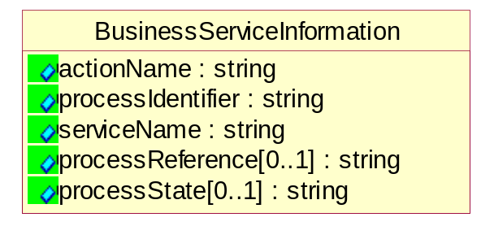
Figure 5-46 BusinessServiceInformation

Attribute | Type | Documentation
actionName | string | The name of Action. For RosettaNet usually any of Request/Confirm/Notify/Query/Response.
processIdentifier | string | The name of the PIP e.g. Notify of Forecast Reply.
serviceName | string | The name of the Business Activity with the "Request/Confirm" part removed. E.g., for the Activity "Request Purchase Order"==> "Purchase Order".
processReference[0..1] | string | The URN for the PIP that includes Cluster/Segment/Process pattern used to identify the interface process (such as PIP3A4)
processState[0..1] | string | The business process (or service) state of the sender of a document. When a service receives this document, the receiver may use the state as a precondition.

ContractInformation
A block of information used to correlate a contract in an executing choreography.
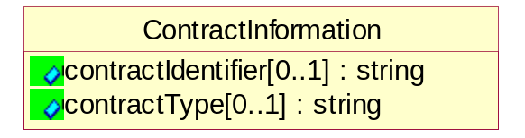
Figure 5-47 ContractInformation

Attribute | Type | Documentation
contractIdentifier[0..1] | string | Unique identification of a contract between the Sender and the Receiver
contractType[0..1] | string | The type of the contract: an attribute describing the type of the ContractIndentification. Valid values are URI, URN,ebXMLCPA, or other values defined by partners.

CorrelationInformation
A block of information used to correlate a requesting document to a responding document and to the contract in an executing choreography.
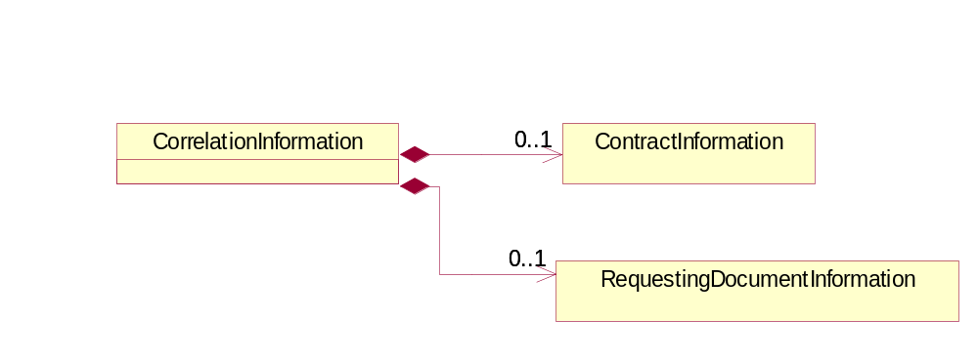
Figure 5-48 CorrelationInformation

Composition | Cardinality | Type | Documentation
ContractInformation | 0..1 | ContractInformation | A block of information used to correlate a contract in an executing choreography.
RequestingDocumentInformation | 0..1 | RequestingDocumentInformation | A block of information used to correlate a requesting document to a responding document in an executing choreography.

DocumentHeader
The object allows for the identification of the sender and receiver of the business document.

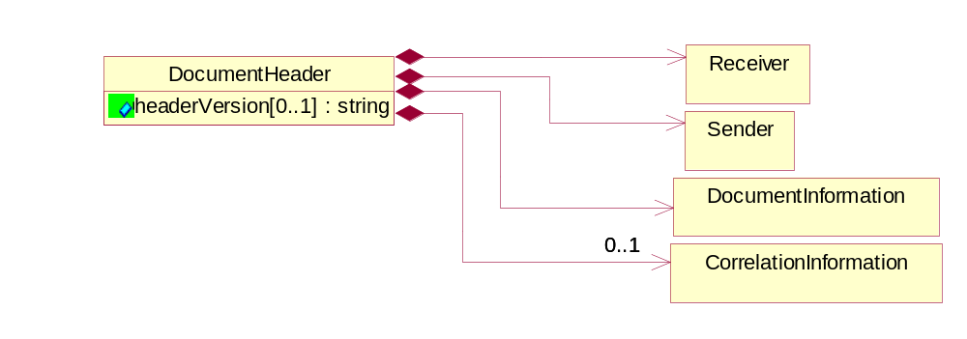
Figure 5-49 DocumentHeader

Attribute | Type | Documentation
headerVersion[0..1] | string | The UN/CEFACT version of the document header.

Composition | Cardinality | Type | Documentation
Sender | 1 | Sender | The object allows the identification of the initiating party of the business message.
CorrelationInformation | 0..1 | CorrelationInformation | A block of information used to correlate a requesting document to a responding document and to the contract in an executing choreography.
DocumentInformation | 1 | DocumentInformation | The object specifies information to identify the business document, a summary of attachments, and information about the business document security.
Receiver | 1 | Receiver | The object allows the identification of the receiving party of the business message.

DocumentIdentification
The object specifies all information necessary to identify the business document.

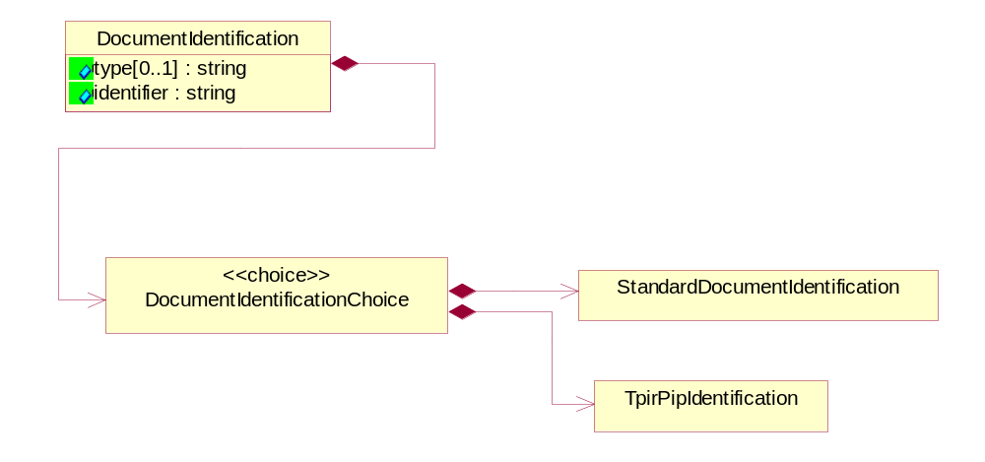
Figure 5-50 DocumentIdentification

Attribute | Type | Documentation
type[0..1] | string | Name of the Action Message
identifier | string | The unique identifier for the document being sent.

Composition | Cardinality | Type | Documentation
DocumentIdentificationChoice | 1 | DocumentIdentificationChoice

DocumentIdentificationChoice

Composition | Cardinality | Type | Documentation
StandardDocumentIdentification | 1 | StandardDocumentIdentification | The object specifies additional information necessary to identify the standard business document.
TpirPipIdentification | 1 | TpirPipIdentification | The object specifies all information necessary to uniquely identify a TPIR-PIP within a Registry or trading partner repository.

DocumentInformation
The object specifies information to identify the business document, a summary of attachments, and information about the business document security.

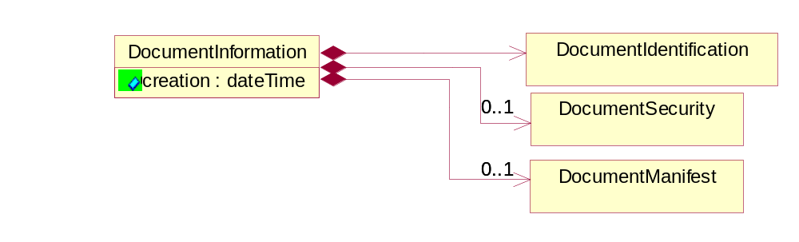
Figure 5-51 DocumentInformation

Attribute | Type | Documentation
creation | dateTime | The creation date and time of the specified Business Document (i.e. the Purchase Order date).

Composition | Cardinality | Type | Documentation
DocumentIdentification | 1 | DocumentIdentification | The object specifies all information necessary to identify the business document.
DocumentSecurity | 0..1 | DocumentSecurity | The object provides additional granularity in specifying business document security (this is in addition to the specified PIP security).
DocumentManifest | 0..1 | DocumentManifest | The block provides a brief summary of attachments and Service Content.

DocumentManifest
The block provides a brief summary of attachments and Service Content.

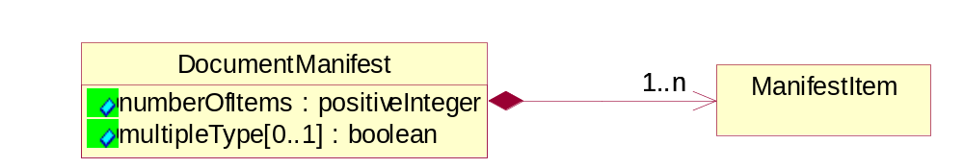
Figure 5-52 DocumentManifest

Attribute | Type | Documentation
numberOfItems | positiveInteger | Total number of documents in the message. The physical count of the attachments in the payload plus the RosettaNet Business Message (for Service Content). The value of this field will be at least 1.
multipleType[0..1] | boolean | Indicates whether the manifest contains documents of multiple types. True if yes, and False if no.

Composition | Cardinality | Type | Documentation
ManifestItem | 1..n | ManifestItem | The object provides details about the specific attachment(s).

DocumentSecurity
The object provides additional granularity in specifying business document security (this is in addition to the specified PIP security).

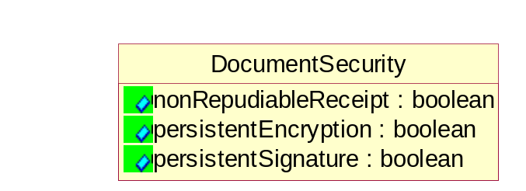
Figure 5-53 DocumentSecurity

Attribute | Type | Documentation
nonRepudiableReceipt | boolean | The value "true" will indicate that a signed acknowledgement for the business document is necessary.
persistentEncryption | boolean | The value "true" will indicate that the Business Document (including the header) needs to be encrypted when stored or transported.
persistentSignature | boolean | The value "true" will indicate that a signature is required to be stored with the document while stored or transported.

ManifestItem
The object provides details about the specific attachment(s).
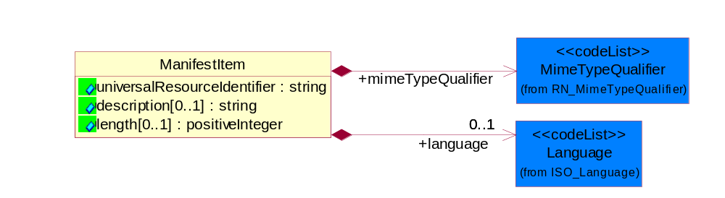
Figure 5-54 ManifestItem

Attribute | Type | Documentation
universalResourceIdentifier | string | The generic set of all names/addresses that are short strings that refer to resources.
description[0..1] | string | A description of the attachment.
length[0..1] | positiveInteger | The size of the attachment in bytes (i.e. 1 000 000 bytes)

Composition | Cardinality | Type | Documentation
mimeTypeQualifier | 1 | MimeTypeQualifier | The MIME type as defined by IANA.  Please refer to http://www.iana.org/assignments/media-types/ for a list of types.
language | 0..1 | Language | For representation of Language name RosettaNet has adopted ISO 639-2; 1998. Refer to the following web page to get the latest version of the standard:  http://www.loc.gov/standards/iso639-2/iso639jac.html  If you need more information about the ISO standard please contact ISO for more details.

PipIdentifier
PIP Identification.[ i.e. PIP3A4]

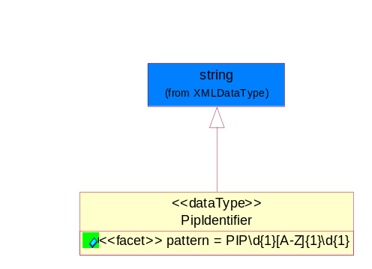
Figure 5-55 PipIdentifier

Attribute | Type | Documentation
pattern |  | PIP\d{1}[A-Z]{1}\d{2}

PipVersion
PIP version number (i.e. 02.02.00).

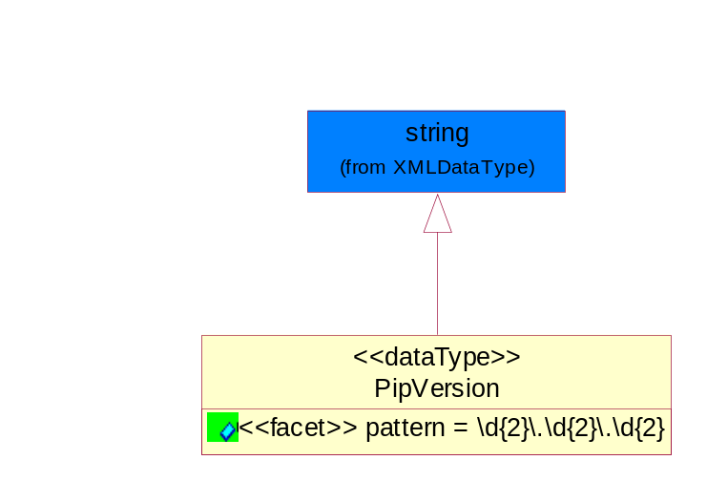
Figure 5-56 PipVersion

Attribute | Type | Documentation
pattern |  | \d{2}\.\d{2}\.\d{2}

Receiver
The object allows the identification of the receiving party of the business message.

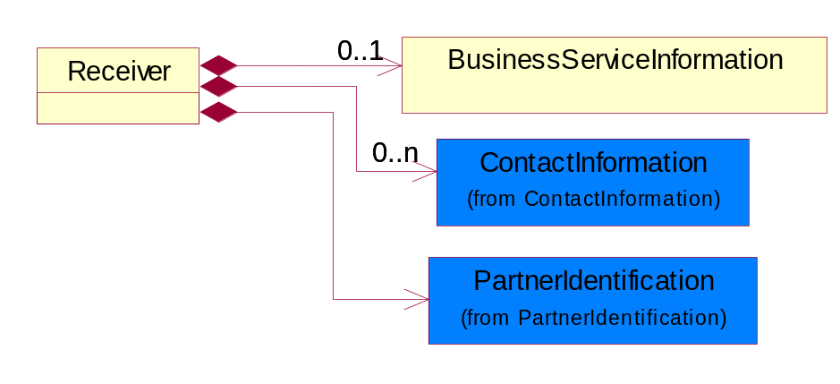
Figure 5-57 Receiver

Composition | Cardinality | Type | Documentation
BusinessServiceInformation | 0..1 | BusinessServiceInformation | The object allows the specification of the business service utilized within the partner company. This may or may not be the same as the information sent by the RNIF.
PartnerIdentification | 1 | PartnerIdentification | The business document must allow for the identity of one or more parties to the transaction.
ContactInformation | 0..n | ContactInformation | The business document must allow for the identification of the name of the department, service or individual to be contacted regarding the context of the business document.

RequestingDocumentInformation
A block of information used to correlate a requesting document to a responding document in an executing choreography.

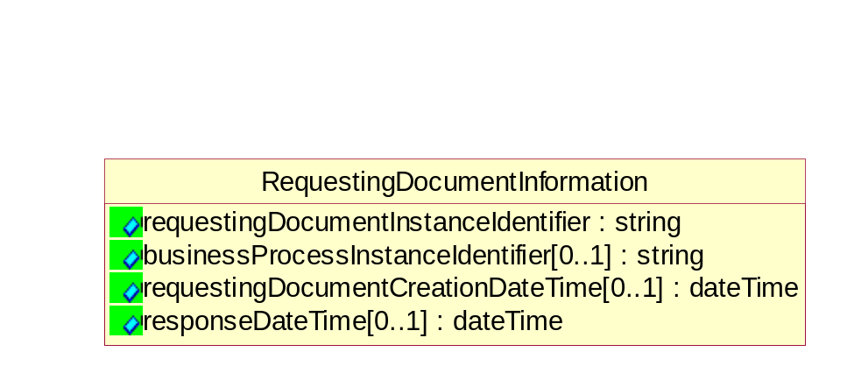
Figure 5-58 RequestingDocumentInformation

Attribute | Type | Documentation
requestingDocumentInstanceIdentifier | string | The Business Document identification number that identifies the requesting Business Document.
businessProcessInstanceIdentifier[0..1] | string | The identifier for the public business process instance being sent that both the sender and receiver can identify.
requestingDocumentCreationDateTime[0..1] | dateTime | The date-time of the requesting business document.
responseDateTime[0..1] | dateTime | The expected time to receive the response. This can not be greater than the PIP TimeToPerform.

Sender
The object allows the identification of the initiating party of the business message.

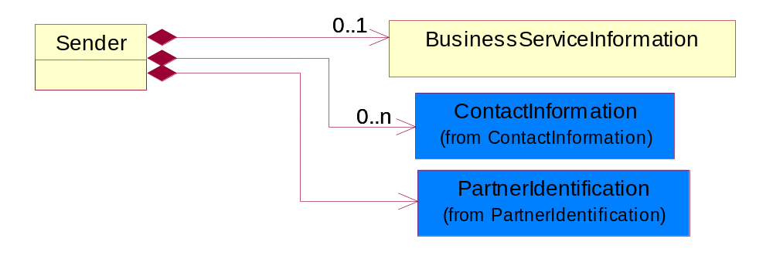
Figure 5-59 Sender

Composition | Cardinality | Type | Documentation
PartnerIdentification | 1 | PartnerIdentification | The business document must allow for the identity of one or more parties to the transaction.
BusinessServiceInformation | 0..1 | BusinessServiceInformation | The object allows the specification of the business service utilized within the partner company. This may or may not be the same as the information sent by the RNIF.
ContactInformation | 0..n | ContactInformation | The business document must allow for the identification of the name of the department, service or individual to be contacted regarding the context of the business document.

StandardDocumentIdentification
The object specifies additional information necessary to identify the standard business document.
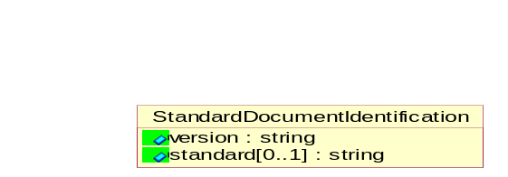
Figure 5-60 StandardDocumentIdentification

Attribute | Type | Documentation
version | string | PIP3A4v01.00
standard[0..1] | string | Identifies the standard used to submit the business document. (e.g. RosettaNet).

TpirPipIdentification
The object specifies all information necessary to uniquely identify a TPIR-PIP within a Registry or trading partner repository.
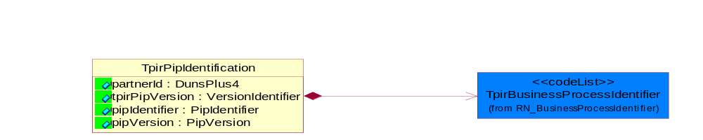
Figure 5-61 TpirPipIdentification

Attribute | Type | Documentation
partnerId | DunsPlus4 | The Trading Partner Identification of MNC that is creating this TPIR PIP.
tpirPipVersion | VersionIdentifier | A TPIR-PIP Version Number (i.e., major and minor version number as XX.XX).
pipIdentifier | PipIdentifier | A TPIR PIP Identification [i.e., 3A4 ).
pipVersion | PipVersion | A TPIR PIP version number (i.e., 02.02.00)

Composition | Cardinality | Type | Documentation
TpirBusinessProcessIdentifier | 1 | TpirBusinessProcessIdentifier | A two alphanumeric character Business Process Identifier to uniquely define the TPIR-PIP "role" within a Business Scenario at a company or MNC level.

VersionIdentifier
Version Number (i.e., major and minor version number as XX.XX).

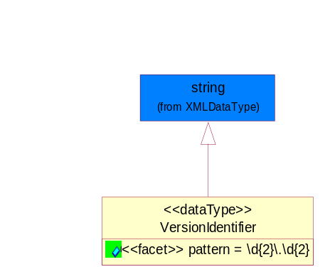
Figure 5-62 VersionIdentifier

Attribute | Type | Documentation
pattern |  | \d{2}\.\d{2}

XML Data Type

boolean

Represents Boolean values, which are either "true" or "false".

dateTime

Represents a specific instance of time.
The pattern for dateTime is CCYY-MM-DDThh:mm:ss where CC represents the century, YY the year, MM the month, and DD the day, preceded by an optional leading negative (-) character to indicate a negative number. If the negative character is omitted, positive (+) is assumed. The T is the date/time separator and hh, mm, and ss represent hour, minute, and second respectively. Additional digits can be used to increase the precision of fractional seconds if desired. For example, the format ss.ss... with any number of digits after the decimal point is supported. The fractional seconds part is optional.
This representation may be immediately followed by a "Z" to indicate Coordinated Universal Time (UTC) or to indicate the time zone. For example, the difference between the local time and Coordinated Universal Time, immediately followed by a sign, + or -, followed by the difference from UTC represented as hh:mm (minutes is required). If the time zone is included, both hours and minutes must be present.

decimal

A data type that contains decimal numbers scaled by a power of 10.

float

Represents single-precision 32-bit floating-point numbers.

nonNegativeInteger

Represents an integer that is greater than or equal to zero. This data type is derived from integer.

positiveInteger

Represents an integer that is greater than zero. This data type is derived from nonNegativeInteger.

string

Represents character string.

