

Description of 2A13 Message

PIP® 2A13
Validated 11.03.00

Specification Information
Name | Description of 2A13 Message
PIP | Distribute Material Composition Information
Cluster | Product Information
Segment | Preparation for Distribution
Publication Date | 30 August 2006
Version Identifier | V11.03

Table of Content

1. Document Management 6
1.1 Legal Disclaimer 6
1.2 Copyright 6
1.3 Trademarks 6
1.4 Acknowledgments 6
1.5 Related Documents 7
1.6 Document Version History 7
1.7 Document Purpose 8
2. Interchange Model 9
2.1 MaterialCompositionInformationDistribution 9
2.1.1 Interchange Diagram 9
2.1.2 Dependency Diagram 10
2.1.3 Condition 10
2.1.4 MaterialCompositionInformationDistribution 11
2.1.5 ProductInformation 12
2.1.6 ProductInformationHeader 14
2.1.7 ProductInformationObject 15
3. Domain Model 17
3.1 Design 17
3.1.1 Design 17
3.1.1.1 Dependency Diagram 17
3.1.1.2 ActualValue 17
3.1.1.3 Attachment 18
3.1.1.4 CAS 18
3.1.1.5 DependentCondition 19
3.1.1.6 Directive 20
3.1.1.7 ManufacturingProcessInfo 21
3.1.1.8 Mass 22
3.1.1.9 MassPercentage 23
3.1.1.10 Material 23
3.1.1.11 MaterialMass 24
3.1.1.12 Note 25
3.1.1.13 ProcessValue 25
3.1.1.14 ProcessValueChoice 26
3.1.1.15 ProductIdentifier 26
3.1.1.16 ProductMass 27
3.1.1.17 Radioactivity 28
3.1.1.18 ReferenceLocator 28
3.1.1.19 ReferenceLocatorChoice 29
3.1.1.20 Subpart 30
3.1.1.21 SubpartIdentifier 31
3.1.1.22 Substance 31
3.1.1.23 SubstanceIdentification 33
3.1.1.24 SubstanceIdentificationChoice 33
3.1.1.25 SubstanceMass 34
3.1.1.26 Text 35
3.1.1.27 Threshold 35
3.1.1.28 Tolerance 35
3.1.1.29 url 36
3.1.1.30 Value 36
3.1.2 CodeList 37
3.1.2.1 ActionCode 37
3.1.2.2 Level 37
3.1.2.3 Compliant 38
4. Universal Structure 39
4.1 ContactInformation 39
4.1.1 ContactInformation 39
4.2 DataType 40
4.2.1 Contact 40
4.2.2 DUNS 40
4.2.3 DUNSPlus4 41
4.2.4 GLN 41
4.2.5 GTIN 42
4.2.6 PercentAmount 42
4.3 Document 43
4.3.1 BusinessDocumentReference 43
4.4 Locations 44
4.4.1 AlternativeIdentifier 44
4.4.2 Location 44
4.4.3 LocationChoice 45
4.4.4 PhysicalAddress 45
4.5 PartnerIdentification 47
4.5.1 FullPartner 47
4.5.2 KnownPartner 47
4.5.3 PartnerIdentification 48
4.5.4 PartnerIdentificationChoice 49
4.5.5 SpecifiedFullPartner 49
4.5.6 SpecifiedKnownPartner 50
4.6 ProductIdentification 50
4.6.1 ProductDescription 50
4.6.2 ProductIdentification 51
4.6.3 ProductIdentificationChoice 52
4.6.4 TextualDescription 52
4.7 CodeList 52
4.7.1 Country 52
4.7.2 CountrySubdivision 52
4.7.3 Language 53
4.7.4 DocumentType 53
4.7.5 MimeTypeQualifier 55
4.7.6 UnitOfMeasure 65
4.7.7 ProcessRoleIdentifier 73
5. System Structure 76
5.1 BusinessProcessIdentifier 76
5.2 BusinessServiceInformation 76
5.3 ContractInformation 77
5.4 CorrelationInformation 78
5.5 DocumentHeader 78
5.6 DocumentIdentification 79
5.7 DocumentIdentificationChoice 80
5.8 DocumentInformation 80
5.9 DocumentManifest 81
5.10 DocumentSecurity 81
5.11 ManifestItem 82
5.12 PipIdentifier 83
5.13 PipVersion 83
5.14 Receiver 84
5.15 RequestingDocumentInformation 85
5.16 Sender 85
5.17 StandardDocumentIdentification 86
5.18 TpirPipIdentification 86
5.19 VersionIdentifier 87
5.20 CodeList 88
5.20.1 TPIRFileType 88
6. XML Data Type 89
6.1 anyURI 89
6.2 boolean 89
6.3 date 89
6.4 dateTime 89
6.5 decimal 89
6.6 float 89
6.7 nonNegativeInteger 89
6.8 positiveInteger 89
6.9 string 90

Table of Figures

Figure ‎2-1 Interchange 9
Figure ‎2-2 Dependency 10
Figure ‎2-3 Condition 10
Figure ‎2-4 MaterialCompositionInformationDistribution 11
Figure ‎2-5 ProductInformation 12
Figure ‎2-6 ProductInformationHeader 14
Figure ‎2-7 ProductInformationObject 15
Figure ‎3-1 Dependency 17
Figure ‎3-2 ActualValue 17
Figure ‎3-3 Attachment 18
Figure ‎3-4 CAS 18
Figure ‎3-5 DependentCondition 19
Figure ‎3-6 Directive 20
Figure ‎3-7 ManufacturingProcessInfo 21
Figure ‎3-8 Mass 22
Figure ‎3-9 MassPercentage 23
Figure ‎3-10 Material 23
Figure ‎3-11 MaterialMass 24
Figure ‎3-12 Note 25
Figure ‎3-13 ProcessValue 25
Figure ‎3-14 ProductIdentifier 26
Figure ‎3-15 ProductMass 27
Figure ‎3-16 Radioactivity 28
Figure ‎3-17 ReferenceLocator 28
Figure ‎3-18 Subpart 30
Figure ‎3-19 SubpartIdentifier 31
Figure ‎3-20 Substance 31
Figure ‎3-21 SubstanceIdentification 33
Figure ‎3-22 SubstanceMass 34
Figure ‎3-23 Text 35
Figure ‎3-24 Threshold 35
Figure ‎3-25 Tolerance 35
Figure ‎3-26 url 36
Figure ‎3-27 Value 36
Figure ‎4-1 ContactInformation 39
Figure ‎4-2 Contact 40
Figure ‎4-3 DUNS 40
Figure ‎4-4 DUNSPlus4 41
Figure ‎4-5 GLN 41
Figure ‎4-6 GTIN 42
Figure ‎4-7 PercentAmount 42
Figure ‎4-8 BusinessDocumentReference 43
Figure ‎4-9 AlternativeIdentifier 44
Figure ‎4-10 Location 44
Figure ‎4-11 PhysicalAddress 45
Figure ‎4-12 FullPartner 47
Figure ‎4-13 KnownPartner 47
Figure ‎4-14 PartnerIdentification 48
Figure ‎4-15 SpecifiedFullPartner 49
Figure ‎4-16 SpecifiedKnownPartner 50
Figure ‎4-17 ProductDescription 50
Figure ‎4-18 ProductIdentification 51
Figure ‎4-19 TextualDescription 52
Figure ‎5-1 BusinessProcessIdentifier 76
Figure ‎5-2 BusinessServiceInformation 76
Figure ‎5-3 ContractInformation 77
Figure ‎5-4 CorrelationInformation 78
Figure ‎5-5 DocumentHeader 78
Figure ‎5-6 DocumentIdentification 79
Figure ‎5-7 DocumentInformation 80
Figure ‎5-8 DocumentManifest 81
Figure ‎5-9 DocumentSecurity 81
Figure ‎5-10 ManifestItem 82
Figure ‎5-11 PipIdentifier 83
Figure ‎5-12 PipVersion 83
Figure ‎5-13 Receiver 84
Figure ‎5-14 RequestingDocumentInformation 85
Figure ‎5-15 Sender 85
Figure ‎5-16 StandardDocumentIdentification 86
Figure ‎5-17 TpirPipIdentification 86
Figure ‎5-18 VersionIdentifier 87

Document Management

Legal Disclaimer
RosettaNet, its members, officers, directors, employees, or agents shall not be liable for any injury, loss, damages, financial or otherwise, arising from, related to, or caused by the use of this document or the specifications herein, as well as associated guidelines and schemas. The use of said specifications shall constitute your express consent to the foregoing exculpation.

Copyright
©2006 RosettaNet. All rights reserved. No part of this publication may be reproduced, stored in a retrieval system, or transmitted, in any form or by any means, electronic, mechanical, photocopying, recording, or otherwise, without the inclusion of this copyright notice. Any derivative works must cite the copyright notice. Any public redistribution or sale of this publication or derivative works requires prior written permission of the publisher.

Trademarks
RosettaNet, Partner Interface Process, PIP and the RosettaNet logo are trademarks or registered trademarks of "RosettaNet," a non-profit organization. All other product names and company logos mentioned herein are the trademarks of their respective owners. In the best effort, all terms mentioned in this document that are known to be trademarks or registered trademarks have been appropriately recognized in the first occurrence of the term.

Acknowledgments
This document has been prepared by RosettaNet (http://www.rosettanet.org/) from requirements gathered during the Milestone Program and in conformance with the methodology. Listed below are the legal entities that contributed to the design and development of this PIP.
ADOS Co., Ltd. | Agere Systems
Agilent Technologies | Amkor Technology, Inc.
Centor Software | Cisco Systems
Korea Electronics Industry, including Samsung & LG | Ericsson
Future Electronics Inc. | Globetronics SDH. BHD
Intel Corporation | KYOCERA Corporation
LG Electronics Inc., Quality & Reliability Center | MIMOS Berhad
Motorola | Motorola, Inc.
Motorola Semiconductor Products Sector | Motorola SPS
National Semiconductor | NEC Corporation
NEC Electronics | NEC Electronics (Europe) GmbH
Nichicon Corporation | Nippon Chemi-Con Corporation
Nokia | Nokia Corporation
Nokia Oyj | SAP
Siemens AG | School of Social Ecology, University of California Irvine
Sony | Sony EMCS Corporation
Sony Corporation | Sterling Commerce
STMicroelectronics | STMicroelectronics Inc
STMicroelectronics N.V. | Synapsis Technology, Inc.
Ted Haas Consulting, LLC | Texas Instruments
Texas Instruments, Inc. | Texas Instruments, Japan Ltd

Related Documents
- Associated PIP Message Schemas (included with PIP Specification only)
- Description of Partner Interface Process for 2A13
- Message Structure

Document Version History
Version | Date | Description
Validated 11.00.00 | 10 Jan 2005 | RosettaNet: Marking the end of validation period with PIP version promotion. Made few changes to the message due to approved change requests submitted by validation partners.
Validated 11.01.00 | 30 Mar 2005 | Validated version. Updated to accommodate requirement from iNEMI, to support WEEE and RoHS Directives.
Validated 11.02.00 | 29 Jun 2005 | Validated version. Updated according to Change Request to be used as the responding message for PIP 2A15.
Validated 11.03.00 | 30 Aug 2006 | Validated Version. Updated according to Change Request of Maintenance Program 2006

Document Purpose
The purpose of the document is to explain the structure, the association between objects, the content of objects and the definition for single elements to a non-technical audience.

Interchange Model

MaterialCompositionInformationDistribution

Interchange Diagram
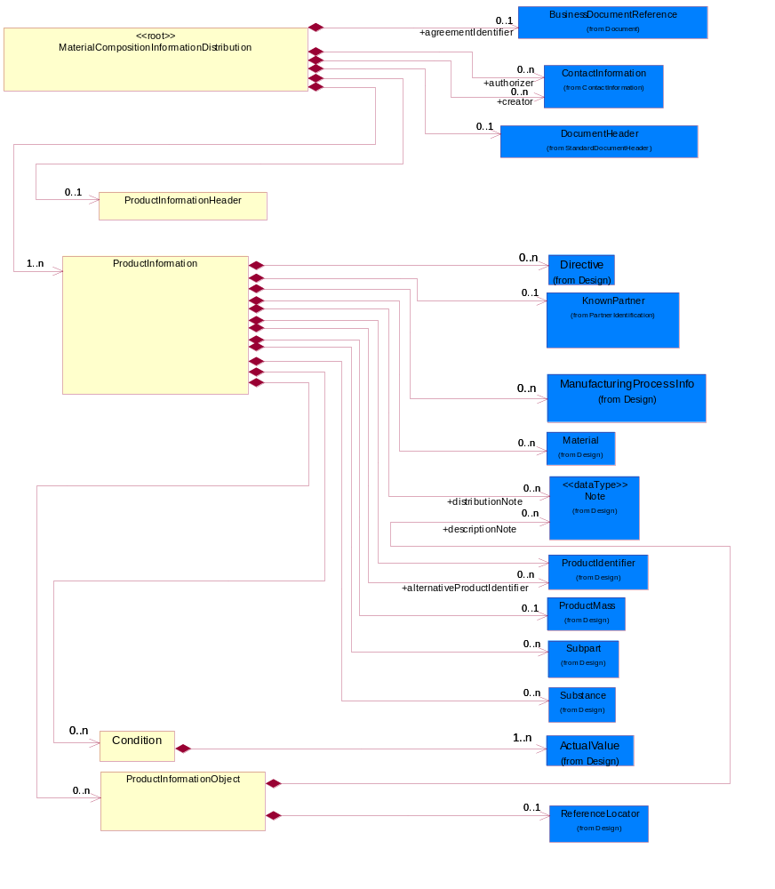
Figure ‎2-1 Interchange

Dependency Diagram
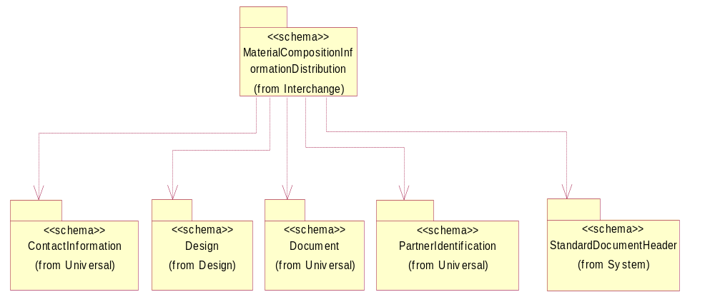
Figure ‎2-2 Dependency

Condition
An operational or testing condition necessary to produce the value for a given property. To report results of a material composition when "one or more conditions" have been applied to it. The list of conditions could grow, such is the case of a product, the list of conditions could be represented as a table of values.
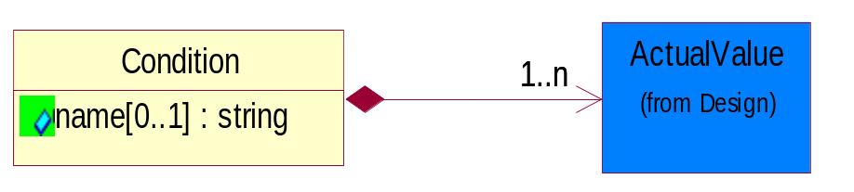
Figure ‎2-3 Condition

Attribute | Type | Documentation
name[0..1] | string | The name of the condition which could be a pre-defined rule in Information Distribution Agreement. For example, ISO test #123ABC could be the condition rule used to test outer wrapping of a power cord which has 0.1% Cadmium.

Composition | Cardinality | Type | Documentation
ActualValue | 1..n | ActualValue | Collection of elements to capture value and type.

MaterialCompositionInformationDistribution
A message wrapper or root element for the response message of Material Composition Information.
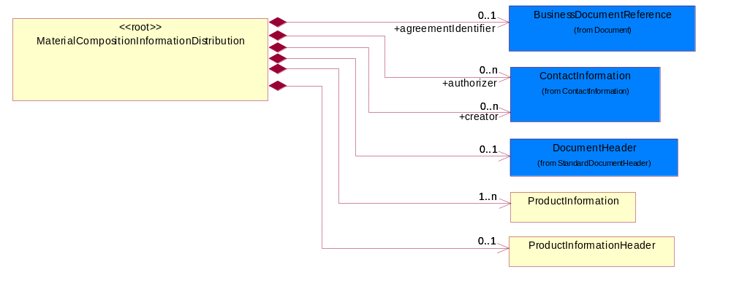
Figure ‎2-4 MaterialCompositionInformationDistribution

Composition | Cardinality | Type | Documentation
DocumentHeader | 0..1 | DocumentHeader | The object allows for the identification of the sender and receiver of the business document.
ProductInformationHeader | 0..1 | ProductInformationHeader | The collection of header information(s) related to one or more product.
agreementIdentifier | 0..1 | BusinessDocumentReference | Known as IDA (Information Distribution Agreement) requirement for the purpose of cross-reference to a specifing line/position in the agreement/contract.  A mutually agreed identifier assgined to the Information Distribution Agreement under which ths information distribution is taking place. Preferable document identifier should be contract (COT).
ProductInformation | 1..n | ProductInformation | The collection of information related to a product or a product family.
authorizer | 0..n | ContactInformation | The person who authorise the release of the report and certify that the declaration is true and complete.
creator | 0..n | ContactInformation | The person who complete the material composition declaration.

ProductInformation
The collection of information related to a product or a product family.
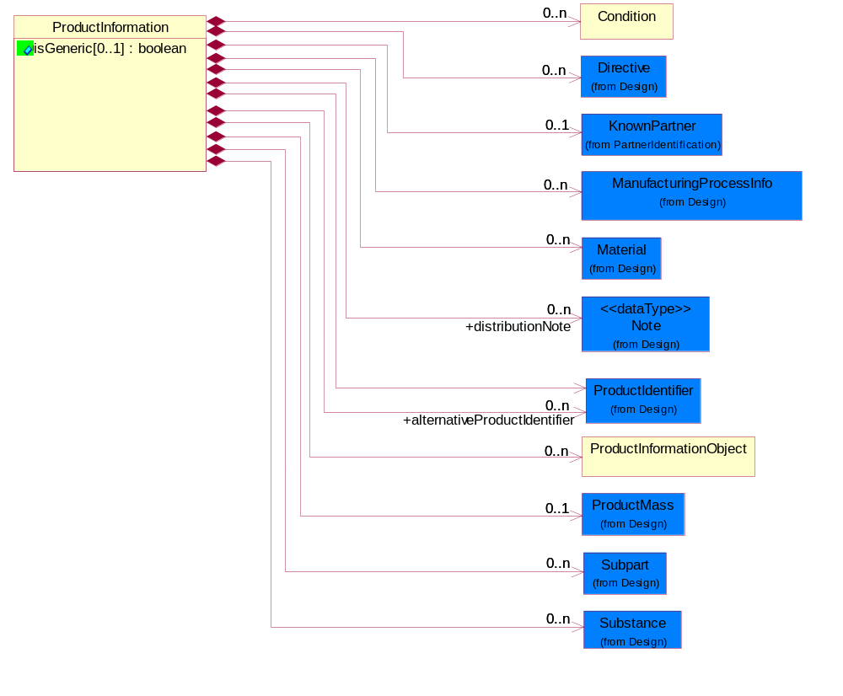
Figure ‎2-5 ProductInformation

Attribute | Type | Documentation
isGeneric[0..1] | boolean | To identify the subsequent product reporting as a product family (generic) reporting.

Composition | Cardinality | Type | Documentation
ProductMass | 0..1 | ProductMass | Product Total Mass (weight) MUST be specified in KIG (kg) (kilogram) even the actual value ranges from nano grams to giga kilograms. The unit of measure would still be KIG (kg).
Subpart | 0..n | Subpart | Subpart indicates the aggregation for all such subparts; i.e., if there are four such subparts, the values indicated are totaled and sent.  A typical implementation of subpart(s) within subpart(s) would be in one of the following nested levels of 0, 1 and/or 2.
Substance | 0..n | Substance | Substance definition block/class.
Material | 0..n | Material | Material definition block/class.
ProductInformationObject | 0..n | ProductInformationObject | A Meta data structure used to describe a logical representation of arbitrary data. This is also known as Attachments. This will be used as a sub-class subordinate to the ProductInformation data structure.
distributionNote | 0..n | Note | Distribution specific notations. Additonal notation for the distribution, product information, substance or radioactivity.
KnownPartner | 0..1 | KnownPartner | The business document must describe the trading partners in the business transaction.
Directive | 0..n | Directive | Describes the explicit declaration of compliance to one or more compliance directives; and also specify any exemption to the compliance.
Condition | 0..n | Condition | An operational or testing condition necessary to produce the value for a given property. To report results of a material composition when "one or more conditions" have been applied to it. The list of conditions could grow, such is the case of a product, the list of conditions could be represented as a table of values.
ManufacturingProcessInfo | 0..n | ManufacturingProcessInfo | Provides information with regards to the manufacturing process of a product or subpart.
alternativeProductIdentifier | 0..n | ProductIdentifier | Provide additional product identifier data, which are different from the sender's product identifier. This is required when the receiver and sender have their own proprietary product name, code etc.
ProductIdentifier | 1 | ProductIdentifier | The collection of data structure to identify a product or a product family.

ProductInformationHeader
The collection of header information(s) related to one or more product.
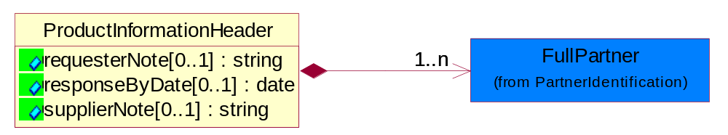
Figure ‎2-6 ProductInformationHeader

Attribute | Type | Documentation
requesterNote[0..1] | string | Requestor comments or URL for additional information.
responseByDate[0..1] | date | This field identifies the date when the supplier is expected to respond to the request for information.
supplierNote[0..1] | string | Supplier comments or URL for additional information.

Composition | Cardinality | Type | Documentation
FullPartner | 1..n | FullPartner | The business document must describe the trading partners in the business transaction. This data structure provide the flexibility to describe a partner in all possible methods as for new, existing or known partner.

ProductInformationObject
A Meta data structure used to describe a logical representation of arbitrary data. This is also known as Attachments. This will be used as a sub-class subordinate to the ProductInformation data structure.
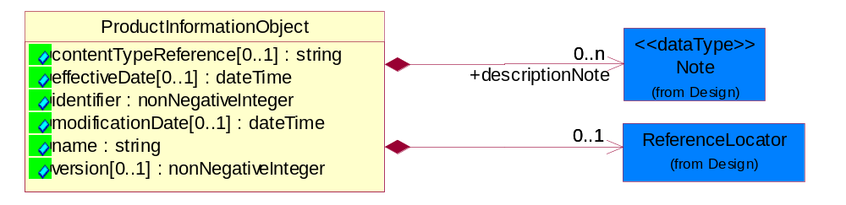
Figure ‎2-7 ProductInformationObject

Attribute | Type | Documentation
contentTypeReference[0..1] | string | A unique identifier that defines the category of information provided by this ProductInformationObject.
effectiveDate[0..1] | dateTime | The date when the information becomes effective.
identifier | nonNegativeInteger | The identifier for a ProductInformationObject unique in the namespace of the notification.
modificationDate[0..1] | dateTime | The last time a change was made.
name | string | The name of the ProductInformationObject, also known as Attachment.
version[0..1] | nonNegativeInteger | An arbitrary identifier indicating a content revision level.

Composition | Cardinality | Type | Documentation
ReferenceLocator | 0..1 | ReferenceLocator | Meta data describing a logical representation of a set of arbitrary data. A collection of properties identifying a ProductInformationObject with an attachment.
descriptionNote | 0..n | Note | Additonal notation that characterizes or otherwise identifies this ProductInformationObject.

Domain Model

Design

Design

Dependency Diagram
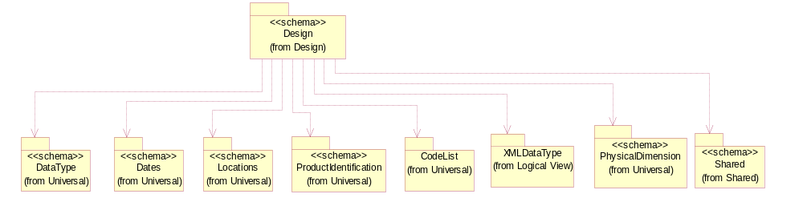
Figure ‎3-8 Dependency

ActualValue
Collection of elements to capture value and type.
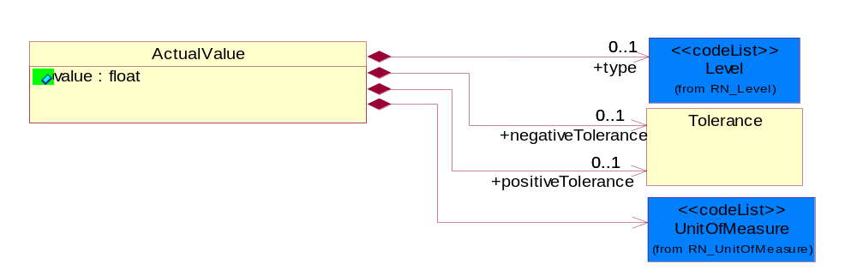
Figure ‎3-9 ActualValue

Attribute | Type | Documentation
value | Float | The actual value recorded from the tests conducted based on test condition or dependent conditions. Extension to DependentCondition.

Composition | Cardinality | Type | Documentation
negativeTolerance | 0..1 | Tolerance | A negative tolerance expressed as a non-negative real number to be subtracted from the current value and as a non-negative percent of the current value.
positiveTolerance | 0..1 | Tolerance | A positive tolerance expressed as a non-negative real number to be added to the current value and as a non-negative percent of the current value.
UnitOfMeasure | 1 | UnitOfMeasure | Code identifying a product unit of measure.
type | 0..1 | Level | A qualifier describing the kind of measurement a value represents.

Attachment
Meta data describing a logical representation of a set of arbitrary data. A collection of properties identifying a ProductInformationObject with an attachment.
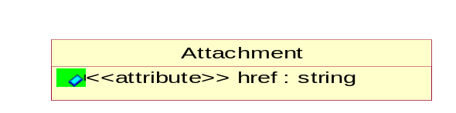
Figure ‎3-10 Attachment

Attribute | Type | Documentation
href | string | A reference to the Content-Id attribute of MIME-attachment specified as "cid:MIME_content-id_of_attachment" in accrodance with RFC 2392 (http://rfc.fh-koeln.de/rfc/html/rfc2392.html) and RNIF 2.0

CAS
The CAS identifier is part of the CAS Registry and is a numeric identifier that can contain up to 9 digits, divided by hyphens into 3 parts: the right digit is a check digit to verify by computer the validity and uniqueness of the entire number for example, 58-08-2 is the CAS Registry Number for caffeine. If other than CAS numbers are used, this string pattern could be different.
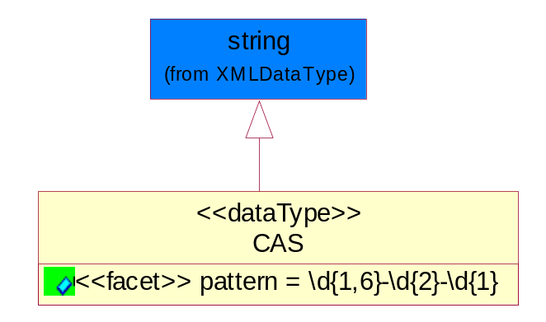
Figure ‎3-11 CAS

Attribute | Type | Documentation
Pattern |  | \d{1,6}-\d{2}-\d{1}

DependentCondition
An operational or testing condition necessary to produce the value for a given property. To report results of a material composition when "one or more conditions" have been applied to it. The list of conditions could grow, such is the case of a product, the list of conditions could be represented as a table of values.
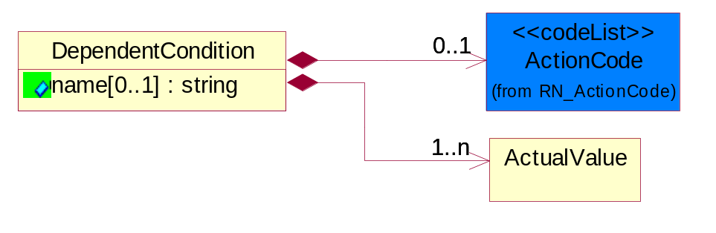
Figure ‎3-12 DependentCondition

Attribute | Type | Documentation
name[0..1] | string | The name of the condition which could be a pre-defined rule in Information Distribution Agreement. For example, ISO test #123ABC could be the condition rule used to test outer wrapping of a power cord which has 0.1% Cadmium.

Composition | Cardinality | Type | Documentation
ActionCode | 0..1 | ActionCode | Code identifying the business action that must be performed on or with data. These codes will result in a subsequent action to the Material Composition data.
ActualValue | 1..n | ActualValue | Collection of elements to capture value and type.

Directive
Describes the explicit declaration of compliance to one or more compliance directives; and also specify any exemption to the compliance.
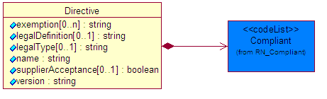
Figure ‎3-13 Directive

Attribute | Type | Documentation
exemption[0..n] | string | Provides the exemptions claimed for this part of this directive. A part may be compliant to a directive but only because it falls under one or more exemptions.
legalDefinition[0..1] | string | A legal statement which explains the extent to which the user may rely on the information provided in the declaration and which may limit liability.
legalType[0..1] | string | Describes the type of legal statement. Example are Simplified, Detailed, EMS, Custom etc.
name | string | The unique name of the directive of legistlation. Example EU RoHS, WEEE etc.
supplierAcceptance[0..1] | boolean | Indicates the supplier acceptance of the legal statement. True if Accepted, and False if Not Accepted.
version | string | The version of the directive for which this part is being declared.

Composition | Cardinality | Type | Documentation
Compliant | 1 | Compliant | Describes the Directive Complaint level of a product, subpart or substance.

ManufacturingProcessInfo
Provides information with regards to the manufacturing process of a product or subpart.
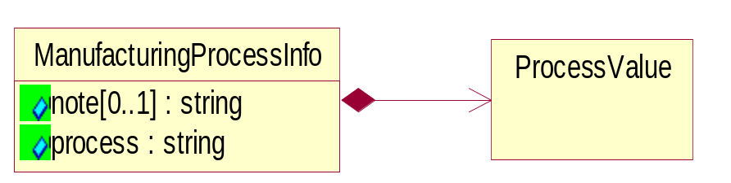
Figure ‎3-14 ManufacturingProcessInfo

Attribute | Type | Documentation
note[0..1] | string | Additonal notation that characterizes or otherwise identifies this Manufacturing Process.
Process | string | Describes a process invloved in manufacturing a product. Example are Add Terminal Plating and Surface Thickness, Terminal Base Alloy and Base or Core Thickness, Grid Array Materials, Max Reflow Temperature, Max Reflow Cycles, J-STD-020 Moisture etc.

Composition | Cardinality | Type | Documentation
ProcessValue | 1 | ProcessValue | Describes the value of manufacturing process. Example are surface thickness measurement, temperature setting, material type etc.

Mass
Based on ECTD/IEC specification, Mass should be specified in kilogram (KG) per IEC 61360 - 1 (Annex B) - (http://www.iec.ch/tc3/txt/143.htm) format for floating point, positive or negative.
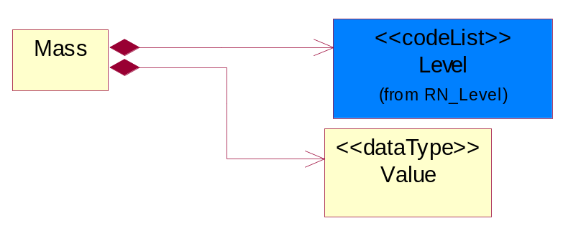
Figure ‎3-15 Mass

Composition | Cardinality | Type | Documentation
Value | 1 | Value | Based on ECTD/IEC specification, Mass should be specified in kilogram (KG) per IEC 61360 - 1 (Annex B) - (http://www.iec.ch/tc3/txt/143.htm) format for floating point, positive or negative.  Example of preferred format:  a. 2kg - will be specified as 2.0E KG  b. 200g - will be specified as 200.0E - 3 KG  c. 20mg - will be specified as 20.0E- 6 KG
Level | 1 | Level | This is to qualify the type of the product, material or substance mass either maximum, minimum, typical, nominal independently or with any combination such as when specifying range of mass between minimum and maximum. In this case, the mass reporting will loop and for each instance it will have different Level entry.

MassPercentage
Weight percentage of total mass. Usually specified for parts per million (ppm). A number representing a percentage value, e.g. 75.125 represents 75 1/8 percent.
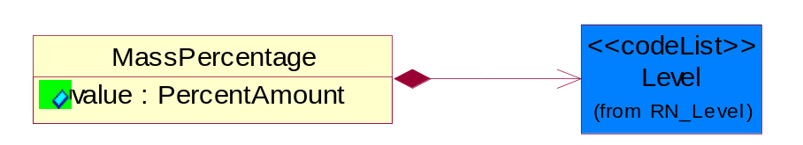
Figure ‎3-16 MassPercentage

Attribute | Type | Documentation
Value | PercentAmount | A number representing a percentage value, e.g. 75.125 represents 75 1/8 percent

Composition | Cardinality | Type | Documentation
Level | 1 | Level | This is to qualify the type of the product, material or substance mass either maximum, minimum, typical, nominal independently or with any combination such as when specifying range of mass between minimum and maximum. In this case, the mass reporting will loop and for each instance it will have different Level entry.

Material
Material definition block/class.
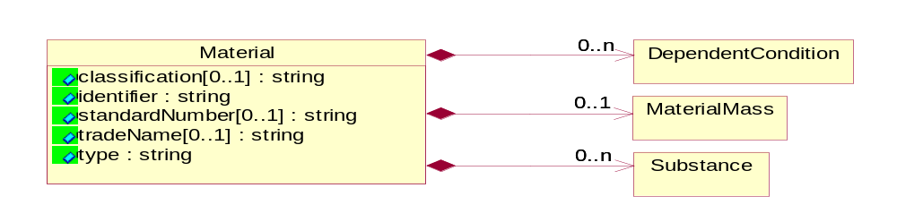
Figure ‎3-17 Material

Attribute |  | Type |  | Documentation
classification[0..1] |  | string |  | Classification e.g. JGPSSI classification system.
Identifier |  | string |  | Identifier for the material either using ISO, or MaterialClassification.
standardNumber[0..1] |  | string |  | ISO or other international standards number identifying material.
tradeName[0..1] |  | string |  | Commercial name of the material.
Type |  | string |  | The name of the material e.g Copper, Alloy, Polymer, Glass, etc.
Composition | Cardinality |  | Type |  | Documentation
MaterialMass | 0..1 |  | MaterialMass |  | Material Total Mass (weight) MUST be specified in KIG (kg) (kilogram) even the actual value ranges from nano grams to giga kilograms. The unit of measure would still be KIG (kg).
DependentCondition | 0..n |  | DependentCondition |  | An operational or testing condition necessary to produce the value for a given property. To report results of a material composition when "one or more conditions" have been applied to it. The list of conditions could grow, such is the case of a product, the list of conditions could be represented as a table of values.
Substance | 0..n |  | Substance |  | Substance definition block/class.

MaterialMass
Material Total Mass (weight) MUST be specified in KIG (kg) (kilogram) even the actual value ranges from nano grams to giga kilograms. The unit of measure would still be KIG (kg).
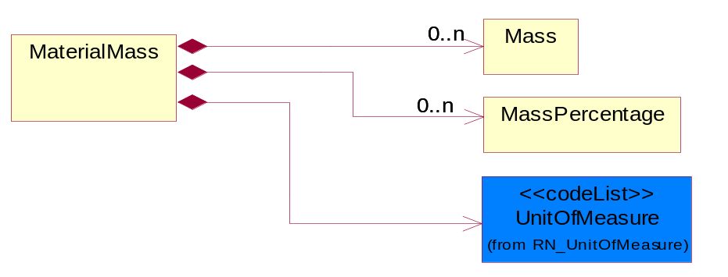
Figure ‎3-18 MaterialMass

Composition | Cardinality | Type | Documentation
Mass | 0..n | Mass | Based on ECTD/IEC specification, Mass should be specified in kilogram (KG) per IEC 61360 - 1 (Annex B) - (http://www.iec.ch/tc3/txt/143.htm) format for floating point, positive or negative.
UnitOfMeasure | 1 | UnitOfMeasure | Code identifying a product unit of measure.
MassPercentage | 0..n | MassPercentage | Weight percentage of total mass. Usually specified for parts per million (ppm). A number representing a percentage value, e.g. 75.125 represents 75 1/8 percent.

Note
Additonal notation for the notification, product information, substance or radioactivity.
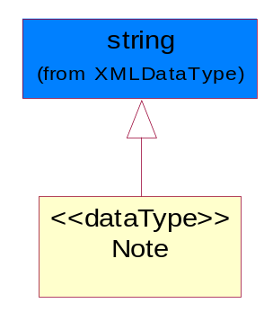
Figure ‎3-19 Note

ProcessValue
Describes the value of manufacturing process. Example are surface thickness measurement, temperature setting, material type etc.

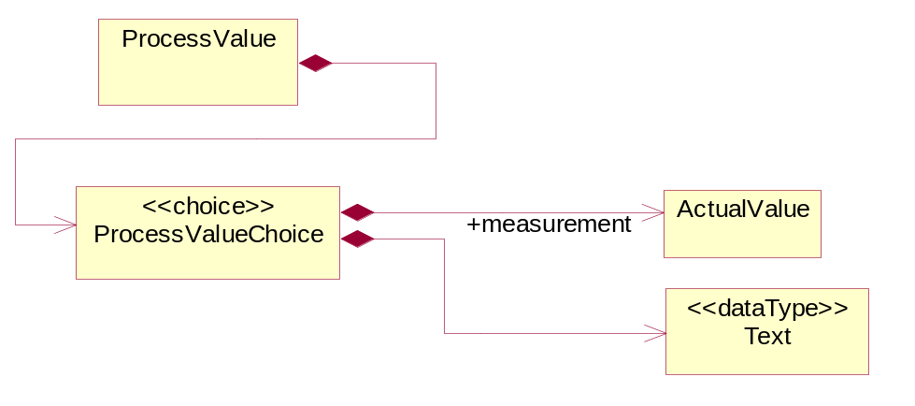
Figure ‎3-20 ProcessValue
Composition | Cardinality | Type | Documentation
ProcessValueChoice | 1 | ProcessValueChoice

ProcessValueChoice
Composition | Cardinality | Type | Documentation
measurement | 1 | ActualValue | The measurement value of a manufacturing process. Example are surface thickness, temperature etc.
Text | 1 | Text | The textual value of a manufacturing process. Example are material type, moisture setting standard etc.

ProductIdentifier
The collection of data structure to identify a product or a product family.
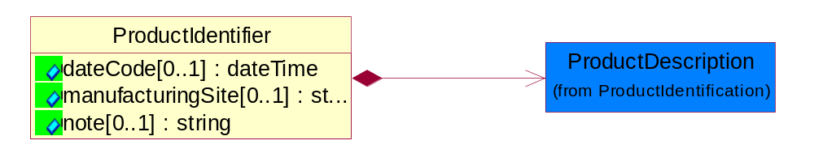
Figure ‎3-21 ProductIdentifier

Attribute | Type | Documentation
dateCode[0..1] | dateTime | The date when the group or batch of product becomes effective.
manufacturingSite[0..1] | string | Identify the site where a group or batch of product is manufactured.
note[0..1] | string | Additonal notation that characterizes or otherwise identifies this Product.

Composition | Cardinality | Type | Documentation
ProductDescription | 1 | ProductDescription | The business document must allow for the identification of the product and multiple textual descriptions of a product.

ProductMass
Product Total Mass (weight) MUST be specified in KIG (kg) (kilogram) even the actual value ranges from nano grams to giga kilograms. The unit of measure would still be KIG (kg).
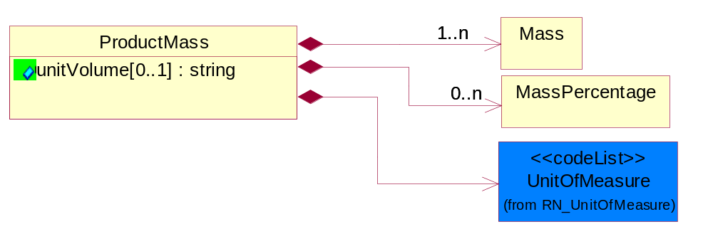
Figure ‎3-22 ProductMass

Attribute | Type | Documentation
unitVolume[0..1] | string | Describes the scoped weight to a unit volume such as cubic meter or cubic feet, square meter or square foot etc. To provide concise reporting of bulk materials, components, sub-assemblies and finished products.

Composition | Cardinality | Type | Documentation
Mass | 1..n | Mass | Based on ECTD/IEC specification, Mass should be specified in kilogram (KG) per IEC 61360 - 1 (Annex B) - (http://www.iec.ch/tc3/txt/143.htm) format for floating point, positive or negative.
UnitOfMeasure | 1 | UnitOfMeasure | Code identifying a product unit of measure.
MassPercentage | 0..n | MassPercentage | Weight percentage of total mass. Usually specified for parts per million (ppm). A number representing a percentage value, e.g. 75.125 represents 75 1/8 percent.

Radioactivity
Radioactivity isotope name, code and other details
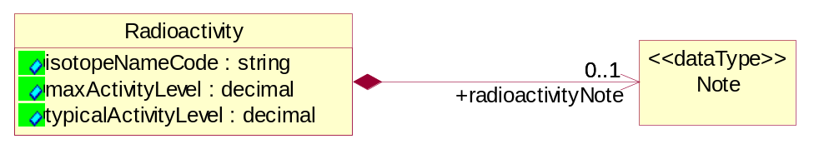
Figure ‎3-23 Radioactivity

Attribute | Type | Documentation
isotopeNameCode | string | If the substance is radioactive the radioactive Isotope element name and code e.g. Ni-63 should be provided.
maxActivityLevel | decimal | The maximum activity level in MBecquerel's (MBq).
typicalActivityLevel | decimal | The typical activity level in MBecquerel's (MBq)

Composition | Cardinality | Type | Documentation
radioactivityNote | 0..1 | Note | Additional information about the radioactivity.

ReferenceLocator
Meta data describing a logical representation of a set of arbitrary data. A collection of properties identifying a ProductInformationObject with an attachment.
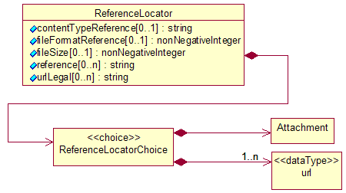
Figure ‎3-24 ReferenceLocator

Attribute | Type | Documentation
contentTypeReference[0..1] | string | A unique identifier that defines the category of information provided by this ProductInformationObject.
fileFormatReference[0..1] | nonNegativeInteger | A unique identifier that defines the type data encoding for this ProductInformationObject.
fileSize[0..1] | nonNegativeInteger | The size of an object.
reference[0..n] | string | Represented as a URL (Uniform Resource Locator defined in accordance with RFC 2396 http://www.w3.org/Addressing). The URL's purpose is to provide supplementary information related to the ProductInformationObject.
urlLegal[0..n] | string | Using a URL (Uniform Resource Locator defined in accordance with RFC 2396 http://www.w3.org/Addressing) to describe terms, conditions, disclaimers, warnings, limitations, or other information related to the ProductInformationObject.

Composition | Cardinality | Type | Documentation
ReferenceLocatorChoice | 1 | ReferenceLocatorChoice

ReferenceLocatorChoice
Composition | Cardinality | Type | Documentation
url | 1..n | url | The URL (Uniform Resource Locator defined in accordance with RFC 2396 http://www.w3.org/Addressing) is used for accessing dynamic supplementary information maintained by a domain authority. It is used as a storage area for an attachment. When this request is rendered it will return only the requested attached data.
Attachment | 1 | Attachment | Meta data describing a logical representation of a set of arbitrary data. A collection of properties identifying a ProductInformationObject with an attachment.

Subpart
Subpart indicates the aggregation for all such subparts; i.e., if there are four such subparts, the values indicated are totaled and sent.
A typical implementation of subpart(s) within subpart(s) would be in one of the following nested levels of 0, 1 and/or 2.
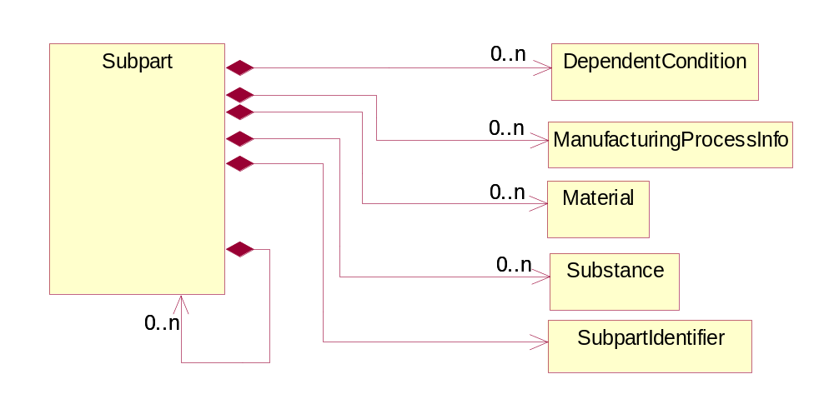
Figure ‎3-25 Subpart

Composition | Cardinality | Type | Documentation
DependentCondition | 0..n | DependentCondition | An operational or testing condition necessary to produce the value for a given property. To report results of a material composition when "one or more conditions" have been applied to it. The list of conditions could grow, such is the case of a product, the list of conditions could be represented as a table of values.
Material | 0..n | Material | Material definition block/class.
Substance | 0..n | Substance | Substance definition block/class.
ManufacturingProcessInfo | 0..n | ManufacturingProcessInfo | Provides information with regards to the manufacturing process of a product or subpart.
SubpartIdentifier | 1 | SubpartIdentifier | Identification for the Subpart.

SubpartIdentifier
Identification for the Subpart.
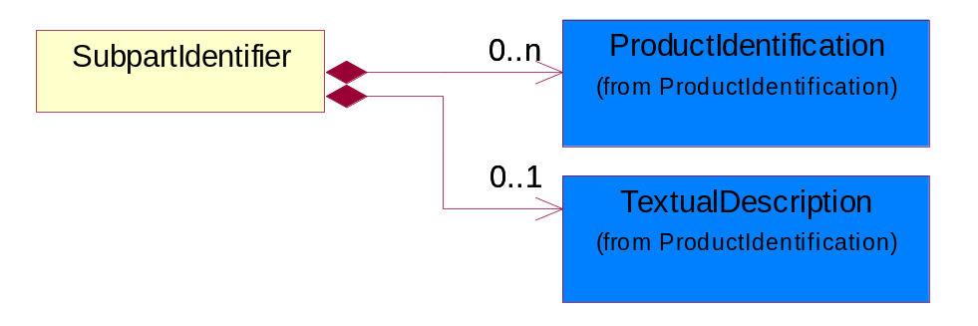
Figure ‎3-26 SubpartIdentifier

Composition | Cardinality | Type | Documentation
ProductIdentification | 0..n | ProductIdentification | The object provides the identifier(s) of a product.
TextualDescription | 0..1 | TextualDescription | The business document must allow for multiple levels of textual description of an event or object.

Substance
Substance definition block/class.
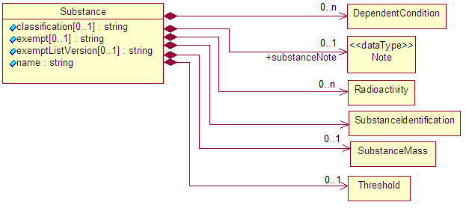
Figure ‎3-27 Substance

Attribute | Type | Documentation
classification[0..1] | string | Classification e.g. JGPSSI classification system.
exempt[0..1] | string | This field identifies any RoHS exemptions which apply to the item.
exemptListVersion[0..1] | string | The version of exempt list for which this substance is referring.
name | string | The substance name e.g. Copper (Cu) or group name e.g. Nickel compunds.

Composition | Cardinality | Type | Documentation
Radioactivity | 0..n | Radioactivity | Radioactivity isotope name, code and other details
substanceNote | 0..1 | Note | Additonal notation that characterizes or otherwise identifies this Substance.
SubstanceMass | 0..1 | SubstanceMass | Substance Total Mass (weight) MUST be specified in KIG (kg) (kilogram) even the actual value ranges from nano grams to giga kilograms. The unit of measure would still be KIG (kg).
SubstanceIdentification | 1 | SubstanceIdentification | A structured and broadly accepted way of identifying a substance. RosettaNet has adopted CAS (Chemical Abstract Numbering System), http://chemfinder.camsoft.com or any alternative identifiers.
DependentCondition | 0..n | DependentCondition | An operational or testing condition necessary to produce the value for a given property. To report results of a material composition when "one or more conditions" have been applied to it. The list of conditions could grow, such is the case of a product, the list of conditions could be represented as a table of values.
Threshold | 0..1 | Threshold | Limit of the substance content level according to the standard, e.g. RoHS, WEEE.

SubstanceIdentification
A structured and broadly accepted way of identifying a substance. RosettaNet has adopted CAS (Chemical Abstract Numbering System), http://chemfinder.camsoft.com or any alternative identifiers.
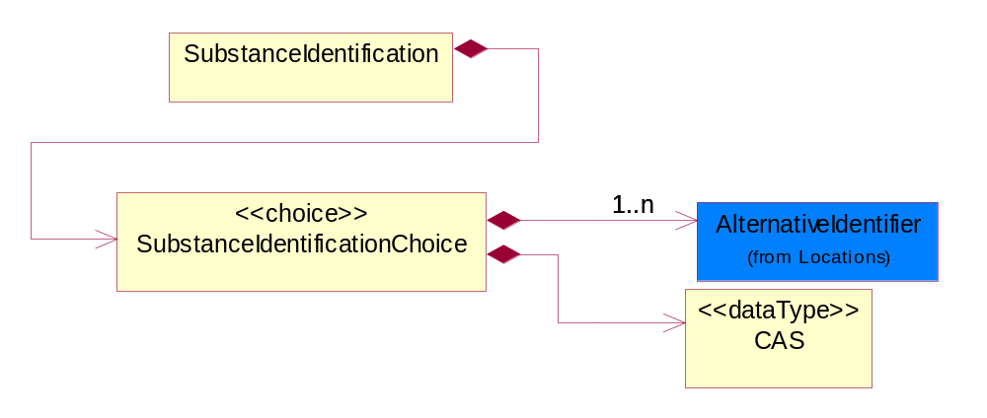
Figure ‎3-28 SubstanceIdentification

Composition | Cardinality | Type | Documentation
SubstanceIdentificationChoice | 1 | SubstanceIdentificationChoice

SubstanceIdentificationChoice
Composition | Cardinality | Type | Documentation
CAS | 1 | CAS | The CAS identifier is part of the CAS Registry and is a numeric identifier that can contain up to 9 digits, divided by hyphens into 3 parts: the right digit is a check digit to verify by computer the validity and uniqueness of the entire number for example, 58-08-2 is the CAS Registry Number for caffeine. If other than CAS numbers are used, this string pattern could be different.
AlternativeIdentifier | 1..n | AlternativeIdentifier | Identifies the specified code and the name of the organization that a code is utilized from.

SubstanceMass
Substance Total Mass (weight) MUST be specified in KIG (kg) (kilogram) even the actual value ranges from nano grams to giga kilograms. The unit of measure would still be KIG (kg).
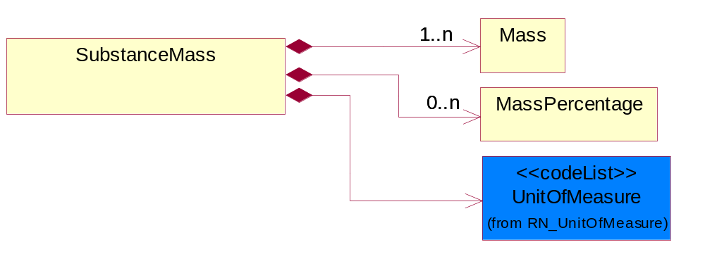
Figure ‎3-29 SubstanceMass

Composition | Cardinality | Type | Documentation
Mass | 1..n | Mass | Based on ECTD/IEC specification, Mass should be specified in kilogram (KG) per IEC 61360 - 1 (Annex B) - (http://www.iec.ch/tc3/txt/143.htm) format for floating point, positive or negative.
UnitOfMeasure | 1 | UnitOfMeasure | Code identifying a product unit of measure.
MassPercentage | 0..n | MassPercentage | Weight percentage of total mass. Usually specified for parts per million (ppm). A number representing a percentage value, e.g. 75.125 represents 75 1/8 percent.

Text
The textual value of a manufacturing process. Example are material type, moisture setting standard etc.
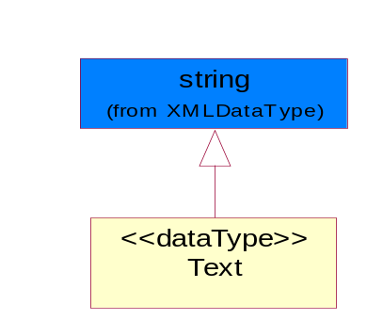
Figure ‎3-30 Text

Threshold
Limit of the substance content level according to the standard, e.g. RoHS, WEEE.
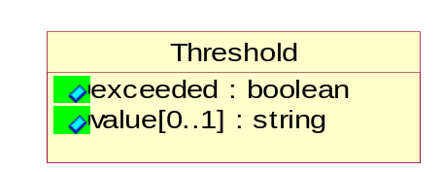
Figure ‎3-31 Threshold

Attribute | Type | Documentation
exceeded | boolean | Indicate whether the substance content level has exceeded the threshold.
value[0..1] | string | The value of the substance content.

Tolerance
Collection defined to specify tolerance levels. Extension to DependentCondition.
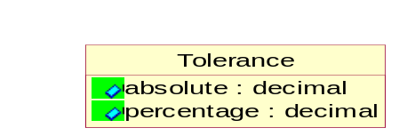
Figure ‎3-32 Tolerance

Attribute | Type | Documentation
absolute | decimal | A tolerance expressed as a real number.
percentage | decimal | A tolerance expressed as a percentage of the current value.

url
The URL (Uniform Resource Locator defined in accordance with RFC 2396 http://www.w3.org/Addressing) is used for accessing dynamic supplementary information maintained by a domain authority. It is used as a storage area for an attachment. When this request is rendered it will return only the requested attached data.
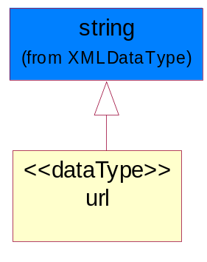
Figure ‎3-33 url

Value
Based on ECTD/IEC specification, Mass should be specified in kilogram (KG) per IEC 61360 - 1 (Annex B) - (http://www.iec.ch/tc3/txt/143.htm) format for floating point, positive or negative.

Example of preferred format:
a. 2kg - will be specified as 2.0E KG
b. 200g - will be specified as 200.0E - 3 KG
c. 20mg - will be specified as 20.0E- 6 KG

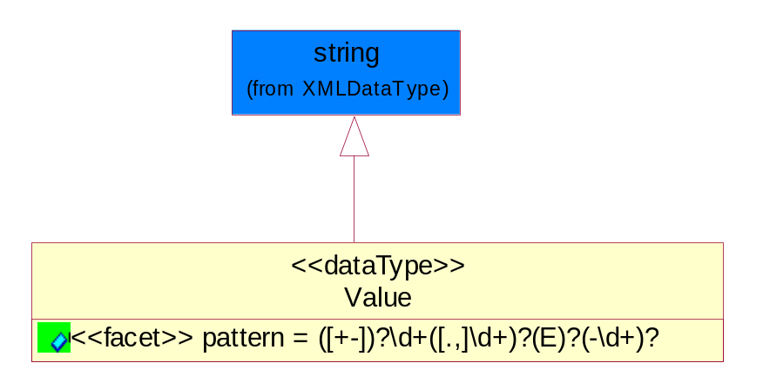
Figure ‎3-34 Value

Attribute | Type | Documentation
pattern |  | For reals, MAY have (+-) and then MUST have 1 or more digits, and then MUST have a period (or comma) and then MUST have or more digits.  For floating numbers, MAY have (+-) and then MUST have 1 or more digits, and then MUST have a period (or comma) and then MUST have or more digits and then MAY have 'E' and then MAY have (-) sign and then MAY have 1 or 2 digits.

CodeList

ActionCode
Code identifying the business action that must be performed on or with data. These codes will result in a subsequent action to the Material Composition data.
Name | Documentation
ADD | Add the business information to an information system.
CHG | The change request made accepted.
DEL | Delete the business infomation from an information system.
REQ | The business information accepted with change.
REV | Revise the business information from an information system.
UCH | Unchanged.

Level
This is to qualify the type of the product, material or substance mass either maximum, minimum, typical, nominal independently or with any combination such as when specifying range of mass between minimum and maximum. In this case, the mass reporting will loop and for each instance it will have different Level entry.
Name | Documentation
MAX | A Maximum level of the mass (weight) MUST be specified as KIG (kilogram) using ECTD/IEC/ISO Specification for the UOM field.
MIN | A Minimum level of the mass (weight) MUST be specified as KIG (kilogram) using ECTD/IEC/ISO Specification for the UOM field.
NOM | A Nominal level of the mass (weight) MUST be specified as KIG (kilogram) using ECTD/IEC/ISO Specification for the UOM field.
TYP | A Typical level of the mass (weight) MUST be specified as KIG (kilogram) using ECTD/IEC/ISO Specification for the UOM field.

Compliant
Describes the Directive Complaint level of a product, subpart or substance.
Name | Documentation
CEX | Compliant with exemptions.
CLE | Compliant with lead exemptions.
CMP | Compliant.
NCP | Not Compliant.
OBP | Obsolete part.
UNK | Unknown part.

Universal Structure

ContactInformation

ContactInformation
The business document must allow for the identification of the name of the department, service or individual to be contacted regarding the context of the business document.
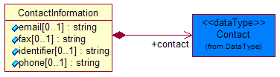
Figure ‎4-35 ContactInformation

Attribute | Type | Documentation
email[0..1] | string | The electronic mail for the specified contact.
fax[0..1] | string | The fax number for the specified contact.
identifier[0..1] | string | Identifies the role of the contact (i.e. Service Technician, Account Manager) in the Business Process.
phone[0..1] | string | The telephone number for the specified contact.

Composition | Cardinality | Type | Documentation
contact | 1 | Contact | The name of the department, service or individual to be contacted within the organization.

DataType

Contact
The name of the department, service or individual to be contacted within the organization.

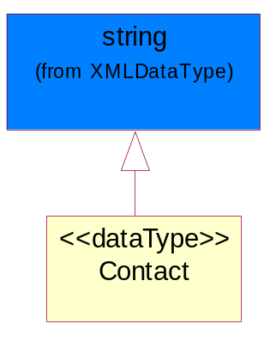
Figure ‎4-36 Contact

DUNS
A number assigned by Dun and Bradstreet to identify a business location.
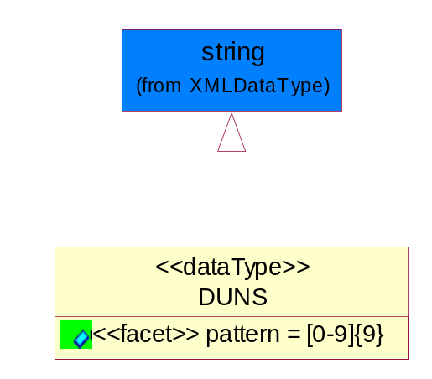
Figure ‎4-37 DUNS

Attribute | Type | Documentation
pattern |  | [0-9]{9}

DUNSPlus4
A identifier to specify a specific location within a business location.

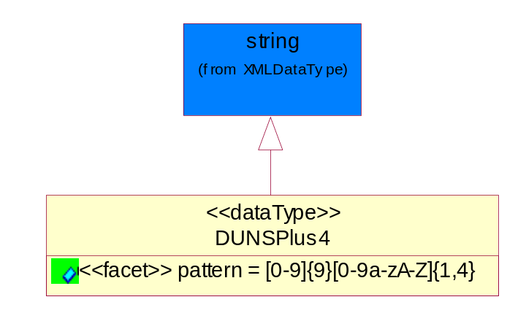
Figure ‎4-38 DUNSPlus4

Attribute | Type | Documentation
pattern |  | Data Universal Numbering System +4 (DUNS+4) number means the DUNS number assigned by Dun and Bradstreet, Inc. (D&B) plus an alphanumeric of length 4 suffix that may be assigned by a business concern.

GLN
Global Location Number (GLN) - A identifier to identify legal entities, trading parties and location.
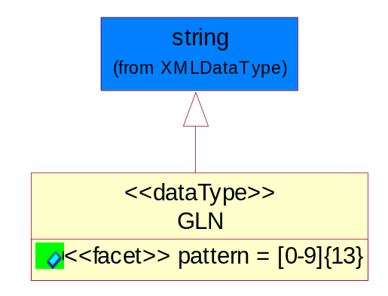
Figure ‎4-39 GLN

Attribute | Type | Documentation
pattern |  | [0-9]{13}

GTIN
Global Trade Identification Number (GTIN).
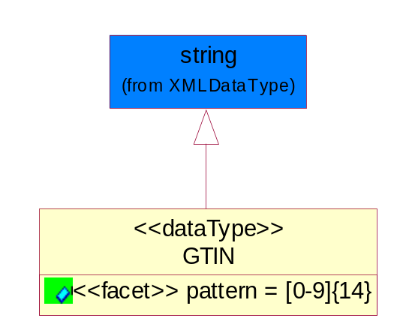
Figure ‎4-40 GTIN

Attribute | Type | Documentation
pattern |  | [0-9]{14}

PercentAmount
A number representing a percentage value, e.g. 75.125 represents 75 1/8 percent.
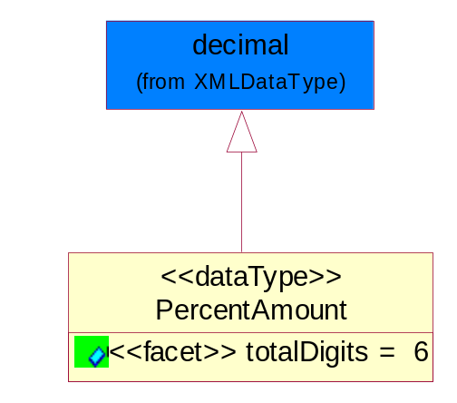
Figure ‎4-41 PercentAmount

Attribute | Type | Documentation
totalDigits |  | 6

Document

BusinessDocumentReference
The business document reference object allows for the indirect referencing of a relationship to other business related documents.
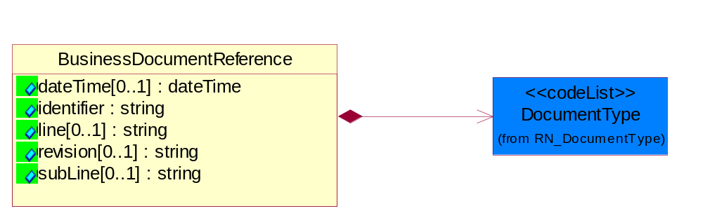
Figure ‎4-42 BusinessDocumentReference

Attribute | Type | Documentation
dateTime[0..1] | dateTime | The date-time stamp indicating on the referenced business document.
identifier | string | Unique identification of the referenced business document.
line[0..1] | string | References the specific line number of the specified business document.
revision[0..1] | string | Referenced the revision of the specified business document.
subLine[0..1] | string | References the specific subline number of the specified business document.

Composition | Cardinality | Type | Documentation
DocumentType | 1 | DocumentType | A code identifying the business context of a document.

Locations

AlternativeIdentifier
Identifies the specified code and the name of the organization that a code is utilized from.
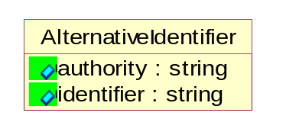

Figure ‎4-43 AlternativeIdentifier

Attribute | Type | Documentation
authority | string | The name of the organization that a code is utilized from.
identifier | string | The specified code to represent an entity (e.g. product, location, partner, etc.)

Location
The business document must specify a location.
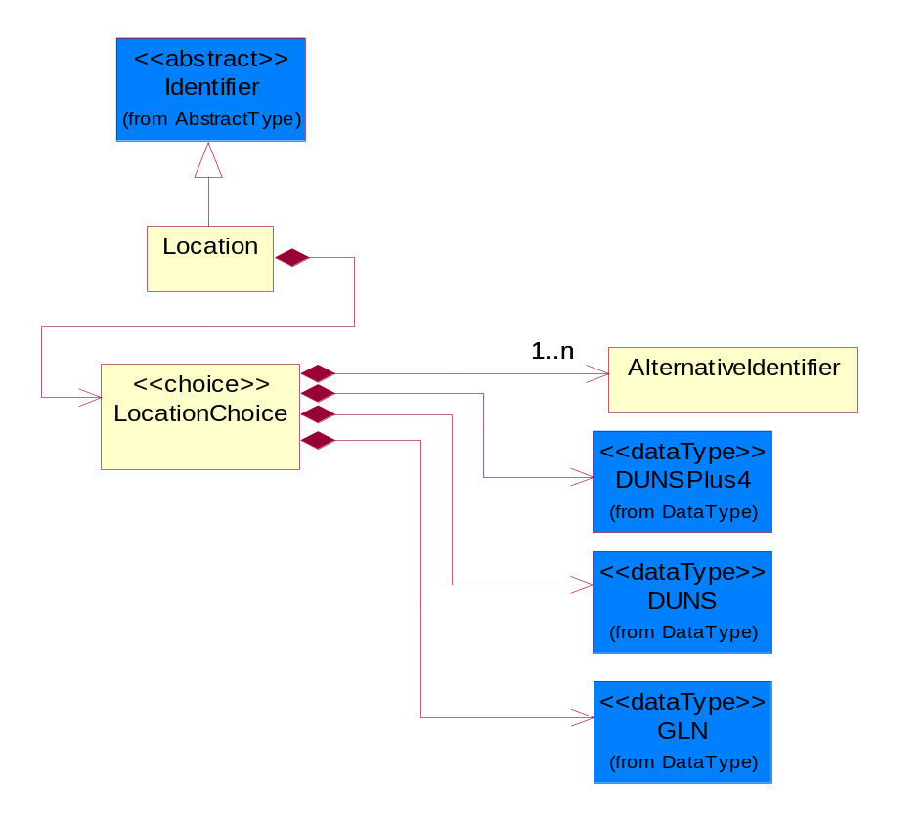
Figure ‎4-44 Location

Composition | Cardinality | Type | Documentation
LocationChoice | 1 | LocationChoice

LocationChoice

Composition | Cardinality | Type | Documentation
DUNSPlus4 | 1 | DUNSPlus4 | A identifier to specify a specific location within a business location.
DUNS | 1 | DUNS | A number assigned by Dun and Bradstreet to identify a business location.
AlternativeIdentifier | 1..n | AlternativeIdentifier | Identifies the specified code and the name of the organization that a code is utilized from.
GLN | 1 | GLN | Global Location Number (GLN) - A identifier to identify legal entities, trading parties and location.

PhysicalAddress
The business document must provide a physical address for a party to the business transaction.
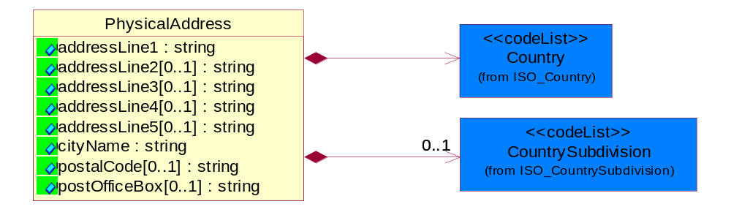
Figure ‎4-45 PhysicalAddress

Attribute | Type | Documentation
addressLine1 | string | The first line of a physical address.
addressLine2[0..1] | string | The second line of a physical address.
addressLine3[0..1] | string | The third line of a physical address.
addressLine4[0..1] | string | The fourth line of a physical address.
addressLine5[0..1] | string | The fifth line of a physical address.
cityName | string | The name of a city.
postalCode[0..1] | string | Identifying geographic location as specified by a national postal code.
postOfficeBox[0..1] | string | The Post Office Box identifier used to identify a party's post office box.

Composition | Cardinality | Type | Documentation
Country | 1 | Country | For representation of Country name RosettaNet has adopted ISO 3166-3; 1999. Refer to the following web page to get the latest version of the standard:  http://www.iso.ch/iso/en/prods-services/iso3166ma/02iso-3166-code-lists/index.html  If you need more information about the ISO standard please contact ISO for more details.
CountrySubdivision | 0..1 | CountrySubdivision | For representation of a Countries subdivisions RosettaNet has adopted ISO 3166-3; 1999. Refer to the following web page to get the latest version of the standard:  http://www.iso.ch/iso/en/prods-services/iso3166ma/02iso-3166-code-lists/index.html  If you need more information about the ISO standard please contact ISO for more details.

PartnerIdentification

FullPartner
The business document must describe the trading partners in the business transaction. This data structure provide the flexibility to describe a partner in all possible methods as for new, existing or known partner.
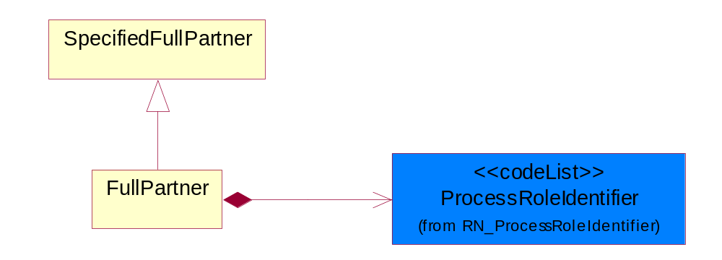
Figure ‎4-46 FullPartner

Composition | Cardinality | Type | Documentation
ProcessRoleIdentifier | 1 | ProcessRoleIdentifier | Describes the role of the partner in the business process. A partner will fulfill at least one or more roles during the business process.

KnownPartner
The business document must describe the trading partners in the business transaction.
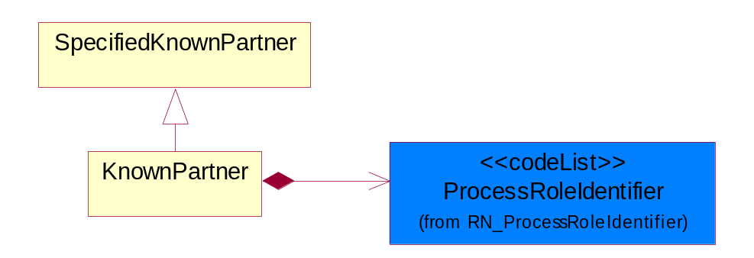
Figure ‎4-47 KnownPartner

Composition | Cardinality | Type | Documentation
ProcessRoleIdentifier | 1 | ProcessRoleIdentifier | Describes the role of the partner in the business process. A partner will fulfill at least one or more roles during the business process.

PartnerIdentification
The business document must allow for the identity of one or more parties to the transaction.
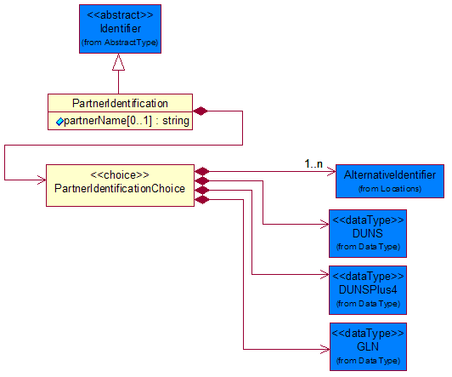
Figure ‎4-48 PartnerIdentification

Attribute | Type | Documentation
partnerName[0..1] | string | The name of the partner’s company/business.

Composition | Cardinality | Type | Documentation
PartnerIdentificationChoice | 1 | PartnerIdentificationChoice

PartnerIdentificationChoice

Composition | Cardinality | Type | Documentation
DUNS | 1 | DUNS | A number assigned by Dun and Bradstreet to identify a business location.
DUNSPlus4 | 1 | DUNSPlus4 | A identifier to specify a specific location within a business location.
AlternativeIdentifier | 1..n | AlternativeIdentifier | Identifies the specified code and the name of the organization that a code is utilized from.
GLN | 1 | GLN | Global Location Number (GLN) - A identifier to identify legal entities, trading parties and location.

SpecifiedFullPartner
The business document must describe the trading partners in the business transaction. This data structure provide the flexibility to describe a partner in all possible methods as for new, existing or known partner. This is specifically for partner who role has been specified.
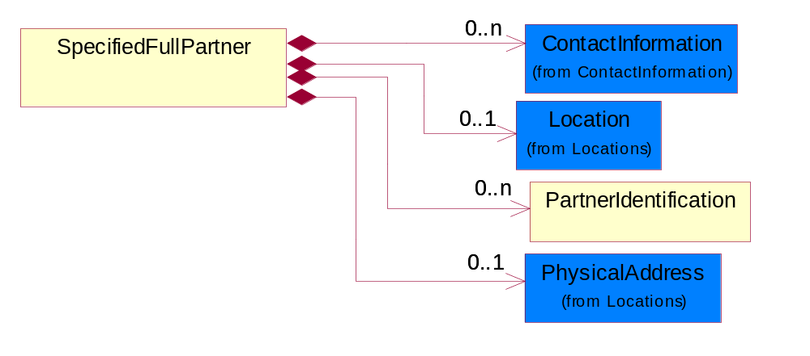
Figure ‎4-49 SpecifiedFullPartner

Composition | Cardinality | Type | Documentation
ContactInformation | 0..n | ContactInformation | The business document must allow for the identification of the name of the department, service or individual to be contacted regarding the context of the business document.
Location | 0..1 | Location | The business document must specify a location.
PartnerIdentification | 0..n | PartnerIdentification | The business document must allow for the identity of one or more parties to the transaction.
PhysicalAddress | 0..1 | PhysicalAddress | The business document must provide a physical address for a party to the business transaction.

SpecifiedKnownPartner
The business document must describe the trading partners in the business transaction.
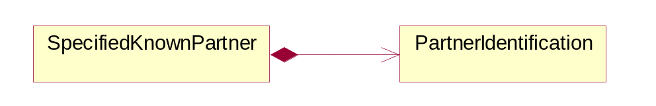
Figure ‎4-50 SpecifiedKnownPartner

Composition | Cardinality | Type | Documentation
PartnerIdentification | 1 | PartnerIdentification | The business document must allow for the identity of one or more parties to the transaction.

ProductIdentification

ProductDescription
The business document must allow for the identification of the product and multiple textual descriptions of a product.
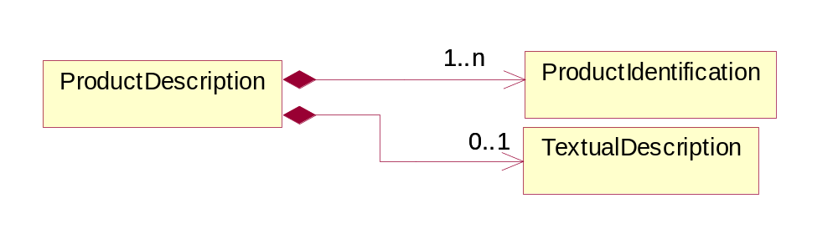
Figure ‎4-51 ProductDescription

Composition | Cardinality | Type | Documentation
ProductIdentification | 1..n | ProductIdentification | The object provides the identifier(s) of a product.
TextualDescription | 0..1 | TextualDescription | The business document must allow for multiple levels of textual description of an event or object.

ProductIdentification
The object provides the identifier(s) of a product.
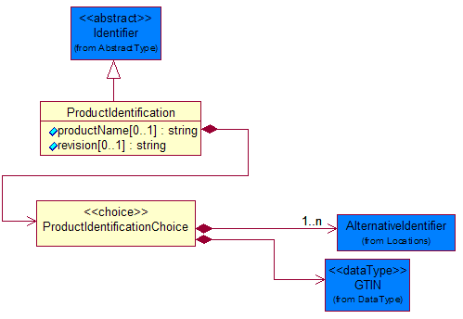
Figure ‎4-52 ProductIdentification

Attribute | Type | Documentation
productName[0..1] | string | The name of the product.
revision[0..1] | string | Referenced the specified product revision.

Composition | Cardinality | Type | Documentation
ProductIdentificationChoice | 1 | ProductIdentificationChoice

ProductIdentificationChoice

Composition | Cardinality | Type | Documentation
AlternativeIdentifier | 1..n | AlternativeIdentifier | Identifies the specified code and the name of the organization that a code is utilized from.
GTIN | 1 | GTIN | Global Trade Identification Number (GTIN).

TextualDescription
The business document must allow for multiple levels of textual description of an event or object.
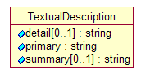
Figure ‎4-53 TextualDescription

Attribute | Type | Documentation
detail[0..1] | string | A detail description of an event or object.
primary | string | A phrase or single word description of an event or object.
summary[0..1] | string | A condensed description of an event or object.

CodeList

Country
For representation of Country name RosettaNet has adopted ISO 3166-3; 1999. Refer to the following web page to get the latest version of the standard:
http://www.iso.ch/iso/en/prods-services/iso3166ma/02iso-3166-code-lists/index.html

If you need more information about the ISO standard please contact ISO for more details.

CountrySubdivision
For representation of a Countries subdivisions RosettaNet has adopted ISO 3166-3; 1999. Refer to the following web page to get the latest version of the standard:
http://www.iso.ch/iso/en/prods-services/iso3166ma/02iso-3166-code-lists/index.html

If you need more information about the ISO standard please contact ISO for more details.

Language
For representation of Language name RosettaNet has adopted ISO 639-2; 1998. Refer to the following web page to get the latest version of the standard:

http://www.loc.gov/standards/iso639-2/iso639jac.html

If you need more information about the ISO standard please contact ISO for more details.

DocumentType
A code identifying the business context of a document.
Instance | Documentation
CBN | Product batch number of customer.
CCN | Customs clearance number.
CFA | Failure Analysis - Request document that will accompany the product providing characteristics of the component failure.
CIN | Commercial Invoice.
CNM | Traditional credit note or memo.
CON | In a virtual sourcing relationship, a third party trading partner is supplying a part to a customer on behalf of another company that has taken the order for the customer. In this case a Customer Order Number is associated to the request for material that is sent to the virtual trading partners.
COT | Contract.
CRN | Unique consumption reference number identifying the product consumption issue i.e. one-to-one relationship with physical flow.
DEM | Traditional debit note or memo.
DEN | Delivery Note.
DIN | Discontinuation Notice.
DRN | Drawing Number.
FUO | Sales order or transfer order fulfilling demand out of a facility (outbound shipment).
INV | Invoice.
LID | Location Identifier. Data for on-site work that have to be done on the machine (associated with preventive maintenance order)
MEN | Master Event Number.
MID | Machine Identifier. Data for on-site work that have to be done on the machine (associated with preventive maintenance order)
MON | Model Number.
OCL | The unique identifier assigned by the OEM for a warranty claim.
OGA | Other governmental agency issued document.
OPO | The unique identifier assigned by the OEM for a part order.
OPR | The unique identifier assigned by the OEM for a part return.
PFA | Failure Analysis - Request document that will accompany the product providing characteristics of the product failure.
PII | Refers to previously issued invoice.
PLS | Unique number that identifies packing form prior to shipment.
POI | Purchase Order IN.
PON | Production order number for material release.
POO | Purchase Order OUT
PRC | Product Catalog.
PSI | Refers to previously issued self-billing invoice.
PUO | Purchase Order.
QUO | Quote.
REC | Document identifying the receipt of materials or products into a facility against a purchase order or transfer order (inbound shipment).
REO | Purchase order or transfer order replenishing inventory into a facility (inbound shipment).
REQ | Requisition.
RMA | Returned Material Authorization.
RPO | Purchase order for materials or product returned to and reworked by a supplier.
RTA | Remittance Advice - Remittance details.
SAO | Sales Order.
SBC | Credit Memo used in self-billing scenario.
SBD | Debit Memo used in self-billing scenario.
SBI | Invoice in self billing scenario.
SBN | Product batch number of supplier.
SCA | Similar to contracts - Contains the quantity of an article that is to be ordered from a vendor and the price for article or service that is to be procured.
SEN | Serial Number.
SEO | A document that gives a repair provider the necessary authorization to repair or upgrade a product either at the customer site or at the repair provider’s site.
SHD | Shipping Document.
SNC | Shipset Number on Code List.
SPC | The unique identifier assigned by the ASP for a warranty claim.
SPN | Spec Number.
SPO | The unique identifier assigned by the ASP for a part order.
SPR | The unique identifier assigned by the ASP for a part return.
SPW | The unique identifier assigned by the ASP to reference a work order.
SRI | A document that contains the shipping reference number which allows the product to be tracked within the outsourced logistic providers network.
TRO | Order which results in materials or products being moved from one facility to another (outbound shipment and inbound shipment).
WAB | Waybill.
WAC | Denotes a warranty claim.
WOO | Work Order.

MimeTypeQualifier
The MIME type as defined by IANA.

Please refer to http://www.iana.org/assignments/media-types/ for a list of types.
Instance | Documentation
application/activemessage | [Shapiro]
application/andrew-inset | [Borenstein]
application/applefile | [Faltstrom]
application/atomicmail | [Borenstein]
application/batch-SMTP | [RFC2442]
application/beep+xml | [RFC3080]
application/cals-1840 | [RFC1895]
application/cnrp+xml | [RFCCNRP]
application/commonground | [Glazer]
application/cpl+xml
application/cybercash | [Eastlake]
application/dca-rft | [Campbell]
application/dec-dx | [Campbell]
application/dicom | [RFC3240]
application/dvcs | [RFC3029]
application/EDI-Consent | [RFC1767]
application/EDIFACT | [RFC1767]
application/EDI-X12 | [RFC1767]
application/eshop | [Katz]
application/font-tdpfr | [RFC3073]
application/http | [RFC2616]
application/hyperstudio | [Domino]
application/iges | [Parks]
application/index | [RFC2652]
application/index.cmd | [RFC2652]
application/index.obj | [RFC2652]
application/index.response | [RFC2652]
application/index.vnd | [RFC2652]
application/iotp | [RFC2935]
application/ipp | [RFC2910]
application/isup | [RFC3204]
application/mac-binhex40 | [Faltstrom]
application/macwriteii | [Lindner]
application/marc | [RFC2220]
application/mathematica | [Van Nostern]
application/msword | [Lindner]
application/news-message-id | [RFC1036,Spencer]
application/news-transmission | [RFC1036, Spencer]
application/ocsp-request | [RFC2560]
application/ocsp-response | [RFC2560]
application/octet-stream | [RFC2045,RFC2046]
application/oda | [RFC2045,RFC2046]
application/ogg | [RFC-walleij-ogg-mediatype-08.txt]
application/parityfec | [RFC3009]
application/pdf | [Lindner]
application/pgp-encrypted | [RFC3156]
application/pgp-keys | [RFC3156]
application/pgp-signature | [RFC3156]
application/pkcs10 | [RFC2311]
application/pkcs7-mime | [RFC2311]
application/pkcs7-signature | [RFC2311]
application/pkix-cert | [RFC2585]
application/pkixcmp | [RFC2510]
application/pkix-crl | [RFC2585]
application/postscript | [RFC2045,RFC2046]
application/prs.alvestrand.titrax-sheet | [Alvestrand]
application/prs.cww | [Rungchavalnont]
application/prs.nprend | [Doggett]
application/prs.plucker | [Janssen]
application/qsig | [RFC3204]
application/reginfo+xml | [RFC-ietf-sipping-reg-event-00.txt]
application/remote-printing | [RFC1486,Rose]
application/riscos | [Smith]
application/rtf | [Lindner]
application/sdp | [RFC2327]
application/set-payment | [Korver]
application/set-payment-initiation | [Korver]
application/set-registration | [Korver]
application/set-registration-initiation | [Korver]
application/sgml | [RFC1874]
application/sgml-open-catalog | [Grosso]
application/sieve | [RFC3028]
application/slate | [Crowley]
application/timestamp-query | [RFC3161]
application/timestamp-reply | [RFC3161]
application/tve-trigger | [Welsh]
application/vemmi | [RFC2122]
application/vnd.3gpp.pic-bw-large | [Meredith]
application/vnd.3gpp.pic-bw-small | [Meredith]
application/vnd.3gpp.pic-bw-var | [Meredith]
application/vnd.3gpp.sms | [Meredith]
application/vnd.3M.Post-it-Notes | [O'Brien]
application/vnd.accpac.simply.aso | [Leow]
application/vnd.accpac.simply.imp | [Leow]
application/vnd.acucobol | [Lubin]
application/vnd.acucorp | [Lubin]
application/vnd.adobe.xfdf | [Perelman]
application/vnd.aether.imp | [Moskowitz]
application/vnd.amiga.ami | [Blumberg]
application/vnd.anser-web-certificate-issue-initiation | [Mori]
application/vnd.anser-web-funds-transfer-initiation | [Mori]
application/vnd.audiograph | [Slusanschi]
application/vnd.blueice.multipass | [Holmstrom]
application/vnd.bmi | [Gotoh]
application/vnd.businessobjects | [Imoucha]
application/vnd.canon-cpdl | [Muto]
application/vnd.canon-lips | [Muto]
application/vnd.cinderella | [Kortenkamp]
application/vnd.claymore | [Simpson]
application/vnd.commerce-battelle | [Applebaum]
application/vnd.commonspace | [Chandhok]
application/vnd.contact.cmsg | [Patz]
application/vnd.cosmocaller | [Dellutri]
application/vnd.ctc-posml | [Kohlhepp]
application/vnd.cups-postscript | [Sweet]
application/vnd.cups-raster | [Sweet]
application/vnd.cups-raw | [Sweet]
application/vnd.curl | [Byrnes]
application/vnd.cybank | [Helmee]
application/vnd.data-vision.rdz | [Fields]
application/vnd.dna | [Searcy]
application/vnd.dpgraph | [Parker]
application/vnd.dreamfactory | [Appleton]
application/vnd.dxr | [Duffy]
application/vnd.ecdis-update | [Buettgenbach]
application/vnd.ecowin.chart | [Olsson]
application/vnd.ecowin.filerequest | [Olsson]
application/vnd.ecowin.fileupdate | [Olsson]
application/vnd.ecowin.series | [Olsson]
application/vnd.ecowin.seriesrequest | [Olsson]
application/vnd.ecowin.seriesupdate | [Olsson]
application/vnd.enliven | [Santinelli]
application/vnd.epson.esf | [Hoshina]
application/vnd.epson.msf | [Hoshina]
application/vnd.epson.quickanime | [Gu]
application/vnd.epson.salt | [Nagatomo]
application/vnd.epson.ssf | [Hoshina]
application/vnd.ericsson.quickcall | [Tidwell]
application/vnd.eudora.data | [Resnick]
application/vnd.fdf | [Zilles]
application/vnd.ffsns | [Holstage]
application/vnd.FloGraphIt | [Floersch]
application/vnd.framemaker | [Wexler]
application/vnd.fsc.weblaunch | [D.Smith]
application/vnd.fujitsu.oasys | [Togashi]
application/vnd.fujitsu.oasys2 | [Togashi]
application/vnd.fujitsu.oasys3 | [Okudaira]
application/vnd.fujitsu.oasysgp | [Sugimoto]
application/vnd.fujitsu.oasysprs | [Ogita]
application/vnd.fujixerox.ddd | [Onda]
application/vnd.fujixerox.docuworks | [Taguchi]
application/vnd.fujixerox.docuworks.binder | [Matsumoto]
application/vnd.fut-misnet | [Pruulmann]
application/vnd.grafeq | [Tupper]
application/vnd.groove-account | [Joseph]
application/vnd.groove-help | [Joseph]
application/vnd.groove-identity-message | [Joseph]
application/vnd.groove-injector | [Joseph]
application/vnd.groove-tool-message | [Joseph]
application/vnd.groove-tool-template | [Joseph]
application/vnd.groove-vcard | [Joseph]
application/vnd.hbci | [Hammann]
application/vnd.hhe.lesson-player | [Jones]
application/vnd.hp-HPGL | [Pentecost]
application/vnd.hp-hpid | [Gupta]
application/vnd.hp-hps | [Aubrey]
application/vnd.hp-PCL | [Pentecost]
application/vnd.hp-PCLXL | [Pentecost]
application/vnd.httphone | [Lefevre]
application/vnd.hzn-3d-crossword | [Minnis]
application/vnd.ibm.afplinedata | [Buis]
application/vnd.ibm.electronic-media | [Tantlinger]
application/vnd.ibm.MiniPay | [Herzberg]
application/vnd.ibm.modcap | [Hohensee]
application/vnd.ibm.secure-container | [Tantlinger]
application/vnd.informix-visionary | [Gales]
application/vnd.intercon.formnet | [Gurak]
application/vnd.intertrust.digibox | [Tomasello]
application/vnd.intertrust.nncp | [Tomasello]
application/vnd.intu.qbo | [Scratchley]
application/vnd.intu.qfx | [Scratchley]
application/vnd.irepository.package+xml | [Knowles]
application/vnd.is-xpr | [Natarajan]
application/vnd.japannet-directory-service | [Fujii]
application/vnd.japannet-jpnstore-wakeup | [Yoshitake]
application/vnd.japannet-payment-wakeup | [Fujii]
application/vnd.japannet-registration | [Yoshitake]
application/vnd.japannet-registration-wakeup | [Fujii]
application/vnd.japannet-setstore-wakeup | [Yoshitake]
application/vnd.japannet-verification | [Yoshitake]
application/vnd.japannet-verification-wakeup | [Fujii]
application/vnd.jisp | [Deckers]
application/vnd.kde.karbon | [Faure]
application/vnd.kde.kchart | [Faure]
application/vnd.kde.kformula | [Faure]
application/vnd.kde.kivio | [Faure]
application/vnd.kde.kontour | [Faure]
application/vnd.kde.kpresenter | [Faure]
application/vnd.kde.kspread | [Faure]
application/vnd.kde.kword | [Faure]
application/vnd.kenameaapp | [DiGiorgio-Haag]
application/vnd.koan | [Cole]
application/vnd.liberty-request+xml | [McDowell]
application/vnd.llamagraphics.life-balance.desktop | [White]
application/vnd.lotus-1-2-3 | [Wattenberger]
application/vnd.lotus-approach | [Wattenberger]
application/vnd.lotus-freelance | [Wattenberger]
application/vnd.lotus-notes | [Laramie]
application/vnd.lotus-organizer | [Wattenberger]
application/vnd.lotus-screencam | [Wattenberger]
application/vnd.lotus-wordpro | [Wattenberger]
application/vnd.mcd | [Gotoh]
application/vnd.mediastation.cdkey | [Flurry]
application/vnd.meridian-slingshot | [Wedel]
application/vnd.micrografx.flo | [Prevo]
application/vnd.micrografx.igx | [Prevo]
application/vnd.mif | [Wexler]
application/vnd.minisoft-hp3000-save | [Bartram]
application/vnd.mitsubishi.misty-guard.trustweb | [Tanaka]
application/vnd.Mobius.DAF | [Kabayama]
application/vnd.Mobius.DIS | [Kabayama]
application/vnd.Mobius.MBK | [Devasia]
application/vnd.Mobius.MQY | [Devasia]
application/vnd.Mobius.MSL | [Kabayama]
application/vnd.Mobius.PLC | [Kabayama]
application/vnd.Mobius.TXF | [Kabayama]
application/vnd.mophun.application | [Wennerstrom]
application/vnd.mophun.certificate | [Wennerstrom]
application/vnd.motorola.flexsuite | [Patton]
application/vnd.motorola.flexsuite.adsi | [Patton]
application/vnd.motorola.flexsuite.fis | [Patton]
application/vnd.motorola.flexsuite.gotap | [Patton]
application/vnd.motorola.flexsuite.kmr | [Patton]
application/vnd.motorola.flexsuite.ttc | [Patton]
application/vnd.motorola.flexsuite.wem | [Patton]
application/vnd.mozilla.xul+xml | [McDaniel]
application/vnd.ms-artgalry | [Slawson]
application/vnd.ms-asf | [Fleischman]
application/vnd.mseq | [Le Bodic]
application/vnd.ms-excel | [Gill]
application/vnd.msign | [Borcherding]
application/vnd.ms-lrm | [Ledoux]
application/vnd.ms-powerpoint | [Gill]
application/vnd.ms-project | [Gill]
application/vnd.ms-tnef | [Gill]
application/vnd.ms-works | [Gill]
application/vnd.ms-wpl | [Plastina]
application/vnd.musician | [Adams]
application/vnd.music-niff | [Butler]
application/vnd.netfpx | [Mutz]
application/vnd.noblenet-directory | [Solomon]
application/vnd.noblenet-sealer | [Solomon]
application/vnd.noblenet-web | [Solomon]
application/vnd.novadigm.EDM | [Swenson]
application/vnd.novadigm.EDX | [Swenson]
application/vnd.novadigm.EXT | [Swenson]
application/vnd.obn | [Hessling]
application/vnd.osa.netdeploy | [Klos]
application/vnd.palm | [Peacock]
application/vnd.pg.format | [Gandert]
application/vnd.pg.osasli | [Gandert]
application/vnd.powerbuilder6 | [Guy]
application/vnd.powerbuilder6-s | [Guy]
application/vnd.powerbuilder7 | [Shilts]
application/vnd.powerbuilder75 | [Shilts]
application/vnd.powerbuilder75-s | [Shilts]
application/vnd.powerbuilder7-s | [Shilts]
application/vnd.previewsystems.box | [Smolgovsky]
application/vnd.publishare-delta-tree | [Ben-Kiki]
application/vnd.pvi.ptid1 | [Lamb]
application/vnd.pwg-multiplexed | [RFC3391]
application/vnd.pwg-xhtml-print+xml | [Wright]
application/vnd.Quark.QuarkXPress | [Scheidler]
application/vnd.rapid | [Szekely]
application/vnd.s3sms | [Tarkkala]
application/vnd.sealed.net | [Lambert]
application/vnd.seemail | [Webb]
application/vnd.shana.informed.formdata | [Selzler]
application/vnd.shana.informed.formtemplate | [Selzler]
application/vnd.shana.informed.interchange | [Selzler]
application/vnd.shana.informed.package | [Selzler]
application/vnd.smaf | [Takahashi]
application/vnd.sss-cod | [Dani]
application/vnd.sss-dtf | [Bruno]
application/vnd.sss-ntf | [Bruno]
application/vnd.street-stream | [Levitt]
application/vnd.svd | [Becker]
application/vnd.swiftview-ics | [Widener]
application/vnd.triscape.mxs | [Simonoff]
application/vnd.trueapp | [Hepler]
application/vnd.truedoc | [Chase]
application/vnd.ufdl | [Manning]
application/vnd.uplanet.alert | [Martin]
application/vnd.uplanet.alert-wbxml | [Martin]
application/vnd.uplanet.bearer-choice | [Martin]
application/vnd.uplanet.bearer-choice-wbxml | [Martin]
application/vnd.uplanet.cacheop | [Martin]
application/vnd.uplanet.cacheop-wbxml | [Martin]
application/vnd.uplanet.channel | [Martin]
application/vnd.uplanet.channel-wbxml | [Martin]
application/vnd.uplanet.list | [Martin]
application/vnd.uplanet.listcmd | [Martin]
application/vnd.uplanet.listcmd-wbxml | [Martin]
application/vnd.uplanet.list-wbxml | [Martin]
application/vnd.uplanet.signal | [Martin]
application/vnd.vcx | [T.Sugimoto]
application/vnd.vectorworks | [Pharr]
application/vnd.vidsoft.vidconference | [Hess]
application/vnd.visio | [Sandal]
application/vnd.visionary | [Aravindakumar]
application/vnd.vividence.scriptfile | [Risher]
application/vnd.vsf | [Rowe]
application/vnd.wap.sic | [WAP-Forum]
application/vnd.wap.slc | [WAP-Forum]
application/vnd.wap.wbxml | [Stark]
application/vnd.wap.wmlc | [Stark]
application/vnd.wap.wmlscriptc | [Stark]
application/vnd.webturbo | [Rehem]
application/vnd.wrq-hp3000-labelled | [Bartram]
application/vnd.wt.stf | [Wohler]
application/vnd.wv.csp+wbxml | [Salmi]
application/vnd.xara | [Matthewman]
application/vnd.xfdl | [Manning]
application/vnd.yellowriver-custom-menu | [Yellow]
application/whoispp-query | [RFC2957]
application/whoispp-response | [RFC2958]
application/wita | [Campbell]
application/wordperfect5.1 | [Lindner]
application/x400-bp | [RFC1494]
application/xhtml+xml | [RFC3236]
application/xml | [RFC3023]
application/xml-dtd | [RFC3023]
application/xml-external-parsed-entity | [RFC3023]
application/zip | [Lindner]
audio/32kadpcm | [RFC2421,RFC2422]
audio/AMR | [RFC3267]
audio/AMR-WB | [RFC3267]
audio/basic | [RFC2045,RFC2046]
audio/CN | [RFC3389]
audio/DAT12 | [RFC3190]
audio/DVI4
audio/EVRC | [RFC-ietf-avt-evrc-smv-03.txt]
audio/EVRC0 | [RFC-ietf-avt-evrc-smv-03.txt]
audio/G.722.1 | [RFC3047]
audio/G722
audio/G723
audio/G726-16
audio/G726-24
audio/G726-32
audio/G726-40
audio/G728
audio/G729
audio/G729D
audio/G729E
audio/GSM
audio/GSM-EFR
audio/L16 | [RFC2586]
audio/L20 | [RFC3190]
audio/L24 | [RFC3190]
audio/L8
audio/LPC
audio/MP4A-LATM | [RFC3016]
audio/MPA
audio/mpa-robust | [RFC3119]
audio/mpeg | [RFC3003]
audio/parityfec | [RFC3009]
audio/PCMA
audio/PCMU
audio/prs.sid | [Walleij]
audio/QCELP
audio/RED
audio/SMV | [RFC-ietf-avt-evrc-smv-03.txt]
audio/SMV0 | [RFC-ietf-avt-evrc-smv-03.txt]
audio/telephone-event | [RFC2833]
audio/tone | [RFC2833]
audio/VDVI
audio/vnd.3gpp.iufp | [Belling]
audio/vnd.cisco.nse | [Kumar]
audio/vnd.cns.anp1 | [McLaughlin]
audio/vnd.cns.inf1 | [McLaughlin]
audio/vnd.digital-winds | [Strazds]
audio/vnd.everad.plj | [Cicelsky]
audio/vnd.lucent.voice | [Vaudreuil]
audio/vnd.nortel.vbk | [Parsons]
audio/vnd.nuera.ecelp4800 | [Fox]
audio/vnd.nuera.ecelp7470 | [Fox]
audio/vnd.nuera.ecelp9600 | [Fox]
audio/vnd.octel.sbc | [Vaudreuil]
audio/vnd.qcelp | [Lundblade]
audio/vnd.rhetorex.32kadpcm | [Vaudreuil]
audio/vnd.vmx.cvsd | [Vaudreuil]
image/cgm | Computer Graphics Metafile
image/g3fax | [RFC1494]
image/gif | [RFC2045,RFC2046]
image/ief | [RFC1314] Image Exchange Format
image/jpeg | [RFC2045,RFC2046]
image/naplps | [Ferber]
image/png | [Randers-Pehrson]
image/prs.btif | [Simon]
image/prs.pti | [Laun]
image/t38 | [RFC3362]
image/tiff | [RFC3302] Tag Image File Format
image/tiff-fx | [RFC3250] Tag Image File Format Fax eXtended
image/vnd.cns.inf2 | [McLaughlin]
image/vnd.djvu | [Bottou]
image/vnd.dwg | [Moline]
image/vnd.dxf | [Moline]
image/vnd.fastbidsheet | [Becker]
image/vnd.fpx | [Spencer]
image/vnd.fst | [Fuldseth]
image/vnd.fujixerox.edmics-mmr | [Onda]
image/vnd.fujixerox.edmics-rlc | [Onda]
image/vnd.globalgraphics.pgb | [Bailey]
image/vnd.mix | [Reddy]
image/vnd.ms-modi | [Vaughan]
image/vnd.net-fpx | [Spencer]
image/vnd.svf | [Moline]
image/vnd.wap.wbmp | [Stark]
image/vnd.xiff | [S.Martin]
message/delivery-status | [RFC1894]
message/disposition-notification | [RFC2298]
message/external-body | [RFC2045,RFC2046]
message/http | [RFC2616]
message/news | [RFC 1036, H.Spencer]
message/partial | [RFC2045,RFC2046]
message/rfc822 | [RFC2045,RFC2046]
message/s-http | [RFC2660]
message/sip | [RFC3261]
message/sipfrag | [RFC3420]
model/iges | [Parks]
model/mesh | [RFC2077]
model/vnd.dwf | [Pratt]
model/vnd.flatland.3dml | [Powers]
model/vnd.gdl | [Babits]
model/vnd.gs-gdl | [Babits]
model/vnd.gtw | [Ozaki]
model/vnd.mts | [Rabinovitch]
model/vnd.parasolid.transmit.binary | [Parasolid]
model/vnd.parasolid.transmit.text | [Parasolid]
model/vnd.vtu | [Rabinovitch]
model/vrml | [RFC2077]
multipart/alternative | [RFC2045,RFC2046]
multipart/appledouble | [Faltstrom]
multipart/byteranges | [RFC2068]
multipart/digest | [RFC2045,RFC2046]
multipart/encrypted | [RFC1847]
multipart/form-data | [RFC2388]
multipart/header-set | [Crocker]
multipart/mixed | [RFC2045,RFC2046]
multipart/parallel | [RFC2045,RFC2046]
multipart/related | [RFC2387]
multipart/report | [RFC1892]
multipart/signed | [RFC1847]
multipart/voice-message | [RFC2421,RFC2423]
text/calendar | [RFC2445]
text/css | [RFC2318]
text/directory | [RFC2425]
text/enriched | [RFC1896]
text/html | [RFC2854]
text/parityfec | [RFC3009]
text/plain | [RFC2646,RFC2046]
text/prs.lines.tag | [Lines]
text/rfc822-headers | [RFC1892]
text/richtext | [RFC2045,RFC2046]
text/rtf | [Lindner]
text/sgml | [RFC1874]
text/t140 | [RFC2793]
text/tab-separated-values | [Lindner]
text/uri-list | [RFC2483]
text/vnd.abc | [Allen]
text/vnd.curl | [Byrnes]
text/vnd.DMClientScript | [Bradley]
text/vnd.fly | [Gurney]
text/vnd.fmi.flexstor | [Hurtta]
text/vnd.in3d.3dml | [Powers]
text/vnd.in3d.spot | [Powers]
text/vnd.IPTC.NewsML | [IPTC]
text/vnd.IPTC.NITF | [IPTC]
text/vnd.latex-z | [Lubos]
text/vnd.motorola.reflex | [Patton]
text/vnd.ms-mediapackage | [Nelson]
text/vnd.net2phone.commcenter.command | [Xie]
text/vnd.sun.j2me.app-descriptor | [G.Adams]
text/vnd.wap.si | [WAP-Forum]
text/vnd.wap.sl | [WAP-Forum]
text/vnd.wap.wml | [Stark]
text/vnd.wap.wmlscript | [Stark]
text/xml | [RFC3023]
text/xml-external-parsed-entity | [RFC3023]
video/BMPEG
video/BT656
video/CelB
video/DV | [RFC3189]
video/H261
video/H263
video/H263-1998
video/H263-2000
video/JPEG
video/MP1S
video/MP2P
video/MP2T
video/MP4V-ES | [RFC3016]
video/mpeg | [RFC2045,RFC2046]
video/MPV
video/nv
video/parityfec | [RFC3009]
video/pointer | [RFC2862]
video/quicktime | [Lindner]
video/SMPTE292M | [RFC-avt-smpte292-video-08.txt]
video/vnd.fvt | [Fuldseth]
video/vnd.motorola.video | [McGinty]
video/vnd.motorola.videop | [McGinty]
video/vnd.mpegurl | [Recktenwald]
video/vnd.nokia.interleaved-multimedia | [Kangaslampi]
video/vnd.objectvideo | [Clark]
video/vnd.vivo | [Wolfe]

UnitOfMeasure
Code identifying a product unit of measure.
Instance | Documentation
10P | 10-pack.
1BF | 100 Board Feet.
1FC | 20 Foot Container.
1GR | Gram/Cubic Centimeter.
1GT | 10,000 Gallon Tankcar.
1KB | 25 Kilogram Bulk Bag.
1KD | 10 Kilogram Drum.
1KP | 1000-pack.
1PA | 20-Pack.
1PB | 50 Pound Bag.
1PD | 100 Pound Drum.
2FC | 40 Foot Container.
2GR | Gram/square meter.
2GT | 20,000 Gallon Tankcar.
2KB | 300 Kilogram Bulk Bag.
2KD | 15 Kilogram Drum.
2PA | 100-Pack.
3GR | Grams Per 100 Centimeters.
3KB | 500 Kilogram Bulk Bag.
3KD | 55 Gallon Drum.
4GR | Grams Per 100 Grams.
4KD | 115 Kilogram Drum.
50P | 50-pack.
5GR | Grams Per Cubic Centimeter.
6GR | Grams Per Square Centimeter.
7GR | Grams Per Square Meter.
ACR | Acre.
ACT | Actual Pounds.
ALU | Aluminum Pounds Only.
AMP | Ampere.
ASM | Angstrom.
BAB | Base Box.
BAC | Batch.
BAE | Bale.
BAG | Bag.
BAL | Ball.
BAN | Band.
BAP | Batting Pound.
BAR | Bar.
BAS | Basket.
BAT | Batt.
BAW | Base Weight.
BEA | Beam.
BEC | Becquerel/kilogram.
BEL | Belt.
BIL | Billet.
BIN | Bin.
BIT | Bit.
BKC | Bulk Car Load.
BLO | Block.
BOA | Board.
BOF | Board Feet.
BOL | Bolt.
BOT | Bottle.
BOX | Box.
BRD | Barrels Per Day.
BRE | Barrel.
BRI | Barrel (Imperial).
BRM | Barrels Per Minute.
BTF | British Thermal Units (BTUs) Per Cubic Foot.
BTP | British Thermal Units (BTUs) Per Pound.
BTU | British Thermal Unit (BTU).
BUC | Bucket.
BUD | Bushel, Dry Imperial.
BUK | Bunks.
BUL | Bulk.
BUN | Bundle.
BUP | Bulk Pack.
BUS | Bushel.
BYT | Bytes.
CAA | Carat.
CAB | Carboy.
CAC | Card.
CAD | Candela.
CAG | Cartridge.
CAK | Cask.
CAL | Calorie.
CAN | Can.
CAO | Carload.
CAR | Car.
CAS | Case.
CAT | Canister.
CAW | Catchweight.
CEL | Cell.
CEM | Centimeter.
CEP | Centipoise (CPS).
CET | Centiliter.
CGM | Centigram.
CHA | Chains (Land Survey).
CHE | Chest.
CNN | Connector.
COG | Coil Group.
COI | Coil.
COL | Coulomb.
COM | Composite Product Pounds (Total Weight).
CON | Cone.
COT | Container.
COV | Cover.
CRA | Crate.
CRT | Carton.
CSE | Cassette.
CUB | Cubic centimeter.
CUC | Cubic centimeter/second.
CUF | Cubic Foot.
CUI | Cubic inch.
CUM | Cubicmeter.
CUP | Cup.
CUY | Cubic yard.
CYC | Cycles.
CYL | Cylinder.
DAY | Day.
DCB | Decibels.
DCG | Decagram.
DCL | Deciliter.
DEA | Deal.
DEC | Decimeter.
DEF | Degree Fahrenheit.
DEG | Degree Celsius.
DEP | Dep. Factor.
DGM | Decigram.
DIE | Die.
DIL | Display.
DIP | Dispenser.
DOZ | Dozen.
DRA | Dram.
DRU | Drum.
DRY | Dry Pounds.
EAC | Each.
ELE | Electrical Capacitance.
FAR | Farads.
FFA | Femtofarad.
FLO | Fluid Ounce.
FOI | Fluid Ounce (Imperial).
FOO | Foot.
FOU | Fluid Ounce US.
FUU | Fuel Usage (Gallons).
GAL | Gallon.
GAS | Gage Systems.
GIH | Gigahertz.
GIJ | Gigajoules.
GIL | Gill (Imperial).
GOB | Gross Barrels.
GOG | Gross Gallons.
GOK | Gross Kilogram.
GOT | Gross Ton.
GOY | Gross Yard.
GRA | Gram.
GRG | Great Gross (Dozen Gross).
GRK | Grams Per Kilogram.
GRL | Grams Per Liter.
GRM | Grams Per Milliliter.
GRN | Grain.
GRO | Gross.
GRP | Group.
HAG | Half Gallon.
HAH | Half Hour.
HAL | Half Liter.
HAN | Hank.
HEA | Heat lots.
HEC | Hectare.
HEL | Hectoliter.
HEP | Hectopascal.
HER | Hertz.
HNY | Henry.
HOS | Hours.
HOU | Hour.
HUA | Hundredth of a Carat.
HUB | Hundred Boxes.
HUC | Hundred Count.
HUS | Hundred Sheets.
IMG | Imperial Gallons.
INC | Inch.
JAR | Jar.
JOI | Joint.
JOU | Joule.
KBY | Kilobyte.
KEG | Keg.
KEL | Kelvin.
KHO | Kilometer/hour.
KIC | Kilogram per cubic meter.
KIE | Kilometer.
KIG | Kilogram.
KIH | Kilohertz.
KIK | Kilobecquerel/Kilogram.
KIL | Kiloampere.
KIM | Kilogram/square meter.
KIO | Kiloohm.
KIS | Kilogramm pro Sekunde.
KIT | Kit.
KIV | Kilovolt.
KIW | Kilowatt.
KJL | Kilojoule.
KKG | Kilogram/Kilogram.
KUD | Kubikdezimeter.
KUM | Kubikmeter pro Sekunde.
KWH | Kilowatt-hour.
LIF | Lifts.
LIM | Link.
LIQ | Liquid Pounds.
LIT | Liter.
LOA | Load.
LOT | Lot.
LUG | Lug.
MAM | Milliamps/mm.
MAT | Mat.
MBY | Megabyte.
MCG | Microgram.
MCM | Milligrams Per Cubic Meter.
MCR | Micron.
MEG | Megagram.
MEH | Megahertz.
MEP | Megapascal.
MET | Meter.
MEW | Megawatt.
MGM | Milligram.
MIB | Million BTU's.
MIC | Mikrogram/cubic meter.
MIG | Micrograms Per Cubic Meter.
MIL | Mile.
MIM | Micrometer.
MIN | Minute.
MIP | Millipascal seconds.
MIS | Microsecond.
MIT | Miter.
MIV | Millivolt.
MIW | Milliwatt.
MJO | Millijoule.
MLA | Milliampere.
MLB | Millibar.
MLC | Milligram/cubic meter.
MLI | Milliliter.
MLK | Milligram/kilogram.
MLL | Milligram/Liter.
MLS | Miles.
MME | Millimeter.
MMH | Millimeter H20.
MMK | Millimol/kilogram.
MMO | Millimol.
MOK | Mol/kilogram.
MOL | Mol.
MON | Month.
MPH | Megagrams Per Hour.
MSC | Millisecond.
MSM | Milligrams Per Square Meter.
MTA | Millitesla.
MTQ | Meter pro Quadratsekunde.
MTS | Meters per second.
MUL | Multichip - When 2 or more dies (chips) are merged into one package.
MVS | Millivolts.
MVT | Millivolt.
NAA | Nanoamps.
NAM | Nanometer.
NAS | Nanosecond.
NEB | Net Barrels.
NEG | Net Gallons.
NEI | Net Imperial Gallons.
NEL | Net Liters.
NEW | Newton.
OCT | Ohm/ct.
OHM | Ohm.
OMM | Ohm/mm.
ONE | One.
OSQ | Ohm/sq.
OTP | One Thousand Pieces.
OUN | Ounce.
OVI | Ohm/via.
PAC | Parcel.
PAD | Pad.
PAG | Package.
PAI | Pail.
PAK | Pack (PAK).
PAL | Pallet.
PAN | Panel.
PAR | Pair.
PAS | Pascal.
PAT | Packet.
PEC | Percent.
PEG | Percentage.
PEH | Percent Per 1000 Hours.
PEN | Pennyweight.
PER | Per Hundred Pieces.
PEW | Percent Weight.
PFR | Picofarad.
PID | Pint U.S. Dry.
PIE | Piece.
PIL | Pint - US liquid.
PLA | Plate.
PLL | Pallet (Lift).
PLT | Pallete.
PLU | Pallet/Unit Load.
POF | Pounds Per Foot.
POG | Pounds Per Gallon.
PON | Pound.
POP | Pounds Per Piece of Product.
POS | Pounds Per 1000 Square Feet.
POT | Pounds Per Thousand.
PPB | Parts per billion (US).
PPM | Parts per million.
PPP | Pounds Per Pound of Product.
PSC | Picosecond.
PSS | Pascal second.
QUA | Quart - US liquid.
RAC | Rack.
REA | Ream of 500 Sheets.
REE | Reel.
RIN | Ring.
ROD | Rod.
ROL | Roll.
SAC | Sack.
SBB | Super Bulk Bag.
SEC | Second.
SET | Set.
SHE | Sheet.
SHI | Shipment.
SHM | Sheet - Metric measure.
SHO | Shot.
SID | Disk (Disc).
SKE | Skein.
SKI | Skid.
SLE | Sleeve.
SLI | Slip Sheet.
SMI | Square mile.
SMM | Square millimeter.
SPO | Spool.
SQF | Square foot.
SQI | Square inch.
SQK | Square kilometer.
SQM | Square meter.
SQS | Square meter/second.
SQU | Square.
SQY | Square Yard.
STI | Stick.
STM | Statute Mile.
STR | Strip.
TAB | Tablet.
TAN | Tank.
TAT | Tank Truck.
TES | Tesla.
THO | Thousand.
TNN | Tonne.
TON | Ton.
TOR | Torr.
TOT | Tote.
TRA | Train.
TRF | Track Foot.
TRL | Trailer.
TRO | Troy.
TRU | Truckload.
TRY | Tray.
TRZ | Troy OZ.
TUB | Tube.
ULU | Unitless Unit of Measure.
UNT | Unit.
USG | US gallon.
USP | US pound.
UST | US ton.
VIA | Vial.
VOL | Volt.
VTA | Volts (Alternating Current).
VTD | Volts (Direct Current).
VTM | Volts Per Meter.
WAF | Wafer.
WAR | Watt.
WEE | Week.
WRA | Wrap.
YAR | Yard.
YEA | Year.

ProcessRoleIdentifier
Describes the role of the partner in the business process. A partner will fulfill at least one or more roles during the business process.
Instance | Documentation
ADM | Administered by - The party who is the administrative authority of an account.
ALT | Alternate approval by - The party who has approved a request in the event the approver is not able to respond.
APP | Approval by - The party who has approved a request.
BIF | Bill from - The party that will issue the invoice.
BIT | Bill to - The party that will pay the invoice.
CBK | Customs Broker - CustomsBroker  This object represents the party that declare the shipment on behalf of declarant.
CLM | Claimed By - This object represents the claimant.
CNC | Cancellation party - The party who is cancelling the shipping order.
COR | Change originated by - The party who originates a proposed change.
COW | Change owned by - The party who owns or who is assigned responsibility for a proposed change.
CRA | Credit applicant - The party who is applying for credit.
CRE | Created by - The party responsible for creating a process or task.
DCT | Declared To - This object represents the party that the declaration goes to.
DIS | Distributed by - The party who supplies products to retailers.
DST | Distributed To - This object represents the party to send information to.
FIN | Financed by - The party who is the financier.
FNB | Founded by - The party who performs the act, process, or art of casting metals.
FOR | Forwarded to - The party to whom a business document has been forwarded.
INL | Inventory location - The party where the inventory product entry is located.
INO | Inventory owner - The party that owns the inventory product entry.
ITF | In transit from - The party sending the product quantity in a product location transfer.
ITT | In transit to - The party receiving the product quantity in a product location transfer.
LGP | Logistics Provided By - The party who handles the details of an operation.
MFG | Manufactured by - The party who creates, processes or produces goods especially in large quantities and by means of industrial machines.
OWN | Owned by - The party who owns a process.
PCW | Primary Contract With - The primary party with whom a contract is formed.
PNB | Planning By - The party who establishes goals, policies or procedures.
PUR | Purchased by - The party who is a purchaser of a product.
REA | Requested approval by - The party who has been selected to approve a request.
REC | Received by - The party who has received a product shipment.
REQ | Requested by - The party who has initiated a request.
RES | Respond to - The party to whom a responding business document must be sent when it is not equal to the partner specified in the document header.
RET | Return by - The party responsible for either carrying or forwarding the returned product.
REV | Reviewed by - The party responsible for reviewing a business document.
RLS | Released By - This object represents the party that releases the goods.
RTT | ReturnTo - The partner and/or location to which the returned product must be delivered.
SBF | Self-billing from - The party who initiates the billing in self-billing scenario.
SBT | Self-billing to - The party whom the invoice is addressed to.
SCB | Subcontracted By - The party who is contracted to perform part or all of another party's contract.
SCP | Shipping charges paid by - The party responsible for administering payment of the shipping charges.
SCW | Secondary Contract With - The subsequent party(ies) with whom a contract is formed.
SHF | Ship From - The collection of business properties used to identify the business partner initiating a shipment or transaction.
SHT | Ship To - The partner and/or location to which the product must be delivered.
SLD | Sold to - The party to whom a product has been sold.
SOB | Sold By - The seller involved in a business transaction.
SPL | Supplied by - The party who supplies an item, part or assembly.
SRT | Submit returns to - The party to whom product returns are to be submitted.
STR | Stored By - This object represents the party that stores the goods.
SVA | ShipVia - The partner and/or location through which the product must be shipped, such as the "cross dock" at a shipping hub.  It must not be specified for the last leg, since this would be the same as the final destination specified in the ShipmentInformation/shipTo.
TFR | Transfer From - The party responsible for making the payment (Payer).
TRA | Transported by - The party responsible for either carrying or forwarding the product.
TTR | Transfer To - The party who is receiving the payment (payee).
ULR | Ultimate recipient - The party who ultimately receives the shipment, when an intermediate party takes responsibility for payment and final delivery.
USE | Used by - The party who is the end user of the product.
UST | Unstuffed By - This object represents the party that unstuffs the goods.
WHB | Warehoused By - The party who stocks or stores products.

System Structure

BusinessProcessIdentifier
A Business Process Identifier to uniquely define the TPIR-PIP 'role' within a Business Scenario at a company or MNC level. The identifier MUST be composed of alphanumeric characters only and its length MUST be between one and twelve characters.
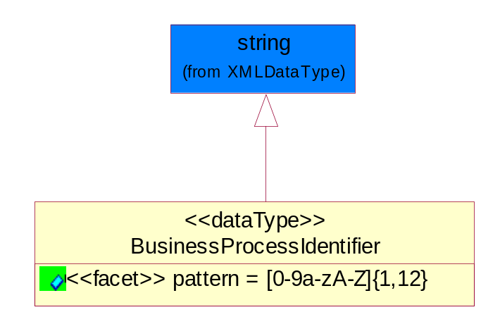
Figure ‎5-54 BusinessProcessIdentifier

Attribute | Type | Documentation
pattern |  | [0-9a-zA-Z]{1,12}

BusinessServiceInformation
The object allows the specification of the business service utilized within the partner company. This may or may not be the same as the information sent by the RNIF.
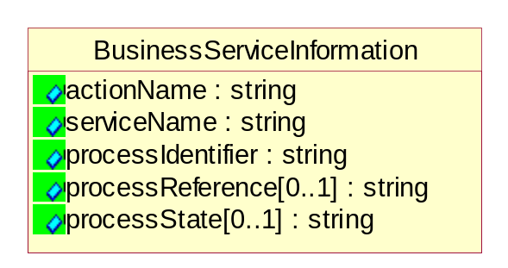
Figure ‎5-55 BusinessServiceInformation

Attribute | Type | Documentation
actionName | string | The name of Action. For RosettaNet usually any of Request/Confirm/Notify/Query/Response.
serviceName | string | The name of the Business Activity with the "Request/Confirm" part removed. E.g., for the Activity "Request Purchase Order"==> "Purchase Order".
processIdentifier | string | The name of the PIP e.g. Notify of Forecast Reply.
processReference[0..1] | string | The URN for the PIP that includes Cluster/Segment/Process pattern used to identify the interface process (such as PIP3A4)
processState[0..1] | string | The business process (or service) state of the sender of a document. When a service receives this document, the receiver may use the state as a precondition.

ContractInformation
A block of information used to correlate a contract in an executing choreography.

Figure ‎5-56 ContractInformation

Attribute | Type | Documentation
contractIdentifier[0..1] | string | Unique identification of a contract between the Sender and the Receiver
contractType[0..1] | string | The type of the contract: an attribute describing the type of the ContractIndentification. Valid values are URI, URN,ebXMLCPA, or other values defined by partners.

CorrelationInformation
A block of information used to correlate a requesting document to a responding document and to the contract in an executing choreography.
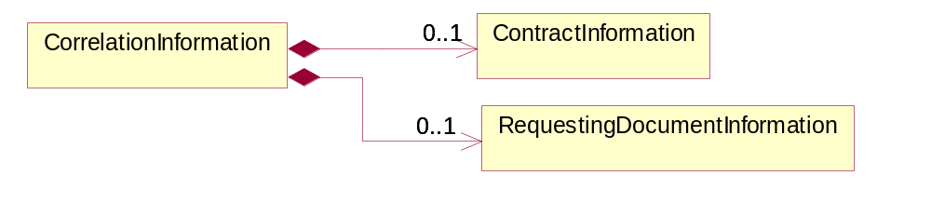
Figure ‎5-57 CorrelationInformation

Composition | Cardinality | Type | Documentation
ContractInformation | 0..1 | ContractInformation | A block of information used to correlate a contract in an executing choreography.
RequestingDocumentInformation | 0..1 | RequestingDocumentInformation | A block of information used to correlate a requesting document to a responding document in an executing choreography.

DocumentHeader
The object allows for the identification of the sender and receiver of the business document.
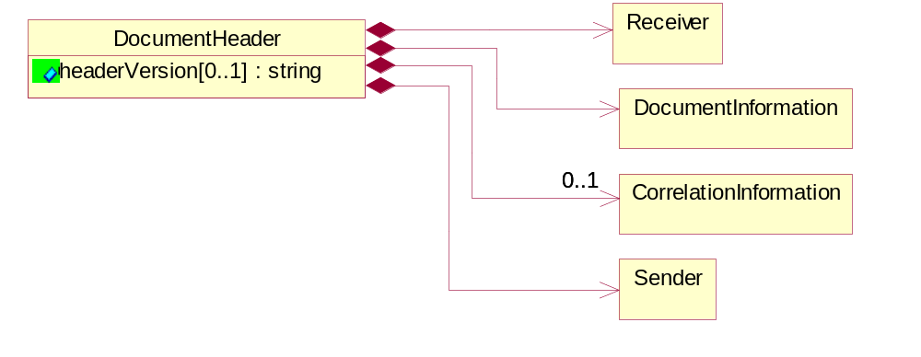
Figure ‎5-58 DocumentHeader

Attribute | Type | Documentation
headerVersion[0..1] | string | The UN/CEFACT version of the document header.

Composition | Cardinality | Type | Documentation
Sender | 1 | Sender | The object allows the identification of the initiating party of the business message.
CorrelationInformation | 0..1 | CorrelationInformation | A block of information used to correlate a requesting document to a responding document and to the contract in an executing choreography.
DocumentInformation | 1 | DocumentInformation | The object specifies information to identify the business document, a summary of attachments, and information about the business document security.
Receiver | 1 | Receiver | The object allows the identification of the receiving party of the business message.

DocumentIdentification
The object specifies all information necessary to identify the business document.
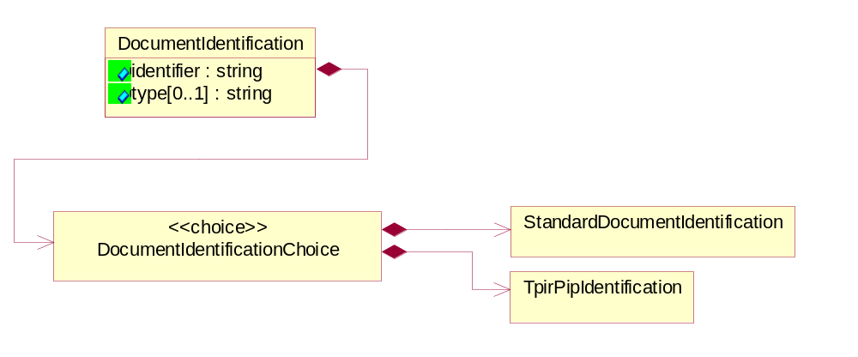
Figure ‎5-59 DocumentIdentification

Attribute | Type | Documentation
identifier | string | The unique identifier for the document being sent.
type[0..1] | string | Name of the Action Message

Composition | Cardinality | Type | Documentation
DocumentIdentificationChoice | 1 | DocumentIdentificationChoice

DocumentIdentificationChoice

Composition | Cardinality | Type | Documentation
StandardDocumentIdentification | 1 | StandardDocumentIdentification | The object specifies additional information necessary to identify the standard business document.
TpirPipIdentification | 1 | TpirPipIdentification | The object specifies all information necessary to uniquely identify a TPIR-PIP within a Registry or trading partner repository.

DocumentInformation
The object specifies information to identify the business document, a summary of attachments, and information about the business document security.
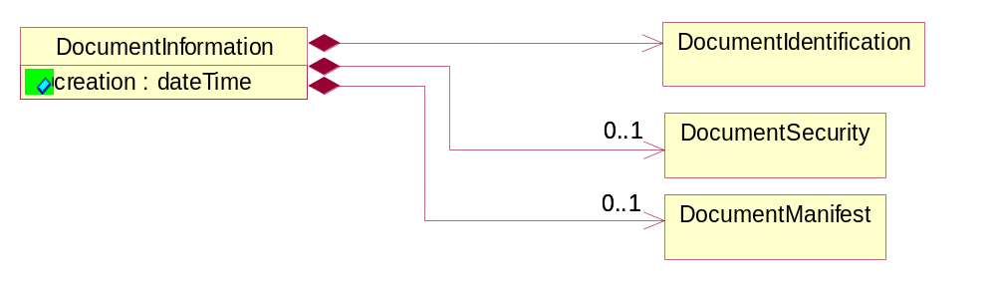
Figure ‎5-60 DocumentInformation

Attribute | Type | Documentation
creation | dateTime | The creation date and time of the specified Business Document (i.e. the Purchase Order date).

Composition | Cardinality | Type | Documentation
DocumentIdentification | 1 | DocumentIdentification | The object specifies all information necessary to identify the business document.
DocumentSecurity | 0..1 | DocumentSecurity | The object provides additional granularity in specifying business document security (this is in addition to the specified PIP security).
DocumentManifest | 0..1 | DocumentManifest | The block provides a brief summary of attachments and Service Content.

DocumentManifest
The block provides a brief summary of attachments and Service Content.
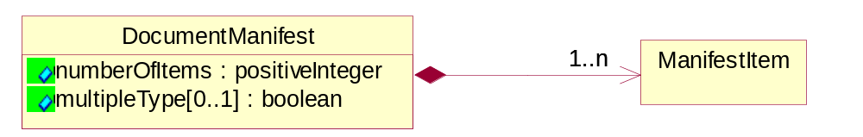
Figure ‎5-61 DocumentManifest

Attribute | Type | Documentation
numberOfItems | positiveInteger | Total number of documents in the message. The physical count of the attachments in the payload plus the RosettaNet Business Message (for Service Content). The value of this field will be at least 1.
multipleType[0..1] | boolean | Indicates whether the manifest contains documents of multiple types. True if yes, and False if no.

Composition | Cardinality | Type | Documentation
ManifestItem | 1..n | ManifestItem | The object provides details about the specific attachment(s).

DocumentSecurity
The object provides additional granularity in specifying business document security (this is in addition to the specified PIP security).

Figure ‎5-62 DocumentSecurity

Attribute | Type | Documentation
nonRepudiableReceipt | boolean | The value "true" will indicate that a signed acknowledgement for the business document is necessary.
persistentEncryption | boolean | The value "true" will indicate that the Business Document (including the header) needs to be encrypted when stored or transported.
persistentSignature | boolean | The value "true" will indicate that a signature is required to be stored with the document while stored or transported.

ManifestItem
The object provides details about the specific attachment(s).
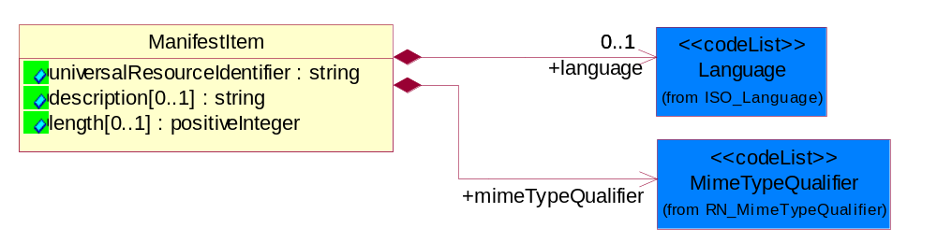
Figure ‎5-63 ManifestItem

Attribute | Type | Documentation
universalResourceIdentifier | string | The generic set of all names/addresses that are short strings that refer to resources.
description[0..1] | string | A description of the attachment.
length[0..1] | positiveInteger | The size of the attachment in bytes (i.e. 1 000 000 bytes)

Composition | Cardinality | Type | Documentation
mimeTypeQualifier | 1 | MimeTypeQualifier | The MIME type as defined by IANA.  Please refer to http://www.iana.org/assignments/media-types/ for a list of types.
language | 0..1 | Language | For representation of Language name RosettaNet has adopted ISO 639-2; 1998. Refer to the following web page to get the latest version of the standard:  http://www.loc.gov/standards/iso639-2/iso639jac.html  If you need more information about the ISO standard please contact ISO for more details.

PipIdentifier
PIP Identification.[ i.e. PIP3A4]

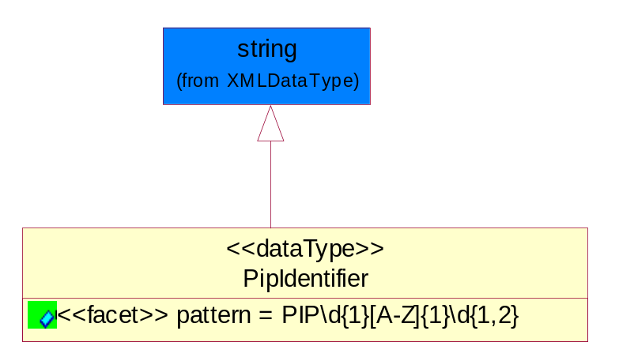
Figure ‎5-64 PipIdentifier

Attribute | Type | Documentation
pattern |  | PIP\d{1}[A-Z]{1}\d{1,2}

PipVersion
PIP version number (i.e. 02.02.00).

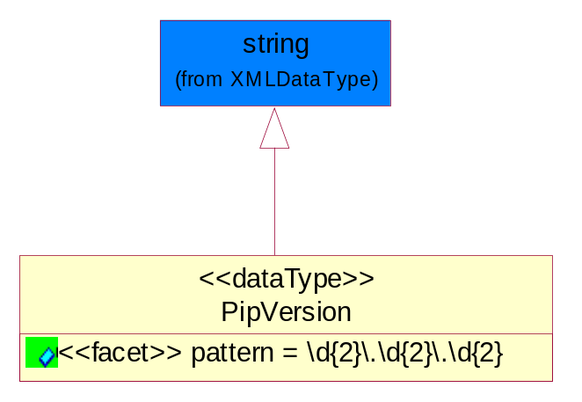
Figure ‎5-65 PipVersion

Attribute | Type | Documentation
pattern |  | \d{2}\.\d{2}\.\d{2}

Receiver
The object allows the identification of the receiving party of the business message.
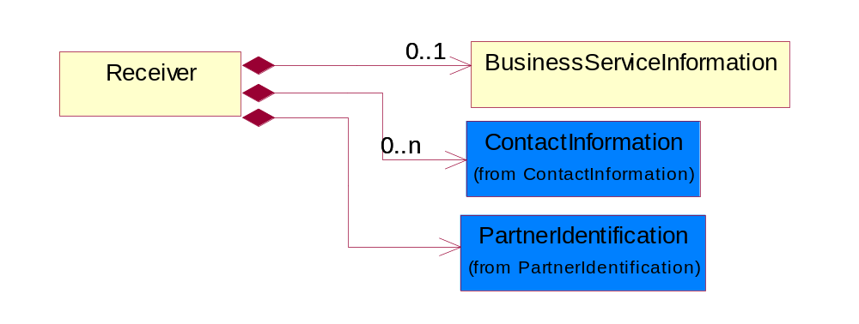
Figure ‎5-66 Receiver

Composition | Cardinality | Type | Documentation
BusinessServiceInformation | 0..1 | BusinessServiceInformation | The object allows the specification of the business service utilized within the partner company. This may or may not be the same as the information sent by the RNIF.
PartnerIdentification | 1 | PartnerIdentification | The business document must allow for the identity of one or more parties to the transaction.
ContactInformation | 0..n | ContactInformation | The business document must allow for the identification of the name of the department, service or individual to be contacted regarding the context of the business document.

RequestingDocumentInformation
A block of information used to correlate a requesting document to a responding document in an executing choreography.

Figure ‎5-67 RequestingDocumentInformation

Attribute | Type | Documentation
businessProcessInstanceIdentifier[0..1] | string | The identifier for the public business process instance being sent that both the sender and receiver can identify.
responseDateTime[0..1] | dateTime | The expected time to receive the response. This can not be greater than the PIP TimeToPerform.
requestingDocumentCreationDateTime[0..1] | dateTime | The date-time of the requesting business document.
requestingDocumentInstanceIdentifier | string | The Business Document identification number that identifies the requesting Business Document.

Sender
The object allows the identification of the initiating party of the business message.
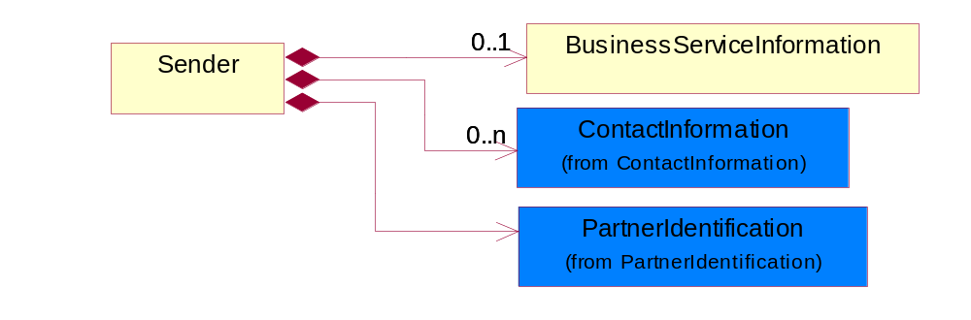
Figure ‎5-68 Sender

Composition | Cardinality | Type | Documentation
PartnerIdentification | 1 | PartnerIdentification | The business document must allow for the identity of one or more parties to the transaction.
BusinessServiceInformation | 0..1 | BusinessServiceInformation | The object allows the specification of the business service utilized within the partner company. This may or may not be the same as the information sent by the RNIF.
ContactInformation | 0..n | ContactInformation | The business document must allow for the identification of the name of the department, service or individual to be contacted regarding the context of the business document.

StandardDocumentIdentification
The object specifies additional information necessary to identify the standard business document.
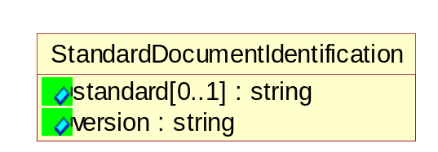
Figure ‎5-69 StandardDocumentIdentification

Attribute | Type | Documentation
standard[0..1] | string | Identifies the standard used to submit the business document. (e.g. RosettaNet).
version | string | PIP3A4v01.00

TpirPipIdentification
The object specifies all information necessary to uniquely identify a TPIR-PIP within a Registry or trading partner repository.

Figure ‎5-70 TpirPipIdentification

Attribute | Type | Documentation
partnerId | DUNSPlus4 | The Trading Partner Identification of MNC that is creating this TPIR PIP.
pipIdentifier | PipIdentifier | A TPIR PIP Identification [i.e., 3A4 ).
pipVersion | PipVersion | A TPIR PIP version number (i.e., 02.02.00)
tpirPipVersion | VersionIdentifier | A TPIR-PIP Version Number (i.e., major and minor version number as XX.XX).
tpirBusinessProcessIdentifier[0..1] | BusinessProcessIdentifier | A Business Process Identifier to uniquely define the TPIR-PIP 'role' within a Business Scenario at a company or MNC level. The identifier MUST be composed of alphanumeric characters only and its length MUST be between one and twelve characters.
uri[0..1] | anyURI | Describes the destination uri for the TPIR form.

Composition | Cardinality | Type | Documentation
fileType | 0..1 | TPIRFileType | Describes the file type of the TPIR form (PDF, XDP or XML).

VersionIdentifier
Version Number (i.e., major and minor version number as XX.XX).

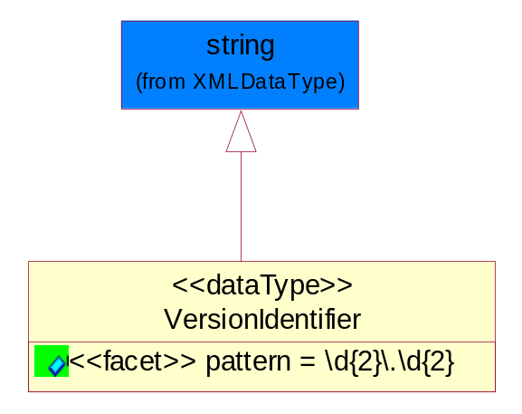
Figure ‎5-71 VersionIdentifier

Attribute | Type | Documentation
pattern |  | \d{2}\.\d{2}

CodeList

TPIRFileType
A code identifying the file type of TPIR form.
Name | Documentation
PDF | Portable Document Format.
XDP | XML Data Package.
XML | eXtensible Markup Language.

XML Data Type

anyURI
Represents a URI as defined by RFC 2396. An anyURI value can be absolute or relative, and may have an optional fragment identifier.

boolean
Represents Boolean values, which are either "true" or "false".

date
For the represents a calendar date.
The pattern for a date is CCYY-MM-DD where CC represents the century, YY the year, MM the month, and DD the day, with an optional time zone indicator as allowed for dateTime.

dateTime
Represents a specific instance of time.
The pattern for dateTime is CCYY-MM-DDThh:mm:ss where CC represents the century, YY the year, MM the month, and DD the day, preceded by an optional leading negative (-) character to indicate a negative number. If the negative character is omitted, positive (+) is assumed. The T is the date/time separator and hh, mm, and ss represent hour, minute, and second respectively. Additional digits can be used to increase the precision of fractional seconds if desired. For example, the format ss.ss... with any number of digits after the decimal point is supported. The fractional seconds part is optional.
This representation may be immediately followed by a "Z" to indicate Coordinated Universal Time (UTC) or to indicate the time zone. For example, the difference between the local time and Coordinated Universal Time, immediately followed by a sign, + or -, followed by the difference from UTC represented as hh:mm (minutes is required). If the time zone is included, both hours and minutes must be present.

decimal
A data type that contains decimal numbers scaled by a power of 10.

float
Represents single-precision 32-bit floating-point numbers.

nonNegativeInteger
Represents an integer that is greater than or equal to zero. This data type is derived from integer.

positiveInteger
Represents an integer that is greater than zero. This data type is derived from nonNegativeInteger.

string
Represents character string.

