

Description of
Partner Interface Process® for 2A13

Validated 11.03.00

Specification Information
Name | Distribute Material Composition Information
Cluster | Product Information
Segment | Preparation for Distribution
Publication Date | 30 August 2006
Version Identifier | V11.03

Table of Contents
1 Document Management 4
1.1 Legal Disclaimer 4
1.2 Copyright 4
1.3 Trademarks 4
1.4 Acknowledgments 4
1.5 Related Documents 5
1.6 Document Version History 5
1.7 Document Structure 6
2 Business Process 7
2.1 Business Process Definition 7
2.1.1 Executive Summary 7
2.1.2 Business Process Description 8
2.1.3 Business Process Context Diagram 9
2.2 PIP Scope Description 10
2.2.1 Business Process Scope Diagram 10
2.3 PIP Business Document 11
2.4 PIP Business Process Flow Diagram 11
2.5 PIP Start State 12
2.6 PIP End States 12
2.7 Partner Role Descriptions 13
2.8 Business Process Activity Controls 13
3 Network and Implementation Specification 14
3.1 Business Action and Business Signal Specifications 14
3.2 Business Transaction Dialog Specification 14
3.2.1 Message Exchange Controls 15
3.2.2 Communications Specification 15

List of Figures:
Figure 1: High-level Context Diagram 9
Figure 2: Business Process Scope Diagram 10
Figure 3: Activity Diagram of Distribute Material Composition Information 11
Figure 4: Sequence Diagram of Distribute Material Composition Information 14

List of Tables:
Table 1: PIP Business Document 11
Table 2: PIP Start State 12
Table 3: PIP End State 12
Table 4: PIP Failure State 12
Table 5: Partner Role Description 13
Table 6: Business Activity Description 13
Table 7: Business Activity Performance Control 13
Table 8: Network Component Specification 14
Table 9: Business Action – Business Document Mapping 14
Table 10: Message Exchange Control 15
Table 11: Dialog: Service-Service 15

Document Management

Legal Disclaimer
RosettaNet™, its members, officers, directors, employees, or agents shall not be liable for any injury, loss, damages, financial or otherwise, arising from, related to, or caused by the use of this document or the specifications herein, as well as associated guidelines and schemas. The use of said specifications shall constitute your express consent to the foregoing exculpation.

Copyright
©2006 RosettaNet. All rights reserved. No part of this publication may be reproduced, stored in a retrieval system, or transmitted, in any form or by any means, electronic, mechanical, photocopying, recording, or otherwise, without the prior written permission of the publisher. Printed in the United States of America.

Trademarks
RosettaNet, Partner Interface Process, PIP and the RosettaNet logo are trademarks or registered trademarks of "RosettaNet," a non-profit organization. All other product names and company logos mentioned herein are the trademarks of their respective owners. In the best effort, all terms mentioned in this document that are known to be trademarks or registered trademarks have been appropriately recognized in the first occurrence of the term.

Acknowledgments
This document has been prepared by RosettaNet (http://www.rosettanet.org/) from requirements gathered during the Milestone Program and in conformance with the methodology. Listed below are the legal entities that contributed to the design and development of this PIP.
ADOS Co., Ltd. | Agere Systems
Agilent Technologies | Amkor Technology, Inc.
Centor Software | Cisco Systems
Korea Electronics Industry, including Samsung & LG | Ericsson
Future Electronics Inc. | Globetronics SDH. BHD
Intel Corporation | KYOCERA Corporation
LG Electronics Inc., Quality & Reliability Center | MIMOS Berhad
Motorola | Motorola, Inc.
Motorola Semiconductor Products Sector | Motorola SPS
National Semiconductor | NEC Corporation
NEC Electronics | NEC Electronics (Europe) GmbH
Nichicon Corporation | Nippon Chemi-Con Corporation
Nokia | Nokia Corporation
Nokia Oyj | SAP
Siemens AG | School of Social Ecology, University of California Irvine
Sony | Sony EMCS Corporation
Sony Corporation | Sterling Commerce
STMicroelectronics | STMicroelectronics Inc
STMicroelectronics N.V. | Synapsis Technology, Inc.
Ted Haas Consulting, LLC | Texas Instruments
Texas Instruments, Inc. | Texas Instruments, Japan Ltd

Related Documents
- Associated PIP Message Schemas (included within the PIP Specification package only)
- Description of 2A13 Message
- Messages Structure
- XML instance of ebXML BPSS for PIP 2A13

Document Version History
Version | Date | Description
Validated 11.00.00 | 10 Jan 2005 | RosettaNet: Marking the end of validation period with PIP version promotion. Made few changes to the message due to approved change requests submitted by validation partners.
Validated 11.01.00 | 30 Mar 2005 | Validated version. Updated to accommodate requirement from iNEMI, to support WEEE and RoHS Directives.
Validated 11.02.00 | 29 Jun 2005 | Validated version. Updated according to Change Request to make this a response message for PIP2A15 requesting message.
Validated 11.03.00 | 30 Aug 2006 | Validated version. Updated according to Change Request Maintenance Program 2006.

Document Structure
A Partner Interface Process (PIP) Specification is comprised of the following two parts:
- Business Process. Captures the semantics of the business process and the flow of the message exchange between roles as they perform business activities.
- Network and Implementation Specification. Specifies the network protocol message formats and communications requirements between peer-protocols supported by network components in the RosettaNet Implementation Framework.

Business Process

Business Process Definition
The Material Composition Information attempts to contain sufficient product material composition information to be exchanged in order to satisfy legislative requirements. This process is part of a broader objective of driving to environmental improvements in the design phase of the product life cycle in addition to providing this information to a customer and other stakeholders when required. This information distribution applies to materials that are composed in the product. Process chemicals used by manufacturers that do not remain in the product are excluded from the scope of this program.

Executive Summary
Material Composition Information standardizes the mechanisms and formats for interchange of product material composition information exchange across the industry in order to:
- Satisfy legislation
- Drive environmental improvements in design by meeting material bans and restrictions
- Provide information for customer and other stakeholders when required,
The business drivers that impacts such a requirement are:
- An increasing burden for suppliers to gather and report material composition information
- An increasing burden for the customer to gather and achieve sufficient knowledge of the material composition of the purchased product that is used or might be used in their design.
This lack of standardization in exchanging product material composition information in the supply chain is inefficient and costly. Examples include, proprietary based formats in spreadsheets and the message is composed manually and sporadically.
As such, a successful solution for this program would be a common format and an efficient electronic process for reporting material composition information in products.
Material Composition Information process is part of the Design domain.

Business Process Description
The "Distribute Material Composition Information" Partner Interface Process (PIP) is focused on gathering product information that describes the composition of materials in the products. The main drivers for collecting this type of material composition information are due to legal requirements, market requirements for the industry to proactively report this information in their designs.
The process includes the following steps:
- The customer needs to know based on legal or market requirements the materials composition of a purchased product that might be included or are included in his design
- The customer defines the demands and defines the material composition information that is needed. The information needed might be based on guidelines decided by industry and/or based on a agreements.
- The customer makes an agreement with their supplier to provide a material composition information exchange based on a guideline decided by a industry and/or individually. The timing for this agreement differs between companies and thus out of scope for this milestone.
- The customer requests the agreed information from his supplier. The timing for this request differs between companies (e.g., to automatically be provided whenever a new product is released or to be provided only when the customer specifically requests it) and thus the timing of this request is out of scope for this milestone.
- The supplier might have requested this information to be available on demand.
  - If the information is available in-house the supplier sends the requested information to his customer.
  - If the supplier needs to gather some or all of the requested information he uses the same business process as his customer. See items #2.- #4. When all required information is gathered, the supplier compiles the information and sends the requested information to his customer. Compilation or aggregation of in-house information will be done by the supplier’s backend system and are out of the scope of this e-business process.
- The customer receives the information. The customer might store the information in his in-house backend system to be able to provide his customer in his turn with compiled information. Storing and compiling in-house information will be done by customer backend systems and are out of the scope of this e-business process.

Business Process Context Diagram

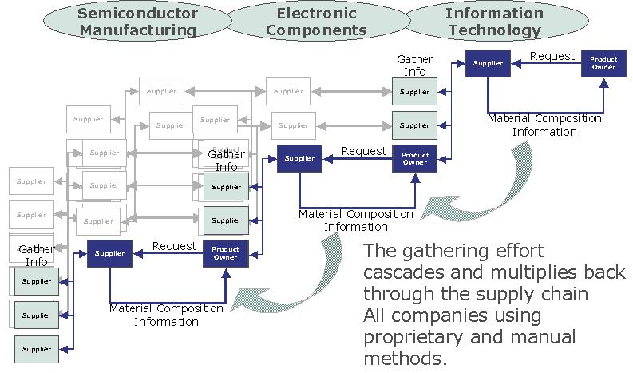
Figure 1: High-level Context Diagram
The above diagram describes:
- The product material composition process begins with a Material Supplier in the Semiconductor Manufacturing (SM) supply chain providing material information to a semiconductor manufacturer or foundry
- The information gathering process is required throughout the Electronic Components (EC) supply chain as each supplier provides this information to their customers
- The product manufacturers in the Information Technology (IT) supply chain are typically the last group of producers to gather product material composition information for all purchased products in the design that make up the final IT product sold to an end customer
The demand for material composition information begins with IT producers and moves back through the supply chain. A proactive “push” point of view has the flow occurring from the bottom of the chain up.
Similar type of flow and roles may happen also in other type of supply chain.
The e-business process defined by this process takes place between ONE supplier and ONE customer.

PIP Scope Description
The purpose of this PIP is to 1) automate product material composition information exchanges between the supply chain partners, 2) improve information exchange quality and efficiency when gathering product material composition data, 3) save time and reduce processing costs, 4) reduce workload in supply chain by introducing a common global approach for sharing product material composition information across the full high-tech supply chain.
Besides PIP2A13, “Distribute Material Composition Information”, RosettaNet is also publishing PIP2A10, "Distribute Design Engineering Information".
Both PIP2A13 and PIP2A10, attempts to address common business challenges delivering same results but implemented under different message dictionaries, RNBD and RNTD respectively.

Business Process Scope Diagram
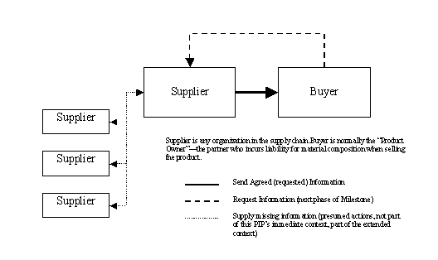
Figure 2: Business Process Scope Diagram

PIP Business Document
Business Document are generated and exchanged by roles performing activities in this PIP. Business Document is listed and defined in Table 1.
Table 1: PIP Business Document
Business Document | Description
Material Composition Information Distribution | Contains detailed product material composition information and references required to identify the reporting. Information in this document is mainly used to make design, manufacturing and recycling decisions. It is also used to ascertain whether suppliers are complying with those requirements, and stores and maintains the data.

PIP Business Process Flow Diagram
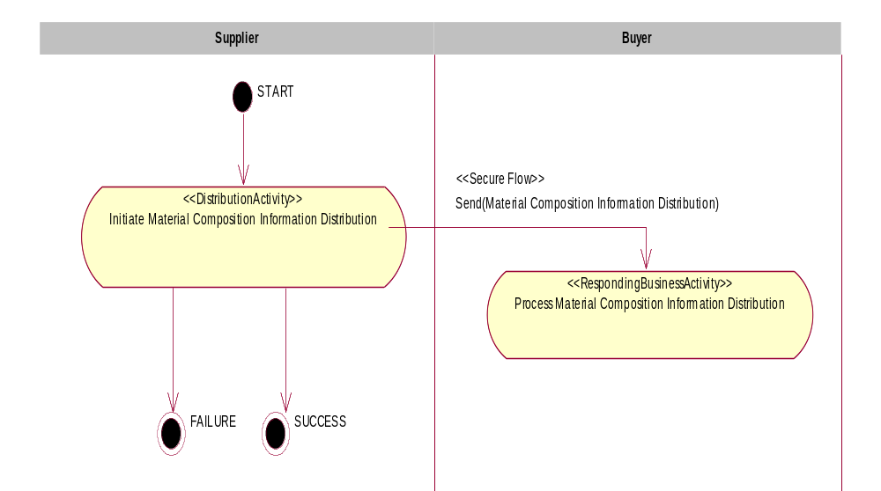
Figure 3: Activity Diagram of Distribute Material Composition Information

PIP Start State
The start state is comprised of the following conditions:
Table 2: PIP Start State
 | Approved | Exist |  | Valid | Non-Repudiated | Retry Count | Authorized
 | Approved | Party | In Backend System
TPA |  |  | 
Sending Partner |  |  |  | 
Receiving Partner |  | 
Business Document |  |  |  |  |  |  | 

PIP End States
The end state is comprised of the following conditions:
Table 3: PIP End State
 | Approved | Exist |  | Valid | Non-Repudiated | Retry Count | Authorized
 | Approved | Party | In Backend system
Acknowledgment of Receipt |  |  |  | 
Receiving Partner |  |  |  |  |  |  | 

The PIP failure state is comprised of one or more of the following conditions:
Table 4: PIP Failure State
 | NO | Exceeded
Success | 
Retry Count |  | 

Partner Role Descriptions
Table 5 describes the partner roles in this PIP.
Table 5: Partner Role Description
Role Name | Role Description
Supplier | Party, which is requesting Business Activity. Primary initiator of this Business Activity is a group called “material composition data management group”, within an organization. This group could belong to a larger group called Environment, Health and Safety Group.
Buyer | Party, which is responding to a Business Activity Request. This could be a group that merely maintains the database. The actual user of product material composition information is a design engineer whom uses the information in design, manufacturing and recycling decisions.

Business Process Activity Controls
Table 6 describes the interaction between roles performing business activity in this PIP.
Table 6: Business Activity Description
Role  Name | Activity Name | Activity Description
Supplier | Initiate Material Composition Information Distribution | Material Composition Group initiates Material Composition Information Distribution to a Recipient. The Distribution contains detailed product material composition information, which could be used by the recipient to make design, manufacturing, recycling decisions and also to ascertain whether the suppliers are complying with requirements set forth by the Supplier.
Table 7 details the security, audit and process controls relating to activity performed in the PIP.
Table 7: Business Activity Performance Control
Role  Name | Activity  Name | Acknowledgment  of Receipt |  | Time to Perform | Retry Count | Is Authorization Required? | Non-Repudiation of Origin and Content?
Role  Name | Activity  Name | Non-Repudiation Required? | Time to Acknowledge
Supplier | Initiate Material Composition Information Distribution | N | 2 hrs | N/A | 3 | N | N
Note: All time parameters are defined as (hrs or mins), i.e. 2 hrs

Network and Implementation Specification
Each network component maps into a role of the PIP model. Table 8 specifies the mapping between roles and network components.
Table 8: Network Component Specification
Network Component | Classification | Maps to Role in Business Process
Supplier Service | Business Service | Supplier
Buyer Service | Business Service | Buyer

Business Action and Business Signal Specifications
Each business action maps to a Business Document of the PIP model. Table 9 specifies the mapping between Business Documents and business actions.
Table 9: Business Action – Business Document Mapping
Business Action | Business Document | Document Function
Material Composition Information Distribution Action | Material Composition Information Distribution | Request

Business Transaction Dialog Specification
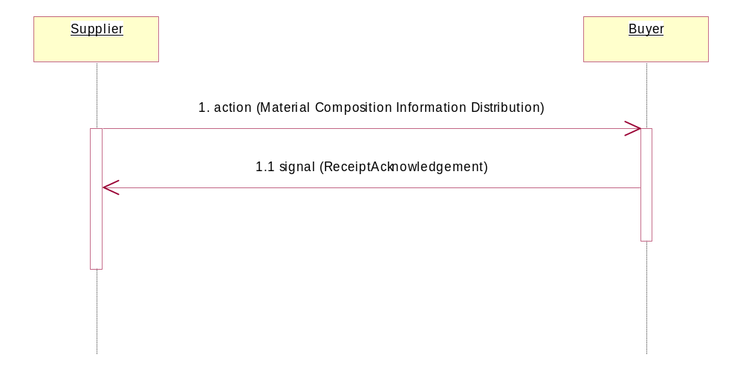
Figure 4: Sequence Diagram of Distribute Material Composition Information

Message Exchange Controls
Table 10: Message Exchange Control
# | Name |  | Time to Acknowledge Receipt Signal |  | Time to Respond to Action |  | Included in Time to Perform |  | Is Authorization Required? |  | Is Non-Repudiation Required? |  | Is Secure Transport Required?
1. |  | Material Composition Information Distribution Action |  | 2 hrs |  | N/A |  | N/A |  | N |  | N |  | Y
1.1. |  | Receipt Acknowledgment |  | N/A |  | N/A |  | N/A |  | N |  | N |  | Y
Note: All time parameters are defined as (hrs or mins), i.e. 2 hrs

Communications Specification
Table 11: Dialog: Service-Service
# | Business Message | Digital Signature Required? | SSL Required?
1. | Material Composition Information Distribution | N | Y
1.1. | Receipt Acknowledgment | N | Y

RosettaNet Business Dictionary – http://www.rosettanet.org/businessdictionary
RosettaNet Technical Dictionary – http://www.rosettanet.org/technicaldictionary

