

Description of 2A15 Message

PIP® 2A15
Release 11.00.00A

Specification Information
Name | Description Of 2A15 Message
PIP | Request Material Composition Information
Cluster | Product Information
Segment | Preparation for Distribution
Publication Date | 3 Aug 2005
Version Identifier | R11.00A

Table of Content

1. Document Management 5
1.1 Legal Disclaimer 5
1.2 Copyright 5
1.3 Trademarks 5
1.4 Acknowledgments 5
1.5 Related Documents 6
1.6 Document Version History 6
1.7 Document Purpose 6
2. Interchange Model 7
2.1 MaterialCompositionInformationRequest 7
2.1.1 Dependency Diagram 7
2.1.2 Interchange Diagram 7
2.1.3 MaterialCompositionInformationRequest 8
2.1.4 ProductIdentifier 8
2.1.5 ProductInformation 9
2.1.6 ProductInformationObject 10
2.1.7 Subpart 12
3. Domain Model 13
3.1 Design 13
3.1.1 Design 13
3.1.1.1 Dependency Diagram 13
3.1.1.2 Attachment 13
3.1.1.3 Directive 13
3.1.1.4 Mass 14
3.1.1.5 MassPercentage 16
3.1.1.6 Note 16
3.1.1.7 ProductMass 17
3.1.1.8 ReferenceLocator 18
3.1.1.9 ReferenceLocatorChoice 19
3.1.1.10 SubpartIdentifier 20
3.1.1.11 url 20
3.1.1.12 Value 21
3.1.2 CodeList 22
3.1.2.1 Level 22
3.1.2.2 Compliant 22
4. Universal Structure 23
4.1 ContactInformation 23
4.1.1 ContactInformation 23
4.2 DataType 24
4.2.1 Contact 24
4.2.2 DUNS 24
4.2.3 DUNSPlus4 25
4.2.4 GLN 25
4.2.5 GTIN 26
4.2.6 PercentAmount 26
4.3 Document 27
4.3.1 BusinessDocumentReference 27
4.4 Locations 28
4.4.1 AlternativeIdentifier 28
4.5 PartnerIdentification 28
4.5.1 PartnerIdentification 28
4.5.2 PartnerIdentificationChoice 29
4.6 ProductIdentification 30
4.6.1 ProductDescription 30
4.6.2 ProductIdentification 30
4.6.3 ProductIdentificationChoice 31
4.6.4 TextualDescription 32
4.7 CodeList 32
4.7.1 Language 32
4.7.2 DocumentType 32
4.7.3 MimeTypeQualifier 34
4.7.4 UnitOfMeasure 45
5. System Structure 52
5.1 BusinessProcessIdentifier 52
5.2 BusinessServiceInformation 52
5.3 ContractInformation 53
5.4 CorrelationInformation 54
5.5 DocumentHeader 54
5.6 DocumentIdentification 55
5.7 DocumentIdentificationChoice 56
5.8 DocumentInformation 56
5.9 DocumentManifest 57
5.10 DocumentSecurity 58
5.11 ManifestItem 58
5.12 PipIdentifier 59
5.13 PipVersion 60
5.14 Receiver 61
5.15 RequestingDocumentInformation 61
5.16 Sender 62
5.17 StandardDocumentIdentification 63
5.18 TpirPipIdentification 63
5.19 VersionIdentifier 64
5.20 CodeList 65
5.20.1 TPIRFileType 65
6. XML Data Type 65
6.1 anyURI 65
6.2 boolean 65
6.3 dateTime 66
6.4 decimal 66
6.5 nonNegativeInteger 66
6.6 positiveInteger 66
6.7 string 66

Table of Figures

Figure 2-1 Dependency 7
Figure 2-2 Interchange 7
Figure 2-3 MaterialCompositionInformationRequest 8
Figure 2-4 ProductIdentifier 9
Figure 2-5 ProductInformation 9
Figure 2-6 ProductInformationObject 11
Figure 2-7 Subpart 12
Figure 3-1 Dependency 13
Figure 3-2 Attachment 13
Figure 3-3 Directive 14
Figure 3-4 Mass 15
Figure 3-5 MassPercentage 16
Figure 3-6 Note 17
Figure 3-7 ProductMass 17
Figure 3-8 ReferenceLocator 18
Figure 3-9 SubpartIdentifier 20
Figure 3-10 url 21
Figure 3-11 Value 21
Figure 4-1 ContactInformation 23
Figure 4-2 Contact 24
Figure 4-3 DUNS 24
Figure 4-4 DUNSPlus4 25
Figure 4-5 GLN 25
Figure 4-6 GTIN 26
Figure 4-7 PercentAmount 26
Figure 4-8 BusinessDocumentReference 27
Figure 4-9 AlternativeIdentifier 28
Figure 4-10 PartnerIdentification 29
Figure 4-11 ProductDescription 30
Figure 4-12 ProductIdentification 31
Figure 4-13 TextualDescription 32
Figure 5-1 BusinessProcessIdentifier 52
Figure 5-2 BusinessServiceInformation 53
Figure 5-3 ContractInformation 53
Figure 5-4 CorrelationInformation 54
Figure 5-5 DocumentHeader 55
Figure 5-6 DocumentIdentification 56
Figure 5-7 DocumentInformation 57
Figure 5-8 DocumentManifest 57
Figure 5-9 DocumentSecurity 58
Figure 5-10 ManifestItem 59
Figure 5-11 PipIdentifier 60
Figure 5-12 PipVersion 60
Figure 5-13 Receiver 61
Figure 5-14 RequestingDocumentInformation 62
Figure 5-15 Sender 62
Figure 5-16 StandardDocumentIdentification 63
Figure 5-17 TpirPipIdentification 64
Figure 5-18 VersionIdentifier 65

Document Management

Legal Disclaimer
RosettaNet, its members, officers, directors, employees, or agents shall not be liable for any injury, loss, damages, financial or otherwise, arising from, related to, or caused by the use of this document or the specifications herein, as well as associated guidelines and schemas. The use of said specifications shall constitute your express consent to the foregoing exculpation.

Copyright
©2005 RosettaNet. All rights reserved. No part of this publication may be reproduced, stored in a retrieval system, or transmitted, in any form or by any means, electronic, mechanical, photocopying, recording, or otherwise, without the inclusion of this copyright notice. Any derivative works must cite the copyright notice. Any public redistribution or sale of this publication or derivative works requires prior written permission of the publisher.

Trademarks
RosettaNet, Partner Interface Process, PIP and the RosettaNet logo are trademarks or registered trademarks of "RosettaNet," a non-profit organization. All other product names and company logos mentioned herein are the trademarks of their respective owners. In the best effort, all terms mentioned in this document that are known to be trademarks or registered trademarks have been appropriately recognized in the first occurrence of the term.

Acknowledgments
This document has been prepared by RosettaNet (http://www.rosettanet.org/) from requirements gathered during the Milestone Program and in conformance with the methodology. Listed below are the legal entities that contributed to the design and development of this PIP.
ADOS Co., Ltd. | Agere Systems
Agilent Technologies | Amkor Technology, Inc.
Centor Software | Cisco Systems
Korea Electronics Industry, including Samsung & LG | Ericsson
Future Electronics Inc. | Globetronics Snd. Bhd.
Intel Corporation | KYOCERA Corporation
LG Electronics Inc., Quality & Reliability Center | MIMOS Berhad
Motorola | Motorola, Inc.
Motorola Semiconductor Products Sector | Motorola SPS
National Semiconductor | NEC Corporation
NEC Electronics | NEC Electronics (Europe) GmbH
Nichicon Corporation | Nippon Chemi-Con Corporation
Nokia | Nokia Corporation
Nokia Oyj | SAP
Siemens AG | School of Social Ecology, University of California Irvine
Sony | Sony EMCS Corporation
Sony Corporation | Sterling Commerce
STMicroelectronics N.V. | Synapsis Technology, Inc.
Ted Haas Consulting, LLC | Texas Instruments
Texas Instruments, Inc. | Texas Instruments, Japan Ltd.

Related Documents
- Associated PIP Message Schemas (included with PIP Specification only)
- Description of Partner Interface Process for 2A15
- Message Structure

Document Version History
Version | Date | Description
Release 11.00.00A | 3 Aug 2005 | Initial Release version.

Document Purpose
The purpose of the document is to explain the structure, the association between objects, the content of objects and the definition for single elements to a non-technical audience.

Interchange Model

MaterialCompositionInformationRequest

Dependency Diagram
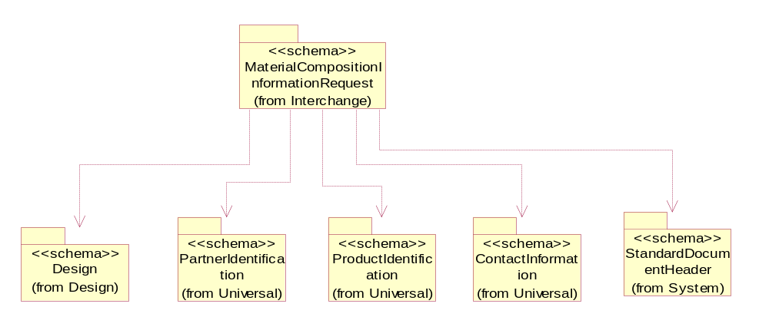
Figure 2-1 Dependency

Interchange Diagram
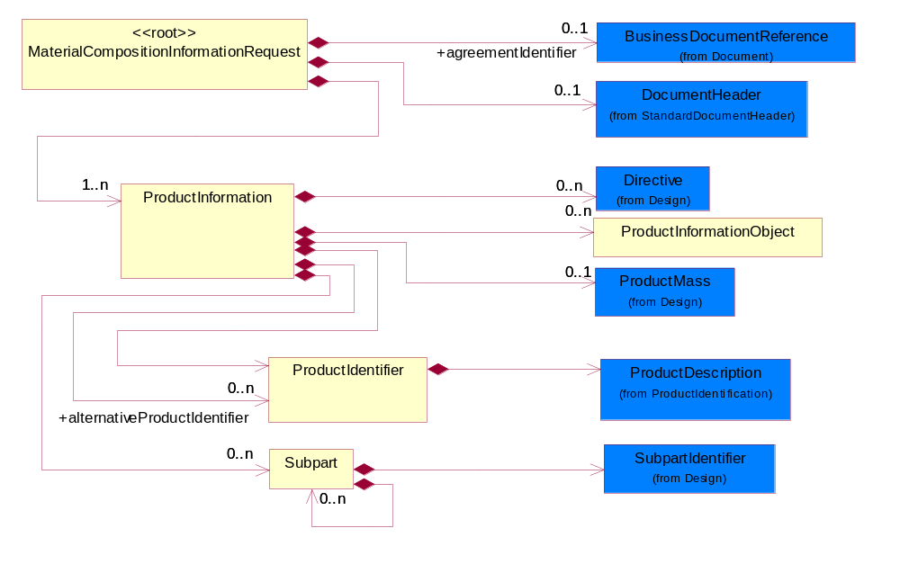
Figure 2-2 Interchange

MaterialCompositionInformationRequest

A message wrapper or root element for the request message of Material Composition Information.

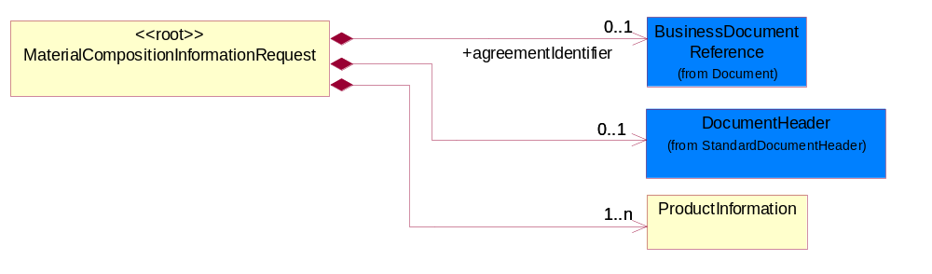
Figure 2-3 MaterialCompositionInformationRequest

Composition | Cardinality | Type | Documentation
agreementIdentifier | 0..1 | BusinessDocumentReference | Known as IDA (Information Distribution Agreement) requirement for the purpose of cross-reference to a specifing line/position in the agreement/contract.  A mutually agreed identifier assgined to the Information Distribution Agreement under which ths information distribution is taking place. Preferable document identifier should be contract (COT).
DocumentHeader | 0..1 | DocumentHeader | The object allows for the identification of the sender and receiver of the business document.
ProductInformation | 1..n | ProductInformation | The collection of information related to a product or a product family.

ProductIdentifier

The collection of data structure to identify a product or a product family.

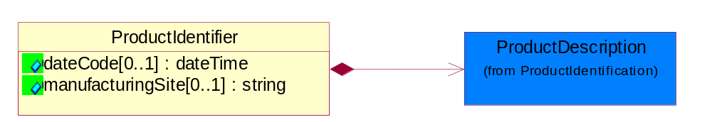
Figure 2-4 ProductIdentifier

Attribute | Type | Documentation
dateCode[0..1] | dateTime | The date when the group or batch of product becomes effective.
manufacturingSite[0..1] | string | Identify the site where a group or batch of product is manufactured.

Composition | Cardinality | Type | Documentation
ProductDescription | 1 | ProductDescription | The business document must allow for the identification of the product and multiple textual descriptions of a product.

ProductInformation

The collection of information related to a product or a product family.

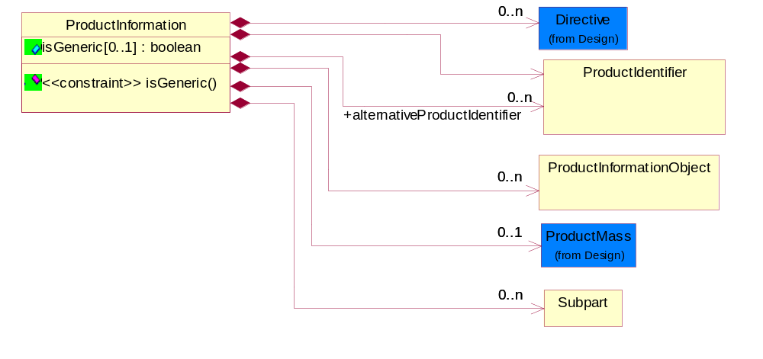
Figure 2-5 ProductInformation

Attribute | Type | Documentation
isGeneric[0..1] | boolean | To identify the subsequent product reporting as a product family (generic) reporting.

Composition | Cardinality | Type | Documentation
Directive | 0..n | Directive | Describes the explicit declaration of compliance to one or more compliance directives; and also specify any exemption to the compliance.
ProductMass | 0..1 | ProductMass | Product Total Mass (weight) MUST be specified in KIG (kg) (kilogram) even the actual value ranges from nano grams to giga kilograms. The unit of measure would still be KIG (kg).
Subpart | 0..n | Subpart | Subpart indicates the aggregation for all such subparts; i.e., if there are four such subparts, the values indicated are totaled and sent.  A typical implementation of subpart(s) within subpart(s) would be in one of the following nested levels of 0, 1 and/or 2.
ProductIdentifier | 1 | ProductIdentifier | The collection of data structure to identify a product or a product family.
alternativeProductIdentifier | 0..n | ProductIdentifier | Provide additional product identifier data, which are different from the sender's product identifier. This is required when the receiver and sender have their own proprietary product name, code etc.
ProductInformationObject | 0..n | ProductInformationObject | A Meta data structure used to describe a logical representation of arbitrary data. This is also known as Attachments. This will be used as a sub-class subordinate to the ProductInformation data structure.

Constraint | Documentation
isGeneric | If occurrence of tns:ProductInformation/tns:IsGeneric is 1 then the value of tns:ProductInformation/tns:IsGeneric MUST be 'true'.

ProductInformationObject

A Meta data structure used to describe a logical representation of arbitrary data. This is also known as Attachments. This will be used as a sub-class subordinate to the ProductInformation data structure.

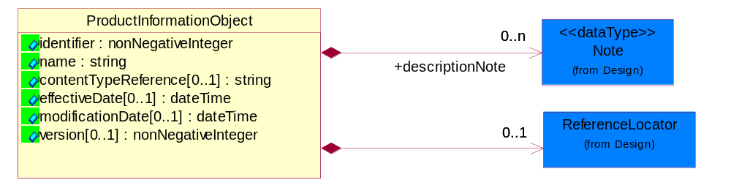
Figure 2-6 ProductInformationObject

Attribute | Type | Documentation
identifier | nonNegativeInteger | The identifier for a ProductInformationObject unique in the namespace of the notification.
name | string | The name of the ProductInformationObject, also known as Attachment.
contentTypeReference[0..1] | string | A unique identifier that defines the category of information provided by this ProductInformationObject.
effectiveDate[0..1] | dateTime | The date when the information becomes effective.
modificationDate[0..1] | dateTime | The last time a change was made.
version[0..1] | nonNegativeInteger | An arbitrary identifier indicating a content revision level.

Composition | Cardinality | Type | Documentation
ReferenceLocator | 0..1 | ReferenceLocator | Meta data describing a logical representation of a set of arbitrary data. A collection of properties identifying a ProductInformationObject with an attachment.
descriptionNote | 0..n | Note | Additonal notation that characterizes or otherwise identifies this ProductInformationObject.

Subpart

Subpart indicates the aggregation for all such subparts; i.e., if there are four such subparts, the values indicated are totaled and sent.
A typical implementation of subpart(s) within subpart(s) would be in one of the following nested levels of 0, 1 and/or 2.

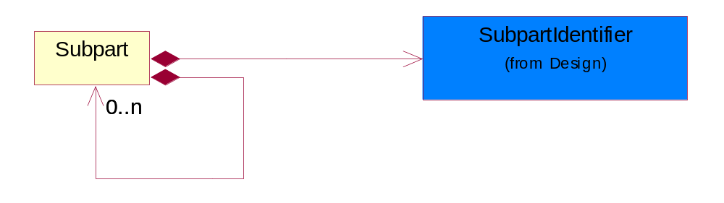
Figure 2-7 Subpart

Composition | Cardinality | Type | Documentation
SubpartIdentifier | 1 | SubpartIdentifier | Identification for the Subpart.

Domain Model

Design

Design

Dependency Diagram
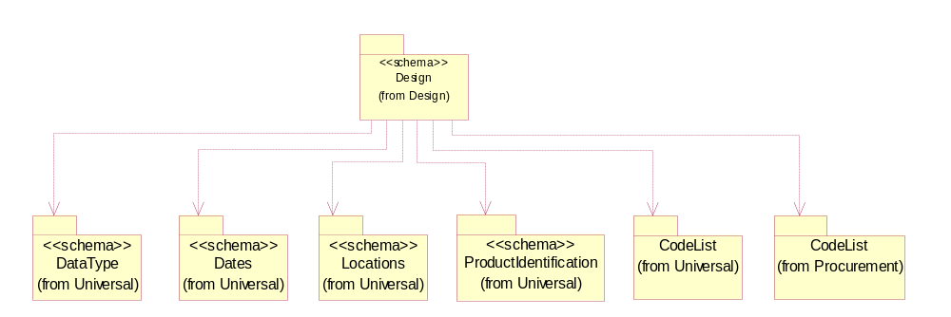
Figure 3-8 Dependency

Attachment

Meta data describing a logical representation of a set of arbitrary data. A collection of properties identifying a ProductInformationObject with an attachment.

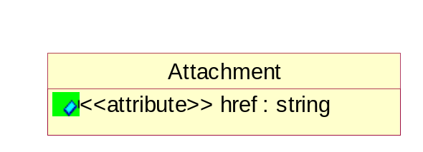
Figure 3-9 Attachment

Attribute | Type | Documentation
href | string | A reference to the Content-Id attribute of MIME-attachment specified as "cid:MIME_content-id_of_attachment" in accrodance with RFC 2392 (http://rfc.fh-koeln.de/rfc/html/rfc2392.html) and RNIF 2.0

Directive

Describes the explicit declaration of compliance to one or more compliance directives; and also specify any exemption to the compliance.

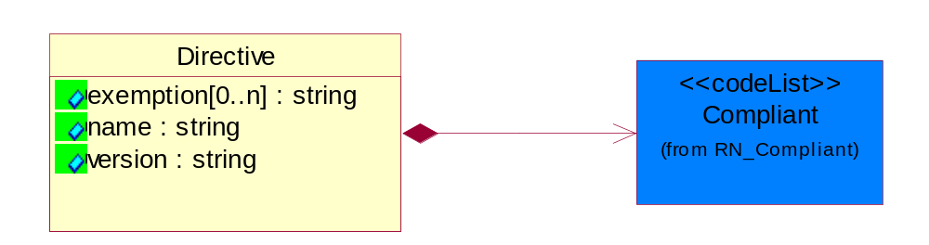
Figure 3-10 Directive

Attribute | Type | Documentation
exemption[0..n] | string | Provides the exemptions claimed for this part of this directive. A part may be compliant to a directive but only because it falls under one or more exemptions.
name | string | The unique name of the directive of legistlation. Example EU RoHS, WEEE etc.
version | string | The version of the directive for which this part is being declared.

Composition | Cardinality | Type | Documentation
Compliant | 1 | Compliant | Describes the Directive Complaint level of a product, subpart or substance.

Mass

Based on ECTD/IEC specification, Mass should be specified in kilogram (KG) per IEC 61360 - 1 (Annex B) - (http://www.iec.ch/tc3/txt/143.htm) format for floating point, positive or negative.

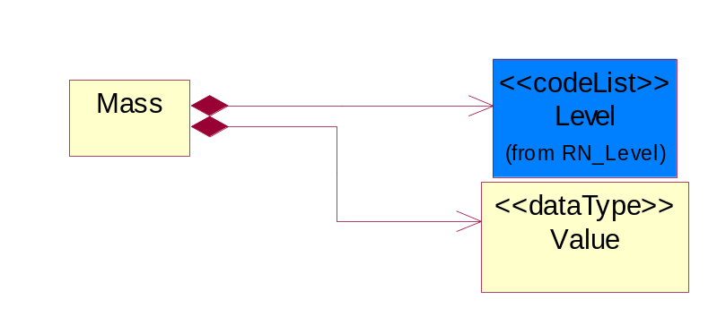
Figure 3-11 Mass

Composition | Cardinality | Type | Documentation
Value | 1 | Value | Based on ECTD/IEC specification, Mass should be specified in kilogram (KG) per IEC 61360 - 1 (Annex B) - (http://www.iec.ch/tc3/txt/143.htm) format for floating point, positive or negative.  Example of preferred format:  a. 2kg - will be specified as 2.0E KG  b. 200g - will be specified as 200.0E - 3 KG  c. 20mg - will be specified as 20.0E- 6 KG
Level | 1 | Level | This is to qualify the type of the product, material or substance mass either maximum, minimum, typical, nominal independently or with any combination such as when specifying range of mass between minimum and maximum. In this case, the mass reporting will loop and for each instance it will have different Level entry.

MassPercentage

Weight percentage of total mass. Usually specified for parts per million (ppm). A number representing a percentage value, e.g. 75.125 represents 75 1/8 percent.

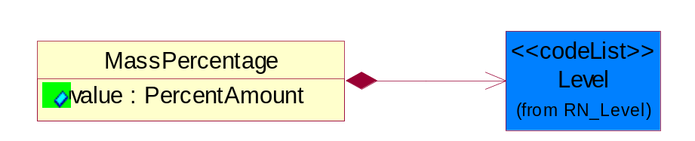
Figure 3-12 MassPercentage

Attribute | Type | Documentation
value | PercentAmount | A number representing a percentage value, e.g. 75.125 represents 75 1/8 percent

Composition | Cardinality | Type | Documentation
Level | 1 | Level | This is to qualify the type of the product, material or substance mass either maximum, minimum, typical, nominal independently or with any combination such as when specifying range of mass between minimum and maximum. In this case, the mass reporting will loop and for each instance it will have different Level entry.

Note

Additonal notation for the notification, product information, substance or radioactivity.

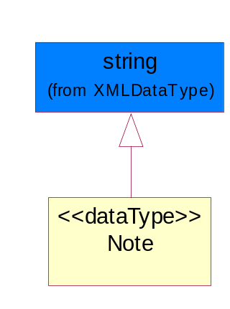
Figure 3-13 Note

ProductMass

Product Total Mass (weight) MUST be specified in KIG (kg) (kilogram) even the actual value ranges from nano grams to giga kilograms. The unit of measure would still be KIG (kg).

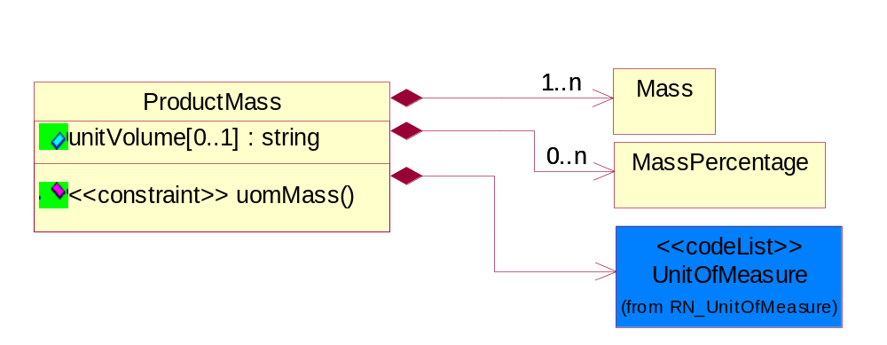
Figure 3-14 ProductMass

Attribute | Type | Documentation
unitVolume[0..1] | string | Describes the scoped weight to a unit volume such as cubic meter or cubic feet, square meter or square foot etc. To provide concise reporting of bulk materials, components, sub-assemblies and finished products.

Composition | Cardinality | Type | Documentation
Mass | 1..n | Mass | Based on ECTD/IEC specification, Mass should be specified in kilogram (KG) per IEC 61360 - 1 (Annex B) - (http://www.iec.ch/tc3/txt/143.htm) format for floating point, positive or negative.
UnitOfMeasure | 1 | UnitOfMeasure | Code identifying a product unit of measure.
MassPercentage | 0..n | MassPercentage | Weight percentage of total mass. Usually specified for parts per million (ppm). A number representing a percentage value, e.g. 75.125 represents 75 1/8 percent.

Constraint | Documentation
uomMass | If occurrence of Mass is between 1 and unbounded then the value of UnitOfMeasure MUST be 'KIG'.

ReferenceLocator

Meta data describing a logical representation of a set of arbitrary data. A collection of properties identifying a ProductInformationObject with an attachment.

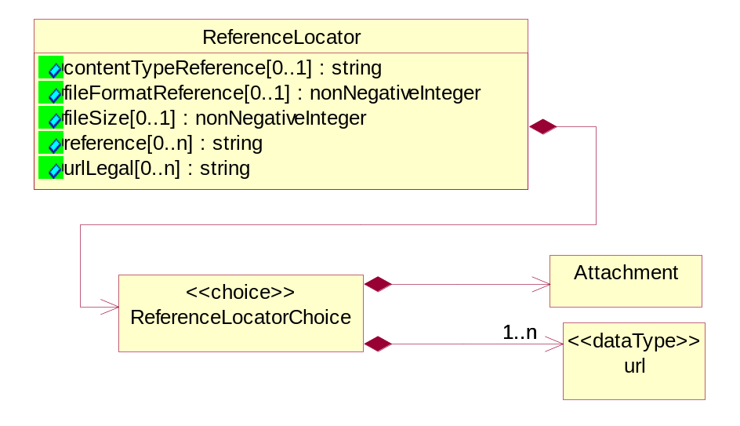
Figure 3-15 ReferenceLocator

Attribute | Type | Documentation
contentTypeReference[0..1] | string | A unique identifier that defines the category of information provided by this ProductInformationObject.
fileFormatReference[0..1] | nonNegativeInteger | A unique identifier that defines the type data encoding for this ProductInformationObject.
fileSize[0..1] | nonNegativeInteger | The size of an object.
reference[0..n] | string | Represented as a URL (Uniform Resource Locator defined in accordance with RFC 2396 http://www.w3.org/Addressing). The URL's purpose is to provide supplementary information related to the ProductInformationObject.
urlLegal[0..n] | string | Using a URL (Uniform Resource Locator defined in accordance with RFC 2396 http://www.w3.org/Addressing) to describe terms, conditions, disclaimers, warnings, limitations, or other information related to the ProductInformationObject.

Composition | Cardinality | Type | Documentation
ReferenceLocatorChoice | 1 | ReferenceLocatorChoice

ReferenceLocatorChoice

Composition | Cardinality | Type | Documentation
url | 1..n | url | The URL (Uniform Resource Locator defined in accordance with RFC 2396 http://www.w3.org/Addressing) is used for accessing dynamic supplementary information maintained by a domain authority. It is used as a storage area for an attachment. When this request is rendered it will return only the requested attached data.
Attachment | 1 | Attachment | Meta data describing a logical representation of a set of arbitrary data. A collection of properties identifying a ProductInformationObject with an attachment.

SubpartIdentifier

Identification for the Subpart.

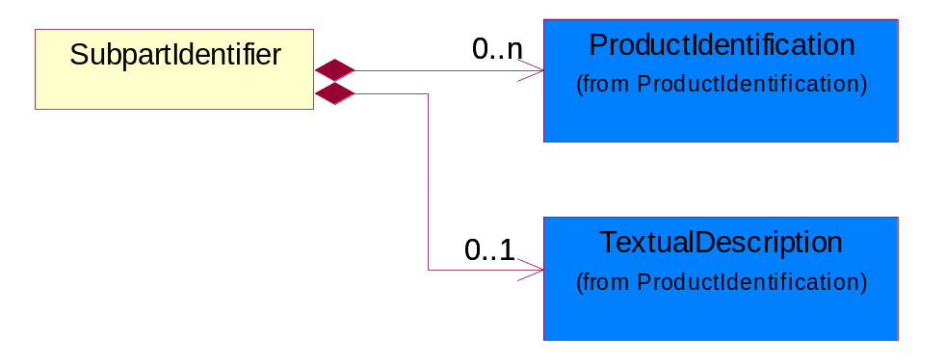
Figure 3-16 SubpartIdentifier

Composition | Cardinality | Type | Documentation
ProductIdentification | 0..n | ProductIdentification | The object provides the identifier(s) of a product.
TextualDescription | 0..1 | TextualDescription | The business document must allow for multiple levels of textual description of an event or object.

url

The URL (Uniform Resource Locator defined in accordance with RFC 2396 http://www.w3.org/Addressing) is used for accessing dynamic supplementary information maintained by a domain authority. It is used as a storage area for an attachment. When this request is rendered it will return only the requested attached data.

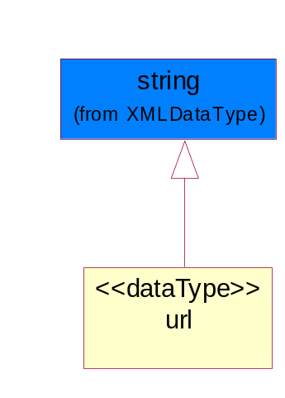
Figure 3-17 url

Value

Based on ECTD/IEC specification, Mass should be specified in kilogram (KG) per IEC 61360 - 1 (Annex B) - (http://www.iec.ch/tc3/txt/143.htm) format for floating point, positive or negative.

Example of preferred format:
a. 2kg - will be specified as 2.0E KG
b. 200g - will be specified as 200.0E - 3 KG
c. 20mg - will be specified as 20.0E- 6 KG

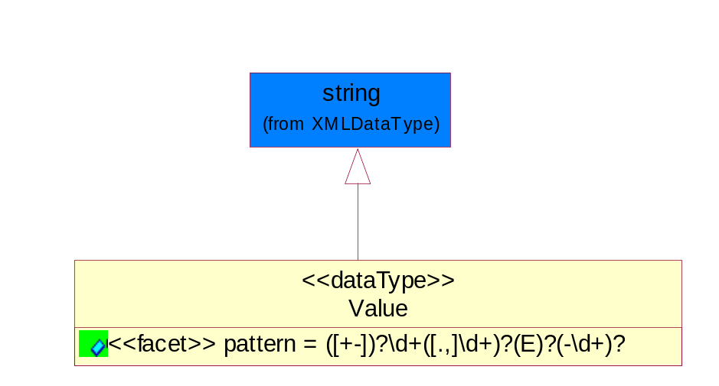
Figure 3-18 Value

Attribute | Type | Documentation
pattern |  | For reals, MAY have (+-) and then MUST have 1 or more digits, and then MUST have a period (or comma) and then MUST have or more digits.  For floating numbers, MAY have (+-) and then MUST have 1 or more digits, and then MUST have a period (or comma) and then MUST have or more digits and then MAY have 'E' and then MAY have (-) sign and then MAY have 1 or 2 digits.

CodeList

Level

This is to qualify the type of the product, material or substance mass either maximum, minimum, typical, nominal independently or with any combination such as when specifying range of mass between minimum and maximum. In this case, the mass reporting will loop and for each instance it will have different Level entry.

Name | Documentation
MAX | A Maximum level of the mass (weight) MUST be specified as KIG (kilogram) using ECTD/IEC/ISO Specification for the UOM field.
MIN | A Minimum level of the mass (weight) MUST be specified as KIG (kilogram) using ECTD/IEC/ISO Specification for the UOM field.
NOM | A Nominal level of the mass (weight) MUST be specified as KIG (kilogram) using ECTD/IEC/ISO Specification for the UOM field.
TYP | A Typical level of the mass (weight) MUST be specified as KIG (kilogram) using ECTD/IEC/ISO Specification for the UOM field.

Compliant

Describes the Directive Complaint level of a product, subpart or substance.

Name | Documentation
CEX | Compliant with exemptions.
CLE | Compliant with lead exemptions.
CMP | Compliant.
NCP | Not Compliant.
OBP | Obsolete part.
UNK | Unknown part.

Universal Structure

ContactInformation

ContactInformation

The business document must allow for the identification of the name of the department, service or individual to be contacted regarding the context of the business document.

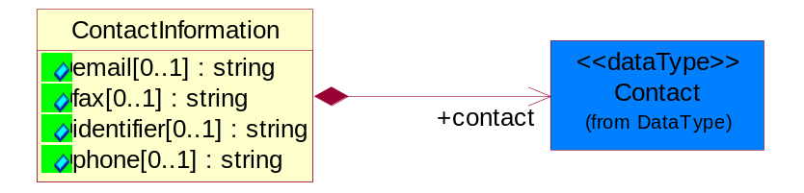
Figure 4-19 ContactInformation

Attribute | Type | Documentation
email[0..1] | string | The electronic mail for the specified contact.
fax[0..1] | string | The fax number for the specified contact.
identifier[0..1] | string | Identifies the role of the contact (i.e. Service Technician, Account Manager) in the Business Process.
phone[0..1] | string | The telephone number for the specified contact.

Composition | Cardinality | Type | Documentation
contact | 1 | Contact | The name of the department, service or individual to be contacted within the organization.

DataType

Contact

The name of the department, service or individual to be contacted within the organization.

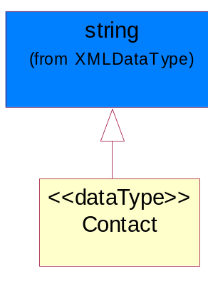
Figure 4-20 Contact

DUNS

A number assigned by Dun and Bradstreet to identify a business location.

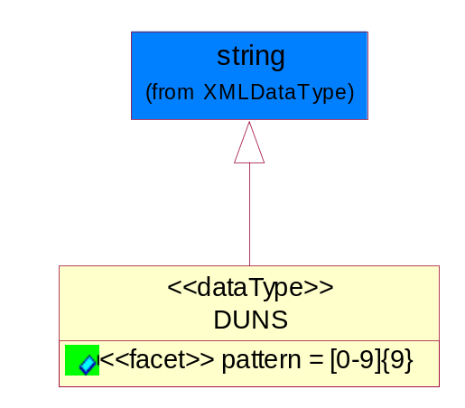
Figure 4-21 DUNS

Attribute | Type | Documentation
pattern |  | [0-9]{9}

DUNSPlus4

A identifier to specify a specific location within a business location.

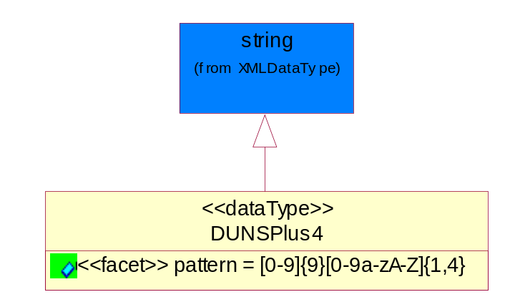
Figure 4-22 DUNSPlus4

Attribute | Type | Documentation
pattern |  | Data Universal Numbering System +4 (DUNS+4) number means the DUNS number assigned by Dun and Bradstreet, Inc. (D&B) plus an alphanumeric of length 4 suffix that may be assigned by a business concern.

GLN

Global Location Number (GLN) - A identifier to identify legal entities, trading parties and location.

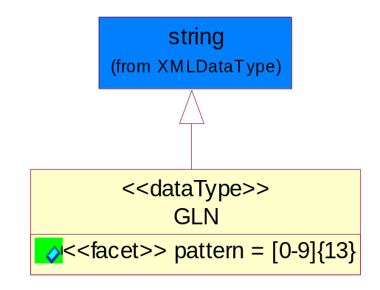
Figure 4-23 GLN

Attribute | Type | Documentation
pattern |  | [0-9]{13}

GTIN

Global Trade Identification Number (GTIN).

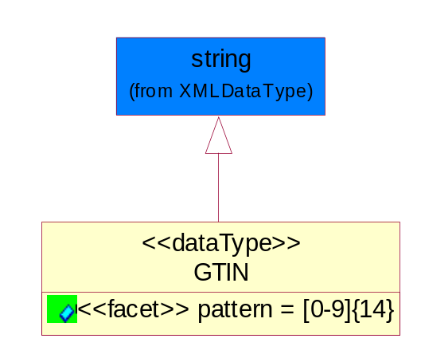
Figure 4-24 GTIN

Attribute | Type | Documentation
pattern |  | [0-9]{14}

PercentAmount

A number representing a percentage value, e.g. 75.125 represents 75 1/8 percent.

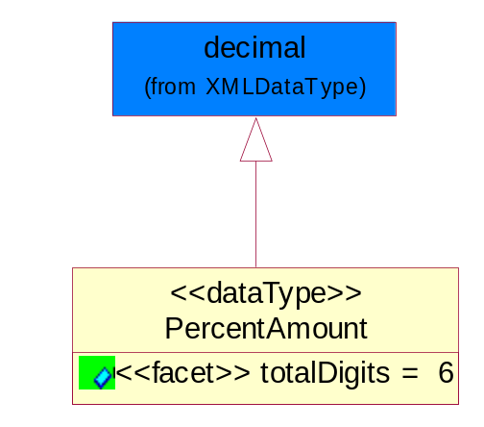
Figure 4-25 PercentAmount

Attribute | Type | Documentation
totalDigits |  | 6

Document

BusinessDocumentReference

The business document reference object allows for the indirect referencing of a relationship to other business related documents.

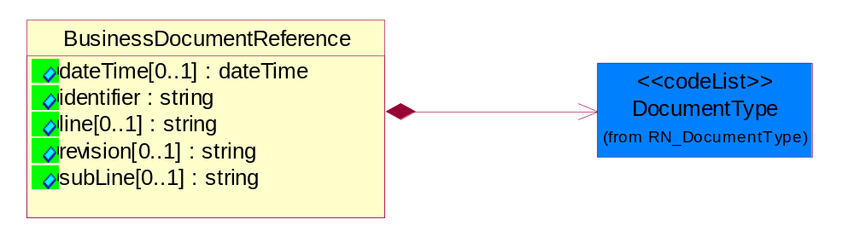
Figure 4-26 BusinessDocumentReference

Attribute | Type | Documentation
dateTime[0..1] | dateTime | The date-time stamp indicating on the referenced business document.
identifier | string | Unique identification of the referenced business document.
line[0..1] | string | References the specific line number of the specified business document.
revision[0..1] | string | Referenced the revision of the specified business document.
subLine[0..1] | string | References the specific subline number of the specified business document.

Composition | Cardinality | Type | Documentation
DocumentType | 1 | DocumentType | A code identifying the business context of a document.

Locations

AlternativeIdentifier

Identifies the specified code and the name of the organization that a code is utilized from.

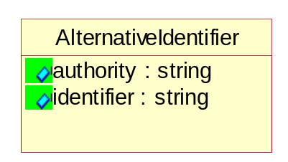
Figure 4-27 AlternativeIdentifier

Attribute | Type | Documentation
authority | string | The name of the organization that a code is utilized from.
identifier | string | The specified code to represent an entity (e.g. product, location, partner, etc.)

PartnerIdentification

PartnerIdentification

The business document must allow for the identity of one or more parties to the transaction.

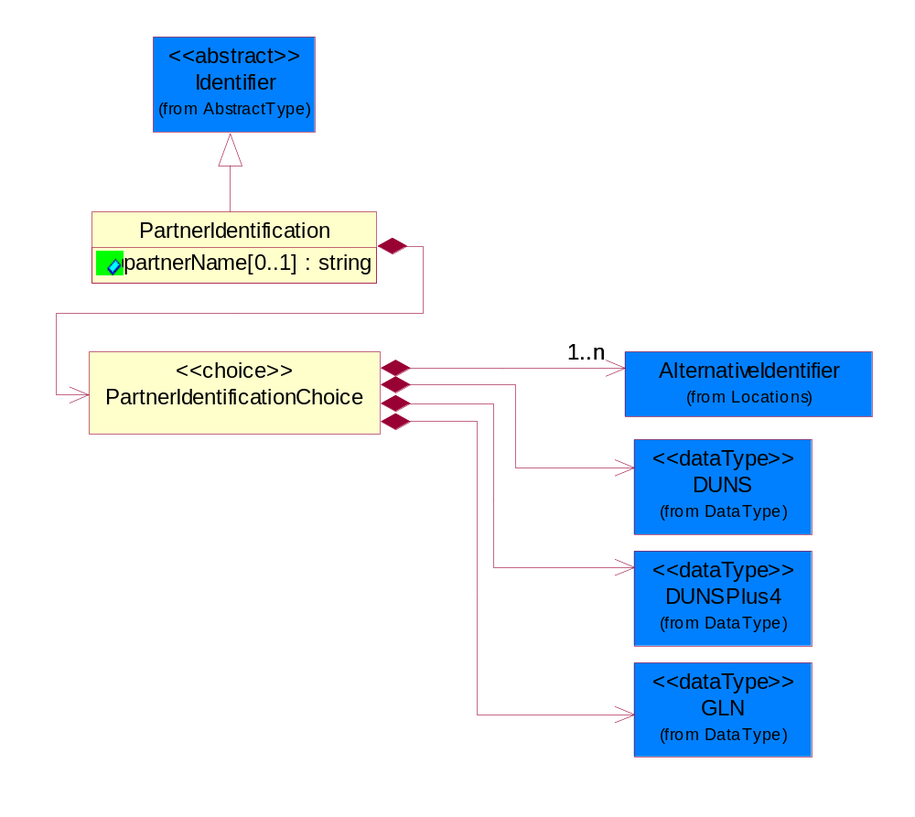
Figure 4-28 PartnerIdentification

Attribute | Type | Documentation
partnerName[0..1] | string | The name of the partner’s company/business.

Composition | Cardinality | Type | Documentation
PartnerIdentificationChoice | 1 | PartnerIdentificationChoice

PartnerIdentificationChoice

Composition | Cardinality | Type | Documentation
DUNS | 1 | DUNS | A number assigned by Dun and Bradstreet to identify a business location.
DUNSPlus4 | 1 | DUNSPlus4 | A identifier to specify a specific location within a business location.
AlternativeIdentifier | 1..n | AlternativeIdentifier | Identifies the specified code and the name of the organization that a code is utilized from.
GLN | 1 | GLN | Global Location Number (GLN) - A identifier to identify legal entities, trading parties and location.

ProductIdentification

ProductDescription

The business document must allow for the identification of the product and multiple textual descriptions of a product.

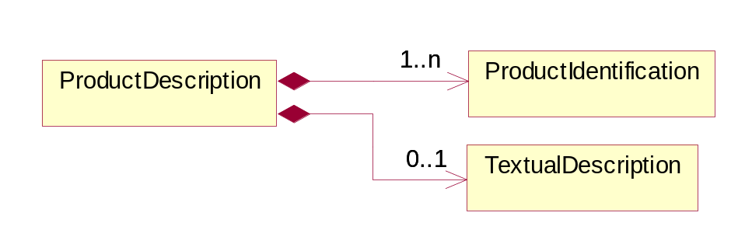
Figure 4-29 ProductDescription

Composition | Cardinality | Type | Documentation
ProductIdentification | 1..n | ProductIdentification | The object provides the identifier(s) of a product.
TextualDescription | 0..1 | TextualDescription | The business document must allow for multiple levels of textual description of an event or object.

ProductIdentification

The object provides the identifier(s) of a product.

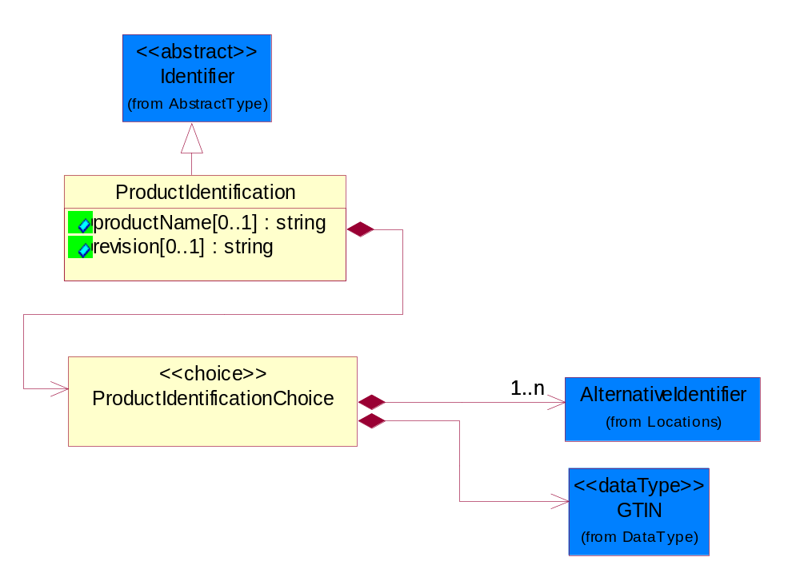
Figure 4-30 ProductIdentification

Attribute | Type | Documentation
productName[0..1] | string | The name of the product.
revision[0..1] | string | Referenced the specified product revision.

Composition | Cardinality | Type | Documentation
ProductIdentificationChoice | 1 | ProductIdentificationChoice

ProductIdentificationChoice

Composition | Cardinality | Type | Documentation
AlternativeIdentifier | 1..n | AlternativeIdentifier | Identifies the specified code and the name of the organization that a code is utilized from.
GTIN | 1 | GTIN | Global Trade Identification Number (GTIN).

TextualDescription

The business document must allow for multiple levels of textual description of an event or object.

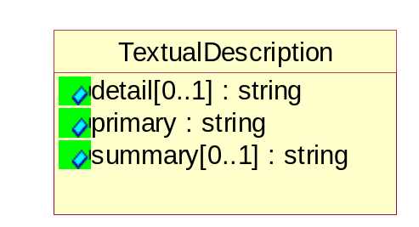
Figure 4-31 TextualDescription

Attribute | Type | Documentation
detail[0..1] | string | A detail description of an event or object.
primary | string | A phrase or single word description of an event or object.
summary[0..1] | string | A condensed description of an event or object.

CodeList

Language

For representation of Language name RosettaNet has adopted ISO 639-2; 1998. Refer to the following web page to get the latest version of the standard:

http://www.loc.gov/standards/iso639-2/iso639jac.html

If you need more information about the ISO standard please contact ISO for more details.

DocumentType

A code identifying the business context of a document.

Instance | Documentation
CBN | Product batch number of customer.
CCN | Customs clearance number.
CFA | Failure Analysis - Request document that will accompany the product providing characteristics of the component failure.
CIN | Commercial Invoice.
CNM | Traditional credit note or memo.
CON | In a virtual sourcing relationship, a third party trading partner is supplying a part to a customer on behalf of another company that has taken the order for the customer. In this case a Customer Order Number is associated to the request for material that is sent to the virtual trading partners.
COT | Contract.
CRN | Unique consumption reference number identifying the product consumption issue i.e. one-to-one relationship with physical flow.
DEM | Traditional debit note or memo.
DEN | Delivery Note.
DIN | Discontinuation Notice.
DRN | Drawing Number.
FUO | Sales order or transfer order fulfilling demand out of a facility (outbound shipment).
INV | Invoice.
LID | Location Identifier. Data for on-site work that have to be done on the machine (associated with preventive maintenance order)
MEN | Master Event Number.
MID | Machine Identifier. Data for on-site work that have to be done on the machine (associated with preventive maintenance order)
MON | Model Number.
OCL | The unique identifier assigned by the OEM for a warranty claim.
OPO | The unique identifier assigned by the OEM for a part order.
OPR | The unique identifier assigned by the OEM for a part return.
PFA | Failure Analysis - Request document that will accompany the product providing characteristics of the product failure.
PII | Refers to previously issued invoice.
PLS | Unique number that identifies packing form prior to shipment.
POI | Purchase Order IN.
PON | Production order number for material release.
POO | Purchase Order OUT
PRC | Product Catalog.
PSI | Refers to previously issued self-billing invoice.
PUO | Purchase Order.
QUO | Quote.
REC | Document identifying the receipt of materials or products into a facility against a purchase order or transfer order (inbound shipment).
REO | Purchase order or transfer order replenishing inventory into a facility (inbound shipment).
REQ | Requisition.
RMA | Returned Material Authorization.
RPO | Purchase order for materials or product returned to and reworked by a supplier.
SAO | Sales Order.
SBC | Credit Memo used in self-billing scenario.
SBD | Debit Memo used in self-billing scenario.
SBI | Invoice in self billing scenario.
SBN | Product batch number of supplier.
SCA | Similar to contracts - Contains the quantity of an article that is to be ordered from a vendor and the price for article or service that is to be procured.
SEN | Serial Number.
SEO | A document that gives a repair provider the necessary authorization to repair or upgrade a product either at the customer site or at the repair provider’s site.
SNC | Shipset Number on Code List.
SPC | The unique identifier assigned by the ASP for a warranty claim.
SPN | Spec Number.
SPO | The unique identifier assigned by the ASP for a part order.
SPR | The unique identifier assigned by the ASP for a part return.
SPW | The unique identifier assigned by the ASP to reference a work order.
SRI | A document that contains the shipping reference number which allows the product to be tracked within the outsourced logistic providers network.
TRO | Order which results in materials or products being moved from one facility to another (outbound shipment and inbound shipment).
WAB | Waybill.
WAC | Denotes a warranty claim.
WOO | Work Order.

MimeTypeQualifier

The MIME type as defined by IANA.

Please refer to http://www.iana.org/assignments/media-types/ for a list of types.

Instance | Documentation
application/activemessage | [Shapiro]
application/andrew-inset | [Borenstein]
application/applefile | [Faltstrom]
application/atomicmail | [Borenstein]
application/batch-SMTP | [RFC2442]
application/beep+xml | [RFC3080]
application/cals-1840 | [RFC1895]
application/cnrp+xml | [RFCCNRP]
application/commonground | [Glazer]
application/cpl+xml
application/cybercash | [Eastlake]
application/dca-rft | [Campbell]
application/dec-dx | [Campbell]
application/dicom | [RFC3240]
application/dvcs | [RFC3029]
application/EDI-Consent | [RFC1767]
application/EDIFACT | [RFC1767]
application/EDI-X12 | [RFC1767]
application/eshop | [Katz]
application/font-tdpfr | [RFC3073]
application/http | [RFC2616]
application/hyperstudio | [Domino]
application/iges | [Parks]
application/index | [RFC2652]
application/index.cmd | [RFC2652]
application/index.obj | [RFC2652]
application/index.response | [RFC2652]
application/index.vnd | [RFC2652]
application/iotp | [RFC2935]
application/ipp | [RFC2910]
application/isup | [RFC3204]
application/mac-binhex40 | [Faltstrom]
application/macwriteii | [Lindner]
application/marc | [RFC2220]
application/mathematica | [Van Nostern]
application/msword | [Lindner]
application/news-message-id | [RFC1036,Spencer]
application/news-transmission | [RFC1036, Spencer]
application/ocsp-request | [RFC2560]
application/ocsp-response | [RFC2560]
application/octet-stream | [RFC2045,RFC2046]
application/oda | [RFC2045,RFC2046]
application/ogg | [RFC-walleij-ogg-mediatype-08.txt]
application/parityfec | [RFC3009]
application/pdf | [Lindner]
application/pgp-encrypted | [RFC3156]
application/pgp-keys | [RFC3156]
application/pgp-signature | [RFC3156]
application/pkcs10 | [RFC2311]
application/pkcs7-mime | [RFC2311]
application/pkcs7-signature | [RFC2311]
application/pkix-cert | [RFC2585]
application/pkixcmp | [RFC2510]
application/pkix-crl | [RFC2585]
application/postscript | [RFC2045,RFC2046]
application/prs.alvestrand.titrax-sheet | [Alvestrand]
application/prs.cww | [Rungchavalnont]
application/prs.nprend | [Doggett]
application/prs.plucker | [Janssen]
application/qsig | [RFC3204]
application/reginfo+xml | [RFC-ietf-sipping-reg-event-00.txt]
application/remote-printing | [RFC1486,Rose]
application/riscos | [Smith]
application/rtf | [Lindner]
application/sdp | [RFC2327]
application/set-payment | [Korver]
application/set-payment-initiation | [Korver]
application/set-registration | [Korver]
application/set-registration-initiation | [Korver]
application/sgml | [RFC1874]
application/sgml-open-catalog | [Grosso]
application/sieve | [RFC3028]
application/slate | [Crowley]
application/timestamp-query | [RFC3161]
application/timestamp-reply | [RFC3161]
application/tve-trigger | [Welsh]
application/vemmi | [RFC2122]
application/vnd.3gpp.pic-bw-large | [Meredith]
application/vnd.3gpp.pic-bw-small | [Meredith]
application/vnd.3gpp.pic-bw-var | [Meredith]
application/vnd.3gpp.sms | [Meredith]
application/vnd.3M.Post-it-Notes | [O'Brien]
application/vnd.accpac.simply.aso | [Leow]
application/vnd.accpac.simply.imp | [Leow]
application/vnd.acucobol | [Lubin]
application/vnd.acucorp | [Lubin]
application/vnd.adobe.xfdf | [Perelman]
application/vnd.aether.imp | [Moskowitz]
application/vnd.amiga.ami | [Blumberg]
application/vnd.anser-web-certificate-issue-initiation | [Mori]
application/vnd.anser-web-funds-transfer-initiation | [Mori]
application/vnd.audiograph | [Slusanschi]
application/vnd.blueice.multipass | [Holmstrom]
application/vnd.bmi | [Gotoh]
application/vnd.businessobjects | [Imoucha]
application/vnd.canon-cpdl | [Muto]
application/vnd.canon-lips | [Muto]
application/vnd.cinderella | [Kortenkamp]
application/vnd.claymore | [Simpson]
application/vnd.commerce-battelle | [Applebaum]
application/vnd.commonspace | [Chandhok]
application/vnd.contact.cmsg | [Patz]
application/vnd.cosmocaller | [Dellutri]
application/vnd.ctc-posml | [Kohlhepp]
application/vnd.cups-postscript | [Sweet]
application/vnd.cups-raster | [Sweet]
application/vnd.cups-raw | [Sweet]
application/vnd.curl | [Byrnes]
application/vnd.cybank | [Helmee]
application/vnd.data-vision.rdz | [Fields]
application/vnd.dna | [Searcy]
application/vnd.dpgraph | [Parker]
application/vnd.dreamfactory | [Appleton]
application/vnd.dxr | [Duffy]
application/vnd.ecdis-update | [Buettgenbach]
application/vnd.ecowin.chart | [Olsson]
application/vnd.ecowin.filerequest | [Olsson]
application/vnd.ecowin.fileupdate | [Olsson]
application/vnd.ecowin.series | [Olsson]
application/vnd.ecowin.seriesrequest | [Olsson]
application/vnd.ecowin.seriesupdate | [Olsson]
application/vnd.enliven | [Santinelli]
application/vnd.epson.esf | [Hoshina]
application/vnd.epson.msf | [Hoshina]
application/vnd.epson.quickanime | [Gu]
application/vnd.epson.salt | [Nagatomo]
application/vnd.epson.ssf | [Hoshina]
application/vnd.ericsson.quickcall | [Tidwell]
application/vnd.eudora.data | [Resnick]
application/vnd.fdf | [Zilles]
application/vnd.ffsns | [Holstage]
application/vnd.FloGraphIt | [Floersch]
application/vnd.framemaker | [Wexler]
application/vnd.fsc.weblaunch | [D.Smith]
application/vnd.fujitsu.oasys | [Togashi]
application/vnd.fujitsu.oasys2 | [Togashi]
application/vnd.fujitsu.oasys3 | [Okudaira]
application/vnd.fujitsu.oasysgp | [Sugimoto]
application/vnd.fujitsu.oasysprs | [Ogita]
application/vnd.fujixerox.ddd | [Onda]
application/vnd.fujixerox.docuworks | [Taguchi]
application/vnd.fujixerox.docuworks.binder | [Matsumoto]
application/vnd.fut-misnet | [Pruulmann]
application/vnd.grafeq | [Tupper]
application/vnd.groove-account | [Joseph]
application/vnd.groove-help | [Joseph]
application/vnd.groove-identity-message | [Joseph]
application/vnd.groove-injector | [Joseph]
application/vnd.groove-tool-message | [Joseph]
application/vnd.groove-tool-template | [Joseph]
application/vnd.groove-vcard | [Joseph]
application/vnd.hbci | [Hammann]
application/vnd.hhe.lesson-player | [Jones]
application/vnd.hp-HPGL | [Pentecost]
application/vnd.hp-hpid | [Gupta]
application/vnd.hp-hps | [Aubrey]
application/vnd.hp-PCL | [Pentecost]
application/vnd.hp-PCLXL | [Pentecost]
application/vnd.httphone | [Lefevre]
application/vnd.hzn-3d-crossword | [Minnis]
application/vnd.ibm.afplinedata | [Buis]
application/vnd.ibm.electronic-media | [Tantlinger]
application/vnd.ibm.MiniPay | [Herzberg]
application/vnd.ibm.modcap | [Hohensee]
application/vnd.ibm.secure-container | [Tantlinger]
application/vnd.informix-visionary | [Gales]
application/vnd.intercon.formnet | [Gurak]
application/vnd.intertrust.digibox | [Tomasello]
application/vnd.intertrust.nncp | [Tomasello]
application/vnd.intu.qbo | [Scratchley]
application/vnd.intu.qfx | [Scratchley]
application/vnd.irepository.package+xml | [Knowles]
application/vnd.is-xpr | [Natarajan]
application/vnd.japannet-directory-service | [Fujii]
application/vnd.japannet-jpnstore-wakeup | [Yoshitake]
application/vnd.japannet-payment-wakeup | [Fujii]
application/vnd.japannet-registration | [Yoshitake]
application/vnd.japannet-registration-wakeup | [Fujii]
application/vnd.japannet-setstore-wakeup | [Yoshitake]
application/vnd.japannet-verification | [Yoshitake]
application/vnd.japannet-verification-wakeup | [Fujii]
application/vnd.jisp | [Deckers]
application/vnd.kde.karbon | [Faure]
application/vnd.kde.kchart | [Faure]
application/vnd.kde.kformula | [Faure]
application/vnd.kde.kivio | [Faure]
application/vnd.kde.kontour | [Faure]
application/vnd.kde.kpresenter | [Faure]
application/vnd.kde.kspread | [Faure]
application/vnd.kde.kword | [Faure]
application/vnd.kenameaapp | [DiGiorgio-Haag]
application/vnd.koan | [Cole]
application/vnd.liberty-request+xml | [McDowell]
application/vnd.llamagraphics.life-balance.desktop | [White]
application/vnd.lotus-1-2-3 | [Wattenberger]
application/vnd.lotus-approach | [Wattenberger]
application/vnd.lotus-freelance | [Wattenberger]
application/vnd.lotus-notes | [Laramie]
application/vnd.lotus-organizer | [Wattenberger]
application/vnd.lotus-screencam | [Wattenberger]
application/vnd.lotus-wordpro | [Wattenberger]
application/vnd.mcd | [Gotoh]
application/vnd.mediastation.cdkey | [Flurry]
application/vnd.meridian-slingshot | [Wedel]
application/vnd.micrografx.flo | [Prevo]
application/vnd.micrografx.igx | [Prevo]
application/vnd.mif | [Wexler]
application/vnd.minisoft-hp3000-save | [Bartram]
application/vnd.mitsubishi.misty-guard.trustweb | [Tanaka]
application/vnd.Mobius.DAF | [Kabayama]
application/vnd.Mobius.DIS | [Kabayama]
application/vnd.Mobius.MBK | [Devasia]
application/vnd.Mobius.MQY | [Devasia]
application/vnd.Mobius.MSL | [Kabayama]
application/vnd.Mobius.PLC | [Kabayama]
application/vnd.Mobius.TXF | [Kabayama]
application/vnd.mophun.application | [Wennerstrom]
application/vnd.mophun.certificate | [Wennerstrom]
application/vnd.motorola.flexsuite | [Patton]
application/vnd.motorola.flexsuite.adsi | [Patton]
application/vnd.motorola.flexsuite.fis | [Patton]
application/vnd.motorola.flexsuite.gotap | [Patton]
application/vnd.motorola.flexsuite.kmr | [Patton]
application/vnd.motorola.flexsuite.ttc | [Patton]
application/vnd.motorola.flexsuite.wem | [Patton]
application/vnd.mozilla.xul+xml | [McDaniel]
application/vnd.ms-artgalry | [Slawson]
application/vnd.ms-asf | [Fleischman]
application/vnd.mseq | [Le Bodic]
application/vnd.ms-excel | [Gill]
application/vnd.msign | [Borcherding]
application/vnd.ms-lrm | [Ledoux]
application/vnd.ms-powerpoint | [Gill]
application/vnd.ms-project | [Gill]
application/vnd.ms-tnef | [Gill]
application/vnd.ms-works | [Gill]
application/vnd.ms-wpl | [Plastina]
application/vnd.musician | [Adams]
application/vnd.music-niff | [Butler]
application/vnd.netfpx | [Mutz]
application/vnd.noblenet-directory | [Solomon]
application/vnd.noblenet-sealer | [Solomon]
application/vnd.noblenet-web | [Solomon]
application/vnd.novadigm.EDM | [Swenson]
application/vnd.novadigm.EDX | [Swenson]
application/vnd.novadigm.EXT | [Swenson]
application/vnd.obn | [Hessling]
application/vnd.osa.netdeploy | [Klos]
application/vnd.palm | [Peacock]
application/vnd.pg.format | [Gandert]
application/vnd.pg.osasli | [Gandert]
application/vnd.powerbuilder6 | [Guy]
application/vnd.powerbuilder6-s | [Guy]
application/vnd.powerbuilder7 | [Shilts]
application/vnd.powerbuilder75 | [Shilts]
application/vnd.powerbuilder75-s | [Shilts]
application/vnd.powerbuilder7-s | [Shilts]
application/vnd.previewsystems.box | [Smolgovsky]
application/vnd.publishare-delta-tree | [Ben-Kiki]
application/vnd.pvi.ptid1 | [Lamb]
application/vnd.pwg-multiplexed | [RFC3391]
application/vnd.pwg-xhtml-print+xml | [Wright]
application/vnd.Quark.QuarkXPress | [Scheidler]
application/vnd.rapid | [Szekely]
application/vnd.s3sms | [Tarkkala]
application/vnd.sealed.net | [Lambert]
application/vnd.seemail | [Webb]
application/vnd.shana.informed.formdata | [Selzler]
application/vnd.shana.informed.formtemplate | [Selzler]
application/vnd.shana.informed.interchange | [Selzler]
application/vnd.shana.informed.package | [Selzler]
application/vnd.smaf | [Takahashi]
application/vnd.sss-cod | [Dani]
application/vnd.sss-dtf | [Bruno]
application/vnd.sss-ntf | [Bruno]
application/vnd.street-stream | [Levitt]
application/vnd.svd | [Becker]
application/vnd.swiftview-ics | [Widener]
application/vnd.triscape.mxs | [Simonoff]
application/vnd.trueapp | [Hepler]
application/vnd.truedoc | [Chase]
application/vnd.ufdl | [Manning]
application/vnd.uplanet.alert | [Martin]
application/vnd.uplanet.alert-wbxml | [Martin]
application/vnd.uplanet.bearer-choice | [Martin]
application/vnd.uplanet.bearer-choice-wbxml | [Martin]
application/vnd.uplanet.cacheop | [Martin]
application/vnd.uplanet.cacheop-wbxml | [Martin]
application/vnd.uplanet.channel | [Martin]
application/vnd.uplanet.channel-wbxml | [Martin]
application/vnd.uplanet.list | [Martin]
application/vnd.uplanet.listcmd | [Martin]
application/vnd.uplanet.listcmd-wbxml | [Martin]
application/vnd.uplanet.list-wbxml | [Martin]
application/vnd.uplanet.signal | [Martin]
application/vnd.vcx | [T.Sugimoto]
application/vnd.vectorworks | [Pharr]
application/vnd.vidsoft.vidconference | [Hess]
application/vnd.visio | [Sandal]
application/vnd.visionary | [Aravindakumar]
application/vnd.vividence.scriptfile | [Risher]
application/vnd.vsf | [Rowe]
application/vnd.wap.sic | [WAP-Forum]
application/vnd.wap.slc | [WAP-Forum]
application/vnd.wap.wbxml | [Stark]
application/vnd.wap.wmlc | [Stark]
application/vnd.wap.wmlscriptc | [Stark]
application/vnd.webturbo | [Rehem]
application/vnd.wrq-hp3000-labelled | [Bartram]
application/vnd.wt.stf | [Wohler]
application/vnd.wv.csp+wbxml | [Salmi]
application/vnd.xara | [Matthewman]
application/vnd.xfdl | [Manning]
application/vnd.yellowriver-custom-menu | [Yellow]
application/whoispp-query | [RFC2957]
application/whoispp-response | [RFC2958]
application/wita | [Campbell]
application/wordperfect5.1 | [Lindner]
application/x400-bp | [RFC1494]
application/xhtml+xml | [RFC3236]
application/xml | [RFC3023]
application/xml-dtd | [RFC3023]
application/xml-external-parsed-entity | [RFC3023]
application/zip | [Lindner]
audio/32kadpcm | [RFC2421,RFC2422]
audio/AMR | [RFC3267]
audio/AMR-WB | [RFC3267]
audio/basic | [RFC2045,RFC2046]
audio/CN | [RFC3389]
audio/DAT12 | [RFC3190]
audio/DVI4
audio/EVRC | [RFC-ietf-avt-evrc-smv-03.txt]
audio/EVRC0 | [RFC-ietf-avt-evrc-smv-03.txt]
audio/G.722.1 | [RFC3047]
audio/G722
audio/G723
audio/G726-16
audio/G726-24
audio/G726-32
audio/G726-40
audio/G728
audio/G729
audio/G729D
audio/G729E
audio/GSM
audio/GSM-EFR
audio/L16 | [RFC2586]
audio/L20 | [RFC3190]
audio/L24 | [RFC3190]
audio/L8
audio/LPC
audio/MP4A-LATM | [RFC3016]
audio/MPA
audio/mpa-robust | [RFC3119]
audio/mpeg | [RFC3003]
audio/parityfec | [RFC3009]
audio/PCMA
audio/PCMU
audio/prs.sid | [Walleij]
audio/QCELP
audio/RED
audio/SMV | [RFC-ietf-avt-evrc-smv-03.txt]
audio/SMV0 | [RFC-ietf-avt-evrc-smv-03.txt]
audio/telephone-event | [RFC2833]
audio/tone | [RFC2833]
audio/VDVI
audio/vnd.3gpp.iufp | [Belling]
audio/vnd.cisco.nse | [Kumar]
audio/vnd.cns.anp1 | [McLaughlin]
audio/vnd.cns.inf1 | [McLaughlin]
audio/vnd.digital-winds | [Strazds]
audio/vnd.everad.plj | [Cicelsky]
audio/vnd.lucent.voice | [Vaudreuil]
audio/vnd.nortel.vbk | [Parsons]
audio/vnd.nuera.ecelp4800 | [Fox]
audio/vnd.nuera.ecelp7470 | [Fox]
audio/vnd.nuera.ecelp9600 | [Fox]
audio/vnd.octel.sbc | [Vaudreuil]
audio/vnd.qcelp | [Lundblade]
audio/vnd.rhetorex.32kadpcm | [Vaudreuil]
audio/vnd.vmx.cvsd | [Vaudreuil]
image/cgm | Computer Graphics Metafile
image/g3fax | [RFC1494]
image/gif | [RFC2045,RFC2046]
image/ief | [RFC1314] Image Exchange Format
image/jpeg | [RFC2045,RFC2046]
image/naplps | [Ferber]
image/png | [Randers-Pehrson]
image/prs.btif | [Simon]
image/prs.pti | [Laun]
image/t38 | [RFC3362]
image/tiff | [RFC3302] Tag Image File Format
image/tiff-fx | [RFC3250] Tag Image File Format Fax eXtended
image/vnd.cns.inf2 | [McLaughlin]
image/vnd.djvu | [Bottou]
image/vnd.dwg | [Moline]
image/vnd.dxf | [Moline]
image/vnd.fastbidsheet | [Becker]
image/vnd.fpx | [Spencer]
image/vnd.fst | [Fuldseth]
image/vnd.fujixerox.edmics-mmr | [Onda]
image/vnd.fujixerox.edmics-rlc | [Onda]
image/vnd.globalgraphics.pgb | [Bailey]
image/vnd.mix | [Reddy]
image/vnd.ms-modi | [Vaughan]
image/vnd.net-fpx | [Spencer]
image/vnd.svf | [Moline]
image/vnd.wap.wbmp | [Stark]
image/vnd.xiff | [S.Martin]
message/delivery-status | [RFC1894]
message/disposition-notification | [RFC2298]
message/external-body | [RFC2045,RFC2046]
message/http | [RFC2616]
message/news | [RFC 1036, H.Spencer]
message/partial | [RFC2045,RFC2046]
message/rfc822 | [RFC2045,RFC2046]
message/s-http | [RFC2660]
message/sip | [RFC3261]
message/sipfrag | [RFC3420]
model/iges | [Parks]
model/mesh | [RFC2077]
model/vnd.dwf | [Pratt]
model/vnd.flatland.3dml | [Powers]
model/vnd.gdl | [Babits]
model/vnd.gs-gdl | [Babits]
model/vnd.gtw | [Ozaki]
model/vnd.mts | [Rabinovitch]
model/vnd.parasolid.transmit.binary | [Parasolid]
model/vnd.parasolid.transmit.text | [Parasolid]
model/vnd.vtu | [Rabinovitch]
model/vrml | [RFC2077]
multipart/alternative | [RFC2045,RFC2046]
multipart/appledouble | [Faltstrom]
multipart/byteranges | [RFC2068]
multipart/digest | [RFC2045,RFC2046]
multipart/encrypted | [RFC1847]
multipart/form-data | [RFC2388]
multipart/header-set | [Crocker]
multipart/mixed | [RFC2045,RFC2046]
multipart/parallel | [RFC2045,RFC2046]
multipart/related | [RFC2387]
multipart/report | [RFC1892]
multipart/signed | [RFC1847]
multipart/voice-message | [RFC2421,RFC2423]
text/calendar | [RFC2445]
text/css | [RFC2318]
text/directory | [RFC2425]
text/enriched | [RFC1896]
text/html | [RFC2854]
text/parityfec | [RFC3009]
text/plain | [RFC2646,RFC2046]
text/prs.lines.tag | [Lines]
text/rfc822-headers | [RFC1892]
text/richtext | [RFC2045,RFC2046]
text/rtf | [Lindner]
text/sgml | [RFC1874]
text/t140 | [RFC2793]
text/tab-separated-values | [Lindner]
text/uri-list | [RFC2483]
text/vnd.abc | [Allen]
text/vnd.curl | [Byrnes]
text/vnd.DMClientScript | [Bradley]
text/vnd.fly | [Gurney]
text/vnd.fmi.flexstor | [Hurtta]
text/vnd.in3d.3dml | [Powers]
text/vnd.in3d.spot | [Powers]
text/vnd.IPTC.NewsML | [IPTC]
text/vnd.IPTC.NITF | [IPTC]
text/vnd.latex-z | [Lubos]
text/vnd.motorola.reflex | [Patton]
text/vnd.ms-mediapackage | [Nelson]
text/vnd.net2phone.commcenter.command | [Xie]
text/vnd.sun.j2me.app-descriptor | [G.Adams]
text/vnd.wap.si | [WAP-Forum]
text/vnd.wap.sl | [WAP-Forum]
text/vnd.wap.wml | [Stark]
text/vnd.wap.wmlscript | [Stark]
text/xml | [RFC3023]
text/xml-external-parsed-entity | [RFC3023]
video/BMPEG
video/BT656
video/CelB
video/DV | [RFC3189]
video/H261
video/H263
video/H263-1998
video/H263-2000
video/JPEG
video/MP1S
video/MP2P
video/MP2T
video/MP4V-ES | [RFC3016]
video/mpeg | [RFC2045,RFC2046]
video/MPV
video/nv
video/parityfec | [RFC3009]
video/pointer | [RFC2862]
video/quicktime | [Lindner]
video/SMPTE292M | [RFC-avt-smpte292-video-08.txt]
video/vnd.fvt | [Fuldseth]
video/vnd.motorola.video | [McGinty]
video/vnd.motorola.videop | [McGinty]
video/vnd.mpegurl | [Recktenwald]
video/vnd.nokia.interleaved-multimedia | [Kangaslampi]
video/vnd.objectvideo | [Clark]
video/vnd.vivo | [Wolfe]

UnitOfMeasure

Code identifying a product unit of measure.

Instance | Documentation
1BF | 100 Board Feet.
1FC | 20 Foot Container.
1GR | Gram/Cubic Centimeter.
1GT | 10,000 Gallon Tankcar.
1KB | 25 Kilogram Bulk Bag.
1KD | 10 Kilogram Drum.
1PA | 20-Pack.
1PB | 50 Pound Bag.
1PD | 100 Pound Drum.
2FC | 40 Foot Container.
2GR | Gram/square meter.
2GT | 20,000 Gallon Tankcar.
2KB | 300 Kilogram Bulk Bag.
2KD | 15 Kilogram Drum.
2PA | 100-Pack.
3GR | Grams Per 100 Centimeters.
3KB | 500 Kilogram Bulk Bag.
3KD | 55 Gallon Drum.
4GR | Grams Per 100 Grams.
4KD | 115 Kilogram Drum.
5GR | Grams Per Cubic Centimeter.
6GR | Grams Per Square Centimeter.
7GR | Grams Per Square Meter.
ACR | Acre.
ACT | Actual Pounds.
ALU | Aluminum Pounds Only.
AMP | Ampere.
BAB | Base Box.
BAC | Batch.
BAE | Bale.
BAG | Bag.
BAL | Ball.
BAN | Band.
BAP | Batting Pound.
BAR | Bar.
BAS | Basket.
BAT | Batt.
BAW | Base Weight.
BEA | Beam.
BEC | Becquerel/kilogram.
BEL | Belt.
BIL | Billet.
BIN | Bin.
BKC | Bulk Car Load.
BLO | Block.
BOA | Board.
BOF | Board Feet.
BOL | Bolt.
BOT | Bottle.
BOX | Box.
BRD | Barrels Per Day.
BRE | Barrel.
BRI | Barrel (Imperial).
BRM | Barrels Per Minute.
BTF | British Thermal Units (BTUs) Per Cubic Foot.
BTP | British Thermal Units (BTUs) Per Pound.
BTU | British Thermal Unit (BTU).
BUC | Bucket.
BUD | Bushel, Dry Imperial.
BUK | Bunks.
BUL | Bulk.
BUN | Bundle.
BUP | Bulk Pack.
BUS | Bushel.
CAA | Carat.
CAB | Carboy.
CAC | Card.
CAD | Candela.
CAG | Cartridge.
CAK | Cask.
CAL | Calorie.
CAN | Can.
CAO | Carload.
CAR | Car.
CAS | Case.
CAT | Canister.
CAW | Catchweight.
CEL | Cell.
CEM | Centimeter.
CEP | Centipoise (CPS).
CET | Centiliter.
CHA | Chains (Land Survey).
CHE | Chest.
CNN | Connector.
COG | Coil Group.
COI | Coil.
COL | Coulomb.
COM | Composite Product Pounds (Total Weight).
CON | Cone.
COT | Container.
COV | Cover.
CRA | Crate.
CRT | Carton.
CSE | Cassette.
CUB | Cubic centimeter.
CUC | Cubic centimeter/second.
CUF | Cubic Foot.
CUI | Cubic inch.
CUM | Cubicmeter.
CUP | Cup.
CUY | Cubic yard.
CYC | Cycles.
CYL | Cylinder.
DAY | Day.
DEA | Deal.
DEC | Decimeter.
DEF | Degree Fahrenheit.
DEG | Degree Celsius.
DEP | Dep. Factor.
DIE | Die.
DIL | Display.
DIP | Dispenser.
DOZ | Dozen.
DRA | Dram.
DRU | Drum.
DRY | Dry Pounds.
EAC | Each.
ELE | Electrical Capacitance.
FAR | Farads.
FFA | Femtofarad.
FLO | Fluid Ounce.
FOI | Fluid Ounce (Imperial).
FOO | Foot.
FOU | Fluid Ounce US.
FUU | Fuel Usage (Gallons).
GAL | Gallon.
GAS | Gage Systems.
GIH | Gigahertz.
GIJ | Gigajoules.
GIL | Gill (Imperial).
GOB | Gross Barrels.
GOG | Gross Gallons.
GOK | Gross Kilogram.
GOT | Gross Ton.
GOY | Gross Yard.
GRA | Gram.
GRG | Great Gross (Dozen Gross).
GRK | Grams Per Kilogram.
GRL | Grams Per Liter.
GRM | Grams Per Milliliter.
GRN | Grain.
GRO | Gross.
GRP | Group.
HAG | Half Gallon.
HAH | Half Hour.
HAL | Half Liter.
HAN | Hank.
HEA | Heat lots.
HEC | Hectare.
HEL | Hectoliter.
HEP | Hectopascal.
HER | Hertz.
HOS | Hours.
HOU | Hour.
HUA | Hundredth of a Carat.
HUB | Hundred Boxes.
HUC | Hundred Count.
HUS | Hundred Sheets.
IMG | Imperial Gallons.
INC | Inch.
JAR | Jar.
JOI | Joint.
JOU | Joule.
KEG | Keg.
KEL | Kelvin.
KHO | Kilometer/hour.
KIC | Kilogram per cubic meter.
KIE | Kilometer.
KIG | Kilogram.
KIH | Kilohertz.
KIK | Kilobecquerel/Kilogram.
KIL | Kiloampere.
KIM | Kilogram/square meter.
KIO | Kiloohm.
KIS | Kilogramm pro Sekunde.
KIT | Kit.
KIV | Kilovolt.
KIW | Kilowatt.
KKG | Kilogram/Kilogram.
KUD | Kubikdezimeter.
KUM | Kubikmeter pro Sekunde.
KWH | Kilowatt-hour.
LIF | Lifts.
LIM | Link.
LIQ | Liquid Pounds.
LIT | Liter.
LOA | Load.
LOT | Lot.
LUG | Lug.
MAM | Milliamps/mm.
MAT | Mat.
MCM | Milligrams Per Cubic Meter.
MCR | Micron.
MEG | Megagram.
MEH | Megahertz.
MEP | Megapascal.
MET | Meter.
MEW | Megawatt.
MIB | Million BTU's.
MIC | Mikrogram/cubic meter.
MIG | Micrograms Per Cubic Meter.
MIL | Mile.
MIM | Micrometer.
MIN | Minute.
MIP | Millipascal seconds.
MIS | Microsecond.
MIT | Miter.
MIV | Millivolt.
MIW | Milliwatt.
MJO | Millijoule.
MLA | Milliampere.
MLB | Millibar.
MLC | Milligram/cubic meter.
MLI | Milliliter.
MLK | Milligram/kilogram.
MLL | Milligram/Liter.
MME | Millimeter.
MMH | Millimeter H20.
MMK | Millimol/kilogram.
MMO | Millimol.
MOK | Mol/kilogram.
MOL | Mol.
MON | Month.
MPH | Megagrams Per Hour.
MSC | Millisecond.
MSM | Milligrams Per Square Meter.
MTA | Millitesla.
MTQ | Meter pro Quadratsekunde.
MTS | Meters per second.
MUL | Multichip - When 2 or more dies (chips) are merged into one package.
NAA | Nanoamps.
NAM | Nanometer.
NAS | Nanosecond.
NEB | Net Barrels.
NEG | Net Gallons.
NEI | Net Imperial Gallons.
NEL | Net Liters.
NEW | Newton.
OCT | Ohm/ct.
OHM | Ohm.
OMM | Ohm/mm.
ONE | One.
OSQ | Ohm/sq.
OTP | One Thousand Pieces.
OUN | Ounce.
OVI | Ohm/via.
PAC | Parcel.
PAD | Pad.
PAG | Package.
PAI | Pail.
PAK | Pack (PAK).
PAL | Pallet.
PAN | Panel.
PAR | Pair.
PAS | Pascal.
PAT | Packet.
PEC | Percent.
PEG | Percentage.
PEH | Percent Per 1000 Hours.
PEN | Pennyweight.
PER | Per Hundred Pieces.
PEW | Percent Weight.
PID | Pint U.S. Dry.
PIE | Piece.
PIL | Pint - US liquid.
PLA | Plate.
PLL | Pallet (Lift).
PLT | Pallete.
PLU | Pallet/Unit Load.
POF | Pounds Per Foot.
POG | Pounds Per Gallon.
PON | Pound.
POP | Pounds Per Piece of Product.
POS | Pounds Per 1000 Square Feet.
POT | Pounds Per Thousand.
PPB | Parts per billion (US).
PPM | Parts per million.
PPP | Pounds Per Pound of Product.
PSC | Picosecond.
PSS | Pascal second.
QUA | Quart - US liquid.
RAC | Rack.
REA | Ream of 500 Sheets.
REE | Reel.
RIN | Ring.
ROD | Rod.
ROL | Roll.
SAC | Sack.
SBB | Super Bulk Bag.
SEC | Second.
SET | Set.
SHE | Sheet.
SHI | Shipment.
SHM | Sheet - Metric measure.
SHO | Shot.
SID | Disk (Disc).
SKE | Skein.
SKI | Skid.
SLE | Sleeve.
SLI | Slip Sheet.
SMI | Square mile.
SMM | Square millimeter.
SPO | Spool.
SQF | Square foot.
SQI | Square inch.
SQK | Square kilometer.
SQM | Square meter.
SQS | Square meter/second.
SQU | Square.
SQY | Square Yard.
STI | Stick.
STM | Statute Mile.
STR | Strip.
TAB | Tablet.
TAN | Tank.
TAT | Tank Truck.
TES | Tesla.
THO | Thousand.
TNN | Tonne.
TON | Ton.
TOR | Torr.
TOT | Tote.
TRA | Train.
TRF | Track Foot.
TRL | Trailer.
TRO | Troy.
TRU | Truckload.
TRY | Tray.
TRZ | Troy OZ.
TUB | Tube.
ULU | Unitless Unit of Measure.
USG | US gallon.
USP | US pound.
UST | US ton.
VIA | Vial.
VOL | Volt.
WAF | Wafer.
WAR | Watt.
WEE | Week.
WRA | Wrap.
YAR | Yard.
YEA | Year.

System Structure

BusinessProcessIdentifier

A Business Process Identifier to uniquely define the TPIR-PIP 'role' within a Business Scenario at a company or MNC level. The identifier MUST be composed of alphanumeric characters only and its length MUST be between one and twelve characters.

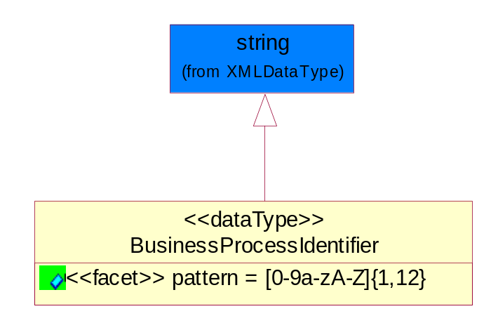
Figure 5-32 BusinessProcessIdentifier

Attribute | Type | Documentation
pattern |  | [0-9a-zA-Z]{1,12}

BusinessServiceInformation

The object allows the specification of the business service utilized within the partner company. This may or may not be the same as the information sent by the RNIF.

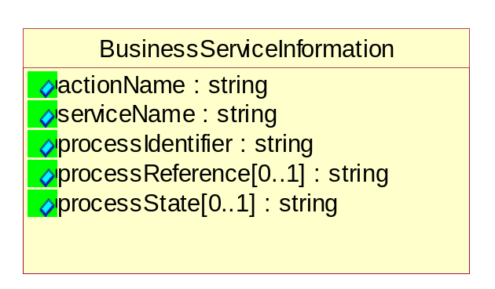
Figure 5-33 BusinessServiceInformation

Attribute | Type | Documentation
actionName | string | The name of Action. For RosettaNet usually any of Request/Confirm/Notify/Query/Response.
serviceName | string | The name of the Business Activity with the "Request/Confirm" part removed. E.g., for the Activity "Request Purchase Order"==> "Purchase Order".
processIdentifier | string | The name of the PIP e.g. Notify of Forecast Reply.
processReference[0..1] | string | The URN for the PIP that includes Cluster/Segment/Process pattern used to identify the interface process (such as PIP3A4)
processState[0..1] | string | The business process (or service) state of the sender of a document. When a service receives this document, the receiver may use the state as a precondition.

ContractInformation

A block of information used to correlate a contract in an executing choreography.


Figure 5-34 ContractInformation

Attribute | Type | Documentation
contractIdentifier[0..1] | string | Unique identification of a contract between the Sender and the Receiver
contractType[0..1] | string | The type of the contract: an attribute describing the type of the ContractIndentification. Valid values are URI, URN,ebXMLCPA, or other values defined by partners.

CorrelationInformation

A block of information used to correlate a requesting document to a responding document and to the contract in an executing choreography.

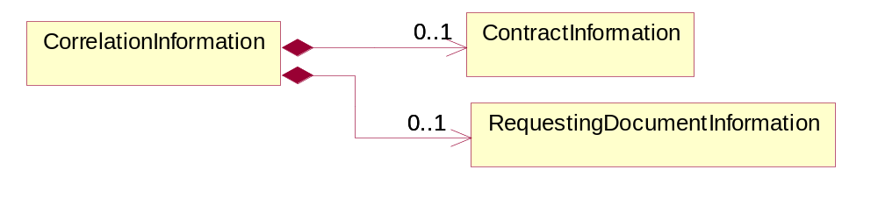
Figure 5-35 CorrelationInformation

Composition | Cardinality | Type | Documentation
ContractInformation | 0..1 | ContractInformation | A block of information used to correlate a contract in an executing choreography.
RequestingDocumentInformation | 0..1 | RequestingDocumentInformation | A block of information used to correlate a requesting document to a responding document in an executing choreography.

DocumentHeader

The object allows for the identification of the sender and receiver of the business document.

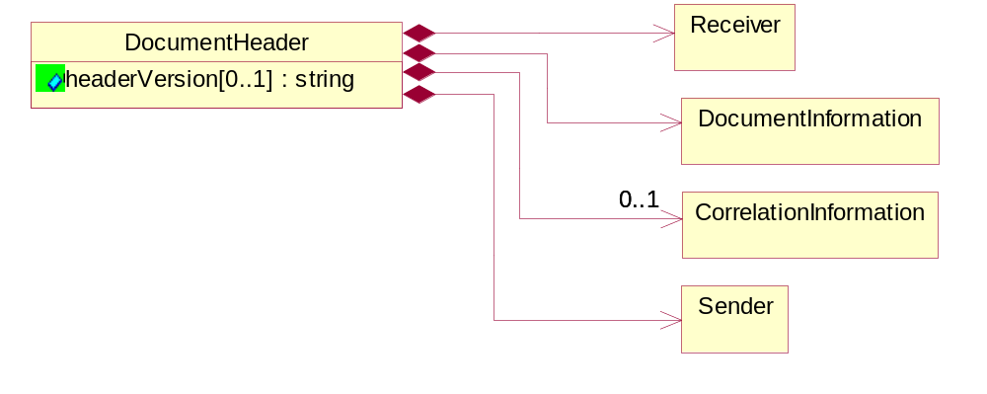
Figure 5-36 DocumentHeader

Attribute | Type | Documentation
headerVersion[0..1] | string | The UN/CEFACT version of the document header.

Composition | Cardinality | Type | Documentation
Sender | 1 | Sender | The object allows the identification of the initiating party of the business message.
CorrelationInformation | 0..1 | CorrelationInformation | A block of information used to correlate a requesting document to a responding document and to the contract in an executing choreography.
DocumentInformation | 1 | DocumentInformation | The object specifies information to identify the business document, a summary of attachments, and information about the business document security.
Receiver | 1 | Receiver | The object allows the identification of the receiving party of the business message.

DocumentIdentification

The object specifies all information necessary to identify the business document.

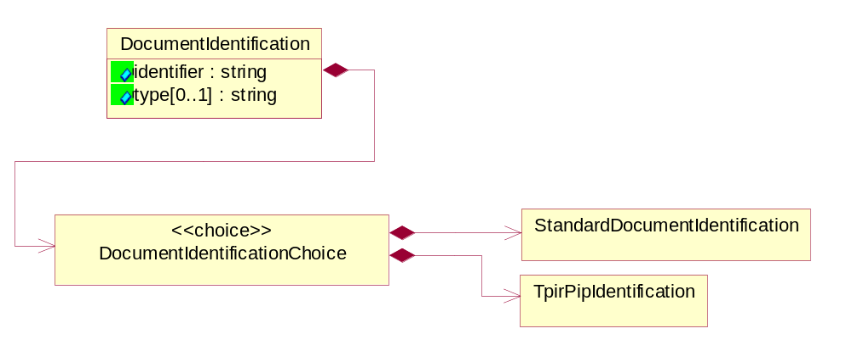
Figure 5-37 DocumentIdentification

Attribute | Type | Documentation
identifier | string | The unique identifier for the document being sent.
type[0..1] | string | Name of the Action Message

Composition | Cardinality | Type | Documentation
DocumentIdentificationChoice | 1 | DocumentIdentificationChoice

DocumentIdentificationChoice

Composition | Cardinality | Type | Documentation
StandardDocumentIdentification | 1 | StandardDocumentIdentification | The object specifies additional information necessary to identify the standard business document.
TpirPipIdentification | 1 | TpirPipIdentification | The object specifies all information necessary to uniquely identify a TPIR-PIP within a Registry or trading partner repository.

DocumentInformation

The object specifies information to identify the business document, a summary of attachments, and information about the business document security.

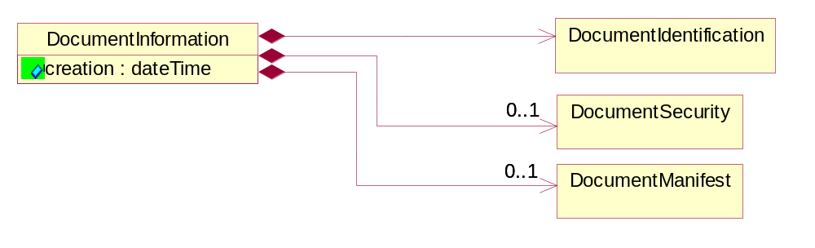
Figure 5-38 DocumentInformation

Attribute | Type | Documentation
creation | dateTime | The creation date and time of the specified Business Document (i.e. the Purchase Order date).

Composition | Cardinality | Type | Documentation
DocumentIdentification | 1 | DocumentIdentification | The object specifies all information necessary to identify the business document.
DocumentSecurity | 0..1 | DocumentSecurity | The object provides additional granularity in specifying business document security (this is in addition to the specified PIP security).
DocumentManifest | 0..1 | DocumentManifest | The block provides a brief summary of attachments and Service Content.

DocumentManifest

The block provides a brief summary of attachments and Service Content.

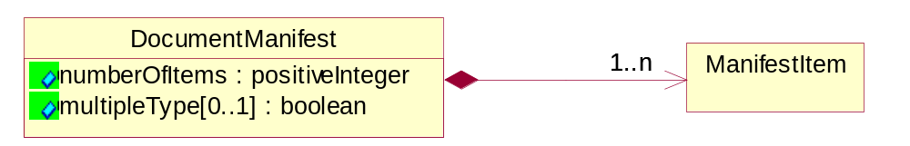
Figure 5-39 DocumentManifest

Attribute | Type | Documentation
numberOfItems | positiveInteger | Total number of documents in the message. The physical count of the attachments in the payload plus the RosettaNet Business Message (for Service Content). The value of this field will be at least 1.
multipleType[0..1] | boolean | Indicates whether the manifest contains documents of multiple types. True if yes, and False if no.

Composition | Cardinality | Type | Documentation
ManifestItem | 1..n | ManifestItem | The object provides details about the specific attachment(s).

DocumentSecurity

The object provides additional granularity in specifying business document security (this is in addition to the specified PIP security).


Figure 5-40 DocumentSecurity

Attribute | Type | Documentation
nonRepudiableReceipt | boolean | The value "true" will indicate that a signed acknowledgement for the business document is necessary.
persistentEncryption | boolean | The value "true" will indicate that the Business Document (including the header) needs to be encrypted when stored or transported.
persistentSignature | boolean | The value "true" will indicate that a signature is required to be stored with the document while stored or transported.

ManifestItem

The object provides details about the specific attachment(s).

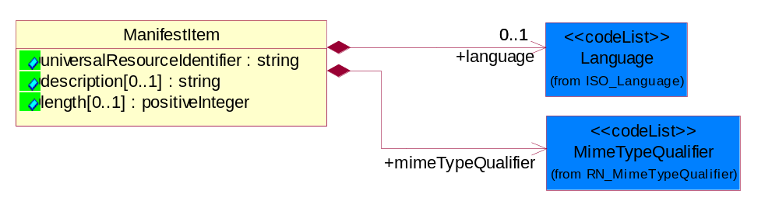
Figure 5-41 ManifestItem

Attribute | Type | Documentation
universalResourceIdentifier | string | The generic set of all names/addresses that are short strings that refer to resources.
description[0..1] | string | A description of the attachment.
length[0..1] | positiveInteger | The size of the attachment in bytes (i.e. 1 000 000 bytes)

Composition | Cardinality | Type | Documentation
mimeTypeQualifier | 1 | MimeTypeQualifier | The MIME type as defined by IANA.  Please refer to http://www.iana.org/assignments/media-types/ for a list of types.
language | 0..1 | Language | For representation of Language name RosettaNet has adopted ISO 639-2; 1998. Refer to the following web page to get the latest version of the standard:  http://www.loc.gov/standards/iso639-2/iso639jac.html  If you need more information about the ISO standard please contact ISO for more details.

PipIdentifier

PIP Identification.[ i.e. PIP3A4]

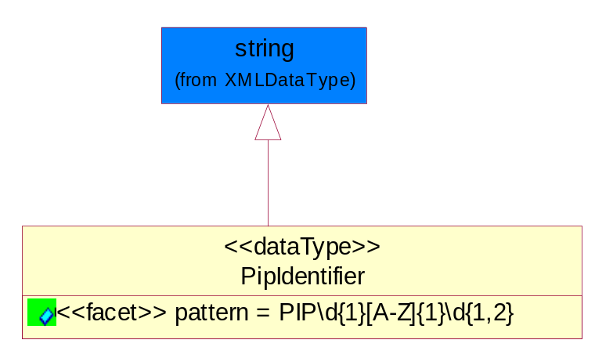
Figure 5-42 PipIdentifier

Attribute | Type | Documentation
pattern |  | PIP\d{1}[A-Z]{1}\d{1,2}

PipVersion

PIP version number (i.e. 02.02.00).

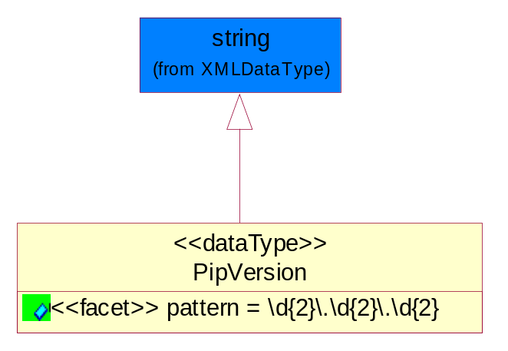
Figure 5-43 PipVersion

Attribute | Type | Documentation
pattern |  | \d{2}\.\d{2}\.\d{2}

Receiver

The object allows the identification of the receiving party of the business message.

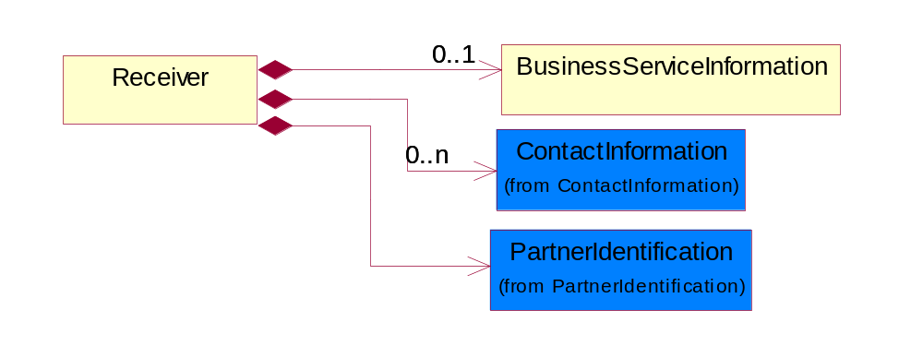
Figure 5-44 Receiver

Composition | Cardinality | Type | Documentation
BusinessServiceInformation | 0..1 | BusinessServiceInformation | The object allows the specification of the business service utilized within the partner company. This may or may not be the same as the information sent by the RNIF.
PartnerIdentification | 1 | PartnerIdentification | The business document must allow for the identity of one or more parties to the transaction.
ContactInformation | 0..n | ContactInformation | The business document must allow for the identification of the name of the department, service or individual to be contacted regarding the context of the business document.

RequestingDocumentInformation

A block of information used to correlate a requesting document to a responding document in an executing choreography.


Figure 5-45 RequestingDocumentInformation

Attribute | Type | Documentation
businessProcessInstanceIdentifier[0..1] | string | The identifier for the public business process instance being sent that both the sender and receiver can identify.
responseDateTime[0..1] | dateTime | The expected time to receive the response. This can not be greater than the PIP TimeToPerform.
requestingDocumentCreationDateTime[0..1] | dateTime | The date-time of the requesting business document.
requestingDocumentInstanceIdentifier | string | The Business Document identification number that identifies the requesting Business Document.

Sender

The object allows the identification of the initiating party of the business message.

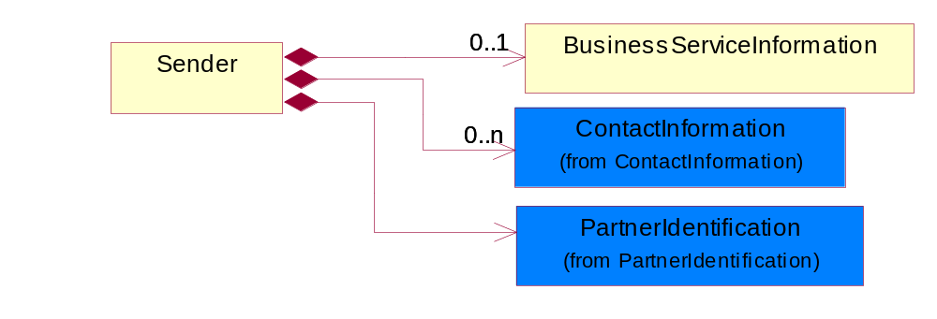
Figure 5-46 Sender

Composition | Cardinality | Type | Documentation
PartnerIdentification | 1 | PartnerIdentification | The business document must allow for the identity of one or more parties to the transaction.
BusinessServiceInformation | 0..1 | BusinessServiceInformation | The object allows the specification of the business service utilized within the partner company. This may or may not be the same as the information sent by the RNIF.
ContactInformation | 0..n | ContactInformation | The business document must allow for the identification of the name of the department, service or individual to be contacted regarding the context of the business document.

StandardDocumentIdentification

The object specifies additional information necessary to identify the standard business document.

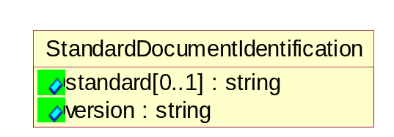
Figure 5-47 StandardDocumentIdentification

Attribute | Type | Documentation
standard[0..1] | string | Identifies the standard used to submit the business document. (e.g. RosettaNet).
version | string | PIP3A4v01.00

TpirPipIdentification

The object specifies all information necessary to uniquely identify a TPIR-PIP within a Registry or trading partner repository.

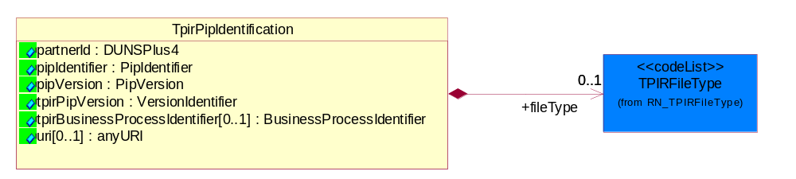
Figure 5-48 TpirPipIdentification

Attribute | Type | Documentation
partnerId | DUNSPlus4 | The Trading Partner Identification of MNC that is creating this TPIR PIP.
pipIdentifier | PipIdentifier | A TPIR PIP Identification [i.e., 3A4 ).
pipVersion | PipVersion | A TPIR PIP version number (i.e., 02.02.00)
tpirPipVersion | VersionIdentifier | A TPIR-PIP Version Number (i.e., major and minor version number as XX.XX).
tpirBusinessProcessIdentifier[0..1] | BusinessProcessIdentifier | A Business Process Identifier to uniquely define the TPIR-PIP 'role' within a Business Scenario at a company or MNC level. The identifier MUST be composed of alphanumeric characters only and its length MUST be between one and twelve characters.
uri[0..1] | anyURI | Describes the destination uri for the TPIR form.

Composition | Cardinality | Type | Documentation
fileType | 0..1 | TPIRFileType | Describes the file type of the TPIR form (PDF, XDP or XML).

VersionIdentifier

Version Number (i.e., major and minor version number as XX.XX).

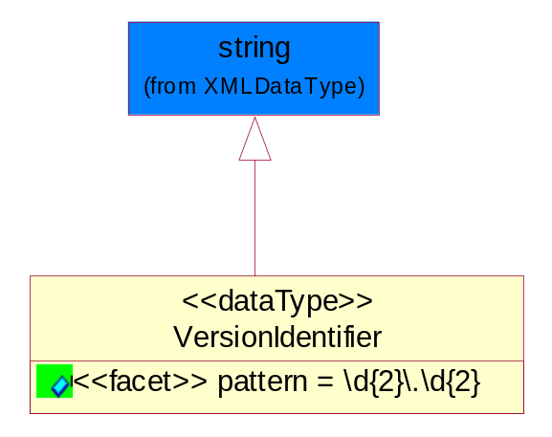
Figure 5-49 VersionIdentifier

Attribute | Type | Documentation
pattern |  | \d{2}\.\d{2}

CodeList

TPIRFileType

A code identifying the file type of TPIR form.

Name | Documentation
PDF | Portable Document Format.
XDP | XML Data Package.
XML | eXtensible Markup Language.

XML Data Type

anyURI

Represents a URI as defined by RFC 2396. An anyURI value can be absolute or relative, and may have an optional fragment identifier.

boolean

Represents Boolean values, which are either "true" or "false".

dateTime

Represents a specific instance of time.
The pattern for dateTime is CCYY-MM-DDThh:mm:ss where CC represents the century, YY the year, MM the month, and DD the day, preceded by an optional leading negative (-) character to indicate a negative number. If the negative character is omitted, positive (+) is assumed. The T is the date/time separator and hh, mm, and ss represent hour, minute, and second respectively. Additional digits can be used to increase the precision of fractional seconds if desired. For example, the format ss.ss... with any number of digits after the decimal point is supported. The fractional seconds part is optional.

This representation may be immediately followed by a "Z" to indicate Coordinated Universal Time (UTC) or to indicate the time zone. For example, the difference between the local time and Coordinated Universal Time, immediately followed by a sign, + or -, followed by the difference from UTC represented as hh:mm (minutes is required). If the time zone is included, both hours and minutes must be present.

decimal

A data type that contains decimal numbers scaled by a power of 10.

nonNegativeInteger

Represents an integer that is greater than or equal to zero. This data type is derived from integer.

positiveInteger

Represents an integer that is greater than zero. This data type is derived from nonNegativeInteger.

string

Represents character string.

