

Description of
Partner Interface Process® for 2A16

Validated 11.00.00

Specification Information
Name | Distribute Engineering Information Inquiry
Cluster | Product Information
Segment | Preparation for Distribution
Publication Date | 03 March 2008
Version Identifier | V11.00

Table of Contents
1 Document Management 4
1.1 Legal Disclaimer 4
1.2 Copyright 4
1.3 Trademarks 4
1.4 Acknowledgments 4
1.5 Related Documents 5
1.6 Document Version History 5
1.7 Document Structure 5
2 Business Process 6
2.1 Business Process Definition 6
2.1.1 Business Process Description 6
2.2 PIP Scope Description 7
2.3 PIP Business Document 8
2.4 PIP Business Process Flow Diagram 8
2.5 PIP Start State 9
2.6 PIP End States 9
2.7 Partner Role Description 10
2.8 Business Process Activity Controls 10
3 Network and Implementation Specification 11
3.1 Business Action and Business Signal Specifications 11
3.2 Business Transaction Dialog Specification 11
3.2.1 Message Exchange Controls 12
3.2.2 Communications Specification 12

List of Figures:
Figure 1: Activity Diagram for Engineering Information Inquiry Distribution 7
Figure 2: Sequence Diagram for Engineering Information Inquiry Distribution 11

List of Tables:
Table 1: PIP Business Document 8
Table 2: PIP Start State 9
Table 3: PIP End State 9
Table 4: PIP Failure State 9
Table 5: Partner Role Description 10
Table 6: Business Activity Description 10
Table 7: Business Activity Performance Control 10
Table 8: Network Component Specification 11
Table 9: Business Action – Business Document Mapping 11
Table 10: Message Exchange Control 12
Table 11: Dialog: Service-Service 12

Document Management

Legal Disclaimer
RosettaNet™, its members, officers, directors, employees, or agents shall not be liable for any injury, loss, damages, financial or otherwise, arising from, related to, or caused by the use of this document or the specifications herein, as well as associated guidelines and schemas. The use of said specifications shall constitute your express consent to the foregoing exculpation.

Copyright
©2008 RosettaNet. All rights reserved. No part of this publication may be reproduced, stored in a retrieval system, or transmitted, in any form or by any means, electronic, mechanical, photocopying, recording, or otherwise, without the prior written permission of the publisher. Printed in the United States of America.

Trademarks
RosettaNet, Partner Interface Process, PIP and the RosettaNet logo are trademarks or registered trademarks of "RosettaNet," a non-profit organization. All other product names and company logos mentioned herein are the trademarks of their respective owners. In the best effort, all terms mentioned in this document that are known to be trademarks or registered trademarks have been appropriately recognized in the first occurrence of the term.

Acknowledgments
This document has been prepared by RosettaNet (http://www.rosettanet.org/) from requirements gathered during the Milestone Program and in conformance with the methodology. Listed below are the legal entities that contributed to the design and development of this PIP.
ADOS | Cisco Systems
E2open | Electronic Devices Information Services (ELISNET)
Freescale Semiconductor | Fujitsu
Hitachi Japan | Intel
Japan Aviation Electronics Industry | Kyocera
Matsushita Electric Industrial | NEC Electronics
NEC Tokin | SONY Electronics
Sterling Commerce | STMicroelectronics Japan
Taiyo Yuden | Toshiba
Tyco Electronics

Related Documents
- Associated PIP Message Schemas (included within the PIP Specification package only)
- Description of 2A16 Message
- Messages Structure
- XML instance of ebXML BPSS for PIP 2A16

Document Version History
Version | Date | Description
Validated 11.00.00 | 03 March 2008 | Validated Version  Milestone Program: Engineering Information Management

Document Structure
A Partner Interface Process (PIP) Specification is comprised of the following two parts:
- Business Process. Captures the semantics of the business process and the flow of the message exchange between roles as they perform business activities.
- Network and Implementation Specification. Specifies the network protocol message formats and communications requirements between peer-protocols supported by network components in the RosettaNet Implementation Framework.

Business Process

Business Process Definition

Business Process Description
The engineering information exchange process is initiated during the electric/electronics part selection for OEM products. Generally, after the initial research is completed, the product design engineer and/or procurement engineer must secure information from the part supplier for very detailed design engineering information on the part. The current process utilizes email, fax, phone or a request form to collect information. If the supplier does not have information on hand, then the supplier replies with when the information will be available and an estimated due date for when the information can be distributed (which is for most cases).
The initial request from the customer may be traced until the request has been completed or canceled. In some cases, the customer does not place a request after receiving the initial reply of the distribution schedule from the supplier (related to unsatisfactory delivery timing for the product information).
The following tasks are supported within the Engineering Information business process:
  - Inquiry for engineering information (Query)
  - Reply with information availability (Response)
  - Request for engineering information (Request)
  - Response with requested engineering information (Response)
Example: The Customer requests “3D CAD model” and “Material Composition Information” for a CPU. The supplier replies that they only have a “2D CAD model” and “Material Composition Information.” The Customer accepts the 2D model, then places an official request for “2D Model” and “Material Composition Information”.
- Inquire Engineering Information Availability
  - Customer inquires to the supplier if the engineering information can be supplied.
  - Supplier replies the availability and estimated delivery date to the Customer.
  - Customer reviews the reply
- Requests Engineering Information
  - Customer requests information
    - Supplier delivers requested information at one time or one by one (if multi item request).
    - After all requested information is delivered, the Supplier sends completion notice to the Customer. This is to close the request number by both of Customer and Supplier. Information might be delivered to different location/person through different methods such as email, postal mail, RosettaNet PIP’s. So completion notice may help to make sure the request status.
    - Delivery of the information (or objects) could be done via PIP2A13 Distribute Material Composition Information.

PIP Scope Description
The purpose of this PIP is to
    - Automate the product engineering information exchanges between the supply chain partners
    - Improve the information exchange quality and efficiency when gathering product engineering data
    - Save time and reduce processing costs during engineering information exchange
    - Reduce the workload in supply chain by introducing a common global approach for sharing product engineering information across the full high-tech supply chain

PIP Business Document
Business Document are generated and exchanged by roles performing activities in this PIP. Business Document is listed and defined in Table 1.
Table 1: PIP Business Document
Business Document | Description
Engineering Information Inquiry Distribution | A business model to request and reply for information availability, formal request and notification of completion of detailed design of engineering information from product design engineer in the case of electric/ electronics part selection for OEM products.

PIP Business Process Flow Diagram
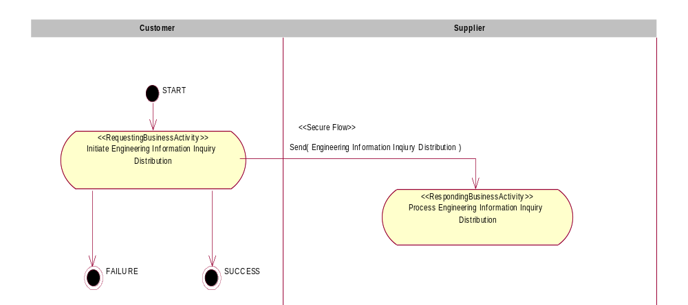
Figure 1: Activity Diagram for Engineering Information Inquiry Distribution

PIP Start State
The start state is comprised of the following conditions:
Table 2: PIP Start State
 | Approved | Exist Party | Exist In Backend System | Valid | Non-Repudiated | Retry Count | Authorized
TPA |  |  | 
Sending Partner |  |  |  | 
Receiving Partner |  | 
Business Document |  |  |  | 

PIP End States
The end state is comprised of the following conditions:
Table 3: PIP End State
 | Approved | Exist Party | Exist In Backend system | Valid | Non-Repudiated | Retry Count | Authorized
Acknowledgment of Receipt |  |  |  | 
Receiving Partner |  |  |  |  |  |  | 

The PIP failure state is comprised of one or more of the following conditions
Table 4: PIP Failure State
 | NO | Exceeded
Success | 
Retry Count |  | 

Partner Role Description
Table 5 describes the partner roles in this PIP:
Table 5: Partner Role Description
Role Name | Role Description
Customer | Requestor of the engineering information or objects for OEM product design, manufacturing and/or QA.
Supplier | Provider of engineering information or objects to sell the part and let the customer use the part correctly.

Table 6 describes the interaction between roles performing business activity in this PIP.
Table 6: Business Activity Description
Role Name |  | Activity Name |  | Activity Description
Customer | Initiate Engineering Information Inquiry Distribution |  | Customer to request or enquire engineering information from Supplier.

Table 7 details the security, audit and process controls relating to activity performed in the PIP.
Table 7: Business Activity Performance Control
Role  Name | Activity  Name | Acknowledgment of Receipt Non-Repudiation Required? | Acknowledgment of Receipt Time to Acknowledge | Time to Perform | Retry Count | Is Authorization Required? | Non-Repudiation of Origin and Content?
Customer | Initiate Engineering Information Inquiry Distribution | N | 2 hrs | N/A | 3 | N | N

Network and Implementation Specification
Each network component maps into a role of the PIP model. Table 8 specifies the mapping between roles and network components.
Table 8: Network Component Specification
Network Component | Classification | Maps to Role in Business Process
Customer Service | Business Service | Customer
Supplier Service | Business Service | Supplier

Each business action maps to a Business Document of the PIP model. Table 9 specifies the mapping between Business Documents and business actions.
Table 9: Business Action – Business Document Mapping
Business Action | Business Document | Document Function
Engineering Information Inquiry Distribution Action | Engineering Information Inquiry Distribution | Request

Business Transaction Dialog Specification
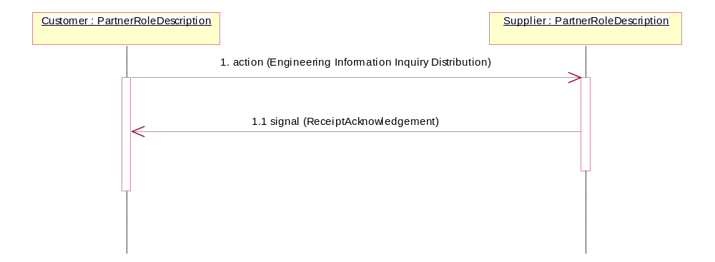
Figure 2: Sequence Diagram for Engineering Information Inquiry Distribution

Message Exchange Controls
Table 10: Message Exchange Control
# | Name |  | Time to Acknowledge Receipt Signal |  | Time to Respond to Action |  | Included in Time to Perform | Is Authorization Required? | Is Non-Repudiation Required? | Is Secure Transport Required?
1 |  | Engineering Information Inquiry Distribution Action |  | 2 hrs |  | N/A | N/A | N | N | Y
2 |  | Receipt Acknowledgment |  | N/A |  | N/A | N/A | N | N | Y

Communications Specification
Table 11: Dialog: Service-Service
# | Business Message | Digital Signature Required? | SSL Required?
1 | Engineering Information Inquiry Distribution | N | Y
2 | Receipt Acknowledgment | N | Y

