

Description of 2A17 Message

PIP® 2A17
Validated 11.00.00

Specification Information
Name | Description of 2A17 Message
PIP | Notify Of Certificate Of Analysis
Cluster | Product Information
Segment | Preparation for Distribution
Publication Date | 27 June 2008
Version Identifier | V11.00

Table of Content

1. Document Management 6
1.1 Legal Disclaimer 6
1.2 Copyright 6
1.3 Trademarks 6
1.4 Acknowledgments 6
1.5 Related Documents 6
1.6 Document Version History 7
1.7 Document Purpose 7
2. Interchange Model 8
2.1 CertificateOfAnalysisNotification 8
2.1.1 Interchange Diagram 8
2.1.2 Dependency Diagram 9
2.1.3 CertificateOfAnalysis 9
2.1.4 CertificateOfAnalysisNotification 10
2.1.5 Characteristic 10
2.1.6 Container 11
2.1.7 LotIdentification 12
2.1.8 Material 13
2.1.9 MaterialSpecification 14
2.1.10 Packaging 14
2.1.11 QualityData 15
2.1.12 Requirement 17
2.1.13 Sample 18
2.1.14 TestingData 18
2.1.15 Valve 19
2.2 CodeList 20
2.2.1 DocumentIssuanceType 20
2.2.2 Plan 20
2.2.3 Phase 20
2.2.4 LotType 21
3. Domain Model 22
3.1 Manufacturing 22
3.1.1 Manufacturing 22
3.1.1.1 Dependency Diagram 22
3.1.1.2 LotQuantity 22
3.1.2 CodeList 23
3.1.2.1 LotQuantityClassification 23
3.2 Shared 24
3.2.1 Shared 24
3.2.1.1 Dependency Diagram 24
3.3 Design 25
3.3.1 Design 25
3.3.1.1 Dependency Diagram 25
3.3.1.2 Tolerance 25
3.3.2 CodeList 26
3.3.2.1 Level 26
3.4 Procurement 27
3.4.1 Procurement 27
3.4.1.1 Dependency Diagram 27
4. Universal Structure 28
4.1 ContactInformation 28
4.1.1 ContactInformation 28
4.2 DataType 29
4.2.1 Contact 29
4.2.2 DUNS 29
4.2.3 DUNSPlus4 30
4.2.4 GLN 30
4.3 Document 31
4.3.1 BusinessDocumentReference 31
4.4 Locations 31
4.4.1 AlternativeIdentifier 31
4.4.2 Location 32
4.4.3 LocationChoice 33
4.4.4 PhysicalAddress 33
4.5 PartnerIdentification 35
4.5.1 FullPartner 35
4.5.2 PartnerIdentification 36
4.5.3 PartnerIdentificationChoice 37
4.5.4 SpecifiedFullPartner 37
4.6 PhysicalDimension 38
4.6.1 Measure 38
4.6.2 Volume 38
4.6.3 Weight 39
4.7 CodeList 40
4.7.1 Country 40
4.7.2 CountrySubdivision 40
4.7.3 Language 40
4.7.4 DocumentType 40
4.7.5 MimeTypeQualifier 42
4.7.6 UnitOfMeasure 53
4.7.7 ProcessRoleIdentifier 66
4.7.8 WeightType 69
5. System Structure 70
5.1 BusinessProcessIdentifier 70
5.2 BusinessServiceInformation 70
5.3 ContractInformation 71
5.4 CorrelationInformation 71
5.5 DocumentHeader 72
5.6 DocumentIdentification 73
5.7 DocumentIdentificationChoice 73
5.8 DocumentInformation 74
5.9 DocumentManifest 75
5.10 DocumentSecurity 75
5.11 ManifestItem 76
5.12 PipIdentifier 77
5.13 PipVersion 77
5.14 Receiver 78
5.15 RequestingDocumentInformation 78
5.16 Sender 79
5.17 StandardDocumentIdentification 80
5.18 pirPipIdentification 80
5.19 VersionIdentifier 81
5.20 CodeList 81
5.20.1 TPIRFileType 81
6. XML Data Type 82
6.1 anyURI 82
6.2 boolean 82
6.3 date 82
6.4 dateTime 82
6.5 decimal 82
6.6 duration 82
6.7 float 82
6.8 positiveInteger 82
6.9 string 83

Table of Figures

Figure ‎2-1 Interchange 8
Figure ‎2-2 Dependency 9
Figure ‎2-3 CertificateOfAnalysis 9
Figure ‎2-4 CertificateOfAnalysisNotification 10
Figure ‎2-5 Characteristic 10
Figure ‎2-6 Container 11
Figure ‎2-7 LotIdentification 12
Figure ‎2-8 Material 13
Figure ‎2-9 MaterialSpecification 14
Figure ‎2-10 Packaging 14
Figure ‎2-11 QualityData 15
Figure ‎2-12 Requirement 17
Figure ‎2-13 Sample 18
Figure ‎2-14 TestingData 18
Figure ‎2-15 Valve 19
Figure ‎3-1 Dependency 22
Figure ‎3-2 LotQuantity 22
Figure ‎3-3 Dependency 24
Figure ‎3-4 Dependency 25
Figure ‎3-5 Tolerance 25
Figure ‎3-6 Dependency 27
Figure ‎4-1 ContactInformation 28
Figure ‎4-2 Contact 29
Figure ‎4-3 DUNS 29
Figure ‎4-4 DUNSPlus4 30
Figure ‎4-5 GLN 30
Figure ‎4-6 BusinessDocumentReference 31
Figure ‎4-7 AlternativeIdentifier 31
Figure ‎4-8 Location 32
Figure ‎4-9 PhysicalAddress 33
Figure ‎4-10 FullPartner 35
Figure ‎4-11 PartnerIdentification 36
Figure ‎4-12 SpecifiedFullPartner 37
Figure ‎4-13 Measure 38
Figure ‎4-14 Volume 38
Figure ‎4-15 Weight 39
Figure ‎5-1 BusinessProcessIdentifier 70
Figure ‎5-2 BusinessServiceInformation 70
Figure ‎5-3 ContractInformation 71
Figure ‎5-4 CorrelationInformation 71
Figure ‎5-5 DocumentHeader 72
Figure ‎5-6 DocumentIdentification 73
Figure ‎5-7 DocumentInformation 74
Figure ‎5-8 DocumentManifest 75
Figure ‎5-9 DocumentSecurity 75
Figure ‎5-10 ManifestItem 76
Figure ‎5-11 PipIdentifier 77
Figure ‎5-12 PipVersion 77
Figure ‎5-13 Receiver 78
Figure ‎5-14 RequestingDocumentInformation 78
Figure ‎5-15 Sender 79
Figure ‎5-16 StandardDocumentIdentification 80
Figure ‎5-17 TpirPipIdentification 80
Figure ‎5-18 VersionIdentifier 81

Document Management

Legal Disclaimer
RosettaNet, its members, officers, directors, employees, or agents shall not be liable for any injury, loss, damages, financial or otherwise, arising from, related to, or caused by the use of this document or the specifications herein, as well as associated guidelines and schemas. The use of said specifications shall constitute your express consent to the foregoing exculpation.

Copyright
©2008 RosettaNet. All rights reserved. No part of this publication may be reproduced, stored in a retrieval system, or transmitted, in any form or by any means, electronic, mechanical, photocopying, recording, or otherwise, without the inclusion of this copyright notice. Any derivative works must cite the copyright notice. Any public redistribution or sale of this publication or derivative works requires prior written permission of the publisher.

Trademarks
RosettaNet, Partner Interface Process, PIP and the RosettaNet logo are trademarks or registered trademarks of "RosettaNet," a non-profit organization. All other product names and company logos mentioned herein are the trademarks of their respective owners. In the best effort, all terms mentioned in this document that are known to be trademarks or registered trademarks have been appropriately recognized in the first occurrence of the term.

Acknowledgments
This document has been prepared by RosettaNet (http://www.rosettanet.org/) from requirements gathered during the Milestone Program and in conformance with the methodology. Listed below are the legal entities that contributed to the design and development of this PIP.
Air Products & Chemicals (APCI) | LINDE (formally BOC Edwards)
Intel | IBM
InSync Software | ATMI

Related Documents
- Associated PIP Message Schemas (included with PIP Specification only)
- Description of Partner Interface Process for 2A17
- Message Structure

Document Version History
Version | Date | Description
Validated 11.00.00 | 27 June 2008 | Validated Version: Milestone Program –Certificate of Analysis

Document Purpose
The purpose of the document is to explain the structure, the association between objects, the content of objects and the definition for single elements to a non-technical audience.

Interchange Model

CertificateOfAnalysisNotification

Interchange Diagram
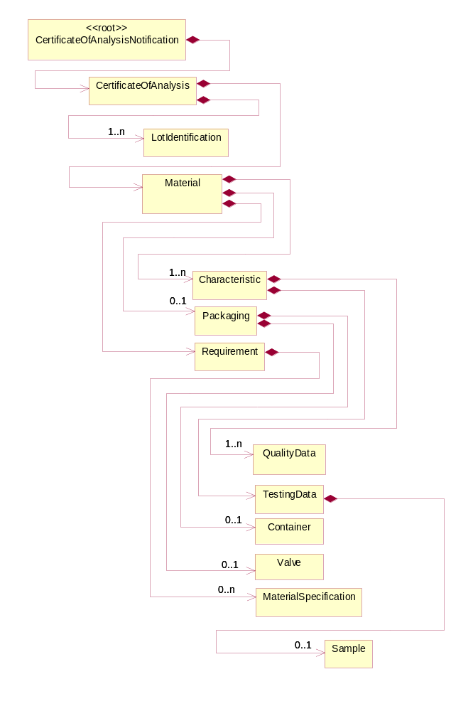
Figure ‎2-1 Interchange

Dependency Diagram
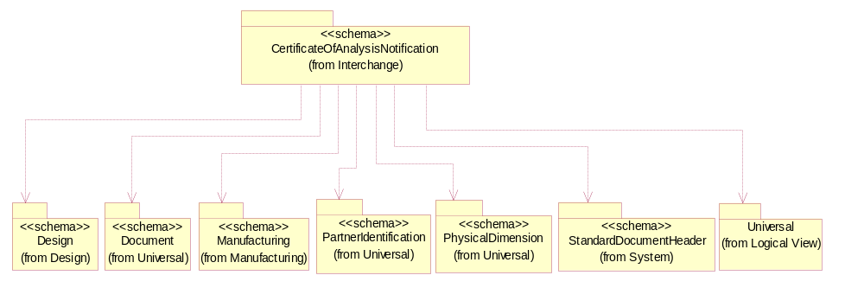
Figure ‎2-2 Dependency

CertificateOfAnalysis
The collection of business properties that describes the content of a Certificate of Analysis.
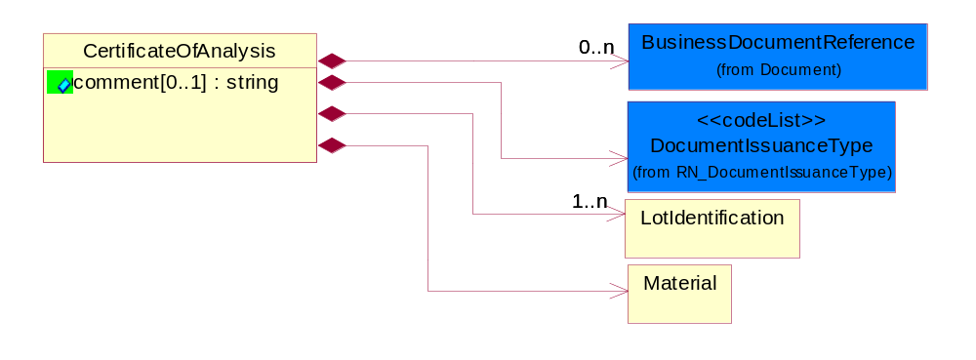
Figure ‎2-3 CertificateOfAnalysis

Attribute | Type | Documentation
comment[0..1] | string | This object represents the free form text of comment.

Composition | Cardinality | Type | Documentation
BusinessDocumentReference | 0..n | BusinessDocumentReference | The business document reference object allows for the indirect referencing of a relationship to other business related documents.
Material | 1 | Material | The collection of business properties that describes a material. Material is the combination of substance & package e.g. substance is Helium, package is container & valve used.
DocumentIssuanceType | 1 | DocumentIssuanceType | This object represents the type of document release.
LotIdentification | 1..n | LotIdentification | This object identifies a lot which associates the product with a specific group of products with some similar attributes.

CertificateOfAnalysisNotification
The message wrapper for 2A17.
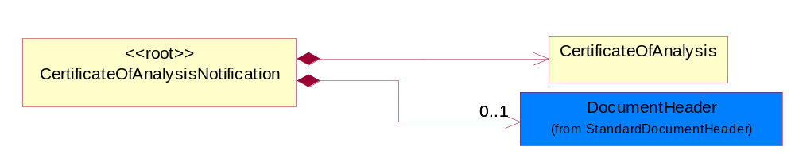
Figure ‎2-4 CertificateOfAnalysisNotification

Composition | Cardinality | Type | Documentation
CertificateOfAnalysis | 1 | CertificateOfAnalysis | The collection of business properties that describes the content of a Certificate of Analysis.
DocumentHeader | 0..1 | DocumentHeader | The object allows for the identification of the sender and receiver of the business document.

Characteristic
The collection of business properties that describes chemical or physical properties of components or contaminants and its related testing information.
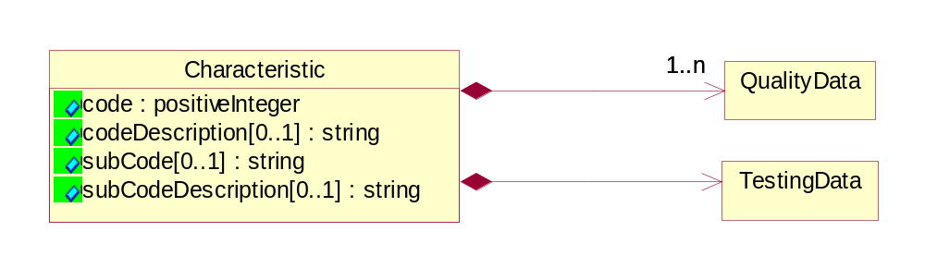
Figure ‎2-5 Characteristic

Attribute | Type | Documentation
code | positiveInteger | This object represents the characteristics of a material.
codeDescription[0..1] | string | This object represents the free form text description of characteristic.
subCode[0..1] | string | For Characteristics that have many variations, the SubCode will provide a more detailed definition of the exact test or parameter that is being reported. The receiver's back-end system may require more information than is given by the characteristic alone to correctly process the associated quality value. The SubCode provides the additional information required for correct processing of the submitted value.
subCodeDescription[0..1] | string | The textual description of the SubCode. In the event that a message fails validation or is rejected by the receiver's system due to the value held in SubCode, the information provided in SubCode Description may aid in diagnosing and correcting the error.

Composition | Cardinality | Type | Documentation
TestingData | 1 | TestingData | The collection of business properties that describes the testing data for a material's characteristic.
QualityData | 1..n | QualityData | The collection of business properties that captures value and type for Quality Data (Testing Result) for a material's characteristic.

Container
The collection of business properties that describes the container of the package.
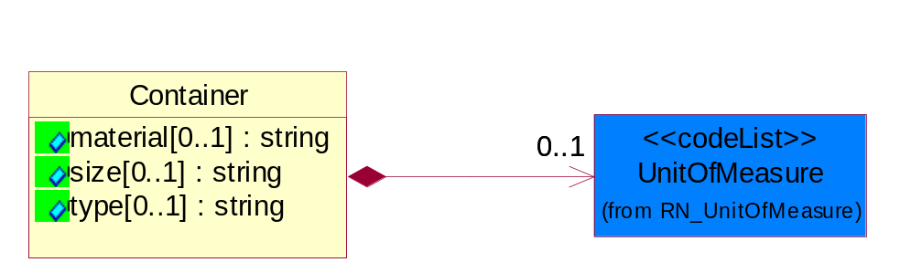
Figure ‎2-6 Container

Attribute | Type | Documentation
material[0..1] | string | This object represents the material of construction of a container.
size[0..1] | string | This object represents the capacity of the container.
type[0..1] | string | This object the type of container.

Composition | Cardinality | Type | Documentation
UnitOfMeasure | 0..1 | UnitOfMeasure | Code identifying a product unit of measure.

LotIdentification
This object identifies a lot which associates the product with a specific group of products with some similar attributes.
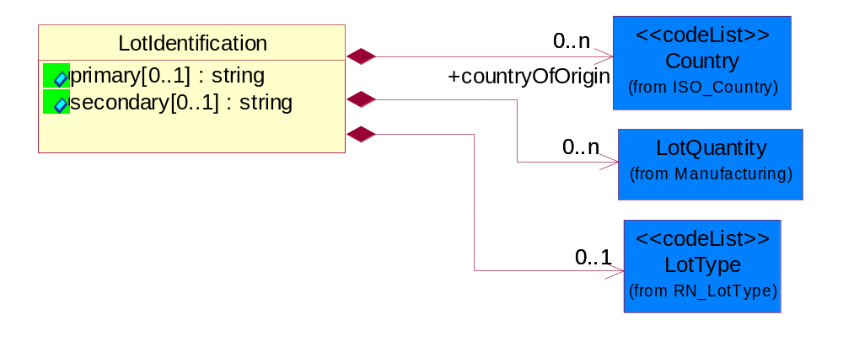
Figure ‎2-7 LotIdentification

Attribute | Type | Documentation
primary[0..1] | string | The primary lot identifier (Lot Number).
secondary[0..1] | string | The secondary lot identifier (Batch Number).

Composition | Cardinality | Type | Documentation
countryOfOrigin | 0..n | Country | This object represents the country where the product originates.
LotQuantity | 0..n | LotQuantity | The collection of business properties that describe the quantity of items in a lot.
LotType | 0..1 | LotType | The value in this field indicates whether the lot number or the batch number of the product to be filled in. Use PRI to indicate the primary field(Lot Number), or SEC to indicate the secondary field (Batch Number).

Material
The collection of business properties that describes a material. Material is the combination of substance & package e.g. substance is Helium, package is container & valve used.
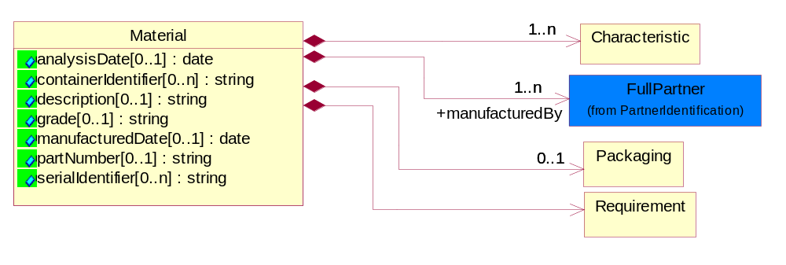
Figure ‎2-8 Material

Attribute | Type | Documentation
analysisDate[0..1] | date | This object represents the date the analytical qualifications testing of the material is completed.
containerIdentifier[0..n] | string | This object represents the unique identifier for a material's container.
description[0..1] | string | This object represents the free form text description of a material.
grade[0..1] | string | This object represents the grade of the material which is used by the material provider to succinctly describe the material quality. The grade code is typically comprised of many more attributes which specifically define the material's quality.
manufacturedDate[0..1] | date | This object represents the date the substance was packaged as a final shippable material.
partNumber[0..1] | string | This object represents the unique identifier for a material.
serialIdentifier[0..n] | string | This object represents the unique serialized identifier for a material.

Composition | Cardinality | Type | Documentation
Requirement | 1 | Requirement | The collection of business properties that describes the buyer's requirement.
Characteristic | 1..n | Characteristic | The collection of business properties that describes chemical or physical properties of components or contaminants and its related testing information.
manufacturedBy | 1..n | FullPartner | Manufactured by - The party who creates, processes or produces goods especially in large quantities and by means of industrial machines.
Packaging | 0..1 | Packaging | The collection of business properties that describes the packaging of a substance.

MaterialSpecification
The collection of business properties that describes the material's specification.
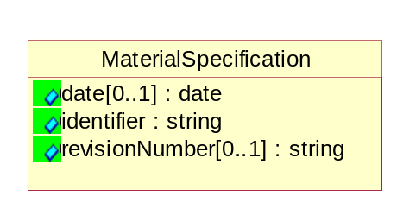
Figure ‎2-9 MaterialSpecification

Attribute | Type | Documentation
date[0..1] | date | This object represents the date that the last material specification revision was implemented.
identifier | string | This object identifying the material specification.
revisionNumber[0..1] | string | This object represents the number of times a buyer has altered of modified the details which describe the material specification number.

Packaging
The collection of business properties that describes the packaging of a substance.
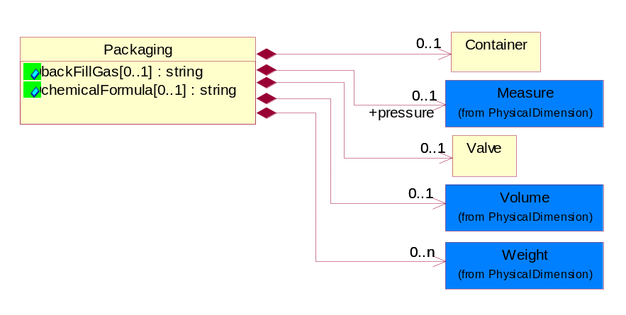
Figure ‎2-10 Packaging

Attribute | Type | Documentation
backFillGas[0..1] | string | This object represents a substance added to the container which is not part of the finished end item but is necessary to extract or remove the finished item from the container.
chemicalFormula[0..1] | string | This object represents the chemical formula for the substance.

Composition | Cardinality | Type | Documentation
Weight | 0..n | Weight | The business document must be able to express the weight of an object.
Volume | 0..1 | Volume | The business document must be able to express the volume of an object.
Container | 0..1 | Container | The collection of business properties that describes the container of the package.
Valve | 0..1 | Valve | The collection of business properties that describes the control device or tap of the package.
pressure | 0..1 | Measure | The business document must be able to express the pressure of an object.

QualityData
The collection of business properties that captures value and type for Quality Data (Testing Result) for a material's characteristic.
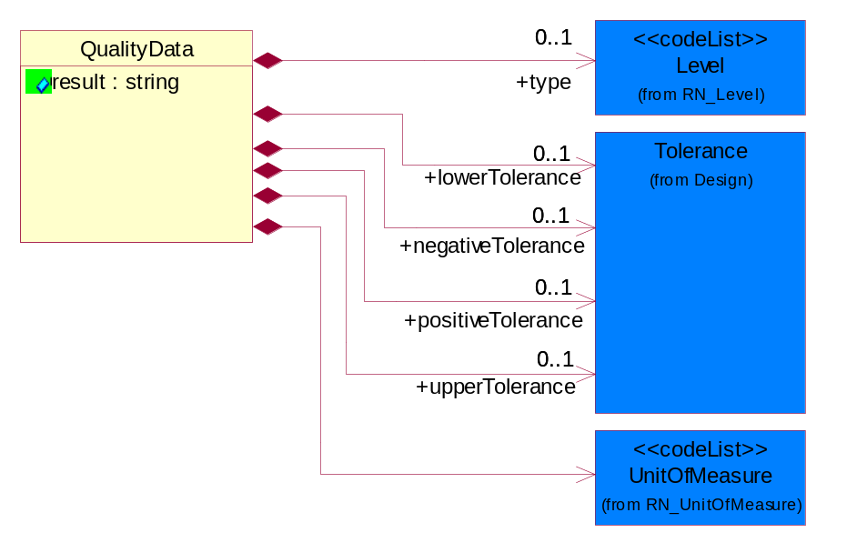
Figure ‎2-11 QualityData

Attribute | Type | Documentation
result | string | The actual or defined quality value associated with a specific measurement.

Composition | Cardinality | Type | Documentation
type | 0..1 | Level | A qualifier describing the kind of measurement a value represents.
negativeTolerance | 0..1 | Tolerance | A negative tolerance expressed as a non-negative real number to be subtracted from the current value and as a non-negative percent of the current value.
positiveTolerance | 0..1 | Tolerance | A positive tolerance expressed as a non-negative real number to be added to the current value and as a non-negative percent of the current value.
upperTolerance | 0..1 | Tolerance | A upper tolerance expressed as a non-negative real number to be subtracted from the current value and as a non-negative percent of the current value that served as upper specification limit.
lowerTolerance | 0..1 | Tolerance | A lower tolerance expressed as a non-negative real number to be subtracted from the current value and as a non-negative percent of the current value that served as lower specification limit.
UnitOfMeasure | 1 | UnitOfMeasure | Code identifying a product unit of measure.

Requirement
The collection of business properties that describes the buyer's requirement.
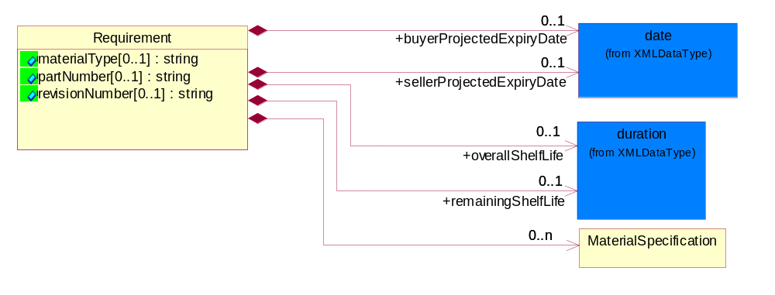
Figure ‎2-12 Requirement

Attribute | Type | Documentation
materialType[0..1] | string | This object represents the information provided by the buyer to the seller used to categorize materials.
partNumber[0..1] | string | This object represents the identifier provided by the buyer to the seller of the identifier used within the buyer's system to define a material.
revisionNumber[0..1] | string | This object represents the number of times a buyer has altered of modified the details which describe their part number.

Composition | Cardinality | Type | Documentation
MaterialSpecification | 0..n | MaterialSpecification | The collection of business properties that describes the material's specification.
overallShelfLife | 0..1 | duration | This object is provided by the buyer to the seller that defines the overall useable life of the material from the receiver's perspective.
remainingShelfLife | 0..1 | duration | This object is provided by the buyer to the seller that defines the useable life of the material from the buyer's perspective which must remain on the material when the material is received by the buyer.
sellerProjectedExpiryDate | 0..1 | date | This object represents the seller-specified projected date when material shelf life expires.
buyerProjectedExpiryDate | 0..1 | date | This object represents the buyer-specified projected date when material shelf life expires.

Sample
The collection of business properties that describes the sampling for a material's characteristic.
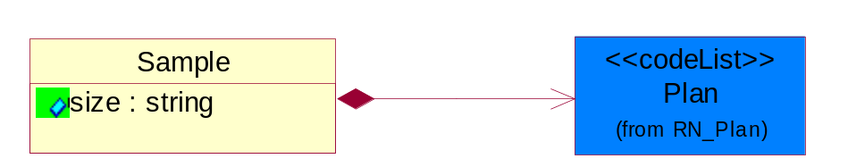
Figure ‎2-13 Sample

Attribute | Type | Documentation
size | string | This objects represents the size of the sample used to report the quality data of the characteristic.

Composition | Cardinality | Type | Documentation
Plan | 1 | Plan | This object represents the sampling plan at the batch or individual level.

TestingData
The collection of business properties that describes the testing data for a material's characteristic.
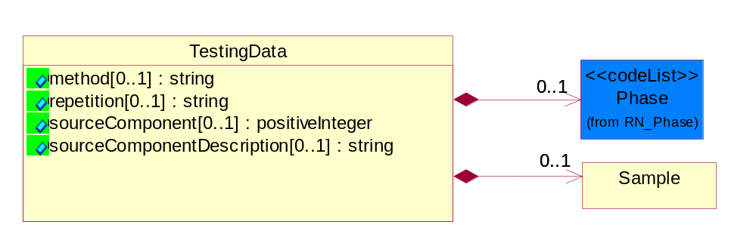
Figure ‎2-14 TestingData

Attribute | Type | Documentation
method[0..1] | string | This object represents the analytical technique used to measure the quality data of the characteristic.
repetition[0..1] | string | This object represents the number of times that the test was run on the sample or multiple samples of the same lot.
sourceComponent[0..1] | positiveInteger | This object represents the component that is the source of the individual characteristics. In the case of mixtures (multiple chemical substances combined into a single material), the testing equipment cannot test some aspects of the substance (the material characteristic; the test) when is it combined. Therefore, the tests must be run on the individual substances prior to combination. The source component identifies each of those substances on which the tests where run. The same test can be run on each of the individual substances as well as on the combined substance.
sourceComponentDescription[0..1] | string | In the event that a message fails validation or is rejected by the receiver's system due to the value held in Source Component, the information provided in Source Component Description may aid in diagnosing and correcting the error.

Composition | Cardinality | Type | Documentation
Sample | 0..1 | Sample | The collection of business properties that describes the sampling for a material's characteristic.
Phase | 0..1 | Phase | This object is to standardize the allowed values which partners can exchange for the field element Phase.

Valve
The collection of business properties that describes the control device or tap of the package.
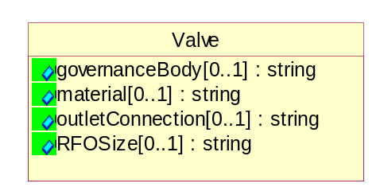
Figure ‎2-15 Valve

Attribute | Type | Documentation
governanceBody[0..1] | string | This object represents the regulatory body to which the valve conforms.
material[0..1] | string | This object represents the material of construction of the valve which may be part of the package.
outletConnection[0..1] | string | This object represents the valve type that defines the specific threaded connection of the valve which is used to convey the proper fitting to extract product from a container.
RFOSize[0..1] | string | This object represents the size of the Restrictive Flow Orifice inserted into a valve.

CodeList

DocumentIssuanceType
This object represents the type of document release.

Name | Documentation
ORI | Original.
POR | Pre-Ship Original.
PRP | Pre-Ship Replacement.
REP | Replacement.

Plan
This object represents the sampling plan at the batch or individual level.

Name | Documentation
BAM | Batch analyzed across multiple inspection lots.
BAS | Batch analyzed within a single inspection lot.
CCS | Calculated Characteristic.
GRT | Guaranteed - static, known analytical value.
IAZ | Individually analyzed.
SRC | Source - analytical value reported for component material.
UAV | Unanalyzed- static, known analytical value.

Phase
This object is to standardize the allowed values which partners can exchange for the field element Phase.

Name | Documentation
GAS | Gas Phase.
LIQ | Liquid Phase.
SOL | Solid Phase.

LotType
The value in this field indicates whether the lot number or the batch number of the product to be filled in. Use PRI to indicate the primary field (Lot Number), or SEC to indicate the secondary field (Batch Number).

Name | Documentation
PRI | Primary field - lot number.
SEC | Secondary field - batch number.

Domain Model

Manufacturing

Manufacturing

Dependency Diagram
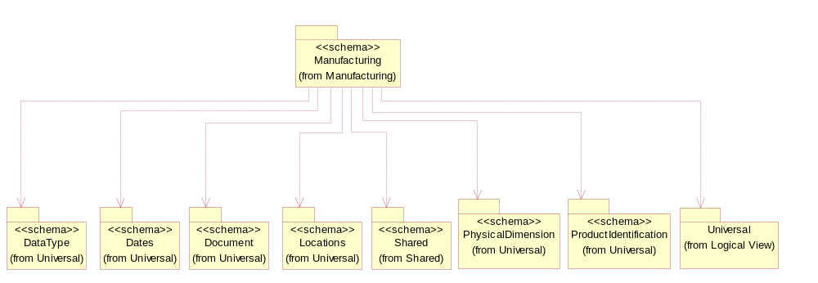
Figure ‎3-16 Dependency

LotQuantity
The collection of business properties that describe the quantity of items in a lot.
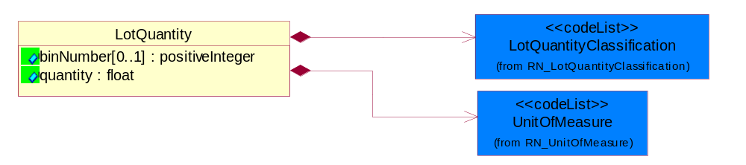
Figure ‎3-17 LotQuantity

Attribute | Type | Documentation
binNumber[0..1] | positiveInteger | Code number used to segregate lot quantities by performance after final testing.
quantity | float | A quantity specifying the number of product units.

Composition | Cardinality | Type | Documentation
UnitOfMeasure | 1 | UnitOfMeasure | Code identifying a product unit of measure.
LotQuantityClassification | 1 | LotQuantityClassification | Code identifying the classification of a manufacturing lot quantity.

CodeList

LotQuantityClassification
Code identifying the classification of a manufacturing lot quantity.

Name | Documentation
ACC | Acceptable. The lot quantity meets the minimum requirements.
BON | Bonus. A positive variance in the lot quantity.
BTE | Bin Test. Bin Test Quantity.
CQU | Change Quantity. The change quantity event and quantity is intended to be used when the quantity of a lot changes for a reason other then those we have defined events for (scrap, reject, and bonus).
CUR | Current. Current Quantity.
GRO | Gross. The initial quantity of the lot.
LPR | Lot probe.
MER | Merge. Merge Quantity.
NET | Net. The final quantity of the lot.
PFI | Projected final. The estimated final quantity of the lot.
PLO | Previous lot. The quantity of the preceding lot.
REC | Receipt. Receipt Quantity.
REJ | Reject. Reject/Loss Quantity.
SCH | Schedule. A lot is still physically in the Die Bank (before being started) but has been allocated to start and as a result, is not available for being considered for planning purposes as it is already committed to.
SCR | Scrap. The quantity of products which is disposed of.
SHI | Ship. Actual Ship Quantity.
SPL | Split. Split Quantity.
STA | Start. Start Quantity.

Shared

Shared

Dependency Diagram
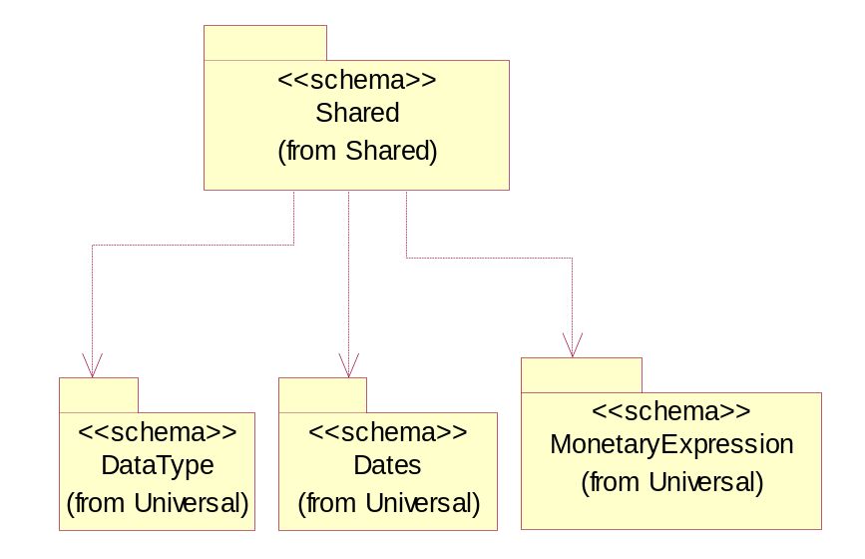
Figure ‎3-18 Dependency

Design

Design

Dependency Diagram
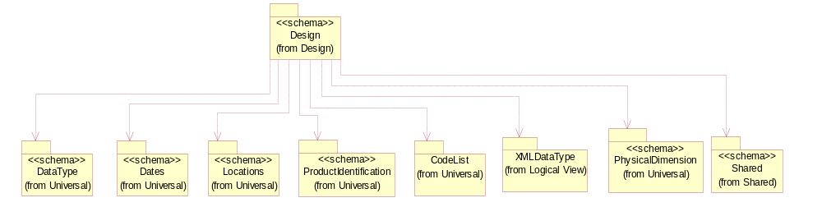
Figure ‎3-19 Dependency

Tolerance
Collection defined to specify tolerance levels. Extension to DependentCondition.
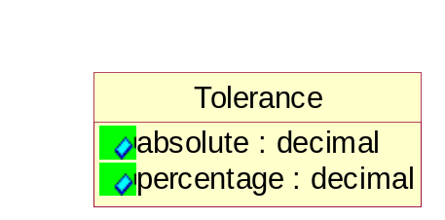
Figure ‎3-20 Tolerance

Attribute | Type | Documentation
absolute | decimal | A tolerance expressed as a real number.
percentage | decimal | A tolerance expressed as a percentage of the current value.

CodeList

Level
This is to qualify the type of the product, material or substance mass either maximum, minimum, typical, nominal independently or with any combination such as when specifying range of mass between minimum and maximum. In this case, the mass reporting will loop and for each instance it will have different Level entry.

Name | Documentation
ACT | Actual Value.
AVG | Average.
CON | Control Interval.
EXP | Expanded Uncertainty.
GRT | Value Greater Than.
LST | Value Less Than.
MAV | Maximum Average.
MAX | A Maximum level of the mass (weight) MUST be specified as KIG (kilogram) using ECTD/IEC/ISO Specification for the UOM field.
MDL | Method Detection Limit.
MIN | A Minimum level of the mass (weight) MUST be specified as KIG (kilogram) using ECTD/IEC/ISO Specification for the UOM field.
NOM | Nominal - a Specification Limit or Target Value e.g. a Nominal level of the mass (weight) MUST be specified as KIG (kilogram) using ECTD/IEC/ISO Specification for the UOM field.
STD | Standard Deviation.
TYP | A Typical level of the mass (weight) MUST be specified as KIG (kilogram) using ECTD/IEC/ISO Specification for the UOM field.

Procurement

Procurement

Dependency Diagram
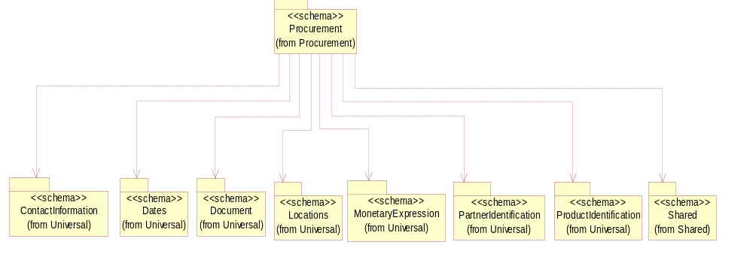
Figure ‎3-21 Dependency

Universal Structure

ContactInformation

ContactInformation
The business document must allow for the identification of the name of the department, service or individual to be contacted regarding the context of the business document.
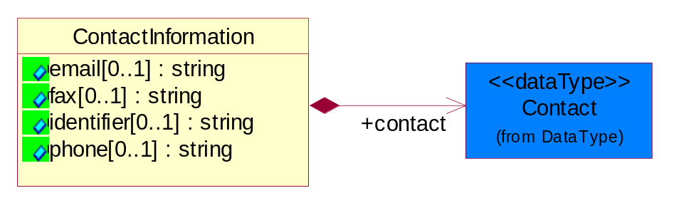
Figure ‎4-22 ContactInformation

Attribute | Type | Documentation
email[0..1] | string | The electronic mail for the specified contact.
fax[0..1] | string | The fax number for the specified contact.
identifier[0..1] | string | Identifies the role of the contact (i.e. Service Technician, Account Manager) in the Business Process.
phone[0..1] | string | The telephone number for the specified contact.

Composition | Cardinality | Type | Documentation
contact | 1 | Contact | The name of the department, service or individual to be contacted within the organization.

DataType

Contact
The name of the department, service or individual to be contacted within the organization.
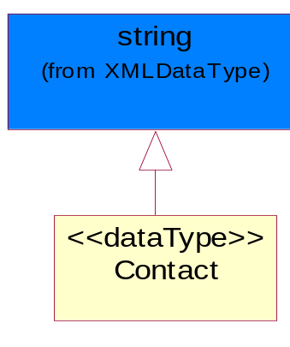
Figure ‎4-23 Contact

DUNS
A number assigned by Dun and Bradstreet to identify a business location.
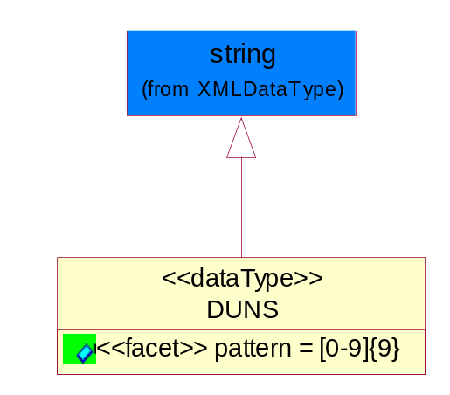
Figure ‎4-24 DUNS

Attribute | Type | Documentation
pattern |  | [0-9]{9}

DUNSPlus4
A identifier to specify a specific location within a business location.
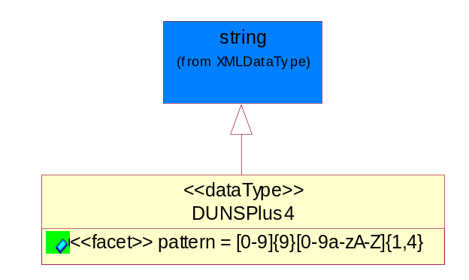
Figure ‎4-25 DUNSPlus4

Attribute | Type | Documentation
pattern |  | Data Universal Numbering System +4 (DUNS+4) number means the DUNS number assigned by Dun and Bradstreet, Inc. (D&B) plus an alphanumeric of length 4 suffix that may be assigned by a business concern.

GLN
Global Location Number (GLN) - A identifier to identify legal entities, trading parties and location.
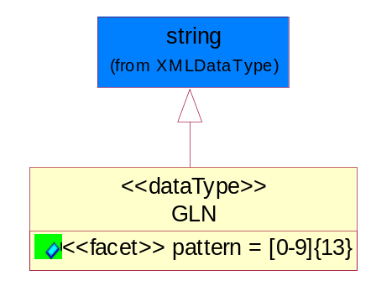
Figure ‎4-26 GLN

Attribute | Type | Documentation
pattern |  | [0-9]{13}

Document

BusinessDocumentReference
The business document reference object allows for the indirect referencing of a relationship to other business related documents.
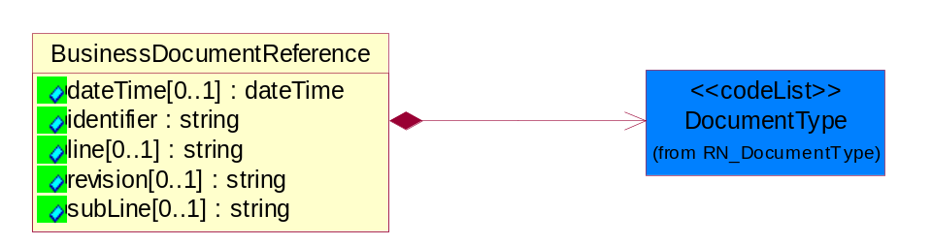
Figure ‎4-27 BusinessDocumentReference

Attribute | Type | Documentation
dateTime[0..1] | dateTime | The date-time stamp indicating on the referenced business document.
identifier | string | Unique identification of the referenced business document.
line[0..1] | string | References the specific line number of the specified business document.
revision[0..1] | string | Referenced the revision of the specified business document.
subLine[0..1] | string | References the specific subline number of the specified business document.

Composition | Cardinality | Type | Documentation
DocumentType | 1 | DocumentType | A code identifying the business context of a document.

Locations

AlternativeIdentifier
Identifies the specified code and the name of the organization that a code is utilized from.
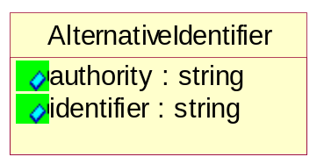
Figure ‎4-28 AlternativeIdentifier

Attribute | Type | Documentation
authority | string | The name of the organization that a code is utilized from.
identifier | string | The specified code to represent an entity (e.g. product, location, partner, etc.).

Location
The business document must specify a location.
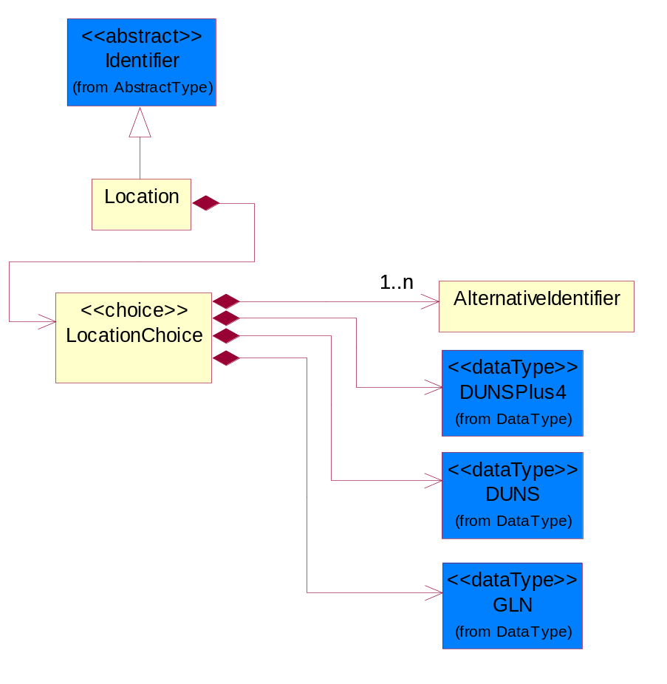
Figure ‎4-29 Location

Composition | Cardinality | Type | Documentation
LocationChoice | 1 | LocationChoice

LocationChoice

Composition | Cardinality | Type | Documentation
DUNSPlus4 | 1 | DUNSPlus4 | A identifier to specify a specific location within a business location.
DUNS | 1 | DUNS | A number assigned by Dun and Bradstreet to identify a business location.
AlternativeIdentifier | 1..n | AlternativeIdentifier | Identifies the specified code and the name of the organization that a code is utilized from.
GLN | 1 | GLN | Global Location Number (GLN) - A identifier to identify legal entities, trading parties and location.

PhysicalAddress
The business document must provide a physical address for a party to the business transaction.
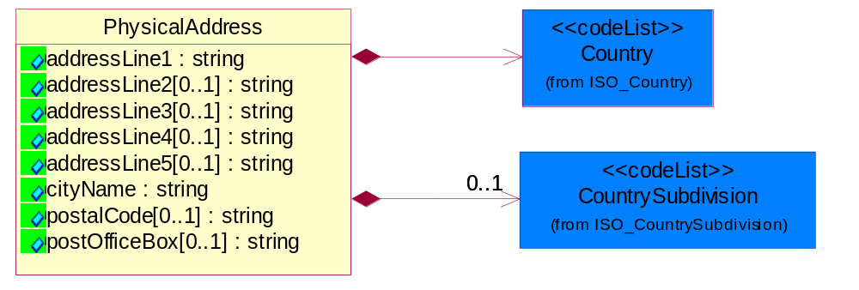
Figure ‎4-30 PhysicalAddress

Attribute | Type | Documentation
addressLine1 | string | The first line of a physical address.
addressLine2[0..1] | string | The second line of a physical address.
addressLine3[0..1] | string | The third line of a physical address.
addressLine4[0..1] | string | The fourth line of a physical address.
addressLine5[0..1] | string | The fifth line of a physical address.
cityName | string | The name of a city.
postalCode[0..1] | string | Identifying geographic location as specified by a national postal code.
postOfficeBox[0..1] | string | The Post Office Box identifier used to identify a party's post office box.

Composition | Cardinality | Type | Documentation
Country | 1 | Country | For representation of Country name RosettaNet has adopted ISO 3166-3; 1999. Refer to the following web page to get the latest version of the standard:  http://www.iso.ch/iso/en/prods-services/iso3166ma/02iso-3166-code-lists/index.html  If you need more information about the ISO standard please contact ISO for more details.
CountrySubdivision | 0..1 | CountrySubdivision | For representation of a Countries subdivisions RosettaNet has adopted ISO 3166-3; 1999. Refer to the following web page to get the latest version of the standard:  http://www.iso.ch/iso/en/prods-services/iso3166ma/02iso-3166-code-lists/index.html  If you need more information about the ISO standard please contact ISO for more details.

PartnerIdentification

FullPartner
The business document must describe the trading partners in the business transaction. This data structure provide the flexibility to describe a partner in all possible methods as for new, existing or known partner.
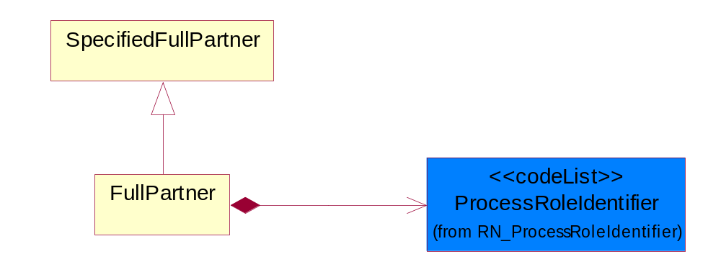
Figure ‎4-31 FullPartner

Composition | Cardinality | Type | Documentation
ProcessRoleIdentifier | 1 | ProcessRoleIdentifier | Describes the role of the partner in the business process. A partner will fulfill at least one or more roles during the business process.

PartnerIdentification
The business document must allow for the identity of one or more parties to the transaction.
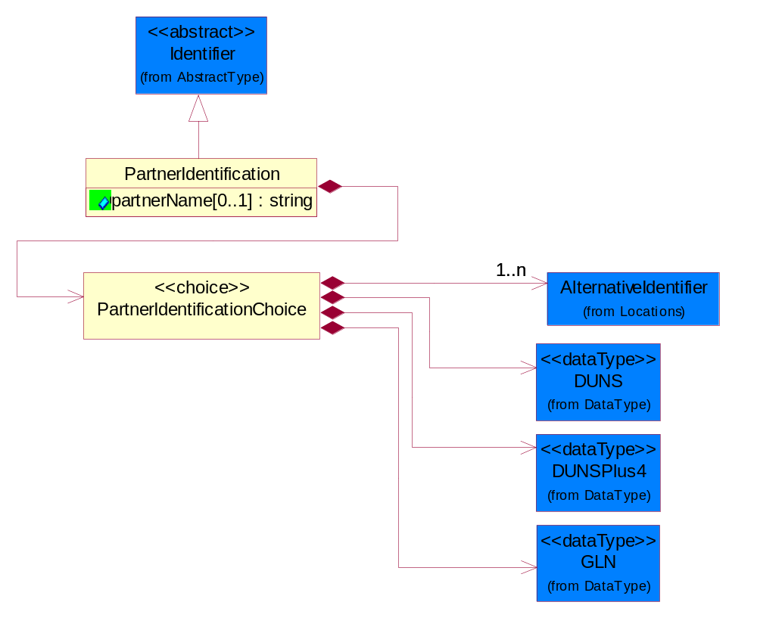
Figure ‎4-32 PartnerIdentification

Attribute | Type | Documentation
partnerName[0..1] | string | The name of the partner’s company/business.

Composition | Cardinality | Type | Documentation
PartnerIdentificationChoice | 1 | PartnerIdentificationChoice

PartnerIdentificationChoice

Composition | Cardinality | Type | Documentation
DUNS | 1 | DUNS | A number assigned by Dun and Bradstreet to identify a business location.
DUNSPlus4 | 1 | DUNSPlus4 | A identifier to specify a specific location within a business location.
AlternativeIdentifier | 1..n | AlternativeIdentifier | Identifies the specified code and the name of the organization that a code is utilized from.
GLN | 1 | GLN | Global Location Number (GLN) - A identifier to identify legal entities, trading parties and location.

SpecifiedFullPartner
The business document must describe the trading partners in the business transaction. This data structure provide the flexibility to describe a partner in all possible methods as for new, existing or known partner. This is specifically for partner who role has been specified.
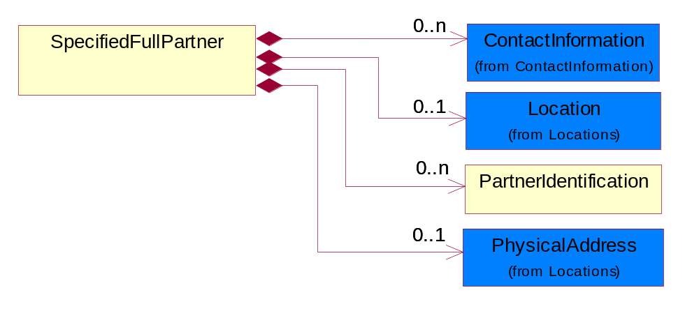
Figure ‎4-33 SpecifiedFullPartner

Composition | Cardinality | Type | Documentation
ContactInformation | 0..n | ContactInformation | The business document must allow for the identification of the name of the department, service or individual to be contacted regarding the context of the business document.
Location | 0..1 | Location | The business document must specify a location.
PartnerIdentification | 0..n | PartnerIdentification | The business document must allow for the identity of one or more parties to the transaction.
PhysicalAddress | 0..1 | PhysicalAddress | The business document must provide a physical address for a party to the business transaction.

PhysicalDimension

Measure
The business document must describe measurement information.
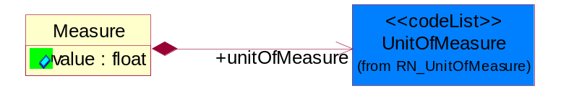
Figure ‎4-34 Measure

Attribute | Type | Documentation
value | float | The worth of an object in the specified unit of measure.

Composition | Cardinality | Type | Documentation
unitOfMeasure | 1 | UnitOfMeasure | To express the unit type of measurement.

Volume
The business document must be able to express the volume of an object.
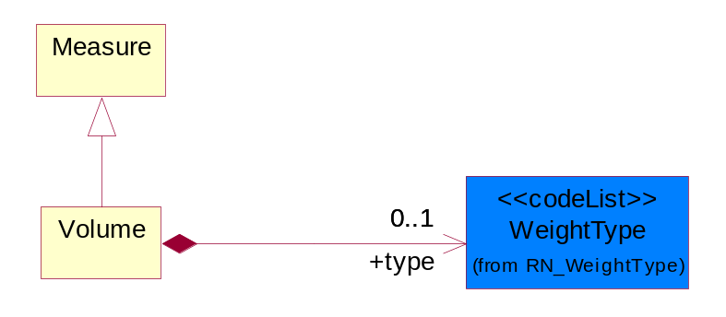
Figure ‎4-35 Volume

Composition | Cardinality | Type | Documentation
type | 0..1 | WeightType | A code identifying the type of volumn.

Weight
The business document must be able to express the weight of an object.
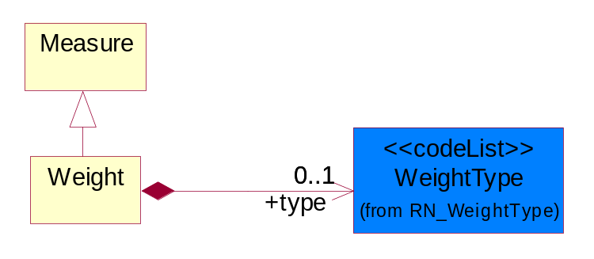
Figure ‎4-36 Weight

Composition | Cardinality | Type | Documentation
type | 0..1 | WeightType | A code identifying the type of weight.

CodeList

Country
For representation of Country name RosettaNet has adopted ISO 3166-3; 1999. Refer to the following web page to get the latest version of the standard:
http://www.iso.ch/iso/en/prods-services/iso3166ma/02iso-3166-code-lists/index.html

If you need more information about the ISO standard please contact ISO for more details.

CountrySubdivision
For representation of a Countries subdivisions RosettaNet has adopted ISO 3166-3; 1999. Refer to the following web page to get the latest version of the standard:
http://www.iso.ch/iso/en/prods-services/iso3166ma/02iso-3166-code-lists/index.html

If you need more information about the ISO standard please contact ISO for more details.

Language
For representation of Language name RosettaNet has adopted ISO 639-2; 1998. Refer to the following web page to get the latest version of the standard:

http://www.loc.gov/standards/iso639-2/iso639jac.html

If you need more information about the ISO standard please contact ISO for more details.

DocumentType
A code identifying the business context of a document.

Instance | Documentation
ARA | Authorization Request Approval.
CAR | Certificate of Analysis Response.
CBN | Product batch number of customer.
CCN | Customs clearance number.
CFA | Failure Analysis - Request document that will accompany the product providing characteristics of the component failure.
CIN | Commercial Invoice.
CNM | Traditional credit note or memo.
COA | Certificate of Analysis.
CON | In a virtual sourcing relationship, a third party trading partner is supplying a part to a customer on behalf of another company that has taken the order for the customer. In this case a Customer Order Number is associated to the request for material that is sent to the virtual trading partners.
COS | Consumption Notice.
COT | Contract.
CRN | Unique consumption reference number identifying the product consumption issue i.e. one-to-one relationship with physical flow.
DEM | Traditional debit note or memo.
DEN | Delivery Note.
DIN | Discontinuation Notice.
DOR | Delivery Order.
DRN | Drawing Number.
DRR | Design Registration Request.
ECO | Engineering Change Order - The proprietary unique identification number that represents an engineering change order.
EDD | Export Declaration Document.
EIR | Engineering Information Request.
EOL | End of Life.
FUO | Sales order or transfer order fulfilling demand out of a facility (outbound shipment).
IDD | Import Declaration Document.
INV | Invoice.
LID | Location Identifier. Data for on-site work that have to be done on the machine (associated with preventive maintenance order).
MEN | Master Event Number.
MID | Machine Identifier. Data for on-site work that have to be done on the machine (associated with preventive maintenance order).
MON | Model Number.
OCL | The unique identifier assigned by the OEM for a warranty claim.
OGA | Other governmental agency issued document.
OPO | The unique identifier assigned by the OEM for a part order.
OPR | The unique identifier assigned by the OEM for a part return.
PCN | Product/Process Change.
PFA | Failure Analysis - Request document that will accompany the product providing characteristics of the product failure.
PII | Refers to previously issued invoice.
PLS | Unique number that identifies packing form prior to shipment.
POI | Purchase Order IN.
PON | Production order number for material release.
POO | Purchase Order OUT.
PRC | Product Catalog.
PSI | Refers to previously issued self-billing invoice.
PUO | Purchase Order.
QUO | Quote.
REC | Document identifying the receipt of materials or products into a facility against a purchase order or transfer order (inbound shipment).
REN | Release Number.
REO | Purchase order or transfer order replenishing inventory into a facility (inbound shipment).
REQ | Requisition.
RMA | Returned Material Authorization.
RPO | Purchase order for materials or product returned to and reworked by a supplier.
RTA | Remittance Advice - Remittance details.
SAO | Sales Order.
SBC | Credit Memo used in self-billing scenario.
SBD | Debit Memo used in self-billing scenario.
SBI | Invoice in self billing scenario.
SBN | Product batch number of supplier.
SCA | Similar to contracts - Contains the quantity of an article that is to be ordered from a vendor and the price for article or service that is to be procured.
SEN | Serial Number.
SEO | A document that gives a repair provider the necessary authorization to repair or upgrade a product either at the customer site or at the repair provider’s site.
SHD | Shipping Document.
SNC | Shipset Number on Code List.
SPC | The unique identifier assigned by the ASP for a warranty claim.
SPN | Spec Number.
SPO | The unique identifier assigned by the ASP for a part order.
SPR | The unique identifier assigned by the ASP for a part return.
SPW | The unique identifier assigned by the ASP to reference a work order.
SRI | A document that contains the shipping reference number which allows the product to be tracked within the outsourced logistic providers network.
TRO | Order which results in materials or products being moved from one facility to another (outbound shipment and inbound shipment).
WAB | Waybill.
WAC | Denotes a warranty claim.
WOO | Work Order.

MimeTypeQualifier
The MIME type as defined by IANA.

Please refer to http://www.iana.org/assignments/media-types/ for a list of types.

Instance | Documentation
application/activemessage | [Shapiro]
application/andrew-inset | [Borenstein]
application/applefile | [Faltstrom]
application/atomicmail | [Borenstein]
application/batch-SMTP | [RFC2442]
application/beep+xml | [RFC3080]
application/cals-1840 | [RFC1895]
application/cnrp+xml | [RFCCNRP]
application/commonground | [Glazer]
application/cpl+xml
application/cybercash | [Eastlake]
application/dca-rft | [Campbell]
application/dec-dx | [Campbell]
application/dicom | [RFC3240]
application/dvcs | [RFC3029]
application/EDI-Consent | [RFC1767]
application/EDIFACT | [RFC1767]
application/EDI-X12 | [RFC1767]
application/eshop | [Katz]
application/font-tdpfr | [RFC3073]
application/http | [RFC2616]
application/hyperstudio | [Domino]
application/iges | [Parks]
application/index | [RFC2652]
application/index.cmd | [RFC2652]
application/index.obj | [RFC2652]
application/index.response | [RFC2652]
application/index.vnd | [RFC2652]
application/iotp | [RFC2935]
application/ipp | [RFC2910]
application/isup | [RFC3204]
application/mac-binhex40 | [Faltstrom]
application/macwriteii | [Lindner]
application/marc | [RFC2220]
application/mathematica | [Van Nostern]
application/msword | [Lindner]
application/news-message-id | [RFC1036,Spencer]
application/news-transmission | [RFC1036, Spencer]
application/ocsp-request | [RFC2560]
application/ocsp-response | [RFC2560]
application/octet-stream | [RFC2045,RFC2046]
application/oda | [RFC2045,RFC2046]
application/ogg | [RFC-walleij-ogg-mediatype-08.txt]
application/parityfec | [RFC3009]
application/pdf | [Lindner]
application/pgp-encrypted | [RFC3156]
application/pgp-keys | [RFC3156]
application/pgp-signature | [RFC3156]
application/pkcs10 | [RFC2311]
application/pkcs7-mime | [RFC2311]
application/pkcs7-signature | [RFC2311]
application/pkix-cert | [RFC2585]
application/pkixcmp | [RFC2510]
application/pkix-crl | [RFC2585]
application/postscript | [RFC2045,RFC2046]
application/prs.alvestrand.titrax-sheet | [Alvestrand]
application/prs.cww | [Rungchavalnont]
application/prs.nprend | [Doggett]
application/prs.plucker | [Janssen]
application/qsig | [RFC3204]
application/reginfo+xml | [RFC-ietf-sipping-reg-event-00.txt]
application/remote-printing | [RFC1486,Rose]
application/riscos | [Smith]
application/rtf | [Lindner]
application/sdp | [RFC2327]
application/set-payment | [Korver]
application/set-payment-initiation | [Korver]
application/set-registration | [Korver]
application/set-registration-initiation | [Korver]
application/sgml | [RFC1874]
application/sgml-open-catalog | [Grosso]
application/sieve | [RFC3028]
application/slate | [Crowley]
application/timestamp-query | [RFC3161]
application/timestamp-reply | [RFC3161]
application/tve-trigger | [Welsh]
application/vemmi | [RFC2122]
application/vnd.3gpp.pic-bw-large | [Meredith]
application/vnd.3gpp.pic-bw-small | [Meredith]
application/vnd.3gpp.pic-bw-var | [Meredith]
application/vnd.3gpp.sms | [Meredith]
application/vnd.3M.Post-it-Notes | [O'Brien]
application/vnd.accpac.simply.aso | [Leow]
application/vnd.accpac.simply.imp | [Leow]
application/vnd.acucobol | [Lubin]
application/vnd.acucorp | [Lubin]
application/vnd.adobe.xfdf | [Perelman]
application/vnd.aether.imp | [Moskowitz]
application/vnd.amiga.ami | [Blumberg]
application/vnd.anser-web-certificate-issue-initiation | [Mori]
application/vnd.anser-web-funds-transfer-initiation | [Mori]
application/vnd.audiograph | [Slusanschi]
application/vnd.blueice.multipass | [Holmstrom]
application/vnd.bmi | [Gotoh]
application/vnd.businessobjects | [Imoucha]
application/vnd.canon-cpdl | [Muto]
application/vnd.canon-lips | [Muto]
application/vnd.cinderella | [Kortenkamp]
application/vnd.claymore | [Simpson]
application/vnd.commerce-battelle | [Applebaum]
application/vnd.commonspace | [Chandhok]
application/vnd.contact.cmsg | [Patz]
application/vnd.cosmocaller | [Dellutri]
application/vnd.ctc-posml | [Kohlhepp]
application/vnd.cups-postscript | [Sweet]
application/vnd.cups-raster | [Sweet]
application/vnd.cups-raw | [Sweet]
application/vnd.curl | [Byrnes]
application/vnd.cybank | [Helmee]
application/vnd.data-vision.rdz | [Fields]
application/vnd.dna | [Searcy]
application/vnd.dpgraph | [Parker]
application/vnd.dreamfactory | [Appleton]
application/vnd.dxr | [Duffy]
application/vnd.ecdis-update | [Buettgenbach]
application/vnd.ecowin.chart | [Olsson]
application/vnd.ecowin.filerequest | [Olsson]
application/vnd.ecowin.fileupdate | [Olsson]
application/vnd.ecowin.series | [Olsson]
application/vnd.ecowin.seriesrequest | [Olsson]
application/vnd.ecowin.seriesupdate | [Olsson]
application/vnd.enliven | [Santinelli]
application/vnd.epson.esf | [Hoshina]
application/vnd.epson.msf | [Hoshina]
application/vnd.epson.quickanime | [Gu]
application/vnd.epson.salt | [Nagatomo]
application/vnd.epson.ssf | [Hoshina]
application/vnd.ericsson.quickcall | [Tidwell]
application/vnd.eudora.data | [Resnick]
application/vnd.fdf | [Zilles]
application/vnd.ffsns | [Holstage]
application/vnd.FloGraphIt | [Floersch]
application/vnd.framemaker | [Wexler]
application/vnd.fsc.weblaunch | [D.Smith]
application/vnd.fujitsu.oasys | [Togashi]
application/vnd.fujitsu.oasys2 | [Togashi]
application/vnd.fujitsu.oasys3 | [Okudaira]
application/vnd.fujitsu.oasysgp | [Sugimoto]
application/vnd.fujitsu.oasysprs | [Ogita]
application/vnd.fujixerox.ddd | [Onda]
application/vnd.fujixerox.docuworks | [Taguchi]
application/vnd.fujixerox.docuworks.binder | [Matsumoto]
application/vnd.fut-misnet | [Pruulmann]
application/vnd.grafeq | [Tupper]
application/vnd.groove-account | [Joseph]
application/vnd.groove-help | [Joseph]
application/vnd.groove-identity-message | [Joseph]
application/vnd.groove-injector | [Joseph]
application/vnd.groove-tool-message | [Joseph]
application/vnd.groove-tool-template | [Joseph]
application/vnd.groove-vcard | [Joseph]
application/vnd.hbci | [Hammann]
application/vnd.hhe.lesson-player | [Jones]
application/vnd.hp-HPGL | [Pentecost]
application/vnd.hp-hpid | [Gupta]
application/vnd.hp-hps | [Aubrey]
application/vnd.hp-PCL | [Pentecost]
application/vnd.hp-PCLXL | [Pentecost]
application/vnd.httphone | [Lefevre]
application/vnd.hzn-3d-crossword | [Minnis]
application/vnd.ibm.afplinedata | [Buis]
application/vnd.ibm.electronic-media | [Tantlinger]
application/vnd.ibm.MiniPay | [Herzberg]
application/vnd.ibm.modcap | [Hohensee]
application/vnd.ibm.secure-container | [Tantlinger]
application/vnd.informix-visionary | [Gales]
application/vnd.intercon.formnet | [Gurak]
application/vnd.intertrust.digibox | [Tomasello]
application/vnd.intertrust.nncp | [Tomasello]
application/vnd.intu.qbo | [Scratchley]
application/vnd.intu.qfx | [Scratchley]
application/vnd.irepository.package+xml | [Knowles]
application/vnd.is-xpr | [Natarajan]
application/vnd.japannet-directory-service | [Fujii]
application/vnd.japannet-jpnstore-wakeup | [Yoshitake]
application/vnd.japannet-payment-wakeup | [Fujii]
application/vnd.japannet-registration | [Yoshitake]
application/vnd.japannet-registration-wakeup | [Fujii]
application/vnd.japannet-setstore-wakeup | [Yoshitake]
application/vnd.japannet-verification | [Yoshitake]
application/vnd.japannet-verification-wakeup | [Fujii]
application/vnd.jisp | [Deckers]
application/vnd.kde.karbon | [Faure]
application/vnd.kde.kchart | [Faure]
application/vnd.kde.kformula | [Faure]
application/vnd.kde.kivio | [Faure]
application/vnd.kde.kontour | [Faure]
application/vnd.kde.kpresenter | [Faure]
application/vnd.kde.kspread | [Faure]
application/vnd.kde.kword | [Faure]
application/vnd.kenameaapp | [DiGiorgio-Haag]
application/vnd.koan | [Cole]
application/vnd.liberty-request+xml | [McDowell]
application/vnd.llamagraphics.life-balance.desktop | [White]
application/vnd.lotus-1-2-3 | [Wattenberger]
application/vnd.lotus-approach | [Wattenberger]
application/vnd.lotus-freelance | [Wattenberger]
application/vnd.lotus-notes | [Laramie]
application/vnd.lotus-organizer | [Wattenberger]
application/vnd.lotus-screencam | [Wattenberger]
application/vnd.lotus-wordpro | [Wattenberger]
application/vnd.mcd | [Gotoh]
application/vnd.mediastation.cdkey | [Flurry]
application/vnd.meridian-slingshot | [Wedel]
application/vnd.micrografx.flo | [Prevo]
application/vnd.micrografx.igx | [Prevo]
application/vnd.mif | [Wexler]
application/vnd.minisoft-hp3000-save | [Bartram]
application/vnd.mitsubishi.misty-guard.trustweb | [Tanaka]
application/vnd.Mobius.DAF | [Kabayama]
application/vnd.Mobius.DIS | [Kabayama]
application/vnd.Mobius.MBK | [Devasia]
application/vnd.Mobius.MQY | [Devasia]
application/vnd.Mobius.MSL | [Kabayama]
application/vnd.Mobius.PLC | [Kabayama]
application/vnd.Mobius.TXF | [Kabayama]
application/vnd.mophun.application | [Wennerstrom]
application/vnd.mophun.certificate | [Wennerstrom]
application/vnd.motorola.flexsuite | [Patton]
application/vnd.motorola.flexsuite.adsi | [Patton]
application/vnd.motorola.flexsuite.fis | [Patton]
application/vnd.motorola.flexsuite.gotap | [Patton]
application/vnd.motorola.flexsuite.kmr | [Patton]
application/vnd.motorola.flexsuite.ttc | [Patton]
application/vnd.motorola.flexsuite.wem | [Patton]
application/vnd.mozilla.xul+xml | [McDaniel]
application/vnd.ms-artgalry | [Slawson]
application/vnd.ms-asf | [Fleischman]
application/vnd.mseq | [Le Bodic]
application/vnd.ms-excel | [Gill]
application/vnd.msign | [Borcherding]
application/vnd.ms-lrm | [Ledoux]
application/vnd.ms-powerpoint | [Gill]
application/vnd.ms-project | [Gill]
application/vnd.ms-tnef | [Gill]
application/vnd.ms-works | [Gill]
application/vnd.ms-wpl | [Plastina]
application/vnd.musician | [Adams]
application/vnd.music-niff | [Butler]
application/vnd.netfpx | [Mutz]
application/vnd.noblenet-directory | [Solomon]
application/vnd.noblenet-sealer | [Solomon]
application/vnd.noblenet-web | [Solomon]
application/vnd.novadigm.EDM | [Swenson]
application/vnd.novadigm.EDX | [Swenson]
application/vnd.novadigm.EXT | [Swenson]
application/vnd.obn | [Hessling]
application/vnd.osa.netdeploy | [Klos]
application/vnd.palm | [Peacock]
application/vnd.pg.format | [Gandert]
application/vnd.pg.osasli | [Gandert]
application/vnd.powerbuilder6 | [Guy]
application/vnd.powerbuilder6-s | [Guy]
application/vnd.powerbuilder7 | [Shilts]
application/vnd.powerbuilder75 | [Shilts]
application/vnd.powerbuilder75-s | [Shilts]
application/vnd.powerbuilder7-s | [Shilts]
application/vnd.previewsystems.box | [Smolgovsky]
application/vnd.publishare-delta-tree | [Ben-Kiki]
application/vnd.pvi.ptid1 | [Lamb]
application/vnd.pwg-multiplexed | [RFC3391]
application/vnd.pwg-xhtml-print+xml | [Wright]
application/vnd.Quark.QuarkXPress | [Scheidler]
application/vnd.rapid | [Szekely]
application/vnd.s3sms | [Tarkkala]
application/vnd.sealed.net | [Lambert]
application/vnd.seemail | [Webb]
application/vnd.shana.informed.formdata | [Selzler]
application/vnd.shana.informed.formtemplate | [Selzler]
application/vnd.shana.informed.interchange | [Selzler]
application/vnd.shana.informed.package | [Selzler]
application/vnd.smaf | [Takahashi]
application/vnd.sss-cod | [Dani]
application/vnd.sss-dtf | [Bruno]
application/vnd.sss-ntf | [Bruno]
application/vnd.street-stream | [Levitt]
application/vnd.svd | [Becker]
application/vnd.swiftview-ics | [Widener]
application/vnd.triscape.mxs | [Simonoff]
application/vnd.trueapp | [Hepler]
application/vnd.truedoc | [Chase]
application/vnd.ufdl | [Manning]
application/vnd.uplanet.alert | [Martin]
application/vnd.uplanet.alert-wbxml | [Martin]
application/vnd.uplanet.bearer-choice | [Martin]
application/vnd.uplanet.bearer-choice-wbxml | [Martin]
application/vnd.uplanet.cacheop | [Martin]
application/vnd.uplanet.cacheop-wbxml | [Martin]
application/vnd.uplanet.channel | [Martin]
application/vnd.uplanet.channel-wbxml | [Martin]
application/vnd.uplanet.list | [Martin]
application/vnd.uplanet.listcmd | [Martin]
application/vnd.uplanet.listcmd-wbxml | [Martin]
application/vnd.uplanet.list-wbxml | [Martin]
application/vnd.uplanet.signal | [Martin]
application/vnd.vcx | [T.Sugimoto]
application/vnd.vectorworks | [Pharr]
application/vnd.vidsoft.vidconference | [Hess]
application/vnd.visio | [Sandal]
application/vnd.visionary | [Aravindakumar]
application/vnd.vividence.scriptfile | [Risher]
application/vnd.vsf | [Rowe]
application/vnd.wap.sic | [WAP-Forum]
application/vnd.wap.slc | [WAP-Forum]
application/vnd.wap.wbxml | [Stark]
application/vnd.wap.wmlc | [Stark]
application/vnd.wap.wmlscriptc | [Stark]
application/vnd.webturbo | [Rehem]
application/vnd.wrq-hp3000-labelled | [Bartram]
application/vnd.wt.stf | [Wohler]
application/vnd.wv.csp+wbxml | [Salmi]
application/vnd.xara | [Matthewman]
application/vnd.xfdl | [Manning]
application/vnd.yellowriver-custom-menu | [Yellow]
application/whoispp-query | [RFC2957]
application/whoispp-response | [RFC2958]
application/wita | [Campbell]
application/wordperfect5.1 | [Lindner]
application/x400-bp | [RFC1494]
application/xhtml+xml | [RFC3236]
application/xml | [RFC3023]
application/xml-dtd | [RFC3023]
application/xml-external-parsed-entity | [RFC3023]
application/zip | [Lindner]
audio/32kadpcm | [RFC2421,RFC2422]
audio/AMR | [RFC3267]
audio/AMR-WB | [RFC3267]
audio/basic | [RFC2045,RFC2046]
audio/CN | [RFC3389]
audio/DAT12 | [RFC3190]
audio/DVI4
audio/EVRC | [RFC-ietf-avt-evrc-smv-03.txt]
audio/EVRC0 | [RFC-ietf-avt-evrc-smv-03.txt]
audio/G.722.1 | [RFC3047]
audio/G722
audio/G723
audio/G726-16
audio/G726-24
audio/G726-32
audio/G726-40
audio/G728
audio/G729
audio/G729D
audio/G729E
audio/GSM
audio/GSM-EFR
audio/L16 | [RFC2586]
audio/L20 | [RFC3190]
audio/L24 | [RFC3190]
audio/L8
audio/LPC
audio/MP4A-LATM | [RFC3016]
audio/MPA
audio/mpa-robust | [RFC3119]
audio/mpeg | [RFC3003]
audio/parityfec | [RFC3009]
audio/PCMA
audio/PCMU
audio/prs.sid | [Walleij]
audio/QCELP
audio/RED
audio/SMV | [RFC-ietf-avt-evrc-smv-03.txt]
audio/SMV0 | [RFC-ietf-avt-evrc-smv-03.txt]
audio/telephone-event | [RFC2833]
audio/tone | [RFC2833]
audio/VDVI
audio/vnd.3gpp.iufp | [Belling]
audio/vnd.cisco.nse | [Kumar]
audio/vnd.cns.anp1 | [McLaughlin]
audio/vnd.cns.inf1 | [McLaughlin]
audio/vnd.digital-winds | [Strazds]
audio/vnd.everad.plj | [Cicelsky]
audio/vnd.lucent.voice | [Vaudreuil]
audio/vnd.nortel.vbk | [Parsons]
audio/vnd.nuera.ecelp4800 | [Fox]
audio/vnd.nuera.ecelp7470 | [Fox]
audio/vnd.nuera.ecelp9600 | [Fox]
audio/vnd.octel.sbc | [Vaudreuil]
audio/vnd.qcelp | [Lundblade]
audio/vnd.rhetorex.32kadpcm | [Vaudreuil]
audio/vnd.vmx.cvsd | [Vaudreuil]
image/cgm | Computer Graphics Metafile
image/g3fax | [RFC1494]
image/gif | [RFC2045,RFC2046]
image/ief | [RFC1314] Image Exchange Format
image/jpeg | [RFC2045,RFC2046]
image/naplps | [Ferber]
image/png | [Randers-Pehrson]
image/prs.btif | [Simon]
image/prs.pti | [Laun]
image/t38 | [RFC3362]
image/tiff | [RFC3302] Tag Image File Format
image/tiff-fx | [RFC3250] Tag Image File Format Fax eXtended
image/vnd.cns.inf2 | [McLaughlin]
image/vnd.djvu | [Bottou]
image/vnd.dwg | [Moline]
image/vnd.dxf | [Moline]
image/vnd.fastbidsheet | [Becker]
image/vnd.fpx | [Spencer]
image/vnd.fst | [Fuldseth]
image/vnd.fujixerox.edmics-mmr | [Onda]
image/vnd.fujixerox.edmics-rlc | [Onda]
image/vnd.globalgraphics.pgb | [Bailey]
image/vnd.mix | [Reddy]
image/vnd.ms-modi | [Vaughan]
image/vnd.net-fpx | [Spencer]
image/vnd.svf | [Moline]
image/vnd.wap.wbmp | [Stark]
image/vnd.xiff | [S.Martin]
message/delivery-status | [RFC1894]
message/disposition-notification | [RFC2298]
message/external-body | [RFC2045,RFC2046]
message/http | [RFC2616]
message/news | [RFC 1036, H.Spencer]
message/partial | [RFC2045,RFC2046]
message/rfc822 | [RFC2045,RFC2046]
message/s-http | [RFC2660]
message/sip | [RFC3261]
message/sipfrag | [RFC3420]
model/iges | [Parks]
model/mesh | [RFC2077]
model/vnd.dwf | [Pratt]
model/vnd.flatland.3dml | [Powers]
model/vnd.gdl | [Babits]
model/vnd.gs-gdl | [Babits]
model/vnd.gtw | [Ozaki]
model/vnd.mts | [Rabinovitch]
model/vnd.parasolid.transmit.binary | [Parasolid]
model/vnd.parasolid.transmit.text | [Parasolid]
model/vnd.vtu | [Rabinovitch]
model/vrml | [RFC2077]
multipart/alternative | [RFC2045,RFC2046]
multipart/appledouble | [Faltstrom]
multipart/byteranges | [RFC2068]
multipart/digest | [RFC2045,RFC2046]
multipart/encrypted | [RFC1847]
multipart/form-data | [RFC2388]
multipart/header-set | [Crocker]
multipart/mixed | [RFC2045,RFC2046]
multipart/parallel | [RFC2045,RFC2046]
multipart/related | [RFC2387]
multipart/report | [RFC1892]
multipart/signed | [RFC1847]
multipart/voice-message | [RFC2421,RFC2423]
text/calendar | [RFC2445]
text/css | [RFC2318]
text/directory | [RFC2425]
text/enriched | [RFC1896]
text/html | [RFC2854]
text/parityfec | [RFC3009]
text/plain | [RFC2646,RFC2046]
text/prs.lines.tag | [Lines]
text/rfc822-headers | [RFC1892]
text/richtext | [RFC2045,RFC2046]
text/rtf | [Lindner]
text/sgml | [RFC1874]
text/t140 | [RFC2793]
text/tab-separated-values | [Lindner]
text/uri-list | [RFC2483]
text/vnd.abc | [Allen]
text/vnd.curl | [Byrnes]
text/vnd.DMClientScript | [Bradley]
text/vnd.fly | [Gurney]
text/vnd.fmi.flexstor | [Hurtta]
text/vnd.in3d.3dml | [Powers]
text/vnd.in3d.spot | [Powers]
text/vnd.IPTC.NewsML | [IPTC]
text/vnd.IPTC.NITF | [IPTC]
text/vnd.latex-z | [Lubos]
text/vnd.motorola.reflex | [Patton]
text/vnd.ms-mediapackage | [Nelson]
text/vnd.net2phone.commcenter.command | [Xie]
text/vnd.sun.j2me.app-descriptor | [G.Adams]
text/vnd.wap.si | [WAP-Forum]
text/vnd.wap.sl | [WAP-Forum]
text/vnd.wap.wml | [Stark]
text/vnd.wap.wmlscript | [Stark]
text/xml | [RFC3023]
text/xml-external-parsed-entity | [RFC3023]
video/BMPEG
video/BT656
video/CelB
video/DV | [RFC3189]
video/H261
video/H263
video/H263-1998
video/H263-2000
video/JPEG
video/MP1S
video/MP2P
video/MP2T
video/MP4V-ES | [RFC3016]
video/mpeg | [RFC2045,RFC2046]
video/MPV
video/nv
video/parityfec | [RFC3009]
video/pointer | [RFC2862]
video/quicktime | [Lindner]
video/SMPTE292M | [RFC-avt-smpte292-video-08.txt]
video/vnd.fvt | [Fuldseth]
video/vnd.motorola.video | [McGinty]
video/vnd.motorola.videop | [McGinty]
video/vnd.mpegurl | [Recktenwald]
video/vnd.nokia.interleaved-multimedia | [Kangaslampi]
video/vnd.objectvideo | [Clark]
video/vnd.vivo | [Wolfe]

UnitOfMeasure
Code identifying a product unit of measure.

Instance | Documentation
10P | 10-pack.
1BF | 100 Board Feet.
1FC | 20 Foot Container.
1GR | Gram/Cubic Centimeter.
1GT | 10,000 Gallon Tankcar.
1KB | 25 Kilogram Bulk Bag.
1KD | 10 Kilogram Drum.
1KP | 1000-pack.
1M2 | 1/Square Meter (1/M2).
1PA | 20-Pack.
1PB | 50 Pound Bag.
1PD | 100 Pound Drum.
1PM | 1/minute (1/min).
22S | Square Millimeter/Second (mm2/s).
2FC | 40 Foot Container.
2GR | Gram/square meter.
2GT | 20,000 Gallon Tankcar.
2KB | 300 Kilogram Bulk Bag.
2KD | 15 Kilogram Drum.
2PA | 100-Pack.
3GR | Grams Per 100 Centimeters.
3KB | 500 Kilogram Bulk Bag.
3KD | 55 Gallon Drum.
3MH | Cubic Millimeters/Hour (mm3/hour).
4GR | Grams Per 100 Grams.
4KD | 115 Kilogram Drum.
50P | 50-pack.
5GR | Grams Per Cubic Centimeter.
6GR | Grams Per Square Centimeter.
7GR | Grams Per Square Meter.
ABC | Absorbance per centimeter (Absorbance per cm).
ABU | Absorbance per Unit (absorbance per unit).
ACC | Atoms per Cubic Centimeters (atoms per cu cm).
ACR | Acre.
ACS | Acidic strength/concentration.
ACT | Actual Pounds.
ACU | Activity unit (Activ.unit).
ALU | Aluminum Pounds Only.
AM1 | Ampoule.
AMN | Ångstroms/Minute (Ångst/min).
AMP | Ampere.
ANG | Angstrom (A).
APB | Atomic Parts per Billion (atomic ppb).
APG | API Specific Gravity (API Grav).
APM | Atomic Parts per Million (atomic ppm).
APT | Atomic Parts per Trillion (atomic ppt).
APU | APHA Units (apha).
ASC | Atoms per Square Centimeters (atoms per sq cm).
ASM | Angstrom.
ASY | Assembly (ASY).
ATG | Atmospheric gauge.
ATM | Atmosphere absolute.
ATP | Atomic %.
ATY | Activity.
BAB | Base Box.
BAC | Batch.
BAE | Bale.
BAG | Bag.
BAL | Ball.
BAN | Band.
BAP | Batting Pound.
BAR | Bar.
BAS | Basket.
BAT | Batt.
BAW | Base Weight.
BEA | Beam.
BEC | Becquerel/kilogram.
BEL | Belt.
BHP | Brake HP.
BIL | Billet.
BIN | Bin.
BIT | Bit.
BKC | Bulk Car Load.
BLN | Balance.
BLO | Block.
BOA | Board.
BOF | Board Feet.
BOL | Bolt.
BOT | Bottle.
BOX | Box.
BRB | Bar absolute.
BRD | Barrels Per Day.
BRE | Barrel.
BRI | Barrel (Imperial).
BRM | Barrels Per Minute.
BTF | British Thermal Units (BTUs) Per Cubic Foot.
BTP | British Thermal Units (BTUs) Per Pound.
BTU | British Thermal Unit (BTU).
BUB | Bubbler.
BUC | Bucket.
BUD | Bushel, Dry Imperial.
BUK | Bunks.
BUL | Bulk.
BUN | Bundle.
BUP | Bulk Pack.
BUS | Bushel.
BYT | Bytes.
C0W | Counts per Wafer (Counts/wf).
C3M | Cubic centimeter per minute (cm3/minute).
CAA | Carat.
CAB | Carboy.
CAC | Card.
CAD | Candela.
CAG | Cartridge.
CAK | Cask.
CAL | Calorie.
CAN | Can.
CAO | Carload.
CAR | Car.
CAS | Case.
CAT | Canister.
CAW | Catchweight.
CC2 | Centipoises per hour per square centimeters (cps per hr per sq cm).
CCC | Counts per Square Centimeters (Counts/cm2).
CD3 | Cubic decimeter (Cubic dec).
CEL | Cell.
CEM | Centimeter.
CEP | Centipoises (CPS).
CET | Centiliter.
CGM | Centigram.
CHA | Chains (Land Survey).
CHE | Chest.
CM2 | Square centimeter (cm2).
CMH | Centimeter/hour (cm/h).
CML | Colony/Milliliter (col/ml).
CMS | Centimeter/Second (cm/s).
CNN | Connector.
COG | Coil Group.
COI | Coil.
COL | Coulomb.
COM | Composite Product Pounds (Total Weight).
CON | Cone.
COT | Container.
COV | Cover.
CRA | Crate.
CRT | Carton.
CSE | Cassette.
CST | Centistokes.
CUB | Cubic centimeter.
CUC | Cubic centimeter/second.
CUF | Cubic Foot.
CUI | Cubic inch.
CUM | Cubic meter.
CUP | Cup.
CUY | Cubic yard.
CYC | Cycles.
CYL | Cylinder.
DAL | Dalton units (dalton).
DAY | Day.
DCB | Decibels.
DCG | Decagram.
DCL | Deciliter.
DCM | Defects per Square Centimeters (Defects/cm2).
DE1 | Defects.
DE2 | Degrees in Angles.
DE3 | Degree.
DEA | Deal.
DEC | Decimeter.
DEF | Degree Fahrenheit.
DEG | Degree Celsius.
DEP | Dep. Factor.
DFW | Defects per Wafer (Defects/Wafer).
DGM | Decigram.
DIE | Die.
DIL | Display.
DIP | Dispenser.
DNC | Dynes per centimeter (Dynes per cm).
DOZ | Dozen.
DPM | Parts per Million per Day (ppm per day).
DRA | Dram.
DRU | Drum.
DRY | Dry Pounds.
EAC | Each.
ELE | Electrical Capacitance.
EML | Enzyme Units/Milliliter (Enzyme/ml).
ENU | Enzyme Units (Enzy.Units).
EQ2 | Milliequivalent per 30 Kg (mequ/30Kg).
EQG | Milliequivalent per gram (milliequivalent per g).
EQK | Milliequivalent per Kilogram (mequ/Kg).
EQM | Milliequivalent per Millimeter (milliequivalent per mm).
FAR | Farads.
FFA | Femtofarad.
FIN | 1/32 inch.
FLO | Fluid Ounce.
FOI | Fluid Ounce (Imperial).
FOO | Foot.
FOU | Fluid Ounce US.
FPS | Feet per second (Feet/s).
FRH | Sales FT3 at 60°F per hour (FTR/hour).
FRM | Sales FT3 at 60°F per minute (FTR/min).
FTR | Sales FT3 at 60°F, 14.7 psia (SFT3_60F_S).
FTS | Sales FT3 at 70°F, 14.7 psia (SFT3_70F_S).
FTT | 1000 FT3 at 60°F, 14.7 psia (KFT3_60F_S).
FTU | 1000 FT3 at 70°F, 14.7 psia (KFT3_70F_S).
FUU | Fuel Usage (Gallons).
G2S | Gram square per second (g²/s).
GAI | Gram act. ingrd. (g act.ing).
GAL | Gallon.
GAS | Gage Systems.
GAU | Gram Gold.
GCL | Gardner Color.
GEG | Keim/Gramm (keim/g).
GEQ | Gram per Equivalent (g/Eq).
GGM | Gram per gram mole (g/gmole).
GHG | Gram per Hectogram (g/hg).
GIH | Gigahertz.
GIJ | Gigajoules.
GIL | Gill (Imperial).
GM4 | Gram per 100 Milliliters (g/100ml).
GME | Gram per Mole Equivalent (g/mole Eq).
GMO | Gram per Mol (g/mol).
GNL | Gram act.Ingrd per Liter (gai/liter).
GOB | Gross Barrels.
GOG | Gross Gallons.
GOH | Gigaohm (GOhm).
GOK | Gross Kilogram.
GOT | Gross Ton.
GOY | Gross Yard.
GPN | US Gallon per minute (gpm US).
GRA | Gram.
GRG | Great Gross (Dozen Gross).
GRK | Grams Per Kilogram.
GRL | Grams Per Liter.
GRM | Grams Per Milliliter.
GRN | Grain.
GRO | Gross.
GRP | Group.
HAG | Half Gallon.
HAH | Half Hour.
HAL | Half Liter.
HAN | Hank.
HEA | Heat lots.
HEC | Hectare.
HEL | Hectoliter.
HEP | Hectopascal.
HER | Hertz.
HGM | Hegman.
HNY | Henry.
HOS | Hours.
HOU | Hour.
HUA | Hundredth of a Carat.
HUB | Hundred Boxes.
HUC | Hundred Count.
HUS | Hundred Sheets.
HZM | Hertz per Minute (Hertz per min).
IH2 | Inches of Water Gauge (inH2O-g).
IHG | Inches of Mercury Gauge (inHg-g).
ILB | Inch pounds (in.lb).
IMG | Imperial Gallons.
INC | Inch.
IPS | Inch per second (inch / sec).
JAR | Jar.
JKG | Joule/Kilogram (J/kg).
JMO | Joule/Mol (J/mol).
JOI | Joint.
JOU | Joule.
KAI | Kilogram act. Ingrd. (kg ac.ing.).
KAK | kg act.ingrd. / kg (kai/kg).
KBY | Kilobyte.
KCM | Kilogram per cm2 gauge (kg/cm2-g).
KD3 | Kilogram per Cubic Decimeter (kg/dm3).
KEG | Keg.
KEL | Kelvin.
KGE | Container Fill Weight in Kg/Ea.
KGH | Kilogram per Hour (kg/h).
KGL | Kilograms per Liter (kg/L).
KGM | Kilogram/Mol (kg/mol).
KGS | Kilogram per Second (kg/s).
KHO | Kilometer/hour.
KIC | Kilogram per cubic meter.
KIE | Kilometer.
KIG | Kilogram.
KIH | Kilohertz.
KIK | Kilobecquerel/Kilogram.
KIL | Kiloampere.
KIM | Kilogram/square meter.
KIO | Kiloohm.
KIS | Kilogramm pro Sekunde.
KIT | Kit.
KIV | Kilovolt.
KIW | Kilowatt.
KJK | Kilojoule per kilogram (KJ/kg).
KJL | Kilojoule.
KJM | Kilojoule/Mol (KJ/mol).
KKG | Kilogram/Kilogram.
KMK | Cubic meter/Cubic meter (m3/m3).
KMN | Kelvin per Minute (K/min).
KMS | Kelvin per Second (K/s).
KNM | Kilonewton per square meter (kN/m2).
KNT | Kilonewton (ND).
KPA | Kilopascal (kPa).
KRU | Kreb Unit.
KTN | Kilotonne (kt).
KUD | Kubikdezimeter.
KUM | Kubikmeter pro Sekunde.
KVA | Kilovoltampere (kVA).
KWH | Kilowatt-hour.
KWR | Kilovolt ampere reactive hours (KVAH reac.).
LBH | US Pound per Hour (lb/hour).
LBM | US Pound per minute (lb/min).
LG2 | Liter per Gram per Centimeter (l/g/cm).
LGC | Liters per Gram-Centimeters (l/g-cm).
LHK | Liter per 100 km (l/100 km).
LIF | Lifts.
LIM | Link.
LIQ | Liquid Pounds.
LIT | Liter.
LMI | Liter per Minute (l/min).
LMS | Liter per Molsecond (l/mol.s).
LOA | Load.
LOT | Lot.
LPD | Light Point Defects per Wafer (LPD/Wafer).
LPH | Liter per hour (l/hr).
LUG | Lug.
M15 | Micron per 15 Square Millimeters (mu per 15 sq mm).
M20 | Micron per 20 Square Millimeters (mu per 20 sq mm).
M25 | Micron per 25 Square Millimeters (mu per 25 sq mm).
M26 | Micron per 26 by 8 Millimeters (mu per 26 by 8 mm).
M2G | Meters square per gram (m sq per gram).
M3A | Sales m3 at 15 °C, 1 atmos (Sm3_15C_S).
M3B | Sales m3 at 21 °C, 1 atmos (Sm3_21C_S).
M3C | Sales m3 at 10 °C, 1 atmos (Sm3_10C_S).
M3D | Sales m3 at 43 °C, 1 bar (Sm3_43C_D).
M3E | Sales m3 at 9 °C, 1 bar (Sm3_9C_D).
M3F | Sales m3 at 15 °C, 1 bar (Sm3_15C_D).
M3G | Sales m3 at 27 °C, 1 atmos (Sm3_27C_S).
M3H | Cubic Meter per Hour (m3/h).
M3J | Sales m3 at 35 °C, 1 atmos (Sm3_35C_S).
M3K | Cubic Meter/Kilogram (m3/Kg).
M3M | Milliliter per Cubic Meter (ml/m3).
M3N | Mol per Cubic Meter (Mol/m3).
MAM | Milliamps/mm.
MAT | Mat.
MBY | Megabyte.
MBZ | Meterbar per Second (m.bar/s).
MC2 | Millisecond per Centimeter (mS/cm).
MCA | Microampere (µA).
MCG | Microgram.
MCH | Micromhos (µmhos).
MCK | Microcuries per Kilogram (µci/kg).
MCL | Microcuries per Gaseous Liter (µc/l).
MCM | Milligrams Per Cubic Meter.
MCN | Metal Can.
MCP | Manifolded Cylinder Pack.
MCR | Micron.
MEG | Megagram.
MEH | Megahertz.
MEJ | Megajoule (MJ).
MEP | Megapascal.
MET | Meter.
MEW | Megawatt.
MFD | Microfarad (µF).
MGA | Milligram per Amp (mg per amp).
MGF | Milligram per Square Centimeter (mg/cm2).
MGG | Milligram per Gram (mg/g).
MGL | Microgram per Liter (µg/l).
MGM | Milligram.
MGO | Megohm (MOhm).
MGR | Micrograms per Gram (µg/g).
MGS | Milligram per Second (mg per sec).
MH1 | Millimeter per Hour (mm/h).
MHC | Micromhos per Centimeter (µmhos/cm).
MHR | Meter per Hour (m/h).
MHV | Megavolt.
MIB | Million BTU's.
MIC | Mikrogram/cubic meter.
MIG | Micrograms Per Cubic Meter.
MIL | Mile.
MIM | Micrometer.
MIN | Minute.
MIP | Millipascal seconds.
MIS | Microsecond.
MIT | Miter.
MIV | Millivolt.
MIW | Milliwatt.
MJM | Wobbe Number (MJ/m3).
MJO | Millijoule.
MKG | Milligrams of KOH per Gram (mg KOH per g).
MKL | Millimol per Gram (mmol/g).
ML1 | Milliliter per Liter (ml/l).
ML2 | Milliliter per Liter (ml/l).
ML3 | Mol per Liter (Mol/Liter).
ML4 | Millimol per Liter (Millimol/l).
MLA | Milliampere.
MLB | Millibar.
MLC | Milligram/cubic meter.
MLG | Milliliter per Gallon (ml per gal).
MLI | Milliliter.
MLK | Milligram/kilogram.
MLL | Milligram/Liter.
MLM | Mole per Mole (mole/mole).
MLP | Mole Percent (% mole).
MLR | Microliter (µl).
MLS | Miles.
MLW | Milliliter act. Ingr. (ml act.in.).
MM3 | Cubic Millimeter (mm3).
MMA | Millimeter per Year (mm/a).
MME | Millimeter.
MMG | Millimol/gram (mmol/g).
MMH | Millimeter H20.
MMK | Millimol/kilogram.
MMM | 0.000001 meter (1 millionth of a meter). (Micrometer/Micron).
MMN | Meter per Minute (m/min).
MMO | Millimol.
MMS | Millimeter per Second (mm/s).
MNM | Millinewton per meter (mN/m).
MNT | Meganewton (MN).
MOK | Mol/kilogram.
MOL | Mol.
MON | Month.
MPB | Mass parts per billion (ppb(m)).
MPG | Miles per Gallon (US) (Mi/Gal(US)).
MPH | Megagrams Per Hour.
MPM | Mass Parts per Million (ppm(m)).
MPT | Mass Parts per Trillion (ppt(m)).
MPZ | Meterpascal per Second (m.Pa/s).
MQG | Mircoequivalent per Gram (microeq/g).
MRF | Millifarad (mF).
MS1 | MilliSiemen per Centimeter (mS/cm).
MS2 | Meter per Second Squared (m/s2).
MS3 | Microsiemens per Centimeter (µS/cm).
MSC | Millisecond.
MSM | Milligrams Per Square Meter.
MTA | Millitesla.
MTQ | Meter pro Quadratsekunde.
MTR | Meter (m).
MTS | Meters per second.
MUL | Multichip - When 2 or more dies (chips) are merged into one package.
MVA | Megavoltampere (MVA).
MVS | Millivolts.
MVT | Millivolt.
MWH | Megawatt Hours (mwh).
MWR | Megavolt Ampere Reactive Hours (MVAH reac.).
MWT | Molecular Weight (mW).
MYS | Micro Siemens (mic. Siem.).
N2M | Newton/Square millimeter (N/mm2).
NAA | Nanoamps.
NAM | Nanometer.
NAS | Nanosecond.
NEB | Net Barrels.
NEG | Net Gallons.
NEI | Net Imperial Gallons.
NEL | Net Liters.
NEW | Newton.
NM2 | Newton per Square Meter (N/m²).
NM3 | Normal m3 at 0°C, 1 atmos (Normal m3).
NMH | Newton per Hour (N/h).
NMM | Newton per Millimeter (N/mm).
NMR | Normal m3 per Hour (Nm3/h).
NOL | Normality.
NPK | Nowpac Container (Nowpac).
NRG | Bar Gauge.
NRU | Nanofarad (nF).
NTU | Nephelometric Turbidity Units (NTU).
NTY | Equivalents per Liter (equ/l).
NUM | Numbers.
NWM | Newton per Meter (N/m).
NXM | Newton per 25 mm (N/25mm).
O2P | Percent Oxygen (% Oxygen).
OCT | Ohm/ct.
OHC | Ohm-Centimeter (ohm cm).
OHM | Ohm.
OMM | Ohm/mm.
ONE | One.
OPH | Operating hour (Oper. Hour).
OSQ | Ohm/sq.
OTP | One Thousand Pieces.
OUN | Ounce.
OVI | Ohm/via.
OZG | Ounce per Gallon (oz per gal).
PAC | Parcel.
PAD | Pad.
PAG | Package.
PAI | Pail.
PAK | Pack (PAK).
PAL | Pallet.
PAN | Panel.
PAR | Pair.
PAS | Pascal.
PAT | Packet.
PBA | PPBA Silicon (ppba Si).
PBW | Parts Per Billion by Weight (ppbw).
PC2 | Parts per Square Centimeters (part per sq cm).
PCA | Percent Active (% Active).
PCL | Picocuries per Liter (pCi/l).
PEC | Percent.
PEG | Percentage.
PEH | Percent Per 1000 Hours.
PEN | Pennyweight.
PER | Per Hundred Pieces.
PEW | Percent Weight.
PF3 | Per Cubic Foot (per cu ft).
PF4 | Particles per Cubic Feet (particles per cu ft).
PFA | Percent Failed Area (Failed Area %).
PFR | Picofarad.
PH | PH Factor (pH).
PI2 | Parts per Square Inch (part per sq in).
PID | Pint U.S. Dry.
PIE | Piece.
PIL | Pint - US liquid.
PL1 | Parts per Liter (parts per l).
PL2 | Parts per Milliliter (parts per ml).
PL3 | Part per Millilitre (Part/ml).
PLA | Plate.
PLI | Pounds per Linear Inch (lb/Lin. In).
PLL | Pallet (Lift).
PLR | Per Liter.
PLT | Palette.
PLU | Pallet/Unit Load.
PMA | Percent Mass (%(m)).
PMI | Per Mille (%0).
PML | Particles per Milliliter (particles/mL).
PMO | Per Mille mass (%0(mass)).
PMP | Parts Per Million Platinum (ppm Pt).
PMV | Parts Per Million (weight/Vol) (ppm (w/v)).
PMW | Parts Per Million by Weight (ppmw).
PNJ | Particles per Injection (particles per inj).
PNT | Points.
POF | Pounds Per Foot.
POG | Pounds Per Gallon.
PON | Pound.
POP | Pounds Per Piece of Product.
POR | Pores.
POS | Pounds Per 1000 Square Feet.
POT | Pounds Per Thousand.
PP3 | Parts per Million mole (ppm mole).
PP4 | Parts per Billion Mole (ppb mole).
PPB | Parts per billion (US).
PPF | Parts per Ft3 (Parts/Ft3).
PPH | Parts Per Hundred (pph).
PPM | Parts per million.
PPP | Pounds Per Pound of Product.
PPT | Parts per Trillion (ppt).
PRS | Number of Persons.
PSA | Pounds per Square Inch Absolute.
PSC | Picosecond.
PSG | Pound per Square Inch Gauge (psi gauge).
PSI | PSI Unit (PSI).
PSS | Pascal second.
PSV | Poise.
PTL | Particles per Liter (Part/Liter).
PWF | Particles per Wafer (particles/wf).
QML | Kilomol (kmol).
QUA | Quart - US liquid.
RAC | Rack.
REA | Ream of 500 Sheets.
REE | Reel.
RIN | Ring.
RLU | Relative Light Unit (RLU).
ROD | Rod.
ROL | Roll.
RPM | Revolutions per Minute (Revs/min).
SAC | Sack.
SBB | Super Bulk Bag.
SCL | Scales.
SEC | Second.
SET | Set.
SHE | Sheet.
SHI | Shipment.
SHM | Sheet - Metric measure.
SHO | Shot.
SID | Disk (Disc).
SIE | Siemens per Meter (Siemens/m).
SKE | Skein.
SKI | Skid.
SLE | Sleeve.
SLI | Slip Sheet.
SMI | Square mile.
SMM | Square millimeter.
SPO | Spool.
SQF | Square foot.
SQI | Square inch.
SQK | Square kilometer.
SQM | Square meter.
SQS | Square meter/second.
SQU | Square.
SQY | Square Yard.
STI | Stick.
STM | Statute Mile.
STP | Steps.
STR | Strip.
STU | Stabilizer Units (SU).
SVU | Say Bolt Viscosity Units (SVU).
TAB | Tablet.
TAN | Tank.
TAR | Target pieces (target).
TAT | Tank Truck.
TES | Tesla.
THO | Thousand.
TM3 | 1/Cubic Meter (1/m3).
TNN | Tonne.
TOM | Ton per Cubic Meter (t/m3).
TON | Ton.
TOR | Torr.
TOT | Tote.
TPT | Pass Test (Pass).
TRA | Train.
TRF | Track Foot.
TRL | Trailer.
TRO | Troy.
TRU | Truckload.
TRY | Tray.
TRZ | Troy OZ.
TUB | Tube.
ULU | Unitless Unit of Measure.
UNT | Unit.
USG | US gallon.
USP | US pound.
UST | US ton.
VAL | VO mat. (Value).
VAP | Voltampere (VA).
VHN | Vickers Micro-Hardness (VHN10).
VIA | Vial.
VMP | Molar %.
VOL | Volt.
VPB | Volume Parts per Billion (ppb(V)).
VPC | Percent Volume (%(V)).
VPM | Volume Parts per Million (ppm(V)).
VPR | Per Mille Volume (%O(V)).
VPT | Volume parts per Trillion (ppt(V)).
VTA | Volts (Alternating Current).
VTD | Volts (Direct Current).
VTM | Volts Per Meter.
WAF | Wafer.
WAR | Watt.
WEE | Week.
WPT | Parts Per Trillion by Weight (pptw).
WRA | Wrap.
YAR | Yard.
YEA | Year.

ProcessRoleIdentifier
Describes the role of the partner in the business process. A partner will fulfill at least one or more roles during the business process.

Instance | Documentation
ADM | Administered by - The party who is the administrative authority of an account.
ALT | Alternate approval by - The party who has approved a request in the event the approver is not able to respond.
APP | Approval by - The party who has approved a request.
AUT | Authorized By - The party who has authorized a request.
BIF | Bill from - The party that will issue the invoice.
BIT | Bill to - The party that will pay the invoice.
CBK | Customs Broker - CustomsBroker  This object represents the party that declare the shipment on behalf of declarant.
CLF | Collect From - To enable the buyer to specify the location of where products not supplied directly by the seller/installer may be collected.
CLM | Claimed By - This object represents the claimant.
CNC | Cancellation party - The party who is cancelling the shipping order.
COR | Change originated by - The party who originates a proposed change.
COW | Change owned by - The party who owns or who is assigned responsibility for a proposed change.
CRA | Credit applicant - The party who is applying for credit.
CRE | Created by - The party responsible for creating a process or task.
CSP | Contract Service Provider.
CWN | contractOwner - The party who is the owner of the contract. For example, in the direct business, the buyer is the contract owner. In the distribution business, the buyer is the distributor and the contract owner is the reseller.
DCE | DesignCustomerApplicationEngineer. The demand customer's Field Application Engineer.
DCT | Declared To - This object represents the party that the declaration goes to.
DCU | DesignCustomer. The owner of the product for which the design has been created.
DIS | Distributed by - The party who supplies products to retailers.
DLR | Declared By - This object represents the party that declare the shipment.
DST | Distributed To - This object represents the party to send information to.
FCP | Forecast Partner - The collection of business properties that describes the partner types for a forecast.
FIA | From Install At - The collection of sender business properties that describes a business partners' identity, their contact information, where they are physically located and their function in a supply chain.
FIN | Financed by - The party who is the financier.
FNB | Founded by - The party who performs the act, process, or art of casting metals.
FOR | Forwarded to - The party to whom a business document has been forwarded.
IMB | Imported By - The party responsible for importing the product.
INL | Inventory location - The party where the inventory product entry is located.
INO | Inventory owner - The party that owns the inventory product entry.
ITF | In transit from - The party sending the product quantity in a product location transfer.
ITL | installAt - The partner and/or location to which the product must be set up for use or service.
ITT | In transit to - The party receiving the product quantity in a product location transfer.
LGP | Logistics Provided By - The party who handles the details of an operation.
MFG | Manufactured by - The party who creates, processes or produces goods especially in large quantities and by means of industrial machines.
OWN | Owned by - The party who owns a process.
PAE | ProductProviderFieldApplicationEngineer. The product provider Field Application Engineer.
PCW | Primary Contract With - The primary party with whom a contract is formed.
PNB | Planning By - The party who establishes goals, policies or procedures.
PSR | ProductProviderSalesRepresentative. The product provider sales representative.
PUR | Purchased by - The party who is a purchaser of a product.
REA | Requested approval by - The party who has been selected to approve a request.
REC | Received by - The party who has received a product shipment.
REQ | Requested by - The party who has initiated a request.
RES | Respond to - The party to whom a responding business document must be sent when it is not equal to the partner specified in the document header.
RET | Return by - The party responsible for either carrying or forwarding the returned product.
REV | Reviewed by - The party responsible for reviewing a business document.
RFR | receivedFrom - The partner and/or location from where the product was shipped.
RLS | Released By - This object represents the party that releases the goods.
RMT | remitTo - The partner to which payment for a business document is sent.
RPB | Repaired By - The collection of business properties used to identify the business partner responsible for the repair or  rework of a product.
RQT | Refer Quote To - The partner to whom a quote request is being referred.
RSF | Requested Ship From - The party where the product is requested to be shipped from.
RTT | ReturnTo - The partner and/or location to which the returned product must be delivered.
SBF | Self-billing from - The party who initiates the billing in self-billing scenario.
SBT | Self-billing to - The party whom the invoice is addressed to.
SCB | Subcontracted By - The party who is contracted to perform part or all of another party's contract.
SCP | Shipping charges paid by - The party responsible for administering payment of the shipping charges.
SCW | Secondary Contract With - The subsequent party(ies) with whom a contract is formed.
SHF | Ship From - The collection of business properties used to identify the business partner initiating a shipment or transaction.
SHT | Ship To - The partner and/or location to which the product must be delivered.
SLD | Sold to - The party to whom a product has been sold.
SOB | Sold By - The seller involved in a business transaction.
SPL | Supplied by - The party who supplies an item, part or assembly.
SPS | Service Provider Site - Identification for the location of the ASP site that is ordering the replacement parts and/or performing the repair.
SRT | Submit returns to - The party to whom product returns are to be submitted.
STR | Stored By - This object represents the party that stores the goods.
SVA | ShipVia - The partner and/or location through which the product must be shipped, such as the "cross dock" at a shipping hub.  It must not be specified for the last leg, since this would be the same as the final destination specified in the ShipmentInformation/shipTo.
TFR | Transfer From - The party responsible for making the payment (Payer).
TIA | To lnstall At - The collection of receiver business properties that describes business partners' identity, their contact information, where they are physically located and their function in a supply chain.
TMT | Transfer Manufacturing To - The movement of the manufacturing process to another site.
TRA | Transported by - The party responsible for either carrying or forwarding the product.
TSB | Tested By - The collection of business properties used to identify the specific location and resources used to conduct a defined cycle or steps or measurements required to confirm a result or event.
TTR | Transfer To - The party who is receiving the payment (payee).
ULR | Ultimate recipient - The party who ultimately receives the shipment, when an intermediate party takes responsibility for payment and final delivery.
USE | Used by - The party who is the end user of the product.
UST | Unstuffed By - This object represents the party that unstuffs the goods.
WHB | Warehoused By - The party who stocks or stores products.

WeightType
A code identifying the type of weight.

Instance | Documentation
CHR | Chargeable.
DMN | Dimensional.
EXA | Exact Net.
GNR | General.
GRS | Gross.
NET | Net.
NOM | Nominal Net.
TAR | Tare.

System Structure

BusinessProcessIdentifier
A Business Process Identifier to uniquely define the TPIR-PIP 'role' within a Business Scenario at a company or MNC level. The identifier MUST be composed of alphanumeric characters only and its length MUST be between one and twelve characters.
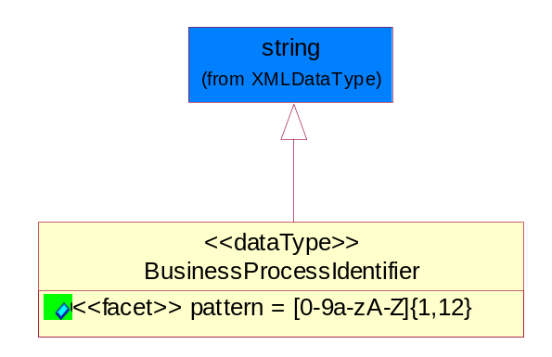
Figure ‎5-37 BusinessProcessIdentifier

Attribute | Type | Documentation
pattern |  | [0-9a-zA-Z]{1,12}

BusinessServiceInformation
The object allows the specification of the business service utilized within the partner company. This may or may not be the same as the information sent by the RNIF.
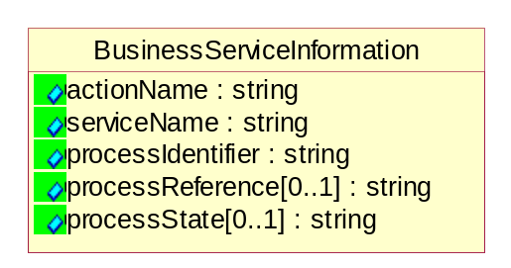
Figure ‎5-38 BusinessServiceInformation

Attribute | Type | Documentation
actionName | string | The name of Action. For RosettaNet usually any of Request/Confirm/Notify/Query/Response.
serviceName | string | The name of the Business Activity with the "Request/Confirm" part removed. E.g., for the Activity "Request Purchase Order"==> "Purchase Order".
processIdentifier | string | The name of the PIP e.g. Notify of Forecast Reply.
processReference[0..1] | string | The URN for the PIP that includes Cluster/Segment/Process pattern used to identify the interface process (such as PIP3A4)
processState[0..1] | string | The business process (or service) state of the sender of a document. When a service receives this document, the receiver may use the state as a precondition.

ContractInformation
A block of information used to correlate a contract in an executing choreography.
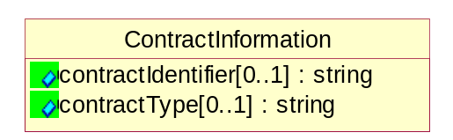
Figure ‎5-39 ContractInformation

Attribute | Type | Documentation
contractIdentifier[0..1] | string | Unique identification of a contract between the Sender and the Receiver
contractType[0..1] | string | The type of the contract: an attribute describing the type of the ContractIndentification. Valid values are URI, URN,ebXMLCPA, or other values defined by partners.

CorrelationInformation
A block of information used to correlate a requesting document to a responding document and to the contract in an executing choreography.
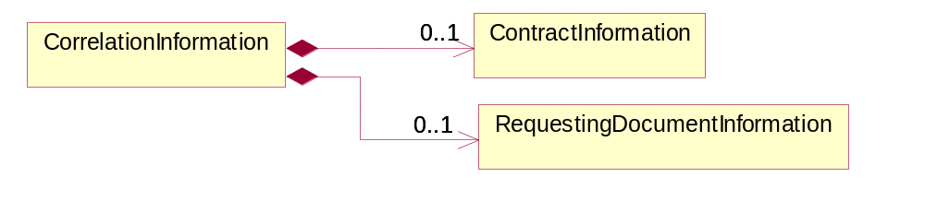
Figure ‎5-40 CorrelationInformation

Composition | Cardinality | Type | Documentation
ContractInformation | 0..1 | ContractInformation | A block of information used to correlate a contract in an executing choreography.
RequestingDocumentInformation | 0..1 | RequestingDocumentInformation | A block of information used to correlate a requesting document to a responding document in an executing choreography.

DocumentHeader
The object allows for the identification of the sender and receiver of the business document.
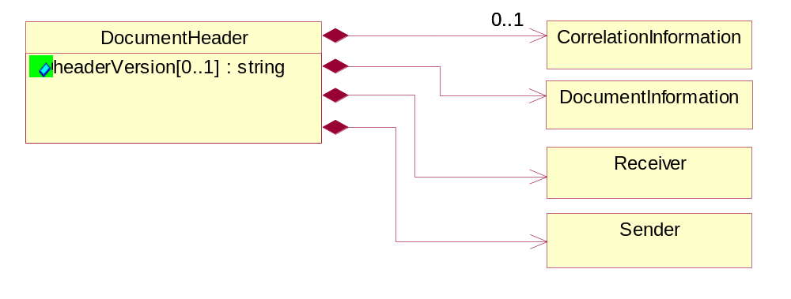
Figure ‎5-41 DocumentHeader

Attribute | Type | Documentation
headerVersion[0..1] | string | The UN/CEFACT version of the document header.

Composition | Cardinality | Type | Documentation
Sender | 1 | Sender | The object allows the identification of the initiating party of the business message.
CorrelationInformation | 0..1 | CorrelationInformation | A block of information used to correlate a requesting document to a responding document and to the contract in an executing choreography.
DocumentInformation | 1 | DocumentInformation | The object specifies information to identify the business document, a summary of attachments, and information about the business document security.
Receiver | 1 | Receiver | The object allows the identification of the receiving party of the business message.

DocumentIdentification
The object specifies all information necessary to identify the business document.
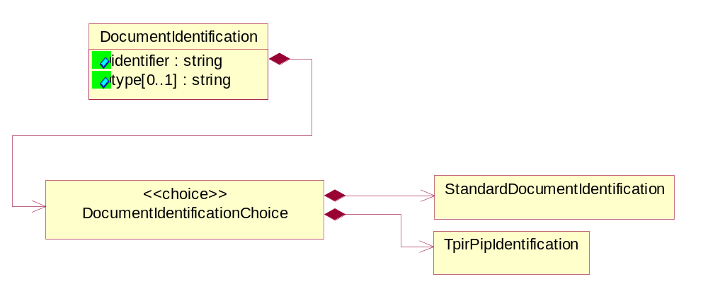
Figure ‎5-42 DocumentIdentification

Attribute | Type | Documentation
identifier | string | The unique identifier for the document being sent.
type[0..1] | string | Name of the Action Message

Composition | Cardinality | Type | Documentation
DocumentIdentificationChoice | 1 | DocumentIdentificationChoice

DocumentIdentificationChoice

Composition | Cardinality | Type | Documentation
StandardDocumentIdentification | 1 | StandardDocumentIdentification | The object specifies additional information necessary to identify the standard business document.
TpirPipIdentification | 1 | TpirPipIdentification | The object specifies all information necessary to uniquely identify a TPIR-PIP within a Registry or trading partner repository.

DocumentInformation
The object specifies information to identify the business document, a summary of attachments, and information about the business document security.
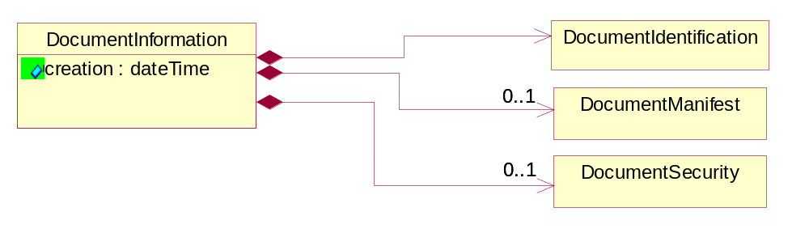
Figure ‎5-43 DocumentInformation

Attribute | Type | Documentation
creation | dateTime | The creation date and time of the specified Business Document (i.e. the Purchase Order date).

Composition | Cardinality | Type | Documentation
DocumentIdentification | 1 | DocumentIdentification | The object specifies all information necessary to identify the business document.
DocumentSecurity | 0..1 | DocumentSecurity | The object provides additional granularity in specifying business document security (this is in addition to the specified PIP security).
DocumentManifest | 0..1 | DocumentManifest | The block provides a brief summary of attachments and Service Content.

DocumentManifest
The block provides a brief summary of attachments and Service Content.
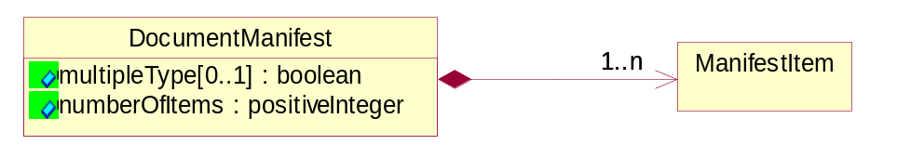
Figure ‎5-44 DocumentManifest

Attribute | Type | Documentation
multipleType[0..1] | boolean | Indicates whether the manifest contains documents of multiple types. True if yes, and False if no.
numberOfItems | positiveInteger | Total number of documents in the message. The physical count of the attachments in the payload plus the RosettaNet Business Message (for Service Content). The value of this field will be at least 1.

Composition | Cardinality | Type | Documentation
ManifestItem | 1..n | ManifestItem | The object provides details about the specific attachment(s).

DocumentSecurity
The object provides additional granularity in specifying business document security (this is in addition to the specified PIP security).
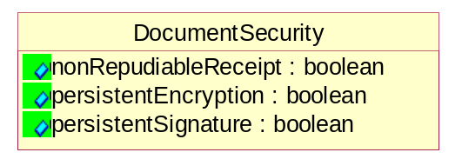
Figure ‎5-45 DocumentSecurity

Attribute | Type | Documentation
nonRepudiableReceipt | boolean | The value "true" will indicate that a signed acknowledgement for the business document is necessary.
persistentEncryption | boolean | The value "true" will indicate that the Business Document (including the header) needs to be encrypted when stored or transported.
persistentSignature | boolean | The value "true" will indicate that a signature is required to be stored with the document while stored or transported.

ManifestItem
The object provides details about the specific attachment(s).

Figure ‎5-46 ManifestItem

Attribute | Type | Documentation
description[0..1] | string | A description of the attachment.
length[0..1] | positiveInteger | The size of the attachment in bytes (i.e. 1 000 000 bytes)
universalResourceIdentifier | string | The generic set of all names/addresses that are short strings that refer to resources.

Composition | Cardinality | Type | Documentation
mimeTypeQualifier | 1 | MimeTypeQualifier | The MIME type as defined by IANA.  Please refer to http://www.iana.org/assignments/media-types/ for a list of types.
language | 0..1 | Language | For representation of Language name RosettaNet has adopted ISO 639-2; 1998. Refer to the following web page to get the latest version of the standard:  http://www.loc.gov/standards/iso639-2/iso639jac.html  If you need more information about the ISO standard please contact ISO for more details.

PipIdentifier
PIP Identification.[ i.e. PIP3A4]
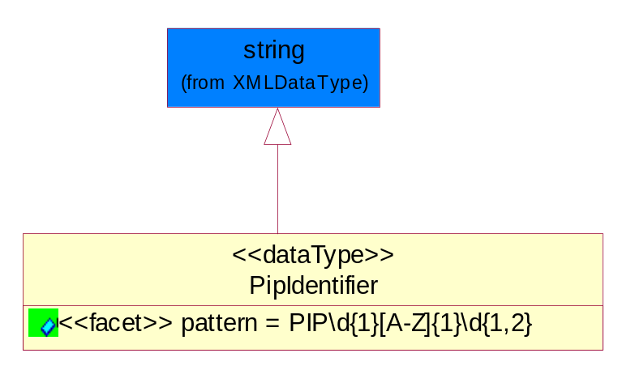
Figure ‎5-47 PipIdentifier

Attribute | Type | Documentation
pattern |  | PIP\d{1}[A-Z]{1}\d{1,2}

PipVersion
PIP version number (i.e. 02.02.00).
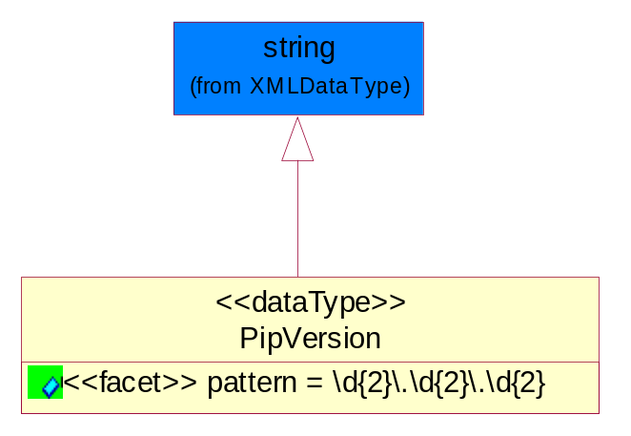
Figure ‎5-48 PipVersion

Attribute | Type | Documentation
pattern |  | \d{2}\.\d{2}\.\d{2}

Receiver
The object allows the identification of the receiving party of the business message.
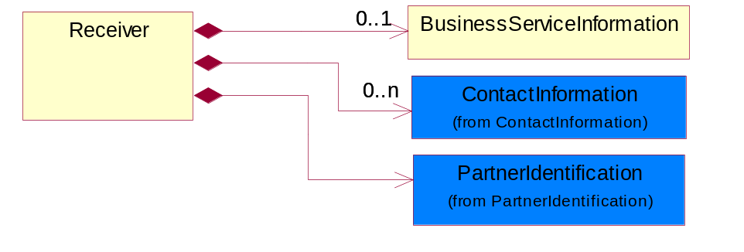
Figure ‎5-49 Receiver

Composition | Cardinality | Type | Documentation
BusinessServiceInformation | 0..1 | BusinessServiceInformation | The object allows the specification of the business service utilized within the partner company. This may or may not be the same as the information sent by the RNIF.
PartnerIdentification | 1 | PartnerIdentification | The business document must allow for the identity of one or more parties to the transaction.
ContactInformation | 0..n | ContactInformation | The business document must allow for the identification of the name of the department, service or individual to be contacted regarding the context of the business document.

RequestingDocumentInformation
A block of information used to correlate a requesting document to a responding document in an executing choreography.
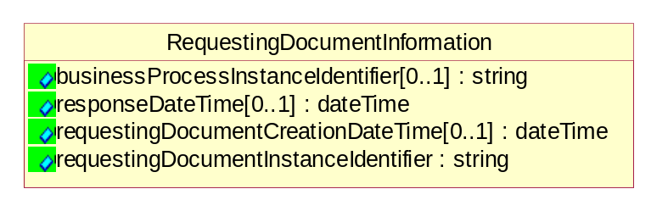
Figure ‎5-50 RequestingDocumentInformation

Attribute | Type | Documentation
businessProcessInstanceIdentifier[0..1] | string | The identifier for the public business process instance being sent that both the sender and receiver can identify.
responseDateTime[0..1] | dateTime | The expected time to receive the response. This can not be greater than the PIP TimeToPerform.
requestingDocumentCreationDateTime[0..1] | dateTime | The date-time of the requesting business document.
requestingDocumentInstanceIdentifier | string | The Business Document identification number that identifies the requesting Business Document.

Sender
The object allows the identification of the initiating party of the business message.
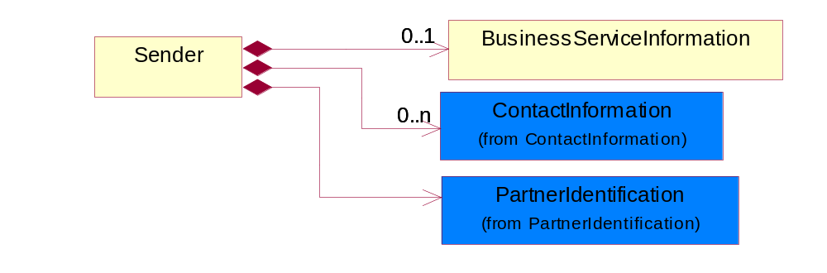
Figure ‎5-51 Sender

Composition | Cardinality | Type | Documentation
PartnerIdentification | 1 | PartnerIdentification | The business document must allow for the identity of one or more parties to the transaction.
BusinessServiceInformation | 0..1 | BusinessServiceInformation | The object allows the specification of the business service utilized within the partner company. This may or may not be the same as the information sent by the RNIF.
ContactInformation | 0..n | ContactInformation | The business document must allow for the identification of the name of the department, service or individual to be contacted regarding the context of the business document.

StandardDocumentIdentification
The object specifies additional information necessary to identify the standard business document.
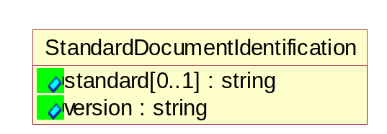
Figure ‎5-52 StandardDocumentIdentification

Attribute | Type | Documentation
standard[0..1] | string | Identifies the standard used to submit the business document. (e.g. RosettaNet).
version | string | PIP3A4v01.00

pirPipIdentification
The object specifies all information necessary to uniquely identify a TPIR-PIP within a Registry or trading partner repository.
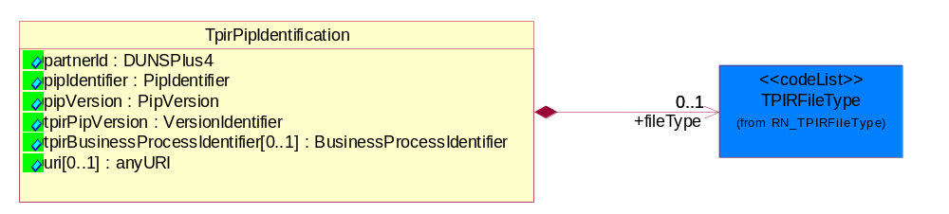
Figure ‎5-53 TpirPipIdentification

Attribute | Type | Documentation
partnerId | DUNSPlus4 | The Trading Partner Identification of MNC that is creating this TPIR PIP.
pipIdentifier | PipIdentifier | A TPIR PIP Identification [i.e., 3A4 ).
pipVersion | PipVersion | A TPIR PIP version number (i.e., 02.02.00)
tpirPipVersion | VersionIdentifier | A TPIR-PIP Version Number (i.e., major and minor version number as XX.XX).
tpirBusinessProcessIdentifier[0..1] | BusinessProcessIdentifier | A Business Process Identifier to uniquely define the TPIR-PIP 'role' within a Business Scenario at a company or MNC level. The identifier MUST be composed of alphanumeric characters only and its length MUST be between one and twelve characters.
uri[0..1] | anyURI | Describes the destination uri for the TPIR form.

Composition | Cardinality | Type | Documentation
fileType | 0..1 | TPIRFileType | Describes the file type of the TPIR form (PDF, XDP or XML).

VersionIdentifier
Version Number (i.e., major and minor version number as XX.XX).
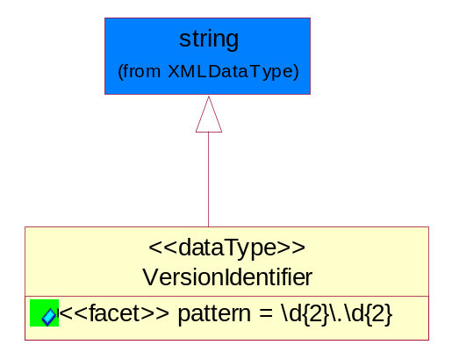
Figure ‎5-54 VersionIdentifier

Attribute | Type | Documentation
pattern |  | \d{2}\.\d{2}

CodeList

TPIRFileType
A code identifying the file type of TPIR form.

Name | Documentation
PDF | Portable Document Format.
XDP | XML Data Package.
XML | eXtensible Markup Language.

XML Data Type

anyURI
Represents a URI as defined by RFC 2396. An anyURI value can be absolute or relative, and may have an optional fragment identifier.

boolean
Represents Boolean values, which are either "true" or "false".

date
For the represents a calendar date.
The pattern for a date is CCYY-MM-DD where CC represents the century, YY the year, MM the month, and DD the day, with an optional time zone indicator as allowed for dateTime.

dateTime
Represents a specific instance of time.
The pattern for dateTime is CCYY-MM-DDThh:mm:ss where CC represents the century, YY the year, MM the month, and DD the day, preceded by an optional leading negative (-) character to indicate a negative number. If the negative character is omitted, positive (+) is assumed. The T is the date/time separator and hh, mm, and ss represent hour, minute, and second respectively. Additional digits can be used to increase the precision of fractional seconds if desired. For example, the format ss.ss... with any number of digits after the decimal point is supported. The fractional seconds part is optional.
This representation may be immediately followed by a "Z" to indicate Coordinated Universal Time (UTC) or to indicate the time zone. For example, the difference between the local time and Coordinated Universal Time, immediately followed by a sign, + or -, followed by the difference from UTC represented as hh:mm (minutes is required). If the time zone is included, both hours and minutes must be present.

decimal
A data type that contains decimal numbers scaled by a power of 10.

duration
Represents a duration of time.
The pattern for duration is PnYnMnDTnHnMnS, where nY represents the number of years, nM the number of months, nD the number of days, T the date/time separator, nH the number of hours, nM the number of minutes, and nS the number of seconds.

float
Represents single-precision 32-bit floating-point numbers.

positiveInteger
Represents an integer that is greater than zero. This data type is derived from nonNegativeInteger.

string
Represents character string.

