

Description of
Partner Interface Process® for 2A17

Validated 11.00.00

Specification Information
Name | Notify Of Certificate Of Analysis
Cluster | Product Information
Segment | Preparation for Distribution
Publication Date | 27 June 2008
Version Identifier | V11.00

Table of Contents
1 Document Management 4
1.1 Legal Disclaimer 4
1.2 Copyright 4
1.3 Trademarks 4
1.4 Acknowledgments 4
1.5 Related Documents 4
1.6 Document Version History 4
1.7 Document Structure 5
2 Business Process 6
2.1 Business Process Definition 6
2.1.1 Business Process Description 6
2.2 PIP Scope Description 7
2.2.1 Business Process Scope Diagram 7
2.3 PIP Business Document 8
2.4 PIP Business Process Flow Diagram 8
2.5 PIP Start State 9
2.6 PIP End States 9
2.7 Partner Role Descriptions 10
2.8 Business Process Activity Controls 10
3 Network and Implementation Specification 11
3.1 Business Action and Business Signal Specifications 11
3.2 Business Transaction Dialog Specification 11
3.2.1 Message Exchange Controls 12
3.2.2 Communications Specification 12

List of Figures:
Figure 1: Business Process Scope Diagram 7
Figure 2: Activity Diagram of Notify Of Certificate Of Analysis 8
Figure 3: Sequence Diagram of Notify Of Certificate Of Analysis 11

List of Tables:
Table 1: PIP Business Document 8
Table 2: PIP Start State 9
Table 3: PIP End State 9
Table 4: PIP Failure State 9
Table 5: Partner Role Description 10
Table 6: Business Activity Description 10
Table 7: Business Activity Performance Control 10
Table 8: Network Component Specification 11
Table 9: Business Action – Business Document Mapping 11
Table 10: Message Exchange Control 12
Table 11: Dialog: Service-Service 12

Document Management

Legal Disclaimer
RosettaNet™, its members, officers, directors, employees, or agents shall not be liable for any injury, loss, damages, financial or otherwise, arising from, related to, or caused by the use of this document or the specifications herein, as well as associated guidelines and schemas. The use of said specifications shall constitute your express consent to the foregoing exculpation.

Copyright
©2008 RosettaNet. All rights reserved. No part of this publication may be reproduced, stored in a retrieval system, or transmitted, in any form or by any means, electronic, mechanical, photocopying, recording, or otherwise, without the prior written permission of the publisher. Printed in the United States of America.

Trademarks
RosettaNet, Partner Interface Process, PIP and the RosettaNet logo are trademarks or registered trademarks of “RosettaNet,” a non-profit organization. All other product names and company logos mentioned herein are the trademarks of their respective owners. In the best effort, all terms mentioned in this document that are known to be trademarks or registered trademarks have been appropriately recognized in the first occurrence of the term.

Acknowledgments
This document has been prepared by RosettaNet (http://www.rosettanet.org/) from requirements gathered during the Milestone Program and in conformance with the methodology. Listed below are the legal entities that contributed to the design and development of this PIP.
Air Products & Chemicals (APCI) | LINDE (formally BOC Edwards)
Intel | IBM
InSync Software | ATMI

Related Documents
- Associated PIP Message Schemas (included within the PIP Specification package only)
- Description of 2A17 Message
- Messages Structure
- XML instance of ebXML BPSS for PIP 2A17

Document Version History
Version | Date | Description
Validated 11.00.00 | 27 June 2008 | Validated Version: Milestone Program – Certificate of Analysis

Document Structure
A Partner Interface Process (PIP) Specification is comprised of the following two parts:
- Business Process. Captures the semantics of the business process and the flow of the message exchange between roles as they perform business activities.
- Network and Implementation Specification. Specifies the network protocol message formats and communications requirements between peer-protocols supported by network components in the RosettaNet Implementation Framework.

Business Process

Business Process Definition
PIP 2A17, The “Notify of Certificate of Analysis” Partner Interface Process™ is sent by supplier to customer, to allow customer to verify the delivered material meets the agreed upon requirements during the time of delivery or prior to delivery.

Business Process Description

Certificate of Analysis is a document attesting to the quality or purity of the material being shipped. The origin of the certificate of analysis may be the manufacturer of the material, the distributor, or another third party, such as an inspection firm or independent laboratory. In most cases the document is created by the manufacturer and certifies that the material shipped has been tested in his facility and found to conform to the agreed upon specifications. The certificate of analysis details the test methods and results obtained for the specific material and package being supplied.

A Certificate of Analysis is provided from the seller (supplier) to the buyer (customer) to allow verification that the delivered material meets the agreed upon requirements. It is provided at the time of delivery, but may be provided prior to delivery to allow pre-shipment approval. A certificate of analysis is used in several industries including, but not limited to, electronic, chemical, industrial gas, petrochemical, textile, etc.
This PIP can help to:-
- Eliminate manual processing and scanning of certificates of analysis for both partners removing the opportunity for inaccurate data entry.
- Eliminate the unmanageable variety of electronic certificate of analysis approaches currently existing in the industry.
- Provide the data electronically for product receipt and verification of compliance versus specifications.
- Allow multiple connections using a single data standard reducing the overall cost.
The recipient may optionally respond to the forecast using PIP 2A18, "Notify of Certificate of Analysis Response".
Should this transaction not complete successfully, the requesting partner executes PIP0A1, "Notification of Failure."

PIP Scope Description
PIP 2A17 "Notify of Certificate of Analysis" is provided from the seller (supplier) to the buyer (customer) to allow verification that the delivered material meets the agreed upon requirements.

Business Process Scope Diagram
Prior to the sending of PIP 2A17 "Notify of Certificate of Analysis", seller (supplier) & buyer (customer) have confirmed the purchase order via PIP 3A4 “Request Purchase Order”. PIP 3B2 “Notify of Shipment” will be sent together with PIP 2A17, or prior to the sending of PIP 2A17.
SELLER
(SUPPLIER)
BUYER
(CUSTOMER)
PIP 3A4: Request Purchase Order
Specifications Agreement
Agreement
Specifications Agreement
PIP 3A4: Purchase Order Confirmation
PO Created
PO Accepted, Material Picked, Shipment Created
PIP 3B2: Notify of Advance Shipment
PIP 2A17: Notify of Certificate of Analysis
(Optional) PIP 2A18: Notify of Certificate of Analysis Response
Material Shipped
Material Received
Optional – Validate Material
Invoice Created
PIP 3C3: Notify of Invoice
EFT Payment Submitted
Figure 1: Business Process Scope Diagram

PIP Business Document
Business Document are generated and exchanged by roles performing activities in this PIP. Business Document is listed and defined in Table 1.
Table 1: PIP Business Document
Business Document | Description
Certificate Of Analysis Notification | A request to provided from the seller to the buyer to allow verification that the delivered material meets the agreed upon requirements.

PIP Business Process Flow Diagram
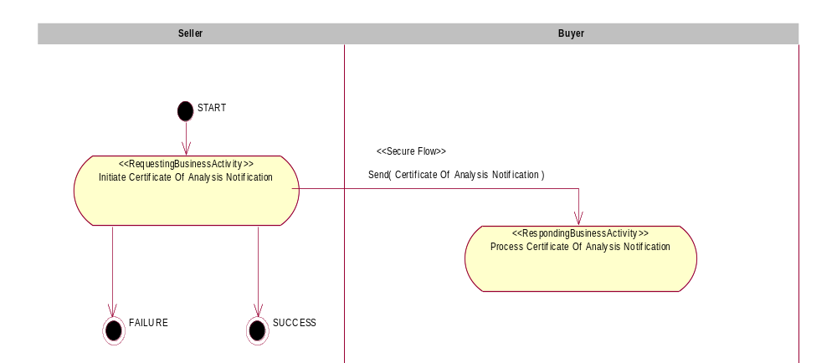
Figure 2: Activity Diagram of Notify Of Certificate Of Analysis

PIP Start State
The start state is comprised of the following conditions:
Table 2: PIP Start State
 | Approved | Exist |  | Valid | Non-Repudiated | Retry Count | Authorized
 | Approved | Party | In Backend System
TPA |  |  | 
Sending Partner |  |  |  | 
Receiving Partner |  | 
Business Document |  |  |  |  |  |  | 

PIP End States
The end state is comprised of the following conditions:
Table 3: PIP End State
 | Approved | Exist |  | Valid | Non-Repudiated | Retry Count | Authorized
 | Approved | Party | In Backend system
Acknowledgment of Receipt |  |  |  |  | 
Receiving Partner |  |  |  |  |  |  | 

The PIP failure state is comprised of one or more of the following conditions:
Table 4: PIP Failure State
 | NO | Exceeded
Success | 
Retry Count |  | 

Partner Role Descriptions
Table 5 describes the partner roles in this PIP.
Table 5: Partner Role Description
Role Name | Role Description
Seller | An organization that sells products to partners in the supply chain (supplier). Initiates the Certificate of Analysis Notification to Certificate Receiver (buyer) to verify the delivered materials meets the agreed upon requirements.
Buyer | An employee or organization that buys products from a partner in the supply chain (customer). Initiates the Certificate Of Analysis Response Notification when the certificate is received from Certificate Provider (seller).

Business Process Activity Controls
Table 6 describes the interaction between roles performing business activity in this PIP.
Table 6: Business Activity Description
Role  Name | Activity Name | Activity Description
Seller | Initiate Certificate Of Analysis Notification | The seller initiates a Certificate of Analysis to buyer to verify the delivered materials meets the agreed upon requirements.
Table 7 details the security, audit and process controls relating to activity performed in the PIP.
Table 7: Business Activity Performance Control
Role  Name | Activity  Name | Acknowledgment  of Receipt |  | Time to Perform | Retry Count | Is Authorization Required? | Non-Repudiation of Origin and Content?
Role  Name | Activity  Name | Non-Repudiation Required? | Time to Acknowledge
Seller | Initiate Certificate Of Analysis Notification | Y | 2 hrs | N/A | 3 | Y | Y

Network and Implementation Specification
Each network component maps into a role of the PIP model. Table 8 specifies the mapping between roles and network components.
Table 8: Network Component Specification
Network Component | Classification | Maps to Role in Business Process
Seller Service | Business Service | Seller
Buyer Service | Business Service | Buyer

Business Action and Business Signal Specifications
Each business action maps to a Business Document of the PIP model. Table 9 specifies the mapping between Business Documents and business actions.
Table 9: Business Action – Business Document Mapping
Business Action | Business Document | Document Function
Certificate Of Analysis Notification Action | Certificate Of Analysis Notification | Notification

Business Transaction Dialog Specification
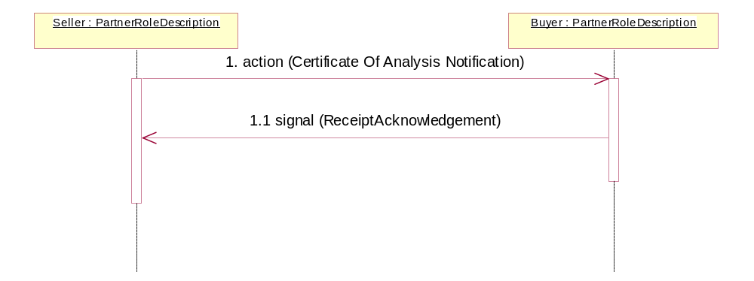
Figure 3: Sequence Diagram of Notify Of Certificate Of Analysis

Message Exchange Controls
Table 10: Message Exchange Control
# | Name |  | Time to Acknowledge Receipt Signal |  | Time to Respond to Action |  | Included in Time to Perform |  | Is Authorization Required? |  | Is Non-Repudiation Required? |  | Is Secure Transport Required?
1. |  | Certificate Of Analysis Notification Action |  | 2 hrs |  | N/A |  | N/A |  | Y |  | Y |  | Y
1.1. |  | Receipt Acknowledgment |  | N/A |  | N/A |  | N/A |  | Y |  | Y |  | Y

Communications Specification
Table 11: Dialog: Service-Service
# | Business Message | Digital Signature Required? | SSL Required?
1. | Certificate Of Analysis Notification | Y | Y
1.1. | Receipt Acknowledgment | Y | Y

