

Description of 2A18 Message

PIP® 2A18
Validated 11.00.00

Specification Information
Name | Description of 2A18 Message
PIP | Notify Of Certificate Of Analysis Response
Cluster | Product Information
Segment | Preparation for Distribution
Publication Date | 01 July 2008
Version Identifier | V11.00

Table of Content

1. Document Management 5
1.1 Legal Disclaimer 5
1.2 Copyright 5
1.3 Trademarks 5
1.4 Acknowledgments 5
1.5 Related Documents 5
1.6 Document Version History 6
1.7 Document Purpose 6
2. Interchange Model 7
2.1 CertificateOfAnalysisResponseNotification 7
2.1.1 Interchange Diagram 7
2.1.2 Dependency Diagram 7
2.1.3 CertificateOfAnalysisResponse 8
2.1.4 CertificateOfAnalysisResponseNotification 8
3. Domain Model 9
3.1 Shared 9
3.1.1 Shared 9
3.1.1.1 Dependency Diagram 9
3.2 Procurement 10
3.2.1 Procurement 10
3.2.1.1 Dependency Diagram 10
3.2.1.2 ResponseStatus 10
3.2.1.3 Response 11
4. Universal Structure 12
4.1 ContactInformation 12
4.1.1 ContactInformation 12
4.2 DataType 12
4.2.1 Contact 12
4.2.2 DUNS 13
4.2.3 DUNSPlus4 13
4.2.4 GLN 14
4.3 Document 14
4.3.1 BusinessDocumentReference 14
4.4 Locations 15
4.4.1 AlternativeIdentifier 15
4.5 PartnerIdentification 16
4.5.1 PartnerIdentification 16
4.5.2 PartnerIdentificationChoice 17
4.6 CodeList 17
4.6.1 Language 17
4.6.2 DocumentType 17
4.6.3 MimeTypeQualifier 19
5. System Structure 30
5.1 BusinessProcessIdentifier 30
5.2 BusinessServiceInformation 30
5.3 ContractInformation 31
5.4 CorrelationInformation 31
5.5 DocumentHeader 32
5.6 DocumentIdentification 33
5.7 DocumentIdentificationChoice 33
5.8 DocumentInformation 34
5.9 DocumentManifest 34
5.10 DocumentSecurity 35
5.11 ManifestItem 35
5.12 PipIdentifier 36
5.13 PipVersion 37
5.14 Receiver 37
5.15 RequestingDocumentInformation 38
5.16 Sender 38
5.17 StandardDocumentIdentification 39
5.18 TpirPipIdentification 39
5.19 VersionIdentifier 40
5.20 CodeList 41
5.20.1 TPIRFileType 41
6. XML Data Type 42
6.1 anyURI 42
6.2 boolean 42
6.3 dateTime 42
6.4 positiveInteger 42
6.5 string 42

Table of Figures

Figure ‎2-1 Interchange 7
Figure ‎2-2 Dependency 7
Figure ‎2-3 CertificateOfAnalysisResponse 8
Figure ‎2-4 CertificateOfAnalysisResponseNotification 8
Figure ‎3-1 Dependency 9
Figure ‎3-2 Dependency 10
Figure ‎3-3 ResponseStatus 10
Figure ‎4-1 ContactInformation 12
Figure ‎4-2 Contact 12
Figure ‎4-3 DUNS 13
Figure ‎4-4 DUNSPlus4 13
Figure ‎4-5 GLN 14
Figure ‎4-6 BusinessDocumentReference 14
Figure ‎4-7 AlternativeIdentifier 15
Figure ‎4-8 PartnerIdentification 16
Figure ‎5-1 BusinessProcessIdentifier 30
Figure ‎5-2 BusinessServiceInformation 30
Figure ‎5-3 ContractInformation 31
Figure ‎5-4 CorrelationInformation 31
Figure ‎5-5 DocumentHeader 32
Figure ‎5-6 DocumentIdentification 33
Figure ‎5-7 DocumentInformation 34
Figure ‎5-8 DocumentManifest 34
Figure ‎5-9 DocumentSecurity 35
Figure ‎5-10 ManifestItem 35
Figure ‎5-11 PipIdentifier 36
Figure ‎5-12 PipVersion 37
Figure ‎5-13 Receiver 37
Figure ‎5-14 RequestingDocumentInformation 38
Figure ‎5-15 Sender 38
Figure ‎5-16 StandardDocumentIdentification 39
Figure ‎5-17 TpirPipIdentification 39
Figure ‎5-18 VersionIdentifier 40

Document Management

Legal Disclaimer
RosettaNet, its members, officers, directors, employees, or agents shall not be liable for any injury, loss, damages, financial or otherwise, arising from, related to, or caused by the use of this document or the specifications herein, as well as associated guidelines and schemas. The use of said specifications shall constitute your express consent to the foregoing exculpation.

Copyright
©2008 RosettaNet. All rights reserved. No part of this publication may be reproduced, stored in a retrieval system, or transmitted, in any form or by any means, electronic, mechanical, photocopying, recording, or otherwise, without the inclusion of this copyright notice. Any derivative works must cite the copyright notice. Any public redistribution or sale of this publication or derivative works requires prior written permission of the publisher.

Trademarks
RosettaNet, Partner Interface Process, PIP and the RosettaNet logo are trademarks or registered trademarks of "RosettaNet," a non-profit organization. All other product names and company logos mentioned herein are the trademarks of their respective owners. In the best effort, all terms mentioned in this document that are known to be trademarks or registered trademarks have been appropriately recognized in the first occurrence of the term.

Acknowledgments
This document has been prepared by RosettaNet (http://www.rosettanet.org/) from requirements gathered during the Milestone Program and in conformance with the methodology. Listed below are the legal entities that contributed to the design and development of this PIP.
Air Products & Chemicals (APCI) | LINDE (formally BOC Edwards)
Intel | IBM
InSync Software | ATMI

Related Documents
- Associated PIP Message Schemas (included with PIP Specification only)
- Description of Partner Interface Process for 2A18
- Message Structure

Document Version History
Version | Date | Description
Validated 11.00.00 | 01 July 2008 | Validated Version - Milestone Program: Notify Of Certificate Of Analysis Response

Document Purpose
The purpose of the document is to explain the structure, the association between objects, the content of objects and the definition for single elements to a non-technical audience.

Interchange Model

CertificateOfAnalysisResponseNotification

Interchange Diagram
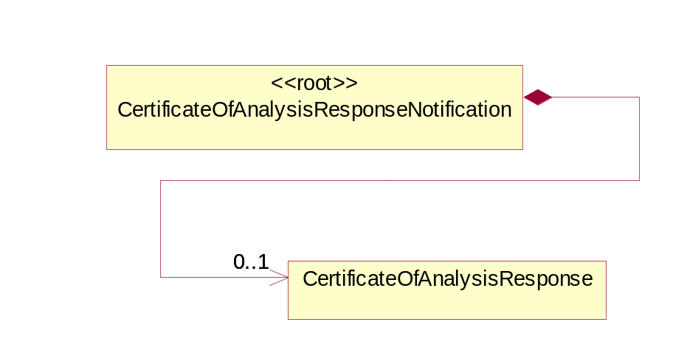
Figure ‎2-1 Interchange

Dependency Diagram
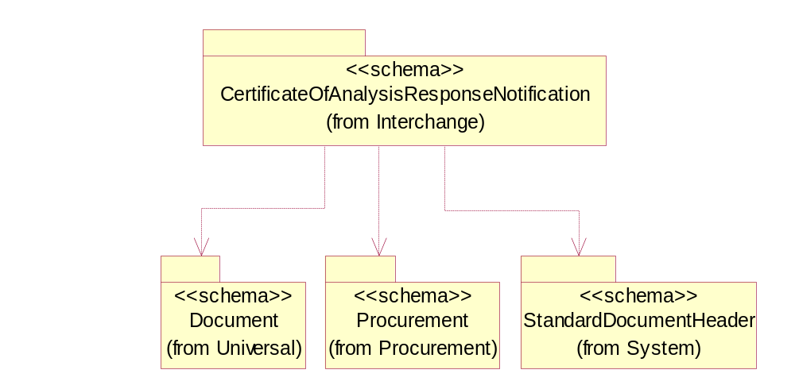
Figure ‎2-2 Dependency

CertificateOfAnalysisResponse
The placeholder for response status information.
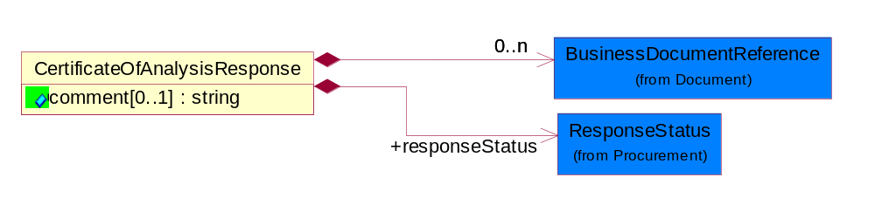
Figure ‎2-3 CertificateOfAnalysisResponse

Attribute | Type | Documentation
comment[0..1] | string | This object represents the free form text of comment.

Composition | Cardinality | Type | Documentation
responseStatus | 1 | ResponseStatus | Response information from buyer after the seller sends the Certificate Of Analysis Notification to the buyer.
BusinessDocumentReference | 0..n | BusinessDocumentReference | The business document reference object allows for the indirect referencing of a relationship to other business related documents.

CertificateOfAnalysisResponseNotification
The message wrapper for 2A18.
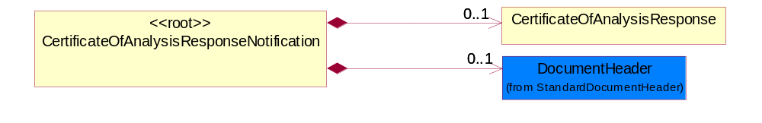
Figure ‎2-4 CertificateOfAnalysisResponseNotification

Composition | Cardinality | Type | Documentation
DocumentHeader | 0..1 | DocumentHeader | The object allows for the identification of the sender and receiver of the business document.
CertificateOfAnalysisResponse | 0..1 | CertificateOfAnalysisResponse | The placeholder for response status information.

Domain Model

Shared

Shared

Dependency Diagram
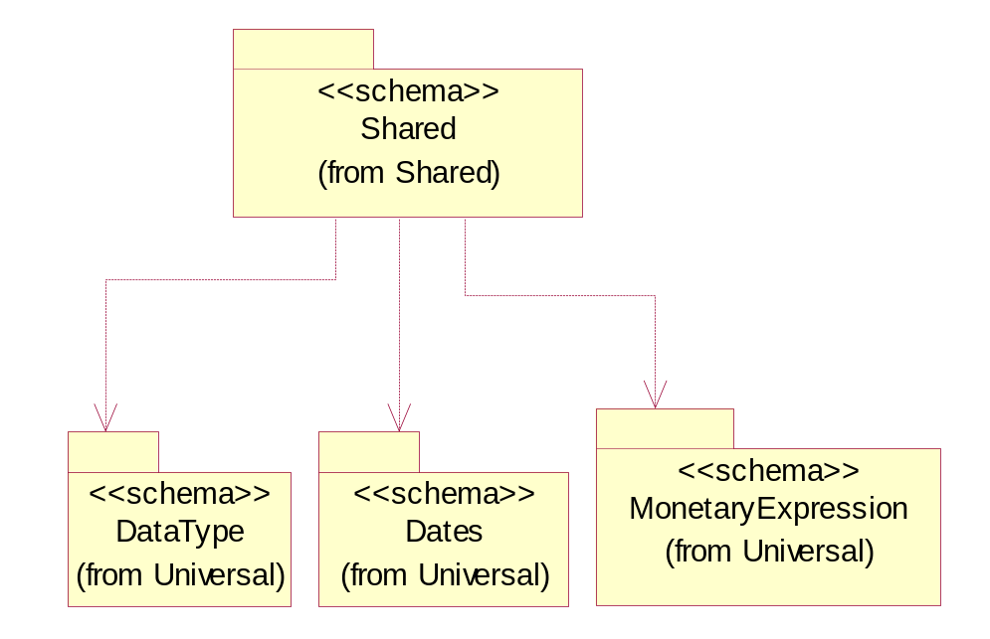
Figure ‎3-5 Dependency

Procurement

Procurement

Dependency Diagram
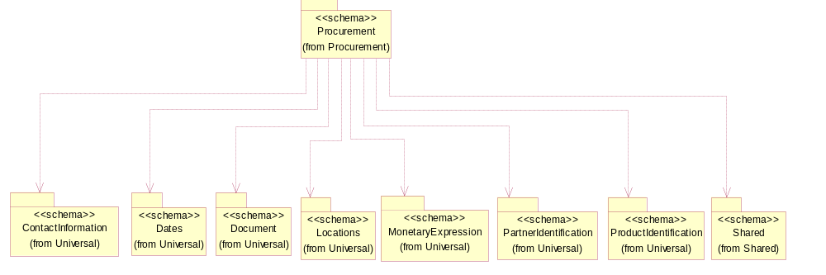
Figure ‎3-6 Dependency

ResponseStatus
Response information from business message receiver after the business message provider sends the business message to the receiver.

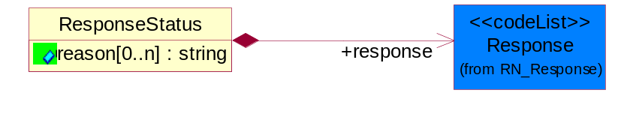
Figure ‎3-7 ResponseStatus

Attribute | Type | Documentation
reason[0..n] | string | Detailed description of Receiver company-specific reason for response. Gives Provider information to modify/correct the business message information.  (Note: Usage for Certificate of Analysis, it is required for "reject" and "pending" responses, optional for "accept" and "request CofA" response)

Composition | Cardinality | Type | Documentation
response | 1 | Response | Communicates quality validation from receiver to provider.

Response
Code identifying forecast disposition at the GTIN level.

Name | Documentation
ACC | Accept.
APC | Available to Promise with Changes.
ATP | Available to Promise.
AWC | Accept with Changes.
PEN | Pending.
RBM | Request business message - To request for the business message request again.
REJ | Reject.

Universal Structure

ContactInformation

ContactInformation
The business document must allow for the identification of the name of the department, service or individual to be contacted regarding the context of the business document.
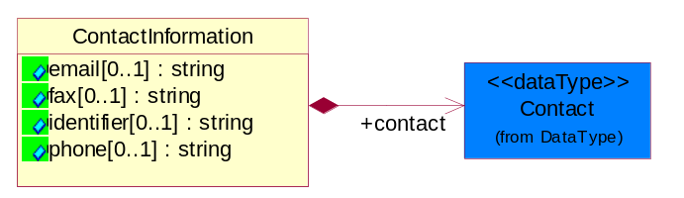
Figure ‎4-8 ContactInformation

Attribute | Type | Documentation
email[0..1] | string | The electronic mail for the specified contact.
fax[0..1] | string | The fax number for the specified contact.
identifier[0..1] | string | Identifies the role of the contact (i.e. Service Technician, Account Manager) in the Business Process.
phone[0..1] | string | The telephone number for the specified contact.

Composition | Cardinality | Type | Documentation
contact | 1 | Contact | The name of the department, service or individual to be contacted within the organization.

DataType

Contact
The name of the department, service or individual to be contacted within the organization.
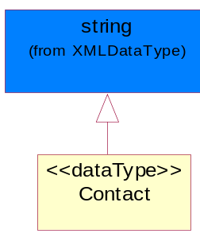
Figure ‎4-9 Contact

DUNS
A number assigned by Dun and Bradstreet to identify a business location.
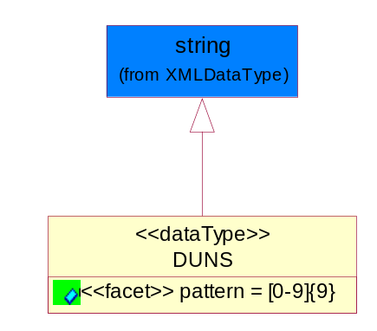
Figure ‎4-10 DUNS

Attribute | Type | Documentation
pattern |  | [0-9]{9}

DUNSPlus4
A identifier to specify a specific location within a business location.
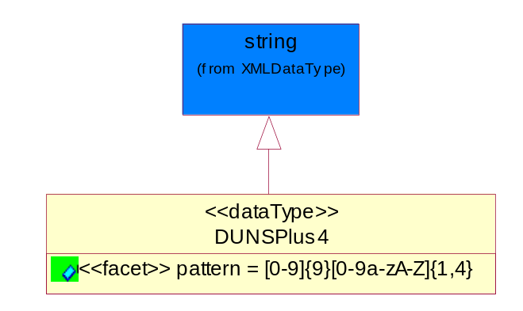
Figure ‎4-11 DUNSPlus4

Attribute | Type | Documentation
pattern |  | Data Universal Numbering System +4 (DUNS+4) number means the DUNS number assigned by Dun and Bradstreet, Inc. (D&B) plus an alphanumeric of length 4 suffix that may be assigned by a business concern.

GLN
Global Location Number (GLN) - A identifier to identify legal entities, trading parties and location.
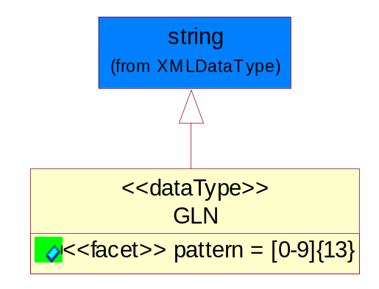
Figure ‎4-12 GLN

Attribute | Type | Documentation
pattern |  | [0-9]{13}

Document

BusinessDocumentReference
The business document reference object allows for the indirect referencing of a relationship to other business related documents.
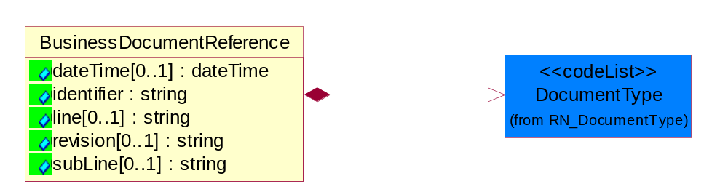
Figure ‎4-13 BusinessDocumentReference

Attribute | Type | Documentation
dateTime[0..1] | dateTime | The date-time stamp indicating on the referenced business document.
identifier | string | Unique identification of the referenced business document.
line[0..1] | string | References the specific line number of the specified business document.
revision[0..1] | string | Referenced the revision of the specified business document.
subLine[0..1] | string | References the specific subline number of the specified business document.

Composition | Cardinality | Type | Documentation
DocumentType | 1 | DocumentType | A code identifying the business context of a document.

Locations

AlternativeIdentifier
Identifies the specified code and the name of the organization that a code is utilized from.
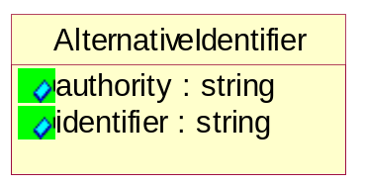
Figure ‎4-14 AlternativeIdentifier

Attribute | Type | Documentation
authority | string | The name of the organization that a code is utilized from.
identifier | string | The specified code to represent an entity (e.g. product, location, partner, etc.).

PartnerIdentification

PartnerIdentification
The business document must allow for the identity of one or more parties to the transaction.
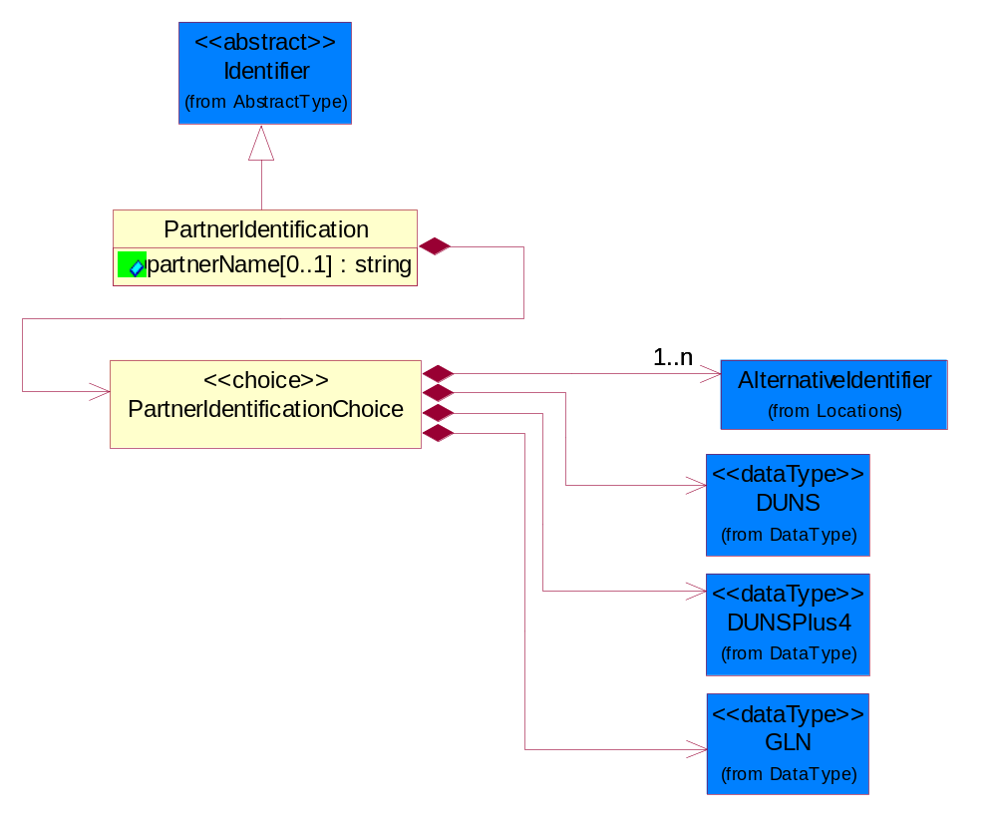
Figure ‎4-15 PartnerIdentification

Attribute | Type | Documentation
partnerName[0..1] | string | The name of the partner’s company/business.

Composition | Cardinality | Type | Documentation
PartnerIdentificationChoice | 1 | PartnerIdentificationChoice

PartnerIdentificationChoice

Composition | Cardinality | Type | Documentation
DUNS | 1 | DUNS | A number assigned by Dun and Bradstreet to identify a business location.
DUNSPlus4 | 1 | DUNSPlus4 | A identifier to specify a specific location within a business location.
AlternativeIdentifier | 1..n | AlternativeIdentifier | Identifies the specified code and the name of the organization that a code is utilized from.
GLN | 1 | GLN | Global Location Number (GLN) - A identifier to identify legal entities, trading parties and location.

CodeList

Language
For representation of Language name RosettaNet has adopted ISO 639-2; 1998. Refer to the following web page to get the latest version of the standard:

http://www.loc.gov/standards/iso639-2/iso639jac.html

If you need more information about the ISO standard please contact ISO for more details.

DocumentType
A code identifying the business context of a document.

Instance | Documentation
ARA | Authorization Request Approval.
CAR | Certificate of Analysis Response.
CBN | Product batch number of customer.
CCN | Customs clearance number.
CFA | Failure Analysis - Request document that will accompany the product providing characteristics of the component failure.
CIN | Commercial Invoice.
CNM | Traditional credit note or memo.
COA | Certificate of Analysis.
CON | In a virtual sourcing relationship, a third party trading partner is supplying a part to a customer on behalf of another company that has taken the order for the customer. In this case a Customer Order Number is associated to the request for material that is sent to the virtual trading partners.
COS | Consumption Notice.
COT | Contract.
CRN | Unique consumption reference number identifying the product consumption issue i.e. one-to-one relationship with physical flow.
DEM | Traditional debit note or memo.
DEN | Delivery Note.
DIN | Discontinuation Notice.
DOR | Delivery Order.
DRN | Drawing Number.
DRR | Design Registration Request.
ECO | Engineering Change Order - The proprietary unique identification number that represents an engineering change order.
EDD | Export Declaration Document.
EIR | Engineering Information Request.
EOL | End of Life.
FUO | Sales order or transfer order fulfilling demand out of a facility (outbound shipment).
IDD | Import Declaration Document.
INV | Invoice.
LID | Location Identifier. Data for on-site work that have to be done on the machine (associated with preventive maintenance order).
MEN | Master Event Number.
MID | Machine Identifier. Data for on-site work that have to be done on the machine (associated with preventive maintenance order).
MON | Model Number.
OCL | The unique identifier assigned by the OEM for a warranty claim.
OGA | Other governmental agency issued document.
OPO | The unique identifier assigned by the OEM for a part order.
OPR | The unique identifier assigned by the OEM for a part return.
PCN | Product/Process Change.
PFA | Failure Analysis - Request document that will accompany the product providing characteristics of the product failure.
PII | Refers to previously issued invoice.
PLS | Unique number that identifies packing form prior to shipment.
POI | Purchase Order IN.
PON | Production order number for material release.
POO | Purchase Order OUT.
PRC | Product Catalog.
PSI | Refers to previously issued self-billing invoice.
PUO | Purchase Order.
QUO | Quote.
REC | Document identifying the receipt of materials or products into a facility against a purchase order or transfer order (inbound shipment).
REN | Release Number.
REO | Purchase order or transfer order replenishing inventory into a facility (inbound shipment).
REQ | Requisition.
RMA | Returned Material Authorization.
RPO | Purchase order for materials or product returned to and reworked by a supplier.
RTA | Remittance Advice - Remittance details.
SAO | Sales Order.
SBC | Credit Memo used in self-billing scenario.
SBD | Debit Memo used in self-billing scenario.
SBI | Invoice in self billing scenario.
SBN | Product batch number of supplier.
SCA | Similar to contracts - Contains the quantity of an article that is to be ordered from a vendor and the price for article or service that is to be procured.
SEN | Serial Number.
SEO | A document that gives a repair provider the necessary authorization to repair or upgrade a product either at the customer site or at the repair provider’s site.
SHD | Shipping Document.
SNC | Shipset Number on Code List.
SPC | The unique identifier assigned by the ASP for a warranty claim.
SPN | Spec Number.
SPO | The unique identifier assigned by the ASP for a part order.
SPR | The unique identifier assigned by the ASP for a part return.
SPW | The unique identifier assigned by the ASP to reference a work order.
SRI | A document that contains the shipping reference number which allows the product to be tracked within the outsourced logistic providers network.
TRO | Order which results in materials or products being moved from one facility to another (outbound shipment and inbound shipment).
WAB | Waybill.
WAC | Denotes a warranty claim.
WOO | Work Order.

MimeTypeQualifier
The MIME type as defined by IANA.

Please refer to http://www.iana.org/assignments/media-types/ for a list of types.

Instance | Documentation
application/activemessage | [Shapiro]
application/andrew-inset | [Borenstein]
application/applefile | [Faltstrom]
application/atomicmail | [Borenstein]
application/batch-SMTP | [RFC2442]
application/beep+xml | [RFC3080]
application/cals-1840 | [RFC1895]
application/cnrp+xml | [RFCCNRP]
application/commonground | [Glazer]
application/cpl+xml
application/cybercash | [Eastlake]
application/dca-rft | [Campbell]
application/dec-dx | [Campbell]
application/dicom | [RFC3240]
application/dvcs | [RFC3029]
application/EDI-Consent | [RFC1767]
application/EDIFACT | [RFC1767]
application/EDI-X12 | [RFC1767]
application/eshop | [Katz]
application/font-tdpfr | [RFC3073]
application/http | [RFC2616]
application/hyperstudio | [Domino]
application/iges | [Parks]
application/index | [RFC2652]
application/index.cmd | [RFC2652]
application/index.obj | [RFC2652]
application/index.response | [RFC2652]
application/index.vnd | [RFC2652]
application/iotp | [RFC2935]
application/ipp | [RFC2910]
application/isup | [RFC3204]
application/mac-binhex40 | [Faltstrom]
application/macwriteii | [Lindner]
application/marc | [RFC2220]
application/mathematica | [Van Nostern]
application/msword | [Lindner]
application/news-message-id | [RFC1036,Spencer]
application/news-transmission | [RFC1036, Spencer]
application/ocsp-request | [RFC2560]
application/ocsp-response | [RFC2560]
application/octet-stream | [RFC2045,RFC2046]
application/oda | [RFC2045,RFC2046]
application/ogg | [RFC-walleij-ogg-mediatype-08.txt]
application/parityfec | [RFC3009]
application/pdf | [Lindner]
application/pgp-encrypted | [RFC3156]
application/pgp-keys | [RFC3156]
application/pgp-signature | [RFC3156]
application/pkcs10 | [RFC2311]
application/pkcs7-mime | [RFC2311]
application/pkcs7-signature | [RFC2311]
application/pkix-cert | [RFC2585]
application/pkixcmp | [RFC2510]
application/pkix-crl | [RFC2585]
application/postscript | [RFC2045,RFC2046]
application/prs.alvestrand.titrax-sheet | [Alvestrand]
application/prs.cww | [Rungchavalnont]
application/prs.nprend | [Doggett]
application/prs.plucker | [Janssen]
application/qsig | [RFC3204]
application/reginfo+xml | [RFC-ietf-sipping-reg-event-00.txt]
application/remote-printing | [RFC1486,Rose]
application/riscos | [Smith]
application/rtf | [Lindner]
application/sdp | [RFC2327]
application/set-payment | [Korver]
application/set-payment-initiation | [Korver]
application/set-registration | [Korver]
application/set-registration-initiation | [Korver]
application/sgml | [RFC1874]
application/sgml-open-catalog | [Grosso]
application/sieve | [RFC3028]
application/slate | [Crowley]
application/timestamp-query | [RFC3161]
application/timestamp-reply | [RFC3161]
application/tve-trigger | [Welsh]
application/vemmi | [RFC2122]
application/vnd.3gpp.pic-bw-large | [Meredith]
application/vnd.3gpp.pic-bw-small | [Meredith]
application/vnd.3gpp.pic-bw-var | [Meredith]
application/vnd.3gpp.sms | [Meredith]
application/vnd.3M.Post-it-Notes | [O'Brien]
application/vnd.accpac.simply.aso | [Leow]
application/vnd.accpac.simply.imp | [Leow]
application/vnd.acucobol | [Lubin]
application/vnd.acucorp | [Lubin]
application/vnd.adobe.xfdf | [Perelman]
application/vnd.aether.imp | [Moskowitz]
application/vnd.amiga.ami | [Blumberg]
application/vnd.anser-web-certificate-issue-initiation | [Mori]
application/vnd.anser-web-funds-transfer-initiation | [Mori]
application/vnd.audiograph | [Slusanschi]
application/vnd.blueice.multipass | [Holmstrom]
application/vnd.bmi | [Gotoh]
application/vnd.businessobjects | [Imoucha]
application/vnd.canon-cpdl | [Muto]
application/vnd.canon-lips | [Muto]
application/vnd.cinderella | [Kortenkamp]
application/vnd.claymore | [Simpson]
application/vnd.commerce-battelle | [Applebaum]
application/vnd.commonspace | [Chandhok]
application/vnd.contact.cmsg | [Patz]
application/vnd.cosmocaller | [Dellutri]
application/vnd.ctc-posml | [Kohlhepp]
application/vnd.cups-postscript | [Sweet]
application/vnd.cups-raster | [Sweet]
application/vnd.cups-raw | [Sweet]
application/vnd.curl | [Byrnes]
application/vnd.cybank | [Helmee]
application/vnd.data-vision.rdz | [Fields]
application/vnd.dna | [Searcy]
application/vnd.dpgraph | [Parker]
application/vnd.dreamfactory | [Appleton]
application/vnd.dxr | [Duffy]
application/vnd.ecdis-update | [Buettgenbach]
application/vnd.ecowin.chart | [Olsson]
application/vnd.ecowin.filerequest | [Olsson]
application/vnd.ecowin.fileupdate | [Olsson]
application/vnd.ecowin.series | [Olsson]
application/vnd.ecowin.seriesrequest | [Olsson]
application/vnd.ecowin.seriesupdate | [Olsson]
application/vnd.enliven | [Santinelli]
application/vnd.epson.esf | [Hoshina]
application/vnd.epson.msf | [Hoshina]
application/vnd.epson.quickanime | [Gu]
application/vnd.epson.salt | [Nagatomo]
application/vnd.epson.ssf | [Hoshina]
application/vnd.ericsson.quickcall | [Tidwell]
application/vnd.eudora.data | [Resnick]
application/vnd.fdf | [Zilles]
application/vnd.ffsns | [Holstage]
application/vnd.FloGraphIt | [Floersch]
application/vnd.framemaker | [Wexler]
application/vnd.fsc.weblaunch | [D.Smith]
application/vnd.fujitsu.oasys | [Togashi]
application/vnd.fujitsu.oasys2 | [Togashi]
application/vnd.fujitsu.oasys3 | [Okudaira]
application/vnd.fujitsu.oasysgp | [Sugimoto]
application/vnd.fujitsu.oasysprs | [Ogita]
application/vnd.fujixerox.ddd | [Onda]
application/vnd.fujixerox.docuworks | [Taguchi]
application/vnd.fujixerox.docuworks.binder | [Matsumoto]
application/vnd.fut-misnet | [Pruulmann]
application/vnd.grafeq | [Tupper]
application/vnd.groove-account | [Joseph]
application/vnd.groove-help | [Joseph]
application/vnd.groove-identity-message | [Joseph]
application/vnd.groove-injector | [Joseph]
application/vnd.groove-tool-message | [Joseph]
application/vnd.groove-tool-template | [Joseph]
application/vnd.groove-vcard | [Joseph]
application/vnd.hbci | [Hammann]
application/vnd.hhe.lesson-player | [Jones]
application/vnd.hp-HPGL | [Pentecost]
application/vnd.hp-hpid | [Gupta]
application/vnd.hp-hps | [Aubrey]
application/vnd.hp-PCL | [Pentecost]
application/vnd.hp-PCLXL | [Pentecost]
application/vnd.httphone | [Lefevre]
application/vnd.hzn-3d-crossword | [Minnis]
application/vnd.ibm.afplinedata | [Buis]
application/vnd.ibm.electronic-media | [Tantlinger]
application/vnd.ibm.MiniPay | [Herzberg]
application/vnd.ibm.modcap | [Hohensee]
application/vnd.ibm.secure-container | [Tantlinger]
application/vnd.informix-visionary | [Gales]
application/vnd.intercon.formnet | [Gurak]
application/vnd.intertrust.digibox | [Tomasello]
application/vnd.intertrust.nncp | [Tomasello]
application/vnd.intu.qbo | [Scratchley]
application/vnd.intu.qfx | [Scratchley]
application/vnd.irepository.package+xml | [Knowles]
application/vnd.is-xpr | [Natarajan]
application/vnd.japannet-directory-service | [Fujii]
application/vnd.japannet-jpnstore-wakeup | [Yoshitake]
application/vnd.japannet-payment-wakeup | [Fujii]
application/vnd.japannet-registration | [Yoshitake]
application/vnd.japannet-registration-wakeup | [Fujii]
application/vnd.japannet-setstore-wakeup | [Yoshitake]
application/vnd.japannet-verification | [Yoshitake]
application/vnd.japannet-verification-wakeup | [Fujii]
application/vnd.jisp | [Deckers]
application/vnd.kde.karbon | [Faure]
application/vnd.kde.kchart | [Faure]
application/vnd.kde.kformula | [Faure]
application/vnd.kde.kivio | [Faure]
application/vnd.kde.kontour | [Faure]
application/vnd.kde.kpresenter | [Faure]
application/vnd.kde.kspread | [Faure]
application/vnd.kde.kword | [Faure]
application/vnd.kenameaapp | [DiGiorgio-Haag]
application/vnd.koan | [Cole]
application/vnd.liberty-request+xml | [McDowell]
application/vnd.llamagraphics.life-balance.desktop | [White]
application/vnd.lotus-1-2-3 | [Wattenberger]
application/vnd.lotus-approach | [Wattenberger]
application/vnd.lotus-freelance | [Wattenberger]
application/vnd.lotus-notes | [Laramie]
application/vnd.lotus-organizer | [Wattenberger]
application/vnd.lotus-screencam | [Wattenberger]
application/vnd.lotus-wordpro | [Wattenberger]
application/vnd.mcd | [Gotoh]
application/vnd.mediastation.cdkey | [Flurry]
application/vnd.meridian-slingshot | [Wedel]
application/vnd.micrografx.flo | [Prevo]
application/vnd.micrografx.igx | [Prevo]
application/vnd.mif | [Wexler]
application/vnd.minisoft-hp3000-save | [Bartram]
application/vnd.mitsubishi.misty-guard.trustweb | [Tanaka]
application/vnd.Mobius.DAF | [Kabayama]
application/vnd.Mobius.DIS | [Kabayama]
application/vnd.Mobius.MBK | [Devasia]
application/vnd.Mobius.MQY | [Devasia]
application/vnd.Mobius.MSL | [Kabayama]
application/vnd.Mobius.PLC | [Kabayama]
application/vnd.Mobius.TXF | [Kabayama]
application/vnd.mophun.application | [Wennerstrom]
application/vnd.mophun.certificate | [Wennerstrom]
application/vnd.motorola.flexsuite | [Patton]
application/vnd.motorola.flexsuite.adsi | [Patton]
application/vnd.motorola.flexsuite.fis | [Patton]
application/vnd.motorola.flexsuite.gotap | [Patton]
application/vnd.motorola.flexsuite.kmr | [Patton]
application/vnd.motorola.flexsuite.ttc | [Patton]
application/vnd.motorola.flexsuite.wem | [Patton]
application/vnd.mozilla.xul+xml | [McDaniel]
application/vnd.ms-artgalry | [Slawson]
application/vnd.ms-asf | [Fleischman]
application/vnd.mseq | [Le Bodic]
application/vnd.ms-excel | [Gill]
application/vnd.msign | [Borcherding]
application/vnd.ms-lrm | [Ledoux]
application/vnd.ms-powerpoint | [Gill]
application/vnd.ms-project | [Gill]
application/vnd.ms-tnef | [Gill]
application/vnd.ms-works | [Gill]
application/vnd.ms-wpl | [Plastina]
application/vnd.musician | [Adams]
application/vnd.music-niff | [Butler]
application/vnd.netfpx | [Mutz]
application/vnd.noblenet-directory | [Solomon]
application/vnd.noblenet-sealer | [Solomon]
application/vnd.noblenet-web | [Solomon]
application/vnd.novadigm.EDM | [Swenson]
application/vnd.novadigm.EDX | [Swenson]
application/vnd.novadigm.EXT | [Swenson]
application/vnd.obn | [Hessling]
application/vnd.osa.netdeploy | [Klos]
application/vnd.palm | [Peacock]
application/vnd.pg.format | [Gandert]
application/vnd.pg.osasli | [Gandert]
application/vnd.powerbuilder6 | [Guy]
application/vnd.powerbuilder6-s | [Guy]
application/vnd.powerbuilder7 | [Shilts]
application/vnd.powerbuilder75 | [Shilts]
application/vnd.powerbuilder75-s | [Shilts]
application/vnd.powerbuilder7-s | [Shilts]
application/vnd.previewsystems.box | [Smolgovsky]
application/vnd.publishare-delta-tree | [Ben-Kiki]
application/vnd.pvi.ptid1 | [Lamb]
application/vnd.pwg-multiplexed | [RFC3391]
application/vnd.pwg-xhtml-print+xml | [Wright]
application/vnd.Quark.QuarkXPress | [Scheidler]
application/vnd.rapid | [Szekely]
application/vnd.s3sms | [Tarkkala]
application/vnd.sealed.net | [Lambert]
application/vnd.seemail | [Webb]
application/vnd.shana.informed.formdata | [Selzler]
application/vnd.shana.informed.formtemplate | [Selzler]
application/vnd.shana.informed.interchange | [Selzler]
application/vnd.shana.informed.package | [Selzler]
application/vnd.smaf | [Takahashi]
application/vnd.sss-cod | [Dani]
application/vnd.sss-dtf | [Bruno]
application/vnd.sss-ntf | [Bruno]
application/vnd.street-stream | [Levitt]
application/vnd.svd | [Becker]
application/vnd.swiftview-ics | [Widener]
application/vnd.triscape.mxs | [Simonoff]
application/vnd.trueapp | [Hepler]
application/vnd.truedoc | [Chase]
application/vnd.ufdl | [Manning]
application/vnd.uplanet.alert | [Martin]
application/vnd.uplanet.alert-wbxml | [Martin]
application/vnd.uplanet.bearer-choice | [Martin]
application/vnd.uplanet.bearer-choice-wbxml | [Martin]
application/vnd.uplanet.cacheop | [Martin]
application/vnd.uplanet.cacheop-wbxml | [Martin]
application/vnd.uplanet.channel | [Martin]
application/vnd.uplanet.channel-wbxml | [Martin]
application/vnd.uplanet.list | [Martin]
application/vnd.uplanet.listcmd | [Martin]
application/vnd.uplanet.listcmd-wbxml | [Martin]
application/vnd.uplanet.list-wbxml | [Martin]
application/vnd.uplanet.signal | [Martin]
application/vnd.vcx | [T.Sugimoto]
application/vnd.vectorworks | [Pharr]
application/vnd.vidsoft.vidconference | [Hess]
application/vnd.visio | [Sandal]
application/vnd.visionary | [Aravindakumar]
application/vnd.vividence.scriptfile | [Risher]
application/vnd.vsf | [Rowe]
application/vnd.wap.sic | [WAP-Forum]
application/vnd.wap.slc | [WAP-Forum]
application/vnd.wap.wbxml | [Stark]
application/vnd.wap.wmlc | [Stark]
application/vnd.wap.wmlscriptc | [Stark]
application/vnd.webturbo | [Rehem]
application/vnd.wrq-hp3000-labelled | [Bartram]
application/vnd.wt.stf | [Wohler]
application/vnd.wv.csp+wbxml | [Salmi]
application/vnd.xara | [Matthewman]
application/vnd.xfdl | [Manning]
application/vnd.yellowriver-custom-menu | [Yellow]
application/whoispp-query | [RFC2957]
application/whoispp-response | [RFC2958]
application/wita | [Campbell]
application/wordperfect5.1 | [Lindner]
application/x400-bp | [RFC1494]
application/xhtml+xml | [RFC3236]
application/xml | [RFC3023]
application/xml-dtd | [RFC3023]
application/xml-external-parsed-entity | [RFC3023]
application/zip | [Lindner]
audio/32kadpcm | [RFC2421,RFC2422]
audio/AMR | [RFC3267]
audio/AMR-WB | [RFC3267]
audio/basic | [RFC2045,RFC2046]
audio/CN | [RFC3389]
audio/DAT12 | [RFC3190]
audio/DVI4
audio/EVRC | [RFC-ietf-avt-evrc-smv-03.txt]
audio/EVRC0 | [RFC-ietf-avt-evrc-smv-03.txt]
audio/G.722.1 | [RFC3047]
audio/G722
audio/G723
audio/G726-16
audio/G726-24
audio/G726-32
audio/G726-40
audio/G728
audio/G729
audio/G729D
audio/G729E
audio/GSM
audio/GSM-EFR
audio/L16 | [RFC2586]
audio/L20 | [RFC3190]
audio/L24 | [RFC3190]
audio/L8
audio/LPC
audio/MP4A-LATM | [RFC3016]
audio/MPA
audio/mpa-robust | [RFC3119]
audio/mpeg | [RFC3003]
audio/parityfec | [RFC3009]
audio/PCMA
audio/PCMU
audio/prs.sid | [Walleij]
audio/QCELP
audio/RED
audio/SMV | [RFC-ietf-avt-evrc-smv-03.txt]
audio/SMV0 | [RFC-ietf-avt-evrc-smv-03.txt]
audio/telephone-event | [RFC2833]
audio/tone | [RFC2833]
audio/VDVI
audio/vnd.3gpp.iufp | [Belling]
audio/vnd.cisco.nse | [Kumar]
audio/vnd.cns.anp1 | [McLaughlin]
audio/vnd.cns.inf1 | [McLaughlin]
audio/vnd.digital-winds | [Strazds]
audio/vnd.everad.plj | [Cicelsky]
audio/vnd.lucent.voice | [Vaudreuil]
audio/vnd.nortel.vbk | [Parsons]
audio/vnd.nuera.ecelp4800 | [Fox]
audio/vnd.nuera.ecelp7470 | [Fox]
audio/vnd.nuera.ecelp9600 | [Fox]
audio/vnd.octel.sbc | [Vaudreuil]
audio/vnd.qcelp | [Lundblade]
audio/vnd.rhetorex.32kadpcm | [Vaudreuil]
audio/vnd.vmx.cvsd | [Vaudreuil]
image/cgm | Computer Graphics Metafile
image/g3fax | [RFC1494]
image/gif | [RFC2045,RFC2046]
image/ief | [RFC1314] Image Exchange Format
image/jpeg | [RFC2045,RFC2046]
image/naplps | [Ferber]
image/png | [Randers-Pehrson]
image/prs.btif | [Simon]
image/prs.pti | [Laun]
image/t38 | [RFC3362]
image/tiff | [RFC3302] Tag Image File Format
image/tiff-fx | [RFC3250] Tag Image File Format Fax eXtended
image/vnd.cns.inf2 | [McLaughlin]
image/vnd.djvu | [Bottou]
image/vnd.dwg | [Moline]
image/vnd.dxf | [Moline]
image/vnd.fastbidsheet | [Becker]
image/vnd.fpx | [Spencer]
image/vnd.fst | [Fuldseth]
image/vnd.fujixerox.edmics-mmr | [Onda]
image/vnd.fujixerox.edmics-rlc | [Onda]
image/vnd.globalgraphics.pgb | [Bailey]
image/vnd.mix | [Reddy]
image/vnd.ms-modi | [Vaughan]
image/vnd.net-fpx | [Spencer]
image/vnd.svf | [Moline]
image/vnd.wap.wbmp | [Stark]
image/vnd.xiff | [S.Martin]
message/delivery-status | [RFC1894]
message/disposition-notification | [RFC2298]
message/external-body | [RFC2045,RFC2046]
message/http | [RFC2616]
message/news | [RFC 1036, H.Spencer]
message/partial | [RFC2045,RFC2046]
message/rfc822 | [RFC2045,RFC2046]
message/s-http | [RFC2660]
message/sip | [RFC3261]
message/sipfrag | [RFC3420]
model/iges | [Parks]
model/mesh | [RFC2077]
model/vnd.dwf | [Pratt]
model/vnd.flatland.3dml | [Powers]
model/vnd.gdl | [Babits]
model/vnd.gs-gdl | [Babits]
model/vnd.gtw | [Ozaki]
model/vnd.mts | [Rabinovitch]
model/vnd.parasolid.transmit.binary | [Parasolid]
model/vnd.parasolid.transmit.text | [Parasolid]
model/vnd.vtu | [Rabinovitch]
model/vrml | [RFC2077]
multipart/alternative | [RFC2045,RFC2046]
multipart/appledouble | [Faltstrom]
multipart/byteranges | [RFC2068]
multipart/digest | [RFC2045,RFC2046]
multipart/encrypted | [RFC1847]
multipart/form-data | [RFC2388]
multipart/header-set | [Crocker]
multipart/mixed | [RFC2045,RFC2046]
multipart/parallel | [RFC2045,RFC2046]
multipart/related | [RFC2387]
multipart/report | [RFC1892]
multipart/signed | [RFC1847]
multipart/voice-message | [RFC2421,RFC2423]
text/calendar | [RFC2445]
text/css | [RFC2318]
text/directory | [RFC2425]
text/enriched | [RFC1896]
text/html | [RFC2854]
text/parityfec | [RFC3009]
text/plain | [RFC2646,RFC2046]
text/prs.lines.tag | [Lines]
text/rfc822-headers | [RFC1892]
text/richtext | [RFC2045,RFC2046]
text/rtf | [Lindner]
text/sgml | [RFC1874]
text/t140 | [RFC2793]
text/tab-separated-values | [Lindner]
text/uri-list | [RFC2483]
text/vnd.abc | [Allen]
text/vnd.curl | [Byrnes]
text/vnd.DMClientScript | [Bradley]
text/vnd.fly | [Gurney]
text/vnd.fmi.flexstor | [Hurtta]
text/vnd.in3d.3dml | [Powers]
text/vnd.in3d.spot | [Powers]
text/vnd.IPTC.NewsML | [IPTC]
text/vnd.IPTC.NITF | [IPTC]
text/vnd.latex-z | [Lubos]
text/vnd.motorola.reflex | [Patton]
text/vnd.ms-mediapackage | [Nelson]
text/vnd.net2phone.commcenter.command | [Xie]
text/vnd.sun.j2me.app-descriptor | [G.Adams]
text/vnd.wap.si | [WAP-Forum]
text/vnd.wap.sl | [WAP-Forum]
text/vnd.wap.wml | [Stark]
text/vnd.wap.wmlscript | [Stark]
text/xml | [RFC3023]
text/xml-external-parsed-entity | [RFC3023]
video/BMPEG
video/BT656
video/CelB
video/DV | [RFC3189]
video/H261
video/H263
video/H263-1998
video/H263-2000
video/JPEG
video/MP1S
video/MP2P
video/MP2T
video/MP4V-ES | [RFC3016]
video/mpeg | [RFC2045,RFC2046]
video/MPV
video/nv
video/parityfec | [RFC3009]
video/pointer | [RFC2862]
video/quicktime | [Lindner]
video/SMPTE292M | [RFC-avt-smpte292-video-08.txt]
video/vnd.fvt | [Fuldseth]
video/vnd.motorola.video | [McGinty]
video/vnd.motorola.videop | [McGinty]
video/vnd.mpegurl | [Recktenwald]
video/vnd.nokia.interleaved-multimedia | [Kangaslampi]
video/vnd.objectvideo | [Clark]
video/vnd.vivo | [Wolfe]

System Structure

BusinessProcessIdentifier
A Business Process Identifier to uniquely define the TPIR-PIP 'role' within a Business Scenario at a company or MNC level. The identifier MUST be composed of alphanumeric characters only and its length MUST be between one and twelve characters.
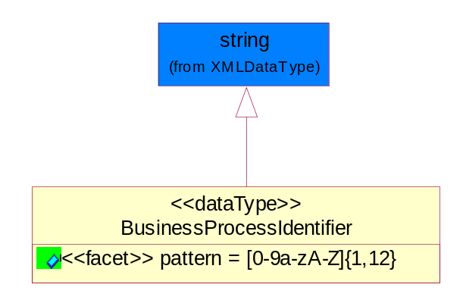
Figure ‎5-16 BusinessProcessIdentifier

Attribute | Type | Documentation
pattern |  | [0-9a-zA-Z]{1,12}

BusinessServiceInformation
The object allows the specification of the business service utilized within the partner company. This may or may not be the same as the information sent by the RNIF.
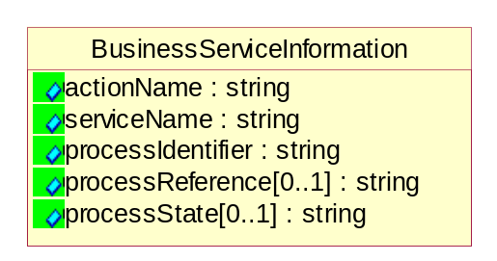
Figure ‎5-17 BusinessServiceInformation

Attribute | Type | Documentation
actionName | string | The name of Action. For RosettaNet usually any of Request/Confirm/Notify/Query/Response.
serviceName | string | The name of the Business Activity with the "Request/Confirm" part removed. E.g., for the Activity "Request Purchase Order"==> "Purchase Order".
processIdentifier | string | The name of the PIP e.g. Notify of Forecast Reply.
processReference[0..1] | string | The URN for the PIP that includes Cluster/Segment/Process pattern used to identify the interface process (such as PIP3A4)
processState[0..1] | string | The business process (or service) state of the sender of a document. When a service receives this document, the receiver may use the state as a precondition.

ContractInformation
A block of information used to correlate a contract in an executing choreography.
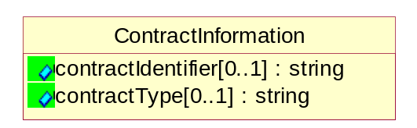
Figure ‎5-18 ContractInformation

Attribute | Type | Documentation
contractIdentifier[0..1] | string | Unique identification of a contract between the Sender and the Receiver
contractType[0..1] | string | The type of the contract: an attribute describing the type of the ContractIndentification. Valid values are URI, URN,ebXMLCPA, or other values defined by partners.

CorrelationInformation
A block of information used to correlate a requesting document to a responding document and to the contract in an executing choreography.
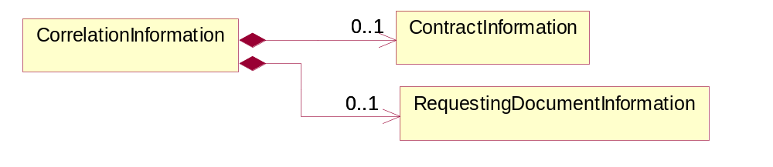
Figure ‎5-19 CorrelationInformation

Composition | Cardinality | Type | Documentation
ContractInformation | 0..1 | ContractInformation | A block of information used to correlate a contract in an executing choreography.
RequestingDocumentInformation | 0..1 | RequestingDocumentInformation | A block of information used to correlate a requesting document to a responding document in an executing choreography.

DocumentHeader
The object allows for the identification of the sender and receiver of the business document.
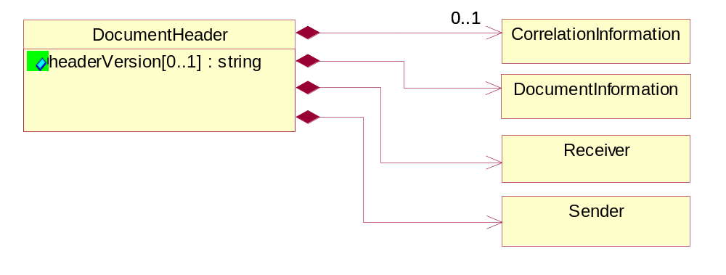
Figure ‎5-20 DocumentHeader

Attribute | Type | Documentation
headerVersion[0..1] | string | The UN/CEFACT version of the document header.

Composition | Cardinality | Type | Documentation
Sender | 1 | Sender | The object allows the identification of the initiating party of the business message.
CorrelationInformation | 0..1 | CorrelationInformation | A block of information used to correlate a requesting document to a responding document and to the contract in an executing choreography.
DocumentInformation | 1 | DocumentInformation | The object specifies information to identify the business document, a summary of attachments, and information about the business document security.
Receiver | 1 | Receiver | The object allows the identification of the receiving party of the business message.

DocumentIdentification
The object specifies all information necessary to identify the business document.
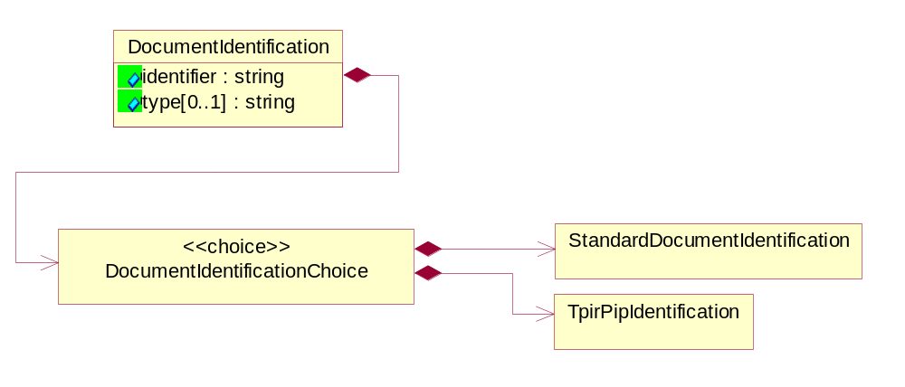
Figure ‎5-21 DocumentIdentification

Attribute | Type | Documentation
identifier | string | The unique identifier for the document being sent.
type[0..1] | string | Name of the Action Message

Composition | Cardinality | Type | Documentation
DocumentIdentificationChoice | 1 | DocumentIdentificationChoice

DocumentIdentificationChoice

Composition | Cardinality | Type | Documentation
StandardDocumentIdentification | 1 | StandardDocumentIdentification | The object specifies additional information necessary to identify the standard business document.
TpirPipIdentification | 1 | TpirPipIdentification | The object specifies all information necessary to uniquely identify a TPIR-PIP within a Registry or trading partner repository.

DocumentInformation
The object specifies information to identify the business document, a summary of attachments, and information about the business document security.
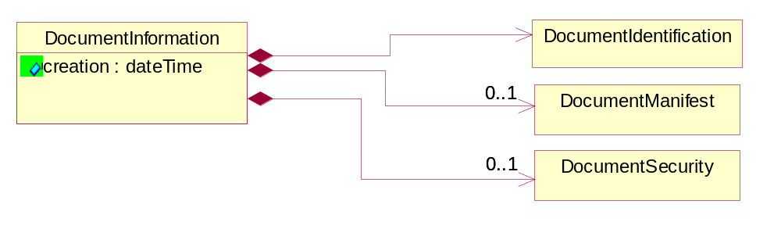
Figure ‎5-22 DocumentInformation

Attribute | Type | Documentation
creation | dateTime | The creation date and time of the specified Business Document (i.e. the Purchase Order date).

Composition | Cardinality | Type | Documentation
DocumentIdentification | 1 | DocumentIdentification | The object specifies all information necessary to identify the business document.
DocumentSecurity | 0..1 | DocumentSecurity | The object provides additional granularity in specifying business document security (this is in addition to the specified PIP security).
DocumentManifest | 0..1 | DocumentManifest | The block provides a brief summary of attachments and Service Content.

DocumentManifest
The block provides a brief summary of attachments and Service Content.
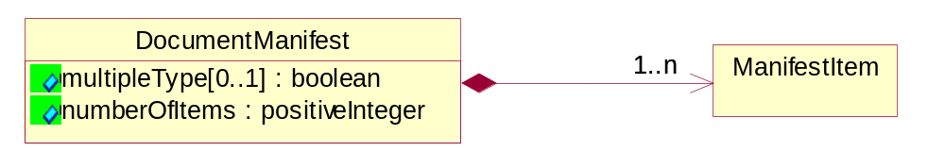
Figure ‎5-23 DocumentManifest

Attribute | Type | Documentation
multipleType[0..1] | boolean | Indicates whether the manifest contains documents of multiple types. True if yes, and False if no.
numberOfItems | positiveInteger | Total number of documents in the message. The physical count of the attachments in the payload plus the RosettaNet Business Message (for Service Content). The value of this field will be at least 1.

Composition | Cardinality | Type | Documentation
ManifestItem | 1..n | ManifestItem | The object provides details about the specific attachment(s).

DocumentSecurity
The object provides additional granularity in specifying business document security (this is in addition to the specified PIP security).

Figure ‎5-24 DocumentSecurity

Attribute | Type | Documentation
nonRepudiableReceipt | boolean | The value "true" will indicate that a signed acknowledgement for the business document is necessary.
persistentEncryption | boolean | The value "true" will indicate that the Business Document (including the header) needs to be encrypted when stored or transported.
persistentSignature | boolean | The value "true" will indicate that a signature is required to be stored with the document while stored or transported.

ManifestItem
The object provides details about the specific attachment(s).

Figure ‎5-25 ManifestItem

Attribute | Type | Documentation
description[0..1] | string | A description of the attachment.
length[0..1] | positiveInteger | The size of the attachment in bytes (i.e. 1 000 000 bytes)
universalResourceIdentifier | string | The generic set of all names/addresses that are short strings that refer to resources.

Composition | Cardinality | Type | Documentation
mimeTypeQualifier | 1 | MimeTypeQualifier | The MIME type as defined by IANA.  Please refer to http://www.iana.org/assignments/media-types/ for a list of types.
language | 0..1 | Language | For representation of Language name RosettaNet has adopted ISO 639-2; 1998. Refer to the following web page to get the latest version of the standard:  http://www.loc.gov/standards/iso639-2/iso639jac.html  If you need more information about the ISO standard please contact ISO for more details.

PipIdentifier
PIP Identification.[ i.e. PIP3A4]
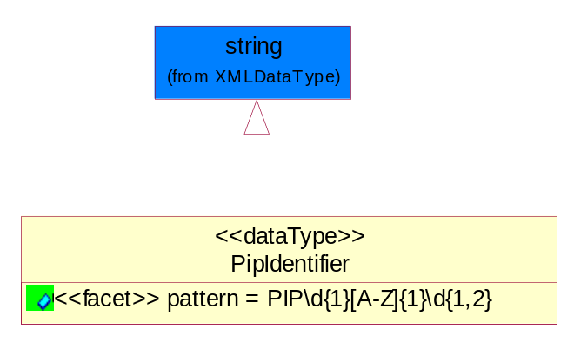
Figure ‎5-26 PipIdentifier

Attribute | Type | Documentation
pattern |  | PIP\d{1}[A-Z]{1}\d{1,2}

PipVersion
PIP version number (i.e. 02.02.00).
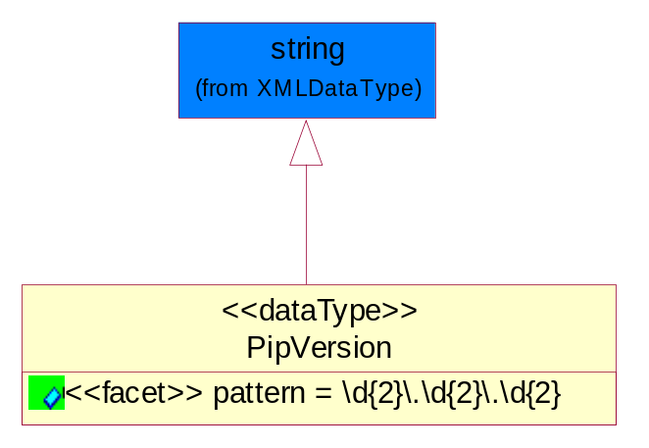
Figure ‎5-27 PipVersion

Attribute | Type | Documentation
pattern |  | \d{2}\.\d{2}\.\d{2}

Receiver
The object allows the identification of the receiving party of the business message.
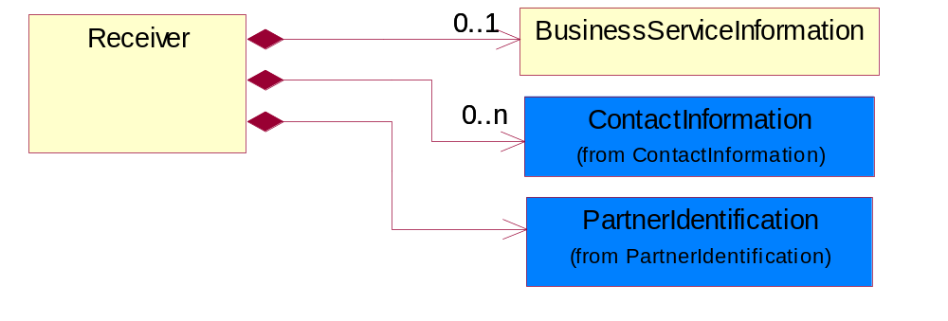
Figure ‎5-28 Receiver

Composition | Cardinality | Type | Documentation
BusinessServiceInformation | 0..1 | BusinessServiceInformation | The object allows the specification of the business service utilized within the partner company. This may or may not be the same as the information sent by the RNIF.
PartnerIdentification | 1 | PartnerIdentification | The business document must allow for the identity of one or more parties to the transaction.
ContactInformation | 0..n | ContactInformation | The business document must allow for the identification of the name of the department, service or individual to be contacted regarding the context of the business document.

RequestingDocumentInformation
A block of information used to correlate a requesting document to a responding document in an executing choreography.

Figure ‎5-29 RequestingDocumentInformation

Attribute | Type | Documentation
businessProcessInstanceIdentifier[0..1] | string | The identifier for the public business process instance being sent that both the sender and receiver can identify.
responseDateTime[0..1] | dateTime | The expected time to receive the response. This can not be greater than the PIP TimeToPerform.
requestingDocumentCreationDateTime[0..1] | dateTime | The date-time of the requesting business document.
requestingDocumentInstanceIdentifier | string | The Business Document identification number that identifies the requesting Business Document.

Sender
The object allows the identification of the initiating party of the business message.
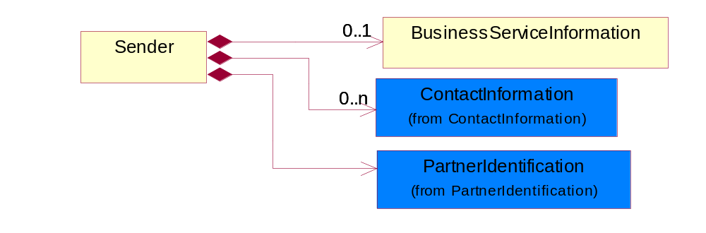
Figure ‎5-30 Sender

Composition | Cardinality | Type | Documentation
PartnerIdentification | 1 | PartnerIdentification | The business document must allow for the identity of one or more parties to the transaction.
BusinessServiceInformation | 0..1 | BusinessServiceInformation | The object allows the specification of the business service utilized within the partner company. This may or may not be the same as the information sent by the RNIF.
ContactInformation | 0..n | ContactInformation | The business document must allow for the identification of the name of the department, service or individual to be contacted regarding the context of the business document.

StandardDocumentIdentification
The object specifies additional information necessary to identify the standard business document.
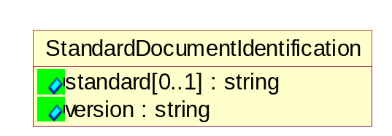
Figure ‎5-31 StandardDocumentIdentification

Attribute | Type | Documentation
standard[0..1] | string | Identifies the standard used to submit the business document. (e.g. RosettaNet).
version | string | PIP3A4v01.00

TpirPipIdentification
The object specifies all information necessary to uniquely identify a TPIR-PIP within a Registry or trading partner repository.

Figure ‎5-32 TpirPipIdentification

Attribute | Type | Documentation
partnerId | DUNSPlus4 | The Trading Partner Identification of MNC that is creating this TPIR PIP.
pipIdentifier | PipIdentifier | A TPIR PIP Identification [i.e., 3A4 ).
pipVersion | PipVersion | A TPIR PIP version number (i.e., 02.02.00)
tpirPipVersion | VersionIdentifier | A TPIR-PIP Version Number (i.e., major and minor version number as XX.XX).
tpirBusinessProcessIdentifier[0..1] | BusinessProcessIdentifier | A Business Process Identifier to uniquely define the TPIR-PIP 'role' within a Business Scenario at a company or MNC level. The identifier MUST be composed of alphanumeric characters only and its length MUST be between one and twelve characters.
uri[0..1] | anyURI | Describes the destination uri for the TPIR form.

Composition | Cardinality | Type | Documentation
fileType | 0..1 | TPIRFileType | Describes the file type of the TPIR form (PDF, XDP or XML).

VersionIdentifier
Version Number (i.e., major and minor version number as XX.XX).
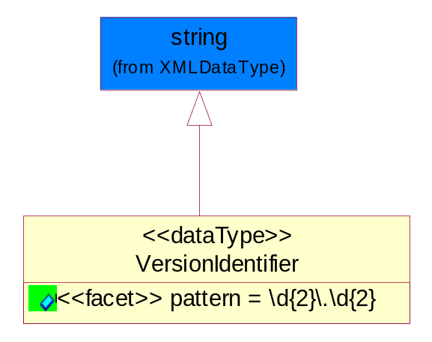
Figure ‎5-33 VersionIdentifier

Attribute | Type | Documentation
pattern |  | \d{2}\.\d{2}

CodeList

TPIRFileType
A code identifying the file type of TPIR form.

Name | Documentation
PDF | Portable Document Format.
XDP | XML Data Package.
XML | eXtensible Markup Language.

XML Data Type

anyURI
Represents a URI as defined by RFC 2396. An anyURI value can be absolute or relative, and may have an optional fragment identifier.

boolean
Represents Boolean values, which are either "true" or "false".

dateTime
Represents a specific instance of time.
The pattern for dateTime is CCYY-MM-DDThh:mm:ss where CC represents the century, YY the year, MM the month, and DD the day, preceded by an optional leading negative (-) character to indicate a negative number. If the negative character is omitted, positive (+) is assumed. The T is the date/time separator and hh, mm, and ss represent hour, minute, and second respectively. Additional digits can be used to increase the precision of fractional seconds if desired. For example, the format ss.ss... with any number of digits after the decimal point is supported. The fractional seconds part is optional.
This representation may be immediately followed by a "Z" to indicate Coordinated Universal Time (UTC) or to indicate the time zone. For example, the difference between the local time and Coordinated Universal Time, immediately followed by a sign, + or -, followed by the difference from UTC represented as hh:mm (minutes is required). If the time zone is included, both hours and minutes must be present.

positiveInteger
Represents an integer that is greater than zero. This data type is derived from nonNegativeInteger.

string
Represents character string.

