

Description of 2A1 Message

PIP® 2A1
Validated 11.00.00

Specification Information
Name | Description Of 2A1 Message
PIP | Distribute Product Catalog Information
Cluster | Product Information
Segment | Preparation for Distribution
Publication Date | 23 June 2008
Version Identifier | V11.00

Table of Content

1. Document Management 7
1.1 Legal Disclaimer 7
1.2 Copyright 7
1.3 Trademarks 7
1.4 Acknowledgments 7
1.5 Related Documents 8
1.6 Document Version History 8
1.7 Document Purpose 8
2. Interchange Model 9
2.1 ProductCatalogInformationDistribution 9
2.1.1 Interchange Diagram 9
2.1.2 Dependency Diagram 10
2.1.3 ProductCatalog 10
2.1.4 ProductCatalogInformationDistribution 12
2.1.5 ProductIdentificationInformation 12
2.1.6 ProductInformation 13
2.1.7 ProductLifeCycle 14
2.1.8 ProductLineItem 15
2.1.9 ProductPriceAndAvailability 16
2.1.10 ProductProcurement 17
3. Domain Model 19
3.1 Design 19
3.1.1 Design 19
3.1.1.1 Dependency Diagram 19
3.1.1.2 LifeCycleStatus 19
3.1.2 CodeList 20
3.1.2.1 ActionCode 20
3.1.2.2 ABCCode 20
3.1.2.3 ProductLifeCycleStatusCode 20
3.1.2.4 CatalogType 21
3.2 Procurement 22
3.2.1 Procurement 22
3.2.1.1 Dependency Diagram 22
3.2.1.2 IsCallFactory 22
3.2.1.3 IsCostChange 22
3.2.1.4 IsPriceProtect 23
3.2.1.5 IsSoleSource 23
3.2.1.6 IsSuggestedResaleChange 24
3.2.1.7 LeadTimeQuantity 24
3.2.1.8 OrderProvision 25
3.2.1.9 PriceList 26
3.2.1.10 PricingDetail 27
3.2.1.11 ProductAvailability 28
3.2.1.12 ProductClassification 28
3.2.1.13 ProductClassificationChoice 29
3.2.1.14 ProductLeadTime 29
3.2.1.15 ProductPricing 30
3.2.1.16 ProductQuantityRange 31
3.2.1.17 SubstituteProductReference 32
3.2.1.18 UNSPSC 32
3.2.2 CodeList 33
3.2.2.1 ProductSubstitutionReason 33
3.2.2.2 LeadTimeClassificationCode 33
3.2.2.3 ProductProcurementType 34
3.3 Logistics 36
3.3.1 Logistics 36
3.3.1.1 Dependency Diagram 36
3.3.1.2 ExportLicense 36
3.3.1.3 GeographicRegion 37
3.3.1.4 IsHazardousMaterial 38
3.3.1.5 ManufacturerProfile 38
3.3.1.6 MassPhysicalDimension 39
3.3.1.7 ProductAttribute 39
3.3.1.8 ProductLicenseRequired 40
3.3.1.9 ProductPackaging 41
3.3.2 CodeList 42
3.3.2.1 NationalExportControlClassification 42
3.4 Marketing 43
3.4.1 Marketing 43
3.4.1.1 Dependency Diagram 43
3.4.1.2 ChangeNotification 43
3.4.1.3 IsDesignWin 44
3.4.1.4 MarketingInstruction 44
3.5 Shared 45
3.5.1 Shared 45
3.5.1.1 Dependency Diagram 45
3.5.1.2 DatePeriodAndDuration 45
3.5.1.3 DatePeriodAndDurationChoice 46
3.5.1.4 Duration 46
3.5.1.5 MonetaryAmount 47
3.5.1.6 ProductQuantity 48
3.5.1.7 Warranty 48
3.5.2 CodeList 49
3.5.2.1 InvoiceChargeType 49
3.5.2.2 MonetaryAmountType 50
3.5.2.3 PackageTypeCode 50
3.5.2.4 PricingTypeCode 51
3.5.2.5 ProductStatusCode 53
3.5.2.6 Interval 53
3.5.2.7 WarrantyType 54
3.5.2.8 AmountType 54
4. Universal Structure 56
4.1 ContactInformation 56
4.1.1 ContactInformation 56
4.2 DataType 57
4.2.1 Contact 57
4.2.2 DUNS 57
4.2.3 DUNSPlus4 58
4.2.4 GLN 58
4.2.5 GTIN 59
4.3 Dates 59
4.3.1 DatePeriod 59
4.4 Document 60
4.4.1 BusinessDocumentReference 60
4.5 Locations 60
4.5.1 AlternativeIdentifier 60
4.5.2 Location 61
4.5.3 LocationChoice 62
4.6 MonetaryExpression 62
4.6.1 FinancialAmount 62
4.7 PartnerIdentification 63
4.7.1 PartnerIdentification 63
4.7.2 PartnerIdentificationChoice 64
4.8 PhysicalDimension 64
4.8.1 Linear 64
4.8.2 Measure 65
4.8.3 Volume 65
4.8.4 Weight 66
4.9 ProductIdentification 66
4.9.1 ProductDescription 66
4.9.2 ProductIdentification 67
4.9.3 ProductIdentificationChoice 67
4.9.4 TextualDescription 68
4.10 CodeList 68
4.10.1 Country 68
4.10.2 Currency 68
4.10.3 Language 69
4.10.4 DocumentType 69
4.10.5 MimeTypeQualifier 71
4.10.6 UnitOfMeasure 82
4.10.7 WeightType 89
5. System Structure 90
5.1 BusinessProcessIdentifier 90
5.2 BusinessServiceInformation 90
5.3 ContractInformation 91
5.4 CorrelationInformation 91
5.5 DocumentHeader 92
5.6 DocumentIdentification 93
5.7 DocumentIdentificationChoice 93
5.8 DocumentInformation 94
5.9 DocumentManifest 94
5.10 DocumentSecurity 95
5.11 ManifestItem 96
5.12 PipIdentifier 97
5.13 PipVersion 97
5.14 Receiver 98
5.15 RequestingDocumentInformation 99
5.16 Sender 99
5.17 StandardDocumentIdentification 100
5.18 TpirPipIdentification 100
5.19 VersionIdentifier 101
5.20 CodeList 102
5.20.1 TPIRFileType 102
6. XML Data Type 103
6.1 anyURI 103
6.2 boolean 103
6.3 date 103
6.4 dateTime 103
6.5 duration 103
6.6 float 103
6.7 positiveInteger 103
6.8 string 104

Table of Figures

Figure 2-1 Interchange 9
Figure 2-2 Dependency 10
Figure 2-3 ProductCatalog 10
Figure 2-4 ProductIdentificationInformation 12
Figure 2-5 ProductInformation 13
Figure 2-6 ProductLifeCycle 14
Figure 2-7 ProductLineItem 15
Figure 2-8 ProductPriceAndAvailability 16
Figure 2-9 ProductProcurement 17
Figure 3-1 Dependency 19
Figure 3-2 LifeCycleStatus 19
Figure 3-3 Dependency 22
Figure 3-4 IsCallFactory 22
Figure 3-5 IsCostChange 22
Figure 3-6 IsPriceProtect 23
Figure 3-7 IsSoleSource 23
Figure 3-8 IsSuggestedResaleChange 24
Figure 3-9 LeadTimeQuantity 24
Figure 3-10 OrderProvision 25
Figure 3-11 PriceList 26
Figure 3-12 PricingDetail 27
Figure 3-13 ProductAvailability 28
Figure 3-14 ProductClassification 28
Figure 3-15 ProductLeadTime 29
Figure 3-16 ProductPricing 30
Figure 3-17 ProductQuantityRange 31
Figure 3-18 SubstituteProductReference 32
Figure 3-19 UNSPSC 32
Figure 3-20 Dependency 36
Figure 3-21 ExportLicense 36
Figure 3-22 GeographicRegion 37
Figure 3-23 IsHazardousMaterial 38
Figure 3-24 ManufacturerProfile 38
Figure 3-25 MassPhysicalDimension 39
Figure 3-26 ProductAttribute 39
Figure 3-27 ProductLicenseRequired 40
Figure 3-28 ProductPackaging 41
Figure 3-29 Dependency 43
Figure 3-30 ChangeNotification 43
Figure 3-31 IsDesignWin 44
Figure 3-32 MarketingInstruction 44
Figure 3-33 Dependency 45
Figure 3-34 DatePeriodAndDuration 45
Figure 3-35 Duration 46
Figure 3-36 MonetaryAmount 47
Figure 3-37 ProductQuantity 48
Figure 3-38 Warranty 48
Figure 4-1 ContactInformation 56
Figure 4-2 Contact 57
Figure 4-3 DUNS 57
Figure 4-4 DUNSPlus4 58
Figure 4-5 GLN 58
Figure 4-6 GTIN 59
Figure 4-7 DatePeriod 59
Figure 4-8 BusinessDocumentReference 60
Figure 4-9 AlternativeIdentifier 60
Figure 4-10 Location 61
Figure 4-11 FinancialAmount 62
Figure 4-12 PartnerIdentification 63
Figure 4-13 Linear 64
Figure 4-14 Measure 65
Figure 4-15 Volume 65
Figure 4-16 Weight 66
Figure 4-17 ProductDescription 66
Figure 4-18 ProductIdentification 67
Figure 4-19 TextualDescription 68
Figure 5-1 BusinessProcessIdentifier 90
Figure 5-2 BusinessServiceInformation 90
Figure 5-3 ContractInformation 91
Figure 5-4 CorrelationInformation 91
Figure 5-5 DocumentHeader 92
Figure 5-6 DocumentIdentification 93
Figure 5-7 DocumentInformation 94
Figure 5-8 DocumentManifest 94
Figure 5-9 DocumentSecurity 95
Figure 5-10 ManifestItem 96
Figure 5-11 PipIdentifier 97
Figure 5-12 PipVersion 97
Figure 5-13 Receiver 98
Figure 5-14 RequestingDocumentInformation 99
Figure 5-15 Sender 99
Figure 5-16 StandardDocumentIdentification 100
Figure 5-17 TpirPipIdentification 100
Figure 5-18 VersionIdentifier 101

Document Management

Legal Disclaimer
RosettaNet, its members, officers, directors, employees, or agents shall not be liable for any injury, loss, damages, financial or otherwise, arising from, related to, or caused by the use of this document or the specifications herein, as well as associated guidelines and schemas. The use of said specifications shall constitute your express consent to the foregoing exculpation.

Copyright
©2008 RosettaNet. All rights reserved. No part of this publication may be reproduced, stored in a retrieval system, or transmitted, in any form or by any means, electronic, mechanical, photocopying, recording, or otherwise, without the inclusion of this copyright notice. Any derivative works must cite the copyright notice. Any public redistribution or sale of this publication or derivative works requires prior written permission of the publisher.

Trademarks
RosettaNet, Partner Interface Process, PIP and the RosettaNet logo are trademarks or registered trademarks of "RosettaNet," a non-profit organization. All other product names and company logos mentioned herein are the trademarks of their respective owners. In the best effort, all terms mentioned in this document that are known to be trademarks or registered trademarks have been appropriately recognized in the first occurrence of the term.

Acknowledgments
This document has been prepared by RosettaNet (http://www.rosettanet.org/) from requirements gathered during the Milestone Program and in conformance with the methodology. Listed below are the legal entities that contributed to the design and development of this PIP.
Aankhen Inc. | Arrow Electronics, Inc.
ASBISC Enterprises Ltd. | BCM Electronics
Cisco Systems | Deloitte Consulting Pte. Ltd.
Deloitte Consulting Sdn BHD | E-Vision
Globetronics SDH. BHD | Hewlett Packard Far East PTE LTD
Hewlett Packard Imaging & Printing Group | HP
HP IPG | IBM
Intel Corporation | International Business Machines
MIMOS Berhad | Motorola Semiconductor Products, Inc.
Oracle | Philips Semiconductors
Pioneer-Standard Electronics | SAP
SAP America | SAP Labs
Sterling Commerce | Sun Microsystems
Viacore | Viacore Inc.

Related Documents
- Associated PIP Message Schemas (included with PIP Specification only)
- Description of Partner Interface Process for 2A1
- Message Structure

Document Version History
Version | Date | Description
Validated 11.00.00 | 23 June 2008 | Validated Version: RosettaNet Schema to Market to Validation 2008

Document Purpose
The purpose of the document is to explain the structure, the association between objects, the content of objects and the definition for single elements to a non-technical audience.

Interchange Model

ProductCatalogInformationDistribution

Interchange Diagram
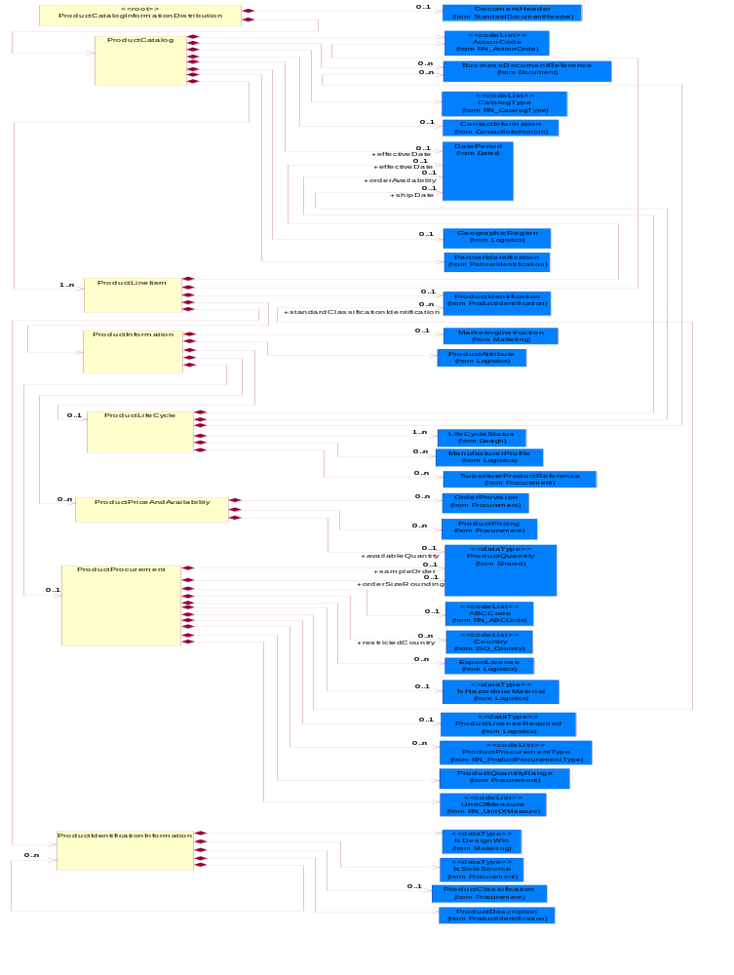
Figure 2-1 Interchange

Dependency Diagram
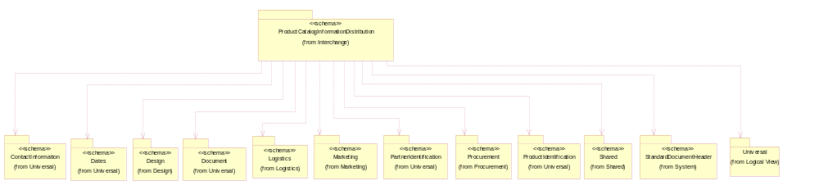
Figure 2-2 Dependency

ProductCatalog
The collection of business properties that describe one or more products with attributes complete and sufficient to allow the procurement process of the trading partner to take action.
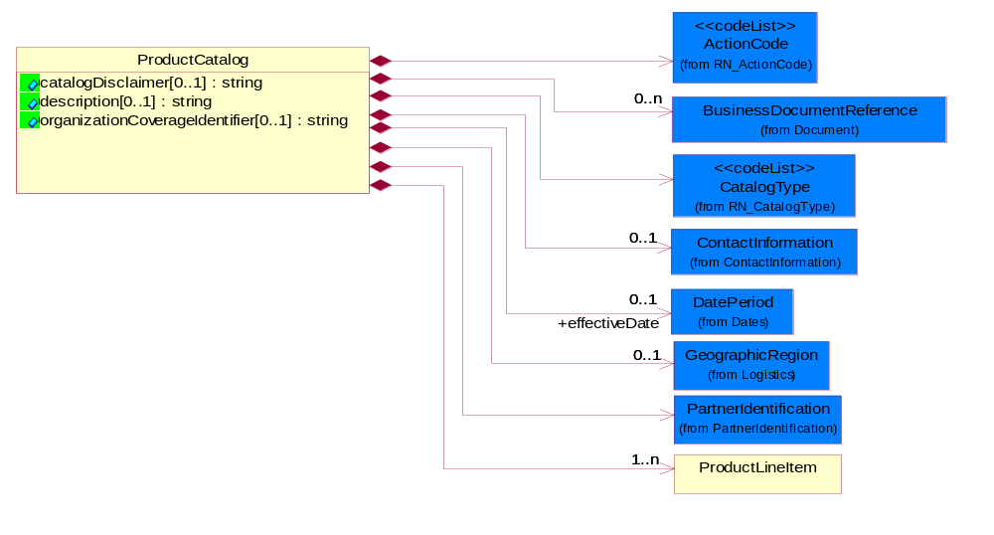
Figure 2-3 ProductCatalog

Attribute | Type | Documentation
catalogDisclaimer[0..1] | string | A textual description of the disclaimers about the catalog information.
description[0..1] | string | A textual description of the contents about the catalog information.
organizationCoverageIdentifier[0..1] | string | The unique identifier assigned for an organization coverage.

Composition | Cardinality | Type | Documentation
CatalogType | 1 | CatalogType | Code identifying the type of product catalog information distributed to a partner.
BusinessDocumentReference | 0..n | BusinessDocumentReference | The business document reference object allows for the indirect referencing of a relationship to other business related documents.
effectiveDate | 0..1 | DatePeriod | The date information or an activity becomes effective.
ActionCode | 1 | ActionCode | Code identifying the business action that must be performed on or with data. These codes will result in a subsequent action to the Material Composition data.
ProductLineItem | 1..n | ProductLineItem | The collection of business properties that describe a business document entry for a product.
ContactInformation | 0..1 | ContactInformation | The business document must allow for the identification of the name of the department, service or individual to be contacted regarding the context of the business document.
PartnerIdentification | 1 | PartnerIdentification | The business document must allow for the identity of one or more parties to the transaction.
GeographicRegion | 0..1 | GeographicRegion | The collection of business properties that reflects multiple countries of choice or a specified region.

ProductCatalogInformationDistribution
A wrapper or a root message for PIP2A1.

Composition | Cardinality | Type | Documentation
DocumentHeader | 0..1 | DocumentHeader | The object allows for the identification of the sender and receiver of the business document.
ProductCatalog | 1 | ProductCatalog | The collection of business properties that describe one or more products with attributes complete and sufficient to allow the procurement process of the trading partner to take action.

ProductIdentificationInformation
The collection of business properties that describes product identification.
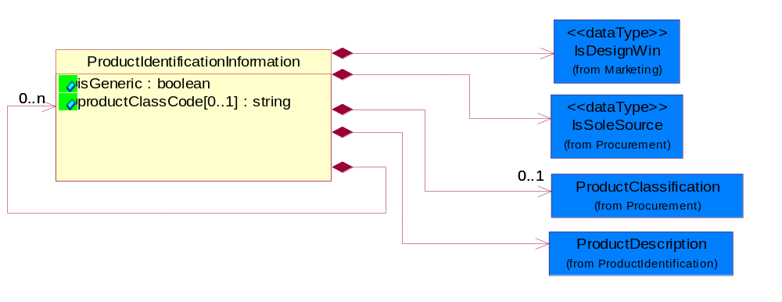
Figure 2-4 ProductIdentificationInformation

Attribute | Type | Documentation
isGeneric | boolean | To identify the subsequent product reporting as a product family (generic) reporting.
productClassCode[0..1] | string | A code for a class of products whose values are the values of the attribute ec.dictionary:class:id in the RosettaNet Technical Dictionary and are defined by the ec.dictionary:class:names:preferred.name and the ec.dictionary:class:definition.short element values in the RosettaNet Technical Dictionary.

Composition | Cardinality | Type | Documentation
ProductDescription | 1 | ProductDescription | The business document must allow for the identification of the product and multiple textual descriptions of a product.
IsDesignWin | 1 | IsDesignWin | Indicates whether a product has design win process.
IsSoleSource | 1 | IsSoleSource | Indicates whether the product is intended to be purchased by one manufacturer or multi-sourcing is allowed.
ProductClassification | 0..1 | ProductClassification | Identifier to identify product classification.

ProductInformation
The collection of business properties that describes attributes of the product.
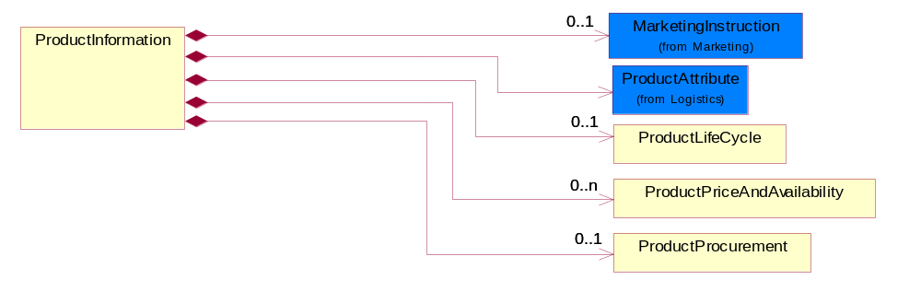
Figure 2-5 ProductInformation

Composition | Cardinality | Type | Documentation
ProductLifeCycle | 0..1 | ProductLifeCycle | The collection of business properties that describes lifecycle information about the product.
MarketingInstruction | 0..1 | MarketingInstruction | The collection of business properties that describe the product marketing instruction information.
ProductPriceAndAvailability | 0..n | ProductPriceAndAvailability | The collection of business properties that describe a product's price and availability.
ProductProcurement | 0..1 | ProductProcurement | The collection of business properties that describe the product procurement.
ProductAttribute | 1 | ProductAttribute | The collection of business properties that describes attributes of the product.

ProductLifeCycle
The collection of business properties that describes lifecycle information about the product.
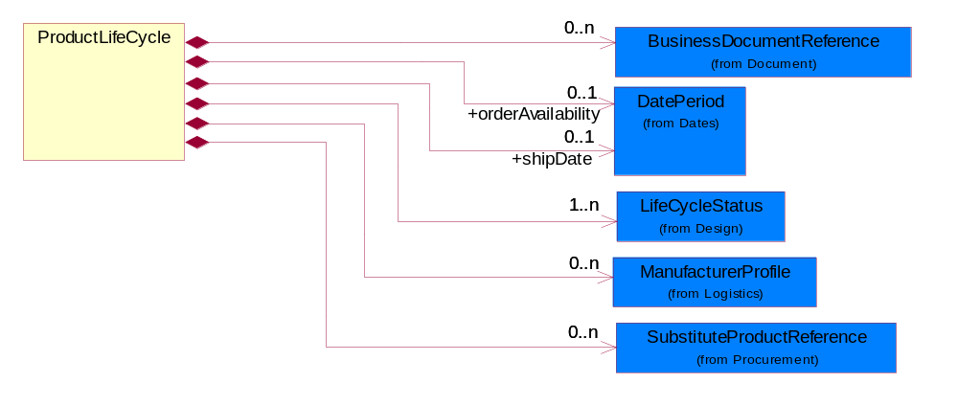
Figure 2-6 ProductLifeCycle

Composition | Cardinality | Type | Documentation
BusinessDocumentReference | 0..n | BusinessDocumentReference | The business document reference object allows for the indirect referencing of a relationship to other business related documents.
ManufacturerProfile | 0..n | ManufacturerProfile | The collection of business properties that describe a manufacturer's product.
orderAvailability | 0..1 | DatePeriod | The date the product is available for ordering by a partner role.
SubstituteProductReference | 0..n | SubstituteProductReference | The collection of business properties describing a product that is being substituted for a requested product.
shipDate | 0..1 | DatePeriod | The (GMT) local date the product is shipped.
LifeCycleStatus | 1..n | LifeCycleStatus | An indication of a product's state at a point in time in the entire existence of a product from concept to the point where the product no longer exists for any business purposes.

ProductLineItem
The collection of business properties that describe a business document entry for a product.
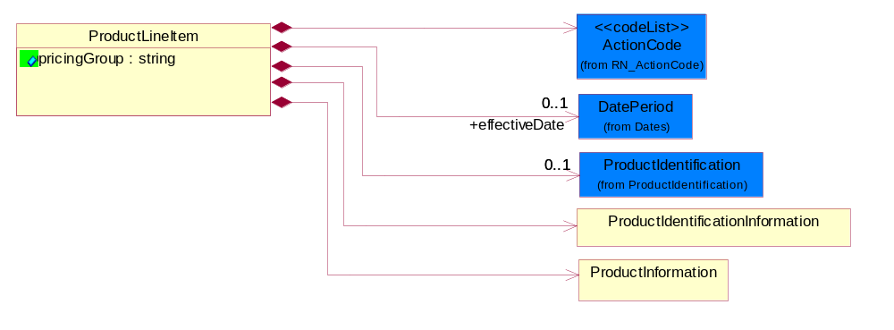
Figure 2-7 ProductLineItem

Attribute | Type | Documentation
pricingGroup | string | Clustering of products with similar pricing and/or marketing characteristics so that discounts and promotions can be applied to a group rather than to each individual product. A product might be a member of multiple pricing groups.

Composition | Cardinality | Type | Documentation
effectiveDate | 0..1 | DatePeriod | The date information or an activity becomes effective.
ActionCode | 1 | ActionCode | Code identifying the business action that must be performed on or with data. These codes will result in a subsequent action to the Material Composition data.
ProductIdentificationInformation | 1 | ProductIdentificationInformation | The collection of business properties that describes product identification.
ProductIdentification | 0..1 | ProductIdentification | The object provides the identifier(s) of a product.
ProductInformation | 1 | ProductInformation | The collection of business properties that describes attributes of the product.

ProductPriceAndAvailability
The collection of business properties that describe a product's price and availability.
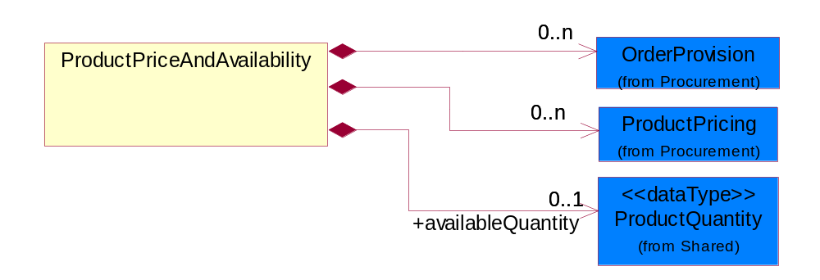

Figure 2-8 ProductPriceAndAvailability

Composition | Cardinality | Type | Documentation
OrderProvision | 0..n | OrderProvision | Extended ordering and product lead time instructions.
ProductPricing | 0..n | ProductPricing | The collection of business properties that describe the type of pricing and financial amount for a product.
availableQuantity | 0..1 | ProductQuantity | The product quantity available for sale.

ProductProcurement
The collection of business properties that describe the product procurement.
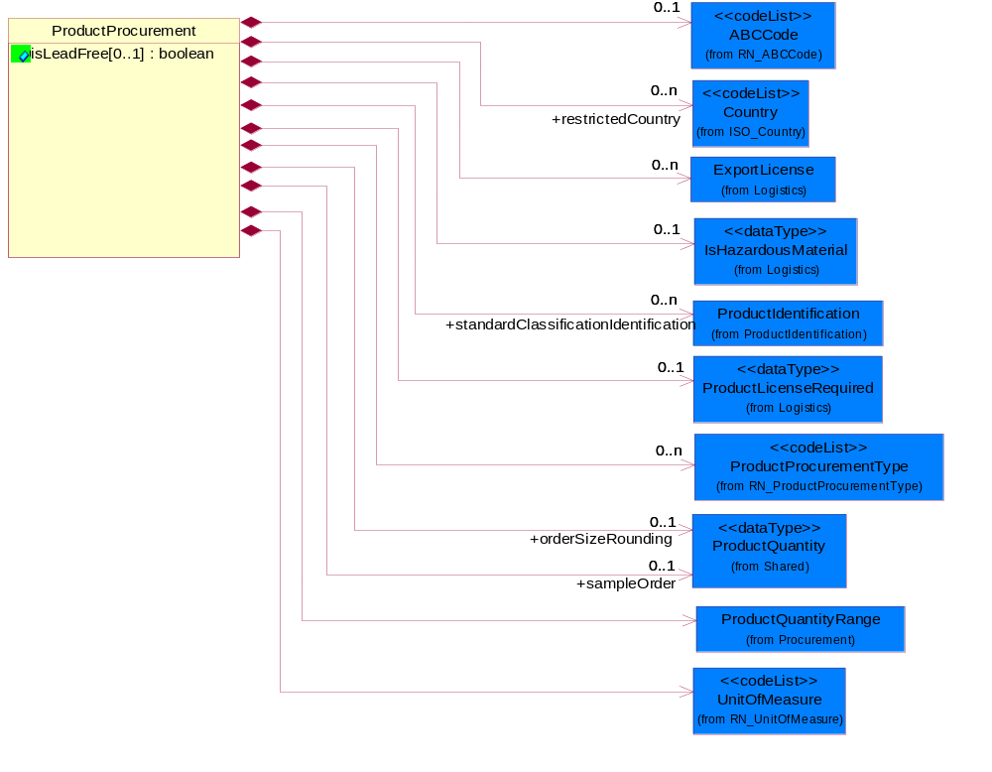
Figure 2-9 ProductProcurement

Attribute | Type | Documentation
isLeadFree[0..1] | boolean | Indicates whether the product is free of lead.

Composition | Cardinality | Type | Documentation
ExportLicense | 0..n | ExportLicense | The collection of business properties that describe an export license number.
UnitOfMeasure | 1 | UnitOfMeasure | Code identifying a product unit of measure.
IsHazardousMaterial | 0..1 | IsHazardousMaterial | Indicates whether the product contains hazardous material.
ProductLicenseRequired | 0..1 | ProductLicenseRequired | Indicates that a special permit is required in order to purchase or use the product.
ProductQuantityRange | 1 | ProductQuantityRange | The collection of business properties that describe an upper and lower range of product quantity.
restrictedCountry | 0..n | Country | Country where product is not destined for shipment.
standardClassificationIdentification | 0..n | ProductIdentification | The use of a commonly used classification scheme to classify one or more aspects of a product. While these classifications schemes may be widely used, the values for these schemes may change frequently to reflect new information and thus are not suitable to be listed as RosettaNet entitry instances.
ProductProcurementType | 0..n | ProductProcurementType | States that describe product procurement conditions.
ABCCode | 0..1 | ABCCode | Code identifying manufacturing process classifications for inventory used to communicate inventory importance to a company based upon cost and usage.
orderSizeRounding | 0..1 | ProductQuantity | The quantity of products which is a standard ordering unit. Actual order quantities must be multiples of this quantity and is equal to or smaller than the minimum order quantity.
sampleOrder | 0..1 | ProductQuantity | The maximum ordering quantity for samples of this part.

Domain Model

Design

Design

Dependency Diagram
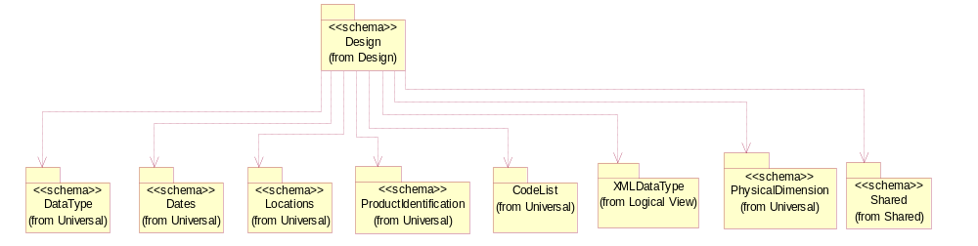
Figure 3-10 Dependency

LifeCycleStatus
An indication of a product's state at a point in time in the entire existence of a product from concept to the point where the product no longer exists for any business purposes.
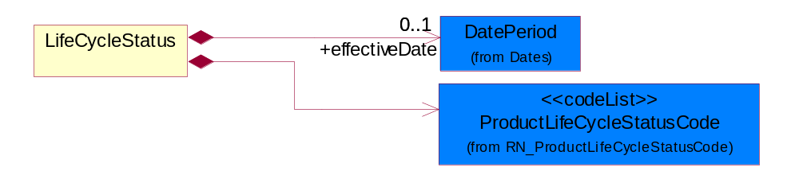
Figure 3-11 LifeCycleStatus

Composition | Cardinality | Type | Documentation
effectiveDate | 0..1 | DatePeriod | The date information or an activity becomes effective, i.e. product design release date after design approval and prototyping.
ProductLifeCycleStatusCode | 1 | ProductLifeCycleStatusCode | States that describe the product lifecycle.

CodeList

ActionCode
Code identifying the business action that must be performed on or with data. These codes will result in a subsequent action to the Material Composition data.

Name | Documentation
ADD | Add the business information to an information system.
CHG | The change request made accepted.
DEL | Delete the business infomation from an information system.
REQ | The business information accepted with change.
REV | Revise the business information from an information system.
UCH | Unchanged.

ABCCode
Code identifying manufacturing process classifications for inventory used to communicate inventory importance to a company based upon cost and usage.

Name | Documentation
CDA | Highest importance.
CDB | Medium importance.
CDC | Lowest importance.

ProductLifeCycleStatusCode
States that describe the product lifecycle.

Name | Documentation
ACT | Active.
ALO | The quantity available to buyer.
BOR | Back Ordered.
DCN | Discontinued. No longer available.
DCN | Discontinued - No longer available.
EOL | End of Life - period or date where the product obsolescence begins, ship or order still active.
LOD | Product Phase Out/See Last Order Date. Limitations on shipments can occur, but orders are pressed toward final and last buy. Product should not be considered for new designs. Capacity declining rapidly. Formal discontinuance notice may be issued.
NPR | New Product.
NPR | New product.
NRC | Not Recommended/Declining. Orders and shipments permitted. Product not recommended for new designs.Capacity beginning to decline.
OBS | Obsolete no longer orderable or shippable.
OHL | On Hold - Orderable, but not shippable.
PEN | Product Introduction Pending No orders or product shipments permitted. Product is in planning or early design stage. Samples may or may not exist. Specification changes can occur and planned introduction dates may be delayed.
PLS | Product Last Shipments. Shipments made to existing orders. Manufacturing capacity limitations may exist. New orders are limited to existing or residual inventory. Product in final stage of shipments after a formal Life Time Buy notice or product cancellation.
PMA | Product Maturity/Saturation. Orders and shipments permitted. Sales and capacity have leveled out.
POS | Purchase order with supplier.
POS | Purchase Order with Supplier.
REP | Replaced.
REP | Replaced.
RGW | Product Rapid Growth. Orders and shipments permitted. Product in rapid growth phase. Manufacturing capacity is being added.
RMP | Product Newly Introduced/Ramp-Up. Orders and shipments permitted. Beginning to ramp up production. Can supply limited quantities.
RPO | Removed From Active Portfolio. No new orders, no shipments, and no inventory exist. Product is considered no longer available. Inventory is removed. All supporting hardware, software, and documentation for the product are removed.
SGM | Product Stable Growth/Maturity. Orders and shipments permitted. Product is highly recommended for use in new designs. Product growth stabilizes and peaks. Product quality is very high.
UAV | Unavailable through program - May not use.
UNR | Unreleased - Upcoming product, not orderable.

CatalogType
Code identifying the type of product catalog information distributed to a partner.

Name | Documentation
PAR | Partial - Subset of catalog or products.
WHO | Whole - Complete set of products with same catalog ID and version.

Procurement

Procurement

Dependency Diagram
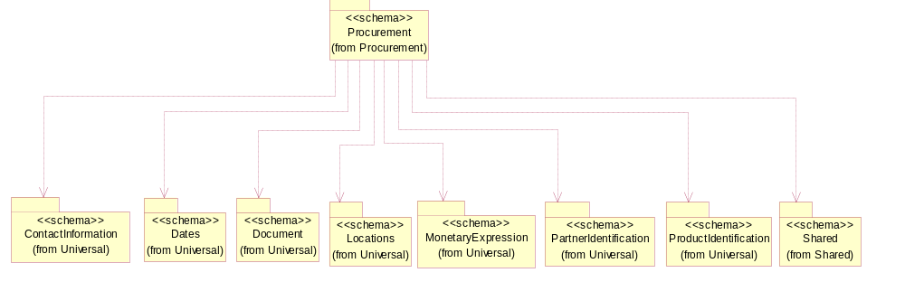
Figure 3-12 Dependency

IsCallFactory
An indicator for the receiver to call the manufacturer to obtain current information.
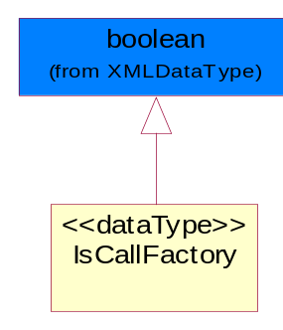
Figure 3-13 IsCallFactory

IsCostChange
An indicator for the receiver to take note that the cost has changed.
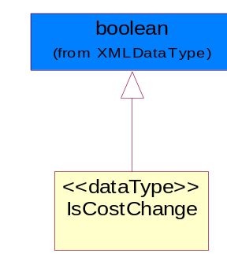
Figure 3-14 IsCostChange

IsPriceProtect
Indicates whether the product pricing is protected.
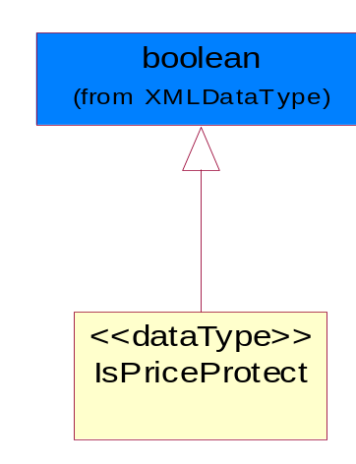
Figure 3-15 IsPriceProtect

IsSoleSource
Indicates whether the product is intended to be purchased by one manufacturer or multi-sourcing is allowed.
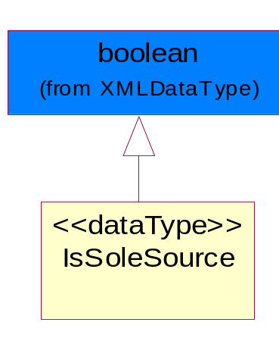
Figure 3-16 IsSoleSource

IsSuggestedResaleChange
An indicator for the receiver to take note that the Suggested Resale Price has changed.
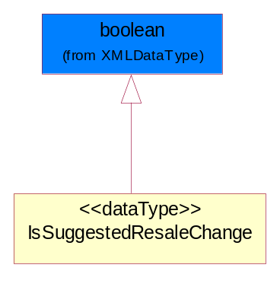
Figure 3-17 IsSuggestedResaleChange

LeadTimeQuantity
The collection of business propeties that describe manufacturing lead time quantity from the time of order placement to the time the product ships.
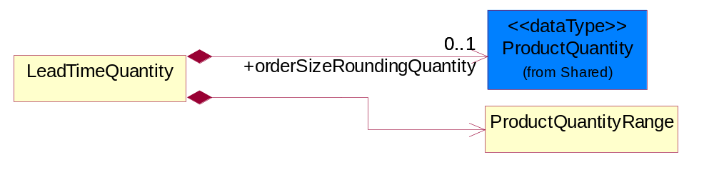
Figure 3-18 LeadTimeQuantity

Composition | Cardinality | Type | Documentation
ProductQuantityRange | 1 | ProductQuantityRange | The collection of business properties that describe an upper and lower range of product quantity.
orderSizeRoundingQuantity | 0..1 | ProductQuantity | The quantity of products which is a standard ordering unit. Actual order quantities must be multiples of this quantity and is equal to or smaller than the minimum.

OrderProvision
Extended ordering and product lead time instructions.
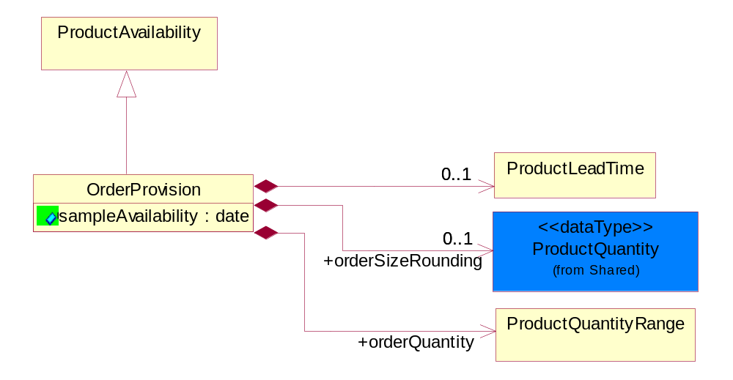
Figure 3-19 OrderProvision

Attribute | Type | Documentation
sampleAvailability | date | The sample of a product was made available.

Composition | Cardinality | Type | Documentation
ProductLeadTime | 0..1 | ProductLeadTime | The collection of business properties that describe lead time information about the product.
orderSizeRounding | 0..1 | ProductQuantity | The quantity of products which is a standard ordering unit. Actual order quantities must be multiples of this quantity and is equal to or smaller than the minimum order quantity.
orderQuantity | 1 | ProductQuantityRange | The collection of business properties that describe various types of product quantity used in an ordering process.

PriceList
The collection of business properties that describe product pricing in a proprietary price list document.
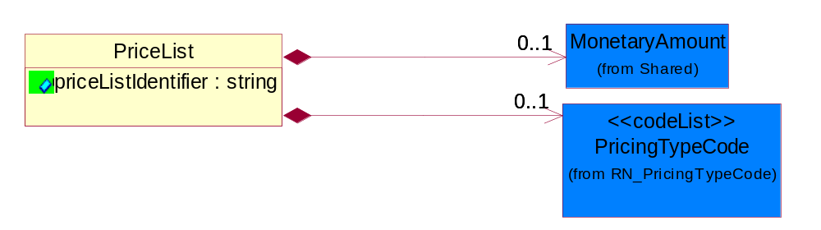
Figure 3-20 PriceList

Attribute | Type | Documentation
priceListIdentifier | string | The unique identifier that references a specific price list used for product pricing.

Composition | Cardinality | Type | Documentation
MonetaryAmount | 0..1 | MonetaryAmount | The collection of business properties that describe the monetary amount defined by a specified currency.
PricingTypeCode | 0..1 | PricingTypeCode | Code identifying the type of pricing available for a product.

PricingDetail
The collection of business properties that describe pricing for a product or service.
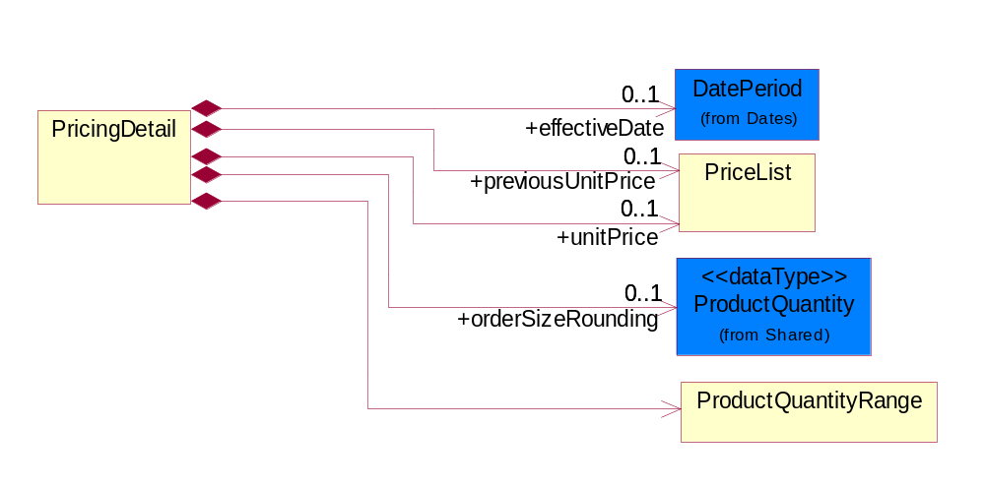
Figure 3-21 PricingDetail

Composition | Cardinality | Type | Documentation
effectiveDate | 0..1 | DatePeriod | The date information or an activity becomes effective.
previousUnitPrice | 0..1 | PriceList | The partner's cost to purchase the product prior to the effective date of the price drop.
unitPrice | 0..1 | PriceList | Agreed upon sale price for each unit ordered.
orderSizeRounding | 0..1 | ProductQuantity | The quantity of products which is a standard ordering unit. Actual order quantities must be multiples of this quantity and is equal to or smaller than the minimum order quantity.
ProductQuantityRange | 1 | ProductQuantityRange | The collection of business properties that describe an upper and lower range of product quantity.

ProductAvailability
The collection of business properties that describe a product's time frame for being available to a customer.
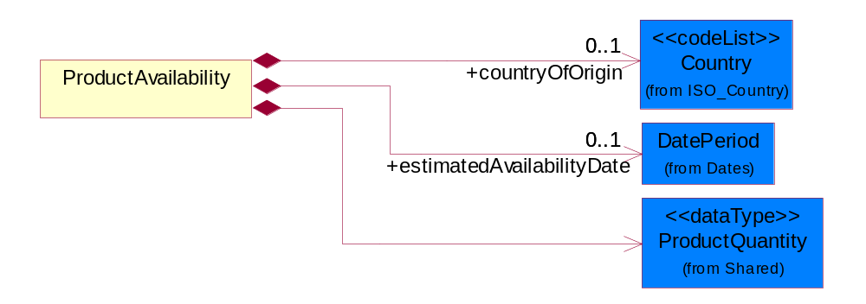
Figure 3-22 ProductAvailability

Composition | Cardinality | Type | Documentation
estimatedAvailabilityDate | 0..1 | DatePeriod | The estimate date the product will be available.
countryOfOrigin | 0..1 | Country | Country where product originates.
ProductQuantity | 1 | ProductQuantity | A quantity specifying the number of product units.

ProductClassification
Identifier to identify product classification.
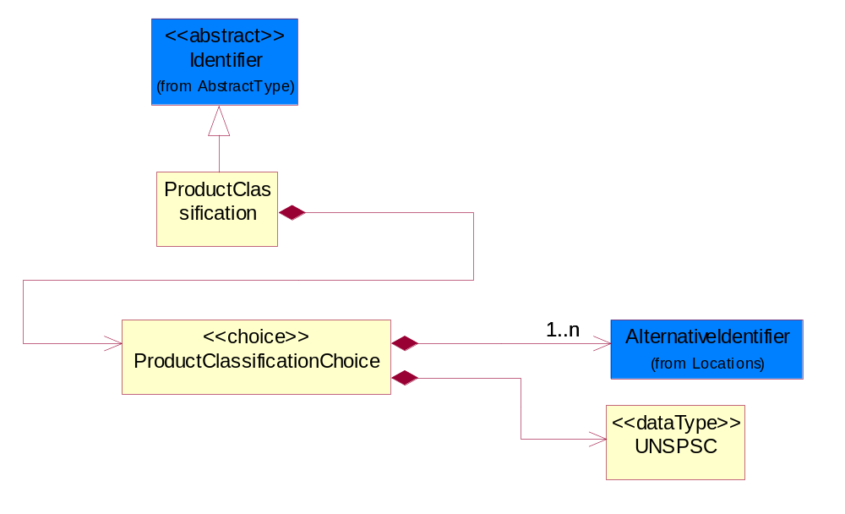
Figure 3-23 ProductClassification

Composition | Cardinality | Type | Documentation
ProductClassificationChoice | 1 | ProductClassificationChoice | Choices to identify product classification.

ProductClassificationChoice
Choices to identify product classification.

Composition | Cardinality | Type | Documentation
AlternativeIdentifier | 1..n | AlternativeIdentifier | Identifies the specified code and the name of the organization that a code is utilized from.
UNSPSC | 1 | UNSPSC | Identifier to identify product classification. RosettaNet has adopted the UNSPSC. Refer to UN/SPSC Website for specific values: http://www.unspsc.org/.

ProductLeadTime
The collection of business properties that describe lead time information about the product.
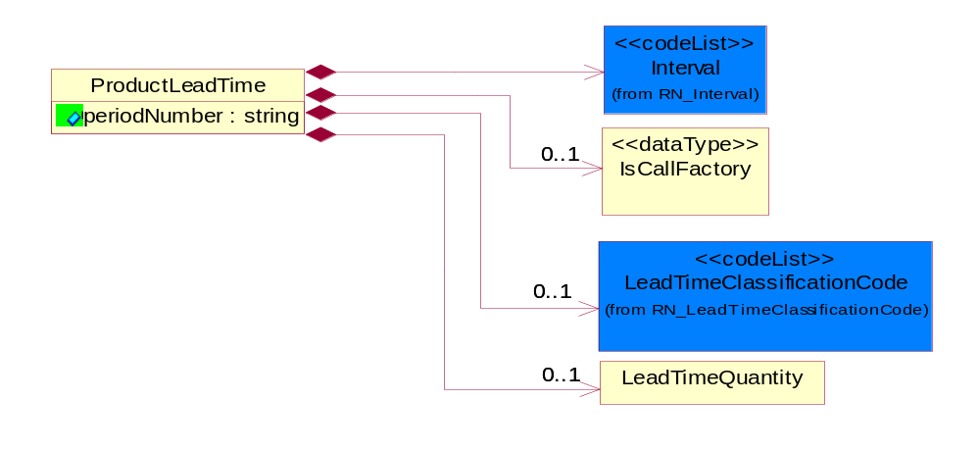
Figure 3-24 ProductLeadTime

Attribute | Type | Documentation
periodNumber | string | The number of measurable units in a date/time period.

Composition | Cardinality | Type | Documentation
LeadTimeQuantity | 0..1 | LeadTimeQuantity | The collection of business propeties that describe manufacturing lead time quantity from the time of order placement to the time the product ships.
IsCallFactory | 0..1 | IsCallFactory | An indicator for the receiver to call the manufacturer to obtain current information.
LeadTimeClassificationCode | 0..1 | LeadTimeClassificationCode | Code identifying the classification of a product lead time for ordering.
Interval | 1 | Interval | Code specifying a forecasting interval.

ProductPricing
The collection of business properties that describe the type of pricing and financial amount for a product.

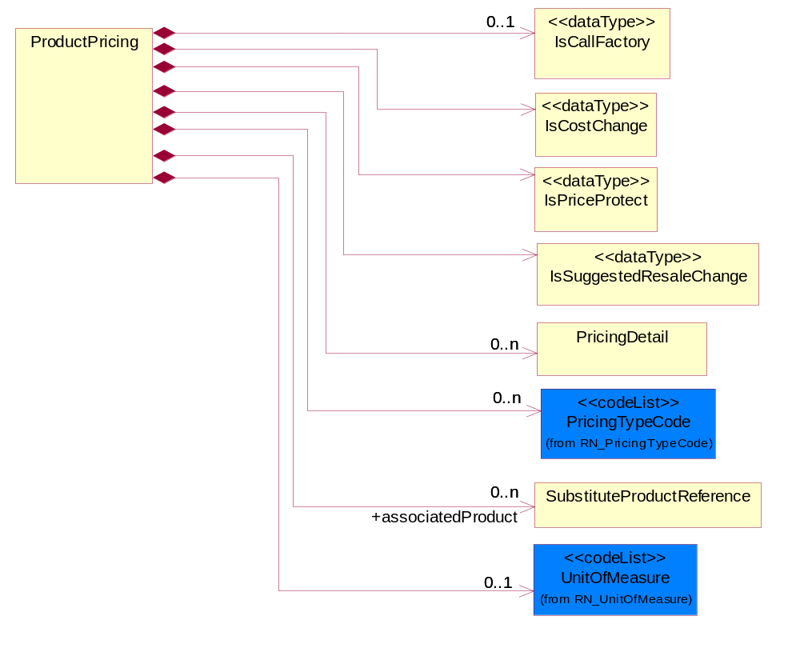
Figure 3-25 ProductPricing

Composition | Cardinality | Type | Documentation
IsCallFactory | 0..1 | IsCallFactory | An indicator for the receiver to call the manufacturer to obtain current information.
IsCostChange | 1 | IsCostChange | An indicator for the receiver to take note that the cost has changed.
IsPriceProtect | 1 | IsPriceProtect | Indicates whether the product pricing is protected.
IsSuggestedResaleChange | 1 | IsSuggestedResaleChange | An indicator for the receiver to take note that the Suggested Resale Price has changed.
PricingDetail | 0..n | PricingDetail | The collection of business properties that describe pricing for a product or service.
PricingTypeCode | 0..n | PricingTypeCode | Code identifying the type of pricing available for a product.
associatedProduct | 0..n | SubstituteProductReference | The product associated.
UnitOfMeasure | 0..1 | UnitOfMeasure | Code identifying a product unit of measure.

ProductQuantityRange
The collection of business properties that describe an upper and lower range of product quantity.
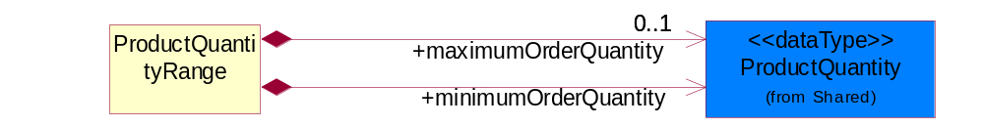
Figure 3-26 ProductQuantityRange

Composition | Cardinality | Type | Documentation
maximumOrderQuantity | 0..1 | ProductQuantity | A numeric expression of the maximum number of product line items that may be ordered.
minimumOrderQuantity | 1 | ProductQuantity | A numeric expression of the minimum number of product line items that may be ordered.

SubstituteProductReference
The collection of business properties describing a product that is being substituted for a requested product.
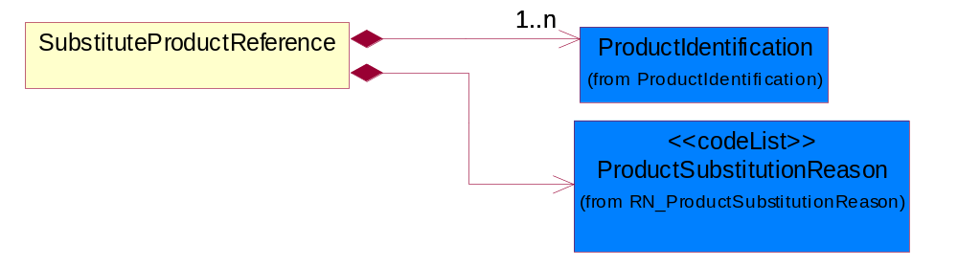
Figure 3-27 SubstituteProductReference

Composition | Cardinality | Type | Documentation
ProductSubstitutionReason | 1 | ProductSubstitutionReason | A code identifying the reason a product is substituted for the original product requested.
ProductIdentification | 1..n | ProductIdentification | The object provides the identifier(s) of a product.

UNSPSC
Identifier to identify product classification. RosettaNet has adopted the UNSPSC. Refer to UN/SPSC Website for specific values: http://www.unspsc.org/.
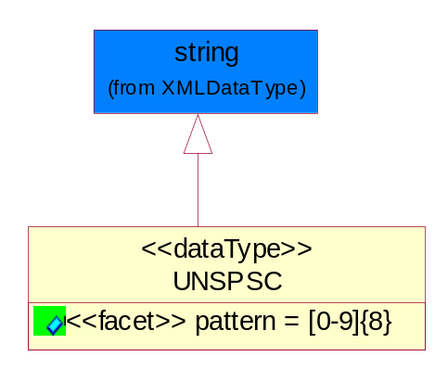
Figure 3-28 UNSPSC

Attribute | Type | Documentation
pattern

CodeList

ProductSubstitutionReason
A code identifying the reason a product is substituted for the original product requested.

Name | Documentation
BEP | Better Product - The requested part number is currently not available offering product upgrade.
CMP | Component of the identified product is a component of this referenced product.
DWN | Downgrade - The identified product is a downgrade for this referenced product.
IPN | Invalid Part Number - The requested part number is invalid.
PRE | Predecessor - The product that existed prior.
QRH | Quality / Reliability Hold.
REP | Retired product - The requested part number is no longer available.
RPL | Replace - The identified product is a replacement for this referenced product.
SCC | Successor - The superseding product that will be replacing the current product.

LeadTimeClassificationCode
Code identifying the classification of a product lead time for ordering.

Name | Documentation
ASA | As Available - A product marked as "As Available" orders for this product but supply is quite uncertain-normally this has been used when a product is being WDFM (withdraw from marketing) or has reached end of life (EOL).
ASS | Assembly - Time period required by a company production line to manufacture a component or module from sub components. This lead-time may include actual manufacturing cycle time, testing time, and queuing time.
CLF | Call Factory - Contact the factory for the most current information.
DTS | Dock to Stock - Time period required to move product from a product seller's or product receiver's dock through a warehousing process until the product is documented as available for buyer's use. If the seller's dock is identified, this lead-time also includes carrier transit time between seller's dock to buyer's dock.
EOL | End of Life.
INS | Individual Scheduled-a product marked as "Individual Scheduled" by the manufacturing facility. When doing this they will take into consideration the current supply situation / extended leadtime as well as capacity situation for the current product.
MAR | Market - Time period quoted by a seller for the availability of product. This lead time includes actual manufacturing cycle time and existing.
NOS | No Supply - A product marked "No Supply" and will not be able to fulfill orders for this product.
ODP | Order Processing - Time period required by a seller to receive a purchase order and respond with a confirmation to the buyer.
PLA | Planned Availability - A product marked as "Planned Availability" yet available on the market but has been announced with a certain date. Once this date has been passed the product will get a "normal" leadtime.
PRC | Procurement - Time period required by a buyer to process a quote or internal demand signal to issue a purchase order.
PRD | Production.
SUP | Start Up.
TRN | Transit - Time period required to move a product from one location to another.

ProductProcurementType
States that describe product procurement conditions.

Name | Documentation
AAP | Product is eligible to be ordered as part of Authorized Assembly Program.
ALC | Allocation.
BLK | Bulk.
CQS | Custom QS is the availability of expedited shipping for certain models or configurations (but not all) of the product specified.
CSU | Product is eligible for customer set up.
DPA | Distributor Price Adjustment - Used to indicate that the distributor price is negotiable.
JIT | Just in Time.
LBD | Limited Book Device - Engineering devices that have not reached final revision, or sample products.
NAP | Not Applicable.
NCN | Non-Cancelable, Non-returnable.
NPB | Non Published Book device - Products available for sale but not published in General Price Book.
NPI | New Product Introduction - Products that are new to the market.
NSB | Non Stockable Book devices - Software products or other products containing software that will under go revision changes. (software, boards, evaluation tools).
ONC | On Contract - Used to indicate that the product is attached to the purchase agreement.
QUS | Quickship - QuickShip is the availability of expedited shipping for the product specified.
REP | Replenishment - Product is eligible to be ordered for inventory replenishment agreements.
SBD | Standard Book Device - Standard products available for sale.
SEG | Segmented - Used to identify products that are under planned procurement processes.
SPS | Supply Split.
SUB | Sub contract.
VMI | Vendor Management Inventory.

Logistics

Logistics

Dependency Diagram
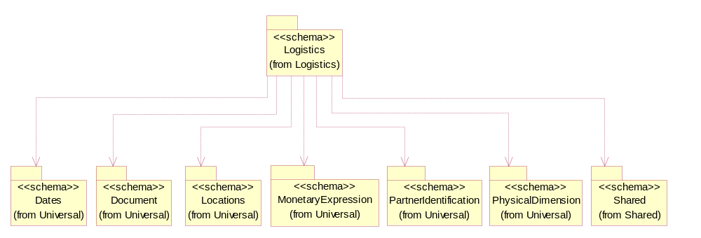
Figure 3-29 Dependency

ExportLicense
The collection of business properties that describe an export license number.

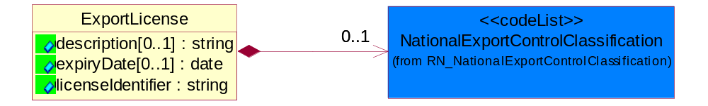
Figure 3-30 ExportLicense

Attribute | Type | Documentation
description[0..1] | string | The description of inventory item to appear on the commercial invoice.
expiryDate[0..1] | date | The date that a contractual agreement expires.
licenseIdentifier | string | The unique identifier representing a license.

Composition | Cardinality | Type | Documentation
NationalExportControlClassification | 0..1 | NationalExportControlClassification | Code identifying product classification for export regulation.

GeographicRegion
The collection of business properties that reflects multiple countries of choice or a specified region.
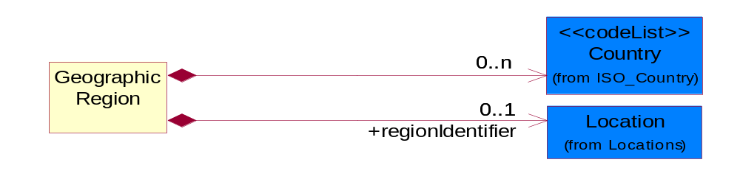
Figure 3-31 GeographicRegion

Composition | Cardinality | Type | Documentation
Country | 0..n | Country | For representation of Country name RosettaNet has adopted ISO 3166-3; 1999. Refer to the following web page to get the latest version of the standard:  http://www.iso.ch/iso/en/prods-services/iso3166ma/02iso-3166-code-lists/index.html  If you need more information about the ISO standard please contact ISO for more details.
regionIdentifier | 0..1 | Location | Identifying a geographic region.

IsHazardousMaterial
Indicates whether the product contains hazardous material.
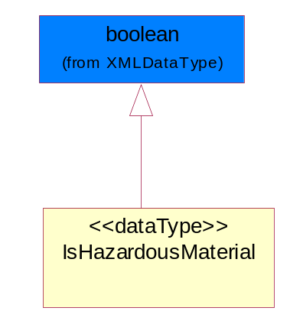
Figure 3-32 IsHazardousMaterial

ManufacturerProfile
The collection of business properties that describe a manufacturer's product.
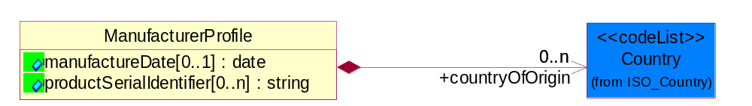
Figure 3-33 ManufacturerProfile

Attribute | Type | Documentation
manufactureDate[0..1] | date | The date the product was manufactured.
productSerialIdentifier[0..n] | string | Serial number(s) of a product.

Composition | Cardinality | Type | Documentation
countryOfOrigin | 0..n | Country | Country where product originates.

MassPhysicalDimension
The physical dimension of unit of mass used for measuring the masses of weights, volumes etc.
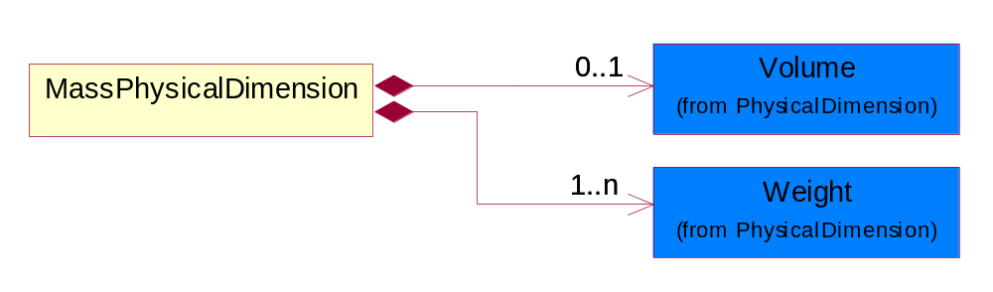
Figure 3-34 MassPhysicalDimension

Composition | Cardinality | Type | Documentation
Volume | 0..1 | Volume | The business document must be able to express the volume of an object.
Weight | 1..n | Weight | The business document must be able to express the weight of an object.

ProductAttribute
The collection of business properties that describes attributes of the product.
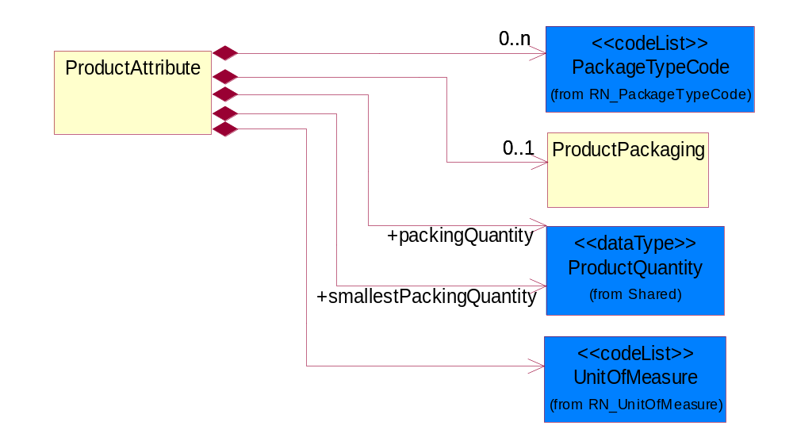
Figure 3-35 ProductAttribute

Composition | Cardinality | Type | Documentation
ProductPackaging | 0..1 | ProductPackaging | The collection of business properties that describe a product's packaging attributes.
packingQuantity | 1 | ProductQuantity | The quantity of products contained in an outer packing unit.
smallestPackingQuantity | 1 | ProductQuantity | The quantity of products contained in an inner packing unit or a sub-packing unit.
UnitOfMeasure | 1 | UnitOfMeasure | Code identifying a product unit of measure.
PackageTypeCode | 0..n | PackageTypeCode | Code specifying the type of packaging for a product.

ProductLicenseRequired
Indicates that a special permit is required in order to purchase or use the product.
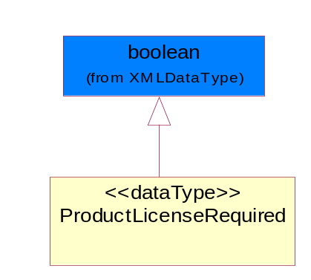
Figure 3-36 ProductLicenseRequired

ProductPackaging
The collection of business properties that describe a product's packaging attributes.
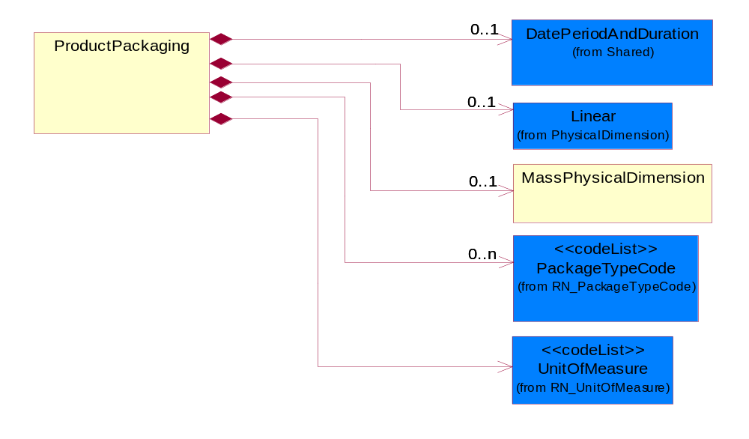

Figure 3-37 ProductPackaging

Composition | Cardinality | Type | Documentation
MassPhysicalDimension | 0..1 | MassPhysicalDimension | The physical dimension of unit of mass used for measuring the masses of weights, volumes etc.
Linear | 0..1 | Linear | The business document must be able to express the linear dimensions of an object.
UnitOfMeasure | 1 | UnitOfMeasure | Code identifying a product unit of measure.
DatePeriodAndDuration | 0..1 | DatePeriodAndDuration | The collection of business properties that describe a date period or duration.
PackageTypeCode | 0..n | PackageTypeCode | Code specifying the type of packaging for a product.

CodeList

NationalExportControlClassification
Code identifying product classification for export regulation.

Name | Documentation
CLE | Clearance - The cargo will be or has been cleared.
CUC | Already customs cleared in the importing country, arrangement for inspection are not necessary because they were cleared before.
DET | Detention - The cargo has been or will be detained.
DOR | Documents Required - Pertinent documents are required.
DRC | Documents Requirements Completed - All requirements for documents have been completed.
FUM | Fumigation - The cargo has been or will be fumigated.
IAC | Inspection Arrangements Completed - Arrangements for inspection of the cargo have been completed.
IAR | Inspection Arrangements Required - Arrangements for inspection of the cargo are required.
INS | Inspection - The cargo has been or will be inspected.
LWI | Lowest Importance.
NCP | No Customs Procedure - Customs clearance not required.
SAC | Safety Arrangements Completed - Arrangements for safeguarding the cargo have been completed.
SAR | Safety Arrangements Required - Arrangements for safeguarding the cargo are required.
SCR | Security - The cargo has been or will be secured.
SEC | Security Arrangements Completed - Arrangements for storing the cargo have been completed.
SER | Security Arrangements Required - Arrangements for the security of the cargo are required.
STR | Storage arrangements required - Arrangements for storing the cargo are required.
TAC | Transport Arrangements Completed - All arrangements for transport have been completed.
TAR | Transport Arrangements Required - Transport has to be arranged.

Marketing

Marketing

Dependency Diagram
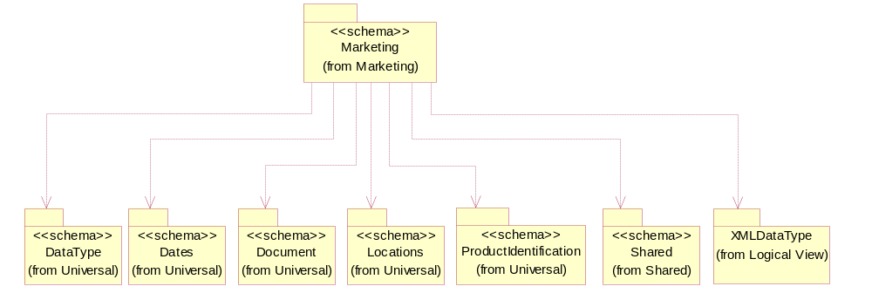
Figure 3-38 Dependency

ChangeNotification
The collection of business properties that describe the product change notification information.
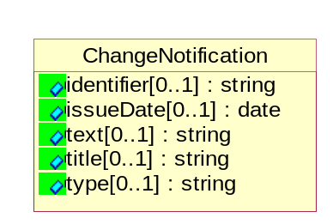
Figure 3-39 ChangeNotification

Attribute | Type | Documentation
identifier[0..1] | string | The issuer's proprietary number that is assigned to the product change notification.
issueDate[0..1] | date | The date that the issuer of the product change notification assigns it to be published.
text[0..1] | string | A free form textual description of information, relating to a product.
title[0..1] | string | The issuer's descriptor name of the product change notification.
type[0..1] | string | The category of change that the product change notification entails. Typically it is Fit, Form, Function, or FYI (For Your Information) only.

IsDesignWin
Indicates whether a product has design win process.
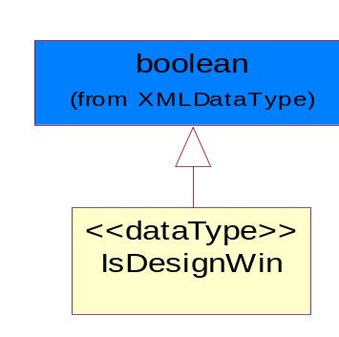
Figure 3-40 IsDesignWin

MarketingInstruction
The collection of business properties that describe the product marketing instruction information.
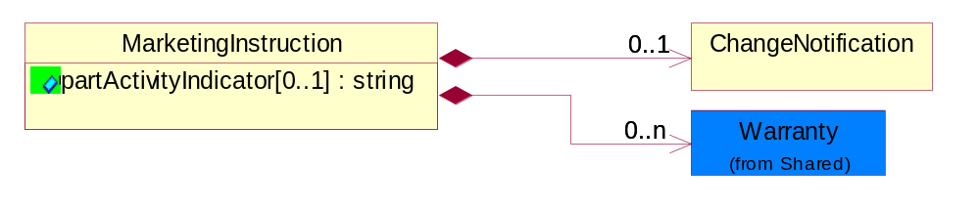
Figure 3-41 MarketingInstruction

Attribute | Type | Documentation
partActivityIndicator[0..1] | string | Describes relative actions that apply to the product.

Composition | Cardinality | Type | Documentation
ChangeNotification | 0..1 | ChangeNotification | The collection of business properties that describe the product change notification information.
Warranty | 0..n | Warranty | The collection of business properties that describes the details of a warranty applied to a product or service

Shared

Shared

Dependency Diagram
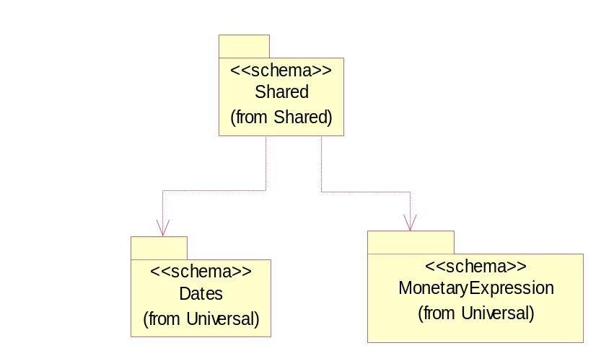
Figure 3-42 Dependency

DatePeriodAndDuration
The collection of business properties that describe a date period or duration.
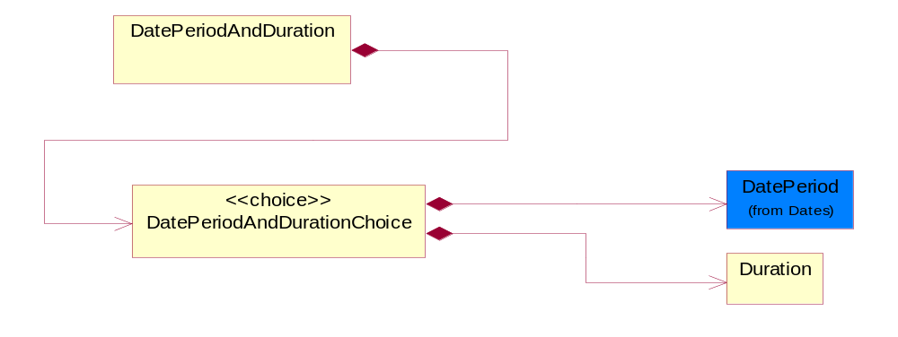
Figure 3-43 DatePeriodAndDuration

Composition | Cardinality | Type | Documentation
DatePeriodAndDurationChoice | 1 | DatePeriodAndDurationChoice | The choice structure for DatePeriodAndDuration.

DatePeriodAndDurationChoice
The choice structure for DatePeriodAndDuration.

Composition | Cardinality | Type | Documentation
DatePeriod | 1 | DatePeriod | The business document must allow for the computation or statement of a duration based upon a beginning and an ending date.
Duration | 1 | Duration | This object allows representation of a duration of time.

Duration
This object allows representation of a duration of time.
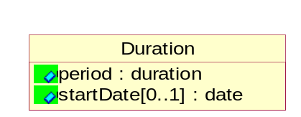
Figure 3-44 Duration

Attribute | Type | Documentation
period | duration | Represents a duration of time.
startDate[0..1] | date | The date indicating the beginning of the duration.

MonetaryAmount
The collection of business properties that describe the monetary amount defined by a specified currency.
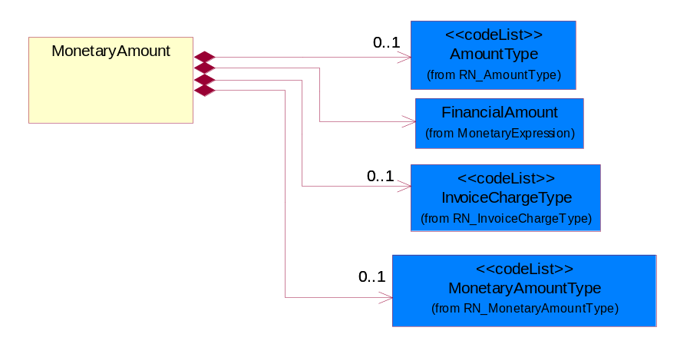
Figure 3-45 MonetaryAmount

Composition | Cardinality | Type | Documentation
FinancialAmount | 1 | FinancialAmount | The business document must express financial amounts.
InvoiceChargeType | 0..1 | InvoiceChargeType | Code identifying the values for the types of charges contained in an invoice.
MonetaryAmountType | 0..1 | MonetaryAmountType | Code identifying whether the monetary amount is a debit or credit.
AmountType | 0..1 | AmountType | Code identifying the type of monetary amount.

ProductQuantity
A quantity specifying the number of product units.
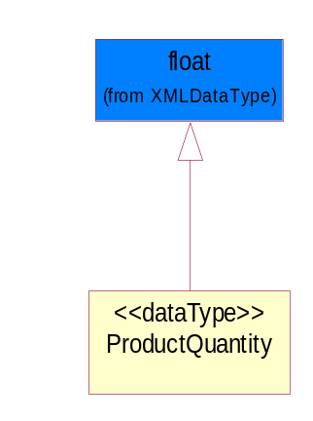
Figure 3-46 ProductQuantity

Warranty
The collection of business properties that describes the details of a warranty applied to a product or service
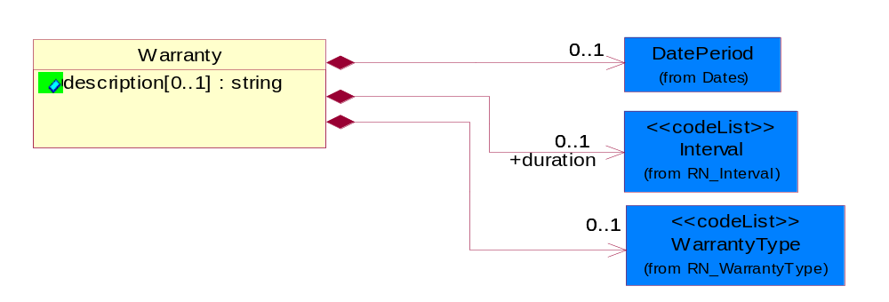
Figure 3-47 Warranty

Attribute | Type | Documentation
description[0..1] | string | The issuer's proprietary number that is assigned to the product change notification.

Composition | Cardinality | Type | Documentation
DatePeriod | 0..1 | DatePeriod | The business document must allow for the computation or statement of a duration based upon a beginning and an ending date.
duration | 0..1 | Interval | The length of time a product is under warranty.
WarrantyType | 0..1 | WarrantyType | The classification of each warranty coverage type that can be claimed.

CodeList

InvoiceChargeType
Code identifying the values for the types of charges contained in an invoice.

Name | Documentation
ALC | Allowances and Charges.
CUC | Custom Charges.
DEA | Deposit Amount.
ESC | Expedited Shipping Charge - Charge for accelerating the delivery of a product.
FRC | Freight Charges.
HAC | Handling Charges.
LEC | Lease Charge - Charge for the use of a product in which the purchaser assumes certain responsibilities of ownership.
LIC | License Charge - Charge for the use of a product (usually software) in which the manufacturer maintains ownership of the product.
MAC | Maintenance Charge - Charge (usually periodic) for providing maintenance support for a product.
PUC | Purchase Charge - Charge for a product in which the buyer takes all responsibilities of ownership.
QUD | Quantity Discount.
REC | Rental Charge - Charge for the use of a product (usually hardware) in which the manufacturer maintains ownership of the product.

MonetaryAmountType
Code identifying whether the monetary amount is a debit or credit.

Name | Documentation
CRE | Credit.
DEB | Debit.
ZER | Zero remit.

PackageTypeCode
Code specifying the type of packaging for a product.

Name | Documentation
6PC | 6 Pack-packaged in multiples of 6 units.
BAG | Bag.
BIN | Bin.
BOX | Box.
BPC | Bulk Pack - Packaged in large volume.
BUD | Bundle.
CAN | Can.
CAR | Carrier.
CLD | Cylinder.
CMS | CLAMSHELL - Packaged in a device with two hinged jaws.
COI | Coil.
CON | Container.
CPK | C-PAK - A powerful vacuum unit complete with filter/cyclone and starter placed inside a heavy-duty container; a flexfiber cyclone for coarse separation; or packaged in covered tape.
CRT | Crate.
CTN | Carton.
DRM | Drum.
DSM | Diskette Mailer - A container made of a small plastic magnetic disk enclosed in a stiff envelope with a radial slit; used to store data.
FLC | FLATPK Carrier - Packaged and laid in full length.
GLP | Gel Pack - Packaged in a colloid or semi-solid substance container.
IND | Individual - Each packed separately.
KDB | Knockdown Tote Bin.
KIT | Kit.
OTH | Other - The package type is not contained in this list; contact manufacturer for the specific package type.
PAG | Package.
PAK | Packed.
PAL | Pallet.
PBG | Plastic Ball Grind array.
PJA | Peanut Jar-packaged in a container filled with foam inserts.
PLC | PLC - Plastic Chip Carrier.
REB | Retail Box - Packaged in a container that is for direct sales to the consumer.
REL | Reel.
ROL | Roll.
SAC | Sack.
SDC | Standard Carton - General pack that is commonly used or established as an acceptable media.
SKI | Skid.
SLV | Sleeve.
SSP | Sample Shipper - A portion, piece, or segment that is representative of a whole.
TAP | Tape - Material/Method of holding a string of computer chips.
TBE | Tube - Packaged in a cylinder container.
TBN | Tote Bin.
TNR | Tape and Reel - Used to identify that a product is packaged in a tape and reel form.
TQF | Thin Quad Flat Package.
TRA | Tray - Packaged on a shallow flat receptacle with a raised edge or rim, used for carrying or holding pieces.
TUB | Tub.
WFB | Wafer Boat - A small thin circular slice of a semiconducting material, such as pure silicon, on which an integrated circuit can be formed.
WFP | Waffle Pack- Die that are packaged in a cavity with a defined matrix; typically a 2-inch or 4-inch square carrier with separate compartments for each die.

PricingTypeCode
Code identifying the type of pricing available for a product.

Name | Documentation
ACR | Authorized Cost and Resale.
ACS | Authorized Cost - The negotiated cost agreed upon between the supplier and distributor at the time the “debit?is authorized.
ACT | Authorized cost.
ANY | Any available.
ARS | Authorized resale.
ASP | Average Selling Price - Manufacturer's published price.
BPA | Budgetary Price Amount.
BPP | Broken Purchase Price.
BSH | Book-Ship.
CAT | Catalog price - Book (the supplier’s published cost at the time of transaction) or Published Price.
CMC | Commercial.
CMD | Commodity.
CMF | Contract Manufacturing.
CON | Contract.
COS | Cost - Price for which the distributor purchased the parts.
DBC | Disti Book Cost.
DFR | Duty free.
DIS | Distribution.
DPD | Duty paid.
DTP | Distribution price.
EDU | Education.
ERT | E-Rate.
EXC | Exception.
FGM | Federal government.
GEN | General.
HIE | Higher Education.
LCL | Local.
LGM | Local government.
LIS | List.
MPR | Market price.
MRP | Manufacturer's recommendation for unit pricing.
MSR | Manufacturer Suggested Retail Price (MSRP).
MUS | Minimum Unit Sale (MUS) - Manufacturer requirement of total dollar value for design opportunity.
NPF | Nonprofit.
OEM | Original Equipment Manufacturing (OEM).
OVP | OEM Volume Pricing - Original equipment manufacturing price per volume ordered.
PED | Primary Education.
QUO | Quote Price
RCS | Requested Cost (RCS) - Reseller requested cost to the manufacturer.
RFB | Refurbished.
RIN | Religious Institution.
RSP | Resale - Price the distributor is authorized to use for sale to their customer (RSP).
SCE | Special Education.
SEC | Security and management reseller.
SED | Secondary Education.
SEV | Service provider.
SGM | State Government.
SPD | Special Discount Price.
SPE | Special Education.
SPL | Samples.
SRP | Suggested Resale Price.
STR | Standard Rebate.
THP | Threshold Price.
TOC | Total Other Charges - Suggested resale price - The sum total of all distributor added charges to the customer for value added services, including but not limited to programming, tape and reel, labeling, date coding, kitting and in-house assembly.

ProductStatusCode
Code specifying the production status of an item.

Name | Documentation
ACT | Active.
ALO | The quantity available to buyer.
BOR | Back Ordered.
DCN | Discontinued. No longer available.
NPR | New Product.
POS | Purchase Order with Supplier.
REP | Replaced.

Interval
Code specifying a forecasting interval.

Name | Documentation
1WM | 1st week of the month.
2WM | 2nd week of the month.
3WM | 3rd week of the month.
4WM | 4th week of the month.
5DW | 5 day work week-Monday through Friday.
5WM | 5th week of the month.
CAD | Calendar day-period given as a number of days including weekends and holidays.
CAW | Calendar week-period given as a number of 7 day-weeks including holidays.
DAY | Day.
FMP | Four month period.
FRI | Friday.
HFM | Half month.
HFW | Half week.
HFY | Half year.
HOU | Hour.
IND | Indefinite-an indefinite period.
MIN | Minute.
MOD | Monday.
MON | Month.
MTF | Monday through Friday.
MTS | Monday through Saturday.
MTU | Monday through Sunday.
QUA | Quarter.
SAT | Saturday.
SUN | Sunday.
TDP | Ten days period-period of 10 days.
THU | Thursday.
TMP | Two month period.
TUE | Tuesday.
TWP | Two week period.
UNS | Unspecified.
WDY | Work day.
WED | Wednesday.
WEE | Week.
WOR | Working days - days when the partner company normally works.
YEA | Year.

WarrantyType
The classification of each warranty coverage type that can be claimed.

Name | Documentation
CRI | Carry In - The warranty coverage for a unit that is carried in for repair.
DEP | Depot.
EVN | Event - The labor warranty coverage per incident.
FCL | Facilitation.
FLL | Full - A warranty which covers all aspects of the product.
LTD | Limited - A warranty which only certain aspects of the product which is described more fully in the warranty description.
OEM | OEM Service Pack.
ONS | Onsite - The warranty coverage for repairing a unit at the customer's location.
PCI | Portable Carry In - The warranty coverage for a portable unit that is carried in for repair.
PCK | Support Pack.
PLA | Parts and Labor - A warranty which covers both the parts cost as well as any labor charges required to replace those parts.
PRO | Parts Only - A warranty which covers only the parts cost of the product.
PRT | Part - The spare parts warranty coverage.
STD | Standard - Indicates standard warranty coverage.

AmountType
Code identifying the type of monetary amount.

Name | Documentation
DIS | Discount Value - The monetary amount of the discount on the price applied to a customer order.
FRE | Freight Charges - The monetary amount to be paid for freight transportation.
INS | InsuranceCharges - The monetary amount to be paid for freight insurance.
MAT | Material Cost - This object represents the material cost for the product.
MIS | Miscellaneous Charges - The monetary amount to be paid for miscellaneous charges.
PRC | Processing Charges - The monetary amount to be paid by consignee for consignment manufacturer.
TOD | Total Amount Due - Total amount due upon receipt of statement.
TOT | Total Amount - Total price for an entire business document.
TOV | Total Value Added Amount - The total amount of the shipment including any value added tax.
UNI | Unit Price - Agreed upon sale price for each unit ordered.
VAD | Value Added Unit Price - The price of a unit including any value added tax.

Universal Structure

ContactInformation

ContactInformation
The business document must allow for the identification of the name of the department, service or individual to be contacted regarding the context of the business document.
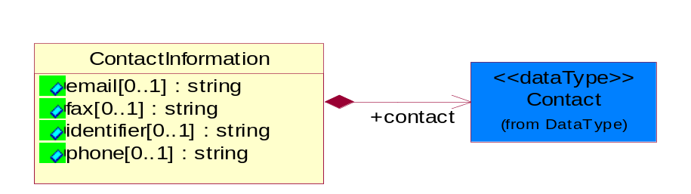
Figure 4-48 ContactInformation

Attribute | Type | Documentation
email[0..1] | string | The electronic mail for the specified contact.
fax[0..1] | string | The fax number for the specified contact.
identifier[0..1] | string | Identifies the role of the contact (i.e. Service Technician, Account Manager) in the Business Process.
phone[0..1] | string | The telephone number for the specified contact.

Composition | Cardinality | Type | Documentation
contact | 1 | Contact | The name of the department, service or individual to be contacted within the organization.

DataType

Contact
The name of the department, service or individual to be contacted within the organization.
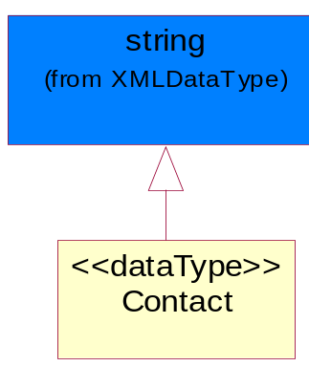
Figure 4-49 Contact

DUNS
A number assigned by Dun and Bradstreet to identify a business location.
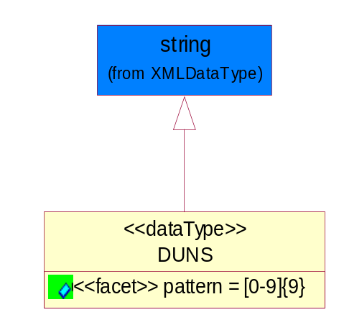
Figure 4-50 DUNS

Attribute | Type | Documentation
pattern |  | [0-9]{9}

DUNSPlus4
A identifier to specify a specific location within a business location.
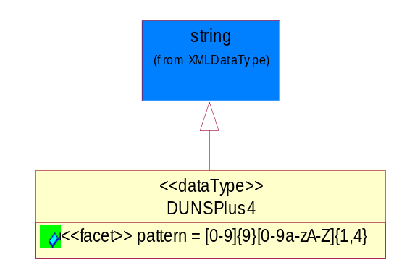
Figure 4-51 DUNSPlus4

Attribute | Type | Documentation
pattern |  | Data Universal Numbering System +4 (DUNS+4) number means the DUNS number assigned by Dun and Bradstreet, Inc. (D&B) plus an alphanumeric of length 4 suffix that may be assigned by a business concern.

GLN
Global Location Number (GLN) - A identifier to identify legal entities, trading parties and location.
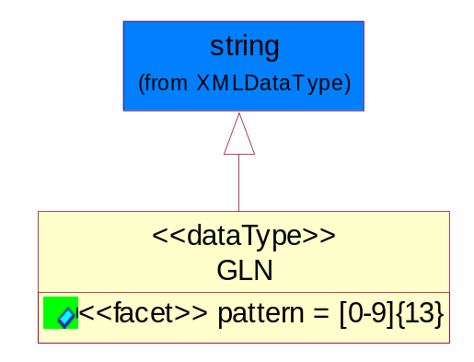
Figure 4-52 GLN

Attribute | Type | Documentation
pattern |  | [0-9]{13}

GTIN
Global Trade Identification Number (GTIN).
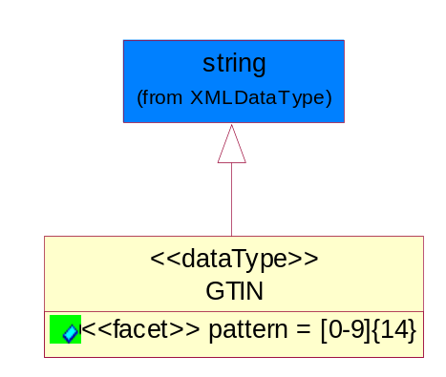
Figure 4-53 GTIN

Attribute | Type | Documentation
pattern |  | [0-9]{14}

Dates

DatePeriod
The business document must allow for the computation or statement of a duration based upon a beginning and an ending date.
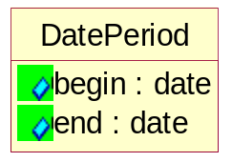
Figure 4-54 DatePeriod

Attribute | Type | Documentation
begin | date | The date indicating the beginning of the date period.
end | date | The date indicating the ending of the date period.

Document

BusinessDocumentReference
The business document reference object allows for the indirect referencing of a relationship to other business related documents.
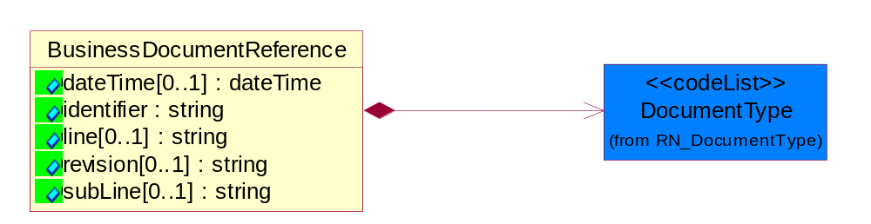
Figure 4-55 BusinessDocumentReference

Attribute | Type | Documentation
dateTime[0..1] | dateTime | The date-time stamp indicating on the referenced business document.
identifier | string | Unique identification of the referenced business document.
line[0..1] | string | References the specific line number of the specified business document.
revision[0..1] | string | Referenced the revision of the specified business document.
subLine[0..1] | string | References the specific subline number of the specified business document.

Composition | Cardinality | Type | Documentation
DocumentType | 1 | DocumentType | A code identifying the business context of a document.

Locations

AlternativeIdentifier
Identifies the specified code and the name of the organization that a code is utilized from.
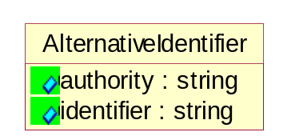
Figure 4-56 AlternativeIdentifier

Attribute | Type | Documentation
authority | string | The name of the organization that a code is utilized from.
identifier | string | The specified code to represent an entity (e.g. product, location, partner, etc.).

Location
The business document must specify a location.
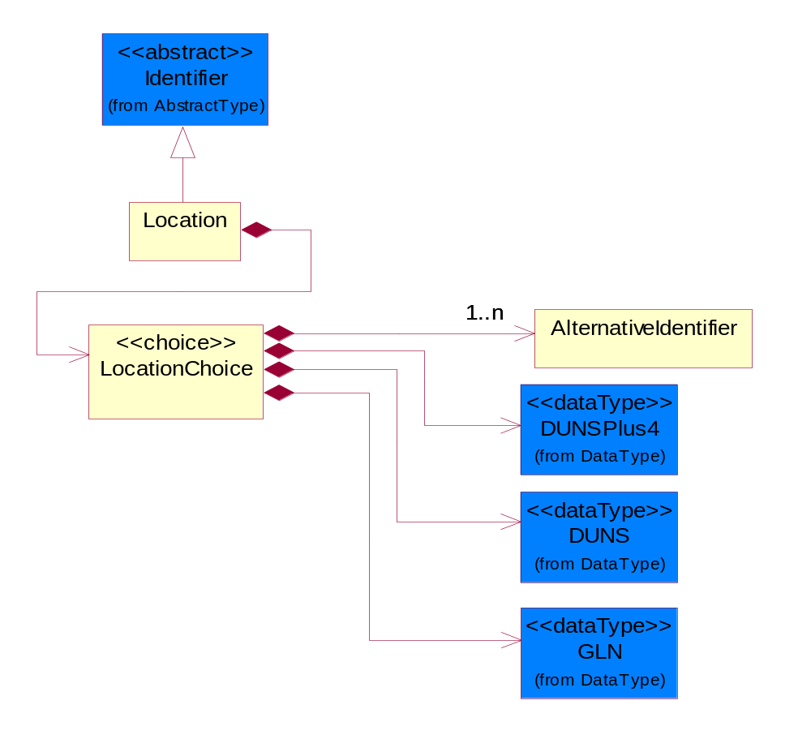
Figure 4-57 Location

Composition | Cardinality | Type | Documentation
LocationChoice | 1 | LocationChoice

LocationChoice

Composition | Cardinality | Type | Documentation
DUNSPlus4 | 1 | DUNSPlus4 | A identifier to specify a specific location within a business location.
DUNS | 1 | DUNS | A number assigned by Dun and Bradstreet to identify a business location.
AlternativeIdentifier | 1..n | AlternativeIdentifier | Identifies the specified code and the name of the organization that a code is utilized from.
GLN | 1 | GLN | Global Location Number (GLN) - A identifier to identify legal entities, trading parties and location.

MonetaryExpression

FinancialAmount
The business document must express financial amounts.
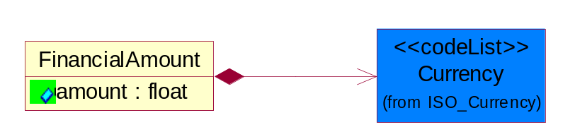
Figure 4-58 FinancialAmount

Attribute | Type | Documentation
amount | float | Specifies the monetary amount.

Composition | Cardinality | Type | Documentation
Currency | 1 | Currency | For representation of Currency codes RosettaNet has adopted ISO 4217; 1995. The British Standards Institution (BSI) is the ISO 4217 Maintenance Agency. Refer to the following web page to get the latest version of the standard:  http://www.bsi-global.com/Technical+Information/Publications/_Publications/tig90.xalter  If you need more information about the ISO standard please contact ISO for more details.

PartnerIdentification

PartnerIdentification
The business document must allow for the identity of one or more parties to the transaction.
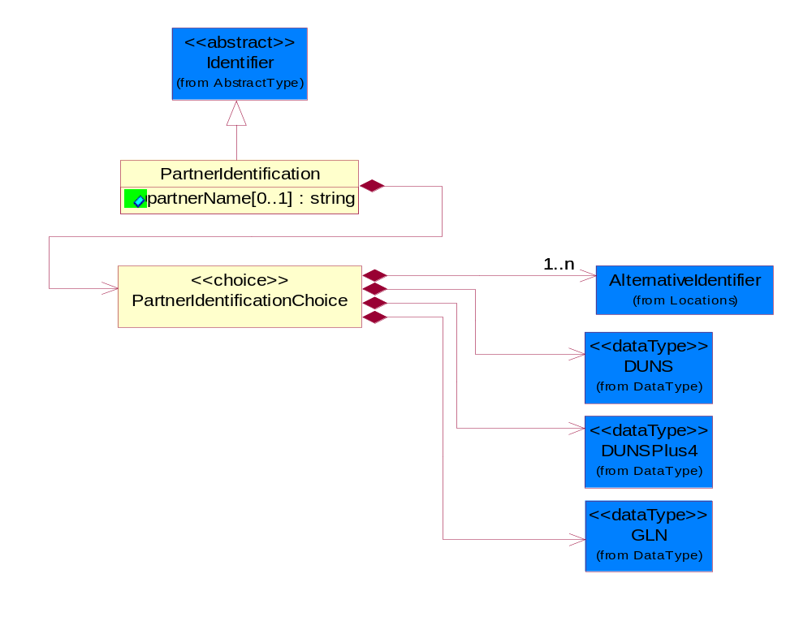
Figure 4-59 PartnerIdentification

Attribute | Type | Documentation
partnerName[0..1] | string | The name of the partner’s company/business.

Composition | Cardinality | Type | Documentation
PartnerIdentificationChoice | 1 | PartnerIdentificationChoice

PartnerIdentificationChoice

Composition | Cardinality | Type | Documentation
DUNS | 1 | DUNS | A number assigned by Dun and Bradstreet to identify a business location.
DUNSPlus4 | 1 | DUNSPlus4 | A identifier to specify a specific location within a business location.
AlternativeIdentifier | 1..n | AlternativeIdentifier | Identifies the specified code and the name of the organization that a code is utilized from.
GLN | 1 | GLN | Global Location Number (GLN) - A identifier to identify legal entities, trading parties and location.

PhysicalDimension

Linear
The business document must be able to express the linear dimensions of an object.
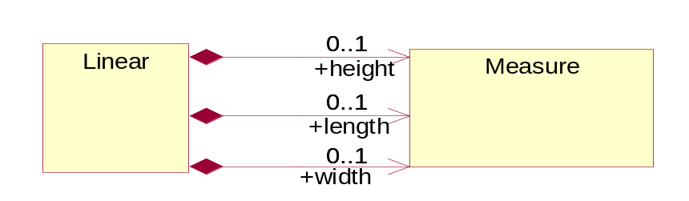
Figure 4-60 Linear

Composition | Cardinality | Type | Documentation
height | 0..1 | Measure | To express the height of an object.
length | 0..1 | Measure | To express the length of an object.
width | 0..1 | Measure | To express the weight of an object.

Measure
The business document must describe measurement information.
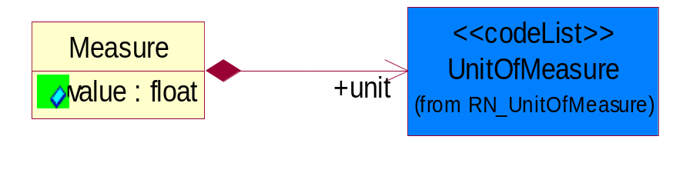
Figure 4-61 Measure

Attribute | Type | Documentation
value | float | The worth of an object in the specified unit of measure.

Composition | Cardinality | Type | Documentation
unit | 1 | UnitOfMeasure | To express the unit type of measurement.

Volume
The business document must be able to express the volume of an object.
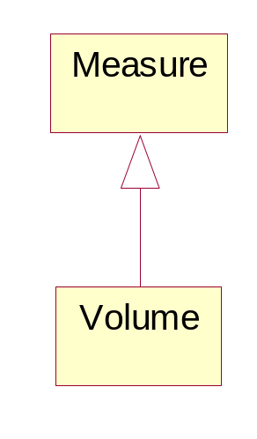
Figure 4-62 Volume

Weight
The business document must be able to express the weight of an object.
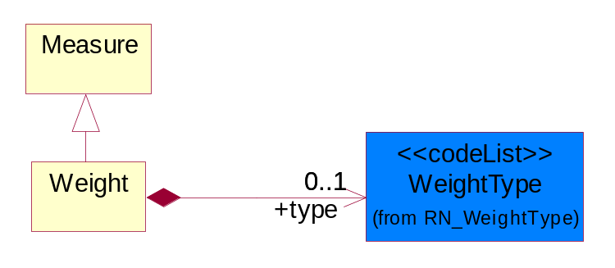
Figure 4-63 Weight

Composition | Cardinality | Type | Documentation
type | 0..1 | WeightType | A code identifying the type of weight.

ProductIdentification

ProductDescription
The business document must allow for the identification of the product and multiple textual descriptions of a product.
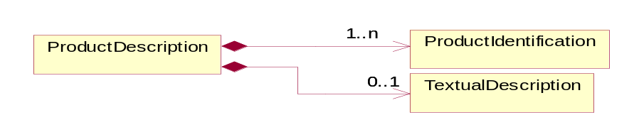
Figure 4-64 ProductDescription

Composition | Cardinality | Type | Documentation
ProductIdentification | 1..n | ProductIdentification | The object provides the identifier(s) of a product.
TextualDescription | 0..1 | TextualDescription | The business document must allow for multiple levels of textual description of an event or object.

ProductIdentification
The object provides the identifier(s) of a product.
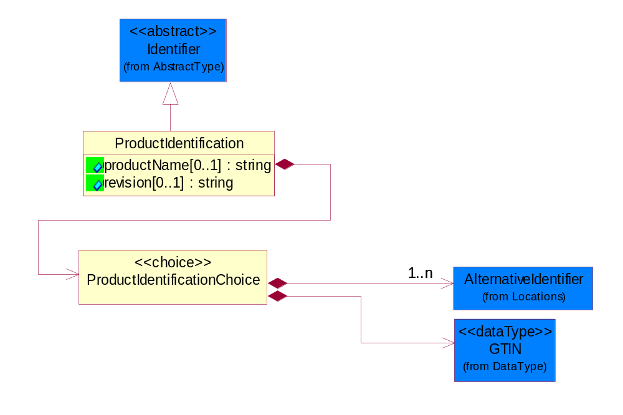
Figure 4-65 ProductIdentification

Attribute | Type | Documentation
productName[0..1] | string | The name of the product.
revision[0..1] | string | Referenced the specified product revision.

Composition | Cardinality | Type | Documentation
ProductIdentificationChoice | 1 | ProductIdentificationChoice

ProductIdentificationChoice

Composition | Cardinality | Type | Documentation
AlternativeIdentifier | 1..n | AlternativeIdentifier | Identifies the specified code and the name of the organization that a code is utilized from.
GTIN | 1 | GTIN | Global Trade Identification Number (GTIN).

TextualDescription
The business document must allow for multiple levels of textual description of an event or object.
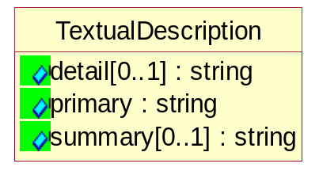
Figure 4-66 TextualDescription

Attribute | Type | Documentation
detail[0..1] | string | A detail description of an event or object.
primary | string | A phrase or single word description of an event or object.
summary[0..1] | string | A condensed description of an event or object.

CodeList

Country
For representation of Country name RosettaNet has adopted ISO 3166-3; 1999. Refer to the following web page to get the latest version of the standard:
http://www.iso.ch/iso/en/prods-services/iso3166ma/02iso-3166-code-lists/index.html

If you need more information about the ISO standard please contact ISO for more details.

Currency
For representation of Currency codes RosettaNet has adopted ISO 4217; 1995. The British Standards Institution (BSI) is the ISO 4217 Maintenance Agency. Refer to the following web page to get the latest version of the standard:
http://www.bsi-global.com/Technical+Information/Publications/_Publications/tig90.xalter

If you need more information about the ISO standard please contact ISO for more details.

Language
For representation of Language name RosettaNet has adopted ISO 639-2; 1998. Refer to the following web page to get the latest version of the standard:

http://www.loc.gov/standards/iso639-2/iso639jac.html

If you need more information about the ISO standard please contact ISO for more details.

DocumentType
A code identifying the business context of a document.

Instance | Documentation
ARA | Authorization Request Approval.
CBN | Product batch number of customer.
CCN | Customs clearance number.
CFA | Failure Analysis - Request document that will accompany the product providing characteristics of the component failure.
CIN | Commercial Invoice.
CNM | Traditional credit note or memo.
CON | In a virtual sourcing relationship, a third party trading partner is supplying a part to a customer on behalf of another company that has taken the order for the customer. In this case a Customer Order Number is associated to the request for material that is sent to the virtual trading partners.
COS | Consumption Notice.
COT | Contract.
CRN | Unique consumption reference number identifying the product consumption issue i.e. one-to-one relationship with physical flow.
DEM | Traditional debit note or memo.
DEN | Delivery Note.
DIN | Discontinuation Notice.
DOR | Delivery Order.
DRN | Drawing Number.
DRR | Design Registration Request.
ECO | Engineering Change Order - The proprietary unique identification number that represents an engineering change order.
EIR | Engineering Information Request.
EOL | End of Life.
FUO | Sales order or transfer order fulfilling demand out of a facility (outbound shipment).
INV | Invoice.
LID | Location Identifier. Data for on-site work that have to be done on the machine (associated with preventive maintenance order).
MEN | Master Event Number.
MID | Machine Identifier. Data for on-site work that have to be done on the machine (associated with preventive maintenance order).
MON | Model Number.
OCL | The unique identifier assigned by the OEM for a warranty claim.
OGA | Other governmental agency issued document.
OPO | The unique identifier assigned by the OEM for a part order.
OPR | The unique identifier assigned by the OEM for a part return.
PCN | Product/Process Change.
PFA | Failure Analysis - Request document that will accompany the product providing characteristics of the product failure.
PII | Refers to previously issued invoice.
PLS | Unique number that identifies packing form prior to shipment.
POI | Purchase Order IN.
PON | Production order number for material release.
POO | Purchase Order OUT.
PRC | Product Catalog.
PSI | Refers to previously issued self-billing invoice.
PUO | Purchase Order.
QUO | Quote.
REC | Document identifying the receipt of materials or products into a facility against a purchase order or transfer order (inbound shipment).
REO | Purchase order or transfer order replenishing inventory into a facility (inbound shipment).
REQ | Requisition.
RMA | Returned Material Authorization.
RPO | Purchase order for materials or product returned to and reworked by a supplier.
RTA | Remittance Advice - Remittance details.
SAO | Sales Order.
SBC | Credit Memo used in self-billing scenario.
SBD | Debit Memo used in self-billing scenario.
SBI | Invoice in self billing scenario.
SBN | Product batch number of supplier.
SCA | Similar to contracts - Contains the quantity of an article that is to be ordered from a vendor and the price for article or service that is to be procured.
SEN | Serial Number.
SEO | A document that gives a repair provider the necessary authorization to repair or upgrade a product either at the customer site or at the repair provider’s site.
SHD | Shipping Document.
SNC | Shipset Number on Code List.
SPC | The unique identifier assigned by the ASP for a warranty claim.
SPN | Spec Number.
SPO | The unique identifier assigned by the ASP for a part order.
SPR | The unique identifier assigned by the ASP for a part return.
SPW | The unique identifier assigned by the ASP to reference a work order.
SRI | A document that contains the shipping reference number which allows the product to be tracked within the outsourced logistic providers network.
TRO | Order which results in materials or products being moved from one facility to another (outbound shipment and inbound shipment).
WAB | Waybill.
WAC | Denotes a warranty claim.
WOO | Work Order.

MimeTypeQualifier
The MIME type as defined by IANA.

Please refer to http://www.iana.org/assignments/media-types/ for a list of types.

Instance | Documentation
application/activemessage | [Shapiro]
application/andrew-inset | [Borenstein]
application/applefile | [Faltstrom]
application/atomicmail | [Borenstein]
application/batch-SMTP | [RFC2442]
application/beep+xml | [RFC3080]
application/cals-1840 | [RFC1895]
application/cnrp+xml | [RFCCNRP]
application/commonground | [Glazer]
application/cpl+xml
application/cybercash | [Eastlake]
application/dca-rft | [Campbell]
application/dec-dx | [Campbell]
application/dicom | [RFC3240]
application/dvcs | [RFC3029]
application/EDI-Consent | [RFC1767]
application/EDIFACT | [RFC1767]
application/EDI-X12 | [RFC1767]
application/eshop | [Katz]
application/font-tdpfr | [RFC3073]
application/http | [RFC2616]
application/hyperstudio | [Domino]
application/iges | [Parks]
application/index | [RFC2652]
application/index.cmd | [RFC2652]
application/index.obj | [RFC2652]
application/index.response | [RFC2652]
application/index.vnd | [RFC2652]
application/iotp | [RFC2935]
application/ipp | [RFC2910]
application/isup | [RFC3204]
application/mac-binhex40 | [Faltstrom]
application/macwriteii | [Lindner]
application/marc | [RFC2220]
application/mathematica | [Van Nostern]
application/msword | [Lindner]
application/news-message-id | [RFC1036,Spencer]
application/news-transmission | [RFC1036, Spencer]
application/ocsp-request | [RFC2560]
application/ocsp-response | [RFC2560]
application/octet-stream | [RFC2045,RFC2046]
application/oda | [RFC2045,RFC2046]
application/ogg | [RFC-walleij-ogg-mediatype-08.txt]
application/parityfec | [RFC3009]
application/pdf | [Lindner]
application/pgp-encrypted | [RFC3156]
application/pgp-keys | [RFC3156]
application/pgp-signature | [RFC3156]
application/pkcs10 | [RFC2311]
application/pkcs7-mime | [RFC2311]
application/pkcs7-signature | [RFC2311]
application/pkix-cert | [RFC2585]
application/pkixcmp | [RFC2510]
application/pkix-crl | [RFC2585]
application/postscript | [RFC2045,RFC2046]
application/prs.alvestrand.titrax-sheet | [Alvestrand]
application/prs.cww | [Rungchavalnont]
application/prs.nprend | [Doggett]
application/prs.plucker | [Janssen]
application/qsig | [RFC3204]
application/reginfo+xml | [RFC-ietf-sipping-reg-event-00.txt]
application/remote-printing | [RFC1486,Rose]
application/riscos | [Smith]
application/rtf | [Lindner]
application/sdp | [RFC2327]
application/set-payment | [Korver]
application/set-payment-initiation | [Korver]
application/set-registration | [Korver]
application/set-registration-initiation | [Korver]
application/sgml | [RFC1874]
application/sgml-open-catalog | [Grosso]
application/sieve | [RFC3028]
application/slate | [Crowley]
application/timestamp-query | [RFC3161]
application/timestamp-reply | [RFC3161]
application/tve-trigger | [Welsh]
application/vemmi | [RFC2122]
application/vnd.3gpp.pic-bw-large | [Meredith]
application/vnd.3gpp.pic-bw-small | [Meredith]
application/vnd.3gpp.pic-bw-var | [Meredith]
application/vnd.3gpp.sms | [Meredith]
application/vnd.3M.Post-it-Notes | [O'Brien]
application/vnd.accpac.simply.aso | [Leow]
application/vnd.accpac.simply.imp | [Leow]
application/vnd.acucobol | [Lubin]
application/vnd.acucorp | [Lubin]
application/vnd.adobe.xfdf | [Perelman]
application/vnd.aether.imp | [Moskowitz]
application/vnd.amiga.ami | [Blumberg]
application/vnd.anser-web-certificate-issue-initiation | [Mori]
application/vnd.anser-web-funds-transfer-initiation | [Mori]
application/vnd.audiograph | [Slusanschi]
application/vnd.blueice.multipass | [Holmstrom]
application/vnd.bmi | [Gotoh]
application/vnd.businessobjects | [Imoucha]
application/vnd.canon-cpdl | [Muto]
application/vnd.canon-lips | [Muto]
application/vnd.cinderella | [Kortenkamp]
application/vnd.claymore | [Simpson]
application/vnd.commerce-battelle | [Applebaum]
application/vnd.commonspace | [Chandhok]
application/vnd.contact.cmsg | [Patz]
application/vnd.cosmocaller | [Dellutri]
application/vnd.ctc-posml | [Kohlhepp]
application/vnd.cups-postscript | [Sweet]
application/vnd.cups-raster | [Sweet]
application/vnd.cups-raw | [Sweet]
application/vnd.curl | [Byrnes]
application/vnd.cybank | [Helmee]
application/vnd.data-vision.rdz | [Fields]
application/vnd.dna | [Searcy]
application/vnd.dpgraph | [Parker]
application/vnd.dreamfactory | [Appleton]
application/vnd.dxr | [Duffy]
application/vnd.ecdis-update | [Buettgenbach]
application/vnd.ecowin.chart | [Olsson]
application/vnd.ecowin.filerequest | [Olsson]
application/vnd.ecowin.fileupdate | [Olsson]
application/vnd.ecowin.series | [Olsson]
application/vnd.ecowin.seriesrequest | [Olsson]
application/vnd.ecowin.seriesupdate | [Olsson]
application/vnd.enliven | [Santinelli]
application/vnd.epson.esf | [Hoshina]
application/vnd.epson.msf | [Hoshina]
application/vnd.epson.quickanime | [Gu]
application/vnd.epson.salt | [Nagatomo]
application/vnd.epson.ssf | [Hoshina]
application/vnd.ericsson.quickcall | [Tidwell]
application/vnd.eudora.data | [Resnick]
application/vnd.fdf | [Zilles]
application/vnd.ffsns | [Holstage]
application/vnd.FloGraphIt | [Floersch]
application/vnd.framemaker | [Wexler]
application/vnd.fsc.weblaunch | [D.Smith]
application/vnd.fujitsu.oasys | [Togashi]
application/vnd.fujitsu.oasys2 | [Togashi]
application/vnd.fujitsu.oasys3 | [Okudaira]
application/vnd.fujitsu.oasysgp | [Sugimoto]
application/vnd.fujitsu.oasysprs | [Ogita]
application/vnd.fujixerox.ddd | [Onda]
application/vnd.fujixerox.docuworks | [Taguchi]
application/vnd.fujixerox.docuworks.binder | [Matsumoto]
application/vnd.fut-misnet | [Pruulmann]
application/vnd.grafeq | [Tupper]
application/vnd.groove-account | [Joseph]
application/vnd.groove-help | [Joseph]
application/vnd.groove-identity-message | [Joseph]
application/vnd.groove-injector | [Joseph]
application/vnd.groove-tool-message | [Joseph]
application/vnd.groove-tool-template | [Joseph]
application/vnd.groove-vcard | [Joseph]
application/vnd.hbci | [Hammann]
application/vnd.hhe.lesson-player | [Jones]
application/vnd.hp-HPGL | [Pentecost]
application/vnd.hp-hpid | [Gupta]
application/vnd.hp-hps | [Aubrey]
application/vnd.hp-PCL | [Pentecost]
application/vnd.hp-PCLXL | [Pentecost]
application/vnd.httphone | [Lefevre]
application/vnd.hzn-3d-crossword | [Minnis]
application/vnd.ibm.afplinedata | [Buis]
application/vnd.ibm.electronic-media | [Tantlinger]
application/vnd.ibm.MiniPay | [Herzberg]
application/vnd.ibm.modcap | [Hohensee]
application/vnd.ibm.secure-container | [Tantlinger]
application/vnd.informix-visionary | [Gales]
application/vnd.intercon.formnet | [Gurak]
application/vnd.intertrust.digibox | [Tomasello]
application/vnd.intertrust.nncp | [Tomasello]
application/vnd.intu.qbo | [Scratchley]
application/vnd.intu.qfx | [Scratchley]
application/vnd.irepository.package+xml | [Knowles]
application/vnd.is-xpr | [Natarajan]
application/vnd.japannet-directory-service | [Fujii]
application/vnd.japannet-jpnstore-wakeup | [Yoshitake]
application/vnd.japannet-payment-wakeup | [Fujii]
application/vnd.japannet-registration | [Yoshitake]
application/vnd.japannet-registration-wakeup | [Fujii]
application/vnd.japannet-setstore-wakeup | [Yoshitake]
application/vnd.japannet-verification | [Yoshitake]
application/vnd.japannet-verification-wakeup | [Fujii]
application/vnd.jisp | [Deckers]
application/vnd.kde.karbon | [Faure]
application/vnd.kde.kchart | [Faure]
application/vnd.kde.kformula | [Faure]
application/vnd.kde.kivio | [Faure]
application/vnd.kde.kontour | [Faure]
application/vnd.kde.kpresenter | [Faure]
application/vnd.kde.kspread | [Faure]
application/vnd.kde.kword | [Faure]
application/vnd.kenameaapp | [DiGiorgio-Haag]
application/vnd.koan | [Cole]
application/vnd.liberty-request+xml | [McDowell]
application/vnd.llamagraphics.life-balance.desktop | [White]
application/vnd.lotus-1-2-3 | [Wattenberger]
application/vnd.lotus-approach | [Wattenberger]
application/vnd.lotus-freelance | [Wattenberger]
application/vnd.lotus-notes | [Laramie]
application/vnd.lotus-organizer | [Wattenberger]
application/vnd.lotus-screencam | [Wattenberger]
application/vnd.lotus-wordpro | [Wattenberger]
application/vnd.mcd | [Gotoh]
application/vnd.mediastation.cdkey | [Flurry]
application/vnd.meridian-slingshot | [Wedel]
application/vnd.micrografx.flo | [Prevo]
application/vnd.micrografx.igx | [Prevo]
application/vnd.mif | [Wexler]
application/vnd.minisoft-hp3000-save | [Bartram]
application/vnd.mitsubishi.misty-guard.trustweb | [Tanaka]
application/vnd.Mobius.DAF | [Kabayama]
application/vnd.Mobius.DIS | [Kabayama]
application/vnd.Mobius.MBK | [Devasia]
application/vnd.Mobius.MQY | [Devasia]
application/vnd.Mobius.MSL | [Kabayama]
application/vnd.Mobius.PLC | [Kabayama]
application/vnd.Mobius.TXF | [Kabayama]
application/vnd.mophun.application | [Wennerstrom]
application/vnd.mophun.certificate | [Wennerstrom]
application/vnd.motorola.flexsuite | [Patton]
application/vnd.motorola.flexsuite.adsi | [Patton]
application/vnd.motorola.flexsuite.fis | [Patton]
application/vnd.motorola.flexsuite.gotap | [Patton]
application/vnd.motorola.flexsuite.kmr | [Patton]
application/vnd.motorola.flexsuite.ttc | [Patton]
application/vnd.motorola.flexsuite.wem | [Patton]
application/vnd.mozilla.xul+xml | [McDaniel]
application/vnd.ms-artgalry | [Slawson]
application/vnd.ms-asf | [Fleischman]
application/vnd.mseq | [Le Bodic]
application/vnd.ms-excel | [Gill]
application/vnd.msign | [Borcherding]
application/vnd.ms-lrm | [Ledoux]
application/vnd.ms-powerpoint | [Gill]
application/vnd.ms-project | [Gill]
application/vnd.ms-tnef | [Gill]
application/vnd.ms-works | [Gill]
application/vnd.ms-wpl | [Plastina]
application/vnd.musician | [Adams]
application/vnd.music-niff | [Butler]
application/vnd.netfpx | [Mutz]
application/vnd.noblenet-directory | [Solomon]
application/vnd.noblenet-sealer | [Solomon]
application/vnd.noblenet-web | [Solomon]
application/vnd.novadigm.EDM | [Swenson]
application/vnd.novadigm.EDX | [Swenson]
application/vnd.novadigm.EXT | [Swenson]
application/vnd.obn | [Hessling]
application/vnd.osa.netdeploy | [Klos]
application/vnd.palm | [Peacock]
application/vnd.pg.format | [Gandert]
application/vnd.pg.osasli | [Gandert]
application/vnd.powerbuilder6 | [Guy]
application/vnd.powerbuilder6-s | [Guy]
application/vnd.powerbuilder7 | [Shilts]
application/vnd.powerbuilder75 | [Shilts]
application/vnd.powerbuilder75-s | [Shilts]
application/vnd.powerbuilder7-s | [Shilts]
application/vnd.previewsystems.box | [Smolgovsky]
application/vnd.publishare-delta-tree | [Ben-Kiki]
application/vnd.pvi.ptid1 | [Lamb]
application/vnd.pwg-multiplexed | [RFC3391]
application/vnd.pwg-xhtml-print+xml | [Wright]
application/vnd.Quark.QuarkXPress | [Scheidler]
application/vnd.rapid | [Szekely]
application/vnd.s3sms | [Tarkkala]
application/vnd.sealed.net | [Lambert]
application/vnd.seemail | [Webb]
application/vnd.shana.informed.formdata | [Selzler]
application/vnd.shana.informed.formtemplate | [Selzler]
application/vnd.shana.informed.interchange | [Selzler]
application/vnd.shana.informed.package | [Selzler]
application/vnd.smaf | [Takahashi]
application/vnd.sss-cod | [Dani]
application/vnd.sss-dtf | [Bruno]
application/vnd.sss-ntf | [Bruno]
application/vnd.street-stream | [Levitt]
application/vnd.svd | [Becker]
application/vnd.swiftview-ics | [Widener]
application/vnd.triscape.mxs | [Simonoff]
application/vnd.trueapp | [Hepler]
application/vnd.truedoc | [Chase]
application/vnd.ufdl | [Manning]
application/vnd.uplanet.alert | [Martin]
application/vnd.uplanet.alert-wbxml | [Martin]
application/vnd.uplanet.bearer-choice | [Martin]
application/vnd.uplanet.bearer-choice-wbxml | [Martin]
application/vnd.uplanet.cacheop | [Martin]
application/vnd.uplanet.cacheop-wbxml | [Martin]
application/vnd.uplanet.channel | [Martin]
application/vnd.uplanet.channel-wbxml | [Martin]
application/vnd.uplanet.list | [Martin]
application/vnd.uplanet.listcmd | [Martin]
application/vnd.uplanet.listcmd-wbxml | [Martin]
application/vnd.uplanet.list-wbxml | [Martin]
application/vnd.uplanet.signal | [Martin]
application/vnd.vcx | [T.Sugimoto]
application/vnd.vectorworks | [Pharr]
application/vnd.vidsoft.vidconference | [Hess]
application/vnd.visio | [Sandal]
application/vnd.visionary | [Aravindakumar]
application/vnd.vividence.scriptfile | [Risher]
application/vnd.vsf | [Rowe]
application/vnd.wap.sic | [WAP-Forum]
application/vnd.wap.slc | [WAP-Forum]
application/vnd.wap.wbxml | [Stark]
application/vnd.wap.wmlc | [Stark]
application/vnd.wap.wmlscriptc | [Stark]
application/vnd.webturbo | [Rehem]
application/vnd.wrq-hp3000-labelled | [Bartram]
application/vnd.wt.stf | [Wohler]
application/vnd.wv.csp+wbxml | [Salmi]
application/vnd.xara | [Matthewman]
application/vnd.xfdl | [Manning]
application/vnd.yellowriver-custom-menu | [Yellow]
application/whoispp-query | [RFC2957]
application/whoispp-response | [RFC2958]
application/wita | [Campbell]
application/wordperfect5.1 | [Lindner]
application/x400-bp | [RFC1494]
application/xhtml+xml | [RFC3236]
application/xml | [RFC3023]
application/xml-dtd | [RFC3023]
application/xml-external-parsed-entity | [RFC3023]
application/zip | [Lindner]
audio/32kadpcm | [RFC2421,RFC2422]
audio/AMR | [RFC3267]
audio/AMR-WB | [RFC3267]
audio/basic | [RFC2045,RFC2046]
audio/CN | [RFC3389]
audio/DAT12 | [RFC3190]
audio/DVI4
audio/EVRC | [RFC-ietf-avt-evrc-smv-03.txt]
audio/EVRC0 | [RFC-ietf-avt-evrc-smv-03.txt]
audio/G.722.1 | [RFC3047]
audio/G722
audio/G723
audio/G726-16
audio/G726-24
audio/G726-32
audio/G726-40
audio/G728
audio/G729
audio/G729D
audio/G729E
audio/GSM
audio/GSM-EFR
audio/L16 | [RFC2586]
audio/L20 | [RFC3190]
audio/L24 | [RFC3190]
audio/L8
audio/LPC
audio/MP4A-LATM | [RFC3016]
audio/MPA
audio/mpa-robust | [RFC3119]
audio/mpeg | [RFC3003]
audio/parityfec | [RFC3009]
audio/PCMA
audio/PCMU
audio/prs.sid | [Walleij]
audio/QCELP
audio/RED
audio/SMV | [RFC-ietf-avt-evrc-smv-03.txt]
audio/SMV0 | [RFC-ietf-avt-evrc-smv-03.txt]
audio/telephone-event | [RFC2833]
audio/tone | [RFC2833]
audio/VDVI
audio/vnd.3gpp.iufp | [Belling]
audio/vnd.cisco.nse | [Kumar]
audio/vnd.cns.anp1 | [McLaughlin]
audio/vnd.cns.inf1 | [McLaughlin]
audio/vnd.digital-winds | [Strazds]
audio/vnd.everad.plj | [Cicelsky]
audio/vnd.lucent.voice | [Vaudreuil]
audio/vnd.nortel.vbk | [Parsons]
audio/vnd.nuera.ecelp4800 | [Fox]
audio/vnd.nuera.ecelp7470 | [Fox]
audio/vnd.nuera.ecelp9600 | [Fox]
audio/vnd.octel.sbc | [Vaudreuil]
audio/vnd.qcelp | [Lundblade]
audio/vnd.rhetorex.32kadpcm | [Vaudreuil]
audio/vnd.vmx.cvsd | [Vaudreuil]
image/cgm | Computer Graphics Metafile
image/g3fax | [RFC1494]
image/gif | [RFC2045,RFC2046]
image/ief | [RFC1314] Image Exchange Format
image/jpeg | [RFC2045,RFC2046]
image/naplps | [Ferber]
image/png | [Randers-Pehrson]
image/prs.btif | [Simon]
image/prs.pti | [Laun]
image/t38 | [RFC3362]
image/tiff | [RFC3302] Tag Image File Format
image/tiff-fx | [RFC3250] Tag Image File Format Fax eXtended
image/vnd.cns.inf2 | [McLaughlin]
image/vnd.djvu | [Bottou]
image/vnd.dwg | [Moline]
image/vnd.dxf | [Moline]
image/vnd.fastbidsheet | [Becker]
image/vnd.fpx | [Spencer]
image/vnd.fst | [Fuldseth]
image/vnd.fujixerox.edmics-mmr | [Onda]
image/vnd.fujixerox.edmics-rlc | [Onda]
image/vnd.globalgraphics.pgb | [Bailey]
image/vnd.mix | [Reddy]
image/vnd.ms-modi | [Vaughan]
image/vnd.net-fpx | [Spencer]
image/vnd.svf | [Moline]
image/vnd.wap.wbmp | [Stark]
image/vnd.xiff | [S.Martin]
message/delivery-status | [RFC1894]
message/disposition-notification | [RFC2298]
message/external-body | [RFC2045,RFC2046]
message/http | [RFC2616]
message/news | [RFC 1036, H.Spencer]
message/partial | [RFC2045,RFC2046]
message/rfc822 | [RFC2045,RFC2046]
message/s-http | [RFC2660]
message/sip | [RFC3261]
message/sipfrag | [RFC3420]
model/iges | [Parks]
model/mesh | [RFC2077]
model/vnd.dwf | [Pratt]
model/vnd.flatland.3dml | [Powers]
model/vnd.gdl | [Babits]
model/vnd.gs-gdl | [Babits]
model/vnd.gtw | [Ozaki]
model/vnd.mts | [Rabinovitch]
model/vnd.parasolid.transmit.binary | [Parasolid]
model/vnd.parasolid.transmit.text | [Parasolid]
model/vnd.vtu | [Rabinovitch]
model/vrml | [RFC2077]
multipart/alternative | [RFC2045,RFC2046]
multipart/appledouble | [Faltstrom]
multipart/byteranges | [RFC2068]
multipart/digest | [RFC2045,RFC2046]
multipart/encrypted | [RFC1847]
multipart/form-data | [RFC2388]
multipart/header-set | [Crocker]
multipart/mixed | [RFC2045,RFC2046]
multipart/parallel | [RFC2045,RFC2046]
multipart/related | [RFC2387]
multipart/report | [RFC1892]
multipart/signed | [RFC1847]
multipart/voice-message | [RFC2421,RFC2423]
text/calendar | [RFC2445]
text/css | [RFC2318]
text/directory | [RFC2425]
text/enriched | [RFC1896]
text/html | [RFC2854]
text/parityfec | [RFC3009]
text/plain | [RFC2646,RFC2046]
text/prs.lines.tag | [Lines]
text/rfc822-headers | [RFC1892]
text/richtext | [RFC2045,RFC2046]
text/rtf | [Lindner]
text/sgml | [RFC1874]
text/t140 | [RFC2793]
text/tab-separated-values | [Lindner]
text/uri-list | [RFC2483]
text/vnd.abc | [Allen]
text/vnd.curl | [Byrnes]
text/vnd.DMClientScript | [Bradley]
text/vnd.fly | [Gurney]
text/vnd.fmi.flexstor | [Hurtta]
text/vnd.in3d.3dml | [Powers]
text/vnd.in3d.spot | [Powers]
text/vnd.IPTC.NewsML | [IPTC]
text/vnd.IPTC.NITF | [IPTC]
text/vnd.latex-z | [Lubos]
text/vnd.motorola.reflex | [Patton]
text/vnd.ms-mediapackage | [Nelson]
text/vnd.net2phone.commcenter.command | [Xie]
text/vnd.sun.j2me.app-descriptor | [G.Adams]
text/vnd.wap.si | [WAP-Forum]
text/vnd.wap.sl | [WAP-Forum]
text/vnd.wap.wml | [Stark]
text/vnd.wap.wmlscript | [Stark]
text/xml | [RFC3023]
text/xml-external-parsed-entity | [RFC3023]
video/BMPEG
video/BT656
video/CelB
video/DV | [RFC3189]
video/H261
video/H263
video/H263-1998
video/H263-2000
video/JPEG
video/MP1S
video/MP2P
video/MP2T
video/MP4V-ES | [RFC3016]
video/mpeg | [RFC2045,RFC2046]
video/MPV
video/nv
video/parityfec | [RFC3009]
video/pointer | [RFC2862]
video/quicktime | [Lindner]
video/SMPTE292M | [RFC-avt-smpte292-video-08.txt]
video/vnd.fvt | [Fuldseth]
video/vnd.motorola.video | [McGinty]
video/vnd.motorola.videop | [McGinty]
video/vnd.mpegurl | [Recktenwald]
video/vnd.nokia.interleaved-multimedia | [Kangaslampi]
video/vnd.objectvideo | [Clark]
video/vnd.vivo | [Wolfe]

UnitOfMeasure
Code identifying a product unit of measure.

Instance | Documentation
10P | 10-pack.
1BF | 100 Board Feet.
1FC | 20 Foot Container.
1GR | Gram/Cubic Centimeter.
1GT | 10,000 Gallon Tankcar.
1KB | 25 Kilogram Bulk Bag.
1KD | 10 Kilogram Drum.
1KP | 1000-pack.
1PA | 20-Pack.
1PB | 50 Pound Bag.
1PD | 100 Pound Drum.
2FC | 40 Foot Container.
2GR | Gram/square meter.
2GT | 20,000 Gallon Tankcar.
2KB | 300 Kilogram Bulk Bag.
2KD | 15 Kilogram Drum.
2PA | 100-Pack.
3GR | Grams Per 100 Centimeters.
3KB | 500 Kilogram Bulk Bag.
3KD | 55 Gallon Drum.
4GR | Grams Per 100 Grams.
4KD | 115 Kilogram Drum.
50P | 50-pack.
5GR | Grams Per Cubic Centimeter.
6GR | Grams Per Square Centimeter.
7GR | Grams Per Square Meter.
ACR | Acre.
ACT | Actual Pounds.
ALU | Aluminum Pounds Only.
AMP | Ampere.
ASM | Angstrom.
BAB | Base Box.
BAC | Batch.
BAE | Bale.
BAG | Bag.
BAL | Ball.
BAN | Band.
BAP | Batting Pound.
BAR | Bar.
BAS | Basket.
BAT | Batt.
BAW | Base Weight.
BEA | Beam.
BEC | Becquerel/kilogram.
BEL | Belt.
BIL | Billet.
BIN | Bin.
BIT | Bit.
BKC | Bulk Car Load.
BLO | Block.
BOA | Board.
BOF | Board Feet.
BOL | Bolt.
BOT | Bottle.
BOX | Box.
BRD | Barrels Per Day.
BRE | Barrel.
BRI | Barrel (Imperial).
BRM | Barrels Per Minute.
BTF | British Thermal Units (BTUs) Per Cubic Foot.
BTP | British Thermal Units (BTUs) Per Pound.
BTU | British Thermal Unit (BTU).
BUC | Bucket.
BUD | Bushel, Dry Imperial.
BUK | Bunks.
BUL | Bulk.
BUN | Bundle.
BUP | Bulk Pack.
BUS | Bushel.
BYT | Bytes.
CAA | Carat.
CAB | Carboy.
CAC | Card.
CAD | Candela.
CAG | Cartridge.
CAK | Cask.
CAL | Calorie.
CAN | Can.
CAO | Carload.
CAR | Car.
CAS | Case.
CAT | Canister.
CAW | Catchweight.
CEL | Cell.
CEM | Centimeter.
CEP | Centipoise (CPS).
CET | Centiliter.
CGM | Centigram.
CHA | Chains (Land Survey).
CHE | Chest.
CNN | Connector.
COG | Coil Group.
COI | Coil.
COL | Coulomb.
COM | Composite Product Pounds (Total Weight).
CON | Cone.
COT | Container.
COV | Cover.
CRA | Crate.
CRT | Carton.
CSE | Cassette.
CUB | Cubic centimeter.
CUC | Cubic centimeter/second.
CUF | Cubic Foot.
CUI | Cubic inch.
CUM | Cubicmeter.
CUP | Cup.
CUY | Cubic yard.
CYC | Cycles.
CYL | Cylinder.
DAY | Day.
DCB | Decibels.
DCG | Decagram.
DCL | Deciliter.
DEA | Deal.
DEC | Decimeter.
DEF | Degree Fahrenheit.
DEG | Degree Celsius.
DEP | Dep. Factor.
DGM | Decigram.
DIE | Die.
DIL | Display.
DIP | Dispenser.
DOZ | Dozen.
DRA | Dram.
DRU | Drum.
DRY | Dry Pounds.
EAC | Each.
ELE | Electrical Capacitance.
FAR | Farads.
FFA | Femtofarad.
FLO | Fluid Ounce.
FOI | Fluid Ounce (Imperial).
FOO | Foot.
FOU | Fluid Ounce US.
FUU | Fuel Usage (Gallons).
GAL | Gallon.
GAS | Gage Systems.
GIH | Gigahertz.
GIJ | Gigajoules.
GIL | Gill (Imperial).
GOB | Gross Barrels.
GOG | Gross Gallons.
GOK | Gross Kilogram.
GOT | Gross Ton.
GOY | Gross Yard.
GRA | Gram.
GRG | Great Gross (Dozen Gross).
GRK | Grams Per Kilogram.
GRL | Grams Per Liter.
GRM | Grams Per Milliliter.
GRN | Grain.
GRO | Gross.
GRP | Group.
HAG | Half Gallon.
HAH | Half Hour.
HAL | Half Liter.
HAN | Hank.
HEA | Heat lots.
HEC | Hectare.
HEL | Hectoliter.
HEP | Hectopascal.
HER | Hertz.
HNY | Henry.
HOS | Hours.
HOU | Hour.
HUA | Hundredth of a Carat.
HUB | Hundred Boxes.
HUC | Hundred Count.
HUS | Hundred Sheets.
IMG | Imperial Gallons.
INC | Inch.
JAR | Jar.
JOI | Joint.
JOU | Joule.
KBY | Kilobyte.
KEG | Keg.
KEL | Kelvin.
KHO | Kilometer/hour.
KIC | Kilogram per cubic meter.
KIE | Kilometer.
KIG | Kilogram.
KIH | Kilohertz.
KIK | Kilobecquerel/Kilogram.
KIL | Kiloampere.
KIM | Kilogram/square meter.
KIO | Kiloohm.
KIS | Kilogramm pro Sekunde.
KIT | Kit.
KIV | Kilovolt.
KIW | Kilowatt.
KJL | Kilojoule.
KKG | Kilogram/Kilogram.
KUD | Kubikdezimeter.
KUM | Kubikmeter pro Sekunde.
KWH | Kilowatt-hour.
LIF | Lifts.
LIM | Link.
LIQ | Liquid Pounds.
LIT | Liter.
LOA | Load.
LOT | Lot.
LUG | Lug.
MAM | Milliamps/mm.
MAT | Mat.
MBY | Megabyte.
MCG | Microgram.
MCM | Milligrams Per Cubic Meter.
MCR | Micron.
MEG | Megagram.
MEH | Megahertz.
MEP | Megapascal.
MET | Meter.
MEW | Megawatt.
MGM | Milligram.
MIB | Million BTU's.
MIC | Mikrogram/cubic meter.
MIG | Micrograms Per Cubic Meter.
MIL | Mile.
MIM | Micrometer.
MIN | Minute.
MIP | Millipascal seconds.
MIS | Microsecond.
MIT | Miter.
MIV | Millivolt.
MIW | Milliwatt.
MJO | Millijoule.
MLA | Milliampere.
MLB | Millibar.
MLC | Milligram/cubic meter.
MLI | Milliliter.
MLK | Milligram/kilogram.
MLL | Milligram/Liter.
MLS | Miles.
MME | Millimeter.
MMH | Millimeter H20.
MMK | Millimol/kilogram.
MMO | Millimol.
MOK | Mol/kilogram.
MOL | Mol.
MON | Month.
MPH | Megagrams Per Hour.
MSC | Millisecond.
MSM | Milligrams Per Square Meter.
MTA | Millitesla.
MTQ | Meter pro Quadratsekunde.
MTS | Meters per second.
MUL | Multichip - When 2 or more dies (chips) are merged into one package.
MVS | Millivolts.
MVT | Millivolt.
NAA | Nanoamps.
NAM | Nanometer.
NAS | Nanosecond.
NEB | Net Barrels.
NEG | Net Gallons.
NEI | Net Imperial Gallons.
NEL | Net Liters.
NEW | Newton.
OCT | Ohm/ct.
OHM | Ohm.
OMM | Ohm/mm.
ONE | One.
OSQ | Ohm/sq.
OTP | One Thousand Pieces.
OUN | Ounce.
OVI | Ohm/via.
PAC | Parcel.
PAD | Pad.
PAG | Package.
PAI | Pail.
PAK | Pack (PAK).
PAL | Pallet.
PAN | Panel.
PAR | Pair.
PAS | Pascal.
PAT | Packet.
PEC | Percent.
PEG | Percentage.
PEH | Percent Per 1000 Hours.
PEN | Pennyweight.
PER | Per Hundred Pieces.
PEW | Percent Weight.
PFR | Picofarad.
PID | Pint U.S. Dry.
PIE | Piece.
PIL | Pint - US liquid.
PLA | Plate.
PLL | Pallet (Lift).
PLT | Pallete.
PLU | Pallet/Unit Load.
POF | Pounds Per Foot.
POG | Pounds Per Gallon.
PON | Pound.
POP | Pounds Per Piece of Product.
POS | Pounds Per 1000 Square Feet.
POT | Pounds Per Thousand.
PPB | Parts per billion (US).
PPM | Parts per million.
PPP | Pounds Per Pound of Product.
PSC | Picosecond.
PSS | Pascal second.
QUA | Quart - US liquid.
RAC | Rack.
REA | Ream of 500 Sheets.
REE | Reel.
RIN | Ring.
ROD | Rod.
ROL | Roll.
SAC | Sack.
SBB | Super Bulk Bag.
SEC | Second.
SET | Set.
SHE | Sheet.
SHI | Shipment.
SHM | Sheet - Metric measure.
SHO | Shot.
SID | Disk (Disc).
SKE | Skein.
SKI | Skid.
SLE | Sleeve.
SLI | Slip Sheet.
SMI | Square mile.
SMM | Square millimeter.
SPO | Spool.
SQF | Square foot.
SQI | Square inch.
SQK | Square kilometer.
SQM | Square meter.
SQS | Square meter/second.
SQU | Square.
SQY | Square Yard.
STI | Stick.
STM | Statute Mile.
STR | Strip.
TAB | Tablet.
TAN | Tank.
TAT | Tank Truck.
TES | Tesla.
THO | Thousand.
TNN | Tonne.
TON | Ton.
TOR | Torr.
TOT | Tote.
TRA | Train.
TRF | Track Foot.
TRL | Trailer.
TRO | Troy.
TRU | Truckload.
TRY | Tray.
TRZ | Troy OZ.
TUB | Tube.
ULU | Unitless Unit of Measure.
UNT | Unit.
USG | US gallon.
USP | US pound.
UST | US ton.
VIA | Vial.
VOL | Volt.
VTA | Volts (Alternating Current).
VTD | Volts (Direct Current).
VTM | Volts Per Meter.
WAF | Wafer.
WAR | Watt.
WEE | Week.
WRA | Wrap.
YAR | Yard.
YEA | Year.

WeightType
A code identifying the type of weight.

Instance | Documentation
CHR | Chargeable.
DMN | Dimensional.
GNR | General.
GRS | Gross.
NET | Net.

System Structure

BusinessProcessIdentifier
A Business Process Identifier to uniquely define the TPIR-PIP 'role' within a Business Scenario at a company or MNC level. The identifier MUST be composed of alphanumeric characters only and its length MUST be between one and twelve characters.
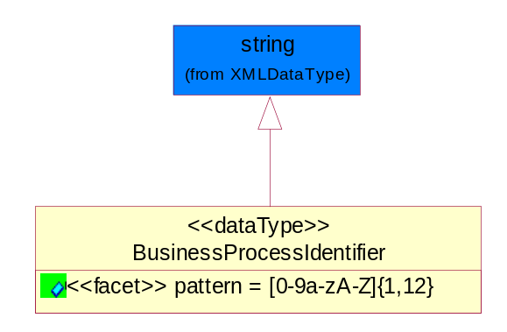
Figure 5-67 BusinessProcessIdentifier

Attribute | Type | Documentation
pattern |  | [0-9a-zA-Z]{1,12}

BusinessServiceInformation
The object allows the specification of the business service utilized within the partner company. This may or may not be the same as the information sent by the RNIF.
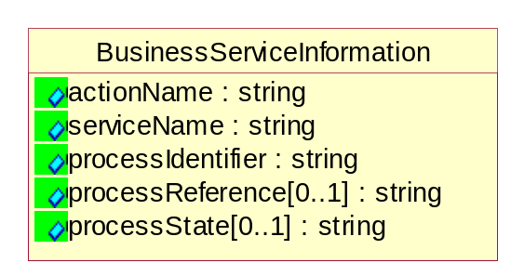
Figure 5-68 BusinessServiceInformation

Attribute | Type | Documentation
actionName | string | The name of Action. For RosettaNet usually any of Request/Confirm/Notify/Query/Response.
serviceName | string | The name of the Business Activity with the "Request/Confirm" part removed. E.g., for the Activity "Request Purchase Order"==> "Purchase Order".
processIdentifier | string | The name of the PIP e.g. Notify of Forecast Reply.
processReference[0..1] | string | The URN for the PIP that includes Cluster/Segment/Process pattern used to identify the interface process (such as PIP3A4)
processState[0..1] | string | The business process (or service) state of the sender of a document. When a service receives this document, the receiver may use the state as a precondition.

ContractInformation
A block of information used to correlate a contract in an executing choreography.

Figure 5-69 ContractInformation

Attribute | Type | Documentation
contractIdentifier[0..1] | string | Unique identification of a contract between the Sender and the Receiver
contractType[0..1] | string | The type of the contract: an attribute describing the type of the ContractIndentification. Valid values are URI, URN,ebXMLCPA, or other values defined by partners.

CorrelationInformation
A block of information used to correlate a requesting document to a responding document and to the contract in an executing choreography.
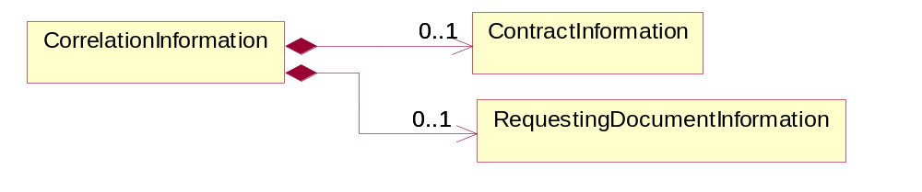
Figure 5-70 CorrelationInformation

Composition | Cardinality | Type | Documentation
ContractInformation | 0..1 | ContractInformation | A block of information used to correlate a contract in an executing choreography.
RequestingDocumentInformation | 0..1 | RequestingDocumentInformation | A block of information used to correlate a requesting document to a responding document in an executing choreography.

DocumentHeader
The object allows for the identification of the sender and receiver of the business document.
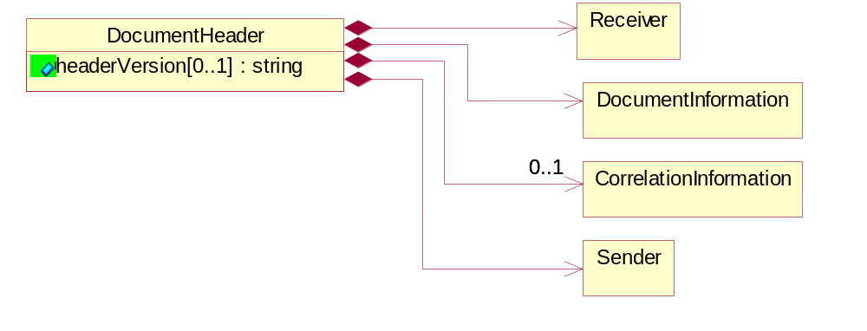
Figure 5-71 DocumentHeader

Attribute | Type | Documentation
headerVersion[0..1] | string | The UN/CEFACT version of the document header.

Composition | Cardinality | Type | Documentation
Sender | 1 | Sender | The object allows the identification of the initiating party of the business message.
CorrelationInformation | 0..1 | CorrelationInformation | A block of information used to correlate a requesting document to a responding document and to the contract in an executing choreography.
DocumentInformation | 1 | DocumentInformation | The object specifies information to identify the business document, a summary of attachments, and information about the business document security.
Receiver | 1 | Receiver | The object allows the identification of the receiving party of the business message.

DocumentIdentification
The object specifies all information necessary to identify the business document.
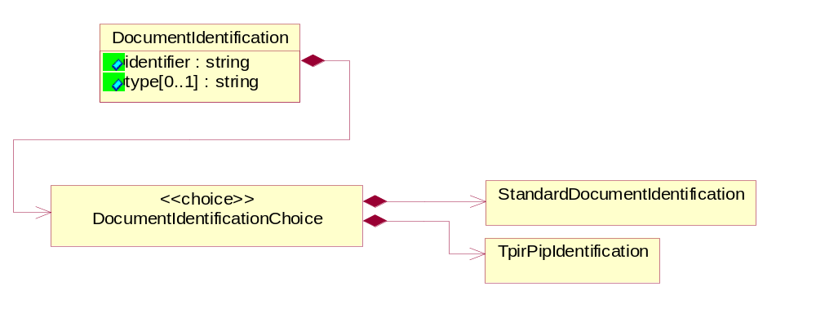
Figure 5-72 DocumentIdentification

Attribute | Type | Documentation
identifier | string | The unique identifier for the document being sent.
type[0..1] | string | Name of the Action Message

Composition | Cardinality | Type | Documentation
DocumentIdentificationChoice | 1 | DocumentIdentificationChoice

DocumentIdentificationChoice

Composition | Cardinality | Type | Documentation
StandardDocumentIdentification | 1 | StandardDocumentIdentification | The object specifies additional information necessary to identify the standard business document.
TpirPipIdentification | 1 | TpirPipIdentification | The object specifies all information necessary to uniquely identify a TPIR-PIP within a Registry or trading partner repository.

DocumentInformation
The object specifies information to identify the business document, a summary of attachments, and information about the business document security.
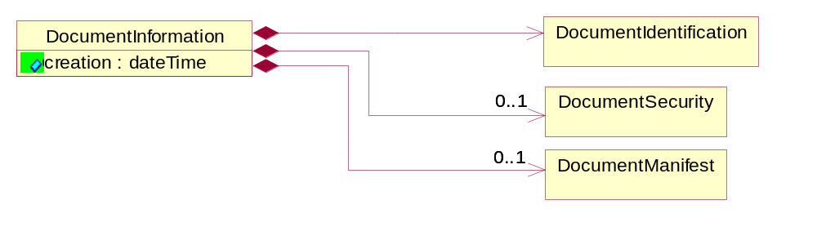
Figure 5-73 DocumentInformation

Attribute | Type | Documentation
creation | dateTime | The creation date and time of the specified Business Document (i.e. the Purchase Order date).

Composition | Cardinality | Type | Documentation
DocumentIdentification | 1 | DocumentIdentification | The object specifies all information necessary to identify the business document.
DocumentSecurity | 0..1 | DocumentSecurity | The object provides additional granularity in specifying business document security (this is in addition to the specified PIP security).
DocumentManifest | 0..1 | DocumentManifest | The block provides a brief summary of attachments and Service Content.

DocumentManifest
The block provides a brief summary of attachments and Service Content.
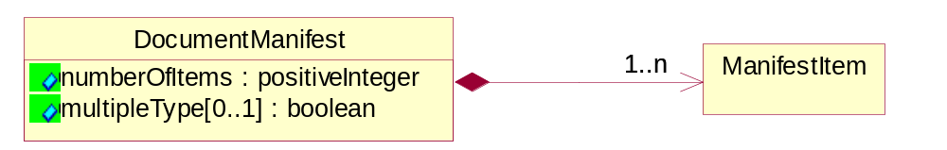
Figure 5-74 DocumentManifest

Attribute | Type | Documentation
numberOfItems | positiveInteger | Total number of documents in the message. The physical count of the attachments in the payload plus the RosettaNet Business Message (for Service Content). The value of this field will be at least 1.
multipleType[0..1] | boolean | Indicates whether the manifest contains documents of multiple types. True if yes, and False if no.

Composition | Cardinality | Type | Documentation
ManifestItem | 1..n | ManifestItem | The object provides details about the specific attachment(s).

DocumentSecurity
The object provides additional granularity in specifying business document security (this is in addition to the specified PIP security).

Figure 5-75 DocumentSecurity

Attribute | Type | Documentation
nonRepudiableReceipt | boolean | The value "true" will indicate that a signed acknowledgement for the business document is necessary.
persistentEncryption | boolean | The value "true" will indicate that the Business Document (including the header) needs to be encrypted when stored or transported.
persistentSignature | boolean | The value "true" will indicate that a signature is required to be stored with the document while stored or transported.

ManifestItem
The object provides details about the specific attachment(s).
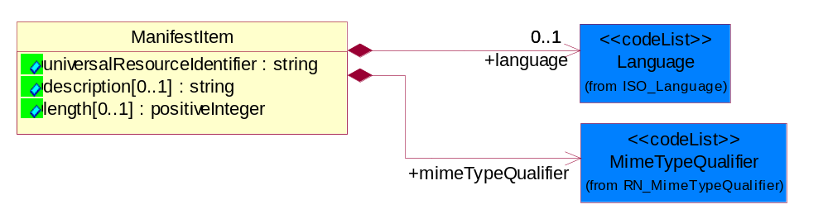
Figure 5-76 ManifestItem

Attribute | Type | Documentation
universalResourceIdentifier | string | The generic set of all names/addresses that are short strings that refer to resources.
description[0..1] | string | A description of the attachment.
length[0..1] | positiveInteger | The size of the attachment in bytes (i.e. 1 000 000 bytes)

Composition | Cardinality | Type | Documentation
mimeTypeQualifier | 1 | MimeTypeQualifier | The MIME type as defined by IANA.  Please refer to http://www.iana.org/assignments/media-types/ for a list of types.
language | 0..1 | Language | For representation of Language name RosettaNet has adopted ISO 639-2; 1998. Refer to the following web page to get the latest version of the standard:  http://www.loc.gov/standards/iso639-2/iso639jac.html  If you need more information about the ISO standard please contact ISO for more details.

PipIdentifier
PIP Identification.[ i.e. PIP3A4]
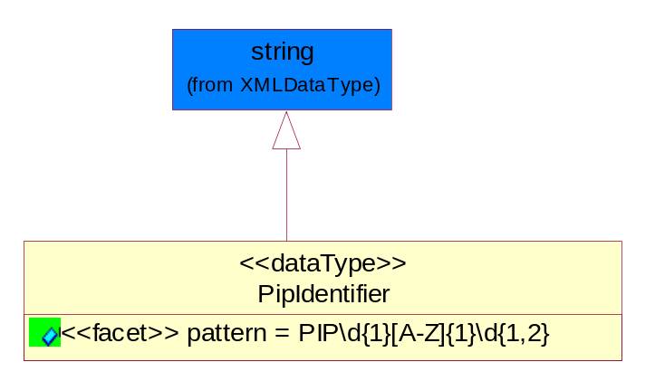
Figure 5-77 PipIdentifier

Attribute | Type | Documentation
pattern |  | PIP\d{1}[A-Z]{1}\d{1,2}

PipVersion
PIP version number (i.e. 02.02.00).
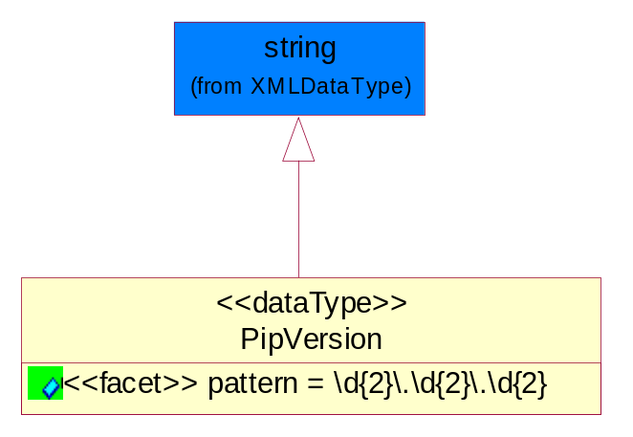
Figure 5-78 PipVersion

Attribute | Type | Documentation
pattern |  | \d{2}\.\d{2}\.\d{2}

Receiver
The object allows the identification of the receiving party of the business message.
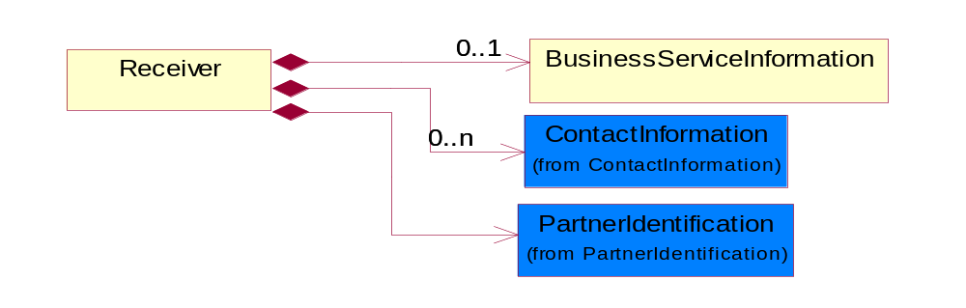
Figure 5-79 Receiver

Composition | Cardinality | Type | Documentation
BusinessServiceInformation | 0..1 | BusinessServiceInformation | The object allows the specification of the business service utilized within the partner company. This may or may not be the same as the information sent by the RNIF.
PartnerIdentification | 1 | PartnerIdentification | The business document must allow for the identity of one or more parties to the transaction.
ContactInformation | 0..n | ContactInformation | The business document must allow for the identification of the name of the department, service or individual to be contacted regarding the context of the business document.

RequestingDocumentInformation
A block of information used to correlate a requesting document to a responding document in an executing choreography.
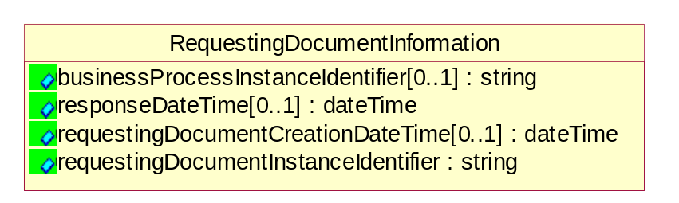
Figure 5-80 RequestingDocumentInformation

Attribute | Type | Documentation
businessProcessInstanceIdentifier[0..1] | string | The identifier for the public business process instance being sent that both the sender and receiver can identify.
responseDateTime[0..1] | dateTime | The expected time to receive the response. This can not be greater than the PIP TimeToPerform.
requestingDocumentCreationDateTime[0..1] | dateTime | The date-time of the requesting business document.
requestingDocumentInstanceIdentifier | string | The Business Document identification number that identifies the requesting Business Document.

Sender
The object allows the identification of the initiating party of the business message.
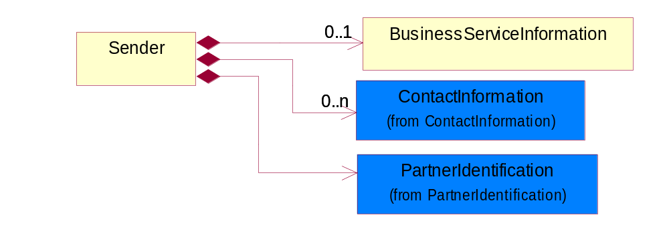
Figure 5-81 Sender

Composition | Cardinality | Type | Documentation
PartnerIdentification | 1 | PartnerIdentification | The business document must allow for the identity of one or more parties to the transaction.
BusinessServiceInformation | 0..1 | BusinessServiceInformation | The object allows the specification of the business service utilized within the partner company. This may or may not be the same as the information sent by the RNIF.
ContactInformation | 0..n | ContactInformation | The business document must allow for the identification of the name of the department, service or individual to be contacted regarding the context of the business document.

StandardDocumentIdentification
The object specifies additional information necessary to identify the standard business document.
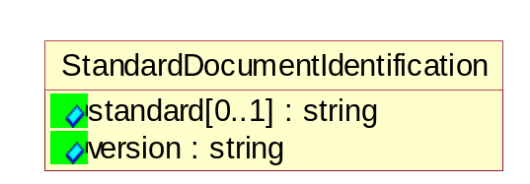
Figure 5-82 StandardDocumentIdentification

Attribute | Type | Documentation
standard[0..1] | string | Identifies the standard used to submit the business document. (e.g. RosettaNet).
version | string | PIP3A4v01.00

TpirPipIdentification
The object specifies all information necessary to uniquely identify a TPIR-PIP within a Registry or trading partner repository.

Figure 5-83 TpirPipIdentification

Attribute | Type | Documentation
partnerId | DUNSPlus4 | The Trading Partner Identification of MNC that is creating this TPIR PIP.
pipIdentifier | PipIdentifier | A TPIR PIP Identification [i.e., 3A4 ).
pipVersion | PipVersion | A TPIR PIP version number (i.e., 02.02.00)
tpirPipVersion | VersionIdentifier | A TPIR-PIP Version Number (i.e., major and minor version number as XX.XX).
tpirBusinessProcessIdentifier[0..1] | BusinessProcessIdentifier | A Business Process Identifier to uniquely define the TPIR-PIP 'role' within a Business Scenario at a company or MNC level. The identifier MUST be composed of alphanumeric characters only and its length MUST be between one and twelve characters.
uri[0..1] | anyURI | Describes the destination uri for the TPIR form.

Composition | Cardinality | Type | Documentation
fileType | 0..1 | TPIRFileType | Describes the file type of the TPIR form (PDF, XDP or XML).

VersionIdentifier
Version Number (i.e., major and minor version number as XX.XX).
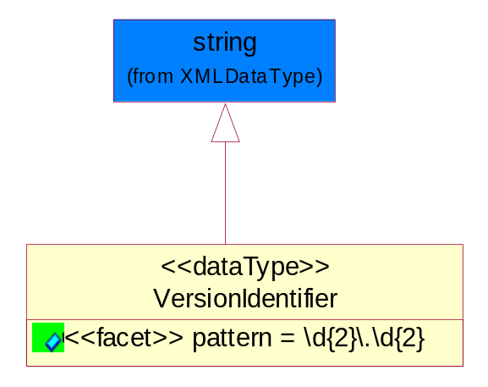
Figure 5-84 VersionIdentifier

Attribute | Type | Documentation
pattern |  | \d{2}\.\d{2}

CodeList

TPIRFileType
A code identifying the file type of TPIR form.

Name | Documentation
PDF | Portable Document Format.
XDP | XML Data Package.
XML | eXtensible Markup Language.

XML Data Type

anyURI
Represents a URI as defined by RFC 2396. An anyURI value can be absolute or relative, and may have an optional fragment identifier.

boolean
Represents Boolean values, which are either "true" or "false".

date
For the represents a calendar date.
The pattern for a date is CCYY-MM-DD where CC represents the century, YY the year, MM the month, and DD the day, with an optional time zone indicator as allowed for dateTime.

dateTime
Represents a specific instance of time.
The pattern for dateTime is CCYY-MM-DDThh:mm:ss where CC represents the century, YY the year, MM the month, and DD the day, preceded by an optional leading negative (-) character to indicate a negative number. If the negative character is omitted, positive (+) is assumed. The T is the date/time separator and hh, mm, and ss represent hour, minute, and second respectively. Additional digits can be used to increase the precision of fractional seconds if desired. For example, the format ss.ss... with any number of digits after the decimal point is supported. The fractional seconds part is optional.
This representation may be immediately followed by a "Z" to indicate Coordinated Universal Time (UTC) or to indicate the time zone. For example, the difference between the local time and Coordinated Universal Time, immediately followed by a sign, + or -, followed by the difference from UTC represented as hh:mm (minutes is required). If the time zone is included, both hours and minutes must be present.

duration
Represents a duration of time.
The pattern for duration is PnYnMnDTnHnMnS, where nY represents the number of years, nM the number of months, nD the number of days, T the date/time separator, nH the number of hours, nM the number of minutes, and nS the number of seconds.

float
Represents single-precision 32-bit floating-point numbers.

positiveInteger
Represents an integer that is greater than zero. This data type is derived from nonNegativeInteger.

string
Represents character string.

