

Description of
Partner Interface Process® for 2A1

Validated 11.00.00

Specification Information
Name | Distribute Product Catalog Information
Cluster | Product Information
Segment | Preparation for Distribution
Publication Date | 23 June 2008
Version Identifier | V11.00

Table of Contents
1 Document Management 4
1.1 Legal Disclaimer 4
1.2 Copyright 4
1.3 Trademarks 4
1.4 Acknowledgments 4
1.5 Related Documents 5
1.6 Document Version History 5
1.7 Document Structure 5
2 Business Process 6
2.1 Business Process Definition 6
2.2 PIP Scope Description 6
2.3 PIP Business Document 7
2.4 PIP Business Process Flow Diagram 7
2.5 PIP Start State 8
2.6 PIP End States 8
2.7 Partner Role Description 9
2.8 Business Process Activity Controls 9
3 Network and Implementation Specification 10
3.1 Business Action and Business Signal Specifications 10
3.2 Business Transaction Dialog Specification 10
3.2.1 Message Exchange Controls 11
3.2.2 Communications Specification 11

List of Figures:
Figure 1: Activity Diagram of Distribute Product Catalog Information 7
Figure 2: Sequence Diagram of Distribute Product Catalog Information 10

List of Tables:
Table 1: PIP Business Document 7
Table 2: PIP Start State 8
Table 3: PIP End State 8
Table 4: PIP Failure State 8
Table 5: Partner Role Description 9
Table 6: Business Activity Description 9
Table 7: Business Activity Performance Control 9
Table 8: Network Component Specification 10
Table 9: Business Action – Business Document Mapping 10
Table 10: Message Exchange Control 11
Table 11: Dialog: Service-Service 11

Document Management

Legal Disclaimer
RosettaNet™, its members, officers, directors, employees, or agents shall not be liable for any injury, loss, damages, financial or otherwise, arising from, related to, or caused by the use of this document or the specifications herein, as well as associated guidelines and schemas. The use of said specifications shall constitute your express consent to the foregoing exculpation.

Copyright
©2008 RosettaNet. All rights reserved. No part of this publication may be reproduced, stored in a retrieval system, or transmitted, in any form or by any means, electronic, mechanical, photocopying, recording, or otherwise, without the prior written permission of the publisher. Printed in the United States of America.

Trademarks
RosettaNet, Partner Interface Process, PIP and the RosettaNet logo are trademarks or registered trademarks of "RosettaNet," a non-profit organization. All other product names and company logos mentioned herein are the trademarks of their respective owners. In the best effort, all terms mentioned in this document that are known to be trademarks or registered trademarks have been appropriately recognized in the first occurrence of the term.

Acknowledgments
This document has been prepared by RosettaNet (http://www.rosettanet.org/) from requirements gathered during the Milestone Program and in conformance with the methodology. Listed below are the legal entities that contributed to the design and development of this PIP.
Aankhen Inc. | Arrow Electronics, Inc.
ASBISC Enterprises Ltd. | BCM Electronics
Cisco Systems | Deloitte Consulting Pte. Ltd.
Deloitte Consulting Sdn BHD | E-Vision
Globetronics SDH. BHD | Hewlett Packard Far East PTE LTD
Hewlett Packard Imaging & Printing Group | HP
HP IPG | IBM
Intel Corporation | International Business Machines
MIMOS Berhad | Motorola Semiconductor Products, Inc.
Oracle | Philips Semiconductors
Pioneer-Standard Electronics | SAP
SAP America | SAP Labs
Sterling Commerce | Sun Microsystems
Viacore | Viacore Inc.

Related Documents
- Associated PIP Message Schemas (included within the PIP Specification package only)
- Description of 2A1 Message
- Messages Structure
- XML instance of ebXML BPSS for PIP 2A1

Document Version History
Version | Date | Description
V11.00.00 | 23 June 2008 | Validated Version: RosettaNet Schema to Market to Validation 2008

Document Structure
A Partner Interface Process (PIP) Specification is comprised of the following two parts:
- Business Process. Captures the semantics of the business process and the flow of the message exchange between roles as they perform business activities.
- Network and Implementation Specification. Specifies the network protocol message formats and communications requirements between peer-protocols supported by network components in the RosettaNet Implementation Framework.

Business Process

Business Process Definition
The "Distribute Product Catalog Information" Partner Interface Process (PIP) enables a buyer to manage the procurement of a specific item from a seller, thereby reducing costs throughout the supply chain by reducing key strokes, errors and the effort to publish & maintain product sales information. The intent of this PIP is used for procurement processes only. Its use will be for sales and marketing purposes. This PIP will also provide the capability to automate the push of product sales information to partners.
Product catalog information will be distributed to a partner in 3 main scenarios:
  - To publish a Whole (brand new full) catalog;
    - Catalog publisher issues a new catalog with a new ID
  - To replace a Whole (existing full catalog) with all new data;
    - Catalog publisher replaces a previously issued catalog with a new catalog including a new ID
  - To update deltas for an entire product. (not subsets of one block – must update all categories) There will be the capability to send complete or partial load of products with a qualifier to identify the dataset that is sent. Every trading partner manages versions internally, there is no specified standard on when to update the version id for a partial or full replace, and reloads are out of scope.
Catalog publisher updates certain products in a previously issued catalog with the same ID.

PIP Scope Description
The purpose of this PIP is to convey a list of one or more products with attributes complete and sufficient to allow the procurement process of the trading partner to take action. It will only include procurement data not technical data. Eight new categories has been identify for this purposes, they are as follows:
- Catalog Descriptor - Header data
- Product Master Identification
- Physical Attributes
- Ordering Instructions
- Pricing
- Availability
- Life Cycle
- Marketing Instructions

PIP Business Document
Business Document are generated and exchanged by roles performing activities in this PIP. Business Document is listed and defined in Table 1.
Table 1: PIP Business Document
Business Document | Description
Product Information Catalog Distribution | A product catalog information notification that contains procurement information.

PIP Business Process Flow Diagram
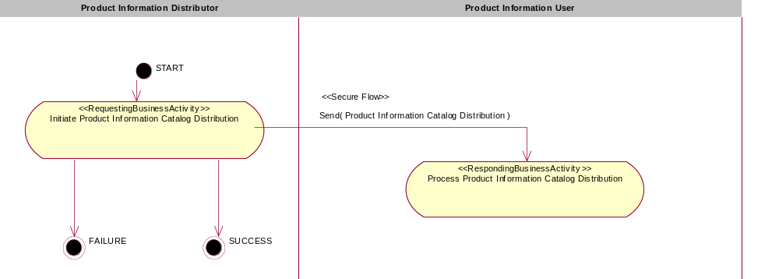
Figure 1: Activity Diagram of Distribute Product Catalog Information

PIP Start State
The start state is comprised of the following conditions:
Table 2: PIP Start State
 | Approved | Exist |  | Valid | Non-Repudiated | Retry Count | Authorized
 | Approved | Party | In Backend System
TPA |  |  | 
Sending Partner |  |  |  | 
Receiving Partner |  | 
BusinessDocument |  |  |  | 

PIP End States
The end state is comprised of the following conditions:
Table 3: PIP End State
 | Approved | Exist |  | Valid | Non-Repudiated | Retry Count | Authorized
 | Approved | Party | In Backend system
Acknowledgment of Receipt |  |  |  | 
Receiving Partner |  |  |  |  |  |  | 

The PIP failure state is comprised of one or more of the following conditions
Table 4: PIP Failure State
 | NO | Exceeded
Success | 
Retry Count |  | 

Partner Role Description
Table 5 describes the partner roles in this PIP:
Table 5: Partner Role Description
Role Name | Role Description
Product Information Distributor | The organization that generates the catalog.
Product Information User | The organization that receives and uses or processes the product information.

Table 6 describes the interaction between roles performing business activity in this PIP.
Table 6: Business Activity Description
Role Name |  | Activity Name |  | Activity Description
Product Information Distributor | Initiate Product Information Catalog Distribution |  | The Product Information Distributor distributes Product Catalog Information to a Product Information User.

Table 7 details the security, audit and process controls relating to activity performed in the PIP.
Table 7: Business Activity Performance Control
Role  Name | Activity  Name | Acknowledgment  of Receipt |  | Time to Perform | Retry Count | Is Authorization Required? | Non-Repudiation of Origin and Content?
Role  Name | Activity  Name | Non-Repudiation Required? | Time to Acknowledge
Product Information Distributor | Initiate Product Information Catalog Distribution | N | 2hrs | N/A | 3 | N | N

Network and Implementation Specification
Each network component maps into a role of the PIP model. Table 8 specifies the mapping between roles and network components.
Table 8: Network Component Specification
Network Component | Classification | Maps to Role in Business Process
Product Information Distributor Service | Business Service | Product Information Distributor
Product Information User Service | Business Service | Product Information User

Business Action and Business Signal Specifications
Each business action maps to a Business Document of the PIP model. Table 9 specifies the mapping between Business Documents and business actions.
Table 9: Business Action – Business Document Mapping
Business Action | Business Document | Document Function
Product Information Catalog Distribution Action | Product Information Catalog Distribution | Request

Business Transaction Dialog Specification
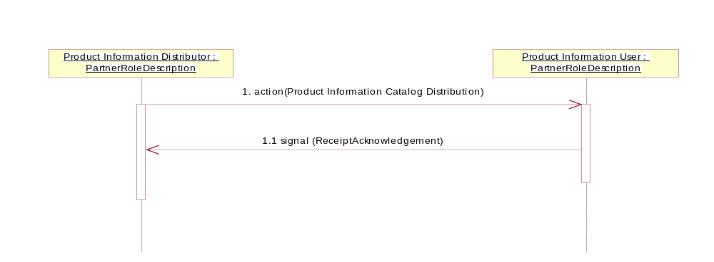

Figure 2: Sequence Diagram of Distribute Product Catalog Information

Message Exchange Controls
Table 10: Message Exchange Control
# | Name | Time to Acknowledge Receipt Signal |  | Time to Respond to Action |  | Included in Time to Perform | Is Authorization Required? | Is Non-Repudiation Required? | Is Secure Transport Required?
1. | Product Catalog Information Notification Action |  | 2hrs |  | N/A | N/A | N | N | Y
1.1. | Receipt Acknowledgment |  | N/A |  | N/A | N/A | N | N | Y

Communications Specification
Table 11: Dialog: Service-Service
# | Business Message | Digital Signature Required? | SSL Required?
1. | Product Catalog Information Distribution | N | Y
1.1. | Receipt Acknowledgment | N | Y

