

Description of
Partner Interface Process® for 2B9

Release 11.00.00A

Specification Information
Name | Notify Of Product Change Acceptance
Cluster | Product Information
Segment | Product Change Notification
Publication Date | 23 February 2007
Version Identifier | R11.00A

Table of Contents
1 Document Management 4
1.1 Legal Disclaimer 4
1.2 Copyright 4
1.3 Trademarks 4
1.4 Acknowledgments 4
1.5 Related Documents 5
1.6 Document Version History 5
1.7 Document Structure 5
2 Business Process 6
2.1 Business Process Definition 6
2.2 PIP Scope Description 6
2.2.1 Business Process Scope Diagram 6
3 PIP Business Document 7
3.1 PIP Business Process Flow Diagram 7
3.2 PIP Start State 8
3.3 PIP End States 8
3.4 Partner Role Description 9
3.5 Business Process Activity Controls 9
4 Network and Implementation Specification 10
4.1 Business Action and Business Signal Specifications 10
4.2 Business Transaction Dialog Specification 10
4.2.1 Message Exchange Controls 11
4.2.2 Communications Specification 11

List of Figures:
Figure 1: Activity Diagram of Notify Of Product Change Acceptance 7
Figure 2: Sequence Diagram of Notify Of Product Change Acceptance 10

List of Tables:
Table 1: PIP Business Documents 7
Table 2: PIP Start State 8
Table 3: PIP End State 8
Table 4: PIP Failure State 8
Table 5: Partner Role Description 9
Table 6: Business Activity Description 9
Table 7: Business Activity Performance Control 9
Table 8: Network Component Specification 10
Table 9: Business Action – Business Document Mapping 10
Table 10: Message Exchange Control 11
Table 11: Dialog: Service-Service 11

Document Management

Legal Disclaimer
RosettaNet™, its members, officers, directors, employees, or agents shall not be liable for any injury, loss, damages, financial or otherwise, arising from, related to, or caused by the use of this document or the specifications herein, as well as associated guidelines and schemas. The use of said specifications shall constitute your express consent to the foregoing exculpation.

Copyright
©2007 RosettaNet. All rights reserved. No part of this publication may be reproduced, stored in a retrieval system, or transmitted, in any form or by any means, electronic, mechanical, photocopying, recording, or otherwise, without the prior written permission of the publisher. Printed in the United States of America.

Trademarks
RosettaNet, Partner Interface Process, PIP and the RosettaNet logo are trademarks or registered trademarks of "RosettaNet," a non-profit organization. All other product names and company logos mentioned herein are the trademarks of their respective owners. In the best effort, all terms mentioned in this document that are known to be trademarks or registered trademarks have been appropriately recognized in the first occurrence of the term.

Acknowledgments
This document has been prepared by RosettaNet (http://www.rosettanet.org/) from requirements gathered during the Milestone Program and in conformance with the methodology. Listed below are the legal entities that contributed to the design and development of this PIP.
EDIFICE | Freescale Semiconductor
Cisco Systems | Motorola
Texas Instruments | SAP
Renesas Technology | Toshiba
Arrow Electronics | Tyco Electronics
Nokia | Sony Electronics
Samsung Electronics | NEC Tokin
PCNALERT | National Semiconductor
RosettaNet Japan

Related Documents
- Associated PIP Message Schemas (included within the PIP Specification package only)
- Description of 2B9 Message
- Messages Structure
- XML instance of ebXML BPSS for PIP 2B9

Document Version History
Version | Date | Description
Release 11.00.00A | 23 Feb 2007 | Release Version

Document Structure
A Partner Interface Process (PIP) Specification is comprised of the following two parts:
- Business Process. Captures the semantics of the business process and the flow of the message exchange between roles as they perform business activities.
- Network and Implementation Specification. Specifies the network protocol message formats and communications requirements between peer-protocols supported by network components in the RosettaNet Implementation Framework.

Business Process

Business Process Definition
The “Product Change Acceptance Notification” Partner Interface enable customer to accept or reject Product Change Notification or End of Life information to supplier. It is always triggered by the customer. It is an optional event, and when it is used as an acceptance it is unconditional.

PIP Scope Description
The purpose of this PIP is to notify supplier of the acceptance / rejection of a product change / EOL event from customer.

Business Process Scope Diagram
Supplier
Customer
Accept or reject PCN/EOL
Update back end system
with related data
Receive XML message
Send XML message
with attachments
(If needed)
Collect mandatory
and optional data

PIP Business Document
Business Document are generated and exchanged by roles performing activities in this PIP. Business Document is listed and defined in Table 1.
Table 1: PIP Business Documents
Business Document | Description
Product Change Acceptance Notification | A request from customer to accept/reject PCN or EOL.

PIP Business Process Flow Diagram
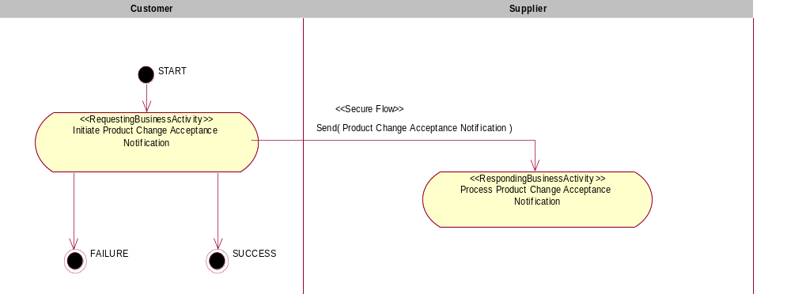

Figure 1: Activity Diagram of Notify Of Product Change Acceptance

PIP Start State
The start state is comprised of the following conditions:
Table 2: PIP Start State
 | Approved | Exist |  | Valid | Non-Repudiated | Retry Count | Authorized
 | Approved | Party | In Backend system
TPA |  |  | 
Sending Partner |  |  |  | 
Receiving Partner |  | 
Business Document |  |  |  |  |  |  | 

PIP End States
The end state is comprised of the following conditions:
Table 3: PIP End State
 | Approved | Exist |  | Valid | Non-Repudiated | Retry Count | Authorized
 | Approved | Party | In Backend system
Acknowledgment of Receipt |  |  |  |  | 
Receiving Partner |  |  |  |  |  |  | 

The PIP failure state is comprised of one or more of the following conditions
Table 4: PIP Failure State
 | NO | Exceeded
Success | 
Retry Count |  | 

Partner Role Description
Table 5 describes the partner roles in this PIP:
Table 5: Partner Role Description
Role Name | Role Description
Customer | Receives notice and coordinates customer review. Sends response, if desired.
Supplier | Initiates notices on behalf of the supplier; monitors customer responses; coordinates supplier response to customer requests.

Business Process Activity Controls
Table 6 describes the interaction between roles performing business activity in this PIP.
Table 6: Business Activity Description
Role Name | Activity Name | Activity Description
Customer | Initiate Product Change Acceptance Notification | Customer has evaluated the change information and is ready to provide final response to supplier.

Table 7 details the security, audit and process controls relating to activity performed in the PIP.
Table 7: Business Activity Performance Control
Role  Name | Activity  Name | Acknowledgment  of Receipt |  | Time to Perform | Retry Count | Is Authorization Required? | Non-Repudiation of Origin and Content?
Role  Name | Activity  Name | Non-Repudiation Required? | Time to Acknowledge
Customer | Initiate Product Change Acceptance Notification | Y | 2 hrs | N/A | 3 | Y | Y

Network and Implementation Specification
Each network component maps into a role of the PIP model. Table 8 specifies the mapping between roles and network components.
Table 8: Network Component Specification
Network Component | Classification | Maps to Role in Business Process
Customer Service | Business Service | Customer
Supplier Service | Business Service | Supplier

Business Action and Business Signal Specifications
Each business action maps to a Business Document of the PIP model. Table 9 specifies the mapping between Business Documents and business actions.
Table 9: Business Action – Business Document Mapping
Business Action | Business Document | Document Function
Product Change Acceptance Notification Action | Product Change Acceptance Notification | Request

Business Transaction Dialog Specification
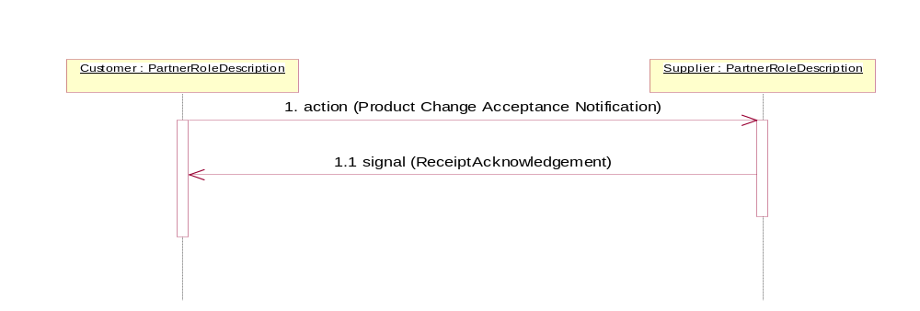
Figure 2: Sequence Diagram of Notify Of Product Change Acceptance

Message Exchange Controls
Table 10: Message Exchange Control
# | Name |  | Time to Acknowledge Receipt Signal |  | Time to Respond to Action |  | Included in Time to Perform | Is Authorization Required? | Is Non-Repudiation Required? | Is Secure Transport Required?
1. |  | Product Change Acceptance Notification Action |  | 2hrs |  | N/A | N/A | Y | Y | Y
1.1. |  | Receipt Acknowledgment |  | N/A |  | N/A | N/A | Y | Y | Y

Communications Specification
Table 11: Dialog: Service-Service
# | Business Message | Digital Signature Required? | SSL Required?
1. | Product Change Acceptance Notification | Y | Y
1.1. | Receipt Acknowledgment | Y | Y

