

Description of
Partner Interface Process® for 3A15

Validated 11.00.00

Specification Information
Name | Notify of Quote Request
Cluster | Order Management
Segment | Quote and Order Entry
Publication Date | 26 January 2010
Version Identifier | V11.00

Table of Contents
1 Document Management 4
1.1 Legal Disclaimer 4
1.2 Copyright 4
1.3 Trademarks 4
1.4 Acknowledgments 4
1.5 Related Documents 5
1.6 Document Version History 5
1.7 Document Structure 5
2 Business Process 6
2.1 Business Process Definition 6
2.1.1 Business Process Context Diagram 7
2.2 PIP Scope Description 8
2.3 PIP Business Documents 8
2.4 PIP Business Process Flow Diagram 8
2.5 PIP Start State 9
2.6 PIP End States 9
2.7 Partner Role Descriptions 10
2.8 Business Process Activity Controls 10
3 Network and Implementation Specification 11
3.1 Business Action and Business Signal Specification 11
3.2 Business Transaction Dialog Specification 11
3.2.1 Message Exchange Controls 12
3.2.2 Communications Specification 12

List of Tables
Table 1: PIP Business Documents 8
Table 2: PIP Start State 9
Table 3: PIP End State 9
Table 4: PIP Failure State 9
Table 5: Partner Role Descriptions 10
Table 6: Business Activity Descriptions 10
Table 7: Business Activity Performance Controls 10
Table 8: Network Component Specification 11
Table 9: Business Action – Business Document Mapping 11
Table 10: Message Exchange Controls 12
Table 11: Notify of Quote Request Dialog: Service-Service 12

Document Management

Legal Disclaimer
RosettaNet™, its members, officers, directors, employees, or agents shall not be liable for any injury, loss, damages, financial or otherwise, arising from, related to, or caused by the use of this document or the specifications herein, as well as associated guidelines and schemas. The use of said specifications shall constitute your express consent to the foregoing exculpation.

Copyright
©2010 RosettaNet. All rights reserved. No part of this publication may be reproduced, stored in a retrieval system, or transmitted, in any form or by any means, electronic, mechanical, photocopying, recording, or otherwise, without the prior written permission of the publisher. Printed in the United States of America.

Trademarks
RosettaNet, Partner Interface Process, PIP and the RosettaNet logo are trademarks or registered trademarks of "RosettaNet," a non-profit organization. All other product names and company logos mentioned herein are the trademarks of their respective owners. In the best effort, all terms mentioned in this document that are known to be trademarks or registered trademarks have been appropriately recognized in the first occurrence of the term.

Acknowledgments
This document has been prepared by RosettaNet (http://www.rosettanet.org/) from requirements gathered during the Milestone Program and in conformance with the methodology.

Related Documents
- Associated PIP Message Schemas (included within the PIP Specification package only)
- Description of PIP3A15 Message
- Message Structure
- XML instance of ebBPSS for PIP 3A15

Document Version History
Version | Date | Description
V11.00.00 | 26 January 2010 | Released as validated during MCC program

Document Structure
A Partner Interface Process (PIP) Specification is comprised of the following two parts:
- Business Process. Captures the semantics of the business process and the flow of the message exchange between roles as they perform business activities.
- Network and Implementation Specification. Specifies the network protocol message formats and communications requirements between peer-protocols supported by network components in the RosettaNet Implementation Framework.

Business Process

Business Process Definition
The "Notify of Quote Request" Partner Interface Process (PIP) enables a buyer to request a product quote from a provider. The prices and product availability reflected in a quote may be influenced by an existing or potential relationship between a buyer and provider.
Quotes may:
- Involve one or more items, fixed price quotes or negotiated prices, configurable or stand alone product.
- Include freight and tax information.
- Be reconciled with purchase orders.
- Support ship from stock and debit credit claims.
Should this transaction not complete successfully, the requesting partner executes PIP0A1, "Notification of Failure."

Business Process Context Diagram
Receive and Process Confirmation
Generate Quote
Process Quote
Buyer
Seller
Generate Confirmation

Send Request

Send Confirmation

- Prior to making any purchase order request, buyer can check for products price and availability using PIP 3A2.
- Quote Request send from buyer to seller, using PIP 3A1 or PIP 3A15 and 3A16.
- Seller needs to acknowledge and confirm to the buyer for the acceptance or rejection of a pending line item in the quote.
- In the event where the seller has any counter proposal on the quote, the seller needs to change and notify the buyer, using PIP 3A1 confirmation or PIP 3A16.

Figure 1: High-level Context Diagram

PIP Scope Description
This PIP provides a buyer with quotes and referrals used to select suppliers and prepare purchase orders.

PIP Business Documents
Business Documents are generated and exchanged by roles performing activities in this PIP. Business Documents are listed and defined in Table 1.
Table 1: PIP Business Documents
Business Document | Description
Quote Request Notification | A Buyer's request for a quote sent to a Seller for response.

PIP Business Process Flow Diagram
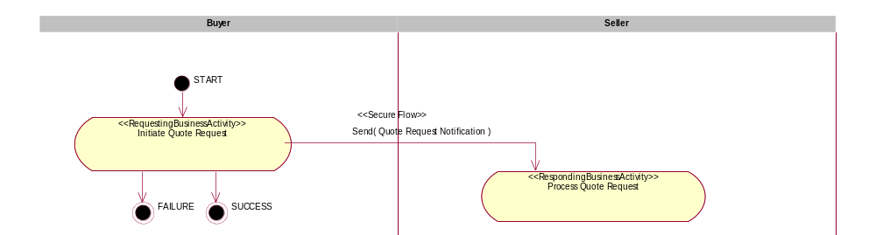
Figure 2: Activity Diagram of Notify of Quote Request

PIP Start State
The start state is comprised of the following condition(s):
Table 2: PIP Start State
 | Approved | Exist |  | Valid | Non-Repudiated | Retry Count | Authorized
 | Approved | Party | In Backend system
TPA |  |  | 
Sending Partner |  |  |  |  |  |  | 
Receiving Partner |  | 
Business Document |  |  |  |  | 

PIP End States
The end state is comprised of the following condition(s):
Table 3: PIP End State
 | Approved | Exist |  | Valid | Non-Repudiated | Retry Count | Authorized
 | Approved | Party | In Backend system
Acknowledgment of Receipt |  |  |  |  | 
Receiving Partner |  |  |  |  |  |  | 
Business Document |  |  |  |  | 

The PIP failure state is comprised of one or more of the following condition(s):
Table 4: PIP Failure State
 | NO | Exceeded
Success | 
Retry Count |  | 

Partner Role Descriptions
Table 6 describes the partner roles in this PIP.
Table 5: Partner Role Descriptions
Role Name | Role Description
Buyer | An employee or organization that buys products for a partner type in the supply chain.
Seller | An organization that sells products to partners in the supply chain.

Business Process Activity Controls
Table 7 describes the interaction between roles performing business activities in this PIP.
Table 6: Business Activity Descriptions
Role  Name | Activity Name | Activity Description
Buyer | Request Quote | The Buyer requests a quote from a Seller.
Seller | Confirm Quote | The Seller confirms a quote from a Buyer.

Table 8 details the security, audit and process controls relating to activities performed in the PIP.
Table 7: Business Activity Performance Controls
Role  Name | Activity  Name | Acknowledgment  of Receipt |  | Time to Perform | Retry Count | Is Authorization Required? | Non-Repudiation of Origin and Content?
Role  Name | Activity  Name | Non-Repudiation Required? | Time to Acknowledge
Buyer | Notify of Quote Request | Y | 2 hrs | 2 hrs | 3 | Y | Y

Network and Implementation Specification
Each network component maps into a role of the PIP model. Table 9 specifies the mapping between roles and network components.
Table 8: Network Component Specification
Network Component | Classification | Maps to Role in Business Process
Buyer Service | Business Service | Buyer
Seller Service | Business Service | Seller

Business Action and Business Signal Specification
Each business action maps to a Business Document of the PIP model. Table 10 specifies the mapping between Business Documents and business actions.
Table 9: Business Action – Business Document Mapping
Business Action | Business Document | Document Function
Quote Request Notification Action | Quote Request Notification | Request

Business Transaction Dialog Specification
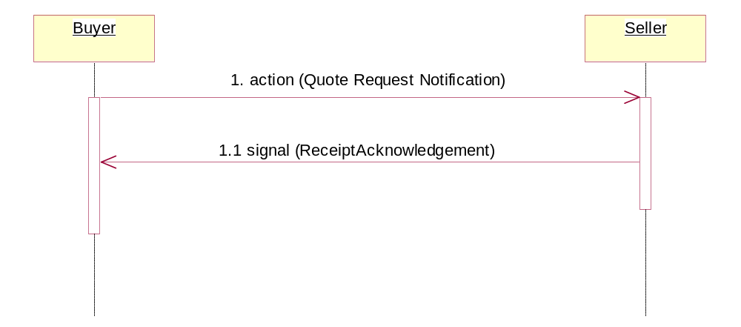
Figure 3: Sequence Diagram of Notify of Quote Request

Message Exchange Controls
Table 10: Message Exchange Controls
# | Name |  | Time to Acknowledge |  | Time to Respond to Action |  | Included in Time to Perform |  | Is Authorization Required? |  | Is Non-Repudiation Required? |  | Is Secure Transport Required?
1. |  | Quote Request Notification Action |  | 2 hrs |  | N/A |  | 2 hrs |  | Y |  | Y |  | Y
1.1. |  | Receipt Acknowledgment |  | N/A |  | N/A |  | N/A |  | Y |  | Y |  | Y

Communications Specification
Table 11: Notify of Quote Request Dialog: Service-Service
# | Business Message | Digital Signature Required? | SSL Required?
1. | Quote Request Notification | Y | Y
1.1. | Receipt Acknowledgment | Y | Y

