

Description of PIP 3A15 Message

PIP® 3A15
V11.00.00

Specification Information
Name | Description of PIP 3A15 Message
PIP | Notify of Quote Request
Cluster | Cluster 3: Order Management
Segment | Segment A: Quote & Order Entry
Publication Date | 26 January 2010
Version Identifier | V11.00

Table of Content

1. Document Management 7
1.1 Legal Disclaimer 7
1.2 Copyright 7
1.3 Trademarks 7
1.4 Acknowledgments 7
1.5 Related Documents 7
1.6 Document Version History 7
1.7 Document Purpose 7
2. Interchange Model 8
2.1 Quote Request Notification 8
2.1.1 Interchange Diagram 8
2.1.2 Dependency Diagram 9
2.1.3 Competitor Reference 9
2.1.4 Product Line Item 10
2.1.5 Quantity 13
2.1.6 Quote 14
2.1.7 Quote Customer Information 16
2.1.8 Quote Line Item 16
2.1.9 Quote Line Item Choice 17
2.1.10 Quote Quantity 17
2.1.11 Quote Request 18
2.1.12 Requote Line Status 18
2.1.13 Service Line Item 19
2.1.14 Service Line Item By Option 21
2.1.15 Transportation Schedule 23
2.1.16 Code List 24
2.1.16.1 Stock Indicator 24
3. Domain Model 25
3.1 Procurement 25
3.1.1 Dependency Diagram 25
3.1.2 Contract Information 25
3.1.3 Customer Information 26
3.1.4 Price Condition 27
3.1.5 Special Discount 28
3.1.6 Tax Exemption 28
3.1.7 Tax Exempt Status 29
3.1.8 Code List 30
3.1.8.1 Transport Event 30
3.1.8.2 Government Priority Rating 30
3.1.8.3 Customer Type 30
3.1.8.4 Tax Exemption Code 31
3.1.8.5 Quote Status 33
3.1.8.6 Quote Type 33
3.1.8.7 Requote Action 34
3.1.8.8 Request Option 34
3.2 Shared 35
3.2.1 Dependency Diagram 35
3.2.2 Carrier Information 36
3.2.3 Date Period And Duration 37
3.2.4 Date Period And Duration Choice 37
3.2.5 Duration 38
3.2.6 Monetary Amount 38
3.2.7 Product Pricing 39
3.2.8 Product Quantity 39
3.2.9 SCAC 40
3.2.10 CodeList 41
3.2.10.1 Invoice Charge Type 41
3.2.10.2 Monetary Amount Type 41
3.2.10.3 Pricing Type Code 42
3.2.10.4 Amount Type 43
4. Universal Structure 44
4.1 Contact Information 44
4.1.1 Contact Information 44
4.2 Data Type 45
4.2.1 Contact 45
4.2.2 DUNS 45
4.2.3 DUNSPlus4 46
4.2.4 GLN 46
4.2.5 GTIN 47
4.2.6 Percent Amount 47
4.3 Dates 48
4.3.1 Date Period 48
4.4 Document 49
4.4.1 Business Document Reference 49
4.5 Locations 50
4.5.1 Alternative Identifier 50
4.5.2 Location 51
4.5.3 Location Choice 51
4.5.4 Physical Address 52
4.6 Monetary Expression 54
4.6.1 Financial Amount 54
4.7 Partner Identification 55
4.7.1 Full Partner 55
4.7.2 Intermittent Partner 56
4.7.3 Known Partner 56
4.7.4 Known Partner Contact 57
4.7.5 New Partner 57
4.7.6 Partner Description 58
4.7.7 PartnerDescriptionChoice 58
4.7.8 Partner Identification 59
4.7.9 Partner Identification Choice 60
4.7.10 Specified Full Partner 61
4.7.11 Specified Intermittent Partner 62
4.7.12 Specified Known Partner 62
4.7.13 Specified Known Partner Contact 63
4.7.14 Specified New Partner 64
4.7.15 Specified Partner Description 65
4.7.16 Specified Partner Description Choice 66
4.8 Product Identification 67
4.8.1 Product Identification 67
4.8.2 Product Identification Choice 67
4.9 Code List 68
4.9.1 Country 68
4.9.2 Country Subdivision 68
4.9.3 Currency 68
4.9.4 Language 68
4.9.5 Document Type 69
4.9.6 Mime Type Qualifier 71
4.9.7 Unit Of Measure 82
4.9.8 Process Role Identifier 95
5. System Structure 98
5.1 Business Process Identifier 98
5.2 Business Service Information 99
5.3 Contract Information 99
5.4 Correlation Information 100
5.5 Document Header 101
5.6 Document Identification 102
5.7 Document Identification Choice 102
5.8 Document Information 103
5.9 Document Manifest 104
5.10 Document Security 105
5.11 Manifest Item 106
5.12 Pip Identifier 107
5.13 Pip Version 107
5.14 Receiver 108
5.15 Requesting Document Information 109
5.16 Sender 110
5.17 Standard Document Identification 111
5.18 Tpir Pip Identification 112
5.19 Version Identifier 113
5.20 Code List 114
5.20.1 TPIR File Type 114
6. XML Data Type 115
6.1 anyURI 115
6.2 boolean 115
6.3 date 115
6.4 Date Time 115
6.5 decimal 115
6.6 duration 115
6.7 float 115
6.8 Positive Integer 115
6.9 string 116

Table of Figures

Figure 2-1 Interchange 8
Figure 2-2 Dependency 9
Figure 2-3 Competitor Reference 9
Figure 2-4 Product Line Item 10
Figure 2-5 Quantity 13
Figure 2-6 Quote 14
Figure 2-7 Quote Customer Information 16
Figure 2-8 Quote Line Item 16
Figure 2-9 Quote Quantity 17
Figure 2-10 Quote Request 18
Figure 2-11 Requote Line Status 18
Figure 2-12 Service Line Item 19
Figure 2-13 Service Line Item By Option 21
Figure 2-14 Transportation Schedule 23
Figure 3-1 Dependency 25
Figure 3-2 Contract Information 25
Figure 3-3 CustomerInformation 26
Figure 3-4 PriceCondition 27
Figure 3-5 Special Discount 28
Figure 3-6 Tax Exemption 28
Figure 3-7 Tax Exempt Status 29
Figure 3-8 Dependency 35
Figure 3-9 Carrier Information 36
Figure 3-10 Date Period And Duration 37
Figure 3-11 Duration 38
Figure 3-12 Monetary Amount 38
Figure 3-13 Product Pricing 39
Figure 3-14 ProductQuantity 39
Figure 3-15 SCAC 40
Figure 4-1 Contact Information 44
Figure 4-2 Contact 45
Figure 4-3 DUNS 45
Figure 4-4 DUNSPlus4 46
Figure 4-5 GLN 46
Figure 4-6 GTIN 47
Figure 4-7 Percent Amount 47
Figure 4-8 Date Period 48
Figure 4-9 Business Document Reference 49
Figure 4-10 Alternative Identifier 50
Figure 4-11 Location 51
Figure 4-12 Physical Address 52
Figure 4-13 Financial Amount 54
Figure 4-14 Full Partner 55
Figure 4-15 Intermittent Partner 56
Figure 4-16 Known Partner 56
Figure 4-17 Known Partner Contact 57
Figure 4-18 New Partner 57
Figure 4-19 Partner Description 58
Figure 4-20 Partner Identification 59
Figure 4-21 Specified Full Partner 61
Figure 4-22 Specified Intermittent Partner 62
Figure 4-23 Specified Known Partner 62
Figure 4-24 Specified Known Partner Contact 63
Figure 4-25 Specified New Partner 64
Figure 4-26 Specified Partner Description 65
Figure 4-27 Product Identification 67
Figure 5-1 Business Process Identifier 98
Figure 5-2 Business Service Information 99
Figure 5-3 Contract Information 99
Figure 5-4 Correlation Information 100
Figure 5-5 Document Header 101
Figure 5-6 Document Identification 102
Figure 5-7 Document Information 103
Figure 5-8 Document Manifest 104
Figure 5-9 Document Security 105
Figure 5-10 Manifest Item 106
Figure 5-11 Pip Identifier 107
Figure 5-12 Pip Version 107
Figure 5-13 Receiver 108
Figure 5-14 Requesting Document Information 109
Figure 5-15 Sender 110
Figure 5-16 Standard Document Identification 111
Figure 5-17 Tpir Pip Identification 112
Figure 5-18 Version Identifier 113

Document Management

Legal Disclaimer
RosettaNet, its members, officers, directors, employees, or agents shall not be liable for any injury, loss, damages, financial or otherwise, arising from, related to, or caused by the use of this document or the specifications herein, as well as associated guidelines and schemas. The use of said specifications shall constitute your express consent to the foregoing exculpation.

Copyright
©2010 RosettaNet. All rights reserved. No part of this publication may be reproduced, stored in a retrieval system, or transmitted, in any form or by any means, electronic, mechanical, photocopying, recording, or otherwise, without the inclusion of this copyright notice. Any derivative works must cite the copyright notice. Any public redistribution or sale of this publication or derivative works requires prior written permission of the publisher.

Trademarks
RosettaNet, Partner Interface Process, PIP and the RosettaNet logo are trademarks or registered trademarks of "RosettaNet," a non-profit organization. All other product names and company logos mentioned herein are the trademarks of their respective owners. In the best effort, all terms mentioned in this document that are known to be trademarks or registered trademarks have been appropriately recognized in the first occurrence of the term.

Acknowledgments
This document has been prepared by RosettaNet (http://www.rosettanet.org/) from requirements gathered during the cluster/segment workshops in conformance with the RosettaNet methodology.

Related Documents
- Associated PIP Message Schemas (included with PIP Specification only)
- Description of Partner Interface Process for 3A15
- Message Structure

Document Version History
Version | Date | Description
V11.00.00 | 26 January 2010 | Released as validated during MCC program

Document Purpose
The purpose of the document is to explain the structure, the association between objects, the content of objects and the definition for single elements to a non-technical audience.

Interchange Model

Quote Request Notification

Interchange Diagram
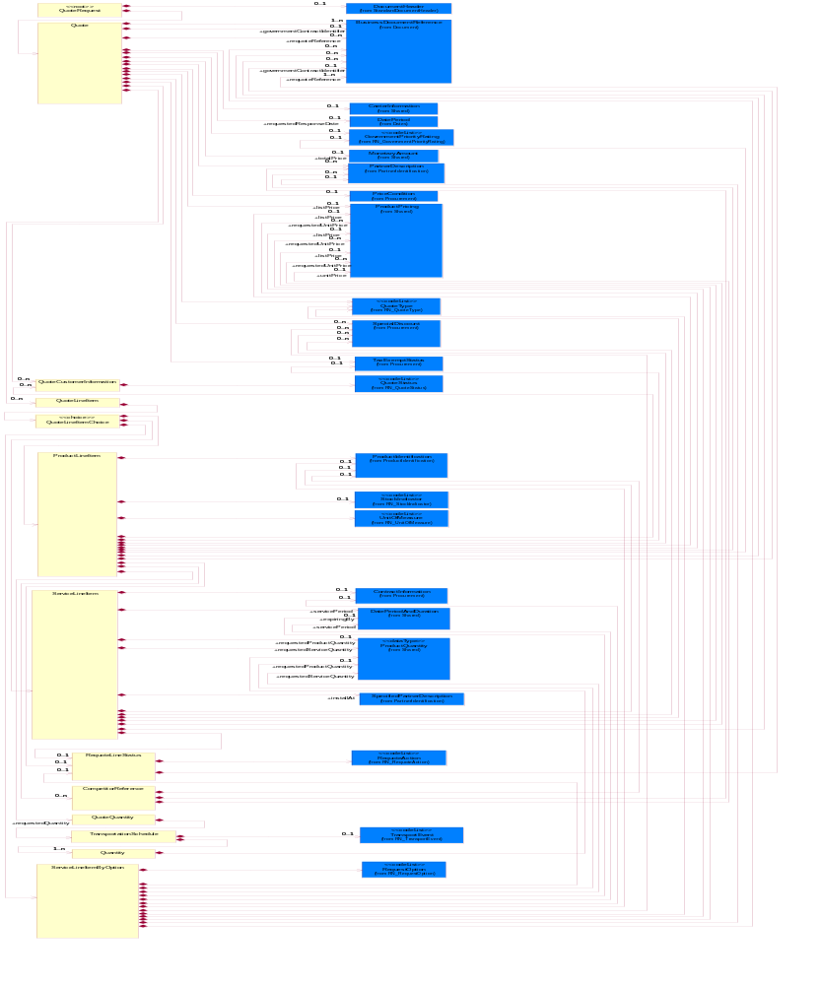
Figure 2-1 Interchange

Dependency Diagram
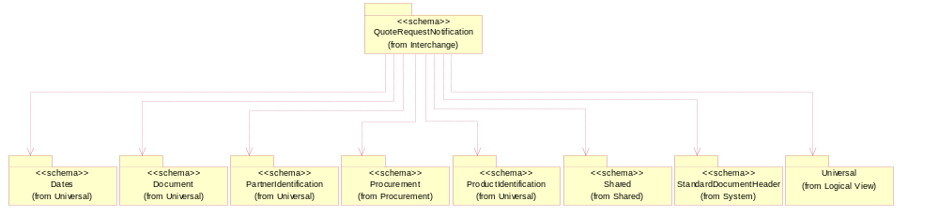
Figure 2-2 Dependency

Competitor Reference
The collection of business properties that describe a competitor's product and pricing for purposes within a quote business document.
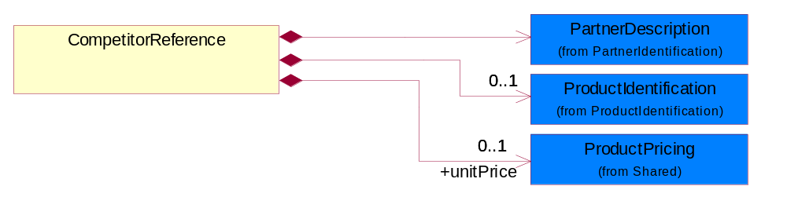
Figure 2-3 Competitor Reference

Composition | Cardinality | Type | Documentation
ProductIdentification | 0..1 | ProductIdentification | The object provides the identifier(s) of a product.
unitPrice | 0..1 | ProductPricing | Agreed upon sale price for each unit ordered.
PartnerDescription | 1 | PartnerDescription | The collection of business properties that describe a business partners' identity, their contact information, where they are physically located and their function in a supply chain.

Product Line Item
The collection of business properties that describe a product entry in a quote business documents. The Recommended ProcessRoleIdentifier for PartnerDescription are SHT - Ship To and RSF - Requested Ship From.
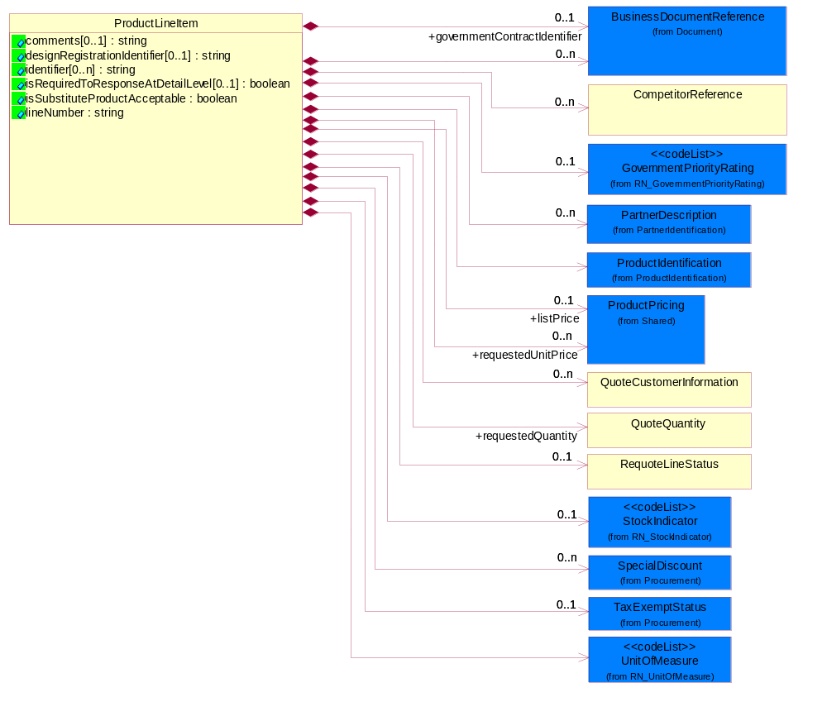
Figure 2-4 Product Line Item

Attribute | Type | Documentation
comments[0..1] | string | Free form textual description of a general nature.
designRegistrationIdentifier[0..1] | string | A proprietary unique identifier for a design registration.
identifier[0..n] | string | A unique serial identifier assigned to a product.
isRequiredToResponseAtDetailLevel[0..1] | boolean | This object representing the option for the response. If the value equals to true, the receiver is required to response to detail level. If the value equals to false, the receiver is only required to reply at summary level.
isSubstituteProductAcceptable | boolean | Indicates whether the requesting party will accept a substitute product for the product requested.
lineNumber | string | Number of the line in the document.

Composition | Cardinality | Type | Documentation
BusinessDocumentReference | 0..n | BusinessDocumentReference | The business document reference object allows for the indirect referencing of a relationship to other business related documents.
GovernmentPriorityRating | 0..1 | GovernmentPriorityRating | If a contract number exists and PO type is Government, a priority rating code is required.
UnitOfMeasure | 1 | UnitOfMeasure | Code identifying a product unit of measure.
governmentContractIdentifier | 0..1 | BusinessDocumentReference | The unique number that identifies a government contract.
ProductIdentification | 1 | ProductIdentification | The object provides the identifier(s) of a product.
CompetitorReference | 0..n | CompetitorReference | The collection of business properties that describe a competitor's product and pricing for purposes within a quote business document.
requestedQuantity | 1 | QuoteQuantity | The quantity of product requested.
RequoteLineStatus | 0..1 | RequoteLineStatus | The collection of business properties that describe a previous quote's identification and status for a given entry on the prior quote.
TaxExemptStatus | 0..1 | TaxExemptStatus | The collection of business properties that describe tax exemption conditions.
QuoteCustomerInformation | 0..n | QuoteCustomerInformation | The collection of business properties that describe the customer who uses a quote business document.
StockIndicator | 0..1 | StockIndicator | Code identifying the amount of stock available at the time of the quote.
SpecialDiscount | 0..n | SpecialDiscount | This object represents a special discount based on the special discount identifier.
requestedUnitPrice | 0..n | ProductPricing | The price requested for a unit of product.
listPrice | 0..1 | ProductPricing | This object represents a pre-discounted price.
PartnerDescription | 0..n | PartnerDescription | The collection of business properties that describe a business partners' identity, their contact information, where they are physically located and their function in a supply chain.

Quantity
The collection of business properties that describe product quantity and associated schedules.
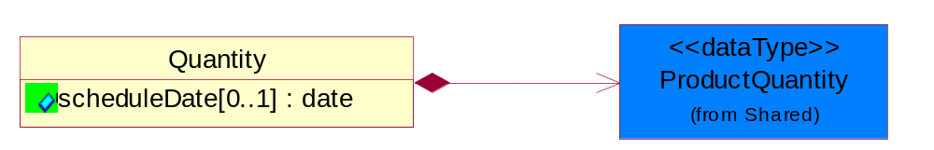
Figure 2-5 Quantity

Attribute | Type | Documentation
scheduleDate[0..1] | date | Specifies a date for the schedule.

Composition | Cardinality | Type | Documentation
ProductQuantity | 1 | ProductQuantity | A quantity specifying the number of product units.

Quote
The collection of business properties that describe an offer to supply a quantity of products at an agreed price and schedule. The Recommended Process Role Identifier for
Partner Description are FIN - Financed By, DIS - Distributed By, RES - Respond To, CWN - Contract Owner and BIT - Bill To.
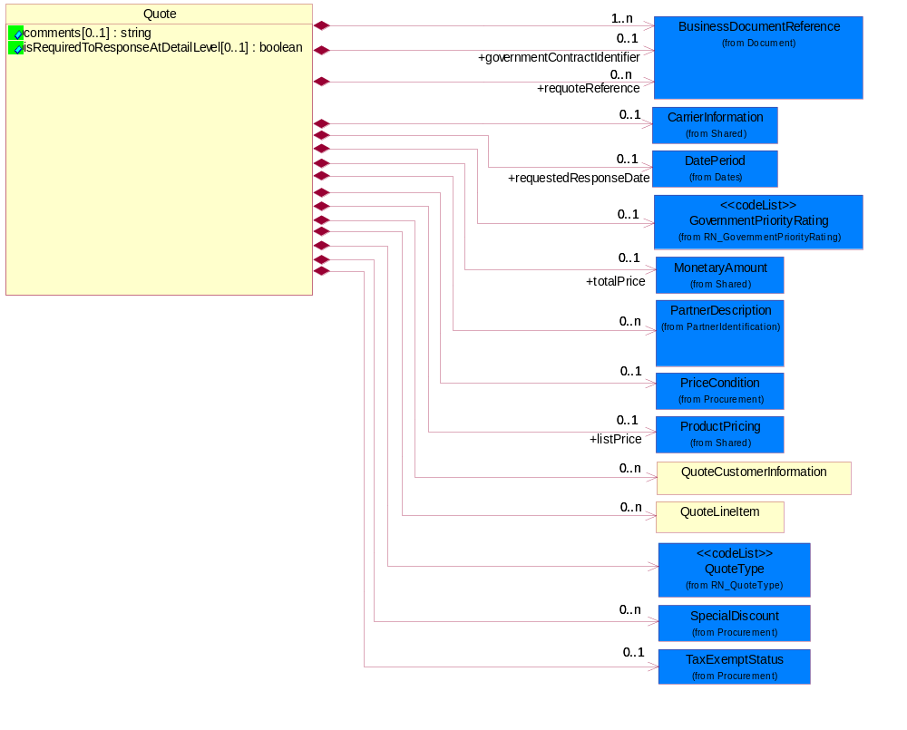
Figure 2-6 Quote

Attribute | Type | Documentation
comments[0..1] | string | Free form textual description of a general nature.
isRequiredToResponseAtDetailLevel[0..1] | boolean | This object representing the option for the response. If the value equals to true, the receiver is required to response to detail level. If the value equals to false, the receiver is only required to reply at summary level.

Composition | Cardinality | Type | Documentation
BusinessDocumentReference | 1..n | BusinessDocumentReference | The business document reference object allows for the indirect referencing of a relationship to other business related documents.
GovernmentPriorityRating | 0..1 | GovernmentPriorityRating | If a contract number exists and PO type is Government, a priority rating code is required.
governmentContractIdentifier | 0..1 | BusinessDocumentReference | The unique number that identifies a government contract.
PriceCondition | 0..1 | PriceCondition | The collection of business properties that define information for special pricing conditions.
requestedResponseDate | 0..1 | DatePeriod | The date for which a response has been requested to be transmitted.
requoteReference | 0..n | BusinessDocumentReference | The document reference for a previous quote.
TaxExemptStatus | 0..1 | TaxExemptStatus | The collection of business properties that describe tax exemption conditions.
QuoteCustomerInformation | 0..n | QuoteCustomerInformation | The collection of business properties that describe the customer who uses a quote business document.
QuoteType | 1 | QuoteType | Code identifying category specification for a quote.
QuoteLineItem | 0..n | QuoteLineItem | The collection of business properties that describe a product entry in a quote business documents.
SpecialDiscount | 0..n | SpecialDiscount | This object represents a special discount based on the special discount identifier.
CarrierInformation | 0..1 | CarrierInformation | The collection of business properties that describe a carrier's identification.
totalPrice | 0..1 | MonetaryAmount | Total price for the entire business document.
listPrice | 0..1 | ProductPricing | This object represents a pre-discounted price.
PartnerDescription | 0..n | PartnerDescription | The collection of business properties that describe a business partners' identity, their contact information, where they are physically located and their function in a supply chain.

Quote Customer Information
The collection of business properties that describe the customer who uses a quote business document.
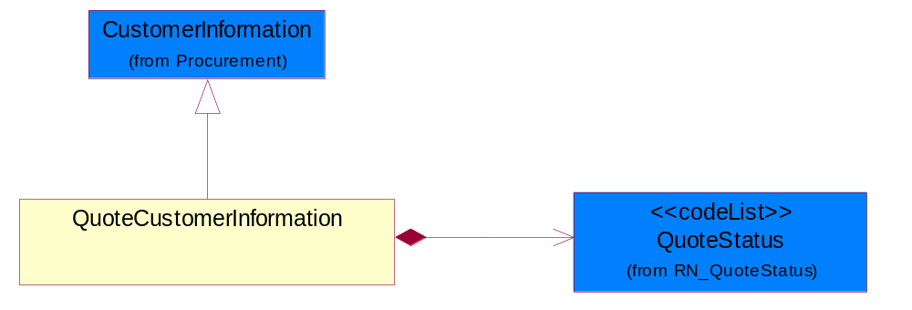
Figure 2-7 Quote Customer Information

Composition | Cardinality | Type | Documentation
QuoteStatus | 1 | QuoteStatus | Code identifying whether business has been secured by the end customer.

Quote Line Item
The collection of business properties that describe a product entry in a quote business documents.
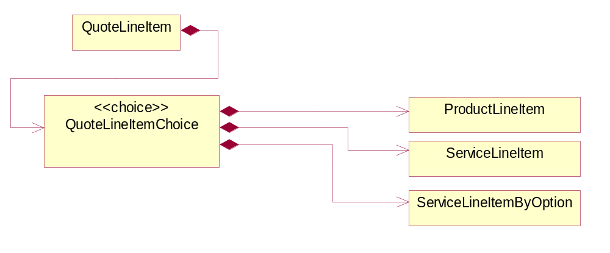
Figure 2-8 Quote Line Item

Composition | Cardinality | Type | Documentation
QuoteLineItemChoice | 1 | QuoteLineItemChoice

Quote Line Item Choice

Composition | Cardinality | Type | Documentation
ProductLineItem | 1 | ProductLineItem | The collection of business properties that describe a product entry in a quote business documents. The Recommended ProcessRoleIdentifier for PartnerDescription are SHT - Ship To and RSF - Requested Ship From.
ServiceLineItem | 1 | ServiceLineItem | The collection of business properties that describe a service entry in a quote business documents.
ServiceLineItemByOption | 1 | ServiceLineItemByOption | The collection of business properties that describe a service entry by option (eg. by Contract, by Product or by Site) in a quote business documents. The Recommended ProcessRoleIdentifier for PartnerDescription is ITL - Install At.

Quote Quantity
The collection of business properties that describe the quantities associated with a product quote.
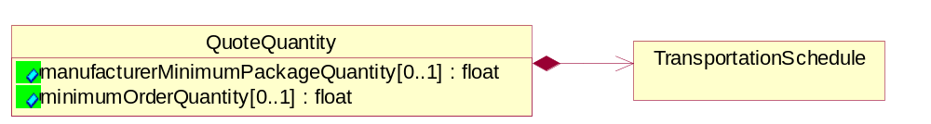
Figure 2-9 Quote Quantity

Attribute | Type | Documentation
manufacturerMinimumPackageQuantity[0..1] | float | The product quantity in a defined package by a manufacturer.
minimumOrderQuantity[0..1] | float | A numeric expression of the minimum number of product line items that may be ordered.

Composition | Cardinality | Type | Documentation
TransportationSchedule | 1 | TransportationSchedule | The collection of business properties that describe product quantity and associated schedules, for a given transportation event.

Quote Request
A message wrapper or root element for PIP3A1.
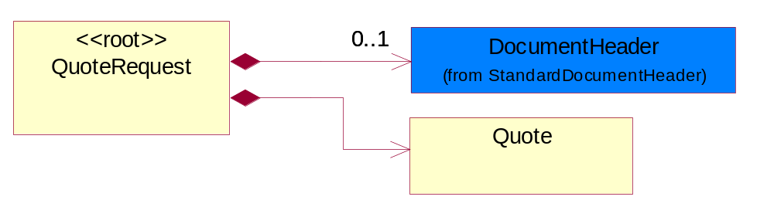
Figure 2-10 Quote Request

Composition | Cardinality | Type | Documentation
DocumentHeader | 0..1 | DocumentHeader | The object allows for the identification of the sender and receiver of the business document.
Quote | 1 | Quote | The collection of business properties that describe an offer to supply a quantity of products at an agreed price and schedule. The Recommended ProcessRoleIdentifier for  PartnerDescription are FIN - Financed By, DIS - Distributed By, RES - Respond To, CWN - Contract Owner and BIT - Bill To.

Requote Line Status
The collection of business properties that describe a previous quote's identification and status for a given entry on the prior quote.
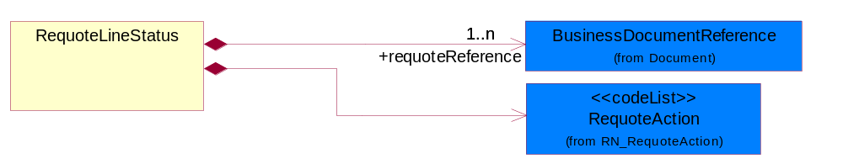
Figure 2-11 Requote Line Status

Composition | Cardinality | Type | Documentation
requoteReference | 1..n | BusinessDocumentReference | The document reference for a previous quote.
RequoteAction | 1 | RequoteAction | Code identifying the type of action to be taken for a given line item on a quote.

Service Line Item
The collection of business properties that describe a service entry in a quote business documents.
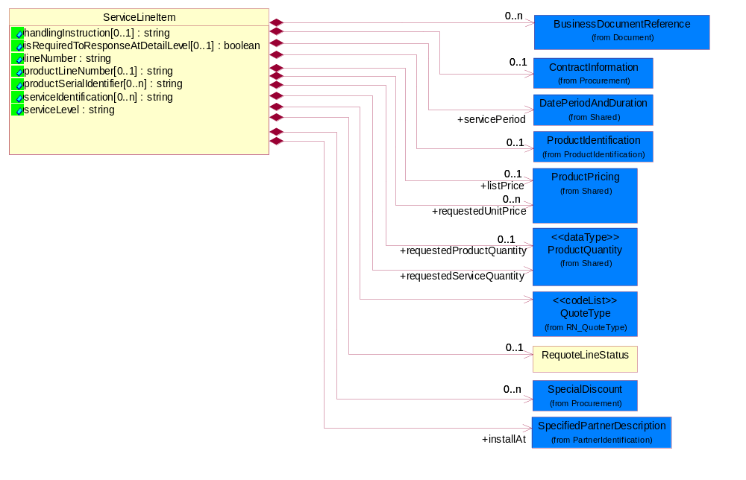
Figure 2-12 Service Line Item

Attribute | Type | Documentation
handlingInstruction[0..1] | string | The object that representing the instruction for quote handling.
isRequiredToResponseAtDetailLevel[0..1] | boolean | This object representing the option for the response. If the value equals to true, the receiver is required to response to detail level. If the value equals to false, the receiver is only required to reply at summary level.
lineNumber | string | Number of the line in the document.
productLineNumber[0..1] | string | The object that representing the line number of the referenced product line item.
productSerialIdentifier[0..n] | string | A unique serial identifier assigned to a product.
serviceIdentification[0..n] | string | A unique serial identifier assigned to a service.
serviceLevel | string | The object that representing the type of service.

Composition | Cardinality | Type | Documentation
installAt | 1 | SpecifiedPartnerDescription | The partner and/or location to which the product must be set up for use or service.
RequoteLineStatus | 0..1 | RequoteLineStatus | The collection of business properties that describe a previous quote's identification and status for a given entry on the prior quote.
ContractInformation | 0..1 | ContractInformation | The collection of business properties that represent a business arrangement for the supply of goods or services at an agreed price.
QuoteType | 1 | QuoteType | Code identifying category specification for a quote.
SpecialDiscount | 0..n | SpecialDiscount | This object represents a special discount based on the special discount identifier.
ProductIdentification | 0..1 | ProductIdentification | The object provides the identifier(s) of a product.
BusinessDocumentReference | 0..n | BusinessDocumentReference | The business document reference object allows for the indirect referencing of a relationship to other business related documents.
servicePeriod | 1 | DatePeriodAndDuration | This object allows representation of a date period by a duration or begin and an end dates for a service period.
requestedServiceQuantity | 1 | ProductQuantity | The quantity of service requested.
requestedProductQuantity | 0..1 | ProductQuantity | The quantity of product requested.
requestedUnitPrice | 0..n | ProductPricing | The price requested for a unit of service.
listPrice | 0..1 | ProductPricing | This object represents a pre-discounted price.

Service Line Item By Option
The collection of business properties that describe a service entry by option (eg. by Contract, by Product or by Site) in a quote business documents. The Recommended ProcessRoleIdentifier for PartnerDescription is ITL - Install At.
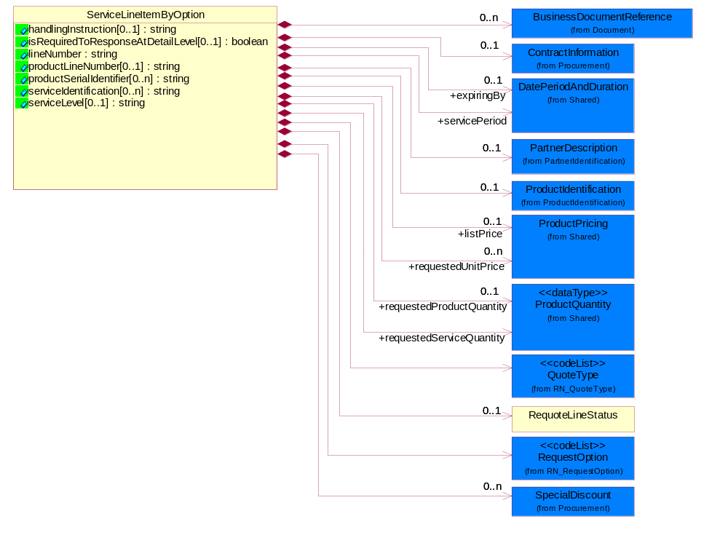
Figure 2-13 Service Line Item By Option

Attribute | Type | Documentation
handlingInstruction[0..1] | string | The object that representing the instruction for quote handling.
isRequiredToResponseAtDetailLevel[0..1] | boolean | This object representing the option for the response. If the value equals to true, the receiver is required to response to detail level. If the value equals to false, the receiver is only required to reply at summary level.
lineNumber | string | Number of the line in the document.
productLineNumber[0..1] | string | The object that representing the line number of the referenced product line item.
productSerialIdentifier[0..n] | string | A unique serial identifier assigned to a product.
serviceIdentification[0..n] | string | A unique serial identifier assigned to a service.
serviceLevel[0..1] | string | The object that representing the type of service.

Composition | Cardinality | Type | Documentation
BusinessDocumentReference | 0..n | BusinessDocumentReference | The business document reference object allows for the indirect referencing of a relationship to other business related documents.
ContractInformation | 0..1 | ContractInformation | The collection of business properties that represent a business arrangement for the supply of goods or services at an agreed price.
ProductIdentification | 0..1 | ProductIdentification | The object provides the identifier(s) of a product.
QuoteType | 1 | QuoteType | Code identifying category specification for a quote.
RequoteLineStatus | 0..1 | RequoteLineStatus | The collection of business properties that describe a previous quote's identification and status for a given entry on the prior quote.
RequestOption | 1 | RequestOption | Code identifying an option for a request, eg. quote request or order request.
SpecialDiscount | 0..n | SpecialDiscount | This object represents a special discount based on the special discount identifier.
servicePeriod | 1 | DatePeriodAndDuration | This object allows representation of a date period by a duration or begin and an end dates for a service period.
expiringBy | 0..1 | DatePeriodAndDuration | Renew all products expiring in this specified period.
requestedServiceQuantity | 1 | ProductQuantity | The quantity of service requested.
requestedProductQuantity | 0..1 | ProductQuantity | The quantity of product requested.
requestedUnitPrice | 0..n | ProductPricing | The price requested for a unit of service.
listPrice | 0..1 | ProductPricing | This object represents a pre-discounted price.
PartnerDescription | 0..1 | PartnerDescription | The collection of business properties that describe a business partners' identity, their contact information, where they are physically located and their function in a supply chain.

Transportation Schedule
The collection of business properties that describe product quantity and associated schedules, for a given transportation event.
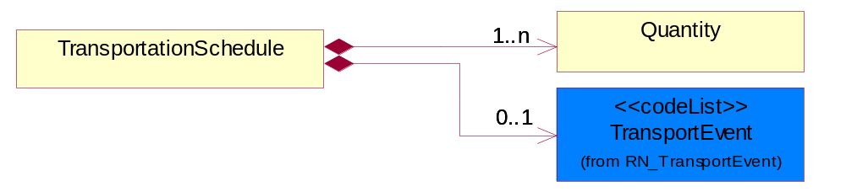
Figure 2-14 Transportation Schedule

Composition | Cardinality | Type | Documentation
Quantity | 1..n | Quantity | The collection of business properties that describe product quantity and associated schedules.
TransportEvent | 0..1 | TransportEvent | Code identifying an event during the transportation of a shipment.

Code List

Stock Indicator
Code identifying the amount of stock available at the time of the quote.

Name | Documentation
DIS | Distributor - Distributor has stock for all of the requested quantity.
FAC | Factory - Factory/seller has stock.
NON | None - Distributor has no stock.
PAR | Partial - Distributor has stock for part of the requested quantity.

Domain Model

Procurement

Dependency Diagram
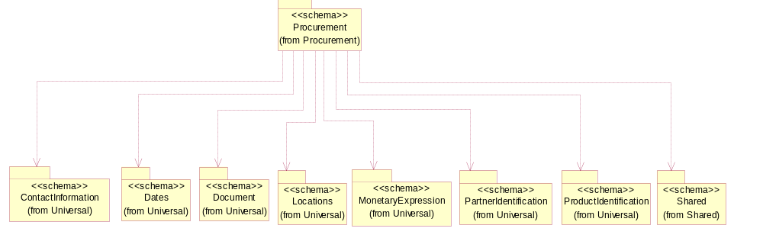
Figure 3-15 Dependency

Contract Information
The collection of business properties that represent a business arrangement for the supply of goods or services at an agreed price.
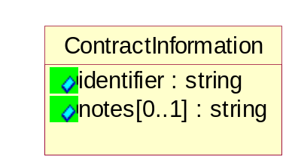
Figure 3-16 Contract Information

Attribute | Type | Documentation
identifier | string | The unique number than identifies a contract.
notes[0..1] | string | A textual description about contract.

Customer Information
The collection of business properties that describe an end user.
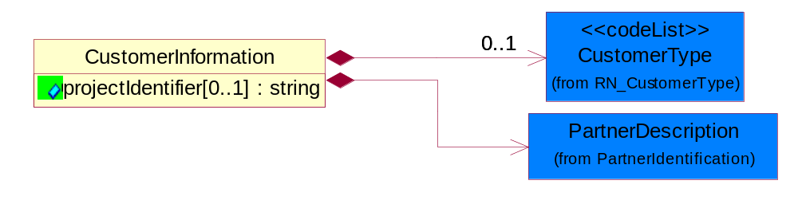
Figure 3-17 CustomerInformation

Attribute | Type | Documentation
projectIdentifier[0..1] | string | The unique identification number that identifies a project for a given customer.

Composition | Cardinality | Type | Documentation
CustomerType | 0..1 | CustomerType | Code identifying the type of end user.
PartnerDescription | 1 | PartnerDescription | The collection of business properties that describe a business partners' identity, their contact information, where they are physically located and their function in a supply chain.

Price Condition
The collection of business properties that define information for special pricing conditions.
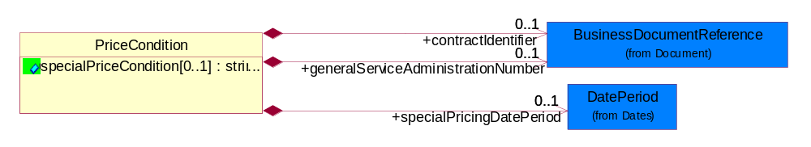
Figure 3-18 PriceCondition

Attribute | Type | Documentation
specialPriceCondition[0..1] | string | Textual description that identifies conditions under which special pricing is applicable.

Composition | Cardinality | Type | Documentation
specialPricingDatePeriod | 0..1 | DatePeriod | The date range indicating when a product's special pricing is valid.
generalServiceAdministrationNumber | 0..1 | BusinessDocumentReference | Identifying number relating to a pre-established end-user pricing agreement.
contractIdentifier | 0..1 | BusinessDocumentReference | The unique number that identifies a contract.

Special Discount
This object represents a special discount based on the special discount identifier.
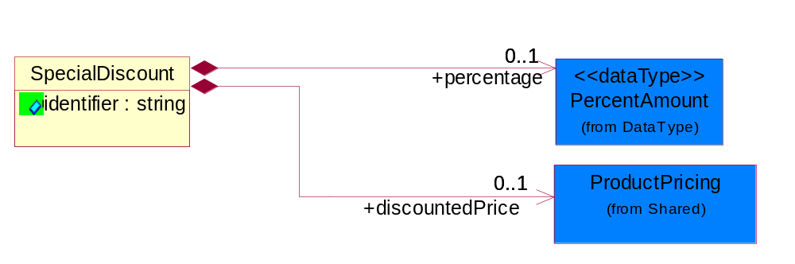
Figure 3-19 Special Discount

Attribute | Type | Documentation
identifier | string | This object representing the special discount identifier.

Composition | Cardinality | Type | Documentation
percentage | 0..1 | PercentAmount | This object represents a special discount percentage.
discountedPrice | 0..1 | ProductPricing | This object represents a special discount price.

Tax Exemption
The collection of business properties that describe tax exemption type and identification information.
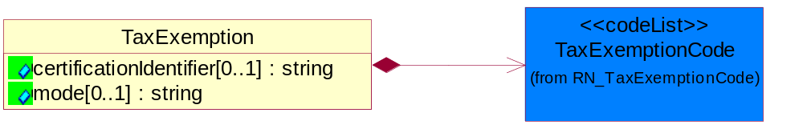
Figure 3-20 Tax Exemption

Attribute | Type | Documentation
certificationIdentifier[0..1] | string | The unique identifier that represents the authorization for a product or service's tax exempt status.
mode[0..1] | string | This object refering to the tax exemption mode by Customs against goods declared eg. duty free, partial tax exemption or full tax exemption.

Composition | Cardinality | Type | Documentation
TaxExemptionCode | 1 | TaxExemptionCode | Code identifying the type of tax exemption for a product or service.

Tax Exempt Status
The collection of business properties that describe tax exemption conditions.
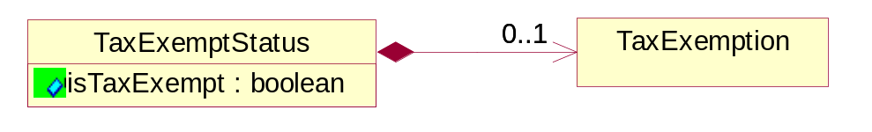
Figure 3-21 Tax Exempt Status

Attribute | Type | Documentation
isTaxExempt | boolean | Indicates whether a product is exempt from taxation.

Composition | Cardinality | Type | Documentation
TaxExemption | 0..1 | TaxExemption | The collection of business properties that describe tax exemption type and identification information.

Code List

Transport Event
Code identifying an event during the transportation of a shipment.

Name | Documentation
DOC | Dock.
PIC | Pickup.
SHP | Ship.

Government Priority Rating
If a contract number exists and PO type is Government, a priority rating code is required.

Name | Documentation
ATE | Atomic energy.
DEF | Defense.
DOE | Domestic energy.
ENP | Energy and related programs.
OTH | Other Defense.

Customer Type
Code identifying the type of end user.

Name | Documentation
ENC | End customer.
ULC | Ultimate customer.

Tax Exemption Code
Code identifying the type of tax exemption for a product or service.

Name | Documentation
AGR | Agriculture.
AQT | Tax exemption for aquatic product for open-sea fishery.
BTL | Tax exemption for border trade with low value - import/export of goods with low value at border.
CPT | Exempt - From County Property Tax.
CRT | Tax exemption for charity - levy free import of commodity for helping the poor charity from beyond the border non-refundable donation to within-border.
CSM | Tax exemption for consignment of assembly and replenishment material and export of finished product.
DIS | Disabled.
DIV | Disabled Veteran.
DPI | Direct Pay ID.
DRD | Tax exemption for disaster relief donation - import goods using disaster relief donation.
EFE | Exempt - For export.
EFR | Exempt - For resale.
EVD | Tax exemption for entire vehicle duty - Levy payment for automobile spare part under the entire vehicle special characterization.
EVI | Tax exemption for entire vehicle special levy - import of automobile spare part under the entire vehicle special characterization.
EXC | Tax exemption for exceptional case - import/export of goods under exceptional levy exemption.
FAD | Tax exemption for free aid - import/export cargo for free aid.
FFE | Tax exemption for import/export of goods by sole foreign capital funded enterprise.
FTZ | Tax exemption for free tax zone - tax free zone for import of self consumption commodity.
GND | Tax exemption for general duty or general levy for import/export goods.
GST | Exempt - Goods and Services Tax.
HOM | Homestead.
ICT | Tax exemption for incentive program - import of equipment under national/foreign capital national development incentive program.
IET | Tax exemption for internally set rule - import/export of goods enjoying temporarily set levy rate.
IFS | Tax exemption for public infrastructure eg. Import of equipment for correspondence, harbor, railroad, road, airport construction.
IGC | Tax exemption for integrated circuit - import of goods for integrated circuit manufacturing companies.
IMM | Tax exemption for import for manufacturing - import of manufacturing material and export of finished product.
ITA | Tax exemption for ITA products - IT product without full levy number.
ITS | Tax exemption for internal sale equipment - equipment and key components of open-sea ships for internal sales.
LAE | Material taxable - labor exempt.
LFC | Tax exemption for local-foreign cooperation - import/export of goods of local-foreign cooperation company.
LFV | Tax exemption for local-foreign joint venture - import/export of goods of local-foreign joint venture company.
LOF | Exempt - Letter on File.
LON | Tax exemption for loan project - import of goods using loan.
LOS | Exempt - Local service.
LOS | Tax exemption for international financial institution loan and foreign government loan, specified electromechanical device spare parts.
LPT | Tax exemption for land petroleum - import of equipment for exploration, extraction of land petroleum.
LPT | Exempt - From Local Property Tax.
MAE | Labor taxable - Material exempt.
MFE | Tax exemption for manufacturing equipment - import of un-priced equipment by foreign company conducting manufacturing trade.
MNE | Tax exemption for import cargo for major national event.
MPT | Tax exemption for marine petroleum - import of equipment for exploration, extraction of marine petroleum.
NDF | Tax exemption for nationally approved duty free - import/export goods which have been approved duty-free by state council.
NE1 | Not exempt - For resale.
NE2 | Not exempt - Not for resale.
NFR | Exempt - Not For Resale.
NOH | Non-homestead.
NOT | Not taxable.
NTL | Tax exemption for nationalization - Import of parts for nationally specified small vehicle and video camera production.
O65 | Over 65.
OLR | Tax exemption because of other legal regulation - Other legal regulation which reduce/eliminate import and export cargo levy.
OPA | Tax exemption for Hong Kong/Macau OPA - HongKong/Macao textile that went through manufacturing in China that has obtaining export permit.
OPS | Open space.
OPT | Other Property Tax exemption.
OSV | Tax exemption for open sea vessels - Open sea ships and equipment component.
OTZ | Tax exemption for other zone that uses special policy to export cargo.
PSL | Exempt - Per State Law.
PST | Exempt - Provincial Sales Tax.
REE | Recurring exempt.
SEG | Tax exemption for scientific education goods - universities and scientific research institution importing scientific educational goods.
SFD | Tax exemption for self funding - import of equipment, spare parts, and fittings, using own funding on top of foreign company investment amount.
SPD | Tax exemption for spare part duty - Levy payment for automobile spare part under the non-entire vehicle special characterization.
SPT | Exempt - From School Property Tax.
SRG | Tax exemption for specific zone for import of self consumption commodity or export cargo.
TNT | Tax exemption for enterprises who import cargo for technological transformations.
TOE | Totally exempt.
TOS | Exempt - Toll service.
TPT | Exempt - From state property tax.
USE | Usage exempt.
USG | Exempt - Sale to U.S. government.
WOF | Working farm.

Quote Status
Code identifying whether business has been secured by the end customer.

Name | Documentation
CLO | Closed Lost.
CWO | Closed Won.
UND | Undetermined.

Quote Type
Code identifying category specification for a quote.

Name | Documentation
ADD | Quote for adding additional product/service to existing contract.
BFB | Bid for Bid - Quote for project not ready for purchase, budgetary pricing.
BFC | Bid for buy - Customer ready to purchase, looking for best price.
BQU | Blanket Quote - Secures pricing for complete parts lists.
BQV | BOM Quote - Complete list of parts provided for a specified project, total package?pricing provided.
BQW | Budgetary Quote - Quote to determine if project is economically feasible.
CHG | Quote for changing existing contract.
CQU | Competitive Quote - Competitor pricing has been provided.
CQV | Contract Quote - Based on previously negotiated contract pricing.
DWG | Quote for downgrading contract.
NCO | Quote for new service contract.
QWR | Quote with Reservations - Quote to hold product for specified delivery.
REN | Quote for contract renewal.
REP | Repair.
REW | Rework.
RFB | Rebid for Buy - Customer requesting requote, possibly looking for better pricing/delivery.
SER | Service.
SFS | Ship from stock and debit. Partner has potential to book business if provided authorization to deviate from standard cost.
UPG | Quote for upgrading contract.

Requote Action
Code identifying the type of action to be taken for a given line item on a quote.

Name | Documentation
ADD | Added.
CHA | Change.
DEL | Deleted.
NAC | No action.
REI | Re-issue.

Request Option
Code identifying an option for a request, eg. quote request or order request.

Name | Documentation
CON | Request By Contract - The requested action will impacts all of the products on the contract. For example,  a) during the quoting process, all the products in the identified contract will be quoted.  b) during the ordering process, all the products in the identified contract will be ordered.
PRO | Request By Product - The requested action will impacts the specific identified product. For example,  a) during the quoting process, all the identified products in the existing contract will be quoted.  b) during the ordering process, all the identified products in the existing contract will be ordered.
SIT | Request By Site - The requested action will impacts all of the products within a specified site. For example,  a) during the quoting process, all the products within an identified site in the contract will be quoted.  a) during the ordering process, all the products within an identified site in the contract will be ordered.
WQO | Request with quote.

Shared

Dependency Diagram
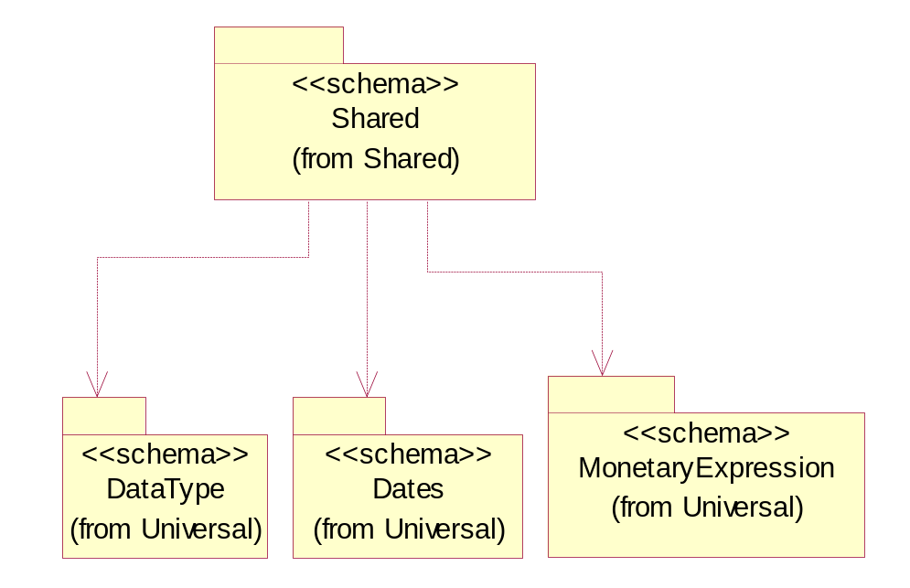
Figure 3-22 Dependency

Carrier Information
The collection of business properties that describe a carrier's identification.
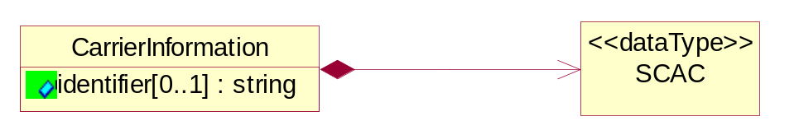
Figure 3-23 Carrier Information

Attribute | Type | Documentation
identifier[0..1] | string | The unique identifier that identifies an account.

Composition | Cardinality | Type | Documentation
SCAC | 1 | SCAC | The Standard Carrier Alpha Code (SCAC) is a unique two-to-four-letter code used to identify transportation companies. NMFTA developed the SCAC identification codes in the mid 1960's to facilitate computerization in the transportation industry.  Refer http://www.nmfta.org for more detail.

Date Period And Duration
The collection of business properties that describe a date period or duration.
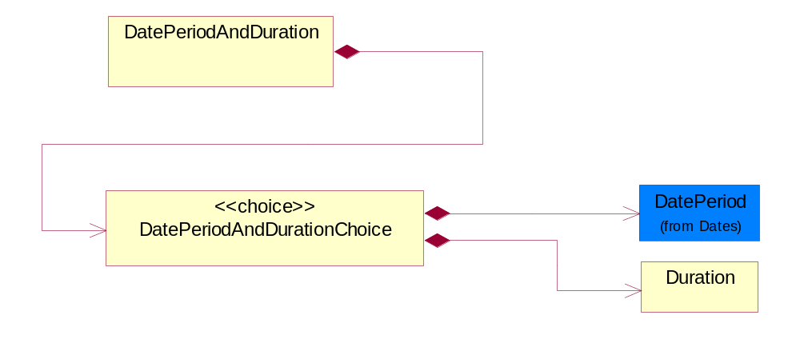
Figure 3-24 Date Period And Duration

Composition | Cardinality | Type | Documentation
DatePeriodAndDurationChoice | 1 | DatePeriodAndDurationChoice | The choice structure for DatePeriodAndDuration.

Date Period And Duration Choice
The choice structure for DatePeriodAndDuration.

Composition | Cardinality | Type | Documentation
DatePeriod | 1 | DatePeriod | The business document must allow for the computation or statement of a duration based upon a beginning and an ending date.
Duration | 1 | Duration | This object allows representation of a duration of time.

Duration
This object allows representation of a duration of time.
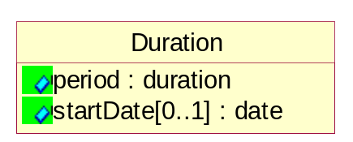
Figure 3-25 Duration

Attribute | Type | Documentation
period | duration | Represents a duration of time.
startDate[0..1] | date | The date indicating the beginning of the duration.

Monetary Amount
The collection of business properties that describe the monetary amount defined by a specified currency.
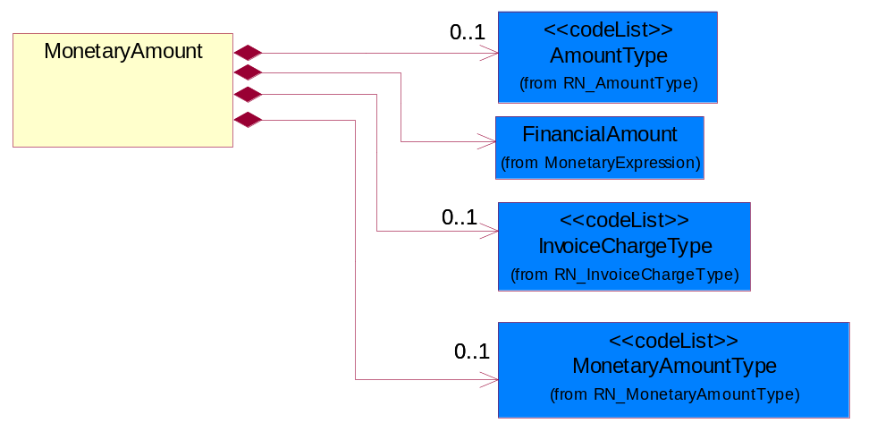
Figure 3-26 Monetary Amount

Composition | Cardinality | Type | Documentation
FinancialAmount | 1 | FinancialAmount | The business document must express financial amounts.
InvoiceChargeType | 0..1 | InvoiceChargeType | Code identifying the values for the types of charges contained in an invoice.
MonetaryAmountType | 0..1 | MonetaryAmountType | Code identifying whether the monetary amount is a debit or credit.
AmountType | 0..1 | AmountType | Code identifying the type of monetary amount.

Product Pricing
The collection of business properties that describe the type of pricing and financial amount for a product.
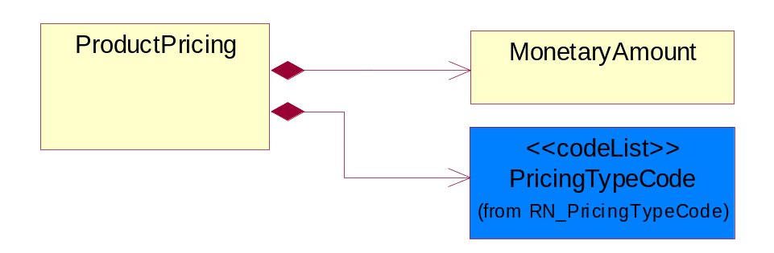
Figure 3-27 Product Pricing

Composition | Cardinality | Type | Documentation
MonetaryAmount | 1 | MonetaryAmount | The collection of business properties that describe the monetary amount defined by a specified currency.
PricingTypeCode | 1 | PricingTypeCode | Code identifying the type of pricing available for a product.

Product Quantity
A quantity specifying the number of product units.
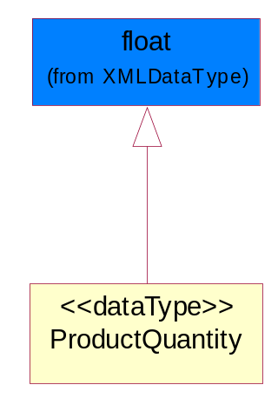
Figure 3-28 ProductQuantity

SCAC
The Standard Carrier Alpha Code (SCAC) is a unique two-to-four-letter code used to identify transportation companies. NMFTA developed the SCAC identification codes in the mid 1960's to facilitate computerization in the transportation industry.

Refer http://www.nmfta.org for more detail.
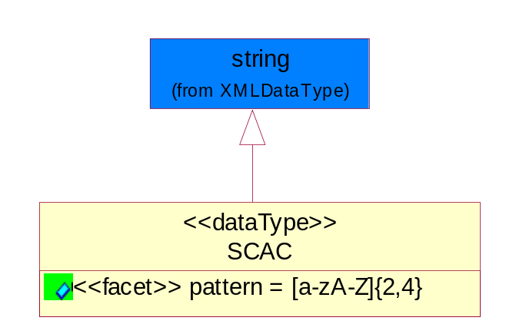
Figure 3-29 SCAC

Attribute | Type | Documentation
pattern |  | [a-zA-Z]{2,4}

CodeList

Invoice Charge Type
Code identifying the values for the types of charges contained in an invoice.

Name | Documentation
ALC | Allowances and Charges.
CUC | Custom Charges.
DEA | Deposit Amount.
ESC | Expedited Shipping Charge - Charge for accelerating the delivery of a product.
FRC | Freight Charges.
HAC | Handling Charges.
LEC | Lease Charge - Charge for the use of a product in which the purchaser assumes certain responsibilities of ownership.
LIC | License Charge - Charge for the use of a product (usually software) in which the manufacturer maintains ownership of the product.
MAC | Maintenance Charge - Charge (usually periodic) for providing maintenance support for a product.
PUC | Purchase Charge - Charge for a product in which the buyer takes all responsibilities of ownership.
QUD | Quantity Discount.
REC | Rental Charge - Charge for the use of a product (usually hardware) in which the manufacturer maintains ownership of the product.

Monetary Amount Type
Code identifying whether the monetary amount is a debit or credit.

Name | Documentation
CRE | Credit.
DEB | Debit.
ZER | Zero remit.

Pricing Type Code
Code identifying the type of pricing available for a product.

Name | Documentation
ACR | Authorized Cost and Resale.
ACS | Authorized Cost - The negotiated cost agreed upon between the supplier and distributor at the time the “debit?is authorized.
ACT | Authorized cost.
ANY | Any available.
ARS | Authorized resale.
ASP | Average Selling Price - Manufacturer's published price.
BPA | Budgetary Price Amount.
BPP | Broken Purchase Price.
BSH | Book-Ship.
CAT | Catalog price - Book (the supplier’s published cost at the time of transaction) or Published Price.
CLM | Claim Amount.
CMC | Commercial.
CMD | Commodity.
CMF | Contract Manufacturing.
CON | Contract.
COS | Cost - Price for which the distributor purchased the parts.
CPL | Country Price List.
DBC | Disti Book Cost.
DFR | Duty free.
DIS | Distribution.
DPD | Duty paid.
DTP | Distribution price.
EDU | Education.
ERT | E-Rate.
EXC | Exception.
FGM | Federal government.
GEN | General.
HIE | Higher Education.
LCL | Local.
LGM | Local government.
LIS | List.
MPR | Market price.
MRP | Manufacturer's recommendation for unit pricing.
MSR | Manufacturer Suggested Retail Price (MSRP).
MUS | Minimum Unit Sale (MUS) - Manufacturer requirement of total dollar value for design opportunity.
NPF | Nonprofit.
OEM | Original Equipment Manufacturing (OEM).
OVP | OEM Volume Pricing - Original equipment manufacturing price per volume ordered.
PED | Primary Education.
QUO | Quote Price
RCS | Requested Cost (RCS) - Reseller requested cost to the manufacturer.
REX | Reseller Expects.
RFB | Refurbished.
RIN | Religious Institution.
RSP | Resale - Price the distributor is authorized to use for sale to their customer (RSP).
SCE | Special Education.
SEC | Security and management reseller.
SED | Secondary Education.
SEV | Service provider.
SGM | State Government.
SPD | Special Discount Price.
SPE | Special Education.
SPL | Samples.
SRP | Suggested Resale Price.
STR | Standard Rebate.
THP | Threshold Price.
TOC | Total Other Charges - Suggested resale price - The sum total of all distributor added charges to the customer for value added services, including but not limited to programming, tape and reel, labeling, date coding, kitting and in-house assembly.

Amount Type
Code identifying the type of monetary amount.

Name | Documentation
DIP | Discount Percentage.
DIS | Discount Value - The monetary amount of the discount on the price applied to a customer order.
FRE | Freight Charges - The monetary amount to be paid for freight transportation.
INS | InsuranceCharges - The monetary amount to be paid for freight insurance.
MAT | Material Cost - This object represents the material cost for the product.
MIS | Miscellaneous Charges - The monetary amount to be paid for miscellaneous charges.
NET | Net Amount.
PRC | Processing Charges - The monetary amount to be paid by consignee for consignment manufacturer.
TOD | Total Amount Due - Total amount due upon receipt of statement.
TOT | Total Amount - Total price for an entire business document.
TOV | Total Value Added Amount - The total amount of the shipment including any value added tax.
UNI | Unit Price - Agreed upon sale price for each unit ordered.
VAD | Value Added Unit Price - The price of a unit including any value added tax.

Universal Structure

Contact Information

Contact Information
The business document must allow for the identification of the name of the department, service or individual to be contacted regarding the context of the business document.
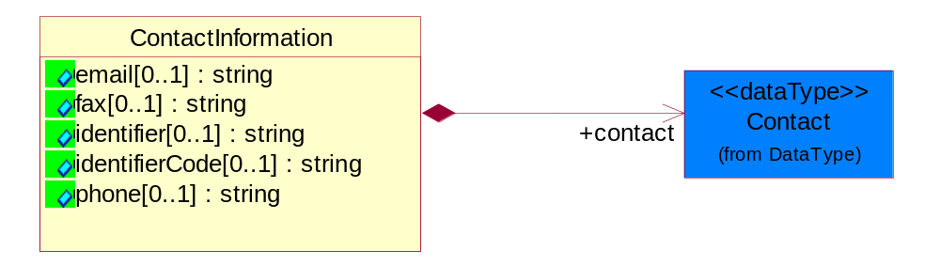
Figure 4-30 Contact Information

Attribute | Type | Documentation
email[0..1] | string | The electronic mail for the specified contact.
fax[0..1] | string | The fax number for the specified contact.
identifier[0..1] | string | Identifies the role of the contact (i.e. Service Technician, Account Manager) in the Business Process.
identifierCode[0..1] | string | IdentifierCode is a unique security authorization code to identify the contact- ie. badge ID.
phone[0..1] | string | The telephone number for the specified contact.

Composition | Cardinality | Type | Documentation
contact | 1 | Contact | The name of the department, service or individual to be contacted within the organization.

Data Type

Contact
The name of the department, service or individual to be contacted within the organization.
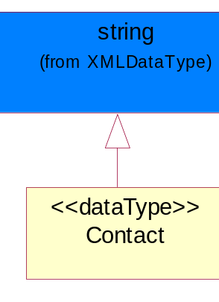
Figure 4-31 Contact

DUNS
A number assigned by Dun and Bradstreet to identify a business location.
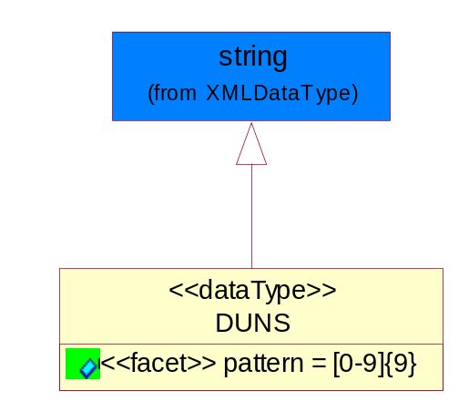
Figure 4-32 DUNS

Attribute | Type | Documentation
pattern |  | [0-9]{9}

DUNSPlus4
A identifier to specify a specific location within a business location.
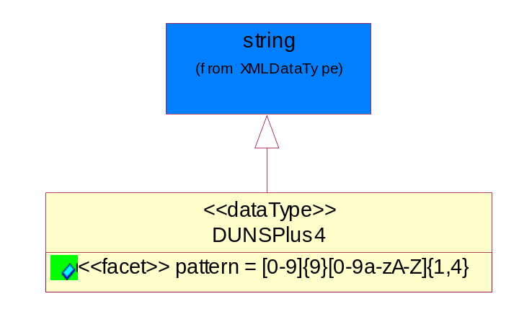
Figure 4-33 DUNSPlus4

Attribute | Type | Documentation
pattern |  | Data Universal Numbering System +4 (DUNS+4) number means the DUNS number assigned by Dun and Bradstreet, Inc. (D&B) plus an alphanumeric of length 4 suffix that may be assigned by a business concern.

GLN
Global Location Number (GLN) - A identifier to identify legal entities, trading parties and location.
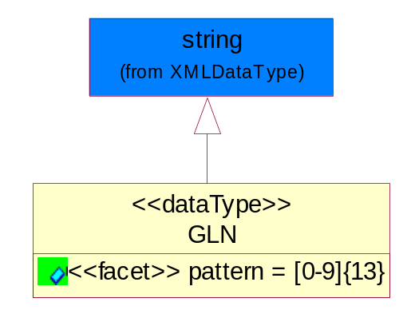
Figure 4-34 GLN

Attribute | Type | Documentation
pattern |  | [0-9]{13}

GTIN
Global Trade Identification Number (GTIN).
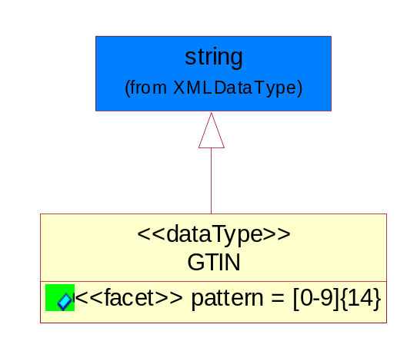
Figure 4-35 GTIN

Attribute | Type | Documentation
pattern |  | [0-9]{14}

Percent Amount
A number representing a percentage value, e.g. 75.125 represents 75 1/8 percent.
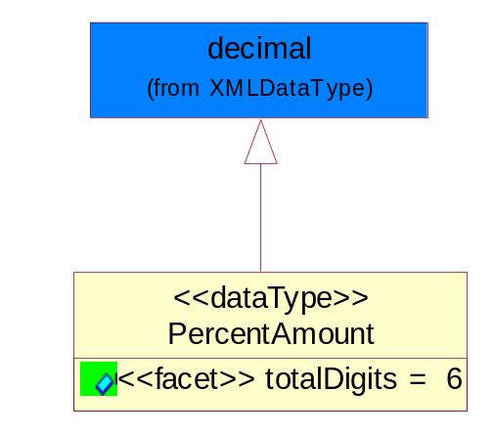
Figure 4-36 Percent Amount

Attribute | Type | Documentation
totalDigits |  | 6

Dates

Date Period
The business document must allow for the computation or statement of a duration based upon a beginning and an ending date.
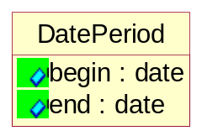
Figure 4-37 Date Period

Attribute | Type | Documentation
begin | date | The date indicating the beginning of the date period.
end | date | The date indicating the ending of the date period.

Document

Business Document Reference
The business document reference object allows for the indirect referencing of a relationship to other business related documents.
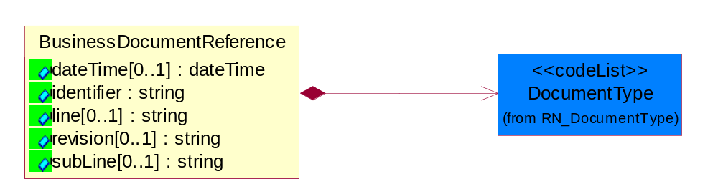
Figure 4-38 Business Document Reference

Attribute | Type | Documentation
dateTime[0..1] | dateTime | The date-time stamp indicating on the referenced business document.
identifier | string | Unique identification of the referenced business document.
line[0..1] | string | References the specific line number of the specified business document.
revision[0..1] | string | Referenced the revision of the specified business document.
subLine[0..1] | string | References the specific subline number of the specified business document.

Composition | Cardinality | Type | Documentation
DocumentType | 1 | DocumentType | A code identifying the business context of a document.

Locations

Alternative Identifier
Identifies the specified code and the name of the organization that a code is utilized from.
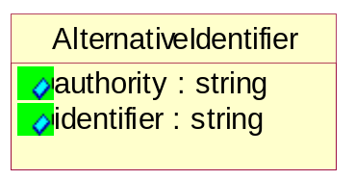
Figure 4-39 Alternative Identifier

Attribute | Type | Documentation
authority | string | The name of the organization that a code is utilized from.
identifier | string | The specified code to represent an entity (e.g. product, location, partner, etc.).

Location
The business document must specify a location.
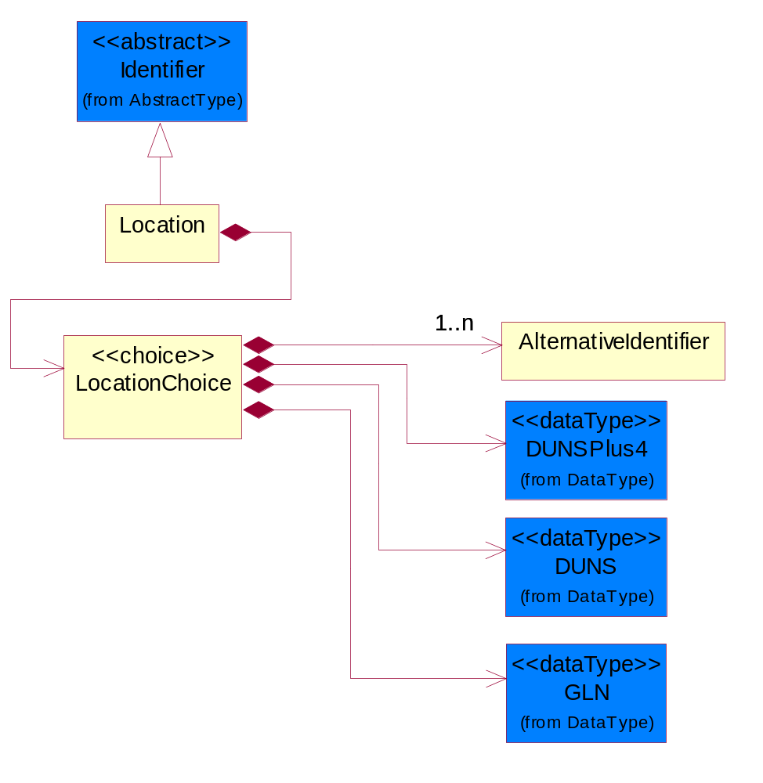
Figure 4-40 Location

Composition | Cardinality | Type | Documentation
LocationChoice | 1 | LocationChoice

Location Choice

Composition | Cardinality | Type | Documentation
DUNSPlus4 | 1 | DUNSPlus4 | A identifier to specify a specific location within a business location.
DUNS | 1 | DUNS | A number assigned by Dun and Bradstreet to identify a business location.
AlternativeIdentifier | 1..n | AlternativeIdentifier | Identifies the specified code and the name of the organization that a code is utilized from.
GLN | 1 | GLN | Global Location Number (GLN) - A identifier to identify legal entities, trading parties and location.

Physical Address
The business document must provide a physical address for a party to the business transaction.
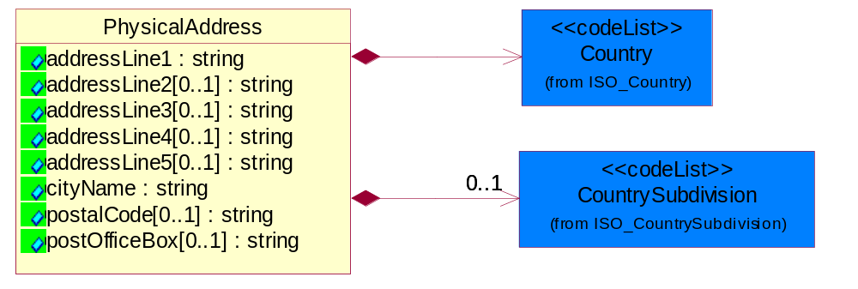
Figure 4-41 Physical Address

Attribute | Type | Documentation
addressLine1 | string | The first line of a physical address.
addressLine2[0..1] | string | The second line of a physical address.
addressLine3[0..1] | string | The third line of a physical address.
addressLine4[0..1] | string | The fourth line of a physical address.
addressLine5[0..1] | string | The fifth line of a physical address.
cityName | string | The name of a city.
postalCode[0..1] | string | Identifying geographic location as specified by a national postal code.
postOfficeBox[0..1] | string | The Post Office Box identifier used to identify a party's post office box.

Composition | Cardinality | Type | Documentation
Country | 1 | Country | For representation of Country name RosettaNet has adopted ISO 3166-3; 1999. Refer to the following web page to get the latest version of the standard:  http://www.iso.ch/iso/en/prods-services/iso3166ma/02iso-3166-code-lists/index.html  If you need more information about the ISO standard please contact ISO for more details.
CountrySubdivision | 0..1 | CountrySubdivision | For representation of a Countries subdivisions RosettaNet has adopted ISO 3166-3; 1999. Refer to the following web page to get the latest version of the standard:  http://www.iso.ch/iso/en/prods-services/iso3166ma/02iso-3166-code-lists/index.html  If you need more information about the ISO standard please contact ISO for more details.

Monetary Expression

Financial Amount
The business document must express financial amounts.
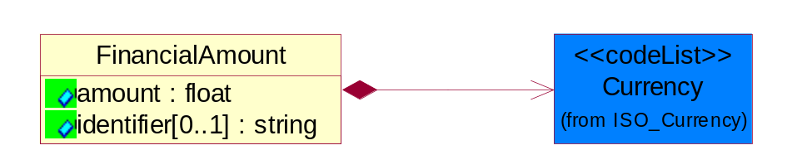
Figure 4-42 Financial Amount

Attribute | Type | Documentation
amount | float | Specifies the monetary amount.
identifier[0..1] | string | Identifier is a unique identifier to which the specific price is tied - ie. promotion name/ program.

Composition | Cardinality | Type | Documentation
Currency | 1 | Currency | For representation of Currency codes RosettaNet has adopted ISO 4217; 1995. The British Standards Institution (BSI) is the ISO 4217 Maintenance Agency. Refer to the following web page to get the latest version of the standard:  http://www.bsi-global.com/Technical+Information/Publications/_Publications/tig90.xalter  If you need more information about the ISO standard please contact ISO for more details.

Partner Identification

Full Partner
The business document must describe the trading partners in the business transaction. This data structure provide the flexibility to describe a partner in all possible methods as for new, existing or known partner.
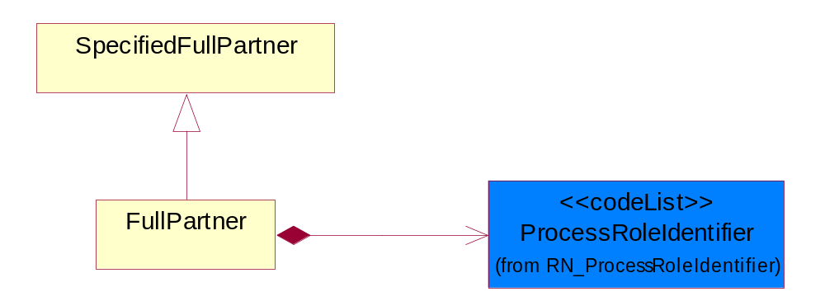
Figure 4-43 Full Partner

Composition | Cardinality | Type | Documentation
ProcessRoleIdentifier | 1 | ProcessRoleIdentifier | Describes the role of the partner in the business process. A partner will fulfill at least one or more roles during the business process.

Intermittent Partner
The business document must describe a physical address for a delivery.
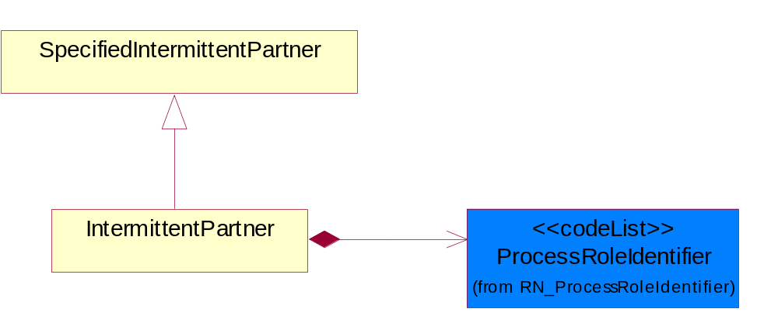
Figure 4-44 Intermittent Partner

Composition | Cardinality | Type | Documentation
ProcessRoleIdentifier | 1 | ProcessRoleIdentifier | Describes the role of the partner in the business process. A partner will fulfill at least one or more roles during the business process.

Known Partner
The business document must describe the trading partners in the business transaction.
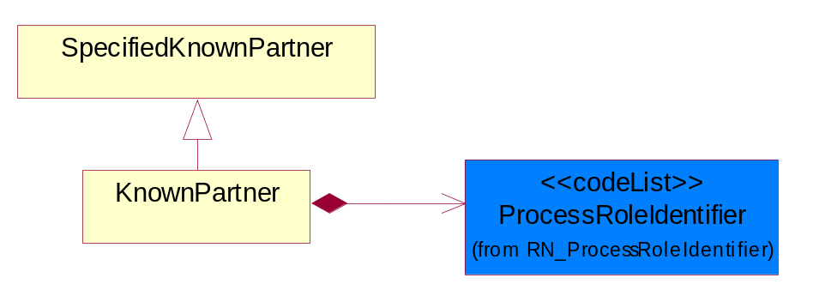
Figure 4-45 Known Partner

Composition | Cardinality | Type | Documentation
ProcessRoleIdentifier | 1 | ProcessRoleIdentifier | Describes the role of the partner in the business process. A partner will fulfill at least one or more roles during the business process.

Known Partner Contact
The business document must describe the trading partners in the business transaction.
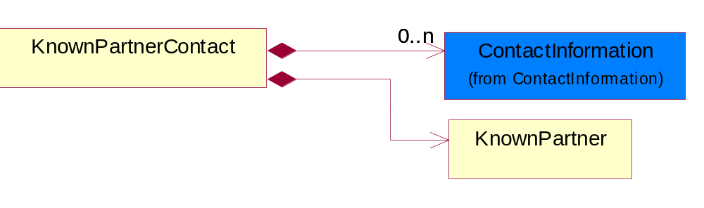
Figure 4-46 Known Partner Contact

Composition | Cardinality | Type | Documentation
KnownPartner | 1 | KnownPartner | The business document must describe the trading partners in the business transaction.
ContactInformation | 0..n | ContactInformation | The business document must allow for the identification of the name of the department, service or individual to be contacted regarding the context of the business document.

New Partner
The business document must describe a new, existing (but known to only one of the parties to the transaction) or an unknown party to the business transaction.
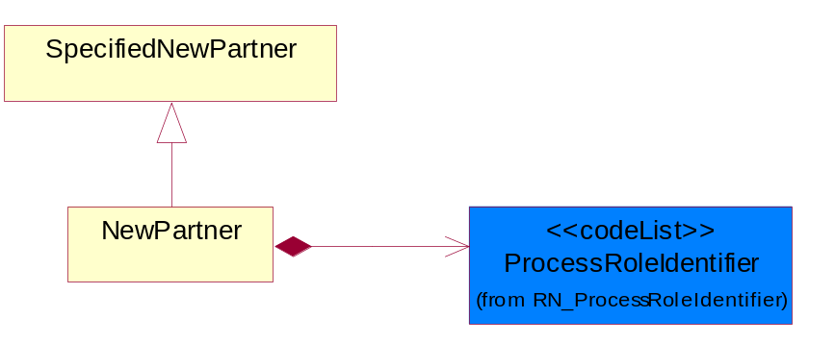
Figure 4-47 New Partner

Composition | Cardinality | Type | Documentation
ProcessRoleIdentifier | 1 | ProcessRoleIdentifier | Describes the role of the partner in the business process. A partner will fulfill at least one or more roles during the business process.

Partner Description
The collection of business properties that describe a business partners' identity, their contact information, where they are physically located and their function in a supply chain.
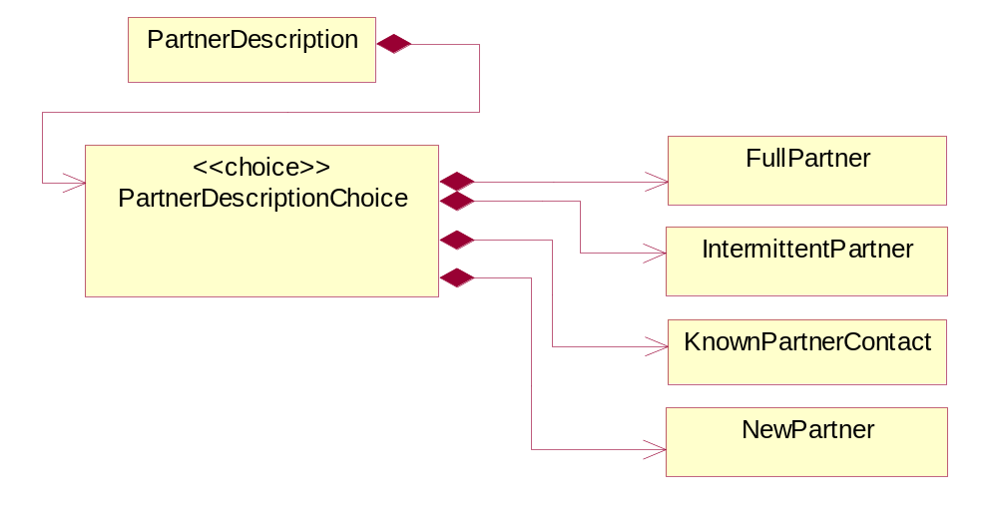
Figure 4-48 Partner Description

Composition | Cardinality | Type | Documentation
PartnerDescriptionChoice | 1 | PartnerDescriptionChoice

PartnerDescriptionChoice

Composition | Cardinality | Type | Documentation
KnownPartnerContact | 1 | KnownPartnerContact | The business document must describe the trading partners in the business transaction.
IntermittentPartner | 1 | IntermittentPartner | The business document must describe a physical address for a delivery.
NewPartner | 1 | NewPartner | The business document must describe a new, existing (but known to only one of the parties to the transaction) or an unknown party to the business transaction.
FullPartner | 1 | FullPartner | The business document must describe the trading partners in the business transaction. This data structure provide the flexibility to describe a partner in all possible methods as for new, existing or known partner.

Partner Identification
The business document must allow for the identity of one or more parties to the transaction.
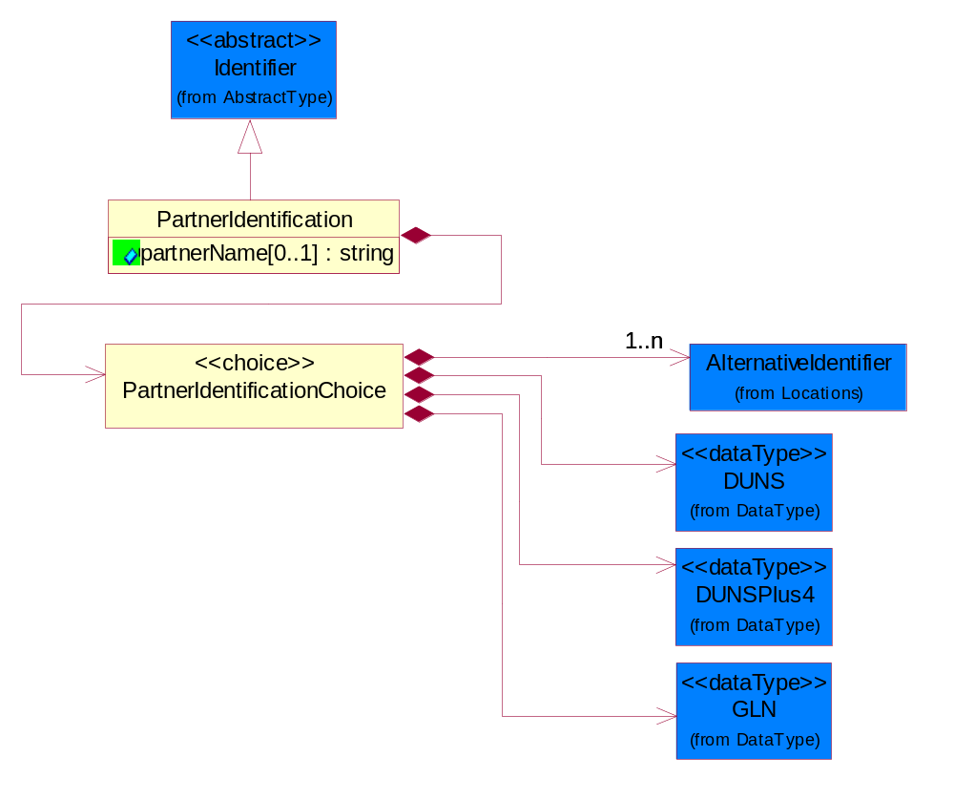
Figure 4-49 Partner Identification

Attribute | Type | Documentation
partnerName[0..1] | string | The name of the partner’s company/business.

Composition | Cardinality | Type | Documentation
PartnerIdentificationChoice | 1 | PartnerIdentificationChoice

Partner Identification Choice

Composition | Cardinality | Type | Documentation
DUNS | 1 | DUNS | A number assigned by Dun and Bradstreet to identify a business location.
DUNSPlus4 | 1 | DUNSPlus4 | A identifier to specify a specific location within a business location.
AlternativeIdentifier | 1..n | AlternativeIdentifier | Identifies the specified code and the name of the organization that a code is utilized from.
GLN | 1 | GLN | Global Location Number (GLN) - A identifier to identify legal entities, trading parties and location.

Specified Full Partner
The business document must describe the trading partners in the business transaction. This data structure provide the flexibility to describe a partner in all possible methods as for new, existing or known partner. This is specifically for partner who role has been specified.
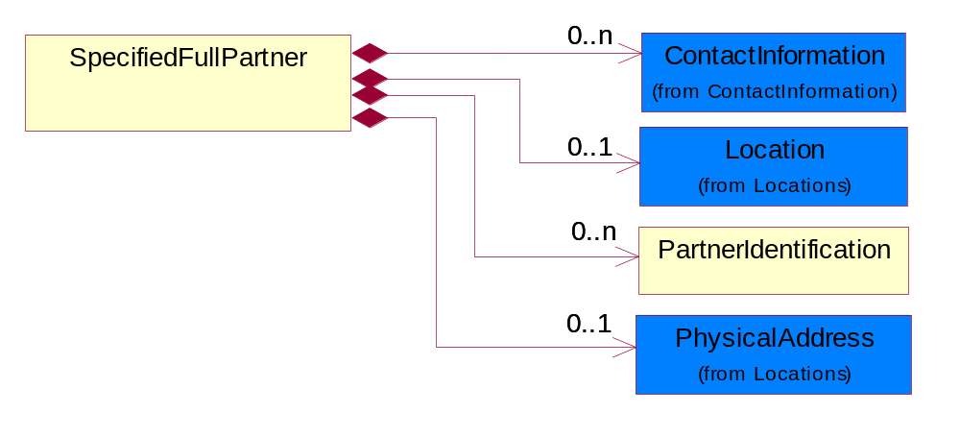
Figure 4-50 Specified Full Partner

Composition | Cardinality | Type | Documentation
ContactInformation | 0..n | ContactInformation | The business document must allow for the identification of the name of the department, service or individual to be contacted regarding the context of the business document.
Location | 0..1 | Location | The business document must specify a location.
PartnerIdentification | 0..n | PartnerIdentification | The business document must allow for the identity of one or more parties to the transaction.
PhysicalAddress | 0..1 | PhysicalAddress | The business document must provide a physical address for a party to the business transaction.

Specified Intermittent Partner
The business document must describe a physical address for a delivery.
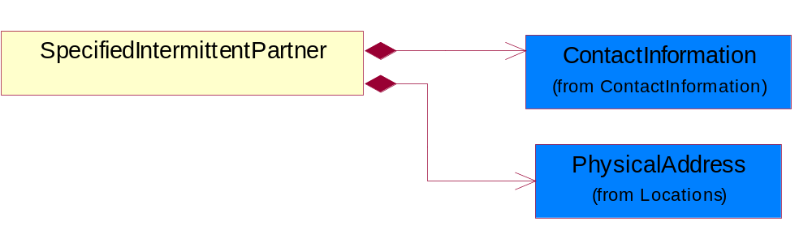
Figure 4-51 Specified Intermittent Partner

Composition | Cardinality | Type | Documentation
ContactInformation | 1 | ContactInformation | The business document must allow for the identification of the name of the department, service or individual to be contacted regarding the context of the business document.
PhysicalAddress | 1 | PhysicalAddress | The business document must provide a physical address for a party to the business transaction.

Specified Known Partner
The business document must describe the trading partners in the business transaction.
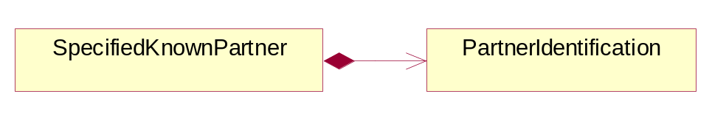
Figure 4-52 Specified Known Partner

Composition | Cardinality | Type | Documentation
PartnerIdentification | 1 | PartnerIdentification | The business document must allow for the identity of one or more parties to the transaction.

Specified Known Partner Contact
The business document must describe the trading partners in the business transaction and allow for a identification of an individual of the trading partner.
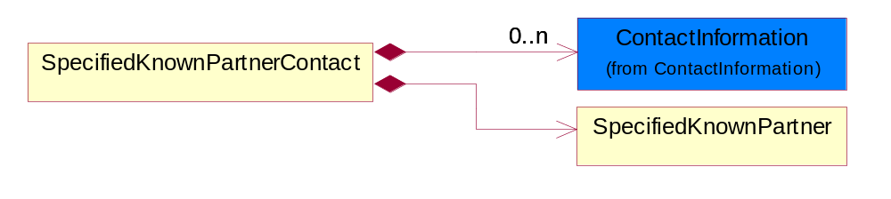
Figure 4-53 Specified Known Partner Contact

Composition | Cardinality | Type | Documentation
SpecifiedKnownPartner | 1 | SpecifiedKnownPartner | The business document must describe the trading partners in the business transaction.
ContactInformation | 0..n | ContactInformation | The business document must allow for the identification of the name of the department, service or individual to be contacted regarding the context of the business document.

Specified New Partner
The business document must describe a new, existing (but known to only one of the parties to the transaction) or an unknown party to the business transaction.
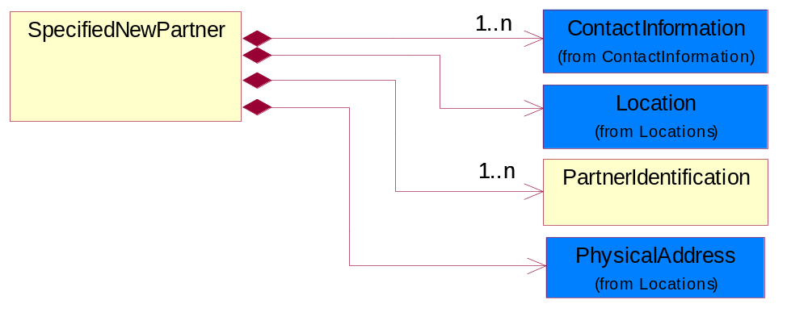
Figure 4-54 Specified New Partner

Composition | Cardinality | Type | Documentation
ContactInformation | 1..n | ContactInformation | The business document must allow for the identification of the name of the department, service or individual to be contacted regarding the context of the business document.
Location | 1 | Location | The business document must specify a location.
PhysicalAddress | 1 | PhysicalAddress | The business document must provide a physical address for a party to the business transaction.
PartnerIdentification | 1..n | PartnerIdentification | The business document must allow for the identity of one or more parties to the transaction.

Specified Partner Description
The collection of business properties that describe a business partners' identity, their contact information, where they are physically located and their function in a supply chain.
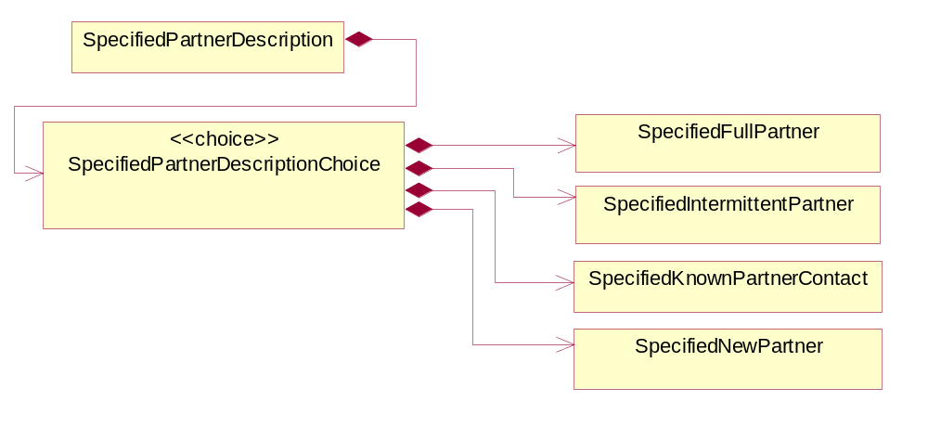
Figure 4-55 Specified Partner Description

Composition | Cardinality | Type | Documentation
SpecifiedPartnerDescriptionChoice | 1 | SpecifiedPartnerDescriptionChoice

Specified Partner Description Choice

Composition | Cardinality | Type | Documentation
SpecifiedKnownPartnerContact | 1 | SpecifiedKnownPartnerContact | The business document must describe the trading partners in the business transaction and allow for a identification of an individual of the trading partner.
SpecifiedIntermittentPartner | 1 | SpecifiedIntermittentPartner | The business document must describe a physical address for a delivery.
SpecifiedNewPartner | 1 | SpecifiedNewPartner | The business document must describe a new, existing (but known to only one of the parties to the transaction) or an unknown party to the business transaction.
SpecifiedFullPartner | 1 | SpecifiedFullPartner | The business document must describe the trading partners in the business transaction. This data structure provide the flexibility to describe a partner in all possible methods as for new, existing or known partner. This is specifically for partner who role has been specified.

Product Identification

Product Identification
The object provides the identifier(s) of a product.
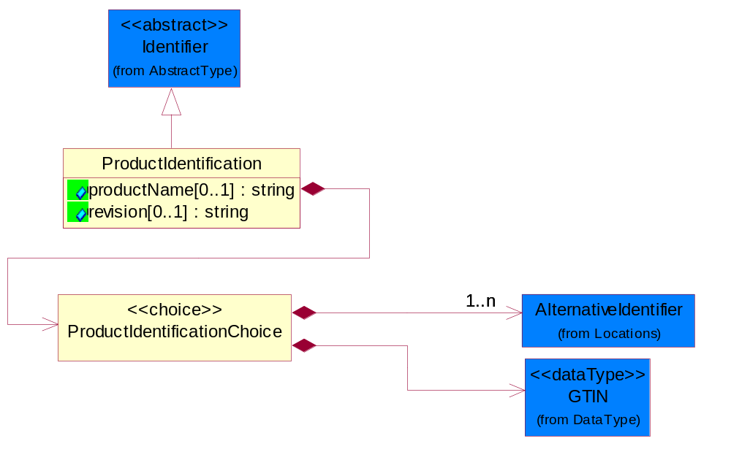
Figure 4-56 Product Identification

Attribute | Type | Documentation
productName[0..1] | string | The name of the product.
revision[0..1] | string | Referenced the specified product revision.

Composition | Cardinality | Type | Documentation
ProductIdentificationChoice | 1 | ProductIdentificationChoice

Product Identification Choice

Composition | Cardinality | Type | Documentation
AlternativeIdentifier | 1..n | AlternativeIdentifier | Identifies the specified code and the name of the organization that a code is utilized from.
GTIN | 1 | GTIN | Global Trade Identification Number (GTIN).

Code List

Country
For representation of Country name RosettaNet has adopted ISO 3166-3; 1999. Refer to the following web page to get the latest version of the standard:
http://www.iso.ch/iso/en/prods-services/iso3166ma/02iso-3166-code-lists/index.html

If you need more information about the ISO standard please contact ISO for more details.

Country Subdivision
For representation of a Countries subdivisions RosettaNet has adopted ISO 3166-3; 1999. Refer to the following web page to get the latest version of the standard:
http://www.iso.ch/iso/en/prods-services/iso3166ma/02iso-3166-code-lists/index.html

If you need more information about the ISO standard please contact ISO for more details.

Currency
For representation of Currency codes RosettaNet has adopted ISO 4217; 1995. The British Standards Institution (BSI) is the ISO 4217 Maintenance Agency. Refer to the following web page to get the latest version of the standard:
http://www.bsi-global.com/Technical+Information/Publications/_Publications/tig90.xalter

If you need more information about the ISO standard please contact ISO for more details.

Language
For representation of Language name RosettaNet has adopted ISO 639-2; 1998. Refer to the following web page to get the latest version of the standard:

http://www.loc.gov/standards/iso639-2/iso639jac.html

If you need more information about the ISO standard please contact ISO for more details.

Document Type
A code identifying the business context of a document.

Instance | Documentation
APM | Applied Promotions.
ARA | Authorization Request Approval.
CAR | Certificate of Analysis Response.
CBN | Product batch number of customer.
CCN | Customs clearance number.
CFA | Failure Analysis - Request document that will accompany the product providing characteristics of the component failure.
CIN | Commercial Invoice.
CNM | Traditional credit note or memo.
COA | Certificate of Analysis.
CON | In a virtual sourcing relationship, a third party trading partner is supplying a part to a customer on behalf of another company that has taken the order for the customer. In this case a Customer Order Number is associated to the request for material that is sent to the virtual trading partners.
COS | Consumption Notice.
COT | Contract.
CRN | Unique consumption reference number identifying the product consumption issue i.e. one-to-one relationship with physical flow.
DEM | Traditional debit note or memo.
DEN | Delivery Note.
DIN | Discontinuation Notice.
DOR | Delivery Order.
DRN | Drawing Number.
DRR | Design Registration Request.
ECO | Engineering Change Order - The proprietary unique identification number that represents an engineering change order.
EDD | Export Declaration Document.
EIR | Engineering Information Request.
EOL | End of Life.
FUO | Sales order or transfer order fulfilling demand out of a facility (outbound shipment).
IDD | Import Declaration Document.
INV | Invoice.
LID | Location Identifier. Data for on-site work that have to be done on the machine (associated with preventive maintenance order).
MEN | Master Event Number.
MID | Machine Identifier. Data for on-site work that have to be done on the machine (associated with preventive maintenance order).
MON | Model Number.
NTS | Notes.
OCL | The unique identifier assigned by the OEM for a warranty claim.
OGA | Other governmental agency issued document.
OPO | The unique identifier assigned by the OEM for a part order.
OPR | The unique identifier assigned by the OEM for a part return.
PCN | Product/Process Change.
PFA | Failure Analysis - Request document that will accompany the product providing characteristics of the product failure.
PII | Refers to previously issued invoice.
PLS | Unique number that identifies packing form prior to shipment.
POI | Purchase Order IN.
PON | Production order number for material release.
POO | Purchase Order OUT.
PRC | Product Catalog.
PSI | Refers to previously issued self-billing invoice.
PUO | Purchase Order.
QUO | Quote.
REC | Document identifying the receipt of materials or products into a facility against a purchase order or transfer order (inbound shipment).
REN | Release Number.
REO | Purchase order or transfer order replenishing inventory into a facility (inbound shipment).
REQ | Requisition.
RMA | Returned Material Authorization.
RPO | Purchase order for materials or product returned to and reworked by a supplier.
RTA | Remittance Advice - Remittance details.
SAO | Sales Order.
SBC | Credit Memo used in self-billing scenario.
SBD | Debit Memo used in self-billing scenario.
SBI | Invoice in self billing scenario.
SBN | Product batch number of supplier.
SCA | Similar to contracts - Contains the quantity of an article that is to be ordered from a vendor and the price for article or service that is to be procured.
SEN | Serial Number.
SEO | A document that gives a repair provider the necessary authorization to repair or upgrade a product either at the customer site or at the repair provider’s site.
SHD | Shipping Document.
SNC | Shipset Number on Code List.
SPC | The unique identifier assigned by the ASP for a warranty claim.
SPN | Spec Number.
SPO | The unique identifier assigned by the ASP for a part order.
SPR | The unique identifier assigned by the ASP for a part return.
SPW | The unique identifier assigned by the ASP to reference a work order.
SRI | A document that contains the shipping reference number which allows the product to be tracked within the outsourced logistic providers network.
SWT | Switch Authorization.
TCS | Terms and Conditions.
TRO | Order which results in materials or products being moved from one facility to another (outbound shipment and inbound shipment).
WAB | Waybill.
WAC | Denotes a warranty claim.
WOO | Work Order.

Mime Type Qualifier
The MIME type as defined by IANA.

Please refer to http://www.iana.org/assignments/media-types/ for a list of types.

Instance | Documentation
application/activemessage | [Shapiro]
application/andrew-inset | [Borenstein]
application/applefile | [Faltstrom]
application/atomicmail | [Borenstein]
application/batch-SMTP | [RFC2442]
application/beep+xml | [RFC3080]
application/cals-1840 | [RFC1895]
application/cnrp+xml | [RFCCNRP]
application/commonground | [Glazer]
application/cpl+xml
application/cybercash | [Eastlake]
application/dca-rft | [Campbell]
application/dec-dx | [Campbell]
application/dicom | [RFC3240]
application/dvcs | [RFC3029]
application/EDI-Consent | [RFC1767]
application/EDIFACT | [RFC1767]
application/EDI-X12 | [RFC1767]
application/eshop | [Katz]
application/font-tdpfr | [RFC3073]
application/http | [RFC2616]
application/hyperstudio | [Domino]
application/iges | [Parks]
application/index | [RFC2652]
application/index.cmd | [RFC2652]
application/index.obj | [RFC2652]
application/index.response | [RFC2652]
application/index.vnd | [RFC2652]
application/iotp | [RFC2935]
application/ipp | [RFC2910]
application/isup | [RFC3204]
application/mac-binhex40 | [Faltstrom]
application/macwriteii | [Lindner]
application/marc | [RFC2220]
application/mathematica | [Van Nostern]
application/msword | [Lindner]
application/news-message-id | [RFC1036,Spencer]
application/news-transmission | [RFC1036, Spencer]
application/ocsp-request | [RFC2560]
application/ocsp-response | [RFC2560]
application/octet-stream | [RFC2045,RFC2046]
application/oda | [RFC2045,RFC2046]
application/ogg | [RFC-walleij-ogg-mediatype-08.txt]
application/parityfec | [RFC3009]
application/pdf | [Lindner]
application/pgp-encrypted | [RFC3156]
application/pgp-keys | [RFC3156]
application/pgp-signature | [RFC3156]
application/pkcs10 | [RFC2311]
application/pkcs7-mime | [RFC2311]
application/pkcs7-signature | [RFC2311]
application/pkix-cert | [RFC2585]
application/pkixcmp | [RFC2510]
application/pkix-crl | [RFC2585]
application/postscript | [RFC2045,RFC2046]
application/prs.alvestrand.titrax-sheet | [Alvestrand]
application/prs.cww | [Rungchavalnont]
application/prs.nprend | [Doggett]
application/prs.plucker | [Janssen]
application/qsig | [RFC3204]
application/reginfo+xml | [RFC-ietf-sipping-reg-event-00.txt]
application/remote-printing | [RFC1486,Rose]
application/riscos | [Smith]
application/rtf | [Lindner]
application/sdp | [RFC2327]
application/set-payment | [Korver]
application/set-payment-initiation | [Korver]
application/set-registration | [Korver]
application/set-registration-initiation | [Korver]
application/sgml | [RFC1874]
application/sgml-open-catalog | [Grosso]
application/sieve | [RFC3028]
application/slate | [Crowley]
application/timestamp-query | [RFC3161]
application/timestamp-reply | [RFC3161]
application/tve-trigger | [Welsh]
application/vemmi | [RFC2122]
application/vnd.3gpp.pic-bw-large | [Meredith]
application/vnd.3gpp.pic-bw-small | [Meredith]
application/vnd.3gpp.pic-bw-var | [Meredith]
application/vnd.3gpp.sms | [Meredith]
application/vnd.3M.Post-it-Notes | [O'Brien]
application/vnd.accpac.simply.aso | [Leow]
application/vnd.accpac.simply.imp | [Leow]
application/vnd.acucobol | [Lubin]
application/vnd.acucorp | [Lubin]
application/vnd.adobe.xfdf | [Perelman]
application/vnd.aether.imp | [Moskowitz]
application/vnd.amiga.ami | [Blumberg]
application/vnd.anser-web-certificate-issue-initiation | [Mori]
application/vnd.anser-web-funds-transfer-initiation | [Mori]
application/vnd.audiograph | [Slusanschi]
application/vnd.blueice.multipass | [Holmstrom]
application/vnd.bmi | [Gotoh]
application/vnd.businessobjects | [Imoucha]
application/vnd.canon-cpdl | [Muto]
application/vnd.canon-lips | [Muto]
application/vnd.cinderella | [Kortenkamp]
application/vnd.claymore | [Simpson]
application/vnd.commerce-battelle | [Applebaum]
application/vnd.commonspace | [Chandhok]
application/vnd.contact.cmsg | [Patz]
application/vnd.cosmocaller | [Dellutri]
application/vnd.ctc-posml | [Kohlhepp]
application/vnd.cups-postscript | [Sweet]
application/vnd.cups-raster | [Sweet]
application/vnd.cups-raw | [Sweet]
application/vnd.curl | [Byrnes]
application/vnd.cybank | [Helmee]
application/vnd.data-vision.rdz | [Fields]
application/vnd.dna | [Searcy]
application/vnd.dpgraph | [Parker]
application/vnd.dreamfactory | [Appleton]
application/vnd.dxr | [Duffy]
application/vnd.ecdis-update | [Buettgenbach]
application/vnd.ecowin.chart | [Olsson]
application/vnd.ecowin.filerequest | [Olsson]
application/vnd.ecowin.fileupdate | [Olsson]
application/vnd.ecowin.series | [Olsson]
application/vnd.ecowin.seriesrequest | [Olsson]
application/vnd.ecowin.seriesupdate | [Olsson]
application/vnd.enliven | [Santinelli]
application/vnd.epson.esf | [Hoshina]
application/vnd.epson.msf | [Hoshina]
application/vnd.epson.quickanime | [Gu]
application/vnd.epson.salt | [Nagatomo]
application/vnd.epson.ssf | [Hoshina]
application/vnd.ericsson.quickcall | [Tidwell]
application/vnd.eudora.data | [Resnick]
application/vnd.fdf | [Zilles]
application/vnd.ffsns | [Holstage]
application/vnd.FloGraphIt | [Floersch]
application/vnd.framemaker | [Wexler]
application/vnd.fsc.weblaunch | [D.Smith]
application/vnd.fujitsu.oasys | [Togashi]
application/vnd.fujitsu.oasys2 | [Togashi]
application/vnd.fujitsu.oasys3 | [Okudaira]
application/vnd.fujitsu.oasysgp | [Sugimoto]
application/vnd.fujitsu.oasysprs | [Ogita]
application/vnd.fujixerox.ddd | [Onda]
application/vnd.fujixerox.docuworks | [Taguchi]
application/vnd.fujixerox.docuworks.binder | [Matsumoto]
application/vnd.fut-misnet | [Pruulmann]
application/vnd.grafeq | [Tupper]
application/vnd.groove-account | [Joseph]
application/vnd.groove-help | [Joseph]
application/vnd.groove-identity-message | [Joseph]
application/vnd.groove-injector | [Joseph]
application/vnd.groove-tool-message | [Joseph]
application/vnd.groove-tool-template | [Joseph]
application/vnd.groove-vcard | [Joseph]
application/vnd.hbci | [Hammann]
application/vnd.hhe.lesson-player | [Jones]
application/vnd.hp-HPGL | [Pentecost]
application/vnd.hp-hpid | [Gupta]
application/vnd.hp-hps | [Aubrey]
application/vnd.hp-PCL | [Pentecost]
application/vnd.hp-PCLXL | [Pentecost]
application/vnd.httphone | [Lefevre]
application/vnd.hzn-3d-crossword | [Minnis]
application/vnd.ibm.afplinedata | [Buis]
application/vnd.ibm.electronic-media | [Tantlinger]
application/vnd.ibm.MiniPay | [Herzberg]
application/vnd.ibm.modcap | [Hohensee]
application/vnd.ibm.secure-container | [Tantlinger]
application/vnd.informix-visionary | [Gales]
application/vnd.intercon.formnet | [Gurak]
application/vnd.intertrust.digibox | [Tomasello]
application/vnd.intertrust.nncp | [Tomasello]
application/vnd.intu.qbo | [Scratchley]
application/vnd.intu.qfx | [Scratchley]
application/vnd.irepository.package+xml | [Knowles]
application/vnd.is-xpr | [Natarajan]
application/vnd.japannet-directory-service | [Fujii]
application/vnd.japannet-jpnstore-wakeup | [Yoshitake]
application/vnd.japannet-payment-wakeup | [Fujii]
application/vnd.japannet-registration | [Yoshitake]
application/vnd.japannet-registration-wakeup | [Fujii]
application/vnd.japannet-setstore-wakeup | [Yoshitake]
application/vnd.japannet-verification | [Yoshitake]
application/vnd.japannet-verification-wakeup | [Fujii]
application/vnd.jisp | [Deckers]
application/vnd.kde.karbon | [Faure]
application/vnd.kde.kchart | [Faure]
application/vnd.kde.kformula | [Faure]
application/vnd.kde.kivio | [Faure]
application/vnd.kde.kontour | [Faure]
application/vnd.kde.kpresenter | [Faure]
application/vnd.kde.kspread | [Faure]
application/vnd.kde.kword | [Faure]
application/vnd.kenameaapp | [DiGiorgio-Haag]
application/vnd.koan | [Cole]
application/vnd.liberty-request+xml | [McDowell]
application/vnd.llamagraphics.life-balance.desktop | [White]
application/vnd.lotus-1-2-3 | [Wattenberger]
application/vnd.lotus-approach | [Wattenberger]
application/vnd.lotus-freelance | [Wattenberger]
application/vnd.lotus-notes | [Laramie]
application/vnd.lotus-organizer | [Wattenberger]
application/vnd.lotus-screencam | [Wattenberger]
application/vnd.lotus-wordpro | [Wattenberger]
application/vnd.mcd | [Gotoh]
application/vnd.mediastation.cdkey | [Flurry]
application/vnd.meridian-slingshot | [Wedel]
application/vnd.micrografx.flo | [Prevo]
application/vnd.micrografx.igx | [Prevo]
application/vnd.mif | [Wexler]
application/vnd.minisoft-hp3000-save | [Bartram]
application/vnd.mitsubishi.misty-guard.trustweb | [Tanaka]
application/vnd.Mobius.DAF | [Kabayama]
application/vnd.Mobius.DIS | [Kabayama]
application/vnd.Mobius.MBK | [Devasia]
application/vnd.Mobius.MQY | [Devasia]
application/vnd.Mobius.MSL | [Kabayama]
application/vnd.Mobius.PLC | [Kabayama]
application/vnd.Mobius.TXF | [Kabayama]
application/vnd.mophun.application | [Wennerstrom]
application/vnd.mophun.certificate | [Wennerstrom]
application/vnd.motorola.flexsuite | [Patton]
application/vnd.motorola.flexsuite.adsi | [Patton]
application/vnd.motorola.flexsuite.fis | [Patton]
application/vnd.motorola.flexsuite.gotap | [Patton]
application/vnd.motorola.flexsuite.kmr | [Patton]
application/vnd.motorola.flexsuite.ttc | [Patton]
application/vnd.motorola.flexsuite.wem | [Patton]
application/vnd.mozilla.xul+xml | [McDaniel]
application/vnd.ms-artgalry | [Slawson]
application/vnd.ms-asf | [Fleischman]
application/vnd.mseq | [Le Bodic]
application/vnd.ms-excel | [Gill]
application/vnd.msign | [Borcherding]
application/vnd.ms-lrm | [Ledoux]
application/vnd.ms-powerpoint | [Gill]
application/vnd.ms-project | [Gill]
application/vnd.ms-tnef | [Gill]
application/vnd.ms-works | [Gill]
application/vnd.ms-wpl | [Plastina]
application/vnd.musician | [Adams]
application/vnd.music-niff | [Butler]
application/vnd.netfpx | [Mutz]
application/vnd.noblenet-directory | [Solomon]
application/vnd.noblenet-sealer | [Solomon]
application/vnd.noblenet-web | [Solomon]
application/vnd.novadigm.EDM | [Swenson]
application/vnd.novadigm.EDX | [Swenson]
application/vnd.novadigm.EXT | [Swenson]
application/vnd.obn | [Hessling]
application/vnd.osa.netdeploy | [Klos]
application/vnd.palm | [Peacock]
application/vnd.pg.format | [Gandert]
application/vnd.pg.osasli | [Gandert]
application/vnd.powerbuilder6 | [Guy]
application/vnd.powerbuilder6-s | [Guy]
application/vnd.powerbuilder7 | [Shilts]
application/vnd.powerbuilder75 | [Shilts]
application/vnd.powerbuilder75-s | [Shilts]
application/vnd.powerbuilder7-s | [Shilts]
application/vnd.previewsystems.box | [Smolgovsky]
application/vnd.publishare-delta-tree | [Ben-Kiki]
application/vnd.pvi.ptid1 | [Lamb]
application/vnd.pwg-multiplexed | [RFC3391]
application/vnd.pwg-xhtml-print+xml | [Wright]
application/vnd.Quark.QuarkXPress | [Scheidler]
application/vnd.rapid | [Szekely]
application/vnd.s3sms | [Tarkkala]
application/vnd.sealed.net | [Lambert]
application/vnd.seemail | [Webb]
application/vnd.shana.informed.formdata | [Selzler]
application/vnd.shana.informed.formtemplate | [Selzler]
application/vnd.shana.informed.interchange | [Selzler]
application/vnd.shana.informed.package | [Selzler]
application/vnd.smaf | [Takahashi]
application/vnd.sss-cod | [Dani]
application/vnd.sss-dtf | [Bruno]
application/vnd.sss-ntf | [Bruno]
application/vnd.street-stream | [Levitt]
application/vnd.svd | [Becker]
application/vnd.swiftview-ics | [Widener]
application/vnd.triscape.mxs | [Simonoff]
application/vnd.trueapp | [Hepler]
application/vnd.truedoc | [Chase]
application/vnd.ufdl | [Manning]
application/vnd.uplanet.alert | [Martin]
application/vnd.uplanet.alert-wbxml | [Martin]
application/vnd.uplanet.bearer-choice | [Martin]
application/vnd.uplanet.bearer-choice-wbxml | [Martin]
application/vnd.uplanet.cacheop | [Martin]
application/vnd.uplanet.cacheop-wbxml | [Martin]
application/vnd.uplanet.channel | [Martin]
application/vnd.uplanet.channel-wbxml | [Martin]
application/vnd.uplanet.list | [Martin]
application/vnd.uplanet.listcmd | [Martin]
application/vnd.uplanet.listcmd-wbxml | [Martin]
application/vnd.uplanet.list-wbxml | [Martin]
application/vnd.uplanet.signal | [Martin]
application/vnd.vcx | [T.Sugimoto]
application/vnd.vectorworks | [Pharr]
application/vnd.vidsoft.vidconference | [Hess]
application/vnd.visio | [Sandal]
application/vnd.visionary | [Aravindakumar]
application/vnd.vividence.scriptfile | [Risher]
application/vnd.vsf | [Rowe]
application/vnd.wap.sic | [WAP-Forum]
application/vnd.wap.slc | [WAP-Forum]
application/vnd.wap.wbxml | [Stark]
application/vnd.wap.wmlc | [Stark]
application/vnd.wap.wmlscriptc | [Stark]
application/vnd.webturbo | [Rehem]
application/vnd.wrq-hp3000-labelled | [Bartram]
application/vnd.wt.stf | [Wohler]
application/vnd.wv.csp+wbxml | [Salmi]
application/vnd.xara | [Matthewman]
application/vnd.xfdl | [Manning]
application/vnd.yellowriver-custom-menu | [Yellow]
application/whoispp-query | [RFC2957]
application/whoispp-response | [RFC2958]
application/wita | [Campbell]
application/wordperfect5.1 | [Lindner]
application/x400-bp | [RFC1494]
application/xhtml+xml | [RFC3236]
application/xml | [RFC3023]
application/xml-dtd | [RFC3023]
application/xml-external-parsed-entity | [RFC3023]
application/zip | [Lindner]
audio/32kadpcm | [RFC2421,RFC2422]
audio/AMR | [RFC3267]
audio/AMR-WB | [RFC3267]
audio/basic | [RFC2045,RFC2046]
audio/CN | [RFC3389]
audio/DAT12 | [RFC3190]
audio/DVI4
audio/EVRC | [RFC-ietf-avt-evrc-smv-03.txt]
audio/EVRC0 | [RFC-ietf-avt-evrc-smv-03.txt]
audio/G.722.1 | [RFC3047]
audio/G722
audio/G723
audio/G726-16
audio/G726-24
audio/G726-32
audio/G726-40
audio/G728
audio/G729
audio/G729D
audio/G729E
audio/GSM
audio/GSM-EFR
audio/L16 | [RFC2586]
audio/L20 | [RFC3190]
audio/L24 | [RFC3190]
audio/L8
audio/LPC
audio/MP4A-LATM | [RFC3016]
audio/MPA
audio/mpa-robust | [RFC3119]
audio/mpeg | [RFC3003]
audio/parityfec | [RFC3009]
audio/PCMA
audio/PCMU
audio/prs.sid | [Walleij]
audio/QCELP
audio/RED
audio/SMV | [RFC-ietf-avt-evrc-smv-03.txt]
audio/SMV0 | [RFC-ietf-avt-evrc-smv-03.txt]
audio/telephone-event | [RFC2833]
audio/tone | [RFC2833]
audio/VDVI
audio/vnd.3gpp.iufp | [Belling]
audio/vnd.cisco.nse | [Kumar]
audio/vnd.cns.anp1 | [McLaughlin]
audio/vnd.cns.inf1 | [McLaughlin]
audio/vnd.digital-winds | [Strazds]
audio/vnd.everad.plj | [Cicelsky]
audio/vnd.lucent.voice | [Vaudreuil]
audio/vnd.nortel.vbk | [Parsons]
audio/vnd.nuera.ecelp4800 | [Fox]
audio/vnd.nuera.ecelp7470 | [Fox]
audio/vnd.nuera.ecelp9600 | [Fox]
audio/vnd.octel.sbc | [Vaudreuil]
audio/vnd.qcelp | [Lundblade]
audio/vnd.rhetorex.32kadpcm | [Vaudreuil]
audio/vnd.vmx.cvsd | [Vaudreuil]
image/cgm | Computer Graphics Metafile
image/g3fax | [RFC1494]
image/gif | [RFC2045,RFC2046]
image/ief | [RFC1314] Image Exchange Format
image/jpeg | [RFC2045,RFC2046]
image/naplps | [Ferber]
image/png | [Randers-Pehrson]
image/prs.btif | [Simon]
image/prs.pti | [Laun]
image/t38 | [RFC3362]
image/tiff | [RFC3302] Tag Image File Format
image/tiff-fx | [RFC3250] Tag Image File Format Fax eXtended
image/vnd.cns.inf2 | [McLaughlin]
image/vnd.djvu | [Bottou]
image/vnd.dwg | [Moline]
image/vnd.dxf | [Moline]
image/vnd.fastbidsheet | [Becker]
image/vnd.fpx | [Spencer]
image/vnd.fst | [Fuldseth]
image/vnd.fujixerox.edmics-mmr | [Onda]
image/vnd.fujixerox.edmics-rlc | [Onda]
image/vnd.globalgraphics.pgb | [Bailey]
image/vnd.mix | [Reddy]
image/vnd.ms-modi | [Vaughan]
image/vnd.net-fpx | [Spencer]
image/vnd.svf | [Moline]
image/vnd.wap.wbmp | [Stark]
image/vnd.xiff | [S.Martin]
message/delivery-status | [RFC1894]
message/disposition-notification | [RFC2298]
message/external-body | [RFC2045,RFC2046]
message/http | [RFC2616]
message/news | [RFC 1036, H.Spencer]
message/partial | [RFC2045,RFC2046]
message/rfc822 | [RFC2045,RFC2046]
message/s-http | [RFC2660]
message/sip | [RFC3261]
message/sipfrag | [RFC3420]
model/iges | [Parks]
model/mesh | [RFC2077]
model/vnd.dwf | [Pratt]
model/vnd.flatland.3dml | [Powers]
model/vnd.gdl | [Babits]
model/vnd.gs-gdl | [Babits]
model/vnd.gtw | [Ozaki]
model/vnd.mts | [Rabinovitch]
model/vnd.parasolid.transmit.binary | [Parasolid]
model/vnd.parasolid.transmit.text | [Parasolid]
model/vnd.vtu | [Rabinovitch]
model/vrml | [RFC2077]
multipart/alternative | [RFC2045,RFC2046]
multipart/appledouble | [Faltstrom]
multipart/byteranges | [RFC2068]
multipart/digest | [RFC2045,RFC2046]
multipart/encrypted | [RFC1847]
multipart/form-data | [RFC2388]
multipart/header-set | [Crocker]
multipart/mixed | [RFC2045,RFC2046]
multipart/parallel | [RFC2045,RFC2046]
multipart/related | [RFC2387]
multipart/report | [RFC1892]
multipart/signed | [RFC1847]
multipart/voice-message | [RFC2421,RFC2423]
text/calendar | [RFC2445]
text/css | [RFC2318]
text/directory | [RFC2425]
text/enriched | [RFC1896]
text/html | [RFC2854]
text/parityfec | [RFC3009]
text/plain | [RFC2646,RFC2046]
text/prs.lines.tag | [Lines]
text/rfc822-headers | [RFC1892]
text/richtext | [RFC2045,RFC2046]
text/rtf | [Lindner]
text/sgml | [RFC1874]
text/t140 | [RFC2793]
text/tab-separated-values | [Lindner]
text/uri-list | [RFC2483]
text/vnd.abc | [Allen]
text/vnd.curl | [Byrnes]
text/vnd.DMClientScript | [Bradley]
text/vnd.fly | [Gurney]
text/vnd.fmi.flexstor | [Hurtta]
text/vnd.in3d.3dml | [Powers]
text/vnd.in3d.spot | [Powers]
text/vnd.IPTC.NewsML | [IPTC]
text/vnd.IPTC.NITF | [IPTC]
text/vnd.latex-z | [Lubos]
text/vnd.motorola.reflex | [Patton]
text/vnd.ms-mediapackage | [Nelson]
text/vnd.net2phone.commcenter.command | [Xie]
text/vnd.sun.j2me.app-descriptor | [G.Adams]
text/vnd.wap.si | [WAP-Forum]
text/vnd.wap.sl | [WAP-Forum]
text/vnd.wap.wml | [Stark]
text/vnd.wap.wmlscript | [Stark]
text/xml | [RFC3023]
text/xml-external-parsed-entity | [RFC3023]
video/BMPEG
video/BT656
video/CelB
video/DV | [RFC3189]
video/H261
video/H263
video/H263-1998
video/H263-2000
video/JPEG
video/MP1S
video/MP2P
video/MP2T
video/MP4V-ES | [RFC3016]
video/mpeg | [RFC2045,RFC2046]
video/MPV
video/nv
video/parityfec | [RFC3009]
video/pointer | [RFC2862]
video/quicktime | [Lindner]
video/SMPTE292M | [RFC-avt-smpte292-video-08.txt]
video/vnd.fvt | [Fuldseth]
video/vnd.motorola.video | [McGinty]
video/vnd.motorola.videop | [McGinty]
video/vnd.mpegurl | [Recktenwald]
video/vnd.nokia.interleaved-multimedia | [Kangaslampi]
video/vnd.objectvideo | [Clark]
video/vnd.vivo | [Wolfe]

Unit Of Measure
Code identifying a product unit of measure.

Instance | Documentation
10P | 10-pack.
1BF | 100 Board Feet.
1FC | 20 Foot Container.
1GR | Gram/Cubic Centimeter.
1GT | 10,000 Gallon Tankcar.
1KB | 25 Kilogram Bulk Bag.
1KD | 10 Kilogram Drum.
1KP | 1000-pack.
1M2 | 1/Square Meter (1/M2).
1PA | 20-Pack.
1PB | 50 Pound Bag.
1PD | 100 Pound Drum.
1PM | 1/minute (1/min).
22S | Square Millimeter/Second (mm2/s).
2FC | 40 Foot Container.
2GR | Gram/square meter.
2GT | 20,000 Gallon Tankcar.
2KB | 300 Kilogram Bulk Bag.
2KD | 15 Kilogram Drum.
2PA | 100-Pack.
3GR | Grams Per 100 Centimeters.
3KB | 500 Kilogram Bulk Bag.
3KD | 55 Gallon Drum.
3MH | Cubic Millimeters/Hour (mm3/hour).
4GR | Grams Per 100 Grams.
4KD | 115 Kilogram Drum.
50P | 50-pack.
5GR | Grams Per Cubic Centimeter.
6GR | Grams Per Square Centimeter.
7GR | Grams Per Square Meter.
ABC | Absorbance per centimeter (Absorbance per cm).
ABU | Absorbance per Unit (absorbance per unit).
ACC | Atoms per Cubic Centimeters (atoms per cu cm).
ACR | Acre.
ACS | Acidic strength/concentration.
ACT | Actual Pounds.
ACU | Activity unit (Activ.unit).
ALU | Aluminum Pounds Only.
AM1 | Ampoule.
AMN | Ångstroms/Minute (Ångst/min).
AMP | Ampere.
ANG | Angstrom (A).
APB | Atomic Parts per Billion (atomic ppb).
APG | API Specific Gravity (API Grav).
APM | Atomic Parts per Million (atomic ppm).
APT | Atomic Parts per Trillion (atomic ppt).
APU | APHA Units (apha).
ASC | Atoms per Square Centimeters (atoms per sq cm).
ASM | Angstrom.
ASY | Assembly (ASY).
ATG | Atmospheric gauge.
ATM | Atmosphere absolute.
ATP | Atomic %.
ATY | Activity.
BAB | Base Box.
BAC | Batch.
BAE | Bale.
BAG | Bag.
BAL | Ball.
BAN | Band.
BAP | Batting Pound.
BAR | Bar.
BAS | Basket.
BAT | Batt.
BAW | Base Weight.
BEA | Beam.
BEC | Becquerel/kilogram.
BEL | Belt.
BHP | Brake HP.
BIL | Billet.
BIN | Bin.
BIT | Bit.
BKC | Bulk Car Load.
BLN | Balance.
BLO | Block.
BOA | Board.
BOF | Board Feet.
BOL | Bolt.
BOT | Bottle.
BOX | Box.
BRB | Bar absolute.
BRD | Barrels Per Day.
BRE | Barrel.
BRI | Barrel (Imperial).
BRM | Barrels Per Minute.
BTF | British Thermal Units (BTUs) Per Cubic Foot.
BTP | British Thermal Units (BTUs) Per Pound.
BTU | British Thermal Unit (BTU).
BUB | Bubbler.
BUC | Bucket.
BUD | Bushel, Dry Imperial.
BUK | Bunks.
BUL | Bulk.
BUN | Bundle.
BUP | Bulk Pack.
BUS | Bushel.
BYT | Bytes.
C0W | Counts per Wafer (Counts/wf).
C3M | Cubic centimeter per minute (cm3/minute).
CAA | Carat.
CAB | Carboy.
CAC | Card.
CAD | Candela.
CAG | Cartridge.
CAK | Cask.
CAL | Calorie.
CAN | Can.
CAO | Carload.
CAR | Car.
CAS | Case.
CAT | Canister.
CAW | Catchweight.
CC2 | Centipoises per hour per square centimeters (cps per hr per sq cm).
CCC | Counts per Square Centimeters (Counts/cm2).
CD3 | Cubic decimeter (Cubic dec).
CEL | Cell.
CEM | Centimeter.
CEP | Centipoises (CPS).
CET | Centiliter.
CGM | Centigram.
CHA | Chains (Land Survey).
CHE | Chest.
CM2 | Square centimeter (cm2).
CMH | Centimeter/hour (cm/h).
CML | Colony/Milliliter (col/ml).
CMS | Centimeter/Second (cm/s).
CNN | Connector.
COG | Coil Group.
COI | Coil.
COL | Coulomb.
COM | Composite Product Pounds (Total Weight).
CON | Cone.
COT | Container.
COV | Cover.
CRA | Crate.
CRT | Carton.
CSE | Cassette.
CST | Centistokes.
CUB | Cubic centimeter.
CUC | Cubic centimeter/second.
CUF | Cubic Foot.
CUI | Cubic inch.
CUM | Cubic meter.
CUP | Cup.
CUY | Cubic yard.
CYC | Cycles.
CYL | Cylinder.
DAL | Dalton units (dalton).
DAY | Day.
DCB | Decibels.
DCG | Decagram.
DCL | Deciliter.
DCM | Defects per Square Centimeters (Defects/cm2).
DE1 | Defects.
DE2 | Degrees in Angles.
DE3 | Degree.
DEA | Deal.
DEC | Decimeter.
DEF | Degree Fahrenheit.
DEG | Degree Celsius.
DEP | Dep. Factor.
DFW | Defects per Wafer (Defects/Wafer).
DGM | Decigram.
DIE | Die.
DIL | Display.
DIP | Dispenser.
DNC | Dynes per centimeter (Dynes per cm).
DOZ | Dozen.
DPM | Parts per Million per Day (ppm per day).
DRA | Dram.
DRU | Drum.
DRY | Dry Pounds.
EAC | Each.
ELE | Electrical Capacitance.
EML | Enzyme Units/Milliliter (Enzyme/ml).
ENU | Enzyme Units (Enzy.Units).
EQ2 | Milliequivalent per 30 Kg (mequ/30Kg).
EQG | Milliequivalent per gram (milliequivalent per g).
EQK | Milliequivalent per Kilogram (mequ/Kg).
EQM | Milliequivalent per Millimeter (milliequivalent per mm).
FAR | Farads.
FFA | Femtofarad.
FIN | 1/32 inch.
FLO | Fluid Ounce.
FOI | Fluid Ounce (Imperial).
FOO | Foot.
FOU | Fluid Ounce US.
FPS | Feet per second (Feet/s).
FRH | Sales FT3 at 60°F per hour (FTR/hour).
FRM | Sales FT3 at 60°F per minute (FTR/min).
FTR | Sales FT3 at 60°F, 14.7 psia (SFT3_60F_S).
FTS | Sales FT3 at 70°F, 14.7 psia (SFT3_70F_S).
FTT | 1000 FT3 at 60°F, 14.7 psia (KFT3_60F_S).
FTU | 1000 FT3 at 70°F, 14.7 psia (KFT3_70F_S).
FUU | Fuel Usage (Gallons).
G2S | Gram square per second (g²/s).
GAI | Gram act. ingrd. (g act.ing).
GAL | Gallon.
GAS | Gage Systems.
GAU | Gram Gold.
GCL | Gardner Color.
GEG | Keim/Gramm (keim/g).
GEQ | Gram per Equivalent (g/Eq).
GGM | Gram per gram mole (g/gmole).
GHG | Gram per Hectogram (g/hg).
GIH | Gigahertz.
GIJ | Gigajoules.
GIL | Gill (Imperial).
GM4 | Gram per 100 Milliliters (g/100ml).
GME | Gram per Mole Equivalent (g/mole Eq).
GMO | Gram per Mol (g/mol).
GNL | Gram act.Ingrd per Liter (gai/liter).
GOB | Gross Barrels.
GOG | Gross Gallons.
GOH | Gigaohm (GOhm).
GOK | Gross Kilogram.
GOT | Gross Ton.
GOY | Gross Yard.
GPN | US Gallon per minute (gpm US).
GRA | Gram.
GRG | Great Gross (Dozen Gross).
GRK | Grams Per Kilogram.
GRL | Grams Per Liter.
GRM | Grams Per Milliliter.
GRN | Grain.
GRO | Gross.
GRP | Group.
HAG | Half Gallon.
HAH | Half Hour.
HAL | Half Liter.
HAN | Hank.
HEA | Heat lots.
HEC | Hectare.
HEL | Hectoliter.
HEP | Hectopascal.
HER | Hertz.
HGM | Hegman.
HNY | Henry.
HOS | Hours.
HOU | Hour.
HUA | Hundredth of a Carat.
HUB | Hundred Boxes.
HUC | Hundred Count.
HUS | Hundred Sheets.
HZM | Hertz per Minute (Hertz per min).
IH2 | Inches of Water Gauge (inH2O-g).
IHG | Inches of Mercury Gauge (inHg-g).
ILB | Inch pounds (in.lb).
IMG | Imperial Gallons.
INC | Inch.
IPS | Inch per second (inch / sec).
JAR | Jar.
JKG | Joule/Kilogram (J/kg).
JMO | Joule/Mol (J/mol).
JOI | Joint.
JOU | Joule.
KAI | Kilogram act. Ingrd. (kg ac.ing.).
KAK | kg act.ingrd. / kg (kai/kg).
KBY | Kilobyte.
KCM | Kilogram per cm2 gauge (kg/cm2-g).
KD3 | Kilogram per Cubic Decimeter (kg/dm3).
KEG | Keg.
KEL | Kelvin.
KGE | Container Fill Weight in Kg/Ea.
KGH | Kilogram per Hour (kg/h).
KGL | Kilograms per Liter (kg/L).
KGM | Kilogram/Mol (kg/mol).
KGS | Kilogram per Second (kg/s).
KHO | Kilometer/hour.
KIC | Kilogram per cubic meter.
KIE | Kilometer.
KIG | Kilogram.
KIH | Kilohertz.
KIK | Kilobecquerel/Kilogram.
KIL | Kiloampere.
KIM | Kilogram/square meter.
KIO | Kiloohm.
KIS | Kilogramm pro Sekunde.
KIT | Kit.
KIV | Kilovolt.
KIW | Kilowatt.
KJK | Kilojoule per kilogram (KJ/kg).
KJL | Kilojoule.
KJM | Kilojoule/Mol (KJ/mol).
KKG | Kilogram/Kilogram.
KMK | Cubic meter/Cubic meter (m3/m3).
KMN | Kelvin per Minute (K/min).
KMS | Kelvin per Second (K/s).
KNM | Kilonewton per square meter (kN/m2).
KNT | Kilonewton (ND).
KPA | Kilopascal (kPa).
KRU | Kreb Unit.
KTN | Kilotonne (kt).
KUD | Kubikdezimeter.
KUM | Kubikmeter pro Sekunde.
KVA | Kilovoltampere (kVA).
KWH | Kilowatt-hour.
KWR | Kilovolt ampere reactive hours (KVAH reac.).
LBH | US Pound per Hour (lb/hour).
LBM | US Pound per minute (lb/min).
LG2 | Liter per Gram per Centimeter (l/g/cm).
LGC | Liters per Gram-Centimeters (l/g-cm).
LHK | Liter per 100 km (l/100 km).
LIF | Lifts.
LIM | Link.
LIQ | Liquid Pounds.
LIT | Liter.
LMI | Liter per Minute (l/min).
LMS | Liter per Molsecond (l/mol.s).
LOA | Load.
LOT | Lot.
LPD | Light Point Defects per Wafer (LPD/Wafer).
LPH | Liter per hour (l/hr).
LUG | Lug.
M15 | Micron per 15 Square Millimeters (mu per 15 sq mm).
M20 | Micron per 20 Square Millimeters (mu per 20 sq mm).
M25 | Micron per 25 Square Millimeters (mu per 25 sq mm).
M26 | Micron per 26 by 8 Millimeters (mu per 26 by 8 mm).
M2G | Meters square per gram (m sq per gram).
M3A | Sales m3 at 15 °C, 1 atmos (Sm3_15C_S).
M3B | Sales m3 at 21 °C, 1 atmos (Sm3_21C_S).
M3C | Sales m3 at 10 °C, 1 atmos (Sm3_10C_S).
M3D | Sales m3 at 43 °C, 1 bar (Sm3_43C_D).
M3E | Sales m3 at 9 °C, 1 bar (Sm3_9C_D).
M3F | Sales m3 at 15 °C, 1 bar (Sm3_15C_D).
M3G | Sales m3 at 27 °C, 1 atmos (Sm3_27C_S).
M3H | Cubic Meter per Hour (m3/h).
M3J | Sales m3 at 35 °C, 1 atmos (Sm3_35C_S).
M3K | Cubic Meter/Kilogram (m3/Kg).
M3M | Milliliter per Cubic Meter (ml/m3).
M3N | Mol per Cubic Meter (Mol/m3).
MAM | Milliamps/mm.
MAT | Mat.
MBY | Megabyte.
MBZ | Meterbar per Second (m.bar/s).
MC2 | Millisecond per Centimeter (mS/cm).
MCA | Microampere (µA).
MCG | Microgram.
MCH | Micromhos (µmhos).
MCK | Microcuries per Kilogram (µci/kg).
MCL | Microcuries per Gaseous Liter (µc/l).
MCM | Milligrams Per Cubic Meter.
MCN | Metal Can.
MCP | Manifolded Cylinder Pack.
MCR | Micron.
MEG | Megagram.
MEH | Megahertz.
MEJ | Megajoule (MJ).
MEP | Megapascal.
MET | Meter.
MEW | Megawatt.
MFD | Microfarad (µF).
MGA | Milligram per Amp (mg per amp).
MGF | Milligram per Square Centimeter (mg/cm2).
MGG | Milligram per Gram (mg/g).
MGL | Microgram per Liter (µg/l).
MGM | Milligram.
MGO | Megohm (MOhm).
MGR | Micrograms per Gram (µg/g).
MGS | Milligram per Second (mg per sec).
MH1 | Millimeter per Hour (mm/h).
MHC | Micromhos per Centimeter (µmhos/cm).
MHR | Meter per Hour (m/h).
MHV | Megavolt.
MIB | Million BTU's.
MIC | Mikrogram/cubic meter.
MIG | Micrograms Per Cubic Meter.
MIL | Mile.
MIM | Micrometer.
MIN | Minute.
MIP | Millipascal seconds.
MIS | Microsecond.
MIT | Miter.
MIV | Millivolt.
MIW | Milliwatt.
MJM | Wobbe Number (MJ/m3).
MJO | Millijoule.
MKG | Milligrams of KOH per Gram (mg KOH per g).
MKL | Millimol per Gram (mmol/g).
ML1 | Milliliter per Liter (ml/l).
ML2 | Milliliter per Liter (ml/l).
ML3 | Mol per Liter (Mol/Liter).
ML4 | Millimol per Liter (Millimol/l).
MLA | Milliampere.
MLB | Millibar.
MLC | Milligram/cubic meter.
MLG | Milliliter per Gallon (ml per gal).
MLI | Milliliter.
MLK | Milligram/kilogram.
MLL | Milligram/Liter.
MLM | Mole per Mole (mole/mole).
MLP | Mole Percent (% mole).
MLR | Microliter (µl).
MLS | Miles.
MLW | Milliliter act. Ingr. (ml act.in.).
MM3 | Cubic Millimeter (mm3).
MMA | Millimeter per Year (mm/a).
MME | Millimeter.
MMG | Millimol/gram (mmol/g).
MMH | Millimeter H20.
MMK | Millimol/kilogram.
MMM | 0.000001 meter (1 millionth of a meter). (Micrometer/Micron).
MMN | Meter per Minute (m/min).
MMO | Millimol.
MMS | Millimeter per Second (mm/s).
MNM | Millinewton per meter (mN/m).
MNT | Meganewton (MN).
MOK | Mol/kilogram.
MOL | Mol.
MON | Month.
MPB | Mass parts per billion (ppb(m)).
MPG | Miles per Gallon (US) (Mi/Gal(US)).
MPH | Megagrams Per Hour.
MPM | Mass Parts per Million (ppm(m)).
MPT | Mass Parts per Trillion (ppt(m)).
MPZ | Meterpascal per Second (m.Pa/s).
MQG | Mircoequivalent per Gram (microeq/g).
MRF | Millifarad (mF).
MS1 | MilliSiemen per Centimeter (mS/cm).
MS2 | Meter per Second Squared (m/s2).
MS3 | Microsiemens per Centimeter (µS/cm).
MSC | Millisecond.
MSM | Milligrams Per Square Meter.
MTA | Millitesla.
MTQ | Meter pro Quadratsekunde.
MTR | Meter (m).
MTS | Meters per second.
MUL | Multichip - When 2 or more dies (chips) are merged into one package.
MVA | Megavoltampere (MVA).
MVS | Millivolts.
MVT | Millivolt.
MWH | Megawatt Hours (mwh).
MWR | Megavolt Ampere Reactive Hours (MVAH reac.).
MWT | Molecular Weight (mW).
MYS | Micro Siemens (mic. Siem.).
N2M | Newton/Square millimeter (N/mm2).
NAA | Nanoamps.
NAM | Nanometer.
NAS | Nanosecond.
NEB | Net Barrels.
NEG | Net Gallons.
NEI | Net Imperial Gallons.
NEL | Net Liters.
NEW | Newton.
NM2 | Newton per Square Meter (N/m²).
NM3 | Normal m3 at 0°C, 1 atmos (Normal m3).
NMH | Newton per Hour (N/h).
NMM | Newton per Millimeter (N/mm).
NMR | Normal m3 per Hour (Nm3/h).
NOL | Normality.
NPK | Nowpac Container (Nowpac).
NRG | Bar Gauge.
NRU | Nanofarad (nF).
NTU | Nephelometric Turbidity Units (NTU).
NTY | Equivalents per Liter (equ/l).
NUM | Numbers.
NWM | Newton per Meter (N/m).
NXM | Newton per 25 mm (N/25mm).
O2P | Percent Oxygen (% Oxygen).
OCT | Ohm/ct.
OHC | Ohm-Centimeter (ohm cm).
OHM | Ohm.
OMM | Ohm/mm.
ONE | One.
OPH | Operating hour (Oper. Hour).
OSQ | Ohm/sq.
OTP | One Thousand Pieces.
OUN | Ounce.
OVI | Ohm/via.
OZG | Ounce per Gallon (oz per gal).
PAC | Parcel.
PAD | Pad.
PAG | Package.
PAI | Pail.
PAK | Pack (PAK).
PAL | Pallet.
PAN | Panel.
PAR | Pair.
PAS | Pascal.
PAT | Packet.
PBA | PPBA Silicon (ppba Si).
PBW | Parts Per Billion by Weight (ppbw).
PC2 | Parts per Square Centimeters (part per sq cm).
PCA | Percent Active (% Active).
PCL | Picocuries per Liter (pCi/l).
PEC | Percent.
PEG | Percentage.
PEH | Percent Per 1000 Hours.
PEN | Pennyweight.
PER | Per Hundred Pieces.
PEW | Percent Weight.
PF3 | Per Cubic Foot (per cu ft).
PF4 | Particles per Cubic Feet (particles per cu ft).
PFA | Percent Failed Area (Failed Area %).
PFR | Picofarad.
PH | PH Factor (pH).
PI2 | Parts per Square Inch (part per sq in).
PID | Pint U.S. Dry.
PIE | Piece.
PIL | Pint - US liquid.
PL1 | Parts per Liter (parts per l).
PL2 | Parts per Milliliter (parts per ml).
PL3 | Part per Millilitre (Part/ml).
PLA | Plate.
PLI | Pounds per Linear Inch (lb/Lin. In).
PLL | Pallet (Lift).
PLR | Per Liter.
PLT | Palette.
PLU | Pallet/Unit Load.
PMA | Percent Mass (%(m)).
PMI | Per Mille (%0).
PML | Particles per Milliliter (particles/mL).
PMO | Per Mille mass (%0(mass)).
PMP | Parts Per Million Platinum (ppm Pt).
PMV | Parts Per Million (weight/Vol) (ppm (w/v)).
PMW | Parts Per Million by Weight (ppmw).
PNJ | Particles per Injection (particles per inj).
PNT | Points.
POF | Pounds Per Foot.
POG | Pounds Per Gallon.
PON | Pound.
POP | Pounds Per Piece of Product.
POR | Pores.
POS | Pounds Per 1000 Square Feet.
POT | Pounds Per Thousand.
PP3 | Parts per Million mole (ppm mole).
PP4 | Parts per Billion Mole (ppb mole).
PPB | Parts per billion (US).
PPF | Parts per Ft3 (Parts/Ft3).
PPH | Parts Per Hundred (pph).
PPM | Parts per million.
PPP | Pounds Per Pound of Product.
PPT | Parts per Trillion (ppt).
PRS | Number of Persons.
PSA | Pounds per Square Inch Absolute.
PSC | Picosecond.
PSG | Pound per Square Inch Gauge (psi gauge).
PSI | PSI Unit (PSI).
PSS | Pascal second.
PSV | Poise.
PTL | Particles per Liter (Part/Liter).
PWF | Particles per Wafer (particles/wf).
QML | Kilomol (kmol).
QUA | Quart - US liquid.
RAC | Rack.
REA | Ream of 500 Sheets.
REE | Reel.
RIN | Ring.
RLU | Relative Light Unit (RLU).
ROD | Rod.
ROL | Roll.
RPM | Revolutions per Minute (Revs/min).
SAC | Sack.
SBB | Super Bulk Bag.
SCL | Scales.
SEC | Second.
SET | Set.
SHE | Sheet.
SHI | Shipment.
SHM | Sheet - Metric measure.
SHO | Shot.
SID | Disk (Disc).
SIE | Siemens per Meter (Siemens/m).
SKE | Skein.
SKI | Skid.
SLE | Sleeve.
SLI | Slip Sheet.
SMI | Square mile.
SMM | Square millimeter.
SPO | Spool.
SQF | Square foot.
SQI | Square inch.
SQK | Square kilometer.
SQM | Square meter.
SQS | Square meter/second.
SQU | Square.
SQY | Square Yard.
STI | Stick.
STM | Statute Mile.
STP | Steps.
STR | Strip.
STU | Stabilizer Units (SU).
SVU | Say Bolt Viscosity Units (SVU).
TAB | Tablet.
TAN | Tank.
TAR | Target pieces (target).
TAT | Tank Truck.
TES | Tesla.
THO | Thousand.
TM3 | 1/Cubic Meter (1/m3).
TNN | Tonne.
TOM | Ton per Cubic Meter (t/m3).
TON | Ton.
TOR | Torr.
TOT | Tote.
TPT | Pass Test (Pass).
TRA | Train.
TRF | Track Foot.
TRL | Trailer.
TRO | Troy.
TRU | Truckload.
TRY | Tray.
TRZ | Troy OZ.
TUB | Tube.
ULU | Unitless Unit of Measure.
UNT | Unit.
USG | US gallon.
USP | US pound.
UST | US ton.
VAL | VO mat. (Value).
VAP | Voltampere (VA).
VHN | Vickers Micro-Hardness (VHN10).
VIA | Vial.
VMP | Molar %.
VOL | Volt.
VPB | Volume Parts per Billion (ppb(V)).
VPC | Percent Volume (%(V)).
VPM | Volume Parts per Million (ppm(V)).
VPR | Per Mille Volume (%O(V)).
VPT | Volume parts per Trillion (ppt(V)).
VTA | Volts (Alternating Current).
VTD | Volts (Direct Current).
VTM | Volts Per Meter.
WAF | Wafer.
WAR | Watt.
WEE | Week.
WPT | Parts Per Trillion by Weight (pptw).
WRA | Wrap.
YAR | Yard.
YEA | Year.

Process Role Identifier
Describes the role of the partner in the business process. A partner will fulfill at least one or more roles during the business process.

Instance | Documentation
ADM | Administered by - The party who is the administrative authority of an account.
ALT | Alternate approval by - The party who has approved a request in the event the approver is not able to respond.
APP | Approval by - The party who has approved a request.
AUT | Authorized By - The party who has authorized a request.
BIF | Bill from - The party that will issue the invoice.
BIT | Bill to - The party that will pay the invoice.
CBK | Customs Broker - CustomsBroker  This object represents the party that declare the shipment on behalf of declarant.
CLF | Collect From - To enable the buyer to specify the location of where products not supplied directly by the seller/installer may be collected.
CLM | Claimed By - This object represents the claimant.
CNC | Cancellation party - The party who is cancelling the shipping order.
COR | Change originated by - The party who originates a proposed change.
COW | Change owned by - The party who owns or who is assigned responsibility for a proposed change.
CRA | Credit applicant - The party who is applying for credit.
CRE | Created by - The party responsible for creating a process or task.
CSP | Contract Service Provider.
CWN | contractOwner - The party who is the owner of the contract. For example, in the direct business, the buyer is the contract owner. In the distribution business, the buyer is the distributor and the contract owner is the reseller.
DCE | DesignCustomerApplicationEngineer. The demand customer's Field Application Engineer.
DCT | Declared To - This object represents the party that the declaration goes to.
DCU | DesignCustomer. The owner of the product for which the design has been created.
DIS | Distributed by - The party who supplies products to retailers.
DLR | Declared By - This object represents the party that declare the shipment.
DST | Distributed To - This object represents the party to send information to.
FCP | Forecast Partner - The collection of business properties that describes the partner types for a forecast.
FIA | From Install At - The collection of sender business properties that describes a business partners' identity, their contact information, where they are physically located and their function in a supply chain.
FIN | Financed by - The party who is the financier.
FNB | Founded by - The party who performs the act, process, or art of casting metals.
FOR | Forwarded to - The party to whom a business document has been forwarded.
IMB | Imported By - The party responsible for importing the product.
INL | Inventory location - The party where the inventory product entry is located.
INO | Inventory owner - The party that owns the inventory product entry.
ITF | In transit from - The party sending the product quantity in a product location transfer.
ITL | installAt - The partner and/or location to which the product must be set up for use or service.
ITT | In transit to - The party receiving the product quantity in a product location transfer.
LGP | Logistics Provided By - The party who handles the details of an operation.
MFG | Manufactured by - The party who creates, processes or produces goods especially in large quantities and by means of industrial machines.
OWN | Owned by - The party who owns a process.
PAE | ProductProviderFieldApplicationEngineer. The product provider Field Application Engineer.
PCW | Primary Contract With - The primary party with whom a contract is formed.
PNB | Planning By - The party who establishes goals, policies or procedures.
PSR | ProductProviderSalesRepresentative. The product provider sales representative.
PUR | Purchased by - The party who is a purchaser of a product.
REA | Requested approval by - The party who has been selected to approve a request.
REC | Received by - The party who has received a product shipment.
REQ | Requested by - The party who has initiated a request.
RES | Respond to - The party to whom a responding business document must be sent when it is not equal to the partner specified in the document header.
RET | Return by - The party responsible for either carrying or forwarding the returned product.
REV | Reviewed by - The party responsible for reviewing a business document.
RFR | receivedFrom - The partner and/or location from where the product was shipped.
RLS | Released By - This object represents the party that releases the goods.
RMT | remitTo - The partner to which payment for a business document is sent.
RPB | Repaired By - The collection of business properties used to identify the business partner responsible for the repair or  rework of a product.
RQT | Refer Quote To - The partner to whom a quote request is being referred.
RSF | Requested Ship From - The party where the product is requested to be shipped from.
RTT | ReturnTo - The partner and/or location to which the returned product must be delivered.
SBF | Self-billing from - The party who initiates the billing in self-billing scenario.
SBT | Self-billing to - The party whom the invoice is addressed to.
SCB | Subcontracted By - The party who is contracted to perform part or all of another party's contract.
SCP | Shipping charges paid by - The party responsible for administering payment of the shipping charges.
SCW | Secondary Contract With - The subsequent party(ies) with whom a contract is formed.
SHF | Ship From - The collection of business properties used to identify the business partner initiating a shipment or transaction.
SHT | Ship To - The partner and/or location to which the product must be delivered.
SLD | Sold to - The party to whom a product has been sold.
SOB | Sold By - The seller involved in a business transaction.
SPL | Supplied by - The party who supplies an item, part or assembly.
SPS | Service Provider Site - Identification for the location of the ASP site that is ordering the replacement parts and/or performing the repair.
SRT | Submit returns to - The party to whom product returns are to be submitted.
STR | Stored By - This object represents the party that stores the goods.
SVA | ShipVia - The partner and/or location through which the product must be shipped, such as the "cross dock" at a shipping hub.  It must not be specified for the last leg, since this would be the same as the final destination specified in the ShipmentInformation/shipTo.
TFR | Transfer From - The party responsible for making the payment (Payer).
TIA | To lnstall At - The collection of receiver business properties that describes business partners' identity, their contact information, where they are physically located and their function in a supply chain.
TMT | Transfer Manufacturing To - The movement of the manufacturing process to another site.
TRA | Transported by - The party responsible for either carrying or forwarding the product.
TSB | Tested By - The collection of business properties used to identify the specific location and resources used to conduct a defined cycle or steps or measurements required to confirm a result or event.
TTR | Transfer To - The party who is receiving the payment (payee).
ULR | Ultimate recipient - The party who ultimately receives the shipment, when an intermediate party takes responsibility for payment and final delivery.
USE | Used by - The party who is the end user of the product.
UST | Unstuffed By - This object represents the party that unstuffs the goods.
WHB | Warehoused By - The party who stocks or stores products.

System Structure

Business Process Identifier
A Business Process Identifier to uniquely define the TPIR-PIP 'role' within a Business Scenario at a company or MNC level. The identifier MUST be composed of alphanumeric characters only and its length MUST be between one and twelve characters.
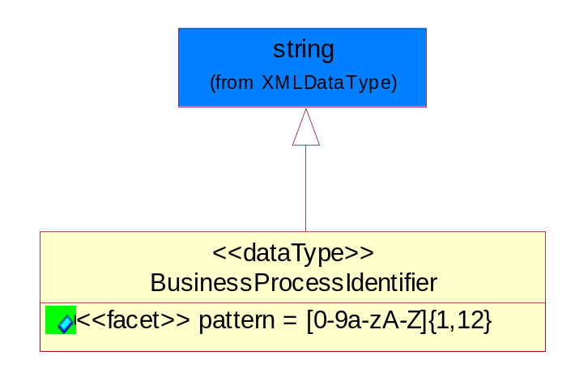
Figure 5-57 Business Process Identifier

Attribute | Type | Documentation
pattern |  | [0-9a-zA-Z]{1,12}

Business Service Information
The object allows the specification of the business service utilized within the partner company. This may or may not be the same as the information sent by the RNIF.
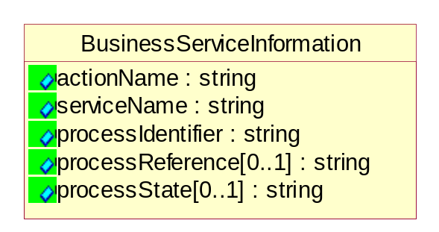
Figure 5-58 Business Service Information

Attribute | Type | Documentation
actionName | string | The name of Action. For RosettaNet usually any of Request/Confirm/Notify/Query/Response.
serviceName | string | The name of the Business Activity with the "Request/Confirm" part removed. E.g., for the Activity "Request Purchase Order"==> "Purchase Order".
processIdentifier | string | The name of the PIP e.g. Notify of Forecast Reply.
processReference[0..1] | string | The URN for the PIP that includes Cluster/Segment/Process pattern used to identify the interface process (such as PIP3A4)
processState[0..1] | string | The business process (or service) state of the sender of a document. When a service receives this document, the receiver may use the state as a precondition.

Contract Information
A block of information used to correlate a contract in an executing choreography.

Figure 5-59 Contract Information

Attribute | Type | Documentation
contractIdentifier[0..1] | string | Unique identification of a contract between the Sender and the Receiver
contractType[0..1] | string | The type of the contract: an attribute describing the type of the ContractIndentification. Valid values are URI, URN,ebXMLCPA, or other values defined by partners.

Correlation Information
A block of information used to correlate a requesting document to a responding document and to the contract in an executing choreography.
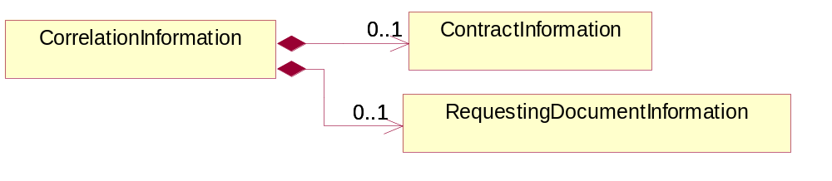
Figure 5-60 Correlation Information

Composition | Cardinality | Type | Documentation
ContractInformation | 0..1 | ContractInformation | A block of information used to correlate a contract in an executing choreography.
RequestingDocumentInformation | 0..1 | RequestingDocumentInformation | A block of information used to correlate a requesting document to a responding document in an executing choreography.

Document Header
The object allows for the identification of the sender and receiver of the business document.
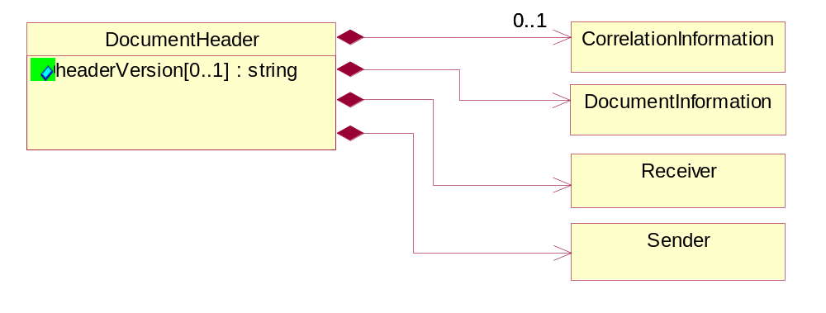
Figure 5-61 Document Header

Attribute | Type | Documentation
headerVersion[0..1] | string | The UN/CEFACT version of the document header.

Composition | Cardinality | Type | Documentation
Sender | 1 | Sender | The object allows the identification of the initiating party of the business message.
CorrelationInformation | 0..1 | CorrelationInformation | A block of information used to correlate a requesting document to a responding document and to the contract in an executing choreography.
DocumentInformation | 1 | DocumentInformation | The object specifies information to identify the business document, a summary of attachments, and information about the business document security.
Receiver | 1 | Receiver | The object allows the identification of the receiving party of the business message.

Document Identification
The object specifies all information necessary to identify the business document.
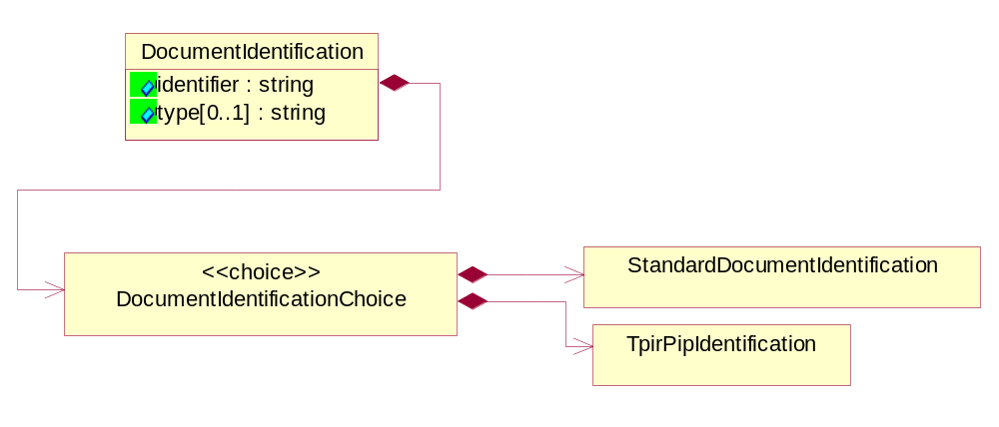
Figure 5-62 Document Identification

Attribute | Type | Documentation
identifier | string | The unique identifier for the document being sent.
type[0..1] | string | Name of the Action Message

Composition | Cardinality | Type | Documentation
DocumentIdentificationChoice | 1 | DocumentIdentificationChoice

Document Identification Choice

Composition | Cardinality | Type | Documentation
StandardDocumentIdentification | 1 | StandardDocumentIdentification | The object specifies additional information necessary to identify the standard business document.
TpirPipIdentification | 1 | TpirPipIdentification | The object specifies all information necessary to uniquely identify a TPIR-PIP within a Registry or trading partner repository.

Document Information
The object specifies information to identify the business document, a summary of attachments, and information about the business document security.
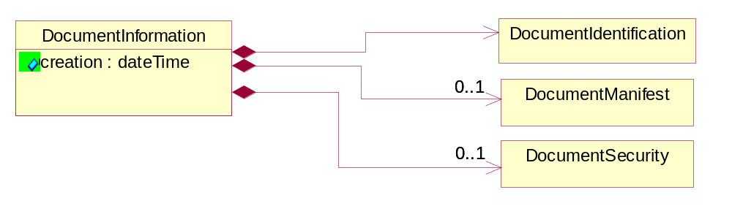
Figure 5-63 Document Information

Attribute | Type | Documentation
creation | dateTime | The creation date and time of the specified Business Document (i.e. the Purchase Order date).

Composition | Cardinality | Type | Documentation
DocumentIdentification | 1 | DocumentIdentification | The object specifies all information necessary to identify the business document.
DocumentSecurity | 0..1 | DocumentSecurity | The object provides additional granularity in specifying business document security (this is in addition to the specified PIP security).
DocumentManifest | 0..1 | DocumentManifest | The block provides a brief summary of attachments and Service Content.

Document Manifest
The block provides a brief summary of attachments and Service Content.
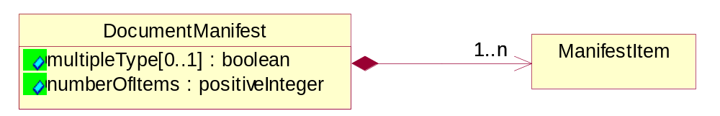
Figure 5-64 Document Manifest

Attribute | Type | Documentation
multipleType[0..1] | boolean | Indicates whether the manifest contains documents of multiple types. True if yes, and False if no.
numberOfItems | positiveInteger | Total number of documents in the message. The physical count of the attachments in the payload plus the RosettaNet Business Message (for Service Content). The value of this field will be at least 1.

Composition | Cardinality | Type | Documentation
ManifestItem | 1..n | ManifestItem | The object provides details about the specific attachment(s).

Document Security
The object provides additional granularity in specifying business document security (this is in addition to the specified PIP security).

Figure 5-65 Document Security

Attribute | Type | Documentation
nonRepudiableReceipt | boolean | The value "true" will indicate that a signed acknowledgement for the business document is necessary.
persistentEncryption | boolean | The value "true" will indicate that the Business Document (including the header) needs to be encrypted when stored or transported.
persistentSignature | boolean | The value "true" will indicate that a signature is required to be stored with the document while stored or transported.

Manifest Item
The object provides details about the specific attachment(s).

Figure 5-66 Manifest Item

Attribute | Type | Documentation
description[0..1] | string | A description of the attachment.
length[0..1] | positiveInteger | The size of the attachment in bytes (i.e. 1 000 000 bytes)
universalResourceIdentifier | string | The generic set of all names/addresses that are short strings that refer to resources.

Composition | Cardinality | Type | Documentation
mimeTypeQualifier | 1 | MimeTypeQualifier | The MIME type as defined by IANA.  Please refer to http://www.iana.org/assignments/media-types/ for a list of types.
language | 0..1 | Language | For representation of Language name RosettaNet has adopted ISO 639-2; 1998. Refer to the following web page to get the latest version of the standard:  http://www.loc.gov/standards/iso639-2/iso639jac.html  If you need more information about the ISO standard please contact ISO for more details.

Pip Identifier
PIP Identification.[ i.e. PIP3A4]
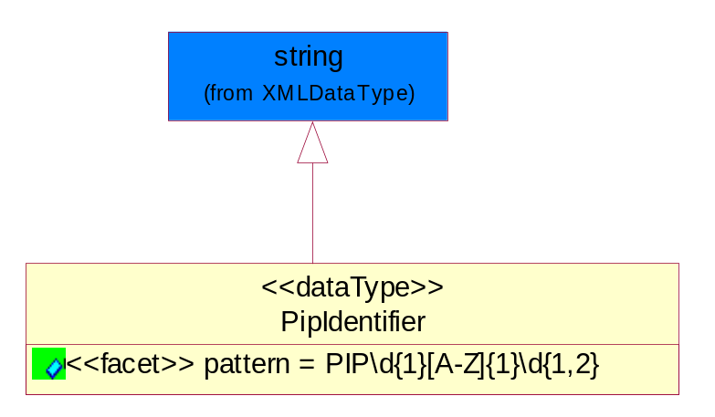
Figure 5-67 Pip Identifier

Attribute | Type | Documentation
pattern |  | PIP\d{1}[A-Z]{1}\d{1,2}

Pip Version
PIP version number (i.e. 02.02.00).
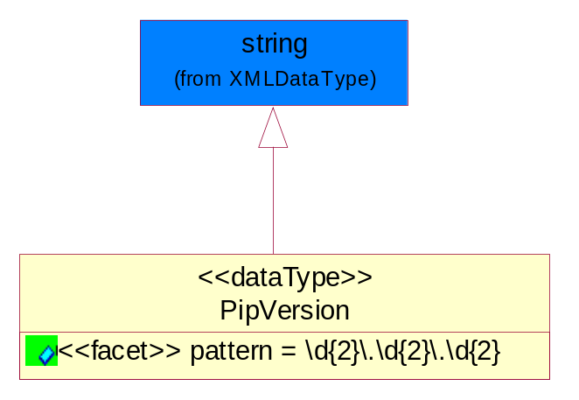
Figure 5-68 Pip Version

Attribute | Type | Documentation
pattern |  | \d{2}\.\d{2}\.\d{2}

Receiver
The object allows the identification of the receiving party of the business message.
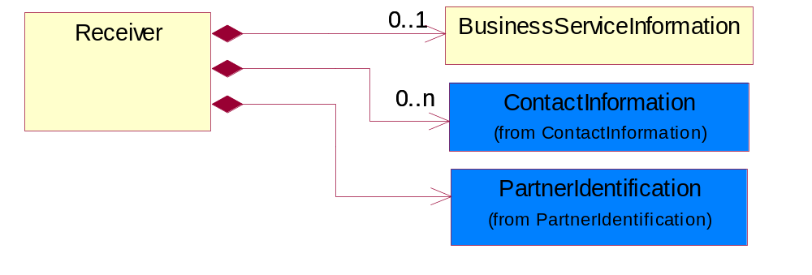
Figure 5-69 Receiver

Composition | Cardinality | Type | Documentation
BusinessServiceInformation | 0..1 | BusinessServiceInformation | The object allows the specification of the business service utilized within the partner company. This may or may not be the same as the information sent by the RNIF.
PartnerIdentification | 1 | PartnerIdentification | The business document must allow for the identity of one or more parties to the transaction.
ContactInformation | 0..n | ContactInformation | The business document must allow for the identification of the name of the department, service or individual to be contacted regarding the context of the business document.

Requesting Document Information
A block of information used to correlate a requesting document to a responding document in an executing choreography.

Figure 5-70 Requesting Document Information

Attribute | Type | Documentation
businessProcessInstanceIdentifier[0..1] | string | The identifier for the public business process instance being sent that both the sender and receiver can identify.
responseDateTime[0..1] | dateTime | The expected time to receive the response. This can not be greater than the PIP TimeToPerform.
requestingDocumentCreationDateTime[0..1] | dateTime | The date-time of the requesting business document.
requestingDocumentInstanceIdentifier | string | The Business Document identification number that identifies the requesting Business Document.

Sender
The object allows the identification of the initiating party of the business message.
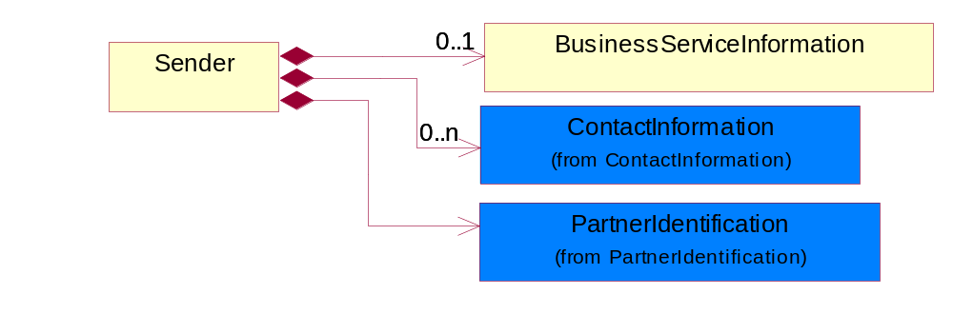
Figure 5-71 Sender

Composition | Cardinality | Type | Documentation
PartnerIdentification | 1 | PartnerIdentification | The business document must allow for the identity of one or more parties to the transaction.
BusinessServiceInformation | 0..1 | BusinessServiceInformation | The object allows the specification of the business service utilized within the partner company. This may or may not be the same as the information sent by the RNIF.
ContactInformation | 0..n | ContactInformation | The business document must allow for the identification of the name of the department, service or individual to be contacted regarding the context of the business document.

Standard Document Identification
The object specifies additional information necessary to identify the standard business document.
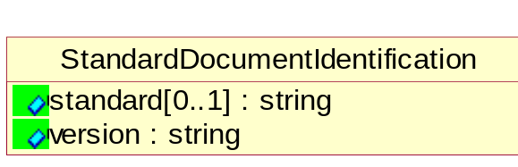
Figure 5-72 Standard Document Identification

Attribute | Type | Documentation
standard[0..1] | string | Identifies the standard used to submit the business document. (e.g. RosettaNet).
version | string | PIP3A4v01.00

Tpir Pip Identification
The object specifies all information necessary to uniquely identify a TPIR-PIP within a Registry or trading partner repository.

Figure 5-73 Tpir Pip Identification

Attribute | Type | Documentation
partnerId | DUNSPlus4 | The Trading Partner Identification of MNC that is creating this TPIR PIP.
pipIdentifier | PipIdentifier | A TPIR PIP Identification [i.e., 3A4 ).
pipVersion | PipVersion | A TPIR PIP version number (i.e., 02.02.00)
tpirPipVersion | VersionIdentifier | A TPIR-PIP Version Number (i.e., major and minor version number as XX.XX).
tpirBusinessProcessIdentifier[0..1] | BusinessProcessIdentifier | A Business Process Identifier to uniquely define the TPIR-PIP 'role' within a Business Scenario at a company or MNC level. The identifier MUST be composed of alphanumeric characters only and its length MUST be between one and twelve characters.
uri[0..1] | anyURI | Describes the destination uri for the TPIR form.

Composition | Cardinality | Type | Documentation
fileType | 0..1 | TPIRFileType | Describes the file type of the TPIR form (PDF, XDP or XML).

Version Identifier
Version Number (i.e., major and minor version number as XX.XX).
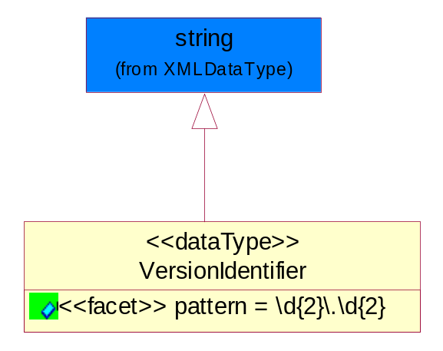
Figure 5-74 Version Identifier

Attribute | Type | Documentation
pattern |  | \d{2}\.\d{2}

Code List

TPIR File Type
A code identifying the file type of TPIR form.

Name | Documentation
PDF | Portable Document Format.
XDP | XML Data Package.
XML | eXtensible Markup Language.

XML Data Type

anyURI
Represents a URI as defined by RFC 2396. An anyURI value can be absolute or relative, and may have an optional fragment identifier.

boolean
Represents Boolean values, which are either "true" or "false".

date
For the represents a calendar date.
The pattern for a date is CCYY-MM-DD where CC represents the century, YY the year, MM the month, and DD the day, with an optional time zone indicator as allowed for dateTime.

Date Time
Represents a specific instance of time.
The pattern for dateTime is CCYY-MM-DDThh:mm:ss where CC represents the century, YY the year, MM the month, and DD the day, preceded by an optional leading negative (-) character to indicate a negative number. If the negative character is omitted, positive (+) is assumed. The T is the date/time separator and hh, mm, and ss represent hour, minute, and second respectively. Additional digits can be used to increase the precision of fractional seconds if desired. For example, the format ss.ss... with any number of digits after the decimal point is supported. The fractional seconds part is optional. This representation may be immediately followed by a "Z" to indicate Coordinated Universal Time (UTC) or to indicate the time zone. For example, the difference between the local time and Coordinated Universal Time, immediately followed by a sign, + or -, followed by the difference from UTC represented as hh:mm (minutes is required). If the time zone is included, both hours and minutes must be present.

decimal
A data type that contains decimal numbers scaled by a power of 10.

duration
Represents a duration of time.
The pattern for duration is PnYnMnDTnHnMnS, where nY represents the number of years, nM the number of months, nD the number of days, T the date/time separator, nH the number of hours, nM the number of minutes, and nS the number of seconds.

float
Represents single-precision 32-bit floating-point numbers.

Positive Integer
Represents an integer that is greater than zero. This data type is derived from nonNegativeInteger.

string
Represents character string.

