

Description of
Partner Interface Process® for 3A1

Validated 11.00.00

Specification Information
Name | Request Quote
Cluster | Order Management
Segment | Quote and Order Entry
Publication Date | 7 November 2005
Version Identifier | V11.00

Table of Contents
1 Document Management 4
1.1 Legal Disclaimer 4
1.2 Copyright 4
1.3 Trademarks 4
1.4 Acknowledgments 4
1.5 Related Documents 5
1.6 Document Version History 5
1.7 Document Structure 5
2 Business Process 6
2.1 Business Process Definition 6
2.1.1 Business Process Context Diagram 7
2.2 PIP Scope Description 8
2.2.1 Business Process Scope Diagram 8
2.3 PIP Business Documents 9
2.4 PIP Business Process Flow Diagram 9
2.5 PIP Start State 10
2.6 PIP End States 10
2.7 Partner Role Descriptions 11
2.8 Business Process Activity Controls 11
3 Network and Implementation Specification 12
3.1 Business Action and Business Signal Specification 12
3.2 Business Transaction Dialog Specification 12
3.2.1 Message Exchange Controls 13
3.2.2 Communications Specification 13

List of Figures
Figure 1: High-level Context Diagram 7
Figure 2: Business Process Context Diagram 8
Figure 3: Activity Diagram of Quote Request 9
Figure 4: Sequence Diagram of Quote Request 13

List of Tables
Table 1: PIP Business Documents 9
Table 2: PIP Start State 10
Table 3: PIP End State 10
Table 4: PIP Failure State 10
Table 5: Partner Role Descriptions 11
Table 6: Business Activity Descriptions 11
Table 7: Business Activity Performance Controls 11
Table 8: Network Component Specification 12
Table 9: Business Action – Business Document Mapping 12
Table 10: Message Exchange Controls 13
Table 11: Purchase Order Request Confirmation Dialog: Service-Service 13

Document Management

Legal Disclaimer
RosettaNet™, its members, officers, directors, employees, or agents shall not be liable for any injury, loss, damages, financial or otherwise, arising from, related to, or caused by the use of this document or the specifications herein, as well as associated guidelines and schemas. The use of said specifications shall constitute your express consent to the foregoing exculpation.

Copyright
©2005 RosettaNet. All rights reserved. No part of this publication may be reproduced, stored in a retrieval system, or transmitted, in any form or by any means, electronic, mechanical, photocopying, recording, or otherwise, without the prior written permission of the publisher. Printed in the United States of America.

Trademarks
RosettaNet, Partner Interface Process, PIP and the RosettaNet logo are trademarks or registered trademarks of "RosettaNet," a non-profit organization. All other product names and company logos mentioned herein are the trademarks of their respective owners. In the best effort, all terms mentioned in this document that are known to be trademarks or registered trademarks have been appropriately recognized in the first occurrence of the term.

Acknowledgments
This document has been prepared by RosettaNet (http://www.rosettanet.org/) from requirements gathered during the Milestone Program and in conformance with the methodology.

Related Documents
- Associated PIP Message Schemas (included within the PIP Specification package only)
- Description of PIP3A1 Message
- Message Structure
- XML instance of ebBPSS for PIP 3A1

Document Version History
Version | Date | Description
Release 11.01.00B | 7 November 2005 | Release Version

Document Structure
A Partner Interface Process (PIP) Specification is comprised of the following two parts:
- Business Process. Captures the semantics of the business process and the flow of the message exchange between roles as they perform business activities.
- Network and Implementation Specification. Specifies the network protocol message formats and communications requirements between peer-protocols supported by network components in the RosettaNet Implementation Framework.

Business Process

Business Process Definition
The "Request Quote" Partner Interface Process (PIP) enables a buyer to request a product quote from a provider, and a provider to respond with either a quote or a referral. If referred to another provider, the buyer may request a quote from that party. The prices and product availability reflected in a quote may be influenced by an existing or potential relationship between a buyer and provider.
Quotes may:
- Involve one or more items, fixed price quotes or negotiated prices, configurable or stand alone product.
- Include freight and tax information.
- Be reconciled with purchase orders.
- Support ship from stock and debit credit claims.
- Should this transaction not complete successfully, the requesting partner executes PIP0A1, "Notification of Failure."

Business Process Context Diagram
Receive and Process Confirmation
Generate Quote
Process Quote
Buyer
Seller
Generate Confirmation

Send Request

Send Confirmation

- Prior to making any purchase order request, buyer can check for products price and availability using PIP 3A2.
- Quote Request send from buyer to seller, using PIP 3A1.
- Seller needs to acknowledge and confirm to the buyer for the acceptance or rejection of a pending line item in the quote.
- In the event where the seller has any counter proposal on the quote, the seller needs to change and notify the buyer, using PIP 3A1 confirmation.

Figure 1: High-level Context Diagram

PIP Scope Description
This PIP provides a buyer with quotes and referrals used to select suppliers and prepare purchase orders.

Business Process Scope Diagram
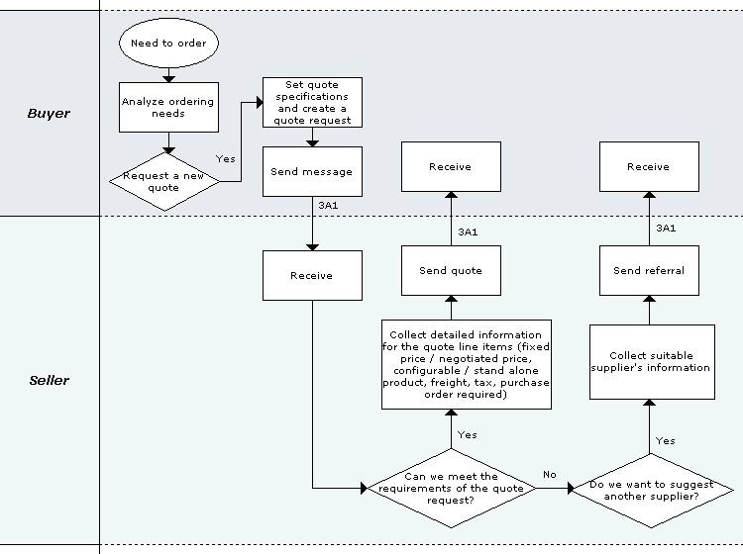
Figure 2: Business Process Context Diagram

PIP Business Documents
Business Documents are generated and exchanged by roles performing activities in this PIP. Business Documents are listed and defined in Table 1.
Table 1: PIP Business Documents
Business Document | Description
Quote Request | A Buyer's request for a quote sent to a Seller for response.
Quote Confirmation | A Seller's response to a request for a quote. Allows for an actual quote, or a referral to another Seller.

PIP Business Process Flow Diagram
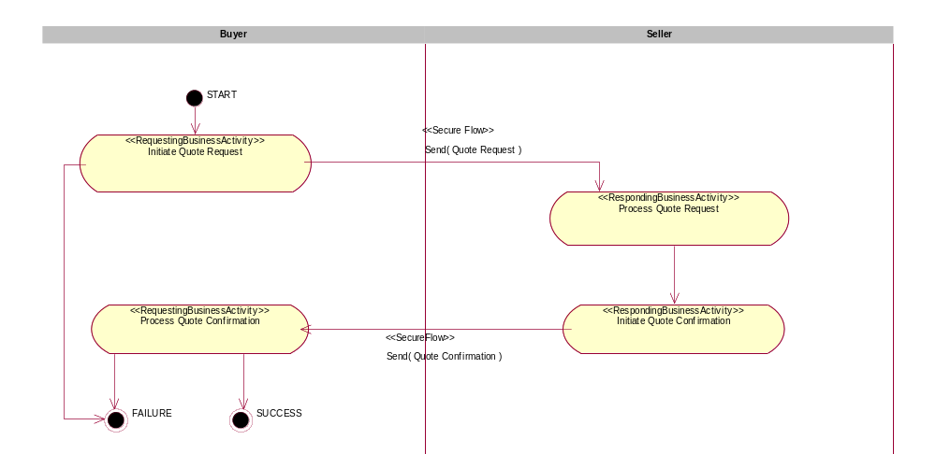
Figure 3: Activity Diagram of Quote Request

PIP Start State
The start state is comprised of the following condition(s):
Table 2: PIP Start State
 | Approved | Exist |  | Valid | Non-Repudiated | Retry Count | Authorized
 | Approved | Party | In Backend system
TPA |  |  | 
Sending Partner |  |  |  |  |  |  | 
Receiving Partner |  | 
Business Document |  |  |  |  | 

PIP End States
The end state is comprised of the following condition(s):
Table 3: PIP End State
 | Approved | Exist |  | Valid | Non-Repudiated | Retry Count | Authorized
 | Approved | Party | In Backend system
Acknowledgment of Receipt |  |  |  |  | 
Receiving Partner |  |  |  |  |  |  | 
Business Document |  |  |  |  | 

The PIP failure state is comprised of one or more of the following condition(s):
Table 4: PIP Failure State
 | NO | Exceeded
Success | 
Retry Count |  | 

Partner Role Descriptions
Table 6 describes the partner roles in this PIP.
Table 5: Partner Role Descriptions
Role Name | Role Description
Buyer | An employee or organization that buys products for a partner type in the supply chain.
Seller | An organization that sells products to partners in the supply chain.

Business Process Activity Controls
Table 7 describes the interaction between roles performing business activities in this PIP.
Table 6: Business Activity Descriptions
Role  Name | Activity Name | Activity Description
Buyer | Request Quote | The Buyer requests a quote from a Seller.
Seller | Confirm Quote | The Seller confirms a quote from a Buyer.

Table 8 details the security, audit and process controls relating to activities performed in the PIP.
Table 7: Business Activity Performance Controls
Role  Name | Activity  Name | Acknowledgment  of Receipt |  | Time to Perform | Retry Count | Is Authorization Required? | Non-Repudiation of Origin and Content?
Role  Name | Activity  Name | Non-Repudiation Required? | Time to Acknowledge
Buyer | Request Quote | Y | 2 hrs | 24 hrs | 3 | Y | Y
Seller | Confirm Quote | Y | 2 hrs | 24 hrs | 3 | Y | Y

Network and Implementation Specification
Each network component maps into a role of the PIP model. Table 9 specifies the mapping between roles and network components.
Table 8: Network Component Specification
Network Component | Classification | Maps to Role in Business Process
Buyer Service | Business Service | Buyer
Seller Service | Business Service | Seller

Business Action and Business Signal Specification
Each business action maps to a Business Document of the PIP model. Table 10 specifies the mapping between Business Documents and business actions.
Table 9: Business Action – Business Document Mapping
Business Action | Business Document | Document Function
Quote Request Action | Quote Request | Request
Quote Confirmation Action | Quote Confirmation | Respond

Business Transaction Dialog Specification
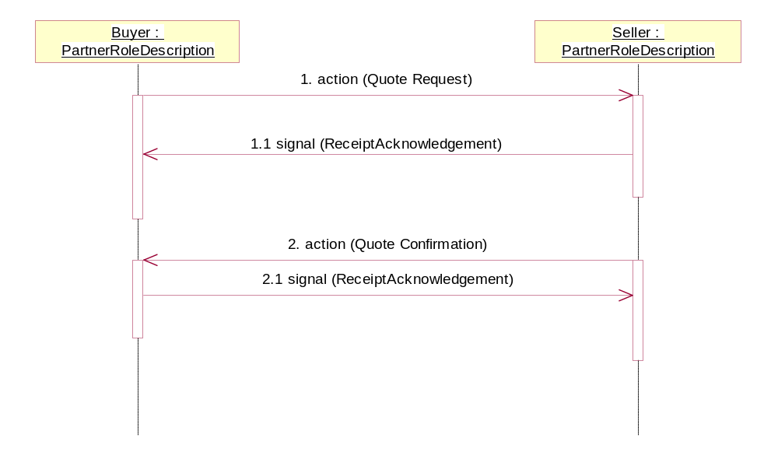
Figure 4: Sequence Diagram of Quote Request

Message Exchange Controls
Table 10: Message Exchange Controls
# | Name |  | Time to Acknowledge |  | Time to Respond to Action |  | Included in Time to Perform |  | Is Authorization Required? |  | Is Non-Repudiation Required? |  | Is Secure Transport Required?
1. |  | Quote Request Action |  | 2 hrs |  | N/A |  | 24 hrs |  | Y |  | Y |  | Y
1.1. |  | Receipt Acknowledgment |  | N/A |  | N/A |  | N/A |  | Y |  | Y |  | Y
2. |  | Quote Confirmation Action |  | 2 hrs |  | N/A |  | 24 hrs |  | Y |  | Y |  | Y
2.1. |  | Receipt Acknowledgment |  | N/A |  | N/A |  | N/A |  | Y |  | Y |  | Y

Communications Specification
Table 11: Quote Request Confirmation Dialog: Service-Service
# | Business Message | Digital Signature Required? | SSL Required?
1. | Quote Request | Y | Y
1.1. | Receipt Acknowledgment | Y | Y
2. | Quote Request | Y | Y
2.1. | Receipt Acknowledgment | Y | Y

