

Description of 3A1 Message

PIP® 3A1
Validated V11.11.00

Specification Information
Name | Description of 3A1 Message
PIP | Request Quote
Cluster | Order Management
Segment | Quote and Order Entry
Publication Date | 02 November 2007
Version Identifier | V11.11

Table of Content

1. Document Management 8
1.1 Legal Disclaimer 8
1.2 Copyright 8
1.3 Trademarks 8
1.4 Acknowledgments 8
1.5 Related Documents 8
1.6 Document Version History 9
1.7 Document Purpose 9
2. Interchange Model 10
2.1 QuoteRequest 10
2.1.1 Interchange Diagram 10
2.1.2 Dependency Diagram 10
2.1.3 CompetitorReference 11
2.1.4 ProductLineItem 12
2.1.5 Quantity 14
2.1.6 Quote 15
2.1.7 QuoteCustomerInformation 17
2.1.8 QuoteLineItem 17
2.1.9 QuoteLineItemChoice 18
2.1.10 QuoteQuantity 18
2.1.11 QuoteRequest 19
2.1.12 RequoteLineStatus 19
2.1.13 ServiceLineItem 20
2.1.14 ServiceLineItemByOption 22
2.1.15 TransportationSchedule 24
2.2 QuoteConfirmation 25
2.2.1 Interchange Diagram 25
2.2.2 Dependency Diagram 25
2.2.3 CompetitorReference 26
2.2.4 OrderLeadTime 26
2.2.5 ProductLineItem 28
2.2.6 Quantity 31
2.2.7 Quote 32
2.2.8 QuoteConfirmation 34
2.2.9 QuoteCustomerInformation 35
2.2.10 QuoteLineItem 36
2.2.11 QuoteLineItemChoice 36
2.2.12 QuoteQuantity 37
2.2.13 RequoteLineStatus 37
2.2.14 ServiceLineItem 38
2.2.15 ServiceLineItemByOption 40
2.2.16 TermsAndConditions 42
2.2.17 TransportationSchedule 43
2.3 CodeList 43
2.3.1 StockIndicator 43
2.3.2 LeadTimeCommencement 43
2.3.3 ProductTerms 44
2.3.4 QuoteLineItemStatus 44
3. Domain Model 45
3.1 Procurement 45
3.1.1 Procurement 45
3.1.1.1 Dependency Diagram 45
3.1.1.2 ContractInformation 45
3.1.1.3 CurrencyConversion 45
3.1.1.4 CustomerInformation 46
3.1.1.5 OtherTaxes 47
3.1.1.6 PriceCondition 47
3.1.1.7 ProductQuantityRange 48
3.1.1.8 SpecialDiscount 48
3.1.1.9 StepPricing 49
3.1.1.10 SubstituteProductReference 50
3.1.1.11 TaxExemption 50
3.1.1.12 TaxExemptStatus 51
3.1.1.13 TaxInformation 51
3.1.1.14 TaxPhrase 52
3.1.1.15 TaxSummary 52
3.1.2 CodeList 53
3.1.2.1 TransportEvent 53
3.1.2.2 GovernmentPriorityRating 53
3.1.2.3 PurchaseOrderStatus 54
3.1.2.4 CustomerType 54
3.1.2.5 ProductSubstitutionReason 54
3.1.2.6 TaxExemptionCode 55
3.1.2.7 LeadTimeClassificationCode 57
3.1.2.8 QuoteStatus 58
3.1.2.9 QuoteType 58
3.1.2.10 RequoteAction 58
3.1.2.11 RequestOption 59
3.1.2.12 QuoteAcknowledgmentReason 59
3.2 Shared 60
3.2.1 Shared 60
3.2.1.1 Dependency Diagram 60
3.2.1.2 CarrierInformation 60
3.2.1.3 DatePeriodAndDuration 61
3.2.1.4 DatePeriodAndDurationChoice 61
3.2.1.5 Duration 62
3.2.1.6 MonetaryAmount 62
3.2.1.7 ProductPricing 63
3.2.1.8 ProductQuantity 63
3.2.1.9 SCAC 64
3.2.2 CodeList 64
3.2.2.1 InvoiceChargeType 64
3.2.2.2 MonetaryAmountType 65
3.2.2.3 PricingTypeCode 65
3.2.2.4 AmountType 66
4. Universal Structure 68
4.1 ContactInformation 68
4.1.1 ContactInformation 68
4.2 DataType 68
4.2.1 Contact 68
4.2.2 DUNS 69
4.2.3 DUNSPlus4 69
4.2.4 GLN 70
4.2.5 GTIN 70
4.2.6 PercentAmount 71
4.3 Dates 71
4.3.1 DatePeriod 71
4.4 Document 72
4.4.1 BusinessDocumentReference 72
4.5 Locations 72
4.5.1 AlternativeIdentifier 72
4.5.2 Location 73
4.5.3 LocationChoice 73
4.5.4 PhysicalAddress 74
4.6 MonetaryExpression 75
4.6.1 FinancialAmount 75
4.6.2 TaxJurisdiction 76
4.7 PartnerIdentification 77
4.7.1 FullPartner 77
4.7.2 IntermittentPartner 77
4.7.3 KnownPartner 78
4.7.4 KnownPartnerContact 78
4.7.5 NewPartner 79
4.7.6 PartnerDescription 80
4.7.7 PartnerDescriptionChoice 80
4.7.8 PartnerIdentification 81
4.7.9 PartnerIdentificationChoice 82
4.7.10 SpecifiedFullPartner 82
4.7.11 SpecifiedIntermittentPartner 83
4.7.12 SpecifiedKnownPartner 83
4.7.13 SpecifiedKnownPartnerContact 84
4.7.14 SpecifiedNewPartner 85
4.7.15 SpecifiedPartnerDescription 86
4.7.16 SpecifiedPartnerDescriptionChoice 86
4.8 ProductIdentification 87
4.8.1 ProductIdentification 87
4.8.2 ProductIdentificationChoice 88
4.9 CodeList 88
4.9.1 Country 88
4.9.2 CountrySubdivision 88
4.9.3 Currency 88
4.9.4 Language 88
4.9.5 DocumentType 89
4.9.6 MimeTypeQualifier 90
4.9.7 UnitOfMeasure 101
4.9.8 ProcessRoleIdentifier 108
5. System Structure 112
5.1 BusinessProcessIdentifier 112
5.2 BusinessServiceInformation 112
5.3 ContractInformation 113
5.4 CorrelationInformation 113
5.5 DocumentHeader 114
5.6 DocumentIdentification 115
5.7 DocumentIdentificationChoice 115
5.8 DocumentInformation 116
5.9 DocumentManifest 116
5.10 DocumentSecurity 117
5.11 ManifestItem 117
5.12 PipIdentifier 118
5.13 PipVersion 119
5.14 Receiver 119
5.15 RequestingDocumentInformation 120
5.16 Sender 121
5.17 StandardDocumentIdentification 121
5.18 TpirPipIdentification 122
5.19 VersionIdentifier 123
5.20 CodeList 123
5.20.1 TPIRFileType 123
6. XML Data Type 124
6.1 anyURI 124
6.2 boolean 124
6.3 date 124
6.4 dateTime 124
6.5 decimal 124
6.6 duration 124
6.7 float 124
6.8 positiveInteger 124
6.9 string 125

Table of Figures

Figure 2-1 Interchange 10
Figure 2-2 Dependency 10
Figure 2-3 CompetitorReference 11
Figure 2-4 ProductLineItem 12
Figure 2-5 Quantity 14
Figure 2-6 Quote 15
Figure 2-7 QuoteCustomerInformation 17
Figure 2-8 QuoteLineItem 17
Figure 2-9 QuoteQuantity 18
Figure 2-10 QuoteRequest 19
Figure 2-11 RequoteLineStatus 19
Figure 2-12 ServiceLineItem 20
Figure 2-13 ServiceLineItemByOption 22
Figure 2-14 TransportationSchedule 24
Figure 2-15 Interchange 25
Figure 2-16 Dependency 25
Figure 2-17 CompetitorReference 26
Figure 2-18 OrderLeadTime 26
Figure 2-19 ProductLineItem 28
Figure 2-20 Quantity 31
Figure 2-21 Quote 32
Figure 2-22 QuoteConfirmation 34
Figure 2-23 QuoteCustomerInformation 35
Figure 2-24 QuoteLineItem 36
Figure 2-25 QuoteQuantity 37
Figure 2-26 RequoteLineStatus 37
Figure 2-27 ServiceLineItem 38
Figure 2-28 ServiceLineItemByOption 40
Figure 2-29 TermsAndConditions 42
Figure 2-30 TransportationSchedule 43
Figure 3-1 Dependency 45
Figure 3-2 ContractInformation 45
Figure 3-3 CurrencyConversion 45
Figure 3-4 CustomerInformation 46
Figure 3-5 OtherTaxes 47
Figure 3-6 PriceCondition 47
Figure 3-7 ProductQuantityRange 48
Figure 3-8 SpecialDiscount 48
Figure 3-9 StepPricing 49
Figure 3-10 SubstituteProductReference 50
Figure 3-11 TaxExemption 50
Figure 3-12 TaxExemptStatus 51
Figure 3-13 TaxInformation 51
Figure 3-14 TaxPhrase 52
Figure 3-15 TaxSummary 52
Figure 3-16 Dependency 60
Figure 3-17 CarrierInformation 60
Figure 3-18 DatePeriodAndDuration 61
Figure 3-19 Duration 62
Figure 3-20 MonetaryAmount 62
Figure 3-21 ProductPricing 63
Figure 3-22 ProductQuantity 63
Figure 3-23 SCAC 64
Figure 4-1 ContactInformation 68
Figure 4-2 Contact 68
Figure 4-3 DUNS 69
Figure 4-4 DUNSPlus4 69
Figure 4-5 GLN 70
Figure 4-6 GTIN 70
Figure 4-7 PercentAmount 71
Figure 4-8 DatePeriod 71
Figure 4-9 BusinessDocumentReference 72
Figure 4-10 AlternativeIdentifier 72
Figure 4-11 Location 73
Figure 4-12 PhysicalAddress 74
Figure 4-13 FinancialAmount 75
Figure 4-14 TaxJurisdiction 76
Figure 4-15 FullPartner 77
Figure 4-16 IntermittentPartner 77
Figure 4-17 KnownPartner 78
Figure 4-18 KnownPartnerContact 78
Figure 4-19 NewPartner 79
Figure 4-20 PartnerDescription 80
Figure 4-21 PartnerIdentification 81
Figure 4-22 SpecifiedFullPartner 82
Figure 4-23 SpecifiedIntermittentPartner 83
Figure 4-24 SpecifiedKnownPartner 83
Figure 4-25 SpecifiedKnownPartnerContact 84
Figure 4-26 SpecifiedNewPartner 85
Figure 4-27 SpecifiedPartnerDescription 86
Figure 4-28 ProductIdentification 87
Figure 5-1 BusinessProcessIdentifier 112
Figure 5-2 BusinessServiceInformation 112
Figure 5-3 ContractInformation 113
Figure 5-4 CorrelationInformation 113
Figure 5-5 DocumentHeader 114
Figure 5-6 DocumentIdentification 115
Figure 5-7 DocumentInformation 116
Figure 5-8 DocumentManifest 116
Figure 5-9 DocumentSecurity 117
Figure 5-10 ManifestItem 117
Figure 5-11 PipIdentifier 118
Figure 5-12 PipVersion 119
Figure 5-13 Receiver 119
Figure 5-14 RequestingDocumentInformation 120
Figure 5-15 Sender 121
Figure 5-16 StandardDocumentIdentification 121
Figure 5-17 TpirPipIdentification 122
Figure 5-18 VersionIdentifier 123

Document Management

Legal Disclaimer
RosettaNet, its members, officers, directors, employees, or agents shall not be liable for any injury, loss, damages, financial or otherwise, arising from, related to, or caused by the use of this document or the specifications herein, as well as associated guidelines and schemas. The use of said specifications shall constitute your express consent to the foregoing exculpation.

Copyright
©2007 RosettaNet. All rights reserved. No part of this publication may be reproduced, stored in a retrieval system, or transmitted, in any form or by any means, electronic, mechanical, photocopying, recording, or otherwise, without the inclusion of this copyright notice. Any derivative works must cite the copyright notice. Any public redistribution or sale of this publication or derivative works requires prior written permission of the publisher.

Trademarks
RosettaNet, Partner Interface Process, PIP and the RosettaNet logo are trademarks or registered trademarks of "RosettaNet," a non-profit organization. All other product names and company logos mentioned herein are the trademarks of their respective owners. In the best effort, all terms mentioned in this document that are known to be trademarks or registered trademarks have been appropriately recognized in the first occurrence of the term.

Acknowledgments
This document has been prepared by RosettaNet (http://www.rosettanet.org/) from requirements gathered during the Milestone Program and in conformance with the methodology. Listed below are the legal entities that contributed to the design and development of this PIP.
Bellsouth Communication Systems | Cisco Systems
Intel | SBC Business Marketing
Sterling Commerce | World Wide Technology (WWT)

Related Documents
- Associated PIP Message Schemas (included with PIP Specification only)
- Description of Partner Interface Process for 3A1
- Message Structure

Document Version History
Version | Date | Description
Validated 11.00.00 | 07 November 2005 | Validated Version
Validated 11.10.00 | 24 May 2006 | Validated Version
Validated 11.11.00 | 02 November 2007 | Validated Version: Milestone Program – Schema2Market

Document Purpose
The purpose of the document is to explain the structure, the association between objects, the content of objects and the definition for single elements to a non-technical audience.

Interchange Model

QuoteRequest

Interchange Diagram
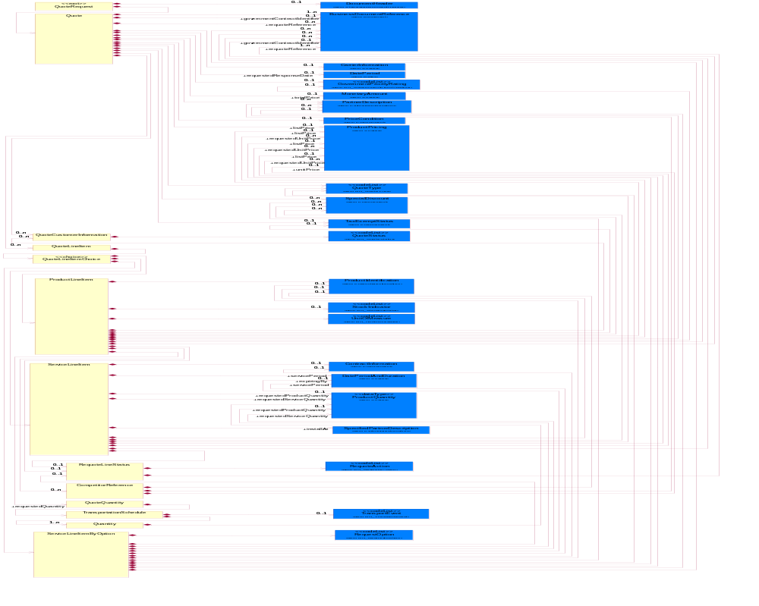
Figure 2-1 Interchange

Dependency Diagram
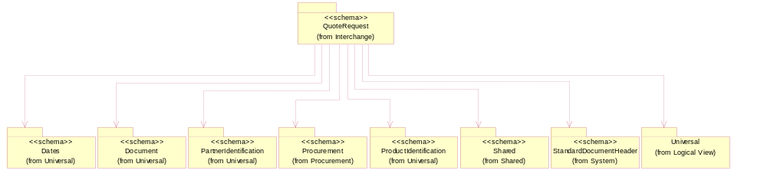
Figure 2-2 Dependency

CompetitorReference
The collection of business properties that describe a competitor's product and pricing for purposes within a quote business document.
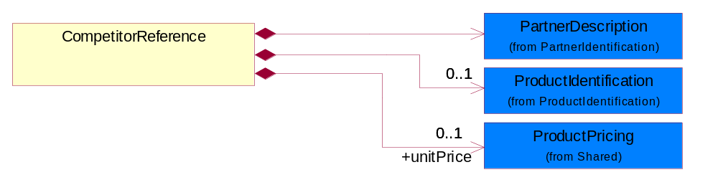
Figure 2-3 CompetitorReference

Composition | Cardinality | Type | Documentation
ProductIdentification | 0..1 | ProductIdentification | The object provides the identifier(s) of a product.
unitPrice | 0..1 | ProductPricing | Agreed upon sale price for each unit ordered.
PartnerDescription | 1 | PartnerDescription | The collection of business properties that describe a business partners' identity, their contact information, where they are physically located and their function in a supply chain.

ProductLineItem
The collection of business properties that describe a product entry in a quote business documents. The Recommended ProcessRoleIdentifier for PartnerDescription are SHT - Ship To and RSF - Requested Ship From.
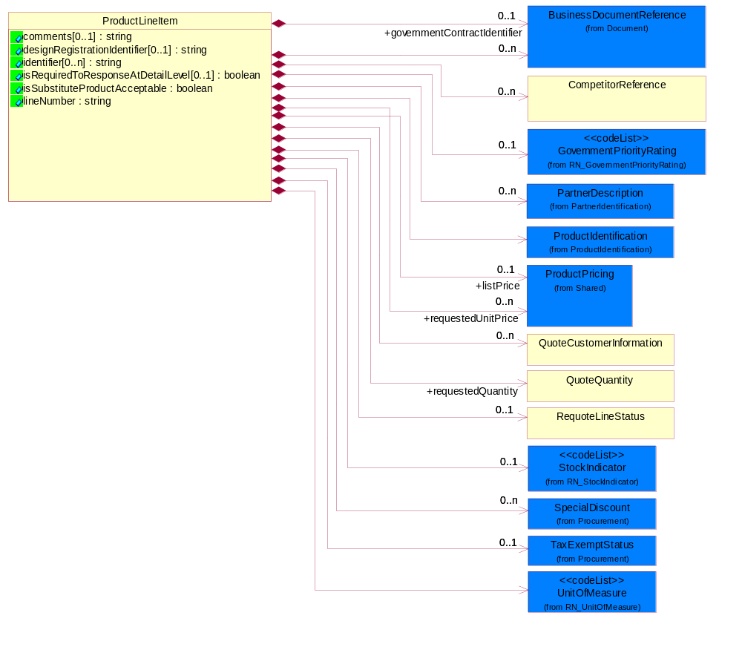
Figure 2-4 ProductLineItem

Attribute | Type | Documentation
comments[0..1] | string | Free form textual description of a general nature.
designRegistrationIdentifier[0..1] | string | A proprietary unique identifier for a design registration.
identifier[0..n] | string | A unique serial identifier assigned to a product.
isRequiredToResponseAtDetailLevel[0..1] | boolean | This object representing the option for the response. If the value equals to true, the receiver is required to response to detail level. If the value equals to false, the receiver is only required to reply at summary level.
isSubstituteProductAcceptable | boolean | Indicates whether the requesting party will accept a substitute product for the product requested.
lineNumber | string | Number of the line in the document.

Composition | Cardinality | Type | Documentation
BusinessDocumentReference | 0..n | BusinessDocumentReference | The business document reference object allows for the indirect referencing of a relationship to other business related documents.
GovernmentPriorityRating | 0..1 | GovernmentPriorityRating | If a contract number exists and PO type is Government, a priority rating code is required.
UnitOfMeasure | 1 | UnitOfMeasure | Code identifying a product unit of measure.
governmentContractIdentifier | 0..1 | BusinessDocumentReference | The unique number that identifies a government contract.
ProductIdentification | 1 | ProductIdentification | The object provides the identifier(s) of a product.
CompetitorReference | 0..n | CompetitorReference | The collection of business properties that describe a competitor's product and pricing for purposes within a quote business document.
requestedQuantity | 1 | QuoteQuantity | The quantity of product requested.
RequoteLineStatus | 0..1 | RequoteLineStatus | The collection of business properties that describe a previous quote's identification and status for a given entry on the prior quote.
TaxExemptStatus | 0..1 | TaxExemptStatus | The collection of business properties that describe tax exemption conditions.
QuoteCustomerInformation | 0..n | QuoteCustomerInformation | The collection of business properties that describe the customer who uses a quote business document.
StockIndicator | 0..1 | StockIndicator | Code identifying the amount of stock available at the time of the quote.
SpecialDiscount | 0..n | SpecialDiscount | This object represents a special discount based on the special discount identifier.
requestedUnitPrice | 0..n | ProductPricing | The price requested for a unit of product.
listPrice | 0..1 | ProductPricing | This object represents a pre-discounted price.
PartnerDescription | 0..n | PartnerDescription | The collection of business properties that describe a business partners' identity, their contact information, where they are physically located and their function in a supply chain.

Quantity
The collection of business properties that describe product quantity and associated schedules.
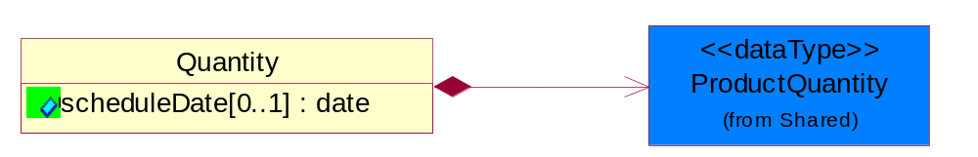
Figure 2-5 Quantity

Attribute | Type | Documentation
scheduleDate[0..1] | date | Specifies a date for the schedule.

Composition | Cardinality | Type | Documentation
ProductQuantity | 1 | ProductQuantity | A quantity specifying the number of product units.

Quote
The collection of business properties that describe an offer to supply a quantity of products at an agreed price and schedule. The Recommended ProcessRoleIdentifier for PartnerDescription are FIN - Financed By, DIS - Distributed By, RES - Respond To, CWN - Contract Owner and BIT - Bill To.
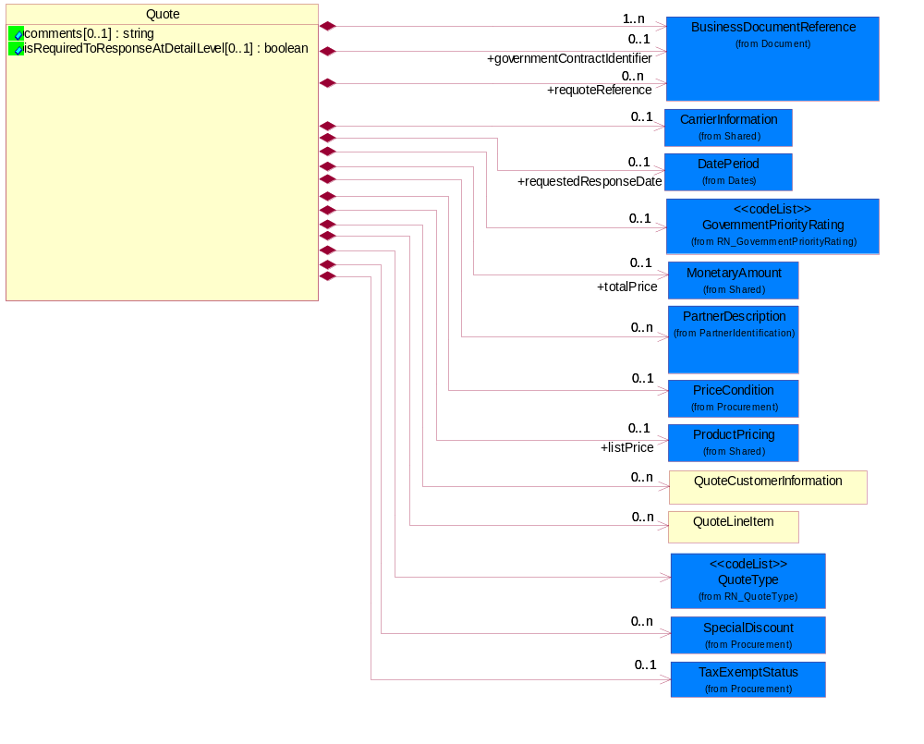
Figure 2-6 Quote

Attribute | Type | Documentation
comments[0..1] | string | Free form textual description of a general nature.
isRequiredToResponseAtDetailLevel[0..1] | boolean | This object representing the option for the response. If the value equals to true, the receiver is required to response to detail level. If the value equals to false, the receiver is only required to reply at summary level.

Composition | Cardinality | Type | Documentation
BusinessDocumentReference | 1..n | BusinessDocumentReference | The business document reference object allows for the indirect referencing of a relationship to other business related documents.
GovernmentPriorityRating | 0..1 | GovernmentPriorityRating | If a contract number exists and PO type is Government, a priority rating code is required.
governmentContractIdentifier | 0..1 | BusinessDocumentReference | The unique number that identifies a government contract.
PriceCondition | 0..1 | PriceCondition | The collection of business properties that define information for special pricing conditions.
requestedResponseDate | 0..1 | DatePeriod | The date for which a response has been requested to be transmitted.
requoteReference | 0..n | BusinessDocumentReference | The document reference for a previous quote.
TaxExemptStatus | 0..1 | TaxExemptStatus | The collection of business properties that describe tax exemption conditions.
QuoteCustomerInformation | 0..n | QuoteCustomerInformation | The collection of business properties that describe the customer who uses a quote business document.
QuoteType | 1 | QuoteType | Code identifying category specification for a quote.
QuoteLineItem | 0..n | QuoteLineItem | The collection of business properties that describe a product entry in a quote business documents.
SpecialDiscount | 0..n | SpecialDiscount | This object represents a special discount based on the special discount identifier.
CarrierInformation | 0..1 | CarrierInformation | The collection of business properties that describe a carrier's identification.
totalPrice | 0..1 | MonetaryAmount | Total price for the entire business document.
listPrice | 0..1 | ProductPricing | This object represents a pre-discounted price.
PartnerDescription | 0..n | PartnerDescription | The collection of business properties that describe a business partners' identity, their contact information, where they are physically located and their function in a supply chain.

QuoteCustomerInformation
The collection of business properties that describe the customer who uses a quote business document.
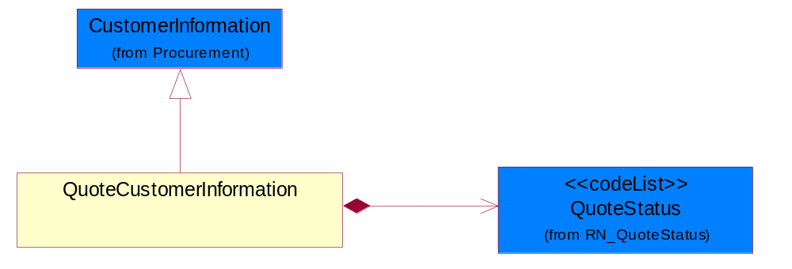
Figure 2-7 QuoteCustomerInformation

Composition | Cardinality | Type | Documentation
QuoteStatus | 1 | QuoteStatus | Code identifying whether business has been secured by the end customer.

QuoteLineItem
The collection of business properties that describe a product entry in a quote business documents.
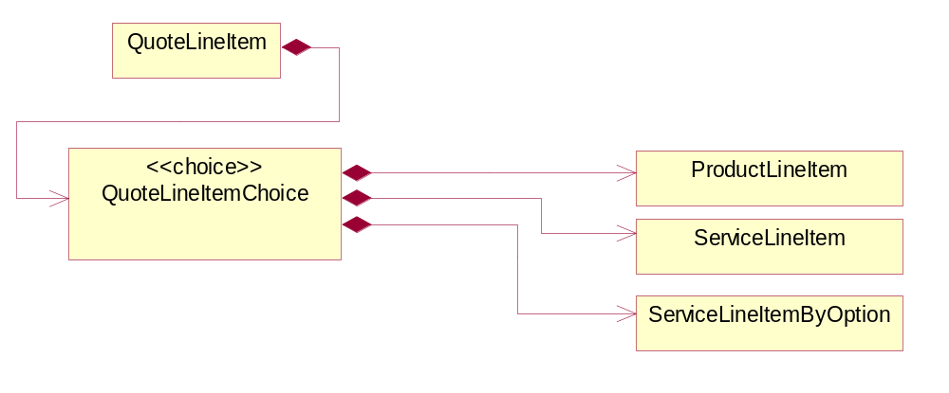
Figure 2-8 QuoteLineItem

Composition | Cardinality | Type | Documentation
QuoteLineItemChoice | 1 | QuoteLineItemChoice

QuoteLineItemChoice

Composition | Cardinality | Type | Documentation
ProductLineItem | 1 | ProductLineItem | The collection of business properties that describe a product entry in a quote business documents. The Recommended ProcessRoleIdentifier for PartnerDescription are SHT - Ship To and RSF - Requested Ship From.
ServiceLineItem | 1 | ServiceLineItem | The collection of business properties that describe a service entry in a quote business documents.
ServiceLineItemByOption | 1 | ServiceLineItemByOption | The collection of business properties that describe a service entry by option (eg. by Contract, by Product or by Site) in a quote business documents. The Recommended ProcessRoleIdentifier for PartnerDescription is ITL - Install At.

QuoteQuantity
The collection of business properties that describe the quantities associated with a product quote.
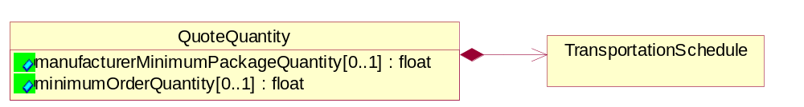
Figure 2-9 QuoteQuantity

Attribute | Type | Documentation
manufacturerMinimumPackageQuantity[0..1] | float | The product quantity in a defined package by a manufacturer.
minimumOrderQuantity[0..1] | float | A numeric expression of the minimum number of product line items that may be ordered.

Composition | Cardinality | Type | Documentation
TransportationSchedule | 1 | TransportationSchedule | The collection of business properties that describe product quantity and associated schedules, for a given transportation event.

QuoteRequest
A message wrapper or root element for PIP3A1.
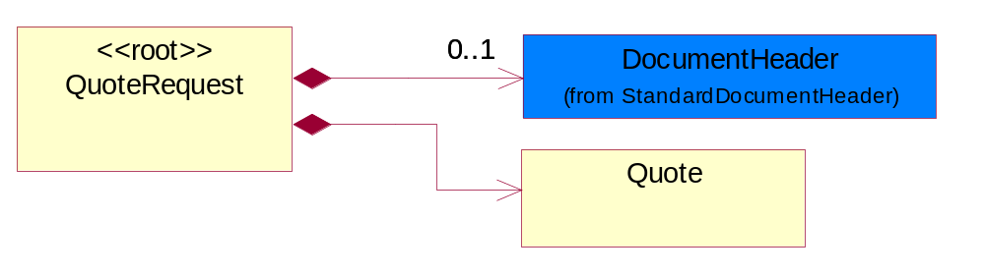
Figure 2-10 QuoteRequest

Composition | Cardinality | Type | Documentation
DocumentHeader | 0..1 | DocumentHeader | The object allows for the identification of the sender and receiver of the business document.
Quote | 1 | Quote | The collection of business properties that describe an offer to supply a quantity of products at an agreed price and schedule. The Recommended ProcessRoleIdentifier for  PartnerDescription are FIN - Financed By, DIS - Distributed By, RES - Respond To, CWN - Contract Owner and BIT - Bill To.

RequoteLineStatus
The collection of business properties that describe a previous quote's identification and status for a given entry on the prior quote.
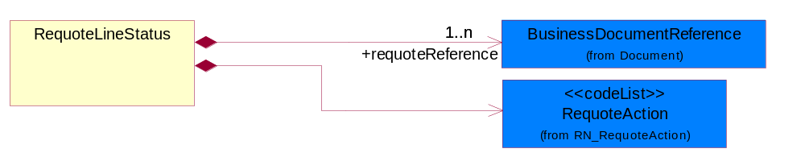
Figure 2-11 RequoteLineStatus

Composition | Cardinality | Type | Documentation
requoteReference | 1..n | BusinessDocumentReference | The document reference for a previous quote.
RequoteAction | 1 | RequoteAction | Code identifying the type of action to be taken for a given line item on a quote.

ServiceLineItem
The collection of business properties that describe a service entry in a quote business documents.
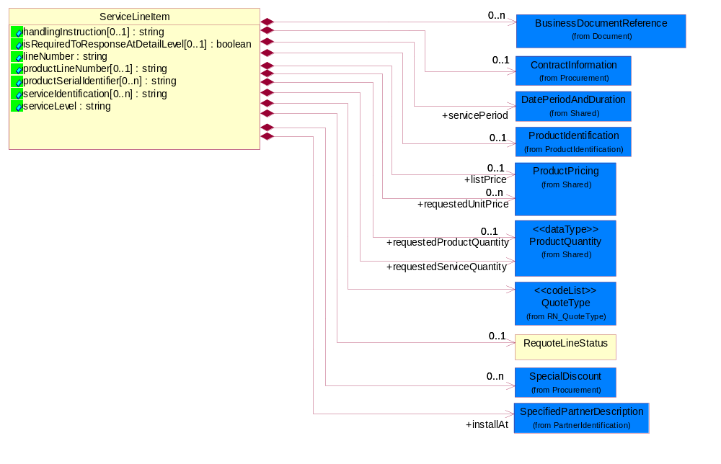
Figure 2-12 ServiceLineItem

Attribute | Type | Documentation
handlingInstruction[0..1] | string | The object that representing the instruction for quote handling.
isRequiredToResponseAtDetailLevel[0..1] | boolean | This object representing the option for the response. If the value equals to true, the receiver is required to response to detail level. If the value equals to false, the receiver is only required to reply at summary level.
lineNumber | string | Number of the line in the document.
productLineNumber[0..1] | string | The object that representing the line number of the referenced product line item.
productSerialIdentifier[0..n] | string | A unique serial identifier assigned to a product.
serviceIdentification[0..n] | string | A unique serial identifier assigned to a service.
serviceLevel | string | The object that representing the type of service.

Composition | Cardinality | Type | Documentation
installAt | 1 | SpecifiedPartnerDescription | The partner and/or location to which the product must be set up for use or service.
RequoteLineStatus | 0..1 | RequoteLineStatus | The collection of business properties that describe a previous quote's identification and status for a given entry on the prior quote.
ContractInformation | 0..1 | ContractInformation | The collection of business properties that represent a business arrangement for the supply of goods or services at an agreed price.
QuoteType | 1 | QuoteType | Code identifying category specification for a quote.
SpecialDiscount | 0..n | SpecialDiscount | This object represents a special discount based on the special discount identifier.
ProductIdentification | 0..1 | ProductIdentification | The object provides the identifier(s) of a product.
BusinessDocumentReference | 0..n | BusinessDocumentReference | The business document reference object allows for the indirect referencing of a relationship to other business related documents.
servicePeriod | 1 | DatePeriodAndDuration | This object allows representation of a date period by a duration or begin and an end dates for a service period.
requestedServiceQuantity | 1 | ProductQuantity | The quantity of service requested.
requestedProductQuantity | 0..1 | ProductQuantity | The quantity of product requested.
requestedUnitPrice | 0..n | ProductPricing | The price requested for a unit of service.
listPrice | 0..1 | ProductPricing | This object represents a pre-discounted price.

ServiceLineItemByOption
The collection of business properties that describe a service entry by option (eg. by Contract, by Product or by Site) in a quote business documents. The Recommended ProcessRoleIdentifier for PartnerDescription is ITL - Install At.
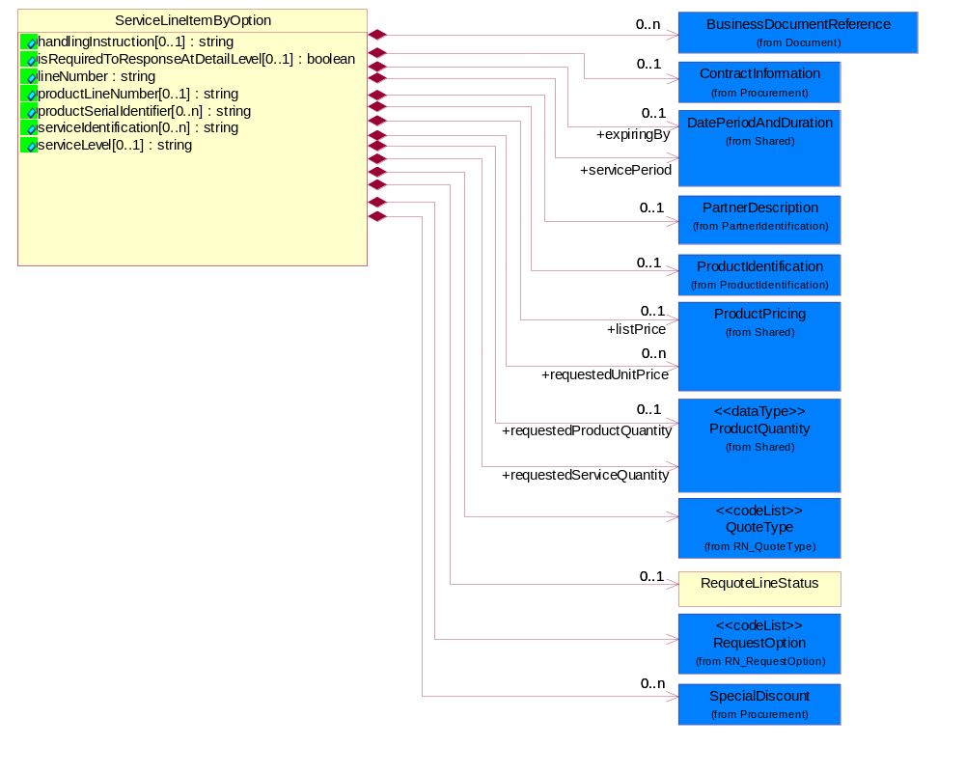
Figure 2-13 ServiceLineItemByOption

Attribute | Type | Documentation
handlingInstruction[0..1] | string | The object that representing the instruction for quote handling.
isRequiredToResponseAtDetailLevel[0..1] | boolean | This object representing the option for the response. If the value equals to true, the receiver is required to response to detail level. If the value equals to false, the receiver is only required to reply at summary level.
lineNumber | string | Number of the line in the document.
productLineNumber[0..1] | string | The object that representing the line number of the referenced product line item.
productSerialIdentifier[0..n] | string | A unique serial identifier assigned to a product.
serviceIdentification[0..n] | string | A unique serial identifier assigned to a service.
serviceLevel[0..1] | string | The object that representing the type of service.

Composition | Cardinality | Type | Documentation
BusinessDocumentReference | 0..n | BusinessDocumentReference | The business document reference object allows for the indirect referencing of a relationship to other business related documents.
ContractInformation | 0..1 | ContractInformation | The collection of business properties that represent a business arrangement for the supply of goods or services at an agreed price.
ProductIdentification | 0..1 | ProductIdentification | The object provides the identifier(s) of a product.
QuoteType | 1 | QuoteType | Code identifying category specification for a quote.
RequoteLineStatus | 0..1 | RequoteLineStatus | The collection of business properties that describe a previous quote's identification and status for a given entry on the prior quote.
RequestOption | 1 | RequestOption | Code identifying an option for a request, eg. quote request or order request.
SpecialDiscount | 0..n | SpecialDiscount | This object represents a special discount based on the special discount identifier.
servicePeriod | 1 | DatePeriodAndDuration | This object allows representation of a date period by a duration or begin and an end dates for a service period.
expiringBy | 0..1 | DatePeriodAndDuration | Renew all products expiring in this specified period.
requestedServiceQuantity | 1 | ProductQuantity | The quantity of service requested.
requestedProductQuantity | 0..1 | ProductQuantity | The quantity of product requested.
requestedUnitPrice | 0..n | ProductPricing | The price requested for a unit of service.
listPrice | 0..1 | ProductPricing | This object represents a pre-discounted price.
PartnerDescription | 0..1 | PartnerDescription | The collection of business properties that describe a business partners' identity, their contact information, where they are physically located and their function in a supply chain.

TransportationSchedule
The collection of business properties that describe product quantity and associated schedules, for a given transportation event.
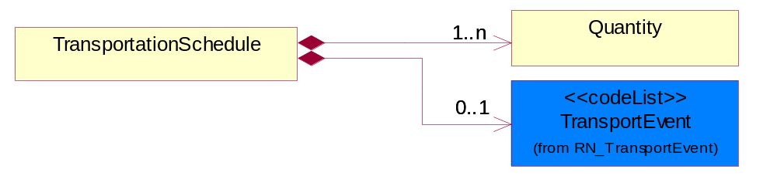
Figure 2-14 TransportationSchedule

Composition | Cardinality | Type | Documentation
Quantity | 1..n | Quantity | The collection of business properties that describe product quantity and associated schedules.
TransportEvent | 0..1 | TransportEvent | Code identifying an event during the transportation of a shipment.

QuoteConfirmation

Interchange Diagram
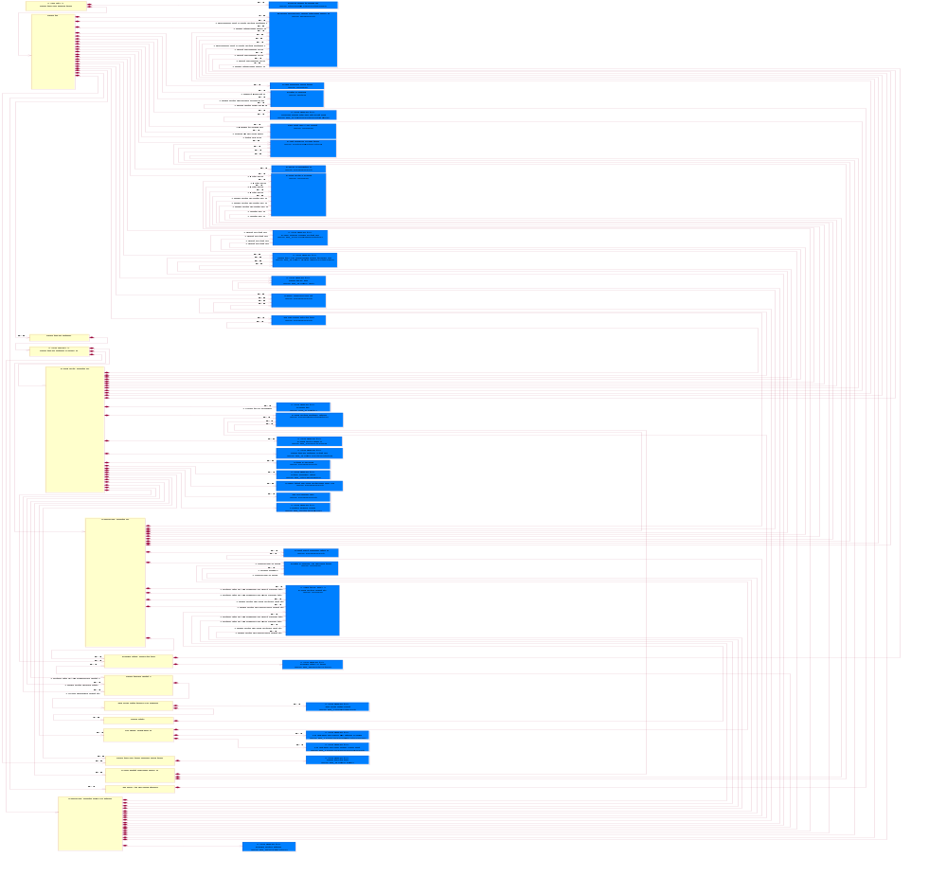
Figure 2-15 Interchange

Dependency Diagram
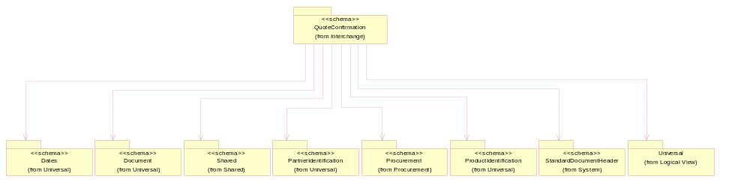
Figure 2-16 Dependency

CompetitorReference
The collection of business properties that describe a competitor's product and pricing for purposes within a quote business document.
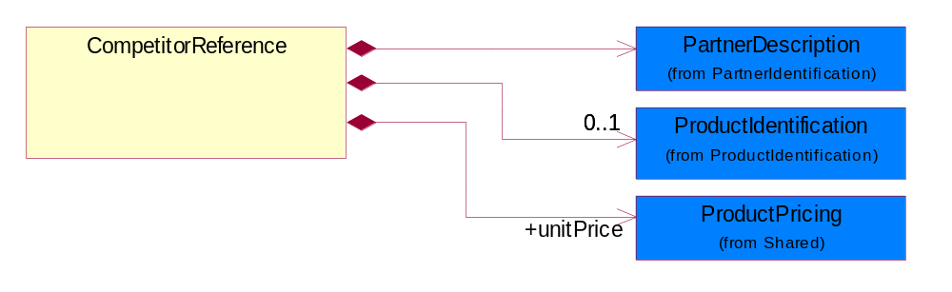
Figure 2-17 CompetitorReference

Composition | Cardinality | Type | Documentation
PartnerDescription | 1 | PartnerDescription | The collection of business properties that describe a business partners' identity, their contact information, where they are physically located and their function in a supply chain.
ProductIdentification | 0..1 | ProductIdentification | The object provides the identifier(s) of a product.
unitPrice | 1 | ProductPricing | Agreed upon sale price for each unit ordered.

OrderLeadTime
The collection of business properties that describe the lead time parameters for a product order.
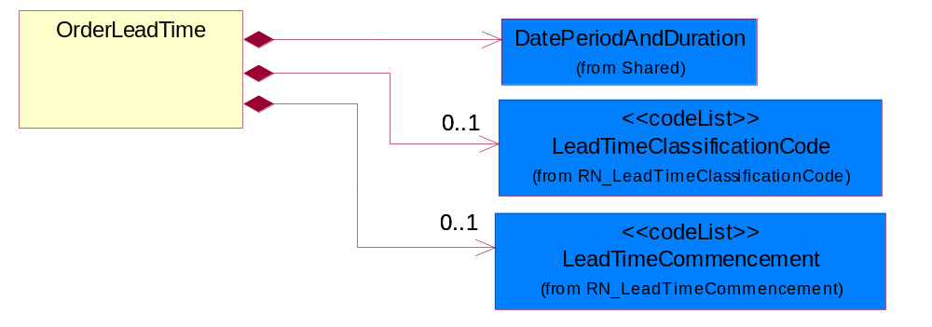
Figure 2-18 OrderLeadTime

Composition | Cardinality | Type | Documentation
LeadTimeClassificationCode | 0..1 | LeadTimeClassificationCode | Code identifying the classification of a product lead time for ordering.
LeadTimeCommencement | 0..1 | LeadTimeCommencement | Code identifying the conditions required for a product lead time to being.
DatePeriodAndDuration | 1 | DatePeriodAndDuration | The collection of business properties that describe a date period or duration.

ProductLineItem
The collection of business properties that describe a product entry in a quote business document. The Recommended ProcessRoleIdentifier for PartnerDescription are RSF - Requested Ship From, SHT - Ship To and SHF - Ship From.
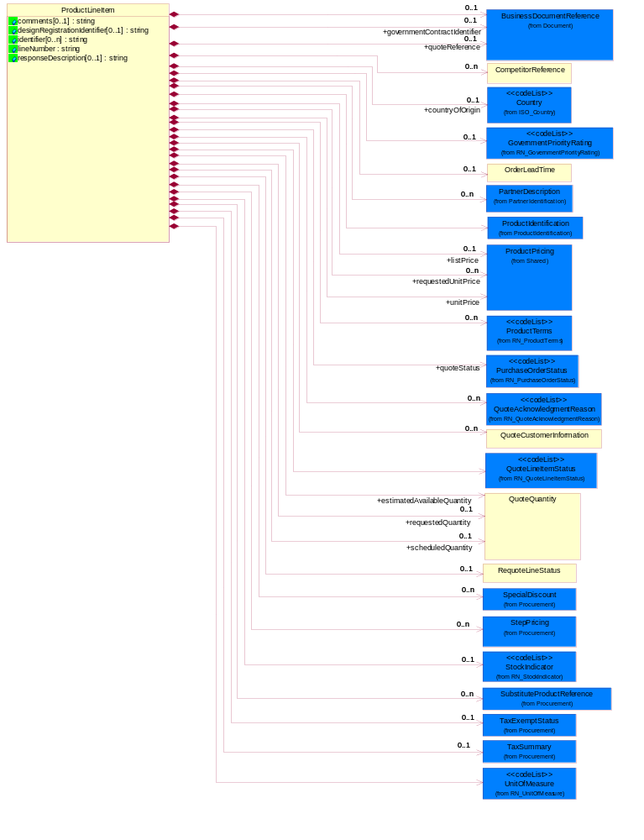
Figure 2-19 ProductLineItem

Attribute | Type | Documentation
comments[0..1] | string | Free form textual description of a general nature.
designRegistrationIdentifier[0..1] | string | A proprietary unique identifier for a design registration.
identifier[0..n] | string | A unique serial identifier assigned to a product.
lineNumber | string | Number of the line in the document.
responseDescription[0..1] | string | This object representing the description of response.

Composition | Cardinality | Type | Documentation
countryOfOrigin | 0..1 | Country | Country where product originates.
BusinessDocumentReference | 0..1 | BusinessDocumentReference | The business document reference object allows for the indirect referencing of a relationship to other business related documents.
estimatedAvailableQuantity | 1 | QuoteQuantity | The estimated available quantity of a product.
GovernmentPriorityRating | 0..1 | GovernmentPriorityRating | If a contract number exists and PO type is Government, a priority rating code is required.
UnitOfMeasure | 1 | UnitOfMeasure | Code identifying a product unit of measure.
governmentContractIdentifier | 0..1 | BusinessDocumentReference | The unique number that identifies a government contract.
OrderLeadTime | 0..1 | OrderLeadTime | The collection of business properties that describe the lead time parameters for a product order.
ProductIdentification | 1 | ProductIdentification | The object provides the identifier(s) of a product.
CompetitorReference | 0..n | CompetitorReference | The collection of business properties that describe a competitor's product and pricing for purposes within a quote business document.
RequoteLineStatus | 0..1 | RequoteLineStatus | The collection of business properties that describe a previous quote's identification and status for a given entry on the prior quote.
StepPricing | 0..n | StepPricing | The collection of business properties that describe a product's variance in pricing in regards to specified date ranges and quantities.
SubstituteProductReference | 0..n | SubstituteProductReference | The collection of business properties describing a product that is being substituted for a requested product.
TaxExemptStatus | 0..1 | TaxExemptStatus | The collection of business properties that describe tax exemption conditions.
QuoteCustomerInformation | 0..n | QuoteCustomerInformation | The collection of business properties that describe the customer who uses a quote business document.
requestedQuantity | 0..1 | QuoteQuantity | The quantity of product requested.
scheduledQuantity | 0..1 | QuoteQuantity | The planned quantity available for delivery or shipment.
StockIndicator | 0..1 | StockIndicator | Code identifying the amount of stock available at the time of the quote.
ProductTerms | 0..n | ProductTerms | Code identifying the terms and conditions for a product being quoted.
QuoteLineItemStatus | 1 | QuoteLineItemStatus | A code identifying the bid status of a line item on a quote.
TaxSummary | 0..1 | TaxSummary | The collection of business properties that describe the total tax information for a local, regional or national taxing authority.
SpecialDiscount | 0..n | SpecialDiscount | This object represents a special discount based on the special discount identifier.
QuoteAcknowledgmentReason | 0..n | QuoteAcknowledgmentReason | Code identifying the reason for acknowledging a quote.
quoteReference | 0..1 | BusinessDocumentReference | This object represents the quote reference, ie. quote identifier & reference line number in the quote.
quoteStatus | 1 | PurchaseOrderStatus | Code identifying the status of a quote.
unitPrice | 1 | ProductPricing | Agreed upon sale price for each unit ordered.
requestedUnitPrice | 0..n | ProductPricing | The price requested for a unit of product.
listPrice | 0..1 | ProductPricing | This object represents a pre-discounted price.
PartnerDescription | 0..n | PartnerDescription | The collection of business properties that describe a business partners' identity, their contact information, where they are physically located and their function in a supply chain.

Quantity
The collection of business properties that describe product quantity and associated schedules.
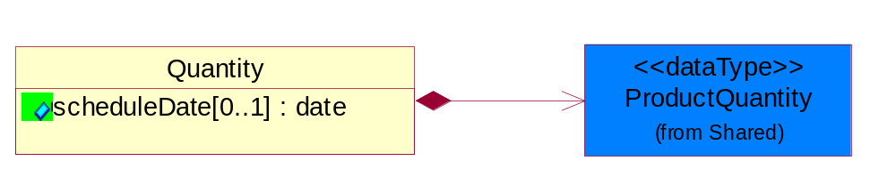
Figure 2-20 Quantity

Attribute | Type | Documentation
scheduleDate[0..1] | date | Specifies a date for the schedule.

Composition | Cardinality | Type | Documentation
ProductQuantity | 1 | ProductQuantity | A quantity specifying the number of product units.

Quote
The collection of business properties that describe an offer to supply a quantity of products at an agreed price and schedule. The Recommended ProcessRoleIdentifier for PartnerDescription are FIN - Financed By, DIS - Distributed By, RQT - Refer Quote To, RES - Respond To, CWN - Contract Owner and BIT - Bill To.
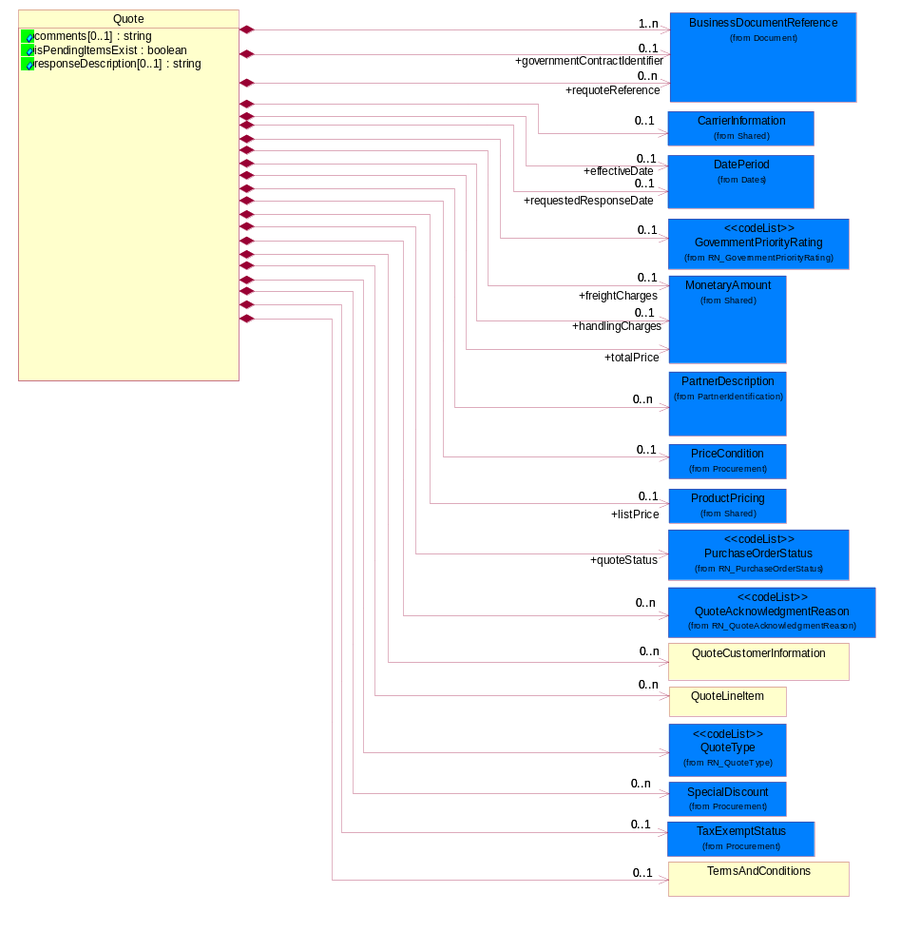
Figure 2-21 Quote

Attribute | Type | Documentation
comments[0..1] | string | Free form textual description of a general nature.
isPendingItemsExist | boolean | Indicates whether any line items in the business document are in a pending status.
responseDescription[0..1] | string | This object representing the description of response.

Composition | Cardinality | Type | Documentation
BusinessDocumentReference | 1..n | BusinessDocumentReference | The business document reference object allows for the indirect referencing of a relationship to other business related documents.
effectiveDate | 0..1 | DatePeriod | The date information or an activity becomes effective.
GovernmentPriorityRating | 0..1 | GovernmentPriorityRating | If a contract number exists and PO type is Government, a priority rating code is required.
governmentContractIdentifier | 0..1 | BusinessDocumentReference | The unique number that identifies a government contract.
PriceCondition | 0..1 | PriceCondition | The collection of business properties that define information for special pricing conditions.
QuoteCustomerInformation | 0..n | QuoteCustomerInformation | The collection of business properties that describe the customer who uses a quote business document.
requestedResponseDate | 0..1 | DatePeriod | The date for which a response has been requested to be transmitted.
requoteReference | 0..n | BusinessDocumentReference | The document reference for a previous quote.
TaxExemptStatus | 0..1 | TaxExemptStatus | The collection of business properties that describe tax exemption conditions.
TermsAndConditions | 0..1 | TermsAndConditions | The collection of business properties that describe the terms and conditions agreed between two parties under which a product or service is provided.
QuoteType | 1 | QuoteType | Code identifying category specification for a quote.
QuoteLineItem | 0..n | QuoteLineItem | The collection of business properties that describe a entry in a quote business document.
SpecialDiscount | 0..n | SpecialDiscount | This object represents a special discount based on the special discount identifier.
QuoteAcknowledgmentReason | 0..n | QuoteAcknowledgmentReason | Code identifying the reason for acknowledging a quote.
quoteStatus | 1 | PurchaseOrderStatus | Code identifying the status of a quote.
CarrierInformation | 0..1 | CarrierInformation | The collection of business properties that describe a carrier's identification.
freightCharges | 0..1 | MonetaryAmount | The monetary amount to be paid for freight transportation.
handlingCharges | 0..1 | MonetaryAmount | The monetary amount to be paid for product handling for pre-, during and post-transportation.
totalPrice | 1 | MonetaryAmount | Total price for the entire business document, including freight, tax and special handling if applicable.
listPrice | 0..1 | ProductPricing | This object represents a pre-discounted price.
PartnerDescription | 0..n | PartnerDescription | The collection of business properties that describe a business partners' identity, their contact information, where they are physically located and their function in a supply chain.

QuoteConfirmation
A message wrapper or root element for PIP3A1.
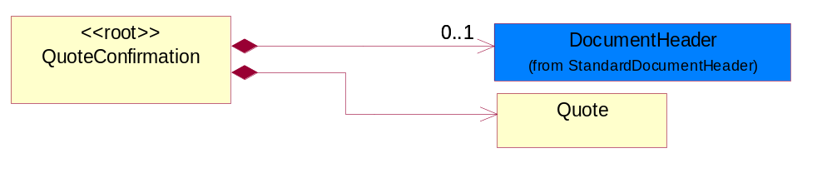
Figure 2-22 QuoteConfirmation

Composition | Cardinality | Type | Documentation
DocumentHeader | 0..1 | DocumentHeader | The object allows for the identification of the sender and receiver of the business document.
Quote | 1 | Quote | The collection of business properties that describe an offer to supply a quantity of products at an agreed price and schedule. The Recommended ProcessRoleIdentifier for  PartnerDescription are FIN - Financed By, DIS - Distributed By, RQT - Refer Quote To, RES - Respond To, CWN - Contract Owner and BIT - Bill To.

QuoteCustomerInformation
The collection of business properties that describe the customer who uses a quote business document.
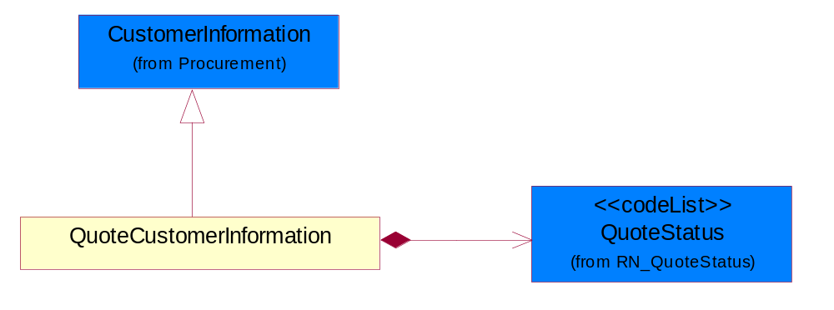
Figure 2-23 QuoteCustomerInformation

Composition | Cardinality | Type | Documentation
QuoteStatus | 1 | QuoteStatus | Code identifying whether business has been secured by the end customer.

QuoteLineItem
The collection of business properties that describe a entry in a quote business document.
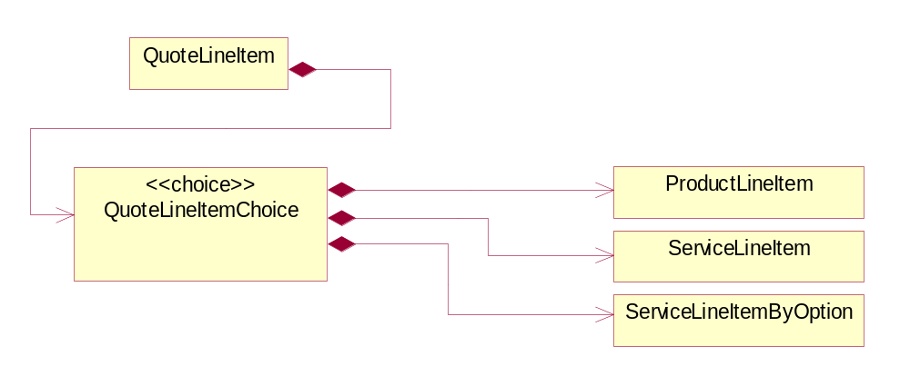
Figure 2-24 QuoteLineItem

Composition | Cardinality | Type | Documentation
QuoteLineItemChoice | 1 | QuoteLineItemChoice

QuoteLineItemChoice

Composition | Cardinality | Type | Documentation
ProductLineItem | 1 | ProductLineItem | The collection of business properties that describe a product entry in a quote business document. The Recommended ProcessRoleIdentifier for PartnerDescription are RSF - Requested Ship From, SHT - Ship To and SHF - Ship From.
ServiceLineItem | 1 | ServiceLineItem | The collection of business properties that describe a service entry in a quote business documents. The Recommended ProcessRoleIdentifier for PartnerDescription is ITL - Install At.
ServiceLineItemByOption | 1 | ServiceLineItemByOption | The collection of business properties that describe a service entry by option (eg. by Contract, by Product or by Site) in a quote business documents. The Recommended ProcessRoleIdentifier for PartnerDescription is ITL - Install At.

QuoteQuantity
The collection of business properties that describe the quantities associated with a product quote.
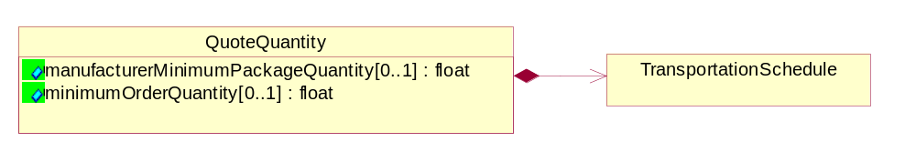
Figure 2-25 QuoteQuantity

Attribute | Type | Documentation
manufacturerMinimumPackageQuantity[0..1] | float | The product quantity in a defined package by a manufacturer.
minimumOrderQuantity[0..1] | float | A numeric expression of the minimum number of product line items that may be ordered.

Composition | Cardinality | Type | Documentation
TransportationSchedule | 1 | TransportationSchedule | The collection of business properties that describe product quantity and associated schedules, for a given transportation event.

RequoteLineStatus
The collection of business properties that describe a previous quote's identification and status for a given entry on the prior quote.
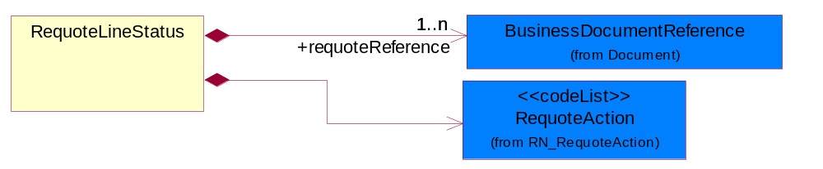
Figure 2-26 RequoteLineStatus

Composition | Cardinality | Type | Documentation
requoteReference | 1..n | BusinessDocumentReference | The document reference for a previous quote.
RequoteAction | 1 | RequoteAction | Code identifying the type of action to be taken for a given line item on a quote.

ServiceLineItem
The collection of business properties that describe a service entry in a quote business documents. The Recommended ProcessRoleIdentifier for PartnerDescription is ITL - Install At.
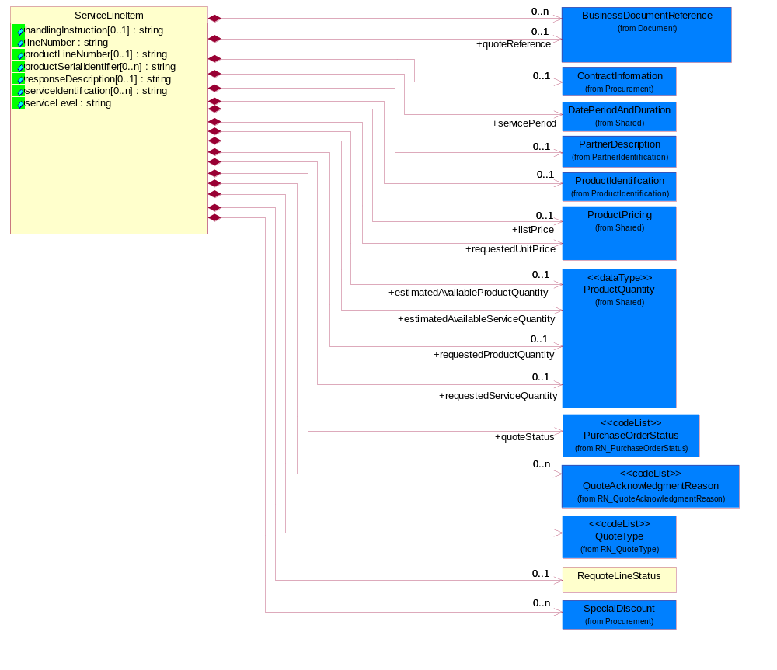
Figure 2-27 ServiceLineItem

Attribute | Type | Documentation
handlingInstruction[0..1] | string | The object that representing the instruction for quote handling.
lineNumber | string | Number of the line in the document.
productLineNumber[0..1] | string | The object that representing the line number of the referenced product line item.
productSerialIdentifier[0..n] | string | A unique serial identifier assigned to a product.
responseDescription[0..1] | string | This object representing the description of response.
serviceIdentification[0..n] | string | A unique serial identifier assigned to a service.
serviceLevel | string | The object that representing the type of service.

Composition | Cardinality | Type | Documentation
ContractInformation | 0..1 | ContractInformation | The collection of business properties that represent a business arrangement for the supply of goods or services at an agreed price.
QuoteType | 1 | QuoteType | Code identifying category specification for a quote.
RequoteLineStatus | 0..1 | RequoteLineStatus | The collection of business properties that describe a previous quote's identification and status for a given entry on the prior quote.
SpecialDiscount | 0..n | SpecialDiscount | This object represents a special discount based on the special discount identifier.
ProductIdentification | 0..1 | ProductIdentification | The object provides the identifier(s) of a product.
QuoteAcknowledgmentReason | 0..n | QuoteAcknowledgmentReason | Code identifying the reason for acknowledging a quote.
BusinessDocumentReference | 0..n | BusinessDocumentReference | The business document reference object allows for the indirect referencing of a relationship to other business related documents.
quoteReference | 0..1 | BusinessDocumentReference | This object represents the quote reference, ie. quote identifier & reference line number in the quote.
quoteStatus | 1 | PurchaseOrderStatus | Code identifying the status of a quote.
servicePeriod | 1 | DatePeriodAndDuration | This object allows representation of a date period by a duration or begin and an end dates for a service period.
requestedServiceQuantity | 0..1 | ProductQuantity | The quantity of service requested.
estimatedAvailableServiceQuantity | 1 | ProductQuantity | The estimated available quantity of a service.
requestedProductQuantity | 0..1 | ProductQuantity | The quantity of product requested.
estimatedAvailableProductQuantity | 0..1 | ProductQuantity | The estimated available quantity of a product.
requestedUnitPrice | 1 | ProductPricing | The price requested for a unit of service.
listPrice | 0..1 | ProductPricing | This object represents a pre-discounted price.
PartnerDescription | 0..1 | PartnerDescription | The collection of business properties that describe a business partners' identity, their contact information, where they are physically located and their function in a supply chain.

ServiceLineItemByOption
The collection of business properties that describe a service entry by option (eg. by Contract, by Product or by Site) in a quote business documents. The Recommended ProcessRoleIdentifier for PartnerDescription is ITL - Install At.
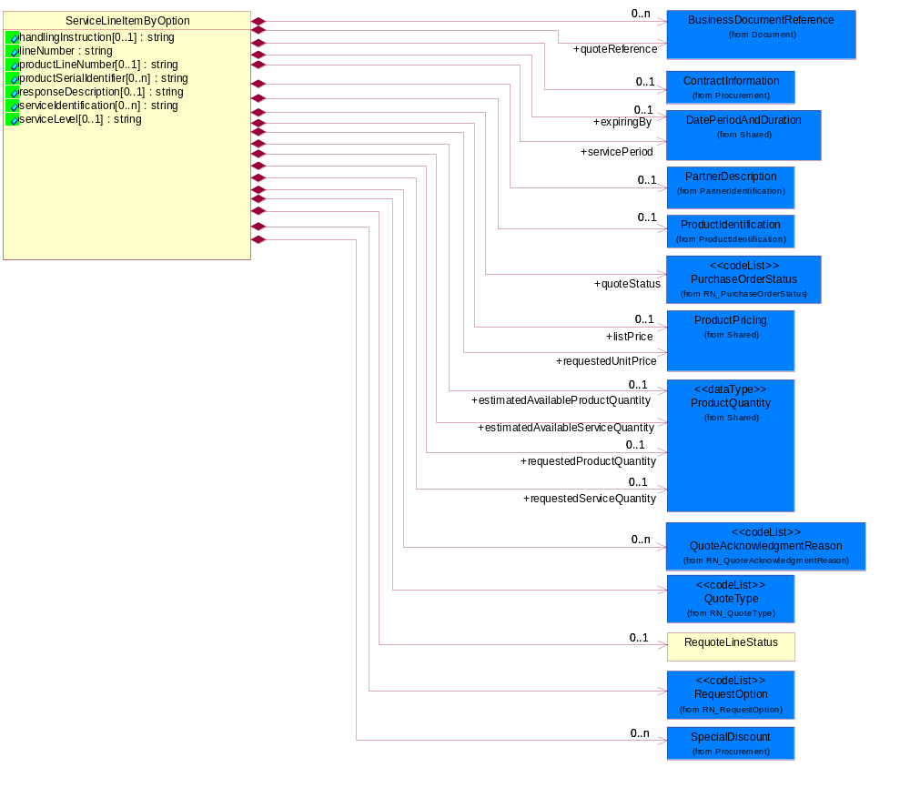
Figure 2-28 ServiceLineItemByOption

Attribute | Type | Documentation
handlingInstruction[0..1] | string | The object that representing the instruction for quote handling.
lineNumber | string | Number of the line in the document.
productLineNumber[0..1] | string | The object that representing the line number of the referenced product line item.
productSerialIdentifier[0..n] | string | A unique serial identifier assigned to a product.
responseDescription[0..1] | string | This object representing the description of response.
serviceIdentification[0..n] | string | A unique serial identifier assigned to a service.
serviceLevel[0..1] | string | The object that representing the type of service.

Composition | Cardinality | Type | Documentation
BusinessDocumentReference | 0..n | BusinessDocumentReference | The business document reference object allows for the indirect referencing of a relationship to other business related documents.
quoteReference | 1 | BusinessDocumentReference | This object represents the quote reference, ie. quote identifier & reference line number in the quote.
ContractInformation | 0..1 | ContractInformation | The collection of business properties that represent a business arrangement for the supply of goods or services at an agreed price.
QuoteType | 1 | QuoteType | Code identifying category specification for a quote.
QuoteAcknowledgmentReason | 0..n | QuoteAcknowledgmentReason | Code identifying the reason for acknowledging a quote.
quoteStatus | 1 | PurchaseOrderStatus | Code identifying the status of a quote.
RequoteLineStatus | 0..1 | RequoteLineStatus | The collection of business properties that describe a previous quote's identification and status for a given entry on the prior quote.
RequestOption | 1 | RequestOption | Code identifying an option for a request, eg. quote request or order request.
SpecialDiscount | 0..n | SpecialDiscount | This object represents a special discount based on the special discount identifier.
ProductIdentification | 0..1 | ProductIdentification | The object provides the identifier(s) of a product.
servicePeriod | 1 | DatePeriodAndDuration | This object allows representation of a date period by a duration or begin and an end dates for a service period.
expiringBy | 0..1 | DatePeriodAndDuration | Renew all products expiring in this specified period.
requestedUnitPrice | 1 | ProductPricing | The price requested for a unit of service.
requestedServiceQuantity | 0..1 | ProductQuantity | The quantity of service requested.
estimatedAvailableServiceQuantity | 1 | ProductQuantity | The quantity of estimated available service.
requestedProductQuantity | 0..1 | ProductQuantity | The quantity of product requested.
estimatedAvailableProductQuantity | 0..1 | ProductQuantity | The quantity of estimated available product.
listPrice | 0..1 | ProductPricing | This object represents a pre-discounted price.
PartnerDescription | 0..1 | PartnerDescription | The collection of business properties that describe a business partners' identity, their contact information, where they are physically located and their function in a supply chain.

TermsAndConditions
The collection of business properties that describe the terms and conditions agreed between two parties under which a product or service is provided.
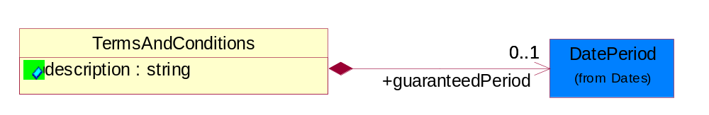
Figure 2-29 TermsAndConditions

Attribute | Type | Documentation
description | string | Free form textual description that contains terms and conditions.

Composition | Cardinality | Type | Documentation
guaranteedPeriod | 0..1 | DatePeriod | A date period, defined by a start date and end date, where terms and conditions are guaranteed.

TransportationSchedule
The collection of business properties that describe product quantity and associated schedules, for a given transportation event.
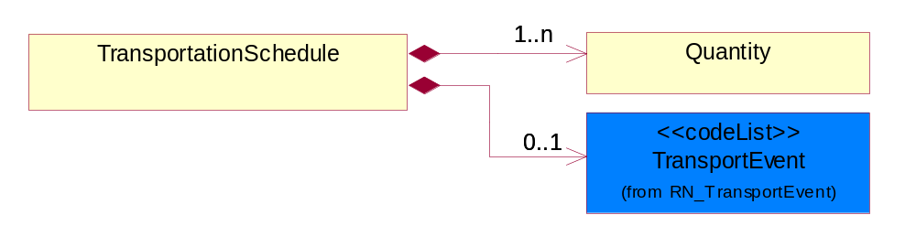
Figure 2-30 TransportationSchedule

Composition | Cardinality | Type | Documentation
Quantity | 1..n | Quantity | The collection of business properties that describe product quantity and associated schedules.
TransportEvent | 0..1 | TransportEvent | Code identifying an event during the transportation of a shipment.

CodeList

StockIndicator
Code identifying the amount of stock available at the time of the quote.

Name | Documentation
DIS | Distributor - Distributor has stock for all of the requested quantity.
FAC | Factory - Factory/seller has stock.
NON | None - Distributor has no stock.
PAR | Partial - Distributor has stock for part of the requested quantity.

LeadTimeCommencement
Code identifying the conditions required for a product lead time to being.

Name | Documentation
ACO | After completion of first article.
ARO | After receipt of order.

ProductTerms
Code identifying the terms and conditions for a product being quoted.

Name | Documentation
EOL | End of Life.
NOC | Non-Cancelable / non-returnable.
OTB | One Time Buy.
PPR | Price Protection.

QuoteLineItemStatus
A code identifying the bid status of a line item on a quote.

Name | Documentation
BID | Bid - The line item has been bid on.
NBI | No Bid - The line item will not be bid on.
PEN | Pending - The line item is pending a bid.

Domain Model

Procurement

Procurement

Dependency Diagram
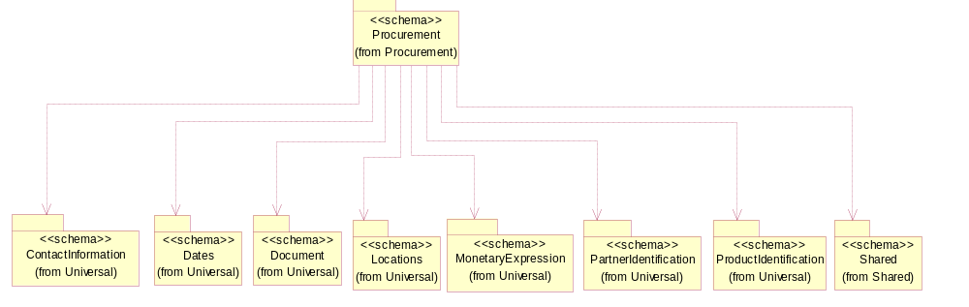
Figure 3-31 Dependency

ContractInformation
The collection of business properties that represent a business arrangement for the supply of goods or services at an agreed price.
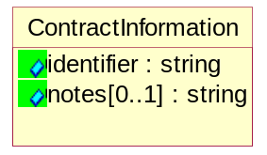
Figure 3-32 ContractInformation
Attribute | Type | Documentation
identifier | string | The unique number than identifies a contract.
notes[0..1] | string | A textual description about contract.

CurrencyConversion
The collection of business properties that describe the exchange of money in circulation.
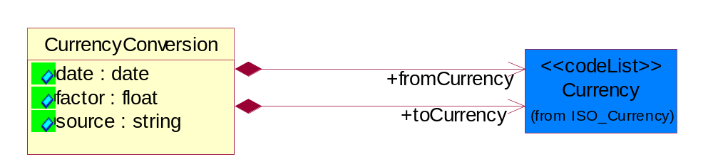
Figure 3-33 CurrencyConversion

Attribute | Type | Documentation
date | date | The date of the exchange rate used to convert between currencies.
factor | float | The conversion factor to apply to convert from the currency of the freight charges to the currency used for payment.
source | string | The source of the exchange rate used to convert between currencies.

Composition | Cardinality | Type | Documentation
toCurrency | 1 | Currency | The currency of the receiving partner in a business transaction.
fromCurrency | 1 | Currency | The currency of the initiating partner in a business transaction.

CustomerInformation
The collection of business properties that describe an end user.
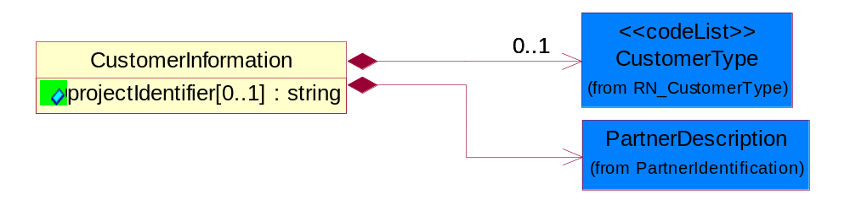
Figure 3-34 CustomerInformation

Attribute | Type | Documentation
projectIdentifier[0..1] | string | The unique identification number that identifies a project for a given customer.

Composition | Cardinality | Type | Documentation
CustomerType | 0..1 | CustomerType | Code identifying the type of end user.
PartnerDescription | 1 | PartnerDescription | The collection of business properties that describe a business partners' identity, their contact information, where they are physically located and their function in a supply chain.

OtherTaxes
The collection of business properties that describe other tax information.
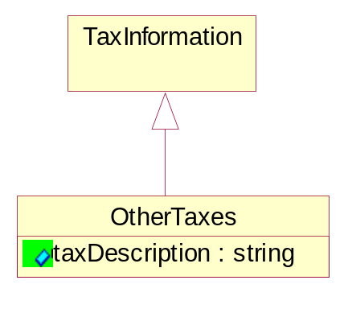
Figure 3-35 OtherTaxes

Attribute | Type | Documentation
taxDescription | string | Describe different kind of taxes, such as goods and services tax, special release tax.

PriceCondition
The collection of business properties that define information for special pricing conditions.
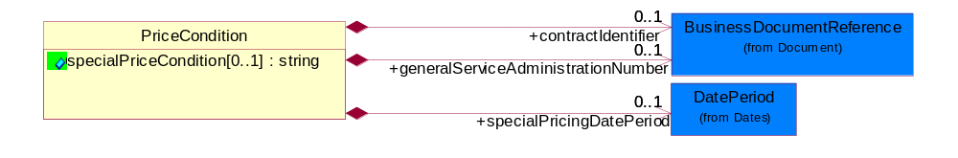
Figure 3-36 PriceCondition

Attribute | Type | Documentation
specialPriceCondition[0..1] | string | Textual description that identifies conditions under which special pricing is applicable.

Composition | Cardinality | Type | Documentation
specialPricingDatePeriod | 0..1 | DatePeriod | The date range indicating when a product's special pricing is valid.
generalServiceAdministrationNumber | 0..1 | BusinessDocumentReference | Identifying number relating to a pre-established end-user pricing agreement.
contractIdentifier | 0..1 | BusinessDocumentReference | The unique number that identifies a contract.

ProductQuantityRange
The collection of business properties that describe an upper and lower range of product quantity.
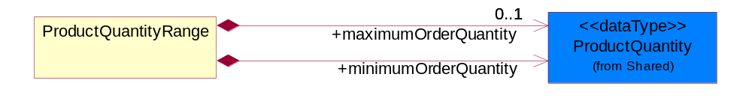
Figure 3-37 ProductQuantityRange

Composition | Cardinality | Type | Documentation
maximumOrderQuantity | 0..1 | ProductQuantity | A numeric expression of the maximum number of product line items that may be ordered.
minimumOrderQuantity | 1 | ProductQuantity | A numeric expression of the minimum number of product line items that may be ordered.

SpecialDiscount
This object represents a special discount based on the special discount identifier.
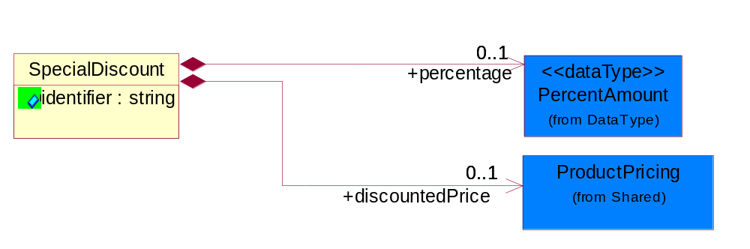
Figure 3-38 SpecialDiscount

Attribute | Type | Documentation
identifier | string | This object representing the special discount identifier.

Composition | Cardinality | Type | Documentation
percentage | 0..1 | PercentAmount | This object represents a special discount percentage.
discountedPrice | 0..1 | ProductPricing | This object represents a special discount price.

StepPricing
The collection of business properties that describe a product's variance in pricing in regards to specified date ranges and quantities.
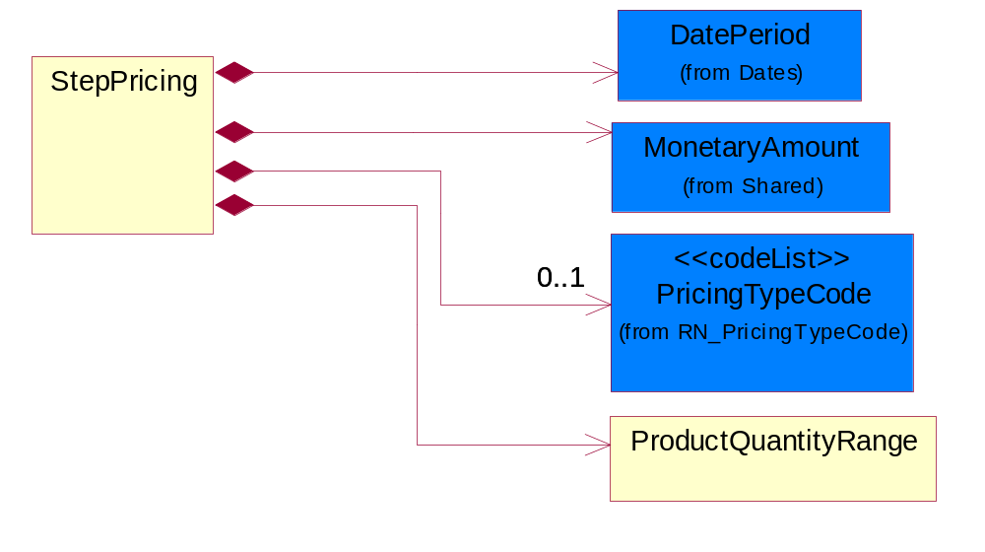
Figure 3-39 StepPricing

Composition | Cardinality | Type | Documentation
ProductQuantityRange | 1 | ProductQuantityRange | The collection of business properties that describe an upper and lower range of product quantity.
DatePeriod | 1 | DatePeriod | The business document must allow for the computation or statement of a duration based upon a beginning and an ending date.
MonetaryAmount | 1 | MonetaryAmount | The collection of business properties that describe the monetary amount defined by a specified currency.
PricingTypeCode | 0..1 | PricingTypeCode | Code identifying the type of pricing available for a product.

SubstituteProductReference
The collection of business properties describing a product that is being substituted for a requested product.
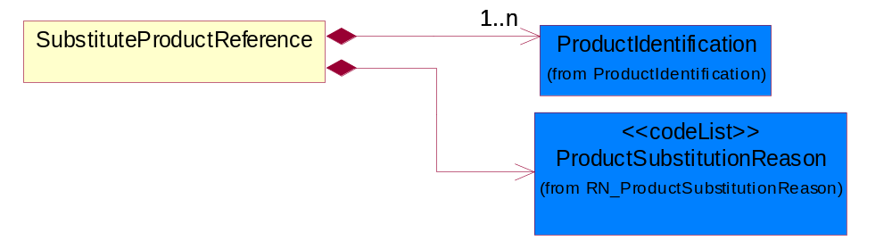
Figure 3-40 SubstituteProductReference

Composition | Cardinality | Type | Documentation
ProductSubstitutionReason | 1 | ProductSubstitutionReason | A code identifying the reason a product is substituted for the original product requested.
ProductIdentification | 1..n | ProductIdentification | The object provides the identifier(s) of a product.

TaxExemption
The collection of business properties that describe tax exemption type and identification information.
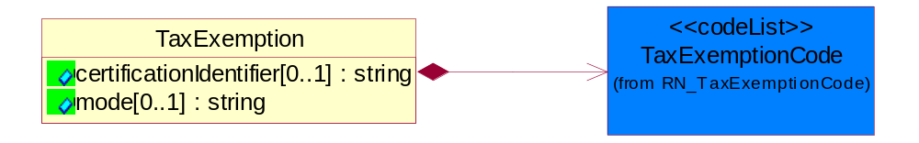
Figure 3-41 TaxExemption

Attribute | Type | Documentation
certificationIdentifier[0..1] | string | The unique identifier that represents the authorization for a product or service's tax exempt status.
mode[0..1] | string | This object refering to the tax exemption mode by Customs against goods declared eg. duty free, partial tax exemption or full tax exemption.

Composition | Cardinality | Type | Documentation
TaxExemptionCode | 1 | TaxExemptionCode | Code identifying the type of tax exemption for a product or service.

TaxExemptStatus
The collection of business properties that describe tax exemption conditions.
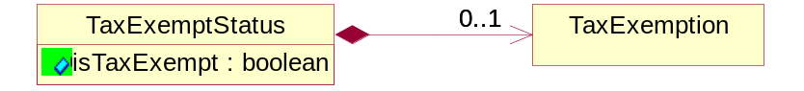
Figure 3-42 TaxExemptStatus

Attribute | Type | Documentation
isTaxExempt | boolean | Indicates whether a product is exempt from taxation.

Composition | Cardinality | Type | Documentation
TaxExemption | 0..1 | TaxExemption | The collection of business properties that describe tax exemption type and identification information.

TaxInformation
The collection of business properties that describe tax information.
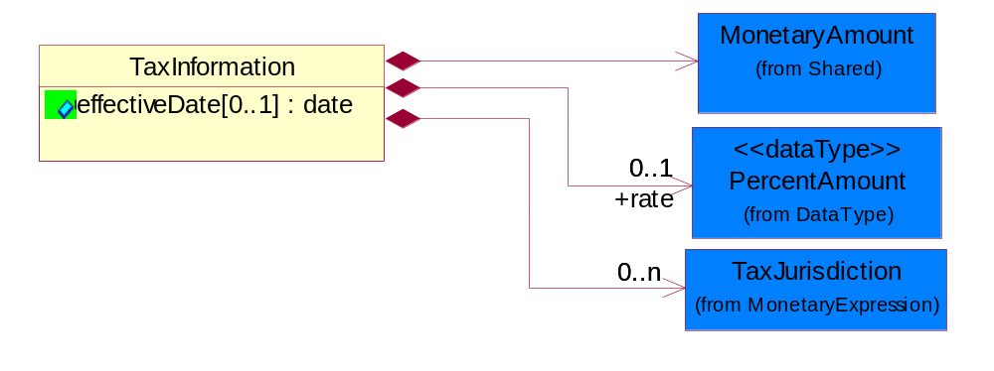
Figure 3-43 TaxInformation

Attribute | Type | Documentation
effectiveDate[0..1] | date | The date tax become effective or applicable.

Composition | Cardinality | Type | Documentation
TaxJurisdiction | 0..n | TaxJurisdiction | The business document must identify the specific tax collection authority.
rate | 0..1 | PercentAmount | The rate used to calculate tax liability.
MonetaryAmount | 1 | MonetaryAmount | The collection of business properties that describe the monetary amount defined by a specified currency.

TaxPhrase
The collection of business properties that describe VAT specific information.
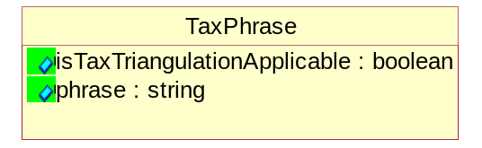
Figure 3-44 TaxPhrase

Attribute | Type | Documentation
isTaxTriangulationApplicable | boolean | Indicates whether intermediate suppliers in a triangulation chain may be able to use a simplified procedure available throughout the EC. Triangulation is a name for a type of transaction that can apply only to EU VAT registered companies dispatching goods to countries within the EU.
phrase | string | Country or territory specific tax qualifier verbiage as and when required for tax audit purposes. Such verbiage should be transmitted and stored with the invoice, and may be required to be in local language. Trading Partners are responsible for ensuring that appropriate verbiage is included as per individual tax authority requirements.

TaxSummary
The collection of business properties that describe the total tax information for a local, regional or national taxing authority.
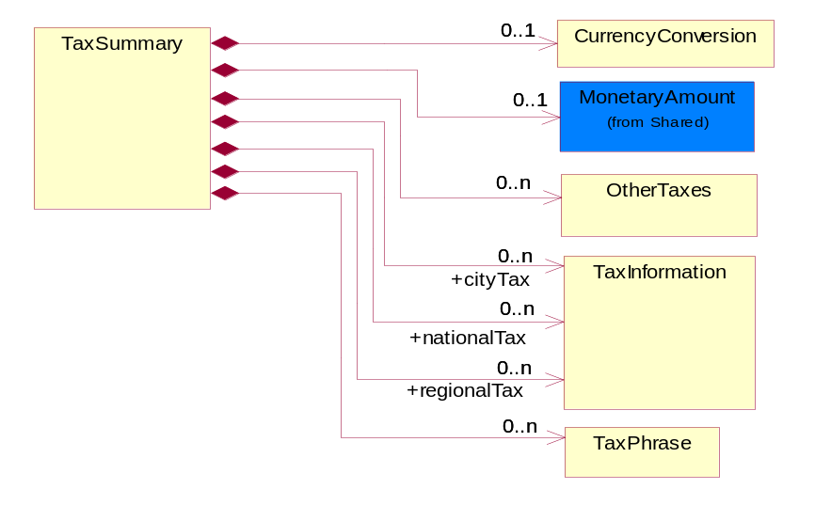
Figure 3-45 TaxSummary

Composition | Cardinality | Type | Documentation
CurrencyConversion | 0..1 | CurrencyConversion | The collection of business properties that describe the exchange of money in circulation.
TaxPhrase | 0..n | TaxPhrase | The collection of business properties that describe VAT specific information.
cityTax | 0..n | TaxInformation | The collection of business properties that describe tax information for the city levying the tax.
nationalTax | 0..n | TaxInformation | The collection of business properties that describe tax information for the country levying the tax.
regionalTax | 0..n | TaxInformation | The collection of business properties that describe tax information for the region levying the tax.
MonetaryAmount | 0..1 | MonetaryAmount | The collection of business properties that describe the monetary amount defined by a specified currency.
OtherTaxes | 0..n | OtherTaxes | The collection of business properties that describe other tax information.

CodeList

TransportEvent
Code identifying an event during the transportation of a shipment.

Name | Documentation
DOC | Dock.
PIC | Pickup.
SHP | Ship.

GovernmentPriorityRating
If a contract number exists and PO type is Government, a priority rating code is required.

Name | Documentation
ATE | Atomic energy.
DEF | Defense.
DOE | Domestic energy.
ENP | Energy and related programs.
OTH | Other Defense.

PurchaseOrderStatus
Code identifying the status of a purchase order.

Name | Documentation
ACC | Accept.
CAN | Cancel.
COM | Complete.
FCL | Finally Closed - Cannot be opened any further updates.
NEW | New - Initial state or and has not been amended yet.
PAR | Partial.
PEN | Pending.
REJ | Reject.
UPD | Update - Open and amended.

CustomerType
Code identifying the type of end user.

Name | Documentation
ENC | End customer.
ULC | Ultimate customer.

ProductSubstitutionReason
A code identifying the reason a product is substituted for the original product requested.

Name | Documentation
BEP | Better Product - The requested part number is currently not available offering product upgrade.
CMP | Component of the identified product is a component of this referenced product.
DWN | Downgrade - The identified product is a downgrade for this referenced product.
IPN | Invalid Part Number - The requested part number is invalid.
PRE | Predecessor - The product that existed prior.
QRH | Quality / Reliability Hold.
REP | Retired product - The requested part number is no longer available.
RPL | Replace - The identified product is a replacement for this referenced product.
SCC | Successor - The superseding product that will be replacing the current product.

TaxExemptionCode
Code identifying the type of tax exemption for a product or service.

Name | Documentation
AGR | Agriculture.
AQT | Tax exemption for aquatic product for open-sea fishery.
BTL | Tax exemption for border trade with low value - import/export of goods with low value at border.
CPT | Exempt - From County Property Tax.
CRT | Tax exemption for charity - levy free import of commodity for helping the poor charity from beyond the border non-refundable donation to within-border.
CSM | Tax exemption for consignment of assembly and replenishment material and export of finished product.
DIS | Disabled.
DIV | Disabled Veteran.
DPI | Direct Pay ID.
DRD | Tax exemption for disaster relief donation - import goods using disaster relief donation.
EFE | Exempt - For export.
EFR | Exempt - For resale.
EVD | Tax exemption for entire vehicle duty - Levy payment for automobile spare part under the entire vehicle special characterization.
EVI | Tax exemption for entire vehicle special levy - import of automobile spare part under the entire vehicle special characterization.
EXC | Tax exemption for exceptional case - import/export of goods under exceptional levy exemption.
FAD | Tax exemption for free aid - import/export cargo for free aid.
FFE | Tax exemption for import/export of goods by sole foreign capital funded enterprise.
FTZ | Tax exemption for free tax zone - tax free zone for import of self consumption commodity.
GND | Tax exemption for general duty or general levy for import/export goods.
GST | Exempt - Goods and Services Tax.
HOM | Homestead.
ICT | Tax exemption for incentive program - import of equipment under national/foreign capital national development incentive program.
IET | Tax exemption for internally set rule - import/export of goods enjoying temporarily set levy rate.
IFS | Tax exemption for public infrastructure eg. Import of equipment for correspondence, harbor, railroad, road, airport construction.
IGC | Tax exemption for integrated circuit - import of goods for integrated circuit manufacturing companies.
IMM | Tax exemption for import for manufacturing - import of manufacturing material and export of finished product.
ITA | Tax exemption for ITA products - IT product without full levy number.
ITS | Tax exemption for internal sale equipment - equipment and key components of open-sea ships for internal sales.
LAE | Material taxable - labor exempt.
LFC | Tax exemption for local-foreign cooperation - import/export of goods of local-foreign cooperation company.
LFV | Tax exemption for local-foreign joint venture - import/export of goods of local-foreign joint venture company.
LOF | Exempt - Letter on File.
LON | Tax exemption for loan project - import of goods using loan.
LOS | Exempt - Local service.
LOS | Tax exemption for international financial institution loan and foreign government loan, specified electromechanical device spare parts.
LPT | Tax exemption for land petroleum - import of equipment for exploration, extraction of land petroleum.
LPT | Exempt - From Local Property Tax.
MAE | Labor taxable - Material exempt.
MFE | Tax exemption for manufacturing equipment - import of un-priced equipment by foreign company conducting manufacturing trade.
MNE | Tax exemption for import cargo for major national event.
MPT | Tax exemption for marine petroleum - import of equipment for exploration, extraction of marine petroleum.
NDF | Tax exemption for nationally approved duty free - import/export goods which have been approved duty-free by state council.
NE1 | Not exempt - For resale.
NE2 | Not exempt - Not for resale.
NFR | Exempt - Not For Resale.
NOH | Non-homestead.
NOT | Not taxable.
NTL | Tax exemption for nationalization - Import of parts for nationally specified small vehicle and video camera production.
O65 | Over 65.
OLR | Tax exemption because of other legal regulation - Other legal regulation which reduce/eliminate import and export cargo levy.
OPA | Tax exemption for Hong Kong/Macau OPA - HongKong/Macao textile that went through manufacturing in China that has obtaining export permit.
OPS | Open space.
OPT | Other Property Tax exemption.
OSV | Tax exemption for open sea vessels - Open sea ships and equipment component.
OTZ | Tax exemption for other zone that uses special policy to export cargo.
PSL | Exempt - Per State Law.
PST | Exempt - Provincial Sales Tax.
REE | Recurring exempt.
SEG | Tax exemption for scientific education goods - universities and scientific research institution importing scientific educational goods.
SFD | Tax exemption for self funding - import of equipment, spare parts, and fittings, using own funding on top of foreign company investment amount.
SPD | Tax exemption for spare part duty - Levy payment for automobile spare part under the non-entire vehicle special characterization.
SPT | Exempt - From School Property Tax.
SRG | Tax exemption for specific zone for import of self consumption commodity or export cargo.
TNT | Tax exemption for enterprises who import cargo for technological transformations.
TOE | Totally exempt.
TOS | Exempt - Toll service.
TPT | Exempt - From state property tax.
USE | Usage exempt.
USG | Exempt - Sale to U.S. government.
WOF | Working farm.

LeadTimeClassificationCode
Code identifying the classification of a product lead time for ordering.

Name | Documentation
ASA | As Available - A product marked as "As Available" orders for this product but supply is quite uncertain-normally this has been used when a product is being WDFM (withdraw from marketing) or has reached end of life (EOL).
ASS | Assembly - Time period required by a company production line to manufacture a component or module from sub components. This lead-time may include actual manufacturing cycle time, testing time, and queuing time.
CLF | Call Factory - Contact the factory for the most current information.
DTS | Dock to Stock - Time period required to move product from a product seller's or product receiver's dock through a warehousing process until the product is documented as available for buyer's use. If the seller's dock is identified, this lead-time also includes carrier transit time between seller's dock to buyer's dock.
EOL | End of Life.
INS | Individual Scheduled-a product marked as "Individual Scheduled" by the manufacturing facility. When doing this they will take into consideration the current supply situation / extended leadtime as well as capacity situation for the current product.
MAR | Market - Time period quoted by a seller for the availability of product. This lead time includes actual manufacturing cycle time and existing.
NOS | No Supply - A product marked "No Supply" and will not be able to fulfill orders for this product.
ODP | Order Processing - Time period required by a seller to receive a purchase order and respond with a confirmation to the buyer.
PLA | Planned Availability - A product marked as "Planned Availability" yet available on the market but has been announced with a certain date. Once this date has been passed the product will get a "normal" leadtime.
PRC | Procurement - Time period required by a buyer to process a quote or internal demand signal to issue a purchase order.
PRD | Production.
SUP | Start Up.
TRN | Transit - Time period required to move a product from one location to another.

QuoteStatus
Code identifying whether business has been secured by the end customer.

Name | Documentation
CLO | Closed Lost.
CWO | Closed Won.
UND | Undetermined.

QuoteType
Code identifying category specification for a quote.

Name | Documentation
ADD | Quote for adding additional product/service to existing contract.
BFB | Bid for Bid - Quote for project not ready for purchase, budgetary pricing.
BFC | Bid for buy - Customer ready to purchase, looking for best price.
BQU | Blanket Quote - Secures pricing for complete parts lists.
BQV | BOM Quote - Complete list of parts provided for a specified project, total package?pricing provided.
BQW | Budgetary Quote - Quote to determine if project is economically feasible.
CHG | Quote for changing existing contract.
CQU | Competitive Quote - Competitor pricing has been provided.
CQV | Contract Quote - Based on previously negotiated contract pricing.
DWG | Quote for downgrading contract.
NCO | Quote for new service contract.
QWR | Quote with Reservations - Quote to hold product for specified delivery.
REN | Quote for contract renewal.
REP | Repair.
REW | Rework.
RFB | Rebid for Buy - Customer requesting requote, possibly looking for better pricing/delivery.
SER | Service.
SFS | Ship from stock and debit. Partner has potential to book business if provided authorization to deviate from standard cost.
UPG | Quote for upgrading contract.

RequoteAction
Code identifying the type of action to be taken for a given line item on a quote.

Name | Documentation
ADD | Added.
CHA | Change.
DEL | Deleted.
NAC | No action.
REI | Re-issue.

RequestOption
Code identifying an option for a request, eg. quote request or order request.

Name | Documentation
CON | Request By Contract - The requested action will impacts all of the products on the contract. For example,  a) during the quoting process, all the products in the identified contract will be quoted.  b) during the ordering process, all the products in the identified contract will be ordered.
PRO | Request By Product - The requested action will impacts the specific identified product. For example,  a) during the quoting process, all the identified products in the existing contract will be quoted.  b) during the ordering process, all the identified products in the existing contract will be ordered.
SIT | Request By Site - The requested action will impacts all of the products within a specified site. For example,  a) during the quoting process, all the products within an identified site in the contract will be quoted.  a) during the ordering process, all the products within an identified site in the contract will be ordered.
WQO | Request with quote.

QuoteAcknowledgmentReason
Code identifying the reason for acknowledging a quote.

Name | Documentation
DSN | Duplicate serial number.
IBL | Invalid/Missing Billing.
ICN | Invalid/Missing contract number.
ICO | Invalid/Missing configuration.
ICW | Invalid/Missing contract owner.
IDT | Invalid/Missing date.
IPC | Invalid/Missing price.
IPL | Invalid/Missing price list.
IPO | Invalid/Missing purchase order number.
IPR | Invalid/Missing product.
IQN | Invalid/Missing quote number.
IQT | Invalid/Missing quantity.
ISA | Invalid/Missing shipping address.
ISL | Invalid/Missing service level.
ISN | Invalid/Missing serial number.
ISV | Invalid/Missing service location  .
OTR | Others.

Shared

Shared

Dependency Diagram
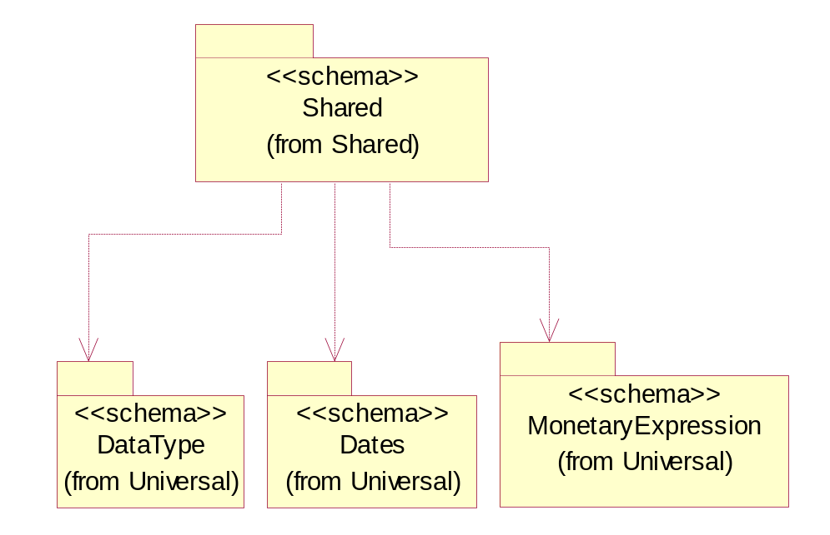
Figure 3-46 Dependency

CarrierInformation
The collection of business properties that describe a carrier's identification.
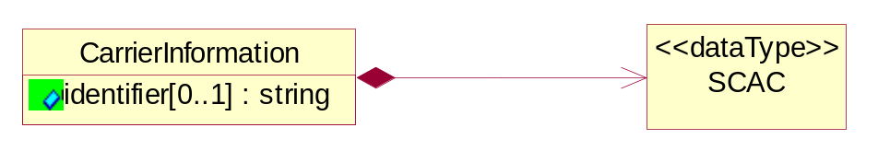
Figure 3-47 CarrierInformation

Attribute | Type | Documentation
identifier[0..1] | string | The unique identifier that identifies an account.

Composition | Cardinality | Type | Documentation
SCAC | 1 | SCAC | The Standard Carrier Alpha Code (SCAC) is a unique two-to-four-letter code used to identify transportation companies. NMFTA developed the SCAC identification codes in the mid 1960's to facilitate computerization in the transportation industry.  Refer http://www.nmfta.org for more detail.

DatePeriodAndDuration
The collection of business properties that describe a date period or duration.
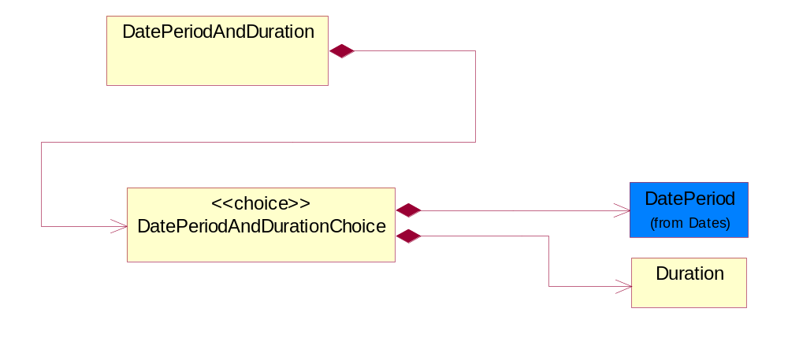
Figure 3-48 DatePeriodAndDuration

Composition | Cardinality | Type | Documentation
DatePeriodAndDurationChoice | 1 | DatePeriodAndDurationChoice | The choice structure for DatePeriodAndDuration.

DatePeriodAndDurationChoice
The choice structure for DatePeriodAndDuration.

Composition | Cardinality | Type | Documentation
DatePeriod | 1 | DatePeriod | The business document must allow for the computation or statement of a duration based upon a beginning and an ending date.
Duration | 1 | Duration | This object allows representation of a duration of time.

Duration
This object allows representation of a duration of time.
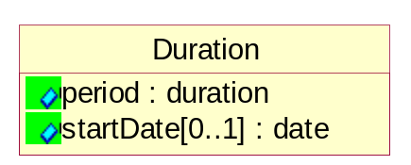
Figure 3-49 Duration

Attribute | Type | Documentation
period | duration | Represents a duration of time.
startDate[0..1] | date | The date indicating the beginning of the duration.

MonetaryAmount
The collection of business properties that describe the monetary amount defined by a specified currency.
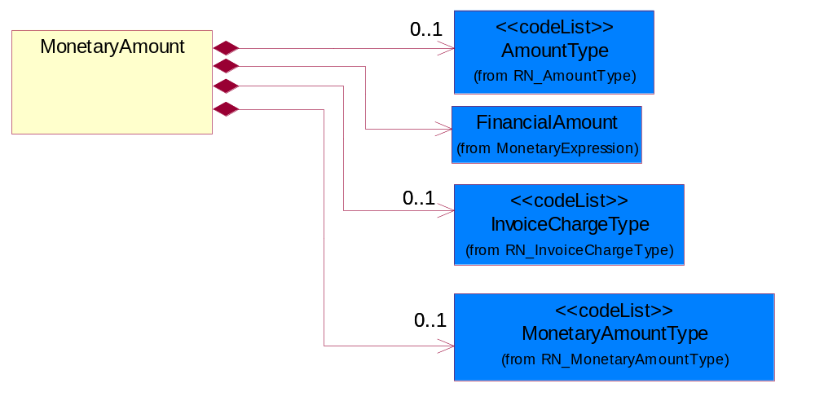
Figure 3-50 MonetaryAmount

Composition | Cardinality | Type | Documentation
FinancialAmount | 1 | FinancialAmount | The business document must express financial amounts.
InvoiceChargeType | 0..1 | InvoiceChargeType | Code identifying the values for the types of charges contained in an invoice.
MonetaryAmountType | 0..1 | MonetaryAmountType | Code identifying whether the monetary amount is a debit or credit.
AmountType | 0..1 | AmountType | Code identifying the type of monetary amount.

ProductPricing
The collection of business properties that describe the type of pricing and financial amount for a product.
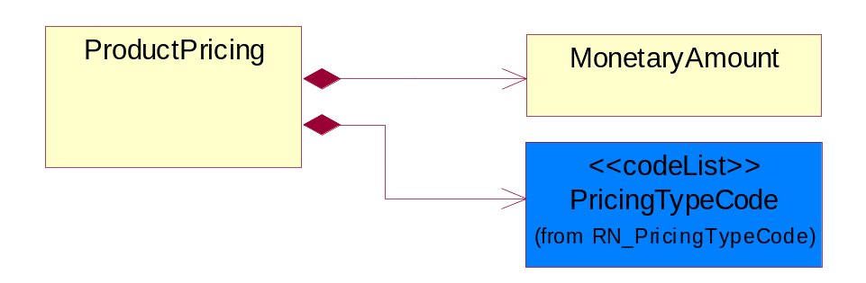
Figure 3-51 ProductPricing

Composition | Cardinality | Type | Documentation
MonetaryAmount | 1 | MonetaryAmount | The collection of business properties that describe the monetary amount defined by a specified currency.
PricingTypeCode | 1 | PricingTypeCode | Code identifying the type of pricing available for a product.

ProductQuantity
A quantity specifying the number of product units.
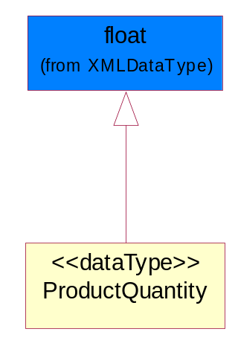
Figure 3-52 ProductQuantity

SCAC
The Standard Carrier Alpha Code (SCAC) is a unique two-to-four-letter code used to identify transportation companies. NMFTA developed the SCAC identification codes in the mid 1960's to facilitate computerization in the transportation industry.

Refer http://www.nmfta.org for more detail.
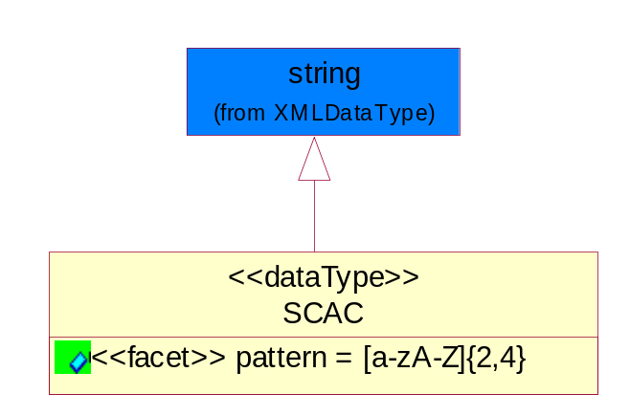
Figure 3-53 SCAC

Attribute | Type | Documentation
pattern |  | [a-zA-Z]{2,4}

CodeList

InvoiceChargeType
Code identifying the values for the types of charges contained in an invoice.

Name | Documentation
ALC | Allowances and Charges.
CUC | Custom Charges.
DEA | Deposit Amount.
ESC | Expedited Shipping Charge - Charge for accelerating the delivery of a product.
FRC | Freight Charges.
HAC | Handling Charges.
LEC | Lease Charge - Charge for the use of a product in which the purchaser assumes certain responsibilities of ownership.
LIC | License Charge - Charge for the use of a product (usually software) in which the manufacturer maintains ownership of the product.
MAC | Maintenance Charge - Charge (usually periodic) for providing maintenance support for a product.
PUC | Purchase Charge - Charge for a product in which the buyer takes all responsibilities of ownership.
QUD | Quantity Discount.
REC | Rental Charge - Charge for the use of a product (usually hardware) in which the manufacturer maintains ownership of the product.

MonetaryAmountType
Code identifying whether the monetary amount is a debit or credit.

Name | Documentation
CRE | Credit.
DEB | Debit.
ZER | Zero remit.

PricingTypeCode
Code identifying the type of pricing available for a product.

Name | Documentation
ACR | Authorized Cost and Resale.
ACS | Authorized Cost - The negotiated cost agreed upon between the supplier and distributor at the time the “debit?is authorized.
ACT | Authorized cost.
ANY | Any available.
ARS | Authorized resale.
ASP | Average Selling Price - Manufacturer's published price.
BPA | Budgetary Price Amount.
BPP | Broken Purchase Price.
BSH | Book-Ship.
CAT | Catalog price - Book (the supplier’s published cost at the time of transaction) or Published Price.
CMC | Commercial.
CMD | Commodity.
CMF | Contract Manufacturing.
CON | Contract.
COS | Cost - Price for which the distributor purchased the parts.
DBC | Disti Book Cost.
DFR | Duty free.
DIS | Distribution.
DPD | Duty paid.
DTP | Distribution price.
EDU | Education.
ERT | E-Rate.
EXC | Exception.
FGM | Federal government.
GEN | General.
HIE | Higher Education.
LCL | Local.
LGM | Local government.
LIS | List.
MPR | Market price.
MRP | Manufacturer's recommendation for unit pricing.
MSR | Manufacturer Suggested Retail Price (MSRP).
MUS | Minimum Unit Sale (MUS) - Manufacturer requirement of total dollar value for design opportunity.
NPF | Nonprofit.
OEM | Original Equipment Manufacturing (OEM).
OVP | OEM Volume Pricing - Original equipment manufacturing price per volume ordered.
PED | Primary Education.
QUO | Quote Price
RCS | Requested Cost (RCS) - Reseller requested cost to the manufacturer.
RFB | Refurbished.
RIN | Religious Institution.
RSP | Resale - Price the distributor is authorized to use for sale to their customer (RSP).
SCE | Special Education.
SEC | Security and management reseller.
SED | Secondary Education.
SEV | Service provider.
SGM | State Government.
SPD | Special Discount Price.
SPE | Special Education.
SPL | Samples.
SRP | Suggested Resale Price.
STR | Standard Rebate.
THP | Threshold Price.
TOC | Total Other Charges - Suggested resale price - The sum total of all distributor added charges to the customer for value added services, including but not limited to programming, tape and reel, labeling, date coding, kitting and in-house assembly.

AmountType
Code identifying the type of monetary amount.

Name | Documentation
DIS | Discount Value - The monetary amount of the discount on the price applied to a customer order.
FRE | Freight Charges - The monetary amount to be paid for freight transportation.
INS | InsuranceCharges - The monetary amount to be paid for freight insurance.
MAT | Material Cost - This object represents the material cost for the product.
MIS | Miscellaneous Charges - The monetary amount to be paid for miscellaneous charges.
PRC | Processing Charges - The monetary amount to be paid by consignee for consignment manufacturer.
TOD | Total Amount Due - Total amount due upon receipt of statement.
TOT | Total Amount - Total price for an entire business document.
TOV | Total Value Added Amount - The total amount of the shipment including any value added tax.
UNI | Unit Price - Agreed upon sale price for each unit ordered.
VAD | Value Added Unit Price - The price of a unit including any value added tax.

Universal Structure

ContactInformation

ContactInformation
The business document must allow for the identification of the name of the department, service or individual to be contacted regarding the context of the business document.
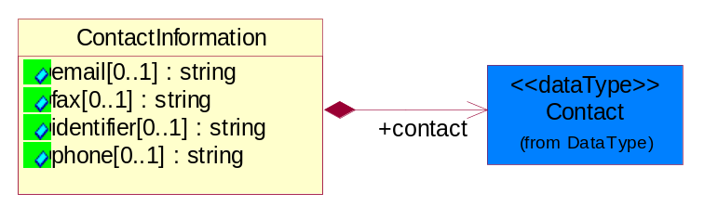
Figure 4-54 ContactInformation

Attribute | Type | Documentation
email[0..1] | string | The electronic mail for the specified contact.
fax[0..1] | string | The fax number for the specified contact.
identifier[0..1] | string | Identifies the role of the contact (i.e. Service Technician, Account Manager) in the Business Process.
phone[0..1] | string | The telephone number for the specified contact.

Composition | Cardinality | Type | Documentation
contact | 1 | Contact | The name of the department, service or individual to be contacted within the organization.

DataType

Contact
The name of the department, service or individual to be contacted within the organization.
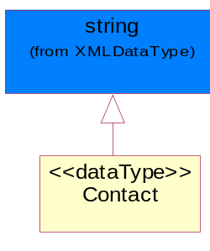
Figure 4-55 Contact

DUNS
A number assigned by Dun and Bradstreet to identify a business location.
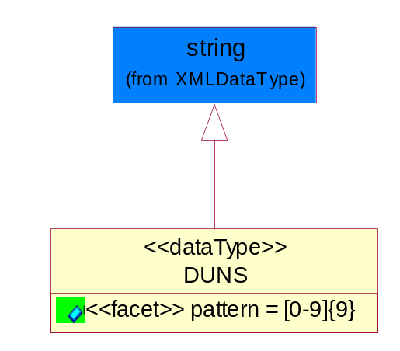
Figure 4-56 DUNS

Attribute | Type | Documentation
pattern |  | [0-9]{9}

DUNSPlus4
A identifier to specify a specific location within a business location.
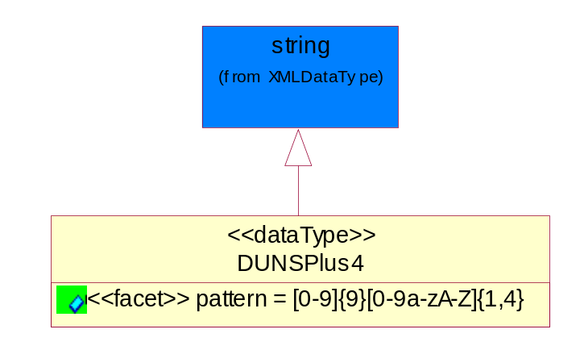
Figure 4-57 DUNSPlus4

Attribute | Type | Documentation
pattern |  | Data Universal Numbering System +4 (DUNS+4) number means the DUNS number assigned by Dun and Bradstreet, Inc. (D&B) plus an alphanumeric of length 4 suffix that may be assigned by a business concern.

GLN
Global Location Number (GLN) - A identifier to identify legal entities, trading parties and location.
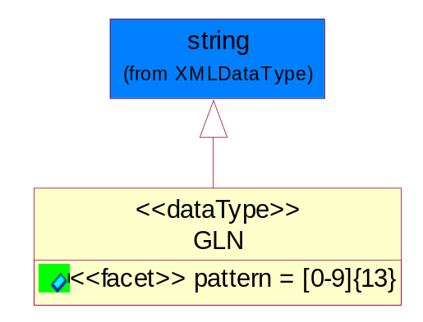
Figure 4-58 GLN

Attribute | Type | Documentation
pattern |  | [0-9]{13}

GTIN
Global Trade Identification Number (GTIN).
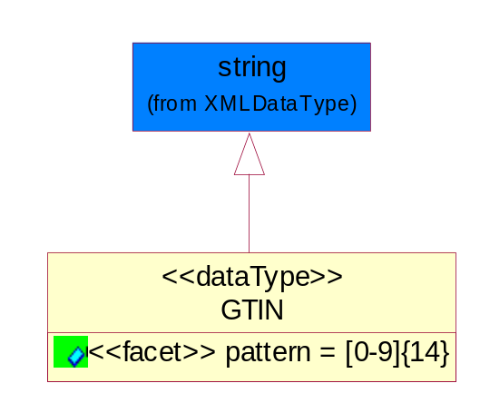
Figure 4-59 GTIN

Attribute | Type | Documentation
pattern |  | [0-9]{14}

PercentAmount
A number representing a percentage value, e.g. 75.125 represents 75 1/8 percent.
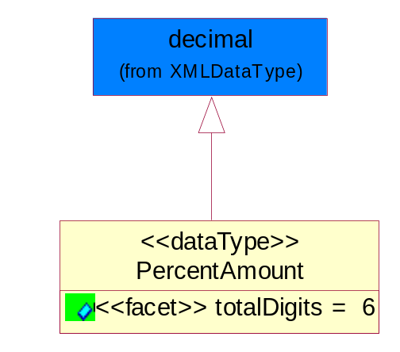
Figure 4-60 PercentAmount

Attribute | Type | Documentation
totalDigits |  | 6

Dates

DatePeriod
The business document must allow for the computation or statement of a duration based upon a beginning and an ending date.
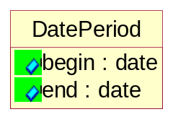
Figure 4-61 DatePeriod

Attribute | Type | Documentation
begin | date | The date indicating the beginning of the date period.
end | date | The date indicating the ending of the date period.

Document

BusinessDocumentReference
The business document reference object allows for the indirect referencing of a relationship to other business related documents.
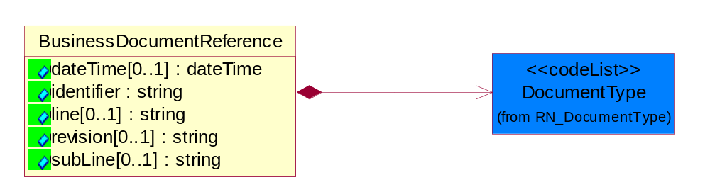
Figure 4-62 BusinessDocumentReference

Attribute | Type | Documentation
dateTime[0..1] | dateTime | The date-time stamp indicating on the referenced business document.
identifier | string | Unique identification of the referenced business document.
line[0..1] | string | References the specific line number of the specified business document.
revision[0..1] | string | Referenced the revision of the specified business document.
subLine[0..1] | string | References the specific subline number of the specified business document.

Composition | Cardinality | Type | Documentation
DocumentType | 1 | DocumentType | A code identifying the business context of a document.

Locations

AlternativeIdentifier
Identifies the specified code and the name of the organization that a code is utilized from.
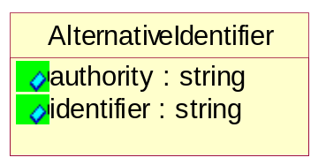
Figure 4-63 AlternativeIdentifier

Attribute | Type | Documentation
authority | string | The name of the organization that a code is utilized from.
identifier | string | The specified code to represent an entity (e.g. product, location, partner, etc.).

Location
The business document must specify a location.
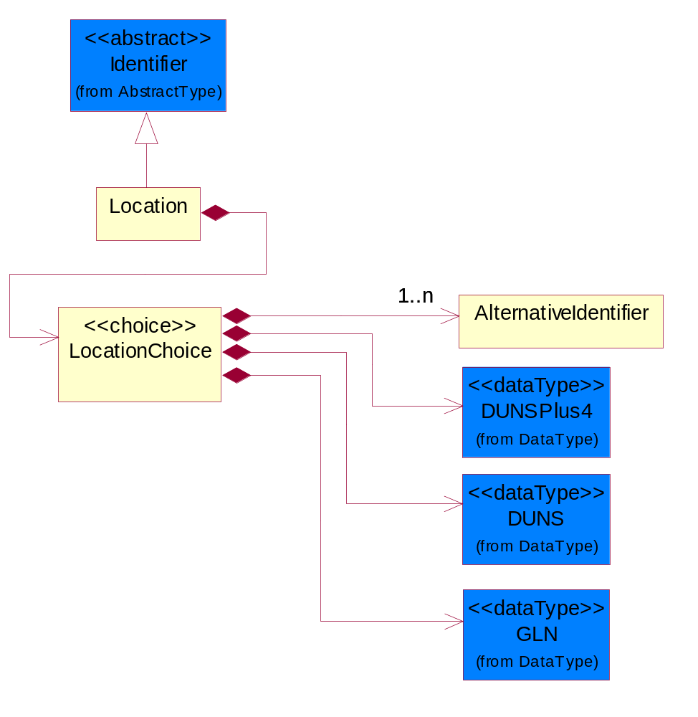
Figure 4-64 Location

Composition | Cardinality | Type | Documentation
LocationChoice | 1 | LocationChoice

LocationChoice

Composition | Cardinality | Type | Documentation
DUNSPlus4 | 1 | DUNSPlus4 | A identifier to specify a specific location within a business location.
DUNS | 1 | DUNS | A number assigned by Dun and Bradstreet to identify a business location.
AlternativeIdentifier | 1..n | AlternativeIdentifier | Identifies the specified code and the name of the organization that a code is utilized from.
GLN | 1 | GLN | Global Location Number (GLN) - A identifier to identify legal entities, trading parties and location.

PhysicalAddress
The business document must provide a physical address for a party to the business transaction.
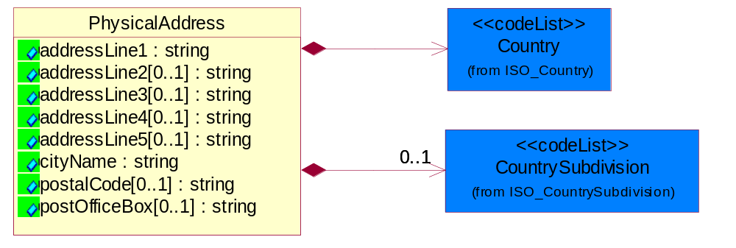
Figure 4-65 PhysicalAddress

Attribute | Type | Documentation
addressLine1 | string | The first line of a physical address.
addressLine2[0..1] | string | The second line of a physical address.
addressLine3[0..1] | string | The third line of a physical address.
addressLine4[0..1] | string | The fourth line of a physical address.
addressLine5[0..1] | string | The fifth line of a physical address.
cityName | string | The name of a city.
postalCode[0..1] | string | Identifying geographic location as specified by a national postal code.
postOfficeBox[0..1] | string | The Post Office Box identifier used to identify a party's post office box.

Composition | Cardinality | Type | Documentation
Country | 1 | Country | For representation of Country name RosettaNet has adopted ISO 3166-3; 1999. Refer to the following web page to get the latest version of the standard:  http://www.iso.ch/iso/en/prods-services/iso3166ma/02iso-3166-code-lists/index.html  If you need more information about the ISO standard please contact ISO for more details.
CountrySubdivision | 0..1 | CountrySubdivision | For representation of a Countries subdivisions RosettaNet has adopted ISO 3166-3; 1999. Refer to the following web page to get the latest version of the standard:  http://www.iso.ch/iso/en/prods-services/iso3166ma/02iso-3166-code-lists/index.html  If you need more information about the ISO standard please contact ISO for more details.

MonetaryExpression

FinancialAmount
The business document must express financial amounts.
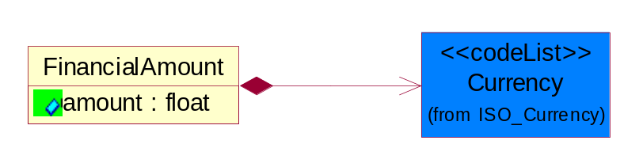
Figure 4-66 FinancialAmount

Attribute | Type | Documentation
amount | float | Specifies the monetary amount.

Composition | Cardinality | Type | Documentation
Currency | 1 | Currency | For representation of Currency codes RosettaNet has adopted ISO 4217; 1995. The British Standards Institution (BSI) is the ISO 4217 Maintenance Agency. Refer to the following web page to get the latest version of the standard:  http://www.bsi-global.com/Technical+Information/Publications/_Publications/tig90.xalter  If you need more information about the ISO standard please contact ISO for more details.

TaxJurisdiction
The business document must identify the specific tax collection authority.
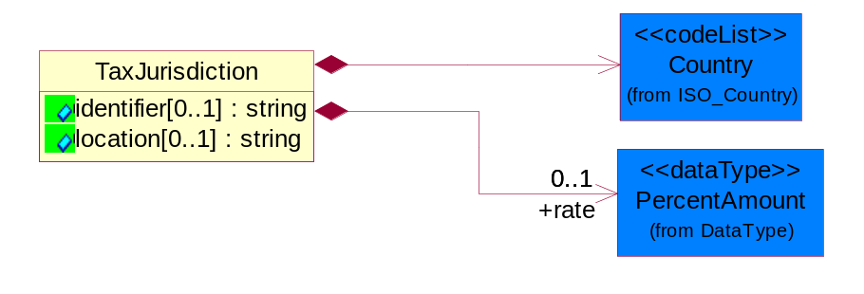
Figure 4-67 TaxJurisdiction

Attribute | Type | Documentation
identifier[0..1] | string | Unique identification for a taxing authority.
location[0..1] | string | Identification of the tax collection authority location.

Composition | Cardinality | Type | Documentation
rate | 0..1 | PercentAmount | This object represents the tax rate.
Country | 1 | Country | For representation of Country name RosettaNet has adopted ISO 3166-3; 1999. Refer to the following web page to get the latest version of the standard:  http://www.iso.ch/iso/en/prods-services/iso3166ma/02iso-3166-code-lists/index.html  If you need more information about the ISO standard please contact ISO for more details.

PartnerIdentification

FullPartner
The business document must describe the trading partners in the business transaction. This data structure provide the flexibility to describe a partner in all possible methods as for new, existing or known partner.
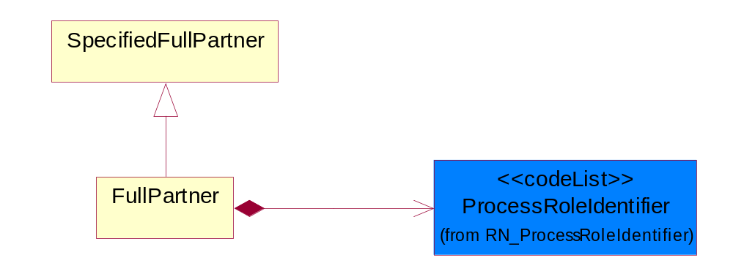
Figure 4-68 FullPartner

Composition | Cardinality | Type | Documentation
ProcessRoleIdentifier | 1 | ProcessRoleIdentifier | Describes the role of the partner in the business process. A partner will fulfill at least one or more roles during the business process.

IntermittentPartner
The business document must describe a physical address for a delivery.
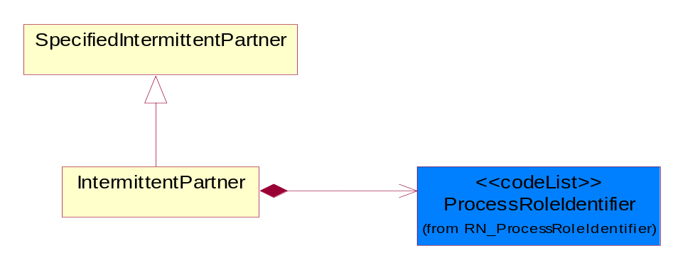
Figure 4-69 IntermittentPartner

Composition | Cardinality | Type | Documentation
ProcessRoleIdentifier | 1 | ProcessRoleIdentifier | Describes the role of the partner in the business process. A partner will fulfill at least one or more roles during the business process.

KnownPartner
The business document must describe the trading partners in the business transaction.
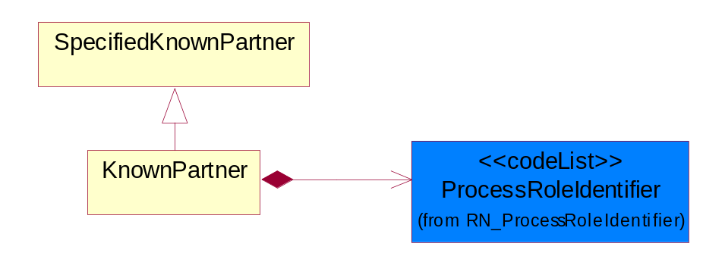
Figure 4-70 KnownPartner

Composition | Cardinality | Type | Documentation
ProcessRoleIdentifier | 1 | ProcessRoleIdentifier | Describes the role of the partner in the business process. A partner will fulfill at least one or more roles during the business process.

KnownPartnerContact
The business document must describe the trading partners in the business transaction.
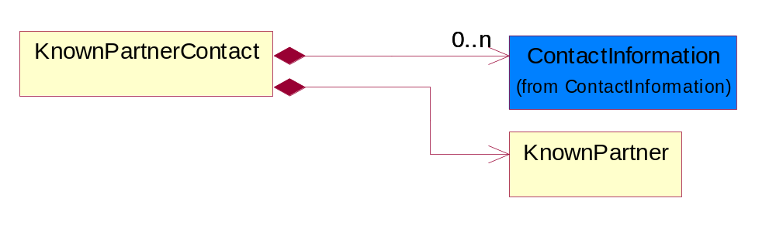
Figure 4-71 KnownPartnerContact

Composition | Cardinality | Type | Documentation
KnownPartner | 1 | KnownPartner | The business document must describe the trading partners in the business transaction.
ContactInformation | 0..n | ContactInformation | The business document must allow for the identification of the name of the department, service or individual to be contacted regarding the context of the business document.

NewPartner
The business document must describe a new, existing (but known to only one of the parties to the transaction) or an unknown party to the business transaction.
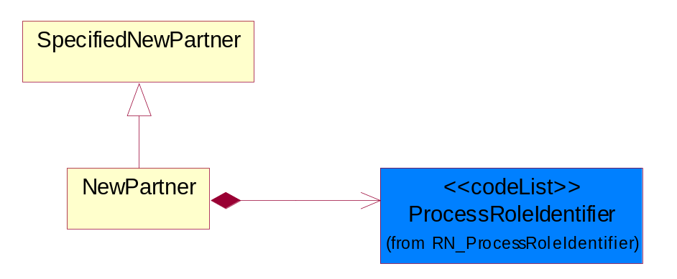
Figure 4-72 NewPartner

Composition | Cardinality | Type | Documentation
ProcessRoleIdentifier | 1 | ProcessRoleIdentifier | Describes the role of the partner in the business process. A partner will fulfill at least one or more roles during the business process.

PartnerDescription
The collection of business properties that describe a business partners' identity, their contact information, where they are physically located and their function in a supply chain.
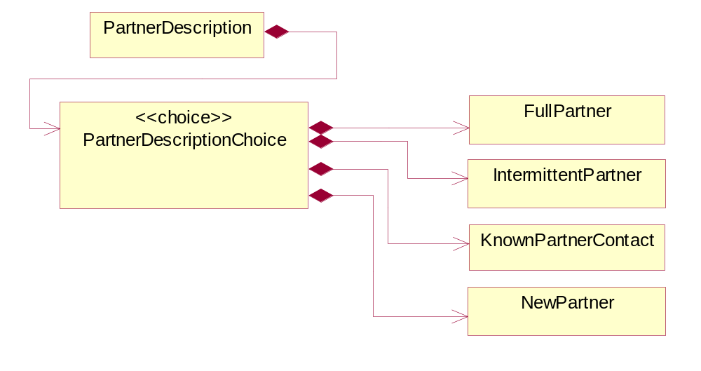
Figure 4-73 PartnerDescription

Composition | Cardinality | Type | Documentation
PartnerDescriptionChoice | 1 | PartnerDescriptionChoice

PartnerDescriptionChoice

Composition | Cardinality | Type | Documentation
KnownPartnerContact | 1 | KnownPartnerContact | The business document must describe the trading partners in the business transaction.
IntermittentPartner | 1 | IntermittentPartner | The business document must describe a physical address for a delivery.
NewPartner | 1 | NewPartner | The business document must describe a new, existing (but known to only one of the parties to the transaction) or an unknown party to the business transaction.
FullPartner | 1 | FullPartner | The business document must describe the trading partners in the business transaction. This data structure provide the flexibility to describe a partner in all possible methods as for new, existing or known partner.

PartnerIdentification
The business document must allow for the identity of one or more parties to the transaction.
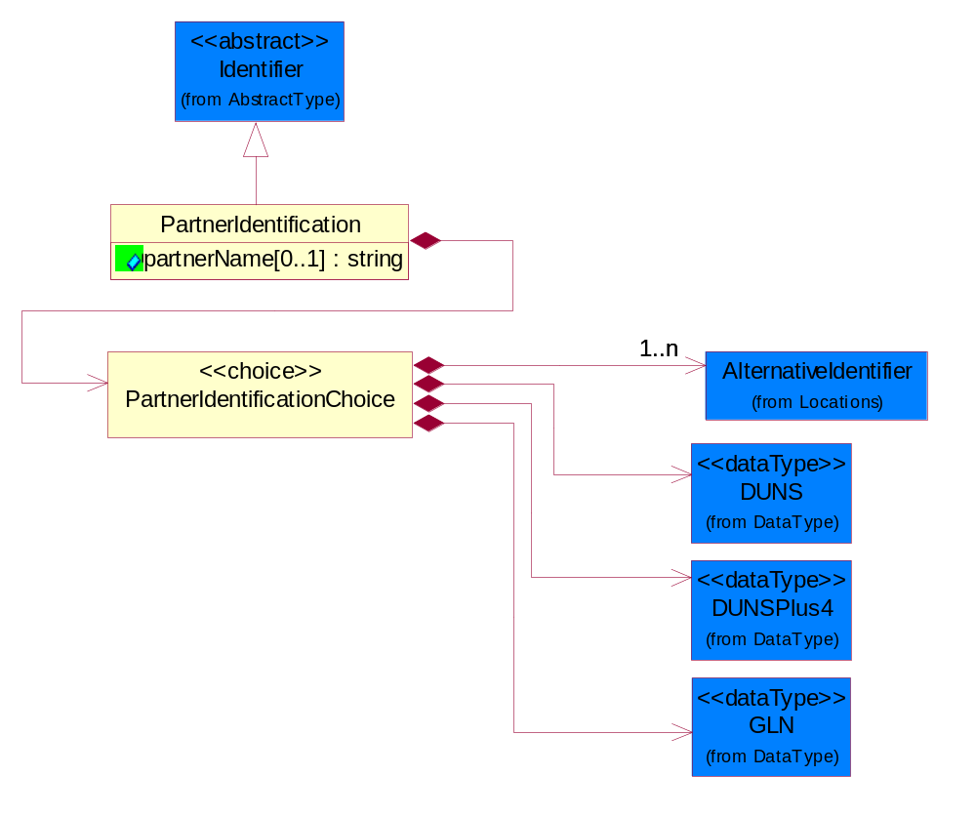
Figure 4-74 PartnerIdentification

Attribute | Type | Documentation
partnerName[0..1] | string | The name of the partner’s company/business.

Composition | Cardinality | Type | Documentation
PartnerIdentificationChoice | 1 | PartnerIdentificationChoice

PartnerIdentificationChoice

Composition | Cardinality | Type | Documentation
DUNS | 1 | DUNS | A number assigned by Dun and Bradstreet to identify a business location.
DUNSPlus4 | 1 | DUNSPlus4 | A identifier to specify a specific location within a business location.
AlternativeIdentifier | 1..n | AlternativeIdentifier | Identifies the specified code and the name of the organization that a code is utilized from.
GLN | 1 | GLN | Global Location Number (GLN) - A identifier to identify legal entities, trading parties and location.

SpecifiedFullPartner
The business document must describe the trading partners in the business transaction. This data structure provide the flexibility to describe a partner in all possible methods as for new, existing or known partner. This is specifically for partner who role has been specified.
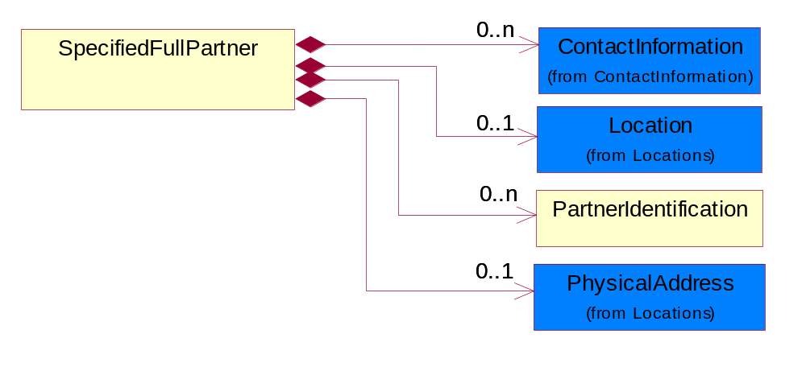
Figure 4-75 SpecifiedFullPartner

Composition | Cardinality | Type | Documentation
ContactInformation | 0..n | ContactInformation | The business document must allow for the identification of the name of the department, service or individual to be contacted regarding the context of the business document.
Location | 0..1 | Location | The business document must specify a location.
PartnerIdentification | 0..n | PartnerIdentification | The business document must allow for the identity of one or more parties to the transaction.
PhysicalAddress | 0..1 | PhysicalAddress | The business document must provide a physical address for a party to the business transaction.

SpecifiedIntermittentPartner
The business document must describe a physical address for a delivery.
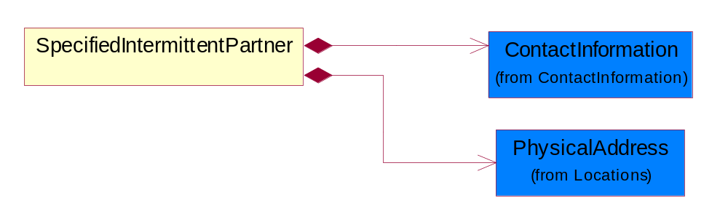
Figure 4-76 SpecifiedIntermittentPartner

Composition | Cardinality | Type | Documentation
ContactInformation | 1 | ContactInformation | The business document must allow for the identification of the name of the department, service or individual to be contacted regarding the context of the business document.
PhysicalAddress | 1 | PhysicalAddress | The business document must provide a physical address for a party to the business transaction.

SpecifiedKnownPartner
The business document must describe the trading partners in the business transaction.
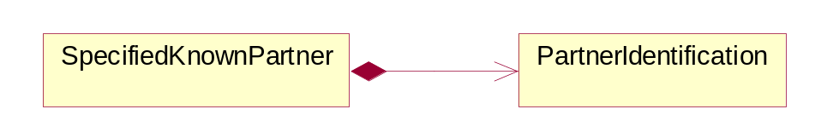
Figure 4-77 SpecifiedKnownPartner

Composition | Cardinality | Type | Documentation
PartnerIdentification | 1 | PartnerIdentification | The business document must allow for the identity of one or more parties to the transaction.

SpecifiedKnownPartnerContact
The business document must describe the trading partners in the business transaction and allow for a identification of an individual of the trading partner.
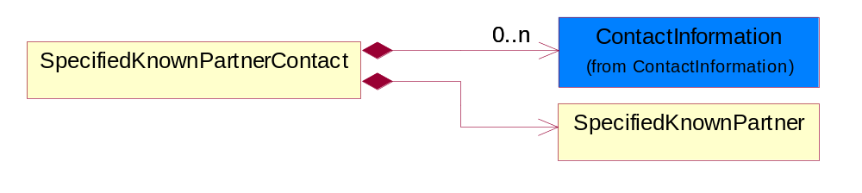
Figure 4-78 SpecifiedKnownPartnerContact

Composition | Cardinality | Type | Documentation
SpecifiedKnownPartner | 1 | SpecifiedKnownPartner | The business document must describe the trading partners in the business transaction.
ContactInformation | 0..n | ContactInformation | The business document must allow for the identification of the name of the department, service or individual to be contacted regarding the context of the business document.

SpecifiedNewPartner
The business document must describe a new, existing (but known to only one of the parties to the transaction) or an unknown party to the business transaction.
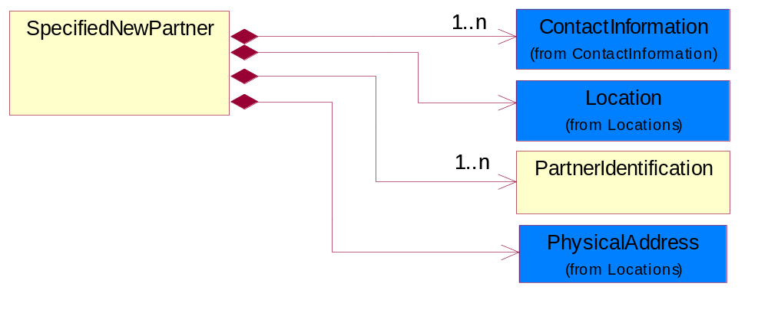
Figure 4-79 SpecifiedNewPartner

Composition | Cardinality | Type | Documentation
ContactInformation | 1..n | ContactInformation | The business document must allow for the identification of the name of the department, service or individual to be contacted regarding the context of the business document.
Location | 1 | Location | The business document must specify a location.
PhysicalAddress | 1 | PhysicalAddress | The business document must provide a physical address for a party to the business transaction.
PartnerIdentification | 1..n | PartnerIdentification | The business document must allow for the identity of one or more parties to the transaction.

SpecifiedPartnerDescription
The collection of business properties that describe a business partners' identity, their contact information, where they are physically located and their function in a supply chain.
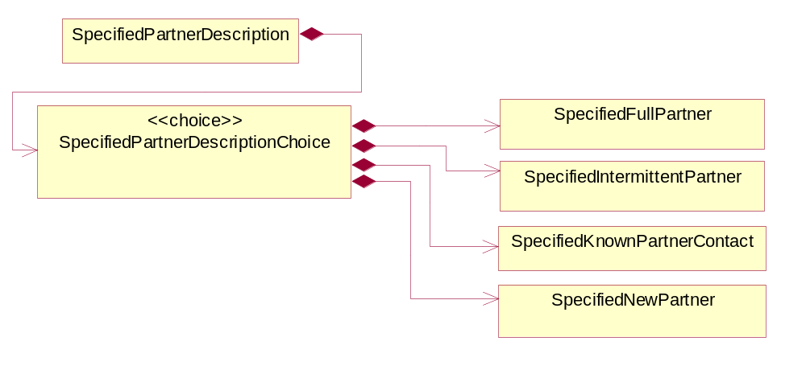
Figure 4-80 SpecifiedPartnerDescription

Composition | Cardinality | Type | Documentation
SpecifiedPartnerDescriptionChoice | 1 | SpecifiedPartnerDescriptionChoice

SpecifiedPartnerDescriptionChoice

Composition | Cardinality | Type | Documentation
SpecifiedKnownPartnerContact | 1 | SpecifiedKnownPartnerContact | The business document must describe the trading partners in the business transaction and allow for a identification of an individual of the trading partner.
SpecifiedIntermittentPartner | 1 | SpecifiedIntermittentPartner | The business document must describe a physical address for a delivery.
SpecifiedNewPartner | 1 | SpecifiedNewPartner | The business document must describe a new, existing (but known to only one of the parties to the transaction) or an unknown party to the business transaction.
SpecifiedFullPartner | 1 | SpecifiedFullPartner | The business document must describe the trading partners in the business transaction. This data structure provide the flexibility to describe a partner in all possible methods as for new, existing or known partner. This is specifically for partner who role has been specified.

ProductIdentification

ProductIdentification
The object provides the identifier(s) of a product.
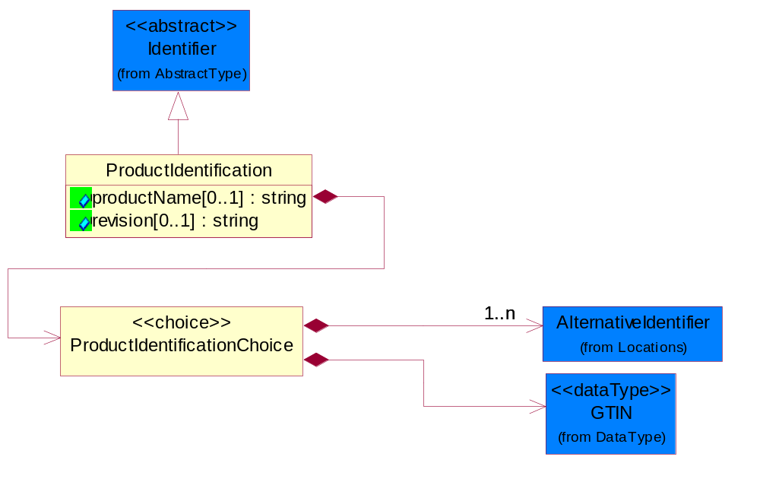
Figure 4-81 ProductIdentification

Attribute | Type | Documentation
productName[0..1] | string | The name of the product.
revision[0..1] | string | Referenced the specified product revision.

Composition | Cardinality | Type | Documentation
ProductIdentificationChoice | 1 | ProductIdentificationChoice

ProductIdentificationChoice

Composition | Cardinality | Type | Documentation
AlternativeIdentifier | 1..n | AlternativeIdentifier | Identifies the specified code and the name of the organization that a code is utilized from.
GTIN | 1 | GTIN | Global Trade Identification Number (GTIN).

CodeList

Country
For representation of Country name RosettaNet has adopted ISO 3166-3; 1999. Refer to the following web page to get the latest version of the standard:
http://www.iso.ch/iso/en/prods-services/iso3166ma/02iso-3166-code-lists/index.html

If you need more information about the ISO standard please contact ISO for more details.

CountrySubdivision
For representation of a Countries subdivisions RosettaNet has adopted ISO 3166-3; 1999. Refer to the following web page to get the latest version of the standard:
http://www.iso.ch/iso/en/prods-services/iso3166ma/02iso-3166-code-lists/index.html

If you need more information about the ISO standard please contact ISO for more details.

Currency
For representation of Currency codes RosettaNet has adopted ISO 4217; 1995. The British Standards Institution (BSI) is the ISO 4217 Maintenance Agency. Refer to the following web page to get the latest version of the standard:
http://www.bsi-global.com/Technical+Information/Publications/_Publications/tig90.xalter

If you need more information about the ISO standard please contact ISO for more details.

Language
For representation of Language name RosettaNet has adopted ISO 639-2; 1998. Refer to the following web page to get the latest version of the standard:

http://www.loc.gov/standards/iso639-2/iso639jac.html

If you need more information about the ISO standard please contact ISO for more details.

DocumentType
A code identifying the business context of a document.

Instance | Documentation
ARA | Authorization Request Approval.
CBN | Product batch number of customer.
CCN | Customs clearance number.
CFA | Failure Analysis - Request document that will accompany the product providing characteristics of the component failure.
CIN | Commercial Invoice.
CNM | Traditional credit note or memo.
CON | In a virtual sourcing relationship, a third party trading partner is supplying a part to a customer on behalf of another company that has taken the order for the customer. In this case a Customer Order Number is associated to the request for material that is sent to the virtual trading partners.
COS | Consumption Notice.
COT | Contract.
CRN | Unique consumption reference number identifying the product consumption issue i.e. one-to-one relationship with physical flow.
DEM | Traditional debit note or memo.
DEN | Delivery Note.
DIN | Discontinuation Notice.
DOR | Delivery Order.
DRN | Drawing Number.
DRR | Design Registration Request.
ECO | Engineering Change Order - The proprietary unique identification number that represents an engineering change order.
EIR | Engineering Information Request.
EOL | End of Life.
FUO | Sales order or transfer order fulfilling demand out of a facility (outbound shipment).
INV | Invoice.
LID | Location Identifier. Data for on-site work that have to be done on the machine (associated with preventive maintenance order).
MEN | Master Event Number.
MID | Machine Identifier. Data for on-site work that have to be done on the machine (associated with preventive maintenance order).
MON | Model Number.
OCL | The unique identifier assigned by the OEM for a warranty claim.
OGA | Other governmental agency issued document.
OPO | The unique identifier assigned by the OEM for a part order.
OPR | The unique identifier assigned by the OEM for a part return.
PCN | Product/Process Change.
PFA | Failure Analysis - Request document that will accompany the product providing characteristics of the product failure.
PII | Refers to previously issued invoice.
PLS | Unique number that identifies packing form prior to shipment.
POI | Purchase Order IN.
PON | Production order number for material release.
POO | Purchase Order OUT.
PRC | Product Catalog.
PSI | Refers to previously issued self-billing invoice.
PUO | Purchase Order.
QUO | Quote.
REC | Document identifying the receipt of materials or products into a facility against a purchase order or transfer order (inbound shipment).
REO | Purchase order or transfer order replenishing inventory into a facility (inbound shipment).
REQ | Requisition.
RMA | Returned Material Authorization.
RPO | Purchase order for materials or product returned to and reworked by a supplier.
RTA | Remittance Advice - Remittance details.
SAO | Sales Order.
SBC | Credit Memo used in self-billing scenario.
SBD | Debit Memo used in self-billing scenario.
SBI | Invoice in self billing scenario.
SBN | Product batch number of supplier.
SCA | Similar to contracts - Contains the quantity of an article that is to be ordered from a vendor and the price for article or service that is to be procured.
SEN | Serial Number.
SEO | A document that gives a repair provider the necessary authorization to repair or upgrade a product either at the customer site or at the repair provider’s site.
SHD | Shipping Document.
SNC | Shipset Number on Code List.
SPC | The unique identifier assigned by the ASP for a warranty claim.
SPN | Spec Number.
SPO | The unique identifier assigned by the ASP for a part order.
SPR | The unique identifier assigned by the ASP for a part return.
SPW | The unique identifier assigned by the ASP to reference a work order.
SRI | A document that contains the shipping reference number which allows the product to be tracked within the outsourced logistic providers network.
TRO | Order which results in materials or products being moved from one facility to another (outbound shipment and inbound shipment).
WAB | Waybill.
WAC | Denotes a warranty claim.
WOO | Work Order.

MimeTypeQualifier
The MIME type as defined by IANA.

Please refer to http://www.iana.org/assignments/media-types/ for a list of types.

Instance | Documentation
application/activemessage | [Shapiro]
application/andrew-inset | [Borenstein]
application/applefile | [Faltstrom]
application/atomicmail | [Borenstein]
application/batch-SMTP | [RFC2442]
application/beep+xml | [RFC3080]
application/cals-1840 | [RFC1895]
application/cnrp+xml | [RFCCNRP]
application/commonground | [Glazer]
application/cpl+xml
application/cybercash | [Eastlake]
application/dca-rft | [Campbell]
application/dec-dx | [Campbell]
application/dicom | [RFC3240]
application/dvcs | [RFC3029]
application/EDI-Consent | [RFC1767]
application/EDIFACT | [RFC1767]
application/EDI-X12 | [RFC1767]
application/eshop | [Katz]
application/font-tdpfr | [RFC3073]
application/http | [RFC2616]
application/hyperstudio | [Domino]
application/iges | [Parks]
application/index | [RFC2652]
application/index.cmd | [RFC2652]
application/index.obj | [RFC2652]
application/index.response | [RFC2652]
application/index.vnd | [RFC2652]
application/iotp | [RFC2935]
application/ipp | [RFC2910]
application/isup | [RFC3204]
application/mac-binhex40 | [Faltstrom]
application/macwriteii | [Lindner]
application/marc | [RFC2220]
application/mathematica | [Van Nostern]
application/msword | [Lindner]
application/news-message-id | [RFC1036,Spencer]
application/news-transmission | [RFC1036, Spencer]
application/ocsp-request | [RFC2560]
application/ocsp-response | [RFC2560]
application/octet-stream | [RFC2045,RFC2046]
application/oda | [RFC2045,RFC2046]
application/ogg | [RFC-walleij-ogg-mediatype-08.txt]
application/parityfec | [RFC3009]
application/pdf | [Lindner]
application/pgp-encrypted | [RFC3156]
application/pgp-keys | [RFC3156]
application/pgp-signature | [RFC3156]
application/pkcs10 | [RFC2311]
application/pkcs7-mime | [RFC2311]
application/pkcs7-signature | [RFC2311]
application/pkix-cert | [RFC2585]
application/pkixcmp | [RFC2510]
application/pkix-crl | [RFC2585]
application/postscript | [RFC2045,RFC2046]
application/prs.alvestrand.titrax-sheet | [Alvestrand]
application/prs.cww | [Rungchavalnont]
application/prs.nprend | [Doggett]
application/prs.plucker | [Janssen]
application/qsig | [RFC3204]
application/reginfo+xml | [RFC-ietf-sipping-reg-event-00.txt]
application/remote-printing | [RFC1486,Rose]
application/riscos | [Smith]
application/rtf | [Lindner]
application/sdp | [RFC2327]
application/set-payment | [Korver]
application/set-payment-initiation | [Korver]
application/set-registration | [Korver]
application/set-registration-initiation | [Korver]
application/sgml | [RFC1874]
application/sgml-open-catalog | [Grosso]
application/sieve | [RFC3028]
application/slate | [Crowley]
application/timestamp-query | [RFC3161]
application/timestamp-reply | [RFC3161]
application/tve-trigger | [Welsh]
application/vemmi | [RFC2122]
application/vnd.3gpp.pic-bw-large | [Meredith]
application/vnd.3gpp.pic-bw-small | [Meredith]
application/vnd.3gpp.pic-bw-var | [Meredith]
application/vnd.3gpp.sms | [Meredith]
application/vnd.3M.Post-it-Notes | [O'Brien]
application/vnd.accpac.simply.aso | [Leow]
application/vnd.accpac.simply.imp | [Leow]
application/vnd.acucobol | [Lubin]
application/vnd.acucorp | [Lubin]
application/vnd.adobe.xfdf | [Perelman]
application/vnd.aether.imp | [Moskowitz]
application/vnd.amiga.ami | [Blumberg]
application/vnd.anser-web-certificate-issue-initiation | [Mori]
application/vnd.anser-web-funds-transfer-initiation | [Mori]
application/vnd.audiograph | [Slusanschi]
application/vnd.blueice.multipass | [Holmstrom]
application/vnd.bmi | [Gotoh]
application/vnd.businessobjects | [Imoucha]
application/vnd.canon-cpdl | [Muto]
application/vnd.canon-lips | [Muto]
application/vnd.cinderella | [Kortenkamp]
application/vnd.claymore | [Simpson]
application/vnd.commerce-battelle | [Applebaum]
application/vnd.commonspace | [Chandhok]
application/vnd.contact.cmsg | [Patz]
application/vnd.cosmocaller | [Dellutri]
application/vnd.ctc-posml | [Kohlhepp]
application/vnd.cups-postscript | [Sweet]
application/vnd.cups-raster | [Sweet]
application/vnd.cups-raw | [Sweet]
application/vnd.curl | [Byrnes]
application/vnd.cybank | [Helmee]
application/vnd.data-vision.rdz | [Fields]
application/vnd.dna | [Searcy]
application/vnd.dpgraph | [Parker]
application/vnd.dreamfactory | [Appleton]
application/vnd.dxr | [Duffy]
application/vnd.ecdis-update | [Buettgenbach]
application/vnd.ecowin.chart | [Olsson]
application/vnd.ecowin.filerequest | [Olsson]
application/vnd.ecowin.fileupdate | [Olsson]
application/vnd.ecowin.series | [Olsson]
application/vnd.ecowin.seriesrequest | [Olsson]
application/vnd.ecowin.seriesupdate | [Olsson]
application/vnd.enliven | [Santinelli]
application/vnd.epson.esf | [Hoshina]
application/vnd.epson.msf | [Hoshina]
application/vnd.epson.quickanime | [Gu]
application/vnd.epson.salt | [Nagatomo]
application/vnd.epson.ssf | [Hoshina]
application/vnd.ericsson.quickcall | [Tidwell]
application/vnd.eudora.data | [Resnick]
application/vnd.fdf | [Zilles]
application/vnd.ffsns | [Holstage]
application/vnd.FloGraphIt | [Floersch]
application/vnd.framemaker | [Wexler]
application/vnd.fsc.weblaunch | [D.Smith]
application/vnd.fujitsu.oasys | [Togashi]
application/vnd.fujitsu.oasys2 | [Togashi]
application/vnd.fujitsu.oasys3 | [Okudaira]
application/vnd.fujitsu.oasysgp | [Sugimoto]
application/vnd.fujitsu.oasysprs | [Ogita]
application/vnd.fujixerox.ddd | [Onda]
application/vnd.fujixerox.docuworks | [Taguchi]
application/vnd.fujixerox.docuworks.binder | [Matsumoto]
application/vnd.fut-misnet | [Pruulmann]
application/vnd.grafeq | [Tupper]
application/vnd.groove-account | [Joseph]
application/vnd.groove-help | [Joseph]
application/vnd.groove-identity-message | [Joseph]
application/vnd.groove-injector | [Joseph]
application/vnd.groove-tool-message | [Joseph]
application/vnd.groove-tool-template | [Joseph]
application/vnd.groove-vcard | [Joseph]
application/vnd.hbci | [Hammann]
application/vnd.hhe.lesson-player | [Jones]
application/vnd.hp-HPGL | [Pentecost]
application/vnd.hp-hpid | [Gupta]
application/vnd.hp-hps | [Aubrey]
application/vnd.hp-PCL | [Pentecost]
application/vnd.hp-PCLXL | [Pentecost]
application/vnd.httphone | [Lefevre]
application/vnd.hzn-3d-crossword | [Minnis]
application/vnd.ibm.afplinedata | [Buis]
application/vnd.ibm.electronic-media | [Tantlinger]
application/vnd.ibm.MiniPay | [Herzberg]
application/vnd.ibm.modcap | [Hohensee]
application/vnd.ibm.secure-container | [Tantlinger]
application/vnd.informix-visionary | [Gales]
application/vnd.intercon.formnet | [Gurak]
application/vnd.intertrust.digibox | [Tomasello]
application/vnd.intertrust.nncp | [Tomasello]
application/vnd.intu.qbo | [Scratchley]
application/vnd.intu.qfx | [Scratchley]
application/vnd.irepository.package+xml | [Knowles]
application/vnd.is-xpr | [Natarajan]
application/vnd.japannet-directory-service | [Fujii]
application/vnd.japannet-jpnstore-wakeup | [Yoshitake]
application/vnd.japannet-payment-wakeup | [Fujii]
application/vnd.japannet-registration | [Yoshitake]
application/vnd.japannet-registration-wakeup | [Fujii]
application/vnd.japannet-setstore-wakeup | [Yoshitake]
application/vnd.japannet-verification | [Yoshitake]
application/vnd.japannet-verification-wakeup | [Fujii]
application/vnd.jisp | [Deckers]
application/vnd.kde.karbon | [Faure]
application/vnd.kde.kchart | [Faure]
application/vnd.kde.kformula | [Faure]
application/vnd.kde.kivio | [Faure]
application/vnd.kde.kontour | [Faure]
application/vnd.kde.kpresenter | [Faure]
application/vnd.kde.kspread | [Faure]
application/vnd.kde.kword | [Faure]
application/vnd.kenameaapp | [DiGiorgio-Haag]
application/vnd.koan | [Cole]
application/vnd.liberty-request+xml | [McDowell]
application/vnd.llamagraphics.life-balance.desktop | [White]
application/vnd.lotus-1-2-3 | [Wattenberger]
application/vnd.lotus-approach | [Wattenberger]
application/vnd.lotus-freelance | [Wattenberger]
application/vnd.lotus-notes | [Laramie]
application/vnd.lotus-organizer | [Wattenberger]
application/vnd.lotus-screencam | [Wattenberger]
application/vnd.lotus-wordpro | [Wattenberger]
application/vnd.mcd | [Gotoh]
application/vnd.mediastation.cdkey | [Flurry]
application/vnd.meridian-slingshot | [Wedel]
application/vnd.micrografx.flo | [Prevo]
application/vnd.micrografx.igx | [Prevo]
application/vnd.mif | [Wexler]
application/vnd.minisoft-hp3000-save | [Bartram]
application/vnd.mitsubishi.misty-guard.trustweb | [Tanaka]
application/vnd.Mobius.DAF | [Kabayama]
application/vnd.Mobius.DIS | [Kabayama]
application/vnd.Mobius.MBK | [Devasia]
application/vnd.Mobius.MQY | [Devasia]
application/vnd.Mobius.MSL | [Kabayama]
application/vnd.Mobius.PLC | [Kabayama]
application/vnd.Mobius.TXF | [Kabayama]
application/vnd.mophun.application | [Wennerstrom]
application/vnd.mophun.certificate | [Wennerstrom]
application/vnd.motorola.flexsuite | [Patton]
application/vnd.motorola.flexsuite.adsi | [Patton]
application/vnd.motorola.flexsuite.fis | [Patton]
application/vnd.motorola.flexsuite.gotap | [Patton]
application/vnd.motorola.flexsuite.kmr | [Patton]
application/vnd.motorola.flexsuite.ttc | [Patton]
application/vnd.motorola.flexsuite.wem | [Patton]
application/vnd.mozilla.xul+xml | [McDaniel]
application/vnd.ms-artgalry | [Slawson]
application/vnd.ms-asf | [Fleischman]
application/vnd.mseq | [Le Bodic]
application/vnd.ms-excel | [Gill]
application/vnd.msign | [Borcherding]
application/vnd.ms-lrm | [Ledoux]
application/vnd.ms-powerpoint | [Gill]
application/vnd.ms-project | [Gill]
application/vnd.ms-tnef | [Gill]
application/vnd.ms-works | [Gill]
application/vnd.ms-wpl | [Plastina]
application/vnd.musician | [Adams]
application/vnd.music-niff | [Butler]
application/vnd.netfpx | [Mutz]
application/vnd.noblenet-directory | [Solomon]
application/vnd.noblenet-sealer | [Solomon]
application/vnd.noblenet-web | [Solomon]
application/vnd.novadigm.EDM | [Swenson]
application/vnd.novadigm.EDX | [Swenson]
application/vnd.novadigm.EXT | [Swenson]
application/vnd.obn | [Hessling]
application/vnd.osa.netdeploy | [Klos]
application/vnd.palm | [Peacock]
application/vnd.pg.format | [Gandert]
application/vnd.pg.osasli | [Gandert]
application/vnd.powerbuilder6 | [Guy]
application/vnd.powerbuilder6-s | [Guy]
application/vnd.powerbuilder7 | [Shilts]
application/vnd.powerbuilder75 | [Shilts]
application/vnd.powerbuilder75-s | [Shilts]
application/vnd.powerbuilder7-s | [Shilts]
application/vnd.previewsystems.box | [Smolgovsky]
application/vnd.publishare-delta-tree | [Ben-Kiki]
application/vnd.pvi.ptid1 | [Lamb]
application/vnd.pwg-multiplexed | [RFC3391]
application/vnd.pwg-xhtml-print+xml | [Wright]
application/vnd.Quark.QuarkXPress | [Scheidler]
application/vnd.rapid | [Szekely]
application/vnd.s3sms | [Tarkkala]
application/vnd.sealed.net | [Lambert]
application/vnd.seemail | [Webb]
application/vnd.shana.informed.formdata | [Selzler]
application/vnd.shana.informed.formtemplate | [Selzler]
application/vnd.shana.informed.interchange | [Selzler]
application/vnd.shana.informed.package | [Selzler]
application/vnd.smaf | [Takahashi]
application/vnd.sss-cod | [Dani]
application/vnd.sss-dtf | [Bruno]
application/vnd.sss-ntf | [Bruno]
application/vnd.street-stream | [Levitt]
application/vnd.svd | [Becker]
application/vnd.swiftview-ics | [Widener]
application/vnd.triscape.mxs | [Simonoff]
application/vnd.trueapp | [Hepler]
application/vnd.truedoc | [Chase]
application/vnd.ufdl | [Manning]
application/vnd.uplanet.alert | [Martin]
application/vnd.uplanet.alert-wbxml | [Martin]
application/vnd.uplanet.bearer-choice | [Martin]
application/vnd.uplanet.bearer-choice-wbxml | [Martin]
application/vnd.uplanet.cacheop | [Martin]
application/vnd.uplanet.cacheop-wbxml | [Martin]
application/vnd.uplanet.channel | [Martin]
application/vnd.uplanet.channel-wbxml | [Martin]
application/vnd.uplanet.list | [Martin]
application/vnd.uplanet.listcmd | [Martin]
application/vnd.uplanet.listcmd-wbxml | [Martin]
application/vnd.uplanet.list-wbxml | [Martin]
application/vnd.uplanet.signal | [Martin]
application/vnd.vcx | [T.Sugimoto]
application/vnd.vectorworks | [Pharr]
application/vnd.vidsoft.vidconference | [Hess]
application/vnd.visio | [Sandal]
application/vnd.visionary | [Aravindakumar]
application/vnd.vividence.scriptfile | [Risher]
application/vnd.vsf | [Rowe]
application/vnd.wap.sic | [WAP-Forum]
application/vnd.wap.slc | [WAP-Forum]
application/vnd.wap.wbxml | [Stark]
application/vnd.wap.wmlc | [Stark]
application/vnd.wap.wmlscriptc | [Stark]
application/vnd.webturbo | [Rehem]
application/vnd.wrq-hp3000-labelled | [Bartram]
application/vnd.wt.stf | [Wohler]
application/vnd.wv.csp+wbxml | [Salmi]
application/vnd.xara | [Matthewman]
application/vnd.xfdl | [Manning]
application/vnd.yellowriver-custom-menu | [Yellow]
application/whoispp-query | [RFC2957]
application/whoispp-response | [RFC2958]
application/wita | [Campbell]
application/wordperfect5.1 | [Lindner]
application/x400-bp | [RFC1494]
application/xhtml+xml | [RFC3236]
application/xml | [RFC3023]
application/xml-dtd | [RFC3023]
application/xml-external-parsed-entity | [RFC3023]
application/zip | [Lindner]
audio/32kadpcm | [RFC2421,RFC2422]
audio/AMR | [RFC3267]
audio/AMR-WB | [RFC3267]
audio/basic | [RFC2045,RFC2046]
audio/CN | [RFC3389]
audio/DAT12 | [RFC3190]
audio/DVI4
audio/EVRC | [RFC-ietf-avt-evrc-smv-03.txt]
audio/EVRC0 | [RFC-ietf-avt-evrc-smv-03.txt]
audio/G.722.1 | [RFC3047]
audio/G722
audio/G723
audio/G726-16
audio/G726-24
audio/G726-32
audio/G726-40
audio/G728
audio/G729
audio/G729D
audio/G729E
audio/GSM
audio/GSM-EFR
audio/L16 | [RFC2586]
audio/L20 | [RFC3190]
audio/L24 | [RFC3190]
audio/L8
audio/LPC
audio/MP4A-LATM | [RFC3016]
audio/MPA
audio/mpa-robust | [RFC3119]
audio/mpeg | [RFC3003]
audio/parityfec | [RFC3009]
audio/PCMA
audio/PCMU
audio/prs.sid | [Walleij]
audio/QCELP
audio/RED
audio/SMV | [RFC-ietf-avt-evrc-smv-03.txt]
audio/SMV0 | [RFC-ietf-avt-evrc-smv-03.txt]
audio/telephone-event | [RFC2833]
audio/tone | [RFC2833]
audio/VDVI
audio/vnd.3gpp.iufp | [Belling]
audio/vnd.cisco.nse | [Kumar]
audio/vnd.cns.anp1 | [McLaughlin]
audio/vnd.cns.inf1 | [McLaughlin]
audio/vnd.digital-winds | [Strazds]
audio/vnd.everad.plj | [Cicelsky]
audio/vnd.lucent.voice | [Vaudreuil]
audio/vnd.nortel.vbk | [Parsons]
audio/vnd.nuera.ecelp4800 | [Fox]
audio/vnd.nuera.ecelp7470 | [Fox]
audio/vnd.nuera.ecelp9600 | [Fox]
audio/vnd.octel.sbc | [Vaudreuil]
audio/vnd.qcelp | [Lundblade]
audio/vnd.rhetorex.32kadpcm | [Vaudreuil]
audio/vnd.vmx.cvsd | [Vaudreuil]
image/cgm | Computer Graphics Metafile
image/g3fax | [RFC1494]
image/gif | [RFC2045,RFC2046]
image/ief | [RFC1314] Image Exchange Format
image/jpeg | [RFC2045,RFC2046]
image/naplps | [Ferber]
image/png | [Randers-Pehrson]
image/prs.btif | [Simon]
image/prs.pti | [Laun]
image/t38 | [RFC3362]
image/tiff | [RFC3302] Tag Image File Format
image/tiff-fx | [RFC3250] Tag Image File Format Fax eXtended
image/vnd.cns.inf2 | [McLaughlin]
image/vnd.djvu | [Bottou]
image/vnd.dwg | [Moline]
image/vnd.dxf | [Moline]
image/vnd.fastbidsheet | [Becker]
image/vnd.fpx | [Spencer]
image/vnd.fst | [Fuldseth]
image/vnd.fujixerox.edmics-mmr | [Onda]
image/vnd.fujixerox.edmics-rlc | [Onda]
image/vnd.globalgraphics.pgb | [Bailey]
image/vnd.mix | [Reddy]
image/vnd.ms-modi | [Vaughan]
image/vnd.net-fpx | [Spencer]
image/vnd.svf | [Moline]
image/vnd.wap.wbmp | [Stark]
image/vnd.xiff | [S.Martin]
message/delivery-status | [RFC1894]
message/disposition-notification | [RFC2298]
message/external-body | [RFC2045,RFC2046]
message/http | [RFC2616]
message/news | [RFC 1036, H.Spencer]
message/partial | [RFC2045,RFC2046]
message/rfc822 | [RFC2045,RFC2046]
message/s-http | [RFC2660]
message/sip | [RFC3261]
message/sipfrag | [RFC3420]
model/iges | [Parks]
model/mesh | [RFC2077]
model/vnd.dwf | [Pratt]
model/vnd.flatland.3dml | [Powers]
model/vnd.gdl | [Babits]
model/vnd.gs-gdl | [Babits]
model/vnd.gtw | [Ozaki]
model/vnd.mts | [Rabinovitch]
model/vnd.parasolid.transmit.binary | [Parasolid]
model/vnd.parasolid.transmit.text | [Parasolid]
model/vnd.vtu | [Rabinovitch]
model/vrml | [RFC2077]
multipart/alternative | [RFC2045,RFC2046]
multipart/appledouble | [Faltstrom]
multipart/byteranges | [RFC2068]
multipart/digest | [RFC2045,RFC2046]
multipart/encrypted | [RFC1847]
multipart/form-data | [RFC2388]
multipart/header-set | [Crocker]
multipart/mixed | [RFC2045,RFC2046]
multipart/parallel | [RFC2045,RFC2046]
multipart/related | [RFC2387]
multipart/report | [RFC1892]
multipart/signed | [RFC1847]
multipart/voice-message | [RFC2421,RFC2423]
text/calendar | [RFC2445]
text/css | [RFC2318]
text/directory | [RFC2425]
text/enriched | [RFC1896]
text/html | [RFC2854]
text/parityfec | [RFC3009]
text/plain | [RFC2646,RFC2046]
text/prs.lines.tag | [Lines]
text/rfc822-headers | [RFC1892]
text/richtext | [RFC2045,RFC2046]
text/rtf | [Lindner]
text/sgml | [RFC1874]
text/t140 | [RFC2793]
text/tab-separated-values | [Lindner]
text/uri-list | [RFC2483]
text/vnd.abc | [Allen]
text/vnd.curl | [Byrnes]
text/vnd.DMClientScript | [Bradley]
text/vnd.fly | [Gurney]
text/vnd.fmi.flexstor | [Hurtta]
text/vnd.in3d.3dml | [Powers]
text/vnd.in3d.spot | [Powers]
text/vnd.IPTC.NewsML | [IPTC]
text/vnd.IPTC.NITF | [IPTC]
text/vnd.latex-z | [Lubos]
text/vnd.motorola.reflex | [Patton]
text/vnd.ms-mediapackage | [Nelson]
text/vnd.net2phone.commcenter.command | [Xie]
text/vnd.sun.j2me.app-descriptor | [G.Adams]
text/vnd.wap.si | [WAP-Forum]
text/vnd.wap.sl | [WAP-Forum]
text/vnd.wap.wml | [Stark]
text/vnd.wap.wmlscript | [Stark]
text/xml | [RFC3023]
text/xml-external-parsed-entity | [RFC3023]
video/BMPEG
video/BT656
video/CelB
video/DV | [RFC3189]
video/H261
video/H263
video/H263-1998
video/H263-2000
video/JPEG
video/MP1S
video/MP2P
video/MP2T
video/MP4V-ES | [RFC3016]
video/mpeg | [RFC2045,RFC2046]
video/MPV
video/nv
video/parityfec | [RFC3009]
video/pointer | [RFC2862]
video/quicktime | [Lindner]
video/SMPTE292M | [RFC-avt-smpte292-video-08.txt]
video/vnd.fvt | [Fuldseth]
video/vnd.motorola.video | [McGinty]
video/vnd.motorola.videop | [McGinty]
video/vnd.mpegurl | [Recktenwald]
video/vnd.nokia.interleaved-multimedia | [Kangaslampi]
video/vnd.objectvideo | [Clark]
video/vnd.vivo | [Wolfe]

UnitOfMeasure
Code identifying a product unit of measure.

Instance | Documentation
10P | 10-pack.
1BF | 100 Board Feet.
1FC | 20 Foot Container.
1GR | Gram/Cubic Centimeter.
1GT | 10,000 Gallon Tankcar.
1KB | 25 Kilogram Bulk Bag.
1KD | 10 Kilogram Drum.
1KP | 1000-pack.
1PA | 20-Pack.
1PB | 50 Pound Bag.
1PD | 100 Pound Drum.
2FC | 40 Foot Container.
2GR | Gram/square meter.
2GT | 20,000 Gallon Tankcar.
2KB | 300 Kilogram Bulk Bag.
2KD | 15 Kilogram Drum.
2PA | 100-Pack.
3GR | Grams Per 100 Centimeters.
3KB | 500 Kilogram Bulk Bag.
3KD | 55 Gallon Drum.
4GR | Grams Per 100 Grams.
4KD | 115 Kilogram Drum.
50P | 50-pack.
5GR | Grams Per Cubic Centimeter.
6GR | Grams Per Square Centimeter.
7GR | Grams Per Square Meter.
ACR | Acre.
ACT | Actual Pounds.
ALU | Aluminum Pounds Only.
AMP | Ampere.
ASM | Angstrom.
BAB | Base Box.
BAC | Batch.
BAE | Bale.
BAG | Bag.
BAL | Ball.
BAN | Band.
BAP | Batting Pound.
BAR | Bar.
BAS | Basket.
BAT | Batt.
BAW | Base Weight.
BEA | Beam.
BEC | Becquerel/kilogram.
BEL | Belt.
BIL | Billet.
BIN | Bin.
BIT | Bit.
BKC | Bulk Car Load.
BLO | Block.
BOA | Board.
BOF | Board Feet.
BOL | Bolt.
BOT | Bottle.
BOX | Box.
BRD | Barrels Per Day.
BRE | Barrel.
BRI | Barrel (Imperial).
BRM | Barrels Per Minute.
BTF | British Thermal Units (BTUs) Per Cubic Foot.
BTP | British Thermal Units (BTUs) Per Pound.
BTU | British Thermal Unit (BTU).
BUC | Bucket.
BUD | Bushel, Dry Imperial.
BUK | Bunks.
BUL | Bulk.
BUN | Bundle.
BUP | Bulk Pack.
BUS | Bushel.
BYT | Bytes.
CAA | Carat.
CAB | Carboy.
CAC | Card.
CAD | Candela.
CAG | Cartridge.
CAK | Cask.
CAL | Calorie.
CAN | Can.
CAO | Carload.
CAR | Car.
CAS | Case.
CAT | Canister.
CAW | Catchweight.
CEL | Cell.
CEM | Centimeter.
CEP | Centipoise (CPS).
CET | Centiliter.
CGM | Centigram.
CHA | Chains (Land Survey).
CHE | Chest.
CNN | Connector.
COG | Coil Group.
COI | Coil.
COL | Coulomb.
COM | Composite Product Pounds (Total Weight).
CON | Cone.
COT | Container.
COV | Cover.
CRA | Crate.
CRT | Carton.
CSE | Cassette.
CUB | Cubic centimeter.
CUC | Cubic centimeter/second.
CUF | Cubic Foot.
CUI | Cubic inch.
CUM | Cubicmeter.
CUP | Cup.
CUY | Cubic yard.
CYC | Cycles.
CYL | Cylinder.
DAY | Day.
DCB | Decibels.
DCG | Decagram.
DCL | Deciliter.
DEA | Deal.
DEC | Decimeter.
DEF | Degree Fahrenheit.
DEG | Degree Celsius.
DEP | Dep. Factor.
DGM | Decigram.
DIE | Die.
DIL | Display.
DIP | Dispenser.
DOZ | Dozen.
DRA | Dram.
DRU | Drum.
DRY | Dry Pounds.
EAC | Each.
ELE | Electrical Capacitance.
FAR | Farads.
FFA | Femtofarad.
FLO | Fluid Ounce.
FOI | Fluid Ounce (Imperial).
FOO | Foot.
FOU | Fluid Ounce US.
FUU | Fuel Usage (Gallons).
GAL | Gallon.
GAS | Gage Systems.
GIH | Gigahertz.
GIJ | Gigajoules.
GIL | Gill (Imperial).
GOB | Gross Barrels.
GOG | Gross Gallons.
GOK | Gross Kilogram.
GOT | Gross Ton.
GOY | Gross Yard.
GRA | Gram.
GRG | Great Gross (Dozen Gross).
GRK | Grams Per Kilogram.
GRL | Grams Per Liter.
GRM | Grams Per Milliliter.
GRN | Grain.
GRO | Gross.
GRP | Group.
HAG | Half Gallon.
HAH | Half Hour.
HAL | Half Liter.
HAN | Hank.
HEA | Heat lots.
HEC | Hectare.
HEL | Hectoliter.
HEP | Hectopascal.
HER | Hertz.
HNY | Henry.
HOS | Hours.
HOU | Hour.
HUA | Hundredth of a Carat.
HUB | Hundred Boxes.
HUC | Hundred Count.
HUS | Hundred Sheets.
IMG | Imperial Gallons.
INC | Inch.
JAR | Jar.
JOI | Joint.
JOU | Joule.
KBY | Kilobyte.
KEG | Keg.
KEL | Kelvin.
KHO | Kilometer/hour.
KIC | Kilogram per cubic meter.
KIE | Kilometer.
KIG | Kilogram.
KIH | Kilohertz.
KIK | Kilobecquerel/Kilogram.
KIL | Kiloampere.
KIM | Kilogram/square meter.
KIO | Kiloohm.
KIS | Kilogramm pro Sekunde.
KIT | Kit.
KIV | Kilovolt.
KIW | Kilowatt.
KJL | Kilojoule.
KKG | Kilogram/Kilogram.
KUD | Kubikdezimeter.
KUM | Kubikmeter pro Sekunde.
KWH | Kilowatt-hour.
LIF | Lifts.
LIM | Link.
LIQ | Liquid Pounds.
LIT | Liter.
LOA | Load.
LOT | Lot.
LUG | Lug.
MAM | Milliamps/mm.
MAT | Mat.
MBY | Megabyte.
MCG | Microgram.
MCM | Milligrams Per Cubic Meter.
MCR | Micron.
MEG | Megagram.
MEH | Megahertz.
MEP | Megapascal.
MET | Meter.
MEW | Megawatt.
MGM | Milligram.
MIB | Million BTU's.
MIC | Mikrogram/cubic meter.
MIG | Micrograms Per Cubic Meter.
MIL | Mile.
MIM | Micrometer.
MIN | Minute.
MIP | Millipascal seconds.
MIS | Microsecond.
MIT | Miter.
MIV | Millivolt.
MIW | Milliwatt.
MJO | Millijoule.
MLA | Milliampere.
MLB | Millibar.
MLC | Milligram/cubic meter.
MLI | Milliliter.
MLK | Milligram/kilogram.
MLL | Milligram/Liter.
MLS | Miles.
MME | Millimeter.
MMH | Millimeter H20.
MMK | Millimol/kilogram.
MMO | Millimol.
MOK | Mol/kilogram.
MOL | Mol.
MON | Month.
MPH | Megagrams Per Hour.
MSC | Millisecond.
MSM | Milligrams Per Square Meter.
MTA | Millitesla.
MTQ | Meter pro Quadratsekunde.
MTS | Meters per second.
MUL | Multichip - When 2 or more dies (chips) are merged into one package.
MVS | Millivolts.
MVT | Millivolt.
NAA | Nanoamps.
NAM | Nanometer.
NAS | Nanosecond.
NEB | Net Barrels.
NEG | Net Gallons.
NEI | Net Imperial Gallons.
NEL | Net Liters.
NEW | Newton.
OCT | Ohm/ct.
OHM | Ohm.
OMM | Ohm/mm.
ONE | One.
OSQ | Ohm/sq.
OTP | One Thousand Pieces.
OUN | Ounce.
OVI | Ohm/via.
PAC | Parcel.
PAD | Pad.
PAG | Package.
PAI | Pail.
PAK | Pack (PAK).
PAL | Pallet.
PAN | Panel.
PAR | Pair.
PAS | Pascal.
PAT | Packet.
PEC | Percent.
PEG | Percentage.
PEH | Percent Per 1000 Hours.
PEN | Pennyweight.
PER | Per Hundred Pieces.
PEW | Percent Weight.
PFR | Picofarad.
PID | Pint U.S. Dry.
PIE | Piece.
PIL | Pint - US liquid.
PLA | Plate.
PLL | Pallet (Lift).
PLT | Pallete.
PLU | Pallet/Unit Load.
POF | Pounds Per Foot.
POG | Pounds Per Gallon.
PON | Pound.
POP | Pounds Per Piece of Product.
POS | Pounds Per 1000 Square Feet.
POT | Pounds Per Thousand.
PPB | Parts per billion (US).
PPM | Parts per million.
PPP | Pounds Per Pound of Product.
PSC | Picosecond.
PSS | Pascal second.
QUA | Quart - US liquid.
RAC | Rack.
REA | Ream of 500 Sheets.
REE | Reel.
RIN | Ring.
ROD | Rod.
ROL | Roll.
SAC | Sack.
SBB | Super Bulk Bag.
SEC | Second.
SET | Set.
SHE | Sheet.
SHI | Shipment.
SHM | Sheet - Metric measure.
SHO | Shot.
SID | Disk (Disc).
SKE | Skein.
SKI | Skid.
SLE | Sleeve.
SLI | Slip Sheet.
SMI | Square mile.
SMM | Square millimeter.
SPO | Spool.
SQF | Square foot.
SQI | Square inch.
SQK | Square kilometer.
SQM | Square meter.
SQS | Square meter/second.
SQU | Square.
SQY | Square Yard.
STI | Stick.
STM | Statute Mile.
STR | Strip.
TAB | Tablet.
TAN | Tank.
TAT | Tank Truck.
TES | Tesla.
THO | Thousand.
TNN | Tonne.
TON | Ton.
TOR | Torr.
TOT | Tote.
TRA | Train.
TRF | Track Foot.
TRL | Trailer.
TRO | Troy.
TRU | Truckload.
TRY | Tray.
TRZ | Troy OZ.
TUB | Tube.
ULU | Unitless Unit of Measure.
UNT | Unit.
USG | US gallon.
USP | US pound.
UST | US ton.
VIA | Vial.
VOL | Volt.
VTA | Volts (Alternating Current).
VTD | Volts (Direct Current).
VTM | Volts Per Meter.
WAF | Wafer.
WAR | Watt.
WEE | Week.
WRA | Wrap.
YAR | Yard.
YEA | Year.

ProcessRoleIdentifier
Describes the role of the partner in the business process. A partner will fulfill at least one or more roles during the business process.

Instance | Documentation
ADM | Administered by - The party who is the administrative authority of an account.
ALT | Alternate approval by - The party who has approved a request in the event the approver is not able to respond.
APP | Approval by - The party who has approved a request.
BIF | Bill from - The party that will issue the invoice.
BIT | Bill to - The party that will pay the invoice.
CBK | Customs Broker - CustomsBroker  This object represents the party that declare the shipment on behalf of declarant.
CLF | Collect From - To enable the buyer to specify the location of where products not supplied directly by the seller/installer may be collected.
CLM | Claimed By - This object represents the claimant.
CNC | Cancellation party - The party who is cancelling the shipping order.
COR | Change originated by - The party who originates a proposed change.
COW | Change owned by - The party who owns or who is assigned responsibility for a proposed change.
CRA | Credit applicant - The party who is applying for credit.
CRE | Created by - The party responsible for creating a process or task.
CSP | Contract Service Provider.
CWN | contractOwner - The party who is the owner of the contract. For example, in the direct business, the buyer is the contract owner. In the distribution business, the buyer is the distributor and the contract owner is the reseller.
DCE | DesignCustomerApplicationEngineer. The demand customer's Field Application Engineer.
DCT | Declared To - This object represents the party that the declaration goes to.
DCU | DesignCustomer. The owner of the product for which the design has been created.
DIS | Distributed by - The party who supplies products to retailers.
DST | Distributed To - This object represents the party to send information to.
FCP | Forecast Partner - The collection of business properties that describes the partner types for a forecast.
FIA | From Install At - The collection of sender business properties that describes a business partners' identity, their contact information, where they are physically located and their function in a supply chain.
FIN | Financed by - The party who is the financier.
FNB | Founded by - The party who performs the act, process, or art of casting metals.
FOR | Forwarded to - The party to whom a business document has been forwarded.
IMB | Imported By - The party responsible for importing the product.
INL | Inventory location - The party where the inventory product entry is located.
INO | Inventory owner - The party that owns the inventory product entry.
ITF | In transit from - The party sending the product quantity in a product location transfer.
ITL | installAt - The partner and/or location to which the product must be set up for use or service.
ITT | In transit to - The party receiving the product quantity in a product location transfer.
LGP | Logistics Provided By - The party who handles the details of an operation.
MFG | Manufactured by - The party who creates, processes or produces goods especially in large quantities and by means of industrial machines.
OWN | Owned by - The party who owns a process.
PAE | ProductProviderFieldApplicationEngineer. The product provider Field Application Engineer.
PCW | Primary Contract With - The primary party with whom a contract is formed.
PNB | Planning By - The party who establishes goals, policies or procedures.
PSR | ProductProviderSalesRepresentative. The product provider sales representative.
PUR | Purchased by - The party who is a purchaser of a product.
REA | Requested approval by - The party who has been selected to approve a request.
REC | Received by - The party who has received a product shipment.
REQ | Requested by - The party who has initiated a request.
RES | Respond to - The party to whom a responding business document must be sent when it is not equal to the partner specified in the document header.
RET | Return by - The party responsible for either carrying or forwarding the returned product.
REV | Reviewed by - The party responsible for reviewing a business document.
RFR | receivedFrom - The partner and/or location from where the product was shipped.
RLS | Released By - This object represents the party that releases the goods.
RMT | remitTo - The partner to which payment for a business document is sent.
RPB | Repaired By - The collection of business properties used to identify the business partner responsible for the repair or  rework of a product.
RQT | Refer Quote To - The partner to whom a quote request is being referred.
RSF | Requested Ship From - The party where the product is requested to be shipped from.
RTT | ReturnTo - The partner and/or location to which the returned product must be delivered.
SBF | Self-billing from - The party who initiates the billing in self-billing scenario.
SBT | Self-billing to - The party whom the invoice is addressed to.
SCB | Subcontracted By - The party who is contracted to perform part or all of another party's contract.
SCP | Shipping charges paid by - The party responsible for administering payment of the shipping charges.
SCW | Secondary Contract With - The subsequent party(ies) with whom a contract is formed.
SHF | Ship From - The collection of business properties used to identify the business partner initiating a shipment or transaction.
SHT | Ship To - The partner and/or location to which the product must be delivered.
SLD | Sold to - The party to whom a product has been sold.
SOB | Sold By - The seller involved in a business transaction.
SPL | Supplied by - The party who supplies an item, part or assembly.
SPS | Service Provider Site - Identification for the location of the ASP site that is ordering the replacement parts and/or performing the repair.
SRT | Submit returns to - The party to whom product returns are to be submitted.
STR | Stored By - This object represents the party that stores the goods.
SVA | ShipVia - The partner and/or location through which the product must be shipped, such as the "cross dock" at a shipping hub.  It must not be specified for the last leg, since this would be the same as the final destination specified in the ShipmentInformation/shipTo.
TFR | Transfer From - The party responsible for making the payment (Payer).
TIA | To lnstall At - The collection of receiver business properties that describes business partners' identity, their contact information, where they are physically located and their function in a supply chain.
TMT | Transfer Manufacturing To - The movement of the manufacturing process to another site.
TRA | Transported by - The party responsible for either carrying or forwarding the product.
TSB | Tested By - The collection of business properties used to identify the specific location and resources used to conduct a defined cycle or steps or measurements required to confirm a result or event.
TTR | Transfer To - The party who is receiving the payment (payee).
ULR | Ultimate recipient - The party who ultimately receives the shipment, when an intermediate party takes responsibility for payment and final delivery.
USE | Used by - The party who is the end user of the product.
UST | Unstuffed By - This object represents the party that unstuffs the goods.
WHB | Warehoused By - The party who stocks or stores products.

System Structure

BusinessProcessIdentifier
A Business Process Identifier to uniquely define the TPIR-PIP 'role' within a Business Scenario at a company or MNC level. The identifier MUST be composed of alphanumeric characters only and its length MUST be between one and twelve characters.
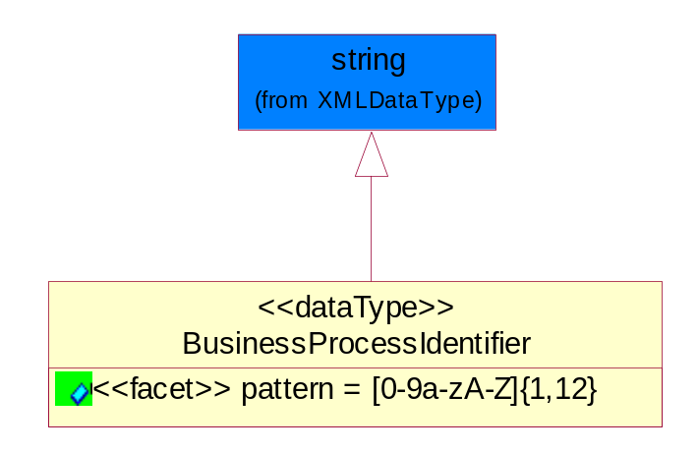
Figure 5-82 BusinessProcessIdentifier

Attribute | Type | Documentation
pattern |  | [0-9a-zA-Z]{1,12}

BusinessServiceInformation
The object allows the specification of the business service utilized within the partner company. This may or may not be the same as the information sent by the RNIF.
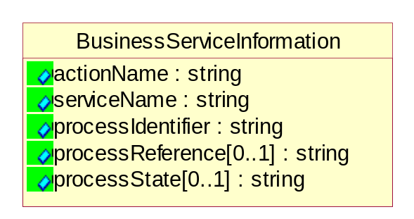
Figure 5-83 BusinessServiceInformation

Attribute | Type | Documentation
actionName | string | The name of Action. For RosettaNet usually any of Request/Confirm/Notify/Query/Response.
serviceName | string | The name of the Business Activity with the "Request/Confirm" part removed. E.g., for the Activity "Request Purchase Order"==> "Purchase Order".
processIdentifier | string | The name of the PIP e.g. Notify of Forecast Reply.
processReference[0..1] | string | The URN for the PIP that includes Cluster/Segment/Process pattern used to identify the interface process (such as PIP3A4)
processState[0..1] | string | The business process (or service) state of the sender of a document. When a service receives this document, the receiver may use the state as a precondition.

ContractInformation
A block of information used to correlate a contract in an executing choreography.

Figure 5-84 ContractInformation

Attribute | Type | Documentation
contractIdentifier[0..1] | string | Unique identification of a contract between the Sender and the Receiver
contractType[0..1] | string | The type of the contract: an attribute describing the type of the ContractIndentification. Valid values are URI, URN,ebXMLCPA, or other values defined by partners.

CorrelationInformation
A block of information used to correlate a requesting document to a responding document and to the contract in an executing choreography.
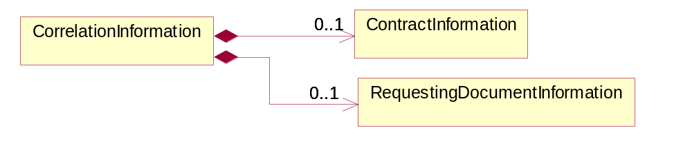
Figure 5-85 CorrelationInformation

Composition | Cardinality | Type | Documentation
ContractInformation | 0..1 | ContractInformation | A block of information used to correlate a contract in an executing choreography.
RequestingDocumentInformation | 0..1 | RequestingDocumentInformation | A block of information used to correlate a requesting document to a responding document in an executing choreography.

DocumentHeader
The object allows for the identification of the sender and receiver of the business document.
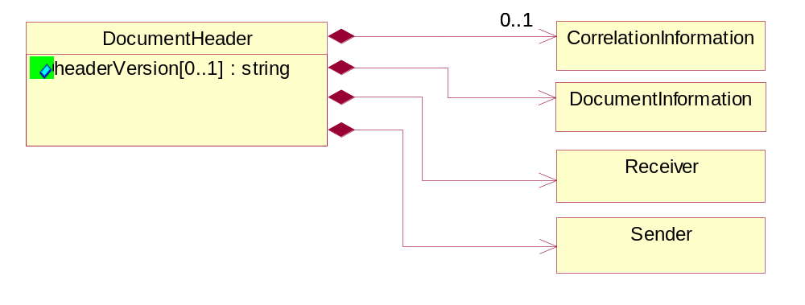
Figure 5-86 DocumentHeader

Attribute | Type | Documentation
headerVersion[0..1] | string | The UN/CEFACT version of the document header.

Composition | Cardinality | Type | Documentation
Sender | 1 | Sender | The object allows the identification of the initiating party of the business message.
CorrelationInformation | 0..1 | CorrelationInformation | A block of information used to correlate a requesting document to a responding document and to the contract in an executing choreography.
DocumentInformation | 1 | DocumentInformation | The object specifies information to identify the business document, a summary of attachments, and information about the business document security.
Receiver | 1 | Receiver | The object allows the identification of the receiving party of the business message.

DocumentIdentification
The object specifies all information necessary to identify the business document.
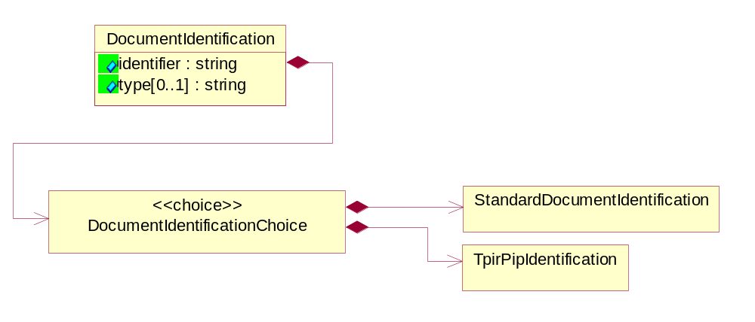
Figure 5-87 DocumentIdentification

Attribute | Type | Documentation
identifier | string | The unique identifier for the document being sent.
type[0..1] | string | Name of the Action Message

Composition | Cardinality | Type | Documentation
DocumentIdentificationChoice | 1 | DocumentIdentificationChoice

DocumentIdentificationChoice

Composition | Cardinality | Type | Documentation
StandardDocumentIdentification | 1 | StandardDocumentIdentification | The object specifies additional information necessary to identify the standard business document.
TpirPipIdentification | 1 | TpirPipIdentification | The object specifies all information necessary to uniquely identify a TPIR-PIP within a Registry or trading partner repository.

DocumentInformation
The object specifies information to identify the business document, a summary of attachments, and information about the business document security.
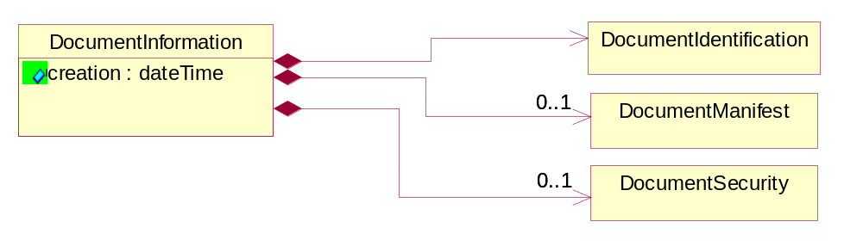
Figure 5-88 DocumentInformation

Attribute | Type | Documentation
creation | dateTime | The creation date and time of the specified Business Document (i.e. the Purchase Order date).

Composition | Cardinality | Type | Documentation
DocumentIdentification | 1 | DocumentIdentification | The object specifies all information necessary to identify the business document.
DocumentSecurity | 0..1 | DocumentSecurity | The object provides additional granularity in specifying business document security (this is in addition to the specified PIP security).
DocumentManifest | 0..1 | DocumentManifest | The block provides a brief summary of attachments and Service Content.

DocumentManifest
The block provides a brief summary of attachments and Service Content.
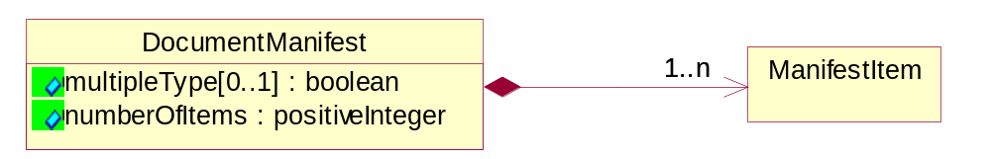
Figure 5-89 DocumentManifest

Attribute | Type | Documentation
multipleType[0..1] | boolean | Indicates whether the manifest contains documents of multiple types. True if yes, and False if no.
numberOfItems | positiveInteger | Total number of documents in the message. The physical count of the attachments in the payload plus the RosettaNet Business Message (for Service Content). The value of this field will be at least 1.

Composition | Cardinality | Type | Documentation
ManifestItem | 1..n | ManifestItem | The object provides details about the specific attachment(s).

DocumentSecurity
The object provides additional granularity in specifying business document security (this is in addition to the specified PIP security).

Figure 5-90 DocumentSecurity

Attribute | Type | Documentation
nonRepudiableReceipt | boolean | The value "true" will indicate that a signed acknowledgement for the business document is necessary.
persistentEncryption | boolean | The value "true" will indicate that the Business Document (including the header) needs to be encrypted when stored or transported.
persistentSignature | boolean | The value "true" will indicate that a signature is required to be stored with the document while stored or transported.

ManifestItem
The object provides details about the specific attachment(s).

Figure 5-91 ManifestItem

Attribute | Type | Documentation
description[0..1] | string | A description of the attachment.
length[0..1] | positiveInteger | The size of the attachment in bytes (i.e. 1 000 000 bytes)
universalResourceIdentifier | string | The generic set of all names/addresses that are short strings that refer to resources.

Composition | Cardinality | Type | Documentation
mimeTypeQualifier | 1 | MimeTypeQualifier | The MIME type as defined by IANA.  Please refer to http://www.iana.org/assignments/media-types/ for a list of types.
language | 0..1 | Language | For representation of Language name RosettaNet has adopted ISO 639-2; 1998. Refer to the following web page to get the latest version of the standard:  http://www.loc.gov/standards/iso639-2/iso639jac.html  If you need more information about the ISO standard please contact ISO for more details.

PipIdentifier
PIP Identification.[ i.e. PIP3A4]
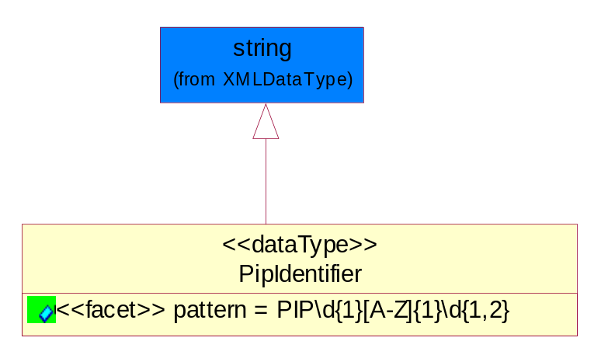
Figure 5-92 PipIdentifier

Attribute | Type | Documentation
pattern |  | PIP\d{1}[A-Z]{1}\d{1,2}

PipVersion
PIP version number (i.e. 02.02.00).
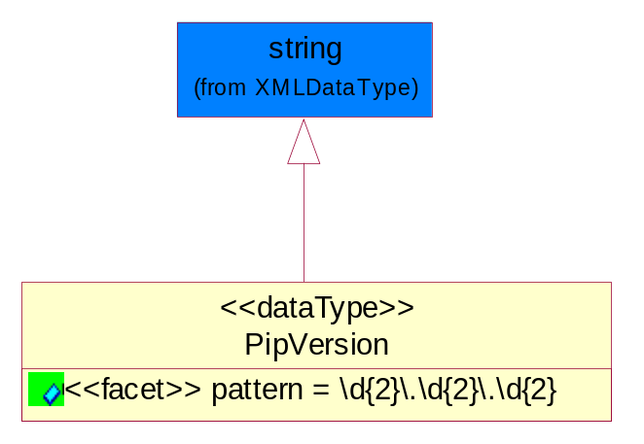
Figure 5-93 PipVersion

Attribute | Type | Documentation
pattern |  | \d{2}\.\d{2}\.\d{2}

Receiver
The object allows the identification of the receiving party of the business message.
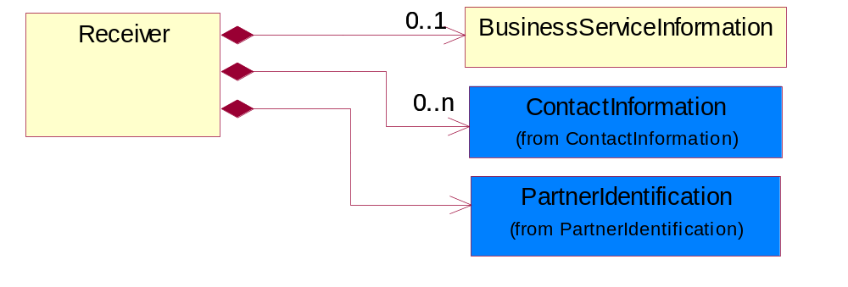
Figure 5-94 Receiver

Composition | Cardinality | Type | Documentation
BusinessServiceInformation | 0..1 | BusinessServiceInformation | The object allows the specification of the business service utilized within the partner company. This may or may not be the same as the information sent by the RNIF.
PartnerIdentification | 1 | PartnerIdentification | The business document must allow for the identity of one or more parties to the transaction.
ContactInformation | 0..n | ContactInformation | The business document must allow for the identification of the name of the department, service or individual to be contacted regarding the context of the business document.

RequestingDocumentInformation
A block of information used to correlate a requesting document to a responding document in an executing choreography.

Figure 5-95 RequestingDocumentInformation

Attribute | Type | Documentation
businessProcessInstanceIdentifier[0..1] | string | The identifier for the public business process instance being sent that both the sender and receiver can identify.
responseDateTime[0..1] | dateTime | The expected time to receive the response. This can not be greater than the PIP TimeToPerform.
requestingDocumentCreationDateTime[0..1] | dateTime | The date-time of the requesting business document.
requestingDocumentInstanceIdentifier | string | The Business Document identification number that identifies the requesting Business Document.

Sender
The object allows the identification of the initiating party of the business message.
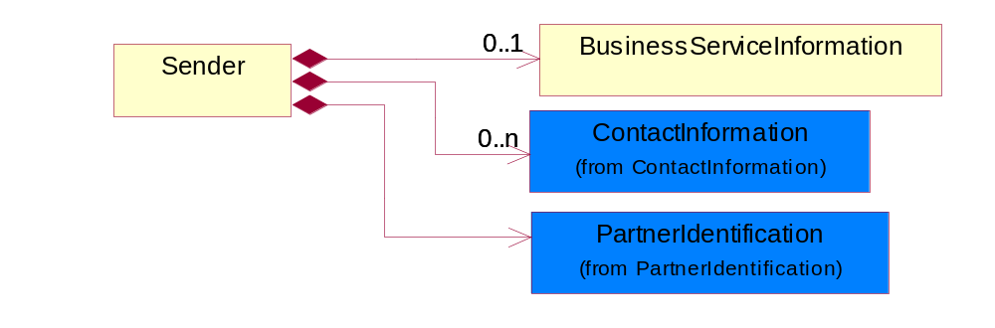
Figure 5-96 Sender

Composition | Cardinality | Type | Documentation
PartnerIdentification | 1 | PartnerIdentification | The business document must allow for the identity of one or more parties to the transaction.
BusinessServiceInformation | 0..1 | BusinessServiceInformation | The object allows the specification of the business service utilized within the partner company. This may or may not be the same as the information sent by the RNIF.
ContactInformation | 0..n | ContactInformation | The business document must allow for the identification of the name of the department, service or individual to be contacted regarding the context of the business document.

StandardDocumentIdentification
The object specifies additional information necessary to identify the standard business document.
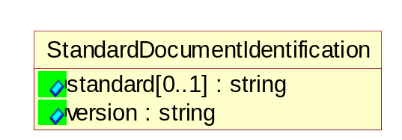
Figure 5-97 StandardDocumentIdentification

Attribute | Type | Documentation
standard[0..1] | string | Identifies the standard used to submit the business document. (e.g. RosettaNet).
version | string | PIP3A4v01.00

TpirPipIdentification
The object specifies all information necessary to uniquely identify a TPIR-PIP within a Registry or trading partner repository.

Figure 5-98 TpirPipIdentification

Attribute | Type | Documentation
partnerId | DUNSPlus4 | The Trading Partner Identification of MNC that is creating this TPIR PIP.
pipIdentifier | PipIdentifier | A TPIR PIP Identification [i.e., 3A4 ).
pipVersion | PipVersion | A TPIR PIP version number (i.e., 02.02.00)
tpirPipVersion | VersionIdentifier | A TPIR-PIP Version Number (i.e., major and minor version number as XX.XX).
tpirBusinessProcessIdentifier[0..1] | BusinessProcessIdentifier | A Business Process Identifier to uniquely define the TPIR-PIP 'role' within a Business Scenario at a company or MNC level. The identifier MUST be composed of alphanumeric characters only and its length MUST be between one and twelve characters.
uri[0..1] | anyURI | Describes the destination uri for the TPIR form.

Composition | Cardinality | Type | Documentation
fileType | 0..1 | TPIRFileType | Describes the file type of the TPIR form (PDF, XDP or XML).

VersionIdentifier
Version Number (i.e., major and minor version number as XX.XX).
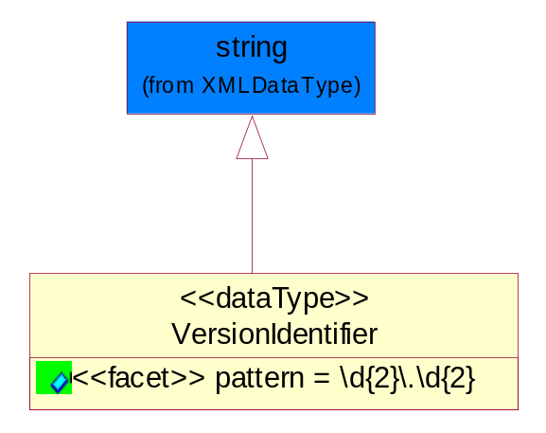
Figure 5-99 VersionIdentifier

Attribute | Type | Documentation
pattern |  | \d{2}\.\d{2}

CodeList

TPIRFileType
A code identifying the file type of TPIR form.

Name | Documentation
PDF | Portable Document Format.
XDP | XML Data Package.
XML | eXtensible Markup Language.

XML Data Type

anyURI
Represents a URI as defined by RFC 2396. An anyURI value can be absolute or relative, and may have an optional fragment identifier.

boolean
Represents Boolean values, which are either "true" or "false".

date
For the represents a calendar date.
The pattern for a date is CCYY-MM-DD where CC represents the century, YY the year, MM the month, and DD the day, with an optional time zone indicator as allowed for dateTime.

dateTime
Represents a specific instance of time.
The pattern for dateTime is CCYY-MM-DDThh:mm:ss where CC represents the century, YY the year, MM the month, and DD the day, preceded by an optional leading negative (-) character to indicate a negative number. If the negative character is omitted, positive (+) is assumed. The T is the date/time separator and hh, mm, and ss represent hour, minute, and second respectively. Additional digits can be used to increase the precision of fractional seconds if desired. For example, the format ss.ss... with any number of digits after the decimal point is supported. The fractional seconds part is optional.
This representation may be immediately followed by a "Z" to indicate Coordinated Universal Time (UTC) or to indicate the time zone. For example, the difference between the local time and Coordinated Universal Time, immediately followed by a sign, + or -, followed by the difference from UTC represented as hh:mm (minutes is required). If the time zone is included, both hours and minutes must be present.

decimal
A data type that contains decimal numbers scaled by a power of 10.

duration
Represents a duration of time.
The pattern for duration is PnYnMnDTnHnMnS, where nY represents the number of years, nM the number of months, nD the number of days, T the date/time separator, nH the number of hours, nM the number of minutes, and nS the number of seconds.

float
Represents single-precision 32-bit floating-point numbers.

positiveInteger
Represents an integer that is greater than zero. This data type is derived from nonNegativeInteger.

string
Represents character string.

