

Description of
Partner Interface Process® for 3A20

Validated 11.00.00

Specification Information
Name | Notify of Purchase Order Confirmation
Cluster | Order Management
Segment | Quote and Order Entry
Publication Date | 17 February 2010
Version Identifier | V11.00

Table of Contents
1 Document Management 4
1.1 Legal Disclaimer 4
1.2 Copyright 4
1.3 Trademarks 4
1.4 Acknowledgments 4
1.5 Related Documents 4
1.6 Document Version History 4
1.7 Document Structure 5
2 Business Process 6
2.1 Business Process Definition 6
2.2 PIP Scope Description 6
2.3 PIP Business Documents 7
2.4 PIP Business Process Flow Diagram 7
2.5 PIP Start State 8
2.6 PIP End States 8
2.7 Partner Role Descriptions 9
2.8 Business Process Activity Controls 9
3 Network and Implementation Specification 10
3.1 Business Action and Business Signal Specification 10
3.2 Business Transaction Dialog Specification 10
3.2.1 Message Exchange Controls 11
3.2.2 Communications Specification 11

List of Figures
Figure 1: Activity Diagram 7
Figure 2: Sequence Diagram 10

List of Tables
Table 1: PIP Business Documents 7
Table 2: PIP Start State 8
Table 3: PIP End State 8
Table 4: PIP Failure State 8
Table 5: Partner Role Descriptions 9
Table 6: Business Activity Descriptions 9
Table 7: Business Activity Performance Controls 9
Table 8: Network Component Specification 10
Table 9: Business Action – Business Document Mapping 10
Table 10: Message Exchange Control 11
Table 11: Dialog: Service-Service 11

Document Management

Legal Disclaimer
RosettaNet™, its members, officers, directors, employees, or agents shall not be liable for any injury, loss, damages, financial or otherwise, arising from, related to, or caused by the use of this document or the specifications herein, as well as associated guidelines and schemas. The use of said specifications shall constitute your express consent to the foregoing exculpation.

Copyright
©2010 RosettaNet. All rights reserved. No part of this publication may be reproduced, stored in a retrieval system, or transmitted, in any form or by any means, electronic, mechanical, photocopying, recording, or otherwise, without the prior written permission of the publisher. Printed in the United States of America.

Trademarks
RosettaNet, Partner Interface Process, PIP and the RosettaNet logo are trademarks or registered trademarks of “RosettaNet,” a non-profit organization. All other product names and company logos mentioned herein are the trademarks of their respective owners. In the best effort, all terms mentioned in this document that are known to be trademarks or registered trademarks have been appropriately recognized in the first occurrence of the term.

Acknowledgments
This document has been prepared by RosettaNet (http://www.rosettanet.org/) from requirements gathered during the Milestone Program and in conformance with the methodology.

Related Documents
- Associated PIP Message Schemas (included within the PIP Specification package only)
- Description of PIP3A20 Message
- Message Structure
- XML instance of ebBPSS for PIP 3A20

Document Version History
Version | Date | Description
Validated 11.00.00 | 17 February 2010 | Validated version : MCC Foundational Program

Document Structure
A Partner Interface Process (PIP) Specification is comprised of the following two parts:
- Business Process. Captures the semantics of the business process and the flow of the message exchange between roles as they perform business activities.
- Network and Implementation Specification. Specifies the network protocol message formats and communications requirements between peer-protocols supported by network components in the RosettaNet Implementation Framework.

Business Process

Business Process Definition
The "Notify of Purchase Order Confirmation" Partner Interface Process™ (PIP) enables a seller to acknowledge, at the line level, if the order is accepted, rejected, or pending.
The seller's acknowledgment may also include related information about delivery expectations.
When a seller acknowledges that the status of a purchase order product line item is "pending," the seller may later use PIP3A7, "Notify of Purchase Order Acknowledgment" to notify the buyer when the product line item is either accepted or rejected.
The process of issuing a purchase order typically occurs after:
- Checking for price and availability
- Requesting quotes
- Transferring shopping carts
The process of issuing a purchase order may be followed by:
- Changing the purchase order
- Canceling the purchase order
- Querying for purchase order status
- Distributing purchase order status
Should this transaction not complete successfully, the requesting partner executes PIP0A1, "Notification of Failure."

PIP Scope Description
This PIP enables a seller to issue a quick response to the buyer that acknowledges which of the purchase order product line items are accepted, rejected, or pending.

PIP Business Documents
Business Documents are generated and exchanged by roles performing activities in this PIP. Business Documents are listed and defined in Table 1.
Table 1: PIP Business Documents
Business Document | Description
Purchase Order Confirmation Notification | Formally confirms the status of line item(s) in a Purchase Order. A Purchase Order line item may have one of the following states: accepted, rejected, or pending.

PIP Business Process Flow Diagram
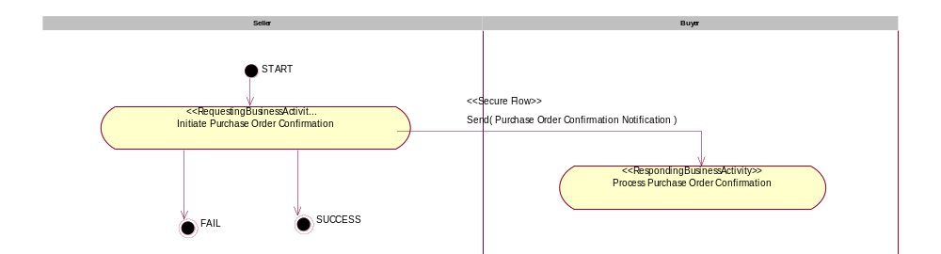

Figure 1: Activity Diagram

PIP Start State
The start state is comprised of the following condition(s):
Table 2: PIP Start State
 | Approved | Exist |  | Valid | Non-Repudiated | Retry Count | Authorized
 | Approved | Party | In Backend system
TPA |  |  | 
Sending Partner |  |  |  |  |  |  | 
Receiving Partner |  | 
Business Document  (Purchase Order Request) |  |  |  |  | 

PIP End States
The end state is comprised of the following condition(s):
Table 3: PIP End State
 | Approved | Exist |  | Valid | Non-Repudiated | Retry Count | Authorized
 | Approved | Party | In Backend system
Acknowledgment of Receipt |  |  |  |  | 
Receiving Partner |  |  |  |  |  |  | 

The PIP failure state is comprised of one or more of the following condition(s):
Table 4: PIP Failure State
 | NO | Exceeded
Success | 
Retry Count |  | 

Partner Role Descriptions
Table 5 describes the partner roles in this PIP.
Table 5: Partner Role Descriptions
Role Name | Role Description
Seller | An organization that sells products to partners in the supply chain.
Buyer | An employee or organization that buys products for a partner type in the supply chain.

Business Process Activity Controls
Table 6 describes the interaction between roles performing business activities in this PIP.
Table 6: Business Activity Descriptions
Role Name | Activity Name | Activity Description
Seller | Initiate Purchase Order Confirmation | The Seller acknowledges, at the line level, if the Purchase Order is accepted, rejected, or pending.

Table 7 details the security, audit and process controls relating to activities performed in the PIP.
Table 7: Business Activity Performance Controls
Role  Name | Activity  Name | Acknowledgment  of Receipt |  | Time to Perform | Retry Count | Is Authorization Required? | Non-Repudiation of Origin and Content?
Role  Name | Activity  Name | Non-Repudiation Required? | Time to Acknowledge
Seller | Initiate Purchase Order Confirmation | Y | 2 hrs | 2 hrs | 3 | Y | Y

Network and Implementation Specification
Each network component maps into a role of the PIP model. Table 8 specifies the mapping between roles and network components.
Table 8: Network Component Specification
Network Component | Classification | Maps to Role in Business Process
Buyer Service | Business Service | Buyer
Seller Service | Business Service | Seller

Business Action and Business Signal Specification
Each business action maps to a Business Document of the PIP model. Table 9 specifies the mapping between Business Documents and business actions.
Table 9: Business Action – Business Document Mapping
Business Action | Business Document | Document Function
Purchase Order Confirmation Notification Action | Purchase Order Confirmation Notification | Response

Business Transaction Dialog Specification
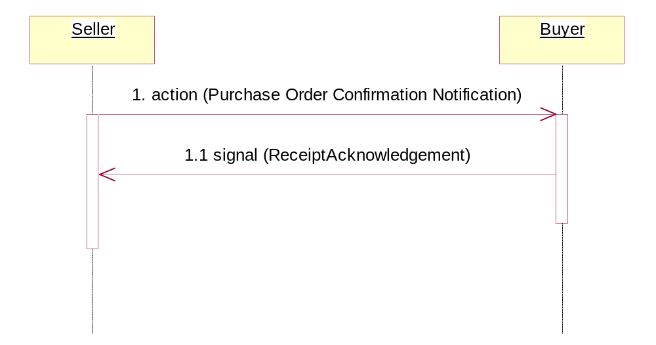
Figure 2: Sequence Diagram

Message Exchange Controls
Table 10: Message Exchange Control
# | Name |  | Time to Acknowledge Receipt Signal |  | Time to Respond to Action |  | Included in Time to Perform |  | Is Authorization Required? |  | Is Non-Repudiation Required? |  | Is Secure Transport Required?
1. |  | Purchase Order Confirmation Action |  | 2 hrs |  | N/A |  | 2 hrs |  | Y |  | Y |  | Y
1.1. |  | Receipt Acknowledgment |  | N/A |  | N/A |  | N/A |  | N |  | Y |  | Y

Communications Specification
Table 11: Dialog: Service-Service
# | Business Message | Digital Signature Required? | SSL Required?
1. | Purchase Order Confirmation | Y | Y
1.1. | Receipt Acknowledgment | Y | Y

