

Description of
Partner Interface Process® for 3A24

Validated 11.00.00

Specification Information
Name | Notify of Purchase Order Cancellation Confirmation
Cluster | Order Management
Segment | Quote and Order Entry
Publication Date | 18 February 2010
Version Identifier | V11.00

Table of Contents
1 Document Management 4
1.1 Legal Disclaimer 4
1.2 Copyright 4
1.3 Trademarks 4
1.4 Acknowledgments 4
1.5 Related Documents 4
1.6 Document Version History 4
1.7 Document Structure 5
2 Business Process 6
2.1 Business Process Definition 6
2.2 PIP Scope Description 6
2.3 PIP Business Documents 7
2.4 PIP Business Process Flow Diagram 7
2.5 PIP Start State 8
2.6 PIP End States 8
2.7 Partner Role Descriptions 9
2.8 Business Process Activity Controls 9
3 Network and Implementation Specification 10
3.1 Business Action and Business Signal Specifications 10
3.2 Business Transaction Dialog Specification 10
3.2.1 Message Exchange Controls 11
3.2.2 Communications Specification 11

List of Figures:
Figure 1: Activity Diagram 7
Figure 2: Sequence Diagram 10

List of Tables:
Table 1: PIP Business Document 7
Table 2: PIP Start State 8
Table 3: PIP End State 8
Table 4: PIP Failure State 8
Table 5: Partner Role Description 9
Table 6: Business Activity Description 9
Table 7: Business Activity Performance Control 9
Table 8: Network Component Specification 10
Table 9: Business Action – Business Document Mapping 10
Table 10: Message Exchange Control 11
Table 11: Dialog: Service-Service 11

Document Management

Legal Disclaimer
RosettaNet™, its members, officers, directors, employees, or agents shall not be liable for any injury, loss, damages, financial or otherwise, arising from, related to, or caused by the use of this document or the specifications herein, as well as associated guidelines and schemas. The use of said specifications shall constitute your express consent to the foregoing exculpation.

Copyright
©2010 RosettaNet. All rights reserved. No part of this publication may be reproduced, stored in a retrieval system, or transmitted, in any form or by any means, electronic, mechanical, photocopying, recording, or otherwise, without the prior written permission of the publisher. Printed in the United States of America.

Trademarks
RosettaNet, Partner Interface Process, PIP and the RosettaNet logo are trademarks or registered trademarks of "RosettaNet," a non-profit organization. All other product names and company logos mentioned herein are the trademarks of their respective owners. In the best effort, all terms mentioned in this document that are known to be trademarks or registered trademarks have been appropriately recognized in the first occurrence of the term.

Acknowledgments
This document has been prepared by RosettaNet (http://www.rosettanet.org/) from requirements gathered during the Milestone Program and in conformance with the methodology.

Related Documents
- Associated PIP Message Schemas (included within the PIP Specification package only)
- Description of 3A24 Message
- Messages Structure
- XML instance of ebXML BPSS for PIP 3A24

Document Version History
Version | Date | Description
Validated 11.00.00 | 18 Feb 2010 | Validated Version: RosettaNet MCC Program

Document Structure
A Partner Interface Process (PIP) Specification is comprised of the following two parts:
- Business Process. Captures the semantics of the business process and the flow of the message exchange between roles as they perform business activities.
- Network and Implementation Specification. Specifies the network protocol message formats and communications requirements between peer-protocols supported by network components in the RosettaNet Implementation Framework.

Business Process
A Partner Interface Process™ (PIP) Specification comprises the following three views of the e-business PIP model.
- Business Operational View (BOV). Captures the semantics of business data entities and their flow of exchange between roles as they perform business activities. The content of the BOV section is based on the PIP Blueprint document created for RosettaNet's business community.
- Functional Service View (FSV). Specifies the network component services and interactions necessary to execute PIPs. The FSV includes all of the transaction dialogs in a PIP Protocol. The purpose of the FSV is to specify a PIP Protocol that is systematically derived from the BOV. The two major components within the FSV are the network component design and network component interactions.
- Implementation Framework View (IFV). Specifies the network protocol message formats and communications requirements between peer-protocols supported by network components in the RosettaNet Implementation Framework. These messages are exchanged when software programs execute a PIP; RosettaNet distributes these as XML Message Guidelines.

Business Process Definition
The "Notify of Purchase Order Cancellation Confirmation" Partner Interface Process™ (PIP) enables a seller to reply to a purchase order cancelation request. The buyer can confirm if the cancellation is accepted or rejected. Canceling a purchase order may occur after a purchase contract has been formed between the buyer and provider.
Should this transaction not complete successfully, the requesting partner executes PIP0A1, "Notification of Failure."

PIP Scope Description
This PIP enables a seller to respond to a purchase order cancelation and to confirm if the cancellation is accepted or rejected.

PIP Business Documents
Business Documents are generated and exchanged by roles performing activities in this PIP. Business Documents are listed and defined in Table 1.
Table 1: PIP Business Document
Business Document | Description
Purchase Order Cancellation Confirmation Notification | Confirms if a Purchase Order Cancellation is accepted or rejected.

PIP Business Process Flow Diagram
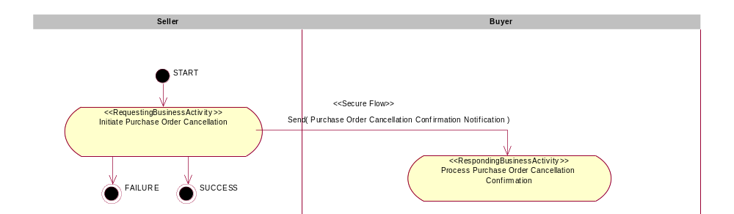
Figure 1: Activity Diagram

PIP Start State
The start state is comprised of the following conditions:
Table 2: PIP Start State
 | Approved | Exist |  | Valid | Non-Repudiated | Retry Count | Authorized
 | Approved | Party | In Backend System
TPA |  |  | 
Sending Partner |  |  |  | 
Receiving Partner |  | 
Business Document |  |  |  |  |  |  | 

PIP End States
The end state is comprised of the following conditions:
Table 3: PIP End State
 | Approved | Exist |  | Valid | Non-Repudiated | Retry Count | Authorized
 | Approved | Party | In Backend system
Acknowledgment of Receipt |  |  |  |  | 
Receiving Partner |  |  |  |  |  |  | 

The PIP failure state is comprised of one or more of the following conditions:
Table 4: PIP Failure State
 | NO | Exceeded
Success | 
Retry Count |  | 

Partner Role Descriptions
Table 5 describes the partner roles in this PIP.
Table 5: Partner Role Description
Role Name | Role Description
Seller | An organization that sells products to partners in the supply chain.
Buyer | An employee or organization that buys products for a partner type in the supply chain.

Business Process Activity Controls
Table 6 describes the interactions between roles performing business activities in this PIP.
Table 6: Business Activity Description
Role Name | Activity Name | Activity Description
Seller | Initiate Purchase Order Cancellation Confirmation | The activity confirms if the cancellation of Purchase Order is accepted or rejected.

Table 7 details the security, audit and process controls relating to activities performed in the PIP.
Table 7: Business Activity Performance Control
Role  Name | Activity  Name | Acknowledgment  of Receipt |  | Time to Perform | Retry Count | Is Authorization Required? | Non-Repudiation of Origin and Content?
Role  Name | Activity  Name | Non-Repudiation Required? | Time to Acknowledge
Seller | Initiate Purchase Order Cancellation Confirmation | Y | 2 hrs | 2 hrs | 3 | Y | Y

Network and Implementation Specification
Each network component maps into a role of the PIP model. Table 8 specifies the mapping between roles and network components.
Table 8: Network Component Specification
Network Component | Classification | Maps to Role in Business Process
Seller Service | Business Service | Seller
Buyer Service | Business Service | Buyer

Business Action and Business Signal Specifications
Each business action maps to a Business Document of the PIP model. Table 9 specifies the mapping between Business Documents and business actions.
Table 9: Business Action – Business Document Mapping
Business Action | Business Document | Document Function
Purchase Order Cancellation Confirmation Notification Action | Purchase Order Cancellation Confirmation Notification | Response

Business Transaction Dialog Specification
Each business activity between roles in the BOV is specified as a business transaction dialog between service network components. A service network component implements protocols that include the service layer, transaction and action layer. A service has “network identity” as a business service. The service has an identity URI that can be registered in directories and used for component communication in a distributed computer system.
The rest of section 3 specifies the network component configuration for this PIP. Each figure specifies the message exchange sequence as network components collaborate to execute this PIP. Each table shows the properties for each of the messages exchanged by the interactions in the corresponding figure.
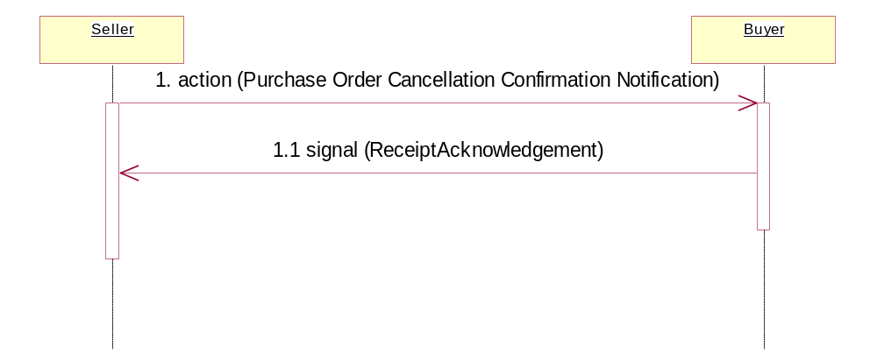
Figure 2: Sequence Diagram

Message Exchange Controls
Table 10: Message Exchange Control
# | Name |  | Time to Acknowledge Receipt Signal |  | Time to Respond to Action |  | Included in Time to Perform |  | Is Authorization Required? |  | Is Non-Repudiation Required? |  | Is Secure Transport Required?
1. |  | Purchase Order Cancellation Confirmation Action |  | 2 hrs |  | N/A |  | Y |  | Y |  | Y |  | Y
1.1. |  | Receipt Acknowledgment |  | N/A |  | N/A |  | N |  | Y |  | Y |  | Y

Communications Specification
Table 11: Dialog: Service-Service
# | Business Message | Digital Signature Required? | SSL Required?
1. | Purchase Order Cancellation Confirmation Notification | Y | Y
1.1. | Receipt Acknowledgment | Y | Y

