

Description of 3A2 Message

PIP® 3A2
Validated 11.00.01

Specification Information
Name | Description Of 3A2 Message
PIP | Request Price And Availability
Cluster | Order Management
Segment | Quote and Order Entry
Publication Date | 10 November 2008
Version Identifier | V11.00

Table of Content

1. Document Management 6
1.1 Legal Disclaimer 6
1.2 Copyright 6
1.3 Trademarks 6
1.4 Acknowledgments 6
1.5 Related Documents 7
1.6 Document Version History 7
1.7 Document Purpose 7
2. Interchange Model 8
2.1 PriceAndAvailabilityRequest 8
2.1.1 Interchange Diagram 8
2.1.2 Dependency Diagram 9
2.1.3 PriceAndAvailabilityRequest 9
2.1.4 ProductPriceAndAvailability 10
2.1.5 ProductPriceAndAvailabilityLineItem 11
2.2 PriceAndAvailabilityResponse 13
2.2.1 Interchange Diagram 13
2.2.2 Dependency Diagram 14
2.2.3 AdditionalProductPriceAndAvailabilityLineItem 14
2.2.4 PriceAndAvailabilityResponse 15
2.2.5 ProductPriceAndAvailability 16
2.2.6 ProductPriceAndAvailabilityLineItem 17
3. Domain Model 19
3.1 Procurement 19
3.1.1 Procurement 19
3.1.1.1 Dependency Diagram 19
3.1.1.2 IsCallFactory 19
3.1.1.3 LeadTimeQuantity 19
3.1.1.4 PriceCondition 20
3.1.1.5 PriceList 21
3.1.1.6 ProductAvailability 21
3.1.1.7 ProductLeadTime 22
3.1.1.8 ProductPricingDetail 23
3.1.1.9 ProductQuantityRange 23
3.1.1.10 StepPricing 24
3.1.1.11 SubstituteProductReference 25
3.1.1.12 WarehouseInformation 25
3.1.1.13 WarehouseLocation 26
3.1.1.14 WarehouseLocationChoice 26
3.1.1.15 WarehouseQuantityInformation 26
3.1.2 CodeList 27
3.1.2.1 ProductSubstitutionReason 27
3.1.2.2 LeadTimeClassificationCode 27
3.1.2.3 ProductAvailabilityCode 28
3.1.2.4 CustomerAuthorizationCode 28
3.2 Shared 29
3.2.1 Shared 29
3.2.1.1 Dependency Diagram 29
3.2.1.2 MonetaryAmount 29
3.2.1.3 ProductQuantity 30
3.2.2 CodeList 30
3.2.2.1 InvoiceChargeType 30
3.2.2.2 MonetaryAmountType 31
3.2.2.3 PackageTypeCode 31
3.2.2.4 PricingTypeCode 32
3.2.2.5 ProductStatusCode 33
3.2.2.6 Interval 34
3.2.2.7 AmountType 35
4. Universal Structure 36
4.1 ContactInformation 36
4.1.1 ContactInformation 36
4.2 DataType 36
4.2.1 Contact 36
4.2.2 DUNS 37
4.2.3 DUNSPlus4 37
4.2.4 GLN 38
4.2.5 GTIN 38
4.3 Dates 38
4.3.1 DatePeriod 38
4.4 Document 39
4.4.1 BusinessDocumentReference 39
4.5 Locations 39
4.5.1 AlternativeIdentifier 39
4.5.2 Location 40
4.5.3 LocationChoice 40
4.5.4 PhysicalAddress 41
4.6 MonetaryExpression 42
4.6.1 FinancialAmount 42
4.7 PartnerIdentification 43
4.7.1 FullPartner 43
4.7.2 IntermittentPartner 43
4.7.3 KnownPartner 44
4.7.4 KnownPartnerContact 44
4.7.5 NewPartner 45
4.7.6 PartnerDescription 45
4.7.7 PartnerDescriptionChoice 46
4.7.8 PartnerIdentification 47
4.7.9 PartnerIdentificationChoice 47
4.7.10 SpecifiedFullPartner 48
4.7.11 SpecifiedIntermittentPartner 49
4.7.12 SpecifiedKnownPartner 49
4.7.13 SpecifiedNewPartner 50
4.8 ProductIdentification 51
4.8.1 ProductIdentification 51
4.8.2 ProductIdentificationChoice 51
4.9 CodeList 52
4.9.1 Country 52
4.9.2 CountrySubdivision 52
4.9.3 Currency 52
4.9.4 Language 52
4.9.5 DocumentType 52
4.9.6 MimeTypeQualifier 54
4.9.7 UnitOfMeasure 65
4.9.8 ProcessRoleIdentifier 72
5. System Structure 76
5.1 BusinessProcessIdentifier 76
5.2 BusinessServiceInformation 76
5.3 ContractInformation 77
5.4 CorrelationInformation 77
5.5 DocumentHeader 78
5.6 DocumentIdentification 79
5.7 DocumentIdentificationChoice 79
5.8 DocumentInformation 80
5.9 DocumentManifest 80
5.10 DocumentSecurity 81
5.11 ManifestItem 82
5.12 PipIdentifier 83
5.13 PipVersion 83
5.14 Receiver 84
5.15 RequestingDocumentInformation 84
5.16 Sender 85
5.17 StandardDocumentIdentification 86
5.18 TpirPipIdentification 86
5.19 VersionIdentifier 87
5.20 CodeList 87
5.20.1 TPIRFileType 87
6. XML Data Type 88
6.1 anyURI 88
6.2 boolean 88
6.3 date 88
6.4 dateTime 88
6.5 float 88
6.6 positiveInteger 88
6.7 string 88

Table of Figures

Figure ‎2-1 Interchange 8
Figure ‎2-2 Dependency 9
Figure ‎2-3 PriceAndAvailabilityRequest 9
Figure ‎2-4 ProductPriceAndAvailability 10
Figure ‎2-5 ProductPriceAndAvailabilityLineItem 11
Figure ‎2-6 Interchange 13
Figure ‎2-7 Dependency 14
Figure ‎2-8 AdditionalProductPriceAndAvailabilityLineItem 14
Figure ‎2-9 PriceAndAvailabilityResponse 15
Figure ‎2-10 ProductPriceAndAvailability 16
Figure ‎2-11 ProductPriceAndAvailabilityLineItem 17
Figure ‎3-1 Dependency 19
Figure ‎3-2 IsCallFactory 19
Figure ‎3-3 LeadTimeQuantity 19
Figure ‎3-4 PriceCondition 20
Figure ‎3-5 PriceList 21
Figure ‎3-6 ProductAvailability 21
Figure ‎3-7 ProductLeadTime 22
Figure ‎3-8 ProductPricingDetail 23
Figure ‎3-9 ProductQuantityRange 23
Figure ‎3-10 StepPricing 24
Figure ‎3-11 SubstituteProductReference 25
Figure ‎3-12 WarehouseInformation 25
Figure ‎3-13 WarehouseLocation 26
Figure ‎3-14 WarehouseQuantityInformation 26
Figure ‎3-15 Dependency 29
Figure ‎3-16 MonetaryAmount 29
Figure ‎3-17 ProductQuantity 30
Figure ‎4-1 ContactInformation 36
Figure ‎4-2 Contact 36
Figure ‎4-3 DUNS 37
Figure ‎4-4 DUNSPlus4 37
Figure ‎4-5 GLN 38
Figure ‎4-6 GTIN 38
Figure ‎4-7 DatePeriod 38
Figure ‎4-8 BusinessDocumentReference 39
Figure ‎4-9 AlternativeIdentifier 39
Figure ‎4-10 Location 40
Figure ‎4-11 PhysicalAddress 41
Figure ‎4-12 FinancialAmount 42
Figure ‎4-13 FullPartner 43
Figure ‎4-14 IntermittentPartner 43
Figure ‎4-15 KnownPartner 44
Figure ‎4-16 KnownPartnerContact 44
Figure ‎4-17 NewPartner 45
Figure ‎4-18 PartnerDescription 45
Figure ‎4-19 PartnerIdentification 47
Figure ‎4-20 SpecifiedFullPartner 48
Figure ‎4-21 SpecifiedIntermittentPartner 49
Figure ‎4-22 SpecifiedKnownPartner 49
Figure ‎4-23 SpecifiedNewPartner 50
Figure ‎4-24 ProductIdentification 51
Figure ‎5-1 BusinessProcessIdentifier 76
Figure ‎5-2 BusinessServiceInformation 76
Figure ‎5-3 ContractInformation 77
Figure ‎5-4 CorrelationInformation 77
Figure ‎5-5 DocumentHeader 78
Figure ‎5-6 DocumentIdentification 79
Figure ‎5-7 DocumentInformation 80
Figure ‎5-8 DocumentManifest 80
Figure ‎5-9 DocumentSecurity 81
Figure ‎5-10 ManifestItem 82
Figure ‎5-11 PipIdentifier 83
Figure ‎5-12 PipVersion 83
Figure ‎5-13 Receiver 84
Figure ‎5-14 84
Figure ‎5-15 Sender 85
Figure ‎5-16 StandardDocumentIdentification 86
Figure ‎5-17 TpirPipIdentification 86
Figure ‎5-18 VersionIdentifier 87

Document Management

Legal Disclaimer
RosettaNet, its members, officers, directors, employees, or agents shall not be liable for any injury, loss, damages, financial or otherwise, arising from, related to, or caused by the use of this document or the specifications herein, as well as associated guidelines and schemas. The use of said specifications shall constitute your express consent to the foregoing exculpation.

Copyright
©2008 RosettaNet. All rights reserved. No part of this publication may be reproduced, stored in a retrieval system, or transmitted, in any form or by any means, electronic, mechanical, photocopying, recording, or otherwise, without the inclusion of this copyright notice. Any derivative works must cite the copyright notice. Any public redistribution or sale of this publication or derivative works requires prior written permission of the publisher.

Trademarks
RosettaNet, Partner Interface Process, PIP and the RosettaNet logo are trademarks or registered trademarks of "RosettaNet," a non-profit organization. All other product names and company logos mentioned herein are the trademarks of their respective owners. In the best effort, all terms mentioned in this document that are known to be trademarks or registered trademarks have been appropriately recognized in the first occurrence of the term.

Acknowledgments
This document has been prepared by RosettaNet (http://www.rosettanet.org/) from requirements gathered during the Milestone Program and in conformance with the methodology. Listed below are the legal entities that contributed to the design and development of this PIP.
Global eXchange Services | Seagate Technology
Sterling Commerce | Tyco Electronics
Arrow Electronics | E-Innovators
GridNode

Related Documents
- Associated PIP Message Schemas (included with PIP Specification only)
- Description of Partner Interface Process for 3A2
- Message Structure

Document Version History
Version | Date | Description
Validated 11.00.00 | 27 June 2008 | Validated Version: RosettaNet Schema to Market to Validation 2008
Validated 11.00.01 | 10 November 2008 | Validated Version: RosettaNet Schema to Market to Validation 2008

Document Purpose
The purpose of the document is to explain the structure, the association between objects, the content of objects and the definition for single elements to a non-technical audience.

Interchange Model

PriceAndAvailabilityRequest

Interchange Diagram
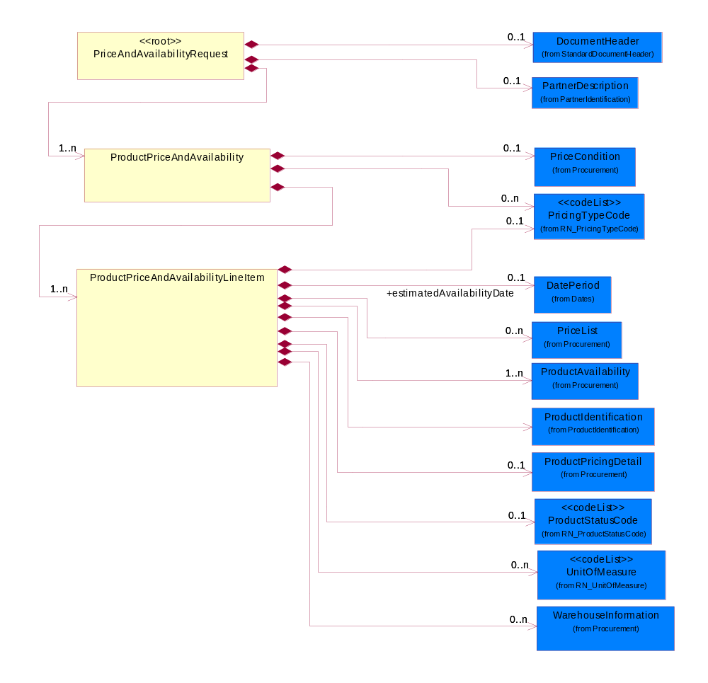
Figure ‎2-1 Interchange

Dependency Diagram
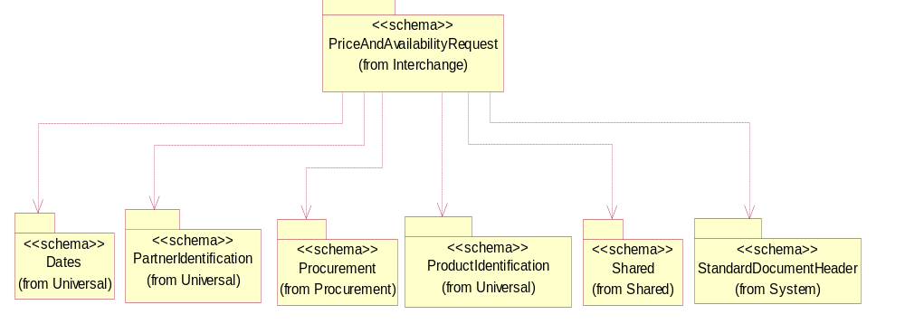
Figure ‎2-2 Dependency

PriceAndAvailabilityRequest
Top level object for a Price And Availability business document.
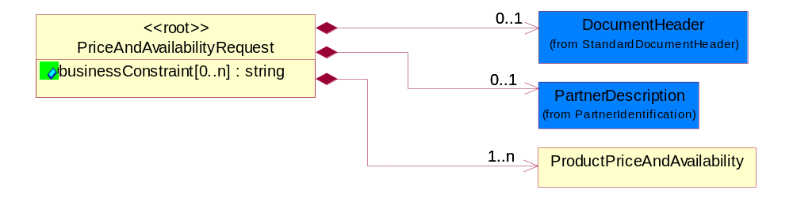
Figure ‎2-3 PriceAndAvailabilityRequest

Attribute | Type | Documentation
businessConstraint[0..n] | string | Constraint that must be met by the entire response document.

Composition | Cardinality | Type | Documentation
DocumentHeader | 0..1 | DocumentHeader | The object allows for the identification of the sender and receiver of the business document.
PartnerDescription | 0..1 | PartnerDescription | The collection of business properties that describe a business partners' identity, their contact information, where they are physically located and their function in a supply chain.
ProductPriceAndAvailability | 1..n | ProductPriceAndAvailability | The collection of business properties that describe a product's price and availability.

ProductPriceAndAvailability
The collection of business properties that describe a product's price and availability.
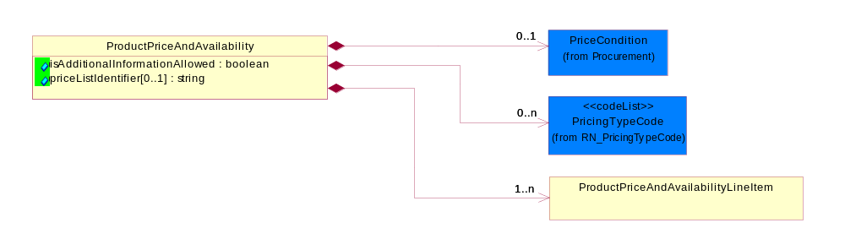
Figure ‎2-4 ProductPriceAndAvailability

Attribute | Type | Documentation
isAdditionalInformationAllowed | boolean | Indicates whether the requesting business document will permit additional information to be returned on the responding document.
priceListIdentifier[0..1] | string | The unique identifier that references a specific price list used for product pricing.

Composition | Cardinality | Type | Documentation
PriceCondition | 0..1 | PriceCondition | The collection of business properties that define information for special pricing conditions.
PricingTypeCode | 0..n | PricingTypeCode | Code identifying the type of pricing available for a product.
ProductPriceAndAvailabilityLineItem | 1..n | ProductPriceAndAvailabilityLineItem | The collection of business properties that describe a product entry for a product price and availability business document.

ProductPriceAndAvailabilityLineItem
The collection of business properties that describe a product entry for a product price and availability business document.
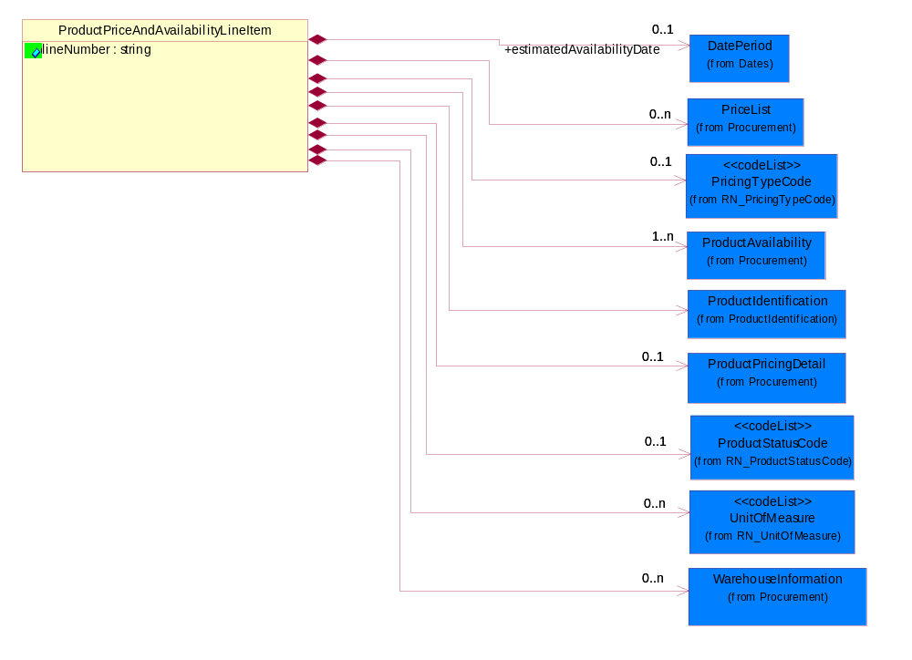
Figure ‎2-5 ProductPriceAndAvailabilityLineItem

Attribute | Type | Documentation
lineNumber | string | Number of the line in the document.

Composition | Cardinality | Type | Documentation
estimatedAvailabilityDate | 0..1 | DatePeriod | The estimated date the product will be available.
PriceList | 0..n | PriceList | The collection of business properties that describe product pricing in a proprietary price list document.
PricingTypeCode | 0..1 | PricingTypeCode | Code identifying the type of pricing available for a product.
ProductAvailability | 1..n | ProductAvailability | The collection of business properties that describe a product's time frame for being available to a customer.
ProductIdentification | 1 | ProductIdentification | The object provides the identifier(s) of a product.
ProductPricingDetail | 0..1 | ProductPricingDetail | The collection of business properties that describe pricing information about a product.
ProductStatusCode | 0..1 | ProductStatusCode | Code specifying the production status of an item.
UnitOfMeasure | 0..n | UnitOfMeasure | Code identifying a product unit of measure.
WarehouseInformation | 0..n | WarehouseInformation | The collection of business properties that describe warehouse information.

PriceAndAvailabilityResponse

Interchange Diagram
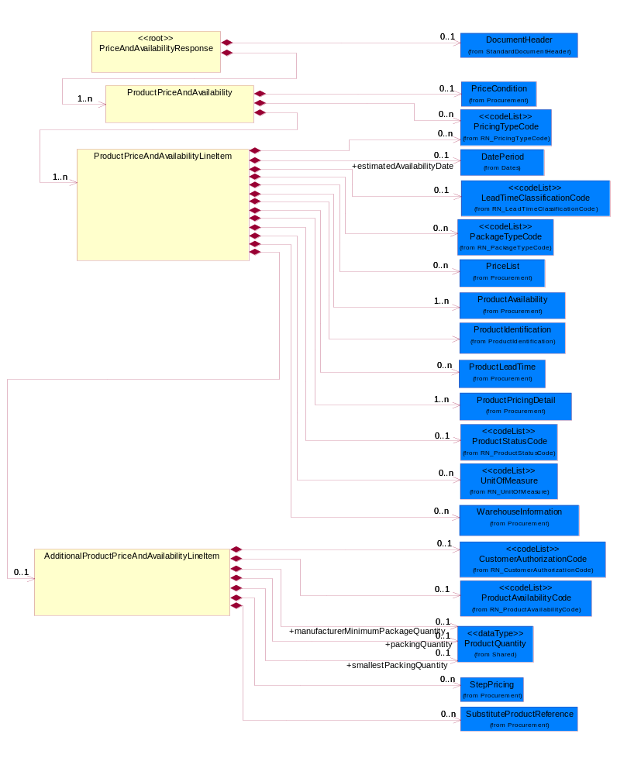
Figure ‎2-6 Interchange

Dependency Diagram
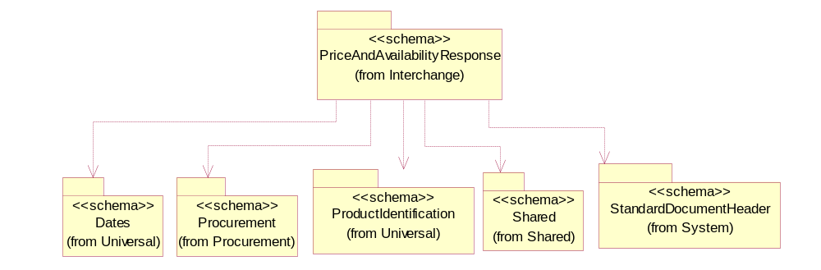
Figure ‎2-7 Dependency

AdditionalProductPriceAndAvailabilityLineItem
The collection of business properties that describe supplemental information, for a line item, given in a PriceAndAvailabilityResponse document.
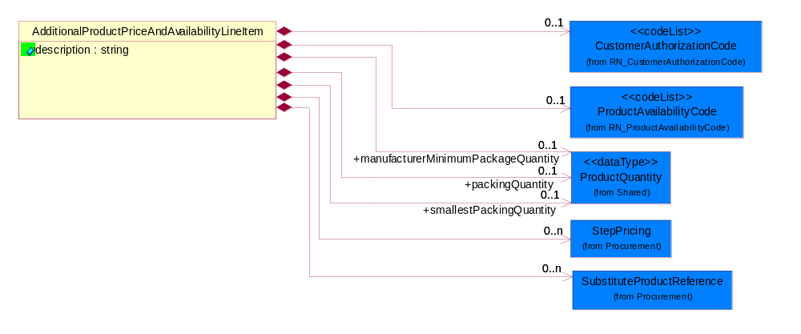
Figure ‎2-8 AdditionalProductPriceAndAvailabilityLineItem

Attribute | Type | Documentation
description | string | A description of a process, thing, action, etc.

Composition | Cardinality | Type | Documentation
CustomerAuthorizationCode | 0..1 | CustomerAuthorizationCode | Code identifying whether a customer is allowed to sell a product.
ProductAvailabilityCode | 0..1 | ProductAvailabilityCode | Code identifying a product's obtainability.
manufacturerMinimumPackageQuantity | 0..1 | ProductQuantity | The product quantity in a defined package by a manufacturer.
packingQuantity | 0..1 | ProductQuantity | The quantity of products contained in an outer packing unit.
smallestPackingQuantity | 0..1 | ProductQuantity | The quantity of products contained in an inner packing unit or a sub-packing unit.
StepPricing | 0..n | StepPricing | The collection of business properties that describe a product's variance in pricing in regards to specified date ranges and quantities.
SubstituteProductReference | 0..n | SubstituteProductReference | The collection of business properties describing a product that is being substituted for a requested product.

PriceAndAvailabilityResponse
Top level object for a Price And Availability business document.
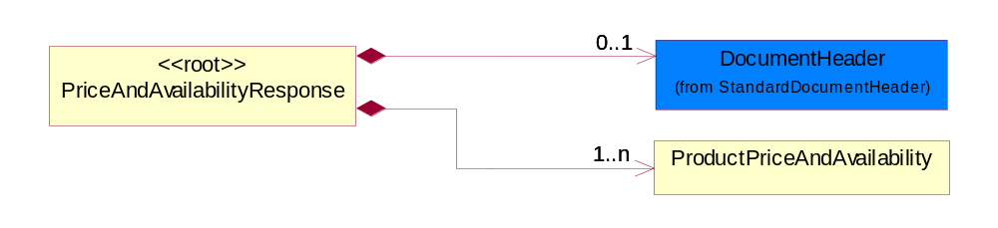
Figure ‎2-9 PriceAndAvailabilityResponse

Composition | Cardinality | Type | Documentation
DocumentHeader | 0..1 | DocumentHeader | The object allows for the identification of the sender and receiver of the business document.
ProductPriceAndAvailability | 1..n | ProductPriceAndAvailability | The collection of data structures for Price And Availability business document.

ProductPriceAndAvailability
The collection of data structures for Price And Availability business document.
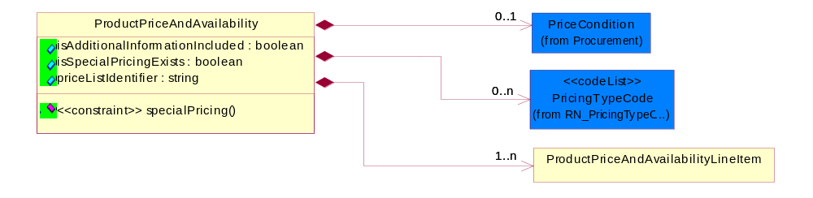
Figure ‎2-10 ProductPriceAndAvailability

Attribute | Type | Documentation
isAdditionalInformationIncluded | boolean | Indicates whether the responding business document has more information in it than what was original requested.
isSpecialPricingExists | boolean | Indicates whether the product has unique pricing associated with it.
priceListIdentifier | string | The unique identifier that references a specific price list used for product pricing.

Composition | Cardinality | Type | Documentation
PriceCondition | 0..1 | PriceCondition | The collection of business properties that define information for special pricing conditions.
PricingTypeCode | 0..n | PricingTypeCode | Code identifying the type of pricing available for a product.
ProductPriceAndAvailabilityLineItem | 1..n | ProductPriceAndAvailabilityLineItem | The collection of business properties that describe a product entry for a product price and availability business document.

Constraint | Documentation
specialPricing | If value of isSpecialPricingExists is equal to "true" then the occurrence of PriceCondition/specialPricingDatePeriod MUST be between 1 and 1.

ProductPriceAndAvailabilityLineItem
The collection of business properties that describe a product entry for a product price and availability business document.
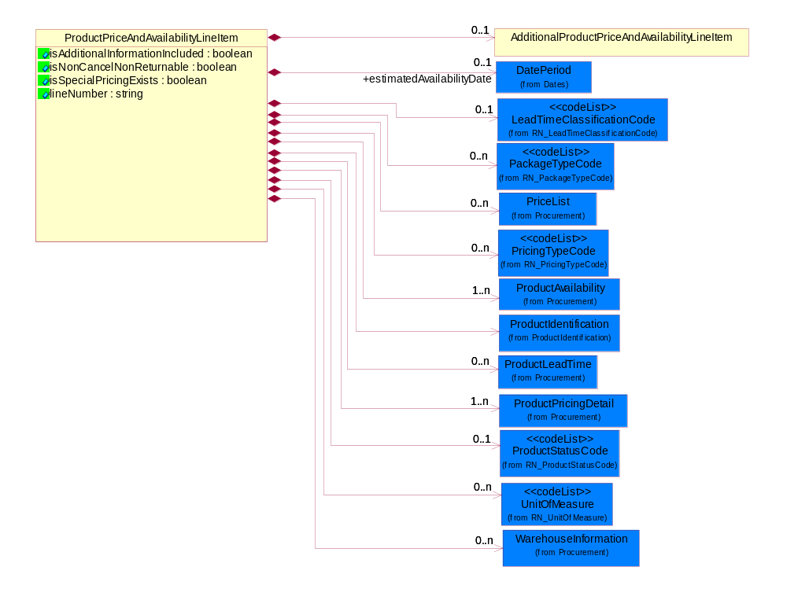
Figure ‎2-11 ProductPriceAndAvailabilityLineItem

Attribute | Type | Documentation
isAdditionalInformationIncluded | boolean | Indicates whether the responding business document has more information in it than what was original requested.
isNonCancelNonReturnable | boolean | Indicates whether the product is non-cancellable / non-returnable, if purchased.
isSpecialPricingExists | boolean | Indicates whether the product has unique pricing associated with it.
lineNumber | string | Number of the line in the document.

Composition | Cardinality | Type | Documentation
AdditionalProductPriceAndAvailabilityLineItem | 0..1 | AdditionalProductPriceAndAvailabilityLineItem | The collection of business properties that describe supplemental information, for a line item, given in a PriceAndAvailabilityResponse document.
estimatedAvailabilityDate | 0..1 | DatePeriod | The estimated date the product will be available.
LeadTimeClassificationCode | 0..1 | LeadTimeClassificationCode | Code identifying the classification of a product lead time for ordering.
PackageTypeCode | 0..n | PackageTypeCode | Code specifying the type of packaging for a product.
PriceList | 0..n | PriceList | The collection of business properties that describe product pricing in a proprietary price list document.
PricingTypeCode | 0..n | PricingTypeCode | Code identifying the type of pricing available for a product.
ProductAvailability | 1..n | ProductAvailability | The collection of business properties that describe a product's time frame for being available to a customer.
ProductIdentification | 1 | ProductIdentification | The object provides the identifier(s) of a product.
ProductLeadTime | 0..n | ProductLeadTime | The collection of business properties that describe lead time information about the product.
ProductPricingDetail | 1..n | ProductPricingDetail | The collection of business properties that describe pricing information about a product.
ProductStatusCode | 0..1 | ProductStatusCode | Code specifying the production status of an item.
UnitOfMeasure | 0..n | UnitOfMeasure | Code identifying a product unit of measure.
WarehouseInformation | 0..n | WarehouseInformation | The collection of business properties that describe warehouse information.

Domain Model

Procurement

Procurement

Dependency Diagram
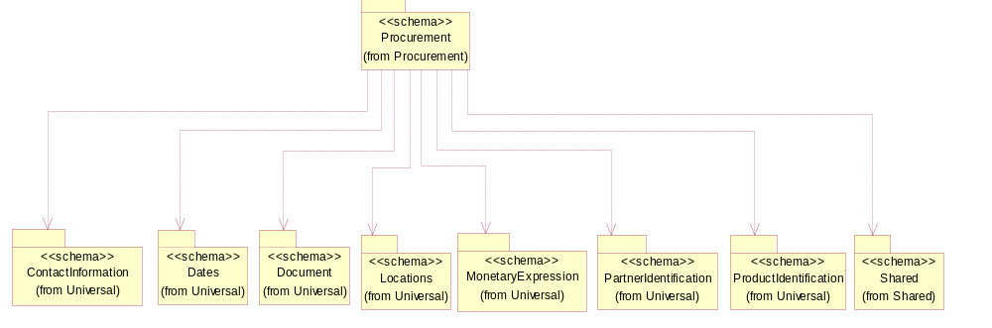
Figure ‎3-12 Dependency

IsCallFactory
An indicator for the receiver to call the manufacturer to obtain current information.
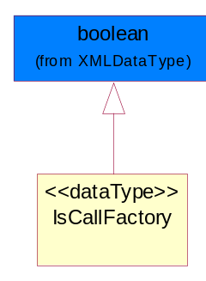
Figure ‎3-13 IsCallFactory

LeadTimeQuantity
The collection of business propeties that describe manufacturing lead time quantity from the time of order placement to the time the product ships.
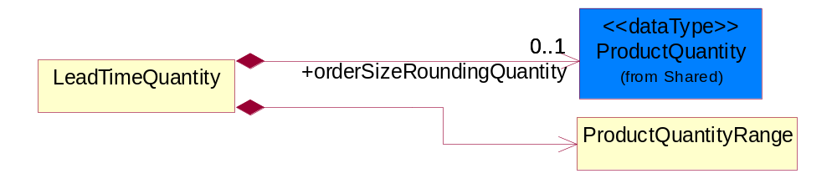
Figure ‎3-14 LeadTimeQuantity

Composition | Cardinality | Type | Documentation
orderSizeRoundingQuantity | 0..1 | ProductQuantity | The quantity of products which is a standard ordering unit. Actual order quantities must be multiples of this quantity and is equal to or smaller than the minimum.
ProductQuantityRange | 1 | ProductQuantityRange | The collection of business properties that describe an upper and lower range of product quantity.

PriceCondition
The collection of business properties that define information for special pricing conditions.
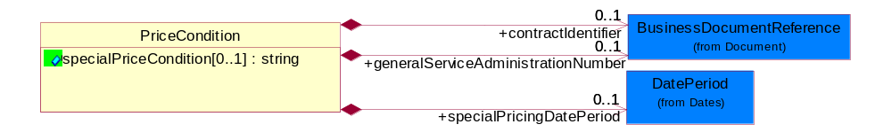
Figure ‎3-15 PriceCondition

Attribute | Type | Documentation
specialPriceCondition[0..1] | string | Textual description that identifies conditions under which special pricing is applicable.

Composition | Cardinality | Type | Documentation
contractIdentifier | 0..1 | BusinessDocumentReference | The unique number that identifies a contract.
generalServiceAdministrationNumber | 0..1 | BusinessDocumentReference | Identifying number relating to a pre-established end-user pricing agreement.
specialPricingDatePeriod | 0..1 | DatePeriod | The date range indicating when a product's special pricing is valid.

PriceList
The collection of business properties that describe product pricing in a proprietary price list document.
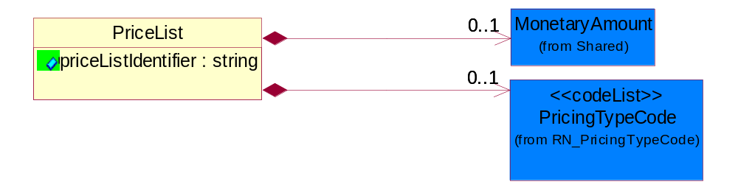
Figure ‎3-16 PriceList

Attribute | Type | Documentation
priceListIdentifier | string | The unique identifier that references a specific price list used for product pricing.

Composition | Cardinality | Type | Documentation
MonetaryAmount | 0..1 | MonetaryAmount | The collection of business properties that describe the monetary amount defined by a specified currency.
PricingTypeCode | 0..1 | PricingTypeCode | Code identifying the type of pricing available for a product.

ProductAvailability
The collection of business properties that describe a product's time frame for being available to a customer.
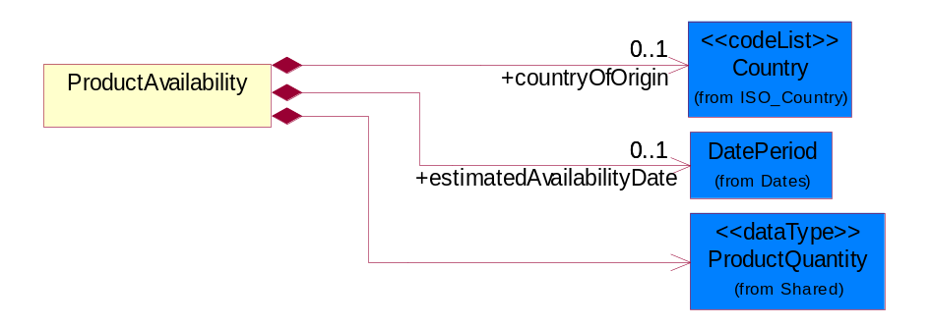
Figure ‎3-17 ProductAvailability

Composition | Cardinality | Type | Documentation
countryOfOrigin | 0..1 | Country | Country where product originates.
estimatedAvailabilityDate | 0..1 | DatePeriod | The estimate date the product will be available.
ProductQuantity | 1 | ProductQuantity | A quantity specifying the number of product units.

ProductLeadTime
The collection of business properties that describe lead time information about the product.
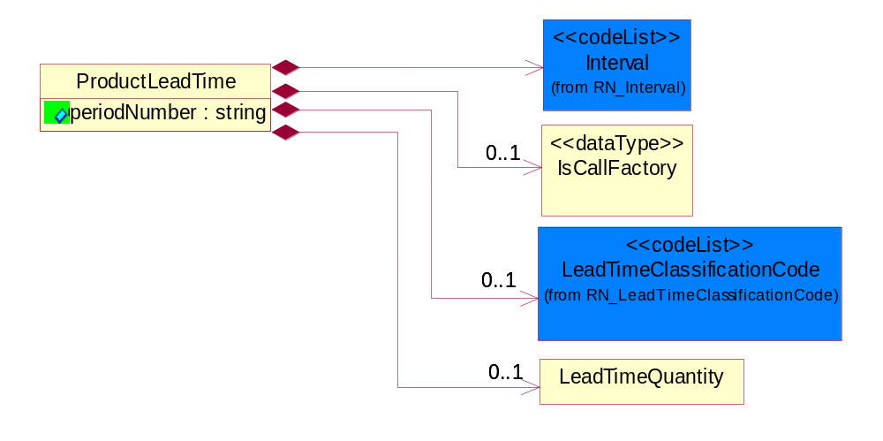
Figure ‎3-18 ProductLeadTime

Attribute | Type | Documentation
periodNumber | string | The number of measurable units in a date/time period.

Composition | Cardinality | Type | Documentation
Interval | 1 | Interval | Code specifying a forecasting interval.
IsCallFactory | 0..1 | IsCallFactory | An indicator for the receiver to call the manufacturer to obtain current information.
LeadTimeClassificationCode | 0..1 | LeadTimeClassificationCode | Code identifying the classification of a product lead time for ordering.
LeadTimeQuantity | 0..1 | LeadTimeQuantity | The collection of business propeties that describe manufacturing lead time quantity from the time of order placement to the time the product ships.

ProductPricingDetail
The collection of business properties that describe pricing information about a product.
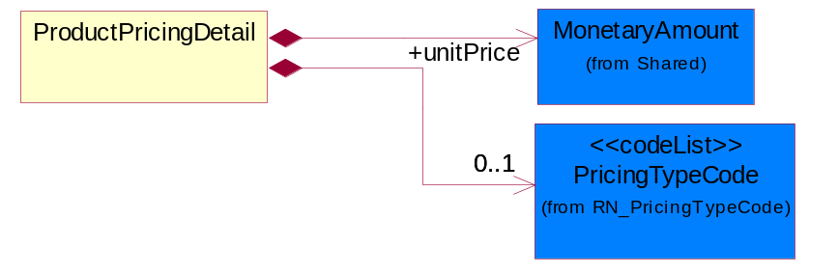
Figure ‎3-19 ProductPricingDetail

Composition | Cardinality | Type | Documentation
unitPrice | 1 | MonetaryAmount | Agreed upon sale price for each unit ordered.
PricingTypeCode | 0..1 | PricingTypeCode | Code identifying the type of pricing available for a product.

ProductQuantityRange
The collection of business properties that describe an upper and lower range of product quantity.
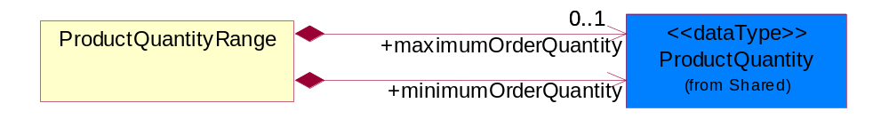
Figure ‎3-20 ProductQuantityRange

Composition | Cardinality | Type | Documentation
maximumOrderQuantity | 0..1 | ProductQuantity | A numeric expression of the maximum number of product line items that may be ordered.
minimumOrderQuantity | 1 | ProductQuantity | A numeric expression of the minimum number of product line items that may be ordered.

StepPricing
The collection of business properties that describe a product's variance in pricing in regards to specified date ranges and quantities.
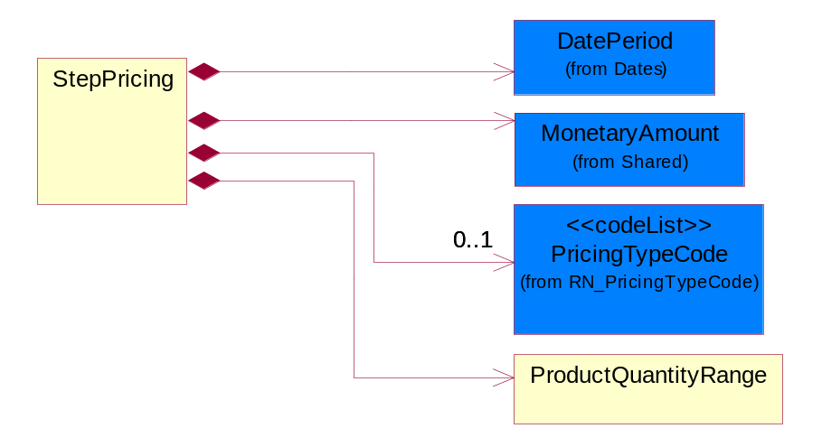
Figure ‎3-21 StepPricing

Composition | Cardinality | Type | Documentation
DatePeriod | 1 | DatePeriod | The business document must allow for the computation or statement of a duration based upon a beginning and an ending date.
MonetaryAmount | 1 | MonetaryAmount | The collection of business properties that describe the monetary amount defined by a specified currency.
PricingTypeCode | 0..1 | PricingTypeCode | Code identifying the type of pricing available for a product.
ProductQuantityRange | 1 | ProductQuantityRange | The collection of business properties that describe an upper and lower range of product quantity.

SubstituteProductReference
The collection of business properties describing a product that is being substituted for a requested product.
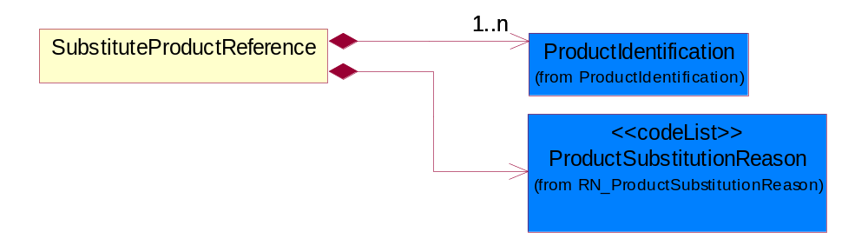
Figure ‎3-22 SubstituteProductReference

Composition | Cardinality | Type | Documentation
ProductIdentification | 1..n | ProductIdentification | The object provides the identifier(s) of a product.
ProductSubstitutionReason | 1 | ProductSubstitutionReason | A code identifying the reason a product is substituted for the original product requested.

WarehouseInformation
The collection of business properties that describe warehouse information.
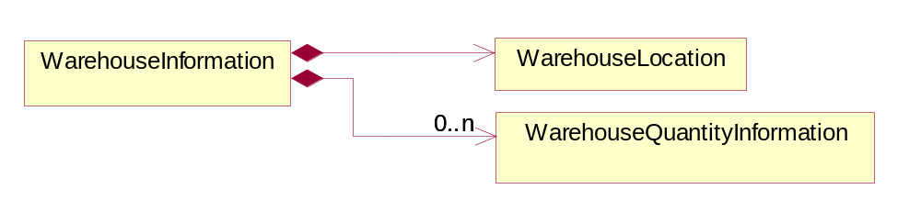
Figure ‎3-23 WarehouseInformation

Composition | Cardinality | Type | Documentation
WarehouseLocation | 1 | WarehouseLocation | The physical address or location identification for a warehouse.
WarehouseQuantityInformation | 0..n | WarehouseQuantityInformation | The collection of business properties that describe the quantity and date that product is available at a warehouse.

WarehouseLocation
The physical address or location identification for a warehouse.
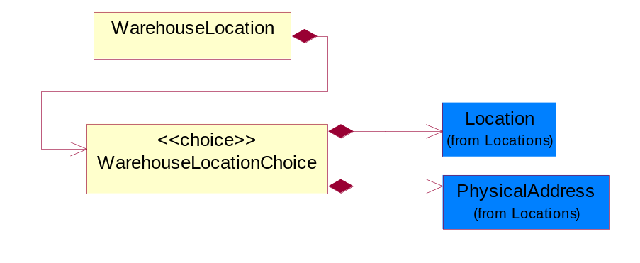
Figure ‎3-24 WarehouseLocation

Composition | Cardinality | Type | Documentation
WarehouseLocationChoice | 1 | WarehouseLocationChoice | Choices of the physical address or location identification for a warehouse.

WarehouseLocationChoice
Choices of the physical address or location identification for a warehouse.

Composition | Cardinality | Type | Documentation
Location | 1 | Location | The business document must specify a location.
PhysicalAddress | 1 | PhysicalAddress | The business document must provide a physical address for a party to the business transaction.

WarehouseQuantityInformation
The collection of business properties that describe the quantity and date that product is available at a warehouse.
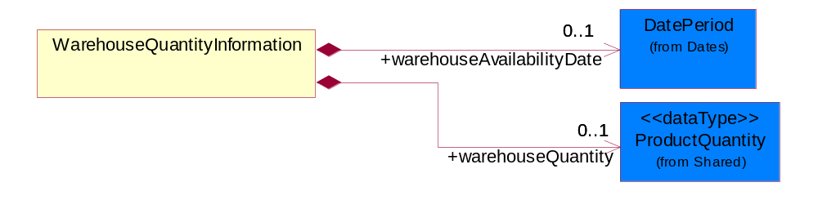
Figure ‎3-25 WarehouseQuantityInformation

Composition | Cardinality | Type | Documentation
warehouseAvailabilityDate | 0..1 | DatePeriod | The date period an item will be available at a particular warehouse.
warehouseQuantity | 0..1 | ProductQuantity | The product quantity associated with a warehouse.

CodeList

ProductSubstitutionReason
A code identifying the reason a product is substituted for the original product requested.

Name | Documentation
BEP | Better Product - The requested part number is currently not available offering product upgrade.
CMP | Component of the identified product is a component of this referenced product.
DWN | Downgrade - The identified product is a downgrade for this referenced product.
IPN | Invalid Part Number - The requested part number is invalid.
PRE | Predecessor - The product that existed prior.
QRH | Quality / Reliability Hold.
REP | Retired product - The requested part number is no longer available.
RPL | Replace - The identified product is a replacement for this referenced product.
SCC | Successor - The superseding product that will be replacing the current product.

LeadTimeClassificationCode
Code identifying the classification of a product lead time for ordering.

Name | Documentation
ASA | As Available - A product marked as "As Available" orders for this product but supply is quite uncertain-normally this has been used when a product is being WDFM (withdraw from marketing) or has reached end of life (EOL).
ASS | Assembly - Time period required by a company production line to manufacture a component or module from sub components. This lead-time may include actual manufacturing cycle time, testing time, and queuing time.
CLF | Call Factory - Contact the factory for the most current information.
DTS | Dock to Stock - Time period required to move product from a product seller's or product receiver's dock through a warehousing process until the product is documented as available for buyer's use. If the seller's dock is identified, this lead-time also includes carrier transit time between seller's dock to buyer's dock.
EOL | End of Life.
INS | Individual Scheduled-a product marked as "Individual Scheduled" by the manufacturing facility. When doing this they will take into consideration the current supply situation / extended leadtime as well as capacity situation for the current product.
MAR | Market - Time period quoted by a seller for the availability of product. This lead time includes actual manufacturing cycle time and existing.
NOS | No Supply - A product marked "No Supply" and will not be able to fulfill orders for this product.
ODP | Order Processing - Time period required by a seller to receive a purchase order and respond with a confirmation to the buyer.
PLA | Planned Availability - A product marked as "Planned Availability" yet available on the market but has been announced with a certain date. Once this date has been passed the product will get a "normal" leadtime.
PRC | Procurement - Time period required by a buyer to process a quote or internal demand signal to issue a purchase order.
PRD | Production.
SUP | Start Up.
TRN | Transit - Time period required to move a product from one location to another.

ProductAvailabilityCode
Code identifying a product's obtainability.

Name | Documentation
FON | Found.
INV | Invalid.
MPF | Multiple Products Found.
NTF | Not Found.

CustomerAuthorizationCode
Code identifying whether a customer is allowed to sell a product.

Name | Documentation
NOL | Not authorized for sale on-line.
NRS | Not authorized for resale.
NSL | Not authorized to sell.
REQ | Authorization required.

Shared

Shared

Dependency Diagram
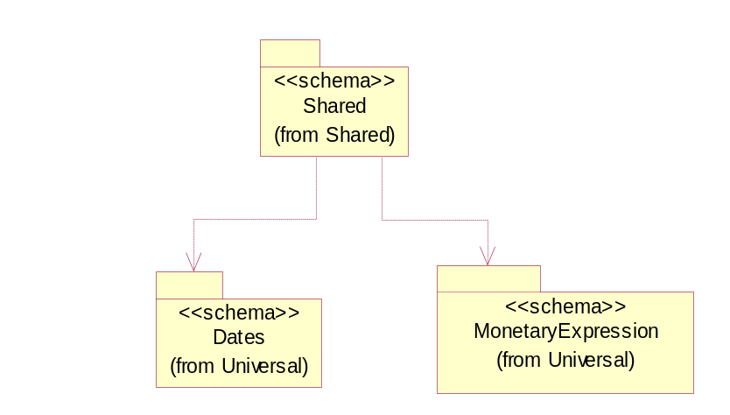
Figure ‎3-26 Dependency

MonetaryAmount
The collection of business properties that describe the monetary amount defined by a specified currency.
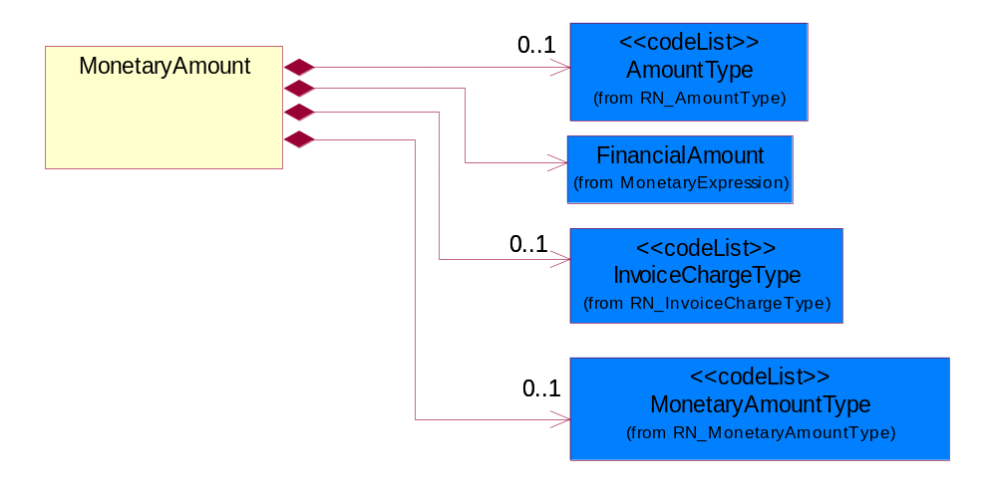
Figure ‎3-27 MonetaryAmount

Composition | Cardinality | Type | Documentation
AmountType | 0..1 | AmountType | Code identifying the type of monetary amount.
FinancialAmount | 1 | FinancialAmount | The business document must express financial amounts.
InvoiceChargeType | 0..1 | InvoiceChargeType | Code identifying the values for the types of charges contained in an invoice.
MonetaryAmountType | 0..1 | MonetaryAmountType | Code identifying whether the monetary amount is a debit or credit.

ProductQuantity
A quantity specifying the number of product units.
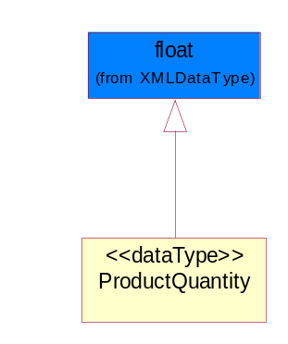
Figure ‎3-28 ProductQuantity

CodeList

InvoiceChargeType
Code identifying the values for the types of charges contained in an invoice.
Name | Documentation
ALC | Allowances and Charges.
CUC | Custom Charges.
DEA | Deposit Amount.
ESC | Expedited Shipping Charge - Charge for accelerating the delivery of a product.
FRC | Freight Charges.
HAC | Handling Charges.
LEC | Lease Charge - Charge for the use of a product in which the purchaser assumes certain responsibilities of ownership.
LIC | License Charge - Charge for the use of a product (usually software) in which the manufacturer maintains ownership of the product.
MAC | Maintenance Charge - Charge (usually periodic) for providing maintenance support for a product.
PUC | Purchase Charge - Charge for a product in which the buyer takes all responsibilities of ownership.
QUD | Quantity Discount.
REC | Rental Charge - Charge for the use of a product (usually hardware) in which the manufacturer maintains ownership of the product.

MonetaryAmountType
Code identifying whether the monetary amount is a debit or credit.
Name | Documentation
CRE | Credit.
DEB | Debit.
ZER | Zero remit.

PackageTypeCode
Code specifying the type of packaging for a product.
Name | Documentation
6PC | 6 Pack-packaged in multiples of 6 units.
BAG | Bag.
BIN | Bin.
BOX | Box.
BPC | Bulk Pack - Packaged in large volume.
BUD | Bundle.
CAN | Can.
CAR | Carrier.
CLD | Cylinder.
CMS | CLAMSHELL - Packaged in a device with two hinged jaws.
COI | Coil.
CON | Container.
CPK | C-PAK - A powerful vacuum unit complete with filter/cyclone and starter placed inside a heavy-duty container; a flexfiber cyclone for coarse separation; or packaged in covered tape.
CRT | Crate.
CTN | Carton.
DRM | Drum.
DSM | Diskette Mailer - A container made of a small plastic magnetic disk enclosed in a stiff envelope with a radial slit; used to store data.
FLC | FLATPK Carrier - Packaged and laid in full length.
GLP | Gel Pack - Packaged in a colloid or semi-solid substance container.
IND | Individual - Each packed separately.
KDB | Knockdown Tote Bin.
KIT | Kit.
OTH | Other - The package type is not contained in this list; contact manufacturer for the specific package type.
PAG | Package.
PAK | Packed.
PAL | Pallet.
PBG | Plastic Ball Grind array.
PJA | Peanut Jar-packaged in a container filled with foam inserts.
PLC | PLC - Plastic Chip Carrier.
REB | Retail Box - Packaged in a container that is for direct sales to the consumer.
REL | Reel.
ROL | Roll.
SAC | Sack.
SDC | Standard Carton - General pack that is commonly used or established as an acceptable media.
SKI | Skid.
SLV | Sleeve.
SSP | Sample Shipper - A portion, piece, or segment that is representative of a whole.
TAP | Tape - Material/Method of holding a string of computer chips.
TBE | Tube - Packaged in a cylinder container.
TBN | Tote Bin.
TNR | Tape and Reel - Used to identify that a product is packaged in a tape and reel form.
TQF | Thin Quad Flat Package.
TRA | Tray - Packaged on a shallow flat receptacle with a raised edge or rim, used for carrying or holding pieces.
TUB | Tub.
WFB | Wafer Boat - A small thin circular slice of a semiconducting material, such as pure silicon, on which an integrated circuit can be formed.
WFP | Waffle Pack- Die that are packaged in a cavity with a defined matrix; typically a 2-inch or 4-inch square carrier with separate compartments for each die.

PricingTypeCode
Code identifying the type of pricing available for a product.
Name | Documentation
ACR | Authorized Cost and Resale.
ACS | Authorized Cost - The negotiated cost agreed upon between the supplier and distributor at the time the “debit?is authorized.
ACT | Authorized cost.
ANY | Any available.
ARS | Authorized resale.
ASP | Average Selling Price - Manufacturer's published price.
BPA | Budgetary Price Amount.
BPP | Broken Purchase Price.
BSH | Book-Ship.
CAT | Catalog price - Book (the supplier’s published cost at the time of transaction) or Published Price.
CMC | Commercial.
CMD | Commodity.
CMF | Contract Manufacturing.
CON | Contract.
COS | Cost - Price for which the distributor purchased the parts.
DBC | Disti Book Cost.
DFR | Duty free.
DIS | Distribution.
DPD | Duty paid.
DTP | Distribution price.
EDU | Education.
ERT | E-Rate.
EXC | Exception.
FGM | Federal government.
GEN | General.
HIE | Higher Education.
LCL | Local.
LGM | Local government.
LIS | List.
MPR | Market price.
MRP | Manufacturer's recommendation for unit pricing.
MSR | Manufacturer Suggested Retail Price (MSRP).
MUS | Minimum Unit Sale (MUS) - Manufacturer requirement of total dollar value for design opportunity.
NPF | Nonprofit.
OEM | Original Equipment Manufacturing (OEM).
OVP | OEM Volume Pricing - Original equipment manufacturing price per volume ordered.
PED | Primary Education.
QUO | Quote Price
RCS | Requested Cost (RCS) - Reseller requested cost to the manufacturer.
RFB | Refurbished.
RIN | Religious Institution.
RSP | Resale - Price the distributor is authorized to use for sale to their customer (RSP).
SCE | Special Education.
SEC | Security and management reseller.
SED | Secondary Education.
SEV | Service provider.
SGM | State Government.
SPD | Special Discount Price.
SPE | Special Education.
SPL | Samples.
SRP | Suggested Resale Price.
STR | Standard Rebate.
THP | Threshold Price.
TOC | Total Other Charges - Suggested resale price - The sum total of all distributor added charges to the customer for value added services, including but not limited to programming, tape and reel, labeling, date coding, kitting and in-house assembly.

ProductStatusCode
Code specifying the production status of an item.
Name | Documentation
ACT | Active.
ALO | The quantity available to buyer.
BOR | Back Ordered.
DCN | Discontinued. No longer available.
NPR | New Product.
POS | Purchase Order with Supplier.
REP | Replaced.

Interval
Code specifying a forecasting interval.
Name | Documentation
1WM | 1st week of the month.
2WM | 2nd week of the month.
3WM | 3rd week of the month.
4WM | 4th week of the month.
5DW | 5 day work week-Monday through Friday.
5WM | 5th week of the month.
CAD | Calendar day-period given as a number of days including weekends and holidays.
CAW | Calendar week-period given as a number of 7 day-weeks including holidays.
DAY | Day.
FMP | Four month period.
FRI | Friday.
HFM | Half month.
HFW | Half week.
HFY | Half year.
HOU | Hour.
IND | Indefinite-an indefinite period.
MIN | Minute.
MOD | Monday.
MON | Month.
MTF | Monday through Friday.
MTS | Monday through Saturday.
MTU | Monday through Sunday.
QUA | Quarter.
SAT | Saturday.
SUN | Sunday.
TDP | Ten days period-period of 10 days.
THU | Thursday.
TMP | Two month period.
TUE | Tuesday.
TWP | Two week period.
UNS | Unspecified.
WDY | Work day.
WED | Wednesday.
WEE | Week.
WOR | Working days - days when the partner company normally works.
YEA | Year.

AmountType
Code identifying the type of monetary amount.
Name | Documentation
DIS | Discount Value - The monetary amount of the discount on the price applied to a customer order.
FRE | Freight Charges - The monetary amount to be paid for freight transportation.
INS | InsuranceCharges - The monetary amount to be paid for freight insurance.
MAT | Material Cost - This object represents the material cost for the product.
MIS | Miscellaneous Charges - The monetary amount to be paid for miscellaneous charges.
PRC | Processing Charges - The monetary amount to be paid by consignee for consignment manufacturer.
TOD | Total Amount Due - Total amount due upon receipt of statement.
TOT | Total Amount - Total price for an entire business document.
TOV | Total Value Added Amount - The total amount of the shipment including any value added tax.
UNI | Unit Price - Agreed upon sale price for each unit ordered.
VAD | Value Added Unit Price - The price of a unit including any value added tax.

Universal Structure

ContactInformation

ContactInformation
The business document must allow for the identification of the name of the department, service or individual to be contacted regarding the context of the business document.
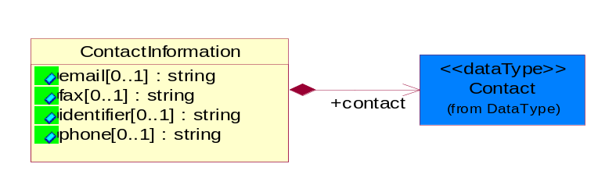
Figure ‎4-29 ContactInformation

Attribute | Type | Documentation
email[0..1] | string | The electronic mail for the specified contact.
fax[0..1] | string | The fax number for the specified contact.
identifier[0..1] | string | Identifies the role of the contact (i.e. Service Technician, Account Manager) in the Business Process.
phone[0..1] | string | The telephone number for the specified contact.

Composition | Cardinality | Type | Documentation
contact | 1 | Contact | The name of the department, service or individual to be contacted within the organization.

DataType

Contact
The name of the department, service or individual to be contacted within the organization.
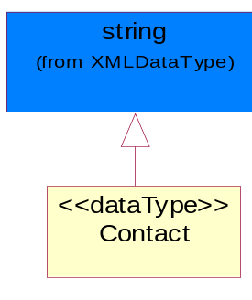
Figure ‎4-30 Contact

DUNS
A number assigned by Dun and Bradstreet to identify a business location.
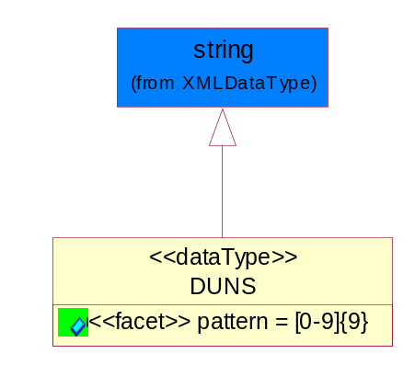
Figure ‎4-31 DUNS

Attribute | Type | Documentation
pattern |  | [0-9]{9}

DUNSPlus4
A identifier to specify a specific location within a business location.
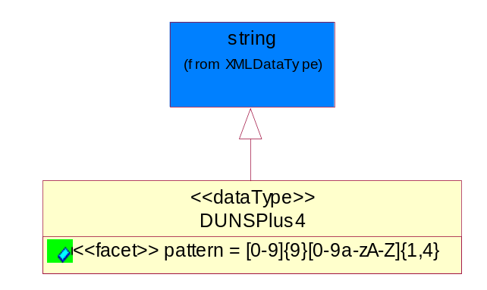
Figure ‎4-32 DUNSPlus4

Attribute | Type | Documentation
pattern |  | Data Universal Numbering System +4 (DUNS+4) number means the DUNS number assigned by Dun and Bradstreet, Inc. (D&B) plus an alphanumeric of length 4 suffix that may be assigned by a business concern.

GLN
Global Location Number (GLN) - A identifier to identify legal entities, trading parties and location.
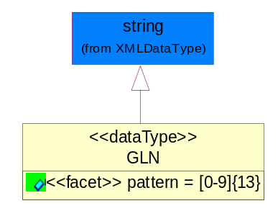
Figure ‎4-33 GLN

Attribute | Type | Documentation
pattern |  | [0-9]{13}

GTIN
Global Trade Identification Number (GTIN).
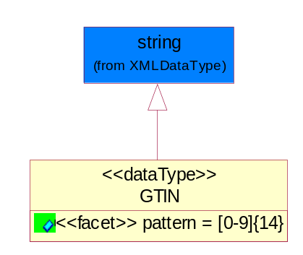
Figure ‎4-34 GTIN

Attribute | Type | Documentation
pattern |  | [0-9]{14}

Dates

DatePeriod
The business document must allow for the computation or statement of a duration based upon a beginning and an ending date.

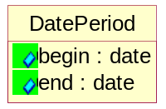
Figure ‎4-35 DatePeriod

Attribute | Type | Documentation
begin | date | The date indicating the beginning of the date period.
end | date | The date indicating the ending of the date period.

Document

BusinessDocumentReference
The business document reference object allows for the indirect referencing of a relationship to other business related documents.
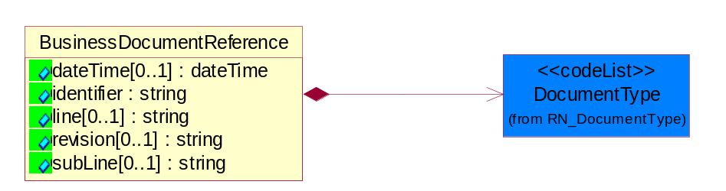
Figure ‎4-36 BusinessDocumentReference

Attribute | Type | Documentation
dateTime[0..1] | dateTime | The date-time stamp indicating on the referenced business document.
identifier | string | Unique identification of the referenced business document.
line[0..1] | string | References the specific line number of the specified business document.
revision[0..1] | string | Referenced the revision of the specified business document.
subLine[0..1] | string | References the specific subline number of the specified business document.

Composition | Cardinality | Type | Documentation
DocumentType | 1 | DocumentType | A code identifying the business context of a document.

Locations

AlternativeIdentifier
Identifies the specified code and the name of the organization that a code is utilized from.
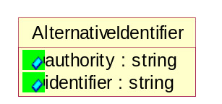
Figure ‎4-37 AlternativeIdentifier

Attribute | Type | Documentation
authority | string | The name of the organization that a code is utilized from.
identifier | string | The specified code to represent an entity (e.g. product, location, partner, etc.).

Location
The business document must specify a location.
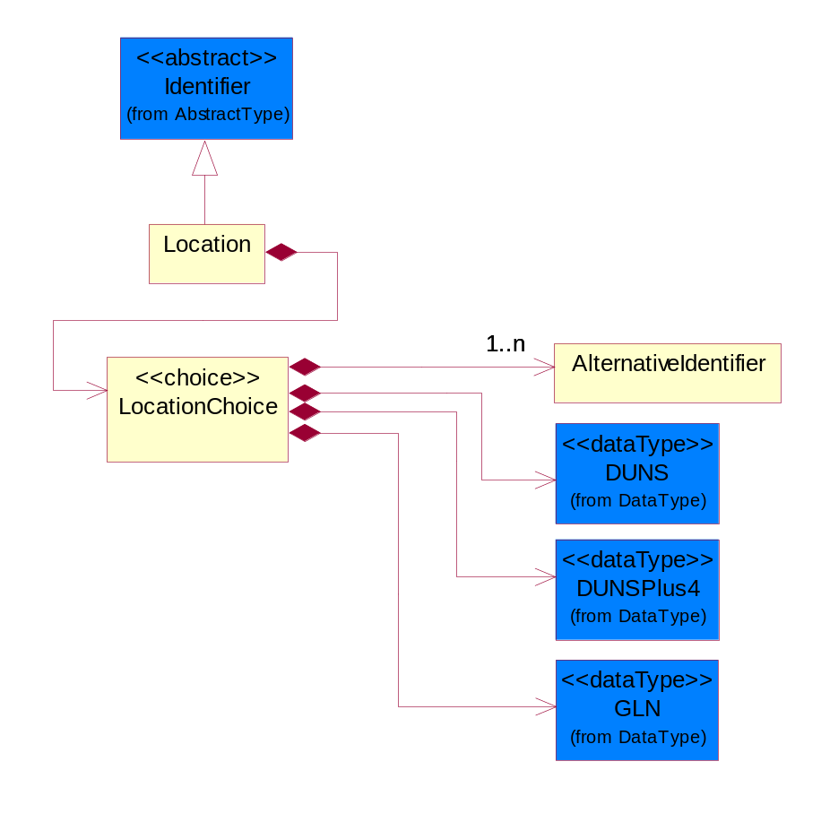
Figure ‎4-38 Location

Composition | Cardinality | Type | Documentation
LocationChoice | 1 | LocationChoice

LocationChoice
Composition | Cardinality | Type | Documentation
AlternativeIdentifier | 1..n | AlternativeIdentifier | Identifies the specified code and the name of the organization that a code is utilized from.
DUNS | 1 | DUNS | A number assigned by Dun and Bradstreet to identify a business location.
DUNSPlus4 | 1 | DUNSPlus4 | A identifier to specify a specific location within a business location.
GLN | 1 | GLN | Global Location Number (GLN) - A identifier to identify legal entities, trading parties and location.

PhysicalAddress
The business document must provide a physical address for a party to the business transaction.
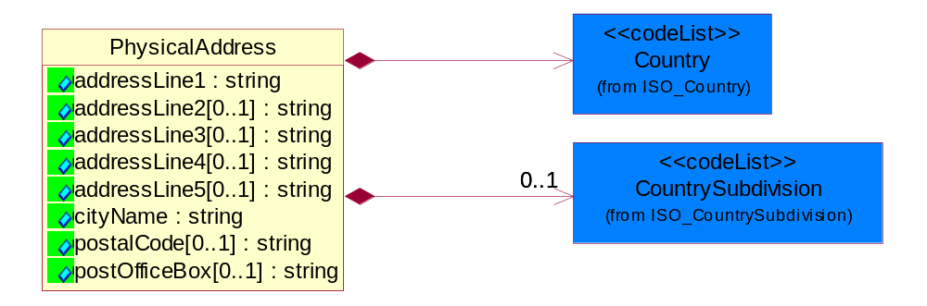
Figure ‎4-39 PhysicalAddress

Attribute | Type | Documentation
addressLine1 | string | The first line of a physical address.
addressLine2[0..1] | string | The second line of a physical address.
addressLine3[0..1] | string | The third line of a physical address.
addressLine4[0..1] | string | The fourth line of a physical address.
addressLine5[0..1] | string | The fifth line of a physical address.
cityName | string | The name of a city.
postalCode[0..1] | string | Identifying geographic location as specified by a national postal code.
postOfficeBox[0..1] | string | The Post Office Box identifier used to identify a party's post office box.

Composition | Cardinality | Type | Documentation
Country | 1 | Country | For representation of Country name RosettaNet has adopted ISO 3166-3; 1999. Refer to the following web page to get the latest version of the standard:  http://www.iso.ch/iso/en/prods-services/iso3166ma/02iso-3166-code-lists/index.html  If you need more information about the ISO standard please contact ISO for more details.
CountrySubdivision | 0..1 | CountrySubdivision | For representation of a Countries subdivisions RosettaNet has adopted ISO 3166-3; 1999. Refer to the following web page to get the latest version of the standard:  http://www.iso.ch/iso/en/prods-services/iso3166ma/02iso-3166-code-lists/index.html  If you need more information about the ISO standard please contact ISO for more details.

MonetaryExpression

FinancialAmount
The business document must express financial amounts.
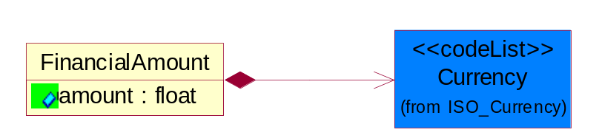
Figure ‎4-40 FinancialAmount

Attribute | Type | Documentation
amount | float | Specifies the monetary amount.

Composition | Cardinality | Type | Documentation
Currency | 1 | Currency | For representation of Currency codes RosettaNet has adopted ISO 4217; 1995. The British Standards Institution (BSI) is the ISO 4217 Maintenance Agency. Refer to the following web page to get the latest version of the standard:  http://www.bsi-global.com/Technical+Information/Publications/_Publications/tig90.xalter  If you need more information about the ISO standard please contact ISO for more details.

PartnerIdentification

FullPartner
The business document must describe the trading partners in the business transaction. This data structure provide the flexibility to describe a partner in all possible methods as for new, existing or known partner.
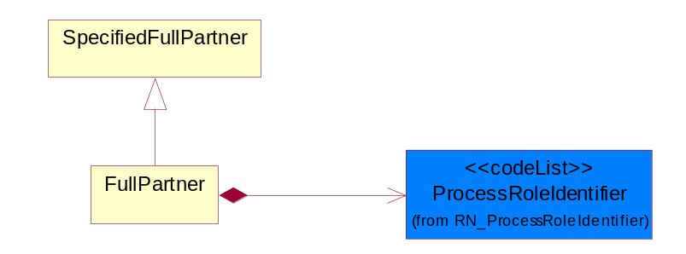
Figure ‎4-41 FullPartner

Composition | Cardinality | Type | Documentation
ProcessRoleIdentifier | 1 | ProcessRoleIdentifier | Describes the role of the partner in the business process. A partner will fulfill at least one or more roles during the business process.

IntermittentPartner
The business document must describe a physical address for a delivery.
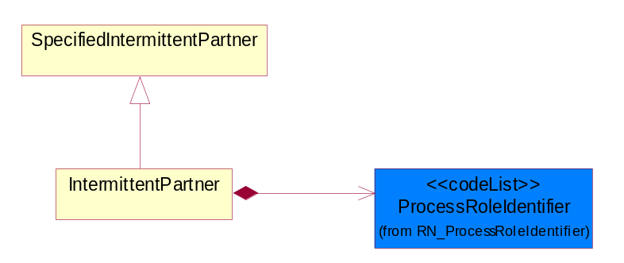
Figure ‎4-42 IntermittentPartner

Composition | Cardinality | Type | Documentation
ProcessRoleIdentifier | 1 | ProcessRoleIdentifier | Describes the role of the partner in the business process. A partner will fulfill at least one or more roles during the business process.

KnownPartner
The business document must describe the trading partners in the business transaction.
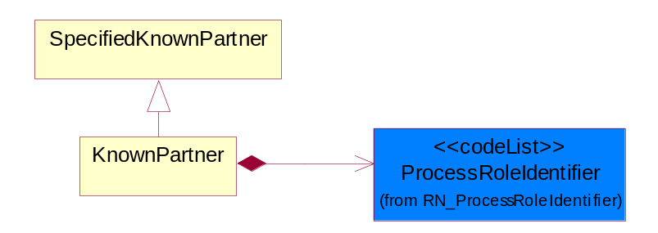
Figure ‎4-43 KnownPartner

Composition | Cardinality | Type | Documentation
ProcessRoleIdentifier | 1 | ProcessRoleIdentifier | Describes the role of the partner in the business process. A partner will fulfill at least one or more roles during the business process.

KnownPartnerContact
The business document must describe the trading partners in the business transaction.
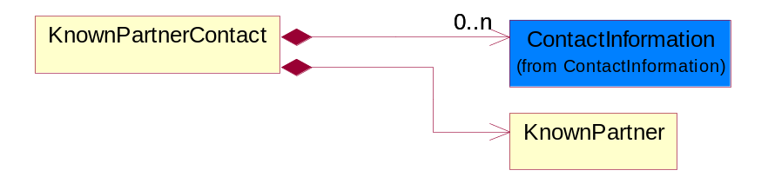
Figure ‎4-44 KnownPartnerContact

Composition | Cardinality | Type | Documentation
ContactInformation | 0..n | ContactInformation | The business document must allow for the identification of the name of the department, service or individual to be contacted regarding the context of the business document.
KnownPartner | 1 | KnownPartner | The business document must describe the trading partners in the business transaction.

NewPartner
The business document must describe a new, existing (but known to only one of the parties to the transaction) or an unknown party to the business transaction.
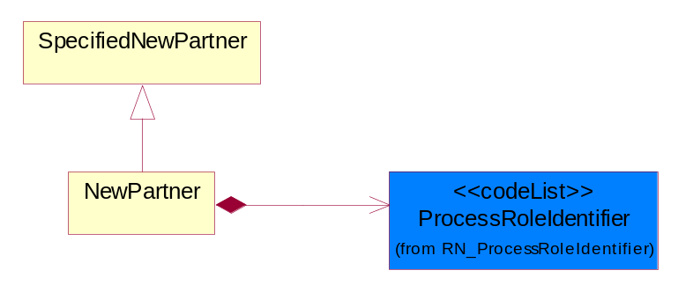
Figure ‎4-45 NewPartner

Composition | Cardinality | Type | Documentation
ProcessRoleIdentifier | 1 | ProcessRoleIdentifier | Describes the role of the partner in the business process. A partner will fulfill at least one or more roles during the business process.

PartnerDescription
The collection of business properties that describe a business partners' identity, their contact information, where they are physically located and their function in a supply chain.
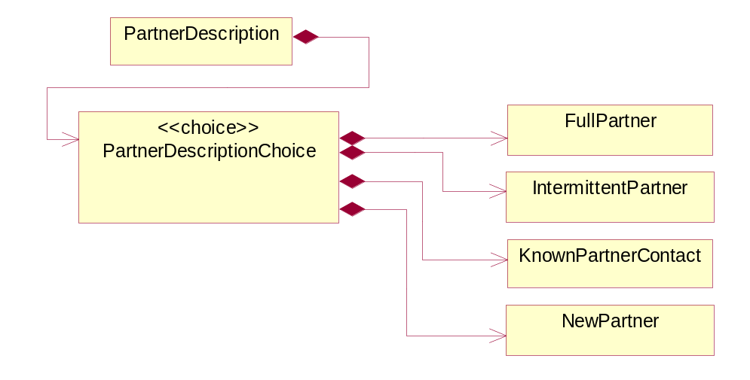
Figure ‎4-46 PartnerDescription

Composition | Cardinality | Type | Documentation
PartnerDescriptionChoice | 1 | PartnerDescriptionChoice

PartnerDescriptionChoice
Composition | Cardinality | Type | Documentation
FullPartner | 1 | FullPartner | The business document must describe the trading partners in the business transaction. This data structure provide the flexibility to describe a partner in all possible methods as for new, existing or known partner.
IntermittentPartner | 1 | IntermittentPartner | The business document must describe a physical address for a delivery.
KnownPartnerContact | 1 | KnownPartnerContact | The business document must describe the trading partners in the business transaction.
NewPartner | 1 | NewPartner | The business document must describe a new, existing (but known to only one of the parties to the transaction) or an unknown party to the business transaction.

PartnerIdentification
The business document must allow for the identity of one or more parties to the transaction.
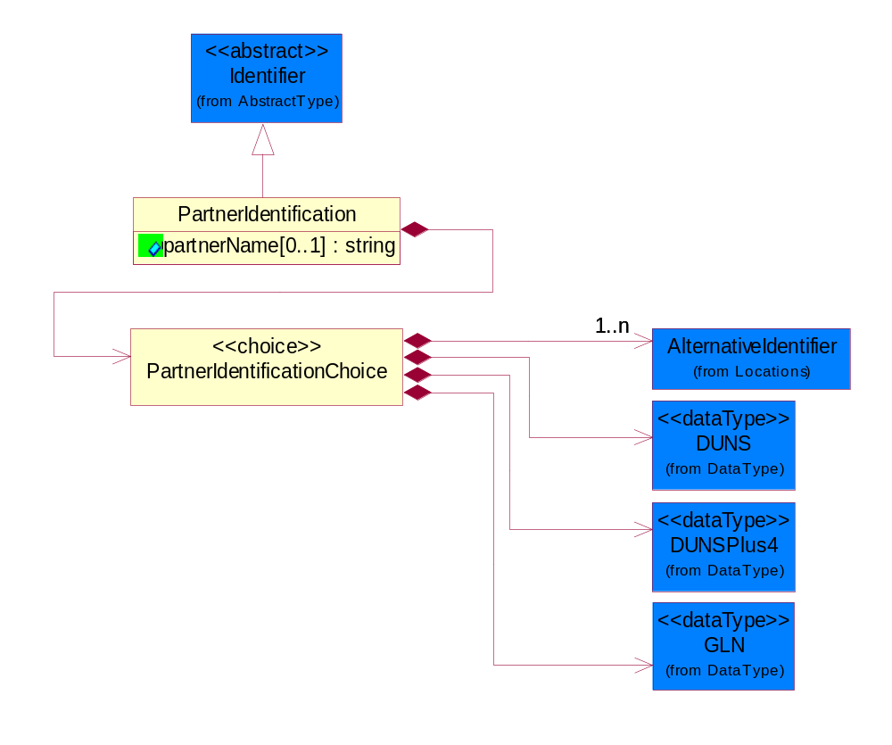
Figure ‎4-47 PartnerIdentification

Attribute | Type | Documentation
partnerName[0..1] | string | The name of the partner’s company/business.

Composition | Cardinality | Type | Documentation
PartnerIdentificationChoice | 1 | PartnerIdentificationChoice

PartnerIdentificationChoice
Composition | Cardinality | Type | Documentation
AlternativeIdentifier | 1..n | AlternativeIdentifier | Identifies the specified code and the name of the organization that a code is utilized from.
DUNS | 1 | DUNS | A number assigned by Dun and Bradstreet to identify a business location.
DUNSPlus4 | 1 | DUNSPlus4 | A identifier to specify a specific location within a business location.
GLN | 1 | GLN | Global Location Number (GLN) - A identifier to identify legal entities, trading parties and location.

SpecifiedFullPartner
The business document must describe the trading partners in the business transaction. This data structure provide the flexibility to describe a partner in all possible methods as for new, existing or known partner. This is specifically for partner who role has been specified.
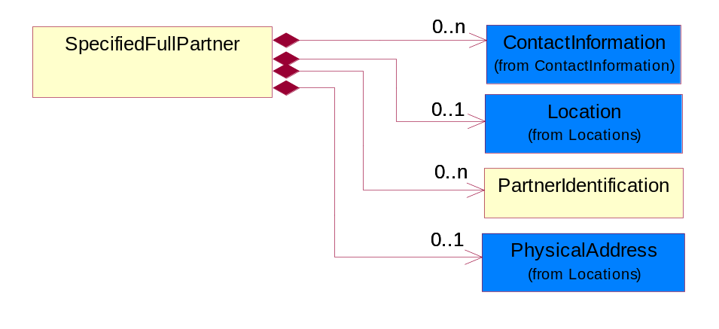
Figure ‎4-48 SpecifiedFullPartner

Composition | Cardinality | Type | Documentation
ContactInformation | 0..n | ContactInformation | The business document must allow for the identification of the name of the department, service or individual to be contacted regarding the context of the business document.
Location | 0..1 | Location | The business document must specify a location.
PartnerIdentification | 0..n | PartnerIdentification | The business document must allow for the identity of one or more parties to the transaction.
PhysicalAddress | 0..1 | PhysicalAddress | The business document must provide a physical address for a party to the business transaction.

SpecifiedIntermittentPartner
The business document must describe a physical address for a delivery.
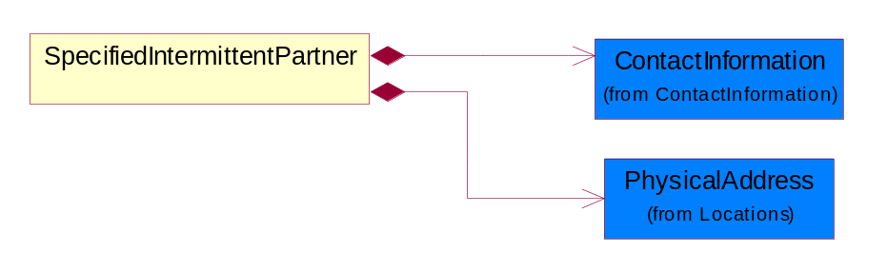
Figure ‎4-49 SpecifiedIntermittentPartner

Composition | Cardinality | Type | Documentation
ContactInformation | 1 | ContactInformation | The business document must allow for the identification of the name of the department, service or individual to be contacted regarding the context of the business document.
PhysicalAddress | 1 | PhysicalAddress | The business document must provide a physical address for a party to the business transaction.

SpecifiedKnownPartner
The business document must describe the trading partners in the business transaction.
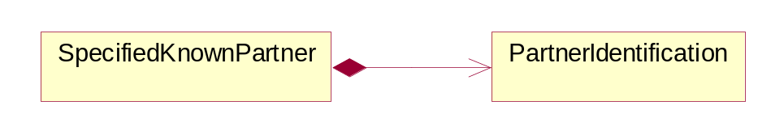
Figure ‎4-50 SpecifiedKnownPartner

Composition | Cardinality | Type | Documentation
PartnerIdentification | 1 | PartnerIdentification | The business document must allow for the identity of one or more parties to the transaction.

SpecifiedNewPartner
The business document must describe a new, existing (but known to only one of the parties to the transaction) or an unknown party to the business transaction.
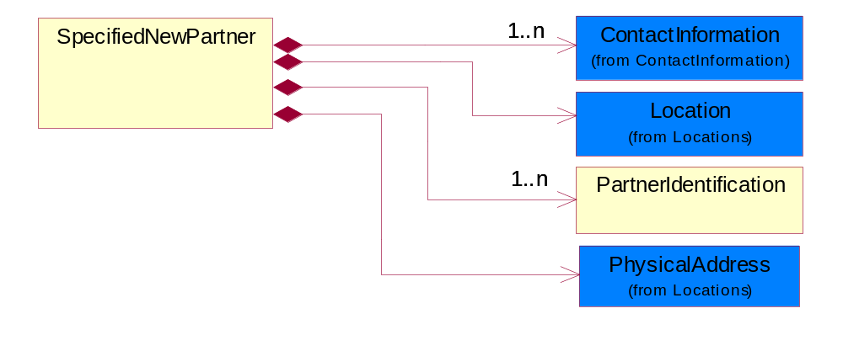
Figure ‎4-51 SpecifiedNewPartner

Composition | Cardinality | Type | Documentation
ContactInformation | 1..n | ContactInformation | The business document must allow for the identification of the name of the department, service or individual to be contacted regarding the context of the business document.
Location | 1 | Location | The business document must specify a location.
PartnerIdentification | 1..n | PartnerIdentification | The business document must allow for the identity of one or more parties to the transaction.
PhysicalAddress | 1 | PhysicalAddress | The business document must provide a physical address for a party to the business transaction.

ProductIdentification

ProductIdentification
The object provides the identifier(s) of a product.
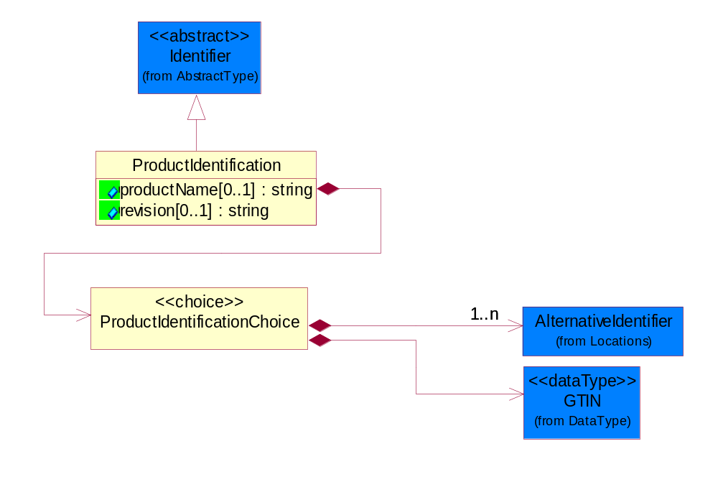
Figure ‎4-52 ProductIdentification

Attribute | Type | Documentation
productName[0..1] | string | The name of the product.
revision[0..1] | string | Referenced the specified product revision.

Composition | Cardinality | Type | Documentation
ProductIdentificationChoice | 1 | ProductIdentificationChoice

ProductIdentificationChoice
Composition | Cardinality | Type | Documentation
AlternativeIdentifier | 1..n | AlternativeIdentifier | Identifies the specified code and the name of the organization that a code is utilized from.
GTIN | 1 | GTIN | Global Trade Identification Number (GTIN).

CodeList

Country
For representation of Country name RosettaNet has adopted ISO 3166-3; 1999. Refer to the following web page to get the latest version of the standard:
http://www.iso.ch/iso/en/prods-services/iso3166ma/02iso-3166-code-lists/index.html

If you need more information about the ISO standard please contact ISO for more details.

CountrySubdivision
For representation of a Countries subdivisions RosettaNet has adopted ISO 3166-3; 1999. Refer to the following web page to get the latest version of the standard:
http://www.iso.ch/iso/en/prods-services/iso3166ma/02iso-3166-code-lists/index.html

If you need more information about the ISO standard please contact ISO for more details.

Currency
For representation of Currency codes RosettaNet has adopted ISO 4217; 1995. The British Standards Institution (BSI) is the ISO 4217 Maintenance Agency. Refer to the following web page to get the latest version of the standard:
http://www.bsi-global.com/Technical+Information/Publications/_Publications/tig90.xalter

If you need more information about the ISO standard please contact ISO for more details.

Language
For representation of Language name RosettaNet has adopted ISO 639-2; 1998. Refer to the following web page to get the latest version of the standard:

http://www.loc.gov/standards/iso639-2/iso639jac.html

If you need more information about the ISO standard please contact ISO for more details.

DocumentType
A code identifying the business context of a document.

Instance | Documentation
ARA | Authorization Request Approval.
CBN | Product batch number of customer.
CCN | Customs clearance number.
CFA | Failure Analysis - Request document that will accompany the product providing characteristics of the component failure.
CIN | Commercial Invoice.
CNM | Traditional credit note or memo.
CON | In a virtual sourcing relationship, a third party trading partner is supplying a part to a customer on behalf of another company that has taken the order for the customer. In this case a Customer Order Number is associated to the request for material that is sent to the virtual trading partners.
COS | Consumption Notice.
COT | Contract.
CRN | Unique consumption reference number identifying the product consumption issue i.e. one-to-one relationship with physical flow.
DEM | Traditional debit note or memo.
DEN | Delivery Note.
DIN | Discontinuation Notice.
DOR | Delivery Order.
DRN | Drawing Number.
DRR | Design Registration Request.
ECO | Engineering Change Order - The proprietary unique identification number that represents an engineering change order.
EIR | Engineering Information Request.
EOL | End of Life.
FUO | Sales order or transfer order fulfilling demand out of a facility (outbound shipment).
INV | Invoice.
LID | Location Identifier. Data for on-site work that have to be done on the machine (associated with preventive maintenance order).
MEN | Master Event Number.
MID | Machine Identifier. Data for on-site work that have to be done on the machine (associated with preventive maintenance order).
MON | Model Number.
OCL | The unique identifier assigned by the OEM for a warranty claim.
OGA | Other governmental agency issued document.
OPO | The unique identifier assigned by the OEM for a part order.
OPR | The unique identifier assigned by the OEM for a part return.
PCN | Product/Process Change.
PFA | Failure Analysis - Request document that will accompany the product providing characteristics of the product failure.
PII | Refers to previously issued invoice.
PLS | Unique number that identifies packing form prior to shipment.
POI | Purchase Order IN.
PON | Production order number for material release.
POO | Purchase Order OUT.
PRC | Product Catalog.
PSI | Refers to previously issued self-billing invoice.
PUO | Purchase Order.
QUO | Quote.
REC | Document identifying the receipt of materials or products into a facility against a purchase order or transfer order (inbound shipment).
REO | Purchase order or transfer order replenishing inventory into a facility (inbound shipment).
REQ | Requisition.
RMA | Returned Material Authorization.
RPO | Purchase order for materials or product returned to and reworked by a supplier.
RTA | Remittance Advice - Remittance details.
SAO | Sales Order.
SBC | Credit Memo used in self-billing scenario.
SBD | Debit Memo used in self-billing scenario.
SBI | Invoice in self billing scenario.
SBN | Product batch number of supplier.
SCA | Similar to contracts - Contains the quantity of an article that is to be ordered from a vendor and the price for article or service that is to be procured.
SEN | Serial Number.
SEO | A document that gives a repair provider the necessary authorization to repair or upgrade a product either at the customer site or at the repair provider’s site.
SHD | Shipping Document.
SNC | Shipset Number on Code List.
SPC | The unique identifier assigned by the ASP for a warranty claim.
SPN | Spec Number.
SPO | The unique identifier assigned by the ASP for a part order.
SPR | The unique identifier assigned by the ASP for a part return.
SPW | The unique identifier assigned by the ASP to reference a work order.
SRI | A document that contains the shipping reference number which allows the product to be tracked within the outsourced logistic providers network.
TRO | Order which results in materials or products being moved from one facility to another (outbound shipment and inbound shipment).
WAB | Waybill.
WAC | Denotes a warranty claim.
WOO | Work Order.

MimeTypeQualifier
The MIME type as defined by IANA.

Please refer to http://www.iana.org/assignments/media-types/ for a list of types.

Instance | Documentation
application/activemessage | [Shapiro]
application/andrew-inset | [Borenstein]
application/applefile | [Faltstrom]
application/atomicmail | [Borenstein]
application/batch-SMTP | [RFC2442]
application/beep+xml | [RFC3080]
application/cals-1840 | [RFC1895]
application/cnrp+xml | [RFCCNRP]
application/commonground | [Glazer]
application/cpl+xml
application/cybercash | [Eastlake]
application/dca-rft | [Campbell]
application/dec-dx | [Campbell]
application/dicom | [RFC3240]
application/dvcs | [RFC3029]
application/EDI-Consent | [RFC1767]
application/EDIFACT | [RFC1767]
application/EDI-X12 | [RFC1767]
application/eshop | [Katz]
application/font-tdpfr | [RFC3073]
application/http | [RFC2616]
application/hyperstudio | [Domino]
application/iges | [Parks]
application/index | [RFC2652]
application/index.cmd | [RFC2652]
application/index.obj | [RFC2652]
application/index.response | [RFC2652]
application/index.vnd | [RFC2652]
application/iotp | [RFC2935]
application/ipp | [RFC2910]
application/isup | [RFC3204]
application/mac-binhex40 | [Faltstrom]
application/macwriteii | [Lindner]
application/marc | [RFC2220]
application/mathematica | [Van Nostern]
application/msword | [Lindner]
application/news-message-id | [RFC1036,Spencer]
application/news-transmission | [RFC1036, Spencer]
application/ocsp-request | [RFC2560]
application/ocsp-response | [RFC2560]
application/octet-stream | [RFC2045,RFC2046]
application/oda | [RFC2045,RFC2046]
application/ogg | [RFC-walleij-ogg-mediatype-08.txt]
application/parityfec | [RFC3009]
application/pdf | [Lindner]
application/pgp-encrypted | [RFC3156]
application/pgp-keys | [RFC3156]
application/pgp-signature | [RFC3156]
application/pkcs10 | [RFC2311]
application/pkcs7-mime | [RFC2311]
application/pkcs7-signature | [RFC2311]
application/pkix-cert | [RFC2585]
application/pkixcmp | [RFC2510]
application/pkix-crl | [RFC2585]
application/postscript | [RFC2045,RFC2046]
application/prs.alvestrand.titrax-sheet | [Alvestrand]
application/prs.cww | [Rungchavalnont]
application/prs.nprend | [Doggett]
application/prs.plucker | [Janssen]
application/qsig | [RFC3204]
application/reginfo+xml | [RFC-ietf-sipping-reg-event-00.txt]
application/remote-printing | [RFC1486,Rose]
application/riscos | [Smith]
application/rtf | [Lindner]
application/sdp | [RFC2327]
application/set-payment | [Korver]
application/set-payment-initiation | [Korver]
application/set-registration | [Korver]
application/set-registration-initiation | [Korver]
application/sgml | [RFC1874]
application/sgml-open-catalog | [Grosso]
application/sieve | [RFC3028]
application/slate | [Crowley]
application/timestamp-query | [RFC3161]
application/timestamp-reply | [RFC3161]
application/tve-trigger | [Welsh]
application/vemmi | [RFC2122]
application/vnd.3gpp.pic-bw-large | [Meredith]
application/vnd.3gpp.pic-bw-small | [Meredith]
application/vnd.3gpp.pic-bw-var | [Meredith]
application/vnd.3gpp.sms | [Meredith]
application/vnd.3M.Post-it-Notes | [O'Brien]
application/vnd.accpac.simply.aso | [Leow]
application/vnd.accpac.simply.imp | [Leow]
application/vnd.acucobol | [Lubin]
application/vnd.acucorp | [Lubin]
application/vnd.adobe.xfdf | [Perelman]
application/vnd.aether.imp | [Moskowitz]
application/vnd.amiga.ami | [Blumberg]
application/vnd.anser-web-certificate-issue-initiation | [Mori]
application/vnd.anser-web-funds-transfer-initiation | [Mori]
application/vnd.audiograph | [Slusanschi]
application/vnd.blueice.multipass | [Holmstrom]
application/vnd.bmi | [Gotoh]
application/vnd.businessobjects | [Imoucha]
application/vnd.canon-cpdl | [Muto]
application/vnd.canon-lips | [Muto]
application/vnd.cinderella | [Kortenkamp]
application/vnd.claymore | [Simpson]
application/vnd.commerce-battelle | [Applebaum]
application/vnd.commonspace | [Chandhok]
application/vnd.contact.cmsg | [Patz]
application/vnd.cosmocaller | [Dellutri]
application/vnd.ctc-posml | [Kohlhepp]
application/vnd.cups-postscript | [Sweet]
application/vnd.cups-raster | [Sweet]
application/vnd.cups-raw | [Sweet]
application/vnd.curl | [Byrnes]
application/vnd.cybank | [Helmee]
application/vnd.data-vision.rdz | [Fields]
application/vnd.dna | [Searcy]
application/vnd.dpgraph | [Parker]
application/vnd.dreamfactory | [Appleton]
application/vnd.dxr | [Duffy]
application/vnd.ecdis-update | [Buettgenbach]
application/vnd.ecowin.chart | [Olsson]
application/vnd.ecowin.filerequest | [Olsson]
application/vnd.ecowin.fileupdate | [Olsson]
application/vnd.ecowin.series | [Olsson]
application/vnd.ecowin.seriesrequest | [Olsson]
application/vnd.ecowin.seriesupdate | [Olsson]
application/vnd.enliven | [Santinelli]
application/vnd.epson.esf | [Hoshina]
application/vnd.epson.msf | [Hoshina]
application/vnd.epson.quickanime | [Gu]
application/vnd.epson.salt | [Nagatomo]
application/vnd.epson.ssf | [Hoshina]
application/vnd.ericsson.quickcall | [Tidwell]
application/vnd.eudora.data | [Resnick]
application/vnd.fdf | [Zilles]
application/vnd.ffsns | [Holstage]
application/vnd.FloGraphIt | [Floersch]
application/vnd.framemaker | [Wexler]
application/vnd.fsc.weblaunch | [D.Smith]
application/vnd.fujitsu.oasys | [Togashi]
application/vnd.fujitsu.oasys2 | [Togashi]
application/vnd.fujitsu.oasys3 | [Okudaira]
application/vnd.fujitsu.oasysgp | [Sugimoto]
application/vnd.fujitsu.oasysprs | [Ogita]
application/vnd.fujixerox.ddd | [Onda]
application/vnd.fujixerox.docuworks | [Taguchi]
application/vnd.fujixerox.docuworks.binder | [Matsumoto]
application/vnd.fut-misnet | [Pruulmann]
application/vnd.grafeq | [Tupper]
application/vnd.groove-account | [Joseph]
application/vnd.groove-help | [Joseph]
application/vnd.groove-identity-message | [Joseph]
application/vnd.groove-injector | [Joseph]
application/vnd.groove-tool-message | [Joseph]
application/vnd.groove-tool-template | [Joseph]
application/vnd.groove-vcard | [Joseph]
application/vnd.hbci | [Hammann]
application/vnd.hhe.lesson-player | [Jones]
application/vnd.hp-HPGL | [Pentecost]
application/vnd.hp-hpid | [Gupta]
application/vnd.hp-hps | [Aubrey]
application/vnd.hp-PCL | [Pentecost]
application/vnd.hp-PCLXL | [Pentecost]
application/vnd.httphone | [Lefevre]
application/vnd.hzn-3d-crossword | [Minnis]
application/vnd.ibm.afplinedata | [Buis]
application/vnd.ibm.electronic-media | [Tantlinger]
application/vnd.ibm.MiniPay | [Herzberg]
application/vnd.ibm.modcap | [Hohensee]
application/vnd.ibm.secure-container | [Tantlinger]
application/vnd.informix-visionary | [Gales]
application/vnd.intercon.formnet | [Gurak]
application/vnd.intertrust.digibox | [Tomasello]
application/vnd.intertrust.nncp | [Tomasello]
application/vnd.intu.qbo | [Scratchley]
application/vnd.intu.qfx | [Scratchley]
application/vnd.irepository.package+xml | [Knowles]
application/vnd.is-xpr | [Natarajan]
application/vnd.japannet-directory-service | [Fujii]
application/vnd.japannet-jpnstore-wakeup | [Yoshitake]
application/vnd.japannet-payment-wakeup | [Fujii]
application/vnd.japannet-registration | [Yoshitake]
application/vnd.japannet-registration-wakeup | [Fujii]
application/vnd.japannet-setstore-wakeup | [Yoshitake]
application/vnd.japannet-verification | [Yoshitake]
application/vnd.japannet-verification-wakeup | [Fujii]
application/vnd.jisp | [Deckers]
application/vnd.kde.karbon | [Faure]
application/vnd.kde.kchart | [Faure]
application/vnd.kde.kformula | [Faure]
application/vnd.kde.kivio | [Faure]
application/vnd.kde.kontour | [Faure]
application/vnd.kde.kpresenter | [Faure]
application/vnd.kde.kspread | [Faure]
application/vnd.kde.kword | [Faure]
application/vnd.kenameaapp | [DiGiorgio-Haag]
application/vnd.koan | [Cole]
application/vnd.liberty-request+xml | [McDowell]
application/vnd.llamagraphics.life-balance.desktop | [White]
application/vnd.lotus-1-2-3 | [Wattenberger]
application/vnd.lotus-approach | [Wattenberger]
application/vnd.lotus-freelance | [Wattenberger]
application/vnd.lotus-notes | [Laramie]
application/vnd.lotus-organizer | [Wattenberger]
application/vnd.lotus-screencam | [Wattenberger]
application/vnd.lotus-wordpro | [Wattenberger]
application/vnd.mcd | [Gotoh]
application/vnd.mediastation.cdkey | [Flurry]
application/vnd.meridian-slingshot | [Wedel]
application/vnd.micrografx.flo | [Prevo]
application/vnd.micrografx.igx | [Prevo]
application/vnd.mif | [Wexler]
application/vnd.minisoft-hp3000-save | [Bartram]
application/vnd.mitsubishi.misty-guard.trustweb | [Tanaka]
application/vnd.Mobius.DAF | [Kabayama]
application/vnd.Mobius.DIS | [Kabayama]
application/vnd.Mobius.MBK | [Devasia]
application/vnd.Mobius.MQY | [Devasia]
application/vnd.Mobius.MSL | [Kabayama]
application/vnd.Mobius.PLC | [Kabayama]
application/vnd.Mobius.TXF | [Kabayama]
application/vnd.mophun.application | [Wennerstrom]
application/vnd.mophun.certificate | [Wennerstrom]
application/vnd.motorola.flexsuite | [Patton]
application/vnd.motorola.flexsuite.adsi | [Patton]
application/vnd.motorola.flexsuite.fis | [Patton]
application/vnd.motorola.flexsuite.gotap | [Patton]
application/vnd.motorola.flexsuite.kmr | [Patton]
application/vnd.motorola.flexsuite.ttc | [Patton]
application/vnd.motorola.flexsuite.wem | [Patton]
application/vnd.mozilla.xul+xml | [McDaniel]
application/vnd.ms-artgalry | [Slawson]
application/vnd.ms-asf | [Fleischman]
application/vnd.mseq | [Le Bodic]
application/vnd.ms-excel | [Gill]
application/vnd.msign | [Borcherding]
application/vnd.ms-lrm | [Ledoux]
application/vnd.ms-powerpoint | [Gill]
application/vnd.ms-project | [Gill]
application/vnd.ms-tnef | [Gill]
application/vnd.ms-works | [Gill]
application/vnd.ms-wpl | [Plastina]
application/vnd.musician | [Adams]
application/vnd.music-niff | [Butler]
application/vnd.netfpx | [Mutz]
application/vnd.noblenet-directory | [Solomon]
application/vnd.noblenet-sealer | [Solomon]
application/vnd.noblenet-web | [Solomon]
application/vnd.novadigm.EDM | [Swenson]
application/vnd.novadigm.EDX | [Swenson]
application/vnd.novadigm.EXT | [Swenson]
application/vnd.obn | [Hessling]
application/vnd.osa.netdeploy | [Klos]
application/vnd.palm | [Peacock]
application/vnd.pg.format | [Gandert]
application/vnd.pg.osasli | [Gandert]
application/vnd.powerbuilder6 | [Guy]
application/vnd.powerbuilder6-s | [Guy]
application/vnd.powerbuilder7 | [Shilts]
application/vnd.powerbuilder75 | [Shilts]
application/vnd.powerbuilder75-s | [Shilts]
application/vnd.powerbuilder7-s | [Shilts]
application/vnd.previewsystems.box | [Smolgovsky]
application/vnd.publishare-delta-tree | [Ben-Kiki]
application/vnd.pvi.ptid1 | [Lamb]
application/vnd.pwg-multiplexed | [RFC3391]
application/vnd.pwg-xhtml-print+xml | [Wright]
application/vnd.Quark.QuarkXPress | [Scheidler]
application/vnd.rapid | [Szekely]
application/vnd.s3sms | [Tarkkala]
application/vnd.sealed.net | [Lambert]
application/vnd.seemail | [Webb]
application/vnd.shana.informed.formdata | [Selzler]
application/vnd.shana.informed.formtemplate | [Selzler]
application/vnd.shana.informed.interchange | [Selzler]
application/vnd.shana.informed.package | [Selzler]
application/vnd.smaf | [Takahashi]
application/vnd.sss-cod | [Dani]
application/vnd.sss-dtf | [Bruno]
application/vnd.sss-ntf | [Bruno]
application/vnd.street-stream | [Levitt]
application/vnd.svd | [Becker]
application/vnd.swiftview-ics | [Widener]
application/vnd.triscape.mxs | [Simonoff]
application/vnd.trueapp | [Hepler]
application/vnd.truedoc | [Chase]
application/vnd.ufdl | [Manning]
application/vnd.uplanet.alert | [Martin]
application/vnd.uplanet.alert-wbxml | [Martin]
application/vnd.uplanet.bearer-choice | [Martin]
application/vnd.uplanet.bearer-choice-wbxml | [Martin]
application/vnd.uplanet.cacheop | [Martin]
application/vnd.uplanet.cacheop-wbxml | [Martin]
application/vnd.uplanet.channel | [Martin]
application/vnd.uplanet.channel-wbxml | [Martin]
application/vnd.uplanet.list | [Martin]
application/vnd.uplanet.listcmd | [Martin]
application/vnd.uplanet.listcmd-wbxml | [Martin]
application/vnd.uplanet.list-wbxml | [Martin]
application/vnd.uplanet.signal | [Martin]
application/vnd.vcx | [T.Sugimoto]
application/vnd.vectorworks | [Pharr]
application/vnd.vidsoft.vidconference | [Hess]
application/vnd.visio | [Sandal]
application/vnd.visionary | [Aravindakumar]
application/vnd.vividence.scriptfile | [Risher]
application/vnd.vsf | [Rowe]
application/vnd.wap.sic | [WAP-Forum]
application/vnd.wap.slc | [WAP-Forum]
application/vnd.wap.wbxml | [Stark]
application/vnd.wap.wmlc | [Stark]
application/vnd.wap.wmlscriptc | [Stark]
application/vnd.webturbo | [Rehem]
application/vnd.wrq-hp3000-labelled | [Bartram]
application/vnd.wt.stf | [Wohler]
application/vnd.wv.csp+wbxml | [Salmi]
application/vnd.xara | [Matthewman]
application/vnd.xfdl | [Manning]
application/vnd.yellowriver-custom-menu | [Yellow]
application/whoispp-query | [RFC2957]
application/whoispp-response | [RFC2958]
application/wita | [Campbell]
application/wordperfect5.1 | [Lindner]
application/x400-bp | [RFC1494]
application/xhtml+xml | [RFC3236]
application/xml | [RFC3023]
application/xml-dtd | [RFC3023]
application/xml-external-parsed-entity | [RFC3023]
application/zip | [Lindner]
audio/32kadpcm | [RFC2421,RFC2422]
audio/AMR | [RFC3267]
audio/AMR-WB | [RFC3267]
audio/basic | [RFC2045,RFC2046]
audio/CN | [RFC3389]
audio/DAT12 | [RFC3190]
audio/DVI4
audio/EVRC | [RFC-ietf-avt-evrc-smv-03.txt]
audio/EVRC0 | [RFC-ietf-avt-evrc-smv-03.txt]
audio/G.722.1 | [RFC3047]
audio/G722
audio/G723
audio/G726-16
audio/G726-24
audio/G726-32
audio/G726-40
audio/G728
audio/G729
audio/G729D
audio/G729E
audio/GSM
audio/GSM-EFR
audio/L16 | [RFC2586]
audio/L20 | [RFC3190]
audio/L24 | [RFC3190]
audio/L8
audio/LPC
audio/MP4A-LATM | [RFC3016]
audio/MPA
audio/mpa-robust | [RFC3119]
audio/mpeg | [RFC3003]
audio/parityfec | [RFC3009]
audio/PCMA
audio/PCMU
audio/prs.sid | [Walleij]
audio/QCELP
audio/RED
audio/SMV | [RFC-ietf-avt-evrc-smv-03.txt]
audio/SMV0 | [RFC-ietf-avt-evrc-smv-03.txt]
audio/telephone-event | [RFC2833]
audio/tone | [RFC2833]
audio/VDVI
audio/vnd.3gpp.iufp | [Belling]
audio/vnd.cisco.nse | [Kumar]
audio/vnd.cns.anp1 | [McLaughlin]
audio/vnd.cns.inf1 | [McLaughlin]
audio/vnd.digital-winds | [Strazds]
audio/vnd.everad.plj | [Cicelsky]
audio/vnd.lucent.voice | [Vaudreuil]
audio/vnd.nortel.vbk | [Parsons]
audio/vnd.nuera.ecelp4800 | [Fox]
audio/vnd.nuera.ecelp7470 | [Fox]
audio/vnd.nuera.ecelp9600 | [Fox]
audio/vnd.octel.sbc | [Vaudreuil]
audio/vnd.qcelp | [Lundblade]
audio/vnd.rhetorex.32kadpcm | [Vaudreuil]
audio/vnd.vmx.cvsd | [Vaudreuil]
image/cgm | Computer Graphics Metafile
image/g3fax | [RFC1494]
image/gif | [RFC2045,RFC2046]
image/ief | [RFC1314] Image Exchange Format
image/jpeg | [RFC2045,RFC2046]
image/naplps | [Ferber]
image/png | [Randers-Pehrson]
image/prs.btif | [Simon]
image/prs.pti | [Laun]
image/t38 | [RFC3362]
image/tiff | [RFC3302] Tag Image File Format
image/tiff-fx | [RFC3250] Tag Image File Format Fax eXtended
image/vnd.cns.inf2 | [McLaughlin]
image/vnd.djvu | [Bottou]
image/vnd.dwg | [Moline]
image/vnd.dxf | [Moline]
image/vnd.fastbidsheet | [Becker]
image/vnd.fpx | [Spencer]
image/vnd.fst | [Fuldseth]
image/vnd.fujixerox.edmics-mmr | [Onda]
image/vnd.fujixerox.edmics-rlc | [Onda]
image/vnd.globalgraphics.pgb | [Bailey]
image/vnd.mix | [Reddy]
image/vnd.ms-modi | [Vaughan]
image/vnd.net-fpx | [Spencer]
image/vnd.svf | [Moline]
image/vnd.wap.wbmp | [Stark]
image/vnd.xiff | [S.Martin]
message/delivery-status | [RFC1894]
message/disposition-notification | [RFC2298]
message/external-body | [RFC2045,RFC2046]
message/http | [RFC2616]
message/news | [RFC 1036, H.Spencer]
message/partial | [RFC2045,RFC2046]
message/rfc822 | [RFC2045,RFC2046]
message/s-http | [RFC2660]
message/sip | [RFC3261]
message/sipfrag | [RFC3420]
model/iges | [Parks]
model/mesh | [RFC2077]
model/vnd.dwf | [Pratt]
model/vnd.flatland.3dml | [Powers]
model/vnd.gdl | [Babits]
model/vnd.gs-gdl | [Babits]
model/vnd.gtw | [Ozaki]
model/vnd.mts | [Rabinovitch]
model/vnd.parasolid.transmit.binary | [Parasolid]
model/vnd.parasolid.transmit.text | [Parasolid]
model/vnd.vtu | [Rabinovitch]
model/vrml | [RFC2077]
multipart/alternative | [RFC2045,RFC2046]
multipart/appledouble | [Faltstrom]
multipart/byteranges | [RFC2068]
multipart/digest | [RFC2045,RFC2046]
multipart/encrypted | [RFC1847]
multipart/form-data | [RFC2388]
multipart/header-set | [Crocker]
multipart/mixed | [RFC2045,RFC2046]
multipart/parallel | [RFC2045,RFC2046]
multipart/related | [RFC2387]
multipart/report | [RFC1892]
multipart/signed | [RFC1847]
multipart/voice-message | [RFC2421,RFC2423]
text/calendar | [RFC2445]
text/css | [RFC2318]
text/directory | [RFC2425]
text/enriched | [RFC1896]
text/html | [RFC2854]
text/parityfec | [RFC3009]
text/plain | [RFC2646,RFC2046]
text/prs.lines.tag | [Lines]
text/rfc822-headers | [RFC1892]
text/richtext | [RFC2045,RFC2046]
text/rtf | [Lindner]
text/sgml | [RFC1874]
text/t140 | [RFC2793]
text/tab-separated-values | [Lindner]
text/uri-list | [RFC2483]
text/vnd.abc | [Allen]
text/vnd.curl | [Byrnes]
text/vnd.DMClientScript | [Bradley]
text/vnd.fly | [Gurney]
text/vnd.fmi.flexstor | [Hurtta]
text/vnd.in3d.3dml | [Powers]
text/vnd.in3d.spot | [Powers]
text/vnd.IPTC.NewsML | [IPTC]
text/vnd.IPTC.NITF | [IPTC]
text/vnd.latex-z | [Lubos]
text/vnd.motorola.reflex | [Patton]
text/vnd.ms-mediapackage | [Nelson]
text/vnd.net2phone.commcenter.command | [Xie]
text/vnd.sun.j2me.app-descriptor | [G.Adams]
text/vnd.wap.si | [WAP-Forum]
text/vnd.wap.sl | [WAP-Forum]
text/vnd.wap.wml | [Stark]
text/vnd.wap.wmlscript | [Stark]
text/xml | [RFC3023]
text/xml-external-parsed-entity | [RFC3023]
video/BMPEG
video/BT656
video/CelB
video/DV | [RFC3189]
video/H261
video/H263
video/H263-1998
video/H263-2000
video/JPEG
video/MP1S
video/MP2P
video/MP2T
video/MP4V-ES | [RFC3016]
video/mpeg | [RFC2045,RFC2046]
video/MPV
video/nv
video/parityfec | [RFC3009]
video/pointer | [RFC2862]
video/quicktime | [Lindner]
video/SMPTE292M | [RFC-avt-smpte292-video-08.txt]
video/vnd.fvt | [Fuldseth]
video/vnd.motorola.video | [McGinty]
video/vnd.motorola.videop | [McGinty]
video/vnd.mpegurl | [Recktenwald]
video/vnd.nokia.interleaved-multimedia | [Kangaslampi]
video/vnd.objectvideo | [Clark]
video/vnd.vivo | [Wolfe]

UnitOfMeasure
Code identifying a product unit of measure.

Instance | Documentation
10P | 10-pack.
1BF | 100 Board Feet.
1FC | 20 Foot Container.
1GR | Gram/Cubic Centimeter.
1GT | 10,000 Gallon Tankcar.
1KB | 25 Kilogram Bulk Bag.
1KD | 10 Kilogram Drum.
1KP | 1000-pack.
1PA | 20-Pack.
1PB | 50 Pound Bag.
1PD | 100 Pound Drum.
2FC | 40 Foot Container.
2GR | Gram/square meter.
2GT | 20,000 Gallon Tankcar.
2KB | 300 Kilogram Bulk Bag.
2KD | 15 Kilogram Drum.
2PA | 100-Pack.
3GR | Grams Per 100 Centimeters.
3KB | 500 Kilogram Bulk Bag.
3KD | 55 Gallon Drum.
4GR | Grams Per 100 Grams.
4KD | 115 Kilogram Drum.
50P | 50-pack.
5GR | Grams Per Cubic Centimeter.
6GR | Grams Per Square Centimeter.
7GR | Grams Per Square Meter.
ACR | Acre.
ACT | Actual Pounds.
ALU | Aluminum Pounds Only.
AMP | Ampere.
ASM | Angstrom.
BAB | Base Box.
BAC | Batch.
BAE | Bale.
BAG | Bag.
BAL | Ball.
BAN | Band.
BAP | Batting Pound.
BAR | Bar.
BAS | Basket.
BAT | Batt.
BAW | Base Weight.
BEA | Beam.
BEC | Becquerel/kilogram.
BEL | Belt.
BIL | Billet.
BIN | Bin.
BIT | Bit.
BKC | Bulk Car Load.
BLO | Block.
BOA | Board.
BOF | Board Feet.
BOL | Bolt.
BOT | Bottle.
BOX | Box.
BRD | Barrels Per Day.
BRE | Barrel.
BRI | Barrel (Imperial).
BRM | Barrels Per Minute.
BTF | British Thermal Units (BTUs) Per Cubic Foot.
BTP | British Thermal Units (BTUs) Per Pound.
BTU | British Thermal Unit (BTU).
BUC | Bucket.
BUD | Bushel, Dry Imperial.
BUK | Bunks.
BUL | Bulk.
BUN | Bundle.
BUP | Bulk Pack.
BUS | Bushel.
BYT | Bytes.
CAA | Carat.
CAB | Carboy.
CAC | Card.
CAD | Candela.
CAG | Cartridge.
CAK | Cask.
CAL | Calorie.
CAN | Can.
CAO | Carload.
CAR | Car.
CAS | Case.
CAT | Canister.
CAW | Catchweight.
CEL | Cell.
CEM | Centimeter.
CEP | Centipoise (CPS).
CET | Centiliter.
CGM | Centigram.
CHA | Chains (Land Survey).
CHE | Chest.
CNN | Connector.
COG | Coil Group.
COI | Coil.
COL | Coulomb.
COM | Composite Product Pounds (Total Weight).
CON | Cone.
COT | Container.
COV | Cover.
CRA | Crate.
CRT | Carton.
CSE | Cassette.
CUB | Cubic centimeter.
CUC | Cubic centimeter/second.
CUF | Cubic Foot.
CUI | Cubic inch.
CUM | Cubicmeter.
CUP | Cup.
CUY | Cubic yard.
CYC | Cycles.
CYL | Cylinder.
DAY | Day.
DCB | Decibels.
DCG | Decagram.
DCL | Deciliter.
DEA | Deal.
DEC | Decimeter.
DEF | Degree Fahrenheit.
DEG | Degree Celsius.
DEP | Dep. Factor.
DGM | Decigram.
DIE | Die.
DIL | Display.
DIP | Dispenser.
DOZ | Dozen.
DRA | Dram.
DRU | Drum.
DRY | Dry Pounds.
EAC | Each.
ELE | Electrical Capacitance.
FAR | Farads.
FFA | Femtofarad.
FLO | Fluid Ounce.
FOI | Fluid Ounce (Imperial).
FOO | Foot.
FOU | Fluid Ounce US.
FUU | Fuel Usage (Gallons).
GAL | Gallon.
GAS | Gage Systems.
GIH | Gigahertz.
GIJ | Gigajoules.
GIL | Gill (Imperial).
GOB | Gross Barrels.
GOG | Gross Gallons.
GOK | Gross Kilogram.
GOT | Gross Ton.
GOY | Gross Yard.
GRA | Gram.
GRG | Great Gross (Dozen Gross).
GRK | Grams Per Kilogram.
GRL | Grams Per Liter.
GRM | Grams Per Milliliter.
GRN | Grain.
GRO | Gross.
GRP | Group.
HAG | Half Gallon.
HAH | Half Hour.
HAL | Half Liter.
HAN | Hank.
HEA | Heat lots.
HEC | Hectare.
HEL | Hectoliter.
HEP | Hectopascal.
HER | Hertz.
HNY | Henry.
HOS | Hours.
HOU | Hour.
HUA | Hundredth of a Carat.
HUB | Hundred Boxes.
HUC | Hundred Count.
HUS | Hundred Sheets.
IMG | Imperial Gallons.
INC | Inch.
JAR | Jar.
JOI | Joint.
JOU | Joule.
KBY | Kilobyte.
KEG | Keg.
KEL | Kelvin.
KHO | Kilometer/hour.
KIC | Kilogram per cubic meter.
KIE | Kilometer.
KIG | Kilogram.
KIH | Kilohertz.
KIK | Kilobecquerel/Kilogram.
KIL | Kiloampere.
KIM | Kilogram/square meter.
KIO | Kiloohm.
KIS | Kilogramm pro Sekunde.
KIT | Kit.
KIV | Kilovolt.
KIW | Kilowatt.
KJL | Kilojoule.
KKG | Kilogram/Kilogram.
KUD | Kubikdezimeter.
KUM | Kubikmeter pro Sekunde.
KWH | Kilowatt-hour.
LIF | Lifts.
LIM | Link.
LIQ | Liquid Pounds.
LIT | Liter.
LOA | Load.
LOT | Lot.
LUG | Lug.
MAM | Milliamps/mm.
MAT | Mat.
MBY | Megabyte.
MCG | Microgram.
MCM | Milligrams Per Cubic Meter.
MCR | Micron.
MEG | Megagram.
MEH | Megahertz.
MEP | Megapascal.
MET | Meter.
MEW | Megawatt.
MGM | Milligram.
MIB | Million BTU's.
MIC | Mikrogram/cubic meter.
MIG | Micrograms Per Cubic Meter.
MIL | Mile.
MIM | Micrometer.
MIN | Minute.
MIP | Millipascal seconds.
MIS | Microsecond.
MIT | Miter.
MIV | Millivolt.
MIW | Milliwatt.
MJO | Millijoule.
MLA | Milliampere.
MLB | Millibar.
MLC | Milligram/cubic meter.
MLI | Milliliter.
MLK | Milligram/kilogram.
MLL | Milligram/Liter.
MLS | Miles.
MME | Millimeter.
MMH | Millimeter H20.
MMK | Millimol/kilogram.
MMO | Millimol.
MOK | Mol/kilogram.
MOL | Mol.
MON | Month.
MPH | Megagrams Per Hour.
MSC | Millisecond.
MSM | Milligrams Per Square Meter.
MTA | Millitesla.
MTQ | Meter pro Quadratsekunde.
MTS | Meters per second.
MUL | Multichip - When 2 or more dies (chips) are merged into one package.
MVS | Millivolts.
MVT | Millivolt.
NAA | Nanoamps.
NAM | Nanometer.
NAS | Nanosecond.
NEB | Net Barrels.
NEG | Net Gallons.
NEI | Net Imperial Gallons.
NEL | Net Liters.
NEW | Newton.
OCT | Ohm/ct.
OHM | Ohm.
OMM | Ohm/mm.
ONE | One.
OSQ | Ohm/sq.
OTP | One Thousand Pieces.
OUN | Ounce.
OVI | Ohm/via.
PAC | Parcel.
PAD | Pad.
PAG | Package.
PAI | Pail.
PAK | Pack (PAK).
PAL | Pallet.
PAN | Panel.
PAR | Pair.
PAS | Pascal.
PAT | Packet.
PEC | Percent.
PEG | Percentage.
PEH | Percent Per 1000 Hours.
PEN | Pennyweight.
PER | Per Hundred Pieces.
PEW | Percent Weight.
PFR | Picofarad.
PID | Pint U.S. Dry.
PIE | Piece.
PIL | Pint - US liquid.
PLA | Plate.
PLL | Pallet (Lift).
PLT | Pallete.
PLU | Pallet/Unit Load.
POF | Pounds Per Foot.
POG | Pounds Per Gallon.
PON | Pound.
POP | Pounds Per Piece of Product.
POS | Pounds Per 1000 Square Feet.
POT | Pounds Per Thousand.
PPB | Parts per billion (US).
PPM | Parts per million.
PPP | Pounds Per Pound of Product.
PSC | Picosecond.
PSS | Pascal second.
QUA | Quart - US liquid.
RAC | Rack.
REA | Ream of 500 Sheets.
REE | Reel.
RIN | Ring.
ROD | Rod.
ROL | Roll.
SAC | Sack.
SBB | Super Bulk Bag.
SEC | Second.
SET | Set.
SHE | Sheet.
SHI | Shipment.
SHM | Sheet - Metric measure.
SHO | Shot.
SID | Disk (Disc).
SKE | Skein.
SKI | Skid.
SLE | Sleeve.
SLI | Slip Sheet.
SMI | Square mile.
SMM | Square millimeter.
SPO | Spool.
SQF | Square foot.
SQI | Square inch.
SQK | Square kilometer.
SQM | Square meter.
SQS | Square meter/second.
SQU | Square.
SQY | Square Yard.
STI | Stick.
STM | Statute Mile.
STR | Strip.
TAB | Tablet.
TAN | Tank.
TAT | Tank Truck.
TES | Tesla.
THO | Thousand.
TNN | Tonne.
TON | Ton.
TOR | Torr.
TOT | Tote.
TRA | Train.
TRF | Track Foot.
TRL | Trailer.
TRO | Troy.
TRU | Truckload.
TRY | Tray.
TRZ | Troy OZ.
TUB | Tube.
ULU | Unitless Unit of Measure.
UNT | Unit.
USG | US gallon.
USP | US pound.
UST | US ton.
VIA | Vial.
VOL | Volt.
VTA | Volts (Alternating Current).
VTD | Volts (Direct Current).
VTM | Volts Per Meter.
WAF | Wafer.
WAR | Watt.
WEE | Week.
WRA | Wrap.
YAR | Yard.
YEA | Year.

ProcessRoleIdentifier
Describes the role of the partner in the business process. A partner will fulfill at least one or more roles during the business process.

Instance | Documentation
ADM | Administered by - The party who is the administrative authority of an account.
ALT | Alternate approval by - The party who has approved a request in the event the approver is not able to respond.
APP | Approval by - The party who has approved a request.
BIF | Bill from - The party that will issue the invoice.
BIT | Bill to - The party that will pay the invoice.
CBK | Customs Broker - CustomsBroker  This object represents the party that declare the shipment on behalf of declarant.
CLM | Claimed By - This object represents the claimant.
CNC | Cancellation party - The party who is cancelling the shipping order.
COR | Change originated by - The party who originates a proposed change.
COW | Change owned by - The party who owns or who is assigned responsibility for a proposed change.
CRA | Credit applicant - The party who is applying for credit.
CRE | Created by - The party responsible for creating a process or task.
CSP | Contract Service Provider.
DCE | DesignCustomerApplicationEngineer. The demand customer's Field Application Engineer.
DCT | Declared To - This object represents the party that the declaration goes to.
DCU | DesignCustomer. The owner of the product for which the design has been created.
DIS | Distributed by - The party who supplies products to retailers.
DST | Distributed To - This object represents the party to send information to.
FIN | Financed by - The party who is the financier.
FNB | Founded by - The party who performs the act, process, or art of casting metals.
FOR | Forwarded to - The party to whom a business document has been forwarded.
INL | Inventory location - The party where the inventory product entry is located.
INO | Inventory owner - The party that owns the inventory product entry.
ITF | In transit from - The party sending the product quantity in a product location transfer.
ITT | In transit to - The party receiving the product quantity in a product location transfer.
LGP | Logistics Provided By - The party who handles the details of an operation.
MFG | Manufactured by - The party who creates, processes or produces goods especially in large quantities and by means of industrial machines.
OWN | Owned by - The party who owns a process.
PAE | ProductProviderFieldApplicationEngineer. The product provider Field Application Engineer.
PCW | Primary Contract With - The primary party with whom a contract is formed.
PNB | Planning By - The party who establishes goals, policies or procedures.
PSR | ProductProviderSalesRepresentative. The product provider sales representative.
PUR | Purchased by - The party who is a purchaser of a product.
REA | Requested approval by - The party who has been selected to approve a request.
REC | Received by - The party who has received a product shipment.
REQ | Requested by - The party who has initiated a request.
RES | Respond to - The party to whom a responding business document must be sent when it is not equal to the partner specified in the document header.
RET | Return by - The party responsible for either carrying or forwarding the returned product.
REV | Reviewed by - The party responsible for reviewing a business document.
RLS | Released By - This object represents the party that releases the goods.
RPB | Repaired By - The collection of business properties used to identify the business partner responsible for the repair or  rework of a product.
RTT | ReturnTo - The partner and/or location to which the returned product must be delivered.
SBF | Self-billing from - The party who initiates the billing in self-billing scenario.
SBT | Self-billing to - The party whom the invoice is addressed to.
SCB | Subcontracted By - The party who is contracted to perform part or all of another party's contract.
SCP | Shipping charges paid by - The party responsible for administering payment of the shipping charges.
SCW | Secondary Contract With - The subsequent party(ies) with whom a contract is formed.
SHF | Ship From - The collection of business properties used to identify the business partner initiating a shipment or transaction.
SHT | Ship To - The partner and/or location to which the product must be delivered.
SLD | Sold to - The party to whom a product has been sold.
SOB | Sold By - The seller involved in a business transaction.
SPL | Supplied by - The party who supplies an item, part or assembly.
SPS | Service Provider Site - Identification for the location of the ASP site that is ordering the replacement parts and/or performing the repair.
SRT | Submit returns to - The party to whom product returns are to be submitted.
STR | Stored By - This object represents the party that stores the goods.
SVA | ShipVia - The partner and/or location through which the product must be shipped, such as the "cross dock" at a shipping hub.  It must not be specified for the last leg, since this would be the same as the final destination specified in the ShipmentInformation/shipTo.
TFR | Transfer From - The party responsible for making the payment (Payer).
TRA | Transported by - The party responsible for either carrying or forwarding the product.
TSB | Tested By - The collection of business properties used to identify the specific location and resources used to conduct a defined cycle or steps or measurements required to confirm a result or event.
TTR | Transfer To - The party who is receiving the payment (payee).
ULR | Ultimate recipient - The party who ultimately receives the shipment, when an intermediate party takes responsibility for payment and final delivery.
USE | Used by - The party who is the end user of the product.
UST | Unstuffed By - This object represents the party that unstuffs the goods.
WHB | Warehoused By - The party who stocks or stores products.

System Structure

BusinessProcessIdentifier
A Business Process Identifier to uniquely define the TPIR-PIP 'role' within a Business Scenario at a company or MNC level. The identifier MUST be composed of alphanumeric characters only and its length MUST be between one and twelve characters.
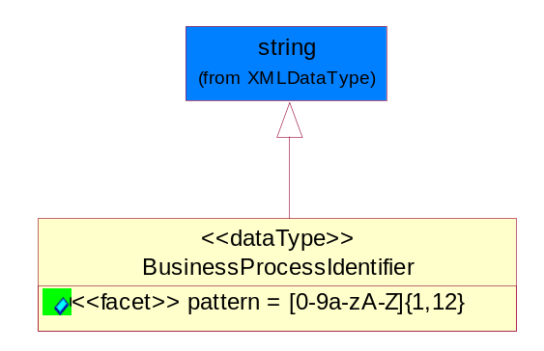
Figure ‎5-53 BusinessProcessIdentifier

Attribute | Type | Documentation
pattern |  | [0-9a-zA-Z]{1,12}

BusinessServiceInformation
The object allows the specification of the business service utilized within the partner company. This may or may not be the same as the information sent by the RNIF.
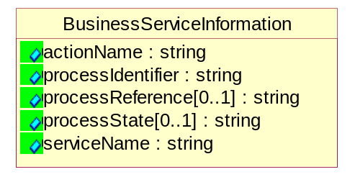
Figure ‎5-54 BusinessServiceInformation

Attribute | Type | Documentation
actionName | string | The name of Action. For RosettaNet usually any of Request/Confirm/Notify/Query/Response.
processIdentifier | string | The name of the PIP e.g. Notify of Forecast Reply.
processReference[0..1] | string | The URN for the PIP that includes Cluster/Segment/Process pattern used to identify the interface process (such as PIP3A4)
processState[0..1] | string | The business process (or service) state of the sender of a document. When a service receives this document, the receiver may use the state as a precondition.
serviceName | string | The name of the Business Activity with the "Request/Confirm" part removed. E.g., for the Activity "Request Purchase Order"==> "Purchase Order".

ContractInformation
A block of information used to correlate a contract in an executing choreography.
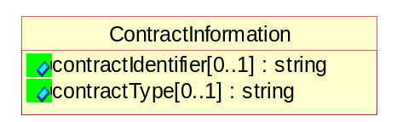
Figure ‎5-55 ContractInformation

Attribute | Type | Documentation
contractIdentifier[0..1] | string | Unique identification of a contract between the Sender and the Receiver
contractType[0..1] | string | The type of the contract: an attribute describing the type of the ContractIndentification. Valid values are URI, URN,ebXMLCPA, or other values defined by partners.

CorrelationInformation
A block of information used to correlate a requesting document to a responding document and to the contract in an executing choreography.
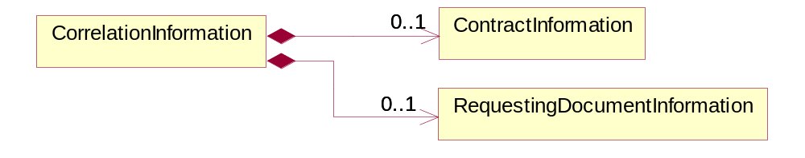
Figure ‎5-56 CorrelationInformation

Composition | Cardinality | Type | Documentation
ContractInformation | 0..1 | ContractInformation | A block of information used to correlate a contract in an executing choreography.
RequestingDocumentInformation | 0..1 | RequestingDocumentInformation | A block of information used to correlate a requesting document to a responding document in an executing choreography.

DocumentHeader
The object allows for the identification of the sender and receiver of the business document.
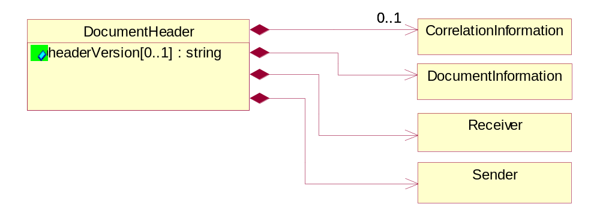
Figure ‎5-57 DocumentHeader

Attribute | Type | Documentation
headerVersion[0..1] | string | The UN/CEFACT version of the document header.

Composition | Cardinality | Type | Documentation
CorrelationInformation | 0..1 | CorrelationInformation | A block of information used to correlate a requesting document to a responding document and to the contract in an executing choreography.
DocumentInformation | 1 | DocumentInformation | The object specifies information to identify the business document, a summary of attachments, and information about the business document security.
Receiver | 1 | Receiver | The object allows the identification of the receiving party of the business message.
Sender | 1 | Sender | The object allows the identification of the initiating party of the business message.

DocumentIdentification
The object specifies all information necessary to identify the business document.
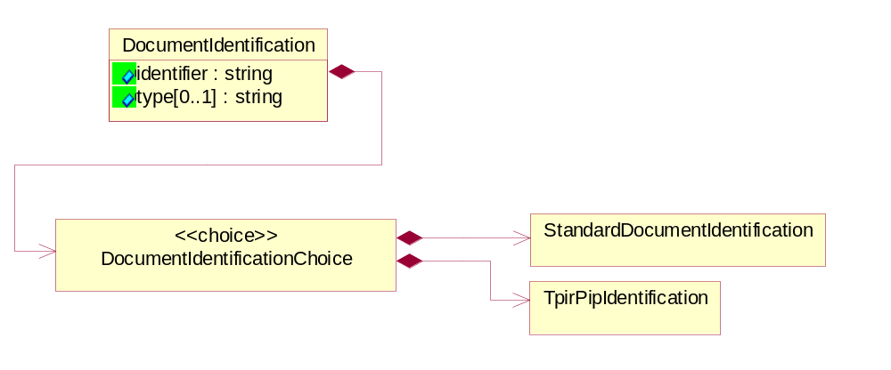
Figure ‎5-58 DocumentIdentification

Attribute | Type | Documentation
identifier | string | The unique identifier for the document being sent.
type[0..1] | string | Name of the Action Message

Composition | Cardinality | Type | Documentation
DocumentIdentificationChoice | 1 | DocumentIdentificationChoice

DocumentIdentificationChoice

Composition | Cardinality | Type | Documentation
StandardDocumentIdentification | 1 | StandardDocumentIdentification | The object specifies additional information necessary to identify the standard business document.
TpirPipIdentification | 1 | TpirPipIdentification | The object specifies all information necessary to uniquely identify a TPIR-PIP within a Registry or trading partner repository.

DocumentInformation
The object specifies information to identify the business document, a summary of attachments, and information about the business document security.
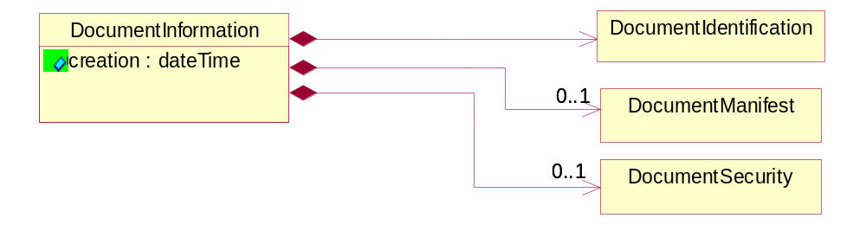
Figure ‎5-59 DocumentInformation

Attribute | Type | Documentation
creation | dateTime | The creation date and time of the specified Business Document (i.e. the Purchase Order date).

Composition | Cardinality | Type | Documentation
DocumentIdentification | 1 | DocumentIdentification | The object specifies all information necessary to identify the business document.
DocumentManifest | 0..1 | DocumentManifest | The block provides a brief summary of attachments and Service Content.
DocumentSecurity | 0..1 | DocumentSecurity | The object provides additional granularity in specifying business document security (this is in addition to the specified PIP security).

DocumentManifest
The block provides a brief summary of attachments and Service Content.
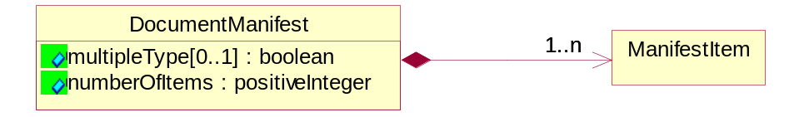
Figure ‎5-60 DocumentManifest

Attribute | Type | Documentation
multipleType[0..1] | boolean | Indicates whether the manifest contains documents of multiple types. True if yes, and False if no.
numberOfItems | positiveInteger | Total number of documents in the message. The physical count of the attachments in the payload plus the RosettaNet Business Message (for Service Content). The value of this field will be at least 1.

Composition | Cardinality | Type | Documentation
ManifestItem | 1..n | ManifestItem | The object provides details about the specific attachment(s).

DocumentSecurity
The object provides additional granularity in specifying business document security (this is in addition to the specified PIP security).

Figure ‎5-61 DocumentSecurity

Attribute | Type | Documentation
nonRepudiableReceipt | boolean | The value "true" will indicate that a signed acknowledgement for the business document is necessary.
persistentEncryption | boolean | The value "true" will indicate that the Business Document (including the header) needs to be encrypted when stored or transported.
persistentSignature | boolean | The value "true" will indicate that a signature is required to be stored with the document while stored or transported.

ManifestItem
The object provides details about the specific attachment(s).
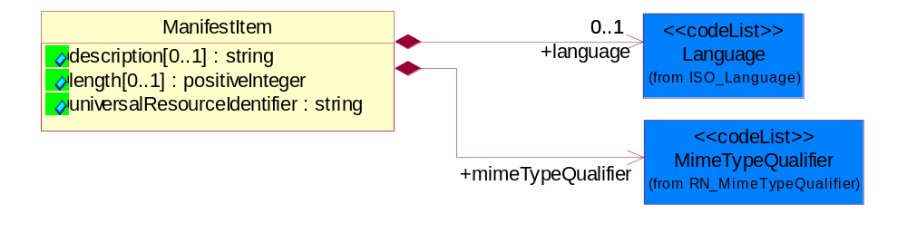
Figure ‎5-62 ManifestItem

Attribute | Type | Documentation
description[0..1] | string | A description of the attachment.
length[0..1] | positiveInteger | The size of the attachment in bytes (i.e. 1 000 000 bytes)
universalResourceIdentifier | string | The generic set of all names/addresses that are short strings that refer to resources.

Composition | Cardinality | Type | Documentation
language | 0..1 | Language | For representation of Language name RosettaNet has adopted ISO 639-2; 1998. Refer to the following web page to get the latest version of the standard:  http://www.loc.gov/standards/iso639-2/iso639jac.html  If you need more information about the ISO standard please contact ISO for more details.
mimeTypeQualifier | 1 | MimeTypeQualifier | The MIME type as defined by IANA.  Please refer to http://www.iana.org/assignments/media-types/ for a list of types.

PipIdentifier
PIP Identification.[ i.e. PIP3A4]
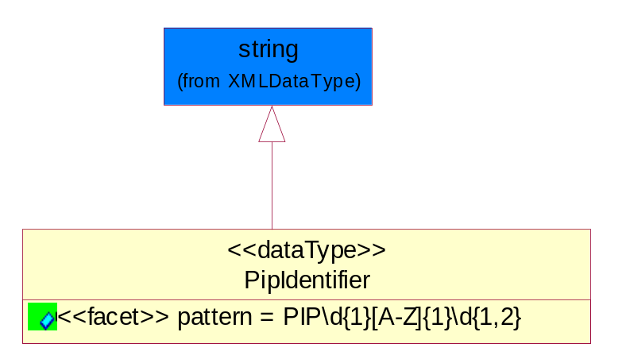
Figure ‎5-63 PipIdentifier

Attribute | Type | Documentation
pattern |  | PIP\d{1}[A-Z]{1}\d{1,2}

PipVersion
PIP version number (i.e. 02.02.00).
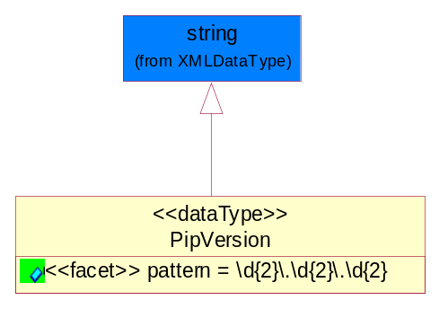
Figure ‎5-64 PipVersion

Attribute | Type | Documentation
pattern |  | \d{2}\.\d{2}\.\d{2}

Receiver
The object allows the identification of the receiving party of the business message.
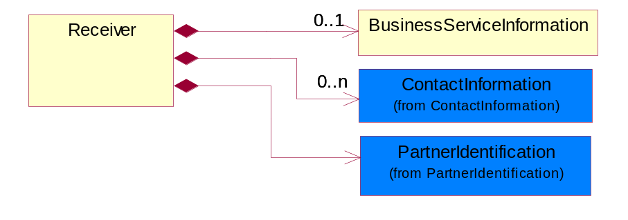
Figure ‎5-65 Receiver

Composition | Cardinality | Type | Documentation
BusinessServiceInformation | 0..1 | BusinessServiceInformation | The object allows the specification of the business service utilized within the partner company. This may or may not be the same as the information sent by the RNIF.
ContactInformation | 0..n | ContactInformation | The business document must allow for the identification of the name of the department, service or individual to be contacted regarding the context of the business document.
PartnerIdentification | 1 | PartnerIdentification | The business document must allow for the identity of one or more parties to the transaction.

RequestingDocumentInformation
A block of information used to correlate a requesting document to a responding document in an executing choreography.

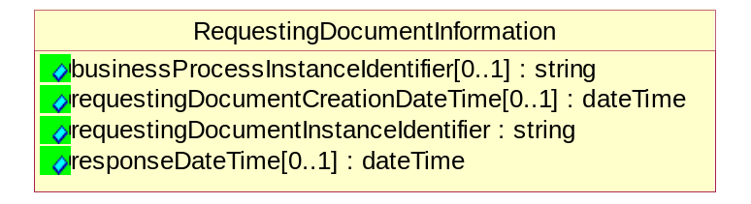

Figure ‎5-66
RequestingDocumentInformation

Attribute | Type | Documentation
businessProcessInstanceIdentifier[0..1] | string | The identifier for the public business process instance being sent that both the sender and receiver can identify.
requestingDocumentCreationDateTime[0..1] | dateTime | The date-time of the requesting business document.
requestingDocumentInstanceIdentifier | string | The Business Document identification number that identifies the requesting Business Document.
responseDateTime[0..1] | dateTime | The expected time to receive the response. This can not be greater than the PIP TimeToPerform.

Sender
The object allows the identification of the initiating party of the business message.
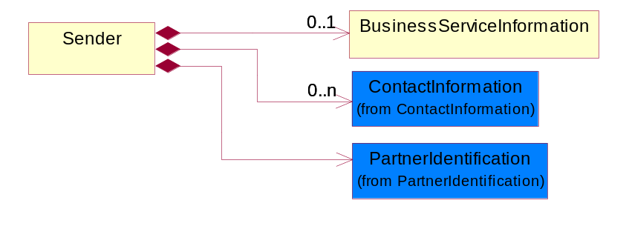
Figure ‎5-67 Sender

Composition | Cardinality | Type | Documentation
BusinessServiceInformation | 0..1 | BusinessServiceInformation | The object allows the specification of the business service utilized within the partner company. This may or may not be the same as the information sent by the RNIF.
ContactInformation | 0..n | ContactInformation | The business document must allow for the identification of the name of the department, service or individual to be contacted regarding the context of the business document.
PartnerIdentification | 1 | PartnerIdentification | The business document must allow for the identity of one or more parties to the transaction.

StandardDocumentIdentification
The object specifies additional information necessary to identify the standard business document.
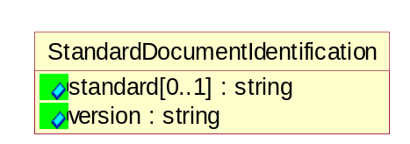
Figure ‎5-68 StandardDocumentIdentification

Attribute | Type | Documentation
standard[0..1] | string | Identifies the standard used to submit the business document. (e.g. RosettaNet).
version | string | PIP3A4v01.00

TpirPipIdentification
The object specifies all information necessary to uniquely identify a TPIR-PIP within a Registry or trading partner repository.
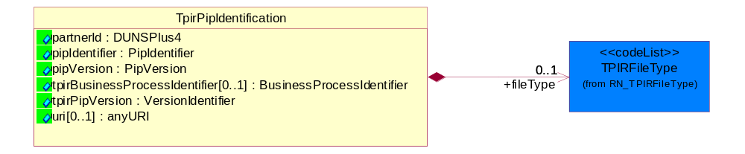
Figure ‎5-69 TpirPipIdentification

Attribute | Type | Documentation
partnerId | DUNSPlus4 | The Trading Partner Identification of MNC that is creating this TPIR PIP.
pipIdentifier | PipIdentifier | A TPIR PIP Identification [i.e., 3A4 ).
pipVersion | PipVersion | A TPIR PIP version number (i.e., 02.02.00)
tpirBusinessProcessIdentifier[0..1] | BusinessProcessIdentifier | A Business Process Identifier to uniquely define the TPIR-PIP 'role' within a Business Scenario at a company or MNC level. The identifier MUST be composed of alphanumeric characters only and its length MUST be between one and twelve characters.
tpirPipVersion | VersionIdentifier | A TPIR-PIP Version Number (i.e., major and minor version number as XX.XX).
uri[0..1] | anyURI | Describes the destination uri for the TPIR form.

Composition | Cardinality | Type | Documentation
fileType | 0..1 | TPIRFileType | Describes the file type of the TPIR form (PDF, XDP or XML).

VersionIdentifier
Version Number (i.e., major and minor version number as XX.XX).
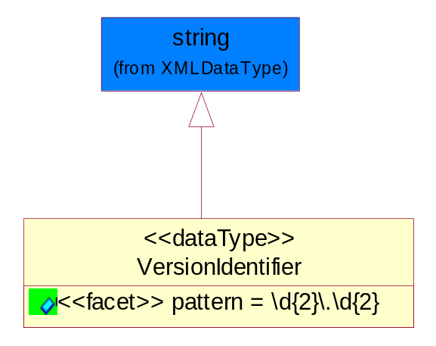
Figure ‎5-70 VersionIdentifier

Attribute | Type | Documentation
pattern |  | \d{2}\.\d{2}

CodeList

TPIRFileType
A code identifying the file type of TPIR form.

Name | Documentation
PDF | Portable Document Format.
XDP | XML Data Package.
XML | eXtensible Markup Language.

XML Data Type

anyURI
Represents a URI as defined by RFC 2396. An anyURI value can be absolute or relative, and may have an optional fragment identifier.

boolean
Represents Boolean values, which are either "true" or "false".

date
For the represents a calendar date.
The pattern for a date is CCYY-MM-DD where CC represents the century, YY the year, MM the month, and DD the day, with an optional time zone indicator as allowed for dateTime.

dateTime
Represents a specific instance of time.
The pattern for dateTime is CCYY-MM-DDThh:mm:ss where CC represents the century, YY the year, MM the month, and DD the day, preceded by an optional leading negative (-) character to indicate a negative number. If the negative character is omitted, positive (+) is assumed. The T is the date/time separator and hh, mm, and ss represent hour, minute, and second respectively. Additional digits can be used to increase the precision of fractional seconds if desired. For example, the format ss.ss... with any number of digits after the decimal point is supported. The fractional seconds part is optional.
This representation may be immediately followed by a "Z" to indicate Coordinated Universal Time (UTC) or to indicate the time zone. For example, the difference between the local time and Coordinated Universal Time, immediately followed by a sign, + or -, followed by the difference from UTC represented as hh:mm (minutes is required). If the time zone is included, both hours and minutes must be present.

float
Represents single-precision 32-bit floating-point numbers.

positiveInteger
Represents an integer that is greater than zero. This data type is derived from nonNegativeInteger.

string
Represents character string.

