

Description of
Partner Interface Process® for 3A2

Validated 11.01.00

Specification Information
Name | Request Price and Availability
Cluster | Order Management
Segment | Quote and Order Entry
Publication Date | 29 January 2010
Version Identifier | V11.01

Table of Contents
1 Document Management 4
1.1 Legal Disclaimer 4
1.2 Copyright 4
1.3 Trademarks 4
1.4 Acknowledgments 4
1.5 Related Documents 4
1.6 Document Version History 5
1.7 Document Structure 5
2 Business Process 6
2.1 Business Process Definition 6
2.2 PIP Scope Description 6
2.3 PIP Business Documents 6
2.4 PIP Business Process Flow Diagram 7
2.5 PIP Start State 7
2.6 PIP End States 8
2.7 Partner Role Descriptions 8
2.8 Business Process Activity Controls 9
3 Network and Implementation Specification 10
3.1 Business Action and Business Signal Specifications 10
3.2 Business Transaction Dialog Specification 11
3.2.1 Message Exchange Controls 11
3.2.2 Communications Specification 12

List of Figures:
Figure 1: Activity Diagram of Request Price and Availability 7
Figure 2: Sequence Diagram of Request Price and Availability 11

List of Tables:
Table 1: PIP Business Document 6
Table 2: PIP Start State 7
Table 3: PIP End State 8
Table 4: PIP Failure State 8
Table 5: Partner Role Description 8
Table 6: Business Activity Description 9
Table 7: Business Activity Performance Control 9
Table 8: Network Component Specification 10
Table 9: Business Action – Business Document Mapping 10
Table 10: Message Exchange Control 11
Table 11: Dialog: Service-Service 12

Document Management

Legal Disclaimer
RosettaNet™, its members, officers, directors, employees, or agents shall not be liable for any injury, loss, damages, financial or otherwise, arising from, related to, or caused by the use of this document or the specifications herein, as well as associated guidelines and schemas. The use of said specifications shall constitute your express consent to the foregoing exculpation.

Copyright
©2010 RosettaNet. All rights reserved. No part of this publication may be reproduced, stored in a retrieval system, or transmitted, in any form or by any means, electronic, mechanical, photocopying, recording, or otherwise, without the prior written permission of the publisher. Printed in the United States of America.

Trademarks
RosettaNet, Partner Interface Process, PIP and the RosettaNet logo are trademarks or registered trademarks of “RosettaNet,” a non-profit organization. All other product names and company logos mentioned herein are the trademarks of their respective owners. In the best effort, all terms mentioned in this document that are known to be trademarks or registered trademarks have been appropriately recognized in the first occurrence of the term.

Acknowledgments
This document has been prepared by RosettaNet (http://www.rosettanet.org/) from requirements gathered during the Milestone Program and in conformance with the methodology.
Global eXchange Services | Seagate Technology
Sterling Commerce | Tyco Electronics
Arrow Electronics | E-Innovators
GridNode

Related Documents
- Associated PIP Message Schemas (included within the PIP Specification package only)
- Description of 3A2 Message
- Messages Structure
- XML instance of ebXML BPSS for PIP 3A2

Document Version History
Version | Date | Description
Validated 11.00.00 | 27 June 2008 | Validated Version: RosettaNet Schema to Market to Validation 2008
Validated 11.00.01 | 10 November 2008 | Validated Version: RosettaNet Schema to Market to Validation 2008
Validated 11.01.00 | 29 January 2010 | Validated Version: RosettaNet MCC Program

Document Structure
A Partner Interface Process (PIP) Specification is comprised of the following two parts:
- Business Process. Captures the semantics of the business process and the flow of the message exchange between roles as they perform business activities.
- Network and Implementation Specification. Specifies the network protocol message formats and communications requirements between peer-protocols supported by network components in the RosettaNet Implementation Framework.

Business Process

Business Process Definition
The "Request Price and Availability" Partner Interface Process™ (PIP) enables a buyer to obtain product price and availability information, for a specific period of time, from a provider. Price and availability checks are less formal than quotes and usually not reconciled with purchase orders.
A price and availability request may be complex and require business rule analysis to generate a response. To facilitate communications between the buyer and the supplier, the request includes both query lines and incomplete results lines. After processing the query, the supplier completes the results lines, adds additional product information as appropriate, and returns the information to the buyer. Should the responding document include information regarding a substitute product, it will require the requester to issue another price and availability request in order to obtain comprehensive information regarding the substitute product.
Should this transaction not complete successfully, the requesting partner executes PIP0A1, "Notification of Failure."

PIP Scope Description
This PIP provides a buyer with product price and availability information used to identify potential suppliers.

PIP Business Documents
Business Documents are generated and exchanged by roles performing activities in this PIP. Business Documents are listed and defined in Table 1.
Table 1: PIP Business Document
Business Document | Description
Price and Availability Request | Requests produce price and availability from a Product Supplier.
Price and Availability Response | Provides response to Customer's query for price and availability.

PIP Business Process Flow Diagram
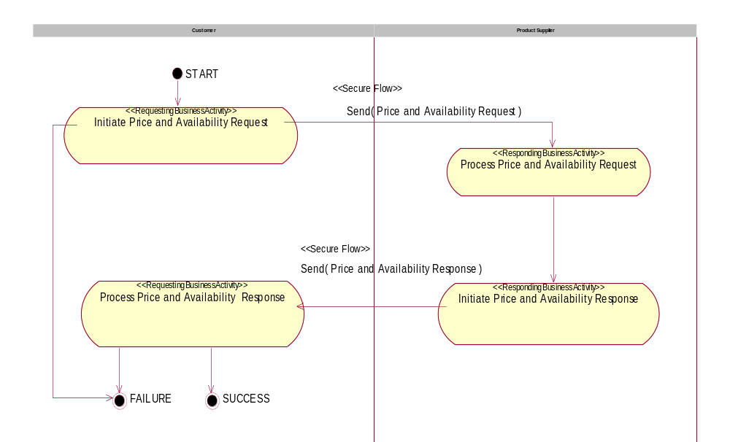
Figure 1: Activity Diagram of Request Price and Availability

PIP Start State
The start state is comprised of the following conditions:
Table 2: PIP Start State
 | Approved | Exist |  | Valid | Non-Repudiated | Retry Count | Authorized
 | Approved | Party | In Backend System
TPA |  |  | 
Sending Partner |  |  |  | 
Receiving Partner |  | 
Business Document |  |  |  | 

PIP End States
The end state is comprised of the following conditions:
Table 3: PIP End State
 | Approved | Exist |  | Valid | Non-Repudiated | Retry Count | Authorized
 | Approved | Party | In Backend system
Acknowledgment of Receipt |  |  |  | 
Receiving Partner |  |  |  |  |  |  | 

The PIP failure state is comprised of one or more of the following conditions:
Table 4: PIP Failure State
 | NO | Exceeded
Success | 
Retry Count |  | 

Partner Role Descriptions
Table 5 describes the partner roles in this PIP.
Table 5: Partner Role Description
Role Name | Role Description
Customer | This partner role creates a demand for a product or service.
Product Supplier | This partner role supplies product to customers in the supply chain.

Business Process Activity Controls
Table 6 describes the interactions between roles performing business activities in this PIP.
Table 6: Business Activity Description
Role  Name | Activity Name | Activity Description
Customer | Initiate Price and Availability Request | Requests product price and availability from a Product Supplier to determine if the Product Supplier can fulfill the Customer's purchasing requirements.
Product Supplier | Initiate Price and Availability Response | Provides response to Customer's query for price and availability.

Table 7 details the security, audit and process controls relating to activities performed in the PIP.
Table 7: Business Activity Performance Control
Role  Name | Activity  Name | Acknowledgment  of Receipt |  | Time to Perform | Retry Count | Is Authorization Required? | Non-Repudiation of Origin and Content?
Role  Name | Activity  Name | Non-Repudiation Required? | Time to Acknowledge
Customer | Initiate Price and Availability Request | N | 24hrs | 24hrs | 3 | N | N
Product Supplier | Initiate Price and Availability Response | N | 24hrs | 24hrs | 3 | N | N

Network and Implementation Specification
Each network component maps into a role of the PIP model. Table 8 specifies the mapping between roles and network components.
Table 8: Network Component Specification
Network Component | Classification | Maps to Role in Business Process
Customer Service | Business Service | Customer
Product Supplier Service | Business Service | Product Supplier

Business Action and Business Signal Specifications
Each business action maps to a Business Document of the PIP model. Table 9 specifies the mapping between Business Documents and business actions.
Table 9: Business Action – Business Document Mapping
Business Action | Business Document | Document Function
Price and Availability Request Action | Price and Availability Request | Request
Price and Availability Response Action | Price and Availability Response | Response

Business Transaction Dialog Specification
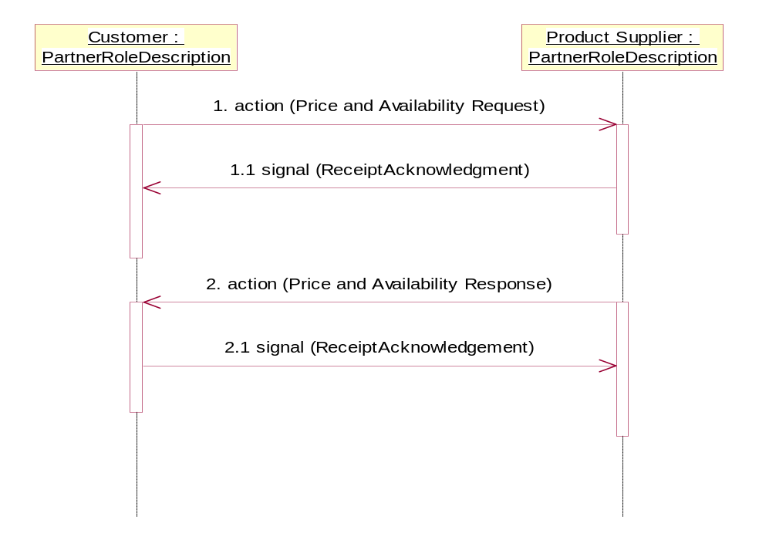
Figure 2: Sequence Diagram of Request Price and Availability

Message Exchange Controls
Table 10: Message Exchange Control
# | Name |  | Time to Acknowledge Receipt Signal |  | Time to Respond to Action |  | Included in Time to Perform |  | Is Authorization Required? |  | Is Non-Repudiation Required? |  | Is Secure Transport Required?
1. |  | Price and Availability Request Action |  | 24hrs |  | 24hrs |  | Y |  | N |  | N |  | Y
1.1. |  | Receipt Acknowledgment |  | N/A |  | N/A |  | Y |  | N |  | N |  | Y
2. |  | Price and Availability Response Action |  | 24hrs |  | N/A |  | Y |  | N |  | N |  | Y
2.1. |  | Receipt Acknowledgment |  | N/A |  | N/A |  | N |  | N |  | N |  | Y

Communications Specification
Table 11: Dialog: Service-Service
# | Business Message | Digital Signature Required? | SSL Required?
1. | Price and Availability Request | Y | Y
1.1. | Receipt Acknowledgment | Y | Y
2. | Price and Availability Response | Y | Y
2.1. | Receipt Acknowledgment | Y | Y

