

Description of 3A4 Message

PIP® 3A4
Validated 11.14.00

Specification Information
Name | Description Of 3A4 Message
PIP | Request Purchase Order
Cluster | Order Management
Segment | Quote and Order Entry
Publication Date | 9 February 2010
Version Identifier | V11.14

Table of Content

1. Document Management 8
1.1 Legal Disclaimer 8
1.2 Copyright 8
1.3 Trademarks 8
1.4 Acknowledgments 8
1.5 Related Documents 8
1.6 Document Version History 9
1.7 Document Purpose 9
2. Interchange Model 10
2.1 PurchaseOrderRequest 10
2.1.1 Interchange Diagram 10
2.1.2 Dependency Diagram 11
2.1.3 OrderLineItem 11
2.1.4 OrderLineItemChoice 12
2.1.5 ProductLineItem 13
2.1.6 ProductSubLineItem 17
2.1.7 PurchaseOrder 20
2.1.8 PurchaseOrderRequest 24
2.1.9 ServiceLineItem 25
2.1.10 ServiceLineItemByOption 28
2.2 PurchaseOrderConfirmation 31
2.2.1 Dependency Diagram 31
2.2.2 Interchange Diagram 32
2.2.3 OrderLineItem 33
2.2.4 OrderLineItemChoice 34
2.2.5 ProductLineItem 35
2.2.6 ProductSubLineItem 39
2.2.7 PurchaseOrder 43
2.2.8 PurchaseOrderConfirmation 47
2.2.9 ServiceLineItem 48
2.2.10 ServiceLineItemByOption 51
2.2.11 TaxSummary 54
3. Domain Model 55
3.1 Procurement 55
3.1.1 Dependency Diagram 55
3.1.2 AccountDescription 56
3.1.3 AlternativeEvent 57
3.1.4 AncillaryDocument 57
3.1.5 ContractInformation 58
3.1.6 CreditCard 58
3.1.7 CustomerInformation 59
3.1.8 DayOfMonth 60
3.1.9 Discounts 60
3.1.10 FinancingTerms 61
3.1.11 MapReference 62
3.1.12 MilestoneDate 63
3.1.13 MilestoneDateChoice 64
3.1.14 NetTerms 64
3.1.15 OrderQuantity 65
3.1.16 OrderShippingInformation 66
3.1.17 PaymentTerms 67
3.1.18 PortalAccess 68
3.1.19 SecondaryBuyer 68
3.1.20 ShippedQuantityInformation 69
3.1.21 SpecialDiscount 69
3.1.22 SpecialHandlingInstruction 70
3.1.23 SubstituteProductReference 70
3.1.24 TaxExemption 71
3.1.25 TaxExemptStatus 71
3.1.26 TransportationEvent 72
3.1.27 CodeList 73
3.1.27.1 TransportEvent 73
3.1.27.2 FinanceTerms 73
3.1.27.3 CreditCardClassification 73
3.1.27.4 AccountClassification 74
3.1.27.5 PaymentCondition 74
3.1.27.6 ConfirmationType 74
3.1.27.7 GovernmentPriorityRating 74
3.1.27.8 PurchaseOrderStatus 75
3.1.27.9 PurchaseOrderType 75
3.1.27.10 CustomerType 76
3.1.27.11 ProductSubstitutionReason 76
3.1.27.12 PurchaseOrderAcknowledgmentReason 76
3.1.27.13 PurchaseOrderFillPriority 77
3.1.27.14 ShipmentTerms 78
3.1.27.15 SpecialFulfillmentRequest 78
3.1.27.16 TaxExemptionCode 80
3.1.27.17 SpecialHandling 82
3.1.27.18 RequestOption 90
3.1.27.19 Event 91
3.1.27.20 DateType 91
3.2 Shared 92
3.2.1 Dependency Diagram 92
3.2.2 CarrierInformation 92
3.2.3 DatePeriodAndDuration 93
3.2.4 DatePeriodAndDurationChoice 93
3.2.5 Duration 94
3.2.6 MonetaryAmount 94
3.2.7 ProductPricing 95
3.2.8 SCAC 95
3.2.9 CodeList 96
3.2.9.1 FreeOnBoard 96
3.2.9.2 InvoiceChargeType 96
3.2.9.3 MonetaryAmountType 96
3.2.9.4 PricingTypeCode 97
3.2.9.5 ShippingServiceLevel 98
3.2.9.6 PaymentMethod 100
3.2.9.7 AmountType 102
4. Universal Structure 103
4.1 ContactInformation 103
4.1.1 ContactInformation 103
4.2 DataType 104
4.2.1 Contact 104
4.2.2 DUNS 104
4.2.3 DUNSPlus4 105
4.2.4 GLN 105
4.2.5 GTIN 106
4.2.6 PercentAmount 106
4.3 Dates 107
4.3.1 DatePeriod 107
4.3.2 DateTimePeriod 107
4.4 Document 108
4.4.1 BusinessDocumentReference 108
4.5 Locations 109
4.5.1 AlternativeIdentifier 109
4.5.2 Location 110
4.5.3 LocationChoice 111
4.5.4 PhysicalAddress 112
4.6 MonetaryExpression 114
4.6.1 FinancialAmount 114
4.6.2 TaxAmount 115
4.6.3 TaxJurisdiction 116
4.7 PartnerIdentification 117
4.7.1 FullPartner 117
4.7.2 IntermittentPartner 118
4.7.3 KnownPartner 118
4.7.4 KnownPartnerContact 119
4.7.5 NewPartner 120
4.7.6 PartnerDescription 121
4.7.7 PartnerDescriptionChoice 122
4.7.8 PartnerIdentification 123
4.7.9 PartnerIdentificationChoice 124
4.7.10 SpecifiedFullPartner 125
4.7.11 SpecifiedIntermittentPartner 126
4.7.12 SpecifiedKnownPartner 127
4.7.13 SpecifiedKnownPartnerContact 128
4.7.14 SpecifiedNewPartner 129
4.7.15 SpecifiedPartnerDescription 130
4.7.16 SpecifiedPartnerDescriptionChoice 131
4.8 ProductIdentification 132
4.8.1 ProductIdentification 132
4.8.2 ProductIdentificationChoice 132
4.9 CodeList 133
4.9.1 Country 133
4.9.2 CountrySubdivision 133
4.9.3 Currency 133
4.9.4 Language 133
4.9.5 DocumentType 134
4.9.6 MimeTypeQualifier 136
4.9.7 TaxType 146
4.9.8 UnitOfMeasure 147
4.9.9 ProcessRoleIdentifier 160
5. System Structure 163
5.1 BusinessProcessIdentifier 163
5.2 BusinessServiceInformation 164
5.3 ContractInformation 165
5.4 CorrelationInformation 166
5.5 DocumentHeader 167
5.6 DocumentIdentification 168
5.7 DocumentIdentificationChoice 168
5.8 DocumentInformation 169
5.9 DocumentManifest 170
5.10 DocumentSecurity 171
5.11 ManifestItem 172
5.12 PipIdentifier 173
5.13 PipVersion 173
5.14 Receiver 174
5.15 RequestingDocumentInformation 175
5.16 Sender 176
5.17 StandardDocumentIdentification 177
5.18 TpirPipIdentification 178
5.19 VersionIdentifier 179
5.20 CodeList 179
5.20.1 TPIRFileType 179
6. XML Data Type 180
6.1 anyURI 180
6.2 boolean 180
6.3 date 180
6.4 dateTime 180
6.5 decimal 180
6.6 duration 180
6.7 float 180
6.8 gDay 181
6.9 positiveInteger 181
6.10 string 181

Table of Figures

Figure ‎2-1 Interchange 10
Figure ‎2-2 Dependency 11
Figure ‎2-3 OrderLineItem 11
Figure ‎2-4 ProductLineItem 13
Figure ‎2-5 ProductSubLineItem 17
Figure ‎2-6 PurchaseOrder 20
Figure ‎2-7 PurchaseOrderRequest 24
Figure ‎2-8 ServiceLineItem 25
Figure ‎2-9 ServiceLineItemByOption 28
Figure ‎2-10 Dependency 31
Figure ‎2-11 Interchange 32
Figure ‎2-12 OrderLineItem 33
Figure ‎2-13 ProductLineItem 35
Figure ‎2-14 ProductSubLineItem 39
Figure ‎2-15 PurchaseOrder 43
Figure ‎2-16 PurchaseOrderConfirmation 47
Figure ‎2-17 ServiceLineItem 48
Figure ‎2-18 ServiceLineItemByOption 51
Figure ‎2-19 TaxSummary 54
Figure ‎3-1 Dependency 55
Figure ‎3-2 AccountDescription 56
Figure ‎3-3 AlternativeEvent 57
Figure ‎3-4 AncillaryDocument 57
Figure ‎3-5 ContractInformation 58
Figure ‎3-6 CreditCard 58
Figure ‎3-7 CustomerInformation 59
Figure ‎3-8 DayOfMonth 60
Figure ‎3-9 Discounts 60
Figure ‎3-10 FinancingTerms 61
Figure ‎3-11 MapReference 62
Figure ‎3-12 MilestoneDate 63
Figure ‎3-13 NetTerms 64
Figure ‎3-14 OrderQuantity 65
Figure ‎3-15 OrderShippingInformation 66
Figure ‎3-16 PaymentTerms 67
Figure ‎3-17 PortalAccess 68
Figure ‎3-18 SecondaryBuyer 68
Figure ‎3-19 ShippedQuantityInformation 69
Figure ‎3-20 SpecialDiscount 69
Figure ‎3-21 SpecialHandlingInstruction 70
Figure ‎3-22 SubstituteProductReference 70
Figure ‎3-23 TaxExemption 71
Figure ‎3-24 TaxExemptStatus 71
Figure ‎3-25 TransportationEvent 72
Figure ‎3-26 Dependency 92
Figure ‎3-27 CarrierInformation 92
Figure ‎3-28 DatePeriodAndDuration 93
Figure ‎3-29 Duration 94
Figure ‎3-30 MonetaryAmount 94
Figure ‎3-31 ProductPricing 95
Figure ‎3-32 SCAC 95
Figure ‎4-1 ContactInformation 103
Figure ‎4-2 Contact 104
Figure ‎4-3 DUNS 104
Figure ‎4-4 DUNSPlus4 105
Figure ‎4-5 GLN 105
Figure ‎4-6 GTIN 106
Figure ‎4-7 PercentAmount 106
Figure ‎4-8 DatePeriod 107
Figure ‎4-9 DateTimePeriod 107
Figure ‎4-10 BusinessDocumentReference 108
Figure ‎4-11 AlternativeIdentifier 109
Figure ‎4-12 Location 110
Figure ‎4-13 PhysicalAddress 112
Figure ‎4-14 FinancialAmount 114
Figure ‎4-15 TaxAmount 115
Figure ‎4-16 TaxJurisdiction 116
Figure ‎4-17 FullPartner 117
Figure ‎4-18 IntermittentPartner 118
Figure ‎4-19 KnownPartner 118
Figure ‎4-20 KnownPartnerContact 119
Figure ‎4-21 NewPartner 120
Figure ‎4-22 PartnerDescription 121
Figure ‎4-23 PartnerIdentification 123
Figure ‎4-24 SpecifiedFullPartner 125
Figure ‎4-25 SpecifiedIntermittentPartner 126
Figure ‎4-26 SpecifiedKnownPartner 127
Figure ‎4-27 SpecifiedKnownPartnerContact 128
Figure ‎4-28 SpecifiedNewPartner 129
Figure ‎4-29 SpecifiedPartnerDescription 130
Figure ‎4-30 ProductIdentification 132
Figure ‎5-1 BusinessProcessIdentifier 163
Figure ‎5-2 BusinessServiceInformation 164
Figure ‎5-3 ContractInformation 165
Figure ‎5-4 CorrelationInformation 166
Figure ‎5-5 DocumentHeader 167
Figure ‎5-6 DocumentIdentification 168
Figure ‎5-7 DocumentInformation 169
Figure ‎5-8 DocumentManifest 170
Figure ‎5-9 DocumentSecurity 171
Figure ‎5-10 ManifestItem 172
Figure ‎5-11 PipIdentifier 173
Figure ‎5-12 PipVersion 173
Figure ‎5-13 Receiver 174
Figure ‎5-14 RequestingDocumentInformation 175
Figure ‎5-15 Sender 176
Figure ‎5-16 StandardDocumentIdentification 177
Figure ‎5-17 TpirPipIdentification 178
Figure ‎5-18 VersionIdentifier 179

Document Management

Legal Disclaimer
RosettaNet, its members, officers, directors, employees, or agents shall not be liable for any injury, loss, damages, financial or otherwise, arising from, related to, or caused by the use of this document or the specifications herein, as well as associated guidelines and schemas. The use of said specifications shall constitute your express consent to the foregoing exculpation.

Copyright
©2010 RosettaNet. All rights reserved. No part of this publication may be reproduced, stored in a retrieval system, or transmitted, in any form or by any means, electronic, mechanical, photocopying, recording, or otherwise, without the inclusion of this copyright notice. Any derivative works must cite the copyright notice. Any public redistribution or sale of this publication or derivative works requires prior written permission of the publisher.

Trademarks
RosettaNet, Partner Interface Process, PIP and the RosettaNet logo are trademarks or registered trademarks of "RosettaNet," a non-profit organization. All other product names and company logos mentioned herein are the trademarks of their respective owners. In the best effort, all terms mentioned in this document that are known to be trademarks or registered trademarks have been appropriately recognized in the first occurrence of the term.

Acknowledgments
This document has been prepared by RosettaNet (http://www.rosettanet.org/) from requirements gathered during the Milestone Program and in conformance with the methodology. Listed below are the legal entities that contributed to the design and development of this PIP.
Cisco Systems | SBC Business Marketing
Bellsouth Communication Systems | Sterling Commerce
Intel | World Wide Technology (WWT)

Related Documents
- Associated PIP Message Schemas (included with PIP Specification only)
- Description of Partner Interface Process for 3A4
- Message Structure

Document Version History
Version | Date | Description
Validated 11.00.00 | 02 August 2005 | Validated version : RosettaNet Automated Enablement (RAE) Milestone Program
Validated 11.01.00 | 08 November 2005 | Validated version : Service Contract Information Management (SCIM) Milestone Program
Validated 11.10.00 | 29 May 2006 | Validated version : Service Contract Information Management (SCIM) Milestone Program
Validated 11.11.00 | 18 July 2006 | Validated version : RosettaNet Automated Enablement (RAE) Milestone Program
Validated 11.12.00 | 19 August 2008 | Validated version : RosettaNet PIP Maintenance
Validated 11.13.00 | 30 July 2009 | Validated version : Q32009 Maintenance Process
Validated 11.14.00 | 9 February 2010 | Validated version : MCC Foundational Program

Document Purpose
The purpose of the document is to explain the structure, the association between objects, the content of objects and the definition for single elements to a non-technical audience.

Interchange Model

PurchaseOrderRequest

Interchange Diagram
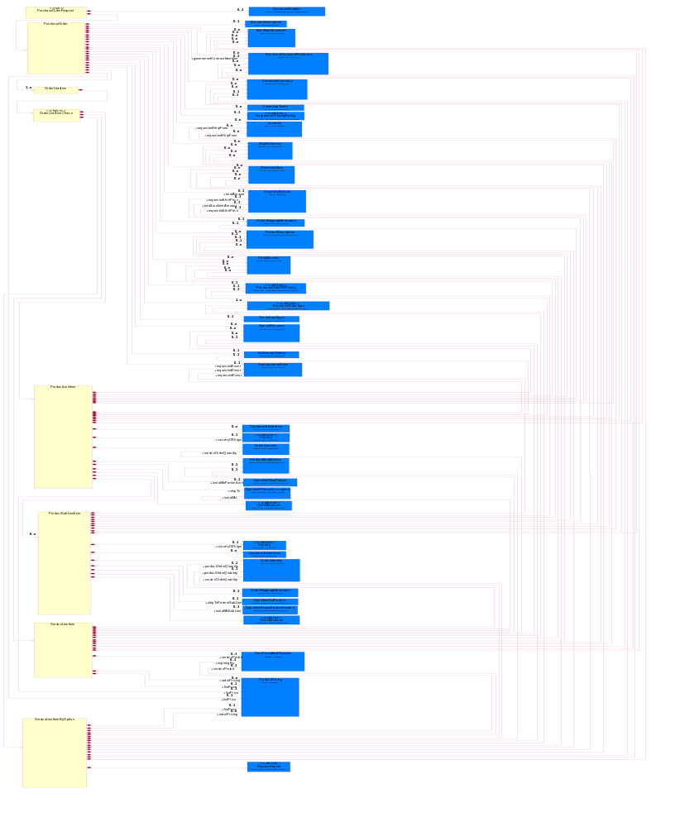
Figure ‎2-1 Interchange

Dependency Diagram
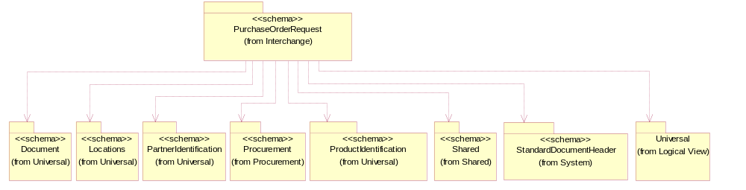
Figure ‎2-2 Dependency

OrderLineItem
The collection of business properties that describe a entry in a purchase order business document.
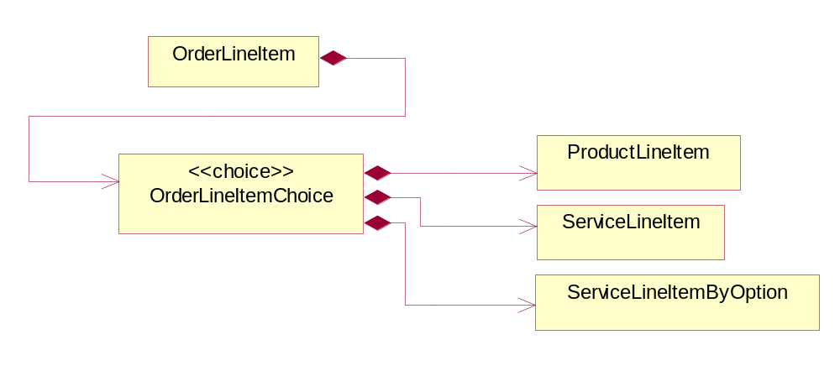
Figure ‎2-3 OrderLineItem

Composition | Cardinality | Type | Documentation
OrderLineItemChoice | 1 | OrderLineItemChoice

OrderLineItemChoice

Composition | Cardinality | Type | Documentation
ProductLineItem | 1 | ProductLineItem | The collection of business properties that describe a business document entry for a product in a purchase order business documents. The Recommended ProcessRoleIdentifier for PartnerDescription is CLF - Collect From.
ServiceLineItem | 1 | ServiceLineItem | The collection of business properties that describe a service entry in a purchase order business documents. The Recommended ProcessRoleIdentifier for PartnerDescription is CLF - Collect From.
ServiceLineItemByOption | 1 | ServiceLineItemByOption | The collection of business properties that describe a service entry by option (eg. by Contract, by Product or by Site) in a purchase order business documents. The Recommended ProcessRoleIdentifier for PartnerDescription are CLF - Collect From and ITL - Install At.

ProductLineItem
The collection of business properties that describe a business document entry for a product in a purchase order business documents. The Recommended ProcessRoleIdentifier for PartnerDescription is CLF - Collect From.
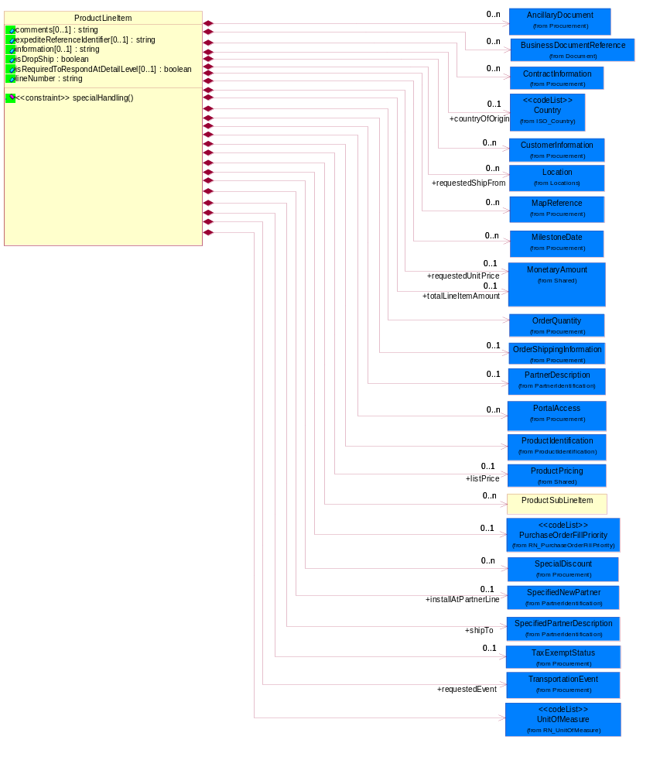
Figure ‎2-4 ProductLineItem

Attribute | Type | Documentation
comments[0..1] | string | Free form textual description of a general nature.
expediteReferenceIdentifier[0..1] | string | The unique identification number for the expediting of a product.
information[0..1] | string | A free form textual description of information, relating to a product.
isDropShip | boolean | Indicates whether the order is a drop shipment.
isRequiredToRespondAtDetailLevel[0..1] | boolean | This object representing the option for the response. If the value equals to true, the receiver is required to response to detail level. If the value equals to false, the receiver is only required to reply at summary level.
lineNumber | string | Number of the line in the document.

Composition | Cardinality | Type | Documentation
ContractInformation | 0..n | ContractInformation | The collection of business properties that represent a business arrangement for the supply of goods or services at an agreed price.
CustomerInformation | 0..n | CustomerInformation | The collection of business properties that describe an end user.
UnitOfMeasure | 1 | UnitOfMeasure | Code identifying a product unit of measure.
PurchaseOrderFillPriority | 0..1 | PurchaseOrderFillPriority | Code identifying fill priority for manufacturing in a constrained condition. Value to be determined by Trading Partner Agreement  1 = highest priority, 5 = medium priority and 9 = lowest priority.
OrderQuantity | 1 | OrderQuantity | The collection of business properties that describe various types of product quantity used in an ordering process.
countryOfOrigin | 0..1 | Country | Country where product originates.
ProductIdentification | 1 | ProductIdentification | The object provides the identifier(s) of a product.
TaxExemptStatus | 0..1 | TaxExemptStatus | The collection of business properties that describe tax exemption conditions.
ProductSubLineItem | 0..n | ProductSubLineItem | The collection of business properties that describe a part of a product line item. The Recommended ProcessRoleIdentifier for PartnerDescription is CLF - Collect From.
OrderShippingInformation | 0..1 | OrderShippingInformation | The collection of business properties that describe information relating to shipping a product.
requestedShipFrom | 0..n | Location | The DUNS or DUNS + 4 number of the location where the product is requested to be shipped from.
shipTo | 1 | SpecifiedPartnerDescription | The partner and/or location to which the product must be delivered.
requestedEvent | 1 | TransportationEvent | The date a transportation event is requested to occur.
installAtPartnerLine | 0..1 | SpecifiedNewPartner | The partner and/or location to which the product must be set up for use or service.
BusinessDocumentReference | 0..n | BusinessDocumentReference | The business document reference object allows for the indirect referencing of a relationship to other business related documents.
SpecialDiscount | 0..n | SpecialDiscount | This object represents a special discount based on the special discount identifier.
requestedUnitPrice | 0..1 | MonetaryAmount | The price requested for a unit of product.
totalLineItemAmount | 0..1 | MonetaryAmount | The monetary total associated with a line item.
listPrice | 0..1 | ProductPricing | This object represents the pre-discounted price.
MilestoneDate | 0..n | MilestoneDate | The collection of business properties that represents milestone dates within the order fulfilment process.
MapReference | 0..n | MapReference | The collections of business properties that represents the install-at address using either a Global Positioning Satellite reference or national mapping grid reference.
PortalAccess | 0..n | PortalAccess | The collection of business properties that represents access path, for use in downloading ancillary documents from a portal or extranet site.
AncillaryDocument | 0..n | AncillaryDocument | The collection of business properties that represents name and version of an ancillary document.
PartnerDescription | 0..1 | PartnerDescription | The collection of business properties that describe a business partners' identity, their contact information, where they are physically located and their function in a supply chain.

Constraint | Documentation
specialHandling | At least one occurrence of "dp:OrderShippingInformation/dp:SpecialHandlingInstruction/dp:Text" , "dp:OrderShippingInformation/dp:SpecialHandlingInstruction/dsh:SpecialHandling" is required.

ProductSubLineItem
The collection of business properties that describe a part of a product line item. The Recommended ProcessRoleIdentifier for PartnerDescription is CLF - Collect From.
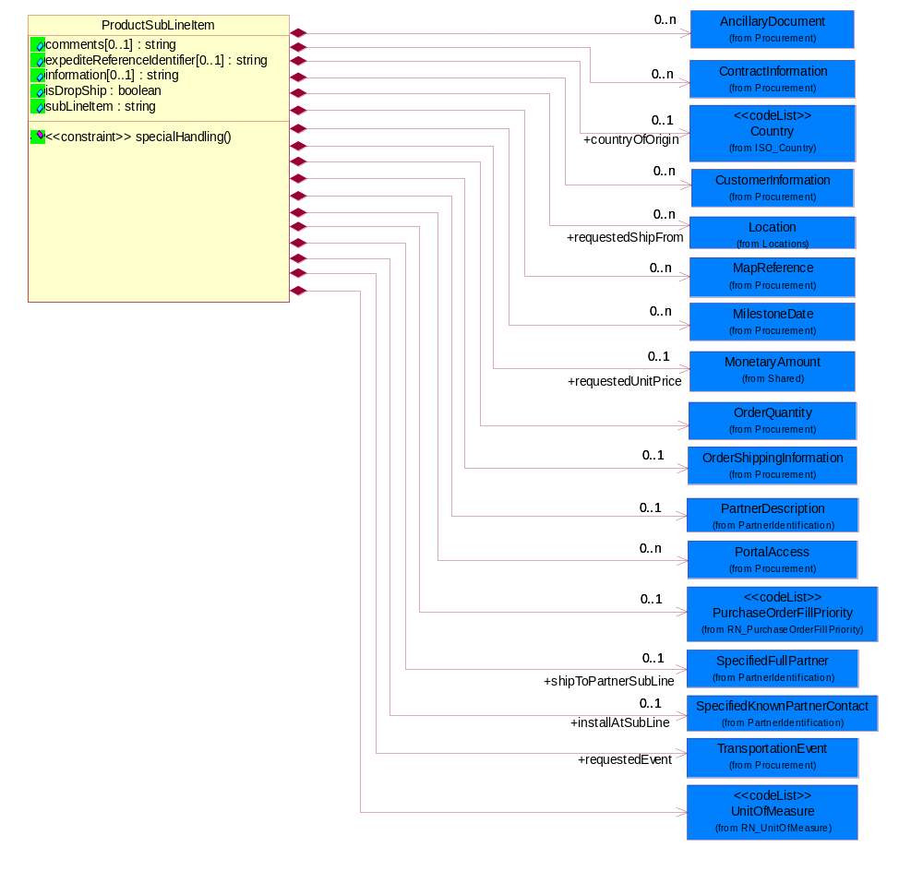
Figure ‎2-5 ProductSubLineItem

Attribute | Type | Documentation
comments[0..1] | string | Free form textual description of a general nature.
expediteReferenceIdentifier[0..1] | string | The unique identification number for the expediting of a product.
information[0..1] | string | A free form textual description of information, relating to a product.
isDropShip | boolean | Indicates whether the order is a drop shipment.
subLineItem | string | Information contained within a subline.

Composition | Cardinality | Type | Documentation
countryOfOrigin | 0..1 | Country | Country where product originates.
ContractInformation | 0..n | ContractInformation | The collection of business properties that represent a business arrangement for the supply of goods or services at an agreed price.
CustomerInformation | 0..n | CustomerInformation | The collection of business properties that describe an end user.
UnitOfMeasure | 1 | UnitOfMeasure | Code identifying a product unit of measure.
PurchaseOrderFillPriority | 0..1 | PurchaseOrderFillPriority | Code identifying fill priority for manufacturing in a constrained condition. Value to be determined by Trading Partner Agreement  1 = highest priority, 5 = medium priority and 9 = lowest priority.
OrderQuantity | 1 | OrderQuantity | The collection of business properties that describe various types of product quantity used in an ordering process.
OrderShippingInformation | 0..1 | OrderShippingInformation | The collection of business properties that describe information relating to shipping a product.
requestedShipFrom | 0..n | Location | The DUNS or DUNS + 4 number of the location where the product is requested to be shipped from.
requestedEvent | 1 | TransportationEvent | The date a transportation event is requested to occur.
installAtSubLine | 0..1 | SpecifiedKnownPartnerContact | The partner and/or location to which the product must be set up for use or service.
requestedUnitPrice | 0..1 | MonetaryAmount | The price requested for a unit of product.
shipToPartnerSubLine | 0..1 | SpecifiedFullPartner | The partner and/or location to which the product must be delivered.
PortalAccess | 0..n | PortalAccess | The collection of business properties that represents access path, for use in downloading ancillary documents from a portal or extranet site.
MilestoneDate | 0..n | MilestoneDate | The collection of business properties that represents milestone dates within the order fulfilment process.
MapReference | 0..n | MapReference | The collections of business properties that represents the install-at address using either a Global Positioning Satellite reference or national mapping grid reference.
AncillaryDocument | 0..n | AncillaryDocument | The collection of business properties that represents name and version of an ancillary document.
PartnerDescription | 0..1 | PartnerDescription | The collection of business properties that describe a business partners' identity, their contact information, where they are physically located and their function in a supply chain.

Constraint | Documentation
specialHandling | At least one occurrence of "dp:OrderShippingInformation/dp:SpecialHandlingInstruction/dp:Text" , "dp:OrderShippingInformation/dp:SpecialHandlingInstruction/dsh:SpecialHandling" is required.

PurchaseOrder
The collection of business properties that describe a buyer's offer to purchase a quantity of products at an agreed price and schedule. The Recommended ProcessRoleIdentifier for PartnerDescription are ITL - Install At, BIT - Bill To, CWN - Contract Owner, SHT - Ship To, RES - Respond To and CLF -Collect From.
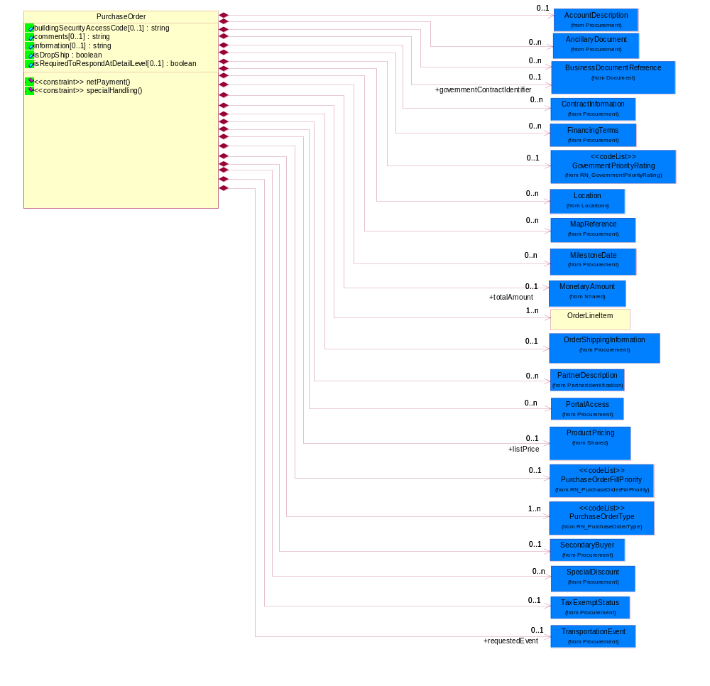
Figure ‎2-6 PurchaseOrder

Attribute | Type | Documentation
buildingSecurityAccessCode[0..1] | string | Access code which may be used to gain entry through an automated security system to an unmanned site.
comments[0..1] | string | Free form textual description of a general nature.
information[0..1] | string | A free form textual description of information, relating to a product.
isDropShip | boolean | Indicates whether the order is a drop shipment.
isRequiredToRespondAtDetailLevel[0..1] | boolean | This object representing the option for the response. If the value equals to true, the receiver is required to response to detail level. If the value equals to false, the receiver is only required to reply at summary level.

Composition | Cardinality | Type | Documentation
AccountDescription | 0..1 | AccountDescription | The collection of business properties that describe a customer or supplier account.
ContractInformation | 0..n | ContractInformation | The collection of business properties that represent a business arrangement for the supply of goods or services at an agreed price.
GovernmentPriorityRating | 0..1 | GovernmentPriorityRating | If a contract number exists and PO type is Government, a priority rating code is required.
PurchaseOrderType | 1..n | PurchaseOrderType | Code identifying category specification for a purchase order.
PurchaseOrderFillPriority | 0..1 | PurchaseOrderFillPriority | Code identifying fill priority for manufacturing in a constrained condition. Value to be determined by Trading Partner Agreement  1 = highest priority, 5 = medium priority and 9 = lowest priority.
FinancingTerms | 0..n | FinancingTerms | The collection of business properties that describe financing terms.
SecondaryBuyer | 0..1 | SecondaryBuyer | The collection of business properties that describe an alternate buyer.
TaxExemptStatus | 0..1 | TaxExemptStatus | The collection of business properties that describe tax exemption conditions.
OrderShippingInformation | 0..1 | OrderShippingInformation | The collection of business properties that describe information relating to shipping a product.
governmentContractIdentifier | 0..1 | BusinessDocumentReference | The unique number that identifies a government contract.
requestedEvent | 0..1 | TransportationEvent | The date a transportation event is requested to occur.
BusinessDocumentReference | 0..n | BusinessDocumentReference | The business document reference object allows for the indirect referencing of a relationship to other business related documents.
OrderLineItem | 1..n | OrderLineItem | The collection of business properties that describe a entry in a purchase order business document.
SpecialDiscount | 0..n | SpecialDiscount | This object represents a special discount based on the special discount identifier.
Location | 0..n | Location | The business document must specify a location.
totalAmount | 0..1 | MonetaryAmount | Total price for an entire business document.
listPrice | 0..1 | ProductPricing | This object represents the pre-discounted price.
PartnerDescription | 0..n | PartnerDescription | The collection of business properties that describe a business partners' identity, their contact information, where they are physically located and their function in a supply chain.
AncillaryDocument | 0..n | AncillaryDocument | The collection of business properties that represents name and version of an ancillary document.
MapReference | 0..n | MapReference | The collections of business properties that represents the install-at address using either a Global Positioning Satellite reference or national mapping grid reference.
MilestoneDate | 0..n | MilestoneDate | The collection of business properties that represents milestone dates within the order fulfilment process.
PortalAccess | 0..n | PortalAccess | The collection of business properties that represents access path, for use in downloading ancillary documents from a portal or extranet site.

Constraint | Documentation
netPayment | At least one occurrence of dp:FinancingTerms/dp:PaymentTerms/dp:NetTerms/dp:Day , dp:FinancingTerms/dp:PaymentTerms/dp:NetTerms/dp:Days is required.
specialHandling | At least one occurrence of dp:OrderShippingInformation/dp:SpecialHandlingInstruction/dp:Text , dp:OrderShippingInformation/dp:SpecialHandlingInstruction/dsh:SpecialHandling is required.

PurchaseOrderRequest
Top level object for a Purchase Order business document.
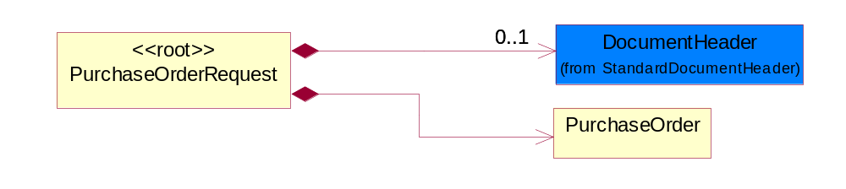
Figure ‎2-7 PurchaseOrderRequest

Composition | Cardinality | Type | Documentation
PurchaseOrder | 1 | PurchaseOrder | The collection of business properties that describe a buyer's offer to purchase a quantity of products at an agreed price and schedule. The Recommended ProcessRoleIdentifier for PartnerDescription are ITL - Install At, BIT - Bill To, CWN - Contract Owner, SHT - Ship To, RES - Respond To and CLF -Collect From.
DocumentHeader | 0..1 | DocumentHeader | The object allows for the identification of the sender and receiver of the business document.

ServiceLineItem
The collection of business properties that describe a service entry in a purchase order business documents. The Recommended ProcessRoleIdentifier for PartnerDescription is CLF - Collect From.
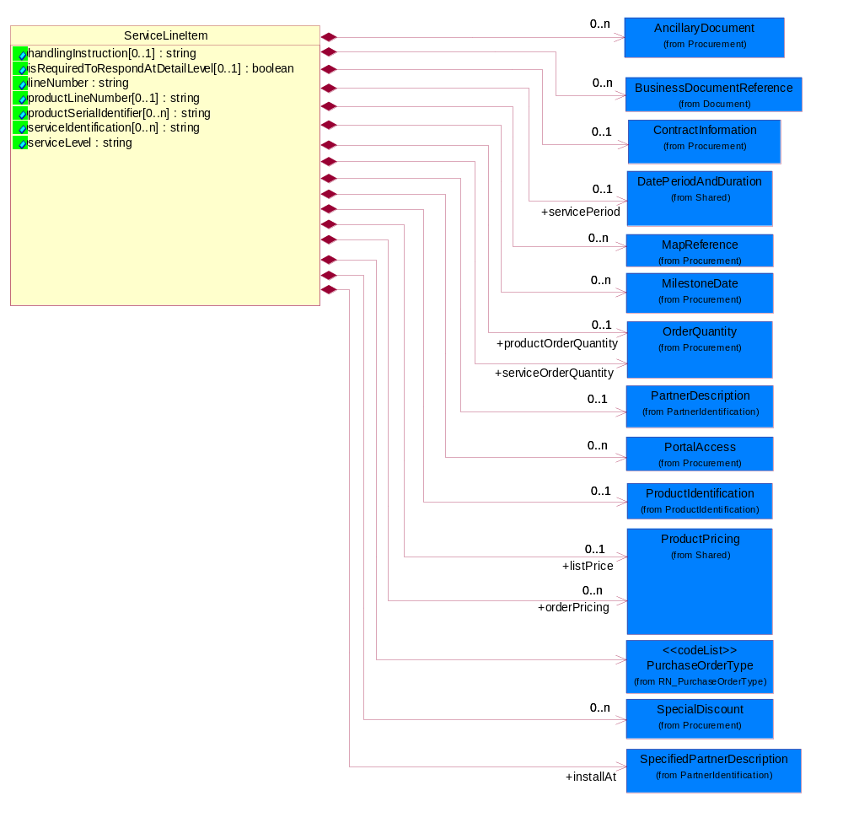
Figure ‎2-8 ServiceLineItem

Attribute | Type | Documentation
handlingInstruction[0..1] | string | Free form textual description of instructions.
isRequiredToRespondAtDetailLevel[0..1] | boolean | This object representing the option for the response. If the value equals to true, the receiver is required to response to detail level. If the value equals to false, the receiver is only required to reply at summary level.
lineNumber | string | Number of the line in the document.
productLineNumber[0..1] | string | The object that representing the line number of the referenced product line item.
productSerialIdentifier[0..n] | string | A unique serial identifier assigned to a product.
serviceIdentification[0..n] | string | A unique serial identifier assigned to a service.
serviceLevel | string | The object that representing the type of service or service name.

Composition | Cardinality | Type | Documentation
BusinessDocumentReference | 0..n | BusinessDocumentReference | The business document reference object allows for the indirect referencing of a relationship to other business related documents.
ContractInformation | 0..1 | ContractInformation | The collection of business properties that represent a business arrangement for the supply of goods or services at an agreed price.
productOrderQuantity | 0..1 | OrderQuantity | The collection of business properties that describe product quantity.
ProductIdentification | 0..1 | ProductIdentification | The object provides the identifier(s) of a product.
PurchaseOrderType | 1 | PurchaseOrderType | Code identifying category specification for a purchase order.
SpecialDiscount | 0..n | SpecialDiscount | This object represents a special discount based on the special discount identifier.
installAt | 1 | SpecifiedPartnerDescription | The partner and/or location to which the product must be set up for use or service.
serviceOrderQuantity | 1 | OrderQuantity | The collection of business properties that describe service quantity.
servicePeriod | 0..1 | DatePeriodAndDuration | This object allows representation of a date period by a duration or begin and an end dates for a service period.
orderPricing | 0..n | ProductPricing | The collection of business properties that describe the type of pricing and financial amount for a purchase order.
listPrice | 0..1 | ProductPricing | This object represents the pre-discounted price.
PortalAccess | 0..n | PortalAccess | The collection of business properties that represents access path, for use in downloading ancillary documents from a portal or extranet site.
PartnerDescription | 0..1 | PartnerDescription | The collection of business properties that describe a business partners' identity, their contact information, where they are physically located and their function in a supply chain.
MilestoneDate | 0..n | MilestoneDate | The collection of business properties that represents milestone dates within the order fulfilment process.
MapReference | 0..n | MapReference | The collections of business properties that represents the install-at address using either a Global Positioning Satellite reference or national mapping grid reference.
AncillaryDocument | 0..n | AncillaryDocument | The collection of business properties that represents name and version of an ancillary document.

ServiceLineItemByOption
The collection of business properties that describe a service entry by option (eg. by Contract, by Product or by Site) in a purchase order business documents. The Recommended ProcessRoleIdentifier for PartnerDescription are CLF - Collect From and ITL - Install At.
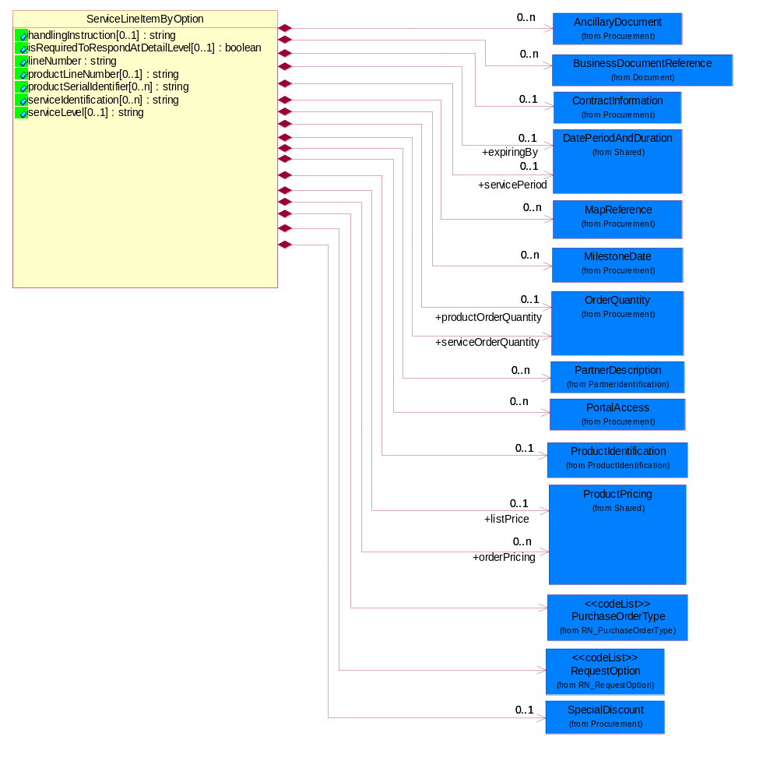
Figure ‎2-9 ServiceLineItemByOption

Attribute | Type | Documentation
handlingInstruction[0..1] | string | Free form textual description of instructions.
isRequiredToRespondAtDetailLevel[0..1] | boolean | This object representing the option for the response. If the value equals to true, the receiver is required to response to detail level. If the value equals to false, the receiver is only required to reply at summary level.
lineNumber | string | Number of the line in the document.
productLineNumber[0..1] | string | The object that representing the line number of the referenced product line item.
productSerialIdentifier[0..n] | string | A unique serial identifier assigned to a product.
serviceIdentification[0..n] | string | A unique serial identifier assigned to a service.
serviceLevel[0..1] | string | The object that representing the type of service or service name.

Composition | Cardinality | Type | Documentation
BusinessDocumentReference | 0..n | BusinessDocumentReference | The business document reference object allows for the indirect referencing of a relationship to other business related documents.
ContractInformation | 0..1 | ContractInformation | The collection of business properties that represent a business arrangement for the supply of goods or services at an agreed price.
productOrderQuantity | 0..1 | OrderQuantity | The collection of business properties that describe product quantity.
serviceOrderQuantity | 1 | OrderQuantity | The collection of business properties that describe service quantity.
ProductIdentification | 0..1 | ProductIdentification | The object provides the identifier(s) of a product.
PurchaseOrderType | 1 | PurchaseOrderType | Code identifying category specification for a purchase order.
RequestOption | 1 | RequestOption | Code identifying an option for a request, eg. quote request or order request.
SpecialDiscount | 0..1 | SpecialDiscount | This object represents a special discount based on the special discount identifier.
servicePeriod | 0..1 | DatePeriodAndDuration | This object allows representation of a date period by a duration or begin and an end dates for a service period.
expiringBy | 0..1 | DatePeriodAndDuration | Renew all products expiring in this specific period.
orderPricing | 0..n | ProductPricing | The collection of business properties that describe the type of pricing and financial amount for a purchase order.
listPrice | 0..1 | ProductPricing | This object represents the pre-discounted price.
PortalAccess | 0..n | PortalAccess | The collection of business properties that represents access path, for use in downloading ancillary documents from a portal or extranet site.
PartnerDescription | 0..n | PartnerDescription | The collection of business properties that describe a business partners' identity, their contact information, where they are physically located and their function in a supply chain.
MilestoneDate | 0..n | MilestoneDate | The collection of business properties that represents milestone dates within the order fulfilment process.
MapReference | 0..n | MapReference | The collections of business properties that represents the install-at address using either a Global Positioning Satellite reference or national mapping grid reference.
AncillaryDocument | 0..n | AncillaryDocument | The collection of business properties that represents name and version of an ancillary document.

PurchaseOrderConfirmation

Dependency Diagram
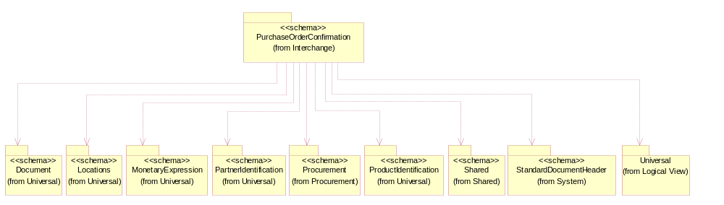
Figure ‎2-10 Dependency

Interchange Diagram
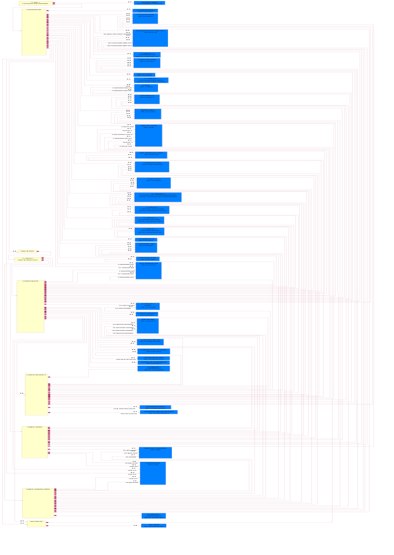
Figure ‎2-11 Interchange

OrderLineItem
The collection of business properties that describe a entry in a purchase order business document.
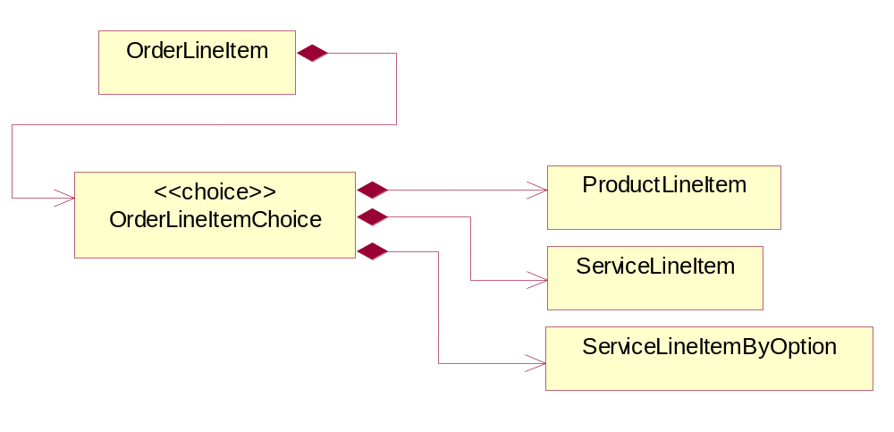
Figure ‎2-12 OrderLineItem

Composition | Cardinality | Type | Documentation
OrderLineItemChoice | 1 | OrderLineItemChoice

OrderLineItemChoice

Composition | Cardinality | Type | Documentation
ProductLineItem | 1 | ProductLineItem | The collection of business properties that describe a business document entry for a product in a purchase order business documents. The Recommended ProcessRoleIdentifier for PartnerDescription are CLF - Collect From, SHF - Ship From and SHT -Ship To.
ServiceLineItem | 1 | ServiceLineItem | The collection of business properties that describe a service entry in a purchase order business documents. The Recommended ProcessRoleIdentifier for PartnerDescription are CLF - Collect From and ITL - Install At.
ServiceLineItemByOption | 1 | ServiceLineItemByOption | The collection of business properties that describe a service entry by option (eg. by Contract, by Product or by Site) in a purchase order business documents. The Recommended ProcessRoleIdentifier for PartnerDescription are CLF - Collect From and ITL - Install At.

ProductLineItem
The collection of business properties that describe a business document entry for a product in a purchase order business documents. The Recommended ProcessRoleIdentifier for PartnerDescription are CLF - Collect From, SHF - Ship From and SHT -Ship To.
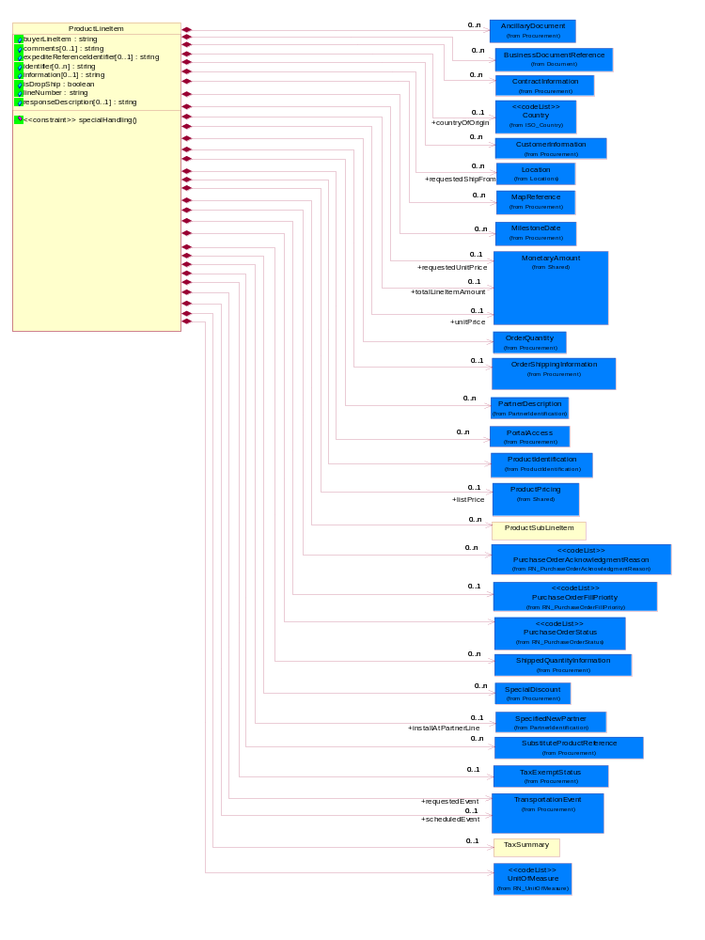
Figure ‎2-13 ProductLineItem

Attribute | Type | Documentation
buyerLineItem | string | Line number assigned to an item by the product buyer.
comments[0..1] | string | Free form textual description of a general nature.
expediteReferenceIdentifier[0..1] | string | The unique identification number for the expediting of a product.
identifier[0..n] | string | A unique serial identifier assigned to a product.
information[0..1] | string | A free form textual description of information, relating to a product.
isDropShip | boolean | Indicates whether the order is a drop shipment.
lineNumber | string | Number of the line in the document.
responseDescription[0..1] | string | This object representing the description of response.

Composition | Cardinality | Type | Documentation
ContractInformation | 0..n | ContractInformation | The collection of business properties that represent a business arrangement for the supply of goods or services at an agreed price.
CustomerInformation | 0..n | CustomerInformation | The collection of business properties that describe an end user.
PurchaseOrderFillPriority | 0..1 | PurchaseOrderFillPriority | Code identifying fill priority for manufacturing in a constrained condition. Value to be determined by Trading Partner Agreement  1 = highest priority, 5 = medium priority and 9 = lowest priority.
OrderQuantity | 1 | OrderQuantity | The collection of business properties that describe various types of product quantity used in an ordering process.
ProductSubLineItem | 0..n | ProductSubLineItem | The collection of business properties that describe a part of a product line item. The Recommended ProcessRoleIdentifier for PartnerDescription are CLF - Collect From.
TaxExemptStatus | 0..1 | TaxExemptStatus | The collection of business properties that describe tax exemption conditions.
PurchaseOrderAcknowledgmentReason | 0..n | PurchaseOrderAcknowledgmentReason | The reason for acknowledging a purchase order.
PurchaseOrderStatus | 1 | PurchaseOrderStatus | Code identifying the status of a purchase order.
UnitOfMeasure | 1 | UnitOfMeasure | Code identifying a product unit of measure.
countryOfOrigin | 0..1 | Country | Country where product originates.
ProductIdentification | 1 | ProductIdentification | The object provides the identifier(s) of a product.
SubstituteProductReference | 0..n | SubstituteProductReference | The collection of business properties describing a product that is being substituted for a requested product.
ShippedQuantityInformation | 0..n | ShippedQuantityInformation | The collection of business properties that describe information regarding the quantity of the product shipped.
OrderShippingInformation | 0..1 | OrderShippingInformation | The collection of business properties that describe information relating to shipping a product.
TaxSummary | 0..1 | TaxSummary | The collection of business properties that describe the total tax information for a local, regional or national taxing authority.
requestedShipFrom | 0..n | Location | The DUNS or DUNS + 4 number of the location where the product is requested to be shipped from.
requestedEvent | 1 | TransportationEvent | The date a transportation event is requested to occur.
installAtPartnerLine | 0..1 | SpecifiedNewPartner | The partner and/or location to which the product must be set up for use or service.
BusinessDocumentReference | 0..n | BusinessDocumentReference | The business document reference object allows for the indirect referencing of a relationship to other business related documents.
scheduledEvent | 0..1 | TransportationEvent | The date a transportation event is scheduled to occur.
SpecialDiscount | 0..n | SpecialDiscount | This object represents a special discount based on the special discount identifier.
requestedUnitPrice | 0..1 | MonetaryAmount | The price requested for a unit of product.
totalLineItemAmount | 0..1 | MonetaryAmount | The monetary total associated with a line item.
unitPrice | 0..1 | MonetaryAmount | Agreed upon sale price for each unit ordered.
listPrice | 0..1 | ProductPricing | This object represents the pre-discounted price.
AncillaryDocument | 0..n | AncillaryDocument | The collection of business properties that represents name and version of an ancillary document.
MapReference | 0..n | MapReference | The collections of business properties that represents the install-at address using either a Global Positioning Satellite reference or national mapping grid reference.
MilestoneDate | 0..n | MilestoneDate | The collection of business properties that represents milestone dates within the order fulfilment process.
PartnerDescription | 0..n | PartnerDescription | The collection of business properties that describe a business partners' identity, their contact information, where they are physically located and their function in a supply chain.
PortalAccess | 0..n | PortalAccess | The collection of business properties that represents access path, for use in downloading ancillary documents from a portal or extranet site.

Constraint | Documentation
specialHandling | At least one occurrence of dp:OrderShippingInformation/dp:SpecialHandlingInstruction/dp:Text , dp:OrderShippingInformation/dp:SpecialHandlingInstruction/dsh:SpecialHandling is required.

ProductSubLineItem
The collection of business properties that describe a part of a product line item. The Recommended ProcessRoleIdentifier for PartnerDescription are CLF - Collect From.
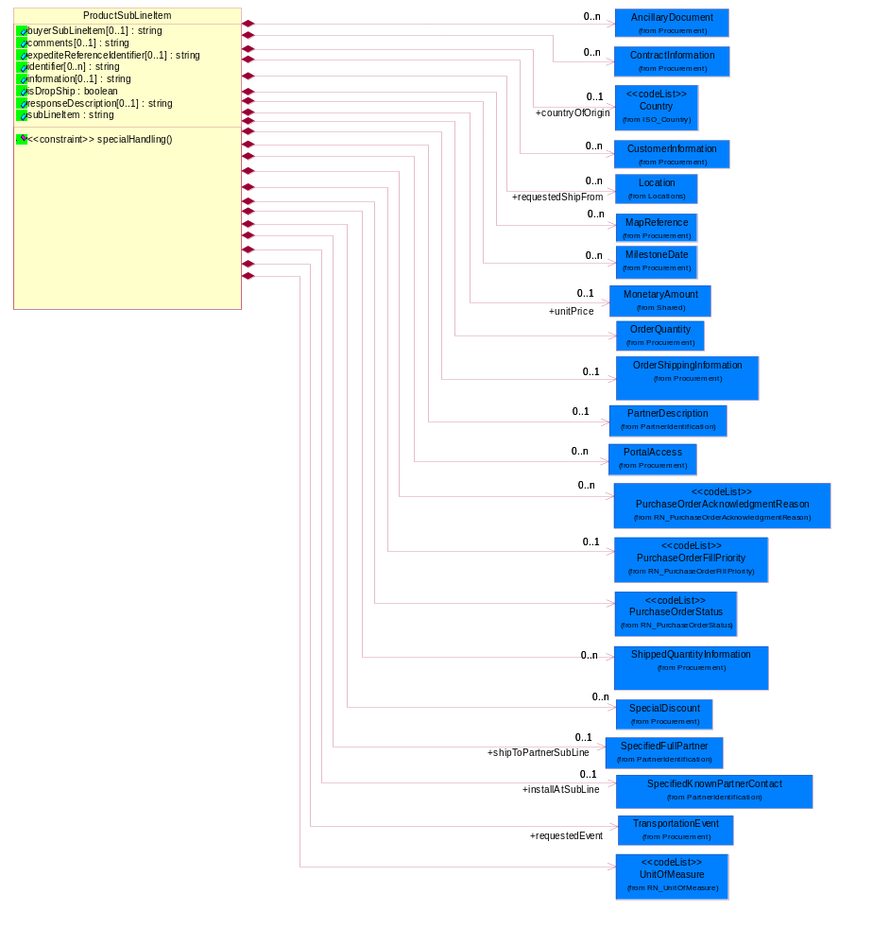
Figure ‎2-14 ProductSubLineItem

Attribute | Type | Documentation
buyerSubLineItem[0..1] | string | The information related to the original buyer submitted document and contained within the subline level.
comments[0..1] | string | Free form textual description of a general nature.
expediteReferenceIdentifier[0..1] | string | The unique identification number for the expediting of a product.
identifier[0..n] | string | A unique serial identifier assigned to a product.
information[0..1] | string | A free form textual description of information, relating to a product.
isDropShip | boolean | Indicates whether the order is a drop shipment.
responseDescription[0..1] | string | This object representing the description of response.
subLineItem | string | Information contained within a subline.

Composition | Cardinality | Type | Documentation
ContractInformation | 0..n | ContractInformation | The collection of business properties that represent a business arrangement for the supply of goods or services at an agreed price.
OrderQuantity | 1 | OrderQuantity | The collection of business properties that describe various types of product quantity used in an ordering process.
CustomerInformation | 0..n | CustomerInformation | The collection of business properties that describe an end user.
OrderShippingInformation | 0..1 | OrderShippingInformation | The collection of business properties that describe information relating to shipping a product.
PurchaseOrderFillPriority | 0..1 | PurchaseOrderFillPriority | Code identifying fill priority for manufacturing in a constrained condition. Value to be determined by Trading Partner Agreement  1 = highest priority, 5 = medium priority and 9 = lowest priority.
countryOfOrigin | 0..1 | Country | Country where product originates.
UnitOfMeasure | 1 | UnitOfMeasure | Code identifying a product unit of measure.
PurchaseOrderAcknowledgmentReason | 0..n | PurchaseOrderAcknowledgmentReason | The reason for acknowledging a purchase order.
PurchaseOrderStatus | 1 | PurchaseOrderStatus | Code identifying the status of a purchase order.
ShippedQuantityInformation | 0..n | ShippedQuantityInformation | The collection of business properties that describe information regarding the quantity of the product shipped.
requestedShipFrom | 0..n | Location | The DUNS or DUNS + 4 number of the location where the product is requested to be shipped from.
requestedEvent | 1 | TransportationEvent | The date a transportation event is requested to occur.
installAtSubLine | 0..1 | SpecifiedKnownPartnerContact | The partner and/or location to which the product must be set up for use or service.
SpecialDiscount | 0..n | SpecialDiscount | This object represents a special discount based on the special discount identifier.
unitPrice | 0..1 | MonetaryAmount | The price for a unit of product.
shipToPartnerSubLine | 0..1 | SpecifiedFullPartner | The partner and/or location to which the product must be delivered.
AncillaryDocument | 0..n | AncillaryDocument | The collection of business properties that represents name and version of an ancillary document.
MapReference | 0..n | MapReference | The collections of business properties that represents the install-at address using either a Global Positioning Satellite reference or national mapping grid reference.
MilestoneDate | 0..n | MilestoneDate | The collection of business properties that represents milestone dates within the order fulfilment process.
PartnerDescription | 0..1 | PartnerDescription | The collection of business properties that describe a business partners' identity, their contact information, where they are physically located and their function in a supply chain.
PortalAccess | 0..n | PortalAccess | The collection of business properties that represents access path, for use in downloading ancillary documents from a portal or extranet site.

Constraint | Documentation
specialHandling | At least one occurrence of dp:OrderShippingInformation/dp:SpecialHandlingInstruction/dp:Text, dp:OrderShippingInformation/dp:SpecialHandlingInstruction/dsh:SpecialHandling is required.

PurchaseOrder
The collection of business properties that describe a buyer's offer to purchase a quantity of products at an agreed price and schedule. The Recommended ProcessRoleIdentifier for PartnerDescription are ITL - Install At, BIT - Bill To, CWN - Contract Owner, SHT - Ship To, RES - Respond To, SHF - Ship From and CLF - Collect From.
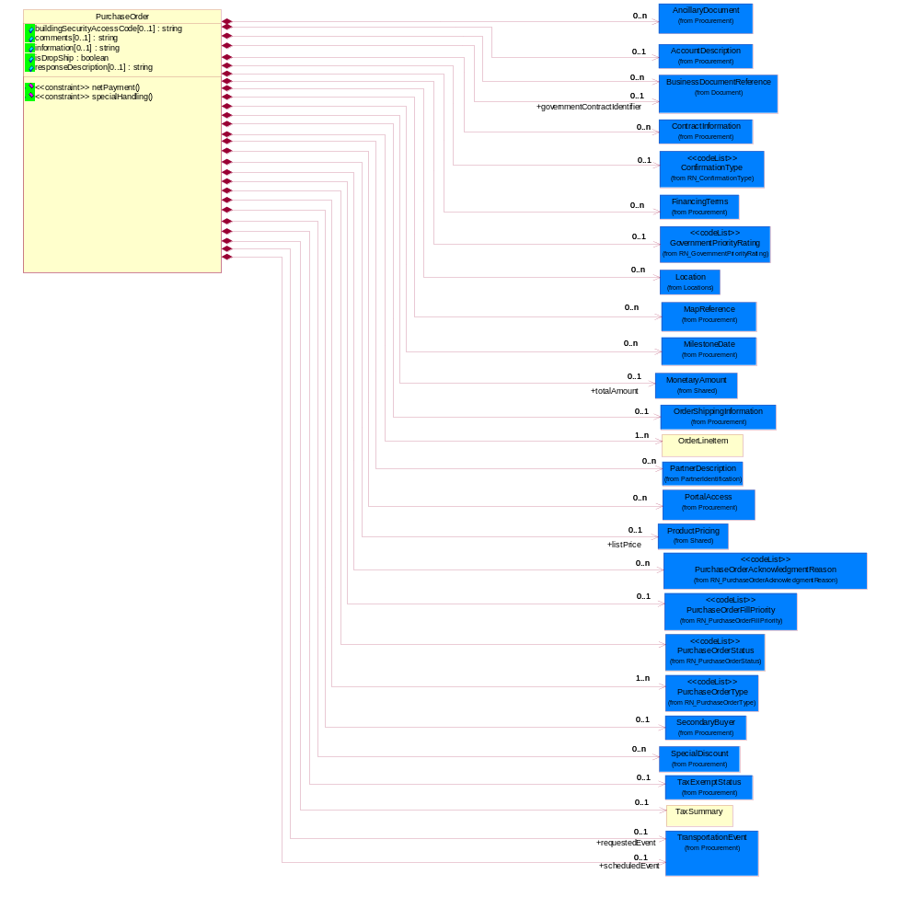
Figure ‎2-15 PurchaseOrder

Attribute | Type | Documentation
buildingSecurityAccessCode[0..1] | string | Access code which may be used to gain entry through an automated security system to an unmanned site.
comments[0..1] | string | Free form textual description of a general nature.
information[0..1] | string | A free form textual description of information, relating to a product.
isDropShip | boolean | Indicates whether the order is a drop shipment.
responseDescription[0..1] | string | This object representing the description of response.

Composition | Cardinality | Type | Documentation
AccountDescription | 0..1 | AccountDescription | The collection of business properties that describe a customer or supplier account.
ContractInformation | 0..n | ContractInformation | The collection of business properties that represent a business arrangement for the supply of goods or services at an agreed price.
GovernmentPriorityRating | 0..1 | GovernmentPriorityRating | If a contract number exists and PO type is Government, a priority rating code is required.
PurchaseOrderType | 1..n | PurchaseOrderType | Code identifying category specification for a purchase order.
PurchaseOrderFillPriority | 0..1 | PurchaseOrderFillPriority | Code identifying fill priority for manufacturing in a constrained condition. Value to be determined by Trading Partner Agreement  1 = highest priority, 5 = medium priority and 9 = lowest priority.
FinancingTerms | 0..n | FinancingTerms | The collection of business properties that describe financing terms.
OrderShippingInformation | 0..1 | OrderShippingInformation | The collection of business properties that describe information relating to shipping a product.
SecondaryBuyer | 0..1 | SecondaryBuyer | The collection of business properties that describe an alternate buyer.
TaxExemptStatus | 0..1 | TaxExemptStatus | The collection of business properties that describe tax exemption conditions.
ConfirmationType | 0..1 | ConfirmationType | A code identifying type of exception process in order to enable the back-end integration.
PurchaseOrderAcknowledgmentReason | 0..n | PurchaseOrderAcknowledgmentReason | The reason for acknowledging a purchase order.
scheduledEvent | 0..1 | TransportationEvent | The date a transportation event is scheduled to occur.
PurchaseOrderStatus | 1 | PurchaseOrderStatus | Code identifying the status of a purchase order.
TaxSummary | 0..1 | TaxSummary | The collection of business properties that describe the total tax information for a local, regional or national taxing authority.
governmentContractIdentifier | 0..1 | BusinessDocumentReference | The unique number that identifies a government contract.
Location | 0..n | Location | The DUNS or DUNS + 4 number of the location where the product is requested to be shipped from.
requestedEvent | 0..1 | TransportationEvent | The date a transportation event is requested to occur.
BusinessDocumentReference | 0..n | BusinessDocumentReference | The business document reference object allows for the indirect referencing of a relationship to other business related documents.
OrderLineItem | 1..n | OrderLineItem | The collection of business properties that describe a entry in a purchase order business document.
SpecialDiscount | 0..n | SpecialDiscount | This object represents a special discount based on the special discount identifier.
totalAmount | 0..1 | MonetaryAmount | Total price for an entire business document.
listPrice | 0..1 | ProductPricing | This object represents the pre-discounted price.
PartnerDescription | 0..n | PartnerDescription | The collection of business properties that describe a business partners' identity, their contact information, where they are physically located and their function in a supply chain.
PortalAccess | 0..n | PortalAccess | The collection of business properties that represents access path, for use in downloading ancillary documents from a portal or extranet site.
MilestoneDate | 0..n | MilestoneDate | The collection of business properties that represents milestone dates within the order fulfilment process.
MapReference | 0..n | MapReference | The collections of business properties that represents the install-at address using either a Global Positioning Satellite reference or national mapping grid reference.
AncillaryDocument | 0..n | AncillaryDocument | The collection of business properties that represents name and version of an ancillary document.

Constraint | Documentation
netPayment | At least one occurrence of dp:FinancingTerms/dp:PaymentTerms/dp:NetTerms/dp:Day , dp:FinancingTerms/dp:PaymentTerms/dp:NetTerms/dp:Days is required.
specialHandling | At least one occurrence of dp:OrderShippingInformation/dp:SpecialHandlingInstruction/dp:Text , dp:OrderShippingInformation/dp:SpecialHandlingInstruction/dsh:SpecialHandling is required.

PurchaseOrderConfirmation
Top level object for a Purchase Order business document.
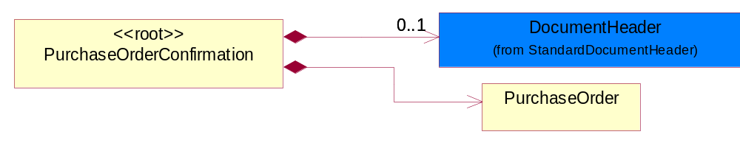
Figure ‎2-16 PurchaseOrderConfirmation

Composition | Cardinality | Type | Documentation
PurchaseOrder | 1 | PurchaseOrder | The collection of business properties that describe a buyer's offer to purchase a quantity of products at an agreed price and schedule. The Recommended ProcessRoleIdentifier for PartnerDescription are ITL - Install At, BIT - Bill To, CWN - Contract Owner, SHT - Ship To, RES - Respond To, SHF - Ship From and CLF - Collect From.
DocumentHeader | 0..1 | DocumentHeader | The object allows for the identification of the sender and receiver of the business document.

ServiceLineItem
The collection of business properties that describe a service entry in a purchase order business documents. The Recommended ProcessRoleIdentifier for PartnerDescription are CLF - Collect From and ITL - Install At.
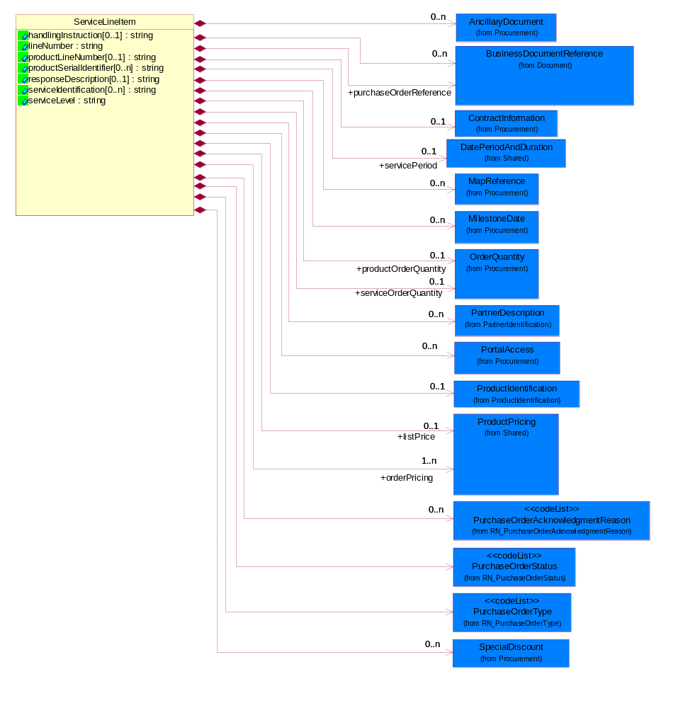
Figure ‎2-17 ServiceLineItem

Attribute | Type | Documentation
handlingInstruction[0..1] | string | Free form textual description of instructions.
lineNumber | string | Number of the line in the document.
productLineNumber[0..1] | string | The object that representing the line number of the referenced product line item.
productSerialIdentifier[0..n] | string | A unique serial identifier assigned to a product.
responseDescription[0..1] | string | This object representing the description of response.
serviceIdentification[0..n] | string | A unique serial identifier assigned to a service.
serviceLevel | string | The object that representing the type of service or service name.

Composition | Cardinality | Type | Documentation
ProductIdentification | 0..1 | ProductIdentification | The object provides the identifier(s) of a product.
ContractInformation | 0..1 | ContractInformation | The collection of business properties that represent a business arrangement for the supply of goods or services at an agreed price.
SpecialDiscount | 0..n | SpecialDiscount | This object represents a special discount based on the special discount identifier.
serviceOrderQuantity | 0..1 | OrderQuantity | The collection of business properties that describe service quantity.
PurchaseOrderAcknowledgmentReason | 0..n | PurchaseOrderAcknowledgmentReason | The reason for acknowledging a purchase order.
PurchaseOrderStatus | 1 | PurchaseOrderStatus | Code identifying the status of a purchase order.
BusinessDocumentReference | 0..n | BusinessDocumentReference | The business document reference object allows for the indirect referencing of a relationship to other business related documents.
PurchaseOrderType | 1 | PurchaseOrderType | Code identifying category specification for a purchase order.
purchaseOrderReference | 1 | BusinessDocumentReference | The purchase order reference object allows for the indirect referencing of a relationship to other purchase order documents.
productOrderQuantity | 0..1 | OrderQuantity | The collection of business properties that describe product quantity.
servicePeriod | 0..1 | DatePeriodAndDuration | This object allows representation of a date period by a duration or begin and an end dates for a service period.
orderPricing | 1..n | ProductPricing | The collection of business properties that describe the type of pricing and financial amount for a purchase order.
listPrice | 0..1 | ProductPricing | This object represents the pre-discounted price.
PartnerDescription | 0..n | PartnerDescription | The collection of business properties that describe a business partners' identity, their contact information, where they are physically located and their function in a supply chain.
AncillaryDocument | 0..n | AncillaryDocument | The collection of business properties that represents name and version of an ancillary document.
MapReference | 0..n | MapReference | The collections of business properties that represents the install-at address using either a Global Positioning Satellite reference or national mapping grid reference.
MilestoneDate | 0..n | MilestoneDate | The collection of business properties that represents milestone dates within the order fulfilment process.
PortalAccess | 0..n | PortalAccess | The collection of business properties that represents access path, for use in downloading ancillary documents from a portal or extranet site.

ServiceLineItemByOption
The collection of business properties that describe a service entry by option (eg. by Contract, by Product or by Site) in a purchase order business documents. The Recommended ProcessRoleIdentifier for PartnerDescription are CLF - Collect From and ITL - Install At.
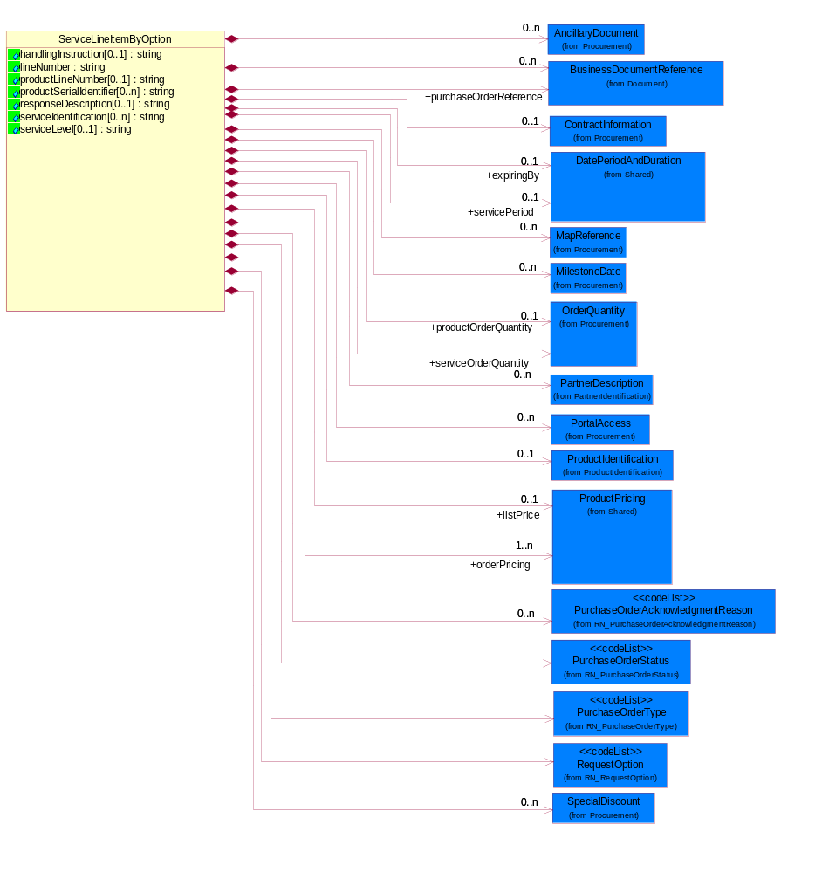
Figure ‎2-18 ServiceLineItemByOption

Attribute | Type | Documentation
handlingInstruction[0..1] | string | Free form textual description of instructions.
lineNumber | string | Number of the line in the document.
productLineNumber[0..1] | string | The object that representing the line number of the referenced product line item.
productSerialIdentifier[0..n] | string | A unique serial identifier assigned to a product.
responseDescription[0..1] | string | This object representing the description of response.
serviceIdentification[0..n] | string | A unique serial identifier assigned to a service.
serviceLevel[0..1] | string | The object that representing the type of service or service name.

Composition | Cardinality | Type | Documentation
BusinessDocumentReference | 0..n | BusinessDocumentReference | The business document reference object allows for the indirect referencing of a relationship to other business related documents.
ContractInformation | 0..1 | ContractInformation | The collection of business properties that represent a business arrangement for the supply of goods or services at an agreed price.
serviceOrderQuantity | 1 | OrderQuantity | The collection of business properties that describe service quantity.
ProductIdentification | 0..1 | ProductIdentification | The object provides the identifier(s) of a product.
PurchaseOrderAcknowledgmentReason | 0..n | PurchaseOrderAcknowledgmentReason | The reason for acknowledging a purchase order.
PurchaseOrderStatus | 1 | PurchaseOrderStatus | Code identifying the status of a purchase order.
PurchaseOrderType | 1 | PurchaseOrderType | Code identifying category specification for a purchase order.
RequestOption | 1 | RequestOption | Code identifying an option for a request, eg. quote request or order request.
SpecialDiscount | 0..n | SpecialDiscount | This object represents a special discount based on the special discount identifier.
purchaseOrderReference | 1 | BusinessDocumentReference | The purchase order reference object allows for the indirect referencing of a relationship to other purchase order documents.
productOrderQuantity | 0..1 | OrderQuantity | The collection of business properties that describe product quantity.
servicePeriod | 0..1 | DatePeriodAndDuration | This object allows representation of a date period by a duration or begin and an end dates for a service period.
expiringBy | 0..1 | DatePeriodAndDuration | Renew all products expiring in this specific period.
orderPricing | 1..n | ProductPricing | The collection of business properties that describe the type of pricing and financial amount for a purchase order.
listPrice | 0..1 | ProductPricing | This object represents the pre-discounted price.
PartnerDescription | 0..n | PartnerDescription | The collection of business properties that describe a business partners' identity, their contact information, where they are physically located and their function in a supply chain.
AncillaryDocument | 0..n | AncillaryDocument | The collection of business properties that represents name and version of an ancillary document.
MapReference | 0..n | MapReference | The collections of business properties that represents the install-at address using either a Global Positioning Satellite reference or national mapping grid reference.
MilestoneDate | 0..n | MilestoneDate | The collection of business properties that represents milestone dates within the order fulfilment process.
PortalAccess | 0..n | PortalAccess | The collection of business properties that represents access path, for use in downloading ancillary documents from a portal or extranet site.

TaxSummary
The collection of business properties that describe the total tax information for a local, regional or national taxing authority.
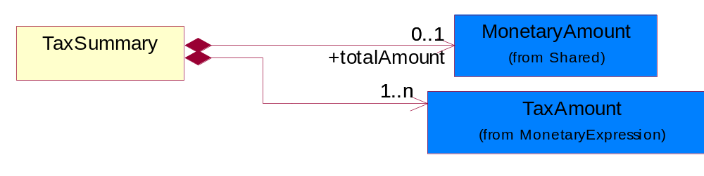
Figure ‎2-19 TaxSummary

Composition | Cardinality | Type | Documentation
TaxAmount | 1..n | TaxAmount | The business document must include a tax amount(s).
totalAmount | 0..1 | MonetaryAmount | The collection of business properties that describe the total of amount being taxed.

Domain Model

Procurement

Dependency Diagram
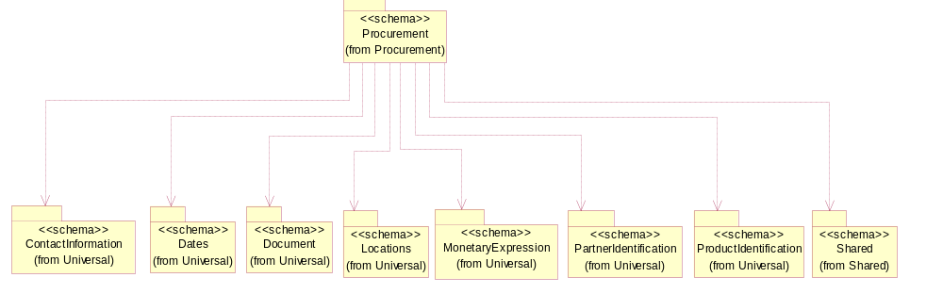
Figure ‎3-20 Dependency

AccountDescription
The collection of business properties that describe a customer or supplier account.
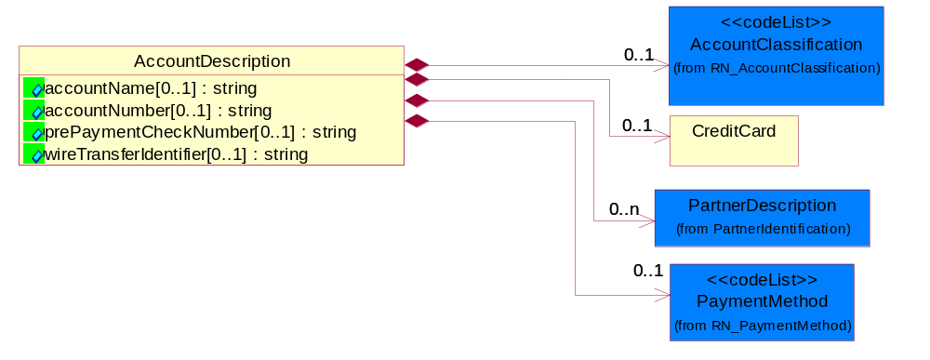
Figure ‎3-21 AccountDescription

Attribute | Type | Documentation
accountName[0..1] | string | The name of a bank account.
accountNumber[0..1] | string | Identification number of an account.
prePaymentCheckNumber[0..1] | string | The check number issued to prepay a monetary amount for an account.
wireTransferIdentifier[0..1] | string | A unique identity of a wire transfer used for reference.

Composition | Cardinality | Type | Documentation
AccountClassification | 0..1 | AccountClassification | Account classification indicating its functionality, e.g., credit card account, debit card account.
CreditCard | 0..1 | CreditCard | A collection of business properties that describe information about a credit card.
PartnerDescription | 0..n | PartnerDescription | The collection of business properties that describe a business partners' identity, their contact information, where they are physically located and their function in a supply chain.
PaymentMethod | 0..1 | PaymentMethod | Code identifying how the trading partner paid the seller for the product.

AlternativeEvent
The structure represents proprietary milestone date description, for use by exception if no entry from the Event code list is appropriate.
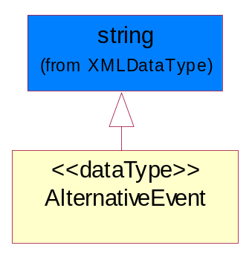
Figure ‎3-22 AlternativeEvent

AncillaryDocument
The collection of business properties that represents name and version of an ancillary document.
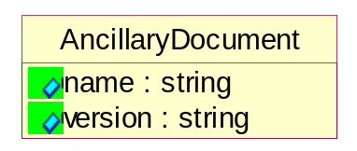
Figure ‎3-23 AncillaryDocument

Attribute | Type | Documentation
name | string | Text field containing the name of each ancillary document associated with the order.
version | string | Text field associated with each document name to identify the version according to a numbering or coding sequence agreeable in the TPA.

ContractInformation
The collection of business properties that represent a business arrangement for the supply of goods or services at an agreed price.
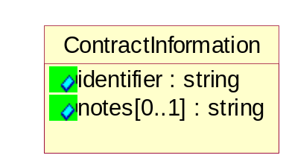
Figure ‎3-24 ContractInformation

Attribute | Type | Documentation
identifier | string | The unique number than identifies a contract.
notes[0..1] | string | A textual description about contract.

CreditCard
A collection of business properties that describe information about a credit card.
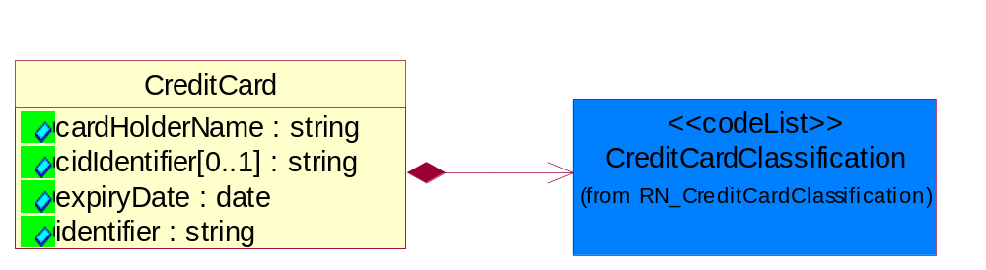
Figure ‎3-25 CreditCard

Attribute | Type | Documentation
cardHolderName | string | The name of the owner of a credit card.
cidIdentifier[0..1] | string | Unique identifier for credit card purchase activity utilized by American Express.
expiryDate | date | The date that a contractual agreement expires.
identifier | string | The unique number that identifies a credit card.

Composition | Cardinality | Type | Documentation
CreditCardClassification | 1 | CreditCardClassification | Code identifying the type of credit card used.

CustomerInformation
The collection of business properties that describe an end user.
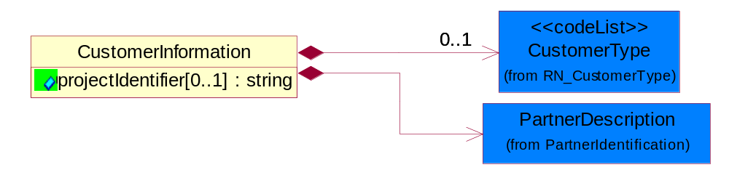
Figure ‎3-26 CustomerInformation

Attribute | Type | Documentation
projectIdentifier[0..1] | string | The unique identification number that identifies a project for a given customer.

Composition | Cardinality | Type | Documentation
CustomerType | 0..1 | CustomerType | Code identifying the type of end user.
PartnerDescription | 1 | PartnerDescription | The collection of business properties that describe a business partners' identity, their contact information, where they are physically located and their function in a supply chain.

DayOfMonth
Specifies a specific day within a month. Value range from 1 to 31.
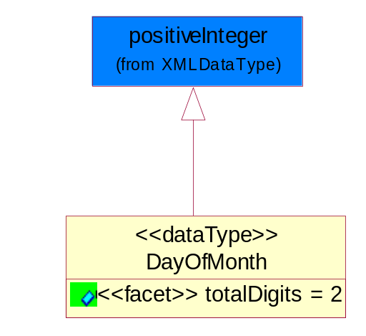
Figure ‎3-27 DayOfMonth

Attribute | Type | Documentation
totalDigits |  | Value with specific maximum number of decimal digits. For more information, see the W3C XML Schema Part 2: Datatypes Recommendation at http://www.w3.org/TR/2001/REC-xmlschema-2-20010502/#element-totalDigits.

Discounts
The collection of business properties that describe payment discounts.
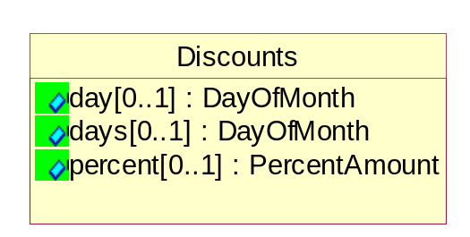
Figure ‎3-28 Discounts

Attribute | Type | Documentation
day[0..1] | DayOfMonth | The specific day of the month a payment is required in order to receive a discount.
days[0..1] | DayOfMonth | The number of days within which a payment is required in order to receive a discount.
percent[0..1] | PercentAmount | The financial percent representing a reduction to the total amount due.

FinancingTerms
The collection of business properties that describe financing terms.
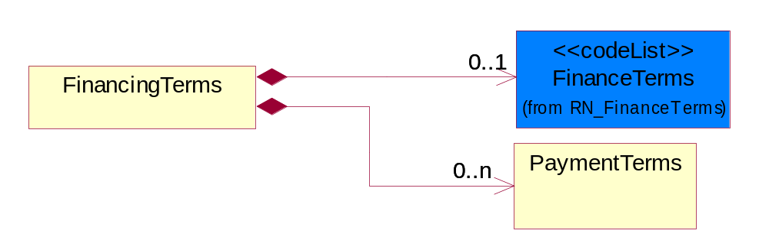
Figure ‎3-29 FinancingTerms

Composition | Cardinality | Type | Documentation
FinanceTerms | 0..1 | FinanceTerms | Code identifying the terms that govern financing.
PaymentTerms | 0..n | PaymentTerms | The collection of business properties that describe payment terms.

MapReference
The collections of business properties that represents the install-at address using either a Global Positioning Satellite reference or national mapping grid reference.
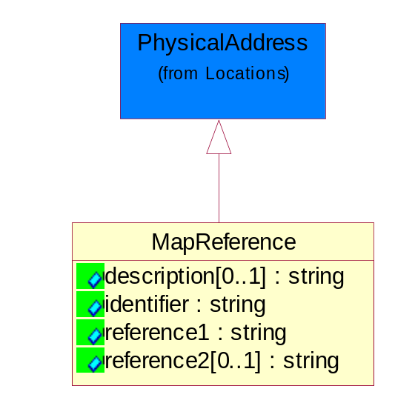
Figure ‎3-30 MapReference

Attribute | Type | Documentation
description[0..1] | string | Describe the map reference for the installation work that has a distinct start and end point which are separated by a significant distance.
identifier | string | Identifier which specifies whether the reference is a GPS reference or a map grid reference.
reference1 | string | Complete map reference in one string (eg. 2 Letter Code + Longitude + Latitude).
reference2[0..1] | string | Additional map reference.

MilestoneDate
The collection of business properties that represents milestone dates within the order fulfilment process.
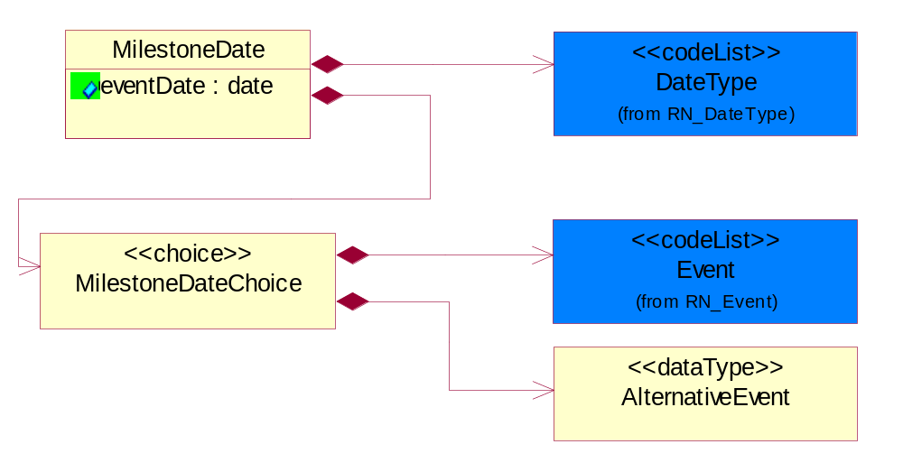
Figure ‎3-31 MilestoneDate

Attribute | Type | Documentation
eventDate | date | Milestone date.

Composition | Cardinality | Type | Documentation
DateType | 1 | DateType | Identifier which occurs with each milestone date to indicate whether the date is Planned, Forecast or Actual.
MilestoneDateChoice | 1 | MilestoneDateChoice | The choice structure to use Event codelist or AlternativeEvent datatype.

MilestoneDateChoice
The choice structure to use Event codelist or AlternativeEvent datatype.

Composition | Cardinality | Type | Documentation
Event | 1 | Event | Possible milestone dates within the life of an installation project. For example: Site Inspection Date; Earliest Start Date and etc.
AlternativeEvent | 1 | AlternativeEvent | The structure represents proprietary milestone date description, for use by exception if no entry from the Event code list is appropriate.

NetTerms
The collection of business properties that describe net payment due terms.
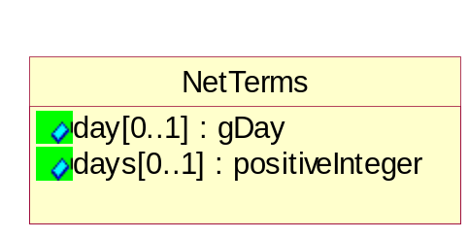
Figure ‎3-32 NetTerms

Attribute | Type | Documentation
day[0..1] | gDay | The specific day of the month a payment is due without incurring late charges.
days[0..1] | positiveInteger | The number of days within which a payment is due without incurring late charges.

OrderQuantity
The collection of business properties that describe various types of product quantity used in an ordering process.
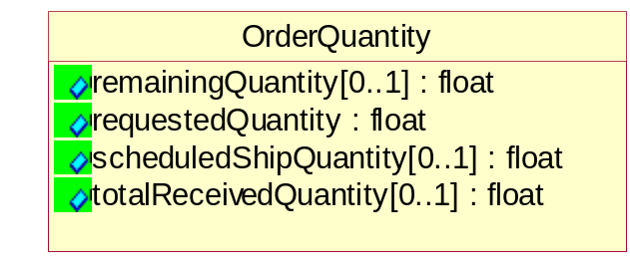
Figure ‎3-33 OrderQuantity

Attribute | Type | Documentation
remainingQuantity[0..1] | float | The quantity of product still remaining to be delivered.
requestedQuantity | float | The quantity of product requested.
scheduledShipQuantity[0..1] | float | Quantity of product shipped currently scheduled for shipment.
totalReceivedQuantity[0..1] | float | The total quantity of product received.

OrderShippingInformation
The collection of business properties that describe information relating to shipping a product.
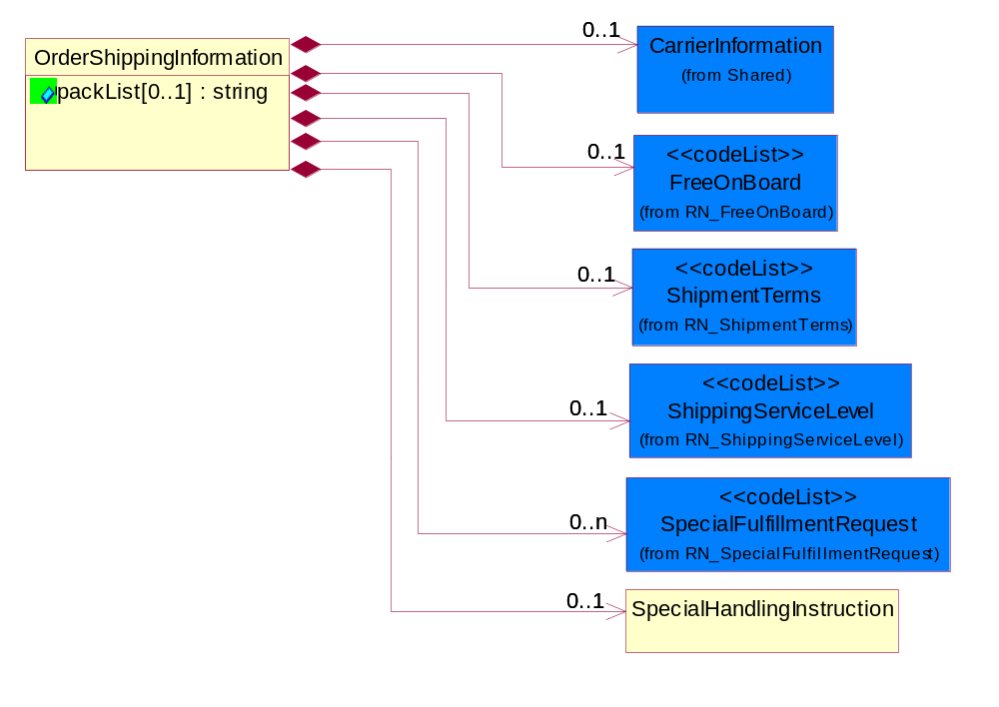
Figure ‎3-34 OrderShippingInformation

Attribute | Type | Documentation
packList[0..1] | string | Free form textual description, on the pack list, of requirements relating to the packing of the product.

Composition | Cardinality | Type | Documentation
SpecialFulfillmentRequest | 0..n | SpecialFulfillmentRequest | Code identifying a special fulfillment request, e.g. delivery options.
SpecialHandlingInstruction | 0..1 | SpecialHandlingInstruction | The collection of business properties that describe product packaging or shipping handling instructions.
ShipmentTerms | 0..1 | ShipmentTerms | Code identifying the terms under which a product is shipped.
CarrierInformation | 0..1 | CarrierInformation | The collection of business properties that describe a carrier's identification.
FreeOnBoard | 0..1 | FreeOnBoard | Code identifying a specified point where a product is delivered or placed on board a carrier without charge.
ShippingServiceLevel | 0..1 | ShippingServiceLevel | Code identifying the shipping service level, e.g., overnight, same day.

PaymentTerms
The collection of business properties that describe payment terms.
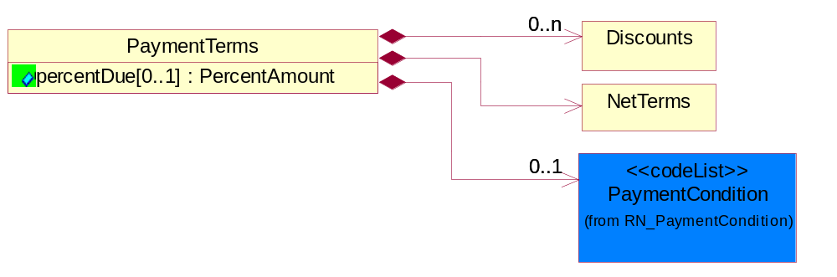
Figure ‎3-35 PaymentTerms

Attribute | Type | Documentation
percentDue[0..1] | PercentAmount | The amount owed expressed as a percentage.

Composition | Cardinality | Type | Documentation
PaymentCondition | 0..1 | PaymentCondition | A code identifying the conditions under which payment will be made.
Discounts | 0..n | Discounts | The collection of business properties that describe payment discounts.
NetTerms | 1 | NetTerms | The collection of business properties that describe net payment due terms.

PortalAccess
The collection of business properties that represents access path, for use in downloading ancillary documents from a portal or extranet site.
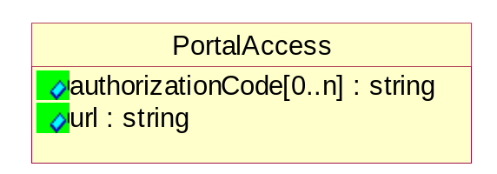
Figure ‎3-36 PortalAccess

Attribute | Type | Documentation
authorizationCode[0..n] | string | Authorization code to portal or extranet where multiple occurences containing access codes such as passwords, PIN numbers etc.
url | string | Hyperlink reference to portal or extranet where ancillary documents can be downloaded.

SecondaryBuyer
The collection of business properties that describe an alternate buyer.
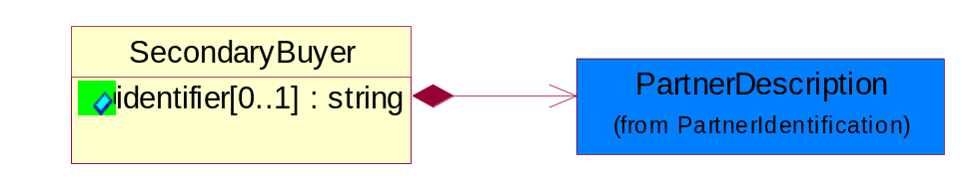
Figure ‎3-37 SecondaryBuyer

Attribute | Type | Documentation
identifier[0..1] | string | Unique number that identifies a purchase order issued by the secondary buyer.

Composition | Cardinality | Type | Documentation
PartnerDescription | 1 | PartnerDescription | The collection of business properties that describe a business partners' identity, their contact information, where they are physically located and their function in a supply chain.

ShippedQuantityInformation
The collection of business properties that describe information regarding the quantity of the product shipped.
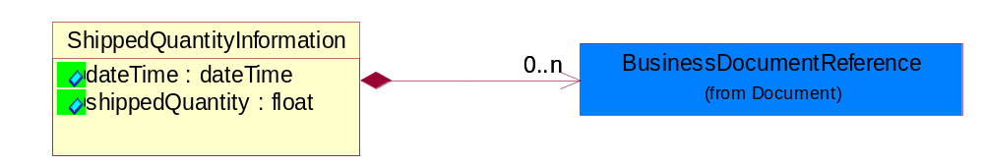
Figure ‎3-38 ShippedQuantityInformation

Attribute | Type | Documentation
dateTime | dateTime | The Date that the specified quantity was shipped.
shippedQuantity | float | Quantity of product shipped.

Composition | Cardinality | Type | Documentation
BusinessDocumentReference | 0..n | BusinessDocumentReference | The business document reference object allows for the indirect referencing of a relationship to other business related documents.

SpecialDiscount
This object represents a special discount based on the special discount identifier.
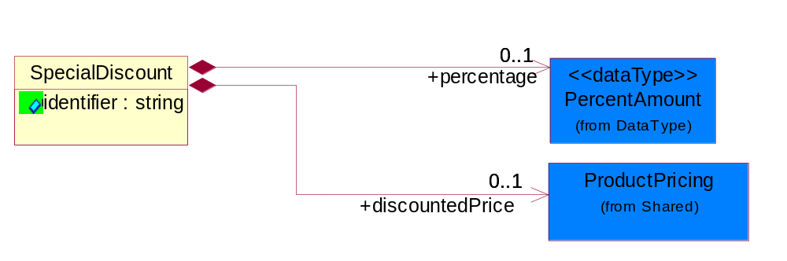
Figure ‎3-39 SpecialDiscount

Attribute | Type | Documentation
identifier | string | This object representing the special discount identifier.

Composition | Cardinality | Type | Documentation
percentage | 0..1 | PercentAmount | This object represents a special discount percentage.
discountedPrice | 0..1 | ProductPricing | This object represents a special discount price.

SpecialHandlingInstruction
The collection of business properties that describe product packaging or shipping handling instructions.
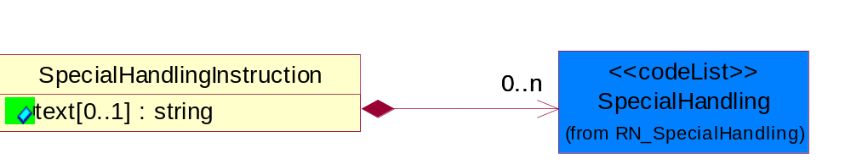
Figure ‎3-40 SpecialHandlingInstruction

Attribute | Type | Documentation
text[0..1] | string | Free form textual description for how specified goods, packages or containers should be handled.

Composition | Cardinality | Type | Documentation
SpecialHandling | 0..n | SpecialHandling | Code identifying special handling or packaging requirements for the product.

SubstituteProductReference
The collection of business properties describing a product that is being substituted for a requested product.
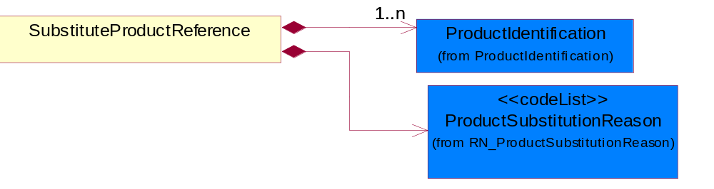
Figure ‎3-41 SubstituteProductReference

Composition | Cardinality | Type | Documentation
ProductSubstitutionReason | 1 | ProductSubstitutionReason | A code identifying the reason a product is substituted for the original product requested.
ProductIdentification | 1..n | ProductIdentification | The object provides the identifier(s) of a product.

TaxExemption
The collection of business properties that describe tax exemption type and identification information.
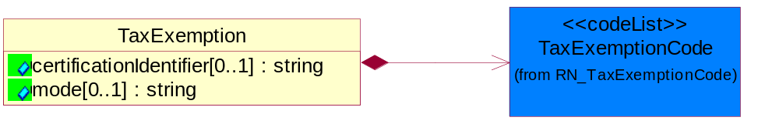
Figure ‎3-42 TaxExemption

Attribute | Type | Documentation
certificationIdentifier[0..1] | string | The unique identifier that represents the authorization for a product or service's tax exempt status.
mode[0..1] | string | This object refering to the tax exemption mode by Customs against goods declared eg. duty free, partial tax exemption or full tax exemption.

Composition | Cardinality | Type | Documentation
TaxExemptionCode | 1 | TaxExemptionCode | Code identifying the type of tax exemption for a product or service.

TaxExemptStatus
The collection of business properties that describe tax exemption conditions.
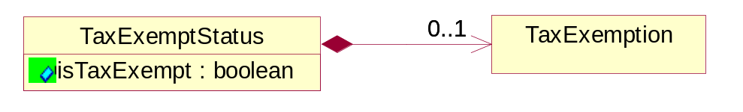
Figure ‎3-43 TaxExemptStatus

Attribute | Type | Documentation
isTaxExempt | boolean | Indicates whether a product is exempt from taxation.

Composition | Cardinality | Type | Documentation
TaxExemption | 0..1 | TaxExemption | The collection of business properties that describe tax exemption type and identification information.

TransportationEvent
The collection of business properties that describe the occurrence of the public conveyance of goods as a commercial enterprise.
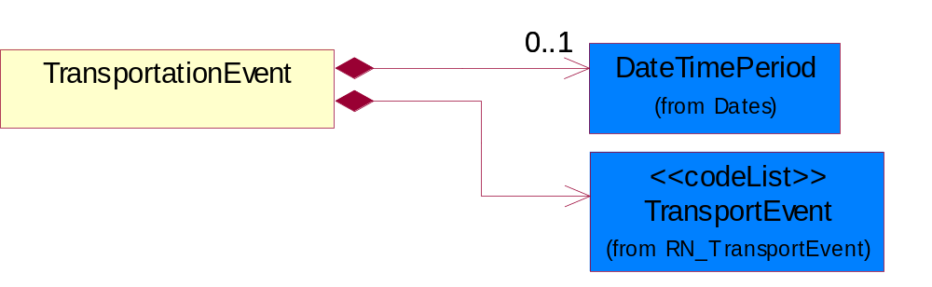
Figure ‎3-44 TransportationEvent

Composition | Cardinality | Type | Documentation
TransportEvent | 1 | TransportEvent | Code identifying an event during the transportation of a shipment.
DateTimePeriod | 0..1 | DateTimePeriod | The business document must allow for the computation or statement of a period of time based upon date and time.

CodeList

TransportEvent
Code identifying an event during the transportation of a shipment.

Name | Documentation
DOC | Dock.
PIC | Pickup.
SHP | Ship.

FinanceTerms
Code identifying the terms that govern financing.

Name | Documentation
BDO | Basic Discount Offered.
BNK | Bank transfer.
CDC | Credit card.
CSM | Consignment.
EPS | Electronic Payment System.
IKP | In Kind Payment.
LOC | Letter of Credit.
LSA | Lease agreement.
MDT | Mutually defined/determined by TPA.
NMI | Net month following invoice.
PBC | Pay by Check.
PCC | Prepay Credit Card.
PPC | Prepay check.
PPW | Prepay wire.
PVC | Previously charged.
PVN | Private netting.
TET | Terms established/determined by TPA.
WRT | Wire transfer.
WVD | Waived.

CreditCardClassification
Code identifying the type of credit card used.

Name | Documentation
AMX | American express.
DIS | Discover.
EUC | EuroCard.
JCU | Japanese Credit Union.
MAC | Master card.
PRO | Procurement.
VIS | Visa.

AccountClassification
Account classification indicating its functionality, e.g., credit card account, debit card account.

Name | Documentation
CHK | Checking.
CRC | Credit Card.
SAV | Savings.

PaymentCondition
A code identifying the conditions under which payment will be made.

Name | Documentation
ACC | Acceptance - Acceptance by buyer of tool/machine to be in working order per spec/contract.
CON | Consumption.
REG | Receipt of Goods.
REI | Receipt of Invoice.
SHI | Shipment.

ConfirmationType
A code identifying type of exception process in order to enable the back-end integration.

Name | Documentation
AMC | Accept with Multiple Changes.
ANC | Accept with No Change.
APC | Accept with Price Change.
APS | Accept with Product Substitution.
ASC | Accept with delivery schedule change.

GovernmentPriorityRating
If a contract number exists and PO type is Government, a priority rating code is required.

Name | Documentation
ATE | Atomic energy.
DEF | Defense.
DOE | Domestic energy.
ENP | Energy and related programs.
OTH | Other Defense.

PurchaseOrderStatus
Code identifying the status of a purchase order.

Name | Documentation
ACC | Accept.
CAN | Cancel.
COM | Complete.
FCL | Finally Closed - Cannot be opened any further updates.
NEW | New - Initial state or and has not been amended yet.
PAR | Partial.
PEN | Pending.
REJ | Reject.
UPD | Update - Open and amended.

PurchaseOrderType
Code identifying category specification for a purchase order.

Name | Documentation
ADD | Order for adding product/service to existing contract.
BLA | Blanket - Osrder quantity for blanket type purchase order is understood to be a blanket quantity maximum.
CCO | Order for contract changes - This order will change the contract.
COO | Consigned Order.
DCO | Order for downgrading contract - This order will downgrade the contract.
DNS | Do Not Ship/invoice only.
DSO | Direct Sales Order.
ERS | ERS, Self Billing Invoise (SBI).
ESD | ESD.
EVA | Evaluation.
EXO | Exchange Order, PO generated to exchange a product that is not related to Warranty Replacement.
FUL | Fulfillment.
GOV | Government.
MSCP | Order handled via Managed Service Channel.
NCO | Order for new contract - This order will initiate a new contract.
NON | Non-cancelable/non-returnable.
PAP | Packaged Product.
PRD | Production, for mass production wafer.
QUO | Quote to order.
RCO | Order for contract renewal - This order will renew the contract.
REP | Repair.
RPD | Risk Production, before the yield is qualifed, the buyer requests the wafer manufacturer to produce the wafer according to the current spec., however, the manufacturer is not responsible for the yield.
RPN | Replenishment, PO generated to replenish stock to achieve target levels.
RWK | Rework.
SAM | Sample.
SIT | Site - Applicable to a single geographical site.
SSO | Standard Sales Order.
STD | Standard.
SVC | Service.
UCO | Order for upgrading contract - This order will upgrade the contract.
WDW | Worldwide - Applicable to worldwide.
WRM | Warranty Replacement.
WRP | Warranty Repair.

CustomerType
Code identifying the type of end user.

Name | Documentation
ENC | End customer.
ULC | Ultimate customer.

ProductSubstitutionReason
A code identifying the reason a product is substituted for the original product requested.

Name | Documentation
BEP | Better Product - The requested part number is currently not available offering product upgrade.
CMP | Component of the identified product is a component of this referenced product.
DWN | Downgrade - The identified product is a downgrade for this referenced product.
IPN | Invalid Part Number - The requested part number is invalid.
PRE | Predecessor - The product that existed prior.
QRH | Quality / Reliability Hold.
REP | Retired product - The requested part number is no longer available.
RPL | Replace - The identified product is a replacement for this referenced product.
SCC | Successor - The superseding product that will be replacing the current product.

PurchaseOrderAcknowledgmentReason
The reason for acknowledging a purchase order.

Name | Documentation
ACC | Accept with Changes.
ALA | Already Acknowledged.
CNO | Contract Number - Invalid or missing contract number.
CRH | Credit Hold.
DAT | Date - Invalid or missing date.
DSN | Duplicate serial number.
EXR | Export Restricted.
IBI | Invalid buyer ID.
IBT | Invalid Bill To - Use if Bill To is missing or invalid.
IFC | Invalid Fulfillment Code - Use if unsupported Fulfillment Code or the code is not the same for all the lines in the purchase order.
IGT | Invalid GTIN.
IID | Invalid ID.
INB | Invalid Billing.
INC | Invalid Configuration.
INI | Insufficient Inventory.
INP | Invalid Product.
IPL | Invalid Price List.
IPO | Purchase Order Number - Invalid or missing purchase order number.
IQR | Invalid Quote Reference.
ISL | Invalid or missing service level or service type.
ISN | Invalid or missing serial number.
IST | Invalid Ship To - User if Ship To is missing or invalid.
NAU | Not Authorized to sell.
OGT | Obsolete GTIN.
PAR | Part Replacement.
PAS | Part Substitution.
PEN | Pending.
PPO | Packaged Product Only - no licenses.
PRI | Pricing - Invalid or missing price.
PRS | Product already Shipped.
QTY | Quantity - Invalid or missing quantity.
RNC | Reject - Non-Cancel/non-returnable.
RNW | Reject - Nsot within cancellation window.
SCR | See Comments for Reason.
SRL | Service Location - Invalid or missing service location.

PurchaseOrderFillPriority
Code identifying fill priority for manufacturing in a constrained condition. Value to be determined by Trading Partner Agreement
1 = highest priority, 5 = medium priority and 9 = lowest priority.

Name | Documentation
HIG | High.
LOW | Low.
MED | Medium.
PR1 | Priority 1.
PR2 | Priority 2.
PR3 | Priority 3.
PR4 | Priority 4.
PR5 | Priority 5.
PR6 | Priority 6.
PR7 | Priority 7.
PR8 | Priority 8.
PR9 | Priority 9.

ShipmentTerms
Code identifying the terms under which a product is shipped.

Name | Documentation
ADC | Advance collect.
ADP | Advance prepaid.
CAA | Cash in advance.
CAD | Cash on delivery.
CFC | Collect, freight credited to payment customer.
CFR | Cost and freight.
CIF | Cost, Insurance and Freight.
CIP | Carriage and Insurance Paid to.
COL | Collect.
CPT | Carriage Paid To.
CRC | Credit card.
CUP | Customer pick-up/backhaul.
DAF | Delivered at Frontier.
DDP | Delivered Duty Paid.
DDU | Delivered Duty Unpaid.
DEQ | Delivered Exquay.
DES | Delivered Ex Ship.
EXW | Ex Works.
FAS | Free Alongside Ship.
FCA | Free Carrier.
FOB | Free On Board.
LEC | Letter of Credit.
NOS | Not specified.
PAE | Payable elsewhere.
PCC | Prepaid but charged to customer.
PIU | Pickup.
PRE | Prepaid only.
PRS | Prepaid (by seller).
RFC | Return container freight paid by customer.
RFF | Return container freight free.
RFS | Return container freight paid by supplier.
TPP | Third Party Pay.

SpecialFulfillmentRequest
Code identifying a special fulfillment request, e.g. delivery options.

Name | Documentation
AQM | Add quantity to make minimum weight requirement.
BIG | Bid Guarantee.
BON | Back order only if new item.
BOO | Back order if out of stock.
BOS | Back order if items are out of stock or not yet published.
COM | Combined small disadvantaged business and labor surplus area set-aside.
CON | Consignment.
CSD | Consolidate Delivery.
DNP | Do Not Preship.
DNS | Do not ship/invoice only.
EIQ | Exclude Import Quota in First Cost.
EPA | Equal Product Allowed.
FAS | Factory Ship.
FIK | Fill or kill.
GUS | Guaranteed Sale.
IIQ | Include Import Quota in First Cost.
LPS | Large purchase set-aside for small business.
LSA | Labor surplus area set-Aside.
MAP | May Preship.
MUD | Mutually Defined.
MYA | Multi-year Award.
NBO | No Back Order.
NOS | No Substitutes.
NPS | Notify prior to shipment if quantity specified is not available.
OQB | On Qualified Bidders List.
OQM | On Qualified Manufacturers List.
OUS | Other Unlisted Sales Condition.
PLS | Partial labor surplus area set aside.
RAS | Restricted to approved sources.
REI | Restricted to educational institutions.
RHB | Restricted to historically black college or university or minority institution.
RIP | Restricted to industrial preparedness program participants.
RQP | Restricted to Qualified Products List (QPL) Products.
RUC | Restricted to U.S. and Canadian Sources.
RYI | Restricted to Young Investigator Program.
SA8 | Section (8a) set-aside.
SAI | Set-aside for american indian-owned business.
SAS | Ship as soon as possible.
SBA | Ship Per Release or Buyer Authorization.
SBS | Small business with small disadvantaged business consideration set-aside.
SDS | Small disadvantaged business set-aside.
SFT | Ship Full Truck only.
SHC | Ship Complete.
SIA | Substitute Item Allowed.
SIP | Ship In-Place.
SMP | Small purchase set aside for small businesses.
SP1 | Ship Partial - balance back order.
SP2 | Ship Partial - Balance Cancel.
SP3 | Ship Partial - Balance Substitute.
SP4 | Ship Partial - Carload Lots Only.
SP5 | Ship Partial - Item Qty Proportional To Total Order.
SP6 | Ship Partial - Truckload Lots Only.
SPR | Ship Per Release.
SPS | Ship Per Schedule.
SRA | Small Remaining Balance Cancellation Allowed.
SRN | Small Remaining Balance Cancellation Not Allowed.
URP | Unrestricted Procurement.
WAR | Warranty.
WHS | Warehouse Ship.

TaxExemptionCode
Code identifying the type of tax exemption for a product or service.

Name | Documentation
AGR | Agriculture.
AQT | Tax exemption for aquatic product for open-sea fishery.
BTL | Tax exemption for border trade with low value - import/export of goods with low value at border.
CPT | Exempt - From County Property Tax.
CRT | Tax exemption for charity - levy free import of commodity for helping the poor charity from beyond the border non-refundable donation to within-border.
CSM | Tax exemption for consignment of assembly and replenishment material and export of finished product.
DIS | Disabled.
DIV | Disabled Veteran.
DPI | Direct Pay ID.
DRD | Tax exemption for disaster relief donation - import goods using disaster relief donation.
EFE | Exempt - For export.
EFR | Exempt - For resale.
EVD | Tax exemption for entire vehicle duty - Levy payment for automobile spare part under the entire vehicle special characterization.
EVI | Tax exemption for entire vehicle special levy - import of automobile spare part under the entire vehicle special characterization.
EXC | Tax exemption for exceptional case - import/export of goods under exceptional levy exemption.
FAD | Tax exemption for free aid - import/export cargo for free aid.
FFE | Tax exemption for import/export of goods by sole foreign capital funded enterprise.
FTZ | Tax exemption for free tax zone - tax free zone for import of self consumption commodity.
GND | Tax exemption for general duty or general levy for import/export goods.
GST | Exempt - Goods and Services Tax.
HOM | Homestead.
ICT | Tax exemption for incentive program - import of equipment under national/foreign capital national development incentive program.
IET | Tax exemption for internally set rule - import/export of goods enjoying temporarily set levy rate.
IFS | Tax exemption for public infrastructure eg. Import of equipment for correspondence, harbor, railroad, road, airport construction.
IGC | Tax exemption for integrated circuit - import of goods for integrated circuit manufacturing companies.
IMM | Tax exemption for import for manufacturing - import of manufacturing material and export of finished product.
ITA | Tax exemption for ITA products - IT product without full levy number.
ITS | Tax exemption for internal sale equipment - equipment and key components of open-sea ships for internal sales.
LAE | Material taxable - labor exempt.
LFC | Tax exemption for local-foreign cooperation - import/export of goods of local-foreign cooperation company.
LFV | Tax exemption for local-foreign joint venture - import/export of goods of local-foreign joint venture company.
LOF | Exempt - Letter on File.
LON | Tax exemption for loan project - import of goods using loan.
LOS | Exempt - Local service.
LOS | Tax exemption for international financial institution loan and foreign government loan, specified electromechanical device spare parts.
LPT | Tax exemption for land petroleum - import of equipment for exploration, extraction of land petroleum.
LPT | Exempt - From Local Property Tax.
MAE | Labor taxable - Material exempt.
MFE | Tax exemption for manufacturing equipment - import of un-priced equipment by foreign company conducting manufacturing trade.
MNE | Tax exemption for import cargo for major national event.
MPT | Tax exemption for marine petroleum - import of equipment for exploration, extraction of marine petroleum.
NDF | Tax exemption for nationally approved duty free - import/export goods which have been approved duty-free by state council.
NE1 | Not exempt - For resale.
NE2 | Not exempt - Not for resale.
NFR | Exempt - Not For Resale.
NOH | Non-homestead.
NOT | Not taxable.
NTL | Tax exemption for nationalization - Import of parts for nationally specified small vehicle and video camera production.
O65 | Over 65.
OLR | Tax exemption because of other legal regulation - Other legal regulation which reduce/eliminate import and export cargo levy.
OPA | Tax exemption for Hong Kong/Macau OPA - HongKong/Macao textile that went through manufacturing in China that has obtaining export permit.
OPS | Open space.
OPT | Other Property Tax exemption.
OSV | Tax exemption for open sea vessels - Open sea ships and equipment component.
OTZ | Tax exemption for other zone that uses special policy to export cargo.
PSL | Exempt - Per State Law.
PST | Exempt - Provincial Sales Tax.
REE | Recurring exempt.
SEG | Tax exemption for scientific education goods - universities and scientific research institution importing scientific educational goods.
SFD | Tax exemption for self funding - import of equipment, spare parts, and fittings, using own funding on top of foreign company investment amount.
SPD | Tax exemption for spare part duty - Levy payment for automobile spare part under the non-entire vehicle special characterization.
SPT | Exempt - From School Property Tax.
SRG | Tax exemption for specific zone for import of self consumption commodity or export cargo.
TNT | Tax exemption for enterprises who import cargo for technological transformations.
TOE | Totally exempt.
TOS | Exempt - Toll service.
TPT | Exempt - From state property tax.
USE | Usage exempt.
USG | Exempt - Sale to U.S. government.
WOF | Working farm.

SpecialHandling
Code identifying special handling or packaging requirements for the product.

Name | Documentation
15M | 15 Minute Window.
24H | 24 Hour Availability.
AAO | Attachments - Advance Only Waybill.
ACC | Accepted by Carrier at Owner's Risk of Freezing.
ACD | Air Conditioning Disconnect and Connect.
ACU | Attachment - Customer's Document.
ADC | Additional Copy of Shipping Papers for Proof of Delivery.
ADF | Advanced Fee.
ADL | Advance Loading.
AGS | Armed Guard Service.
AHM | Accessible Hazardous Material.
AMD | A.M. Delivery Requirement.
ANU | Anchoring and Unanchoring.
ANV | Annual Volume.
APW | Attachment - Prepaid Waybill.
ART | Air Ride Truck Service.
ASE | Attachment - Shipper's Export Document.
ASM | Attachment - Shipper's Manifest.
ASP | Attachment - Shipper's Packing Instructions.
ASR | Assembly Service Requested.
ATD | Aggregate Tender Discount.
ATT | Air Ride Tractor Service.
AUS | Auxiliary Service.
BA1 | Bunker Adjustment - 20 Foot Container.
BA2 | Bunker Adjustment - 40 Foot Container.
BCC | Bill Consignee for Weigh Charges.
BCP | Bypass Consolidation Point.
BFS | Barge Freight All Kinds Service.
BKA | Bunker Adjustment.
BKS | Block Stowage.
BLB | Blocking and Bracing.
BLS | Blind Shipment.
BNS | If Bad Ordered Notify Shipper.
BOL | Bolster Load, Do Not Switch.
BSA | Bunker Surcharge Authorized.
BSC | Bill Shipper for Weigh Charge.
BUA | Bulky Article.
CA1 | Currency Adjustment - 20 Foot Container.
CA2 | Currency Adjustment - 40 Foot Container.
CAA | Cargo Aboard.
CAB | Chain and Binders.
CAC | Carrier Caboose.
CAR | Carrier.
CAT | Cargo Taxes.
CBC | Cargo on Board Certification Required.
CCB | Convert Commercial Bill of Lading (BOL) to Government BOL.
CCE | Certification that the Containers Being Returned Empty Were Received Filled by Rail Freight Service.
CCL | Container, Consolidator Load.
CER | Certification.
CFB | Cleared for Border Crossing.
CFC | Customs Fees - Container Level.
CFE | Cleared for Export.
CFI | Customs Fees - Lift Level.
CFL | Container, Factory Load.
CGC | Carrier Guard Car Service.
CHB | Clearinghouse Balance.
CIP | Commercial Invoice Preparation.
CIR | Circuitous Routing.
CLC | Carrier Load and Consignee Unload.
CLE | Cleaning.
CLH | Consolidation and Line Haul.
CLL | Commodity Loaded Less Than or Equal To the Car Ordered.
CLU | Carrier Load and Carrier Unload.
CNE | Certification That the Newsprint Winding Cores Being Returned Empty Were Received Filled by Rail Freight Service.
COA | Controlled Atmosphere.
COD | Container Diversion.
COL | Container Lease.
COM | Container Mounting.
CON | Conductivity/Anti-static Additive.
COO | Certificate of Origin.
COS | Completing Shipment.
COU | Consignee Unload.
COV | Courier, Overnight.
CPM | Customs Papers Mailed.
CPN | Customer Required PRO Number.
CRA | Class Rates Applied.
CRD | Comb. Rates over Detroit.
CRL | Customer Required Packing List.
CRN | Customer Required Appointment Number.
CRP | Contract Rates Apply.
CRT | Cross Town.
CSD | Courier, Same Day.
CSL | Consolidation.
CSR | Certification that this Shipment is for Recycling as Defined in Applicable Tariffs Containing Such Provisions.
CSU | Constant Surveillance.
CUI | Customs Inspection.
DAN | Dangerous.
DAR | Drop and Run.
DCE | Detention of Conveying Equipment and the Power Unit.
DEM | Demurrage.
DEP | Detention of Conveying Equipment Excluding the Power Unit.
DES | Delivery Service.
DEV | Detention (Vehicle).
DHI | Do not Hump or Hump into.
DID | Direct Delivery.
DNC | Do Not Couple to Double Shelf Couples.
DND | Do Not Divert.
DNF | Do Not Freeze.
DNH | Do Not Hump.
DNP | Do Not Pool.
DNT | Do Not Transfer Contents.
DNU | Do Not Uncouple.
DOD | DOD Constant Surveillance Service.
DOM | Domestic.
DOS | Documentation - Special.
DP1 | Detention With Power Units (30 minute periods).
DP2 | Detention With Power Units (60 minute periods).
DPD | Drayage at Port of Debarkation (Rate Zone).
DPE | Drayage at Port of Embarkation (Rate Zone).
DRO | Drop-Off Delivery.
DSR | Distribution Service Requested.
DSW | Delivery Only on Surrender of Written Order.
DVN | Delivery Verification Not Required.
DWA | Destination Weights Apply.
ECS | Escort/Courier Service.
EET | Electronic Equipment Transfer.
EHM | Endorsed as Hazardous Material.
ELB | Extra Labor.
EMM | Empty Movement.
EMR | Empty Return.
EMS | Emergency Service.
END | Endorsement.
EOS | Escort Service with Overnight Subsistence.
EPP | Export Preparation.
EPT | Export.
EQU | Equipment..
ERA | Expedited Rates Applied.
ERI | Expand Remove and Install.
ESC | Escort.
EST | Escort Services (Telephone).
EUV | Exclusive Use of Vehicle.
EVA | Excessive Valuation Authorized.
EXC | Exempt Commodity.
EXD | Extra Driver.
EXL | Extra Lights.
EXP | Expedite.
EXS | Expedited Service.
EXU | Exclusive Use.
EXW | Excessive Weight.
FIS | Filtration Service.
FLS | Flatrack Surcharge.
FOD | FOD, FOB - Destination.
FOS | FOS, FOB Shipping Point.
FPT | For Processing in Transit.
FRA | Fragile - Handle with Care.
FST | For Storage in Transit.
FUS | Full Service.
GGC | Government Guard Car.
GOC | Government-Owned Containers.
GSS | Greater Security Service.
GVC | Government Caboose.
HAL | Hold at Location.
HAN | Handling.
HAR | Harmless.
HCD | Hazardous Cargo On Deck.
HCT | High Cube Trailer Rates.
HEA | Heat.
HES | Heat - Special.
HFO | Hold for Orders.
HFR | Home for Repair.
HIT | Heat in Transit.
HMS | Hazardous Materials Surcharge.
HOR | Heater or Refrigeration.
HVL | High Value Load.
IHM | Inaccessible Hazardous Material.
IMP | Impactographs.
IMS | Import Shipment.
INB | In-bond.
IND | Inside Delivery.
INH | Inspect Hourly if Car Stopped.
INP | Inside Pickup.
INS | Insulated.
IPM | Intra-Plant Move.
ISS | Intermodal Shipment Service.
ITS | Interline Transfer Service.
JIT | Just-In-Time (JIT).
JLE | Joint Line Exception.
KFF | Keep From Freezing Percent Differential.
KMD | Keep Material Dry.
LAA | Labor Associated with Detention of Conveying Equipment.
LAB | Land Bridge (Import/Export).
LAD | Labor Disturbance.
LAO | Layover.
LAS | Layover Service.
LBD | Labor Disturbance.
LBS | Light Bar Service.
LBT | Low Boy Trailer/Flat Bed.
LC1 | Land Currency Adjustment - 40 Foot Container.
LC2 | Land Currency Adjustment Factor - 20 Foot Container.
LCA | Land Currency Adjustment - 40 Foot Container.
LCF | Land Currency Adjustment Factor - 20 Foot Container.
LDE | Labor Associated with Detention of Conveying Equipment.
LDP | Linehaul from Port of Debarkation.
LEP | Linehaul To Port of Embarkation.
LFC | Less Than Full Carload.
LFL | Less Than Container, Factory Load.
LFV | Loaded to Full Visible Capacity.
LIS | Linehaul Service.
LIU | Live Unload.
LOC | Liability of Carrier.
LOD | Loading Devices.
LPD | Linehaul Percent Differential.
LSO | Local Service Only.
LTC | Less Than Container.
LTD | Liner Terms at Port of Debarkation.
LTE | Liner Terms at Port of Embarkation.
LTL | Less Than Container, Consolidator Load.
LTT | Less Than Truckload.
MAW | Manifest Must Accompany Waybill.
MER | Mechanical Refrigeration.
MFI | Moving Under "For Furtherance Instructions" and May Be Delivered.
MOA | Modified Atmosphere.
MSS | Motor Surveillance Service.
MTS | Multi-Tank Surveillance Service.
MUP | Multiple Pickup.
NCB | Notify Consignee Before Delivery.
NEF | New Equipment First Transborder Movement.
NFE | Not for Export.
NFS | Nontransit Flat Shipment.
NMR | No Marshalling Required for Hazardous Materials.
NPR | No Placards Required.
NRC | Not Restricted Cargo.
NSB | Notify Shipper Before Reconsignment.
NSE | No Special Entrainment Required.
NSI | Notify Shipper Immediately if Shipment is Delayed en Route.
NUW | In Case of Fire Do Not Use Water.
OAH | Offshore - Alaska/Hawaii Service.
ODS | On Deck Stowage.
OHC | Over Height Container.
OTH | Other.
OVF | Overflow.
OVP | Oversized Premium.
OVW | Overweight.
OWR | One Way Rates Applied.
PAD | Pickup and Delivery.
PAS | Partial Shipment.
PAU | Pack and Unpack.
PAW | Preparation of Air Waybill - Origin.
PCC | Preparation of Canadian Customs Invoice.
PDB | Pickup and Delivery Beyond Service Area.
PDL | Percent Differential - Less Than Container.
PDS | Pickup and Delivery From Storage in Transit.
PEE | Preparation of Export Entry.
PFH | Protect From Heat.
PHR | Per Hour Rates Applied.
PIC | Preparation of Insurance Certificate.
PIT | Pier Time.
PIU | Pickup.
PLR | Protect Lowest Through Rate.
PMD | P.M. Delivery Requirement.
PMR | Per Mile Rates Apply.
POC | Port Changes.
PPC | PPC, FOB -Destination charge to customer.
PPD | PPD, Prepay+I35/Add Freight to Invoice.
PPS | Product Protection Service.
PRS | Priority Service.
PSC | Protective Security Service.
PSN | Pickup of Shipments on Saturday, Sunday, and/or Holidays Requiring Absolute Next Day Delivery.
PSP | Pallets/Skids/Platforms.
PSS | Pickup of Shipments Requiring Same Day Delivery Service.
PST | Pickup of Shipments Requiring Same Day Delivery Service and/or Delivery at a Specified Time.
PUE | Preparation of U.S. Export Documentation.
PUP | PUP Trailer Rates Apply.
RAH | Railhead Handling.
RAM | Radioactive Material.
RBC | Render Bill for Charges.
RCD | Reefer Cargo Percent Differential.
RCG | Return Carrier Guard Car Service.
RCP | Railroad Controlled Private Equipment Subject to Demurrage.
RCS | Reconsignment.
REA | Return Authorization.
REC | Return of Empty Container.
RED | Redelivery.
REF | Refrigerated.
REM | Reefer Maintenance.
RER | Reweight Requested.
RES | Reservations.
RFT | Record for Transit.
RMP | Return Movement of Pallet.
ROE | ROEE Van Type Truck.
ROS | Roadrailer Service.
RSC | Requires Shelf Couplers.
RSD | Residential Delivery.
RSM | Reshipment.
RST | Respotting.
RTS | Round Trip Service.
RUO | Rush Order.
RVC | Released Value Charge in Excess of Carrier Maximum Liability.
RWE | Roadway Easy Rates Applied.
SAD | Saturday Delivery.
SAH | Stow Away from Heat.
SAR | Shipper Authorization Required for Diversion or Consignment.
SCA | Service Charge Applies.
SCC | Shipper Load/Carrier Count.
SCG | Shipper Certifies Gross Weight under 240,000 pounds.
SCL | Apply a Uniform Code Council/International Article Numbering Association (UCC/EAN) Serial Shipping Container Label to the Shipping Containers.
SCW | Stretch Wrap.
SDS | Special Dromedary Service.
SEC | Special Equipment Charge.
SED | Shipper Export Declaration Required.
SEE | Stairs, Elevator, Excess Carry.
SES | Security Signature Service.
SFD | Single Factor Origination/Port of Debarkation.
SFO | Single Factor Origination/Destination.
SFP | Single Factor Port of Embarkation/Destination.
SFS | Satisfactory Service Standards.
SGD | Single Driver.
SHH | Shipment Holdover for Holidays.
SHL | Shiftable Load.
SHP | Sunday or Holiday Pickup or Delivery.
SHW | Shipment Holdover for Weekends.
SID | Shipment to be Inspected at Destination and Disposition Instructions will be Furnished.
SIR | Signature Required.
SIS | Single Shipment.
SLC | Shipper Load and Carrier Unload.
SLD | Split Delivery.
SLO | Shipper Load and Count.
SLP | Split Pickup.
SLS | Shipper Load and Consignee Unload.
SMP | Small Package.
SMS | Special Motor Surveillance.
SNT | Shipment from Non-Temp Storage.
SOD | Stop-off at Destination.
SOE | Shipment Holdover on Weekends.
SOH | Shipment Holdover on Holidays.
SOO | Stop-off at Origination.
SOW | Shipment Holdover on Weekdays.
SPC | Special Containers.
SPD | Saturday Pickup or Delivery.
SPL | Shipper Load.
SPP | Special Permit.
SPR | Speed Restricted.
SPS | Special Permits.
SPU | Saturday Pick-Up.
SR1 | Speed Restricted to 15 Miles per Hour.
SR2 | Speed Restricted to 25 Miles per Hour.
SR3 | Speed Restricted to 35 Miles per Hour.
SR4 | Speed Restricted to 45 Miles per Hour.
SRC | Shove to Rest and Cover.
SRG | Storage.
SSC | Stripping, Sorting and Consolidation.
SSD | Subject to Special Detention Rules/Charges.
SSN | Substitute Service Not to be Used.
SSS | Satellite Surveillance Service.
SST | Spot for Storage - No Shipment.
STM | Special Train Movement.
STO | Stop-off.
STR | Signature and Tally Record.
STT | Stack Train.
STW | Stowage.
SUR | Supervisor Requested.
SVR | Surveying Routes.
TAT | Tendered as Truckload (Truckload Service Requested).
TCL | Trailer, Consolidator Load.
TDS | Time of Delivery and Signature Required.
TEC | Temperature Control.
TER | Termination.
TFL | Trailer, Factory Load.
TFP | Transfer Product.
THC | Terminal Handling Charges.
TLO | Top Load Only.
TMV | Tendering of Multiple Vehicles.
TOC | Truckload-Double Operator-Common Carrier.
TOP | Truckload-Double Operator-Padded Van.
TOS | Total Shipment.
TPS | Third Party Service.
TRA | Truck Rates Applicable.
TRP | Trailer Preparation - Special.
TRS | Trade Show.
TSN | Transmit a Ship Notice/Manifest Transaction Set.
TSS | Transit Shipment.
TTD | Team Track Delivery.
TTR | Tentative Release - Tentatively releasing the shipment either for import or export and subject to compliance to additional conditions which could be executed later.
TVR | Time Volume Rates Only.
UAP | Unload as Placarded.
UAT | Use of Alternate Terminal.
ULS | Unload from Left Side of Car.
UNH | Use No Hooks.
UNI | Unitized.
UNP | Unpacking.
UOR | Unloading or Reloading.
UPP | Unprotected Perishable.
URS | Unload from Right Side of Car.
VEI | Ventilation Instructions.
VEW | Verification Weigh.
WAI | Waive Inspection.
WCO | Weigh to Check for Overload.
WEE | Weigh Empty.
WEV | Weight Verification.
WID | Waived Inspection - Set Direct.
WPD | Written Proof of Delivery.
WTA | Waiting Time Authorized.

RequestOption
Code identifying an option for a request, eg. quote request or order request.

Name | Documentation
CON | Request By Contract - The requested action will impacts all of the products on the contract. For example,  a) during the quoting process, all the products in the identified contract will be quoted.  b) during the ordering process, all the products in the identified contract will be ordered.
PRO | Request By Product - The requested action will impacts the specific identified product. For example,  a) during the quoting process, all the identified products in the existing contract will be quoted.  b) during the ordering process, all the identified products in the existing contract will be ordered.
SIT | Request By Site - The requested action will impacts all of the products within a specified site. For example,  a) during the quoting process, all the products within an identified site in the contract will be quoted.  a) during the ordering process, all the products within an identified site in the contract will be ordered.
WQO | Request with quote.

Event
Possible milestone dates within the life of an installation project. For example: Site Inspection Date; Earliest Start Date and etc.

Name | Documentation
ACA | ACA - Air-conditioning Arrangement Date.
ACT | ACT - Acceptance Testing Date.
APG | APG - All permit granted.
APS | APS - All permit submitted.
CME | CME - Commissioning End.
CWE | CWE - Civil Work end.
CWS | CWS - Civil Work start.
DDR | DDR - Detail Design Ready.
DEL | DEL - Delivery.
DIN | DIN - De-Installation Date.
DSF | DSF - Date Suitable Site Found.
DSS | DSS - Date Search for suitable Site started.
EDS | EDS - Equipment Delivered To Site.
EIN | EIN - Equipment Installed.
ESD | ESD - Earliest Start Date.
ETS | ETS - Equipment tested/ approved (commissioned).
EWC | EWC - Engineering Work Complete.
FSA | FSA - Floor Space Allocation Date.
INT | INT - Integration.
ITE | ITE - Installation of Telecom equipment.
LSG | LSG - Lease signed.
NCA | NCA - Network connectivity arrangement date.
PAC | PAC - Power Arrangement / connection date.
PDA | PDA - Power Density Arrangement Date.
RIN | RIN - Reinstallation Date.
SAB | SAB - Site Access Booked Date.
SID | SID - Site Inspection Date.
SPV | SPV - Site pre-validated.
SRF | SRF - Site Acquisition Request Form Released.
SRR | SRR - Site Acquisition Request Received.
STI | STI - Site Work agreed for Telecom Implementation.
SVL | SVL - Site validated.
TSS | TSS - Technical Site Survey.

DateType
Identifier which occurs with each milestone date to indicate whether the date is Planned, Forecast or Actual.

Name | Documentation
ACT | ACT - Actual.
FCT | FCT - Forecast.
PLN | PLN - Planned.

Shared

Dependency Diagram
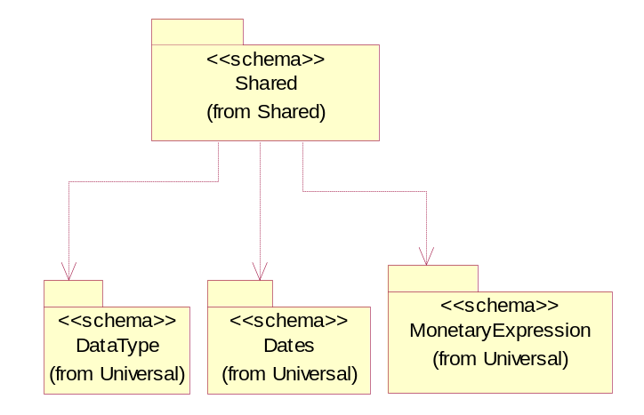
Figure ‎3-45 Dependency

CarrierInformation
The collection of business properties that describe a carrier's identification.
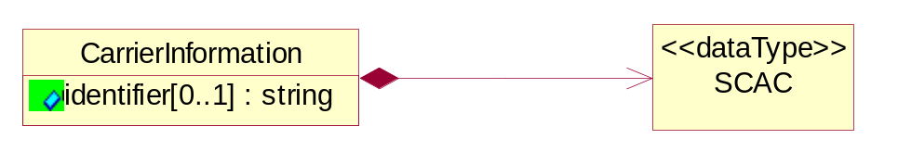
Figure ‎3-46 CarrierInformation

Attribute | Type | Documentation
identifier[0..1] | string | The unique identifier that identifies an account.

Composition | Cardinality | Type | Documentation
SCAC | 1 | SCAC | The Standard Carrier Alpha Code (SCAC) is a unique two-to-four-letter code used to identify transportation companies. NMFTA developed the SCAC identification codes in the mid 1960's to facilitate computerization in the transportation industry.  Refer http://www.nmfta.org for more detail.

DatePeriodAndDuration
The collection of business properties that describe a date period or duration.
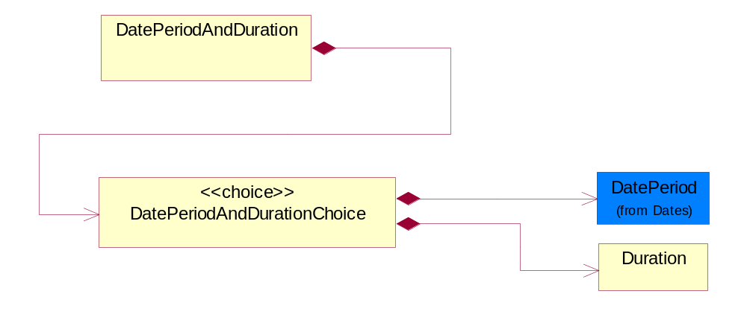
Figure ‎3-47 DatePeriodAndDuration

Composition | Cardinality | Type | Documentation
DatePeriodAndDurationChoice | 1 | DatePeriodAndDurationChoice | The choice structure for DatePeriodAndDuration.

DatePeriodAndDurationChoice
The choice structure for DatePeriodAndDuration.

Composition | Cardinality | Type | Documentation
DatePeriod | 1 | DatePeriod | The business document must allow for the computation or statement of a duration based upon a beginning and an ending date.
Duration | 1 | Duration | This object allows representation of a duration of time.

Duration
This object allows representation of a duration of time.
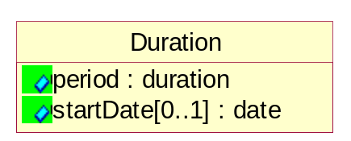
Figure ‎3-48 Duration

Attribute | Type | Documentation
period | duration | Represents a duration of time.
startDate[0..1] | date | The date indicating the beginning of the duration.

MonetaryAmount
The collection of business properties that describe the monetary amount defined by a specified currency.
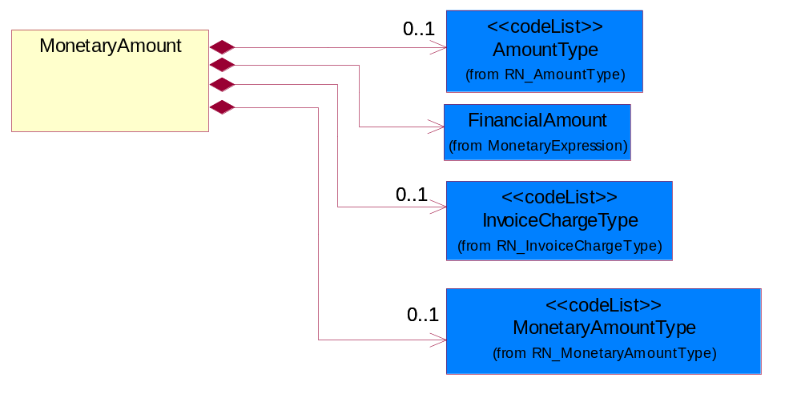
Figure ‎3-49 MonetaryAmount

Composition | Cardinality | Type | Documentation
FinancialAmount | 1 | FinancialAmount | The business document must express financial amounts.
InvoiceChargeType | 0..1 | InvoiceChargeType | Code identifying the values for the types of charges contained in an invoice.
MonetaryAmountType | 0..1 | MonetaryAmountType | Code identifying whether the monetary amount is a debit or credit.
AmountType | 0..1 | AmountType | Code identifying the type of monetary amount.

ProductPricing
The collection of business properties that describe the type of pricing and financial amount for a product.
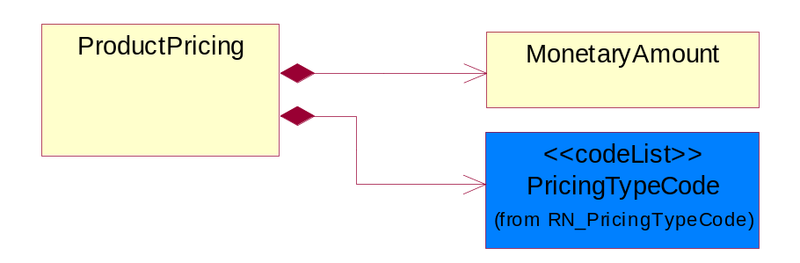
Figure ‎3-50 ProductPricing

Composition | Cardinality | Type | Documentation
MonetaryAmount | 1 | MonetaryAmount | The collection of business properties that describe the monetary amount defined by a specified currency.
PricingTypeCode | 1 | PricingTypeCode | Code identifying the type of pricing available for a product.

SCAC
The Standard Carrier Alpha Code (SCAC) is a unique two-to-four-letter code used to identify transportation companies. NMFTA developed the SCAC identification codes in the mid 1960's to facilitate computerization in the transportation industry.

Refer http://www.nmfta.org for more detail.
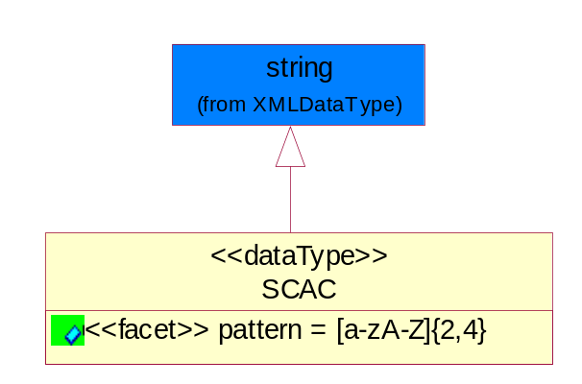
Figure ‎3-51 SCAC

Attribute | Type | Documentation
pattern |  | [a-zA-Z]{2,4}

CodeList

FreeOnBoard
Code identifying a specified point where a product is delivered or placed on board a carrier without charge.

Name | Documentation
DES | Destination.
NMA | Name Address.
ORG | Origin.

InvoiceChargeType
Code identifying the values for the types of charges contained in an invoice.

Name | Documentation
ALC | Allowances and Charges.
CUC | Custom Charges.
DEA | Deposit Amount.
ESC | Expedited Shipping Charge - Charge for accelerating the delivery of a product.
FRC | Freight Charges.
HAC | Handling Charges.
LEC | Lease Charge - Charge for the use of a product in which the purchaser assumes certain responsibilities of ownership.
LIC | License Charge - Charge for the use of a product (usually software) in which the manufacturer maintains ownership of the product.
MAC | Maintenance Charge - Charge (usually periodic) for providing maintenance support for a product.
PUC | Purchase Charge - Charge for a product in which the buyer takes all responsibilities of ownership.
QUD | Quantity Discount.
REC | Rental Charge - Charge for the use of a product (usually hardware) in which the manufacturer maintains ownership of the product.

MonetaryAmountType
Code identifying whether the monetary amount is a debit or credit.

Name | Documentation
CRE | Credit.
DEB | Debit.
ZER | Zero remit.

PricingTypeCode
Code identifying the type of pricing available for a product.

Name | Documentation
ACR | Authorized Cost and Resale.
ACS | Authorized Cost - The negotiated cost agreed upon between the supplier and distributor at the time the “debit?is authorized.
ACT | Authorized cost.
ANY | Any available.
ARS | Authorized resale.
ASP | Average Selling Price - Manufacturer's published price.
BPA | Budgetary Price Amount.
BPP | Broken Purchase Price.
BSH | Book-Ship.
CAT | Catalog price - Book (the supplier’s published cost at the time of transaction) or Published Price.
CLM | Claim Amount.
CMC | Commercial.
CMD | Commodity.
CMF | Contract Manufacturing.
CON | Contract.
COS | Cost - Price for which the distributor purchased the parts.
CPL | Country Price List.
DBC | Disti Book Cost.
DFR | Duty free.
DIS | Distribution.
DPD | Duty paid.
DTP | Distribution price.
EDU | Education.
ERT | E-Rate.
EXC | Exception.
FGM | Federal government.
GEN | General.
HIE | Higher Education.
LCL | Local.
LGM | Local government.
LIS | List.
MPR | Market price.
MRP | Manufacturer's recommendation for unit pricing.
MSR | Manufacturer Suggested Retail Price (MSRP).
MUS | Minimum Unit Sale (MUS) - Manufacturer requirement of total dollar value for design opportunity.
NPF | Nonprofit.
OEM | Original Equipment Manufacturing (OEM).
OVP | OEM Volume Pricing - Original equipment manufacturing price per volume ordered.
PED | Primary Education.
QUO | Quote Price
RCS | Requested Cost (RCS) - Reseller requested cost to the manufacturer.
REX | Reseller Expects.
RFB | Refurbished.
RIN | Religious Institution.
RSP | Resale - Price the distributor is authorized to use for sale to their customer (RSP).
SCE | Special Education.
SEC | Security and management reseller.
SED | Secondary Education.
SEV | Service provider.
SGM | State Government.
SPD | Special Discount Price.
SPE | Special Education.
SPL | Samples.
SRP | Suggested Resale Price.
STR | Standard Rebate.
THP | Threshold Price.
TOC | Total Other Charges - Suggested resale price - The sum total of all distributor added charges to the customer for value added services, including but not limited to programming, tape and reel, labeling, date coding, kitting and in-house assembly.

ShippingServiceLevel
Code identifying the shipping service level, e.g., overnight, same day.

Name | Documentation
1BD | 1BD, Same Business Day - 4 hour Response Time.
5BD | 5 Business Days.
9AM | 9 A.M.
ACH | Air Charter.
AEC | Air Economy.
AIC | Air Cargo.
AM | A.M.
ARS | Authorized Return Service.
ATA | Airport to Airport.
ATD | Airport to Door.
BCT | Bulk Commodity Train.
BUC | Business Class.
CBS | Consignee Billing Service.
COE | Courier Express.
DCR | Delivery Confirmation Return.
DEC | Delivery Confirmation.
DES | Deferred Service.
DNO | Delivery Notification Only.
DOS | Door Service.
DSN | Delivery scheduled next day by cartage agent.
DSS | Delivery scheduled second day by cartage agent.
DST | Delivery scheduled third day by cartage agent.
DTA | Door to Airport.
DTD | Door to Door.
DTP | Door to Port (Ocean).
ESP | Express Service Plus.
ESV | Expedited Service.
ESW | Expedited Service Worldwide.
EXS | Express Service.
EXW | Express Service - Worldwide.
FIC | First Class.
GEN | General.
GRO | Ground.
ISS | Other intermodal and stack service.
MAF | Manifest freight.
MET | Metro.
MUW | Multiweight.
NBD | Next Business Day.
NDA | Next Day Air.
NEM | Next Morning.
NFO | Next Flight Out.
NHW | Next day Hundred Weight.
NOR | NORMAL - Normal delivery.
NOS | Not served.
OIS | Other Intermodal and Stack service
OTH | Other.
OVN | Overnight.
PAS | Passenger service.
PIU | Pickup.
PM | PM.
PMI | Priority Mail Insured.
POB | P.O. Box/Zip code.
POD | Proof of Delivery (POD) with Signature.
PRM | Priority Mail.
PRS | Premium Surface.
PS1 | Primary Service Area - Next Day by 10:30 A.M.
PS2 | Primary Service Area - Next Day by 5:00 P.M.
PS3 | Primary Service Area - Next Day By 9:30 A.M.
PS4 | Primary Service Area - Next Day by Noon.
PS5 | Primary Service Area - Second Day by Noon.
PTD | Port to Door (Ocean).
PTP | Port to Port (Ocean).
REG | Regular.
SAD | Same day.
SAP | Saturday Pickup.
SAT | Saturday.
SBD | SBD, Second Business Day.
SCH | Scheduled.
SDA | Second Day Air.
SDW | Second Day Hundred Weight.
SED | Second Day.
SEM | Second Morning.
SGW | Standard Ground Hundred Weight.
STC | Standard Class.
STG | Standard Ground.
STO | Standard Ocean.
STS | Standard Service.
SUH | Sunday and Holidays.
TDS | Three Day Service.
TIC | Time Critical.
TRG | Tracking - Ground.

PaymentMethod
Code identifying how the trading partner paid the seller for the product.

Name | Documentation
ACH | Automated Clearing House (ACH).
ACR | ACH Reversal.
BAD | Batched Delivery.
BIA | Billing Account.
BND | Bank Draft.
BOE | Book Entry.
CAC | Cashier's Check.
CAS | Cash.
CBB | Compensation by Balance.
CCP | ACH Savings Cash Concentration/Disbursement Plus (CCD+) Credit.
CCR | CCD+(NACHA Cash Concentration/Disbursement - Funds Transacted Plus an 80 Record Remittance Detail).
CCW | CCD (NACHA Cash Concentration/Disbursement - Funds Transacted without Remittance Information).
CDA | Credit/Debit Account.
CDD | Pre-Arranged Payment or Deposit (PPD) Credit to a Demand Deposit Account.
CDP | ACH Savings Cash Concentration/Disbursement Plus (CCD+) Debit.
CDS | Pre-Arranged Payment or Deposit (PPD) Credit to Savings.
CHE | Check.
CHIPS | Clearing House Interbank Payment System (CHIPS)Funds/Wire Transfer.
CLH | Clearinghouse.
CPC | Collect Payment by Company Check.
CPF | Collect Payment by Certified Funds.
CPP | Pre-Arranged Payment or Deposit Plus Addendum (PPD+) Credit to a Demand Deposit Account.
CRA | Credit Account.
CRC | Credit Card.
CRE | Credit.
CTC | ACH Savings Corporate Trade Exchange (CTX) Credit.
CTD | ACH Savings Corporate Trade Exchange (CTX) Debit.
CTP | CTP (NACHA Corporate Trade Payment - Transaction Plus Remittance Detail in Fixed Format).
CTX | CTX (NACHA Corporate Trade Exchange - Transaction Plus Remittance Detail in ANSI Standard Flexible Format).
CXC | ACH Demand Corporate Trade Exchange (CTX) Credit.
CXD | ACH Demand Corporate Trade Exchange (CTX) Debit.
DBT | Defined by TPA.
DCC | ACH Demand Cash Concentration/Disbursement (CCD) Credit.
DCD | ACH Demand Cash Concentration/Disbursement (CCD) Debit.
DCP | ACH Demand Cash Concentration/Disbursement Plus (CCD+) Credit.
DDA | Pre-Arranged Payment or Deposit (PPD) Debit to a Demand Deposit Account.
DDP | ACH Demand Cash Concentration/Disbursement Plus (CCD+) Debit.
DEB | Debit.
DEC | Debit Card.
DEM | Debit Memo.
DID | Direct Deposit.
DPP | Pre-Arranged Payment or Deposit Plus Addendum (PPD+) Debit to a Demand Deposit Account.
DRA | Draft.
DWO | Discount was Offered.
ECN | EDIBANX Clearing Network.
EFT | EFT.
EPS | Electronic Payment System.
EXC | 1035 Exchange.
FIN | Financed.
FIO | Financial Institution Option.
FPB | Freight Payment Bank.
FRN | Federal Reserve Funds/Wire Transfer - Nonrepetitive.
FRR | Federal Reserve Funds/Wire Transfer - Repetitive.
GRA | Graduated.
INS | Invoiced Separately.
JPO | Joint Purchase Option.
LAP | Lease Agreement is in Place.
LEV | Level (Sum Constant).
LOB | Lock Box.
LOC | Letter of Credit has been provided.
MOD | Money order.
MOO | Money Order.
MOR | Mail order.
NPD | Non-Payment Data.
NPR | No Payment is Required.
OTH | Other.
PAM | Payment has Already been Made.
PAN | Payment is Net.
PAS | Payment after shipment.
PBC | Payment is made by Check.
PBS | Payment before shipment.
PCC | Payment is pre-paid with Credit Card.
PCP | ACH Savings Cash Concentration/Disbursement (PPD+) Credit.
PDD | ACH Savings Cash Concentration/Disbursement (PDD) Debit.
PDP | ACH Savings Cash Concentration/Disbursement (PPD+) Debit.
PIK | Payment was made in Kind.
PME | Payment was Made Electronically.
PMI | Payment will be made the Month after the Invoice.
PMN | Promissory note.
PNA | Private Netting Agreement, Pay by Wire Transfer.
PPC | Payment is made by Pre-paid Check.
PPD | ACH Savings Cash Concentration/Disbursement (PPD) Credit.
PPW | Payment is Pre-paid by Wire.
PRC | Preauthorized Check (Draft).
PRN | Proprietary Network.
PVC | Previously Charged.
PVN | Private Netting, Pay by Check.
PWT | Payment is made via Wire Transfer.
PYN | Payment note.
RDA | Related Detail Account.
SCC | ACH Savings Cash Concentration/Disbursement (CCD) Credit.
SCD | ACH Savings Cash Concentration/Disbursement (CCD) Debit.
SPA | Special Account.
SUA | Summary Account.
SWIFT | Society for Worldwide Interbank Financial Telecommunications (S.W.I.F.T.).
TGT | Telegraphic transfer.
TOF | Transfer of Funds by the banking institution.
TRC | Traveler's Check.
VIS | VISA Special Electronic Funds Transfer Network.
WAI | Waived.
WIT | Wire Transfer.

AmountType
Code identifying the type of monetary amount.

Name | Documentation
DIP | Discount Percentage.
DIS | Discount Value - The monetary amount of the discount on the price applied to a customer order.
FRE | Freight Charges - The monetary amount to be paid for freight transportation.
INS | InsuranceCharges - The monetary amount to be paid for freight insurance.
MAT | Material Cost - This object represents the material cost for the product.
MIS | Miscellaneous Charges - The monetary amount to be paid for miscellaneous charges.
NET | Net Amount.
PRC | Processing Charges - The monetary amount to be paid by consignee for consignment manufacturer.
TOD | Total Amount Due - Total amount due upon receipt of statement.
TOT | Total Amount - Total price for an entire business document.
TOV | Total Value Added Amount - The total amount of the shipment including any value added tax.
UNI | Unit Price - Agreed upon sale price for each unit ordered.
VAD | Value Added Unit Price - The price of a unit including any value added tax.

Universal Structure

ContactInformation

ContactInformation
The business document must allow for the identification of the name of the department, service or individual to be contacted regarding the context of the business document.
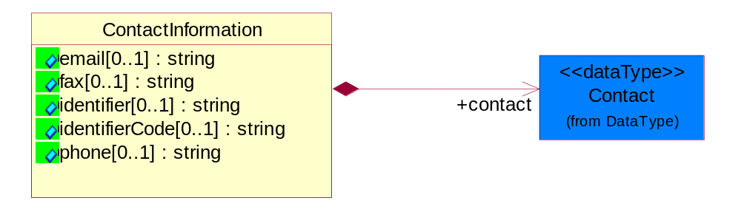
Figure ‎4-52 ContactInformation

Attribute | Type | Documentation
email[0..1] | string | The electronic mail for the specified contact.
fax[0..1] | string | The fax number for the specified contact.
identifier[0..1] | string | Identifies the role of the contact (i.e. Service Technician, Account Manager) in the Business Process.
identifierCode[0..1] | string | IdentifierCode is a unique security authorization code to identify the contact- ie. badge ID.
phone[0..1] | string | The telephone number for the specified contact.

Composition | Cardinality | Type | Documentation
contact | 1 | Contact | The name of the department, service or individual to be contacted within the organization.

DataType

Contact
The name of the department, service or individual to be contacted within the organization.
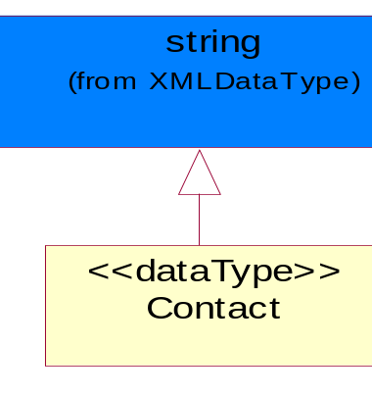
Figure ‎4-53 Contact

DUNS
A number assigned by Dun and Bradstreet to identify a business location.
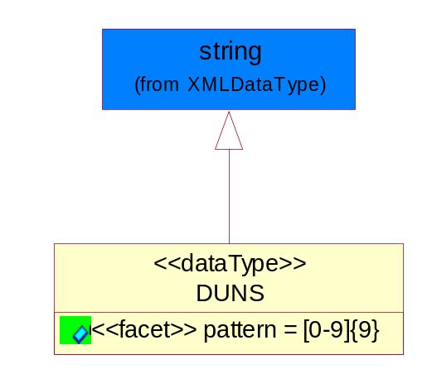
Figure ‎4-54 DUNS

Attribute | Type | Documentation
pattern |  | [0-9]{9}

DUNSPlus4
A identifier to specify a specific location within a business location.
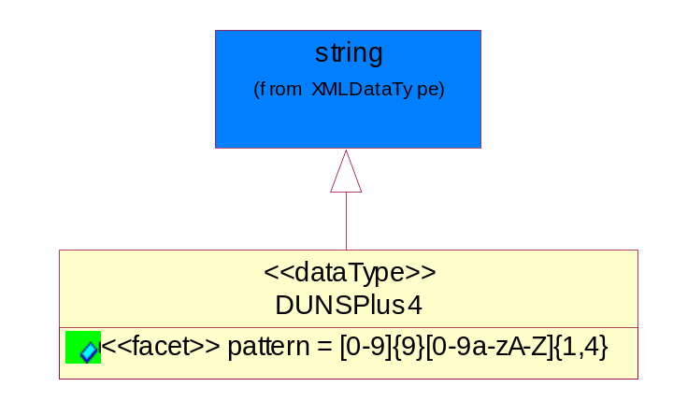
Figure ‎4-55 DUNSPlus4

Attribute | Type | Documentation
pattern |  | Data Universal Numbering System +4 (DUNS+4) number means the DUNS number assigned by Dun and Bradstreet, Inc. (D&B) plus an alphanumeric of length 4 suffix that may be assigned by a business concern.

GLN
Global Location Number (GLN) - A identifier to identify legal entities, trading parties and location.
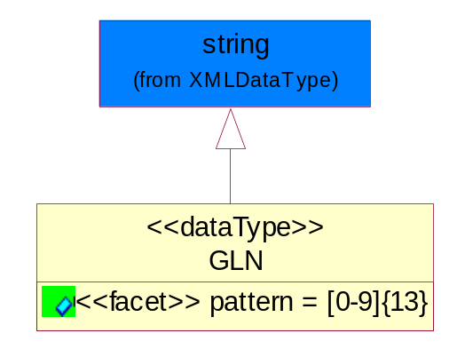
Figure ‎4-56 GLN

Attribute | Type | Documentation
pattern |  | [0-9]{13}

GTIN
Global Trade Identification Number (GTIN).
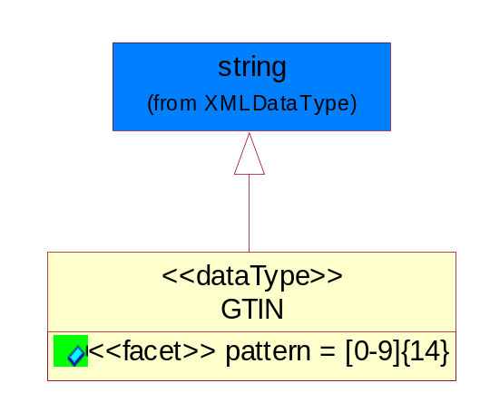
Figure ‎4-57 GTIN

Attribute | Type | Documentation
pattern |  | [0-9]{14}

PercentAmount
A number representing a percentage value, e.g. 75.125 represents 75 1/8 percent.
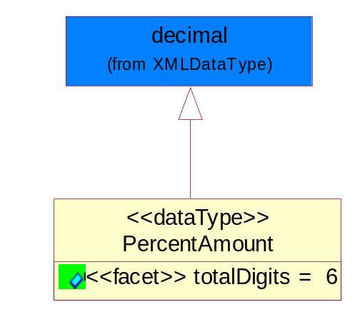
Figure ‎4-58 PercentAmount

Attribute | Type | Documentation
totalDigits |  | 6

Dates

DatePeriod
The business document must allow for the computation or statement of a duration based upon a beginning and an ending date.
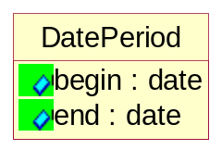
Figure ‎4-59 DatePeriod

Attribute | Type | Documentation
begin | date | The date indicating the beginning of the date period.
end | date | The date indicating the ending of the date period.

DateTimePeriod
The business document must allow for the computation or statement of a period of time based upon date and time.
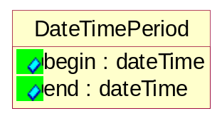
Figure ‎4-60 DateTimePeriod

Attribute | Type | Documentation
begin | dateTime | The date and time indicating the beginning of the date time period.
end | dateTime | The date and time indicating the ending of the date time period.

Document

BusinessDocumentReference
The business document reference object allows for the indirect referencing of a relationship to other business related documents.
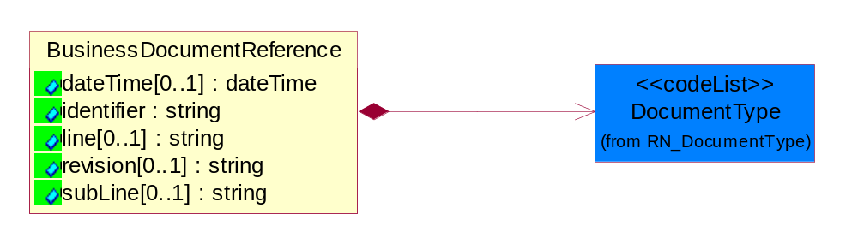
Figure ‎4-61 BusinessDocumentReference

Attribute | Type | Documentation
dateTime[0..1] | dateTime | The date-time stamp indicating on the referenced business document.
identifier | string | Unique identification of the referenced business document.
line[0..1] | string | References the specific line number of the specified business document.
revision[0..1] | string | Referenced the revision of the specified business document.
subLine[0..1] | string | References the specific subline number of the specified business document.

Composition | Cardinality | Type | Documentation
DocumentType | 1 | DocumentType | A code identifying the business context of a document.

Locations

AlternativeIdentifier
Identifies the specified code and the name of the organization that a code is utilized from.
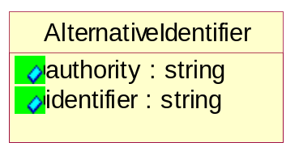
Figure ‎4-62 AlternativeIdentifier

Attribute | Type | Documentation
authority | string | The name of the organization that a code is utilized from.
identifier | string | The specified code to represent an entity (e.g. product, location, partner, etc.).

Location
The business document must specify a location.
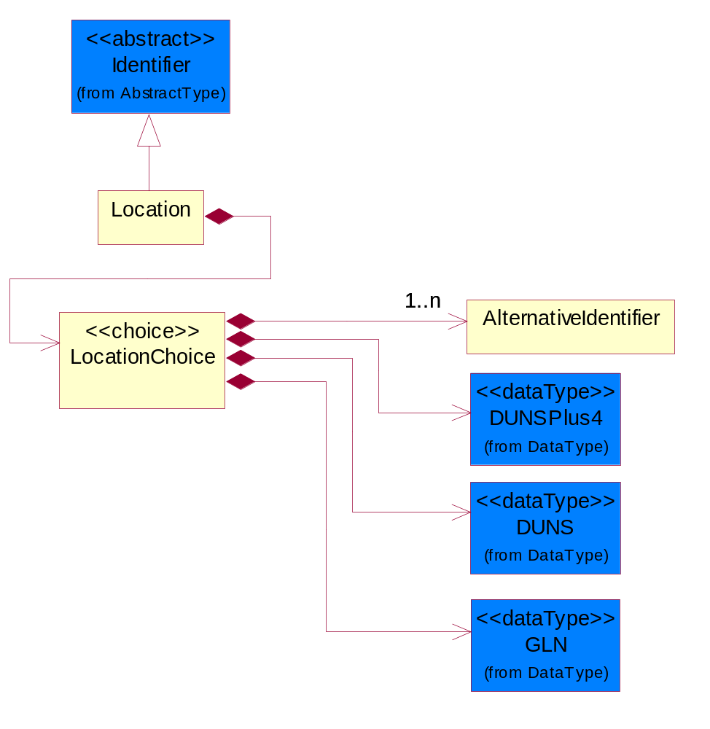
Figure ‎4-63 Location

Composition | Cardinality | Type | Documentation
LocationChoice | 1 | LocationChoice

LocationChoice

Composition | Cardinality | Type | Documentation
DUNSPlus4 | 1 | DUNSPlus4 | A identifier to specify a specific location within a business location.
DUNS | 1 | DUNS | A number assigned by Dun and Bradstreet to identify a business location.
AlternativeIdentifier | 1..n | AlternativeIdentifier | Identifies the specified code and the name of the organization that a code is utilized from.
GLN | 1 | GLN | Global Location Number (GLN) - A identifier to identify legal entities, trading parties and location.

PhysicalAddress
The business document must provide a physical address for a party to the business transaction.
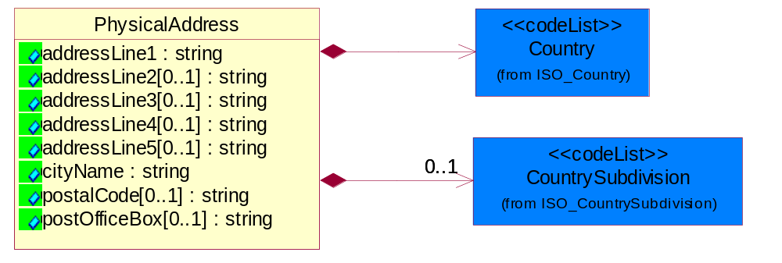
Figure ‎4-64 PhysicalAddress

Attribute | Type | Documentation
addressLine1 | string | The first line of a physical address.
addressLine2[0..1] | string | The second line of a physical address.
addressLine3[0..1] | string | The third line of a physical address.
addressLine4[0..1] | string | The fourth line of a physical address.
addressLine5[0..1] | string | The fifth line of a physical address.
cityName | string | The name of a city.
postalCode[0..1] | string | Identifying geographic location as specified by a national postal code.
postOfficeBox[0..1] | string | The Post Office Box identifier used to identify a party's post office box.

Composition | Cardinality | Type | Documentation
Country | 1 | Country | For representation of Country name RosettaNet has adopted ISO 3166-3; 1999. Refer to the following web page to get the latest version of the standard:  http://www.iso.ch/iso/en/prods-services/iso3166ma/02iso-3166-code-lists/index.html  If you need more information about the ISO standard please contact ISO for more details.
CountrySubdivision | 0..1 | CountrySubdivision | For representation of a Countries subdivisions RosettaNet has adopted ISO 3166-3; 1999. Refer to the following web page to get the latest version of the standard:  http://www.iso.ch/iso/en/prods-services/iso3166ma/02iso-3166-code-lists/index.html  If you need more information about the ISO standard please contact ISO for more details.

MonetaryExpression

FinancialAmount
The business document must express financial amounts.
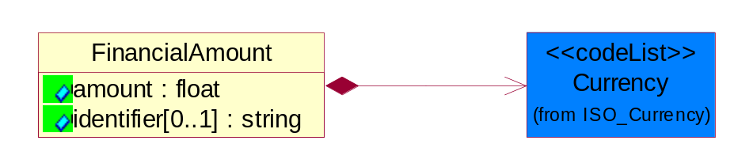
Figure ‎4-65 FinancialAmount

Attribute | Type | Documentation
amount | float | Specifies the monetary amount.
identifier[0..1] | string | Identifier is a unique identifier to which the specific price is tied - ie. promotion name/ program.

Composition | Cardinality | Type | Documentation
Currency | 1 | Currency | For representation of Currency codes RosettaNet has adopted ISO 4217; 1995. The British Standards Institution (BSI) is the ISO 4217 Maintenance Agency. Refer to the following web page to get the latest version of the standard:  http://www.bsi-global.com/Technical+Information/Publications/_Publications/tig90.xalter  If you need more information about the ISO standard please contact ISO for more details.

TaxAmount
The business document must include a tax amount(s).
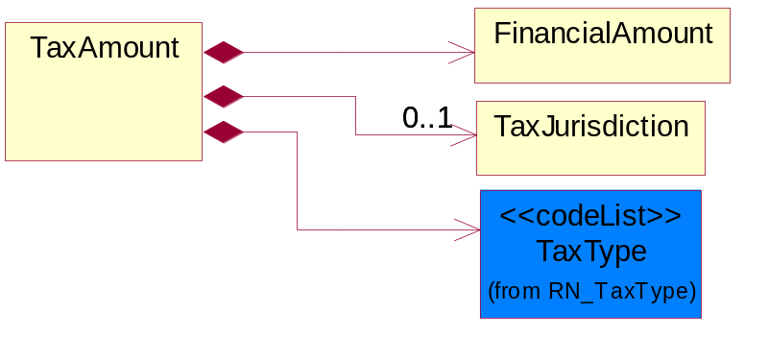
Figure ‎4-66 TaxAmount

Composition | Cardinality | Type | Documentation
FinancialAmount | 1 | FinancialAmount | The business document must express financial amounts.
TaxJurisdiction | 0..1 | TaxJurisdiction | The business document must identify the specific tax collection authority.
TaxType | 1 | TaxType | A code identifying the type of tax.

TaxJurisdiction
The business document must identify the specific tax collection authority.
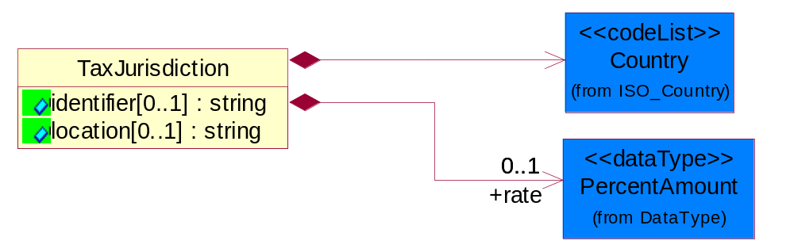
Figure ‎4-67 TaxJurisdiction

Attribute | Type | Documentation
identifier[0..1] | string | Unique identification for a taxing authority.
location[0..1] | string | Identification of the tax collection authority location.

Composition | Cardinality | Type | Documentation
rate | 0..1 | PercentAmount | This object represents the tax rate.
Country | 1 | Country | For representation of Country name RosettaNet has adopted ISO 3166-3; 1999. Refer to the following web page to get the latest version of the standard:  http://www.iso.ch/iso/en/prods-services/iso3166ma/02iso-3166-code-lists/index.html  If you need more information about the ISO standard please contact ISO for more details.

PartnerIdentification

FullPartner
The business document must describe the trading partners in the business transaction. This data structure provide the flexibility to describe a partner in all possible methods as for new, existing or known partner.
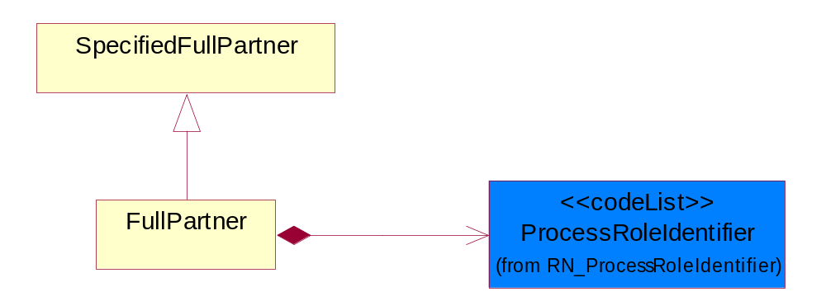
Figure ‎4-68 FullPartner

Composition | Cardinality | Type | Documentation
ProcessRoleIdentifier | 1 | ProcessRoleIdentifier | Describes the role of the partner in the business process. A partner will fulfill at least one or more roles during the business process.

IntermittentPartner
The business document must describe a physical address for a delivery.
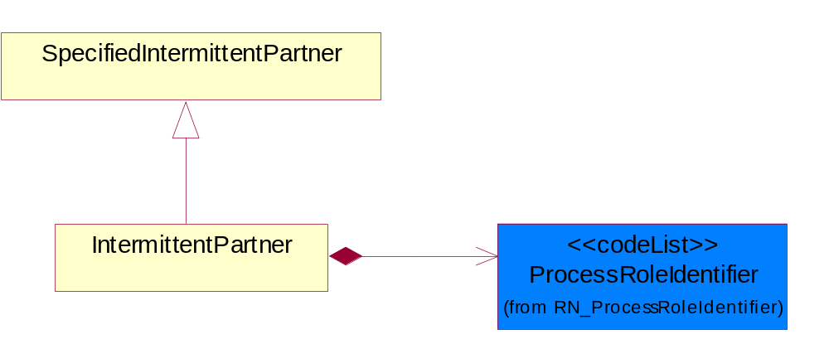
Figure ‎4-69 IntermittentPartner

Composition | Cardinality | Type | Documentation
ProcessRoleIdentifier | 1 | ProcessRoleIdentifier | Describes the role of the partner in the business process. A partner will fulfill at least one or more roles during the business process.

KnownPartner
The business document must describe the trading partners in the business transaction.
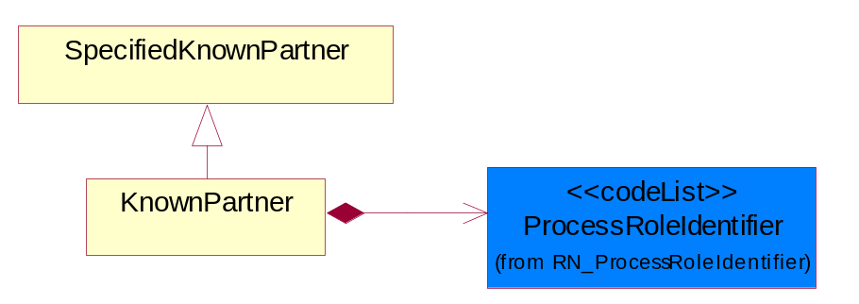
Figure ‎4-70 KnownPartner

Composition | Cardinality | Type | Documentation
ProcessRoleIdentifier | 1 | ProcessRoleIdentifier | Describes the role of the partner in the business process. A partner will fulfill at least one or more roles during the business process.

KnownPartnerContact
The business document must describe the trading partners in the business transaction.
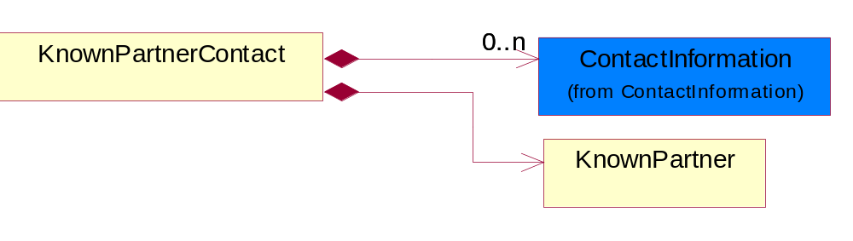
Figure ‎4-71 KnownPartnerContact

Composition | Cardinality | Type | Documentation
KnownPartner | 1 | KnownPartner | The business document must describe the trading partners in the business transaction.
ContactInformation | 0..n | ContactInformation | The business document must allow for the identification of the name of the department, service or individual to be contacted regarding the context of the business document.

NewPartner
The business document must describe a new, existing (but known to only one of the parties to the transaction) or an unknown party to the business transaction.
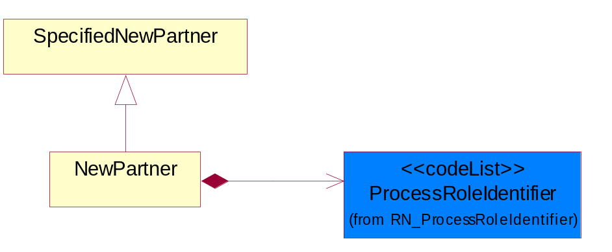
Figure ‎4-72 NewPartner

Composition | Cardinality | Type | Documentation
ProcessRoleIdentifier | 1 | ProcessRoleIdentifier | Describes the role of the partner in the business process. A partner will fulfill at least one or more roles during the business process.

PartnerDescription
The collection of business properties that describe a business partners' identity, their contact information, where they are physically located and their function in a supply chain.
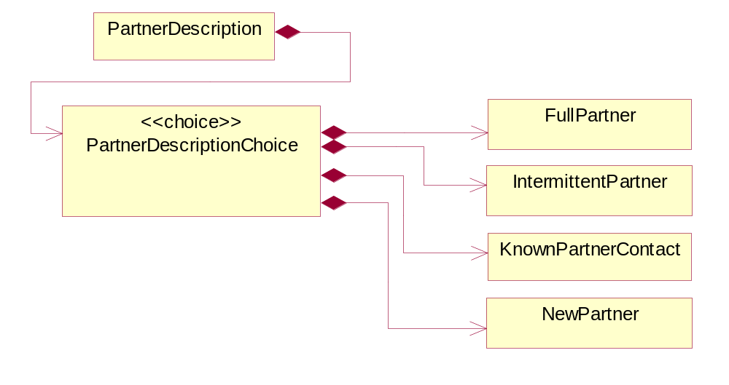
Figure ‎4-73 PartnerDescription

Composition | Cardinality | Type | Documentation
PartnerDescriptionChoice | 1 | PartnerDescriptionChoice

PartnerDescriptionChoice

Composition | Cardinality | Type | Documentation
KnownPartnerContact | 1 | KnownPartnerContact | The business document must describe the trading partners in the business transaction.
IntermittentPartner | 1 | IntermittentPartner | The business document must describe a physical address for a delivery.
NewPartner | 1 | NewPartner | The business document must describe a new, existing (but known to only one of the parties to the transaction) or an unknown party to the business transaction.
FullPartner | 1 | FullPartner | The business document must describe the trading partners in the business transaction. This data structure provide the flexibility to describe a partner in all possible methods as for new, existing or known partner.

PartnerIdentification
The business document must allow for the identity of one or more parties to the transaction.
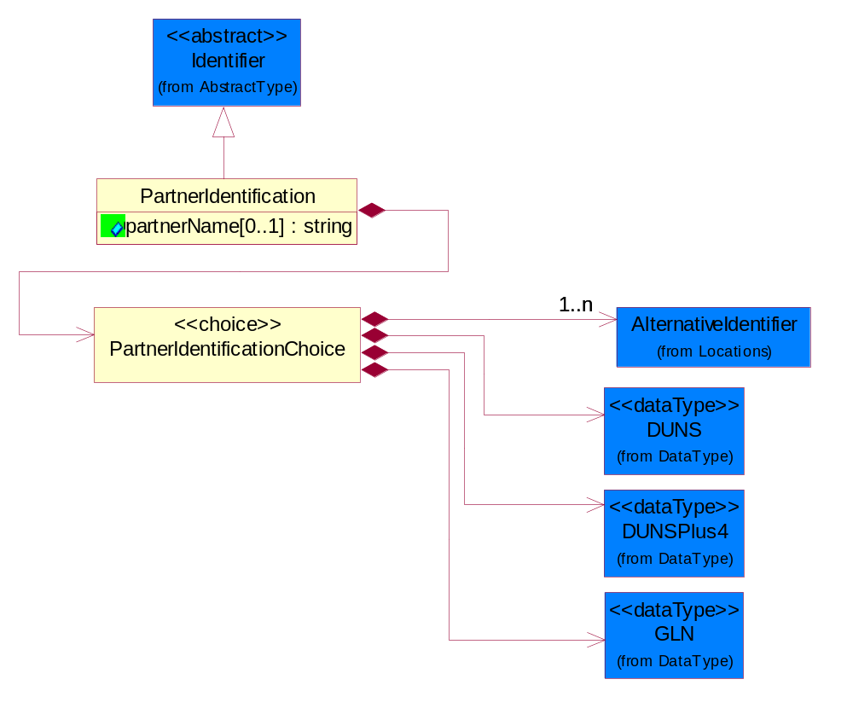
Figure ‎4-74 PartnerIdentification

Attribute | Type | Documentation
partnerName[0..1] | string | The name of the partner’s company/business.

Composition | Cardinality | Type | Documentation
PartnerIdentificationChoice | 1 | PartnerIdentificationChoice

PartnerIdentificationChoice

Composition | Cardinality | Type | Documentation
DUNS | 1 | DUNS | A number assigned by Dun and Bradstreet to identify a business location.
DUNSPlus4 | 1 | DUNSPlus4 | A identifier to specify a specific location within a business location.
AlternativeIdentifier | 1..n | AlternativeIdentifier | Identifies the specified code and the name of the organization that a code is utilized from.
GLN | 1 | GLN | Global Location Number (GLN) - A identifier to identify legal entities, trading parties and location.

SpecifiedFullPartner
The business document must describe the trading partners in the business transaction. This data structure provide the flexibility to describe a partner in all possible methods as for new, existing or known partner. This is specifically for partner who role has been specified.
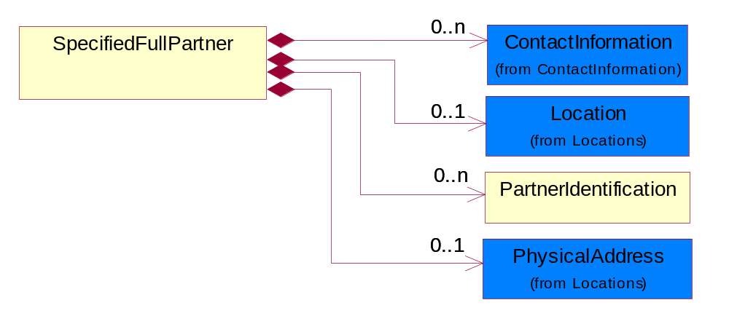
Figure ‎4-75 SpecifiedFullPartner

Composition | Cardinality | Type | Documentation
ContactInformation | 0..n | ContactInformation | The business document must allow for the identification of the name of the department, service or individual to be contacted regarding the context of the business document.
Location | 0..1 | Location | The business document must specify a location.
PartnerIdentification | 0..n | PartnerIdentification | The business document must allow for the identity of one or more parties to the transaction.
PhysicalAddress | 0..1 | PhysicalAddress | The business document must provide a physical address for a party to the business transaction.

SpecifiedIntermittentPartner
The business document must describe a physical address for a delivery.
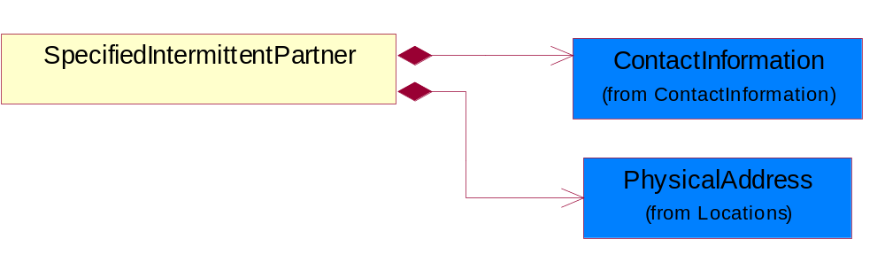
Figure ‎4-76 SpecifiedIntermittentPartner

Composition | Cardinality | Type | Documentation
ContactInformation | 1 | ContactInformation | The business document must allow for the identification of the name of the department, service or individual to be contacted regarding the context of the business document.
PhysicalAddress | 1 | PhysicalAddress | The business document must provide a physical address for a party to the business transaction.

SpecifiedKnownPartner
The business document must describe the trading partners in the business transaction.
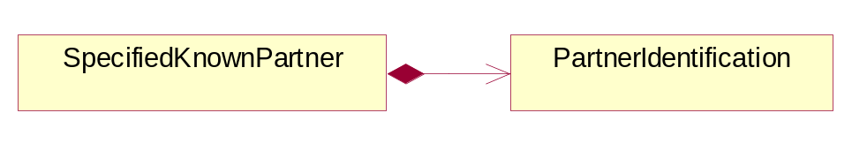
Figure ‎4-77 SpecifiedKnownPartner

Composition | Cardinality | Type | Documentation
PartnerIdentification | 1 | PartnerIdentification | The business document must allow for the identity of one or more parties to the transaction.

SpecifiedKnownPartnerContact
The business document must describe the trading partners in the business transaction and allow for a identification of an individual of the trading partner.
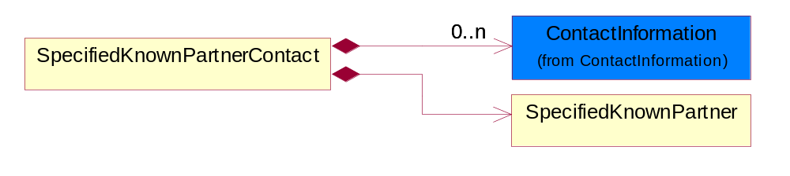
Figure ‎4-78 SpecifiedKnownPartnerContact

Composition | Cardinality | Type | Documentation
SpecifiedKnownPartner | 1 | SpecifiedKnownPartner | The business document must describe the trading partners in the business transaction.
ContactInformation | 0..n | ContactInformation | The business document must allow for the identification of the name of the department, service or individual to be contacted regarding the context of the business document.

SpecifiedNewPartner
The business document must describe a new, existing (but known to only one of the parties to the transaction) or an unknown party to the business transaction.
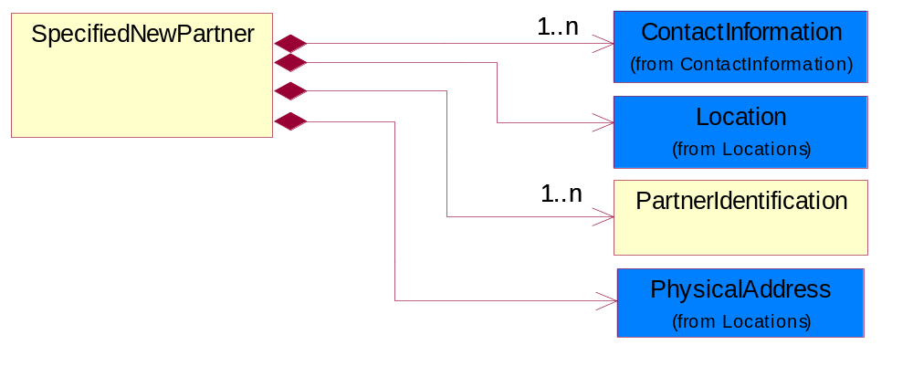
Figure ‎4-79 SpecifiedNewPartner

Composition | Cardinality | Type | Documentation
ContactInformation | 1..n | ContactInformation | The business document must allow for the identification of the name of the department, service or individual to be contacted regarding the context of the business document.
Location | 1 | Location | The business document must specify a location.
PhysicalAddress | 1 | PhysicalAddress | The business document must provide a physical address for a party to the business transaction.
PartnerIdentification | 1..n | PartnerIdentification | The business document must allow for the identity of one or more parties to the transaction.

SpecifiedPartnerDescription
The collection of business properties that describe a business partners' identity, their contact information, where they are physically located and their function in a supply chain.
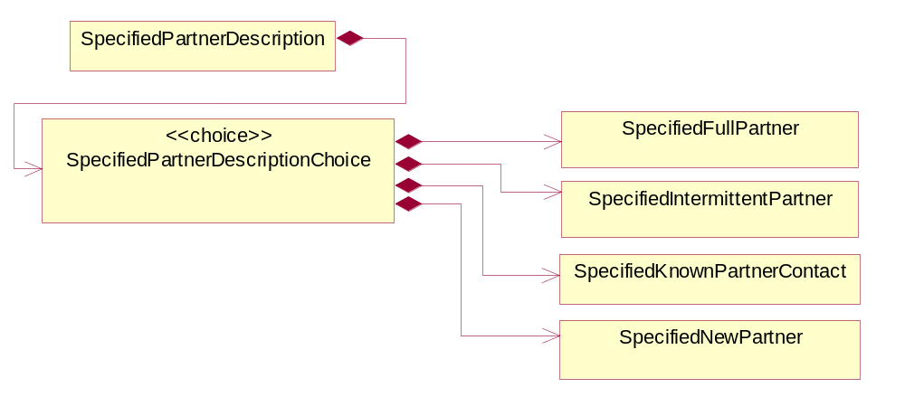
Figure ‎4-80 SpecifiedPartnerDescription

Composition | Cardinality | Type | Documentation
SpecifiedPartnerDescriptionChoice | 1 | SpecifiedPartnerDescriptionChoice

SpecifiedPartnerDescriptionChoice

Composition | Cardinality | Type | Documentation
SpecifiedKnownPartnerContact | 1 | SpecifiedKnownPartnerContact | The business document must describe the trading partners in the business transaction and allow for a identification of an individual of the trading partner.
SpecifiedIntermittentPartner | 1 | SpecifiedIntermittentPartner | The business document must describe a physical address for a delivery.
SpecifiedNewPartner | 1 | SpecifiedNewPartner | The business document must describe a new, existing (but known to only one of the parties to the transaction) or an unknown party to the business transaction.
SpecifiedFullPartner | 1 | SpecifiedFullPartner | The business document must describe the trading partners in the business transaction. This data structure provide the flexibility to describe a partner in all possible methods as for new, existing or known partner. This is specifically for partner who role has been specified.

ProductIdentification

ProductIdentification
The object provides the identifier(s) of a product.
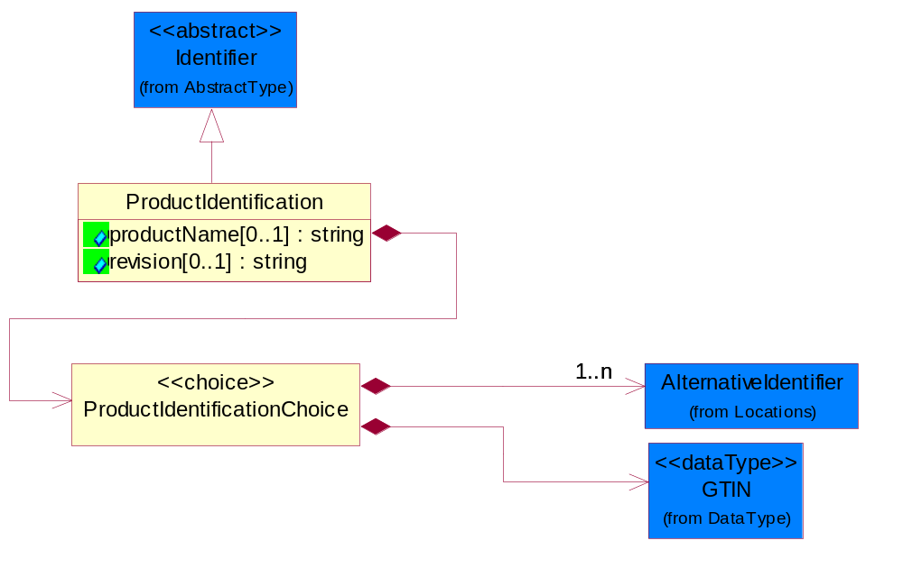
Figure ‎4-81 ProductIdentification

Attribute | Type | Documentation
productName[0..1] | string | The name of the product.
revision[0..1] | string | Referenced the specified product revision.

Composition | Cardinality | Type | Documentation
ProductIdentificationChoice | 1 | ProductIdentificationChoice

ProductIdentificationChoice

Composition | Cardinality | Type | Documentation
AlternativeIdentifier | 1..n | AlternativeIdentifier | Identifies the specified code and the name of the organization that a code is utilized from.
GTIN | 1 | GTIN | Global Trade Identification Number (GTIN).

CodeList

Country
For representation of Country name RosettaNet has adopted ISO 3166-3; 1999. Refer to the following web page to get the latest version of the standard:
http://www.iso.ch/iso/en/prods-services/iso3166ma/02iso-3166-code-lists/index.html

If you need more information about the ISO standard please contact ISO for more details.

CountrySubdivision
For representation of a Countries subdivisions RosettaNet has adopted ISO 3166-3; 1999. Refer to the following web page to get the latest version of the standard:
http://www.iso.ch/iso/en/prods-services/iso3166ma/02iso-3166-code-lists/index.html

If you need more information about the ISO standard please contact ISO for more details.

Currency
For representation of Currency codes RosettaNet has adopted ISO 4217; 1995. The British Standards Institution (BSI) is the ISO 4217 Maintenance Agency. Refer to the following web page to get the latest version of the standard:
http://www.bsi-global.com/Technical+Information/Publications/_Publications/tig90.xalter

If you need more information about the ISO standard please contact ISO for more details.

Language
For representation of Language name RosettaNet has adopted ISO 639-2; 1998. Refer to the following web page to get the latest version of the standard:

http://www.loc.gov/standards/iso639-2/iso639jac.html

If you need more information about the ISO standard please contact ISO for more details.

DocumentType
A code identifying the business context of a document.

Instance | Documentation
APM | Applied Promotions.
ARA | Authorization Request Approval.
CAR | Certificate of Analysis Response.
CBN | Product batch number of customer.
CCN | Customs clearance number.
CFA | Failure Analysis - Request document that will accompany the product providing characteristics of the component failure.
CIN | Commercial Invoice.
CNM | Traditional credit note or memo.
COA | Certificate of Analysis.
CON | In a virtual sourcing relationship, a third party trading partner is supplying a part to a customer on behalf of another company that has taken the order for the customer. In this case a Customer Order Number is associated to the request for material that is sent to the virtual trading partners.
COS | Consumption Notice.
COT | Contract.
CRN | Unique consumption reference number identifying the product consumption issue i.e. one-to-one relationship with physical flow.
DEM | Traditional debit note or memo.
DEN | Delivery Note.
DIN | Discontinuation Notice.
DOR | Delivery Order.
DRN | Drawing Number.
DRR | Design Registration Request.
ECO | Engineering Change Order - The proprietary unique identification number that represents an engineering change order.
EDD | Export Declaration Document.
EIR | Engineering Information Request.
EOL | End of Life.
FUO | Sales order or transfer order fulfilling demand out of a facility (outbound shipment).
IDD | Import Declaration Document.
INV | Invoice.
LID | Location Identifier. Data for on-site work that have to be done on the machine (associated with preventive maintenance order).
MEN | Master Event Number.
MID | Machine Identifier. Data for on-site work that have to be done on the machine (associated with preventive maintenance order).
MON | Model Number.
NTS | Notes.
OCL | The unique identifier assigned by the OEM for a warranty claim.
OGA | Other governmental agency issued document.
OPO | The unique identifier assigned by the OEM for a part order.
OPR | The unique identifier assigned by the OEM for a part return.
PCN | Product/Process Change.
PFA | Failure Analysis - Request document that will accompany the product providing characteristics of the product failure.
PII | Refers to previously issued invoice.
PLS | Unique number that identifies packing form prior to shipment.
POI | Purchase Order IN.
PON | Production order number for material release.
POO | Purchase Order OUT.
PRC | Product Catalog.
PSI | Refers to previously issued self-billing invoice.
PUO | Purchase Order.
QUO | Quote.
REC | Document identifying the receipt of materials or products into a facility against a purchase order or transfer order (inbound shipment).
REN | Release Number.
REO | Purchase order or transfer order replenishing inventory into a facility (inbound shipment).
REQ | Requisition.
RMA | Returned Material Authorization.
RPO | Purchase order for materials or product returned to and reworked by a supplier.
RTA | Remittance Advice - Remittance details.
SAO | Sales Order.
SBC | Credit Memo used in self-billing scenario.
SBD | Debit Memo used in self-billing scenario.
SBI | Invoice in self billing scenario.
SBN | Product batch number of supplier.
SCA | Similar to contracts - Contains the quantity of an article that is to be ordered from a vendor and the price for article or service that is to be procured.
SEN | Serial Number.
SEO | A document that gives a repair provider the necessary authorization to repair or upgrade a product either at the customer site or at the repair provider’s site.
SHD | Shipping Document.
SNC | Shipset Number on Code List.
SPC | The unique identifier assigned by the ASP for a warranty claim.
SPN | Spec Number.
SPO | The unique identifier assigned by the ASP for a part order.
SPR | The unique identifier assigned by the ASP for a part return.
SPW | The unique identifier assigned by the ASP to reference a work order.
SRI | A document that contains the shipping reference number which allows the product to be tracked within the outsourced logistic providers network.
SWT | Switch Authorization.
TCS | Terms and Conditions.
TRO | Order which results in materials or products being moved from one facility to another (outbound shipment and inbound shipment).
WAB | Waybill.
WAC | Denotes a warranty claim.
WOO | Work Order.

MimeTypeQualifier
The MIME type as defined by IANA.

Please refer to http://www.iana.org/assignments/media-types/ for a list of types.

Instance | Documentation
application/activemessage | [Shapiro]
application/andrew-inset | [Borenstein]
application/applefile | [Faltstrom]
application/atomicmail | [Borenstein]
application/batch-SMTP | [RFC2442]
application/beep+xml | [RFC3080]
application/cals-1840 | [RFC1895]
application/cnrp+xml | [RFCCNRP]
application/commonground | [Glazer]
application/cpl+xml
application/cybercash | [Eastlake]
application/dca-rft | [Campbell]
application/dec-dx | [Campbell]
application/dicom | [RFC3240]
application/dvcs | [RFC3029]
application/EDI-Consent | [RFC1767]
application/EDIFACT | [RFC1767]
application/EDI-X12 | [RFC1767]
application/eshop | [Katz]
application/font-tdpfr | [RFC3073]
application/http | [RFC2616]
application/hyperstudio | [Domino]
application/iges | [Parks]
application/index | [RFC2652]
application/index.cmd | [RFC2652]
application/index.obj | [RFC2652]
application/index.response | [RFC2652]
application/index.vnd | [RFC2652]
application/iotp | [RFC2935]
application/ipp | [RFC2910]
application/isup | [RFC3204]
application/mac-binhex40 | [Faltstrom]
application/macwriteii | [Lindner]
application/marc | [RFC2220]
application/mathematica | [Van Nostern]
application/msword | [Lindner]
application/news-message-id | [RFC1036,Spencer]
application/news-transmission | [RFC1036, Spencer]
application/ocsp-request | [RFC2560]
application/ocsp-response | [RFC2560]
application/octet-stream | [RFC2045,RFC2046]
application/oda | [RFC2045,RFC2046]
application/ogg | [RFC-walleij-ogg-mediatype-08.txt]
application/parityfec | [RFC3009]
application/pdf | [Lindner]
application/pgp-encrypted | [RFC3156]
application/pgp-keys | [RFC3156]
application/pgp-signature | [RFC3156]
application/pkcs10 | [RFC2311]
application/pkcs7-mime | [RFC2311]
application/pkcs7-signature | [RFC2311]
application/pkix-cert | [RFC2585]
application/pkixcmp | [RFC2510]
application/pkix-crl | [RFC2585]
application/postscript | [RFC2045,RFC2046]
application/prs.alvestrand.titrax-sheet | [Alvestrand]
application/prs.cww | [Rungchavalnont]
application/prs.nprend | [Doggett]
application/prs.plucker | [Janssen]
application/qsig | [RFC3204]
application/reginfo+xml | [RFC-ietf-sipping-reg-event-00.txt]
application/remote-printing | [RFC1486,Rose]
application/riscos | [Smith]
application/rtf | [Lindner]
application/sdp | [RFC2327]
application/set-payment | [Korver]
application/set-payment-initiation | [Korver]
application/set-registration | [Korver]
application/set-registration-initiation | [Korver]
application/sgml | [RFC1874]
application/sgml-open-catalog | [Grosso]
application/sieve | [RFC3028]
application/slate | [Crowley]
application/timestamp-query | [RFC3161]
application/timestamp-reply | [RFC3161]
application/tve-trigger | [Welsh]
application/vemmi | [RFC2122]
application/vnd.3gpp.pic-bw-large | [Meredith]
application/vnd.3gpp.pic-bw-small | [Meredith]
application/vnd.3gpp.pic-bw-var | [Meredith]
application/vnd.3gpp.sms | [Meredith]
application/vnd.3M.Post-it-Notes | [O'Brien]
application/vnd.accpac.simply.aso | [Leow]
application/vnd.accpac.simply.imp | [Leow]
application/vnd.acucobol | [Lubin]
application/vnd.acucorp | [Lubin]
application/vnd.adobe.xfdf | [Perelman]
application/vnd.aether.imp | [Moskowitz]
application/vnd.amiga.ami | [Blumberg]
application/vnd.anser-web-certificate-issue-initiation | [Mori]
application/vnd.anser-web-funds-transfer-initiation | [Mori]
application/vnd.audiograph | [Slusanschi]
application/vnd.blueice.multipass | [Holmstrom]
application/vnd.bmi | [Gotoh]
application/vnd.businessobjects | [Imoucha]
application/vnd.canon-cpdl | [Muto]
application/vnd.canon-lips | [Muto]
application/vnd.cinderella | [Kortenkamp]
application/vnd.claymore | [Simpson]
application/vnd.commerce-battelle | [Applebaum]
application/vnd.commonspace | [Chandhok]
application/vnd.contact.cmsg | [Patz]
application/vnd.cosmocaller | [Dellutri]
application/vnd.ctc-posml | [Kohlhepp]
application/vnd.cups-postscript | [Sweet]
application/vnd.cups-raster | [Sweet]
application/vnd.cups-raw | [Sweet]
application/vnd.curl | [Byrnes]
application/vnd.cybank | [Helmee]
application/vnd.data-vision.rdz | [Fields]
application/vnd.dna | [Searcy]
application/vnd.dpgraph | [Parker]
application/vnd.dreamfactory | [Appleton]
application/vnd.dxr | [Duffy]
application/vnd.ecdis-update | [Buettgenbach]
application/vnd.ecowin.chart | [Olsson]
application/vnd.ecowin.filerequest | [Olsson]
application/vnd.ecowin.fileupdate | [Olsson]
application/vnd.ecowin.series | [Olsson]
application/vnd.ecowin.seriesrequest | [Olsson]
application/vnd.ecowin.seriesupdate | [Olsson]
application/vnd.enliven | [Santinelli]
application/vnd.epson.esf | [Hoshina]
application/vnd.epson.msf | [Hoshina]
application/vnd.epson.quickanime | [Gu]
application/vnd.epson.salt | [Nagatomo]
application/vnd.epson.ssf | [Hoshina]
application/vnd.ericsson.quickcall | [Tidwell]
application/vnd.eudora.data | [Resnick]
application/vnd.fdf | [Zilles]
application/vnd.ffsns | [Holstage]
application/vnd.FloGraphIt | [Floersch]
application/vnd.framemaker | [Wexler]
application/vnd.fsc.weblaunch | [D.Smith]
application/vnd.fujitsu.oasys | [Togashi]
application/vnd.fujitsu.oasys2 | [Togashi]
application/vnd.fujitsu.oasys3 | [Okudaira]
application/vnd.fujitsu.oasysgp | [Sugimoto]
application/vnd.fujitsu.oasysprs | [Ogita]
application/vnd.fujixerox.ddd | [Onda]
application/vnd.fujixerox.docuworks | [Taguchi]
application/vnd.fujixerox.docuworks.binder | [Matsumoto]
application/vnd.fut-misnet | [Pruulmann]
application/vnd.grafeq | [Tupper]
application/vnd.groove-account | [Joseph]
application/vnd.groove-help | [Joseph]
application/vnd.groove-identity-message | [Joseph]
application/vnd.groove-injector | [Joseph]
application/vnd.groove-tool-message | [Joseph]
application/vnd.groove-tool-template | [Joseph]
application/vnd.groove-vcard | [Joseph]
application/vnd.hbci | [Hammann]
application/vnd.hhe.lesson-player | [Jones]
application/vnd.hp-HPGL | [Pentecost]
application/vnd.hp-hpid | [Gupta]
application/vnd.hp-hps | [Aubrey]
application/vnd.hp-PCL | [Pentecost]
application/vnd.hp-PCLXL | [Pentecost]
application/vnd.httphone | [Lefevre]
application/vnd.hzn-3d-crossword | [Minnis]
application/vnd.ibm.afplinedata | [Buis]
application/vnd.ibm.electronic-media | [Tantlinger]
application/vnd.ibm.MiniPay | [Herzberg]
application/vnd.ibm.modcap | [Hohensee]
application/vnd.ibm.secure-container | [Tantlinger]
application/vnd.informix-visionary | [Gales]
application/vnd.intercon.formnet | [Gurak]
application/vnd.intertrust.digibox | [Tomasello]
application/vnd.intertrust.nncp | [Tomasello]
application/vnd.intu.qbo | [Scratchley]
application/vnd.intu.qfx | [Scratchley]
application/vnd.irepository.package+xml | [Knowles]
application/vnd.is-xpr | [Natarajan]
application/vnd.japannet-directory-service | [Fujii]
application/vnd.japannet-jpnstore-wakeup | [Yoshitake]
application/vnd.japannet-payment-wakeup | [Fujii]
application/vnd.japannet-registration | [Yoshitake]
application/vnd.japannet-registration-wakeup | [Fujii]
application/vnd.japannet-setstore-wakeup | [Yoshitake]
application/vnd.japannet-verification | [Yoshitake]
application/vnd.japannet-verification-wakeup | [Fujii]
application/vnd.jisp | [Deckers]
application/vnd.kde.karbon | [Faure]
application/vnd.kde.kchart | [Faure]
application/vnd.kde.kformula | [Faure]
application/vnd.kde.kivio | [Faure]
application/vnd.kde.kontour | [Faure]
application/vnd.kde.kpresenter | [Faure]
application/vnd.kde.kspread | [Faure]
application/vnd.kde.kword | [Faure]
application/vnd.kenameaapp | [DiGiorgio-Haag]
application/vnd.koan | [Cole]
application/vnd.liberty-request+xml | [McDowell]
application/vnd.llamagraphics.life-balance.desktop | [White]
application/vnd.lotus-1-2-3 | [Wattenberger]
application/vnd.lotus-approach | [Wattenberger]
application/vnd.lotus-freelance | [Wattenberger]
application/vnd.lotus-notes | [Laramie]
application/vnd.lotus-organizer | [Wattenberger]
application/vnd.lotus-screencam | [Wattenberger]
application/vnd.lotus-wordpro | [Wattenberger]
application/vnd.mcd | [Gotoh]
application/vnd.mediastation.cdkey | [Flurry]
application/vnd.meridian-slingshot | [Wedel]
application/vnd.micrografx.flo | [Prevo]
application/vnd.micrografx.igx | [Prevo]
application/vnd.mif | [Wexler]
application/vnd.minisoft-hp3000-save | [Bartram]
application/vnd.mitsubishi.misty-guard.trustweb | [Tanaka]
application/vnd.Mobius.DAF | [Kabayama]
application/vnd.Mobius.DIS | [Kabayama]
application/vnd.Mobius.MBK | [Devasia]
application/vnd.Mobius.MQY | [Devasia]
application/vnd.Mobius.MSL | [Kabayama]
application/vnd.Mobius.PLC | [Kabayama]
application/vnd.Mobius.TXF | [Kabayama]
application/vnd.mophun.application | [Wennerstrom]
application/vnd.mophun.certificate | [Wennerstrom]
application/vnd.motorola.flexsuite | [Patton]
application/vnd.motorola.flexsuite.adsi | [Patton]
application/vnd.motorola.flexsuite.fis | [Patton]
application/vnd.motorola.flexsuite.gotap | [Patton]
application/vnd.motorola.flexsuite.kmr | [Patton]
application/vnd.motorola.flexsuite.ttc | [Patton]
application/vnd.motorola.flexsuite.wem | [Patton]
application/vnd.mozilla.xul+xml | [McDaniel]
application/vnd.ms-artgalry | [Slawson]
application/vnd.ms-asf | [Fleischman]
application/vnd.mseq | [Le Bodic]
application/vnd.ms-excel | [Gill]
application/vnd.msign | [Borcherding]
application/vnd.ms-lrm | [Ledoux]
application/vnd.ms-powerpoint | [Gill]
application/vnd.ms-project | [Gill]
application/vnd.ms-tnef | [Gill]
application/vnd.ms-works | [Gill]
application/vnd.ms-wpl | [Plastina]
application/vnd.musician | [Adams]
application/vnd.music-niff | [Butler]
application/vnd.netfpx | [Mutz]
application/vnd.noblenet-directory | [Solomon]
application/vnd.noblenet-sealer | [Solomon]
application/vnd.noblenet-web | [Solomon]
application/vnd.novadigm.EDM | [Swenson]
application/vnd.novadigm.EDX | [Swenson]
application/vnd.novadigm.EXT | [Swenson]
application/vnd.obn | [Hessling]
application/vnd.osa.netdeploy | [Klos]
application/vnd.palm | [Peacock]
application/vnd.pg.format | [Gandert]
application/vnd.pg.osasli | [Gandert]
application/vnd.powerbuilder6 | [Guy]
application/vnd.powerbuilder6-s | [Guy]
application/vnd.powerbuilder7 | [Shilts]
application/vnd.powerbuilder75 | [Shilts]
application/vnd.powerbuilder75-s | [Shilts]
application/vnd.powerbuilder7-s | [Shilts]
application/vnd.previewsystems.box | [Smolgovsky]
application/vnd.publishare-delta-tree | [Ben-Kiki]
application/vnd.pvi.ptid1 | [Lamb]
application/vnd.pwg-multiplexed | [RFC3391]
application/vnd.pwg-xhtml-print+xml | [Wright]
application/vnd.Quark.QuarkXPress | [Scheidler]
application/vnd.rapid | [Szekely]
application/vnd.s3sms | [Tarkkala]
application/vnd.sealed.net | [Lambert]
application/vnd.seemail | [Webb]
application/vnd.shana.informed.formdata | [Selzler]
application/vnd.shana.informed.formtemplate | [Selzler]
application/vnd.shana.informed.interchange | [Selzler]
application/vnd.shana.informed.package | [Selzler]
application/vnd.smaf | [Takahashi]
application/vnd.sss-cod | [Dani]
application/vnd.sss-dtf | [Bruno]
application/vnd.sss-ntf | [Bruno]
application/vnd.street-stream | [Levitt]
application/vnd.svd | [Becker]
application/vnd.swiftview-ics | [Widener]
application/vnd.triscape.mxs | [Simonoff]
application/vnd.trueapp | [Hepler]
application/vnd.truedoc | [Chase]
application/vnd.ufdl | [Manning]
application/vnd.uplanet.alert | [Martin]
application/vnd.uplanet.alert-wbxml | [Martin]
application/vnd.uplanet.bearer-choice | [Martin]
application/vnd.uplanet.bearer-choice-wbxml | [Martin]
application/vnd.uplanet.cacheop | [Martin]
application/vnd.uplanet.cacheop-wbxml | [Martin]
application/vnd.uplanet.channel | [Martin]
application/vnd.uplanet.channel-wbxml | [Martin]
application/vnd.uplanet.list | [Martin]
application/vnd.uplanet.listcmd | [Martin]
application/vnd.uplanet.listcmd-wbxml | [Martin]
application/vnd.uplanet.list-wbxml | [Martin]
application/vnd.uplanet.signal | [Martin]
application/vnd.vcx | [T.Sugimoto]
application/vnd.vectorworks | [Pharr]
application/vnd.vidsoft.vidconference | [Hess]
application/vnd.visio | [Sandal]
application/vnd.visionary | [Aravindakumar]
application/vnd.vividence.scriptfile | [Risher]
application/vnd.vsf | [Rowe]
application/vnd.wap.sic | [WAP-Forum]
application/vnd.wap.slc | [WAP-Forum]
application/vnd.wap.wbxml | [Stark]
application/vnd.wap.wmlc | [Stark]
application/vnd.wap.wmlscriptc | [Stark]
application/vnd.webturbo | [Rehem]
application/vnd.wrq-hp3000-labelled | [Bartram]
application/vnd.wt.stf | [Wohler]
application/vnd.wv.csp+wbxml | [Salmi]
application/vnd.xara | [Matthewman]
application/vnd.xfdl | [Manning]
application/vnd.yellowriver-custom-menu | [Yellow]
application/whoispp-query | [RFC2957]
application/whoispp-response | [RFC2958]
application/wita | [Campbell]
application/wordperfect5.1 | [Lindner]
application/x400-bp | [RFC1494]
application/xhtml+xml | [RFC3236]
application/xml | [RFC3023]
application/xml-dtd | [RFC3023]
application/xml-external-parsed-entity | [RFC3023]
application/zip | [Lindner]
audio/32kadpcm | [RFC2421,RFC2422]
audio/AMR | [RFC3267]
audio/AMR-WB | [RFC3267]
audio/basic | [RFC2045,RFC2046]
audio/CN | [RFC3389]
audio/DAT12 | [RFC3190]
audio/DVI4
audio/EVRC | [RFC-ietf-avt-evrc-smv-03.txt]
audio/EVRC0 | [RFC-ietf-avt-evrc-smv-03.txt]
audio/G.722.1 | [RFC3047]
audio/G722
audio/G723
audio/G726-16
audio/G726-24
audio/G726-32
audio/G726-40
audio/G728
audio/G729
audio/G729D
audio/G729E
audio/GSM
audio/GSM-EFR
audio/L16 | [RFC2586]
audio/L20 | [RFC3190]
audio/L24 | [RFC3190]
audio/L8
audio/LPC
audio/MP4A-LATM | [RFC3016]
audio/MPA
audio/mpa-robust | [RFC3119]
audio/mpeg | [RFC3003]
audio/parityfec | [RFC3009]
audio/PCMA
audio/PCMU
audio/prs.sid | [Walleij]
audio/QCELP
audio/RED
audio/SMV | [RFC-ietf-avt-evrc-smv-03.txt]
audio/SMV0 | [RFC-ietf-avt-evrc-smv-03.txt]
audio/telephone-event | [RFC2833]
audio/tone | [RFC2833]
audio/VDVI
audio/vnd.3gpp.iufp | [Belling]
audio/vnd.cisco.nse | [Kumar]
audio/vnd.cns.anp1 | [McLaughlin]
audio/vnd.cns.inf1 | [McLaughlin]
audio/vnd.digital-winds | [Strazds]
audio/vnd.everad.plj | [Cicelsky]
audio/vnd.lucent.voice | [Vaudreuil]
audio/vnd.nortel.vbk | [Parsons]
audio/vnd.nuera.ecelp4800 | [Fox]
audio/vnd.nuera.ecelp7470 | [Fox]
audio/vnd.nuera.ecelp9600 | [Fox]
audio/vnd.octel.sbc | [Vaudreuil]
audio/vnd.qcelp | [Lundblade]
audio/vnd.rhetorex.32kadpcm | [Vaudreuil]
audio/vnd.vmx.cvsd | [Vaudreuil]
image/cgm | Computer Graphics Metafile
image/g3fax | [RFC1494]
image/gif | [RFC2045,RFC2046]
image/ief | [RFC1314] Image Exchange Format
image/jpeg | [RFC2045,RFC2046]
image/naplps | [Ferber]
image/png | [Randers-Pehrson]
image/prs.btif | [Simon]
image/prs.pti | [Laun]
image/t38 | [RFC3362]
image/tiff | [RFC3302] Tag Image File Format
image/tiff-fx | [RFC3250] Tag Image File Format Fax eXtended
image/vnd.cns.inf2 | [McLaughlin]
image/vnd.djvu | [Bottou]
image/vnd.dwg | [Moline]
image/vnd.dxf | [Moline]
image/vnd.fastbidsheet | [Becker]
image/vnd.fpx | [Spencer]
image/vnd.fst | [Fuldseth]
image/vnd.fujixerox.edmics-mmr | [Onda]
image/vnd.fujixerox.edmics-rlc | [Onda]
image/vnd.globalgraphics.pgb | [Bailey]
image/vnd.mix | [Reddy]
image/vnd.ms-modi | [Vaughan]
image/vnd.net-fpx | [Spencer]
image/vnd.svf | [Moline]
image/vnd.wap.wbmp | [Stark]
image/vnd.xiff | [S.Martin]
message/delivery-status | [RFC1894]
message/disposition-notification | [RFC2298]
message/external-body | [RFC2045,RFC2046]
message/http | [RFC2616]
message/news | [RFC 1036, H.Spencer]
message/partial | [RFC2045,RFC2046]
message/rfc822 | [RFC2045,RFC2046]
message/s-http | [RFC2660]
message/sip | [RFC3261]
message/sipfrag | [RFC3420]
model/iges | [Parks]
model/mesh | [RFC2077]
model/vnd.dwf | [Pratt]
model/vnd.flatland.3dml | [Powers]
model/vnd.gdl | [Babits]
model/vnd.gs-gdl | [Babits]
model/vnd.gtw | [Ozaki]
model/vnd.mts | [Rabinovitch]
model/vnd.parasolid.transmit.binary | [Parasolid]
model/vnd.parasolid.transmit.text | [Parasolid]
model/vnd.vtu | [Rabinovitch]
model/vrml | [RFC2077]
multipart/alternative | [RFC2045,RFC2046]
multipart/appledouble | [Faltstrom]
multipart/byteranges | [RFC2068]
multipart/digest | [RFC2045,RFC2046]
multipart/encrypted | [RFC1847]
multipart/form-data | [RFC2388]
multipart/header-set | [Crocker]
multipart/mixed | [RFC2045,RFC2046]
multipart/parallel | [RFC2045,RFC2046]
multipart/related | [RFC2387]
multipart/report | [RFC1892]
multipart/signed | [RFC1847]
multipart/voice-message | [RFC2421,RFC2423]
text/calendar | [RFC2445]
text/css | [RFC2318]
text/directory | [RFC2425]
text/enriched | [RFC1896]
text/html | [RFC2854]
text/parityfec | [RFC3009]
text/plain | [RFC2646,RFC2046]
text/prs.lines.tag | [Lines]
text/rfc822-headers | [RFC1892]
text/richtext | [RFC2045,RFC2046]
text/rtf | [Lindner]
text/sgml | [RFC1874]
text/t140 | [RFC2793]
text/tab-separated-values | [Lindner]
text/uri-list | [RFC2483]
text/vnd.abc | [Allen]
text/vnd.curl | [Byrnes]
text/vnd.DMClientScript | [Bradley]
text/vnd.fly | [Gurney]
text/vnd.fmi.flexstor | [Hurtta]
text/vnd.in3d.3dml | [Powers]
text/vnd.in3d.spot | [Powers]
text/vnd.IPTC.NewsML | [IPTC]
text/vnd.IPTC.NITF | [IPTC]
text/vnd.latex-z | [Lubos]
text/vnd.motorola.reflex | [Patton]
text/vnd.ms-mediapackage | [Nelson]
text/vnd.net2phone.commcenter.command | [Xie]
text/vnd.sun.j2me.app-descriptor | [G.Adams]
text/vnd.wap.si | [WAP-Forum]
text/vnd.wap.sl | [WAP-Forum]
text/vnd.wap.wml | [Stark]
text/vnd.wap.wmlscript | [Stark]
text/xml | [RFC3023]
text/xml-external-parsed-entity | [RFC3023]
video/BMPEG
video/BT656
video/CelB
video/DV | [RFC3189]
video/H261
video/H263
video/H263-1998
video/H263-2000
video/JPEG
video/MP1S
video/MP2P
video/MP2T
video/MP4V-ES | [RFC3016]
video/mpeg | [RFC2045,RFC2046]
video/MPV
video/nv
video/parityfec | [RFC3009]
video/pointer | [RFC2862]
video/quicktime | [Lindner]
video/SMPTE292M | [RFC-avt-smpte292-video-08.txt]
video/vnd.fvt | [Fuldseth]
video/vnd.motorola.video | [McGinty]
video/vnd.motorola.videop | [McGinty]
video/vnd.mpegurl | [Recktenwald]
video/vnd.nokia.interleaved-multimedia | [Kangaslampi]
video/vnd.objectvideo | [Clark]
video/vnd.vivo | [Wolfe]

TaxType
A code identifying the type of tax.

Instance | Documentation
FET | Federal Tax.
STT | State Tax.

UnitOfMeasure
Code identifying a product unit of measure.

Instance | Documentation
10P | 10-pack.
1BF | 100 Board Feet.
1FC | 20 Foot Container.
1GR | Gram/Cubic Centimeter.
1GT | 10,000 Gallon Tankcar.
1KB | 25 Kilogram Bulk Bag.
1KD | 10 Kilogram Drum.
1KP | 1000-pack.
1M2 | 1/Square Meter (1/M2).
1PA | 20-Pack.
1PB | 50 Pound Bag.
1PD | 100 Pound Drum.
1PM | 1/minute (1/min).
22S | Square Millimeter/Second (mm2/s).
2FC | 40 Foot Container.
2GR | Gram/square meter.
2GT | 20,000 Gallon Tankcar.
2KB | 300 Kilogram Bulk Bag.
2KD | 15 Kilogram Drum.
2PA | 100-Pack.
3GR | Grams Per 100 Centimeters.
3KB | 500 Kilogram Bulk Bag.
3KD | 55 Gallon Drum.
3MH | Cubic Millimeters/Hour (mm3/hour).
4GR | Grams Per 100 Grams.
4KD | 115 Kilogram Drum.
50P | 50-pack.
5GR | Grams Per Cubic Centimeter.
6GR | Grams Per Square Centimeter.
7GR | Grams Per Square Meter.
ABC | Absorbance per centimeter (Absorbance per cm).
ABU | Absorbance per Unit (absorbance per unit).
ACC | Atoms per Cubic Centimeters (atoms per cu cm).
ACR | Acre.
ACS | Acidic strength/concentration.
ACT | Actual Pounds.
ACU | Activity unit (Activ.unit).
ALU | Aluminum Pounds Only.
AM1 | Ampoule.
AMN | Ångstroms/Minute (Ångst/min).
AMP | Ampere.
ANG | Angstrom (A).
APB | Atomic Parts per Billion (atomic ppb).
APG | API Specific Gravity (API Grav).
APM | Atomic Parts per Million (atomic ppm).
APT | Atomic Parts per Trillion (atomic ppt).
APU | APHA Units (apha).
ASC | Atoms per Square Centimeters (atoms per sq cm).
ASM | Angstrom.
ASY | Assembly (ASY).
ATG | Atmospheric gauge.
ATM | Atmosphere absolute.
ATP | Atomic %.
ATY | Activity.
BAB | Base Box.
BAC | Batch.
BAE | Bale.
BAG | Bag.
BAL | Ball.
BAN | Band.
BAP | Batting Pound.
BAR | Bar.
BAS | Basket.
BAT | Batt.
BAW | Base Weight.
BEA | Beam.
BEC | Becquerel/kilogram.
BEL | Belt.
BHP | Brake HP.
BIL | Billet.
BIN | Bin.
BIT | Bit.
BKC | Bulk Car Load.
BLN | Balance.
BLO | Block.
BOA | Board.
BOF | Board Feet.
BOL | Bolt.
BOT | Bottle.
BOX | Box.
BRB | Bar absolute.
BRD | Barrels Per Day.
BRE | Barrel.
BRI | Barrel (Imperial).
BRM | Barrels Per Minute.
BTF | British Thermal Units (BTUs) Per Cubic Foot.
BTP | British Thermal Units (BTUs) Per Pound.
BTU | British Thermal Unit (BTU).
BUB | Bubbler.
BUC | Bucket.
BUD | Bushel, Dry Imperial.
BUK | Bunks.
BUL | Bulk.
BUN | Bundle.
BUP | Bulk Pack.
BUS | Bushel.
BYT | Bytes.
C0W | Counts per Wafer (Counts/wf).
C3M | Cubic centimeter per minute (cm3/minute).
CAA | Carat.
CAB | Carboy.
CAC | Card.
CAD | Candela.
CAG | Cartridge.
CAK | Cask.
CAL | Calorie.
CAN | Can.
CAO | Carload.
CAR | Car.
CAS | Case.
CAT | Canister.
CAW | Catchweight.
CC2 | Centipoises per hour per square centimeters (cps per hr per sq cm).
CCC | Counts per Square Centimeters (Counts/cm2).
CD3 | Cubic decimeter (Cubic dec).
CEL | Cell.
CEM | Centimeter.
CEP | Centipoises (CPS).
CET | Centiliter.
CGM | Centigram.
CHA | Chains (Land Survey).
CHE | Chest.
CM2 | Square centimeter (cm2).
CMH | Centimeter/hour (cm/h).
CML | Colony/Milliliter (col/ml).
CMS | Centimeter/Second (cm/s).
CNN | Connector.
COG | Coil Group.
COI | Coil.
COL | Coulomb.
COM | Composite Product Pounds (Total Weight).
CON | Cone.
COT | Container.
COV | Cover.
CRA | Crate.
CRT | Carton.
CSE | Cassette.
CST | Centistokes.
CUB | Cubic centimeter.
CUC | Cubic centimeter/second.
CUF | Cubic Foot.
CUI | Cubic inch.
CUM | Cubic meter.
CUP | Cup.
CUY | Cubic yard.
CYC | Cycles.
CYL | Cylinder.
DAL | Dalton units (dalton).
DAY | Day.
DCB | Decibels.
DCG | Decagram.
DCL | Deciliter.
DCM | Defects per Square Centimeters (Defects/cm2).
DE1 | Defects.
DE2 | Degrees in Angles.
DE3 | Degree.
DEA | Deal.
DEC | Decimeter.
DEF | Degree Fahrenheit.
DEG | Degree Celsius.
DEP | Dep. Factor.
DFW | Defects per Wafer (Defects/Wafer).
DGM | Decigram.
DIE | Die.
DIL | Display.
DIP | Dispenser.
DNC | Dynes per centimeter (Dynes per cm).
DOZ | Dozen.
DPM | Parts per Million per Day (ppm per day).
DRA | Dram.
DRU | Drum.
DRY | Dry Pounds.
EAC | Each.
ELE | Electrical Capacitance.
EML | Enzyme Units/Milliliter (Enzyme/ml).
ENU | Enzyme Units (Enzy.Units).
EQ2 | Milliequivalent per 30 Kg (mequ/30Kg).
EQG | Milliequivalent per gram (milliequivalent per g).
EQK | Milliequivalent per Kilogram (mequ/Kg).
EQM | Milliequivalent per Millimeter (milliequivalent per mm).
FAR | Farads.
FFA | Femtofarad.
FIN | 1/32 inch.
FLO | Fluid Ounce.
FOI | Fluid Ounce (Imperial).
FOO | Foot.
FOU | Fluid Ounce US.
FPS | Feet per second (Feet/s).
FRH | Sales FT3 at 60°F per hour (FTR/hour).
FRM | Sales FT3 at 60°F per minute (FTR/min).
FTR | Sales FT3 at 60°F, 14.7 psia (SFT3_60F_S).
FTS | Sales FT3 at 70°F, 14.7 psia (SFT3_70F_S).
FTT | 1000 FT3 at 60°F, 14.7 psia (KFT3_60F_S).
FTU | 1000 FT3 at 70°F, 14.7 psia (KFT3_70F_S).
FUU | Fuel Usage (Gallons).
G2S | Gram square per second (g²/s).
GAI | Gram act. ingrd. (g act.ing).
GAL | Gallon.
GAS | Gage Systems.
GAU | Gram Gold.
GCL | Gardner Color.
GEG | Keim/Gramm (keim/g).
GEQ | Gram per Equivalent (g/Eq).
GGM | Gram per gram mole (g/gmole).
GHG | Gram per Hectogram (g/hg).
GIH | Gigahertz.
GIJ | Gigajoules.
GIL | Gill (Imperial).
GM4 | Gram per 100 Milliliters (g/100ml).
GME | Gram per Mole Equivalent (g/mole Eq).
GMO | Gram per Mol (g/mol).
GNL | Gram act.Ingrd per Liter (gai/liter).
GOB | Gross Barrels.
GOG | Gross Gallons.
GOH | Gigaohm (GOhm).
GOK | Gross Kilogram.
GOT | Gross Ton.
GOY | Gross Yard.
GPN | US Gallon per minute (gpm US).
GRA | Gram.
GRG | Great Gross (Dozen Gross).
GRK | Grams Per Kilogram.
GRL | Grams Per Liter.
GRM | Grams Per Milliliter.
GRN | Grain.
GRO | Gross.
GRP | Group.
HAG | Half Gallon.
HAH | Half Hour.
HAL | Half Liter.
HAN | Hank.
HEA | Heat lots.
HEC | Hectare.
HEL | Hectoliter.
HEP | Hectopascal.
HER | Hertz.
HGM | Hegman.
HNY | Henry.
HOS | Hours.
HOU | Hour.
HUA | Hundredth of a Carat.
HUB | Hundred Boxes.
HUC | Hundred Count.
HUS | Hundred Sheets.
HZM | Hertz per Minute (Hertz per min).
IH2 | Inches of Water Gauge (inH2O-g).
IHG | Inches of Mercury Gauge (inHg-g).
ILB | Inch pounds (in.lb).
IMG | Imperial Gallons.
INC | Inch.
IPS | Inch per second (inch / sec).
JAR | Jar.
JKG | Joule/Kilogram (J/kg).
JMO | Joule/Mol (J/mol).
JOI | Joint.
JOU | Joule.
KAI | Kilogram act. Ingrd. (kg ac.ing.).
KAK | kg act.ingrd. / kg (kai/kg).
KBY | Kilobyte.
KCM | Kilogram per cm2 gauge (kg/cm2-g).
KD3 | Kilogram per Cubic Decimeter (kg/dm3).
KEG | Keg.
KEL | Kelvin.
KGE | Container Fill Weight in Kg/Ea.
KGH | Kilogram per Hour (kg/h).
KGL | Kilograms per Liter (kg/L).
KGM | Kilogram/Mol (kg/mol).
KGS | Kilogram per Second (kg/s).
KHO | Kilometer/hour.
KIC | Kilogram per cubic meter.
KIE | Kilometer.
KIG | Kilogram.
KIH | Kilohertz.
KIK | Kilobecquerel/Kilogram.
KIL | Kiloampere.
KIM | Kilogram/square meter.
KIO | Kiloohm.
KIS | Kilogramm pro Sekunde.
KIT | Kit.
KIV | Kilovolt.
KIW | Kilowatt.
KJK | Kilojoule per kilogram (KJ/kg).
KJL | Kilojoule.
KJM | Kilojoule/Mol (KJ/mol).
KKG | Kilogram/Kilogram.
KMK | Cubic meter/Cubic meter (m3/m3).
KMN | Kelvin per Minute (K/min).
KMS | Kelvin per Second (K/s).
KNM | Kilonewton per square meter (kN/m2).
KNT | Kilonewton (ND).
KPA | Kilopascal (kPa).
KRU | Kreb Unit.
KTN | Kilotonne (kt).
KUD | Kubikdezimeter.
KUM | Kubikmeter pro Sekunde.
KVA | Kilovoltampere (kVA).
KWH | Kilowatt-hour.
KWR | Kilovolt ampere reactive hours (KVAH reac.).
LBH | US Pound per Hour (lb/hour).
LBM | US Pound per minute (lb/min).
LG2 | Liter per Gram per Centimeter (l/g/cm).
LGC | Liters per Gram-Centimeters (l/g-cm).
LHK | Liter per 100 km (l/100 km).
LIF | Lifts.
LIM | Link.
LIQ | Liquid Pounds.
LIT | Liter.
LMI | Liter per Minute (l/min).
LMS | Liter per Molsecond (l/mol.s).
LOA | Load.
LOT | Lot.
LPD | Light Point Defects per Wafer (LPD/Wafer).
LPH | Liter per hour (l/hr).
LUG | Lug.
M15 | Micron per 15 Square Millimeters (mu per 15 sq mm).
M20 | Micron per 20 Square Millimeters (mu per 20 sq mm).
M25 | Micron per 25 Square Millimeters (mu per 25 sq mm).
M26 | Micron per 26 by 8 Millimeters (mu per 26 by 8 mm).
M2G | Meters square per gram (m sq per gram).
M3A | Sales m3 at 15 °C, 1 atmos (Sm3_15C_S).
M3B | Sales m3 at 21 °C, 1 atmos (Sm3_21C_S).
M3C | Sales m3 at 10 °C, 1 atmos (Sm3_10C_S).
M3D | Sales m3 at 43 °C, 1 bar (Sm3_43C_D).
M3E | Sales m3 at 9 °C, 1 bar (Sm3_9C_D).
M3F | Sales m3 at 15 °C, 1 bar (Sm3_15C_D).
M3G | Sales m3 at 27 °C, 1 atmos (Sm3_27C_S).
M3H | Cubic Meter per Hour (m3/h).
M3J | Sales m3 at 35 °C, 1 atmos (Sm3_35C_S).
M3K | Cubic Meter/Kilogram (m3/Kg).
M3M | Milliliter per Cubic Meter (ml/m3).
M3N | Mol per Cubic Meter (Mol/m3).
MAM | Milliamps/mm.
MAT | Mat.
MBY | Megabyte.
MBZ | Meterbar per Second (m.bar/s).
MC2 | Millisecond per Centimeter (mS/cm).
MCA | Microampere (µA).
MCG | Microgram.
MCH | Micromhos (µmhos).
MCK | Microcuries per Kilogram (µci/kg).
MCL | Microcuries per Gaseous Liter (µc/l).
MCM | Milligrams Per Cubic Meter.
MCN | Metal Can.
MCP | Manifolded Cylinder Pack.
MCR | Micron.
MEG | Megagram.
MEH | Megahertz.
MEJ | Megajoule (MJ).
MEP | Megapascal.
MET | Meter.
MEW | Megawatt.
MFD | Microfarad (µF).
MGA | Milligram per Amp (mg per amp).
MGF | Milligram per Square Centimeter (mg/cm2).
MGG | Milligram per Gram (mg/g).
MGL | Microgram per Liter (µg/l).
MGM | Milligram.
MGO | Megohm (MOhm).
MGR | Micrograms per Gram (µg/g).
MGS | Milligram per Second (mg per sec).
MH1 | Millimeter per Hour (mm/h).
MHC | Micromhos per Centimeter (µmhos/cm).
MHR | Meter per Hour (m/h).
MHV | Megavolt.
MIB | Million BTU's.
MIC | Mikrogram/cubic meter.
MIG | Micrograms Per Cubic Meter.
MIL | Mile.
MIM | Micrometer.
MIN | Minute.
MIP | Millipascal seconds.
MIS | Microsecond.
MIT | Miter.
MIV | Millivolt.
MIW | Milliwatt.
MJM | Wobbe Number (MJ/m3).
MJO | Millijoule.
MKG | Milligrams of KOH per Gram (mg KOH per g).
MKL | Millimol per Gram (mmol/g).
ML1 | Milliliter per Liter (ml/l).
ML2 | Milliliter per Liter (ml/l).
ML3 | Mol per Liter (Mol/Liter).
ML4 | Millimol per Liter (Millimol/l).
MLA | Milliampere.
MLB | Millibar.
MLC | Milligram/cubic meter.
MLG | Milliliter per Gallon (ml per gal).
MLI | Milliliter.
MLK | Milligram/kilogram.
MLL | Milligram/Liter.
MLM | Mole per Mole (mole/mole).
MLP | Mole Percent (% mole).
MLR | Microliter (µl).
MLS | Miles.
MLW | Milliliter act. Ingr. (ml act.in.).
MM3 | Cubic Millimeter (mm3).
MMA | Millimeter per Year (mm/a).
MME | Millimeter.
MMG | Millimol/gram (mmol/g).
MMH | Millimeter H20.
MMK | Millimol/kilogram.
MMM | 0.000001 meter (1 millionth of a meter). (Micrometer/Micron).
MMN | Meter per Minute (m/min).
MMO | Millimol.
MMS | Millimeter per Second (mm/s).
MNM | Millinewton per meter (mN/m).
MNT | Meganewton (MN).
MOK | Mol/kilogram.
MOL | Mol.
MON | Month.
MPB | Mass parts per billion (ppb(m)).
MPG | Miles per Gallon (US) (Mi/Gal(US)).
MPH | Megagrams Per Hour.
MPM | Mass Parts per Million (ppm(m)).
MPT | Mass Parts per Trillion (ppt(m)).
MPZ | Meterpascal per Second (m.Pa/s).
MQG | Mircoequivalent per Gram (microeq/g).
MRF | Millifarad (mF).
MS1 | MilliSiemen per Centimeter (mS/cm).
MS2 | Meter per Second Squared (m/s2).
MS3 | Microsiemens per Centimeter (µS/cm).
MSC | Millisecond.
MSM | Milligrams Per Square Meter.
MTA | Millitesla.
MTQ | Meter pro Quadratsekunde.
MTR | Meter (m).
MTS | Meters per second.
MUL | Multichip - When 2 or more dies (chips) are merged into one package.
MVA | Megavoltampere (MVA).
MVS | Millivolts.
MVT | Millivolt.
MWH | Megawatt Hours (mwh).
MWR | Megavolt Ampere Reactive Hours (MVAH reac.).
MWT | Molecular Weight (mW).
MYS | Micro Siemens (mic. Siem.).
N2M | Newton/Square millimeter (N/mm2).
NAA | Nanoamps.
NAM | Nanometer.
NAS | Nanosecond.
NEB | Net Barrels.
NEG | Net Gallons.
NEI | Net Imperial Gallons.
NEL | Net Liters.
NEW | Newton.
NM2 | Newton per Square Meter (N/m²).
NM3 | Normal m3 at 0°C, 1 atmos (Normal m3).
NMH | Newton per Hour (N/h).
NMM | Newton per Millimeter (N/mm).
NMR | Normal m3 per Hour (Nm3/h).
NOL | Normality.
NPK | Nowpac Container (Nowpac).
NRG | Bar Gauge.
NRU | Nanofarad (nF).
NTU | Nephelometric Turbidity Units (NTU).
NTY | Equivalents per Liter (equ/l).
NUM | Numbers.
NWM | Newton per Meter (N/m).
NXM | Newton per 25 mm (N/25mm).
O2P | Percent Oxygen (% Oxygen).
OCT | Ohm/ct.
OHC | Ohm-Centimeter (ohm cm).
OHM | Ohm.
OMM | Ohm/mm.
ONE | One.
OPH | Operating hour (Oper. Hour).
OSQ | Ohm/sq.
OTP | One Thousand Pieces.
OUN | Ounce.
OVI | Ohm/via.
OZG | Ounce per Gallon (oz per gal).
PAC | Parcel.
PAD | Pad.
PAG | Package.
PAI | Pail.
PAK | Pack (PAK).
PAL | Pallet.
PAN | Panel.
PAR | Pair.
PAS | Pascal.
PAT | Packet.
PBA | PPBA Silicon (ppba Si).
PBW | Parts Per Billion by Weight (ppbw).
PC2 | Parts per Square Centimeters (part per sq cm).
PCA | Percent Active (% Active).
PCL | Picocuries per Liter (pCi/l).
PEC | Percent.
PEG | Percentage.
PEH | Percent Per 1000 Hours.
PEN | Pennyweight.
PER | Per Hundred Pieces.
PEW | Percent Weight.
PF3 | Per Cubic Foot (per cu ft).
PF4 | Particles per Cubic Feet (particles per cu ft).
PFA | Percent Failed Area (Failed Area %).
PFR | Picofarad.
PH | PH Factor (pH).
PI2 | Parts per Square Inch (part per sq in).
PID | Pint U.S. Dry.
PIE | Piece.
PIL | Pint - US liquid.
PL1 | Parts per Liter (parts per l).
PL2 | Parts per Milliliter (parts per ml).
PL3 | Part per Millilitre (Part/ml).
PLA | Plate.
PLI | Pounds per Linear Inch (lb/Lin. In).
PLL | Pallet (Lift).
PLR | Per Liter.
PLT | Palette.
PLU | Pallet/Unit Load.
PMA | Percent Mass (%(m)).
PMI | Per Mille (%0).
PML | Particles per Milliliter (particles/mL).
PMO | Per Mille mass (%0(mass)).
PMP | Parts Per Million Platinum (ppm Pt).
PMV | Parts Per Million (weight/Vol) (ppm (w/v)).
PMW | Parts Per Million by Weight (ppmw).
PNJ | Particles per Injection (particles per inj).
PNT | Points.
POF | Pounds Per Foot.
POG | Pounds Per Gallon.
PON | Pound.
POP | Pounds Per Piece of Product.
POR | Pores.
POS | Pounds Per 1000 Square Feet.
POT | Pounds Per Thousand.
PP3 | Parts per Million mole (ppm mole).
PP4 | Parts per Billion Mole (ppb mole).
PPB | Parts per billion (US).
PPF | Parts per Ft3 (Parts/Ft3).
PPH | Parts Per Hundred (pph).
PPM | Parts per million.
PPP | Pounds Per Pound of Product.
PPT | Parts per Trillion (ppt).
PRS | Number of Persons.
PSA | Pounds per Square Inch Absolute.
PSC | Picosecond.
PSG | Pound per Square Inch Gauge (psi gauge).
PSI | PSI Unit (PSI).
PSS | Pascal second.
PSV | Poise.
PTL | Particles per Liter (Part/Liter).
PWF | Particles per Wafer (particles/wf).
QML | Kilomol (kmol).
QUA | Quart - US liquid.
RAC | Rack.
REA | Ream of 500 Sheets.
REE | Reel.
RIN | Ring.
RLU | Relative Light Unit (RLU).
ROD | Rod.
ROL | Roll.
RPM | Revolutions per Minute (Revs/min).
SAC | Sack.
SBB | Super Bulk Bag.
SCL | Scales.
SEC | Second.
SET | Set.
SHE | Sheet.
SHI | Shipment.
SHM | Sheet - Metric measure.
SHO | Shot.
SID | Disk (Disc).
SIE | Siemens per Meter (Siemens/m).
SKE | Skein.
SKI | Skid.
SLE | Sleeve.
SLI | Slip Sheet.
SMI | Square mile.
SMM | Square millimeter.
SPO | Spool.
SQF | Square foot.
SQI | Square inch.
SQK | Square kilometer.
SQM | Square meter.
SQS | Square meter/second.
SQU | Square.
SQY | Square Yard.
STI | Stick.
STM | Statute Mile.
STP | Steps.
STR | Strip.
STU | Stabilizer Units (SU).
SVU | Say Bolt Viscosity Units (SVU).
TAB | Tablet.
TAN | Tank.
TAR | Target pieces (target).
TAT | Tank Truck.
TES | Tesla.
THO | Thousand.
TM3 | 1/Cubic Meter (1/m3).
TNN | Tonne.
TOM | Ton per Cubic Meter (t/m3).
TON | Ton.
TOR | Torr.
TOT | Tote.
TPT | Pass Test (Pass).
TRA | Train.
TRF | Track Foot.
TRL | Trailer.
TRO | Troy.
TRU | Truckload.
TRY | Tray.
TRZ | Troy OZ.
TUB | Tube.
ULU | Unitless Unit of Measure.
UNT | Unit.
USG | US gallon.
USP | US pound.
UST | US ton.
VAL | VO mat. (Value).
VAP | Voltampere (VA).
VHN | Vickers Micro-Hardness (VHN10).
VIA | Vial.
VMP | Molar %.
VOL | Volt.
VPB | Volume Parts per Billion (ppb(V)).
VPC | Percent Volume (%(V)).
VPM | Volume Parts per Million (ppm(V)).
VPR | Per Mille Volume (%O(V)).
VPT | Volume parts per Trillion (ppt(V)).
VTA | Volts (Alternating Current).
VTD | Volts (Direct Current).
VTM | Volts Per Meter.
WAF | Wafer.
WAR | Watt.
WEE | Week.
WPT | Parts Per Trillion by Weight (pptw).
WRA | Wrap.
YAR | Yard.
YEA | Year.

ProcessRoleIdentifier
Describes the role of the partner in the business process. A partner will fulfill at least one or more roles during the business process.

Instance | Documentation
ADM | Administered by - The party who is the administrative authority of an account.
ALT | Alternate approval by - The party who has approved a request in the event the approver is not able to respond.
APP | Approval by - The party who has approved a request.
AUT | Authorized By - The party who has authorized a request.
BIF | Bill from - The party that will issue the invoice.
BIT | Bill to - The party that will pay the invoice.
CBK | Customs Broker - CustomsBroker  This object represents the party that declare the shipment on behalf of declarant.
CLF | Collect From - To enable the buyer to specify the location of where products not supplied directly by the seller/installer may be collected.
CLM | Claimed By - This object represents the claimant.
CNC | Cancellation party - The party who is cancelling the shipping order.
COR | Change originated by - The party who originates a proposed change.
COW | Change owned by - The party who owns or who is assigned responsibility for a proposed change.
CRA | Credit applicant - The party who is applying for credit.
CRE | Created by - The party responsible for creating a process or task.
CSP | Contract Service Provider.
CWN | contractOwner - The party who is the owner of the contract. For example, in the direct business, the buyer is the contract owner. In the distribution business, the buyer is the distributor and the contract owner is the reseller.
DCE | DesignCustomerApplicationEngineer. The demand customer's Field Application Engineer.
DCT | Declared To - This object represents the party that the declaration goes to.
DCU | DesignCustomer. The owner of the product for which the design has been created.
DIS | Distributed by - The party who supplies products to retailers.
DLR | Declared By - This object represents the party that declare the shipment.
DST | Distributed To - This object represents the party to send information to.
FCP | Forecast Partner - The collection of business properties that describes the partner types for a forecast.
FIA | From Install At - The collection of sender business properties that describes a business partners' identity, their contact information, where they are physically located and their function in a supply chain.
FIN | Financed by - The party who is the financier.
FNB | Founded by - The party who performs the act, process, or art of casting metals.
FOR | Forwarded to - The party to whom a business document has been forwarded.
IMB | Imported By - The party responsible for importing the product.
INL | Inventory location - The party where the inventory product entry is located.
INO | Inventory owner - The party that owns the inventory product entry.
ITF | In transit from - The party sending the product quantity in a product location transfer.
ITL | installAt - The partner and/or location to which the product must be set up for use or service.
ITT | In transit to - The party receiving the product quantity in a product location transfer.
LGP | Logistics Provided By - The party who handles the details of an operation.
MFG | Manufactured by - The party who creates, processes or produces goods especially in large quantities and by means of industrial machines.
OWN | Owned by - The party who owns a process.
PAE | ProductProviderFieldApplicationEngineer. The product provider Field Application Engineer.
PCW | Primary Contract With - The primary party with whom a contract is formed.
PNB | Planning By - The party who establishes goals, policies or procedures.
PSR | ProductProviderSalesRepresentative. The product provider sales representative.
PUR | Purchased by - The party who is a purchaser of a product.
REA | Requested approval by - The party who has been selected to approve a request.
REC | Received by - The party who has received a product shipment.
REQ | Requested by - The party who has initiated a request.
RES | Respond to - The party to whom a responding business document must be sent when it is not equal to the partner specified in the document header.
RET | Return by - The party responsible for either carrying or forwarding the returned product.
REV | Reviewed by - The party responsible for reviewing a business document.
RFR | receivedFrom - The partner and/or location from where the product was shipped.
RLS | Released By - This object represents the party that releases the goods.
RMT | remitTo - The partner to which payment for a business document is sent.
RPB | Repaired By - The collection of business properties used to identify the business partner responsible for the repair or  rework of a product.
RQT | Refer Quote To - The partner to whom a quote request is being referred.
RSF | Requested Ship From - The party where the product is requested to be shipped from.
RTT | ReturnTo - The partner and/or location to which the returned product must be delivered.
SBF | Self-billing from - The party who initiates the billing in self-billing scenario.
SBT | Self-billing to - The party whom the invoice is addressed to.
SCB | Subcontracted By - The party who is contracted to perform part or all of another party's contract.
SCP | Shipping charges paid by - The party responsible for administering payment of the shipping charges.
SCW | Secondary Contract With - The subsequent party(ies) with whom a contract is formed.
SHF | Ship From - The collection of business properties used to identify the business partner initiating a shipment or transaction.
SHT | Ship To - The partner and/or location to which the product must be delivered.
SLD | Sold to - The party to whom a product has been sold.
SOB | Sold By - The seller involved in a business transaction.
SPL | Supplied by - The party who supplies an item, part or assembly.
SPS | Service Provider Site - Identification for the location of the ASP site that is ordering the replacement parts and/or performing the repair.
SRT | Submit returns to - The party to whom product returns are to be submitted.
STR | Stored By - This object represents the party that stores the goods.
SVA | ShipVia - The partner and/or location through which the product must be shipped, such as the "cross dock" at a shipping hub.  It must not be specified for the last leg, since this would be the same as the final destination specified in the ShipmentInformation/shipTo.
TFR | Transfer From - The party responsible for making the payment (Payer).
TIA | To lnstall At - The collection of receiver business properties that describes business partners' identity, their contact information, where they are physically located and their function in a supply chain.
TMT | Transfer Manufacturing To - The movement of the manufacturing process to another site.
TRA | Transported by - The party responsible for either carrying or forwarding the product.
TSB | Tested By - The collection of business properties used to identify the specific location and resources used to conduct a defined cycle or steps or measurements required to confirm a result or event.
TTR | Transfer To - The party who is receiving the payment (payee).
ULR | Ultimate recipient - The party who ultimately receives the shipment, when an intermediate party takes responsibility for payment and final delivery.
USE | Used by - The party who is the end user of the product.
UST | Unstuffed By - This object represents the party that unstuffs the goods.
WHB | Warehoused By - The party who stocks or stores products.

System Structure

BusinessProcessIdentifier
A Business Process Identifier to uniquely define the TPIR-PIP 'role' within a Business Scenario at a company or MNC level. The identifier MUST be composed of alphanumeric characters only and its length MUST be between one and twelve characters.
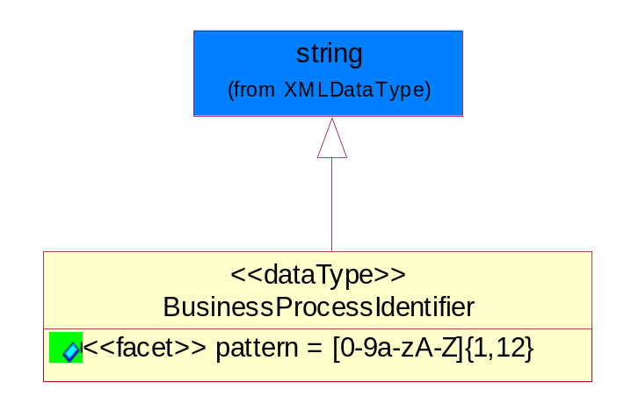
Figure ‎5-82 BusinessProcessIdentifier

Attribute | Type | Documentation
pattern |  | [0-9a-zA-Z]{1,12}

BusinessServiceInformation
The object allows the specification of the business service utilized within the partner company. This may or may not be the same as the information sent by the RNIF.
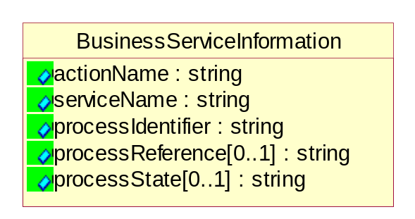
Figure ‎5-83 BusinessServiceInformation

Attribute | Type | Documentation
actionName | string | The name of Action. For RosettaNet usually any of Request/Confirm/Notify/Query/Response.
serviceName | string | The name of the Business Activity with the "Request/Confirm" part removed. E.g., for the Activity "Request Purchase Order"==> "Purchase Order".
processIdentifier | string | The name of the PIP e.g. Notify of Forecast Reply.
processReference[0..1] | string | The URN for the PIP that includes Cluster/Segment/Process pattern used to identify the interface process (such as PIP3A4)
processState[0..1] | string | The business process (or service) state of the sender of a document. When a service receives this document, the receiver may use the state as a precondition.

ContractInformation
A block of information used to correlate a contract in an executing choreography.

Figure ‎5-84 ContractInformation

Attribute | Type | Documentation
contractIdentifier[0..1] | string | Unique identification of a contract between the Sender and the Receiver
contractType[0..1] | string | The type of the contract: an attribute describing the type of the ContractIndentification. Valid values are URI, URN,ebXMLCPA, or other values defined by partners.

CorrelationInformation
A block of information used to correlate a requesting document to a responding document and to the contract in an executing choreography.
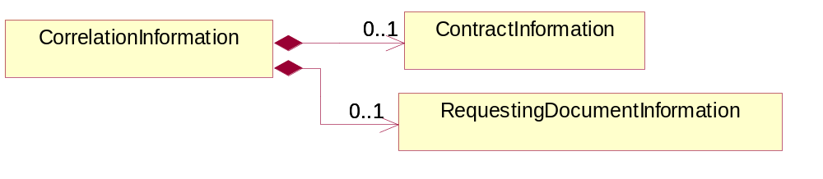
Figure ‎5-85 CorrelationInformation

Composition | Cardinality | Type | Documentation
ContractInformation | 0..1 | ContractInformation | A block of information used to correlate a contract in an executing choreography.
RequestingDocumentInformation | 0..1 | RequestingDocumentInformation | A block of information used to correlate a requesting document to a responding document in an executing choreography.

DocumentHeader
The object allows for the identification of the sender and receiver of the business document.
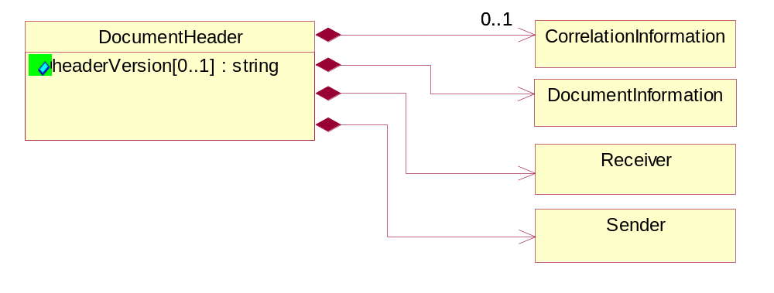
Figure ‎5-86 DocumentHeader

Attribute | Type | Documentation
headerVersion[0..1] | string | The UN/CEFACT version of the document header.

Composition | Cardinality | Type | Documentation
Sender | 1 | Sender | The object allows the identification of the initiating party of the business message.
CorrelationInformation | 0..1 | CorrelationInformation | A block of information used to correlate a requesting document to a responding document and to the contract in an executing choreography.
DocumentInformation | 1 | DocumentInformation | The object specifies information to identify the business document, a summary of attachments, and information about the business document security.
Receiver | 1 | Receiver | The object allows the identification of the receiving party of the business message.

DocumentIdentification
The object specifies all information necessary to identify the business document.
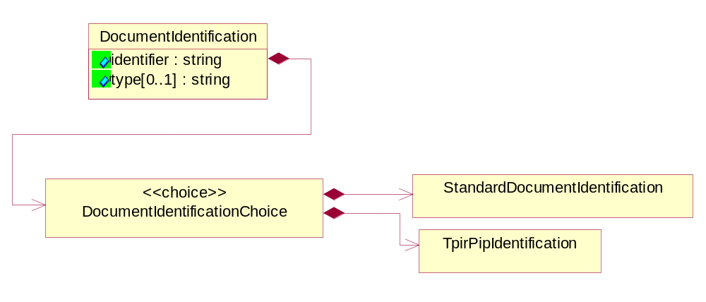
Figure ‎5-87 DocumentIdentification

Attribute | Type | Documentation
identifier | string | The unique identifier for the document being sent.
type[0..1] | string | Name of the Action Message

Composition | Cardinality | Type | Documentation
DocumentIdentificationChoice | 1 | DocumentIdentificationChoice

DocumentIdentificationChoice

Composition | Cardinality | Type | Documentation
StandardDocumentIdentification | 1 | StandardDocumentIdentification | The object specifies additional information necessary to identify the standard business document.
TpirPipIdentification | 1 | TpirPipIdentification | The object specifies all information necessary to uniquely identify a TPIR-PIP within a Registry or trading partner repository.

DocumentInformation
The object specifies information to identify the business document, a summary of attachments, and information about the business document security.
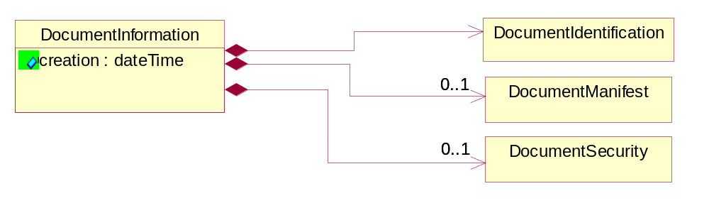
Figure ‎5-88 DocumentInformation

Attribute | Type | Documentation
creation | dateTime | The creation date and time of the specified Business Document (i.e. the Purchase Order date).

Composition | Cardinality | Type | Documentation
DocumentIdentification | 1 | DocumentIdentification | The object specifies all information necessary to identify the business document.
DocumentSecurity | 0..1 | DocumentSecurity | The object provides additional granularity in specifying business document security (this is in addition to the specified PIP security).
DocumentManifest | 0..1 | DocumentManifest | The block provides a brief summary of attachments and Service Content.

DocumentManifest
The block provides a brief summary of attachments and Service Content.
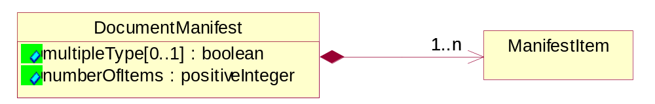
Figure ‎5-89 DocumentManifest

Attribute | Type | Documentation
multipleType[0..1] | boolean | Indicates whether the manifest contains documents of multiple types. True if yes, and False if no.
numberOfItems | positiveInteger | Total number of documents in the message. The physical count of the attachments in the payload plus the RosettaNet Business Message (for Service Content). The value of this field will be at least 1.

Composition | Cardinality | Type | Documentation
ManifestItem | 1..n | ManifestItem | The object provides details about the specific attachment(s).

DocumentSecurity
The object provides additional granularity in specifying business document security (this is in addition to the specified PIP security).

Figure ‎5-90 DocumentSecurity

Attribute | Type | Documentation
nonRepudiableReceipt | boolean | The value "true" will indicate that a signed acknowledgement for the business document is necessary.
persistentEncryption | boolean | The value "true" will indicate that the Business Document (including the header) needs to be encrypted when stored or transported.
persistentSignature | boolean | The value "true" will indicate that a signature is required to be stored with the document while stored or transported.

ManifestItem
The object provides details about the specific attachment(s).

Figure ‎5-91 ManifestItem

Attribute | Type | Documentation
description[0..1] | string | A description of the attachment.
length[0..1] | positiveInteger | The size of the attachment in bytes (i.e. 1 000 000 bytes)
universalResourceIdentifier | string | The generic set of all names/addresses that are short strings that refer to resources.

Composition | Cardinality | Type | Documentation
mimeTypeQualifier | 1 | MimeTypeQualifier | The MIME type as defined by IANA.  Please refer to http://www.iana.org/assignments/media-types/ for a list of types.
language | 0..1 | Language | For representation of Language name RosettaNet has adopted ISO 639-2; 1998. Refer to the following web page to get the latest version of the standard:  http://www.loc.gov/standards/iso639-2/iso639jac.html  If you need more information about the ISO standard please contact ISO for more details.

PipIdentifier
PIP Identification.[ i.e. PIP3A4]
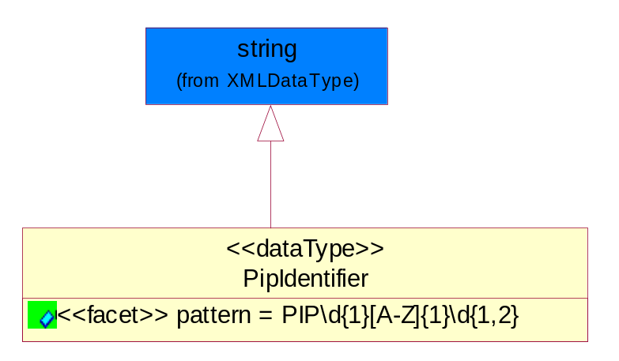
Figure ‎5-92 PipIdentifier

Attribute | Type | Documentation
pattern |  | PIP\d{1}[A-Z]{1}\d{1,2}

PipVersion
PIP version number (i.e. 02.02.00).
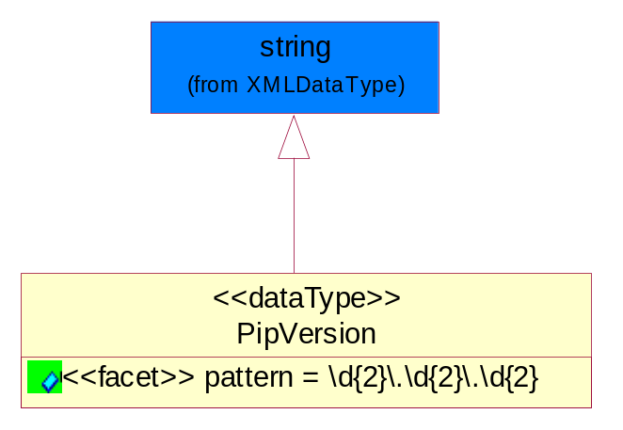
Figure ‎5-93 PipVersion

Attribute | Type | Documentation
Pattern |  | \d{2}\.\d{2}\.\d{2}

Receiver
The object allows the identification of the receiving party of the business message.
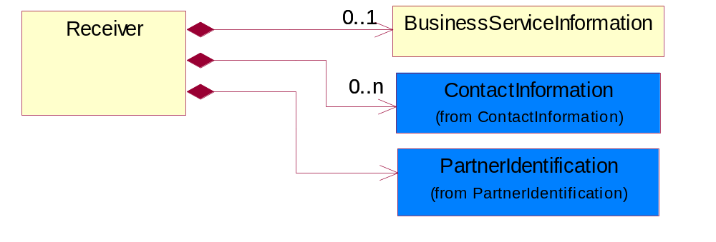
Figure ‎5-94 Receiver

Composition | Cardinality | Type | Documentation
BusinessServiceInformation | 0..1 | BusinessServiceInformation | The object allows the specification of the business service utilized within the partner company. This may or may not be the same as the information sent by the RNIF.
PartnerIdentification | 1 | PartnerIdentification | The business document must allow for the identity of one or more parties to the transaction.
ContactInformation | 0..n | ContactInformation | The business document must allow for the identification of the name of the department, service or individual to be contacted regarding the context of the business document.

RequestingDocumentInformation
A block of information used to correlate a requesting document to a responding document in an executing choreography.

Figure ‎5-95 RequestingDocumentInformation

Attribute | Type | Documentation
businessProcessInstanceIdentifier[0..1] | string | The identifier for the public business process instance being sent that both the sender and receiver can identify.
responseDateTime[0..1] | dateTime | The expected time to receive the response. This can not be greater than the PIP TimeToPerform.
requestingDocumentCreationDateTime[0..1] | dateTime | The date-time of the requesting business document.
requestingDocumentInstanceIdentifier | string | The Business Document identification number that identifies the requesting Business Document.

Sender
The object allows the identification of the initiating party of the business message.
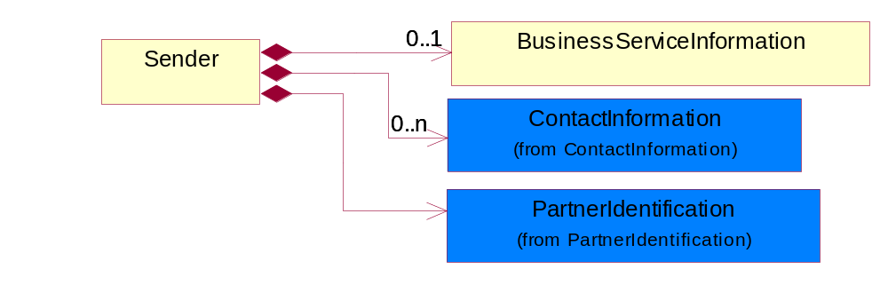
Figure ‎5-96 Sender

Composition | Cardinality | Type | Documentation
PartnerIdentification | 1 | PartnerIdentification | The business document must allow for the identity of one or more parties to the transaction.
BusinessServiceInformation | 0..1 | BusinessServiceInformation | The object allows the specification of the business service utilized within the partner company. This may or may not be the same as the information sent by the RNIF.
ContactInformation | 0..n | ContactInformation | The business document must allow for the identification of the name of the department, service or individual to be contacted regarding the context of the business document.

StandardDocumentIdentification
The object specifies additional information necessary to identify the standard business document.
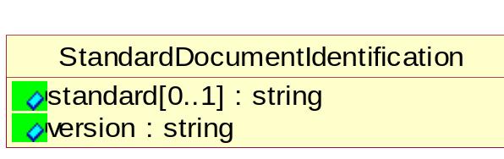
Figure ‎5-97 StandardDocumentIdentification

Attribute | Type | Documentation
standard[0..1] | string | Identifies the standard used to submit the business document. (e.g. RosettaNet).
Version | string | PIP3A4v01.00

TpirPipIdentification
The object specifies all information necessary to uniquely identify a TPIR-PIP within a Registry or trading partner repository.

Figure ‎5-98 TpirPipIdentification

Attribute | Type | Documentation
partnerId | DUNSPlus4 | The Trading Partner Identification of MNC that is creating this TPIR PIP.
pipIdentifier | PipIdentifier | A TPIR PIP Identification [i.e., 3A4 ).
pipVersion | PipVersion | A TPIR PIP version number (i.e., 02.02.00)
tpirPipVersion | VersionIdentifier | A TPIR-PIP Version Number (i.e., major and minor version number as XX.XX).
tpirBusinessProcessIdentifier[0..1] | BusinessProcessIdentifier | A Business Process Identifier to uniquely define the TPIR-PIP 'role' within a Business Scenario at a company or MNC level. The identifier MUST be composed of alphanumeric characters only and its length MUST be between one and twelve characters.
uri[0..1] | anyURI | Describes the destination uri for the TPIR form.

Composition | Cardinality | Type | Documentation
fileType | 0..1 | TPIRFileType | Describes the file type of the TPIR form (PDF, XDP or XML).

VersionIdentifier
Version Number (i.e., major and minor version number as XX.XX).
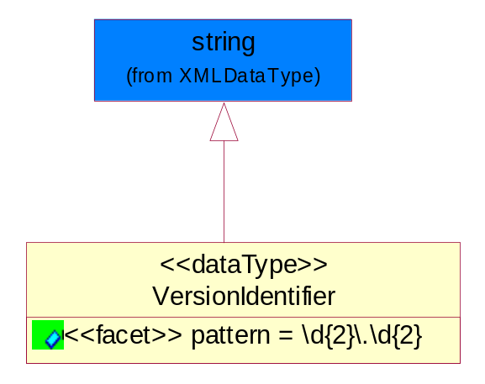
Figure ‎5-99 VersionIdentifier

Attribute | Type | Documentation
Pattern |  | \d{2}\.\d{2}

CodeList

TPIRFileType
A code identifying the file type of TPIR form.

Name | Documentation
PDF | Portable Document Format.
XDP | XML Data Package.
XML | eXtensible Markup Language.

XML Data Type

anyURI
Represents a URI as defined by RFC 2396. An anyURI value can be absolute or relative, and may have an optional fragment identifier.

boolean
Represents Boolean values, which are either "true" or "false".

date
For the represents a calendar date.
The pattern for a date is CCYY-MM-DD where CC represents the century, YY the year, MM the month, and DD the day, with an optional time zone indicator as allowed for dateTime.

dateTime
Represents a specific instance of time.
The pattern for dateTime is CCYY-MM-DDThh:mm:ss where CC represents the century, YY the year, MM the month, and DD the day, preceded by an optional leading negative (-) character to indicate a negative number. If the negative character is omitted, positive (+) is assumed. The T is the date/time separator and hh, mm, and ss represent hour, minute, and second respectively. Additional digits can be used to increase the precision of fractional seconds if desired. For example, the format ss.ss... with any number of digits after the decimal point is supported. The fractional seconds part is optional.
This representation may be immediately followed by a "Z" to indicate Coordinated Universal Time (UTC) or to indicate the time zone. For example, the difference between the local time and Coordinated Universal Time, immediately followed by a sign, + or -, followed by the difference from UTC represented as hh:mm (minutes is required). If the time zone is included, both hours and minutes must be present.

decimal
A data type that contains decimal numbers scaled by a power of 10.

duration
Represents a duration of time.
The pattern for duration is PnYnMnDTnHnMnS, where nY represents the number of years, nM the number of months, nD the number of days, T the date/time separator, nH the number of hours, nM the number of minutes, and nS the number of seconds.

float
Represents single-precision 32-bit floating-point numbers.

gDay
Represents a Gregorian day that recurs, specifically a day of the month such as the fifth day of the month. A gDay is the space of a set of calendar dates. Specifically, it is a set of one-day long, monthly periodic instances.
The pattern for gDay is ---DD with optional time zone indicator as allowed for date.

positiveInteger
Represents an integer that is greater than zero. This data type is derived from nonNegativeInteger.

string
Represents character string.

