

Description of
Partner Interface Process® for 3A4

Validated 11.14.00

Specification Information
Name | Request Purchase Order
Cluster | Order Management
Segment | Quote and Order Entry
Publication Date | 9 February 2010
Version Identifier | V11.14

Table of Contents
1 Document Management 4
1.1 Legal Disclaimer 4
1.2 Copyright 4
1.3 Trademarks 4
1.4 Acknowledgments 4
1.5 Related Documents 5
1.6 Document Version History 5
1.7 Document Structure 5
2 Business Process 6
2.1 Business Process Definition 6
2.1.1 Executive Summary 6
2.1.2 Business Process Description 7
2.1.3 Business Process Context Diagram 8
2.2 PIP Scope Description 9
2.2.1 Business Process Scope Diagram 9
2.3 PIP Business Documents 10
2.4 PIP Business Process Flow Diagram 10
2.5 PIP Start State 11
2.6 PIP End States 11
2.7 Partner Role Descriptions 12
2.8 Business Process Activity Controls 12
3 Network and Implementation Specification 13
3.1 Business Action and Business Signal Specification 13
3.2 Business Transaction Dialog Specification 13
3.2.1 Message Exchange Controls 14
3.2.2 Communications Specification 14

List of Figures
Figure 1: High-level Context Diagram 8
Figure 2: Business Process Scope Diagram 9
Figure 3: Activity Diagram of Request Purchase Order 10
Figure 4: Sequence Diagram of Request Purchase Order 13

List of Tables
Table 1: PIP Business Documents 10
Table 2: PIP Start State 11
Table 3: PIP End State 11
Table 4: PIP Failure State 11
Table 5: Partner Role Descriptions 12
Table 6: Business Activity Descriptions 12
Table 7: Business Activity Performance Controls 12
Table 8: Network Component Specification 13
Table 9: Business Action – Business Document Mapping 13
Table 10: Message Exchange Control 14
Table 11: Dialog: Service-Service 14

Document Management

Legal Disclaimer
RosettaNet™, its members, officers, directors, employees, or agents shall not be liable for any injury, loss, damages, financial or otherwise, arising from, related to, or caused by the use of this document or the specifications herein, as well as associated guidelines and schemas. The use of said specifications shall constitute your express consent to the foregoing exculpation.

Copyright
©2010 RosettaNet. All rights reserved. No part of this publication may be reproduced, stored in a retrieval system, or transmitted, in any form or by any means, electronic, mechanical, photocopying, recording, or otherwise, without the prior written permission of the publisher. Printed in the United States of America.

Trademarks
RosettaNet, Partner Interface Process, PIP and the RosettaNet logo are trademarks or registered trademarks of “RosettaNet,” a non-profit organization. All other product names and company logos mentioned herein are the trademarks of their respective owners. In the best effort, all terms mentioned in this document that are known to be trademarks or registered trademarks have been appropriately recognized in the first occurrence of the term.

Acknowledgments
This document has been prepared by RosettaNet (http://www.rosettanet.org/) from requirements gathered during the Milestone Program and in conformance with the methodology.
Cisco Systems | SBC Business Marketing
Bellsouth Communication Systems | Sterling Commerce
Intel | World Wide Technology (WWT)

Related Documents
- Associated PIP Message Schemas (included within the PIP Specification package only)
- Description of PIP3A4 Message
- Message Structure
- XML instance of ebBPSS for PIP 3A4

Document Version History
Version | Date | Description
Validated 11.00.00 | 02 August 2005 | Validated version : RosettaNet Automated Enablement (RAE) Milestone Program
Validated 11.01.00 | 08 November 2005 | Validated version : Service Contract Information Management (SCIM) Milestone Program
Validated 11.10.00 | 29 May 2006 | Validated version : Service Contract Information Management (SCIM) Milestone Program
Validated 11.11.00 | 18 July 2006 | Validated version : RosettaNet Automated Enablement (RAE) Milestone Program
Validated 11.12.00 | 19 August 2008 | Validated version : RosettaNet PIP Maintenance
Validated 11.13.00 | 30 July 2009 | Validated version : Q32009 Maintenance Process
Validated 11.14.00 | 9 February 2010 | Validated version : MCC Foundational Program

Document Structure
A Partner Interface Process (PIP) Specification is comprised of the following two parts:
- Business Process. Captures the semantics of the business process and the flow of the message exchange between roles as they perform business activities.
- Network and Implementation Specification. Specifies the network protocol message formats and communications requirements between peer-protocols supported by network components in the RosettaNet Implementation Framework.

Business Process

Business Process Definition
The "Request Purchase Order" Partner Interface Process™ (PIP) enables a buyer to issue a purchase order, and a provider to acknowledge, at the line level, if the order is accepted, rejected, or pending.
The provider's acknowledgment may also include related information about delivery expectations.
When a provider acknowledges that the status of a purchase order product line item is "pending," the provider may later use PIP3A7, "Notify Of Purchase Order Acknowledgment" to notify the buyer when the product line item is either accepted or rejected.

Executive Summary
Request Purchase Order standardizes the purchase order request and confirmation process by defining a common vocabulary for transmission of purchase order information. The value propositions of this initiative are:
- Standards based purchase order information increases trading partners (provider and buyer) business efficiency.
- Standards based purchase order information decreases IT support resources and overhead required to assure data integrity.
- Standards based purchase order information enables on demand problem resolution between the trading partners.
- Standards based purchase order information enables rapid new partner setup in B2B environment.
- Standards based purchase order information can be used as a quantifiable metric for customer satisfaction.

Business Process Description
The “Request Purchase Order” Partner Interface Process (PIP) supports the process to send purchase order information to a trading partner.
The process of issuing a purchase order typically occurs after:
- Checking for price and availability
- Requesting quotes
- Transferring shopping carts
The process of issuing a purchase order may be followed by:
- Changing the purchase order
- Canceling the purchase order
- Querying for purchase order status
- Distributing purchase order status
Should this transaction not complete successfully, the requesting partner executes PIP0A1, "Notification Of Failure."

Business Process Context Diagram
Receive and Process Confirmation
Generate Purchase Order
Process Purchase Order
Buyer
Seller
- Prior to making any purchase order request, buyer can check for products price and availability using PIP 3A2, and request for quotation using PIP 3A1.
- Purchase Order Request send from buyer to seller, using PIP 3A4.
- Seller needs to acknowledge and confirm to the buyer for the acceptance or rejection of a pending line item in the purchase order.
- In the event where the seller has any counter proposal on the purchase order, the seller needs to change and notify the buyer, using PIP 3A7.
Generate Confirmation

Send Request

Send Confirmation

Figure 1: High-level Context Diagram

PIP Scope Description
This PIP enables a buyer to issue a purchase order and obtain a quick response from the provider that acknowledges which of the purchase order product line items are accepted, rejected, or pending.

Business Process Scope Diagram
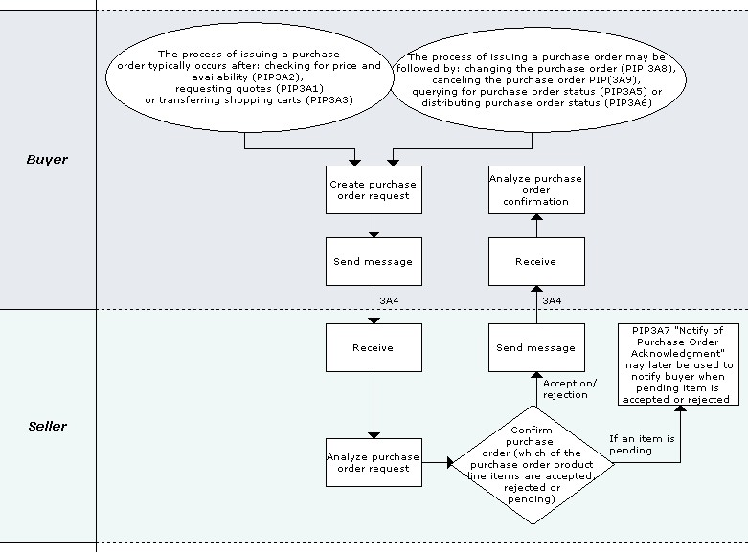

Figure 2: Business Process Scope Diagram

PIP Business Documents
Business Documents are generated and exchanged by roles performing activities in this PIP. Business Documents are listed and defined in Table 1.
Table 1: PIP Business Documents
Business Document | Description
Purchase Order Request | A request to accept a purchase order for fulfillment.
Purchase Order Confirmation | Formally confirms the status of line item(s) in a Purchase Order. A Purchase Order line item may have one of the following states: accepted, rejected, or pending.

PIP Business Process Flow Diagram
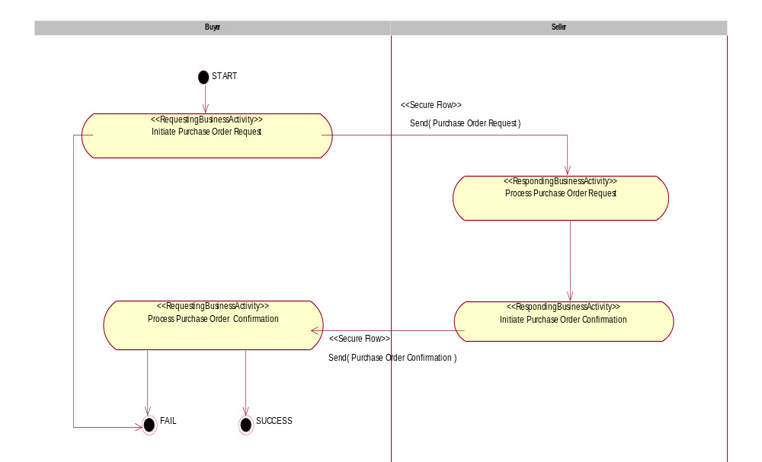

Figure 3: Activity Diagram of Request Purchase Order

PIP Start State
The start state is comprised of the following condition(s):
Table 2: PIP Start State
 | Approved | Exist |  | Valid | Non-Repudiated | Retry Count | Authorized
 | Approved | Party | In Backend system
TPA |  |  | 
Sending Partner |  |  |  |  |  |  | 
Receiving Partner |  | 
Business Document  (Purchase Order Request) |  |  |  |  | 

PIP End States
The end state is comprised of the following condition(s):
Table 3: PIP End State
 | Approved | Exist |  | Valid | Non-Repudiated | Retry Count | Authorized
 | Approved | Party | In Backend system
Acknowledgment of Receipt |  |  |  |  | 
Receiving Partner |  |  |  |  |  |  | 

The PIP failure state is comprised of one or more of the following condition(s):
Table 4: PIP Failure State
 | NO | Exceeded
Success | 
Retry Count |  | 

Partner Role Descriptions
Table 5 describes the partner roles in this PIP.
Table 5: Partner Role Descriptions
Role Name | Role Description
Buyer | An employee or organization that buys products for a partner type in the supply chain.
Seller | An organization that sells products to partners in the supply chain.

Business Process Activity Controls
Table 6 describes the interaction between roles performing business activities in this PIP.
Table 6: Business Activity Descriptions
Role Name | Activity Name | Activity Description
Buyer | Initiate Purchase Order Request | This activity issues a Purchase Order to a Seller.
Seller | Initiate Purchase Order Confirmation | The Seller acknowledges, at the line level, if the Purchase Order is accepted, rejected, or pending.

Table 7 details the security, audit and process controls relating to activities performed in the PIP.
Table 7: Business Activity Performance Controls
Role  Name | Activity  Name | Acknowledgment  of Receipt |  | Time to Perform | Retry Count | Is Authorization Required? | Non-Repudiation of Origin and Content?
Role  Name | Activity  Name | Non-Repudiation Required? | Time to Acknowledge
Buyer | Initiate Purchase Order Request | Y | 2 hrs | 24 hrs | 3 | Y | Y
Seller | Initiate Purchase Order Confirmation | Y | 2 hrs | 24 hrs | 3 | Y | Y

Network and Implementation Specification
Each network component maps into a role of the PIP model. Table 8 specifies the mapping between roles and network components.
Table 8: Network Component Specification
Network Component | Classification | Maps to Role in Business Process
Buyer Service | Business Service | Buyer
Seller Service | Business Service | Seller

Business Action and Business Signal Specification
Each business action maps to a Business Document of the PIP model. Table 9 specifies the mapping between Business Documents and business actions.
Table 9: Business Action – Business Document Mapping
Business Action | Business Document | Document Function
Purchase Order Request Action | Purchase Order Request | Request
Purchase Order Confirmation Action | Purchase Order Confirmation | Respond

Business Transaction Dialog Specification
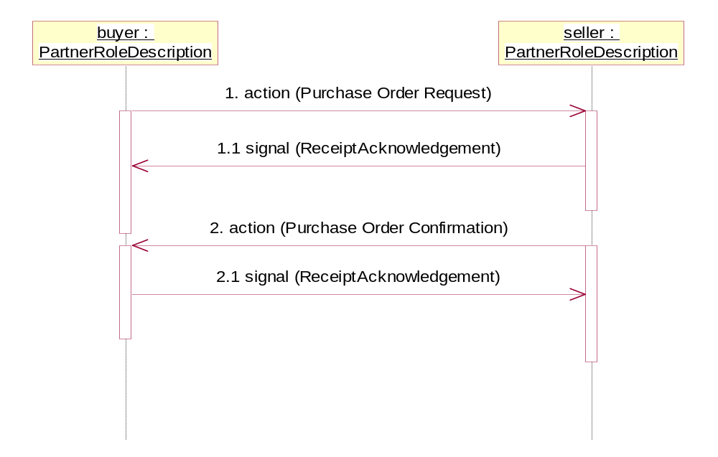
Figure 4: Sequence Diagram of Request Purchase Order

Message Exchange Controls
Table 10: Message Exchange Control
# | Name |  | Time to Acknowledge Receipt Signal |  | Time to Respond to Action |  | Included in Time to Perform |  | Is Authorization Required? |  | Is Non-Repudiation Required? |  | Is Secure Transport Required?
1. |  | Purchase Order Request Action |  | 2 hrs |  | N/A |  | 24 hrs |  | Y |  | Y |  | Y
1.1. |  | Receipt Acknowledgment |  | N/A |  | N/A |  | N/A |  | Y |  | Y |  | Y
2. |  | Purchase Order Confirmation Action |  | 2 hrs |  | N/A |  | N/A |  | Y |  | Y |  | Y
2.1. |  | Receipt Acknowledgment |  | N/A |  | N/A |  | N/A |  | N |  | Y |  | Y

Communications Specification
Table 11: Dialog: Service-Service
# | Business Message | Digital Signature Required? | SSL Required?
1. | Purchase Order Request | Y | Y
1.1. | Receipt Acknowledgment | Y | Y
2. | Purchase Order Confirmation | Y | Y
2.1. | Receipt Acknowledgment | Y | Y

