

Description of
Partner Interface Process® for 3A6

Validated 11.00.00

Specification Information
Name | Distribute Purchase Order Status
Cluster | Order Management
Segment | Quote and Order Entry
Publication Date | 18 July 2008
Version Identifier | V11.00

Table of Contents
1 Document Management 4
1.1 Legal Disclaimer 4
1.2 Copyright 4
1.3 Trademarks 4
1.4 Acknowledgments 4
1.5 Related Documents 5
1.6 Document Version History 5
1.7 Document Structure 5
2 Business Process 6
2.1 Business Process Definition 6
2.1.1 Business Process Context Diagram 6
2.2 PIP Scope Description 7
2.2.1 Business Process Scope Diagram 7
2.3 PIP Business Documents 8
2.4 PIP Business Process Flow Diagram 8
2.5 PIP Start State 9
2.6 PIP End States 9
2.7 Partner Role Descriptions 10
2.8 Business Process Activity Controls 10
3 Network and Implementation Specification 11
3.1 Business Action and Business Signal Specification 11
3.2 Business Transaction Dialog Specification 11
3.2.1 Message Exchange Controls 12
3.2.2 Communications Specification 12

List of Figures
Figure 1: High-level Context Diagram 6
Figure 2: Business Process Scope Diagram 7
Figure 3: Activity Diagram of Distribute Purchase Order Status 8
Figure 4: Sequence Diagram of Distribute Purchase Order Status 11

List of Tables
Table 1: PIP Business Documents 8
Table 2: PIP Start State 9
Table 3: PIP End State 9
Table 4: PIP Failure State 9
Table 5: Partner Role Descriptions 10
Table 6: Business Activity Descriptions 10
Table 7: Business Activity Performance Controls 10
Table 8: Network Component Specification 11
Table 9: Business Action – Business Document Mapping 11
Table 10: Message Exchange Control 12
Table 11: Dialog: Service-Service 12

Document Management

Legal Disclaimer
RosettaNet™, its members, officers, directors, employees, or agents shall not be liable for any injury, loss, damages, financial or otherwise, arising from, related to, or caused by the use of this document or the specifications herein, as well as associated guidelines and schemas. The use of said specifications shall constitute your express consent to the foregoing exculpation.

Copyright
©2008 RosettaNet. All rights reserved. No part of this publication may be reproduced, stored in a retrieval system, or transmitted, in any form or by any means, electronic, mechanical, photocopying, recording, or otherwise, without the prior written permission of the publisher. Printed in the United States of America.

Trademarks
RosettaNet, Partner Interface Process, PIP and the RosettaNet logo are trademarks or registered trademarks of “RosettaNet,” a non-profit organization. All other product names and company logos mentioned herein are the trademarks of their respective owners. In the best effort, all terms mentioned in this document that are known to be trademarks or registered trademarks have been appropriately recognized in the first occurrence of the term.

Acknowledgments
This document has been prepared by RosettaNet (http://www.rosettanet.org/) from requirements gathered during the Milestone Program and in conformance with the methodology.
BCM Electronics | International Business Machines
Bellsouth Communication Systems | MIMOS Berhad.
Cisco Systems | Peregrine Connectivity, Inc.
HP | Peregrine Systems
IBM | Sterling Commerce
Intel Corporation | SBC Business Marketing
Inovis Inc. | World Wide Technology (WWT)

Related Documents
- Associated PIP Message Schemas (included within the PIP Specification package only)
- Description of PIP3A6 Message
- Message Structure
- XML instance of ebBPSS for PIP 3A6

Document Version History
Version | Date | Description
Validated 11.00.00 | 18 July 2008 | Validated Version : RosettaNet Schema to Market to Validation 2008

Document Structure
A Partner Interface Process (PIP) Specification is comprised of the following two parts:
- Business Process. Captures the semantics of the business process and the flow of the message exchange between roles as they perform business activities.
- Network and Implementation Specification. Specifies the network protocol message formats and communications requirements between peer-protocols supported by network components in the RosettaNet Implementation Framework.

Business Process

Business Process Definition
The "Distribute Purchase Order Status" Partner Interface Process™ (PIP) enables a seller to send the status of a product order to a buyer. For example, a product line item may be backordered, shipped, or canceled. Order status is distributed when an open purchase order exists. The trading partner agreement should specify if order status will be distributed periodically, upon the occurrence of various business events, or according to a combination of periodicity and business event criteria.
Should this transaction not complete successfully, the requesting partner executes PIP0A1, "Notification of Failure."

Business Process Context Diagram
Seller
Buyer

Generate Purchase Order Status Distribution
Send Distribution
Process Purchase Order Status Distribution

- Purchase Order Status Distribution send from seller to buyer, using PIP 3A6.

Figure 1: High-level Context Diagram

PIP Scope Description
This PIP enables a seller to distribute a purchase order status and inform buyer which of the purchase order product line items are accepted, rejected, or pending.

Business Process Scope Diagram
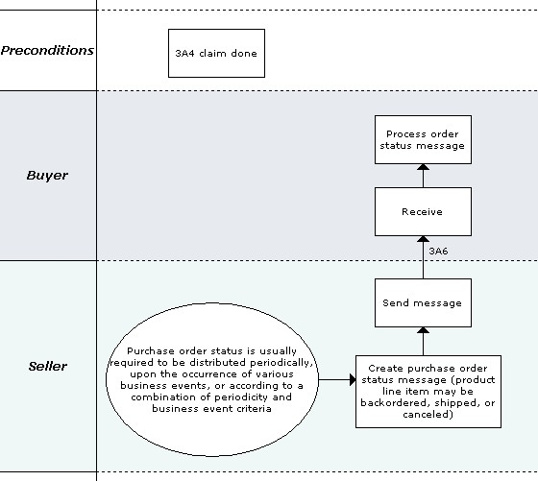

Figure 2: Business Process Scope Diagram

PIP Business Documents
Business Documents are generated and exchanged by roles performing activities in this PIP. Business Documents are listed and defined in Table 1.
Table 1: PIP Business Documents
Business Document | Description
Purchase Order Status Distribution | An unsolicited informal notification of the status of an existing Purchase Order. The status reflects the current state of the Purchase Order at the time of the request.

PIP Business Process Flow Diagram
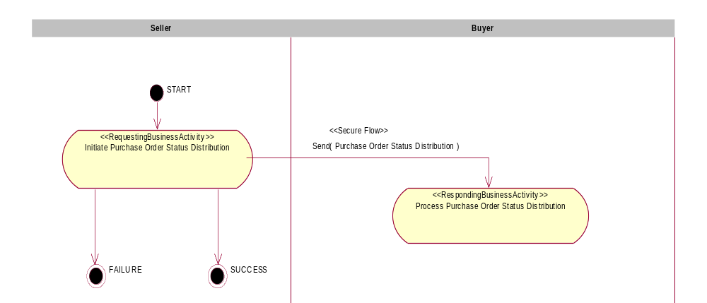

Figure 3: Activity Diagram of Distribute Purchase Order Status

PIP Start State
The start state is comprised of the following condition(s):
Table 2: PIP Start State
 | Approved | Exist |  | Valid | Non-Repudiated | Retry Count | Authorized
 | Approved | Party | In Backend system
TPA |  |  | 
Sending Partner |  |  |  | 
Receiving Partner |  | 
Business Document |  |  |  | 

PIP End States
The end state is comprised of the following condition(s):
Table 3: PIP End State
 | Approved | Exist |  | Valid | Non-Repudiated | Retry Count | Authorized
 | Approved | Party | In Backend system
Acknowledgment of Receipt |  |  |  | 
Receiving Partner |  |  |  |  |  |  | 

The PIP failure state is comprised of one or more of the following condition(s):
Table 4: PIP Failure State
 | NO | Exceeded
Success | 
Retry Count |  | 

Partner Role Descriptions
Table 5 describes the partner roles in this PIP.
Table 5: Partner Role Descriptions
Role Name | Role Description
Buyer | An employee or organization that buys products for a partner type in the supply chain.
Seller | An organization that sells products to partners in the supply chain.

Business Process Activity Controls
Table 6 describes the interaction between roles performing business activities in this PIP.
Table 6: Business Activity Descriptions
Role Name | Activity Name | Activity Description
Seller | Initiate Purchase Order Status Distribution | The Seller distributes the status of an existing Purchase Order to a Buyer.

Table 7 details the security, audit and process controls relating to activities performed in the PIP.
Table 7: Business Activity Performance Controls
Role  Name | Activity  Name | Acknowledgment  of Receipt |  | Time to Perform | Retry Count | Is Authorization Required? | Non-Repudiation of Origin and Content?
Role  Name | Activity  Name | Non-Repudiation Required? | Time to Acknowledge
Seller | Initiate Purchase Order Status Distribution | N | 2 hrs | N/A | 3 | N | N

Network and Implementation Specification
Each network component maps into a role of the PIP model. Table 8 specifies the mapping between roles and network components.
Table 8: Network Component Specification
Network Component | Classification | Maps to Role in Business Process
Buyer Service | Business Service | Buyer
Seller Service | Business Service | Seller

Business Action and Business Signal Specification
Each business action maps to a Business Document of the PIP model. Table 9 specifies the mapping between Business Documents and business actions.
Table 9: Business Action – Business Document Mapping
Business Action | Business Document | Document Function
Purchase Order Status Distribution Action | Purchase Order Status Distribution | Request

Business Transaction Dialog Specification
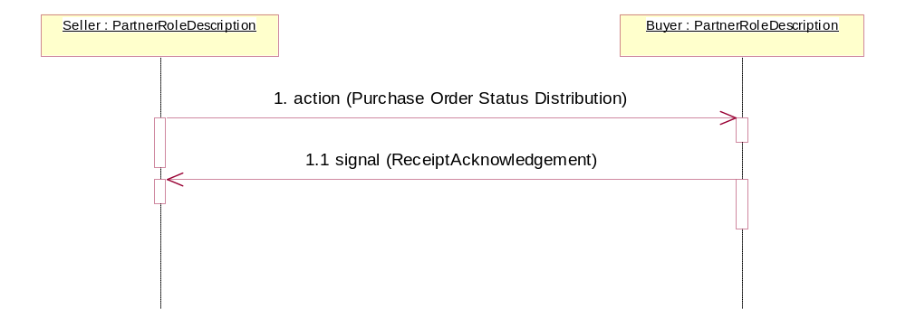
Figure 4: Sequence Diagram of Distribute Purchase Order Status

Message Exchange Controls
Table 10: Message Exchange Control
# | Name |  | Time to Acknowledge Receipt Signal |  | Time to Respond to Action |  | Included in Time to Perform |  | Is Authorization Required? |  | Is Non-Repudiation Required? |  | Is Secure Transport Required?
1. |  | Purchase Order Status Distribution Action |  | 2 hrs |  | N/A |  | N/A |  | N |  | N |  | Y
1.1. |  | Receipt Acknowledgment |  | N/A |  | N/A |  | N/A |  | N |  | N |  | Y

Communications Specification
Table 11: Dialog: Service-Service
# | Business Message | Digital Signature Required? | SSL Required?
1. | Purchase Order Status Distribution | N | Y
1.1. | Receipt Acknowledgment | N | Y

