

Description of
Partner Interface Process® for 3A7

Validated 11.01.00

Specification Information
Name | Notify Of Purchase Order Update
Cluster | Order Management
Segment | Quote and Order Entry
Publication Date | 08 August 2006
Version Identifier | V11.01

Table of Contents
1 Document Management 4
1.1 Legal Disclaimer 4
1.2 Copyright 4
1.3 Trademarks 4
1.4 Acknowledgments 4
1.5 Related Documents 4
1.6 Document Version History 5
1.7 Document Structure 5
2 Business Process 6
2.1 Business Process Definition 6
2.1.1 Executive Summary 6
2.1.2 Business Process Description 7
2.1.3 Business Process Context Diagram 8
2.2 PIP Scope Description 9
2.2.1 Business Process Scope Diagram 9
2.3 PIP Business Documents 10
2.4 PIP Business Process Flow Diagram 10
2.5 PIP Start State 11
2.6 PIP End States 11
2.7 Partner Role Descriptions 12
2.8 Business Process Activity Controls 12
3 Network and Implementation Specification 13
3.1 Business Action and Business Signal Specifications 13
3.2 Business Transaction Dialog Specification 13
3.2.1 Message Exchange Controls 14
3.2.2 Communications Specification 14

List of Figures
Figure 1: High-level Context Diagram 8
Figure 2: Business Process Scope Diagram 9
Figure 3: Activity Diagram of Notify of Purchase Order Update 10
Figure 4: Sequence Diagram of Notify of Purchase Order Update 13

List of Tables
Table 1: PIP Business Documents 10
Table 2: PIP Start State 11
Table 3: PIP End State 11
Table 4: PIP Failure State 11
Table 5: Partner Role Descriptions 12
Table 6: Business Activity Descriptions 12
Table 7: Business Activity Performance Controls 12
Table 8: Network Component Specification 13
Table 9: Business Action – Business Document Mapping 13
Table 10: Message Exchange Controls 14
Table 11: Dialog: Service-Service 14

Document Management

Legal Disclaimer
RosettaNet™, its members, officers, directors, employees, or agents shall not be liable for any injury, loss, damages, financial or otherwise, arising from, related to, or caused by the use of this document or the specifications herein, as well as associated guidelines and schemas. The use of said specifications shall constitute your express consent to the foregoing exculpation.

Copyright
©2006 RosettaNet. All rights reserved. No part of this publication may be reproduced, stored in a retrieval system, or transmitted, in any form or by any means, electronic, mechanical, photocopying, recording, or otherwise, without the prior written permission of the publisher. Printed in the United States of America.

Trademarks
RosettaNet, Partner Interface Process, PIP and the RosettaNet logo are trademarks or registered trademarks of "RosettaNet," a non-profit organization. All other product names and company logos mentioned herein are the trademarks of their respective owners. In the best effort, all terms mentioned in this document that are known to be trademarks or registered trademarks have been appropriately recognized in the first occurrence of the term.

Acknowledgments
This document has been prepared by RosettaNet (http://www.rosettanet.org/) from requirements gathered during the Milestone Program and in conformance with the methodology.

Related Documents
- Associated PIP Message Schemas (included within the PIP Specification package only)
- Description of 3A7 Message
- Message Structure
- XML instance of ebXML BPSS for PIP 3A7

Document Version History
Version | Date | Description
Validated 11.00.00 | 8 June 2006 | Validated Version
Validated 11.01.00 | 08 August 2006 | Validated Version

Document Structure
A Partner Interface Process (PIP) Specification is comprised of the following two parts:
- Business Process. Captures the semantics of the business process and the flow of the message exchange between roles as they perform business activities.
- Network and Implementation Specification. Specifies the network protocol message formats and communications requirements between peer-protocols supported by network components in the RosettaNet Implementation Framework.

Business Process

Business Process Definition
The "Notify of Purchase Order Update" Partner Interface Process™ (PIP) enables a seller to acknowledge acceptance or rejection of a pending line in a purchase order or a purchase order change. This PIP can also be used by the seller to initiate changes to a purchase order. In the event of seller-initiated changes, the requirement for a response document from the buyer can be predetermined within the Trading Partner Agreement. Typically, the buyer must respond with PIP3A8, “Request Purchase Order Change,” to accept the proposed changes. If the changes are not accepted, PIP3A9, “Request Purchase Order Cancel” must be sent by the buyer.

Executive Summary
Notify of Purchase Order Update standardizes the purchase order update process by defining a common vocabulary for transmission of purchase order information. The value propositions of this initiative are:
- Standards based purchase order update information increases trading partners (seller and buyer) business efficiency.
- Standards based purchase order update information decreases IT support resources and overhead required to assure data integrity.
- Standards based purchase order update information enables on demand problem resolution between the trading partners.
- Standards based purchase order update information enables rapid new partner setup in B2B environment.
- Standards based purchase order update information can be used as a quantifiable metric for customer satisfaction.

Business Process Description
The “Notify of Purchase Order Update” Partner Interface Process (PIP) supports the process to send purchase order information to a trading partner.
The process supported by this PIP occurs for two reasons:
1. After a buyer issues a purchase order to a seller and the seller responds by acknowledging that the status of one or more product line items is “pending.” Or after a buyer issues a purchase order change and the seller responds by acknowledging that the status of one or more product line items is “pending.” A seller completes a pending line-level transaction by acknowledging when a product line item has been accepted or rejected. The time period in which a seller must complete transactions is specified in the trading partner agreement. The reason for rejecting a product line item may be included in an update.
2. The seller requests changes to the Purchase Order. The buyer accepts the changes or the purchase order is canceled. Changes are limited to the constrained elements defined in the Trading Partner Agreement. It should also identify the time period in which the buyer needs to send PIP3A8, “Request Purchase Order Change” or PIP3A9, “Request Purchase Order Cancel” to close the messaging process and synchronize both buyer and seller systems.
Should this transaction not complete successfully, the requesting partner executes PIP0A1, "Notification of Failure."

Business Process Context Diagram
Purchase Order Request
Receive and Process Purchase Order
Update Purchase Order
Send Notification
Process Purchase Order Update
Seller
Buyer
Purchase Order was send from buyer to seller earlier, using PIP 3A4.
Seller needs to acknowledge the buyer of the acceptance or rejection of a pending line item in the purchase order; if the seller has any counter proposal, the seller needs to change and notify the buyer, using PIP 3A7.
The buyer will then analyze the updated purchase order, and acknowledge the seller of the acceptance or rejection of the proposed changes.

Figure 1: High-level Context Diagram

PIP Scope Description
This PIP acknowledges acceptance or rejection of pending purchase order transactions. This PIP can also be used by the seller to initiate changes to existing purchase orders.

Business Process Scope Diagram
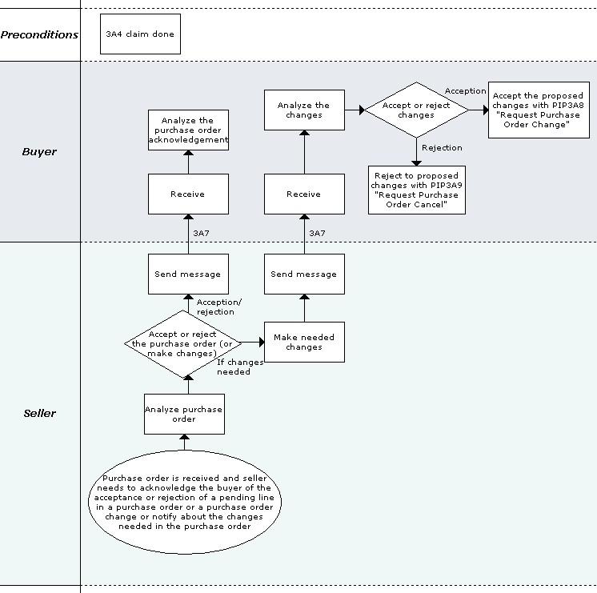
Figure 2: Business Process Scope Diagram

PIP Business Documents
Business Documents are generated and exchanged by roles performing activities in this PIP. Business Documents are listed and defined in Table 1.
Table 1: PIP Business Documents
Business Document | Description
Purchase Order Update Notification | An unsolicited, formal acknowledgment of the acceptance or rejection of a line item in a Purchase Order or a Purchase Order Change, or as a means to communicate Seller initiated changes to the Purchase Order.

PIP Business Process Flow Diagram
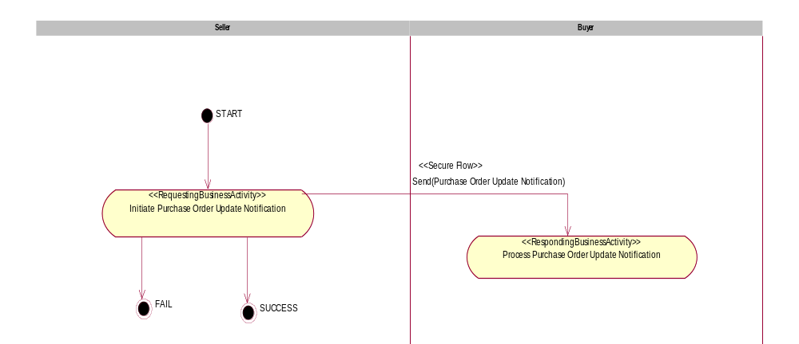

Figure 3: Activity Diagram of Notify of Purchase Order Update

PIP Start State
The start state is comprised of the following condition(s):
Table 2: PIP Start State
 | Approved | Exist |  | Valid | Non-Repudiated | Retry Count | Authorized
 | Approved | Party | In Backend system
TPA |  |  | 
Sending Partner |  |  |  | 
Receiving Partner |  | 
Business Document |  |  |  |  |  |  | 

PIP End States
The end state is comprised of the following condition(s):
Table 3: PIP End State
 | Approved | Exist |  | Valid | Non-Repudiated | Retry Count | Authorized
 | Approved | Party | In Backend system
Acknowledgment of Receipt |  |  |  |  | 
Receiving Partner |  |  |  |  |  |  | 

The PIP failure state is comprised of one or more of the following condition(s):
Table 4: PIP Failure State
 | NO | Exceeded
Success | 
Retry Count |  | 

Partner Role Descriptions
Table 5 describes the partner roles in this PIP.
Table 5: Partner Role Descriptions
Role Name | Role Description
Seller | An organization that sells products to partners in the supply chain.
Buyer | An employee or organization that buys products for a partner type in the supply chain.

Business Process Activity Controls
Table 6 describes the interaction between roles performing business activities in this PIP.
Table 6: Business Activity Descriptions
Role  Name | Activity Name | Activity Description
Seller | Initiate Purchase Order Update Notification | The Seller notifies the Buyer of acceptance or rejection of a pending line item in a Purchase Order or a Purchase Order Change, or communicates a Seller initiated change to a Purchase Order.

Table 7 details the security, audit and process controls relating to activities performed in the PIP.
Table 7: Business Activity Performance Controls
Role  Name | Activity  Name | Acknowledgment  of Receipt |  | Time to Perform | Retry Count | Is Authorization Required? | Non-Repudiation of Origin and Content?
Role  Name | Activity  Name | Non-Repudiation Required? | Time to Acknowledge
Seller | Initiate Purchase Order Update Notification | Y | 2 hrs | N/A | 3 | Y | Y
Note: All time parameters are defined as (hrs or mins), i.e. 2 hrs

Network and Implementation Specification
Each network component maps into a role of the PIP model. Table 8 specifies the mapping between roles and network components.
Table 8: Network Component Specification
Network Component | Classification | Maps to Role in Business Process
Seller Service | Business Service | Seller
Buyer Service | Business Service | Buyer

Business Action and Business Signal Specifications
Each business action maps to a Business Document of the PIP model. Table 9 specifies the mapping between Business Documents and business actions.
Table 9: Business Action – Business Document Mapping
Business Action | Business Document | Document Function
Purchase Order Update Notification Action | Purchase Order Update Notification | Request

Business Transaction Dialog Specification
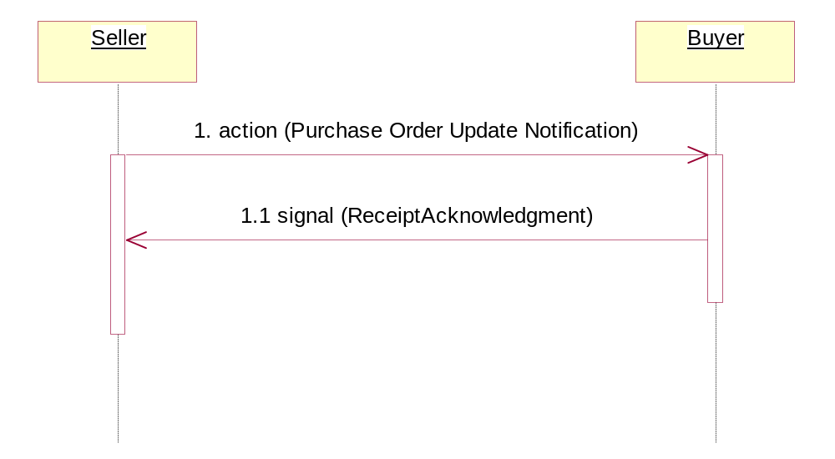
Figure 4: Sequence Diagram of Notify of Purchase Order Update

Message Exchange Controls
Table 10: Message Exchange Controls
# | Name |  | Time to Acknowledge |  | Time to Respond to Action |  | Included in Time to Perform |  | Is Authorization Required? |  | Is Non-Repudiation Required? |  | Is Secure Transport Required?
1. |  | Purchase Order Update Notification Action |  | 2 hrs |  | N/A |  | N/A |  | Y |  | Y |  | Y
1.1. |  | Receipt Acknowledgment |  | N/A |  | N/A |  | N/A |  | Y |  | Y |  | Y
Note: All time parameters are defined as (hrs or mins), i.e. 2 hrs

Communications Specification
Table 11: Dialog: Service-Service
# | Business Message | Digital Signature Required? | SSL Required?
1. | Purchase Order Update Notification | Y | Y
1.1. | Receipt Acknowledgment | Y | Y

