

Description of
Partner Interface Process® for 3A8

Validated 11.01.00

Specification Information
Name | Request Purchase Order Change
Cluster | Order Management
Segment | Quote and Order Entry
Publication Date | 3 February 2010
Version Identifier | V11.01

Table of Contents
1 Document Management 4
1.1 Legal Disclaimer 4
1.2 Copyright 4
1.3 Trademarks 4
1.4 Acknowledgments 4
1.5 Related Documents 4
1.6 Document Version History 4
1.7 Document Structure 5
2 Business Process 6
2.1 Business Process Definition 6
2.1.1 Business Process Description 6
2.2 PIP Business Document 6
2.3 PIP Business Process Flow Diagram 7
2.4 PIP Start State 7
2.5 PIP End States 8
2.6 Partner Role Descriptions 8
2.7 Business Process Activity Controls 8
3 Network and Implementation Specification 10
3.1 Business Action and Business Signal Specifications 10
3.2 Business Transaction Dialog Specification 10
3.2.1 Message Exchange Controls 11
3.2.2 Communications Specification 11

List of Figures:
Figure 1: Activity Diagram of Request Purchase Order Change 7
Figure 2: Sequence Diagram of Request Purchase Order Change 10

List of Tables:
Table 1: PIP Business Document 6
Table 2: PIP Start State 7
Table 3: PIP End State 8
Table 4: PIP Failure State 8
Table 5: Partner Role Description 8
Table 6: Business Activity Description 8
Table 7: Business Activity Performance Control 9
Table 8: Network Component Specification 10
Table 9: Business Action – Business Document Mapping 10
Table 10: Message Exchange Control 11
Table 11: Dialog: Service-Service 11

Document Management

Legal Disclaimer
RosettaNet™, its members, officers, directors, employees, or agents shall not be liable for any injury, loss, damages, financial or otherwise, arising from, related to, or caused by the use of this document or the specifications herein, as well as associated guidelines and schemas. The use of said specifications shall constitute your express consent to the foregoing exculpation.

Copyright
©2010 RosettaNet. All rights reserved. No part of this publication may be reproduced, stored in a retrieval system, or transmitted, in any form or by any means, electronic, mechanical, photocopying, recording, or otherwise, without the prior written permission of the publisher. Printed in the United States of America.

Trademarks
RosettaNet, Partner Interface Process, PIP and the RosettaNet logo are trademarks or registered trademarks of "RosettaNet," a non-profit organization. All other product names and company logos mentioned herein are the trademarks of their respective owners. In the best effort, all terms mentioned in this document that are known to be trademarks or registered trademarks have been appropriately recognized in the first occurrence of the term.

Acknowledgments
This document has been prepared by RosettaNet (http://www.rosettanet.org/) from requirements gathered during the Milestone Program and in conformance with the methodology.

Related Documents
- Associated PIP Message Schemas (included within the PIP Specification package only)
- Description of 3A8 Message
- Messages Structure
- XML instance of ebXML BPSS for PIP 3A8

Document Version History
Version | Date | Description
Validated 11.00.00 | 11 July 2006 | Validated Version
Validated 11.01.00 | 3 February 2010 | Validated Version

Document Structure
A Partner Interface Process (PIP) Specification is comprised of the following two parts:
- Business Process. Captures the semantics of the business process and the flow of the message exchange between roles as they perform business activities.
- Network and Implementation Specification. Specifies the network protocol message formats and communications requirements between peer-protocols supported by network components in the RosettaNet Implementation Framework.

Business Process

Business Process Definition
Enables a buyer to change purchase order line items and obtain a quick response from the seller that acknowledges, at the line level, if the changes are accepted, rejected, or pending.

Business Process Description
The "Request Purchase Order Change" Partner Interface Process™ (PIP) enables a buyer to change a purchase order, and a seller to acknowledge if the changes are accepted, rejected, or pending. Changes to a purchase order may be initiated by the buyer or may occur after the receipt of a seller initiated change in PIP3A7, "Notify of Purchase Order Update."
If a seller acknowledges that the status of a product line item in a purchase order change is "pending," the seller may later use PIP3A7, "Notify of Purchase Order Update" to notify the buyer when the line is either accepted or rejected.
Should this transaction not complete successfully, the requesting partner executes PIP0A1, "Notification of Failure."

PIP Business Document
Business Document are generated and exchanged by roles performing activities in this PIP. Business Document is listed and defined in Table 1.
Table 1: PIP Business Document
Business Document | Description
Purchase Order Change Request | Requests change of an existing purchase order.
Purchase Order Change Confirmation | Confirms the status of line item(s) in a Purchase Order Change Request. A Purchase Order line item may have one of the following states: accepted, rejected, or pending.

PIP Business Process Flow Diagram
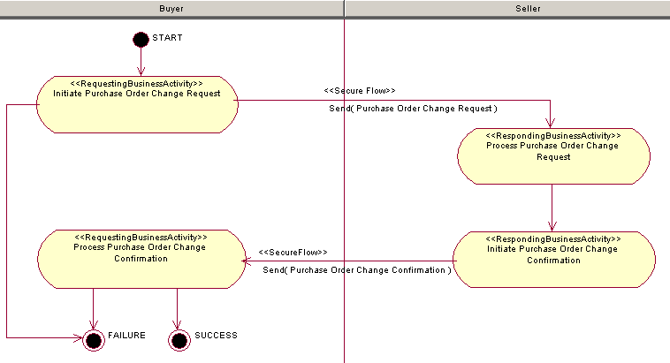
Figure 1: Activity Diagram

PIP Start State
The start state is comprised of the following conditions:
Table 2: PIP Start State
 | Approved | Exist |  | Valid | Non-Repudiated | Retry Count | Authorized
 | Approved | Party | In Backend System
TPA |  |  | 
Sending Partner |  |  |  |  |  |  | 
Receiving Partner |  | 
Business Document  (Purchase Order Change Request) |  |  |  |  | 

PIP End States
The end state is comprised of the following conditions:
Table 3: PIP End State
 | Approved | Exist |  | Valid | Non-Repudiated | Retry Count | Authorized
 | Approved | Party | In Backend system
Acknowledgment of Receipt |  |  |  | 
Receiving Partner |  |  |  |  |  |  | 
Business Document  (Purchase Order Change Confirmation) |  |  |  |  | 

The PIP failure state is comprised of one or more of the following conditions:
Table 4: PIP Failure State
 | NO | Exceeded
Success | 
Retry Count |  | 

Partner Role Descriptions
Table 5 describes the partner roles in this PIP.
Table 5: Partner Role Description
Role Name | Role Description
Seller | An employee or organization that buys products for a partner type in the supply chain.
Buyer | An organization that sells products to partners in the supply chain.

Business Process Activity Controls
Table 6 describes the interaction between roles performing business activity in this PIP.
Table 6: Business Activity Description
Role  Name | Activity Name | Activity Description
Buyer | Request Purchase Order Change | This activity requests changes to a Purchase Order. The Seller acknowledges, at the line level, if the changes are accepted, rejected, or pending.
Table 7 details the security, audit and process controls relating to activity performed in the PIP.
Table 7: Business Activity Performance Control
Role  Name | Activity  Name | Acknowledgment  of Receipt |  | Time to Perform | Retry Count | Is Authorization Required? | Non-Repudiation of Origin and Content?
Role  Name | Activity  Name | Non-Repudiation Required? | Time to Acknowledge
Buyer | Request Purchase Order Change | Y | 2 hrs | 24 hrs | 3 | Y | Y

Network and Implementation Specification
Each network component maps into a role of the PIP model. Table 8 specifies the mapping between roles and network components.
Table 8: Network Component Specification
Network Component | Classification | Maps to Role in Business Process
Buyer Service | Business Service | Buyer
Seller Service | Business Service | Seller

Business Action and Business Signal Specifications
Each business action maps to a Business Document of the PIP model. Table 9 specifies the mapping between Business Documents and business actions.
Table 9: Business Action – Business Document Mapping
Business Action | Business Document | Document Function
Purchase Order Change Request Action | Purchase Order Change Request | Request
Purchase Order Change Confirmation Action | Purchase Order Change Confirmation | Respond

Business Transaction Dialog Specification
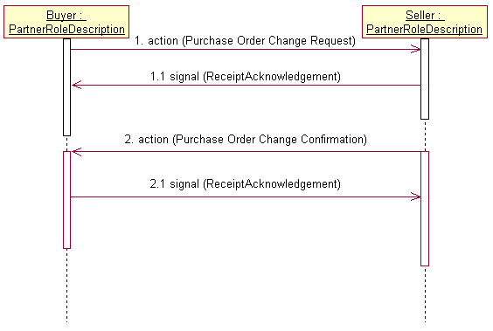
Figure 2: Sequence Diagram of Request Purchase Order Change

Message Exchange Controls
Table 10: Message Exchange Control
# | Name |  | Time to Acknowledge Receipt Signal |  | Time to Respond to Action |  | Included in Time to Perform |  | Is Authorization Required? |  | Is Non-Repudiation Required? |  | Is Secure Transport Required?
1. |  | Purchase Order Change Request Action |  | 2 hrs |  | N/A |  | 24 hrs |  | Y |  | Y |  | Y
1.1. |  | Receipt Acknowledgment |  | N/A |  | N/A |  | N/A |  | Y |  | Y |  | Y
2. |  | Purchase Order Change Confirmation Action |  | 2 hrs |  | N/A |  | N/A |  | Y |  | Y |  | Y
2.1. |  | Receipt Acknowledgment |  | N/A |  | N/A |  | N/A |  | N |  | Y |  | Y

Communications Specification
Table 11: Dialog: Service-Service
# | Business Message | Digital Signature Required? | SSL Required?
1. | Purchase Order Change Request | Y | Y
1.1. | Receipt Acknowledgment | Y | Y
2. | Purchase Order Change Confirmation | Y | Y
2.1. | Receipt Acknowledgment | Y | Y

