

Description of
Partner Interface Process® for 3B12

Validated 11.00.00

Specification Information
Name | Request Shipping Order
Cluster | Order Management
Segment | Transportation and Distribution
Publication Date | 29 July 2006
Version Identifier | V11.00

Table of Contents
1 Document Management 4
1.1 Legal Disclaimer 4
1.2 Copyright 4
1.3 Trademarks 4
1.4 Acknowledgments 4
1.5 Related Documents 5
1.6 Document Version History 5
1.7 Document Structure 5
2 Business Process 6
2.1 Business Process Definition 6
2.1.1 Business Process Description 6
2.2 PIP Business Document 7
2.3 PIP Business Process Flow Diagram 8
2.4 PIP Start State 8
2.5 PIP End States 9
2.6 Partner Role Descriptions 9
2.7 Business Process Activity Controls 10
3 Network and Implementation Specification 11
3.1 Business Action and Business Signal Specifications 11
3.2 Business Transaction Dialog Specification 11
3.2.1 Message Exchange Controls 12
3.2.2 Communications Specification 12

List of Figures:
Figure 1: Activity Diagram of Request Purchase Order 8
Figure 2: Sequence Diagram of Request Purchase Order 11

List of Tables:
Table 1: PIP Business Document 7
Table 2: PIP Start State 8
Table 3: PIP End State 9
Table 4: PIP Failure State 9
Table 5: Partner Role Description 9
Table 6: Business Activity Description 10
Table 7: Business Activity Performance Control 10
Table 8: Network Component Specification 11
Table 9: Business Action – Business Document Mapping 11
Table 10: Message Exchange Control 12
Table 11: Dialog: Service-Service 12

Document Management

Legal Disclaimer
RosettaNet™, its members, officers, directors, employees, or agents shall not be liable for any injury, loss, damages, financial or otherwise, arising from, related to, or caused by the use of this document or the specifications herein, as well as associated guidelines and schemas. The use of said specifications shall constitute your express consent to the foregoing exculpation.

Copyright
©2006 RosettaNet. All rights reserved. No part of this publication may be reproduced, stored in a retrieval system, or transmitted, in any form or by any means, electronic, mechanical, photocopying, recording, or otherwise, without the prior written permission of the publisher. Printed in the United States of America.

Trademarks
RosettaNet, Partner Interface Process, PIP and the RosettaNet logo are trademarks or registered trademarks of "RosettaNet," a non-profit organization. All other product names and company logos mentioned herein are the trademarks of their respective owners. In the best effort, all terms mentioned in this document that are known to be trademarks or registered trademarks have been appropriately recognized in the first occurrence of the term.

Acknowledgments
This document has been prepared by RosettaNet (http://www.rosettanet.org/) from requirements gathered during the Milestone Program and in conformance with the methodology.
APL Logisitics | HP
Bax Global | Intel Corporation
Cisco Systems | Menlo Worldwide
Danzas | MIMOS Berhad
DHL | MITAC International Corp.
Ericsson | Motorola
Exel | Schenker
FEDEX CORPORATE SERVICES | Sterling Commerce
Gridnode, Inc. | Texas Instruments
Gridnode Pte. Ltd.

Related Documents
- Associated PIP Message Schemas (included within the PIP Specification package only)
- Description of 3B12 Message
- Messages Structure
- XML instance of ebXML BPSS for PIP 3B12

Document Version History
Version | Date | Description
Validated 11.00.00 | 29 July 2006 | Validated Version

Document Structure
A Partner Interface Process (PIP) Specification is comprised of the following two parts:
- Business Process. Captures the semantics of the business process and the flow of the message exchange between roles as they perform business activities.
- Network and Implementation Specification. Specifies the network protocol message formats and communications requirements between peer-protocols supported by network components in the RosettaNet Implementation Framework.

Business Process

Business Process Definition
This PIP is designed to enable the communication of shipping orders from a manufacturer or distributor with outsourced logistics operations to its third-party logistics provider.
For example, a manufacturer of semiconductor components may store completed products at a warehouse operated by another company and need to request a third-party to ship the components to its customer whenever a sales order is received. Some third-party logistics providers operate the warehouse for the shipper in addition to transporting the products. Shipping orders may also be used to replenish supplies at the warehouse when stocks reach an agreed upon level.

Business Process Description
All businesses that sell products existing as physical goods, such as raw materials, components and finished goods, must deliver them from their manufacturing or storage location to the customer’s location. This physical movement of products may involve several parties. The first party to the shipment is usually the seller, which initiates the shipping of the products. The second party is usually the buyer, as the consignee to which the products are shipped. Additionally, there may be third-party logistics (3PL) and even fourth-party logistics (4PL) providers, offering services to the shipper such as outsourced light manufacturing, product warehousing, routing and tracking, in addition to physically transporting the products.
The "Description of Partner Interface Process for 3B12" Partner Interface Process™ (PIP) supports a process between two of these parties, in which a Shipper authorizes a Shipping Provider to ship products from one location to another. The Shipper is the organization responsible for the supply of products to its customers, i.e. the first party described above. The Shipping Provider is a third-party that performs the shipping logistics on behalf of the Shipper.
The Shipper uses this PIP to send the Shipping Provider a shipping order and request a confirmation that it is valid. The shipping order specifies which products to ship, how to ship them, the origin and destination locations, and other related information. This is typically triggered by the Shipper receiving a sales order, a return order, a replenishment order or a transfer order for the products. However, it cannot be instigated directly by the receipt of a purchase order.
The Shipper transmits a Shipping Order Request business document to the Shipping Provider. The Shipping Provider responds with a Shipping Order Confirmation business document, which either confirms that the shipping order is valid or rejects it, giving an indication of why it is invalid.
This PIP authorizes the Shipping Provider only to make the shipment as described in the shipping order. However, the Trading Partner Agreement may authorize the Shipping Provider to make partial shipments if insufficient inventory is available. If this is known in advance, the Shipping Order Confirmation business document must specify any reduced quantities of product that are confirmed for delivery. The Shipping Provider must not deviate from the shipping order in any other way. If the Shipping Provider cannot complete the shipping order as requested, the shipping order must be rejected.
Only one shipping order is issued per transaction. If more than one authorization to ship products is required, or if the products are to be shipped via one or more intermediate locations, multiple shipping orders must be sent.
While a shipping order is typically used to initiate the pick-and-pack and shipment of products by the Shipping Provider for delivery to the customer, there are several other ways in which it may be used. For example, it may be a response to a replenishment order from a third-party warehouse, whereby the Shipping Provider is asked to transport an additional supply of products from a factory to the warehouse. Another example might be where defective goods have been returned to a distribution center, and the Shipper issues a shipping order to the Shipping Provider to move them to another location. Note that in this situation, the "Description of Partner Interface Process for 3B12" PIP is not intended to manage the process of negotiating the return from the customer, but can be used to move products once they have been returned to a distribution center.
For international shipments it is necessary to use PIP 3B18, “Notify of Shipping Documentation” to request the necessary shipping documents, such as Commercial Invoices and Export Declarations. However, 3B12 may contain sufficient information for the Shipping Provider to generate all the necessary documents for simple domestic shipments, without requiring the use of 3B18.
Should this transaction not complete successfully, the requesting partner executes PIP0A1, "Notification of Failure."

PIP Business Document
Business Document are generated and exchanged by roles performing activities in this PIP. Business Document is listed and defined in Table 1.
Table 1: PIP Business Document
Business Document | Description
Shipping Order Request | Contains information requesting the shipment of a product or products.
Shipping Order Confirmation | Contains either an acceptance or rejection of the shipping order request, with status information to support this.

PIP Business Process Flow Diagram
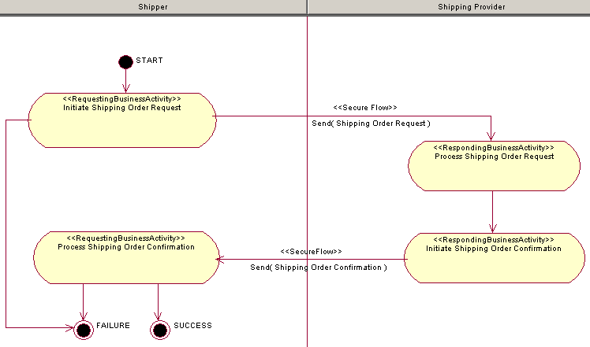
Figure 1: Activity Diagram of Request Shipping Order

PIP Start State
The start state is comprised of the following conditions:
Table 2: PIP Start State
 | Approved | Exist |  | Valid | Non-Repudiated | Retry Count | Authorized
 | Approved | Party | In Backend System
TPA |  |  | 
Sending Partner |  |  |  | 
Receiving Partner |  | 
Business Document |  |  |  |  |  |  | 

PIP End States
The end state is comprised of the following conditions:
Table 3: PIP End State
 | Approved | Exist |  | Valid | Non-Repudiated | Retry Count | Authorized
 | Approved | Party | In Backend system
Acknowledgment of Receipt |  |  |  |  | 
Receiving Partner |  |  |  |  |  |  | 

The PIP failure state is comprised of one or more of the following conditions:
Table 4: PIP Failure State
 | NO | Exceeded
Success | 
Retry Count |  | 

Partner Role Descriptions
Table 5 describes the partner roles in this PIP.
Table 5: Partner Role Description
Role Name | Role Description
Shipper | The organization responsible for authorizing a Shipping Provider to ship products from one location to another.
Shipping Provider | The organization responsible for performing the shipping logistics for the Shipper.

Business Process Activity Controls
Table 6 describes the interaction between roles performing business activity in this PIP.
Table 6: Business Activity Description
Role  Name | Activity Name | Activity Description
Shipper | Initiate Shipping Order Request | A Shipper sends a Shipping Order Request business document to a Shipping Provider.
Shipping Provider | Initiate Shipping Order Confirm | A Shipping Provider sends a Shipping Order Confirmation business document to a Shipper.

Table 7 details the security, audit and process controls relating to activity performed in the PIP.
Table 7: Business Activity Performance Control
Role  Name | Activity  Name | Acknowledgment  of Receipt |  | Time to Perform | Retry Count | Is Authorization Required? | Non-Repudiation of Origin and Content?
Role  Name | Activity  Name | Non-Repudiation Required? | Time to Acknowledge
Shipper | Initiate Shipping Order Request | Y | 2 hrs | 4 hrs | 3 | Y | Y
Shipping Provider | Initiate Shipping Order Confirm | Y | 2 hrs | 4 hrs | 3 | Y | Y

Network and Implementation Specification
Each network component maps into a role of the PIP model. Table 8 specifies the mapping between roles and network components.
Table 8: Network Component Specification
Network Component | Classification | Maps to Role in Business Process
Shipper Service | Business Service | Shipper
Shipping Provider Service | Business Service | Shipping Provider

Business Action and Business Signal Specifications
Each business action maps to a Business Document of the PIP model. Table 9 specifies the mapping between Business Documents and business actions.
Table 9: Business Action – Business Document Mapping
Business Action | Business Document | Document Function
Shipping Order Request Action | Shipping Order Request | Request
Shipping Order Confirmation Action | Shipping Order Confirmation | Respond

Business Transaction Dialog Specification
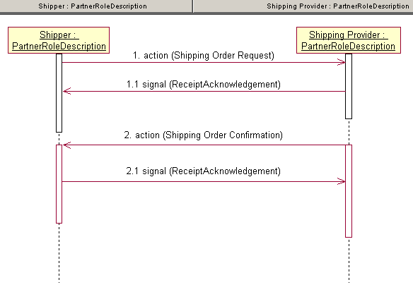
Figure 2: Sequence Diagram of Request Shipping Order

Message Exchange Controls
Table 10: Message Exchange Control
# | Name |  | Time to Acknowledge Receipt Signal |  | Time to Respond to Action |  | Included in Time to Perform |  | Is Authorization Required? |  | Is Non-Repudiation Required? |  | Is Secure Transport Required?
1. |  | Shipping Order Request Action |  | 2 hrs |  | 4 hrs |  | Y |  | Y |  | Y |  | Y
1.1. |  | Receipt Acknowledgment |  | N/A |  | N/A |  | Y |  | Y |  | Y |  | Y
2. |  | Shipping Order Confirmation Action |  | 2 hrs |  | N/A |  | Y |  | Y |  | Y |  | Y
2.1. |  | Receipt Acknowledgment |  | N/A |  | N/A |  | N |  | Y |  | Y |  | Y

Communications Specification
Table 11: Dialog: Service-Service
# | Business Message | Digital Signature Required? | SSL Required?
1. | Shipping Order Request | Y | Y
1.1. | Receipt Acknowledgment | Y | Y
2. | Shipping Order Confirmation | Y | Y
2.1. | Receipt Acknowledgment | Y | Y

