

Description of 3B13 Message

PIP® 3B13
Validated 11.00.00

Specification Information
Name | Description Of 3B13 Message
PIP | Notify Of Shipping Order Confirmation
Cluster | Order Management
Segment | Transportation and Distribution
Publication Date | 18 July 2008
Version Identifier | V11.00

Table of Content

1. Document Management 7
1.1 Legal Disclaimer 7
1.2 Copyright 7
1.3 Trademarks 7
1.4 Acknowledgments 7
1.5 Related Documents 8
1.6 Document Version History 8
1.7 Document Purpose 8
2. Interchange Model 9
2.1 ShippingOrderConfirmationNotification 9
2.1.1 Interchange Diagram 9
2.1.2 Dependency Diagram 10
2.1.3 RequestingOrderInformation 10
2.1.4 RequestingOrderLineItemReference 11
2.1.5 RoutingInformation 11
2.1.6 ShipmentConfirmation 13
2.1.7 ShipmentInformation 14
2.1.8 ShipmentLineItem 16
2.1.9 ShippingContainer 17
2.1.10 ShippingContainerItem 18
2.1.11 ShippingOrderConfirmationNotification 19
2.1.12 SubContainer 19
3. Domain Model 20
3.1 Logistics 20
3.1.1 Logistics 20
3.1.1.1 Dependency Diagram 20
3.1.1.2 DateInformation 20
3.1.1.3 FreightPaymentInformation 21
3.1.1.4 IsPartialShipment 21
3.1.1.5 LinearWithMeasureType 22
3.1.1.6 LotReference 22
3.1.1.7 ManufacturerProfile 23
3.1.1.8 MassPhysicalDimension 23
3.1.1.9 MeasureWithType 24
3.1.1.10 OrderInformation 24
3.1.1.11 PhysicalDimension 25
3.1.1.12 ReturnInstructions 25
3.1.1.13 ReturnLabel 26
3.1.1.14 ShipmentDate 27
3.1.1.15 TrackingReference 27
3.1.2 CodeList 28
3.1.2.1 TrackingReferenceType 28
3.1.2.2 ShipmentMode 28
3.1.2.3 ShipDateCode 29
3.1.2.4 FreightPaymentTerms 32
3.1.2.5 ReturnLabelCode 32
3.1.2.6 LotDiscrepancyReason 33
3.2 Procurement 34
3.2.1 Procurement 34
3.2.1.1 Dependency Diagram 34
3.2.1.2 SpecialHandlingInstruction 34
3.2.2 CodeList 35
3.2.2.1 SpecialHandling 35
3.2.2.2 OrderAdmin 43
3.3 Shared 44
3.3.1 Shared 44
3.3.1.1 Dependency Diagram 44
3.3.1.2 ProductQuantity 44
3.3.1.3 QuantityInformation 44
CodeList 45
3.3.2.1 PackageType 45
3.3.2.2 ShippingServiceLevel 45
4. Universal Structure 48
4.1 ContactInformation 48
4.1.1 ContactInformation 48
4.2 DataType 49
4.2.1 Contact 49
4.2.2 DUNS 49
4.2.3 DUNSPlus4 50
4.2.4 GLN 50
4.2.5 GTIN 51
4.3 Document 51
4.3.1 BusinessDocumentReference 51
4.4 Locations 52
4.4.1 AlternativeIdentifier 52
4.4.2 Location 52
4.4.3 LocationChoice 53
4.4.4 PhysicalAddress 53
4.5 MonetaryExpression 55
4.5.1 FinancialAmount 55
4.6 PartnerIdentification 56
4.6.1 PartnerIdentification 56
4.6.2 PartnerIdentificationChoice 57
4.6.3 SpecifiedFullPartner 57
4.6.4 SpecifiedIntermittentPartner 58
4.6.5 SpecifiedKnownPartner 59
4.6.6 SpecifiedKnownPartnerContact 59
4.6.7 SpecifiedNewPartner 60
4.6.8 SpecifiedPartnerDescription 61
4.6.9 SpecifiedPartnerDescriptionChoice 61
4.7 PhysicalDimension 62
4.7.1 Measure 62
4.7.2 Volume 62
4.7.3 Weight 63
4.8 ProductIdentification 63
4.8.1 ProductIdentification 63
4.8.2 ProductIdentificationChoice 64
4.8.3 TextualDescription 64
4.9 CodeList 65
4.9.1 Country 65
4.9.2 CountrySubdivision 65
4.9.3 Currency 65
4.9.4 Language 65
4.9.5 DocumentType 65
4.9.6 MimeTypeQualifier 67
4.9.7 UnitOfMeasure 78
4.9.8 WeightType 85
5. System Structure 86
5.1 BusinessProcessIdentifier 86
5.2 BusinessServiceInformation 86
5.3 ContractInformation 87
5.4 CorrelationInformation 87
5.5 DocumentHeader 88
5.6 DocumentIdentification 89
5.7 DocumentIdentificationChoice 89
5.8 DocumentInformation 90
5.9 DocumentManifest 90
5.10 DocumentSecurity 91
5.11 ManifestItem 91
5.12 PipIdentifier 92
5.13 PipVersion 93
5.14 Receiver 93
5.15 RequestingDocumentInformation 94
5.16 Sender 94
5.17 StandardDocumentIdentification 95
5.18 TpirPipIdentification 95
5.19 VersionIdentifier 96
5.20 CodeList 96
5.20.1 TPIRFileType 96
6. XML Data Type 97
6.1 anyURI 97
6.2 boolean 97
6.3 date 97
6.4 dateTime 97
6.5 float 97
6.6 integer 97
6.7 positiveInteger 97
6.8 string 97

Table of Figures

Figure ‎2-1 Interchange 9
Figure ‎2-2 Dependency 10
Figure ‎2-3 RequestingOrderInformation 10
Figure ‎2-4 RequestingOrderLineItemReference 11
Figure ‎2-5 RoutingInformation 11
Figure ‎2-6 ShipmentConfirmation 13
Figure ‎2-7 ShipmentInformation 14
Figure ‎2-8 ShipmentLineItem 16
Figure ‎2-9 ShippingContainer 17
Figure ‎2-10 ShippingContainerItem 18
Figure ‎2-11 SubContainer 18
Figure ‎3-1 Dependency 20
Figure ‎3-2 DateInformation 20
Figure ‎3-3 FreightPaymentInformation 21
Figure ‎3-4 IsPartialShipment 21
Figure ‎3-5 LinearWithMeasureType 22
Figure ‎3-6 LotReference 22
Figure ‎3-7 ManufacturerProfile 23
Figure ‎3-8 MassPhysicalDimension 23
Figure ‎3-9 MeasureWithType 24
Figure ‎3-10 OrderInformation 24
Figure ‎3-11 PhysicalDimension 25
Figure ‎3-12 ReturnInstructions 25
Figure ‎3-13 ReturnLabel 26
Figure ‎3-14 ShipmentDate 27
Figure ‎3-15 TrackingReference 27
Figure ‎3-16 Dependency 34
Figure ‎3-17 SpecialHandlingInstruction 34
Figure ‎3-18 Dependency 44
Figure ‎3-19 ProductQuantity 44
Figure ‎3-20 QuantityInformation 44
Figure ‎4-1 ContactInformation 48
Figure ‎4-2 Contact 49
Figure ‎4-3 DUNS 49
Figure ‎4-4 DUNSPlus4 50
Figure ‎4-5 GLN 50
Figure ‎4-6 GTIN 51
Figure ‎4-7 BusinessDocumentReference 51
Figure ‎4-8 AlternativeIdentifier 52
Figure ‎4-9 Location 52
Figure ‎4-10 PhysicalAddress 53
Figure ‎4-11 FinancialAmount 55
Figure ‎4-12 PartnerIdentification 56
Figure ‎4-13 SpecifiedFullPartner 57
Figure ‎4-14 SpecifiedIntermittentPartner 58
Figure ‎4-15 SpecifiedKnownPartner 59
Figure ‎4-16 SpecifiedKnownPartnerContact 59
Figure ‎4-17 SpecifiedNewPartner 60
Figure ‎4-18 SpecifiedPartnerDescription 61
Figure ‎4-19 Measure 62
Figure ‎4-20 Volume 62
Figure ‎4-21 Weight 63
Figure ‎4-22 ProductIdentification 63
Figure ‎4-23 TextualDescription 64
Figure ‎5-1 BusinessProcessIdentifier 86
Figure ‎5-2 BusinessServiceInformation 86
Figure ‎5-3 ContractInformation 87
Figure ‎5-4 CorrelationInformation 87
Figure ‎5-5 DocumentHeader 88
Figure ‎5-6 DocumentIdentification 89
Figure ‎5-7 DocumentInformation 90
Figure ‎5-8 DocumentManifest 90
Figure ‎5-9 DocumentSecurity 91
Figure ‎5-10 ManifestItem 91
Figure ‎5-11 PipIdentifier 92
Figure ‎5-12 PipVersion 93
Figure ‎5-13 Receiver 93
Figure ‎5-14 RequestingDocumentInformation 94
Figure ‎5-15 Sender 94
Figure ‎5-16 StandardDocumentIdentification 95
Figure ‎5-17 TpirPipIdentification 95
Figure ‎5-18 VersionIdentifier 96

Document Management

Legal Disclaimer
RosettaNet, its members, officers, directors, employees, or agents shall not be liable for any injury, loss, damages, financial or otherwise, arising from, related to, or caused by the use of this document or the specifications herein, as well as associated guidelines and schemas. The use of said specifications shall constitute your express consent to the foregoing exculpation.

Copyright
©2008 RosettaNet. All rights reserved. No part of this publication may be reproduced, stored in a retrieval system, or transmitted, in any form or by any means, electronic, mechanical, photocopying, recording, or otherwise, without the inclusion of this copyright notice. Any derivative works must cite the copyright notice. Any public redistribution or sale of this publication or derivative works requires prior written permission of the publisher.

Trademarks
RosettaNet, Partner Interface Process, PIP and the RosettaNet logo are trademarks or registered trademarks of "RosettaNet," a non-profit organization. All other product names and company logos mentioned herein are the trademarks of their respective owners. In the best effort, all terms mentioned in this document that are known to be trademarks or registered trademarks have been appropriately recognized in the first occurrence of the term.

Acknowledgments
This document has been prepared by RosettaNet (http://www.rosettanet.org/) from requirements gathered during the Milestone Program and in conformance with the methodology. Listed below are the legal entities that contributed to the design and development of this PIP.
APL Logisitics | FEDEX CORPORATE SERVICES
Cisco Systems | HP
DHL | Intel
Ericsson | Motorola
Exel

Related Documents
- Associated PIP Message Schemas (included with PIP Specification only)
- Description of Partner Interface Process for 3B13
- Message Structure

Document Version History
Version | Date | Description
Validated 11.00.00 | 18 July 2008 | Validated Version : RosettaNet Schema to Market to Validation 2008

Document Purpose
The purpose of the document is to explain the structure, the association between objects, the content of objects and the definition for single elements to a non-technical audience.

Interchange Model

ShippingOrderConfirmationNotification

Interchange Diagram
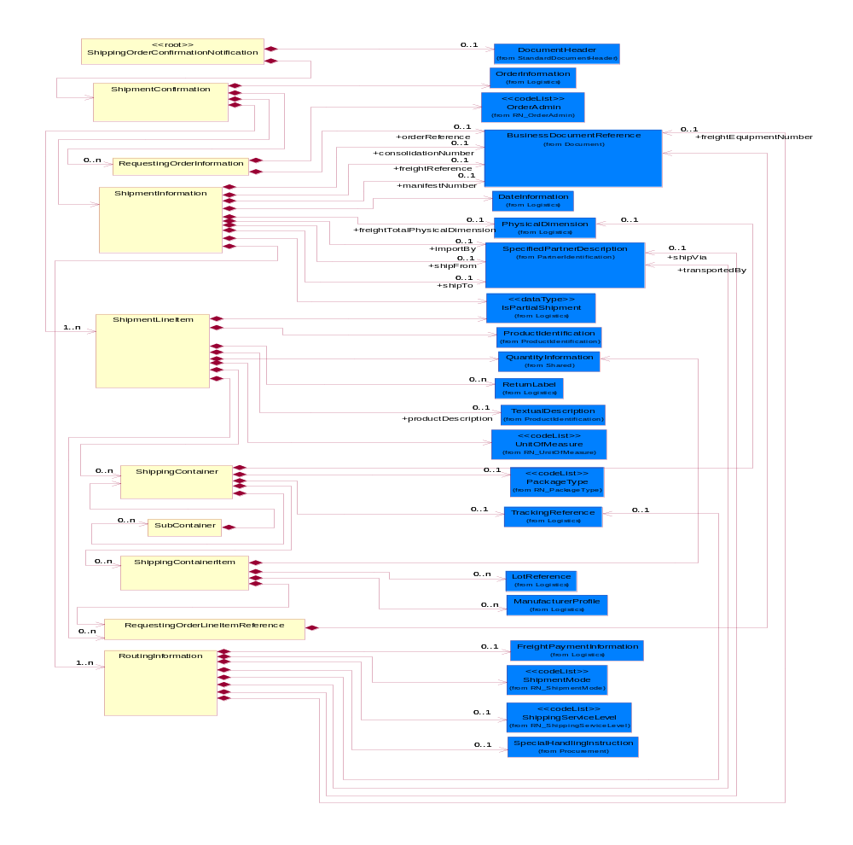Interchange Model

Figure ‎2-1 Interchange

Dependency Diagram
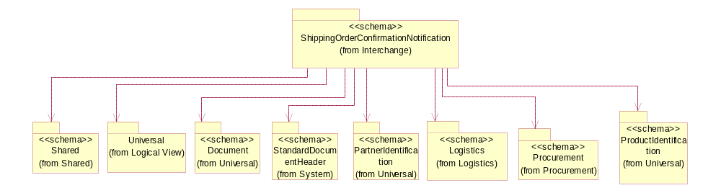
Figure ‎2-2 Dependency

RequestingOrderInformation
The collection of business properties that identifies an order of another type that caused this shipping order to be created.

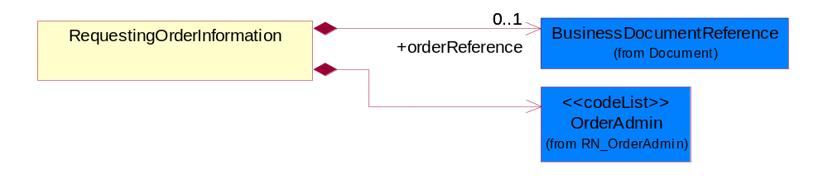
Figure ‎2-3 RequestingOrderInformation

Composition | Cardinality | Type | Documentation
orderReference | 0..1 | BusinessDocumentReference | An additional reference number to identify a single shipment when there are multiple shipments resulting from a single requesting order.
OrderAdmin | 1 | OrderAdmin | Additional administrative code identifying the reason the shipping order is being sent, possibly indicating a predefined workflow.

RequestingOrderLineItemReference
The collection of business properties that references a line item on a requesting document.

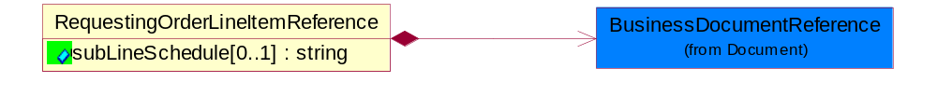
Figure ‎2-4 RequestingOrderLineItemReference

Attribute | Type | Documentation
subLineSchedule[0..1] | string | Number of the schedule within the subline in the document, associated with a given line number.

Composition | Cardinality | Type | Documentation
BusinessDocumentReference | 1 | BusinessDocumentReference | The business document reference object allows for the indirect referencing of a relationship to other business related documents.

RoutingInformation
The collection of business properties that describes a leg used in the routing of a shipment.

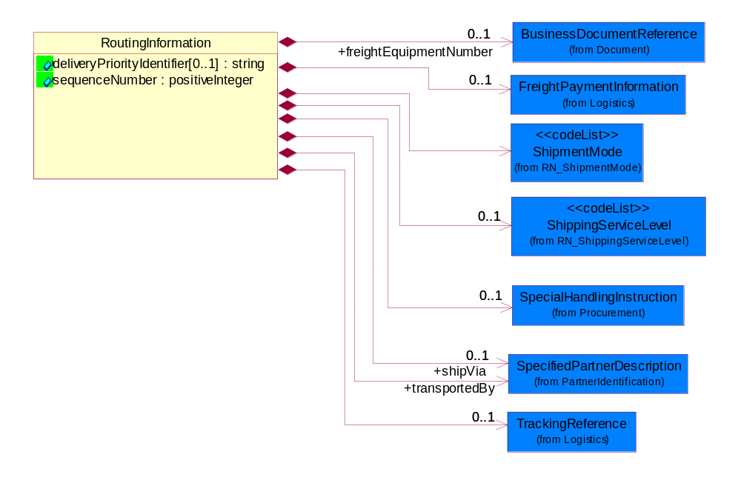
Figure ‎2-5 RoutingInformation

Attribute | Type | Documentation
deliveryPriorityIdentifier[0..1] | string | A numeric data item in the sales order that is used in sequencing how sales order lines are evaluated for shipping.
sequenceNumber | positiveInteger | A positive integer which identifies the order of a designated element within a specified set.

Composition | Cardinality | Type | Documentation
freightEquipmentNumber | 0..1 | BusinessDocumentReference | A number to identify the equipment, such as truck, ship or airplane, used to transport the shipment.
FreightPaymentInformation | 0..1 | FreightPaymentInformation | The collection of business properties that describes payments required for a shipment.
ShipmentMode | 1 | ShipmentMode | The method of transport used for the conveyance of goods.
ShippingServiceLevel | 0..1 | ShippingServiceLevel | Code identifying the shipping service level, e.g., overnight, same day.
SpecialHandlingInstruction | 0..1 | SpecialHandlingInstruction | The collection of business properties that describe product packaging or shipping handling instructions.
shipVia | 0..1 | SpecifiedPartnerDescription | The partner and/or location through which the product must be shipped, such as the "cross dock" at a shipping hub.
transportedBy | 1 | SpecifiedPartnerDescription | The party responsible for either carrying or forwarding the product.
TrackingReference | 0..1 | TrackingReference | Proprietary unique identifier for tracking product shipments.

ShipmentConfirmation
The collection of business properties that confirms that a requested shipment has been sent.

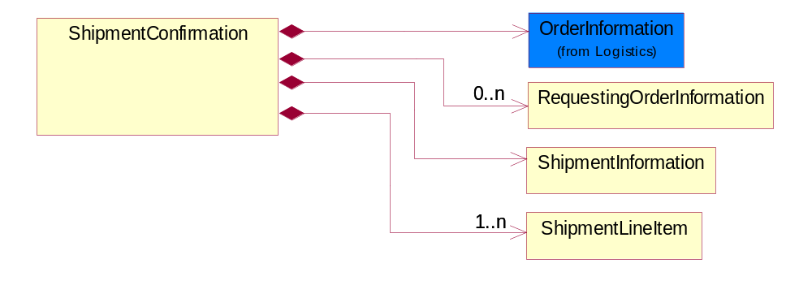
Figure ‎2-6 ShipmentConfirmation

Composition | Cardinality | Type | Documentation
OrderInformation | 1 | OrderInformation | The collection of business properties that identifies a shipping order, including its identity, type and purpose.
RequestingOrderInformation | 0..n | RequestingOrderInformation | The collection of business properties that identifies an order of another type that caused this shipping order to be created.
ShipmentInformation | 1 | ShipmentInformation | The collection of business properties that identifies how a shipment is to be made.
ShipmentLineItem | 1..n | ShipmentLineItem | The collection of business properties that describes the shipping details for a product line item on the shipping order.

ShipmentInformation
The collection of business properties that identifies how a shipment is to be made.

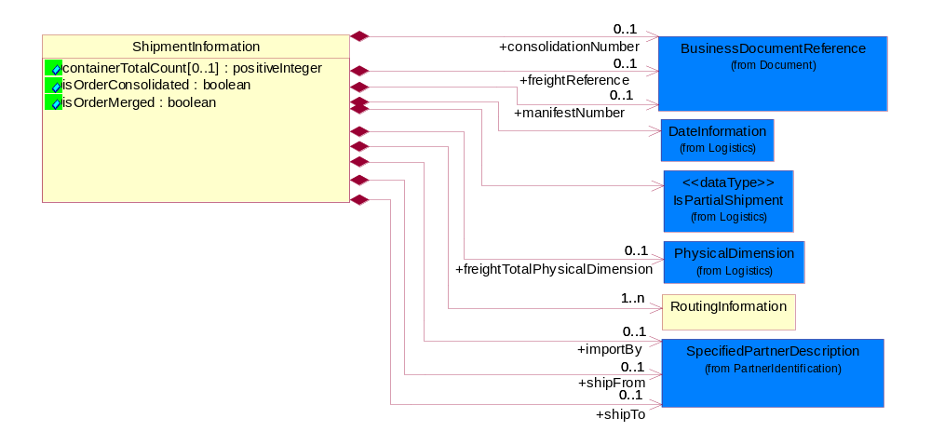
Figure ‎2-7 ShipmentInformation

Attribute | Type | Documentation
containerTotalCount[0..1] | positiveInteger | Indicates the total number of containers in the shipment that belong to this shipping order. This is usually the total number of packed cartons.
isOrderConsolidated | boolean | Indicates whether the shipment will be consolidated with shipments from other requesting orders into a single delivery.
isOrderMerged | boolean | Indicates whether the shipment will be merged with other shipments from the same requesting order into a single delivery.

Composition | Cardinality | Type | Documentation
consolidationNumber | 0..1 | BusinessDocumentReference | A number that identifies other shipping orders that must be delivered to the same location at the same time.
freightReference | 0..1 | BusinessDocumentReference | A reference identifier for the shipment, such as the Bill Of Lading.
manifestNumber | 0..1 | BusinessDocumentReference | The manifest number for the shipment.
DateInformation | 1 | DateInformation | The collection of business properties that identifies a set of dates associated with this transaction.
IsPartialShipment | 1 | IsPartialShipment | The collection of business properties that identifies how a shipment is to be made.
freightTotalPhysicalDimension | 0..1 | PhysicalDimension | The total volume and/or weight of the complete shipment.
RoutingInformation | 1..n | RoutingInformation | The collection of business properties that describes a leg used in the routing of a shipment.
importBy | 0..1 | SpecifiedPartnerDescription | The party responsible for importing the product.
shipFrom | 0..1 | SpecifiedPartnerDescription | The DUNS or DUNS + 4 number of the location from where the product is to be shipped.
shipTo | 0..1 | SpecifiedPartnerDescription | The partner and/or location to which the product must be delivered.

ShipmentLineItem
The collection of business properties that describes the shipping details for a product line item on the shipping order.

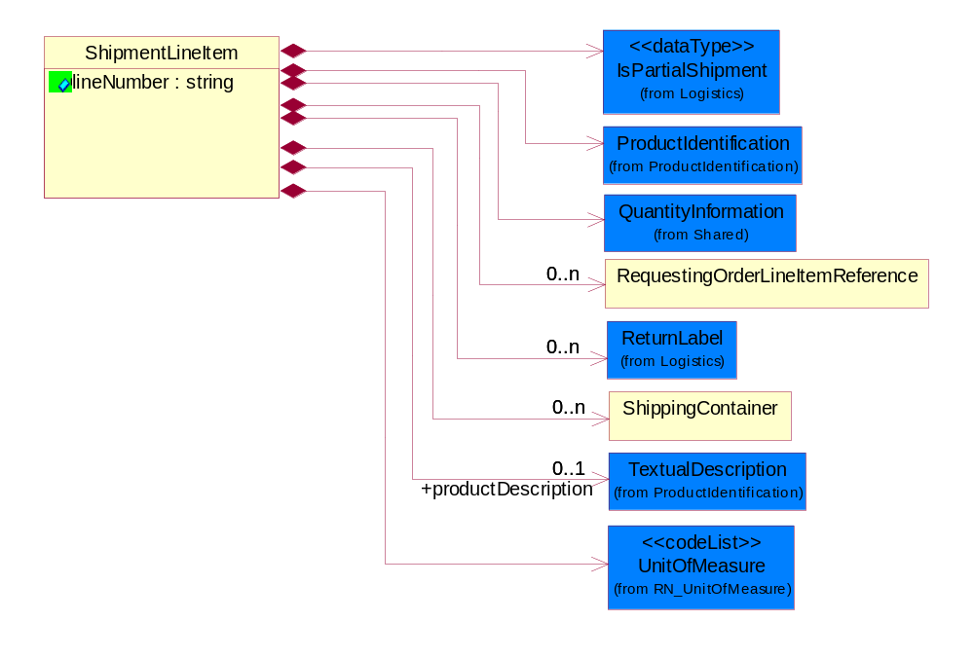
Figure ‎2-8 ShipmentLineItem

Attribute | Type | Documentation
lineNumber | string | Number of the line in the document.

Composition | Cardinality | Type | Documentation
IsPartialShipment | 1 | IsPartialShipment | The collection of business properties that identifies how a shipment is to be made.
ProductIdentification | 1 | ProductIdentification | The object provides the identifier(s) of a product.
QuantityInformation | 1 | QuantityInformation | The collection of business properties that describes information regarding the quantity of the product shipped.
RequestingOrderLineItemReference | 0..n | RequestingOrderLineItemReference | The collection of business properties that references a line item on a requesting document.
ReturnLabel | 0..n | ReturnLabel | The collection of business properties that identifies a return label included in the shipment to facilitate return shipment of products.
ShippingContainer | 0..n | ShippingContainer | The collection of business properties that describe the nature and contents of a shipping unit.
productDescription | 0..1 | TextualDescription | A textual description of the product.
UnitOfMeasure | 1 | UnitOfMeasure | Code identifying a product unit of measure.

ShippingContainer
The collection of business properties that describe the nature and contents of a shipping unit.

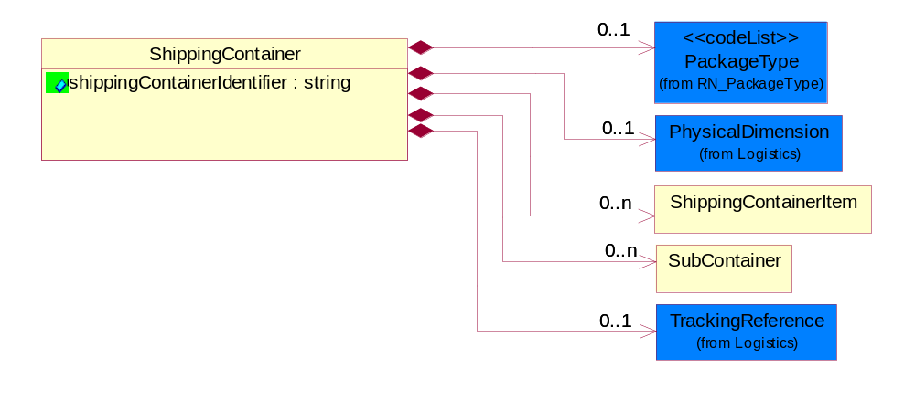
Figure ‎2-9 ShippingContainer

Attribute | Type | Documentation
shippingContainerIdentifier | string | Unique identifier that represents a shipping container. Normally a UCC structured identifier. Also known as a "license plate".

Composition | Cardinality | Type | Documentation
PackageType | 0..1 | PackageType | Code specifying the type of packaging for a product.
PhysicalDimension | 0..1 | PhysicalDimension | The physical dimension of a quantity such as length, time, mass.
ShippingContainerItem | 0..n | ShippingContainerItem | The collection of business properties that describe the nature and contents of the good contained within shipping unit.
SubContainer | 0..n | SubContainer | The collection of business properties that describe the nature and contents of inner containers (packages) contained within an outer shipping unit.
TrackingReference | 0..1 | TrackingReference | Proprietary unique identifier for tracking product shipments.

ShippingContainerItem
The collection of business properties that describe the nature and contents of the good contained within shipping unit.
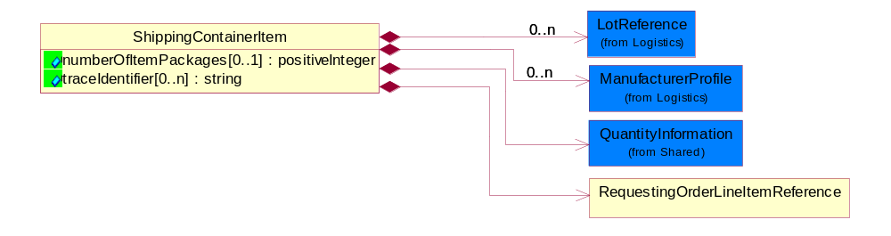
Figure ‎2-10 ShippingContainerItem

Attribute | Type | Documentation
numberOfItemPackages[0..1] | positiveInteger | A numeric expression of the number of item packages within a container.
traceIdentifier[0..n] | string | Free form text for a non-serial lot identifier.

Composition | Cardinality | Type | Documentation
LotReference | 0..n | LotReference | The collection of business properties that describe a manufacturing lot tendered for shipping.
ManufacturerProfile | 0..n | ManufacturerProfile | The collection of business properties that describe a manufacturer's product.
QuantityInformation | 1 | QuantityInformation | The collection of business properties that describes information regarding the quantity of the product shipped.
RequestingOrderLineItemReference | 1 | RequestingOrderLineItemReference | The collection of business properties that references a line item on a requesting document.

ShippingOrderConfirmationNotification
Message wrapper for PIP3B13.

Composition | Cardinality | Type | Documentation
DocumentHeader | 0..1 | DocumentHeader | The object allows for the identification of the sender and receiver of the business document.
ShipmentConfirmation | 1 | ShipmentConfirmation | The collection of business properties that confirms that a requested shipment has been sent.

SubContainer
The collection of business properties that describe the nature and contents of inner containers (packages) contained within an outer shipping unit.
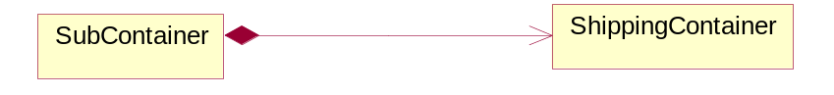
Figure ‎2-11 SubContainer

Composition | Cardinality | Type | Documentation
ShippingContainer | 1 | ShippingContainer | The collection of business properties that describe the nature and contents of a shipping unit.

Domain Model

Logistics

Logistics

Dependency Diagram
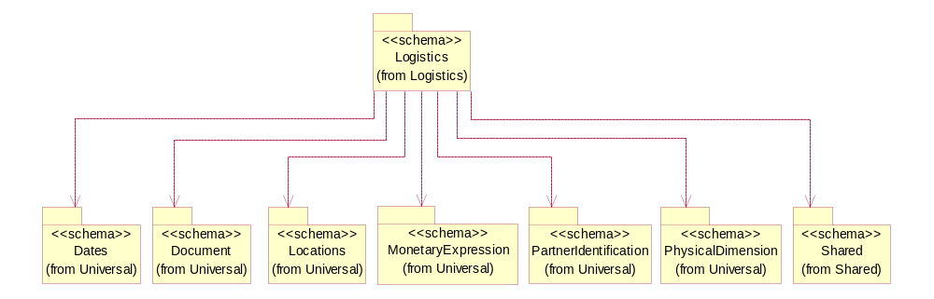

Figure ‎3-12 Dependency

DateInformation
The collection of business properties that identifies a set of dates associated with this transaction.
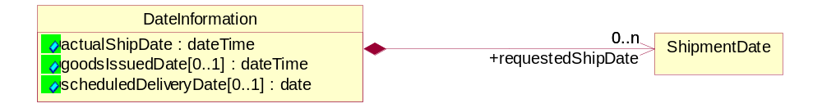
Figure ‎3-13 DateInformation

Attribute | Type | Documentation
actualShipDate | dateTime | The actual date a shipment was sent.
goodsIssuedDate[0..1] | dateTime | The date the goods were issued, i.e. usually when they were picked and packed.
scheduledDeliveryDate[0..1] | date | The (GMT) local date the product is scheduled for delivery.

Composition | Cardinality | Type | Documentation
requestedShipDate | 0..n | ShipmentDate | Date the shipper would like to make shipment or in a response referes to the original date a shipper proposed to ship.

FreightPaymentInformation
The collection of business properties that describes payments required for a shipment.
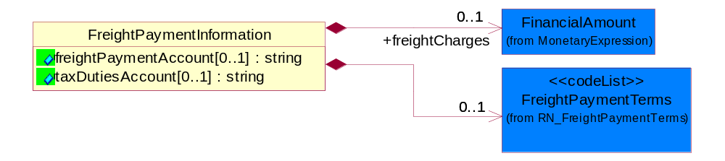
Figure ‎3-14 FreightPaymentInformation

Attribute | Type | Documentation
freightPaymentAccount[0..1] | string | The account number with the shipping carrier of the party paying the carrier fees for the shipment.
taxDutiesAccount[0..1] | string | Identification number of taxes/duties account.

Composition | Cardinality | Type | Documentation
freightCharges | 0..1 | FinancialAmount | The monetary amount to be paid for freight transportation.
FreightPaymentTerms | 0..1 | FreightPaymentTerms | Code identifying responsibility for payment of shipping charges.

IsPartialShipment
The collection of business properties that identifies how a shipment is to be made.
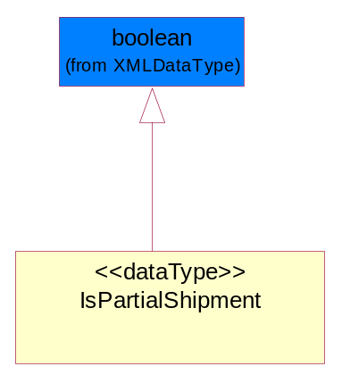
Figure ‎3-15 IsPartialShipment

LinearWithMeasureType
The business document must be able to express the linear dimensions of an object.
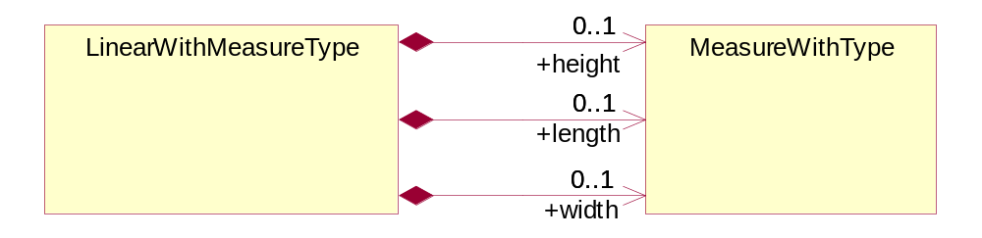
Figure ‎3-16 LinearWithMeasureType

Composition | Cardinality | Type | Documentation
height | 0..1 | MeasureWithType | To express the height of an object.
length | 0..1 | MeasureWithType | To express the length of an object.
width | 0..1 | MeasureWithType | To express the weight of an object.

LotReference
The collection of business properties that describe a manufacturing lot tendered for shipping.
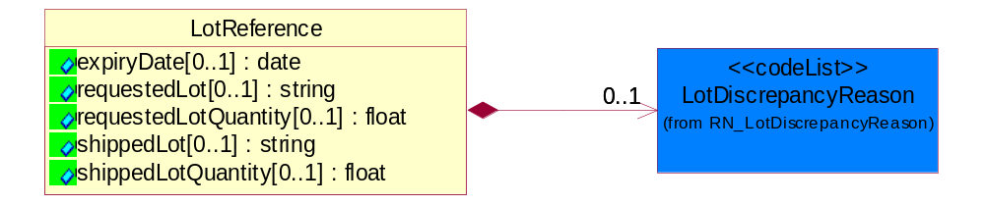
Figure ‎3-17 LotReference

Attribute | Type | Documentation
expiryDate[0..1] | date | The date that a contractual agreement expires.
requestedLot[0..1] | string | The identifier of a manufacturing lot from which a quantity of product was requested.
requestedLotQuantity[0..1] | float | The quantity of product requested from a specific manufacturing lot.
shippedLot[0..1] | string | The identifier of a manufacturing lot from which a quantity of product was shipped.
shippedLotQuantity[0..1] | float | A quantity of product shipped of a specific manufacturing lot within a shipping container.

Composition | Cardinality | Type | Documentation
LotDiscrepancyReason | 0..1 | LotDiscrepancyReason | Code identifying the reason for a discrepency in the lot composition of the shipment.

ManufacturerProfile
The collection of business properties that describe a manufacturer's product.
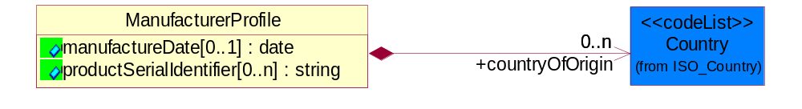
Figure ‎3-18 ManufacturerProfile

Attribute | Type | Documentation
manufactureDate[0..1] | date | The date the product was manufactured.
productSerialIdentifier[0..n] | string | Serial number(s) of a product.

Composition | Cardinality | Type | Documentation
countryOfOrigin | 0..n | Country | Country where product originates.

MassPhysicalDimension
The physical dimension of unit of mass used for measuring the masses of weights, volumes etc.
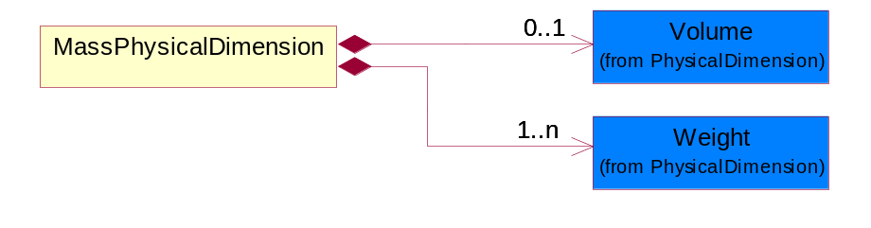
Figure ‎3-19 MassPhysicalDimension

Composition | Cardinality | Type | Documentation
Volume | 0..1 | Volume | The business document must be able to express the volume of an object.
Weight | 1..n | Weight | The business document must be able to express the weight of an object.

MeasureWithType
The business document must describe measurement information.
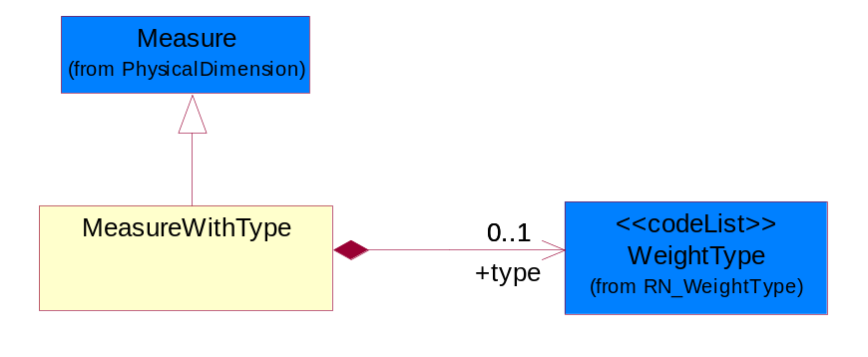
Figure ‎3-20 MeasureWithType

Composition | Cardinality | Type | Documentation
type | 0..1 | WeightType | A code identifying the type of measure.

OrderInformation
The collection of business properties that identifies a shipping order, including its identity, type and purpose.
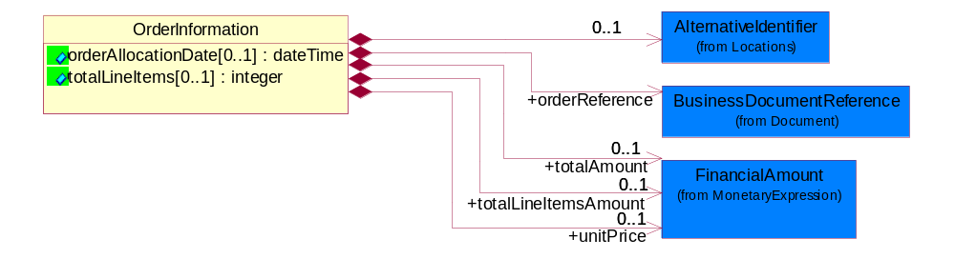
Figure ‎3-21 OrderInformation

Attribute | Type | Documentation
orderAllocationDate[0..1] | dateTime | Specifies an instance in time for the part was allocated.
totalLineItems[0..1] | integer | Total number of line items in an entire business document.

Composition | Cardinality | Type | Documentation
AlternativeIdentifier | 0..1 | AlternativeIdentifier | Identifies the specified code and the name of the organization that a code is utilized from.
orderReference | 1 | BusinessDocumentReference | An additional reference number to identify a single shipment when there are multiple shipments resulting from a single requesting order.
totalAmount | 0..1 | FinancialAmount | Total price for an entire business document.
totalLineItemsAmount | 0..1 | FinancialAmount | Total price for all shipping order line items.
unitPrice | 0..1 | FinancialAmount | Agreed upon Export/Import invoice unit price.

PhysicalDimension
The physical dimension of a quantity such as length, time, mass.
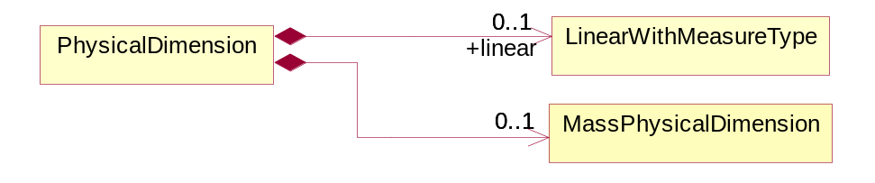
Figure ‎3-22 PhysicalDimension

Composition | Cardinality | Type | Documentation
linear | 0..1 | LinearWithMeasureType | The business document must be able to express the linear dimensions of an object.
MassPhysicalDimension | 0..1 | MassPhysicalDimension | The physical dimension of unit of mass used for measuring the masses of weights, volumes etc.

ReturnInstructions
The collection of business properties that identifies return instructions that should be printed in the native language of the outbound order's receiver country code.
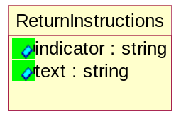
Figure ‎3-23 ReturnInstructions

Attribute | Type | Documentation
indicator | string | An identifier used to specify the lines of the return instructions should be printed.
text | string | Return instructions that should be printed in the native language of the outbound order's receiver country code.

ReturnLabel
The collection of business properties that identifies a return label included in the shipment to facilitate return shipment of products.
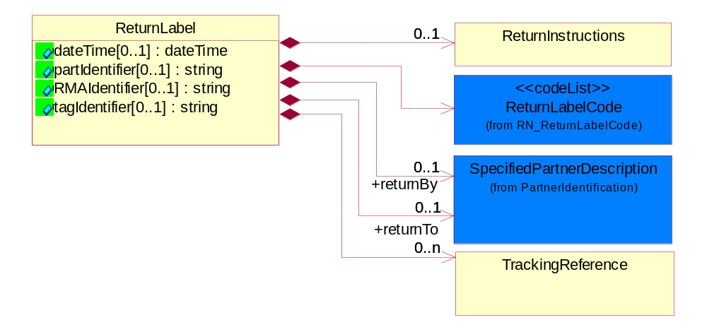
Figure ‎3-24 ReturnLabel

Attribute | Type | Documentation
dateTime[0..1] | dateTime | The expected return date for the part.
partIdentifier[0..1] | string | The unique identifier representing a Return Part number that prints on the return label.
RMAIdentifier[0..1] | string | The unique identifier representing a Return material authorization number.
tagIdentifier[0..1] | string | The unique identifier representing a return tag number.

Composition | Cardinality | Type | Documentation
ReturnInstructions | 0..1 | ReturnInstructions | The collection of business properties that identifies return instructions that should be printed in the native language of the outbound order's receiver country code.
ReturnLabelCode | 1 | ReturnLabelCode | Code specifying the type of return label, e.g. for returning unused or defective parts.
returnBy | 0..1 | SpecifiedPartnerDescription | The party responsible for either carrying or forwarding the returned product.
returnTo | 0..1 | SpecifiedPartnerDescription | The partner and/or location to which the returned product must be delivered.
TrackingReference | 0..n | TrackingReference | Proprietary unique identifier for tracking product shipments.

ShipmentDate
The collection of business properties that identifies a constraint on when the products may be shipped.
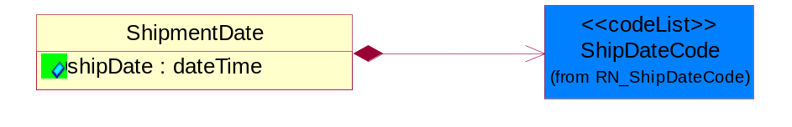
Figure ‎3-25 ShipmentDate

Attribute | Type | Documentation
shipDate | dateTime | The date when the shipment maybe shipped.

Composition | Cardinality | Type | Documentation
ShipDateCode | 1 | ShipDateCode | Code identifying a type of ship date.

TrackingReference
Proprietary unique identifier for tracking product shipments.
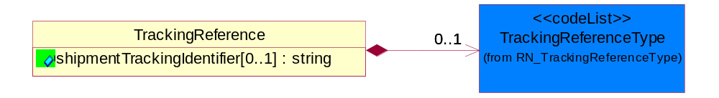
Figure ‎3-26 TrackingReference

Attribute | Type | Documentation
shipmentTrackingIdentifier[0..1] | string | Proprietary unique identifier for tracking product shipments.

Composition | Cardinality | Type | Documentation
TrackingReferenceType | 0..1 | TrackingReferenceType | Code identifying the type of document reference being used to track a shipment.

CodeList

TrackingReferenceType
Code identifying the type of document reference being used to track a shipment.

Name | Documentation
BKN | Booking Number - Shipment identification number assigned by shipper when booking freight shipment with carrier.
BOL | Bill of Lading Number - Shipment identification number on bill of lading issued by shipper, forwarder or carrier.
CIN | Commercial Invoice - An invoice for customs purposes to allow the determination of the proper import/export duty/taxes.
CRN | Carrier Reference Number - Carrier assigned shipment identification number on bill of lading.
FTR | Freight Tracking Reference - Reference number that describes information about tracing shipments during the transportation process.
HAN | House Airwaybill Number - Forwarder assigned shipment identification number on bill of lading issued by forwarder.
MAB | Master Airwaybill Number - Carrier assigned shipment identification number on bill of lading issued by carrier.
OBL | Ocean Bill of Lading Number - Carrier assigned shipment identification number on bill of lading issued by carrier.
PON | Purchase Order Number.
PRO | Pro Number - Carrier assigned shipment identification number on bill of lading.
PSN | Packing Slip Number - Shipment identification number on shipment contents packing list attached to shipment.
RFI | Radio Frequency Identification (RFID).
RRN | Route Reference Number.
SID | Seal Identifier - Trailer or container seal number assigned by party closing doors on trailer or container.
SON | Seller Sales Order Number.
SRN | Shipper Reference Number - Shipper assigned shipment identification number on bill of lading issued by shipper or forwarder.
TRN | Trailer Number - Owner assigned equipment identification number on trailer.

ShipmentMode
The method of transport used for the conveyance of goods.

Name | Documentation
AIE | Air Express.
AIF | Air Freight.
AIR | Air.
COC | Contract Carrier.
COO | Containerized Ocean.
CPI | Customer Pickup.
EXT | Expedited Truck.
INM | Intermodal.
MAT | Mail Transport.
MOT | Motor.
OCE | Ocean.
OTH | Others.
PRC | Private Carrier.
RAI | Rail.
TRK | Truck.

ShipDateCode
Code identifying a type of ship date.

Name | Documentation
ACP | Acceptance.
ACT | Action.
ADY | Arrival at Destination Yard.
AED | Accrual End Date.
AFT | Actual Free Time Expiration Date.
APD | Actual Pickup Date.
APL | Actual Placement.
ASD | Accrual Start Date.
BDO | Beginning Date of Customer Plant Shutdown.
BOI | Bill of Lading Initiated Date.
BOL | Bill of Lading.
BPE | Buy Period Date (End).
BPS | Buy Period Date (Start).
BRD | Backorder Release Date.
CAD | Cancel After This Date.
CBD | Charge Back Date.
CCL | Contract Closed.
CDA | Check Date.
CFP | Contract Final Payment.
CFR | Charged From.
COD | Cutoff Date.
CPC | Contract Physically Completed.
CRE | Customs Release.
CTO | Charged To.
DAG | Delivery Appointment Granted Date.
DAR | Date Available/Constructive Replacement.
DAS | Delivery Appointment Scheduled Date.
DBT | Delivered By This Date.
DDC | Date Delivery Commenced.
DIC | Date Invoice Created.
DIS | Date Issued.
DLC | Date Loading Commenced.
DLD | Date Loading Completed.
DNB | Deliver Not Before Date.
DNL | Deliver No Later Than Date.
DOT | Delivered on This Date.
DPA | Duty Paid.
DRD | Demand Receipt Date.
DRS | Delivery Requested Scheduled Date.
DRT | Delivery Requested on This Date.
DSP | Date Shipped to Port of Embarkation (POE).
DUL | Date Unloaded.
DWO | Deliver Week Of.
ECC | Estimated Contract Completion.
ECL | Extended Closeout.
EDA | Effective Date.
EDB | Expiration Date.
EDD | Estimated Delivery Date.
EDO | Ending Date of Customer Plant Shutdown.
EES | Est. Next Promo, Ship Date End.
EFD | Equipment Furnished Date.
EPD | Earliest Pickup Date.
EPE | Est. Next Promo (Date end).
EPS | Est. Next Promo (Date start).
ERE | Expected Reply.
ESE | Est. Next Promo, Ship Date Start.
FBD | Freight Bill Date.
FOD | First Order Date.
FSD | First Ship Date.
GED | Guarantee Expiration Date.
INS | Inspection.
IVD | Invoice Date.
LAC | Last Acquisition.
LDE | Last Demand.
LPD | Latest Pickup Date.
MNF | Manufacture.
MRB | Must Respond By.
NTF | Notified.
OFD | Offered for Delivery.
OPO | Original Purchase Order Date.
ORD | Ordered.
OTR | Original Transaction.
PAG | Pickup Appointment Granted Date.
PAS | Pickup Appointment Scheduled Date.
PBD | Publication Date.
PCE | Price Change Effective Date.
PCL | Price Change Last Arrival Date.
PCM | Price Change Last Order Date.
PCO | Purchase Order Date.
PCR | Purchase Order Received.
PCS | Price Change Last Ship Date.
PDA | Pack Date.
PDE | Promotion Order Date (End).
PDS | Promotion Order Date (Start).
PFE | Promotion Floor Stock Protect (End).
PFS | Promotion Floor Stock Protect (Start).
PME | Promotion Ship Date (End).
PMO | Promotion End.
PMS | Promotion Ship Date (Start).
PMT | Promotion Start.
PPD | Preferred Payment Date.
PPE | Promotion Performance Date (End).
PPS | Promotion Performance Date (Start).
PRD | Product Receipt Date.
PRE | Period End.
PRQ | Promotion Requested Delivery Date (End).
PRS | Promotion Requested Delivery Date (Start).
PSD | Process Date.
PSH | Pickup Requested Scheduled Date.
PVE | Promotion Invoice Protection Date (End).
PVS | Promotion Invoice Protection Date (Start).
RDD | Requested Delivery Date.
REC | Recorded.
REJ | Rejection.
REL | Released.
REQ | Required By.
RPD | Requested Pack Date.
RSD | Requested Ship Date/Pick-up Date.
SDA | Scheduled Delivery Date - Appointment confirmed.
SDC | Scheduled Delivery Date - Needs confirmation.
SDD | Scheduled Delivery Date.
SHB | Ship Not Before Date.
SHL | Ship Not Later Than Date.
SHO | Shipped on This Date.
SIG | Signature.
SIS | Store Inventory Stock.
SLD | Sold Date.
SLE | Shelf-Life Expiration.
SLG | Sailing Date.
SPA | Scheduled Pick-up Date - Appointment confirmed.
SPE | Spot for Load Exchange Date (Export).
SPL | Spot for Load Date.
SPN | Scheduled Pick-up Date - Needs confirmation.
SPP | Scheduled Pick - Up Date.
SPS | Spot for Storage Date (No shipment).
SPU | Spot for Unload Date.
SSC | Scheduled Service Completion.
SUD | Superseded Date.
SWO | Ship Week Of Date.
TDD | Terms Discount Due Date.
TND | Terms Net Due Date.
TRA | Transfer.
TRS | Transaction Control Date.
VAL | Validated.
WIS | Warehouse Inventory Stock.
WRT | Warranty Expiration.

FreightPaymentTerms
Code identifying responsibility for payment of shipping charges.

Name | Documentation
ADC | Advance Collect.
ADP | Advance Prepaid.
COD | Collect on Delivery.
COF | Collect, freight credited back to customer.
COL | Collect.
CPI | Customer Pick-up/backhaul.
DBS | Defined by buyer and seller.
FOB | FOB Port of Call.
HPR | Half Prepaid.
MIX | Mixed.
NRE | Non Revenue.
PBB | Paid by Buyer.
PBS | Paid by Seller.
PCO | Per Contract.
PIC | Pickup.
PPC | Prepaid but charged to customer.
PPL | Prepaid local, collect outstate.
PPO | Prepaid Only.
PPP | Prepaid by Processor.
PPS | Prepaid (by seller).
PPY | Prepaid and summary bill.
RCF | Return Container Freight Free.
RCG | Return container freight paid by customer.
RCH | Return container freight paid by supplier.
RUL | Rule 11 Shipment.
SFN | Service freight, no charge.
TPP | Third Party Pay.
WCO | Weight Condition.

ReturnLabelCode
Code specifying the type of return label, e.g. for returning unused or defective parts.

Name | Documentation
DFR | Defective - No Return Required.
DFT | Defective.
UNR | Unused - No Return Required.
UNU | Unused.

LotDiscrepancyReason
Code identifying the reason for a discrepency in the lot composition of the shipment.

Name | Documentation
DLO | Damaged Lot - Lot was found to be damaged.
WLO | Wrong Lot - Expecting different lot.
WLQ | Wrong Lot Quantity - Expecting different lot quantity.

Procurement

Procurement

Dependency Diagram
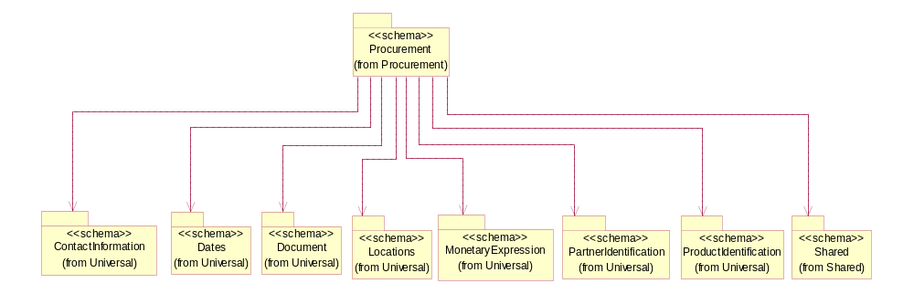

Figure ‎3-27 Dependency

SpecialHandlingInstruction
The collection of business properties that describe product packaging or shipping handling instructions.
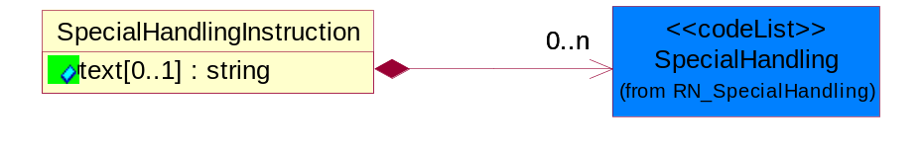
Figure ‎3-28 SpecialHandlingInstruction

Attribute | Type | Documentation
text[0..1] | string | Free form textual description for how specified goods, packages or containers should be handled.

Composition | Cardinality | Type | Documentation
SpecialHandling | 0..n | SpecialHandling | Code identifying special handling or packaging requirements for the product.

CodeList

SpecialHandling
Code identifying special handling or packaging requirements for the product.

Name | Documentation
15M | 15 Minute Window.
24H | 24 Hour Availability.
AAO | Attachments - Advance Only Waybill.
ACC | Accepted by Carrier at Owner's Risk of Freezing.
ACD | Air Conditioning Disconnect and Connect.
ACU | Attachment - Customer's Document.
ADC | Additional Copy of Shipping Papers for Proof of Delivery.
ADF | Advanced Fee.
ADL | Advance Loading.
AGS | Armed Guard Service.
AHM | Accessible Hazardous Material.
AMD | A.M. Delivery Requirement.
ANU | Anchoring and Unanchoring.
ANV | Annual Volume.
APW | Attachment - Prepaid Waybill.
ART | Air Ride Truck Service.
ASE | Attachment - Shipper's Export Document.
ASM | Attachment - Shipper's Manifest.
ASP | Attachment - Shipper's Packing Instructions.
ASR | Assembly Service Requested.
ATD | Aggregate Tender Discount.
ATT | Air Ride Tractor Service.
AUS | Auxiliary Service.
BA1 | Bunker Adjustment - 20 Foot Container.
BA2 | Bunker Adjustment - 40 Foot Container.
BCC | Bill Consignee for Weigh Charges.
BCP | Bypass Consolidation Point.
BFS | Barge Freight All Kinds Service.
BKA | Bunker Adjustment.
BKS | Block Stowage.
BLB | Blocking and Bracing.
BLS | Blind Shipment.
BNS | If Bad Ordered Notify Shipper.
BOL | Bolster Load, Do Not Switch.
BSA | Bunker Surcharge Authorized.
BSC | Bill Shipper for Weigh Charge.
BUA | Bulky Article.
CA1 | Currency Adjustment - 20 Foot Container.
CA2 | Currency Adjustment - 40 Foot Container.
CAA | Cargo Aboard.
CAB | Chain and Binders.
CAC | Carrier Caboose.
CAR | Carrier.
CAT | Cargo Taxes.
CBC | Cargo on Board Certification Required.
CCB | Convert Commercial Bill of Lading (BOL) to Government BOL.
CCE | Certification that the Containers Being Returned Empty Were Received Filled by Rail Freight Service.
CCL | Container, Consolidator Load.
CER | Certification.
CFB | Cleared for Border Crossing.
CFC | Customs Fees - Container Level.
CFE | Cleared for Export.
CFI | Customs Fees - Lift Level.
CFL | Container, Factory Load.
CGC | Carrier Guard Car Service.
CHB | Clearinghouse Balance.
CIP | Commercial Invoice Preparation.
CIR | Circuitous Routing.
CLC | Carrier Load and Consignee Unload.
CLE | Cleaning.
CLH | Consolidation and Line Haul.
CLL | Commodity Loaded Less Than or Equal To the Car Ordered.
CLU | Carrier Load and Carrier Unload.
CNE | Certification That the Newsprint Winding Cores Being Returned Empty Were Received Filled by Rail Freight Service.
COA | Controlled Atmosphere.
COD | Container Diversion.
COL | Container Lease.
COM | Container Mounting.
CON | Conductivity/Anti-static Additive.
COO | Certificate of Origin.
COS | Completing Shipment.
COU | Consignee Unload.
COV | Courier, Overnight.
CPM | Customs Papers Mailed.
CPN | Customer Required PRO Number.
CRA | Class Rates Applied.
CRD | Comb. Rates over Detroit.
CRL | Customer Required Packing List.
CRN | Customer Required Appointment Number.
CRP | Contract Rates Apply.
CRT | Cross Town.
CSD | Courier, Same Day.
CSL | Consolidation.
CSR | Certification that this Shipment is for Recycling as Defined in Applicable Tariffs Containing Such Provisions.
CSU | Constant Surveillance.
CUI | Customs Inspection.
DAN | Dangerous.
DAR | Drop and Run.
DCE | Detention of Conveying Equipment and the Power Unit.
DEM | Demurrage.
DEP | Detention of Conveying Equipment Excluding the Power Unit.
DES | Delivery Service.
DEV | Detention (Vehicle).
DHI | Do not Hump or Hump into.
DID | Direct Delivery.
DNC | Do Not Couple to Double Shelf Couples.
DND | Do Not Divert.
DNF | Do Not Freeze.
DNH | Do Not Hump.
DNP | Do Not Pool.
DNT | Do Not Transfer Contents.
DNU | Do Not Uncouple.
DOD | DOD Constant Surveillance Service.
DOM | Domestic.
DOS | Documentation - Special.
DP1 | Detention With Power Units (30 minute periods).
DP2 | Detention With Power Units (60 minute periods).
DPD | Drayage at Port of Debarkation (Rate Zone).
DPE | Drayage at Port of Embarkation (Rate Zone).
DRO | Drop-Off Delivery.
DSR | Distribution Service Requested.
DSW | Delivery Only on Surrender of Written Order.
DVN | Delivery Verification Not Required.
DWA | Destination Weights Apply.
ECS | Escort/Courier Service.
EET | Electronic Equipment Transfer.
EHM | Endorsed as Hazardous Material.
ELB | Extra Labor.
EMM | Empty Movement.
EMR | Empty Return.
EMS | Emergency Service.
END | Endorsement.
EOS | Escort Service with Overnight Subsistence.
EPP | Export Preparation.
EPT | Export.
EQU | Equipment.
ERA | Expedited Rates Applied.
ERI | Expand Remove and Install.
ESC | Escort.
EST | Escort Services (Telephone).
EUV | Exclusive Use of Vehicle.
EVA | Excessive Valuation Authorized.
EXC | Exempt Commodity.
EXD | Extra Driver.
EXL | Extra Lights.
EXP | Expedite.
EXS | Expedited Service.
EXU | Exclusive Use.
EXW | Excessive Weight.
FIS | Filtration Service.
FLS | Flatrack Surcharge.
FOD | FOD, FOB - Destination.
FOS | FOS, FOB Shipping Point.
FPT | For Processing in Transit.
FRA | Fragile - Handle with Care.
FST | For Storage in Transit.
FUS | Full Service.
GGC | Government Guard Car.
GOC | Government-Owned Containers.
GSS | Greater Security Service.
GVC | Government Caboose.
HAL | Hold at Location.
HAN | Handling.
HAR | Harmless.
HCD | Hazardous Cargo On Deck.
HCT | High Cube Trailer Rates.
HEA | Heat.
HES | Heat - Special.
HFO | Hold for Orders.
HFR | Home for Repair.
HIT | Heat in Transit.
HMS | Hazardous Materials Surcharge.
HOR | Heater or Refrigeration.
HVL | High Value Load.
IHM | Inaccessible Hazardous Material.
IMP | Impactographs.
IMS | Import Shipment.
INB | In-bond.
IND | Inside Delivery.
INH | Inspect Hourly if Car Stopped.
INP | Inside Pickup.
INS | Insulated.
IPM | Intra-Plant Move.
ISS | Intermodal Shipment Service.
ITS | Interline Transfer Service.
JIT | Just-In-Time (JIT).
JLE | Joint Line Exception.
KFF | Keep From Freezing Percent Differential.
KMD | Keep Material Dry.
LAA | Labor Associated with Detention of Conveying Equipment.
LAB | Land Bridge (Import/Export).
LAD | Labor Disturbance.
LAO | Layover.
LAS | Layover Service.
LBD | Labor Disturbance.
LBS | Light Bar Service.
LBT | Low Boy Trailer/Flat Bed.
LC1 | Land Currency Adjustment - 40 Foot Container.
LC2 | Land Currency Adjustment Factor - 20 Foot Container.
LCA | Land Currency Adjustment - 40 Foot Container.
LCF | Land Currency Adjustment Factor - 20 Foot Container.
LDE | Labor Associated with Detention of Conveying Equipment.
LDP | Linehaul from Port of Debarkation.
LEP | Linehaul To Port of Embarkation.
LFC | Less Than Full Carload.
LFL | Less Than Container, Factory Load.
LFV | Loaded to Full Visible Capacity.
LIS | Linehaul Service.
LIU | Live Unload.
LOC | Liability of Carrier.
LOD | Loading Devices.
LPD | Linehaul Percent Differential.
LSO | Local Service Only.
LTC | Less Than Container.
LTD | Liner Terms at Port of Debarkation.
LTE | Liner Terms at Port of Embarkation.
LTL | Less Than Container, Consolidator Load.
LTT | Less Than Truckload.
MAW | Manifest Must Accompany Waybill.
MER | Mechanical Refrigeration.
MFI | Moving Under "For Furtherance Instructions" and May Be Delivered.
MOA | Modified Atmosphere.
MSS | Motor Surveillance Service.
MTS | Multi-Tank Surveillance Service.
MUP | Multiple Pickup.
NCB | Notify Consignee Before Delivery.
NEF | New Equipment First Transborder Movement.
NFE | Not for Export.
NFS | Nontransit Flat Shipment.
NMR | No Marshalling Required for Hazardous Materials.
NPR | No Placards Required.
NRC | Not Restricted Cargo.
NSB | Notify Shipper Before Reconsignment.
NSE | No Special Entrainment Required.
NSI | Notify Shipper Immediately if Shipment is Delayed en Route.
NUW | In Case of Fire Do Not Use Water.
OAH | Offshore - Alaska/Hawaii Service.
ODS | On Deck Stowage.
OHC | Over Height Container.
OTH | Other.
OVF | Overflow.
OVP | Oversized Premium.
OVW | Overweight.
OWR | One Way Rates Applied.
PAD | Pickup and Delivery.
PAS | Partial Shipment.
PAU | Pack and Unpack.
PAW | Preparation of Air Waybill - Origin.
PCC | Preparation of Canadian Customs Invoice.
PDB | Pickup and Delivery Beyond Service Area.
PDL | Percent Differential - Less Than Container.
PDS | Pickup and Delivery From Storage in Transit.
PEE | Preparation of Export Entry.
PFH | Protect From Heat.
PHR | Per Hour Rates Applied.
PIC | Preparation of Insurance Certificate.
PIT | Pier Time.
PIU | Pickup.
PLR | Protect Lowest Through Rate.
PMD | P.M. Delivery Requirement.
PMR | Per Mile Rates Apply.
POC | Port Changes.
PPC | PPC, FOB -Destination charge to customer.
PPD | PPD, Prepay+I35/Add Freight to Invoice.
PPS | Product Protection Service.
PRS | Priority Service.
PSC | Protective Security Service.
PSN | Pickup of Shipments on Saturday, Sunday, and/or Holidays Requiring Absolute Next Day Delivery.
PSP | Pallets/Skids/Platforms.
PSS | Pickup of Shipments Requiring Same Day Delivery Service.
PST | Pickup of Shipments Requiring Same Day Delivery Service and/or Delivery at a Specified Time.
PUE | Preparation of U.S. Export Documentation.
PUP | PUP Trailer Rates Apply.
RAH | Railhead Handling.
RAM | Radioactive Material.
RBC | Render Bill for Charges.
RCD | Reefer Cargo Percent Differential.
RCG | Return Carrier Guard Car Service.
RCP | Railroad Controlled Private Equipment Subject to Demurrage.
RCS | Reconsignment.
REA | Return Authorization.
REC | Return of Empty Container.
RED | Redelivery.
REF | Refrigerated.
REM | Reefer Maintenance.
RER | Reweight Requested.
RES | Reservations.
RFT | Record for Transit.
RMP | Return Movement of Pallet.
ROE | ROEE Van Type Truck.
ROS | Roadrailer Service.
RSC | Requires Shelf Couplers.
RSD | Residential Delivery.
RSM | Reshipment.
RST | Respotting.
RTS | Round Trip Service.
RUO | Rush Order.
RVC | Released Value Charge in Excess of Carrier Maximum Liability.
RWE | Roadway Easy Rates Applied.
SAD | Saturday Delivery.
SAH | Stow Away from Heat.
SAR | Shipper Authorization Required for Diversion or Consignment.
SCA | Service Charge Applies.
SCC | Shipper Load/Carrier Count.
SCG | Shipper Certifies Gross Weight under 240,000 pounds.
SCL | Apply a Uniform Code Council/International Article Numbering Association (UCC/EAN) Serial Shipping Container Label to the Shipping Containers.
SCW | Stretch Wrap.
SDS | Special Dromedary Service.
SEC | Special Equipment Charge.
SED | Shipper Export Declaration Required.
SEE | Stairs, Elevator, Excess Carry.
SES | Security Signature Service.
SFD | Single Factor Origination/Port of Debarkation.
SFO | Single Factor Origination/Destination.
SFP | Single Factor Port of Embarkation/Destination.
SFS | Satisfactory Service Standards.
SGD | Single Driver.
SHH | Shipment Holdover for Holidays.
SHL | Shiftable Load.
SHP | Sunday or Holiday Pickup or Delivery.
SHW | Shipment Holdover for Weekends.
SID | Shipment to be Inspected at Destination and Disposition Instructions will be Furnished.
SIR | Signature Required.
SIS | Single Shipment.
SLC | Shipper Load and Carrier Unload.
SLD | Split Delivery.
SLO | Shipper Load and Count.
SLP | Split Pickup.
SLS | Shipper Load and Consignee Unload.
SMP | Small Package.
SMS | Special Motor Surveillance.
SNT | Shipment from Non-Temp Storage.
SOD | Stop-off at Destination.
SOE | Shipment Holdover on Weekends.
SOH | Shipment Holdover on Holidays.
SOO | Stop-off at Origination.
SOW | Shipment Holdover on Weekdays.
SPC | Special Containers.
SPD | Saturday Pickup or Delivery.
SPL | Shipper Load.
SPP | Special Permit.
SPR | Speed Restricted.
SPS | Special Permits.
SPU | Saturday Pick-Up.
SR1 | Speed Restricted to 15 Miles per Hour.
SR2 | Speed Restricted to 25 Miles per Hour.
SR3 | Speed Restricted to 35 Miles per Hour.
SR4 | Speed Restricted to 45 Miles per Hour.
SRC | Shove to Rest and Cover.
SRG | Storage.
SSC | Stripping, Sorting and Consolidation.
SSD | Subject to Special Detention Rules/Charges.
SSN | Substitute Service Not to be Used.
SSS | Satellite Surveillance Service.
SST | Spot for Storage - No Shipment.
STM | Special Train Movement.
STO | Stop-off.
STR | Signature and Tally Record.
STT | Stack Train.
STW | Stowage.
SUR | Supervisor Requested.
SVR | Surveying Routes.
TAT | Tendered as Truckload (Truckload Service Requested).
TCL | Trailer, Consolidator Load.
TDS | Time of Delivery and Signature Required.
TEC | Temperature Control.
TER | Termination.
TFL | Trailer, Factory Load.
TFP | Transfer Product.
THC | Terminal Handling Charges.
TLO | Top Load Only.
TMV | Tendering of Multiple Vehicles.
TOC | Truckload-Double Operator-Common Carrier.
TOP | Truckload-Double Operator-Padded Van.
TOS | Total Shipment.
TPS | Third Party Service.
TRA | Truck Rates Applicable.
TRP | Trailer Preparation - Special.
TRS | Trade Show.
TSN | Transmit a Ship Notice/Manifest Transaction Set.
TSS | Transit Shipment.
TTD | Team Track Delivery.
TTR | Tentative Release - Tentatively releasing the shipment either for import or export and subject to compliance to additional conditions which could be executed later.
TVR | Time Volume Rates Only.
UAP | Unload as Placarded.
UAT | Use of Alternate Terminal.
ULS | Unload from Left Side of Car.
UNH | Use No Hooks.
UNI | Unitized.
UNP | Unpacking.
UOR | Unloading or Reloading.
UPP | Unprotected Perishable.
URS | Unload from Right Side of Car.
VEI | Ventilation Instructions.
VEW | Verification Weigh.
WAI | Waive Inspection.
WCO | Weigh to Check for Overload.
WEE | Weigh Empty.
WEV | Weight Verification.
WID | Waived Inspection - Set Direct.
WPD | Written Proof of Delivery.
WTA | Waiting Time Authorized.

OrderAdmin
Additional administrative code identifying the reason the shipping order is being sent, possibly indicating a predefined workflow.

Name | Documentation
DDE | Demo Depot.
DOA | DOA.
ERA | E-Rate.
GRA | Government Rated.
INT | Internal/Demo/Evaluation/Sample.
MUL | Multinational.
PRE | Premium.
REP | Replacement.
RZC | Replacement - Zero Cost.
SAM | Sample.
SPR | Special Promotions.
STA | Standard.
TIO | Trade-in Order.
TIR | Trade-in Return.
UPG | Upgrade.
UZC | Upgrade - Zero Cost.

Shared

Shared

Dependency Diagram
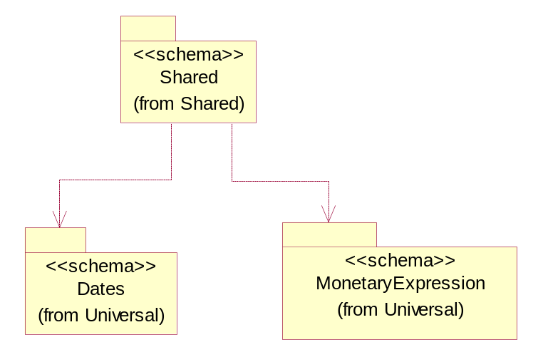

Figure ‎3-29 Dependency

ProductQuantity
A quantity specifying the number of product units.
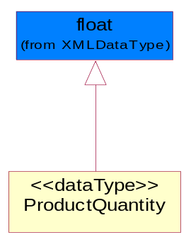
Figure ‎3-30 ProductQuantity

QuantityInformation
The collection of business properties that describes information regarding the quantity of the product shipped.
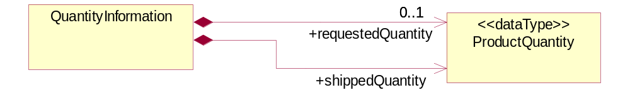
Figure ‎3-31 QuantityInformation

Composition | Cardinality | Type | Documentation
requestedQuantity | 0..1 | ProductQuantity | The quantity of product requested.
shippedQuantity | 1 | ProductQuantity | Quantity of product shipped.

CodeList

PackageType
Code specifying the type of packaging for a product.

Name | Documentation
BOX | Box.
BRL | Barrel.
CRT | Carton.
LPK | Loose Package.
MHC | Material/Method of holding a string of computer chips.
MIX | Mixed Package.
OTH | Others.
PAC | Parcel.
PBG | Plastic Ball Grind Array.
PBX | Paper Box.
PCC | Plastic Chip Carrier.
PLT | Pallet.
REE | Reel.
TQF | Thin Quad Flat Package.
TRA | Tray.
TUB | Plastic tube to hold computer chips.
WDC | Wooden Crate.

ShippingServiceLevel
Code identifying the shipping service level, e.g., overnight, same day.

Name | Documentation
1BD | 1BD, Same Business Day - 4 hour Response Time.
5BD | 5 Business Days.
9AM | 9 A.M.
ACH | Air Charter.
AEC | Air Economy.
AIC | Air Cargo.
AM | A.M.
ARS | Authorized Return Service.
ATA | Airport to Airport.
ATD | Airport to Door.
BCT | Bulk Commodity Train.
BUC | Business Class.
CBS | Consignee Billing Service.
COE | Courier Express.
DCR | Delivery Confirmation Return.
DEC | Delivery Confirmation.
DES | Deferred Service.
DNO | Delivery Notification Only.
DOS | Door Service.
DSN | Delivery scheduled next day by cartage agent.
DSS | Delivery scheduled second day by cartage agent.
DST | Delivery scheduled third day by cartage agent.
DTA | Door to Airport.
DTD | Door to Door.
DTP | Door to Port (Ocean).
ESP | Express Service Plus.
ESV | Expedited Service.
ESW | Expedited Service Worldwide.
EXS | Express Service.
EXW | Express Service - Worldwide.
FIC | First Class.
GEN | General.
GRO | Ground.
ISS | Other intermodal and stack service.
MAF | Manifest freight.
MET | Metro.
MUW | Multiweight.
NBD | Next Business Day.
NDA | Next Day Air.
NEM | Next Morning.
NFO | Next Flight Out.
NHW | Next day Hundred Weight.
NOR | NORMAL - Normal delivery.
NOS | Not served.
OIS | Other Intermodal and Stack service
OTH | Other.
OVN | Overnight.
PAS | Passenger service.
PIU | Pickup.
PM | PM.
PMI | Priority Mail Insured.
POB | P.O. Box/Zip code.
POD | Proof of Delivery (POD) with Signature.
PRM | Priority Mail.
PRS | Premium Surface.
PS1 | Primary Service Area - Next Day by 10:30 A.M.
PS2 | Primary Service Area - Next Day by 5:00 P.M.
PS3 | Primary Service Area - Next Day By 9:30 A.M.
PS4 | Primary Service Area - Next Day by Noon.
PS5 | Primary Service Area - Second Day by Noon.
PTD | Port to Door (Ocean).
PTP | Port to Port (Ocean).
REG | Regular.
SAD | Same day.
SAP | Saturday Pickup.
SAT | Saturday.
SBD | SBD, Second Business Day.
SCH | Scheduled.
SDA | Second Day Air.
SDW | Second Day Hundred Weight.
SED | Second Day.
SEM | Second Morning.
SGW | Standard Ground Hundred Weight.
STC | Standard Class.
STG | Standard Ground.
STO | Standard Ocean.
STS | Standard Service.
SUH | Sunday and Holidays.
TDS | Three Day Service.
TIC | Time Critical.
TRG | Tracking - Ground.

Universal Structure

ContactInformation

ContactInformation
The business document must allow for the identification of the name of the department, service or individual to be contacted regarding the context of the business document.
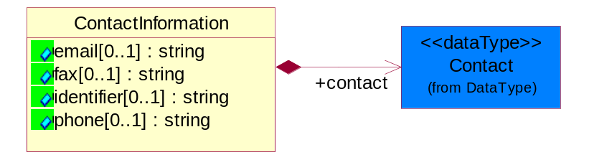
Figure ‎4-32 ContactInformation

Attribute | Type | Documentation
email[0..1] | string | The electronic mail for the specified contact.
fax[0..1] | string | The fax number for the specified contact.
identifier[0..1] | string | Identifies the role of the contact (i.e. Service Technician, Account Manager) in the Business Process.
phone[0..1] | string | The telephone number for the specified contact.

Composition | Cardinality | Type | Documentation
contact | 1 | Contact | The name of the department, service or individual to be contacted within the organization.

DataType

Contact
The name of the department, service or individual to be contacted within the organization.
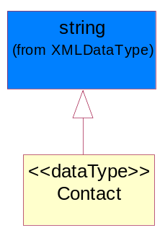
Figure ‎4-33 Contact

DUNS
A number assigned by Dun and Bradstreet to identify a business location.
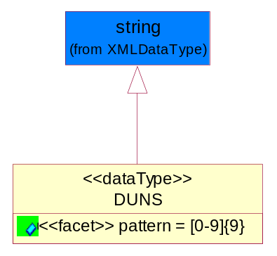
Figure ‎4-34 DUNS

Attribute | Type | Documentation
pattern |  | [0-9]{9}

DUNSPlus4
A identifier to specify a specific location within a business location.
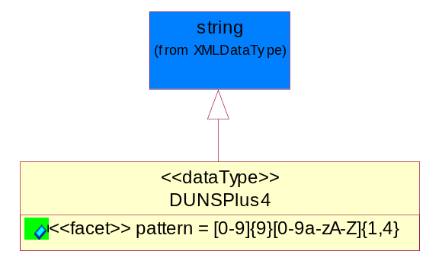
Figure ‎4-35 DUNSPlus4

Attribute | Type | Documentation
pattern |  | Data Universal Numbering System +4 (DUNS+4) number means the DUNS number assigned by Dun and Bradstreet, Inc. (D&B) plus an alphanumeric of length 4 suffix that may be assigned by a business concern.

GLN
Global Location Number (GLN) - A identifier to identify legal entities, trading parties and location.
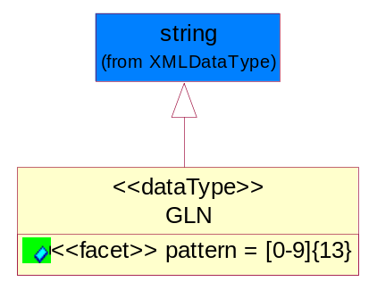
Figure ‎4-36 GLN

Attribute | Type | Documentation
pattern |  | [0-9]{13}

GTIN
Global Trade Identification Number (GTIN).
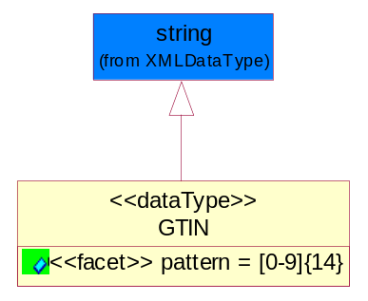
Figure ‎4-37 GTIN

Attribute | Type | Documentation
pattern |  | [0-9]{14}

Document

BusinessDocumentReference
The business document reference object allows for the indirect referencing of a relationship to other business related documents.
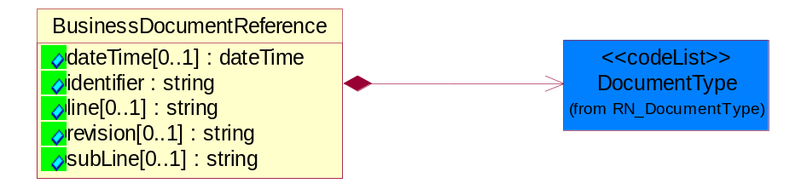
Figure ‎4-38 BusinessDocumentReference

Attribute | Type | Documentation
dateTime[0..1] | dateTime | The date-time stamp indicating on the referenced business document.
identifier | string | Unique identification of the referenced business document.
line[0..1] | string | References the specific line number of the specified business document.
revision[0..1] | string | Referenced the revision of the specified business document.
subLine[0..1] | string | References the specific subline number of the specified business document.

Composition | Cardinality | Type | Documentation
DocumentType | 1 | DocumentType | A code identifying the business context of a document.

Locations

AlternativeIdentifier
Identifies the specified code and the name of the organization that a code is utilized from.
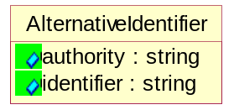
Figure ‎4-39 AlternativeIdentifier

Attribute | Type | Documentation
authority | string | The name of the organization that a code is utilized from.
identifier | string | The specified code to represent an entity (e.g. product, location, partner, etc.).

Location
The business document must specify a location.
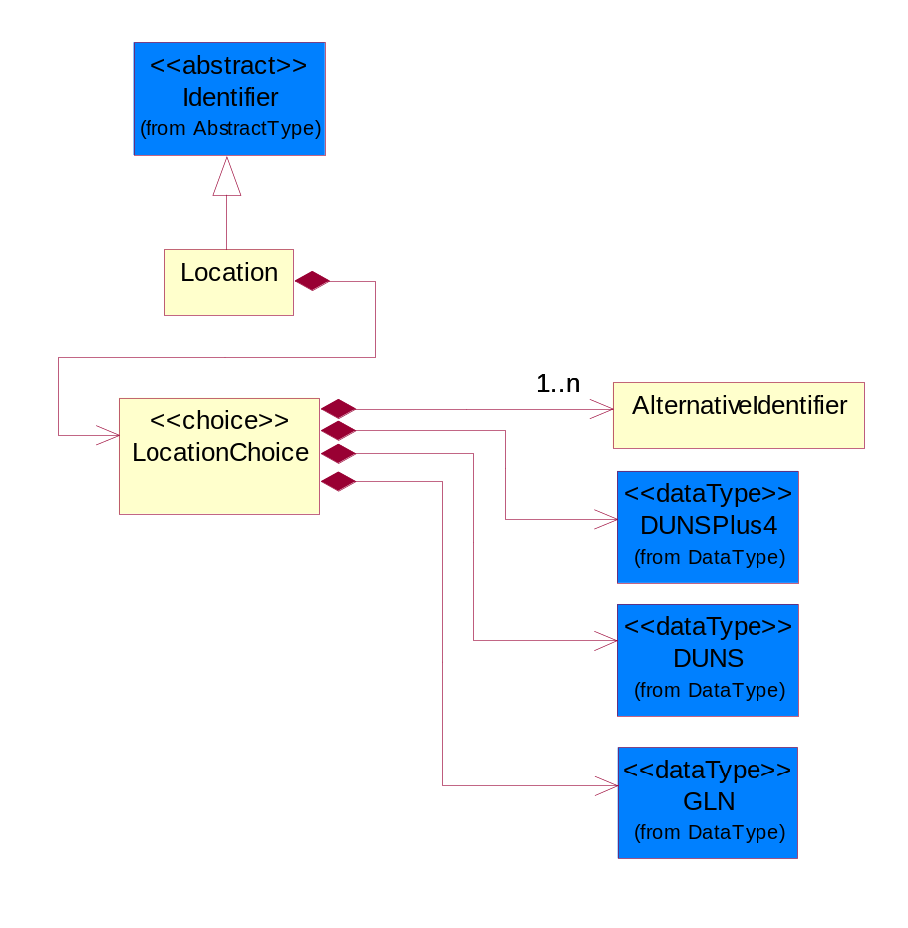
Figure ‎4-40 Location
Composition | Cardinality | Type | Documentation
LocationChoice | 1 | LocationChoice

LocationChoice

Composition | Cardinality | Type | Documentation
AlternativeIdentifier | 1..n | AlternativeIdentifier | Identifies the specified code and the name of the organization that a code is utilized from.
DUNSPlus4 | 1 | DUNSPlus4 | A identifier to specify a specific location within a business location.
DUNS | 1 | DUNS | A number assigned by Dun and Bradstreet to identify a business location.
GLN | 1 | GLN | Global Location Number (GLN) - A identifier to identify legal entities, trading parties and location.

PhysicalAddress
The business document must provide a physical address for a party to the business transaction.
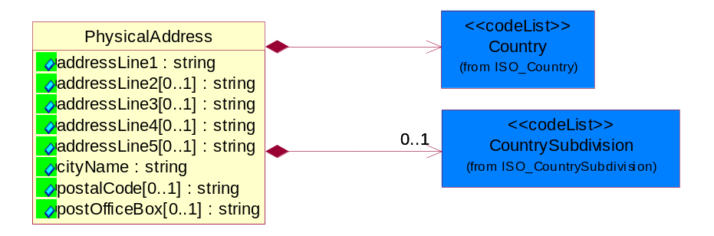
Figure ‎4-41 PhysicalAddress

Attribute |  | Type |  | Documentation
addressLine1 |  | string |  | The first line of a physical address.
addressLine2[0..1] |  | string |  | The second line of a physical address.
addressLine3[0..1] |  | string |  | The third line of a physical address.
addressLine4[0..1] |  | string |  | The fourth line of a physical address.
addressLine5[0..1] |  | string |  | The fifth line of a physical address.
cityName |  | string |  | The name of a city.
postalCode[0..1] |  | string |  | Identifying geographic location as specified by a national postal code.
postOfficeBox[0..1] |  | string |  | The Post Office Box identifier used to identify a party's post office box.
Composition | Cardinality |  | Type |  | Documentation
Country | 1 |  | Country |  | For representation of Country name RosettaNet has adopted ISO 3166-3; 1999. Refer to the following web page to get the latest version of the standard:  http://www.iso.ch/iso/en/prods-services/iso3166ma/02iso-3166-code-lists/index.html  If you need more information about the ISO standard please contact ISO for more details.
CountrySubdivision | 0..1 |  | CountrySubdivision |  | For representation of a Countries subdivisions RosettaNet has adopted ISO 3166-3; 1999. Refer to the following web page to get the latest version of the standard:  http://www.iso.ch/iso/en/prods-services/iso3166ma/02iso-3166-code-lists/index.html  If you need more information about the ISO standard please contact ISO for more details.

MonetaryExpression

FinancialAmount
The business document must express financial amounts.
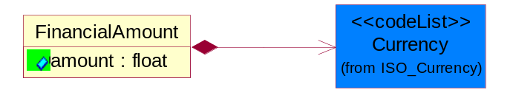
Figure ‎4-42 FinancialAmount

Attribute | Type | Documentation
amount | float | Specifies the monetary amount.

Composition | Cardinality | Type | Documentation
Currency | 1 | Currency | For representation of Currency codes RosettaNet has adopted ISO 4217; 1995. The British Standards Institution (BSI) is the ISO 4217 Maintenance Agency. Refer to the following web page to get the latest version of the standard:  http://www.bsi-global.com/Technical+Information/Publications/_Publications/tig90.xalter  If you need more information about the ISO standard please contact ISO for more details.

PartnerIdentification

PartnerIdentification
The business document must allow for the identity of one or more parties to the transaction.
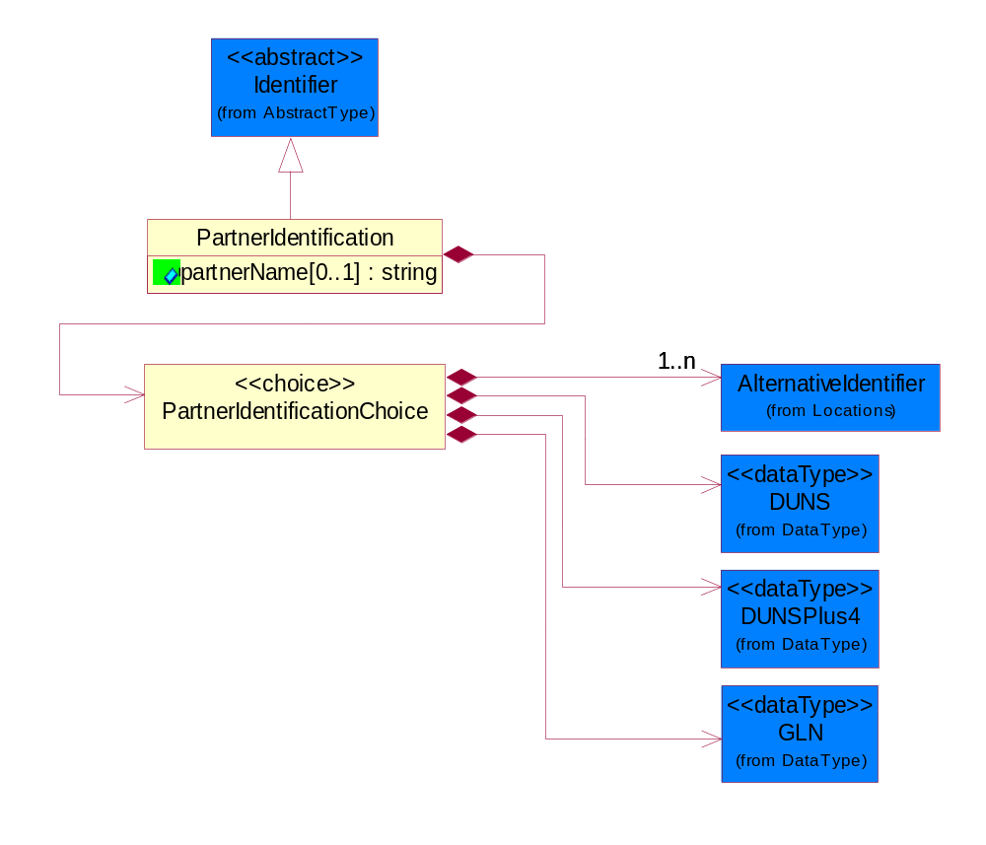
Figure ‎4-43 PartnerIdentification

Attribute | Type | Documentation
partnerName[0..1] | string | The name of the partner’s company/business.

Composition | Cardinality | Type | Documentation
PartnerIdentificationChoice | 1 | PartnerIdentificationChoice

PartnerIdentificationChoice

Composition | Cardinality | Type | Documentation
AlternativeIdentifier | 1..n | AlternativeIdentifier | Identifies the specified code and the name of the organization that a code is utilized from.
DUNS | 1 | DUNS | A number assigned by Dun and Bradstreet to identify a business location.
DUNSPlus4 | 1 | DUNSPlus4 | A identifier to specify a specific location within a business location.
GLN | 1 | GLN | Global Location Number (GLN) - A identifier to identify legal entities, trading parties and location.

SpecifiedFullPartner
The business document must describe the trading partners in the business transaction. This data structure provide the flexibility to describe a partner in all possible methods as for new, existing or known partner. This is specifically for partner who role has been specified.
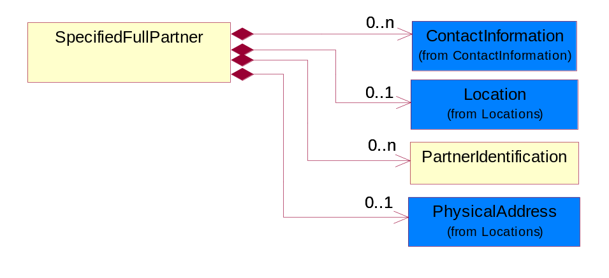
Figure ‎4-44 SpecifiedFullPartner

Composition | Cardinality | Type | Documentation
ContactInformation | 0..n | ContactInformation | The business document must allow for the identification of the name of the department, service or individual to be contacted regarding the context of the business document.
Location | 0..1 | Location | The business document must specify a location.
PartnerIdentification | 0..n | PartnerIdentification | The business document must allow for the identity of one or more parties to the transaction.
PhysicalAddress | 0..1 | PhysicalAddress | The business document must provide a physical address for a party to the business transaction.

SpecifiedIntermittentPartner
The business document must describe a physical address for a delivery.
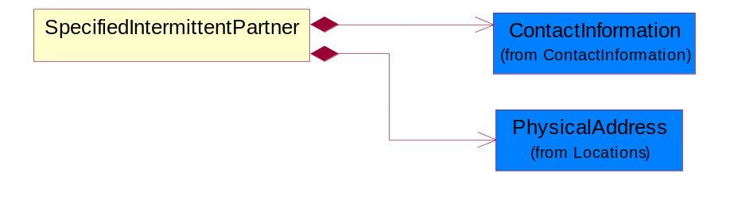
Figure ‎4-45 SpecifiedIntermittentPartner

Composition | Cardinality | Type | Documentation
ContactInformation | 1 | ContactInformation | The business document must allow for the identification of the name of the department, service or individual to be contacted regarding the context of the business document.
PhysicalAddress | 1 | PhysicalAddress | The business document must provide a physical address for a party to the business transaction.

SpecifiedKnownPartner
The business document must describe the trading partners in the business transaction.
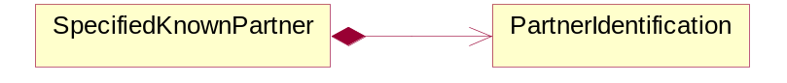
Figure ‎4-46 SpecifiedKnownPartner

Composition | Cardinality | Type | Documentation
PartnerIdentification | 1 | PartnerIdentification | The business document must allow for the identity of one or more parties to the transaction.

SpecifiedKnownPartnerContact
The business document must describe the trading partners in the business transaction and allow for a identification of an individual of the trading partner.
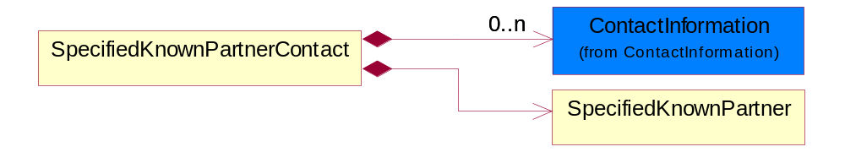
Figure ‎4-47 SpecifiedKnownPartnerContact

Composition | Cardinality | Type | Documentation
ContactInformation | 0..n | ContactInformation | The business document must allow for the identification of the name of the department, service or individual to be contacted regarding the context of the business document.
SpecifiedKnownPartner | 1 | SpecifiedKnownPartner | The business document must describe the trading partners in the business transaction.

SpecifiedNewPartner
The business document must describe a new, existing (but known to only one of the parties to the transaction) or an unknown party to the business transaction.
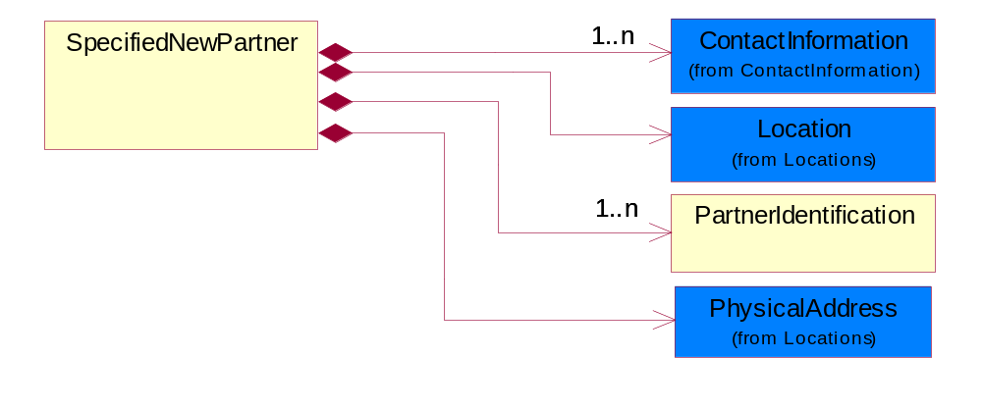
Figure ‎4-48 SpecifiedNewPartner

Composition | Cardinality | Type | Documentation
ContactInformation | 1..n | ContactInformation | The business document must allow for the identification of the name of the department, service or individual to be contacted regarding the context of the business document.
Location | 1 | Location | The business document must specify a location.
PartnerIdentification | 1..n | PartnerIdentification | The business document must allow for the identity of one or more parties to the transaction.
PhysicalAddress | 1 | PhysicalAddress | The business document must provide a physical address for a party to the business transaction.

SpecifiedPartnerDescription
The collection of business properties that describe a business partners' identity, their contact information, where they are physically located and their function in a supply chain.
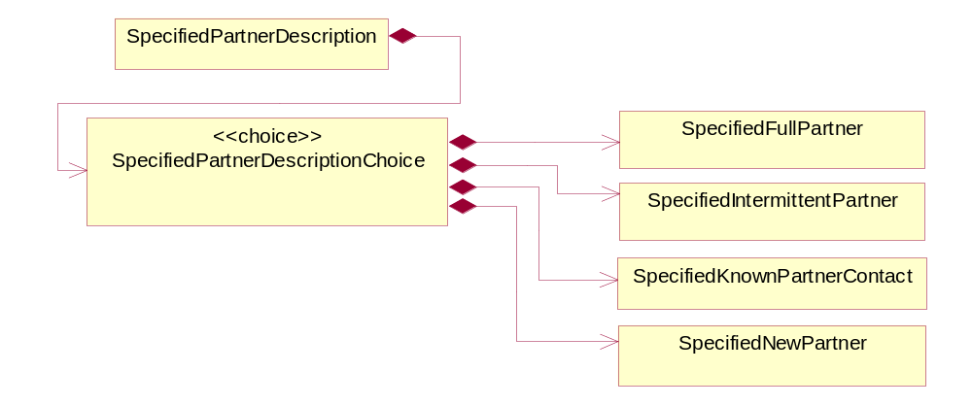
Figure ‎4-49 SpecifiedPartnerDescription

Composition | Cardinality | Type | Documentation
SpecifiedPartnerDescriptionChoice | 1 | SpecifiedPartnerDescriptionChoice

SpecifiedPartnerDescriptionChoice

Composition | Cardinality | Type | Documentation
SpecifiedFullPartner | 1 | SpecifiedFullPartner | The business document must describe the trading partners in the business transaction. This data structure provide the flexibility to describe a partner in all possible methods as for new, existing or known partner. This is specifically for partner who role has been specified.
SpecifiedIntermittentPartner | 1 | SpecifiedIntermittentPartner | The business document must describe a physical address for a delivery.
SpecifiedKnownPartnerContact | 1 | SpecifiedKnownPartnerContact | The business document must describe the trading partners in the business transaction and allow for a identification of an individual of the trading partner.
SpecifiedNewPartner | 1 | SpecifiedNewPartner | The business document must describe a new, existing (but known to only one of the parties to the transaction) or an unknown party to the business transaction.

PhysicalDimension

Measure
The business document must describe measurement information.
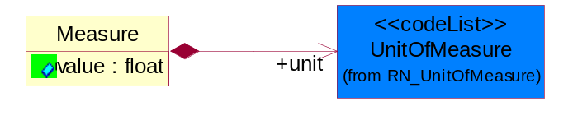
Figure ‎4-50 Measure

Attribute | Type | Documentation
value | float | The worth of an object in the specified unit of measure.

Composition | Cardinality | Type | Documentation
unit | 1 | UnitOfMeasure | To express the unit type of measurement.

Volume
The business document must be able to express the volume of an object.
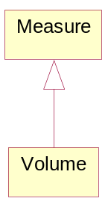
Figure ‎4-51 Volume

Weight
The business document must be able to express the weight of an object.
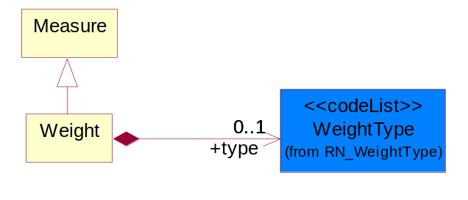
Figure ‎4-52 Weight

Composition | Cardinality | Type | Documentation
type | 0..1 | WeightType | A code identifying the type of weight.

ProductIdentification

ProductIdentification
The object provides the identifier(s) of a product.
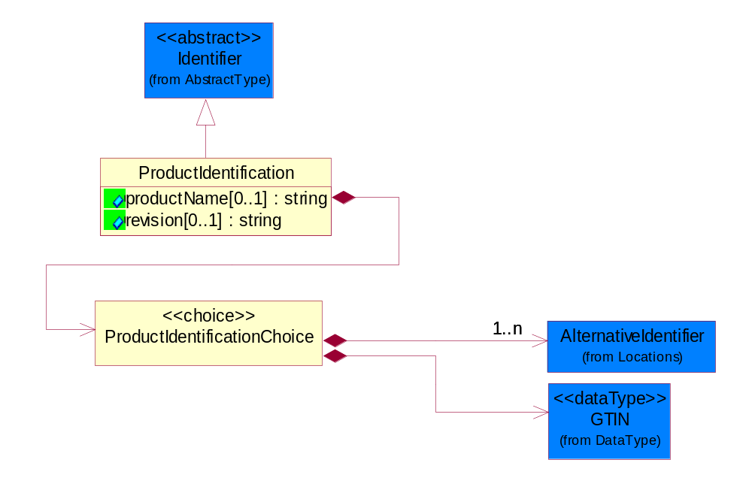
Figure ‎4-53 ProductIdentification

Attribute | Type | Documentation
productName[0..1] | string | The name of the product.
revision[0..1] | string | Referenced the specified product revision.

Composition | Cardinality | Type | Documentation
ProductIdentificationChoice | 1 | ProductIdentificationChoice

ProductIdentificationChoice

Composition | Cardinality | Type | Documentation
AlternativeIdentifier | 1..n | AlternativeIdentifier | Identifies the specified code and the name of the organization that a code is utilized from.
GTIN | 1 | GTIN | Global Trade Identification Number (GTIN).

TextualDescription
The business document must allow for multiple levels of textual description of an event or object.
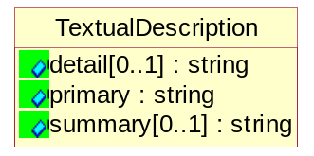
Figure ‎4-54 TextualDescription

Attribute | Type | Documentation
detail[0..1] | string | A detail description of an event or object.
primary | string | A phrase or single word description of an event or object.
summary[0..1] | string | A condensed description of an event or object.

CodeList

Country
For representation of Country name RosettaNet has adopted ISO 3166-3; 1999. Refer to the following web page to get the latest version of the standard:
http://www.iso.ch/iso/en/prods-services/iso3166ma/02iso-3166-code-lists/index.html

If you need more information about the ISO standard please contact ISO for more details.

CountrySubdivision
For representation of a Countries subdivisions RosettaNet has adopted ISO 3166-3; 1999. Refer to the following web page to get the latest version of the standard:
http://www.iso.ch/iso/en/prods-services/iso3166ma/02iso-3166-code-lists/index.html

If you need more information about the ISO standard please contact ISO for more details.

Currency
For representation of Currency codes RosettaNet has adopted ISO 4217; 1995. The British Standards Institution (BSI) is the ISO 4217 Maintenance Agency. Refer to the following web page to get the latest version of the standard:
http://www.bsi-global.com/Technical+Information/Publications/_Publications/tig90.xalter

If you need more information about the ISO standard please contact ISO for more details.

Language
For representation of Language name RosettaNet has adopted ISO 639-2; 1998. Refer to the following web page to get the latest version of the standard:

http://www.loc.gov/standards/iso639-2/iso639jac.html

If you need more information about the ISO standard please contact ISO for more details.

DocumentType
A code identifying the business context of a document.

Instance | Documentation
ARA | Authorization Request Approval.
CBN | Product batch number of customer.
CCN | Customs clearance number.
CFA | Failure Analysis - Request document that will accompany the product providing characteristics of the component failure.
CIN | Commercial Invoice.
CNM | Traditional credit note or memo.
CON | In a virtual sourcing relationship, a third party trading partner is supplying a part to a customer on behalf of another company that has taken the order for the customer. In this case a Customer Order Number is associated to the request for material that is sent to the virtual trading partners.
COS | Consumption Notice.
COT | Contract.
CRN | Unique consumption reference number identifying the product consumption issue i.e. one-to-one relationship with physical flow.
DEM | Traditional debit note or memo.
DEN | Delivery Note.
DIN | Discontinuation Notice.
DOR | Delivery Order.
DRN | Drawing Number.
DRR | Design Registration Request.
ECO | Engineering Change Order - The proprietary unique identification number that represents an engineering change order.
EIR | Engineering Information Request.
EOL | End of Life.
FUO | Sales order or transfer order fulfilling demand out of a facility (outbound shipment).
INV | Invoice.
LID | Location Identifier. Data for on-site work that have to be done on the machine (associated with preventive maintenance order).
MEN | Master Event Number.
MID | Machine Identifier. Data for on-site work that have to be done on the machine (associated with preventive maintenance order).
MON | Model Number.
OCL | The unique identifier assigned by the OEM for a warranty claim.
OGA | Other governmental agency issued document.
OPO | The unique identifier assigned by the OEM for a part order.
OPR | The unique identifier assigned by the OEM for a part return.
PCN | Product/Process Change.
PFA | Failure Analysis - Request document that will accompany the product providing characteristics of the product failure.
PII | Refers to previously issued invoice.
PLS | Unique number that identifies packing form prior to shipment.
POI | Purchase Order IN.
PON | Production order number for material release.
POO | Purchase Order OUT.
PRC | Product Catalog.
PSI | Refers to previously issued self-billing invoice.
PUO | Purchase Order.
QUO | Quote.
REC | Document identifying the receipt of materials or products into a facility against a purchase order or transfer order (inbound shipment).
REO | Purchase order or transfer order replenishing inventory into a facility (inbound shipment).
REQ | Requisition.
RMA | Returned Material Authorization.
RPO | Purchase order for materials or product returned to and reworked by a supplier.
RTA | Remittance Advice - Remittance details.
SAO | Sales Order.
SBC | Credit Memo used in self-billing scenario.
SBD | Debit Memo used in self-billing scenario.
SBI | Invoice in self billing scenario.
SBN | Product batch number of supplier.
SCA | Similar to contracts - Contains the quantity of an article that is to be ordered from a vendor and the price for article or service that is to be procured.
SEN | Serial Number.
SEO | A document that gives a repair provider the necessary authorization to repair or upgrade a product either at the customer site or at the repair provider’s site.
SHD | Shipping Document.
SNC | Shipset Number on Code List.
SPC | The unique identifier assigned by the ASP for a warranty claim.
SPN | Spec Number.
SPO | The unique identifier assigned by the ASP for a part order.
SPR | The unique identifier assigned by the ASP for a part return.
SPW | The unique identifier assigned by the ASP to reference a work order.
SRI | A document that contains the shipping reference number which allows the product to be tracked within the outsourced logistic providers network.
TRO | Order which results in materials or products being moved from one facility to another (outbound shipment and inbound shipment).
WAB | Waybill.
WAC | Denotes a warranty claim.
WOO | Work Order.

MimeTypeQualifier
The MIME type as defined by IANA.

Please refer to http://www.iana.org/assignments/media-types/ for a list of types.

Instance | Documentation
application/activemessage | [Shapiro]
application/andrew-inset | [Borenstein]
application/applefile | [Faltstrom]
application/atomicmail | [Borenstein]
application/batch-SMTP | [RFC2442]
application/beep+xml | [RFC3080]
application/cals-1840 | [RFC1895]
application/cnrp+xml | [RFCCNRP]
application/commonground | [Glazer]
application/cpl+xml
application/cybercash | [Eastlake]
application/dca-rft | [Campbell]
application/dec-dx | [Campbell]
application/dicom | [RFC3240]
application/dvcs | [RFC3029]
application/EDI-Consent | [RFC1767]
application/EDIFACT | [RFC1767]
application/EDI-X12 | [RFC1767]
application/eshop | [Katz]
application/font-tdpfr | [RFC3073]
application/http | [RFC2616]
application/hyperstudio | [Domino]
application/iges | [Parks]
application/index | [RFC2652]
application/index.cmd | [RFC2652]
application/index.obj | [RFC2652]
application/index.response | [RFC2652]
application/index.vnd | [RFC2652]
application/iotp | [RFC2935]
application/ipp | [RFC2910]
application/isup | [RFC3204]
application/mac-binhex40 | [Faltstrom]
application/macwriteii | [Lindner]
application/marc | [RFC2220]
application/mathematica | [Van Nostern]
application/msword | [Lindner]
application/news-message-id | [RFC1036,Spencer]
application/news-transmission | [RFC1036, Spencer]
application/ocsp-request | [RFC2560]
application/ocsp-response | [RFC2560]
application/octet-stream | [RFC2045,RFC2046]
application/oda | [RFC2045,RFC2046]
application/ogg | [RFC-walleij-ogg-mediatype-08.txt]
application/parityfec | [RFC3009]
application/pdf | [Lindner]
application/pgp-encrypted | [RFC3156]
application/pgp-keys | [RFC3156]
application/pgp-signature | [RFC3156]
application/pkcs10 | [RFC2311]
application/pkcs7-mime | [RFC2311]
application/pkcs7-signature | [RFC2311]
application/pkix-cert | [RFC2585]
application/pkixcmp | [RFC2510]
application/pkix-crl | [RFC2585]
application/postscript | [RFC2045,RFC2046]
application/prs.alvestrand.titrax-sheet | [Alvestrand]
application/prs.cww | [Rungchavalnont]
application/prs.nprend | [Doggett]
application/prs.plucker | [Janssen]
application/qsig | [RFC3204]
application/reginfo+xml | [RFC-ietf-sipping-reg-event-00.txt]
application/remote-printing | [RFC1486,Rose]
application/riscos | [Smith]
application/rtf | [Lindner]
application/sdp | [RFC2327]
application/set-payment | [Korver]
application/set-payment-initiation | [Korver]
application/set-registration | [Korver]
application/set-registration-initiation | [Korver]
application/sgml | [RFC1874]
application/sgml-open-catalog | [Grosso]
application/sieve | [RFC3028]
application/slate | [Crowley]
application/timestamp-query | [RFC3161]
application/timestamp-reply | [RFC3161]
application/tve-trigger | [Welsh]
application/vemmi | [RFC2122]
application/vnd.3gpp.pic-bw-large | [Meredith]
application/vnd.3gpp.pic-bw-small | [Meredith]
application/vnd.3gpp.pic-bw-var | [Meredith]
application/vnd.3gpp.sms | [Meredith]
application/vnd.3M.Post-it-Notes | [O'Brien]
application/vnd.accpac.simply.aso | [Leow]
application/vnd.accpac.simply.imp | [Leow]
application/vnd.acucobol | [Lubin]
application/vnd.acucorp | [Lubin]
application/vnd.adobe.xfdf | [Perelman]
application/vnd.aether.imp | [Moskowitz]
application/vnd.amiga.ami | [Blumberg]
application/vnd.anser-web-certificate-issue-initiation | [Mori]
application/vnd.anser-web-funds-transfer-initiation | [Mori]
application/vnd.audiograph | [Slusanschi]
application/vnd.blueice.multipass | [Holmstrom]
application/vnd.bmi | [Gotoh]
application/vnd.businessobjects | [Imoucha]
application/vnd.canon-cpdl | [Muto]
application/vnd.canon-lips | [Muto]
application/vnd.cinderella | [Kortenkamp]
application/vnd.claymore | [Simpson]
application/vnd.commerce-battelle | [Applebaum]
application/vnd.commonspace | [Chandhok]
application/vnd.contact.cmsg | [Patz]
application/vnd.cosmocaller | [Dellutri]
application/vnd.ctc-posml | [Kohlhepp]
application/vnd.cups-postscript | [Sweet]
application/vnd.cups-raster | [Sweet]
application/vnd.cups-raw | [Sweet]
application/vnd.curl | [Byrnes]
application/vnd.cybank | [Helmee]
application/vnd.data-vision.rdz | [Fields]
application/vnd.dna | [Searcy]
application/vnd.dpgraph | [Parker]
application/vnd.dreamfactory | [Appleton]
application/vnd.dxr | [Duffy]
application/vnd.ecdis-update | [Buettgenbach]
application/vnd.ecowin.chart | [Olsson]
application/vnd.ecowin.filerequest | [Olsson]
application/vnd.ecowin.fileupdate | [Olsson]
application/vnd.ecowin.series | [Olsson]
application/vnd.ecowin.seriesrequest | [Olsson]
application/vnd.ecowin.seriesupdate | [Olsson]
application/vnd.enliven | [Santinelli]
application/vnd.epson.esf | [Hoshina]
application/vnd.epson.msf | [Hoshina]
application/vnd.epson.quickanime | [Gu]
application/vnd.epson.salt | [Nagatomo]
application/vnd.epson.ssf | [Hoshina]
application/vnd.ericsson.quickcall | [Tidwell]
application/vnd.eudora.data | [Resnick]
application/vnd.fdf | [Zilles]
application/vnd.ffsns | [Holstage]
application/vnd.FloGraphIt | [Floersch]
application/vnd.framemaker | [Wexler]
application/vnd.fsc.weblaunch | [D.Smith]
application/vnd.fujitsu.oasys | [Togashi]
application/vnd.fujitsu.oasys2 | [Togashi]
application/vnd.fujitsu.oasys3 | [Okudaira]
application/vnd.fujitsu.oasysgp | [Sugimoto]
application/vnd.fujitsu.oasysprs | [Ogita]
application/vnd.fujixerox.ddd | [Onda]
application/vnd.fujixerox.docuworks | [Taguchi]
application/vnd.fujixerox.docuworks.binder | [Matsumoto]
application/vnd.fut-misnet | [Pruulmann]
application/vnd.grafeq | [Tupper]
application/vnd.groove-account | [Joseph]
application/vnd.groove-help | [Joseph]
application/vnd.groove-identity-message | [Joseph]
application/vnd.groove-injector | [Joseph]
application/vnd.groove-tool-message | [Joseph]
application/vnd.groove-tool-template | [Joseph]
application/vnd.groove-vcard | [Joseph]
application/vnd.hbci | [Hammann]
application/vnd.hhe.lesson-player | [Jones]
application/vnd.hp-HPGL | [Pentecost]
application/vnd.hp-hpid | [Gupta]
application/vnd.hp-hps | [Aubrey]
application/vnd.hp-PCL | [Pentecost]
application/vnd.hp-PCLXL | [Pentecost]
application/vnd.httphone | [Lefevre]
application/vnd.hzn-3d-crossword | [Minnis]
application/vnd.ibm.afplinedata | [Buis]
application/vnd.ibm.electronic-media | [Tantlinger]
application/vnd.ibm.MiniPay | [Herzberg]
application/vnd.ibm.modcap | [Hohensee]
application/vnd.ibm.secure-container | [Tantlinger]
application/vnd.informix-visionary | [Gales]
application/vnd.intercon.formnet | [Gurak]
application/vnd.intertrust.digibox | [Tomasello]
application/vnd.intertrust.nncp | [Tomasello]
application/vnd.intu.qbo | [Scratchley]
application/vnd.intu.qfx | [Scratchley]
application/vnd.irepository.package+xml | [Knowles]
application/vnd.is-xpr | [Natarajan]
application/vnd.japannet-directory-service | [Fujii]
application/vnd.japannet-jpnstore-wakeup | [Yoshitake]
application/vnd.japannet-payment-wakeup | [Fujii]
application/vnd.japannet-registration | [Yoshitake]
application/vnd.japannet-registration-wakeup | [Fujii]
application/vnd.japannet-setstore-wakeup | [Yoshitake]
application/vnd.japannet-verification | [Yoshitake]
application/vnd.japannet-verification-wakeup | [Fujii]
application/vnd.jisp | [Deckers]
application/vnd.kde.karbon | [Faure]
application/vnd.kde.kchart | [Faure]
application/vnd.kde.kformula | [Faure]
application/vnd.kde.kivio | [Faure]
application/vnd.kde.kontour | [Faure]
application/vnd.kde.kpresenter | [Faure]
application/vnd.kde.kspread | [Faure]
application/vnd.kde.kword | [Faure]
application/vnd.kenameaapp | [DiGiorgio-Haag]
application/vnd.koan | [Cole]
application/vnd.liberty-request+xml | [McDowell]
application/vnd.llamagraphics.life-balance.desktop | [White]
application/vnd.lotus-1-2-3 | [Wattenberger]
application/vnd.lotus-approach | [Wattenberger]
application/vnd.lotus-freelance | [Wattenberger]
application/vnd.lotus-notes | [Laramie]
application/vnd.lotus-organizer | [Wattenberger]
application/vnd.lotus-screencam | [Wattenberger]
application/vnd.lotus-wordpro | [Wattenberger]
application/vnd.mcd | [Gotoh]
application/vnd.mediastation.cdkey | [Flurry]
application/vnd.meridian-slingshot | [Wedel]
application/vnd.micrografx.flo | [Prevo]
application/vnd.micrografx.igx | [Prevo]
application/vnd.mif | [Wexler]
application/vnd.minisoft-hp3000-save | [Bartram]
application/vnd.mitsubishi.misty-guard.trustweb | [Tanaka]
application/vnd.Mobius.DAF | [Kabayama]
application/vnd.Mobius.DIS | [Kabayama]
application/vnd.Mobius.MBK | [Devasia]
application/vnd.Mobius.MQY | [Devasia]
application/vnd.Mobius.MSL | [Kabayama]
application/vnd.Mobius.PLC | [Kabayama]
application/vnd.Mobius.TXF | [Kabayama]
application/vnd.mophun.application | [Wennerstrom]
application/vnd.mophun.certificate | [Wennerstrom]
application/vnd.motorola.flexsuite | [Patton]
application/vnd.motorola.flexsuite.adsi | [Patton]
application/vnd.motorola.flexsuite.fis | [Patton]
application/vnd.motorola.flexsuite.gotap | [Patton]
application/vnd.motorola.flexsuite.kmr | [Patton]
application/vnd.motorola.flexsuite.ttc | [Patton]
application/vnd.motorola.flexsuite.wem | [Patton]
application/vnd.mozilla.xul+xml | [McDaniel]
application/vnd.ms-artgalry | [Slawson]
application/vnd.ms-asf | [Fleischman]
application/vnd.mseq | [Le Bodic]
application/vnd.ms-excel | [Gill]
application/vnd.msign | [Borcherding]
application/vnd.ms-lrm | [Ledoux]
application/vnd.ms-powerpoint | [Gill]
application/vnd.ms-project | [Gill]
application/vnd.ms-tnef | [Gill]
application/vnd.ms-works | [Gill]
application/vnd.ms-wpl | [Plastina]
application/vnd.musician | [Adams]
application/vnd.music-niff | [Butler]
application/vnd.netfpx | [Mutz]
application/vnd.noblenet-directory | [Solomon]
application/vnd.noblenet-sealer | [Solomon]
application/vnd.noblenet-web | [Solomon]
application/vnd.novadigm.EDM | [Swenson]
application/vnd.novadigm.EDX | [Swenson]
application/vnd.novadigm.EXT | [Swenson]
application/vnd.obn | [Hessling]
application/vnd.osa.netdeploy | [Klos]
application/vnd.palm | [Peacock]
application/vnd.pg.format | [Gandert]
application/vnd.pg.osasli | [Gandert]
application/vnd.powerbuilder6 | [Guy]
application/vnd.powerbuilder6-s | [Guy]
application/vnd.powerbuilder7 | [Shilts]
application/vnd.powerbuilder75 | [Shilts]
application/vnd.powerbuilder75-s | [Shilts]
application/vnd.powerbuilder7-s | [Shilts]
application/vnd.previewsystems.box | [Smolgovsky]
application/vnd.publishare-delta-tree | [Ben-Kiki]
application/vnd.pvi.ptid1 | [Lamb]
application/vnd.pwg-multiplexed | [RFC3391]
application/vnd.pwg-xhtml-print+xml | [Wright]
application/vnd.Quark.QuarkXPress | [Scheidler]
application/vnd.rapid | [Szekely]
application/vnd.s3sms | [Tarkkala]
application/vnd.sealed.net | [Lambert]
application/vnd.seemail | [Webb]
application/vnd.shana.informed.formdata | [Selzler]
application/vnd.shana.informed.formtemplate | [Selzler]
application/vnd.shana.informed.interchange | [Selzler]
application/vnd.shana.informed.package | [Selzler]
application/vnd.smaf | [Takahashi]
application/vnd.sss-cod | [Dani]
application/vnd.sss-dtf | [Bruno]
application/vnd.sss-ntf | [Bruno]
application/vnd.street-stream | [Levitt]
application/vnd.svd | [Becker]
application/vnd.swiftview-ics | [Widener]
application/vnd.triscape.mxs | [Simonoff]
application/vnd.trueapp | [Hepler]
application/vnd.truedoc | [Chase]
application/vnd.ufdl | [Manning]
application/vnd.uplanet.alert | [Martin]
application/vnd.uplanet.alert-wbxml | [Martin]
application/vnd.uplanet.bearer-choice | [Martin]
application/vnd.uplanet.bearer-choice-wbxml | [Martin]
application/vnd.uplanet.cacheop | [Martin]
application/vnd.uplanet.cacheop-wbxml | [Martin]
application/vnd.uplanet.channel | [Martin]
application/vnd.uplanet.channel-wbxml | [Martin]
application/vnd.uplanet.list | [Martin]
application/vnd.uplanet.listcmd | [Martin]
application/vnd.uplanet.listcmd-wbxml | [Martin]
application/vnd.uplanet.list-wbxml | [Martin]
application/vnd.uplanet.signal | [Martin]
application/vnd.vcx | [T.Sugimoto]
application/vnd.vectorworks | [Pharr]
application/vnd.vidsoft.vidconference | [Hess]
application/vnd.visio | [Sandal]
application/vnd.visionary | [Aravindakumar]
application/vnd.vividence.scriptfile | [Risher]
application/vnd.vsf | [Rowe]
application/vnd.wap.sic | [WAP-Forum]
application/vnd.wap.slc | [WAP-Forum]
application/vnd.wap.wbxml | [Stark]
application/vnd.wap.wmlc | [Stark]
application/vnd.wap.wmlscriptc | [Stark]
application/vnd.webturbo | [Rehem]
application/vnd.wrq-hp3000-labelled | [Bartram]
application/vnd.wt.stf | [Wohler]
application/vnd.wv.csp+wbxml | [Salmi]
application/vnd.xara | [Matthewman]
application/vnd.xfdl | [Manning]
application/vnd.yellowriver-custom-menu | [Yellow]
application/whoispp-query | [RFC2957]
application/whoispp-response | [RFC2958]
application/wita | [Campbell]
application/wordperfect5.1 | [Lindner]
application/x400-bp | [RFC1494]
application/xhtml+xml | [RFC3236]
application/xml | [RFC3023]
application/xml-dtd | [RFC3023]
application/xml-external-parsed-entity | [RFC3023]
application/zip | [Lindner]
audio/32kadpcm | [RFC2421,RFC2422]
audio/AMR | [RFC3267]
audio/AMR-WB | [RFC3267]
audio/basic | [RFC2045,RFC2046]
audio/CN | [RFC3389]
audio/DAT12 | [RFC3190]
audio/DVI4
audio/EVRC | [RFC-ietf-avt-evrc-smv-03.txt]
audio/EVRC0 | [RFC-ietf-avt-evrc-smv-03.txt]
audio/G.722.1 | [RFC3047]
audio/G722
audio/G723
audio/G726-16
audio/G726-24
audio/G726-32
audio/G726-40
audio/G728
audio/G729
audio/G729D
audio/G729E
audio/GSM
audio/GSM-EFR
audio/L16 | [RFC2586]
audio/L20 | [RFC3190]
audio/L24 | [RFC3190]
audio/L8
audio/LPC
audio/MP4A-LATM | [RFC3016]
audio/MPA
audio/mpa-robust | [RFC3119]
audio/mpeg | [RFC3003]
audio/parityfec | [RFC3009]
audio/PCMA
audio/PCMU
audio/prs.sid | [Walleij]
audio/QCELP
audio/RED
audio/SMV | [RFC-ietf-avt-evrc-smv-03.txt]
audio/SMV0 | [RFC-ietf-avt-evrc-smv-03.txt]
audio/telephone-event | [RFC2833]
audio/tone | [RFC2833]
audio/VDVI
audio/vnd.3gpp.iufp | [Belling]
audio/vnd.cisco.nse | [Kumar]
audio/vnd.cns.anp1 | [McLaughlin]
audio/vnd.cns.inf1 | [McLaughlin]
audio/vnd.digital-winds | [Strazds]
audio/vnd.everad.plj | [Cicelsky]
audio/vnd.lucent.voice | [Vaudreuil]
audio/vnd.nortel.vbk | [Parsons]
audio/vnd.nuera.ecelp4800 | [Fox]
audio/vnd.nuera.ecelp7470 | [Fox]
audio/vnd.nuera.ecelp9600 | [Fox]
audio/vnd.octel.sbc | [Vaudreuil]
audio/vnd.qcelp | [Lundblade]
audio/vnd.rhetorex.32kadpcm | [Vaudreuil]
audio/vnd.vmx.cvsd | [Vaudreuil]
image/cgm | Computer Graphics Metafile
image/g3fax | [RFC1494]
image/gif | [RFC2045,RFC2046]
image/ief | [RFC1314] Image Exchange Format
image/jpeg | [RFC2045,RFC2046]
image/naplps | [Ferber]
image/png | [Randers-Pehrson]
image/prs.btif | [Simon]
image/prs.pti | [Laun]
image/t38 | [RFC3362]
image/tiff | [RFC3302] Tag Image File Format
image/tiff-fx | [RFC3250] Tag Image File Format Fax eXtended
image/vnd.cns.inf2 | [McLaughlin]
image/vnd.djvu | [Bottou]
image/vnd.dwg | [Moline]
image/vnd.dxf | [Moline]
image/vnd.fastbidsheet | [Becker]
image/vnd.fpx | [Spencer]
image/vnd.fst | [Fuldseth]
image/vnd.fujixerox.edmics-mmr | [Onda]
image/vnd.fujixerox.edmics-rlc | [Onda]
image/vnd.globalgraphics.pgb | [Bailey]
image/vnd.mix | [Reddy]
image/vnd.ms-modi | [Vaughan]
image/vnd.net-fpx | [Spencer]
image/vnd.svf | [Moline]
image/vnd.wap.wbmp | [Stark]
image/vnd.xiff | [S.Martin]
message/delivery-status | [RFC1894]
message/disposition-notification | [RFC2298]
message/external-body | [RFC2045,RFC2046]
message/http | [RFC2616]
message/news | [RFC 1036, H.Spencer]
message/partial | [RFC2045,RFC2046]
message/rfc822 | [RFC2045,RFC2046]
message/s-http | [RFC2660]
message/sip | [RFC3261]
message/sipfrag | [RFC3420]
model/iges | [Parks]
model/mesh | [RFC2077]
model/vnd.dwf | [Pratt]
model/vnd.flatland.3dml | [Powers]
model/vnd.gdl | [Babits]
model/vnd.gs-gdl | [Babits]
model/vnd.gtw | [Ozaki]
model/vnd.mts | [Rabinovitch]
model/vnd.parasolid.transmit.binary | [Parasolid]
model/vnd.parasolid.transmit.text | [Parasolid]
model/vnd.vtu | [Rabinovitch]
model/vrml | [RFC2077]
multipart/alternative | [RFC2045,RFC2046]
multipart/appledouble | [Faltstrom]
multipart/byteranges | [RFC2068]
multipart/digest | [RFC2045,RFC2046]
multipart/encrypted | [RFC1847]
multipart/form-data | [RFC2388]
multipart/header-set | [Crocker]
multipart/mixed | [RFC2045,RFC2046]
multipart/parallel | [RFC2045,RFC2046]
multipart/related | [RFC2387]
multipart/report | [RFC1892]
multipart/signed | [RFC1847]
multipart/voice-message | [RFC2421,RFC2423]
text/calendar | [RFC2445]
text/css | [RFC2318]
text/directory | [RFC2425]
text/enriched | [RFC1896]
text/html | [RFC2854]
text/parityfec | [RFC3009]
text/plain | [RFC2646,RFC2046]
text/prs.lines.tag | [Lines]
text/rfc822-headers | [RFC1892]
text/richtext | [RFC2045,RFC2046]
text/rtf | [Lindner]
text/sgml | [RFC1874]
text/t140 | [RFC2793]
text/tab-separated-values | [Lindner]
text/uri-list | [RFC2483]
text/vnd.abc | [Allen]
text/vnd.curl | [Byrnes]
text/vnd.DMClientScript | [Bradley]
text/vnd.fly | [Gurney]
text/vnd.fmi.flexstor | [Hurtta]
text/vnd.in3d.3dml | [Powers]
text/vnd.in3d.spot | [Powers]
text/vnd.IPTC.NewsML | [IPTC]
text/vnd.IPTC.NITF | [IPTC]
text/vnd.latex-z | [Lubos]
text/vnd.motorola.reflex | [Patton]
text/vnd.ms-mediapackage | [Nelson]
text/vnd.net2phone.commcenter.command | [Xie]
text/vnd.sun.j2me.app-descriptor | [G.Adams]
text/vnd.wap.si | [WAP-Forum]
text/vnd.wap.sl | [WAP-Forum]
text/vnd.wap.wml | [Stark]
text/vnd.wap.wmlscript | [Stark]
text/xml | [RFC3023]
text/xml-external-parsed-entity | [RFC3023]
video/BMPEG
video/BT656
video/CelB
video/DV | [RFC3189]
video/H261
video/H263
video/H263-1998
video/H263-2000
video/JPEG
video/MP1S
video/MP2P
video/MP2T
video/MP4V-ES | [RFC3016]
video/mpeg | [RFC2045,RFC2046]
video/MPV
video/nv
video/parityfec | [RFC3009]
video/pointer | [RFC2862]
video/quicktime | [Lindner]
video/SMPTE292M | [RFC-avt-smpte292-video-08.txt]
video/vnd.fvt | [Fuldseth]
video/vnd.motorola.video | [McGinty]
video/vnd.motorola.videop | [McGinty]
video/vnd.mpegurl | [Recktenwald]
video/vnd.nokia.interleaved-multimedia | [Kangaslampi]
video/vnd.objectvideo | [Clark]
video/vnd.vivo | [Wolfe]

UnitOfMeasure
Code identifying a product unit of measure.

Instance | Documentation
10P | 10-pack.
1BF | 100 Board Feet.
1FC | 20 Foot Container.
1GR | Gram/Cubic Centimeter.
1GT | 10,000 Gallon Tankcar.
1KB | 25 Kilogram Bulk Bag.
1KD | 10 Kilogram Drum.
1KP | 1000-pack.
1PA | 20-Pack.
1PB | 50 Pound Bag.
1PD | 100 Pound Drum.
2FC | 40 Foot Container.
2GR | Gram/square meter.
2GT | 20,000 Gallon Tankcar.
2KB | 300 Kilogram Bulk Bag.
2KD | 15 Kilogram Drum.
2PA | 100-Pack.
3GR | Grams Per 100 Centimeters.
3KB | 500 Kilogram Bulk Bag.
3KD | 55 Gallon Drum.
4GR | Grams Per 100 Grams.
4KD | 115 Kilogram Drum.
50P | 50-pack.
5GR | Grams Per Cubic Centimeter.
6GR | Grams Per Square Centimeter.
7GR | Grams Per Square Meter.
ACR | Acre.
ACT | Actual Pounds.
ALU | Aluminum Pounds Only.
AMP | Ampere.
ASM | Angstrom.
BAB | Base Box.
BAC | Batch.
BAE | Bale.
BAG | Bag.
BAL | Ball.
BAN | Band.
BAP | Batting Pound.
BAR | Bar.
BAS | Basket.
BAT | Batt.
BAW | Base Weight.
BEA | Beam.
BEC | Becquerel/kilogram.
BEL | Belt.
BIL | Billet.
BIN | Bin.
BIT | Bit.
BKC | Bulk Car Load.
BLO | Block.
BOA | Board.
BOF | Board Feet.
BOL | Bolt.
BOT | Bottle.
BOX | Box.
BRD | Barrels Per Day.
BRE | Barrel.
BRI | Barrel (Imperial).
BRM | Barrels Per Minute.
BTF | British Thermal Units (BTUs) Per Cubic Foot.
BTP | British Thermal Units (BTUs) Per Pound.
BTU | British Thermal Unit (BTU).
BUC | Bucket.
BUD | Bushel, Dry Imperial.
BUK | Bunks.
BUL | Bulk.
BUN | Bundle.
BUP | Bulk Pack.
BUS | Bushel.
BYT | Bytes.
CAA | Carat.
CAB | Carboy.
CAC | Card.
CAD | Candela.
CAG | Cartridge.
CAK | Cask.
CAL | Calorie.
CAN | Can.
CAO | Carload.
CAR | Car.
CAS | Case.
CAT | Canister.
CAW | Catchweight.
CEL | Cell.
CEM | Centimeter.
CEP | Centipoise (CPS).
CET | Centiliter.
CGM | Centigram.
CHA | Chains (Land Survey).
CHE | Chest.
CNN | Connector.
COG | Coil Group.
COI | Coil.
COL | Coulomb.
COM | Composite Product Pounds (Total Weight).
CON | Cone.
COT | Container.
COV | Cover.
CRA | Crate.
CRT | Carton.
CSE | Cassette.
CUB | Cubic centimeter.
CUC | Cubic centimeter/second.
CUF | Cubic Foot.
CUI | Cubic inch.
CUM | Cubicmeter.
CUP | Cup.
CUY | Cubic yard.
CYC | Cycles.
CYL | Cylinder.
DAY | Day.
DCB | Decibels.
DCG | Decagram.
DCL | Deciliter.
DEA | Deal.
DEC | Decimeter.
DEF | Degree Fahrenheit.
DEG | Degree Celsius.
DEP | Dep. Factor.
DGM | Decigram.
DIE | Die.
DIL | Display.
DIP | Dispenser.
DOZ | Dozen.
DRA | Dram.
DRU | Drum.
DRY | Dry Pounds.
EAC | Each.
ELE | Electrical Capacitance.
FAR | Farads.
FFA | Femtofarad.
FLO | Fluid Ounce.
FOI | Fluid Ounce (Imperial).
FOO | Foot.
FOU | Fluid Ounce US.
FUU | Fuel Usage (Gallons).
GAL | Gallon.
GAS | Gage Systems.
GIH | Gigahertz.
GIJ | Gigajoules.
GIL | Gill (Imperial).
GOB | Gross Barrels.
GOG | Gross Gallons.
GOK | Gross Kilogram.
GOT | Gross Ton.
GOY | Gross Yard.
GRA | Gram.
GRG | Great Gross (Dozen Gross).
GRK | Grams Per Kilogram.
GRL | Grams Per Liter.
GRM | Grams Per Milliliter.
GRN | Grain.
GRO | Gross.
GRP | Group.
HAG | Half Gallon.
HAH | Half Hour.
HAL | Half Liter.
HAN | Hank.
HEA | Heat lots.
HEC | Hectare.
HEL | Hectoliter.
HEP | Hectopascal.
HER | Hertz.
HNY | Henry.
HOS | Hours.
HOU | Hour.
HUA | Hundredth of a Carat.
HUB | Hundred Boxes.
HUC | Hundred Count.
HUS | Hundred Sheets.
IMG | Imperial Gallons.
INC | Inch.
JAR | Jar.
JOI | Joint.
JOU | Joule.
KBY | Kilobyte.
KEG | Keg.
KEL | Kelvin.
KHO | Kilometer/hour.
KIC | Kilogram per cubic meter.
KIE | Kilometer.
KIG | Kilogram.
KIH | Kilohertz.
KIK | Kilobecquerel/Kilogram.
KIL | Kiloampere.
KIM | Kilogram/square meter.
KIO | Kiloohm.
KIS | Kilogramm pro Sekunde.
KIT | Kit.
KIV | Kilovolt.
KIW | Kilowatt.
KJL | Kilojoule.
KKG | Kilogram/Kilogram.
KUD | Kubikdezimeter.
KUM | Kubikmeter pro Sekunde.
KWH | Kilowatt-hour.
LIF | Lifts.
LIM | Link.
LIQ | Liquid Pounds.
LIT | Liter.
LOA | Load.
LOT | Lot.
LUG | Lug.
MAM | Milliamps/mm.
MAT | Mat.
MBY | Megabyte.
MCG | Microgram.
MCM | Milligrams Per Cubic Meter.
MCR | Micron.
MEG | Megagram.
MEH | Megahertz.
MEP | Megapascal.
MET | Meter.
MEW | Megawatt.
MGM | Milligram.
MIB | Million BTU's.
MIC | Mikrogram/cubic meter.
MIG | Micrograms Per Cubic Meter.
MIL | Mile.
MIM | Micrometer.
MIN | Minute.
MIP | Millipascal seconds.
MIS | Microsecond.
MIT | Miter.
MIV | Millivolt.
MIW | Milliwatt.
MJO | Millijoule.
MLA | Milliampere.
MLB | Millibar.
MLC | Milligram/cubic meter.
MLI | Milliliter.
MLK | Milligram/kilogram.
MLL | Milligram/Liter.
MLS | Miles.
MME | Millimeter.
MMH | Millimeter H20.
MMK | Millimol/kilogram.
MMO | Millimol.
MOK | Mol/kilogram.
MOL | Mol.
MON | Month.
MPH | Megagrams Per Hour.
MSC | Millisecond.
MSM | Milligrams Per Square Meter.
MTA | Millitesla.
MTQ | Meter pro Quadratsekunde.
MTS | Meters per second.
MUL | Multichip - When 2 or more dies (chips) are merged into one package.
MVS | Millivolts.
MVT | Millivolt.
NAA | Nanoamps.
NAM | Nanometer.
NAS | Nanosecond.
NEB | Net Barrels.
NEG | Net Gallons.
NEI | Net Imperial Gallons.
NEL | Net Liters.
NEW | Newton.
OCT | Ohm/ct.
OHM | Ohm.
OMM | Ohm/mm.
ONE | One.
OSQ | Ohm/sq.
OTP | One Thousand Pieces.
OUN | Ounce.
OVI | Ohm/via.
PAC | Parcel.
PAD | Pad.
PAG | Package.
PAI | Pail.
PAK | Pack (PAK).
PAL | Pallet.
PAN | Panel.
PAR | Pair.
PAS | Pascal.
PAT | Packet.
PEC | Percent.
PEG | Percentage.
PEH | Percent Per 1000 Hours.
PEN | Pennyweight.
PER | Per Hundred Pieces.
PEW | Percent Weight.
PFR | Picofarad.
PID | Pint U.S. Dry.
PIE | Piece.
PIL | Pint - US liquid.
PLA | Plate.
PLL | Pallet (Lift).
PLT | Pallete.
PLU | Pallet/Unit Load.
POF | Pounds Per Foot.
POG | Pounds Per Gallon.
PON | Pound.
POP | Pounds Per Piece of Product.
POS | Pounds Per 1000 Square Feet.
POT | Pounds Per Thousand.
PPB | Parts per billion (US).
PPM | Parts per million.
PPP | Pounds Per Pound of Product.
PSC | Picosecond.
PSS | Pascal second.
QUA | Quart - US liquid.
RAC | Rack.
REA | Ream of 500 Sheets.
REE | Reel.
RIN | Ring.
ROD | Rod.
ROL | Roll.
SAC | Sack.
SBB | Super Bulk Bag.
SEC | Second.
SET | Set.
SHE | Sheet.
SHI | Shipment.
SHM | Sheet - Metric measure.
SHO | Shot.
SID | Disk (Disc).
SKE | Skein.
SKI | Skid.
SLE | Sleeve.
SLI | Slip Sheet.
SMI | Square mile.
SMM | Square millimeter.
SPO | Spool.
SQF | Square foot.
SQI | Square inch.
SQK | Square kilometer.
SQM | Square meter.
SQS | Square meter/second.
SQU | Square.
SQY | Square Yard.
STI | Stick.
STM | Statute Mile.
STR | Strip.
TAB | Tablet.
TAN | Tank.
TAT | Tank Truck.
TES | Tesla.
THO | Thousand.
TNN | Tonne.
TON | Ton.
TOR | Torr.
TOT | Tote.
TRA | Train.
TRF | Track Foot.
TRL | Trailer.
TRO | Troy.
TRU | Truckload.
TRY | Tray.
TRZ | Troy OZ.
TUB | Tube.
ULU | Unitless Unit of Measure.
UNT | Unit.
USG | US gallon.
USP | US pound.
UST | US ton.
VIA | Vial.
VOL | Volt.
VTA | Volts (Alternating Current).
VTD | Volts (Direct Current).
VTM | Volts Per Meter.
WAF | Wafer.
WAR | Watt.
WEE | Week.
WRA | Wrap.
YAR | Yard.
YEA | Year.

WeightType
A code identifying the type of weight.

Instance | Documentation
CHR | Chargeable.
DMN | Dimensional.
GNR | General.
GRS | Gross.
NET | Net.

System Structure

BusinessProcessIdentifier
A Business Process Identifier to uniquely define the TPIR-PIP 'role' within a Business Scenario at a company or MNC level. The identifier MUST be composed of alphanumeric characters only and its length MUST be between one and twelve characters.
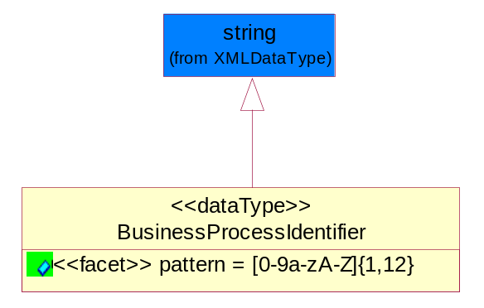
Figure ‎5-55 BusinessProcessIdentifier

Attribute | Type | Documentation
pattern |  | [0-9a-zA-Z]{1,12}

BusinessServiceInformation
The object allows the specification of the business service utilized within the partner company. This may or may not be the same as the information sent by the RNIF.
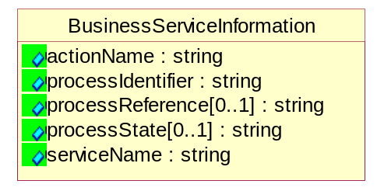
Figure ‎5-56 BusinessServiceInformation

Attribute | Type | Documentation
actionName | string | The name of Action. For RosettaNet usually any of Request/Confirm/Notify/Query/Response.
processIdentifier | string | The name of the PIP e.g. Notify of Forecast Reply.
processReference[0..1] | string | The URN for the PIP that includes Cluster/Segment/Process pattern used to identify the interface process (such as PIP3A4)
processState[0..1] | string | The business process (or service) state of the sender of a document. When a service receives this document, the receiver may use the state as a precondition.
serviceName | string | The name of the Business Activity with the "Request/Confirm" part removed. E.g., for the Activity "Request Purchase Order"==> "Purchase Order".

ContractInformation
A block of information used to correlate a contract in an executing choreography.
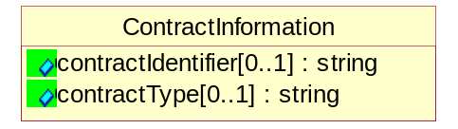
Figure ‎5-57 ContractInformation

Attribute | Type | Documentation
contractIdentifier[0..1] | string | Unique identification of a contract between the Sender and the Receiver
contractType[0..1] | string | The type of the contract: an attribute describing the type of the ContractIndentification. Valid values are URI, URN,ebXMLCPA, or other values defined by partners.

CorrelationInformation
A block of information used to correlate a requesting document to a responding document and to the contract in an executing choreography.
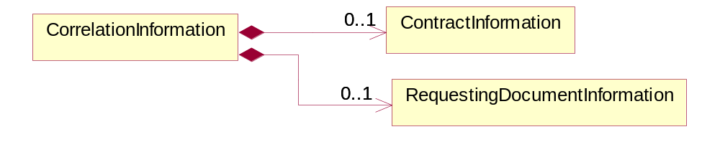
Figure ‎5-58 CorrelationInformation

Composition | Cardinality | Type | Documentation
ContractInformation | 0..1 | ContractInformation | A block of information used to correlate a contract in an executing choreography.
RequestingDocumentInformation | 0..1 | RequestingDocumentInformation | A block of information used to correlate a requesting document to a responding document in an executing choreography.

DocumentHeader
The object allows for the identification of the sender and receiver of the business document.
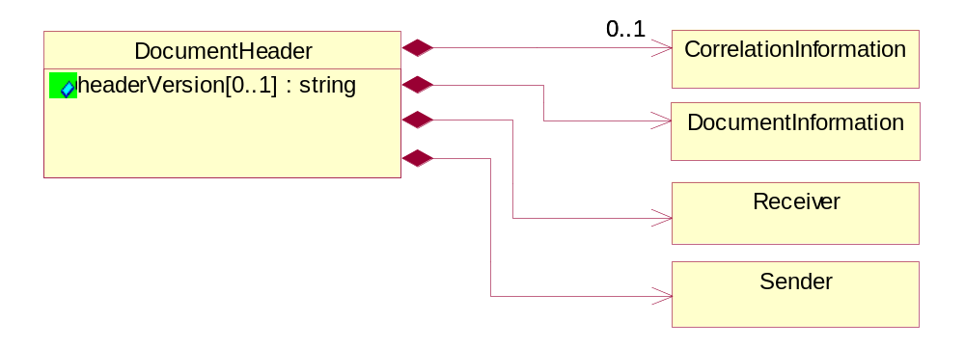
Figure ‎5-59 DocumentHeader

Attribute | Type | Documentation
headerVersion[0..1] | string | The UN/CEFACT version of the document header.

Composition | Cardinality | Type | Documentation
CorrelationInformation | 0..1 | CorrelationInformation | A block of information used to correlate a requesting document to a responding document and to the contract in an executing choreography.
DocumentInformation | 1 | DocumentInformation | The object specifies information to identify the business document, a summary of attachments, and information about the business document security.
Receiver | 1 | Receiver | The object allows the identification of the receiving party of the business message.
Sender | 1 | Sender | The object allows the identification of the initiating party of the business message.

DocumentIdentification
The object specifies all information necessary to identify the business document.
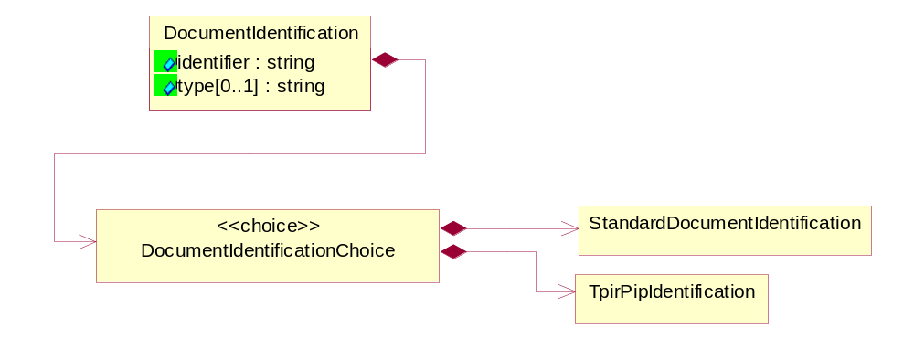
Figure ‎5-60 DocumentIdentification

Attribute | Type | Documentation
identifier | string | The unique identifier for the document being sent.
type[0..1] | string | Name of the Action Message

Composition | Cardinality | Type | Documentation
DocumentIdentificationChoice | 1 | DocumentIdentificationChoice

DocumentIdentificationChoice

Composition | Cardinality | Type | Documentation
StandardDocumentIdentification | 1 | StandardDocumentIdentification | The object specifies additional information necessary to identify the standard business document.
TpirPipIdentification | 1 | TpirPipIdentification | The object specifies all information necessary to uniquely identify a TPIR-PIP within a Registry or trading partner repository.

DocumentInformation
The object specifies information to identify the business document, a summary of attachments, and information about the business document security.
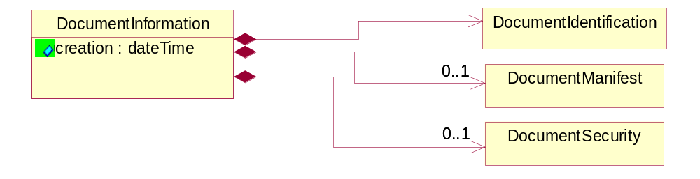
Figure ‎5-61 DocumentInformation

Attribute | Type | Documentation
creation | dateTime | The creation date and time of the specified Business Document (i.e. the Purchase Order date).

Composition | Cardinality | Type | Documentation
DocumentIdentification | 1 | DocumentIdentification | The object specifies all information necessary to identify the business document.
DocumentManifest | 0..1 | DocumentManifest | The block provides a brief summary of attachments and Service Content.
DocumentSecurity | 0..1 | DocumentSecurity | The object provides additional granularity in specifying business document security (this is in addition to the specified PIP security).

DocumentManifest
The block provides a brief summary of attachments and Service Content.
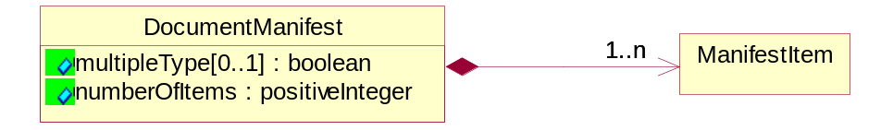
Figure ‎5-62 DocumentManifest

Attribute | Type | Documentation
multipleType[0..1] | boolean | Indicates whether the manifest contains documents of multiple types. True if yes, and False if no.
numberOfItems | positiveInteger | Total number of documents in the message. The physical count of the attachments in the payload plus the RosettaNet Business Message (for Service Content). The value of this field will be at least 1.

Composition | Cardinality | Type | Documentation
ManifestItem | 1..n | ManifestItem | The object provides details about the specific attachment(s).

DocumentSecurity
The object provides additional granularity in specifying business document security (this is in addition to the specified PIP security).
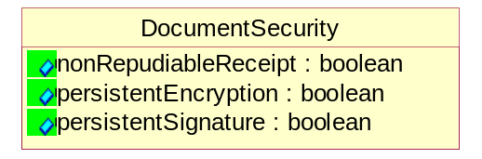
Figure ‎5-63 DocumentSecurity

Attribute | Type | Documentation
nonRepudiableReceipt | boolean | The value "true" will indicate that a signed acknowledgement for the business document is necessary.
persistentEncryption | boolean | The value "true" will indicate that the Business Document (including the header) needs to be encrypted when stored or transported.
persistentSignature | boolean | The value "true" will indicate that a signature is required to be stored with the document while stored or transported.

ManifestItem
The object provides details about the specific attachment(s).
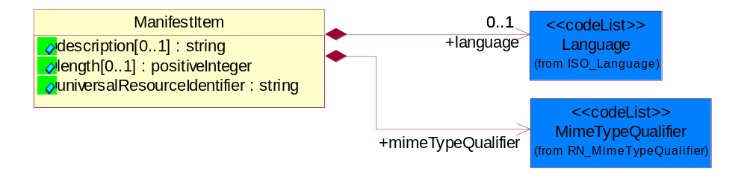
Figure ‎5-64 ManifestItem

Attribute | Type | Documentation
description[0..1] | string | A description of the attachment.
length[0..1] | positiveInteger | The size of the attachment in bytes (i.e. 1 000 000 bytes)
universalResourceIdentifier | string | The generic set of all names/addresses that are short strings that refer to resources.

Composition | Cardinality | Type | Documentation
language | 0..1 | Language | For representation of Language name RosettaNet has adopted ISO 639-2; 1998. Refer to the following web page to get the latest version of the standard:  http://www.loc.gov/standards/iso639-2/iso639jac.html  If you need more information about the ISO standard please contact ISO for more details.
mimeTypeQualifier | 1 | MimeTypeQualifier | The MIME type as defined by IANA.  Please refer to http://www.iana.org/assignments/media-types/ for a list of types.

PipIdentifier
PIP Identification.[ i.e. PIP3A4]
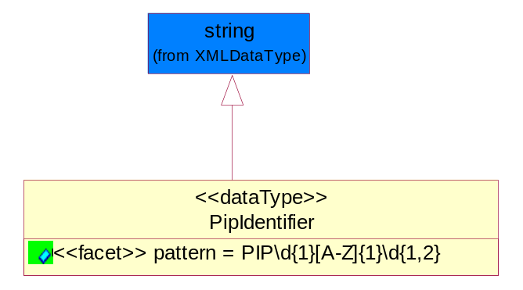
Figure ‎5-65 PipIdentifier

Attribute | Type | Documentation
pattern |  | PIP\d{1}[A-Z]{1}\d{1,2}

PipVersion
PIP version number (i.e. 02.02.00).
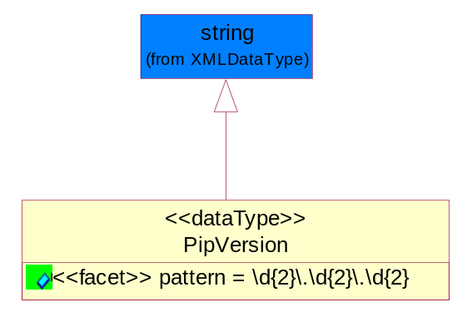
Figure ‎5-66 PipVersion

Attribute | Type | Documentation
pattern |  | \d{2}\.\d{2}\.\d{2}

Receiver
The object allows the identification of the receiving party of the business message.
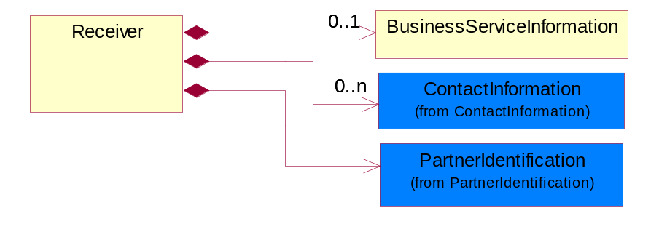
Figure ‎5-67 Receiver

Composition | Cardinality | Type | Documentation
BusinessServiceInformation | 0..1 | BusinessServiceInformation | The object allows the specification of the business service utilized within the partner company. This may or may not be the same as the information sent by the RNIF.
ContactInformation | 0..n | ContactInformation | The business document must allow for the identification of the name of the department, service or individual to be contacted regarding the context of the business document.
PartnerIdentification | 1 | PartnerIdentification | The business document must allow for the identity of one or more parties to the transaction.

RequestingDocumentInformation
A block of information used to correlate a requesting document to a responding document in an executing choreography.
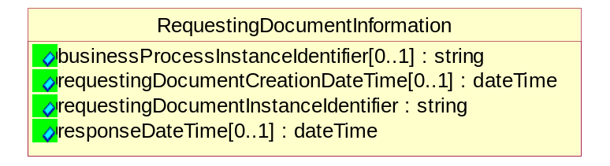
Figure ‎5-68 RequestingDocumentInformation
Attribute | Type | Documentation
businessProcessInstanceIdentifier[0..1] | string | The identifier for the public business process instance being sent that both the sender and receiver can identify.
requestingDocumentCreationDateTime[0..1] | dateTime | The date-time of the requesting business document.
requestingDocumentInstanceIdentifier | string | The Business Document identification number that identifies the requesting Business Document.
responseDateTime[0..1] | dateTime | The expected time to receive the response. This can not be greater than the PIP TimeToPerform.

Sender
The object allows the identification of the initiating party of the business message.
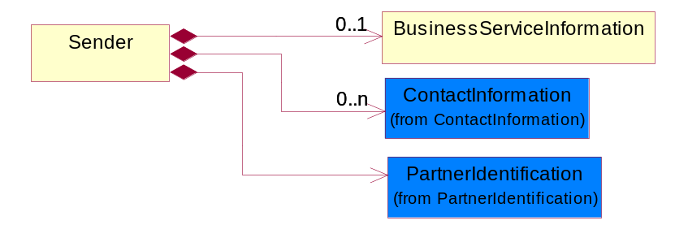
Figure ‎5-69 Sender

Composition | Cardinality | Type | Documentation
BusinessServiceInformation | 0..1 | BusinessServiceInformation | The object allows the specification of the business service utilized within the partner company. This may or may not be the same as the information sent by the RNIF.
ContactInformation | 0..n | ContactInformation | The business document must allow for the identification of the name of the department, service or individual to be contacted regarding the context of the business document.
PartnerIdentification | 1 | PartnerIdentification | The business document must allow for the identity of one or more parties to the transaction.

StandardDocumentIdentification
The object specifies additional information necessary to identify the standard business document.
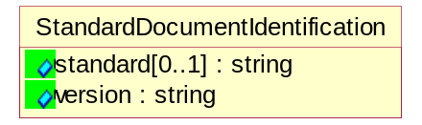
Figure ‎5-70 StandardDocumentIdentification

Attribute | Type | Documentation
standard[0..1] | string | Identifies the standard used to submit the business document. (e.g. RosettaNet).
version | string | PIP3A4v01.00

TpirPipIdentification
The object specifies all information necessary to uniquely identify a TPIR-PIP within a Registry or trading partner repository.
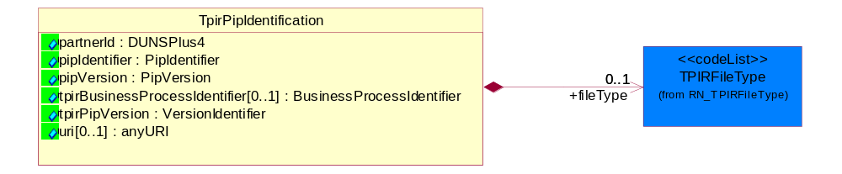
Figure ‎5-71 TpirPipIdentification

Attribute | Type | Documentation
partnerId | DUNSPlus4 | The Trading Partner Identification of MNC that is creating this TPIR PIP.
pipIdentifier | PipIdentifier | A TPIR PIP Identification [i.e., 3A4 ).
pipVersion | PipVersion | A TPIR PIP version number (i.e., 02.02.00)
tpirBusinessProcessIdentifier[0..1] | BusinessProcessIdentifier | A Business Process Identifier to uniquely define the TPIR-PIP 'role' within a Business Scenario at a company or MNC level. The identifier MUST be composed of alphanumeric characters only and its length MUST be between one and twelve characters.
tpirPipVersion | VersionIdentifier | A TPIR-PIP Version Number (i.e., major and minor version number as XX.XX).
uri[0..1] | anyURI | Describes the destination uri for the TPIR form.

Composition | Cardinality | Type | Documentation
fileType | 0..1 | TPIRFileType | Describes the file type of the TPIR form (PDF, XDP or XML).

VersionIdentifier
Version Number (i.e., major and minor version number as XX.XX).
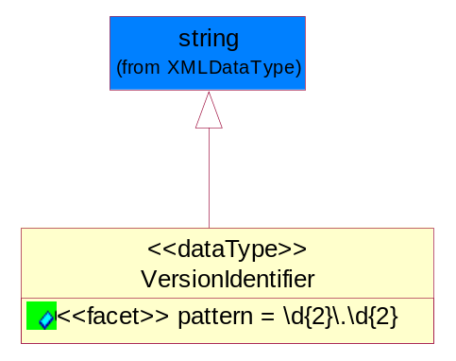
Figure ‎5-72 VersionIdentifier

Attribute | Type | Documentation
pattern |  | \d{2}\.\d{2}

CodeList

TPIRFileType
A code identifying the file type of TPIR form.

Name | Documentation
PDF | Portable Document Format.
XDP | XML Data Package.
XML | eXtensible Markup Language.

XML Data Type

anyURI
Represents a URI as defined by RFC 2396. An anyURI value can be absolute or relative, and may have an optional fragment identifier.

boolean
Represents Boolean values, which are either "true" or "false".

date
For the represents a calendar date.
The pattern for a date is CCYY-MM-DD where CC represents the century, YY the year, MM the month, and DD the day, with an optional time zone indicator as allowed for dateTime.

dateTime
Represents a specific instance of time.
The pattern for dateTime is CCYY-MM-DDThh:mm:ss where CC represents the century, YY the year, MM the month, and DD the day, preceded by an optional leading negative (-) character to indicate a negative number. If the negative character is omitted, positive (+) is assumed. The T is the date/time separator and hh, mm, and ss represent hour, minute, and second respectively. Additional digits can be used to increase the precision of fractional seconds if desired. For example, the format ss.ss... with any number of digits after the decimal point is supported. The fractional seconds part is optional.
This representation may be immediately followed by a "Z" to indicate Coordinated Universal Time (UTC) or to indicate the time zone. For example, the difference between the local time and Coordinated Universal Time, immediately followed by a sign, + or -, followed by the difference from UTC represented as hh:mm (minutes is required). If the time zone is included, both hours and minutes must be present.

float
Represents single-precision 32-bit floating-point numbers.

integer
Represents a sequence of decimal digits with an optional leading sign (+ or -). This data type is derived from decimal.

positiveInteger
Represents an integer that is greater than zero. This data type is derived from nonNegativeInteger.

string
Represents character string.

