

Description of
Partner Interface Process® for 3B13

Validated 11.00.00

Specification Information
Name | Notify Of Shipping Order Confirmation
Cluster | Order Management
Segment | Transportation and Distribution
Publication Date | 18 July 2008
Version Identifier | V11.00

Table of Contents
1 Document Management 4
1.1 Legal Disclaimer 4
1.2 Copyright 4
1.3 Trademarks 4
1.4 Acknowledgments 4
1.5 Related Documents 5
1.6 Document Version History 5
1.7 Document Structure 5
2 Business Process 6
2.1 Business Process Definition 6
2.1.1 Business Process Description 6
2.2 PIP Business Document 8
2.3 PIP Business Process Flow Diagram 8
2.4 PIP Start State 8
2.5 PIP End States 9
2.6 Partner Role Descriptions 9
2.7 Business Process Activity Controls 9
3 Network and Implementation Specification 11
3.1 Business Action and Business Signal Specifications 11
3.2 Business Transaction Dialog Specification 11
3.2.1 Message Exchange Controls 12
3.2.2 Communications Specification 12

List of Figures:
Figure 1: Typical Choreography of Third-Party Logistics PIPs 7
Figure 2: Activity Diagram of Notify Of Shipping Order Confirmation 8
Figure 3: Sequence Diagram of Notify Of Shipping Order Confirmation 11

List of Tables:
Table 1: PIP Business Document 8
Table 2: PIP Start State 8
Table 3: PIP End State 9
Table 4: PIP Failure State 9
Table 5: Partner Role Description 9
Table 6: Business Activity Description 9
Table 7: Business Activity Performance Control 10
Table 8: Network Component Specification 11
Table 9: Business Action – Business Document Mapping 11
Table 10: Message Exchange Control 12
Table 11: Dialog: Service-Service 12

Document Management

Legal Disclaimer
RosettaNet™, its members, officers, directors, employees, or agents shall not be liable for any injury, loss, damages, financial or otherwise, arising from, related to, or caused by the use of this document or the specifications herein, as well as associated guidelines and schemas. The use of said specifications shall constitute your express consent to the foregoing exculpation.

Copyright
©2008 RosettaNet. All rights reserved. No part of this publication may be reproduced, stored in a retrieval system, or transmitted, in any form or by any means, electronic, mechanical, photocopying, recording, or otherwise, without the prior written permission of the publisher. Printed in the United States of America.

Trademarks
RosettaNet, Partner Interface Process, PIP and the RosettaNet logo are trademarks or registered trademarks of "RosettaNet," a non-profit organization. All other product names and company logos mentioned herein are the trademarks of their respective owners. In the best effort, all terms mentioned in this document that are known to be trademarks or registered trademarks have been appropriately recognized in the first occurrence of the term.

Acknowledgments
This document has been prepared by RosettaNet (http://www.rosettanet.org/) from requirements gathered during the Milestone Program and in conformance with the methodology.
APL Logisitics | FEDEX CORPORATE SERVICES
Cisco Systems | HP
DHL | Intel
Ericsson | Motorola
Exel

Related Documents
- Associated PIP Message Schemas (included within the PIP Specification package only)
- Description of 3B13 Message
- Messages Structure
- XML instance of ebXML BPSS for PIP 3B13

Document Version History
Version | Date | Description
Validated 11.00.00 | 18 July 2008 | Validated Version : RosettaNet Schema to Market to Validation 2008

Document Structure
A Partner Interface Process (PIP) Specification is comprised of the following two parts:
- Business Process. Captures the semantics of the business process and the flow of the message exchange between roles as they perform business activities.
- Network and Implementation Specification. Specifies the network protocol message formats and communications requirements between peer-protocols supported by network components in the RosettaNet Implementation Framework.

Business Process

Business Process Definition
This PIP is designed to enable a third-party logistics provider to confirm that a requested shipment has been sent on behalf of a manufacturer or distributor that uses outsourced logistics operations.

Business Process Description
All businesses that sell products existing as physical goods, such as raw materials, components and finished goods, must deliver them from their manufacturing or storage location to the customer’s location. This physical movement of products may involve several parties. The first party to the shipment is usually the seller, which initiates the shipping of the products. The second party is usually the buyer, as the consignee to which the products are shipped. Additionally, there may be third-party logistics (3PL) and even fourth-party logistics (4PL) providers, offering services to the shipper such as outsourced light manufacturing, product warehousing, routing and tracking, in addition to physically transporting the products.
The "Description of Partner Interface Process for 3B13" Partner Interface Process™ (PIP) supports a process between two of these parties, in which a Shipping Provider notifies a Shipper that a previously authorized shipment has been dispatched. The Shipper is the organization responsible for the supply of products to its customers, i.e. the first party described above. The Shipping Provider is a third-party that performs the shipping logistics on behalf of the Shipping Provider.
Figure 3-1 illustrates a typical context for PIP 3B13.
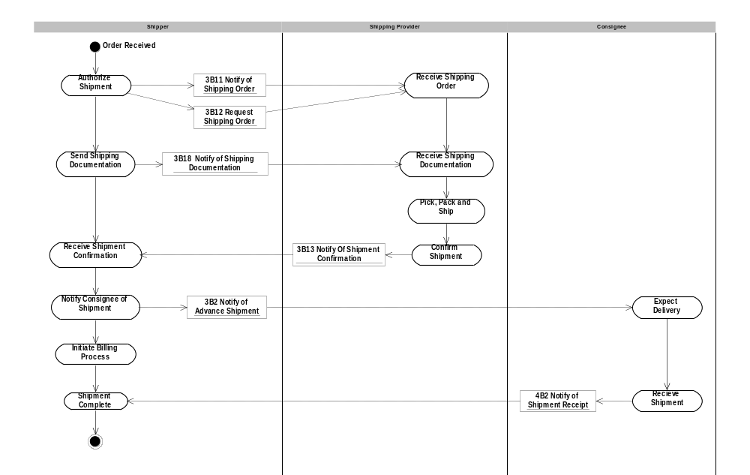
Figure 1: Typical Choreography of Third-Party Logistics PIPs
The Shipper authorizes a Shipping Provider to ship products from one location to another by sending a shipping order using either PIP 3B11 “Notify Of Shipping Order” or PIP 3B12 “Request Shipping Order”. Subsequently, the Shipping Provider uses PIP 3B13 to confirm that the shipment has been sent.
Depending on the Trading Partner Agreement between the Shipper and the Shipping Provider, the Shipping Provider may be authorized to make a partial shipment if insufficient stock is on hand to complete the order. Similarly, the Shipping Provider may be authorized to make multiple partial shipments until the order has been completed, in which case multiple PIP 3B13 messages will be sent. Note that PIP 3B13 is not intended to be used to synchronize inventory information; a separate process should be used to limit the occurrence of partial shipments.
The Shipper may use the information received in PIP 3B13 to trigger the invoicing process.
Also on receipt of PIP 3B13, the Shipper may send PIP 3B2 “Notify Of Advance Shipment” to the customer. PIP 3B13 provides inventory information, such as lot quantity, assembly date and serial numbers, that is required for inclusion in PIP 3B2 “Notify Of Advance Shipment”, allowing the customer to match the received products and enabling payment to the Shipper.
Should this transaction not complete successfully, the requesting partner executes PIP0A1, "Notification Of Failure”.

PIP Business Document
Business Document are generated and exchanged by roles performing activities in this PIP. Business Document is listed and defined in Table 1.
Table 1: PIP Business Document
Business Document | Description
Shipping Order Confirmation Notification | Contains information confirming the shipment of a product or products.

PIP Business Process Flow Diagram
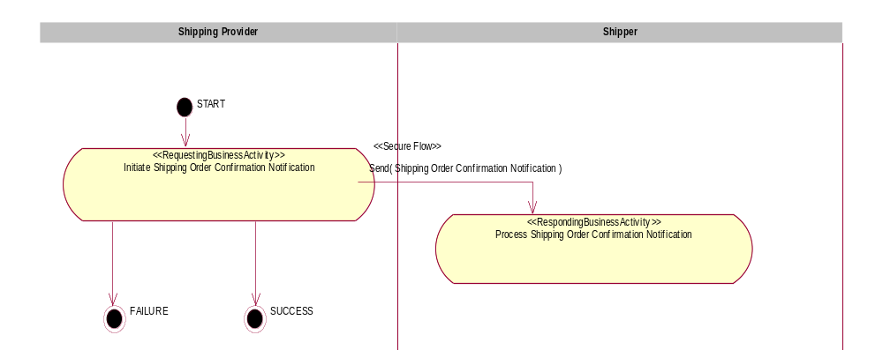
Figure 2: Activity Diagram of Notify Of Shipping Order Confirmation

PIP Start State
The start state is comprised of the following conditions:
Table 2: PIP Start State
 | Approved | Exist |  | Valid | Non-Repudiated | Retry Count | Authorized
 | Approved | Party | In Backend System
TPA |  |  | 
Sending Partner |  |  |  | 
Receiving Partner |  | 
Business Document |  |  |  |  |  |  | 

PIP End States
The end state is comprised of the following conditions:
Table 3: PIP End State
 | Approved | Exist |  | Valid | Non-Repudiated | Retry Count | Authorized
 | Approved | Party | In Backend system
Acknowledgment of Receipt |  |  |  |  | 
Receiving Partner |  |  |  |  |  |  | 
The PIP failure state is comprised of one or more of the following conditions:
Table 4: PIP Failure State
 | NO | Exceeded
Success | 
Retry Count |  | 

Partner Role Descriptions
Table 5 describes the partner roles in this PIP.
Table 5: Partner Role Description
Role Name | Role Description
Shipping Provider | The organization responsible for performing the shipping logistics for the Shipper. The Shipping Provider ships products from one location to another as requested by the shipping order and informs the Shipper when the shipment has been sent.
Shipper | The organization responsible for authorizing a Shipping Provider to ship products from one location to another.

Business Process Activity Controls
Table 6 describes the interaction between roles performing business activity in this PIP.
Table 6: Business Activity Description
Role  Name | Activity Name | Activity Description
Shipping Provider | Initiate Shipping Order Confirmation Notification | A Shipping Provider sends a Shipping Order Confirmation Notification business document to a Shipper.

Table 7 details the security, audit and process controls relating to activity performed in the PIP.
Table 7: Business Activity Performance Control
Role  Name | Activity  Name | Acknowledgment  of Receipt |  | Time to Perform | Retry Count | Is Authorization Required? | Non-Repudiation of Origin and Content?
Role  Name | Activity  Name | Non-Repudiation Required? | Time to Acknowledge
Shipping Provider | Initiate Shipping Order Confirmation Notification | Y | 2 hrs | N/A | 3 | Y | Y

Network and Implementation Specification
Each network component maps into a role of the PIP model. Table 8 specifies the mapping between roles and network components.
Table 8: Network Component Specification
Network Component | Classification | Maps to Role in Business Process
Shipping Provider Service | Business Service | Shipping Provider
Shipper Service | Business Service | Shipper

Business Action and Business Signal Specifications
Each business action maps to a Business Document of the PIP model. Table 9 specifies the mapping between Business Documents and business actions.
Table 9: Business Action – Business Document Mapping
Business Action | Business Document | Document Function
Shipping Order Confirmation Notification Action | Shipping Order Confirmation Notification | Request

Business Transaction Dialog Specification
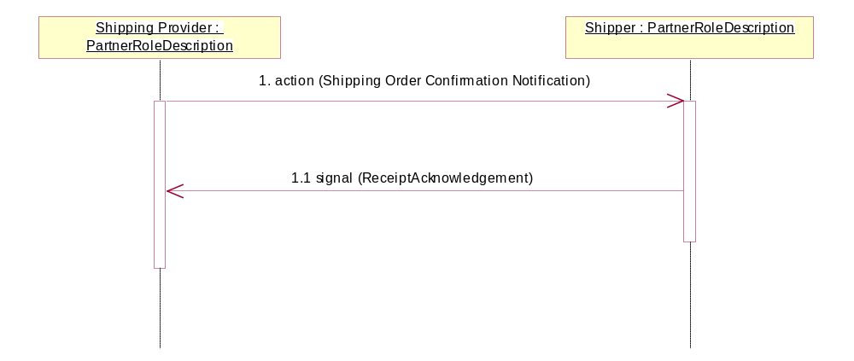
Figure 3: Sequence Diagram of Notify Of Shipping Order Confirmation

Message Exchange Controls
Table 10: Message Exchange Control
# | Name |  | Time to Acknowledge Receipt Signal |  | Time to Respond to Action |  | Included in Time to Perform |  | Is Authorization Required? |  | Is Non-Repudiation Required? |  | Is Secure Transport Required?
1. |  | Shipping Order Confirmation Notification Action |  | 2 hrs |  | N/A |  | N/A |  | Y |  | Y |  | Y
1.1. |  | Receipt Acknowledgment |  | N/A |  | N/A |  | N/A |  | Y |  | Y |  | Y

Communications Specification
Table 11: Dialog: Service-Service
# | Business Message | Digital Signature Required? | SSL Required?
1. | Shipping Order Confirmation Notification | Y | Y
1.1. | Receipt Acknowledgment | Y | Y

