

Description of 3B14 Message

PIP® 3B14
Validated 11.00.01

Specification Information
Name | Description of 3B14 Message
PIP | Request Shipping Order Cancellation
Cluster | Order Management
Segment | Transportation and Distribution
Publication Date | 05 June 2007
Version Identifier | V11.00

Table of Content

1. Document Management 6
1.1 Legal Disclaimer 6
1.2 Copyright 6
1.3 Trademarks 6
1.4 Acknowledgments 6
1.5 Related Documents 6
1.6 Document Version History 6
1.7 Document Purpose 7
2. Interchange Model 8
2.1 ShippingOrderCancellationRequest 8
2.1.1 Interchange Diagram 8
2.1.2 Dependency Diagram 8
2.1.3 RequestingOrderInformation 9
2.1.4 ShippingOrder 9
2.1.5 ShippingOrderCancellationRequest 10
2.2 ShippingOrderCancellationConfirmation 11
2.2.1 Interchange Diagram 11
2.2.2 Dependency Diagram 11
2.2.3 CancellationConfirmation 12
2.2.4 RequestingOrderInformation 12
2.2.5 ShippingOrderCancellation 13
2.2.6 ShippingOrderCancellationConfirmation 14
3. Domain Model 15
3.1 Procurement 15
3.1.1 Procurement 15
3.1.1.1 Dependency Diagram 15
3.1.2 CodeList 15
3.1.2.1 OrderAdmin 15
3.2 Logistics 16
3.2.1 Logistics 16
3.2.1.1 Dependency Diagram 16
3.2.1.2 OrderInformation 16
3.2.2 CodeList 17
3.2.2.1 ShippingOrderCancellationReasonType 17
3.2.2.2 ShippingOrderCancellationStatus 17
3.3 Shared 18
3.3.1 Shared 18
3.3.1.1 Dependency Diagram 18
4. Universal Structure 19
4.1 ContactInformation 19
4.1.1 ContactInformation 19
4.2 DataType 20
4.2.1 Contact 20
4.2.2 DUNS 20
4.2.3 DUNSPlus4 21
4.2.4 GLN 21
4.3 Dates 22
4.4 Document 22
4.4.1 BusinessDocumentReference 22
4.5 Locations 23
4.5.1 AlternativeIdentifier 23
4.5.2 Location 23
4.5.3 LocationChoice 24
4.5.4 PhysicalAddress 24
4.6 MonetaryExpression 26
4.6.1 FinancialAmount 26
4.7 PartnerIdentification 27
4.7.1 PartnerIdentification 27
4.7.2 PartnerIdentificationChoice 28
4.7.3 SpecifiedFullPartner 28
4.7.4 SpecifiedIntermittentPartner 29
4.7.5 SpecifiedKnownPartner 30
4.7.6 SpecifiedKnownPartnerContact 30
4.7.7 SpecifiedNewPartner 31
4.7.8 SpecifiedPartnerDescription 32
4.7.9 SpecifiedPartnerDescriptionChoice 32
4.8 CodeList 34
4.8.1 Country 34
4.8.2 CountrySubdivision 34
4.8.3 Currency 34
4.8.4 Language 34
4.8.5 DocumentType 34
4.8.6 MimeTypeQualifier 36
5. System Structure 47
5.1 BusinessProcessIdentifier 47
5.2 BusinessServiceInformation 47
5.3 ContractInformation 48
5.4 CorrelationInformation 48
5.5 DocumentHeader 49
5.6 DocumentIdentification 50
5.7 DocumentIdentificationChoice 50
5.8 DocumentInformation 51
5.9 DocumentManifest 51
5.10 DocumentSecurity 52
5.11 ManifestItem 53
5.12 PipIdentifier 54
5.13 PipVersion 54
5.14 Receiver 55
5.15 RequestingDocumentInformation 55
5.16 Sender 56
5.17 StandardDocumentIdentification 57
5.18 TpirPipIdentification 57
5.19 VersionIdentifier 58
5.20 CodeList 58
5.20.1 TPIRFileType 58
6. XML Data Type 59
6.1 anyURI 59
6.2 boolean 59
6.3 dateTime 59
6.4 float 59
6.5 integer 59
6.6 positiveInteger 59
6.7 string 59

Table of Figures

Figure ‎2-1 Interchange 8
Figure ‎2-2 Dependency 8
Figure ‎2-3 RequestingOrderInformation 9
Figure ‎2-4 ShippingOrder 9
Figure ‎2-5 ShippingOrderCancellationRequest 10
Figure ‎2-6 Interchange 11
Figure ‎2-7 Dependency 11
Figure ‎2-8 CancellationConfirmation 12
Figure ‎2-9 RequestingOrderInformation 12
Figure ‎2-10 ShippingOrderCancellation 13
Figure ‎2-11 ShippingOrderCancellationConfirmation 14
Figure ‎3-1 Dependency 15
Figure ‎3-2 Dependency 16
Figure ‎3-3 OrderInformation 16
Figure ‎3-4 Dependency 18
Figure ‎4-1 ContactInformation 19
Figure ‎4-2 Contact 20
Figure ‎4-3 DUNS 20
Figure ‎4-4 DUNSPlus4 21
Figure ‎4-5 GLN 21
Figure ‎4-6 BusinessDocumentReference 22
Figure ‎4-7 AlternativeIdentifier 23
Figure ‎4-8 Location 23
Figure ‎4-9 PhysicalAddress 24
Figure ‎4-10 FinancialAmount 26
Figure ‎4-11 PartnerIdentification 27
Figure ‎4-12 SpecifiedFullPartner 28
Figure ‎4-13 SpecifiedIntermittentPartner 29
Figure ‎4-14 SpecifiedKnownPartner 30
Figure ‎4-15 SpecifiedKnownPartnerContact 30
Figure ‎4-16 SpecifiedNewPartner 31
Figure ‎4-17 SpecifiedPartnerDescription 32
Figure ‎5-1 BusinessProcessIdentifier 47
Figure ‎5-2 BusinessServiceInformation 47
Figure ‎5-3 ContractInformation 48
Figure ‎5-4 CorrelationInformation 48
Figure ‎5-5 DocumentHeader 49
Figure ‎5-6 DocumentIdentification 50
Figure ‎5-7 DocumentInformation 51
Figure ‎5-8 DocumentManifest 51
Figure ‎5-9 DocumentSecurity 52
Figure ‎5-10 ManifestItem 53
Figure ‎5-11 PipIdentifier 54
Figure ‎5-12 PipVersion 54
Figure ‎5-13 Receiver 55
Figure ‎5-14 RequestingDocumentInformation 55
Figure ‎5-15 Sender 56
Figure ‎5-16 StandardDocumentIdentification 57
Figure ‎5-17 TpirPipIdentification 57
Figure ‎5-18 VersionIdentifier 58

Document Management

Legal Disclaimer
RosettaNet, its members, officers, directors, employees, or agents shall not be liable for any injury, loss, damages, financial or otherwise, arising from, related to, or caused by the use of this document or the specifications herein, as well as associated guidelines and schemas. The use of said specifications shall constitute your express consent to the foregoing exculpation.

Copyright
©2007 RosettaNet. All rights reserved. No part of this publication may be reproduced, stored in a retrieval system, or transmitted, in any form or by any means, electronic, mechanical, photocopying, recording, or otherwise, without the inclusion of this copyright notice. Any derivative works must cite the copyright notice. Any public redistribution or sale of this publication or derivative works requires prior written permission of the publisher.

Trademarks
RosettaNet, Partner Interface Process, PIP and the RosettaNet logo are trademarks or registered trademarks of "RosettaNet," a non-profit organization. All other product names and company logos mentioned herein are the trademarks of their respective owners. In the best effort, all terms mentioned in this document that are known to be trademarks or registered trademarks have been appropriately recognized in the first occurrence of the term.

Acknowledgments
This document has been prepared by RosettaNet (http://www.rosettanet.org/) from requirements gathered during the Milestone Program and in conformance with the methodology. Listed below are the legal entities that contributed to the design and development of this PIP.

Related Documents
- Associated PIP Message Schemas (included with PIP Specification only)
- Description of Partner Interface Process for 3B14
- Message Structure

Document Version History
Version | Date | Description
Validated 11.00.00 | 14 July 2006 | Validated Version
Validated 11.00.01 | 05 June 2007 | Corrected missing references in document: Description Of Partner Interface Process For 3B14

Document Purpose
The purpose of the document is to explain the structure, the association between objects, the content of objects and the definition for single elements to a non-technical audience.

Interchange Model

ShippingOrderCancellationRequest

Interchange Diagram
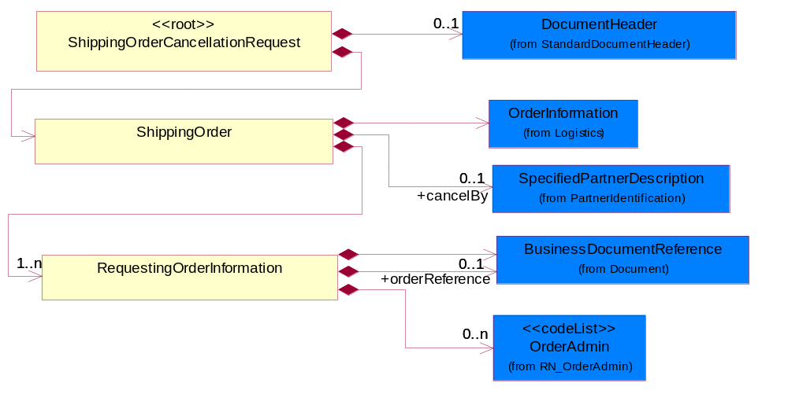
Figure ‎2-1 Interchange

Dependency Diagram
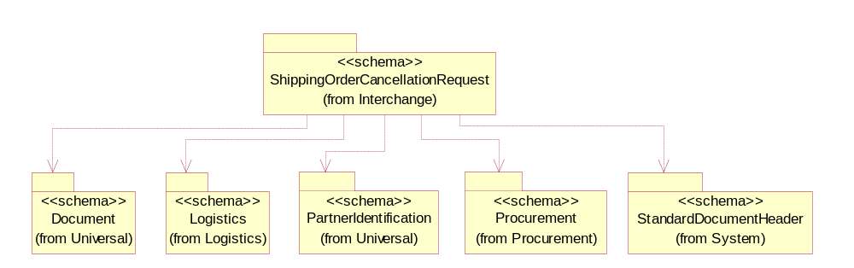
Figure ‎2-2 Dependency

RequestingOrderInformation
The collection of business properties that identifies an order of another type that caused this shipping order to be created.

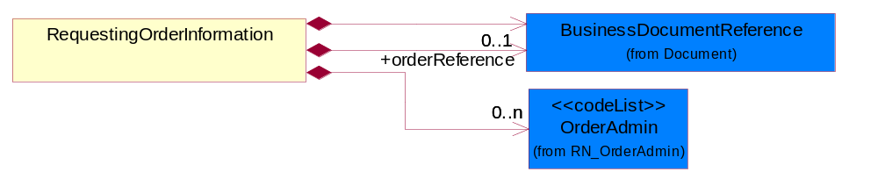
Figure ‎2-3 RequestingOrderInformation

Composition | Cardinality | Type | Documentation
orderReference | 0..1 | BusinessDocumentReference | An additional reference number to identify a single shipment when there are multiple shipments resulting from a single requesting order.
OrderAdmin | 0..n | OrderAdmin | Additional administrative code identifying the reason the shipping order is being sent, possibly indicating a predefined workflow.
BusinessDocumentReference | 1 | BusinessDocumentReference | The business document reference object allows for the indirect referencing of a relationship to other business related documents.

ShippingOrder
The collection of business properties that describes an order to ship products from one location to another.

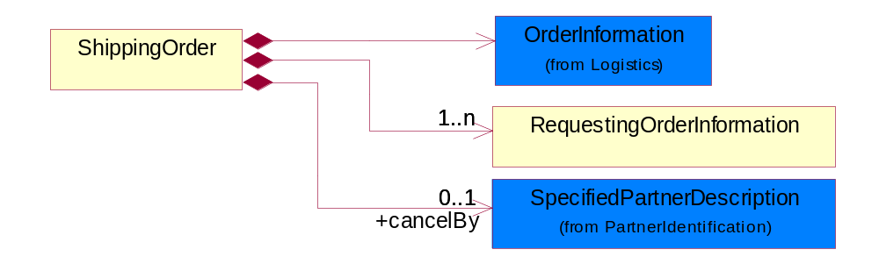
Figure ‎2-4 ShippingOrder

Composition | Cardinality | Type | Documentation
RequestingOrderInformation | 1..n | RequestingOrderInformation | The collection of business properties that identifies an order of another type that caused this shipping order to be created.
cancelBy | 0..1 | SpecifiedPartnerDescription | The party who is cancelling the shipping order.
OrderInformation | 1 | OrderInformation | The collection of business properties that identifies a shipping order, including its identity, type and purpose.

ShippingOrderCancellationRequest
Top level object for a Shipping Order Cancellation Request document.
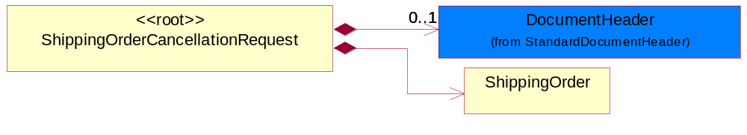
Figure ‎2-5 ShippingOrderCancellationRequest

Composition | Cardinality | Type | Documentation
DocumentHeader | 0..1 | DocumentHeader | The object allows for the identification of the sender and receiver of the business document.
ShippingOrder | 1 | ShippingOrder | The collection of business properties that describes an order to ship products from one location to another.

ShippingOrderCancellationConfirmation

Interchange Diagram
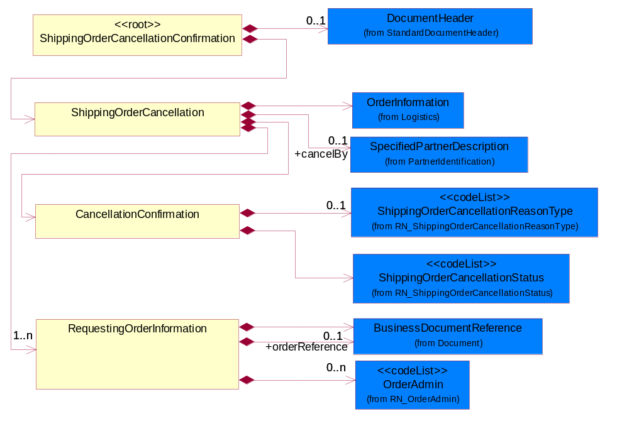
Figure ‎2-6 Interchange

Dependency Diagram
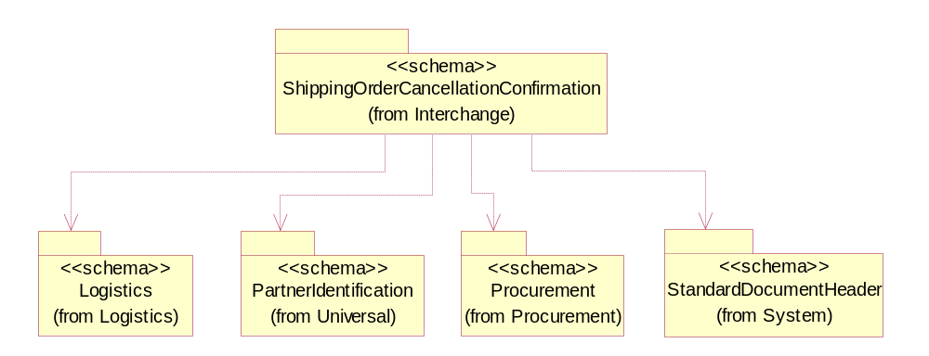
Figure ‎2-7 Dependency

CancellationConfirmation
The collection of business properties that describes the confirmation or rejection of a shipping order cancellation.

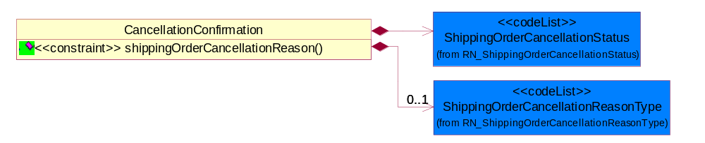
Figure ‎2-8 CancellationConfirmation

Composition | Cardinality | Type | Documentation
ShippingOrderCancellationStatus | 1 | ShippingOrderCancellationStatus | Code identifying the confirmation status of a shipping order cancellation.
ShippingOrderCancellationReasonType | 0..1 | ShippingOrderCancellationReasonType | Code identifying the reason for the rejection of a shipping order cancellation.

Constraint | Documentation
shippingOrderCancellationReason | If value of "dsocs:ShippingOrderCancellationStatus" is equal to 'REJ' then the occurence of "dsocrt:ShippingOrderCancellationReasonType" has to be 1

RequestingOrderInformation
The collection of business properties that identifies an order of another type that caused this shipping order to be created.

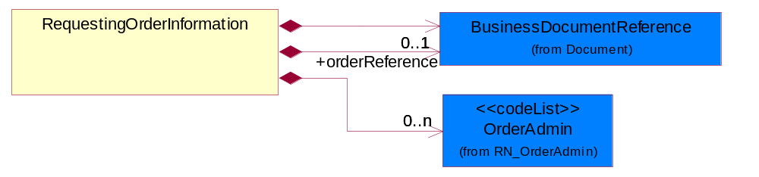
Figure ‎2-9 RequestingOrderInformation

Composition | Cardinality | Type | Documentation
BusinessDocumentReference | 1 | BusinessDocumentReference | The business document reference object allows for the indirect referencing of a relationship to other business related documents.
orderReference | 0..1 | BusinessDocumentReference | An additional reference number to identify a single shipment when there are multiple shipments resulting from a single requesting order.
OrderAdmin | 0..n | OrderAdmin | Additional administrative code identifying the reason the shipping order is being sent, possibly indicating a predefined workflow.

ShippingOrderCancellation
The collection of business properties that describes the cancellation of a shipping order.

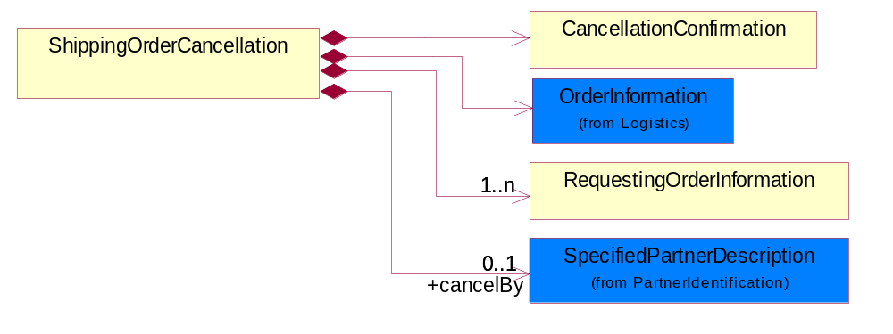
Figure ‎2-10 ShippingOrderCancellation

Composition | Cardinality | Type | Documentation
CancellationConfirmation | 1 | CancellationConfirmation | The collection of business properties that describes the confirmation or rejection of a shipping order cancellation.
RequestingOrderInformation | 1..n | RequestingOrderInformation | The collection of business properties that identifies an order of another type that caused this shipping order to be created.
cancelBy | 0..1 | SpecifiedPartnerDescription | The party who is cancelling the shipping order
OrderInformation | 1 | OrderInformation | The collection of business properties that identifies a shipping order, including its identity, type and purpose.

ShippingOrderCancellationConfirmation
Top level object for a Shipping Order Cancellation Confirmation document.
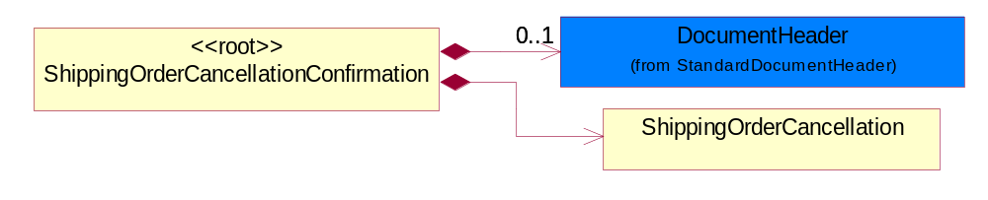
Figure ‎2-11 ShippingOrderCancellationConfirmation

Composition | Cardinality | Type | Documentation
DocumentHeader | 0..1 | DocumentHeader | The object allows for the identification of the sender and receiver of the business document.
ShippingOrderCancellation | 1 | ShippingOrderCancellation | The collection of business properties that describes the cancellation of a shipping order.

Domain Model

Procurement

Procurement

Dependency Diagram
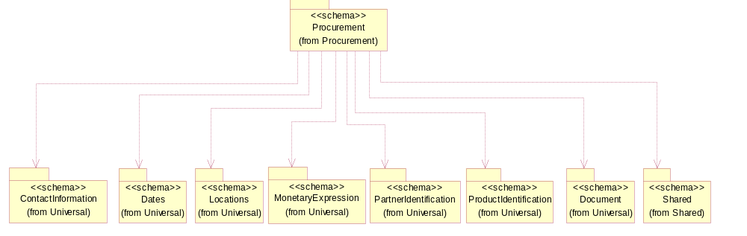
Figure ‎3-12 Dependency

CodeList

OrderAdmin
Additional administrative code identifying the reason the shipping order is being sent, possibly indicating a predefined workflow.

Name | Documentation
DDE | Demo Depot.
DOA | DOA.
ERA | E-Rate.
GRA | Government Rated.
INT | Internal/Demo/Evaluation/Sample.
MUL | Multinational.
PRE | Premium.
REP | Replacement.
RZC | Replacement - Zero Cost.
SAM | Sample.
SPR | Special Promotions.
STA | Standard.
TIO | Trade-in Order.
TIR | Trade-in Return.
UPG | Upgrade.
UZC | Upgrade - Zero Cost.

Logistics

Logistics

Dependency Diagram
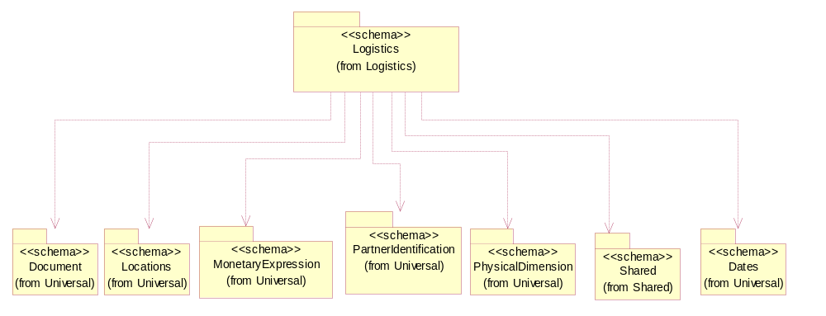
Figure ‎3-13 Dependency

OrderInformation
The collection of business properties that identifies a shipping order, including its identity, type and purpose.
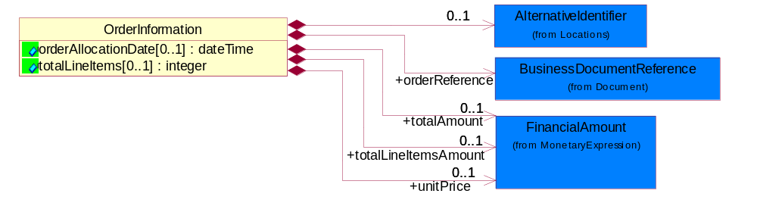
Figure ‎3-14 OrderInformation

Attribute | Type | Documentation
orderAllocationDate[0..1] | dateTime | Specifies an instance in time for the part was allocated.
totalLineItems[0..1] | integer | Total number of line items in an entire business document.

Composition | Cardinality | Type | Documentation
orderReference | 1 | BusinessDocumentReference | An additional reference number to identify a single shipment when there are multiple shipments resulting from a single requesting order.
AlternativeIdentifier | 0..1 | AlternativeIdentifier | Identifies the specified code and the name of the organization that a code is utilized from.
unitPrice | 0..1 | FinancialAmount | Agreed upon Export/Import invoice unit price.
totalAmount | 0..1 | FinancialAmount | Total price for an entire business document.
totalLineItemsAmount | 0..1 | FinancialAmount | Total price for all shipping order line items.

CodeList

ShippingOrderCancellationReasonType
Code identifying the reason for the rejection of a shipping order cancellation.

Name | Documentation
ACA | Already Cancelled.
ADP | Administrative Problem.
ALS | Already Shipped.
APF | Already Packed for Shipment.
APS | Already Partially Shipped.
IVC | Invalid Shipping Order Cancellation.
IVS | Invalid Shipping Order.

ShippingOrderCancellationStatus
Code identifying the confirmation status of a shipping order cancellation.

Name | Documentation
ACP | Accepted.
REJ | Rejected.

Shared

Shared

Dependency Diagram
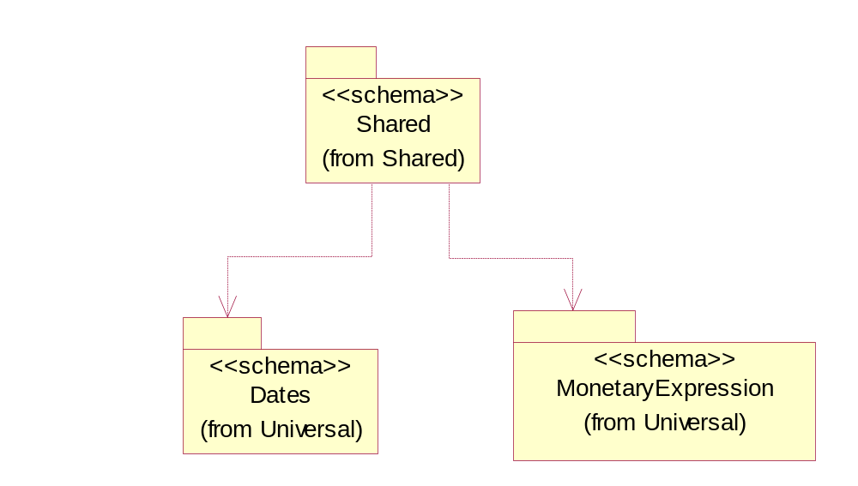
Figure ‎3-15 Dependency

Universal Structure

ContactInformation

ContactInformation
The business document must allow for the identification of the name of the department, service or individual to be contacted regarding the context of the business document.
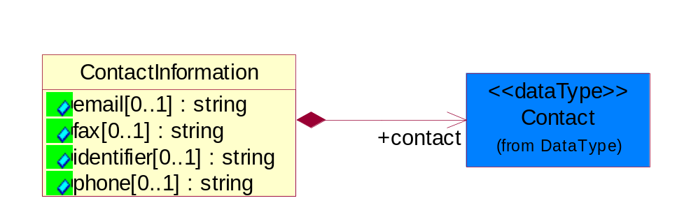
Figure ‎4-16 ContactInformation

Attribute | Type | Documentation
email[0..1] | string | The electronic mail for the specified contact.
fax[0..1] | string | The fax number for the specified contact.
identifier[0..1] | string | Identifies the role of the contact (i.e. Service Technician, Account Manager) in the Business Process.
phone[0..1] | string | The telephone number for the specified contact.

Composition | Cardinality | Type | Documentation
contact | 1 | Contact | The name of the department, service or individual to be contacted within the organization.

DataType

Contact
The name of the department, service or individual to be contacted within the organization.
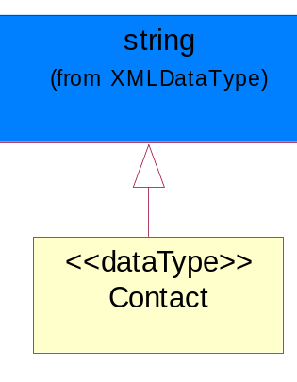
Figure ‎4-17 Contact

DUNS
A number assigned by Dun and Bradstreet to identify a business location.
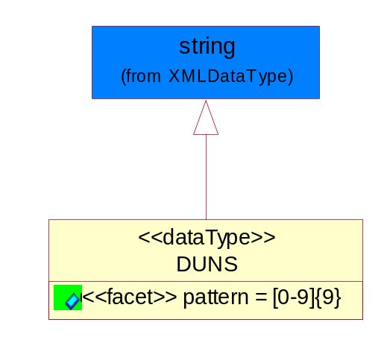
Figure ‎4-18 DUNS

Attribute | Type | Documentation
pattern |  | [0-9]{9}

DUNSPlus4
A identifier to specify a specific location within a business location.
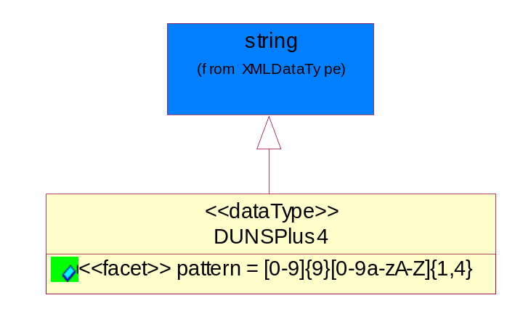
Figure ‎4-19 DUNSPlus4

Attribute | Type | Documentation
pattern |  | Data Universal Numbering System +4 (DUNS+4) number means the DUNS number assigned by Dun and Bradstreet, Inc. (D&B) plus an alphanumeric of length 4 suffix that may be assigned by a business concern.

GLN
Global Location Number (GLN) - A identifier to identify legal entities, trading parties and location.
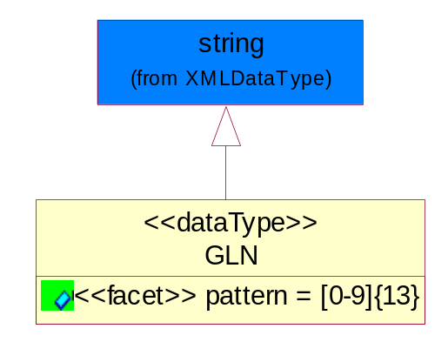
Figure ‎4-20 GLN

Attribute | Type | Documentation
pattern |  | [0-9]{13}

Dates

Document

BusinessDocumentReference
The business document reference object allows for the indirect referencing of a relationship to other business related documents.
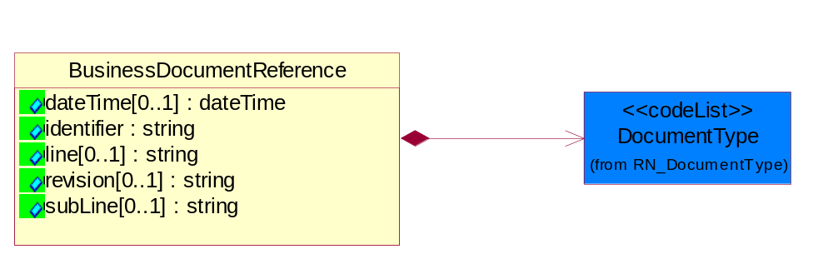
Figure ‎4-21 BusinessDocumentReference

Attribute | Type | Documentation
dateTime[0..1] | dateTime | The date-time stamp indicating on the referenced business document.
identifier | string | Unique identification of the referenced business document.
line[0..1] | string | References the specific line number of the specified business document.
revision[0..1] | string | Referenced the revision of the specified business document.
subLine[0..1] | string | References the specific subline number of the specified business document.

Composition | Cardinality | Type | Documentation
DocumentType | 1 | DocumentType | A code identifying the business context of a document.

Locations

AlternativeIdentifier
Identifies the specified code and the name of the organization that a code is utilized from.
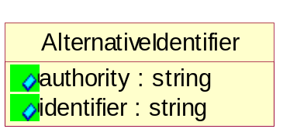
Figure ‎4-22 AlternativeIdentifier

Attribute | Type | Documentation
authority | string | The name of the organization that a code is utilized from.
identifier | string | The specified code to represent an entity (e.g. product, location, partner, etc.)

Location
The business document must specify a location.
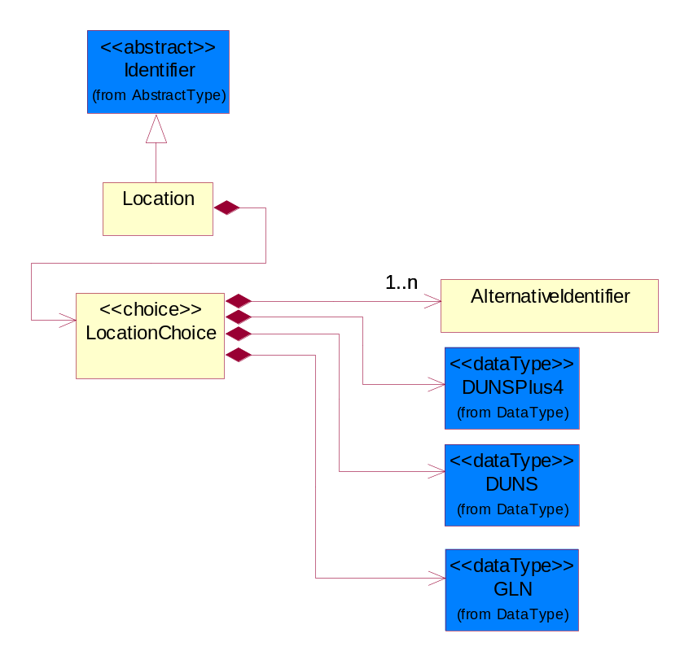
Figure ‎4-23 Location

Composition | Cardinality | Type | Documentation
LocationChoice | 1 | LocationChoice

LocationChoice

Composition | Cardinality | Type | Documentation
DUNSPlus4 | 1 | DUNSPlus4 | A identifier to specify a specific location within a business location.
DUNS | 1 | DUNS | A number assigned by Dun and Bradstreet to identify a business location.
AlternativeIdentifier | 1..n | AlternativeIdentifier | Identifies the specified code and the name of the organization that a code is utilized from.
GLN | 1 | GLN | Global Location Number (GLN) - A identifier to identify legal entities, trading parties and location.

PhysicalAddress
The business document must provide a physical address for a party to the business transaction.
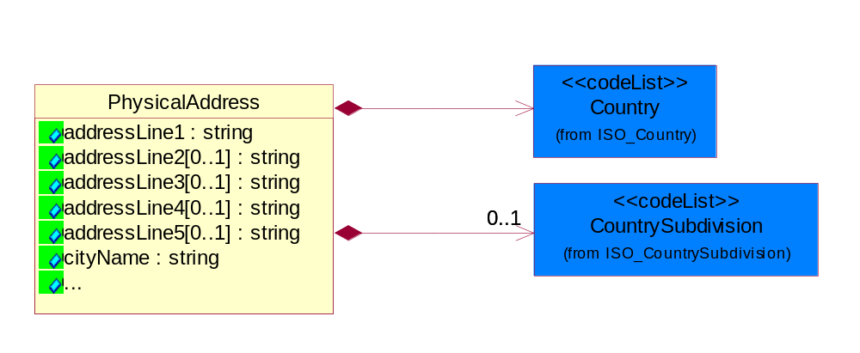
Figure ‎4-24 PhysicalAddress

Attribute | Type | Documentation
addressLine1 | string | The first line of a physical address.
addressLine2[0..1] | string | The second line of a physical address.
addressLine3[0..1] | string | The third line of a physical address.
addressLine4[0..1] | string | The fourth line of a physical address.
addressLine5[0..1] | string | The fifth line of a physical address.
cityName | string | The name of a city.
postalCode[0..1] | string | Identifying geographic location as specified by a national postal code.
postOfficeBox[0..1] | string | The Post Office Box identifier used to identify a party's post office box.

Composition | Cardinality | Type | Documentation
Country | 1 | Country | For representation of Country name RosettaNet has adopted ISO 3166-3; 1999. Refer to the following web page to get the latest version of the standard:  http://www.iso.ch/iso/en/prods-services/iso3166ma/02iso-3166-code-lists/index.html  If you need more information about the ISO standard please contact ISO for more details.
CountrySubdivision | 0..1 | CountrySubdivision | For representation of a Countries subdivisions RosettaNet has adopted ISO 3166-3; 1999. Refer to the following web page to get the latest version of the standard:  http://www.iso.ch/iso/en/prods-services/iso3166ma/02iso-3166-code-lists/index.html  If you need more information about the ISO standard please contact ISO for more details.

MonetaryExpression

FinancialAmount
The business document must express financial amounts.
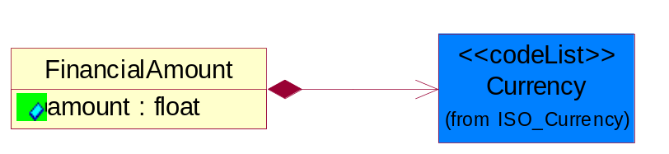
Figure ‎4-25 FinancialAmount

Attribute | Type | Documentation
amount | float | Specifies the monetary amount.

Composition | Cardinality | Type | Documentation
Currency | 1 | Currency | For representation of Currency codes RosettaNet has adopted ISO 4217; 1995. The British Standards Institution (BSI) is the ISO 4217 Maintenance Agency. Refer to the following web page to get the latest version of the standard:  http://www.bsi-global.com/Technical+Information/Publications/_Publications/tig90.xalter  If you need more information about the ISO standard please contact ISO for more details.

PartnerIdentification

PartnerIdentification
The business document must allow for the identity of one or more parties to the transaction.
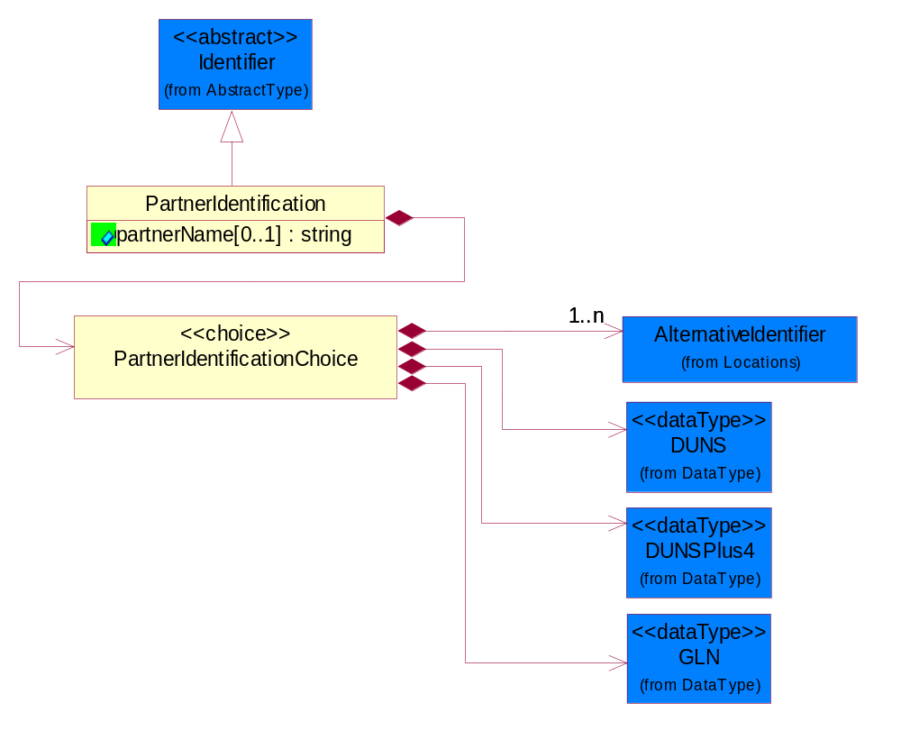
Figure ‎4-26 PartnerIdentification

Attribute | Type | Documentation
partnerName[0..1] | string | The name of the partner’s company/business.

Composition | Cardinality | Type | Documentation
PartnerIdentificationChoice | 1 | PartnerIdentificationChoice

PartnerIdentificationChoice

Composition | Cardinality | Type | Documentation
DUNS | 1 | DUNS | A number assigned by Dun and Bradstreet to identify a business location.
DUNSPlus4 | 1 | DUNSPlus4 | A identifier to specify a specific location within a business location.
AlternativeIdentifier | 1..n | AlternativeIdentifier | Identifies the specified code and the name of the organization that a code is utilized from.
GLN | 1 | GLN | Global Location Number (GLN) - A identifier to identify legal entities, trading parties and location.

SpecifiedFullPartner
The business document must describe the trading partners in the business transaction. This data structure provide the flexibility to describe a partner in all possible methods as for new, existing or known partner. This is specifically for partner who role has been specified.
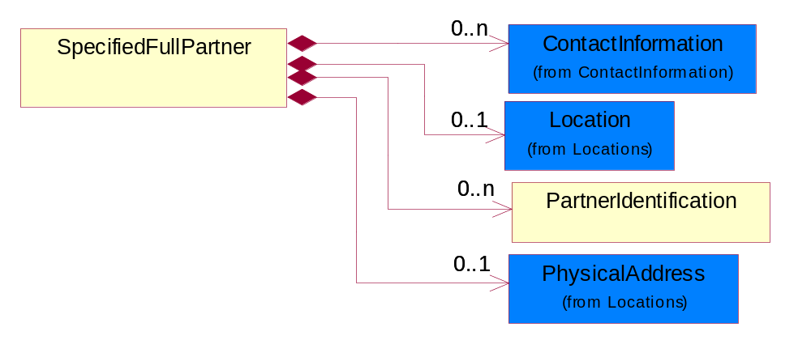
Figure ‎4-27 SpecifiedFullPartner

Composition | Cardinality | Type | Documentation
ContactInformation | 0..n | ContactInformation | The business document must allow for the identification of the name of the department, service or individual to be contacted regarding the context of the business document.
Location | 0..1 | Location | The business document must specify a location.
PartnerIdentification | 0..n | PartnerIdentification | The business document must allow for the identity of one or more parties to the transaction.
PhysicalAddress | 0..1 | PhysicalAddress | The business document must provide a physical address for a party to the business transaction.

SpecifiedIntermittentPartner
The business document must describe a physical address for a delivery.
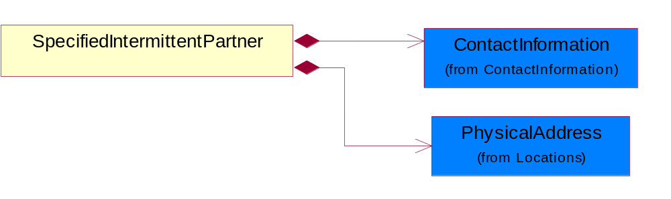
Figure ‎4-28 SpecifiedIntermittentPartner

Composition | Cardinality | Type | Documentation
ContactInformation | 1 | ContactInformation | The business document must allow for the identification of the name of the department, service or individual to be contacted regarding the context of the business document.
PhysicalAddress | 1 | PhysicalAddress | The business document must provide a physical address for a party to the business transaction.

SpecifiedKnownPartner
The business document must describe the trading partners in the business transaction.
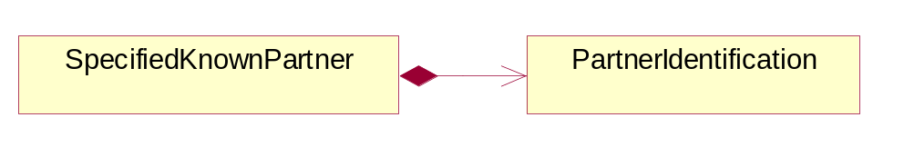
Figure ‎4-29 SpecifiedKnownPartner

Composition | Cardinality | Type | Documentation
PartnerIdentification | 1 | PartnerIdentification | The business document must allow for the identity of one or more parties to the transaction.

SpecifiedKnownPartnerContact
The business document must describe the trading partners in the business transaction and allow for a identification of an individual of the trading partner.
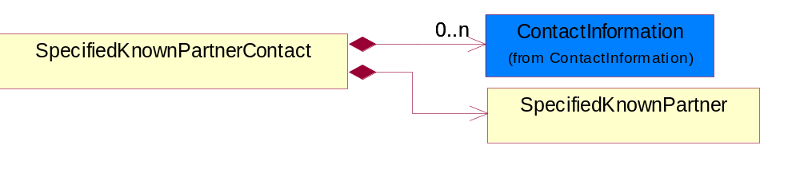
Figure ‎4-30 SpecifiedKnownPartnerContact

Composition | Cardinality | Type | Documentation
SpecifiedKnownPartner | 1 | SpecifiedKnownPartner | The business document must describe the trading partners in the business transaction.
ContactInformation | 0..n | ContactInformation | The business document must allow for the identification of the name of the department, service or individual to be contacted regarding the context of the business document.

SpecifiedNewPartner
The business document must describe a new, existing (but known to only one of the parties to the transaction) or an unknown party to the business transaction.
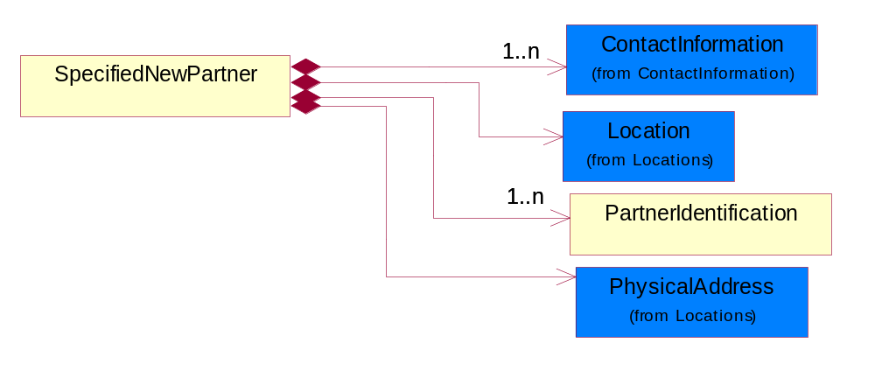
Figure ‎4-31 SpecifiedNewPartner

Composition | Cardinality | Type | Documentation
ContactInformation | 1..n | ContactInformation | The business document must allow for the identification of the name of the department, service or individual to be contacted regarding the context of the business document.
Location | 1 | Location | The business document must specify a location.
PhysicalAddress | 1 | PhysicalAddress | The business document must provide a physical address for a party to the business transaction.
PartnerIdentification | 1..n | PartnerIdentification | The business document must allow for the identity of one or more parties to the transaction.

SpecifiedPartnerDescription
The collection of business properties that describe a business partners' identity, their contact information, where they are physically located and their function in a supply chain.
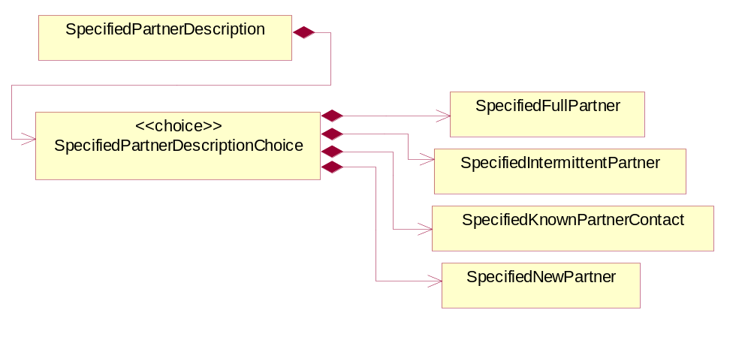
Figure ‎4-32 SpecifiedPartnerDescription

Composition | Cardinality | Type | Documentation
SpecifiedPartnerDescriptionChoice | 1 | SpecifiedPartnerDescriptionChoice

SpecifiedPartnerDescriptionChoice

Composition | Cardinality | Type | Documentation
SpecifiedKnownPartnerContact | 1 | SpecifiedKnownPartnerContact | The business document must describe the trading partners in the business transaction and allow for a identification of an individual of the trading partner.
SpecifiedIntermittentPartner | 1 | SpecifiedIntermittentPartner | The business document must describe a physical address for a delivery.
SpecifiedNewPartner | 1 | SpecifiedNewPartner | The business document must describe a new, existing (but known to only one of the parties to the transaction) or an unknown party to the business transaction.
SpecifiedFullPartner | 1 | SpecifiedFullPartner | The business document must describe the trading partners in the business transaction. This data structure provide the flexibility to describe a partner in all possible methods as for new, existing or known partner. This is specifically for partner who role has been specified.

CodeList

Country
For representation of Country name RosettaNet has adopted ISO 3166-3; 1999. Refer to the following web page to get the latest version of the standard:
http://www.iso.ch/iso/en/prods-services/iso3166ma/02iso-3166-code-lists/index.html

If you need more information about the ISO standard please contact ISO for more details.

CountrySubdivision
For representation of a Countries subdivisions RosettaNet has adopted ISO 3166-3; 1999. Refer to the following web page to get the latest version of the standard:
http://www.iso.ch/iso/en/prods-services/iso3166ma/02iso-3166-code-lists/index.html

If you need more information about the ISO standard please contact ISO for more details.

Currency
For representation of Currency codes RosettaNet has adopted ISO 4217; 1995. The British Standards Institution (BSI) is the ISO 4217 Maintenance Agency. Refer to the following web page to get the latest version of the standard:
http://www.bsi-global.com/Technical+Information/Publications/_Publications/tig90.xalter

If you need more information about the ISO standard please contact ISO for more details.

Language
For representation of Language name RosettaNet has adopted ISO 639-2; 1998. Refer to the following web page to get the latest version of the standard:

http://www.loc.gov/standards/iso639-2/iso639jac.html

If you need more information about the ISO standard please contact ISO for more details.

DocumentType
A code identifying the business context of a document.

Instance | Documentation
CBN | Product batch number of customer.
CCN | Customs clearance number.
CFA | Failure Analysis - Request document that will accompany the product providing characteristics of the component failure.
CIN | Commercial Invoice.
CNM | Traditional credit note or memo.
CON | In a virtual sourcing relationship, a third party trading partner is supplying a part to a customer on behalf of another company that has taken the order for the customer. In this case a Customer Order Number is associated to the request for material that is sent to the virtual trading partners.
COT | Contract.
CRN | Unique consumption reference number identifying the product consumption issue i.e. one-to-one relationship with physical flow.
DEM | Traditional debit note or memo.
DEN | Delivery Note.
DIN | Discontinuation Notice.
DRN | Drawing Number.
FUO | Sales order or transfer order fulfilling demand out of a facility (outbound shipment).
INV | Invoice.
LID | Location Identifier. Data for on-site work that have to be done on the machine (associated with preventive maintenance order)
MEN | Master Event Number.
MID | Machine Identifier. Data for on-site work that have to be done on the machine (associated with preventive maintenance order)
MON | Model Number.
OCL | The unique identifier assigned by the OEM for a warranty claim.
OGA | Other governmental agency issued document.
OPO | The unique identifier assigned by the OEM for a part order.
OPR | The unique identifier assigned by the OEM for a part return.
PFA | Failure Analysis - Request document that will accompany the product providing characteristics of the product failure.
PII | Refers to previously issued invoice.
PLS | Unique number that identifies packing form prior to shipment.
POI | Purchase Order IN.
PON | Production order number for material release.
POO | Purchase Order OUT
PRC | Product Catalog.
PSI | Refers to previously issued self-billing invoice.
PUO | Purchase Order.
QUO | Quote.
REC | Document identifying the receipt of materials or products into a facility against a purchase order or transfer order (inbound shipment).
REO | Purchase order or transfer order replenishing inventory into a facility (inbound shipment).
REQ | Requisition.
RMA | Returned Material Authorization.
RPO | Purchase order for materials or product returned to and reworked by a supplier.
RTA | Remittance Advice - Remittance details.
SAO | Sales Order.
SBC | Credit Memo used in self-billing scenario.
SBD | Debit Memo used in self-billing scenario.
SBI | Invoice in self billing scenario.
SBN | Product batch number of supplier.
SCA | Similar to contracts - Contains the quantity of an article that is to be ordered from a vendor and the price for article or service that is to be procured.
SEN | Serial Number.
SEO | A document that gives a repair provider the necessary authorization to repair or upgrade a product either at the customer site or at the repair provider’s site.
SHD | Shipping Document.
SNC | Shipset Number on Code List.
SPC | The unique identifier assigned by the ASP for a warranty claim.
SPN | Spec Number.
SPO | The unique identifier assigned by the ASP for a part order.
SPR | The unique identifier assigned by the ASP for a part return.
SPW | The unique identifier assigned by the ASP to reference a work order.
SRI | A document that contains the shipping reference number which allows the product to be tracked within the outsourced logistic providers network.
TRO | Order which results in materials or products being moved from one facility to another (outbound shipment and inbound shipment).
WAB | Waybill.
WAC | Denotes a warranty claim.
WOO | Work Order.

MimeTypeQualifier
The MIME type as defined by IANA.

Please refer to http://www.iana.org/assignments/media-types/ for a list of types.

Instance | Documentation
application/activemessage | [Shapiro]
application/andrew-inset | [Borenstein]
application/applefile | [Faltstrom]
application/atomicmail | [Borenstein]
application/batch-SMTP | [RFC2442]
application/beep+xml | [RFC3080]
application/cals-1840 | [RFC1895]
application/cnrp+xml | [RFCCNRP]
application/commonground | [Glazer]
application/cpl+xml
application/cybercash | [Eastlake]
application/dca-rft | [Campbell]
application/dec-dx | [Campbell]
application/dicom | [RFC3240]
application/dvcs | [RFC3029]
application/EDI-Consent | [RFC1767]
application/EDIFACT | [RFC1767]
application/EDI-X12 | [RFC1767]
application/eshop | [Katz]
application/font-tdpfr | [RFC3073]
application/http | [RFC2616]
application/hyperstudio | [Domino]
application/iges | [Parks]
application/index | [RFC2652]
application/index.cmd | [RFC2652]
application/index.obj | [RFC2652]
application/index.response | [RFC2652]
application/index.vnd | [RFC2652]
application/iotp | [RFC2935]
application/ipp | [RFC2910]
application/isup | [RFC3204]
application/mac-binhex40 | [Faltstrom]
application/macwriteii | [Lindner]
application/marc | [RFC2220]
application/mathematica | [Van Nostern]
application/msword | [Lindner]
application/news-message-id | [RFC1036,Spencer]
application/news-transmission | [RFC1036, Spencer]
application/ocsp-request | [RFC2560]
application/ocsp-response | [RFC2560]
application/octet-stream | [RFC2045,RFC2046]
application/oda | [RFC2045,RFC2046]
application/ogg | [RFC-walleij-ogg-mediatype-08.txt]
application/parityfec | [RFC3009]
application/pdf | [Lindner]
application/pgp-encrypted | [RFC3156]
application/pgp-keys | [RFC3156]
application/pgp-signature | [RFC3156]
application/pkcs10 | [RFC2311]
application/pkcs7-mime | [RFC2311]
application/pkcs7-signature | [RFC2311]
application/pkix-cert | [RFC2585]
application/pkixcmp | [RFC2510]
application/pkix-crl | [RFC2585]
application/postscript | [RFC2045,RFC2046]
application/prs.alvestrand.titrax-sheet | [Alvestrand]
application/prs.cww | [Rungchavalnont]
application/prs.nprend | [Doggett]
application/prs.plucker | [Janssen]
application/qsig | [RFC3204]
application/reginfo+xml | [RFC-ietf-sipping-reg-event-00.txt]
application/remote-printing | [RFC1486,Rose]
application/riscos | [Smith]
application/rtf | [Lindner]
application/sdp | [RFC2327]
application/set-payment | [Korver]
application/set-payment-initiation | [Korver]
application/set-registration | [Korver]
application/set-registration-initiation | [Korver]
application/sgml | [RFC1874]
application/sgml-open-catalog | [Grosso]
application/sieve | [RFC3028]
application/slate | [Crowley]
application/timestamp-query | [RFC3161]
application/timestamp-reply | [RFC3161]
application/tve-trigger | [Welsh]
application/vemmi | [RFC2122]
application/vnd.3gpp.pic-bw-large | [Meredith]
application/vnd.3gpp.pic-bw-small | [Meredith]
application/vnd.3gpp.pic-bw-var | [Meredith]
application/vnd.3gpp.sms | [Meredith]
application/vnd.3M.Post-it-Notes | [O'Brien]
application/vnd.accpac.simply.aso | [Leow]
application/vnd.accpac.simply.imp | [Leow]
application/vnd.acucobol | [Lubin]
application/vnd.acucorp | [Lubin]
application/vnd.adobe.xfdf | [Perelman]
application/vnd.aether.imp | [Moskowitz]
application/vnd.amiga.ami | [Blumberg]
application/vnd.anser-web-certificate-issue-initiation | [Mori]
application/vnd.anser-web-funds-transfer-initiation | [Mori]
application/vnd.audiograph | [Slusanschi]
application/vnd.blueice.multipass | [Holmstrom]
application/vnd.bmi | [Gotoh]
application/vnd.businessobjects | [Imoucha]
application/vnd.canon-cpdl | [Muto]
application/vnd.canon-lips | [Muto]
application/vnd.cinderella | [Kortenkamp]
application/vnd.claymore | [Simpson]
application/vnd.commerce-battelle | [Applebaum]
application/vnd.commonspace | [Chandhok]
application/vnd.contact.cmsg | [Patz]
application/vnd.cosmocaller | [Dellutri]
application/vnd.ctc-posml | [Kohlhepp]
application/vnd.cups-postscript | [Sweet]
application/vnd.cups-raster | [Sweet]
application/vnd.cups-raw | [Sweet]
application/vnd.curl | [Byrnes]
application/vnd.cybank | [Helmee]
application/vnd.data-vision.rdz | [Fields]
application/vnd.dna | [Searcy]
application/vnd.dpgraph | [Parker]
application/vnd.dreamfactory | [Appleton]
application/vnd.dxr | [Duffy]
application/vnd.ecdis-update | [Buettgenbach]
application/vnd.ecowin.chart | [Olsson]
application/vnd.ecowin.filerequest | [Olsson]
application/vnd.ecowin.fileupdate | [Olsson]
application/vnd.ecowin.series | [Olsson]
application/vnd.ecowin.seriesrequest | [Olsson]
application/vnd.ecowin.seriesupdate | [Olsson]
application/vnd.enliven | [Santinelli]
application/vnd.epson.esf | [Hoshina]
application/vnd.epson.msf | [Hoshina]
application/vnd.epson.quickanime | [Gu]
application/vnd.epson.salt | [Nagatomo]
application/vnd.epson.ssf | [Hoshina]
application/vnd.ericsson.quickcall | [Tidwell]
application/vnd.eudora.data | [Resnick]
application/vnd.fdf | [Zilles]
application/vnd.ffsns | [Holstage]
application/vnd.FloGraphIt | [Floersch]
application/vnd.framemaker | [Wexler]
application/vnd.fsc.weblaunch | [D.Smith]
application/vnd.fujitsu.oasys | [Togashi]
application/vnd.fujitsu.oasys2 | [Togashi]
application/vnd.fujitsu.oasys3 | [Okudaira]
application/vnd.fujitsu.oasysgp | [Sugimoto]
application/vnd.fujitsu.oasysprs | [Ogita]
application/vnd.fujixerox.ddd | [Onda]
application/vnd.fujixerox.docuworks | [Taguchi]
application/vnd.fujixerox.docuworks.binder | [Matsumoto]
application/vnd.fut-misnet | [Pruulmann]
application/vnd.grafeq | [Tupper]
application/vnd.groove-account | [Joseph]
application/vnd.groove-help | [Joseph]
application/vnd.groove-identity-message | [Joseph]
application/vnd.groove-injector | [Joseph]
application/vnd.groove-tool-message | [Joseph]
application/vnd.groove-tool-template | [Joseph]
application/vnd.groove-vcard | [Joseph]
application/vnd.hbci | [Hammann]
application/vnd.hhe.lesson-player | [Jones]
application/vnd.hp-HPGL | [Pentecost]
application/vnd.hp-hpid | [Gupta]
application/vnd.hp-hps | [Aubrey]
application/vnd.hp-PCL | [Pentecost]
application/vnd.hp-PCLXL | [Pentecost]
application/vnd.httphone | [Lefevre]
application/vnd.hzn-3d-crossword | [Minnis]
application/vnd.ibm.afplinedata | [Buis]
application/vnd.ibm.electronic-media | [Tantlinger]
application/vnd.ibm.MiniPay | [Herzberg]
application/vnd.ibm.modcap | [Hohensee]
application/vnd.ibm.secure-container | [Tantlinger]
application/vnd.informix-visionary | [Gales]
application/vnd.intercon.formnet | [Gurak]
application/vnd.intertrust.digibox | [Tomasello]
application/vnd.intertrust.nncp | [Tomasello]
application/vnd.intu.qbo | [Scratchley]
application/vnd.intu.qfx | [Scratchley]
application/vnd.irepository.package+xml | [Knowles]
application/vnd.is-xpr | [Natarajan]
application/vnd.japannet-directory-service | [Fujii]
application/vnd.japannet-jpnstore-wakeup | [Yoshitake]
application/vnd.japannet-payment-wakeup | [Fujii]
application/vnd.japannet-registration | [Yoshitake]
application/vnd.japannet-registration-wakeup | [Fujii]
application/vnd.japannet-setstore-wakeup | [Yoshitake]
application/vnd.japannet-verification | [Yoshitake]
application/vnd.japannet-verification-wakeup | [Fujii]
application/vnd.jisp | [Deckers]
application/vnd.kde.karbon | [Faure]
application/vnd.kde.kchart | [Faure]
application/vnd.kde.kformula | [Faure]
application/vnd.kde.kivio | [Faure]
application/vnd.kde.kontour | [Faure]
application/vnd.kde.kpresenter | [Faure]
application/vnd.kde.kspread | [Faure]
application/vnd.kde.kword | [Faure]
application/vnd.kenameaapp | [DiGiorgio-Haag]
application/vnd.koan | [Cole]
application/vnd.liberty-request+xml | [McDowell]
application/vnd.llamagraphics.life-balance.desktop | [White]
application/vnd.lotus-1-2-3 | [Wattenberger]
application/vnd.lotus-approach | [Wattenberger]
application/vnd.lotus-freelance | [Wattenberger]
application/vnd.lotus-notes | [Laramie]
application/vnd.lotus-organizer | [Wattenberger]
application/vnd.lotus-screencam | [Wattenberger]
application/vnd.lotus-wordpro | [Wattenberger]
application/vnd.mcd | [Gotoh]
application/vnd.mediastation.cdkey | [Flurry]
application/vnd.meridian-slingshot | [Wedel]
application/vnd.micrografx.flo | [Prevo]
application/vnd.micrografx.igx | [Prevo]
application/vnd.mif | [Wexler]
application/vnd.minisoft-hp3000-save | [Bartram]
application/vnd.mitsubishi.misty-guard.trustweb | [Tanaka]
application/vnd.Mobius.DAF | [Kabayama]
application/vnd.Mobius.DIS | [Kabayama]
application/vnd.Mobius.MBK | [Devasia]
application/vnd.Mobius.MQY | [Devasia]
application/vnd.Mobius.MSL | [Kabayama]
application/vnd.Mobius.PLC | [Kabayama]
application/vnd.Mobius.TXF | [Kabayama]
application/vnd.mophun.application | [Wennerstrom]
application/vnd.mophun.certificate | [Wennerstrom]
application/vnd.motorola.flexsuite | [Patton]
application/vnd.motorola.flexsuite.adsi | [Patton]
application/vnd.motorola.flexsuite.fis | [Patton]
application/vnd.motorola.flexsuite.gotap | [Patton]
application/vnd.motorola.flexsuite.kmr | [Patton]
application/vnd.motorola.flexsuite.ttc | [Patton]
application/vnd.motorola.flexsuite.wem | [Patton]
application/vnd.mozilla.xul+xml | [McDaniel]
application/vnd.ms-artgalry | [Slawson]
application/vnd.ms-asf | [Fleischman]
application/vnd.mseq | [Le Bodic]
application/vnd.ms-excel | [Gill]
application/vnd.msign | [Borcherding]
application/vnd.ms-lrm | [Ledoux]
application/vnd.ms-powerpoint | [Gill]
application/vnd.ms-project | [Gill]
application/vnd.ms-tnef | [Gill]
application/vnd.ms-works | [Gill]
application/vnd.ms-wpl | [Plastina]
application/vnd.musician | [Adams]
application/vnd.music-niff | [Butler]
application/vnd.netfpx | [Mutz]
application/vnd.noblenet-directory | [Solomon]
application/vnd.noblenet-sealer | [Solomon]
application/vnd.noblenet-web | [Solomon]
application/vnd.novadigm.EDM | [Swenson]
application/vnd.novadigm.EDX | [Swenson]
application/vnd.novadigm.EXT | [Swenson]
application/vnd.obn | [Hessling]
application/vnd.osa.netdeploy | [Klos]
application/vnd.palm | [Peacock]
application/vnd.pg.format | [Gandert]
application/vnd.pg.osasli | [Gandert]
application/vnd.powerbuilder6 | [Guy]
application/vnd.powerbuilder6-s | [Guy]
application/vnd.powerbuilder7 | [Shilts]
application/vnd.powerbuilder75 | [Shilts]
application/vnd.powerbuilder75-s | [Shilts]
application/vnd.powerbuilder7-s | [Shilts]
application/vnd.previewsystems.box | [Smolgovsky]
application/vnd.publishare-delta-tree | [Ben-Kiki]
application/vnd.pvi.ptid1 | [Lamb]
application/vnd.pwg-multiplexed | [RFC3391]
application/vnd.pwg-xhtml-print+xml | [Wright]
application/vnd.Quark.QuarkXPress | [Scheidler]
application/vnd.rapid | [Szekely]
application/vnd.s3sms | [Tarkkala]
application/vnd.sealed.net | [Lambert]
application/vnd.seemail | [Webb]
application/vnd.shana.informed.formdata | [Selzler]
application/vnd.shana.informed.formtemplate | [Selzler]
application/vnd.shana.informed.interchange | [Selzler]
application/vnd.shana.informed.package | [Selzler]
application/vnd.smaf | [Takahashi]
application/vnd.sss-cod | [Dani]
application/vnd.sss-dtf | [Bruno]
application/vnd.sss-ntf | [Bruno]
application/vnd.street-stream | [Levitt]
application/vnd.svd | [Becker]
application/vnd.swiftview-ics | [Widener]
application/vnd.triscape.mxs | [Simonoff]
application/vnd.trueapp | [Hepler]
application/vnd.truedoc | [Chase]
application/vnd.ufdl | [Manning]
application/vnd.uplanet.alert | [Martin]
application/vnd.uplanet.alert-wbxml | [Martin]
application/vnd.uplanet.bearer-choice | [Martin]
application/vnd.uplanet.bearer-choice-wbxml | [Martin]
application/vnd.uplanet.cacheop | [Martin]
application/vnd.uplanet.cacheop-wbxml | [Martin]
application/vnd.uplanet.channel | [Martin]
application/vnd.uplanet.channel-wbxml | [Martin]
application/vnd.uplanet.list | [Martin]
application/vnd.uplanet.listcmd | [Martin]
application/vnd.uplanet.listcmd-wbxml | [Martin]
application/vnd.uplanet.list-wbxml | [Martin]
application/vnd.uplanet.signal | [Martin]
application/vnd.vcx | [T.Sugimoto]
application/vnd.vectorworks | [Pharr]
application/vnd.vidsoft.vidconference | [Hess]
application/vnd.visio | [Sandal]
application/vnd.visionary | [Aravindakumar]
application/vnd.vividence.scriptfile | [Risher]
application/vnd.vsf | [Rowe]
application/vnd.wap.sic | [WAP-Forum]
application/vnd.wap.slc | [WAP-Forum]
application/vnd.wap.wbxml | [Stark]
application/vnd.wap.wmlc | [Stark]
application/vnd.wap.wmlscriptc | [Stark]
application/vnd.webturbo | [Rehem]
application/vnd.wrq-hp3000-labelled | [Bartram]
application/vnd.wt.stf | [Wohler]
application/vnd.wv.csp+wbxml | [Salmi]
application/vnd.xara | [Matthewman]
application/vnd.xfdl | [Manning]
application/vnd.yellowriver-custom-menu | [Yellow]
application/whoispp-query | [RFC2957]
application/whoispp-response | [RFC2958]
application/wita | [Campbell]
application/wordperfect5.1 | [Lindner]
application/x400-bp | [RFC1494]
application/xhtml+xml | [RFC3236]
application/xml | [RFC3023]
application/xml-dtd | [RFC3023]
application/xml-external-parsed-entity | [RFC3023]
application/zip | [Lindner]
audio/32kadpcm | [RFC2421,RFC2422]
audio/AMR | [RFC3267]
audio/AMR-WB | [RFC3267]
audio/basic | [RFC2045,RFC2046]
audio/CN | [RFC3389]
audio/DAT12 | [RFC3190]
audio/DVI4
audio/EVRC | [RFC-ietf-avt-evrc-smv-03.txt]
audio/EVRC0 | [RFC-ietf-avt-evrc-smv-03.txt]
audio/G.722.1 | [RFC3047]
audio/G722
audio/G723
audio/G726-16
audio/G726-24
audio/G726-32
audio/G726-40
audio/G728
audio/G729
audio/G729D
audio/G729E
audio/GSM
audio/GSM-EFR
audio/L16 | [RFC2586]
audio/L20 | [RFC3190]
audio/L24 | [RFC3190]
audio/L8
audio/LPC
audio/MP4A-LATM | [RFC3016]
audio/MPA
audio/mpa-robust | [RFC3119]
audio/mpeg | [RFC3003]
audio/parityfec | [RFC3009]
audio/PCMA
audio/PCMU
audio/prs.sid | [Walleij]
audio/QCELP
audio/RED
audio/SMV | [RFC-ietf-avt-evrc-smv-03.txt]
audio/SMV0 | [RFC-ietf-avt-evrc-smv-03.txt]
audio/telephone-event | [RFC2833]
audio/tone | [RFC2833]
audio/VDVI
audio/vnd.3gpp.iufp | [Belling]
audio/vnd.cisco.nse | [Kumar]
audio/vnd.cns.anp1 | [McLaughlin]
audio/vnd.cns.inf1 | [McLaughlin]
audio/vnd.digital-winds | [Strazds]
audio/vnd.everad.plj | [Cicelsky]
audio/vnd.lucent.voice | [Vaudreuil]
audio/vnd.nortel.vbk | [Parsons]
audio/vnd.nuera.ecelp4800 | [Fox]
audio/vnd.nuera.ecelp7470 | [Fox]
audio/vnd.nuera.ecelp9600 | [Fox]
audio/vnd.octel.sbc | [Vaudreuil]
audio/vnd.qcelp | [Lundblade]
audio/vnd.rhetorex.32kadpcm | [Vaudreuil]
audio/vnd.vmx.cvsd | [Vaudreuil]
image/cgm | Computer Graphics Metafile
image/g3fax | [RFC1494]
image/gif | [RFC2045,RFC2046]
image/ief | [RFC1314] Image Exchange Format
image/jpeg | [RFC2045,RFC2046]
image/naplps | [Ferber]
image/png | [Randers-Pehrson]
image/prs.btif | [Simon]
image/prs.pti | [Laun]
image/t38 | [RFC3362]
image/tiff | [RFC3302] Tag Image File Format
image/tiff-fx | [RFC3250] Tag Image File Format Fax eXtended
image/vnd.cns.inf2 | [McLaughlin]
image/vnd.djvu | [Bottou]
image/vnd.dwg | [Moline]
image/vnd.dxf | [Moline]
image/vnd.fastbidsheet | [Becker]
image/vnd.fpx | [Spencer]
image/vnd.fst | [Fuldseth]
image/vnd.fujixerox.edmics-mmr | [Onda]
image/vnd.fujixerox.edmics-rlc | [Onda]
image/vnd.globalgraphics.pgb | [Bailey]
image/vnd.mix | [Reddy]
image/vnd.ms-modi | [Vaughan]
image/vnd.net-fpx | [Spencer]
image/vnd.svf | [Moline]
image/vnd.wap.wbmp | [Stark]
image/vnd.xiff | [S.Martin]
message/delivery-status | [RFC1894]
message/disposition-notification | [RFC2298]
message/external-body | [RFC2045,RFC2046]
message/http | [RFC2616]
message/news | [RFC 1036, H.Spencer]
message/partial | [RFC2045,RFC2046]
message/rfc822 | [RFC2045,RFC2046]
message/s-http | [RFC2660]
message/sip | [RFC3261]
message/sipfrag | [RFC3420]
model/iges | [Parks]
model/mesh | [RFC2077]
model/vnd.dwf | [Pratt]
model/vnd.flatland.3dml | [Powers]
model/vnd.gdl | [Babits]
model/vnd.gs-gdl | [Babits]
model/vnd.gtw | [Ozaki]
model/vnd.mts | [Rabinovitch]
model/vnd.parasolid.transmit.binary | [Parasolid]
model/vnd.parasolid.transmit.text | [Parasolid]
model/vnd.vtu | [Rabinovitch]
model/vrml | [RFC2077]
multipart/alternative | [RFC2045,RFC2046]
multipart/appledouble | [Faltstrom]
multipart/byteranges | [RFC2068]
multipart/digest | [RFC2045,RFC2046]
multipart/encrypted | [RFC1847]
multipart/form-data | [RFC2388]
multipart/header-set | [Crocker]
multipart/mixed | [RFC2045,RFC2046]
multipart/parallel | [RFC2045,RFC2046]
multipart/related | [RFC2387]
multipart/report | [RFC1892]
multipart/signed | [RFC1847]
multipart/voice-message | [RFC2421,RFC2423]
text/calendar | [RFC2445]
text/css | [RFC2318]
text/directory | [RFC2425]
text/enriched | [RFC1896]
text/html | [RFC2854]
text/parityfec | [RFC3009]
text/plain | [RFC2646,RFC2046]
text/prs.lines.tag | [Lines]
text/rfc822-headers | [RFC1892]
text/richtext | [RFC2045,RFC2046]
text/rtf | [Lindner]
text/sgml | [RFC1874]
text/t140 | [RFC2793]
text/tab-separated-values | [Lindner]
text/uri-list | [RFC2483]
text/vnd.abc | [Allen]
text/vnd.curl | [Byrnes]
text/vnd.DMClientScript | [Bradley]
text/vnd.fly | [Gurney]
text/vnd.fmi.flexstor | [Hurtta]
text/vnd.in3d.3dml | [Powers]
text/vnd.in3d.spot | [Powers]
text/vnd.IPTC.NewsML | [IPTC]
text/vnd.IPTC.NITF | [IPTC]
text/vnd.latex-z | [Lubos]
text/vnd.motorola.reflex | [Patton]
text/vnd.ms-mediapackage | [Nelson]
text/vnd.net2phone.commcenter.command | [Xie]
text/vnd.sun.j2me.app-descriptor | [G.Adams]
text/vnd.wap.si | [WAP-Forum]
text/vnd.wap.sl | [WAP-Forum]
text/vnd.wap.wml | [Stark]
text/vnd.wap.wmlscript | [Stark]
text/xml | [RFC3023]
text/xml-external-parsed-entity | [RFC3023]
video/BMPEG
video/BT656
video/CelB
video/DV | [RFC3189]
video/H261
video/H263
video/H263-1998
video/H263-2000
video/JPEG
video/MP1S
video/MP2P
video/MP2T
video/MP4V-ES | [RFC3016]
video/mpeg | [RFC2045,RFC2046]
video/MPV
video/nv
video/parityfec | [RFC3009]
video/pointer | [RFC2862]
video/quicktime | [Lindner]
video/SMPTE292M | [RFC-avt-smpte292-video-08.txt]
video/vnd.fvt | [Fuldseth]
video/vnd.motorola.video | [McGinty]
video/vnd.motorola.videop | [McGinty]
video/vnd.mpegurl | [Recktenwald]
video/vnd.nokia.interleaved-multimedia | [Kangaslampi]
video/vnd.objectvideo | [Clark]
video/vnd.vivo | [Wolfe]

System Structure

BusinessProcessIdentifier
A Business Process Identifier to uniquely define the TPIR-PIP 'role' within a Business Scenario at a company or MNC level. The identifier MUST be composed of alphanumeric characters only and its length MUST be between one and twelve characters.
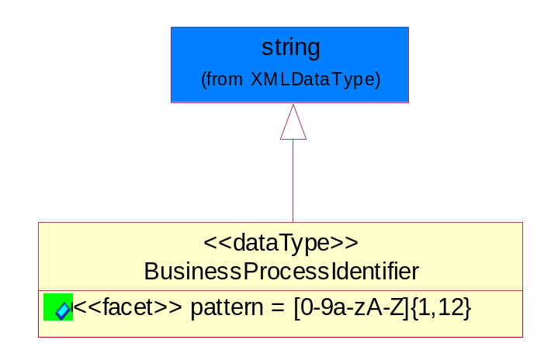
Figure ‎5-33 BusinessProcessIdentifier

Attribute | Type | Documentation
pattern |  | [0-9a-zA-Z]{1,12}

BusinessServiceInformation
The object allows the specification of the business service utilized within the partner company. This may or may not be the same as the information sent by the RNIF.
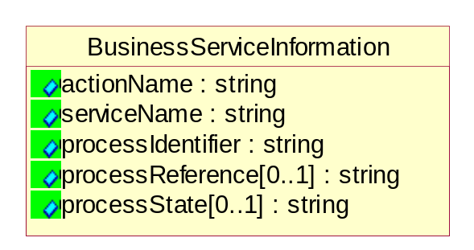
Figure ‎5-34 BusinessServiceInformation

Attribute | Type | Documentation
actionName | string | The name of Action. For RosettaNet usually any of Request/Confirm/Notify/Query/Response.
serviceName | string | The name of the Business Activity with the "Request/Confirm" part removed. E.g., for the Activity "Request Purchase Order"==> "Purchase Order".
processIdentifier | string | The name of the PIP e.g. Notify of Forecast Reply.
processReference[0..1] | string | The URN for the PIP that includes Cluster/Segment/Process pattern used to identify the interface process (such as PIP3A4)
processState[0..1] | string | The business process (or service) state of the sender of a document. When a service receives this document, the receiver may use the state as a precondition.

ContractInformation
A block of information used to correlate a contract in an executing choreography.

Figure ‎5-35 ContractInformation

Attribute | Type | Documentation
contractIdentifier[0..1] | string | Unique identification of a contract between the Sender and the Receiver
contractType[0..1] | string | The type of the contract: an attribute describing the type of the ContractIndentification. Valid values are URI, URN,ebXMLCPA, or other values defined by partners.

CorrelationInformation
A block of information used to correlate a requesting document to a responding document and to the contract in an executing choreography.
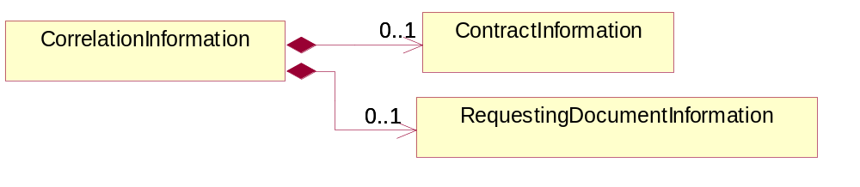
Figure ‎5-36 CorrelationInformation

Composition | Cardinality | Type | Documentation
ContractInformation | 0..1 | ContractInformation | A block of information used to correlate a contract in an executing choreography.
RequestingDocumentInformation | 0..1 | RequestingDocumentInformation | A block of information used to correlate a requesting document to a responding document in an executing choreography.

DocumentHeader
The object allows for the identification of the sender and receiver of the business document.
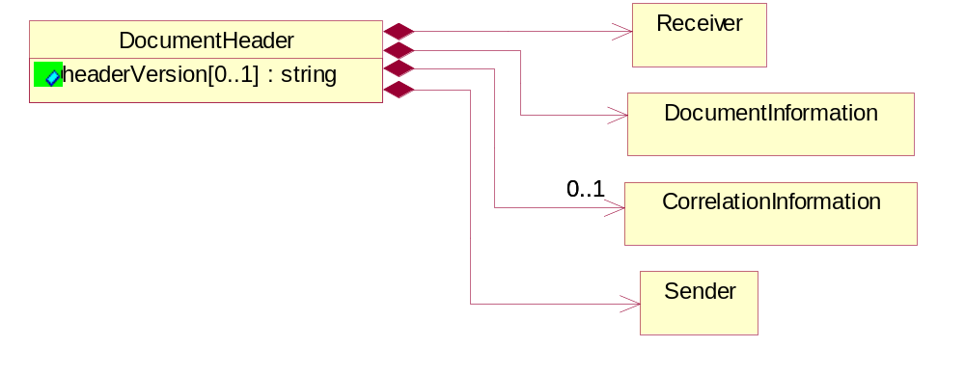
Figure ‎5-37 DocumentHeader

Attribute | Type | Documentation
headerVersion[0..1] | string | The UN/CEFACT version of the document header.

Composition | Cardinality | Type | Documentation
Sender | 1 | Sender | The object allows the identification of the initiating party of the business message.
CorrelationInformation | 0..1 | CorrelationInformation | A block of information used to correlate a requesting document to a responding document and to the contract in an executing choreography.
DocumentInformation | 1 | DocumentInformation | The object specifies information to identify the business document, a summary of attachments, and information about the business document security.
Receiver | 1 | Receiver | The object allows the identification of the receiving party of the business message.

DocumentIdentification
The object specifies all information necessary to identify the business document.
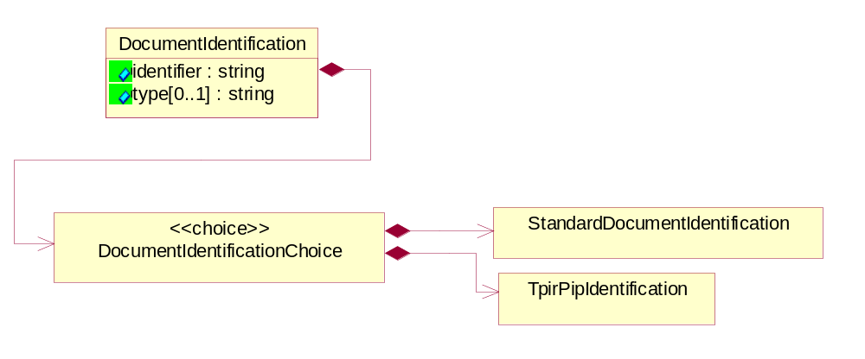
Figure ‎5-38 DocumentIdentification

Attribute | Type | Documentation
identifier | string | The unique identifier for the document being sent.
type[0..1] | string | Name of the Action Message

Composition | Cardinality | Type | Documentation
DocumentIdentificationChoice | 1 | DocumentIdentificationChoice

DocumentIdentificationChoice

Composition | Cardinality | Type | Documentation
StandardDocumentIdentification | 1 | StandardDocumentIdentification | The object specifies additional information necessary to identify the standard business document.
TpirPipIdentification | 1 | TpirPipIdentification | The object specifies all information necessary to uniquely identify a TPIR-PIP within a Registry or trading partner repository.

DocumentInformation
The object specifies information to identify the business document, a summary of attachments, and information about the business document security.
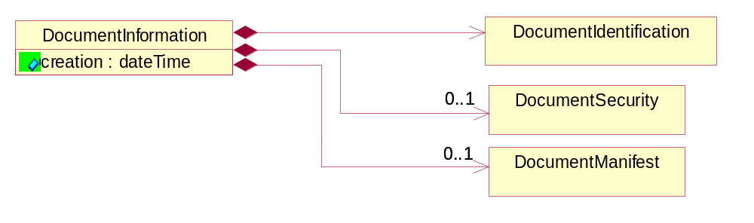
Figure ‎5-39 DocumentInformation

Attribute | Type | Documentation
creation | dateTime | The creation date and time of the specified Business Document (i.e. the Purchase Order date).

Composition | Cardinality | Type | Documentation
DocumentIdentification | 1 | DocumentIdentification | The object specifies all information necessary to identify the business document.
DocumentSecurity | 0..1 | DocumentSecurity | The object provides additional granularity in specifying business document security (this is in addition to the specified PIP security).
DocumentManifest | 0..1 | DocumentManifest | The block provides a brief summary of attachments and Service Content.

DocumentManifest
The block provides a brief summary of attachments and Service Content.
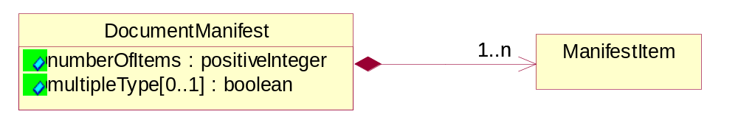
Figure ‎5-40 DocumentManifest

Attribute | Type | Documentation
numberOfItems | positiveInteger | Total number of documents in the message. The physical count of the attachments in the payload plus the RosettaNet Business Message (for Service Content). The value of this field will be at least 1.
multipleType[0..1] | boolean | Indicates whether the manifest contains documents of multiple types. True if yes, and False if no.

Composition | Cardinality | Type | Documentation
ManifestItem | 1..n | ManifestItem | The object provides details about the specific attachment(s).

DocumentSecurity
The object provides additional granularity in specifying business document security (this is in addition to the specified PIP security).

Figure ‎5-41 DocumentSecurity

Attribute | Type | Documentation
nonRepudiableReceipt | boolean | The value "true" will indicate that a signed acknowledgement for the business document is necessary.
persistentEncryption | boolean | The value "true" will indicate that the Business Document (including the header) needs to be encrypted when stored or transported.
persistentSignature | boolean | The value "true" will indicate that a signature is required to be stored with the document while stored or transported.

ManifestItem
The object provides details about the specific attachment(s).
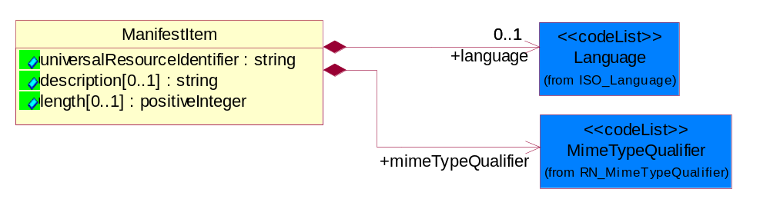
Figure ‎5-42 ManifestItem

Attribute | Type | Documentation
universalResourceIdentifier | string | The generic set of all names/addresses that are short strings that refer to resources.
description[0..1] | string | A description of the attachment.
length[0..1] | positiveInteger | The size of the attachment in bytes (i.e. 1 000 000 bytes)

Composition | Cardinality | Type | Documentation
mimeTypeQualifier | 1 | MimeTypeQualifier | The MIME type as defined by IANA.  Please refer to http://www.iana.org/assignments/media-types/ for a list of types.
language | 0..1 | Language | For representation of Language name RosettaNet has adopted ISO 639-2; 1998. Refer to the following web page to get the latest version of the standard:  http://www.loc.gov/standards/iso639-2/iso639jac.html  If you need more information about the ISO standard please contact ISO for more details.

PipIdentifier
PIP Identification.[ i.e. PIP3A4]
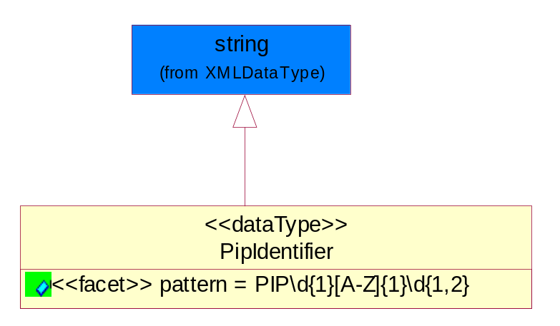
Figure ‎5-43 PipIdentifier

Attribute | Type | Documentation
pattern |  | PIP\d{1}[A-Z]{1}\d{1,2}

PipVersion
PIP version number (i.e. 02.02.00).
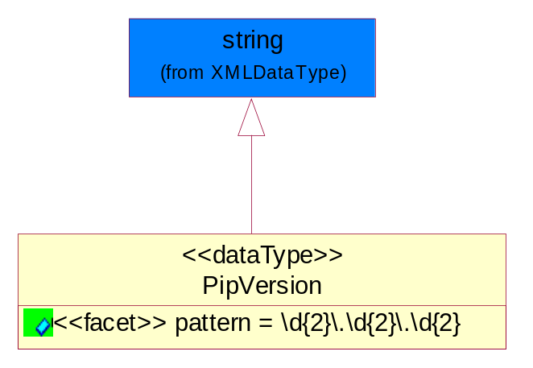
Figure ‎5-44 PipVersion

Attribute | Type | Documentation
pattern |  | \d{2}\.\d{2}\.\d{2}

Receiver
The object allows the identification of the receiving party of the business message.
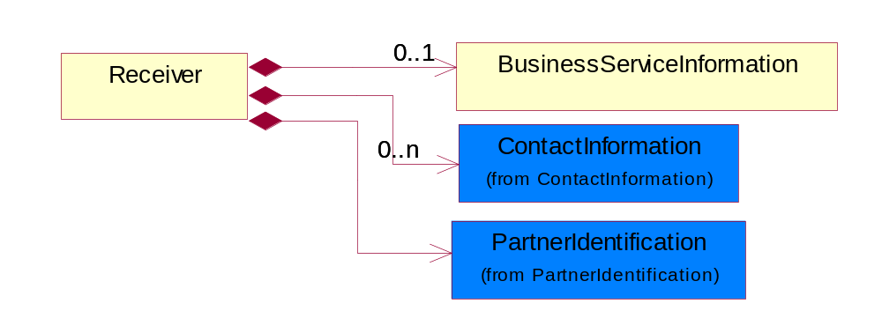
Figure ‎5-45 Receiver

Composition | Cardinality | Type | Documentation
BusinessServiceInformation | 0..1 | BusinessServiceInformation | The object allows the specification of the business service utilized within the partner company. This may or may not be the same as the information sent by the RNIF.
PartnerIdentification | 1 | PartnerIdentification | The business document must allow for the identity of one or more parties to the transaction.
ContactInformation | 0..n | ContactInformation | The business document must allow for the identification of the name of the department, service or individual to be contacted regarding the context of the business document.

RequestingDocumentInformation
A block of information used to correlate a requesting document to a responding document in an executing choreography.

Figure ‎5-46 RequestingDocumentInformation

Attribute | Type | Documentation
businessProcessInstanceIdentifier[0..1] | string | The identifier for the public business process instance being sent that both the sender and receiver can identify.
responseDateTime[0..1] | dateTime | The expected time to receive the response. This can not be greater than the PIP TimeToPerform.
requestingDocumentCreationDateTime[0..1] | dateTime | The date-time of the requesting business document.
requestingDocumentInstanceIdentifier | string | The Business Document identification number that identifies the requesting Business Document.

Sender
The object allows the identification of the initiating party of the business message.
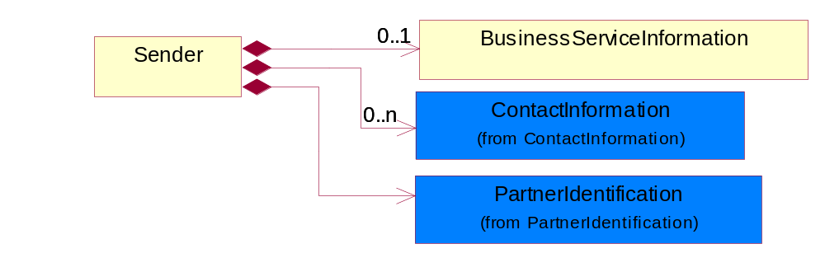
Figure ‎5-47 Sender

Composition | Cardinality | Type | Documentation
PartnerIdentification | 1 | PartnerIdentification | The business document must allow for the identity of one or more parties to the transaction.
BusinessServiceInformation | 0..1 | BusinessServiceInformation | The object allows the specification of the business service utilized within the partner company. This may or may not be the same as the information sent by the RNIF.
ContactInformation | 0..n | ContactInformation | The business document must allow for the identification of the name of the department, service or individual to be contacted regarding the context of the business document.

StandardDocumentIdentification
The object specifies additional information necessary to identify the standard business document.
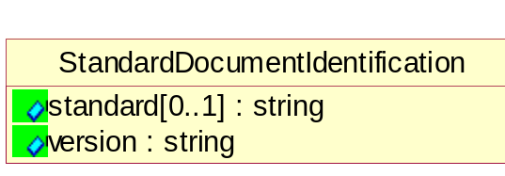
Figure ‎5-48 StandardDocumentIdentification

Attribute | Type | Documentation
standard[0..1] | string | Identifies the standard used to submit the business document. (e.g. RosettaNet).
version | string | PIP3A4v01.00

TpirPipIdentification
The object specifies all information necessary to uniquely identify a TPIR-PIP within a Registry or trading partner repository.

Figure ‎5-49 TpirPipIdentification

Attribute | Type | Documentation
partnerId | DUNSPlus4 | The Trading Partner Identification of MNC that is creating this TPIR PIP.
pipIdentifier | PipIdentifier | A TPIR PIP Identification [i.e., 3A4 ).
pipVersion | PipVersion | A TPIR PIP version number (i.e., 02.02.00)
tpirPipVersion | VersionIdentifier | A TPIR-PIP Version Number (i.e., major and minor version number as XX.XX).
tpirBusinessProcessIdentifier[0..1] | BusinessProcessIdentifier | A Business Process Identifier to uniquely define the TPIR-PIP 'role' within a Business Scenario at a company or MNC level. The identifier MUST be composed of alphanumeric characters only and its length MUST be between one and twelve characters.
uri[0..1] | anyURI | Describes the destination uri for the TPIR form.

Composition | Cardinality | Type | Documentation
fileType | 0..1 | TPIRFileType | Describes the file type of the TPIR form (PDF, XDP or XML).

VersionIdentifier
Version Number (i.e., major and minor version number as XX.XX).
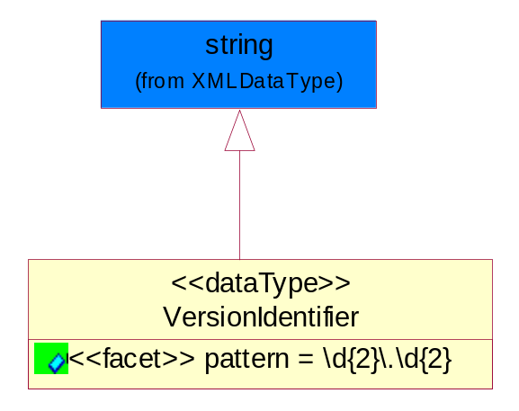
Figure ‎5-50 VersionIdentifier

Attribute | Type | Documentation
pattern |  | \d{2}\.\d{2}

CodeList

TPIRFileType
A code identifying the file type of TPIR form.

Name | Documentation
PDF | Portable Document Format.
XDP | XML Data Package.
XML | eXtensible Markup Language.

XML Data Type

anyURI
Represents a URI as defined by RFC 2396. An anyURI value can be absolute or relative, and may have an optional fragment identifier.

boolean
Represents Boolean values, which are either "true" or "false".

dateTime
Represents a specific instance of time.
The pattern for dateTime is CCYY-MM-DDThh:mm:ss where CC represents the century, YY the year, MM the month, and DD the day, preceded by an optional leading negative (-) character to indicate a negative number. If the negative character is omitted, positive (+) is assumed. The T is the date/time separator and hh, mm, and ss represent hour, minute, and second respectively. Additional digits can be used to increase the precision of fractional seconds if desired. For example, the format ss.ss... with any number of digits after the decimal point is supported. The fractional seconds part is optional.

This representation may be immediately followed by a "Z" to indicate Coordinated Universal Time (UTC) or to indicate the time zone. For example, the difference between the local time and Coordinated Universal Time, immediately followed by a sign, + or -, followed by the difference from UTC represented as hh:mm (minutes is required). If the time zone is included, both hours and minutes must be present.

float
Represents single-precision 32-bit floating-point numbers.

integer
Represents a sequence of decimal digits with an optional leading sign (+ or -). This data type is derived from decimal.

positiveInteger
Represents an integer that is greater than zero. This data type is derived from nonNegativeInteger.

string
Represents character string.

